A+ Computer Science MOUSE BUTTON TEST

Lab Goal : This lab was designed to teach you more about if-else-if statements
Lab Description : Write a program that will test to see which mouse button was pressed. If the left mouse button is pressed, draw a square at that location. If the right mouse button is pressed, draw a circle at that location. If the center wheel button is pressed, draw both circle and square, or draw another shape. Feel free to change the colors, sizes, and shapes however you want.
Note that for every button clicked, it prints a string on the upper left area of the canvas which button was activated. You must have different colors for each string printed. See illustration in class.
Files Needed ::
MouseButtonTester.java
MouseButtonTesterRunner.java

Sample Data :
lots of mouse clicks

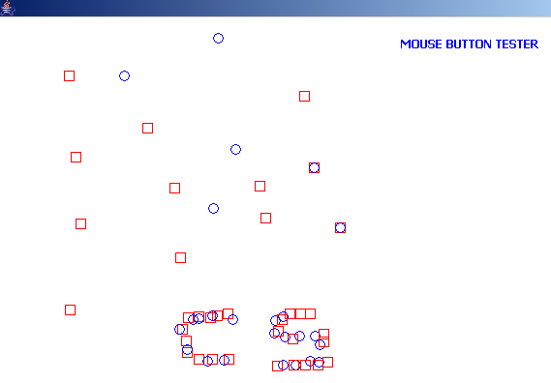
Sample Output :
Google the MouseEvent docs online for additional help.

MouseEvent methods
getX() – gets X position
getY() – gets Y position
getButton() – gets button #

MouseEvent fields
BUTTON1
BUTTON2
BUTTON3

