A+ Computer Science PONG PART IV

Lab Goal : This lab was designed to teach you more inheritance and object oriented programming while learning more about how to write a very simple game.

Lab Description : Now that Block, Ball, and Paddle have all been tested numerous times, we can put them all together to make the Ping Pong Game. The hardest part of the game is getting the paddles to hit the ball. I am giving you some logic to make the Ball hit the left paddle. You must then create the logic to make the Ball hit the right paddle. You will use Pong.java to write the final game.

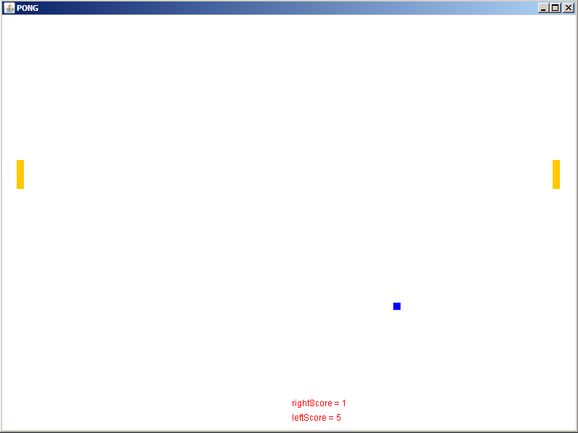
Basic logic to see if the Ball
collides with the left Paddle

if( (ball’s x <= left paddle’s x +left paddle’s width+abs(ball x Spd)
&&
( balls’s y >= left paddle’s y &&
balls’s y <= left paddle’s y + left paddle’s height ||
ball’s y + ball’s height >= left paddle’s y &&
ball’s y + ball’s height < left paddle’s y + paddle’s height ) )
{
if( balls’s x <= left paddle’s x +left paddle’s width – abs(ball x Spd )
set Y speed to negative of current speed
else
set X speed to negative of current speed
}

PONG GAME EXTENSIONS

1. Open the BlinkyBall.java file and write the code for BlinkyBall. BlinkyBall will change colors every time it moves. You must
override some methods and make super calls.

2. Open the SpeedUpBall.java file and write the code for SpeedUpBall. SpeedUpBall will speed up every time it collides with a wall
or a paddle. You must override some methods and make super calls.

3. Create a new Ball named InvisibleBall that will turn invisible randomnly. At random times, it will turn invisible for random
durations of time.

