A+ Computer Science PONG PART I

Lab Goal : This lab was designed to teach you more object oriented programming and how to write a very simple game.

Lab Description : Complete the code for the Block class located in Block.java. Test Block using the BlockTestOne.java and BlockTestTwo.java files. The Block class is the building block for the Pong project. Ball and Paddle are Blocks. Both Ball and Paddle will extend Block. The Block class stores position, size, and color properties.
Files Needed ::
Block.java
BlockTestOne.java
BlockTestTwo.java
Tester.java

public class Block
{
private int xPos; //x position of the block
private int yPos; //y position of the block
private int width; //width of the block
private int height; //height of the block

private Color color; //color of the block

public Block(){
Sample Output ( BlockTestOne.java )
// x – y – wid – ht - color
100 150 10 10 java.awt.Color[r=0,g=0,b=0]
50 50 30 30 java.awt.Color[r=0,g=0,b=0]
350 350 15 15 java.awt.Color[r=255,g=0,b=0]
450 50 20 60 java.awt.Color[r=0,g=255,b=0]
false
true

}

//add other Block constructors

//other modifiers not shown

public void draw(Graphics window){
window.setColor(color);
window.fillRect(getX(), getY(), getWidth(), getHeight());
}
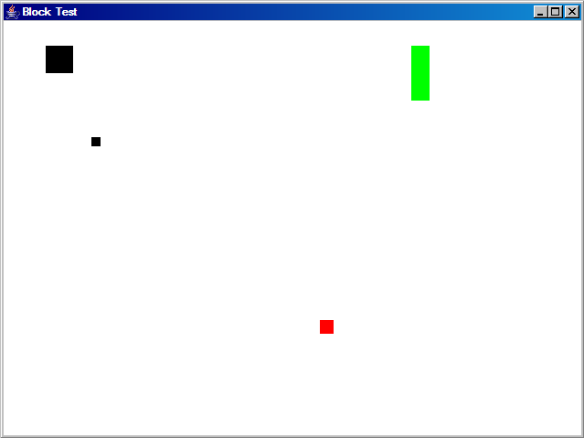
public void draw(Graphics window, Color col)
{

}

public boolean equals(Object obj)
{

}

//other accessors not shown

}

