1776 · 1787 · 1791 • UNITED STATES GOVERNMENT & CIVICS (GC) • COURSE STANDARD EDITION
GOVERNMENT HACK™
TROOPTOTEACHER TECHNOLOGIES
UNIT 1
Foundations of Constitutional Government
COURSE STANDARD EDITION
GC.01–GC.09 • Tennessee U.S. Government & Civics Standards • Grades 9–12
★ TENNESSEE CONNECTION
Tennessee entered the Union in 1796 as the 16th state. Its own state constitution echoes the federal design studied in this unit — a separation of powers among three branches and a Declaration of Rights modeled on the Bill of Rights (GC.06, GC.08).
One common workbook designed for learner variability. Every student works toward the same Tennessee standards; supports vary the means, not the goal or the ceiling.
Release-Ready · Pilot Edition
© 2026 TroopToTeacher Technologies LLC. All rights reserved. ISBN: [to be assigned]

Copyright, Ownership & Framework
Government Hack™ — Unit 1: Foundations of Constitutional Government, Course Standard Edition.
© 2026 TroopToTeacher Technologies LLC. All rights reserved. This workbook is proprietary; reproduction or redistribution outside a licensed classroom is prohibited.
Source integrity. Every primary source in this unit is public-domain and cited to its holding repository (National Archives, Library of Congress). See the Source Library.
Reading provenance (district-clear). Close-Read passages are labeled “Government Hack-authored instructional synthesis” — they build on the standard record and are not presented as primary sources.
Framework stack. This workbook anchors to Tennessee U.S. Government & Civics standards GC.01–GC.09 and the Social Studies Practices (SSP.01–SSP.06), and is designed on CAST UDL 3.0 and an MTSS support model.
Pacing. Each standard is built for one 45-minute class period. Each activity shows a ⏱ ~ minutes estimate at its heading. There is more here than one period holds — your teacher chooses which activities you do in class; the rest may become warm-ups, stations, or homework.

Table of Contents

Tennessee Standards & SSP Crosswalk
Each standard below is taught to the full Course Standard expectation; the Social Studies Practices are embedded in every activity cycle.
Standard | Focus | Student Deck slides
GC.01 | Enlightenment Roots of American Government | 2–8
GC.02 | The Declaration of Independence | 9–15
GC.03 | The Articles of Confederation | 16–22
GC.04 | The Constitutional Convention & Ratification | 23–29
GC.05 | The Preamble: Purposes of Government | 30–36
GC.06 | Principles of Limited Government | 37–43
GC.07 | Structure of the Constitution & How to Amend It | 44–50
GC.08 | The Bill of Rights | 51–57
GC.09 | Republic and Democracy | 58–64

Social Studies Practices (SSP.01–SSP.06)
SSP.01 Gather/evaluate sources · SSP.02 Critically examine a primary source · SSP.03 Synthesize evidence · SSP.04 Construct/communicate argument · SSP.05 Develop historical awareness · SSP.06 Chronological/spatial reasoning. Each Close Read, Primary Source/Data, and CER activity names the practices it builds.

Accessibility, UDL & Accommodations Matrix
One firm learning goal per standard; flexible, universal means. Supports are available by design and never lower the goal. They work alongside — never in place of — required IEP or 504 accommodations.
Universal support | What it is | Where it appears
CORE PATH | Essential instruction every student completes | Every activity
LANGUAGE SUPPORT | Vocabulary, pronunciation, Spanish cognates | Word Bank, Guided/Light Backs
RESPONSE CHOICE | Write, say/record, or diagram | Every activity
SUPPORT OPTION | Optional scaffold that keeps the goal | Guided Support Back, Primary Source
PROGRESS CHECK | Quick DOK-2/3 check to guide reteach/extend | Cornell Notes, Practice Quiz
EXTENSION | Deeper challenge once the goal is met | Extension Bank, CER

How CAST UDL 3.0 is visible in this workbook
Multiple means of Engagement (response choice, relevance via Tennessee Connection), Representation (Word Bank, pronunciation, Spanish, Close-Read supports), and Action & Expression (write/say/diagram, Frayer, CER). No fixed-track labels appear.

My Support Plan (optional — you choose)
Supports are available by design. Check the ones you might try; you can change your mind any time.
Support I might use | When it would help me
Word Bank + Spanish column
Guided or Light Support Back
Response choice (say/record or diagram)
Sentence frames / Rehearsal Lab

How to Use This Workbook
Each standard runs the same seven-activity cycle: (1) Vocabulary Word Bank, (2) Vocabulary Studio, (3) Direct-Teaching Cornell Notes with optional Guided and Light Support Backs, (4) Close Read, (5) Primary Source / Data Analysis, (6) Core Application Practice Quiz, (7) Constructed Response (CER). Work the CORE PATH; reach for SUPPORT OPTIONS as needed.

Label legend — these appear throughout every standard cycle
Label | Meaning
CORE PATH | The essential instruction every student completes.
SUPPORT OPTION | An optional scaffold that keeps the goal, not lowers it.
LANGUAGE SUPPORT | Vocabulary, pronunciation, and Spanish cognates for access.
RESPONSE CHOICE | Show learning by writing, saying/recording, or diagramming.
PROGRESS CHECK | A quick DOK-2/3 check that guides reteach or extend.
EXTENSION | A deeper challenge once the goal is met.

Before You Begin — Set Your Goal
This unit asks one big question: How and why did the Founders build a limited constitutional republic? Set a goal, then note what you already know.
Prompt | Your response
My goal for this unit is…
One thing I already know about this era…
One question I want answered…

Standard GC.01 — Enlightenment Roots of American Government
TN Academic Standard GC.01: Examine the influences of leading European thinkers (e.g., John Locke, Charles-Louis Montesquieu, Thomas Hobbes) and other roots of American government (e.g., Greek democracy, Roman Republic, Magna Carta). (C, E)
LEARNING TARGETS — I can…
• I can I can examine the influences of leading European thinkers (e.g., John Locke, Charles-Louis Montesquieu, Thomas Hobbes) and other roots of American government (e.g., Greek democracy, Roman Republic, Magna Carta)..
Lenses for this standard: Culture (C) · Economics (E)
CORE PATH — the same for every student
Every student works this standard at the same rigor: analyze the sources and vocabulary, then demonstrate learning on the Practice Quiz and CER. UDL and MTSS give you flexible ways in — they never lower the bar. Check yourself against the learning targets on the Cornell Notes page.
SET YOUR GOAL (self-direction)
My goal for this standard — what will I be able to do, and how will I show it?

HOOK — think before you dig in
You already have rights no ruler gave you and none can take away — that's the idea that started a revolution. Where did it come from?

ACTIVATE — what do you already know or wonder?
Jot what you already know or want to find out about this standard. You’ll come back to it.

PREVIEW & PREDICT
Which learning target will be hardest, and why? Connect it to the unit’s big question: How and why did the Founders build a limited constitutional republic?

Activity 1 — Vocabulary (Part A: Reference / Word Bank) — GC.01 ⏱ ~10 min
Use this word bank throughout the standard. The Spanish column supports access, not translation of assessment.
Term | Student-friendly meaning | Spanish
Natural Rights | God-given rights to life, liberty, and property that government does not grant and cannot rightfully take away — central to John Locke's political thought. | derechos naturales
Social Contract | The idea that people agree to give up some freedom to a government in exchange for protection of their rights, and that government's authority comes from the consent of the governed. | contrato social
Magna Carta | The 1215 English charter that limited the king's power and protected certain rights of life, liberty, and property — an early root of limited government and due process. | Carta Magna
LANGUAGE SUPPORT
Pronunciations: Natural Rights (NATCH-rul RYTS); Social Contract (SOH-shul KON-trakt); Magna Carta (MAG-nuh KAR-tuh).

VOCABULARY SELF-CHECK · Knowledge Rating
Rate each term NOW in pencil, then again at the END — growth is the goal; no penalty for “never seen it.”
Term | 1 · never seen it | 2 · heard it | 3 · can use it | 4 · can teach it
Natural Rights
Social Contract
Magna Carta
MAKE IT YOURS (RESPONSE CHOICE): choose ONE term above and show you own it — write a sentence, sketch it, or give a real-world example.

QUICK WRITE
Which of these terms do you think will matter MOST for this standard, and why? You’ll revisit this at the end.

Activity 2 — Vocabulary Studio (Frayer-inspired) — GC.01 ⏱ ~7 min
RESPONSE CHOICE
Complete each studio by writing, speaking, or diagramming.

PRIORITY TERM 1 Natural Rights · ES: derechos naturales
Word-bank meaning to build on: God-given rights to life, liberty, and property that government does not grant and cannot rightfully take away — central to John Locke's political thought.
Definition (in your own words) | Characteristics
Examples | Non-examples
Use it to explain
Write one sentence that uses “Natural Rights” to explain this standard.

PRIORITY TERM 2 Social Contract · ES: contrato social
Word-bank meaning to build on: The idea that people agree to give up some freedom to a government in exchange for protection of their rights, and that government's authority comes from the consent of the governed.
Definition (in your own words) | Characteristics
Examples | Non-examples
Use it to explain
Write one sentence that uses “Social Contract” to explain this standard.

CONNECT THE TERMS (UDL · build understanding)
How do these priority terms fit together? Write or sketch how one leads to or affects another.

Activity 3 — Direct Teaching Cornell Notes — GC.01 ⏱ ~20 min
Name: ______________________ Class / Period: __________ Date: __________
GC.01 — Enlightenment Roots of American Government • Lean Student Deck slides 2–8 • direct-teaching slides 4–6
Your learning targets are on this standard’s opening page — take notes that help you meet them.
Guiding cues | My notes — write your notes here
Key idea of this standard?
One primary source that supports it?
One effect on government or rights?
Key terms →
Keep taking notes — lines run the full width of the page:

DOODLE ZONE — draw your thinking (UDL · another way in)
Need another way in? Sketch the key idea, a quick timeline, or how the pieces connect. Words optional.

Cornell Notes — keep going, then process & check — GC.01
MORE NOTES / DIAGRAMS
Continue your notes here, add a quick sketch, or map how the ideas connect.

Key terms to list
Natural Rights · Social Contract · Magna Carta
Summary — In your own words (2–3 sentences)
PROGRESS CHECK · one question
According to John Locke, where does a government's rightful authority come from?
A. The divine right of kings
B. The strongest military
C. The consent of the people being governed
D. Inherited wealth and land
Commit before you move on — mark it, say it, or explain it aloud.
CHECK YOURSELF — how am I doing?
Which learning targets (on this standard’s opening page) can you now meet? Tick the number; circle any you still need help with.
☐ 1
My 12–15 word headline for this standard

Guided Support for the Cornell Notes — GC.01
These scaffolds support ONLY the Cornell notes — use them to take and process those notes. Optional and easy to set aside; not a separate assignment or a label.
Key vocabulary | What it means
Natural Rights | God-given rights to life, liberty, and property that government does not grant and cannot rightfully take away — central to John Locke's political thought.
Social Contract | The idea that people agree to give up some freedom to a government in exchange for protection of their rights, and that government's authority comes from the consent of the governed.
Magna Carta | The 1215 English charter that limited the king's power and protected certain rights of life, liberty, and property — an early root of limited government and due process.
Break it into steps:
1) Name one cause or effect. 2) Give one piece of evidence. 3) Write one sentence explaining the link.
Sentence frame
One key cause/effect of enlightenment roots of american government was ______, shown by ______, which mattered because ______.
Modeled example (one worked note — yours will differ)
A key idea of enlightenment roots of american government was Natural Rights: God-given rights to life, liberty, and property that government does not grant and cannot rightfully take away — central to John Locke's political thought.
GUIDED NOTE REHEARSAL LAB
Rehearse the cause→effect chain below, then transfer it to your Cornell notes.
Step | Rehearse it here
Name it
Evidence
Explain
Headline
TRANSFER CHECK — move one rehearsed idea onto the front notes

Light Support for the Cornell Notes — GC.01
A lighter scaffold for the SAME Cornell notes. Try the notes first; reach for this only if you need it.
Key vocabulary | Finish the idea — “This term means …”
Natural Rights
Social Contract
Magna Carta
Guiding questions — answer on the lines below (or in your front notes):
• According to Locke, what rights do people have simply by being born, and what is government's job regarding them?
• What limit on the king's power does Magna Carta's Clause 39 establish, and how does it connect to due process today?
• Why does the text say the colonists used 'old ideas, not new ones' to justify independence?

WHICH CUE STILL NEEDS WORK?
Circle the Cornell cue from the front page you still need help with, and tell your teacher so we can go over it.
LIGHT PROCESSING LAB
Answer one guiding question from above in a full sentence, in your own words.

Activity 4 — Close Read — GC.01 ⏱ ~15 min
Reading type: Government Hack-authored instructional synthesis. This is not a primary source. Builds SSP.03 (synthesize) and SSP.05 (historical awareness).
CORE PATH
American ideas about liberty and self-government were not new in 1776 — they grew from older roots. John Locke argued that people are born with natural rights to life, liberty, and property, and that government exists by a social contract to protect them, losing its authority if it fails. Montesquieu urged dividing government power among separate branches; Hobbes explained why people trade some freedom for order. Older models mattered too: Greek democracy, the Roman republic, and the limits on rulers set in Magna Carta (1215) and the English Bill of Rights (1689). The colonists inherited these ideas and reshaped them.
LANGUAGE SUPPORT
Key terms to know first: Natural Rights, Social Contract. Read once for the gist, then again for evidence.
Text-dependent questions (answer in the Evidence Lab below or aloud):
1. According to Locke, what rights do people have simply by being born, and what is government's job regarding them?
2. What limit on the king's power does Magna Carta's Clause 39 establish, and how does it connect to due process today?
3. Why does the text say the colonists used 'old ideas, not new ones' to justify independence?
RESPONSE CHOICE: answer any question by writing in the Evidence Lab, saying/recording it, or diagramming it.
CLOSE-READ EVIDENCE LAB
Log evidence from the passage below.
Question / claim | Exact passage evidence | What the evidence shows

SPACED RETRIEVAL — quick recall (no notes)
Pull it up cold to strengthen memory, then check your notes.
Recall prompt | Your answer (from memory)
One key term or fact from THIS standard
One thing you learned EARLIER in this unit or course
How the two connect

Activity 5 — Primary Source / Data Analysis — GC.01 ⏱ ~15 min
Primary source (oil portrait) — analyze it with HIPPO. Builds SSP.01–SSP.02.
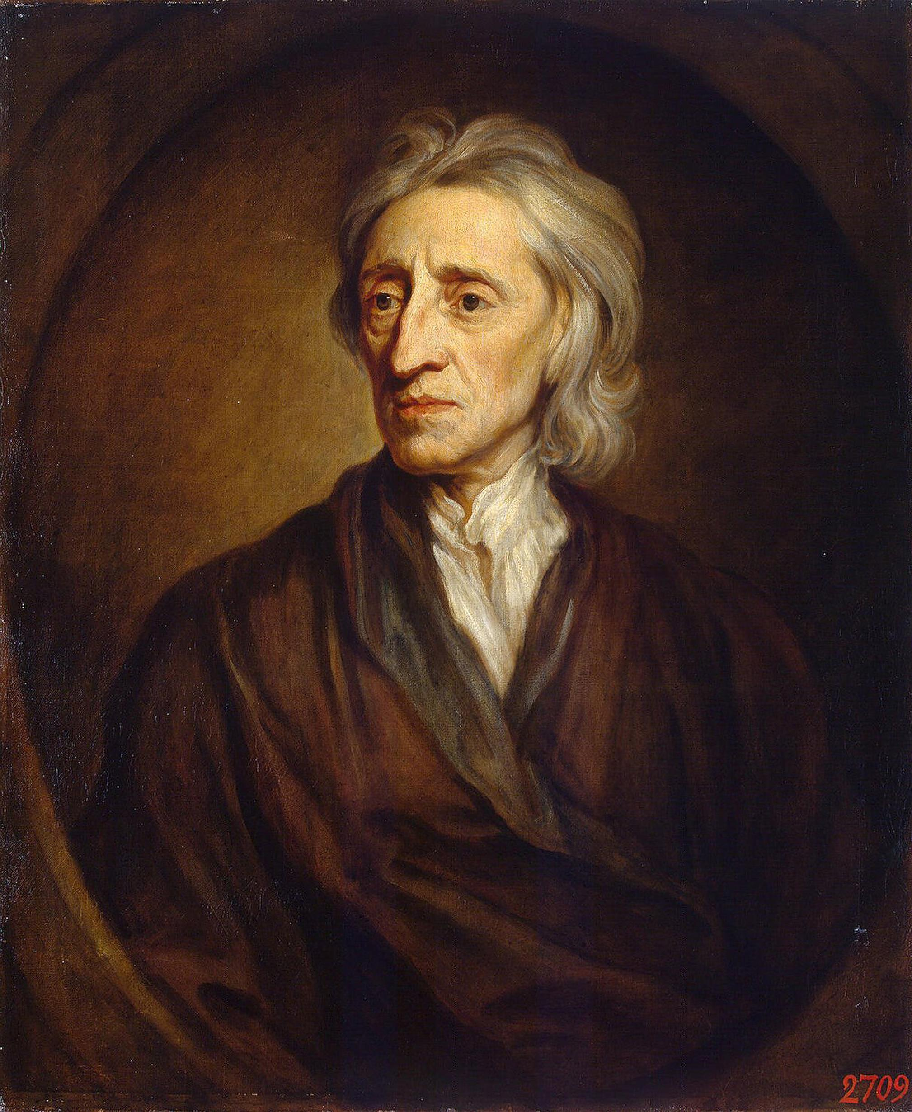
Portrait of John Locke · Sir Godfrey Kneller · 1697
Source: public domain (artist d. 1723) · https://commons.wikimedia.org/wiki/File:Godfrey_Kneller_-_Portrait_of_John_Locke_(Hermitage).jpg Public domain — artist d.1723 (PD-old/PD-US) https://commons.wikimedia.org/wiki/File:Godfrey_Kneller_-_Portrait_of_John_Locke_(Hermitage).jpg
HIPPO — analyze the source (prompt) | Your analysis
H — Historical context: what was happening when this was created?
I — Intended audience: who was meant to see or obey it?
P — Purpose: why was it created?
P — Point of view: whose perspective does it reflect?
O — Outside connection: how does it connect to this standard?
SUPPORT OPTION
Sentence frame: This source shows ______ because it ______, which reveals ______.
CONFIDENCE CHECK-IN
Rate your understanding of this standard (1–4): ______ One thing to revisit: ____________________

Activity 6 — Core Application: Practice Quiz — GC.01 ⏱ ~8 min
RESPONSE CHOICE
Commit to an answer by marking it, saying it, or explaining it aloud before checking. Answer key is in the Teacher Guide (kept separate).
[DOK 1 · item u1-gc01-dok1-1 · pre-field-test]
Which thinker is most associated with natural rights and the social contract?
A. Thomas Hobbes
B. John Locke
C. Julius Caesar
D. King John
[DOK 2 · item u1-gc01-dok2-tc · pre-field-test]
According to John Locke, where does a government's rightful authority come from?
A. The divine right of kings
B. The strongest military
C. The consent of the people being governed
D. Inherited wealth and land

STRETCH — think like a test-writer (open to all)
Write your OWN DOK-3 question for this standard, then a one-sentence answer key. Use the supports below — everyone can do this.
HOW TO WRITE A DOK-3 QUESTION (supports)
DOK-3 = strategic thinking: the reader must analyze, compare, evaluate, or justify using evidence — and there should be more than one defensible answer (not a fact you can just look up).
Sentence starters: “Why did ______ lead to ______?” · “Which mattered more — ______ or ______ — and why?” · “What is the BEST evidence that ______?” · “Evaluate whether ______.” · “Defend or challenge: ______.”
Frame: [Analyze / Evaluate / Justify] + [something from THIS standard] + “using evidence.”
Quick check: does my question make the reader THINK and use evidence? If yes, it’s DOK-3.
Your DOK-3 question | Your answer key (one sentence)

Activity 7 — Constructed Response (CER) — GC.01 ⏱ ~15 min
BIG-QUESTION ORGANIZER (before you write) — How and why did the Founders build a limited constitutional republic?
Plan your argument here, then use it to write your claim, evidence, and reasoning below.
Plan your argument | Your quick notes (from this standard)
My claim (answer the prompt)
Evidence 1 (a source or fact)
Reasoning (why it proves the claim)
CONSTRUCTED RESPONSE (CER) — builds SSP.04 Argumentation
Claim + Evidence + Reasoning: Which European root — Locke's natural rights, Montesquieu's separated powers, or Magna Carta's limits on the king — shaped American government the most? Defend your claim with evidence from two sources.
Part | Write here
Claim
Evidence (two specifics)
Reasoning
SELF-CHECK against the CER rubric (see Toolkit)
Before submitting: Is my claim defensible? Do I have TWO specific pieces of evidence? Does my reasoning explain HOW the evidence proves the claim?

UDL Access, Choice & Reflection — GC.01
UDL ACCESS & MTSS SUPPORT (this standard)
UDL 3.0 (CAST, 2024): read-aloud on request · key terms glossed (EN/ES) · respond in writing, speech, or a labeled diagram · large-print & screen-reader friendly. Same learning target for everyone; supports vary the means, not the ceiling.
MTSS: Tier 1 — this core lesson for all · Tier 2 — small-group reteach of this standard using its Cornell cues + graphic organizer, then re-check · Tier 3 — intensive 1:1 with concrete→representational→abstract scaffolding, progress-monitored to the same standard.
SHOW WHAT YOU KNOW — YOUR WAY (same CER rubric, same standard)
Build your Claim–Evidence–Reasoning in whichever mode lets you think best — the standard and the CER rubric are identical for every mode; the mode changes how you SHOW it, never what you are held to:
WRITE it · SAY it aloud and record it (audio or video) · DRAW and label a diagram that makes the argument · BUILD a model or artifact and caption its claim, evidence, and reasoning.
You may ask for a word processor, speech-to-text, a scribe, or a sentence/argument frame — these change how you produce, not the standard you meet.
CHOICE & VOICE — you decide how to go deeper (pick ONE)
You choose your path to show this standard — every option meets the same target:
DEFEND a term: pick the vocabulary word that matters most and argue why in 2–3 sentences. · CONNECT it: pick a current event, your community, or your own life and explain how this standard shows up there. · TAKE A SIDE: pick one debatable question and argue your position with evidence.
Your pick is yours — bring what matters to you into the work.
REFLECT & CONNECT — how your thinking grew, and whose view you weighed
Reflect (self-awareness): What did you believe about this topic BEFORE, and what changed AFTER? Name one thing to revisit.
Consider another view (empathy): Name one person or group who might see this standard differently than you; state their view fairly in one sentence — even if you disagree.
Norm (restorative): we critique ideas, not people; we assume good faith; we make room for every voice.

Standard GC.02 — The Declaration of Independence
TN Academic Standard GC.02: Examine the Declaration of Independence and American grievances against British rule. (H)
LEARNING TARGETS — I can…
• I can I can examine the Declaration of Independence and American grievances against British rule..
Lenses for this standard: History (H)
CORE PATH — the same for every student
Every student works this standard at the same rigor: analyze the sources and vocabulary, then demonstrate learning on the Practice Quiz and CER. UDL and MTSS give you flexible ways in — they never lower the bar. Check yourself against the learning targets on the Cornell Notes page.
SET YOUR GOAL (self-direction)
My goal for this standard — what will I be able to do, and how will I show it?

HOOK — think before you dig in
'All men are created equal.' A bold claim in 1776 — and the colonists used it to fire a king. How does the Declaration build its case?

ACTIVATE — what do you already know or wonder?
Jot what you already know or want to find out about this standard. You’ll come back to it.

PREVIEW & PREDICT
Which learning target will be hardest, and why? Connect it to the unit’s big question: How and why did the Founders build a limited constitutional republic?

Activity 1 — Vocabulary (Part A: Reference / Word Bank) — GC.02 ⏱ ~10 min
Use this word bank throughout the standard. The Spanish column supports access, not translation of assessment.
Term | Student-friendly meaning | Spanish
Unalienable Rights | Rights so fundamental they cannot be taken away or given up — in the Declaration, 'Life, Liberty and the pursuit of Happiness.' | derechos inalienables
Grievances | Formal complaints; in the Declaration, the list of specific abuses by King George III used to justify independence. | agravios
Declaration of Independence | The 1776 document, drafted mainly by Thomas Jefferson, that announced the colonies' separation from Britain and stated the principles of government by consent. | Declaración de Independencia
LANGUAGE SUPPORT
Pronunciations: Unalienable Rights (un-AY-lee-uh-nuh-bul RYTS); Grievances (GREE-vun-sez); Declaration of Independence (dek-luh-RAY-shun).

VOCABULARY SELF-CHECK · Knowledge Rating
Rate each term NOW in pencil, then again at the END — growth is the goal; no penalty for “never seen it.”
Term | 1 · never seen it | 2 · heard it | 3 · can use it | 4 · can teach it
Unalienable Rights
Grievances
Declaration of Independence
MAKE IT YOURS (RESPONSE CHOICE): choose ONE term above and show you own it — write a sentence, sketch it, or give a real-world example.

QUICK WRITE
Which of these terms do you think will matter MOST for this standard, and why? You’ll revisit this at the end.

Activity 2 — Vocabulary Studio (Frayer-inspired) — GC.02 ⏱ ~7 min
RESPONSE CHOICE
Complete each studio by writing, speaking, or diagramming.

PRIORITY TERM 1 Unalienable Rights · ES: derechos inalienables
Word-bank meaning to build on: Rights so fundamental they cannot be taken away or given up — in the Declaration, 'Life, Liberty and the pursuit of Happiness.'
Definition (in your own words) | Characteristics
Examples | Non-examples
Use it to explain
Write one sentence that uses “Unalienable Rights” to explain this standard.

PRIORITY TERM 2 Declaration of Independence · ES: Declaración de Independencia
Word-bank meaning to build on: The 1776 document, drafted mainly by Thomas Jefferson, that announced the colonies' separation from Britain and stated the principles of government by consent.
Definition (in your own words) | Characteristics
Examples | Non-examples
Use it to explain
Write one sentence that uses “Declaration of Independence” to explain this standard.

CONNECT THE TERMS (UDL · build understanding)
How do these priority terms fit together? Write or sketch how one leads to or affects another.

Activity 3 — Direct Teaching Cornell Notes — GC.02 ⏱ ~20 min
Name: ______________________ Class / Period: __________ Date: __________
GC.02 — The Declaration of Independence • Lean Student Deck slides 9–15 • direct-teaching slides 11–13
Your learning targets are on this standard’s opening page — take notes that help you meet them.
Guiding cues | My notes — write your notes here
Key idea of this standard?
One primary source that supports it?
One effect on government or rights?
Key terms →
Keep taking notes — lines run the full width of the page:

DOODLE ZONE — draw your thinking (UDL · another way in)
Need another way in? Sketch the key idea, a quick timeline, or how the pieces connect. Words optional.

Cornell Notes — keep going, then process & check — GC.02
MORE NOTES / DIAGRAMS
Continue your notes here, add a quick sketch, or map how the ideas connect.

Key terms to list
Unalienable Rights · Grievances · Declaration of Independence
Summary — In your own words (2–3 sentences)
PROGRESS CHECK · one question
The Declaration lists the colonists' natural rights and then a long list of grievances against the king. Why did the writers put these two parts together?
A. To show that when a government repeatedly violates the people's rights, the people may justly alter or abolish it
B. To make the document longer and more impressive
C. To ask King George III to apologize
D. To describe how to run the new state governments
Commit before you move on — mark it, say it, or explain it aloud.
CHECK YOURSELF — how am I doing?
Which learning targets (on this standard’s opening page) can you now meet? Tick the number; circle any you still need help with.
☐ 1
My 12–15 word headline for this standard

Guided Support for the Cornell Notes — GC.02
These scaffolds support ONLY the Cornell notes — use them to take and process those notes. Optional and easy to set aside; not a separate assignment or a label.
Key vocabulary | What it means
Unalienable Rights | Rights so fundamental they cannot be taken away or given up — in the Declaration, 'Life, Liberty and the pursuit of Happiness.'
Grievances | Formal complaints; in the Declaration, the list of specific abuses by King George III used to justify independence.
Declaration of Independence | The 1776 document, drafted mainly by Thomas Jefferson, that announced the colonies' separation from Britain and stated the principles of government by consent.
Break it into steps:
1) Name one cause or effect. 2) Give one piece of evidence. 3) Write one sentence explaining the link.
Sentence frame
One key cause/effect of the declaration of independence was ______, shown by ______, which mattered because ______.
Modeled example (one worked note — yours will differ)
A key idea of the declaration of independence was Unalienable Rights: Rights so fundamental they cannot be taken away or given up — in the Declaration, 'Life, Liberty and the pursuit of Happiness.'
GUIDED NOTE REHEARSAL LAB
Rehearse the cause→effect chain below, then transfer it to your Cornell notes.
Step | Rehearse it here
Name it
Evidence
Explain
Headline
TRANSFER CHECK — move one rehearsed idea onto the front notes

Light Support for the Cornell Notes — GC.02
A lighter scaffold for the SAME Cornell notes. Try the notes first; reach for this only if you need it.
Key vocabulary | Finish the idea — “This term means …”
Unalienable Rights
Grievances
Declaration of Independence
Guiding questions — answer on the lines below (or in your front notes):
• What three unalienable rights does the Declaration name, and where does government get its 'just powers'?
• Choose one grievance against King George III and explain how it violated the colonists' rights.
• How does the Declaration use natural rights to justify the colonies' break from Britain?

WHICH CUE STILL NEEDS WORK?
Circle the Cornell cue from the front page you still need help with, and tell your teacher so we can go over it.
LIGHT PROCESSING LAB
Answer one guiding question from above in a full sentence, in your own words.

Activity 4 — Close Read — GC.02 ⏱ ~15 min
Reading type: Government Hack-authored instructional synthesis. This is not a primary source. Builds SSP.03 (synthesize) and SSP.05 (historical awareness).
CORE PATH
On July 4, 1776, the Continental Congress adopted the Declaration of Independence, drafted mainly by Thomas Jefferson. Its most famous lines borrow directly from Locke: all people are 'created equal' and hold 'unalienable Rights' to 'Life, Liberty and the pursuit of Happiness,' and governments derive 'their just powers from the consent of the governed.' The Declaration then lists specific grievances against King George III — dissolving colonial legislatures, taxing without consent, keeping standing armies. The logic is an argument: because government exists to protect rights, a government that repeatedly violates them may justly be altered or abolished. The Declaration announced not just a separation, but a theory of legitimate government.
LANGUAGE SUPPORT
Key terms to know first: Unalienable Rights, Grievances. Read once for the gist, then again for evidence.
Text-dependent questions (answer in the Evidence Lab below or aloud):
1. What three unalienable rights does the Declaration name, and where does government get its 'just powers'?
2. Choose one grievance against King George III and explain how it violated the colonists' rights.
3. How does the Declaration use natural rights to justify the colonies' break from Britain?
RESPONSE CHOICE: answer any question by writing in the Evidence Lab, saying/recording it, or diagramming it.
CLOSE-READ EVIDENCE LAB
Log evidence from the passage below.
Question / claim | Exact passage evidence | What the evidence shows

SPACED RETRIEVAL — quick recall (no notes)
Pull it up cold to strengthen memory, then check your notes.
Recall prompt | Your answer (from memory)
One key term or fact from THIS standard
One thing you learned EARLIER in this unit or course
How the two connect

Activity 5 — Primary Source / Data Analysis — GC.02 ⏱ ~15 min
Primary source (manuscript on parchment) — analyze it with HIPPO. Builds SSP.01–SSP.02.
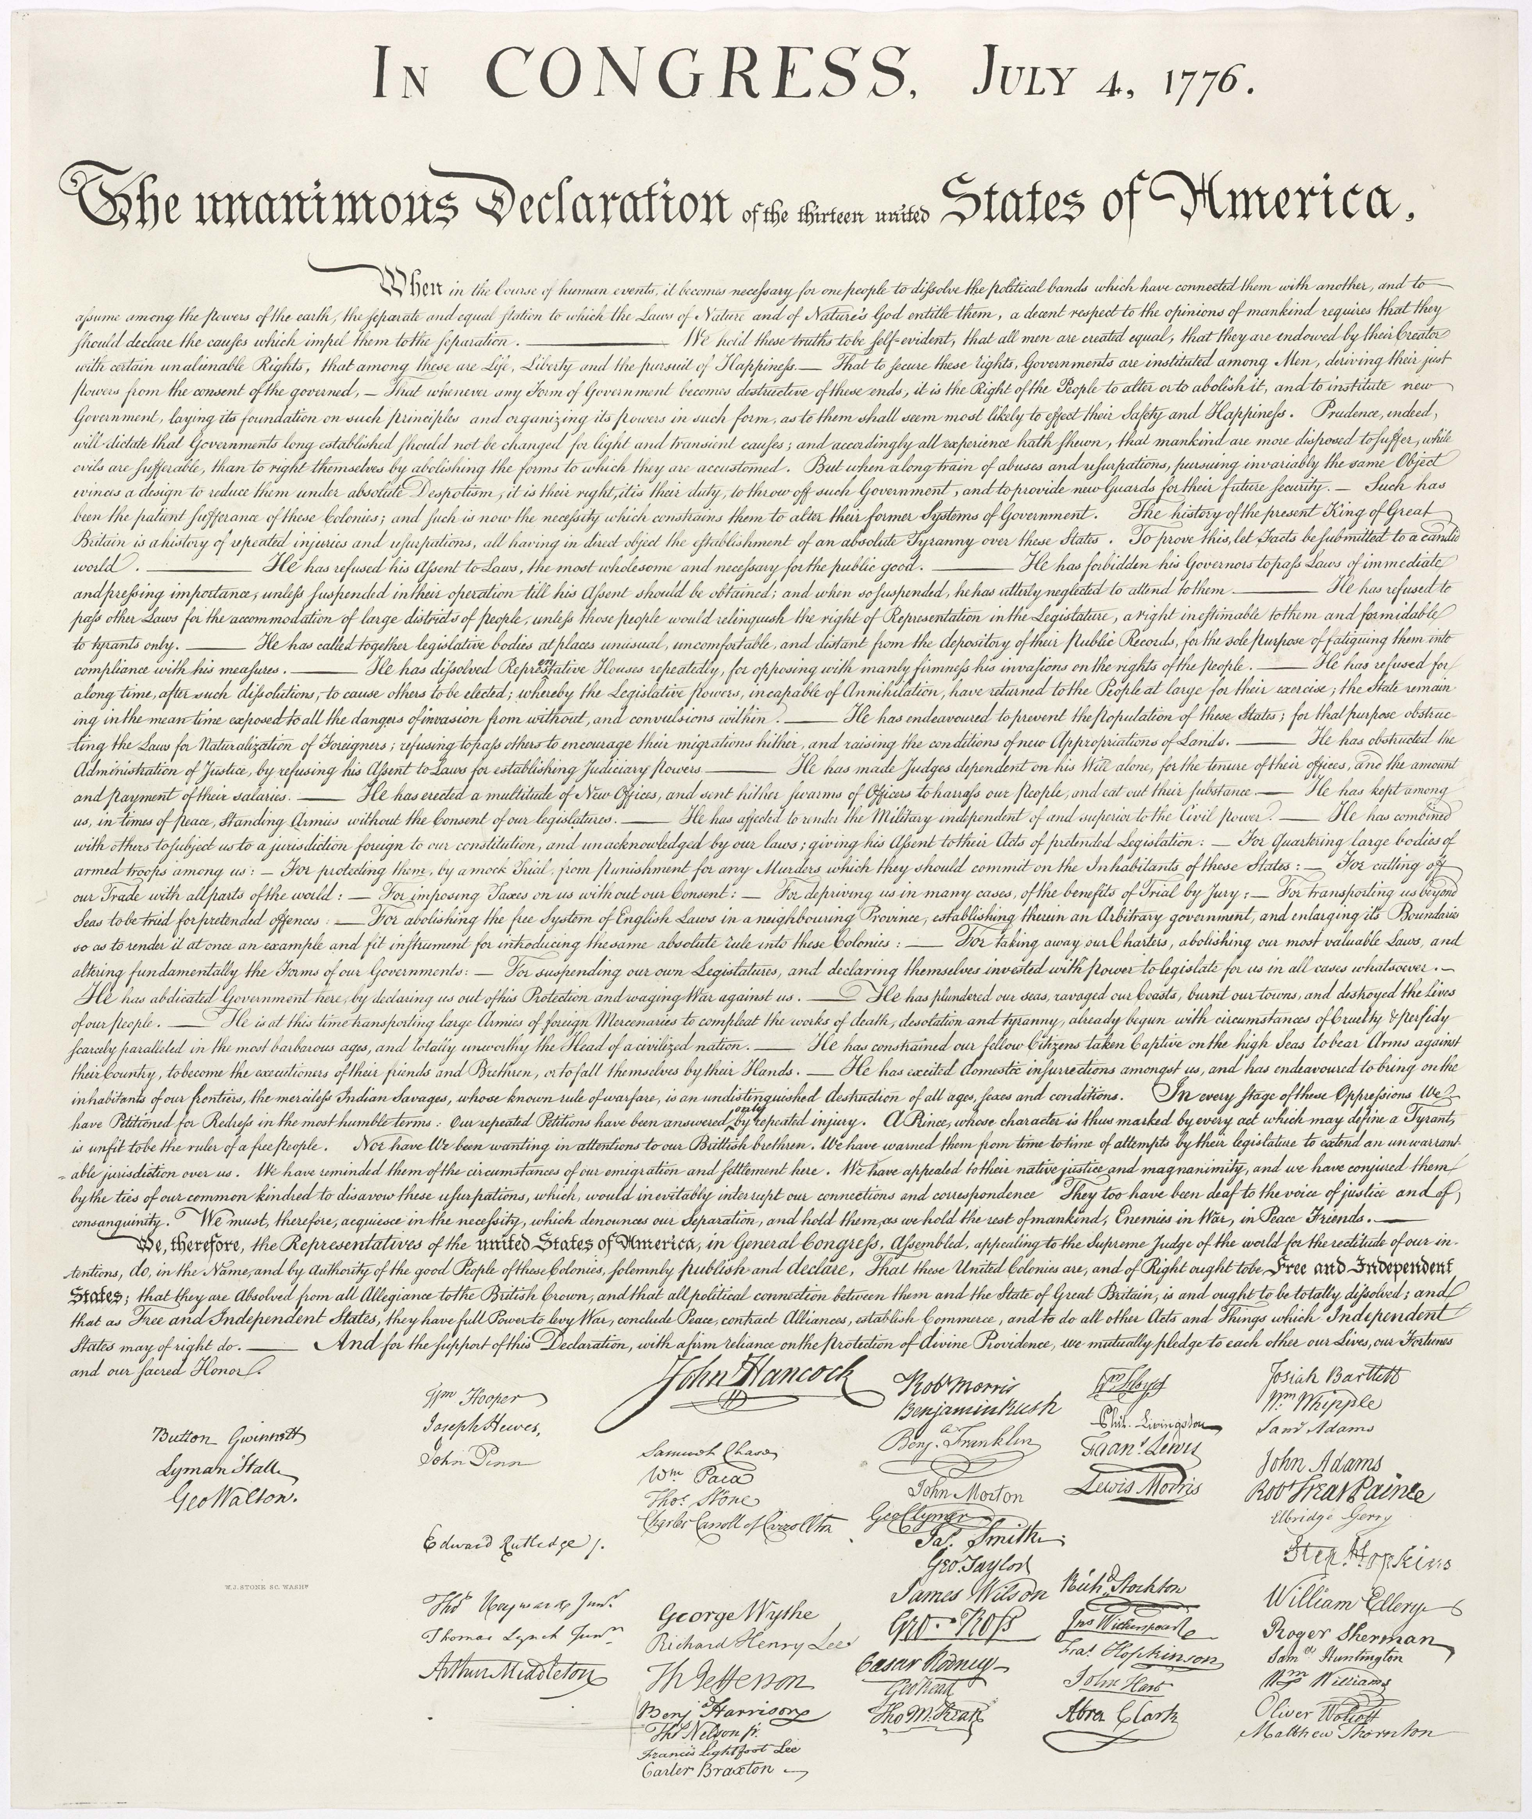
Declaration of Independence (engrossed copy) · Second Continental Congress; engrossed by Timothy Matlack · 1776
Source: U.S. National Archives · https://commons.wikimedia.org/wiki/File:United_States_Declaration_of_Independence.jpg Public domain — U.S. gov document, 1776 https://commons.wikimedia.org/wiki/File:United_States_Declaration_of_Independence.jpg
HIPPO — analyze the source (prompt) | Your analysis
H — Historical context: what was happening when this was created?
I — Intended audience: who was meant to see or obey it?
P — Purpose: why was it created?
P — Point of view: whose perspective does it reflect?
O — Outside connection: how does it connect to this standard?
SUPPORT OPTION
Sentence frame: This source shows ______ because it ______, which reveals ______.
CONFIDENCE CHECK-IN
Rate your understanding of this standard (1–4): ______ One thing to revisit: ____________________

Activity 6 — Core Application: Practice Quiz — GC.02 ⏱ ~8 min
RESPONSE CHOICE
Commit to an answer by marking it, saying it, or explaining it aloud before checking. Answer key is in the Teacher Guide (kept separate).
[DOK 1 · item u1-gc02-dok1-1 · pre-field-test]
According to the Declaration, governments derive their just powers from:
A. the consent of the governed
B. the king
C. the wealthiest citizens
D. the army
[DOK 3 · item u1-gc02-dok3-tc · pre-field-test]
The Declaration lists the colonists' natural rights and then a long list of grievances against the king. Why did the writers put these two parts together?
A. To show that when a government repeatedly violates the people's rights, the people may justly alter or abolish it
B. To make the document longer and more impressive
C. To ask King George III to apologize
D. To describe how to run the new state governments

STRETCH — think like a test-writer (open to all)
Write your OWN DOK-3 question for this standard, then a one-sentence answer key. Use the supports below — everyone can do this.
HOW TO WRITE A DOK-3 QUESTION (supports)
DOK-3 = strategic thinking: the reader must analyze, compare, evaluate, or justify using evidence — and there should be more than one defensible answer (not a fact you can just look up).
Sentence starters: “Why did ______ lead to ______?” · “Which mattered more — ______ or ______ — and why?” · “What is the BEST evidence that ______?” · “Evaluate whether ______.” · “Defend or challenge: ______.”
Frame: [Analyze / Evaluate / Justify] + [something from THIS standard] + “using evidence.”
Quick check: does my question make the reader THINK and use evidence? If yes, it’s DOK-3.
Your DOK-3 question | Your answer key (one sentence)

Activity 7 — Constructed Response (CER) — GC.02 ⏱ ~15 min
BIG-QUESTION ORGANIZER (before you write) — How and why did the Founders build a limited constitutional republic?
Plan your argument here, then use it to write your claim, evidence, and reasoning below.
Plan your argument | Your quick notes (from this standard)
My claim (answer the prompt)
Evidence 1 (a source or fact)
Reasoning (why it proves the claim)
CONSTRUCTED RESPONSE (CER) — builds SSP.04 Argumentation
Claim + Evidence + Reasoning: Was the Declaration of Independence mainly a list of complaints, or an argument about the purpose of government? Defend your claim with two quotations from the text.
Part | Write here
Claim
Evidence (two specifics)
Reasoning
SELF-CHECK against the CER rubric (see Toolkit)
Before submitting: Is my claim defensible? Do I have TWO specific pieces of evidence? Does my reasoning explain HOW the evidence proves the claim?

UDL Access, Choice & Reflection — GC.02
UDL ACCESS & MTSS SUPPORT (this standard)
UDL 3.0 (CAST, 2024): read-aloud on request · key terms glossed (EN/ES) · respond in writing, speech, or a labeled diagram · large-print & screen-reader friendly. Same learning target for everyone; supports vary the means, not the ceiling.
MTSS: Tier 1 — this core lesson for all · Tier 2 — small-group reteach of this standard using its Cornell cues + graphic organizer, then re-check · Tier 3 — intensive 1:1 with concrete→representational→abstract scaffolding, progress-monitored to the same standard.
SHOW WHAT YOU KNOW — YOUR WAY (same CER rubric, same standard)
Build your Claim–Evidence–Reasoning in whichever mode lets you think best — the standard and the CER rubric are identical for every mode; the mode changes how you SHOW it, never what you are held to:
WRITE it · SAY it aloud and record it (audio or video) · DRAW and label a diagram that makes the argument · BUILD a model or artifact and caption its claim, evidence, and reasoning.
You may ask for a word processor, speech-to-text, a scribe, or a sentence/argument frame — these change how you produce, not the standard you meet.
CHOICE & VOICE — you decide how to go deeper (pick ONE)
You choose your path to show this standard — every option meets the same target:
DEFEND a term: pick the vocabulary word that matters most and argue why in 2–3 sentences. · CONNECT it: pick a current event, your community, or your own life and explain how this standard shows up there. · TAKE A SIDE: pick one debatable question and argue your position with evidence.
Your pick is yours — bring what matters to you into the work.
REFLECT & CONNECT — how your thinking grew, and whose view you weighed
Reflect (self-awareness): What did you believe about this topic BEFORE, and what changed AFTER? Name one thing to revisit.
Consider another view (empathy): Name one person or group who might see this standard differently than you; state their view fairly in one sentence — even if you disagree.
Norm (restorative): we critique ideas, not people; we assume good faith; we make room for every voice.

Standard GC.03 — The Articles of Confederation
TN Academic Standard GC.03: Identify the strengths and weaknesses of the Articles of Confederation. (H)
LEARNING TARGETS — I can…
• I can I can identify the strengths and weaknesses of the Articles of Confederation..
Lenses for this standard: History (H)
CORE PATH — the same for every student
Every student works this standard at the same rigor: analyze the sources and vocabulary, then demonstrate learning on the Practice Quiz and CER. UDL and MTSS give you flexible ways in — they never lower the bar. Check yourself against the learning targets on the Cornell Notes page.
SET YOUR GOAL (self-direction)
My goal for this standard — what will I be able to do, and how will I show it?

HOOK — think before you dig in
Imagine a national government that can declare war but can't collect a dime to pay for it. That was America under the Articles. What went wrong?

ACTIVATE — what do you already know or wonder?
Jot what you already know or want to find out about this standard. You’ll come back to it.

PREVIEW & PREDICT
Which learning target will be hardest, and why? Connect it to the unit’s big question: How and why did the Founders build a limited constitutional republic?

Activity 1 — Vocabulary (Part A: Reference / Word Bank) — GC.03 ⏱ ~10 min
Use this word bank throughout the standard. The Spanish column supports access, not translation of assessment.
Term | Student-friendly meaning | Spanish
Confederation | A loose union of independent states that keep most of their power, giving only limited authority to a weak central government. | confederación
Articles of Confederation | The first national constitution of the United States (1781–1789); it created a weak central government that could not tax or regulate trade. | Artículos de la Confederación
Shays's Rebellion | A 1786–1787 uprising of Massachusetts farmers that the weak national government could not put down — exposing the failures of the Articles and pushing leaders toward a new constitution. | Rebelión de Shays
LANGUAGE SUPPORT
Pronunciations: Confederation (kon-fed-uh-RAY-shun); Articles of Confederation (AR-tih-kulz); Shays's Rebellion (SHAYZ ree-BEL-yun).

VOCABULARY SELF-CHECK · Knowledge Rating
Rate each term NOW in pencil, then again at the END — growth is the goal; no penalty for “never seen it.”
Term | 1 · never seen it | 2 · heard it | 3 · can use it | 4 · can teach it
Confederation
Articles of Confederation
Shays's Rebellion
MAKE IT YOURS (RESPONSE CHOICE): choose ONE term above and show you own it — write a sentence, sketch it, or give a real-world example.

QUICK WRITE
Which of these terms do you think will matter MOST for this standard, and why? You’ll revisit this at the end.

Activity 2 — Vocabulary Studio (Frayer-inspired) — GC.03 ⏱ ~7 min
RESPONSE CHOICE
Complete each studio by writing, speaking, or diagramming.

PRIORITY TERM 1 Confederation · ES: confederación
Word-bank meaning to build on: A loose union of independent states that keep most of their power, giving only limited authority to a weak central government.
Definition (in your own words) | Characteristics
Examples | Non-examples
Use it to explain
Write one sentence that uses “Confederation” to explain this standard.

PRIORITY TERM 2 Articles of Confederation · ES: Artículos de la Confederación
Word-bank meaning to build on: The first national constitution of the United States (1781–1789); it created a weak central government that could not tax or regulate trade.
Definition (in your own words) | Characteristics
Examples | Non-examples
Use it to explain
Write one sentence that uses “Articles of Confederation” to explain this standard.

CONNECT THE TERMS (UDL · build understanding)
How do these priority terms fit together? Write or sketch how one leads to or affects another.

Activity 3 — Direct Teaching Cornell Notes — GC.03 ⏱ ~20 min
Name: ______________________ Class / Period: __________ Date: __________
GC.03 — The Articles of Confederation • Lean Student Deck slides 16–22 • direct-teaching slides 18–20
Your learning targets are on this standard’s opening page — take notes that help you meet them.
Guiding cues | My notes — write your notes here
Key idea of this standard?
One primary source that supports it?
One effect on government or rights?
Key terms →
Keep taking notes — lines run the full width of the page:

DOODLE ZONE — draw your thinking (UDL · another way in)
Need another way in? Sketch the key idea, a quick timeline, or how the pieces connect. Words optional.

Cornell Notes — keep going, then process & check — GC.03
MORE NOTES / DIAGRAMS
Continue your notes here, add a quick sketch, or map how the ideas connect.

Key terms to list
Confederation · Articles of Confederation · Shays's Rebellion
Summary — In your own words (2–3 sentences)
PROGRESS CHECK · one question
Under the Articles of Confederation, which power did the national government LACK that caused serious problems?
A. The power to declare war
B. The power to make treaties
C. The power to run a post office
D. The power to tax the states and citizens directly
Commit before you move on — mark it, say it, or explain it aloud.
CHECK YOURSELF — how am I doing?
Which learning targets (on this standard’s opening page) can you now meet? Tick the number; circle any you still need help with.
☐ 1
My 12–15 word headline for this standard

Guided Support for the Cornell Notes — GC.03
These scaffolds support ONLY the Cornell notes — use them to take and process those notes. Optional and easy to set aside; not a separate assignment or a label.
Key vocabulary | What it means
Confederation | A loose union of independent states that keep most of their power, giving only limited authority to a weak central government.
Articles of Confederation | The first national constitution of the United States (1781–1789); it created a weak central government that could not tax or regulate trade.
Shays's Rebellion | A 1786–1787 uprising of Massachusetts farmers that the weak national government could not put down — exposing the failures of the Articles and pushing leaders toward a new constitution.
Break it into steps:
1) Name one cause or effect. 2) Give one piece of evidence. 3) Write one sentence explaining the link.
Sentence frame
One key cause/effect of the articles of confederation was ______, shown by ______, which mattered because ______.
Modeled example (one worked note — yours will differ)
A key idea of the articles of confederation was Confederation: A loose union of independent states that keep most of their power, giving only limited authority to a weak central government.
GUIDED NOTE REHEARSAL LAB
Rehearse the cause→effect chain below, then transfer it to your Cornell notes.
Step | Rehearse it here
Name it
Evidence
Explain
Headline
TRANSFER CHECK — move one rehearsed idea onto the front notes

Light Support for the Cornell Notes — GC.03
A lighter scaffold for the SAME Cornell notes. Try the notes first; reach for this only if you need it.
Key vocabulary | Finish the idea — “This term means …”
Confederation
Articles of Confederation
Shays's Rebellion
Guiding questions — answer on the lines below (or in your front notes):
• According to Article II, how much power did each state keep under the Articles of Confederation?
• Name two powers the national government lacked under the Articles, and explain one problem each caused.
• How did Shays's Rebellion reveal the weaknesses of the Articles?

WHICH CUE STILL NEEDS WORK?
Circle the Cornell cue from the front page you still need help with, and tell your teacher so we can go over it.
LIGHT PROCESSING LAB
Answer one guiding question from above in a full sentence, in your own words.

Activity 4 — Close Read — GC.03 ⏱ ~15 min
Reading type: Government Hack-authored instructional synthesis. This is not a primary source. Builds SSP.03 (synthesize) and SSP.05 (historical awareness).
CORE PATH
Winning independence required a national government, but Americans feared creating another all-powerful ruler. So the Articles of Confederation (ratified 1781) kept the states 'sovereign' and gave Congress only limited powers. Congress could declare war, make treaties, and run a post office — but it could NOT tax, could NOT regulate trade between states, and needed nine of thirteen states to pass major laws and all thirteen to amend the Articles. The result was a government too weak to pay its debts or keep order. When Shays's Rebellion broke out in Massachusetts in 1786, the national government could not raise an army to stop it. Leaders like Washington and Madison concluded the Articles had to be replaced.
LANGUAGE SUPPORT
Key terms to know first: Confederation, Articles of Confederation. Read once for the gist, then again for evidence.
Text-dependent questions (answer in the Evidence Lab below or aloud):
1. According to Article II, how much power did each state keep under the Articles of Confederation?
2. Name two powers the national government lacked under the Articles, and explain one problem each caused.
3. How did Shays's Rebellion reveal the weaknesses of the Articles?
RESPONSE CHOICE: answer any question by writing in the Evidence Lab, saying/recording it, or diagramming it.
CLOSE-READ EVIDENCE LAB
Log evidence from the passage below.
Question / claim | Exact passage evidence | What the evidence shows

SPACED RETRIEVAL — quick recall (no notes)
Pull it up cold to strengthen memory, then check your notes.
Recall prompt | Your answer (from memory)
One key term or fact from THIS standard
One thing you learned EARLIER in this unit or course
How the two connect

Activity 5 — Primary Source / Data Analysis — GC.03 ⏱ ~15 min
Primary source (woodcut political cartoon) — analyze it with HIPPO. Builds SSP.01–SSP.02.
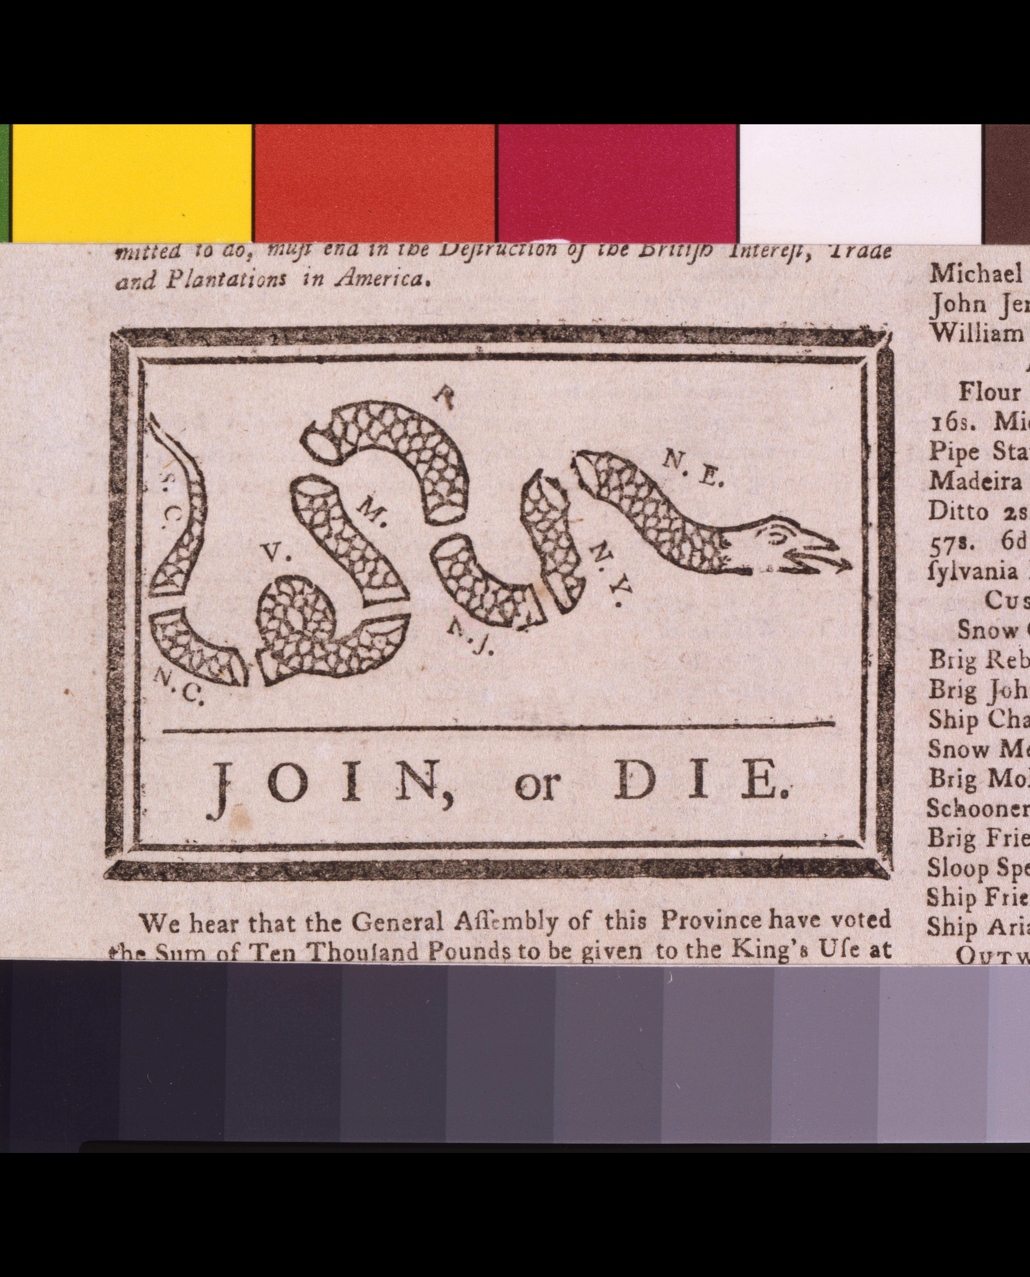
Join, or Die · Benjamin Franklin · 1754
Source: Library of Congress, Prints & Photographs Division · https://www.loc.gov/item/2002695523/ Public domain — published 1754 (pre-1929) https://www.loc.gov/item/2002695523/
HIPPO — analyze the source (prompt) | Your analysis
H — Historical context: what was happening when this was created?
I — Intended audience: who was meant to see or obey it?
P — Purpose: why was it created?
P — Point of view: whose perspective does it reflect?
O — Outside connection: how does it connect to this standard?
SUPPORT OPTION
Sentence frame: This source shows ______ because it ______, which reveals ______.
CONFIDENCE CHECK-IN
Rate your understanding of this standard (1–4): ______ One thing to revisit: ____________________

Activity 6 — Core Application: Practice Quiz — GC.03 ⏱ ~8 min
RESPONSE CHOICE
Commit to an answer by marking it, saying it, or explaining it aloud before checking. Answer key is in the Teacher Guide (kept separate).
[DOK 1 · item u1-gc03-dok1-1 · pre-field-test]
The Articles of Confederation created a national government that was:
A. too weak to tax or regulate trade
B. a monarchy
C. stronger than today's federal government
D. controlled by the president
[DOK 2 · item u1-gc03-dok2-tc · pre-field-test]
Under the Articles of Confederation, which power did the national government LACK that caused serious problems?
A. The power to declare war
B. The power to make treaties
C. The power to run a post office
D. The power to tax the states and citizens directly

STRETCH — think like a test-writer (open to all)
Write your OWN DOK-3 question for this standard, then a one-sentence answer key. Use the supports below — everyone can do this.
HOW TO WRITE A DOK-3 QUESTION (supports)
DOK-3 = strategic thinking: the reader must analyze, compare, evaluate, or justify using evidence — and there should be more than one defensible answer (not a fact you can just look up).
Sentence starters: “Why did ______ lead to ______?” · “Which mattered more — ______ or ______ — and why?” · “What is the BEST evidence that ______?” · “Evaluate whether ______.” · “Defend or challenge: ______.”
Frame: [Analyze / Evaluate / Justify] + [something from THIS standard] + “using evidence.”
Quick check: does my question make the reader THINK and use evidence? If yes, it’s DOK-3.
Your DOK-3 question | Your answer key (one sentence)

Activity 7 — Constructed Response (CER) — GC.03 ⏱ ~15 min
BIG-QUESTION ORGANIZER (before you write) — How and why did the Founders build a limited constitutional republic?
Plan your argument here, then use it to write your claim, evidence, and reasoning below.
Plan your argument | Your quick notes (from this standard)
My claim (answer the prompt)
Evidence 1 (a source or fact)
Reasoning (why it proves the claim)
CONSTRUCTED RESPONSE (CER) — builds SSP.04 Argumentation
Claim + Evidence + Reasoning: Was the greatest weakness of the Articles the lack of taxing power, the lack of a strong executive, or the difficulty of amendment? Defend your claim with evidence.
Part | Write here
Claim
Evidence (two specifics)
Reasoning
SELF-CHECK against the CER rubric (see Toolkit)
Before submitting: Is my claim defensible? Do I have TWO specific pieces of evidence? Does my reasoning explain HOW the evidence proves the claim?

UDL Access, Choice & Reflection — GC.03
UDL ACCESS & MTSS SUPPORT (this standard)
UDL 3.0 (CAST, 2024): read-aloud on request · key terms glossed (EN/ES) · respond in writing, speech, or a labeled diagram · large-print & screen-reader friendly. Same learning target for everyone; supports vary the means, not the ceiling.
MTSS: Tier 1 — this core lesson for all · Tier 2 — small-group reteach of this standard using its Cornell cues + graphic organizer, then re-check · Tier 3 — intensive 1:1 with concrete→representational→abstract scaffolding, progress-monitored to the same standard.
SHOW WHAT YOU KNOW — YOUR WAY (same CER rubric, same standard)
Build your Claim–Evidence–Reasoning in whichever mode lets you think best — the standard and the CER rubric are identical for every mode; the mode changes how you SHOW it, never what you are held to:
WRITE it · SAY it aloud and record it (audio or video) · DRAW and label a diagram that makes the argument · BUILD a model or artifact and caption its claim, evidence, and reasoning.
You may ask for a word processor, speech-to-text, a scribe, or a sentence/argument frame — these change how you produce, not the standard you meet.
CHOICE & VOICE — you decide how to go deeper (pick ONE)
You choose your path to show this standard — every option meets the same target:
DEFEND a term: pick the vocabulary word that matters most and argue why in 2–3 sentences. · CONNECT it: pick a current event, your community, or your own life and explain how this standard shows up there. · TAKE A SIDE: pick one debatable question and argue your position with evidence.
Your pick is yours — bring what matters to you into the work.
REFLECT & CONNECT — how your thinking grew, and whose view you weighed
Reflect (self-awareness): What did you believe about this topic BEFORE, and what changed AFTER? Name one thing to revisit.
Consider another view (empathy): Name one person or group who might see this standard differently than you; state their view fairly in one sentence — even if you disagree.
Norm (restorative): we critique ideas, not people; we assume good faith; we make room for every voice.

Standard GC.04 — The Constitutional Convention & Ratification
TN Academic Standard GC.04: Discuss the Constitutional Convention of 1787, including the Great Compromise and the ensuing debate over ratification between the Federalists and Anti-Federalists. (H)
LEARNING TARGETS — I can…
• I can I can discuss the Constitutional Convention of 1787, including the Great Compromise and the ensuing debate over ratification between the Federalists and Anti-Federalists..
Lenses for this standard: History (H)
CORE PATH — the same for every student
Every student works this standard at the same rigor: analyze the sources and vocabulary, then demonstrate learning on the Practice Quiz and CER. UDL and MTSS give you flexible ways in — they never lower the bar. Check yourself against the learning targets on the Cornell Notes page.
SET YOUR GOAL (self-direction)
My goal for this standard — what will I be able to do, and how will I show it?

HOOK — think before you dig in
Two plans, thirteen stubborn states, one hot Philadelphia summer. How did the Framers turn a deadlock into a Constitution?

ACTIVATE — what do you already know or wonder?
Jot what you already know or want to find out about this standard. You’ll come back to it.

PREVIEW & PREDICT
Which learning target will be hardest, and why? Connect it to the unit’s big question: How and why did the Founders build a limited constitutional republic?

Activity 1 — Vocabulary (Part A: Reference / Word Bank) — GC.04 ⏱ ~10 min
Use this word bank throughout the standard. The Spanish column supports access, not translation of assessment.
Term | Student-friendly meaning | Spanish
Great Compromise | The 1787 agreement creating a two-house Congress: a House based on state population and a Senate with equal representation (two per state) — settling the fight between large and small states. | Gran Compromiso
Federalists | Supporters of ratifying the Constitution who favored a stronger national government; their arguments appear in the Federalist Papers. | federalistas
Anti-Federalists | Opponents of ratifying the Constitution as written, who feared a too-powerful central government and demanded a bill of rights to protect individual liberty. | antifederalistas
LANGUAGE SUPPORT
Pronunciations: Great Compromise (GRAYT KOM-pruh-myz); Federalists (FED-uh-rul-ists); Anti-Federalists (AN-tee-FED-uh-rul-ists).

VOCABULARY SELF-CHECK · Knowledge Rating
Rate each term NOW in pencil, then again at the END — growth is the goal; no penalty for “never seen it.”
Term | 1 · never seen it | 2 · heard it | 3 · can use it | 4 · can teach it
Great Compromise
Federalists
Anti-Federalists
MAKE IT YOURS (RESPONSE CHOICE): choose ONE term above and show you own it — write a sentence, sketch it, or give a real-world example.

QUICK WRITE
Which of these terms do you think will matter MOST for this standard, and why? You’ll revisit this at the end.

Activity 2 — Vocabulary Studio (Frayer-inspired) — GC.04 ⏱ ~7 min
RESPONSE CHOICE
Complete each studio by writing, speaking, or diagramming.

PRIORITY TERM 1 Great Compromise · ES: Gran Compromiso
Word-bank meaning to build on: The 1787 agreement creating a two-house Congress: a House based on state population and a Senate with equal representation (two per state) — settling the fight between large and small states.
Definition (in your own words) | Characteristics
Examples | Non-examples
Use it to explain
Write one sentence that uses “Great Compromise” to explain this standard.

PRIORITY TERM 2 Federalists · ES: federalistas
Word-bank meaning to build on: Supporters of ratifying the Constitution who favored a stronger national government; their arguments appear in the Federalist Papers.
Definition (in your own words) | Characteristics
Examples | Non-examples
Use it to explain
Write one sentence that uses “Federalists” to explain this standard.

CONNECT THE TERMS (UDL · build understanding)
How do these priority terms fit together? Write or sketch how one leads to or affects another.

Activity 3 — Direct Teaching Cornell Notes — GC.04 ⏱ ~20 min
Name: ______________________ Class / Period: __________ Date: __________
GC.04 — The Constitutional Convention & Ratification • Lean Student Deck slides 23–29 • direct-teaching slides 25–27
Your learning targets are on this standard’s opening page — take notes that help you meet them.
Guiding cues | My notes — write your notes here
Key idea of this standard?
One primary source that supports it?
One effect on government or rights?
Key terms →
Keep taking notes — lines run the full width of the page:

DOODLE ZONE — draw your thinking (UDL · another way in)
Need another way in? Sketch the key idea, a quick timeline, or how the pieces connect. Words optional.

Cornell Notes — keep going, then process & check — GC.04
MORE NOTES / DIAGRAMS
Continue your notes here, add a quick sketch, or map how the ideas connect.

Key terms to list
Great Compromise · Federalists · Anti-Federalists
Summary — In your own words (2–3 sentences)
PROGRESS CHECK · one question
The Great Compromise settled which major disagreement at the Constitutional Convention?
A. Whether to have a president or a king
B. How states should be represented in Congress — by population or equally
C. Whether to keep the Articles of Confederation
D. Whether to allow political parties
Commit before you move on — mark it, say it, or explain it aloud.
CHECK YOURSELF — how am I doing?
Which learning targets (on this standard’s opening page) can you now meet? Tick the number; circle any you still need help with.
☐ 1
My 12–15 word headline for this standard

Guided Support for the Cornell Notes — GC.04
These scaffolds support ONLY the Cornell notes — use them to take and process those notes. Optional and easy to set aside; not a separate assignment or a label.
Key vocabulary | What it means
Great Compromise | The 1787 agreement creating a two-house Congress: a House based on state population and a Senate with equal representation (two per state) — settling the fight between large and small states.
Federalists | Supporters of ratifying the Constitution who favored a stronger national government; their arguments appear in the Federalist Papers.
Anti-Federalists | Opponents of ratifying the Constitution as written, who feared a too-powerful central government and demanded a bill of rights to protect individual liberty.
Break it into steps:
1) Name one cause or effect. 2) Give one piece of evidence. 3) Write one sentence explaining the link.
Sentence frame
One key cause/effect of the constitutional convention & ratification was ______, shown by ______, which mattered because ______.
Modeled example (one worked note — yours will differ)
A key idea of the constitutional convention & ratification was Great Compromise: The 1787 agreement creating a two-house Congress: a House based on state population and a Senate with equal representation (two per state) — settling the fight between large and small states.
GUIDED NOTE REHEARSAL LAB
Rehearse the cause→effect chain below, then transfer it to your Cornell notes.
Step | Rehearse it here
Name it
Evidence
Explain
Headline
TRANSFER CHECK — move one rehearsed idea onto the front notes

Light Support for the Cornell Notes — GC.04
A lighter scaffold for the SAME Cornell notes. Try the notes first; reach for this only if you need it.
Key vocabulary | Finish the idea — “This term means …”
Great Compromise
Federalists
Anti-Federalists
Guiding questions — answer on the lines below (or in your front notes):
• How did the Great Compromise resolve the conflict between large and small states?
• In Federalist No. 10, what problem does Madison say a large republic can control better than a small one?
• What was the Anti-Federalists' main fear, and what did they demand before ratifying?

WHICH CUE STILL NEEDS WORK?
Circle the Cornell cue from the front page you still need help with, and tell your teacher so we can go over it.
LIGHT PROCESSING LAB
Answer one guiding question from above in a full sentence, in your own words.

Activity 4 — Close Read — GC.04 ⏱ ~15 min
Reading type: Government Hack-authored instructional synthesis. This is not a primary source. Builds SSP.03 (synthesize) and SSP.05 (historical awareness).
CORE PATH
In 1787, delegates met in Philadelphia — officially to fix the Articles, but they wrote an entirely new Constitution. The hardest fight was representation. Large states backed the Virginia Plan (seats by population); small states backed the New Jersey Plan (equal seats). The Great Compromise split the difference: a House of Representatives based on population and a Senate with two senators per state. The Three-Fifths Compromise, counting enslaved people as three-fifths of a person for representation and taxation, exposed the deep contradiction of slavery in a document about liberty. Once signed, the Constitution faced a fierce ratification debate. Federalists (Madison, Hamilton, Jay, writing as 'Publius' in the Federalist Papers) argued for a stronger union; Anti-Federalists (like 'Brutus') warned of a distant, too-powerful government and demanded a bill of rights.
LANGUAGE SUPPORT
Key terms to know first: Great Compromise, Federalists. Read once for the gist, then again for evidence.
Text-dependent questions (answer in the Evidence Lab below or aloud):
1. How did the Great Compromise resolve the conflict between large and small states?
2. In Federalist No. 10, what problem does Madison say a large republic can control better than a small one?
3. What was the Anti-Federalists' main fear, and what did they demand before ratifying?
RESPONSE CHOICE: answer any question by writing in the Evidence Lab, saying/recording it, or diagramming it.
CLOSE-READ EVIDENCE LAB
Log evidence from the passage below.
Question / claim | Exact passage evidence | What the evidence shows

SPACED RETRIEVAL — quick recall (no notes)
Pull it up cold to strengthen memory, then check your notes.
Recall prompt | Your answer (from memory)
One key term or fact from THIS standard
One thing you learned EARLIER in this unit or course
How the two connect

Activity 5 — Primary Source / Data Analysis — GC.04 ⏱ ~15 min
Document (text primary source — analyze with HIPPO). Builds SSP.01–SSP.02.
FEDERALIST NO. 10
“The latent causes of faction are thus sown in the nature of man… The regulation of these various and interfering interests forms the principal task of modern legislation.”
Source: James Madison (Publius), 1787. Congress.gov / Library of Congress. Public domain. https://guides.loc.gov/federalist-papers/text-1-10
HIPPO — analyze the source (prompt) | Your analysis
H — Historical context: what was happening when this was created?
I — Intended audience: who was meant to see or obey it?
P — Purpose: why was it created?
P — Point of view: whose perspective does it reflect?
O — Outside connection: how does it connect to this standard?
SUPPORT OPTION
Sentence frame: This source shows ______ because it ______, which reveals ______.

EXTEND & RE-ENGAGE (open to all)
Push past the document — corroborate, contextualize, and judge its meaning.
Historian move | Your response
Corroborate — what other source would confirm or complicate this one?
Contextualize — what was happening at the time that explains it?
So what? — why does this source still matter?
CONFIDENCE CHECK-IN
Rate your understanding of this standard (1–4): ______ One thing to revisit: ____________________

Activity 6 — Core Application: Practice Quiz — GC.04 ⏱ ~8 min
RESPONSE CHOICE
Commit to an answer by marking it, saying it, or explaining it aloud before checking. Answer key is in the Teacher Guide (kept separate).
[DOK 1 · item u1-gc04-dok1-1 · pre-field-test]
The Federalist Papers were written to:
A. persuade people to ratify the Constitution
B. declare independence
C. repeal the Bill of Rights
D. end the Convention early
[DOK 3 · item u1-gc04-dok3-tc · pre-field-test]
The Great Compromise settled which major disagreement at the Constitutional Convention?
A. Whether to have a president or a king
B. How states should be represented in Congress — by population or equally
C. Whether to keep the Articles of Confederation
D. Whether to allow political parties

STRETCH — think like a test-writer (open to all)
Write your OWN DOK-3 question for this standard, then a one-sentence answer key. Use the supports below — everyone can do this.
HOW TO WRITE A DOK-3 QUESTION (supports)
DOK-3 = strategic thinking: the reader must analyze, compare, evaluate, or justify using evidence — and there should be more than one defensible answer (not a fact you can just look up).
Sentence starters: “Why did ______ lead to ______?” · “Which mattered more — ______ or ______ — and why?” · “What is the BEST evidence that ______?” · “Evaluate whether ______.” · “Defend or challenge: ______.”
Frame: [Analyze / Evaluate / Justify] + [something from THIS standard] + “using evidence.”
Quick check: does my question make the reader THINK and use evidence? If yes, it’s DOK-3.
Your DOK-3 question | Your answer key (one sentence)

Activity 7 — Constructed Response (CER) — GC.04 ⏱ ~15 min
BIG-QUESTION ORGANIZER (before you write) — How and why did the Founders build a limited constitutional republic?
Plan your argument here, then use it to write your claim, evidence, and reasoning below.
Plan your argument | Your quick notes (from this standard)
My claim (answer the prompt)
Evidence 1 (a source or fact)
Reasoning (why it proves the claim)
CONSTRUCTED RESPONSE (CER) — builds SSP.04 Argumentation
Claim + Evidence + Reasoning: In the ratification debate, whose warning has aged better — the Federalists' case for a strong union, or the Anti-Federalists' fear of centralized power? Use one quote from each side.
Part | Write here
Claim
Evidence (two specifics)
Reasoning
SELF-CHECK against the CER rubric (see Toolkit)
Before submitting: Is my claim defensible? Do I have TWO specific pieces of evidence? Does my reasoning explain HOW the evidence proves the claim?

UDL Access, Choice & Reflection — GC.04
UDL ACCESS & MTSS SUPPORT (this standard)
UDL 3.0 (CAST, 2024): read-aloud on request · key terms glossed (EN/ES) · respond in writing, speech, or a labeled diagram · large-print & screen-reader friendly. Same learning target for everyone; supports vary the means, not the ceiling.
MTSS: Tier 1 — this core lesson for all · Tier 2 — small-group reteach of this standard using its Cornell cues + graphic organizer, then re-check · Tier 3 — intensive 1:1 with concrete→representational→abstract scaffolding, progress-monitored to the same standard.
SHOW WHAT YOU KNOW — YOUR WAY (same CER rubric, same standard)
Build your Claim–Evidence–Reasoning in whichever mode lets you think best — the standard and the CER rubric are identical for every mode; the mode changes how you SHOW it, never what you are held to:
WRITE it · SAY it aloud and record it (audio or video) · DRAW and label a diagram that makes the argument · BUILD a model or artifact and caption its claim, evidence, and reasoning.
You may ask for a word processor, speech-to-text, a scribe, or a sentence/argument frame — these change how you produce, not the standard you meet.
CHOICE & VOICE — you decide how to go deeper (pick ONE)
You choose your path to show this standard — every option meets the same target:
DEFEND a term: pick the vocabulary word that matters most and argue why in 2–3 sentences. · CONNECT it: pick a current event, your community, or your own life and explain how this standard shows up there. · TAKE A SIDE: pick one debatable question and argue your position with evidence.
Your pick is yours — bring what matters to you into the work.
REFLECT & CONNECT — how your thinking grew, and whose view you weighed
Reflect (self-awareness): What did you believe about this topic BEFORE, and what changed AFTER? Name one thing to revisit.
Consider another view (empathy): Name one person or group who might see this standard differently than you; state their view fairly in one sentence — even if you disagree.
Norm (restorative): we critique ideas, not people; we assume good faith; we make room for every voice.

Standard GC.05 — The Preamble: Purposes of Government
TN Academic Standard GC.05: Describe the purposes and functions of government as outlined in the Preamble of the Constitution.
LEARNING TARGETS — I can…
• I can I can describe the purposes and functions of government as outlined in the Preamble of the Constitution..
CORE PATH — the same for every student
Every student works this standard at the same rigor: analyze the sources and vocabulary, then demonstrate learning on the Practice Quiz and CER. UDL and MTSS give you flexible ways in — they never lower the bar. Check yourself against the learning targets on the Cornell Notes page.
SET YOUR GOAL (self-direction)
My goal for this standard — what will I be able to do, and how will I show it?

HOOK — think before you dig in
Six goals, one sentence, and it starts with three world-changing words: 'We the People.' What did the Framers promise?

ACTIVATE — what do you already know or wonder?
Jot what you already know or want to find out about this standard. You’ll come back to it.

PREVIEW & PREDICT
Which learning target will be hardest, and why? Connect it to the unit’s big question: How and why did the Founders build a limited constitutional republic?

Activity 1 — Vocabulary (Part A: Reference / Word Bank) — GC.05 ⏱ ~10 min
Use this word bank throughout the standard. The Spanish column supports access, not translation of assessment.
Term | Student-friendly meaning | Spanish
Preamble | The introduction to the Constitution that states the document's purposes, beginning 'We the People.' | preámbulo
Popular Sovereignty | The principle that government's authority comes from the people — expressed in the Preamble's opening words, 'We the People.' | soberanía popular
General Welfare | The well-being of the whole community; one of the Preamble's stated purposes of government ('promote the general Welfare'). | bienestar general
LANGUAGE SUPPORT
Pronunciations: Preamble (PREE-am-bul); Popular Sovereignty (POP-yuh-lur SOV-rin-tee); General Welfare (JEN-uh-rul WEL-fair).

VOCABULARY SELF-CHECK · Knowledge Rating
Rate each term NOW in pencil, then again at the END — growth is the goal; no penalty for “never seen it.”
Term | 1 · never seen it | 2 · heard it | 3 · can use it | 4 · can teach it
Preamble
Popular Sovereignty
General Welfare
MAKE IT YOURS (RESPONSE CHOICE): choose ONE term above and show you own it — write a sentence, sketch it, or give a real-world example.

QUICK WRITE
Which of these terms do you think will matter MOST for this standard, and why? You’ll revisit this at the end.

Activity 2 — Vocabulary Studio (Frayer-inspired) — GC.05 ⏱ ~7 min
RESPONSE CHOICE
Complete each studio by writing, speaking, or diagramming.

PRIORITY TERM 1 Preamble · ES: preámbulo
Word-bank meaning to build on: The introduction to the Constitution that states the document's purposes, beginning 'We the People.'
Definition (in your own words) | Characteristics
Examples | Non-examples
Use it to explain
Write one sentence that uses “Preamble” to explain this standard.

PRIORITY TERM 2 Popular Sovereignty · ES: soberanía popular
Word-bank meaning to build on: The principle that government's authority comes from the people — expressed in the Preamble's opening words, 'We the People.'
Definition (in your own words) | Characteristics
Examples | Non-examples
Use it to explain
Write one sentence that uses “Popular Sovereignty” to explain this standard.

CONNECT THE TERMS (UDL · build understanding)
How do these priority terms fit together? Write or sketch how one leads to or affects another.

Activity 3 — Direct Teaching Cornell Notes — GC.05 ⏱ ~20 min
Name: ______________________ Class / Period: __________ Date: __________
GC.05 — The Preamble: Purposes of Government • Lean Student Deck slides 30–36 • direct-teaching slides 32–34
Your learning targets are on this standard’s opening page — take notes that help you meet them.
Guiding cues | My notes — write your notes here
Key idea of this standard?
One primary source that supports it?
One effect on government or rights?
Key terms →
Keep taking notes — lines run the full width of the page:

DOODLE ZONE — draw your thinking (UDL · another way in)
Need another way in? Sketch the key idea, a quick timeline, or how the pieces connect. Words optional.

Cornell Notes — keep going, then process & check — GC.05
MORE NOTES / DIAGRAMS
Continue your notes here, add a quick sketch, or map how the ideas connect.

Key terms to list
Preamble · Popular Sovereignty · General Welfare
Summary — In your own words (2–3 sentences)
PROGRESS CHECK · one question
The Preamble begins with the words 'We the People.' Which principle of government does this phrase express?
A. Judicial review
B. Separation of powers
C. Popular sovereignty — government power comes from the people
D. Federalism
Commit before you move on — mark it, say it, or explain it aloud.
CHECK YOURSELF — how am I doing?
Which learning targets (on this standard’s opening page) can you now meet? Tick the number; circle any you still need help with.
☐ 1
My 12–15 word headline for this standard

Guided Support for the Cornell Notes — GC.05
These scaffolds support ONLY the Cornell notes — use them to take and process those notes. Optional and easy to set aside; not a separate assignment or a label.
Key vocabulary | What it means
Preamble | The introduction to the Constitution that states the document's purposes, beginning 'We the People.'
Popular Sovereignty | The principle that government's authority comes from the people — expressed in the Preamble's opening words, 'We the People.'
General Welfare | The well-being of the whole community; one of the Preamble's stated purposes of government ('promote the general Welfare').
Break it into steps:
1) Name one cause or effect. 2) Give one piece of evidence. 3) Write one sentence explaining the link.
Sentence frame
One key cause/effect of the preamble was ______, shown by ______, which mattered because ______.
Modeled example (one worked note — yours will differ)
A key idea of the preamble was Preamble: The introduction to the Constitution that states the document's purposes, beginning 'We the People.'
GUIDED NOTE REHEARSAL LAB
Rehearse the cause→effect chain below, then transfer it to your Cornell notes.
Step | Rehearse it here
Name it
Evidence
Explain
Headline
TRANSFER CHECK — move one rehearsed idea onto the front notes

Light Support for the Cornell Notes — GC.05
A lighter scaffold for the SAME Cornell notes. Try the notes first; reach for this only if you need it.
Key vocabulary | Finish the idea — “This term means …”
Preamble
Popular Sovereignty
General Welfare
Guiding questions — answer on the lines below (or in your front notes):
• What do the first three words of the Preamble tell us about where government power comes from?
• List three of the six purposes of government named in the Preamble.
• How does the phrase 'to ourselves and our Posterity' show the Framers were thinking beyond their own time?

WHICH CUE STILL NEEDS WORK?
Circle the Cornell cue from the front page you still need help with, and tell your teacher so we can go over it.
LIGHT PROCESSING LAB
Answer one guiding question from above in a full sentence, in your own words.

Activity 4 — Close Read — GC.05 ⏱ ~15 min
Reading type: Government Hack-authored instructional synthesis. This is not a primary source. Builds SSP.03 (synthesize) and SSP.05 (historical awareness).
CORE PATH
Before a single power is granted, the Constitution states WHY it exists. The Preamble — 'We the People of the United States' — opens by declaring popular sovereignty: the government's authority comes from the people. It then lists six purposes: to form a more perfect Union, establish Justice, insure domestic Tranquility, provide for the common defence, promote the general Welfare, and secure the Blessings of Liberty for ourselves and future generations ('our Posterity'). The Preamble grants no powers by itself, but it is a mission statement: every power in the articles that follow is meant to serve these ends.
LANGUAGE SUPPORT
Key terms to know first: Preamble, Popular Sovereignty. Read once for the gist, then again for evidence.
Text-dependent questions (answer in the Evidence Lab below or aloud):
1. What do the first three words of the Preamble tell us about where government power comes from?
2. List three of the six purposes of government named in the Preamble.
3. How does the phrase 'to ourselves and our Posterity' show the Framers were thinking beyond their own time?
RESPONSE CHOICE: answer any question by writing in the Evidence Lab, saying/recording it, or diagramming it.
CLOSE-READ EVIDENCE LAB
Log evidence from the passage below.
Question / claim | Exact passage evidence | What the evidence shows

SPACED RETRIEVAL — quick recall (no notes)
Pull it up cold to strengthen memory, then check your notes.
Recall prompt | Your answer (from memory)
One key term or fact from THIS standard
One thing you learned EARLIER in this unit or course
How the two connect

Activity 5 — Primary Source / Data Analysis — GC.05 ⏱ ~15 min
Primary source (manuscript on parchment) — analyze it with HIPPO. Builds SSP.01–SSP.02.
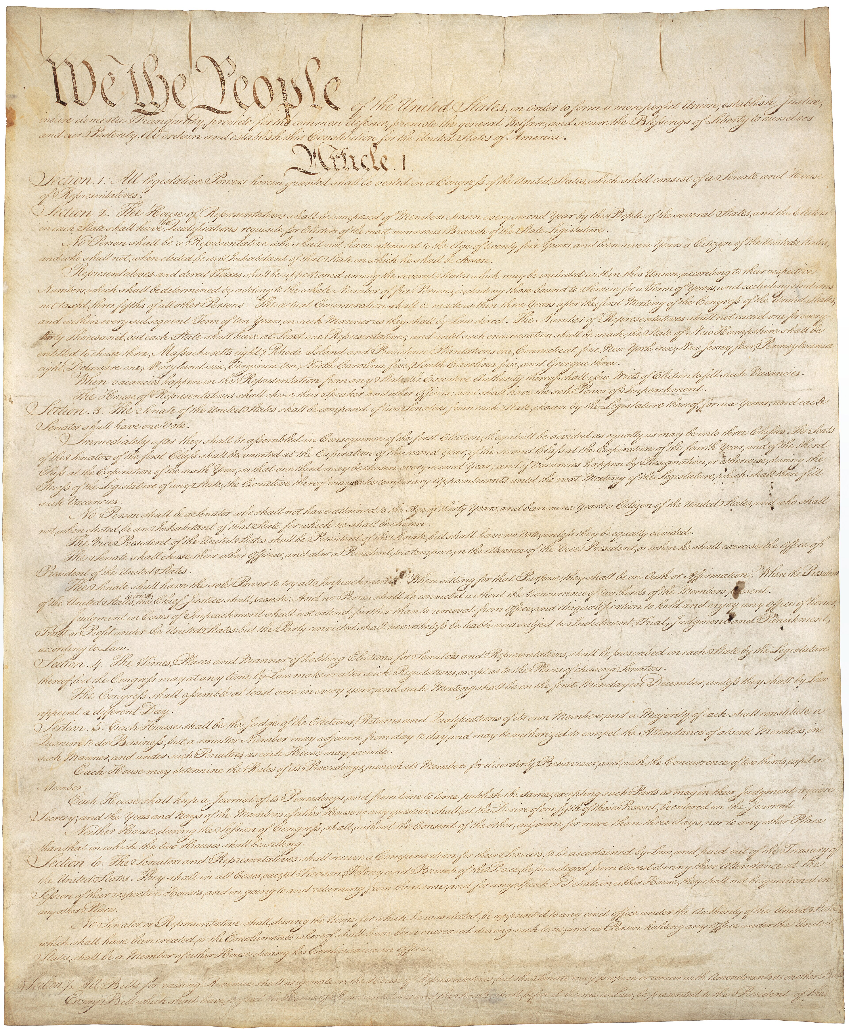
U.S. Constitution, Page 1 (“We the People”) · Constitutional Convention; engrossed by Jacob Shallus · 1787
Source: U.S. National Archives · https://commons.wikimedia.org/wiki/File:Constitution_of_the_United_States_-_DPLA_-_9ca804144bd5965e992ae3528bc3c6a3_(page_1).jpg Public domain — U.S. gov document, 1787 https://commons.wikimedia.org/wiki/File:Constitution_of_the_United_States_-_DPLA_-_9ca804144bd5965e992ae3528bc3c6a3_(page_1).jpg
HIPPO — analyze the source (prompt) | Your analysis
H — Historical context: what was happening when this was created?
I — Intended audience: who was meant to see or obey it?
P — Purpose: why was it created?
P — Point of view: whose perspective does it reflect?
O — Outside connection: how does it connect to this standard?
SUPPORT OPTION
Sentence frame: This source shows ______ because it ______, which reveals ______.
CONFIDENCE CHECK-IN
Rate your understanding of this standard (1–4): ______ One thing to revisit: ____________________

Activity 6 — Core Application: Practice Quiz — GC.05 ⏱ ~8 min
RESPONSE CHOICE
Commit to an answer by marking it, saying it, or explaining it aloud before checking. Answer key is in the Teacher Guide (kept separate).
[DOK 1 · item u1-gc05-dok1-1 · pre-field-test]
'We the People' at the start of the Preamble expresses the principle of:
A. popular sovereignty
B. monarchy
C. judicial review
D. federal supremacy
[DOK 2 · item u1-gc05-dok2-tc · pre-field-test]
The Preamble begins with the words 'We the People.' Which principle of government does this phrase express?
A. Judicial review
B. Separation of powers
C. Popular sovereignty — government power comes from the people
D. Federalism

STRETCH — think like a test-writer (open to all)
Write your OWN DOK-3 question for this standard, then a one-sentence answer key. Use the supports below — everyone can do this.
HOW TO WRITE A DOK-3 QUESTION (supports)
DOK-3 = strategic thinking: the reader must analyze, compare, evaluate, or justify using evidence — and there should be more than one defensible answer (not a fact you can just look up).
Sentence starters: “Why did ______ lead to ______?” · “Which mattered more — ______ or ______ — and why?” · “What is the BEST evidence that ______?” · “Evaluate whether ______.” · “Defend or challenge: ______.”
Frame: [Analyze / Evaluate / Justify] + [something from THIS standard] + “using evidence.”
Quick check: does my question make the reader THINK and use evidence? If yes, it’s DOK-3.
Your DOK-3 question | Your answer key (one sentence)

Activity 7 — Constructed Response (CER) — GC.05 ⏱ ~15 min
BIG-QUESTION ORGANIZER (before you write) — How and why did the Founders build a limited constitutional republic?
Plan your argument here, then use it to write your claim, evidence, and reasoning below.
Plan your argument | Your quick notes (from this standard)
My claim (answer the prompt)
Evidence 1 (a source or fact)
Reasoning (why it proves the claim)
CONSTRUCTED RESPONSE (CER) — builds SSP.04 Argumentation
Claim + Evidence + Reasoning: Of the six purposes in the Preamble, which is most important for a free society today? Defend your claim with reasoning tied to the text.
Part | Write here
Claim
Evidence (two specifics)
Reasoning
SELF-CHECK against the CER rubric (see Toolkit)
Before submitting: Is my claim defensible? Do I have TWO specific pieces of evidence? Does my reasoning explain HOW the evidence proves the claim?

UDL Access, Choice & Reflection — GC.05
UDL ACCESS & MTSS SUPPORT (this standard)
UDL 3.0 (CAST, 2024): read-aloud on request · key terms glossed (EN/ES) · respond in writing, speech, or a labeled diagram · large-print & screen-reader friendly. Same learning target for everyone; supports vary the means, not the ceiling.
MTSS: Tier 1 — this core lesson for all · Tier 2 — small-group reteach of this standard using its Cornell cues + graphic organizer, then re-check · Tier 3 — intensive 1:1 with concrete→representational→abstract scaffolding, progress-monitored to the same standard.
SHOW WHAT YOU KNOW — YOUR WAY (same CER rubric, same standard)
Build your Claim–Evidence–Reasoning in whichever mode lets you think best — the standard and the CER rubric are identical for every mode; the mode changes how you SHOW it, never what you are held to:
WRITE it · SAY it aloud and record it (audio or video) · DRAW and label a diagram that makes the argument · BUILD a model or artifact and caption its claim, evidence, and reasoning.
You may ask for a word processor, speech-to-text, a scribe, or a sentence/argument frame — these change how you produce, not the standard you meet.
CHOICE & VOICE — you decide how to go deeper (pick ONE)
You choose your path to show this standard — every option meets the same target:
DEFEND a term: pick the vocabulary word that matters most and argue why in 2–3 sentences. · CONNECT it: pick a current event, your community, or your own life and explain how this standard shows up there. · TAKE A SIDE: pick one debatable question and argue your position with evidence.
Your pick is yours — bring what matters to you into the work.
REFLECT & CONNECT — how your thinking grew, and whose view you weighed
Reflect (self-awareness): What did you believe about this topic BEFORE, and what changed AFTER? Name one thing to revisit.
Consider another view (empathy): Name one person or group who might see this standard differently than you; state their view fairly in one sentence — even if you disagree.
Norm (restorative): we critique ideas, not people; we assume good faith; we make room for every voice.

Standard GC.06 — Principles of Limited Government
TN Academic Standard GC.06: Describe limited government within the Constitution, including: checks and balances; civilian control of the military; federalism; judicial review; popular sovereignty; rule of law; separation of powers.
LEARNING TARGETS — I can…
• I can I can describe limited government within the Constitution, including: checks and balances; civilian control of the military; federalism; judicial review; popular sovereignty; rule of law; separation of powers..
CORE PATH — the same for every student
Every student works this standard at the same rigor: analyze the sources and vocabulary, then demonstrate learning on the Practice Quiz and CER. UDL and MTSS give you flexible ways in — they never lower the bar. Check yourself against the learning targets on the Cornell Notes page.
SET YOUR GOAL (self-direction)
My goal for this standard — what will I be able to do, and how will I show it?

HOOK — think before you dig in
'If men were angels, no government would be necessary.' Since we're not angels, how did Madison design a government to guard against itself?

ACTIVATE — what do you already know or wonder?
Jot what you already know or want to find out about this standard. You’ll come back to it.

PREVIEW & PREDICT
Which learning target will be hardest, and why? Connect it to the unit’s big question: How and why did the Founders build a limited constitutional republic?

Activity 1 — Vocabulary (Part A: Reference / Word Bank) — GC.06 ⏱ ~10 min
Use this word bank throughout the standard. The Spanish column supports access, not translation of assessment.
Term | Student-friendly meaning | Spanish
Separation of Powers | Dividing government into three branches — legislative, executive, and judicial — so no one branch holds all power. | separación de poderes
Checks and Balances | The system that lets each branch limit the others (e.g., the president vetoes laws; Congress can override; courts can rule laws unconstitutional). | controles y equilibrios
Judicial Review | The power of courts to decide whether a law or government action is constitutional — established in Marbury v. Madison (1803). | revisión judicial
LANGUAGE SUPPORT
Pronunciations: Separation of Powers (sep-uh-RAY-shun); Checks and Balances (CHEKS and BAL-un-sez); Judicial Review (joo-DISH-ul ree-VYOO).

VOCABULARY SELF-CHECK · Knowledge Rating
Rate each term NOW in pencil, then again at the END — growth is the goal; no penalty for “never seen it.”
Term | 1 · never seen it | 2 · heard it | 3 · can use it | 4 · can teach it
Separation of Powers
Checks and Balances
Judicial Review
MAKE IT YOURS (RESPONSE CHOICE): choose ONE term above and show you own it — write a sentence, sketch it, or give a real-world example.

QUICK WRITE
Which of these terms do you think will matter MOST for this standard, and why? You’ll revisit this at the end.

Activity 2 — Vocabulary Studio (Frayer-inspired) — GC.06 ⏱ ~7 min
RESPONSE CHOICE
Complete each studio by writing, speaking, or diagramming.

PRIORITY TERM 1 Checks and Balances · ES: controles y equilibrios
Word-bank meaning to build on: The system that lets each branch limit the others (e.g., the president vetoes laws; Congress can override; courts can rule laws unconstitutional).
Definition (in your own words) | Characteristics
Examples | Non-examples
Use it to explain
Write one sentence that uses “Checks and Balances” to explain this standard.

PRIORITY TERM 2 Judicial Review · ES: revisión judicial
Word-bank meaning to build on: The power of courts to decide whether a law or government action is constitutional — established in Marbury v. Madison (1803).
Definition (in your own words) | Characteristics
Examples | Non-examples
Use it to explain
Write one sentence that uses “Judicial Review” to explain this standard.

CONNECT THE TERMS (UDL · build understanding)
How do these priority terms fit together? Write or sketch how one leads to or affects another.

Activity 3 — Direct Teaching Cornell Notes — GC.06 ⏱ ~20 min
Name: ______________________ Class / Period: __________ Date: __________
GC.06 — Principles of Limited Government • Lean Student Deck slides 37–43 • direct-teaching slides 39–41
Your learning targets are on this standard’s opening page — take notes that help you meet them.
Guiding cues | My notes — write your notes here
Key idea of this standard?
One primary source that supports it?
One effect on government or rights?
Key terms →
Keep taking notes — lines run the full width of the page:

DOODLE ZONE — draw your thinking (UDL · another way in)
Need another way in? Sketch the key idea, a quick timeline, or how the pieces connect. Words optional.

Cornell Notes — keep going, then process & check — GC.06
MORE NOTES / DIAGRAMS
Continue your notes here, add a quick sketch, or map how the ideas connect.

Key terms to list
Separation of Powers · Checks and Balances · Judicial Review
Summary — In your own words (2–3 sentences)
PROGRESS CHECK · one question
In Federalist No. 51, Madison writes that 'ambition must be made to counteract ambition.' Which constitutional design does this describe?
A. Checks and balances that let each branch limit the others
B. Popular sovereignty
C. Federalism between nation and states
D. The amendment process
Commit before you move on — mark it, say it, or explain it aloud.
CHECK YOURSELF — how am I doing?
Which learning targets (on this standard’s opening page) can you now meet? Tick the number; circle any you still need help with.
☐ 1
My 12–15 word headline for this standard

Guided Support for the Cornell Notes — GC.06
These scaffolds support ONLY the Cornell notes — use them to take and process those notes. Optional and easy to set aside; not a separate assignment or a label.
Key vocabulary | What it means
Separation of Powers | Dividing government into three branches — legislative, executive, and judicial — so no one branch holds all power.
Checks and Balances | The system that lets each branch limit the others (e.g., the president vetoes laws; Congress can override; courts can rule laws unconstitutional).
Judicial Review | The power of courts to decide whether a law or government action is constitutional — established in Marbury v. Madison (1803).
Break it into steps:
1) Name one cause or effect. 2) Give one piece of evidence. 3) Write one sentence explaining the link.
Sentence frame
One key cause/effect of principles of limited government was ______, shown by ______, which mattered because ______.
Modeled example (one worked note — yours will differ)
A key idea of principles of limited government was Separation of Powers: Dividing government into three branches — legislative, executive, and judicial — so no one branch holds all power.
GUIDED NOTE REHEARSAL LAB
Rehearse the cause→effect chain below, then transfer it to your Cornell notes.
Step | Rehearse it here
Name it
Evidence
Explain
Headline
TRANSFER CHECK — move one rehearsed idea onto the front notes

Light Support for the Cornell Notes — GC.06
A lighter scaffold for the SAME Cornell notes. Try the notes first; reach for this only if you need it.
Key vocabulary | Finish the idea — “This term means …”
Separation of Powers
Checks and Balances
Judicial Review
Guiding questions — answer on the lines below (or in your front notes):
• Name the three branches of government and one job of each.
• According to Federalist No. 51, why can't we simply trust leaders to limit their own power?
• How did Marbury v. Madison strengthen the system of checks and balances?

WHICH CUE STILL NEEDS WORK?
Circle the Cornell cue from the front page you still need help with, and tell your teacher so we can go over it.
LIGHT PROCESSING LAB
Answer one guiding question from above in a full sentence, in your own words.

Activity 4 — Close Read — GC.06 ⏱ ~15 min
Reading type: Government Hack-authored instructional synthesis. This is not a primary source. Builds SSP.03 (synthesize) and SSP.05 (historical awareness).
CORE PATH
The Framers feared concentrated power, so they built limits into the Constitution's structure. Separation of powers divides government into three branches — Congress makes laws, the president executes them, the courts interpret them. Checks and balances let each branch restrain the others: the president can veto a bill, Congress can override the veto and impeach officials, and the courts can strike down unconstitutional acts through judicial review, established in Marbury v. Madison (1803). Other limits include federalism (power split between nation and states), the rule of law (everyone, including leaders, is bound by law), popular sovereignty, and civilian control of the military. As Madison put it in Federalist No. 51, 'ambition must be made to counteract ambition.'
LANGUAGE SUPPORT
Key terms to know first: Separation of Powers, Checks and Balances. Read once for the gist, then again for evidence.
Text-dependent questions (answer in the Evidence Lab below or aloud):
1. Name the three branches of government and one job of each.
2. According to Federalist No. 51, why can't we simply trust leaders to limit their own power?
3. How did Marbury v. Madison strengthen the system of checks and balances?
RESPONSE CHOICE: answer any question by writing in the Evidence Lab, saying/recording it, or diagramming it.
CLOSE-READ EVIDENCE LAB
Log evidence from the passage below.
Question / claim | Exact passage evidence | What the evidence shows

SPACED RETRIEVAL — quick recall (no notes)
Pull it up cold to strengthen memory, then check your notes.
Recall prompt | Your answer (from memory)
One key term or fact from THIS standard
One thing you learned EARLIER in this unit or course
How the two connect

Activity 5 — Primary Source / Data Analysis — GC.06 ⏱ ~15 min
Primary source (printed title page) — analyze it with HIPPO. Builds SSP.01–SSP.02.
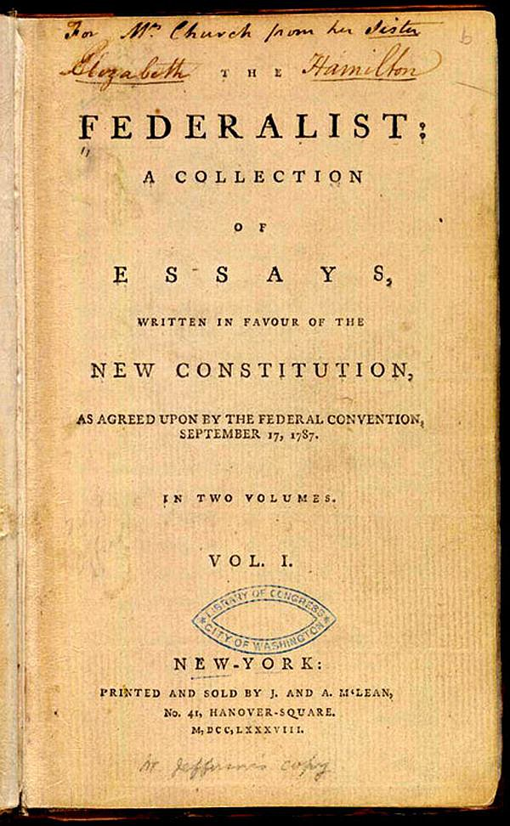
The Federalist, Volume 1 (title page) · Alexander Hamilton, James Madison, John Jay ('Publius') · 1788
Source: Library of Congress, Rare Book & Special Collections · https://commons.wikimedia.org/wiki/File:The_Federalist_(1st_ed,_1788,_vol_I,_title_page).jpg Public domain — published 1788 (pre-1929) https://commons.wikimedia.org/wiki/File:The_Federalist_(1st_ed,_1788,_vol_I,_title_page).jpg
HIPPO — analyze the source (prompt) | Your analysis
H — Historical context: what was happening when this was created?
I — Intended audience: who was meant to see or obey it?
P — Purpose: why was it created?
P — Point of view: whose perspective does it reflect?
O — Outside connection: how does it connect to this standard?
SUPPORT OPTION
Sentence frame: This source shows ______ because it ______, which reveals ______.
CONFIDENCE CHECK-IN
Rate your understanding of this standard (1–4): ______ One thing to revisit: ____________________

Activity 6 — Core Application: Practice Quiz — GC.06 ⏱ ~8 min
RESPONSE CHOICE
Commit to an answer by marking it, saying it, or explaining it aloud before checking. Answer key is in the Teacher Guide (kept separate).
[DOK 1 · item u1-gc06-dok1-1 · pre-field-test]
The power of courts to declare a law unconstitutional is called:
A. judicial review
B. the veto
C. impeachment
D. popular sovereignty
[DOK 3 · item u1-gc06-dok3-tc · pre-field-test]
In Federalist No. 51, Madison writes that 'ambition must be made to counteract ambition.' Which constitutional design does this describe?
A. Checks and balances that let each branch limit the others
B. Popular sovereignty
C. Federalism between nation and states
D. The amendment process

STRETCH — think like a test-writer (open to all)
Write your OWN DOK-3 question for this standard, then a one-sentence answer key. Use the supports below — everyone can do this.
HOW TO WRITE A DOK-3 QUESTION (supports)
DOK-3 = strategic thinking: the reader must analyze, compare, evaluate, or justify using evidence — and there should be more than one defensible answer (not a fact you can just look up).
Sentence starters: “Why did ______ lead to ______?” · “Which mattered more — ______ or ______ — and why?” · “What is the BEST evidence that ______?” · “Evaluate whether ______.” · “Defend or challenge: ______.”
Frame: [Analyze / Evaluate / Justify] + [something from THIS standard] + “using evidence.”
Quick check: does my question make the reader THINK and use evidence? If yes, it’s DOK-3.
Your DOK-3 question | Your answer key (one sentence)

Activity 7 — Constructed Response (CER) — GC.06 ⏱ ~15 min
BIG-QUESTION ORGANIZER (before you write) — How and why did the Founders build a limited constitutional republic?
Plan your argument here, then use it to write your claim, evidence, and reasoning below.
Plan your argument | Your quick notes (from this standard)
My claim (answer the prompt)
Evidence 1 (a source or fact)
Reasoning (why it proves the claim)
CONSTRUCTED RESPONSE (CER) — builds SSP.04 Argumentation
Claim + Evidence + Reasoning: Which principle does the most to prevent tyranny — separation of powers, checks and balances, or federalism? Defend your claim with evidence from the sources.
Part | Write here
Claim
Evidence (two specifics)
Reasoning
SELF-CHECK against the CER rubric (see Toolkit)
Before submitting: Is my claim defensible? Do I have TWO specific pieces of evidence? Does my reasoning explain HOW the evidence proves the claim?

UDL Access, Choice & Reflection — GC.06
UDL ACCESS & MTSS SUPPORT (this standard)
UDL 3.0 (CAST, 2024): read-aloud on request · key terms glossed (EN/ES) · respond in writing, speech, or a labeled diagram · large-print & screen-reader friendly. Same learning target for everyone; supports vary the means, not the ceiling.
MTSS: Tier 1 — this core lesson for all · Tier 2 — small-group reteach of this standard using its Cornell cues + graphic organizer, then re-check · Tier 3 — intensive 1:1 with concrete→representational→abstract scaffolding, progress-monitored to the same standard.
SHOW WHAT YOU KNOW — YOUR WAY (same CER rubric, same standard)
Build your Claim–Evidence–Reasoning in whichever mode lets you think best — the standard and the CER rubric are identical for every mode; the mode changes how you SHOW it, never what you are held to:
WRITE it · SAY it aloud and record it (audio or video) · DRAW and label a diagram that makes the argument · BUILD a model or artifact and caption its claim, evidence, and reasoning.
You may ask for a word processor, speech-to-text, a scribe, or a sentence/argument frame — these change how you produce, not the standard you meet.
CHOICE & VOICE — you decide how to go deeper (pick ONE)
You choose your path to show this standard — every option meets the same target:
DEFEND a term: pick the vocabulary word that matters most and argue why in 2–3 sentences. · CONNECT it: pick a current event, your community, or your own life and explain how this standard shows up there. · TAKE A SIDE: pick one debatable question and argue your position with evidence.
Your pick is yours — bring what matters to you into the work.
REFLECT & CONNECT — how your thinking grew, and whose view you weighed
Reflect (self-awareness): What did you believe about this topic BEFORE, and what changed AFTER? Name one thing to revisit.
Consider another view (empathy): Name one person or group who might see this standard differently than you; state their view fairly in one sentence — even if you disagree.
Norm (restorative): we critique ideas, not people; we assume good faith; we make room for every voice.

Standard GC.07 — Structure of the Constitution & How to Amend It
TN Academic Standard GC.07: Describe the structure of the Constitution and the process to amend it.
LEARNING TARGETS — I can…
• I can I can describe the structure of the Constitution and the process to amend it..
CORE PATH — the same for every student
Every student works this standard at the same rigor: analyze the sources and vocabulary, then demonstrate learning on the Practice Quiz and CER. UDL and MTSS give you flexible ways in — they never lower the bar. Check yourself against the learning targets on the Cornell Notes page.
SET YOUR GOAL (self-direction)
My goal for this standard — what will I be able to do, and how will I show it?

HOOK — think before you dig in
Only 27 changes in more than 230 years. Is the Constitution nearly perfect — or nearly impossible to change? Article V holds the answer.

ACTIVATE — what do you already know or wonder?
Jot what you already know or want to find out about this standard. You’ll come back to it.

PREVIEW & PREDICT
Which learning target will be hardest, and why? Connect it to the unit’s big question: How and why did the Founders build a limited constitutional republic?

Activity 1 — Vocabulary (Part A: Reference / Word Bank) — GC.07 ⏱ ~10 min
Use this word bank throughout the standard. The Spanish column supports access, not translation of assessment.
Term | Student-friendly meaning | Spanish
Amendment | A formal change or addition to the Constitution; there have been 27, beginning with the Bill of Rights. | enmienda
Article V | The part of the Constitution that sets out how it can be amended — a deliberately difficult, two-step process of proposal and ratification. | Artículo V
Ratification | Formal approval; an amendment must be ratified by three-fourths of the states (38 of 50) to take effect. | ratificación
LANGUAGE SUPPORT
Pronunciations: Amendment (uh-MEND-munt); Article V (AR-tih-kul FYV); Ratification (rat-ih-fih-KAY-shun).

VOCABULARY SELF-CHECK · Knowledge Rating
Rate each term NOW in pencil, then again at the END — growth is the goal; no penalty for “never seen it.”
Term | 1 · never seen it | 2 · heard it | 3 · can use it | 4 · can teach it
Amendment
Article V
Ratification
MAKE IT YOURS (RESPONSE CHOICE): choose ONE term above and show you own it — write a sentence, sketch it, or give a real-world example.

QUICK WRITE
Which of these terms do you think will matter MOST for this standard, and why? You’ll revisit this at the end.

Activity 2 — Vocabulary Studio (Frayer-inspired) — GC.07 ⏱ ~7 min
RESPONSE CHOICE
Complete each studio by writing, speaking, or diagramming.

PRIORITY TERM 1 Amendment · ES: enmienda
Word-bank meaning to build on: A formal change or addition to the Constitution; there have been 27, beginning with the Bill of Rights.
Definition (in your own words) | Characteristics
Examples | Non-examples
Use it to explain
Write one sentence that uses “Amendment” to explain this standard.

PRIORITY TERM 2 Article V · ES: Artículo V
Word-bank meaning to build on: The part of the Constitution that sets out how it can be amended — a deliberately difficult, two-step process of proposal and ratification.
Definition (in your own words) | Characteristics
Examples | Non-examples
Use it to explain
Write one sentence that uses “Article V” to explain this standard.

CONNECT THE TERMS (UDL · build understanding)
How do these priority terms fit together? Write or sketch how one leads to or affects another.

Activity 3 — Direct Teaching Cornell Notes — GC.07 ⏱ ~20 min
Name: ______________________ Class / Period: __________ Date: __________
GC.07 — Structure of the Constitution & How to Amend It • Lean Student Deck slides 44–50 • direct-teaching slides 46–48
Your learning targets are on this standard’s opening page — take notes that help you meet them.
Guiding cues | My notes — write your notes here
Key idea of this standard?
One primary source that supports it?
One effect on government or rights?
Key terms →
Keep taking notes — lines run the full width of the page:

DOODLE ZONE — draw your thinking (UDL · another way in)
Need another way in? Sketch the key idea, a quick timeline, or how the pieces connect. Words optional.

Cornell Notes — keep going, then process & check — GC.07
MORE NOTES / DIAGRAMS
Continue your notes here, add a quick sketch, or map how the ideas connect.

Key terms to list
Amendment · Article V · Ratification
Summary — In your own words (2–3 sentences)
PROGRESS CHECK · one question
Why did the Framers make the amendment process in Article V deliberately difficult?
A. To make sure the Constitution could never change
B. To let a single state change it alone
C. To give the president control over amendments
D. So the Constitution could adapt over time, but only with broad agreement across the country
Commit before you move on — mark it, say it, or explain it aloud.
CHECK YOURSELF — how am I doing?
Which learning targets (on this standard’s opening page) can you now meet? Tick the number; circle any you still need help with.
☐ 1
My 12–15 word headline for this standard

Guided Support for the Cornell Notes — GC.07
These scaffolds support ONLY the Cornell notes — use them to take and process those notes. Optional and easy to set aside; not a separate assignment or a label.
Key vocabulary | What it means
Amendment | A formal change or addition to the Constitution; there have been 27, beginning with the Bill of Rights.
Article V | The part of the Constitution that sets out how it can be amended — a deliberately difficult, two-step process of proposal and ratification.
Ratification | Formal approval; an amendment must be ratified by three-fourths of the states (38 of 50) to take effect.
Break it into steps:
1) Name one cause or effect. 2) Give one piece of evidence. 3) Write one sentence explaining the link.
Sentence frame
One key cause/effect of structure of the constitution & how to amend it was ______, shown by ______, which mattered because ______.
Modeled example (one worked note — yours will differ)
A key idea of structure of the constitution & how to amend it was Amendment: A formal change or addition to the Constitution; there have been 27, beginning with the Bill of Rights.
GUIDED NOTE REHEARSAL LAB
Rehearse the cause→effect chain below, then transfer it to your Cornell notes.
Step | Rehearse it here
Name it
Evidence
Explain
Headline
TRANSFER CHECK — move one rehearsed idea onto the front notes

Light Support for the Cornell Notes — GC.07
A lighter scaffold for the SAME Cornell notes. Try the notes first; reach for this only if you need it.
Key vocabulary | Finish the idea — “This term means …”
Amendment
Article V
Ratification
Guiding questions — answer on the lines below (or in your front notes):
• How many Articles does the Constitution have, and what do the first three establish?
• What are the two steps to amend the Constitution, and what fraction is required at each step?
• Why does the difficulty of Article V protect both stability and federalism?

WHICH CUE STILL NEEDS WORK?
Circle the Cornell cue from the front page you still need help with, and tell your teacher so we can go over it.
LIGHT PROCESSING LAB
Answer one guiding question from above in a full sentence, in your own words.

Activity 4 — Close Read — GC.07 ⏱ ~15 min
Reading type: Government Hack-authored instructional synthesis. This is not a primary source. Builds SSP.03 (synthesize) and SSP.05 (historical awareness).
CORE PATH
The Constitution is short and organized: a Preamble and seven Articles. Article I creates the legislative branch (Congress), Article II the executive, Article III the judiciary; Article IV covers the states, Article V the amendment process, Article VI the supremacy of federal law, and Article VII ratification. The Framers knew the document would need to change, so Article V provides a path — but a hard one. An amendment must be proposed by two-thirds of both houses of Congress (or a national convention) and then ratified by three-fourths of the states. This high bar keeps the Constitution stable while still allowing change: in over 230 years it has been amended just 27 times.
LANGUAGE SUPPORT
Key terms to know first: Amendment, Article V. Read once for the gist, then again for evidence.
Text-dependent questions (answer in the Evidence Lab below or aloud):
1. How many Articles does the Constitution have, and what do the first three establish?
2. What are the two steps to amend the Constitution, and what fraction is required at each step?
3. Why does the difficulty of Article V protect both stability and federalism?
RESPONSE CHOICE: answer any question by writing in the Evidence Lab, saying/recording it, or diagramming it.
CLOSE-READ EVIDENCE LAB
Log evidence from the passage below.
Question / claim | Exact passage evidence | What the evidence shows

SPACED RETRIEVAL — quick recall (no notes)
Pull it up cold to strengthen memory, then check your notes.
Recall prompt | Your answer (from memory)
One key term or fact from THIS standard
One thing you learned EARLIER in this unit or course
How the two connect

Activity 5 — Primary Source / Data Analysis — GC.07 ⏱ ~15 min
Primary source (newspaper political cartoon) — analyze it with HIPPO. Builds SSP.01–SSP.02.
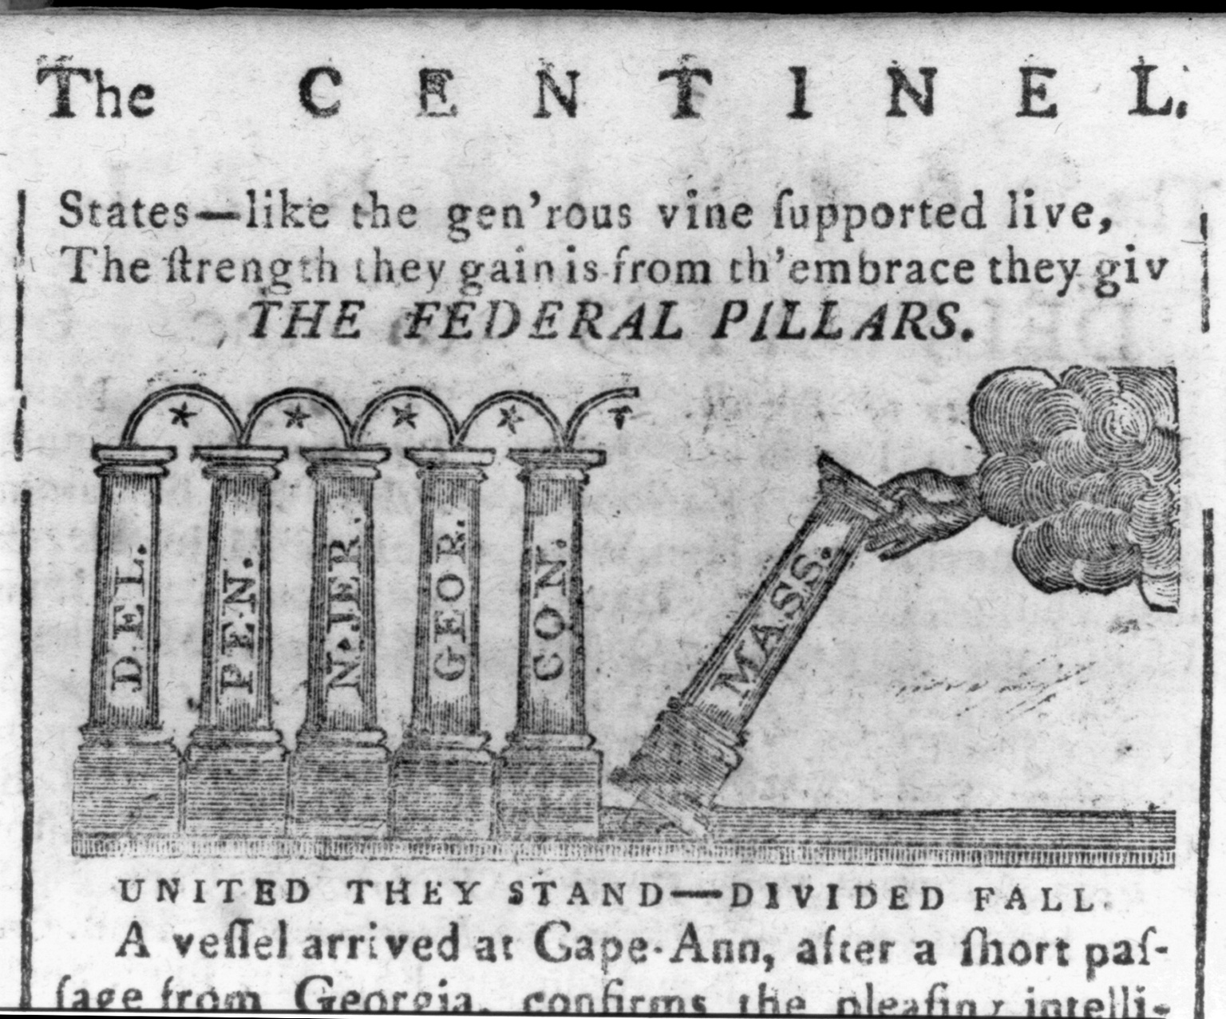
The Federal Edifice (“The Federal Pillars”) · Massachusetts Centinel · 1788
Source: Library of Congress, Prints & Photographs Division · https://www.loc.gov/item/2004676796/ Public domain — published 1788 (pre-1929) https://www.loc.gov/item/2004676796/
HIPPO — analyze the source (prompt) | Your analysis
H — Historical context: what was happening when this was created?
I — Intended audience: who was meant to see or obey it?
P — Purpose: why was it created?
P — Point of view: whose perspective does it reflect?
O — Outside connection: how does it connect to this standard?
SUPPORT OPTION
Sentence frame: This source shows ______ because it ______, which reveals ______.
CONFIDENCE CHECK-IN
Rate your understanding of this standard (1–4): ______ One thing to revisit: ____________________

Activity 6 — Core Application: Practice Quiz — GC.07 ⏱ ~8 min
RESPONSE CHOICE
Commit to an answer by marking it, saying it, or explaining it aloud before checking. Answer key is in the Teacher Guide (kept separate).
[DOK 1 · item u1-gc07-dok1-1 · pre-field-test]
To ratify a constitutional amendment requires approval by:
A. three-fourths of the states
B. the president
C. a simple majority of voters
D. the Supreme Court
[DOK 2 · item u1-gc07-dok2-tc · pre-field-test]
Why did the Framers make the amendment process in Article V deliberately difficult?
A. To make sure the Constitution could never change
B. To let a single state change it alone
C. To give the president control over amendments
D. So the Constitution could adapt over time, but only with broad agreement across the country

STRETCH — think like a test-writer (open to all)
Write your OWN DOK-3 question for this standard, then a one-sentence answer key. Use the supports below — everyone can do this.
HOW TO WRITE A DOK-3 QUESTION (supports)
DOK-3 = strategic thinking: the reader must analyze, compare, evaluate, or justify using evidence — and there should be more than one defensible answer (not a fact you can just look up).
Sentence starters: “Why did ______ lead to ______?” · “Which mattered more — ______ or ______ — and why?” · “What is the BEST evidence that ______?” · “Evaluate whether ______.” · “Defend or challenge: ______.”
Frame: [Analyze / Evaluate / Justify] + [something from THIS standard] + “using evidence.”
Quick check: does my question make the reader THINK and use evidence? If yes, it’s DOK-3.
Your DOK-3 question | Your answer key (one sentence)

Activity 7 — Constructed Response (CER) — GC.07 ⏱ ~15 min
BIG-QUESTION ORGANIZER (before you write) — How and why did the Founders build a limited constitutional republic?
Plan your argument here, then use it to write your claim, evidence, and reasoning below.
Plan your argument | Your quick notes (from this standard)
My claim (answer the prompt)
Evidence 1 (a source or fact)
Reasoning (why it proves the claim)
CONSTRUCTED RESPONSE (CER) — builds SSP.04 Argumentation
Claim + Evidence + Reasoning: Is the difficulty of amending the Constitution a strength or a weakness for a modern democracy? Defend your claim with reasoning tied to Article V.
Part | Write here
Claim
Evidence (two specifics)
Reasoning
SELF-CHECK against the CER rubric (see Toolkit)
Before submitting: Is my claim defensible? Do I have TWO specific pieces of evidence? Does my reasoning explain HOW the evidence proves the claim?

UDL Access, Choice & Reflection — GC.07
UDL ACCESS & MTSS SUPPORT (this standard)
UDL 3.0 (CAST, 2024): read-aloud on request · key terms glossed (EN/ES) · respond in writing, speech, or a labeled diagram · large-print & screen-reader friendly. Same learning target for everyone; supports vary the means, not the ceiling.
MTSS: Tier 1 — this core lesson for all · Tier 2 — small-group reteach of this standard using its Cornell cues + graphic organizer, then re-check · Tier 3 — intensive 1:1 with concrete→representational→abstract scaffolding, progress-monitored to the same standard.
SHOW WHAT YOU KNOW — YOUR WAY (same CER rubric, same standard)
Build your Claim–Evidence–Reasoning in whichever mode lets you think best — the standard and the CER rubric are identical for every mode; the mode changes how you SHOW it, never what you are held to:
WRITE it · SAY it aloud and record it (audio or video) · DRAW and label a diagram that makes the argument · BUILD a model or artifact and caption its claim, evidence, and reasoning.
You may ask for a word processor, speech-to-text, a scribe, or a sentence/argument frame — these change how you produce, not the standard you meet.
CHOICE & VOICE — you decide how to go deeper (pick ONE)
You choose your path to show this standard — every option meets the same target:
DEFEND a term: pick the vocabulary word that matters most and argue why in 2–3 sentences. · CONNECT it: pick a current event, your community, or your own life and explain how this standard shows up there. · TAKE A SIDE: pick one debatable question and argue your position with evidence.
Your pick is yours — bring what matters to you into the work.
REFLECT & CONNECT — how your thinking grew, and whose view you weighed
Reflect (self-awareness): What did you believe about this topic BEFORE, and what changed AFTER? Name one thing to revisit.
Consider another view (empathy): Name one person or group who might see this standard differently than you; state their view fairly in one sentence — even if you disagree.
Norm (restorative): we critique ideas, not people; we assume good faith; we make room for every voice.

Standard GC.08 — The Bill of Rights
TN Academic Standard GC.08: Analyze how the Bill of Rights limits the powers of the government and ensures individual rights. (C)
LEARNING TARGETS — I can…
• I can I can analyze how the Bill of Rights limits the powers of the government and ensures individual rights..
Lenses for this standard: Culture (C)
CORE PATH — the same for every student
Every student works this standard at the same rigor: analyze the sources and vocabulary, then demonstrate learning on the Practice Quiz and CER. UDL and MTSS give you flexible ways in — they never lower the bar. Check yourself against the learning targets on the Cornell Notes page.
SET YOUR GOAL (self-direction)
My goal for this standard — what will I be able to do, and how will I show it?

HOOK — think before you dig in
Ten amendments, one purpose: to tell the government what it may NOT do to you. Why did Americans insist on adding them?

ACTIVATE — what do you already know or wonder?
Jot what you already know or want to find out about this standard. You’ll come back to it.

PREVIEW & PREDICT
Which learning target will be hardest, and why? Connect it to the unit’s big question: How and why did the Founders build a limited constitutional republic?

Activity 1 — Vocabulary (Part A: Reference / Word Bank) — GC.08 ⏱ ~10 min
Use this word bank throughout the standard. The Spanish column supports access, not translation of assessment.
Term | Student-friendly meaning | Spanish
Bill of Rights | The first ten amendments to the Constitution (1791), which protect individual freedoms and limit the power of government. | Carta de Derechos
Reserved Powers | Powers kept by the states or the people, not given to the national government — protected by the Tenth Amendment. | poderes reservados
Due Process | The requirement that government follow fair legal procedures before taking a person's life, liberty, or property — guaranteed by the Fifth Amendment. | debido proceso
LANGUAGE SUPPORT
Pronunciations: Bill of Rights (BIL of RYTS); Reserved Powers (ree-ZURVD POW-erz); Due Process (DOO PROSS-ess).

VOCABULARY SELF-CHECK · Knowledge Rating
Rate each term NOW in pencil, then again at the END — growth is the goal; no penalty for “never seen it.”
Term | 1 · never seen it | 2 · heard it | 3 · can use it | 4 · can teach it
Bill of Rights
Reserved Powers
Due Process
MAKE IT YOURS (RESPONSE CHOICE): choose ONE term above and show you own it — write a sentence, sketch it, or give a real-world example.

QUICK WRITE
Which of these terms do you think will matter MOST for this standard, and why? You’ll revisit this at the end.

Activity 2 — Vocabulary Studio (Frayer-inspired) — GC.08 ⏱ ~7 min
RESPONSE CHOICE
Complete each studio by writing, speaking, or diagramming.

PRIORITY TERM 1 Bill of Rights · ES: Carta de Derechos
Word-bank meaning to build on: The first ten amendments to the Constitution (1791), which protect individual freedoms and limit the power of government.
Definition (in your own words) | Characteristics
Examples | Non-examples
Use it to explain
Write one sentence that uses “Bill of Rights” to explain this standard.

PRIORITY TERM 2 Reserved Powers · ES: poderes reservados
Word-bank meaning to build on: Powers kept by the states or the people, not given to the national government — protected by the Tenth Amendment.
Definition (in your own words) | Characteristics
Examples | Non-examples
Use it to explain
Write one sentence that uses “Reserved Powers” to explain this standard.

CONNECT THE TERMS (UDL · build understanding)
How do these priority terms fit together? Write or sketch how one leads to or affects another.

Activity 3 — Direct Teaching Cornell Notes — GC.08 ⏱ ~20 min
Name: ______________________ Class / Period: __________ Date: __________
GC.08 — The Bill of Rights • Lean Student Deck slides 51–57 • direct-teaching slides 53–55
Your learning targets are on this standard’s opening page — take notes that help you meet them.
Guiding cues | My notes — write your notes here
Key idea of this standard?
One primary source that supports it?
One effect on government or rights?
Key terms →
Keep taking notes — lines run the full width of the page:

DOODLE ZONE — draw your thinking (UDL · another way in)
Need another way in? Sketch the key idea, a quick timeline, or how the pieces connect. Words optional.

Cornell Notes — keep going, then process & check — GC.08
MORE NOTES / DIAGRAMS
Continue your notes here, add a quick sketch, or map how the ideas connect.

Key terms to list
Bill of Rights · Reserved Powers · Due Process
Summary — In your own words (2–3 sentences)
PROGRESS CHECK · one question
The First Amendment begins 'Congress shall make no law…' Why does the Bill of Rights phrase protections as limits on the government rather than as gifts to the people?
A. To show the government created these rights and can remove them
B. Because the Framers saw rights as belonging to people already — the Constitution's job is to stop government from violating them
C. To give Congress more power over speech and religion
D. Because only Congress has rights
Commit before you move on — mark it, say it, or explain it aloud.
CHECK YOURSELF — how am I doing?
Which learning targets (on this standard’s opening page) can you now meet? Tick the number; circle any you still need help with.
☐ 1
My 12–15 word headline for this standard

Guided Support for the Cornell Notes — GC.08
These scaffolds support ONLY the Cornell notes — use them to take and process those notes. Optional and easy to set aside; not a separate assignment or a label.
Key vocabulary | What it means
Bill of Rights | The first ten amendments to the Constitution (1791), which protect individual freedoms and limit the power of government.
Reserved Powers | Powers kept by the states or the people, not given to the national government — protected by the Tenth Amendment.
Due Process | The requirement that government follow fair legal procedures before taking a person's life, liberty, or property — guaranteed by the Fifth Amendment.
Break it into steps:
1) Name one cause or effect. 2) Give one piece of evidence. 3) Write one sentence explaining the link.
Sentence frame
One key cause/effect of the bill of rights was ______, shown by ______, which mattered because ______.
Modeled example (one worked note — yours will differ)
A key idea of the bill of rights was Bill of Rights: The first ten amendments to the Constitution (1791), which protect individual freedoms and limit the power of government.
GUIDED NOTE REHEARSAL LAB
Rehearse the cause→effect chain below, then transfer it to your Cornell notes.
Step | Rehearse it here
Name it
Evidence
Explain
Headline
TRANSFER CHECK — move one rehearsed idea onto the front notes

Light Support for the Cornell Notes — GC.08
A lighter scaffold for the SAME Cornell notes. Try the notes first; reach for this only if you need it.
Key vocabulary | Finish the idea — “This term means …”
Bill of Rights
Reserved Powers
Due Process
Guiding questions — answer on the lines below (or in your front notes):
• List three freedoms protected by the First Amendment.
• According to the Tenth Amendment, who keeps the powers not given to the national government?
• Why does it matter that the Bill of Rights protects 'persons' and not only citizens?

WHICH CUE STILL NEEDS WORK?
Circle the Cornell cue from the front page you still need help with, and tell your teacher so we can go over it.
LIGHT PROCESSING LAB
Answer one guiding question from above in a full sentence, in your own words.

Activity 4 — Close Read — GC.08 ⏱ ~15 min
Reading type: Government Hack-authored instructional synthesis. This is not a primary source. Builds SSP.03 (synthesize) and SSP.05 (historical awareness).
CORE PATH
The Anti-Federalists agreed to the Constitution only if a bill of rights was added. In 1791 the first ten amendments were ratified. The Bill of Rights protects individual freedoms and, notably, most protections apply to 'persons,' not only citizens. The First Amendment guards religion, speech, press, assembly, and petition. The Fourth through Eighth protect people accused of crimes — from unreasonable searches to cruel and unusual punishment — through guarantees like due process. The Ninth Amendment says the people keep other rights not listed, and the Tenth reserves to the states and the people all powers not given to the national government — a cornerstone of federalism. Every clause is a limit on government power. This standard is required instruction under Tennessee law (T.C.A. § 49-6-1028).
LANGUAGE SUPPORT
Key terms to know first: Bill of Rights, Reserved Powers. Read once for the gist, then again for evidence.
Text-dependent questions (answer in the Evidence Lab below or aloud):
1. List three freedoms protected by the First Amendment.
2. According to the Tenth Amendment, who keeps the powers not given to the national government?
3. Why does it matter that the Bill of Rights protects 'persons' and not only citizens?
RESPONSE CHOICE: answer any question by writing in the Evidence Lab, saying/recording it, or diagramming it.
CLOSE-READ EVIDENCE LAB
Log evidence from the passage below.
Question / claim | Exact passage evidence | What the evidence shows

SPACED RETRIEVAL — quick recall (no notes)
Pull it up cold to strengthen memory, then check your notes.
Recall prompt | Your answer (from memory)
One key term or fact from THIS standard
One thing you learned EARLIER in this unit or course
How the two connect

Activity 5 — Primary Source / Data Analysis — GC.08 ⏱ ~15 min
Primary source (manuscript on parchment) — analyze it with HIPPO. Builds SSP.01–SSP.02.
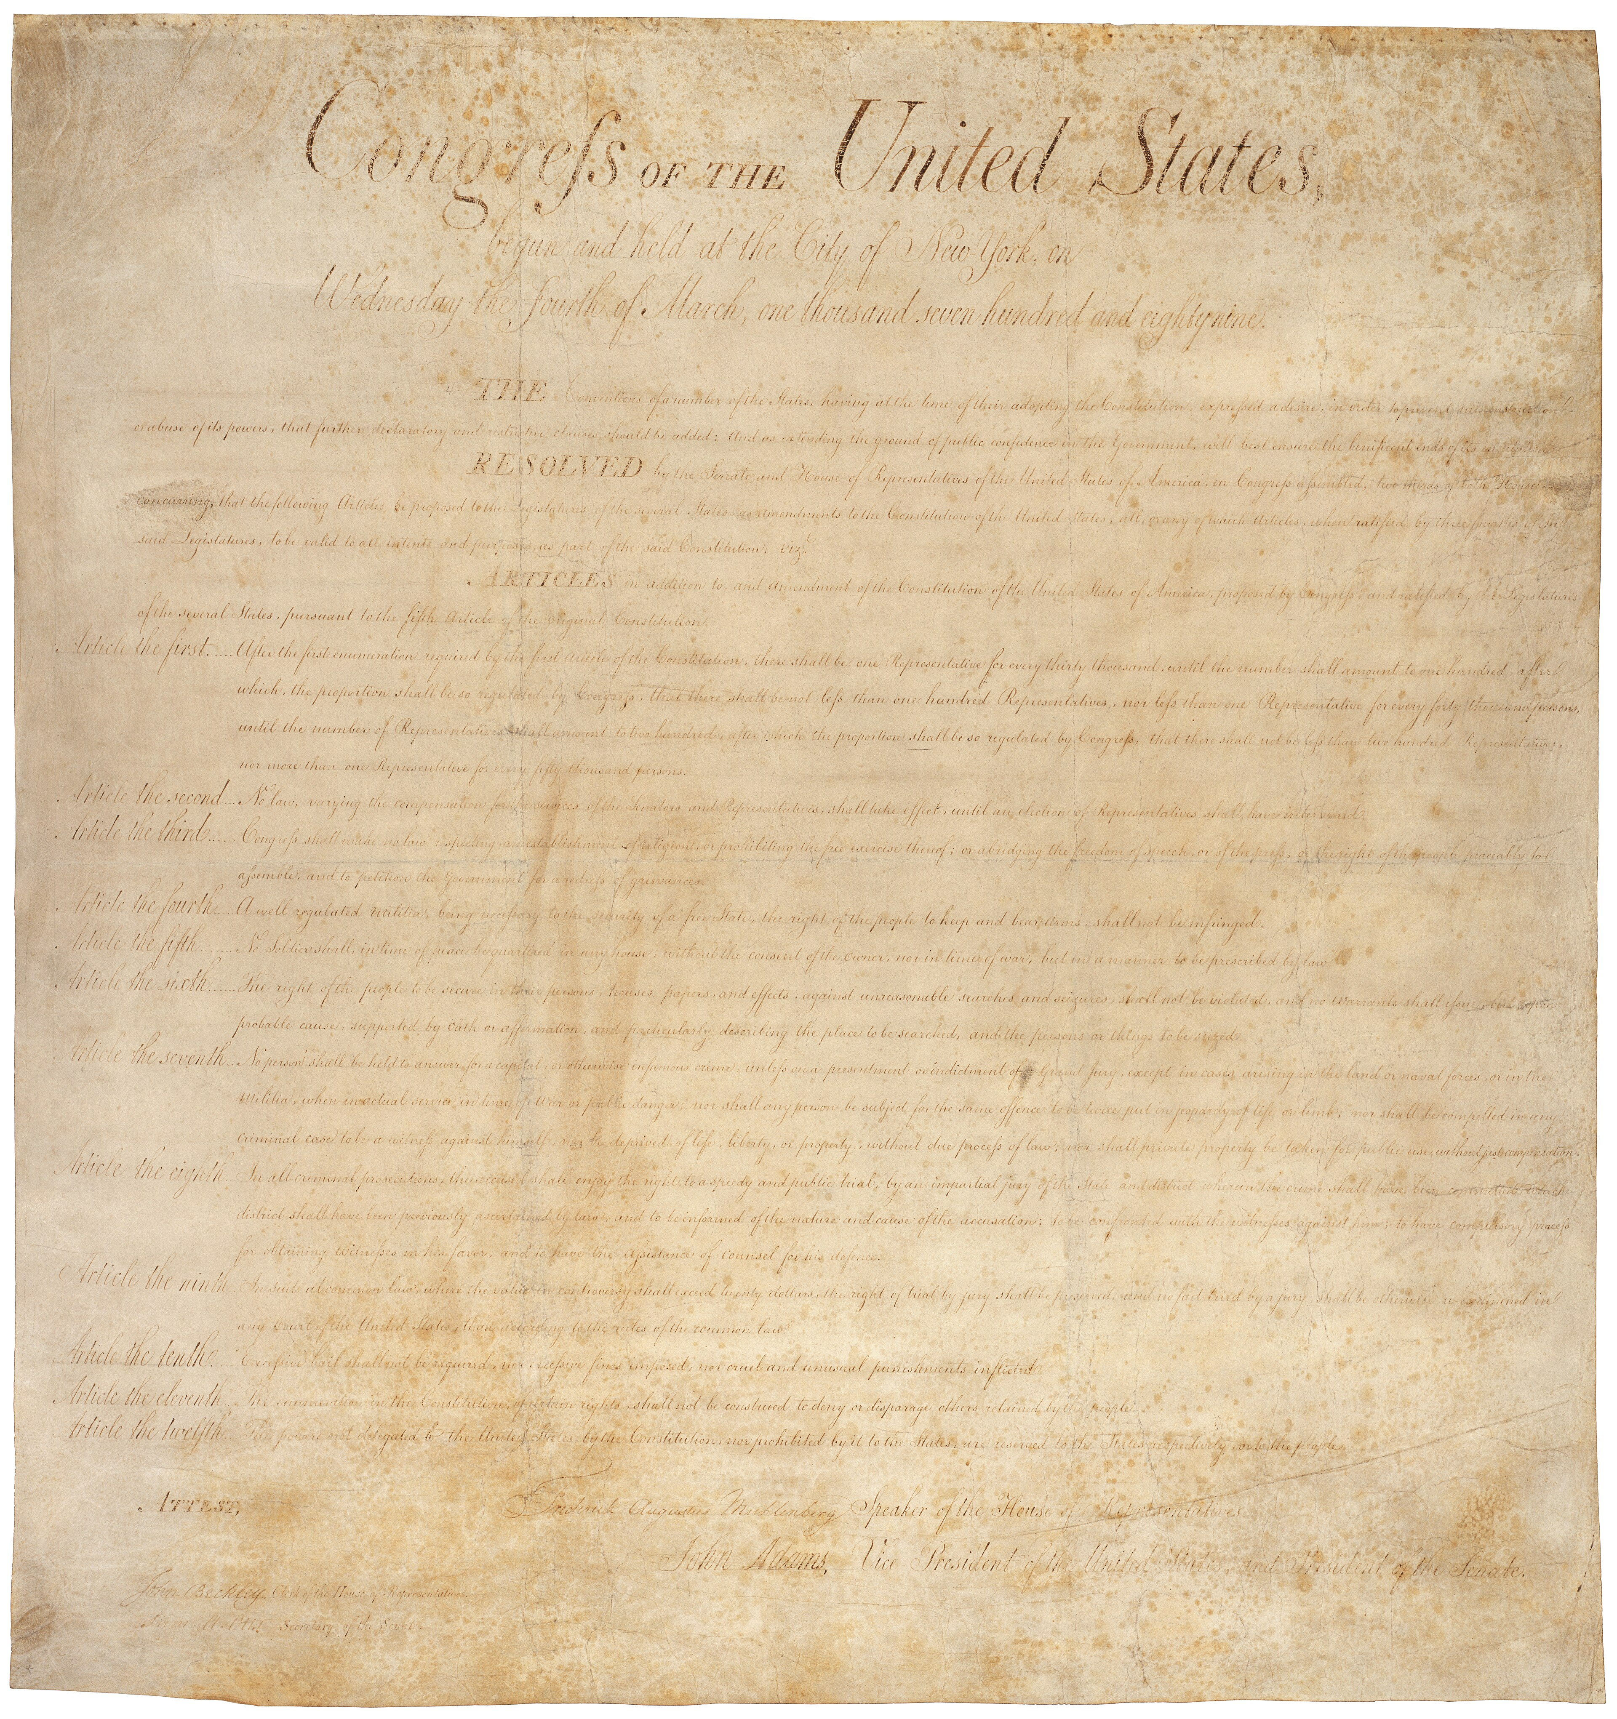
The Bill of Rights (engrossed copy) · 1st U.S. Congress · 1789
Source: U.S. National Archives · https://commons.wikimedia.org/wiki/File:Bill_of_Rights_Pg1of1_AC.jpg Public domain — U.S. gov document, 1789 https://commons.wikimedia.org/wiki/File:Bill_of_Rights_Pg1of1_AC.jpg
HIPPO — analyze the source (prompt) | Your analysis
H — Historical context: what was happening when this was created?
I — Intended audience: who was meant to see or obey it?
P — Purpose: why was it created?
P — Point of view: whose perspective does it reflect?
O — Outside connection: how does it connect to this standard?
SUPPORT OPTION
Sentence frame: This source shows ______ because it ______, which reveals ______.
CONFIDENCE CHECK-IN
Rate your understanding of this standard (1–4): ______ One thing to revisit: ____________________

Activity 6 — Core Application: Practice Quiz — GC.08 ⏱ ~8 min
RESPONSE CHOICE
Commit to an answer by marking it, saying it, or explaining it aloud before checking. Answer key is in the Teacher Guide (kept separate).
[DOK 1 · item u1-gc08-dok1-1 · pre-field-test]
The Bill of Rights is the name for:
A. the first ten amendments to the Constitution
B. the Preamble
C. the Articles of Confederation
D. the Declaration of Independence
[DOK 3 · item u1-gc08-dok3-tc · pre-field-test]
The First Amendment begins 'Congress shall make no law…' Why does the Bill of Rights phrase protections as limits on the government rather than as gifts to the people?
A. To show the government created these rights and can remove them
B. Because the Framers saw rights as belonging to people already — the Constitution's job is to stop government from violating them
C. To give Congress more power over speech and religion
D. Because only Congress has rights

STRETCH — think like a test-writer (open to all)
Write your OWN DOK-3 question for this standard, then a one-sentence answer key. Use the supports below — everyone can do this.
HOW TO WRITE A DOK-3 QUESTION (supports)
DOK-3 = strategic thinking: the reader must analyze, compare, evaluate, or justify using evidence — and there should be more than one defensible answer (not a fact you can just look up).
Sentence starters: “Why did ______ lead to ______?” · “Which mattered more — ______ or ______ — and why?” · “What is the BEST evidence that ______?” · “Evaluate whether ______.” · “Defend or challenge: ______.”
Frame: [Analyze / Evaluate / Justify] + [something from THIS standard] + “using evidence.”
Quick check: does my question make the reader THINK and use evidence? If yes, it’s DOK-3.
Your DOK-3 question | Your answer key (one sentence)

Activity 7 — Constructed Response (CER) — GC.08 ⏱ ~15 min
BIG-QUESTION ORGANIZER (before you write) — How and why did the Founders build a limited constitutional republic?
Plan your argument here, then use it to write your claim, evidence, and reasoning below.
Plan your argument | Your quick notes (from this standard)
My claim (answer the prompt)
Evidence 1 (a source or fact)
Reasoning (why it proves the claim)
CONSTRUCTED RESPONSE (CER) — builds SSP.04 Argumentation
Claim + Evidence + Reasoning: Which amendment in the Bill of Rights does the most to protect individual liberty today? Defend your claim with evidence from the text.
Part | Write here
Claim
Evidence (two specifics)
Reasoning
SELF-CHECK against the CER rubric (see Toolkit)
Before submitting: Is my claim defensible? Do I have TWO specific pieces of evidence? Does my reasoning explain HOW the evidence proves the claim?

UDL Access, Choice & Reflection — GC.08
UDL ACCESS & MTSS SUPPORT (this standard)
UDL 3.0 (CAST, 2024): read-aloud on request · key terms glossed (EN/ES) · respond in writing, speech, or a labeled diagram · large-print & screen-reader friendly. Same learning target for everyone; supports vary the means, not the ceiling.
MTSS: Tier 1 — this core lesson for all · Tier 2 — small-group reteach of this standard using its Cornell cues + graphic organizer, then re-check · Tier 3 — intensive 1:1 with concrete→representational→abstract scaffolding, progress-monitored to the same standard.
SHOW WHAT YOU KNOW — YOUR WAY (same CER rubric, same standard)
Build your Claim–Evidence–Reasoning in whichever mode lets you think best — the standard and the CER rubric are identical for every mode; the mode changes how you SHOW it, never what you are held to:
WRITE it · SAY it aloud and record it (audio or video) · DRAW and label a diagram that makes the argument · BUILD a model or artifact and caption its claim, evidence, and reasoning.
You may ask for a word processor, speech-to-text, a scribe, or a sentence/argument frame — these change how you produce, not the standard you meet.
CHOICE & VOICE — you decide how to go deeper (pick ONE)
You choose your path to show this standard — every option meets the same target:
DEFEND a term: pick the vocabulary word that matters most and argue why in 2–3 sentences. · CONNECT it: pick a current event, your community, or your own life and explain how this standard shows up there. · TAKE A SIDE: pick one debatable question and argue your position with evidence.
Your pick is yours — bring what matters to you into the work.
REFLECT & CONNECT — how your thinking grew, and whose view you weighed
Reflect (self-awareness): What did you believe about this topic BEFORE, and what changed AFTER? Name one thing to revisit.
Consider another view (empathy): Name one person or group who might see this standard differently than you; state their view fairly in one sentence — even if you disagree.
Norm (restorative): we critique ideas, not people; we assume good faith; we make room for every voice.

Standard GC.09 — Republic and Democracy
TN Academic Standard GC.09: Define the concepts of democracy and republic and examine the relationship between the two.
LEARNING TARGETS — I can…
• I can I can define the concepts of democracy and republic and examine the relationship between the two..
CORE PATH — the same for every student
Every student works this standard at the same rigor: analyze the sources and vocabulary, then demonstrate learning on the Practice Quiz and CER. UDL and MTSS give you flexible ways in — they never lower the bar. Check yourself against the learning targets on the Cornell Notes page.
SET YOUR GOAL (self-direction)
My goal for this standard — what will I be able to do, and how will I show it?

HOOK — think before you dig in
Is the United States a democracy or a republic? The answer is 'both, on purpose' — and it changes how your voice reaches government.

ACTIVATE — what do you already know or wonder?
Jot what you already know or want to find out about this standard. You’ll come back to it.

PREVIEW & PREDICT
Which learning target will be hardest, and why? Connect it to the unit’s big question: How and why did the Founders build a limited constitutional republic?

Activity 1 — Vocabulary (Part A: Reference / Word Bank) — GC.09 ⏱ ~10 min
Use this word bank throughout the standard. The Spanish column supports access, not translation of assessment.
Term | Student-friendly meaning | Spanish
Republic | A government in which citizens elect representatives to make laws and decisions on their behalf. | república
Representative Democracy | A system in which the people rule indirectly by electing officials to represent them — the model of U.S. government. | democracia representativa
Direct Democracy | A system in which citizens vote directly on laws themselves, rather than through elected representatives. | democracia directa
LANGUAGE SUPPORT
Pronunciations: Republic (ree-PUB-lik); Representative Democracy (rep-ree-ZEN-tuh-tiv); Direct Democracy (dih-REKT dih-MOK-ruh-see).

VOCABULARY SELF-CHECK · Knowledge Rating
Rate each term NOW in pencil, then again at the END — growth is the goal; no penalty for “never seen it.”
Term | 1 · never seen it | 2 · heard it | 3 · can use it | 4 · can teach it
Republic
Representative Democracy
Direct Democracy
MAKE IT YOURS (RESPONSE CHOICE): choose ONE term above and show you own it — write a sentence, sketch it, or give a real-world example.

QUICK WRITE
Which of these terms do you think will matter MOST for this standard, and why? You’ll revisit this at the end.

Activity 2 — Vocabulary Studio (Frayer-inspired) — GC.09 ⏱ ~7 min
RESPONSE CHOICE
Complete each studio by writing, speaking, or diagramming.

PRIORITY TERM 1 Republic · ES: república
Word-bank meaning to build on: A government in which citizens elect representatives to make laws and decisions on their behalf.
Definition (in your own words) | Characteristics
Examples | Non-examples
Use it to explain
Write one sentence that uses “Republic” to explain this standard.

PRIORITY TERM 2 Direct Democracy · ES: democracia directa
Word-bank meaning to build on: A system in which citizens vote directly on laws themselves, rather than through elected representatives.
Definition (in your own words) | Characteristics
Examples | Non-examples
Use it to explain
Write one sentence that uses “Direct Democracy” to explain this standard.

CONNECT THE TERMS (UDL · build understanding)
How do these priority terms fit together? Write or sketch how one leads to or affects another.

Activity 3 — Direct Teaching Cornell Notes — GC.09 ⏱ ~20 min
Name: ______________________ Class / Period: __________ Date: __________
GC.09 — Republic and Democracy • Lean Student Deck slides 58–64 • direct-teaching slides 60–62
Your learning targets are on this standard’s opening page — take notes that help you meet them.
Guiding cues | My notes — write your notes here
Key idea of this standard?
One primary source that supports it?
One effect on government or rights?
Key terms →
Keep taking notes — lines run the full width of the page:

DOODLE ZONE — draw your thinking (UDL · another way in)
Need another way in? Sketch the key idea, a quick timeline, or how the pieces connect. Words optional.

Cornell Notes — keep going, then process & check — GC.09
MORE NOTES / DIAGRAMS
Continue your notes here, add a quick sketch, or map how the ideas connect.

Key terms to list
Republic · Representative Democracy · Direct Democracy
Summary — In your own words (2–3 sentences)
PROGRESS CHECK · one question
What is the main difference between a direct democracy and a republic (representative democracy)?
A. In a direct democracy citizens vote on laws themselves; in a republic they elect representatives to make laws
B. A republic has no elections
C. A republic is ruled by a king
D. There is no difference
Commit before you move on — mark it, say it, or explain it aloud.
CHECK YOURSELF — how am I doing?
Which learning targets (on this standard’s opening page) can you now meet? Tick the number; circle any you still need help with.
☐ 1
My 12–15 word headline for this standard

Guided Support for the Cornell Notes — GC.09
These scaffolds support ONLY the Cornell notes — use them to take and process those notes. Optional and easy to set aside; not a separate assignment or a label.
Key vocabulary | What it means
Republic | A government in which citizens elect representatives to make laws and decisions on their behalf.
Representative Democracy | A system in which the people rule indirectly by electing officials to represent them — the model of U.S. government.
Direct Democracy | A system in which citizens vote directly on laws themselves, rather than through elected representatives.
Break it into steps:
1) Name one cause or effect. 2) Give one piece of evidence. 3) Write one sentence explaining the link.
Sentence frame
One key cause/effect of republic and democracy was ______, shown by ______, which mattered because ______.
Modeled example (one worked note — yours will differ)
A key idea of republic and democracy was Republic: A government in which citizens elect representatives to make laws and decisions on their behalf.
GUIDED NOTE REHEARSAL LAB
Rehearse the cause→effect chain below, then transfer it to your Cornell notes.
Step | Rehearse it here
Name it
Evidence
Explain
Headline
TRANSFER CHECK — move one rehearsed idea onto the front notes

Light Support for the Cornell Notes — GC.09
A lighter scaffold for the SAME Cornell notes. Try the notes first; reach for this only if you need it.
Key vocabulary | Finish the idea — “This term means …”
Republic
Representative Democracy
Direct Democracy
Guiding questions — answer on the lines below (or in your front notes):
• What is the difference between a direct democracy and a representative democracy (republic)?
• In Federalist No. 10, why does Madison prefer a large republic over a pure democracy?
• How does a constitutional republic balance majority rule with minority rights?

WHICH CUE STILL NEEDS WORK?
Circle the Cornell cue from the front page you still need help with, and tell your teacher so we can go over it.
LIGHT PROCESSING LAB
Answer one guiding question from above in a full sentence, in your own words.

Activity 4 — Close Read — GC.09 ⏱ ~15 min
Reading type: Government Hack-authored instructional synthesis. This is not a primary source. Builds SSP.03 (synthesize) and SSP.05 (historical awareness).
CORE PATH
Americans often call the United States a 'democracy,' but the Framers designed a republic — a representative democracy. In a direct democracy, citizens vote on laws themselves; in a republic, they elect representatives to make laws for them. In Federalist No. 10, Madison argued a large republic would better control the dangers of 'faction' than a small direct democracy. The Constitution guarantees every state 'a Republican Form of Government' (Article IV). A constitutional republic combines majority rule through elections with protection of minority rights and individual liberties through the Constitution — so the majority governs, but cannot simply vote away the basic rights of others.
LANGUAGE SUPPORT
Key terms to know first: Republic, Representative Democracy. Read once for the gist, then again for evidence.
Text-dependent questions (answer in the Evidence Lab below or aloud):
1. What is the difference between a direct democracy and a representative democracy (republic)?
2. In Federalist No. 10, why does Madison prefer a large republic over a pure democracy?
3. How does a constitutional republic balance majority rule with minority rights?
RESPONSE CHOICE: answer any question by writing in the Evidence Lab, saying/recording it, or diagramming it.
CLOSE-READ EVIDENCE LAB
Log evidence from the passage below.
Question / claim | Exact passage evidence | What the evidence shows

SPACED RETRIEVAL — quick recall (no notes)
Pull it up cold to strengthen memory, then check your notes.
Recall prompt | Your answer (from memory)
One key term or fact from THIS standard
One thing you learned EARLIER in this unit or course
How the two connect

Activity 5 — Primary Source / Data Analysis — GC.09 ⏱ ~15 min
Primary source (engraved national emblem) — analyze it with HIPPO. Builds SSP.01–SSP.02.

Great Seal of the United States (obverse) · Charles Thomson & William Barton (design) · 1782
Source: U.S. National Archives / public domain (U.S. government emblem) · https://commons.wikimedia.org/wiki/File:Great_Seal_of_the_United_States_(obverse).svg Public domain — U.S. federal government work https://commons.wikimedia.org/wiki/File:Great_Seal_of_the_United_States_(obverse).svg
HIPPO — analyze the source (prompt) | Your analysis
H — Historical context: what was happening when this was created?
I — Intended audience: who was meant to see or obey it?
P — Purpose: why was it created?
P — Point of view: whose perspective does it reflect?
O — Outside connection: how does it connect to this standard?
SUPPORT OPTION
Sentence frame: This source shows ______ because it ______, which reveals ______.
CONFIDENCE CHECK-IN
Rate your understanding of this standard (1–4): ______ One thing to revisit: ____________________

Activity 6 — Core Application: Practice Quiz — GC.09 ⏱ ~8 min
RESPONSE CHOICE
Commit to an answer by marking it, saying it, or explaining it aloud before checking. Answer key is in the Teacher Guide (kept separate).
[DOK 1 · item u1-gc09-dok1-1 · pre-field-test]
The United States is best described as a:
A. constitutional republic / representative democracy
B. direct democracy
C. monarchy
D. confederation
[DOK 2 · item u1-gc09-dok2-tc · pre-field-test]
What is the main difference between a direct democracy and a republic (representative democracy)?
A. In a direct democracy citizens vote on laws themselves; in a republic they elect representatives to make laws
B. A republic has no elections
C. A republic is ruled by a king
D. There is no difference

STRETCH — think like a test-writer (open to all)
Write your OWN DOK-3 question for this standard, then a one-sentence answer key. Use the supports below — everyone can do this.
HOW TO WRITE A DOK-3 QUESTION (supports)
DOK-3 = strategic thinking: the reader must analyze, compare, evaluate, or justify using evidence — and there should be more than one defensible answer (not a fact you can just look up).
Sentence starters: “Why did ______ lead to ______?” · “Which mattered more — ______ or ______ — and why?” · “What is the BEST evidence that ______?” · “Evaluate whether ______.” · “Defend or challenge: ______.”
Frame: [Analyze / Evaluate / Justify] + [something from THIS standard] + “using evidence.”
Quick check: does my question make the reader THINK and use evidence? If yes, it’s DOK-3.
Your DOK-3 question | Your answer key (one sentence)

Activity 7 — Constructed Response (CER) — GC.09 ⏱ ~15 min
BIG-QUESTION ORGANIZER (before you write) — How and why did the Founders build a limited constitutional republic?
Plan your argument here, then use it to write your claim, evidence, and reasoning below.
Plan your argument | Your quick notes (from this standard)
My claim (answer the prompt)
Evidence 1 (a source or fact)
Reasoning (why it proves the claim)
CONSTRUCTED RESPONSE (CER) — builds SSP.04 Argumentation
Claim + Evidence + Reasoning: Was the Framers' choice of a republic over a direct democracy the right one for a large nation? Defend your claim using Federalist No. 10.
Part | Write here
Claim
Evidence (two specifics)
Reasoning
SELF-CHECK against the CER rubric (see Toolkit)
Before submitting: Is my claim defensible? Do I have TWO specific pieces of evidence? Does my reasoning explain HOW the evidence proves the claim?

UDL Access, Choice & Reflection — GC.09
UDL ACCESS & MTSS SUPPORT (this standard)
UDL 3.0 (CAST, 2024): read-aloud on request · key terms glossed (EN/ES) · respond in writing, speech, or a labeled diagram · large-print & screen-reader friendly. Same learning target for everyone; supports vary the means, not the ceiling.
MTSS: Tier 1 — this core lesson for all · Tier 2 — small-group reteach of this standard using its Cornell cues + graphic organizer, then re-check · Tier 3 — intensive 1:1 with concrete→representational→abstract scaffolding, progress-monitored to the same standard.
SHOW WHAT YOU KNOW — YOUR WAY (same CER rubric, same standard)
Build your Claim–Evidence–Reasoning in whichever mode lets you think best — the standard and the CER rubric are identical for every mode; the mode changes how you SHOW it, never what you are held to:
WRITE it · SAY it aloud and record it (audio or video) · DRAW and label a diagram that makes the argument · BUILD a model or artifact and caption its claim, evidence, and reasoning.
You may ask for a word processor, speech-to-text, a scribe, or a sentence/argument frame — these change how you produce, not the standard you meet.
CHOICE & VOICE — you decide how to go deeper (pick ONE)
You choose your path to show this standard — every option meets the same target:
DEFEND a term: pick the vocabulary word that matters most and argue why in 2–3 sentences. · CONNECT it: pick a current event, your community, or your own life and explain how this standard shows up there. · TAKE A SIDE: pick one debatable question and argue your position with evidence.
Your pick is yours — bring what matters to you into the work.
REFLECT & CONNECT — how your thinking grew, and whose view you weighed
Reflect (self-awareness): What did you believe about this topic BEFORE, and what changed AFTER? Name one thing to revisit.
Consider another view (empathy): Name one person or group who might see this standard differently than you; state their view fairly in one sentence — even if you disagree.
Norm (restorative): we critique ideas, not people; we assume good faith; we make room for every voice.

Your Tennessee Connection
★ TENNESSEE CONNECTION
Tennessee entered the Union in 1796 as the 16th state. Its own state constitution echoes the federal design studied in this unit — a separation of powers among three branches and a Declaration of Rights modeled on the Bill of Rights (GC.06, GC.08).
Reflect (RESPONSE CHOICE): How does a Tennessee connection change the way you understand a national idea? Answer by writing, recording, or diagramming.

Tennessee Civics Investigation
Tennessee's government mirrors the federal framework. Investigate one way your state or local government reflects a principle from this unit — separation of powers, checks and balances, or the protection of individual rights — and record what you find.
Prompt | Your findings
A Tennessee example connected to this unit
One source I could check (library, TN Secretary of State, TSLA, a representative’s office)
How it connects to a standard in this unit
One question I still have

Progress Tracker & Cumulative Review
Track your Progress Check result for each standard and note one thing to revisit.
Standard | Progress Check (✓ / reteach) | One thing to revisit
GC.01
GC.02
GC.03
GC.04
GC.05
GC.06
GC.07
GC.08
GC.09

Optional Extension Bank (higher-DOK, open to all)
Any student may choose an extension. These are EXTENSION, not a track.
GC.01: Which European root — Locke's natural rights, Montesquieu's separated powers, or Magna Carta's limits on the king — shaped American government the most? Defend your claim with evidence from two sources.
GC.02: Was the Declaration of Independence mainly a list of complaints, or an argument about the purpose of government? Defend your claim with two quotations from the text.
GC.03: Was the greatest weakness of the Articles the lack of taxing power, the lack of a strong executive, or the difficulty of amendment? Defend your claim with evidence.
GC.04: In the ratification debate, whose warning has aged better — the Federalists' case for a strong union, or the Anti-Federalists' fear of centralized power? Use one quote from each side.
GC.05: Of the six purposes in the Preamble, which is most important for a free society today? Defend your claim with reasoning tied to the text.
GC.06: Which principle does the most to prevent tyranny — separation of powers, checks and balances, or federalism? Defend your claim with evidence from the sources.
GC.07: Is the difficulty of amending the Constitution a strength or a weakness for a modern democracy? Defend your claim with reasoning tied to Article V.
GC.08: Which amendment in the Bill of Rights does the most to protect individual liberty today? Defend your claim with evidence from the text.
GC.09: Was the Framers' choice of a republic over a direct democracy the right one for a large nation? Defend your claim using Federalist No. 10.

Reusable Toolkit & Source Library

Written Response Rubric (CER)
Level | Claim | Evidence | Reasoning
4 — Strong | Precise, defensible | 2+ accurate, specific | Explains how evidence proves the claim
3 — Proficient | Clear | 2 accurate | Explains the link
2 — Developing | General | 1 accurate | Partial link
1 — Beginning | Unclear/missing | Missing/inaccurate | No reasoning

Source Library — full citations & clickable links
GC.01 — Enlightenment Roots of American Government
Second Treatise of Government. John Locke, 1689. Avalon Project, Yale Law School. Public domain. https://avalon.law.yale.edu/17th_century/locke.asp
Magna Carta, Clause 39. King John of England, 1215. The National Archives (UK). Public domain. https://www.bl.uk/magna-carta
GC.02 — The Declaration of Independence
Declaration of Independence. Continental Congress (drafted by Thomas Jefferson), July 4, 1776. National Archives. Public domain. https://www.archives.gov/founding-docs/declaration-transcript
Declaration of Independence (grievance). Continental Congress, July 4, 1776. National Archives. Public domain. https://www.archives.gov/founding-docs/declaration-transcript
GC.03 — The Articles of Confederation
Articles of Confederation, Article II. Second Continental Congress, ratified 1781. Avalon Project, Yale Law School. Public domain. https://avalon.law.yale.edu/18th_century/artconf.asp
Letter on Shays's Rebellion. George Washington, 1786. National Archives, Founders Online. Public domain. https://founders.archives.gov
GC.04 — The Constitutional Convention & Ratification
Federalist No. 10. James Madison (Publius), 1787. Congress.gov / Library of Congress. Public domain. https://guides.loc.gov/federalist-papers/text-1-10
Brutus No. 1 (Anti-Federalist). 'Brutus' (likely Robert Yates), 1787. Teaching American History / Avalon Project. Public domain. https://teachingamericanhistory.org/document/brutus-i/
GC.05 — The Preamble: Purposes of Government
Preamble to the U.S. Constitution. Constitutional Convention, 1787. National Archives. Public domain. https://www.archives.gov/founding-docs/constitution-transcript
Federalist No. 51. James Madison (Publius), 1788. Congress.gov / Library of Congress. Public domain. https://guides.loc.gov/federalist-papers/text-51-60
GC.06 — Principles of Limited Government
Federalist No. 51. James Madison (Publius), 1788. Congress.gov / Library of Congress. Public domain. https://guides.loc.gov/federalist-papers/text-51-60
Federalist No. 78. Alexander Hamilton (Publius), 1788. Congress.gov / Library of Congress. Public domain. https://guides.loc.gov/federalist-papers/text-71-85
GC.07 — Structure of the Constitution & How to Amend It
U.S. Constitution, Article V. Constitutional Convention, 1787. National Archives. Public domain. https://www.archives.gov/founding-docs/constitution-transcript
U.S. Constitution, structure. Constitutional Convention, 1787. National Archives. Public domain. https://www.archives.gov/founding-docs/constitution-transcript
GC.08 — The Bill of Rights
First Amendment. U.S. Congress (Bill of Rights), ratified 1791. National Archives. Public domain. https://www.archives.gov/founding-docs/bill-of-rights-transcript
Tenth Amendment. U.S. Congress (Bill of Rights), ratified 1791. National Archives. Public domain. https://www.archives.gov/founding-docs/bill-of-rights-transcript
GC.09 — Republic and Democracy
Federalist No. 10. James Madison (Publius), 1787. Congress.gov / Library of Congress. Public domain. https://guides.loc.gov/federalist-papers/text-1-10
U.S. Constitution, Article IV, Section 4. Constitutional Convention, 1787. National Archives. Public domain. https://www.archives.gov/founding-docs/constitution-transcript

Whose Voice Counted? Perspectives on the Founding
This section complicates the founding narrative: whose interests the new government served, who was left out, and who organized in response. It is Government Hack–authored instructional synthesis grounded in this unit's sourced record — not a primary source.

Federalists
Argued for a stronger national union and ratification; Madison and Hamilton defended checks and balances and the large republic in the Federalist Papers (GC.04, GC.06).

Anti-Federalists
Feared a distant, too-powerful central government and refused to ratify without a Bill of Rights to protect individual liberty (GC.04, GC.08).

Enslaved & Free Black Americans
The Three-Fifths Compromise counted enslaved people as three-fifths of a person for representation (GC.04), even as the Declaration proclaimed that 'all men are created equal' (GC.02).

Women & the Unenfranchised
Women, most non-property holders, and Native peoples could not vote at ratification; the Article V amendment process (GC.07) later became the path to expand the franchise.

Unit Reflection
Return to the unit’s big question: How and why did the Founders build a limited constitutional republic? Write a final claim with two pieces of evidence from different standards.
Part | Write here
My claim
Evidence 1 (standard: ___)
Evidence 2 (standard: ___)
Why it matters today

