1787 · 1819 · 1962 • UNITED STATES GOVERNMENT & CIVICS (GC) • COURSE STANDARD EDITION
GOVERNMENT HACK™
TROOPTOTEACHER TECHNOLOGIES
UNIT 3
The Legislative Branch
COURSE STANDARD EDITION
GC.35 · GC.10–GC.15 • Tennessee U.S. Government & Civics Standards • Grades 9–12
★ TENNESSEE CONNECTION
One person, one vote started in Tennessee. Charles Baker, a voter from Shelby County (Memphis), sued because the state had not redrawn its legislative districts since 1901 — leaving a Memphis vote worth about one-eighth of a rural vote. In Baker v. Carr (1962) the Supreme Court ruled that federal courts could hear redistricting cases, opening the door to the 'one person, one vote' standard (GC.11).
One common workbook designed for learner variability. Every student works toward the same Tennessee standards; supports vary the means, not the goal or the ceiling.
Release-Ready · Pilot Edition
© 2026 TroopToTeacher Technologies LLC. All rights reserved. ISBN: [to be assigned]

Copyright, Ownership & Framework
Government Hack™ — Unit 3: The Legislative Branch, Course Standard Edition.
© 2026 TroopToTeacher Technologies LLC. All rights reserved. This workbook is proprietary; reproduction or redistribution outside a licensed classroom is prohibited.
Source integrity. Every primary source in this unit is public-domain and cited to its holding repository (National Archives, Library of Congress). See the Source Library.
Reading provenance (district-clear). Close-Read passages are labeled “Government Hack-authored instructional synthesis” — they build on the standard record and are not presented as primary sources.
Framework stack. This workbook anchors to Tennessee U.S. Government & Civics standards GC.35 · GC.10–GC.15 and the Social Studies Practices (SSP.01–SSP.06), and is designed on CAST UDL 3.0 and an MTSS support model.
Pacing. Each standard is built for one 45-minute class period. Each activity shows a ⏱ ~ minutes estimate at its heading. There is more here than one period holds — your teacher chooses which activities you do in class; the rest may become warm-ups, stations, or homework.

Table of Contents

Tennessee Standards & SSP Crosswalk
Each standard below is taught to the full Course Standard expectation; the Social Studies Practices are embedded in every activity cycle.
Standard | Focus | Student Deck slides
GC.35 | Citizenship & Naturalization | 2–8
GC.10 | Article I & the 17th Amendment | 2–8
GC.11 | Census, Redistricting & Baker v. Carr | 2–8
GC.12 | Leadership of Congress | 2–8
GC.13 | How a Bill Becomes a Law | 2–8
GC.14 | Tennessee's Delegation to Congress | 2–8
GC.15 | The Powers of Congress | 2–8

Social Studies Practices (SSP.01–SSP.06)
SSP.01 Gather/evaluate sources · SSP.02 Critically examine a primary source · SSP.03 Synthesize evidence · SSP.04 Construct/communicate argument · SSP.05 Develop historical awareness · SSP.06 Chronological/spatial reasoning. Each Close Read, Primary Source/Data, and CER activity names the practices it builds.

Accessibility, UDL & Accommodations Matrix
One firm learning goal per standard; flexible, universal means. Supports are available by design and never lower the goal. They work alongside — never in place of — required IEP or 504 accommodations.
Universal support | What it is | Where it appears
CORE PATH | Essential instruction every student completes | Every activity
LANGUAGE SUPPORT | Vocabulary, pronunciation, Spanish cognates | Word Bank, Guided/Light Backs
RESPONSE CHOICE | Write, say/record, or diagram | Every activity
SUPPORT OPTION | Optional scaffold that keeps the goal | Guided Support Back, Primary Source
PROGRESS CHECK | Quick DOK-2/3 check to guide reteach/extend | Cornell Notes, Practice Quiz
EXTENSION | Deeper challenge once the goal is met | Extension Bank, CER

How CAST UDL 3.0 is visible in this workbook
Multiple means of Engagement (response choice, relevance via Tennessee Connection), Representation (Word Bank, pronunciation, Spanish, Close-Read supports), and Action & Expression (write/say/diagram, Frayer, CER). No fixed-track labels appear.

My Support Plan (optional — you choose)
Supports are available by design. Check the ones you might try; you can change your mind any time.
Support I might use | When it would help me
Word Bank + Spanish column
Guided or Light Support Back
Response choice (say/record or diagram)
Sentence frames / Rehearsal Lab

How to Use This Workbook
Each standard runs the same seven-activity cycle: (1) Vocabulary Word Bank, (2) Vocabulary Studio, (3) Direct-Teaching Cornell Notes with optional Guided and Light Support Backs, (4) Close Read, (5) Primary Source / Data Analysis, (6) Core Application Practice Quiz, (7) Constructed Response (CER). Work the CORE PATH; reach for SUPPORT OPTIONS as needed.

Label legend — these appear throughout every standard cycle
Label | Meaning
CORE PATH | The essential instruction every student completes.
SUPPORT OPTION | An optional scaffold that keeps the goal, not lowers it.
LANGUAGE SUPPORT | Vocabulary, pronunciation, and Spanish cognates for access.
RESPONSE CHOICE | Show learning by writing, saying/recording, or diagramming.
PROGRESS CHECK | A quick DOK-2/3 check that guides reteach or extend.
EXTENSION | A deeper challenge once the goal is met.

Before You Begin — Set Your Goal
This unit asks one big question: How does Congress represent the people — and where do its powers begin and end? Set a goal, then note what you already know.
Prompt | Your response
My goal for this unit is…
One thing I already know about this era…
One question I want answered…

Standard GC.35 — Citizenship & Naturalization
TN Academic Standard GC.35: Explain the requirements to be considered a natural-born U.S. citizen, and describe the process of naturalization, including the knowledge required by the Naturalization Test. (T)
LEARNING TARGETS — I can…
• I can I can explain who is a natural-born U.S. citizen and describe the process of naturalization..
Lenses for this standard: Tennessee (T)
CORE PATH — the same for every student
Every student works this standard at the same rigor: analyze the sources and vocabulary, then demonstrate learning on the Practice Quiz and CER. UDL and MTSS give you flexible ways in — they never lower the bar. Check yourself against the learning targets on the Cornell Notes page.
SET YOUR GOAL (self-direction)
My goal for this standard — what will I be able to do, and how will I show it?

HOOK — think before you dig in
You could be asked the same civics question a new citizen must answer to be sworn in. Could you pass the test to join the country you already live in?

ACTIVATE — what do you already know or wonder?
Jot what you already know or want to find out about this standard. You’ll come back to it.

PREVIEW & PREDICT
Which learning target will be hardest, and why? Connect it to the unit’s big question: How does Congress represent the people — and where do its powers begin and end?

Activity 1 — Vocabulary (Part A: Reference / Word Bank) — GC.35 ⏱ ~10 min
Use this word bank throughout the standard. The Spanish column supports access, not translation of assessment.
Term | Student-friendly meaning | Spanish
Natural-Born Citizen | A person who is a U.S. citizen at birth — by being born in the U.S. or, in most cases, to U.S.-citizen parents; a requirement to be President. | ciudadano por nacimiento
Naturalization | The legal process by which a foreign-born person becomes a U.S. citizen, including residency, an application, an interview, the Naturalization Test, and an Oath of Allegiance. | naturalización
Naturalization Test | A civics and English test applicants must pass to naturalize, drawn from 100 questions about American history and government. | examen de naturalización
LANGUAGE SUPPORT
Pronunciations: Natural-Born Citizen (NATCH-rul born SIT-ih-zen); Naturalization (natch-er-uh-lih-ZAY-shun); Naturalization Test (test).

VOCABULARY SELF-CHECK · Knowledge Rating
Rate each term NOW in pencil, then again at the END — growth is the goal; no penalty for “never seen it.”
Term | 1 · never seen it | 2 · heard it | 3 · can use it | 4 · can teach it
Natural-Born Citizen
Naturalization
Naturalization Test
MAKE IT YOURS (RESPONSE CHOICE): choose ONE term above and show you own it — write a sentence, sketch it, or give a real-world example.

QUICK WRITE
Which of these terms do you think will matter MOST for this standard, and why? You’ll revisit this at the end.

Activity 2 — Vocabulary Studio (Frayer-inspired) — GC.35 ⏱ ~7 min
RESPONSE CHOICE
Complete each studio by writing, speaking, or diagramming.

PRIORITY TERM 1 Natural-Born Citizen · ES: ciudadano por nacimiento
Word-bank meaning to build on: A person who is a U.S. citizen at birth — by being born in the U.S. or, in most cases, to U.S.-citizen parents; a requirement to be President.
Definition (in your own words) | Characteristics
Examples | Non-examples
Use it to explain
Write one sentence that uses “Natural-Born Citizen” to explain this standard.

PRIORITY TERM 2 Naturalization · ES: naturalización
Word-bank meaning to build on: The legal process by which a foreign-born person becomes a U.S. citizen, including residency, an application, an interview, the Naturalization Test, and an Oath of Allegiance.
Definition (in your own words) | Characteristics
Examples | Non-examples
Use it to explain
Write one sentence that uses “Naturalization” to explain this standard.

CONNECT THE TERMS (UDL · build understanding)
How do these priority terms fit together? Write or sketch how one leads to or affects another.

Activity 3 — Direct Teaching Cornell Notes — GC.35 ⏱ ~20 min
Name: ______________________ Class / Period: __________ Date: __________
GC.35 — Citizenship & Naturalization • Lean Student Deck slides 2–8 • direct-teaching slides 4–6
Your learning targets are on this standard’s opening page — take notes that help you meet them.
Guiding cues | My notes — write your notes here
Key idea of this standard?
One source that supports it?
One effect on representation or lawmaking?
Key terms →
Keep taking notes — lines run the full width of the page:

DOODLE ZONE — draw your thinking (UDL · another way in)
Need another way in? Sketch the key idea, a quick timeline, or how the pieces connect. Words optional.

Cornell Notes — keep going, then process & check — GC.35
MORE NOTES / DIAGRAMS
Continue your notes here, add a quick sketch, or map how the ideas connect.

Key terms to list
Natural-Born Citizen · Naturalization · Naturalization Test
Summary — In your own words (2–3 sentences)
PROGRESS CHECK · one question
Which power does the Constitution give to Congress regarding citizenship?
A. To choose which states may grant citizenship
B. To deny citizenship to anyone born in the U.S.
C. To establish a uniform rule of naturalization
D. To require every citizen to pass the Naturalization Test
Commit before you move on — mark it, say it, or explain it aloud.
CHECK YOURSELF — how am I doing?
Which learning targets (on this standard’s opening page) can you now meet? Tick the number; circle any you still need help with.
☐ 1
My 12–15 word headline for this standard

Guided Support for the Cornell Notes — GC.35
These scaffolds support ONLY the Cornell notes — use them to take and process those notes. Optional and easy to set aside; not a separate assignment or a label.
Key vocabulary | What it means
Natural-Born Citizen | A person who is a U.S. citizen at birth — by being born in the U.S. or, in most cases, to U.S.-citizen parents; a requirement to be President.
Naturalization | The legal process by which a foreign-born person becomes a U.S. citizen, including residency, an application, an interview, the Naturalization Test, and an Oath of Allegiance.
Naturalization Test | A civics and English test applicants must pass to naturalize, drawn from 100 questions about American history and government.
Break it into steps:
1) Name one cause or effect. 2) Give one piece of evidence. 3) Write one sentence explaining the link.
Sentence frame
One key cause/effect of citizenship & naturalization was ______, shown by ______, which mattered because ______.
Modeled example (one worked note — yours will differ)
A key idea of citizenship & naturalization was Natural-Born Citizen: A person who is a U.S. citizen at birth — by being born in the U.S. or, in most cases, to U.S.-citizen parents; a requirement to be President.
GUIDED NOTE REHEARSAL LAB
Rehearse the cause→effect chain below, then transfer it to your Cornell notes.
Step | Rehearse it here
Name it
Evidence
Explain
Headline
TRANSFER CHECK — move one rehearsed idea onto the front notes

Light Support for the Cornell Notes — GC.35
A lighter scaffold for the SAME Cornell notes. Try the notes first; reach for this only if you need it.
Key vocabulary | Finish the idea — “This term means …”
Natural-Born Citizen
Naturalization
Naturalization Test
Guiding questions — answer on the lines below (or in your front notes):
• What power does Article I, Section 8 give Congress over citizenship, and why does it say 'uniform'?
• According to the 14th Amendment, who is a citizen at birth?
• What must a foreign-born person do to naturalize, and why include a civics test?

WHICH CUE STILL NEEDS WORK?
Circle the Cornell cue from the front page you still need help with, and tell your teacher so we can go over it.
LIGHT PROCESSING LAB
Answer one guiding question from above in a full sentence, in your own words.

Activity 4 — Close Read — GC.35 ⏱ ~15 min
Reading type: Government Hack-authored instructional synthesis. This is not a primary source. Builds SSP.03 (synthesize) and SSP.05 (historical awareness).
CORE PATH
There are two paths to U.S. citizenship. A natural-born citizen is a citizen at birth — generally by being born in the United States (as the 14th Amendment guarantees) or, in most cases, to U.S.-citizen parents. Only a natural-born citizen may become President. A foreign-born person becomes a citizen through naturalization, a process Congress controls under its Article I power to set 'an uniform Rule of Naturalization.' Applicants must meet residency requirements, apply, be interviewed, pass the Naturalization Test on U.S. civics and English, and take an Oath of Allegiance. The 100-question test asks exactly the kind of civics this course teaches — proof that citizenship is not only a status but a body of shared knowledge.
LANGUAGE SUPPORT
Key terms to know first: Natural-Born Citizen, Naturalization. Read once for the gist, then again for evidence.
Text-dependent questions (answer in the Evidence Lab below or aloud):
1. What power does Article I, Section 8 give Congress over citizenship, and why does it say 'uniform'?
2. According to the 14th Amendment, who is a citizen at birth?
3. What must a foreign-born person do to naturalize, and why include a civics test?
RESPONSE CHOICE: answer any question by writing in the Evidence Lab, saying/recording it, or diagramming it.
CLOSE-READ EVIDENCE LAB
Log evidence from the passage below.
Question / claim | Exact passage evidence | What the evidence shows

SPACED RETRIEVAL — quick recall (no notes)
Pull it up cold to strengthen memory, then check your notes.
Recall prompt | Your answer (from memory)
One key term or fact from THIS standard
One thing you learned EARLIER in this unit or course
How the two connect

Activity 5 — Primary Source / Data Analysis — GC.35 ⏱ ~15 min
Primary source (photo) — analyze it with HIPPO. Builds SSP.01–SSP.02.
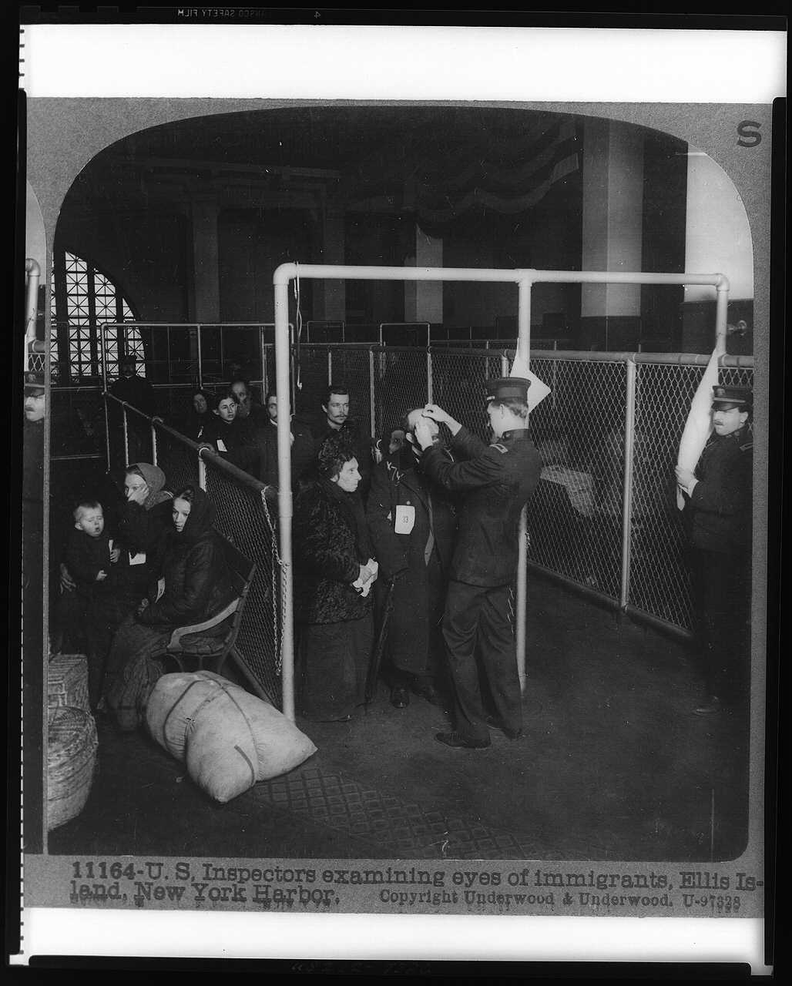
Inspectors examining eyes of immigrants, Ellis Island · LOC · c.1913
Source: Wikimedia Commons · https://commons.wikimedia.org/wiki/File:U.S._inspectors_examining_eyes_of_immigrants,_Ellis_Island,_New_York_Harbor_LCCN97501532.jpg Public domain — U.S. photo pre-1929; LOC no known restrictions https://commons.wikimedia.org/wiki/File:U.S._inspectors_examining_eyes_of_immigrants,_Ellis_Island,_New_York_Harbor_LCCN97501532.jpg
HIPPO — analyze the source (prompt) | Your analysis
H — Historical context: what was happening when this was created?
I — Intended audience: who was meant to see or obey it?
P — Purpose: why was it created?
P — Point of view: whose perspective does it reflect?
O — Outside connection: how does it connect to this standard?
SUPPORT OPTION
Sentence frame: This source shows ______ because it ______, which reveals ______.
CONFIDENCE CHECK-IN
Rate your understanding of this standard (1–4): ______ One thing to revisit: ____________________

Activity 6 — Core Application: Practice Quiz — GC.35 ⏱ ~8 min
RESPONSE CHOICE
Commit to an answer by marking it, saying it, or explaining it aloud before checking. Answer key is in the Teacher Guide (kept separate).
[DOK 1 · item u3-gc35-dok1-1 · pre-field-test]
Becoming a U.S. citizen through a legal process rather than by birth is called:
A. Naturalization
B. Apportionment
C. Cloture
D. Ratification
[DOK 2 · item u1-gc35-dok2-tc · pre-field-test]
Which power does the Constitution give to Congress regarding citizenship?
A. To choose which states may grant citizenship
B. To deny citizenship to anyone born in the U.S.
C. To establish a uniform rule of naturalization
D. To require every citizen to pass the Naturalization Test

STRETCH — think like a test-writer (open to all)
Write your OWN DOK-3 question for this standard, then a one-sentence answer key. Use the supports below — everyone can do this.
HOW TO WRITE A DOK-3 QUESTION (supports)
DOK-3 = strategic thinking: the reader must analyze, compare, evaluate, or justify using evidence — and there should be more than one defensible answer (not a fact you can just look up).
Sentence starters: “Why did ______ lead to ______?” · “Which mattered more — ______ or ______ — and why?” · “What is the BEST evidence that ______?” · “Evaluate whether ______.” · “Defend or challenge: ______.”
Frame: [Analyze / Evaluate / Justify] + [something from THIS standard] + “using evidence.”
Quick check: does my question make the reader THINK and use evidence? If yes, it’s DOK-3.
Your DOK-3 question | Your answer key (one sentence)

Activity 7 — Constructed Response (CER) — GC.35 ⏱ ~15 min
BIG-QUESTION ORGANIZER (before you write) — How does Congress represent the people — and where do its powers begin and end?
Plan your argument here, then use it to write your claim, evidence, and reasoning below.
Plan your argument | Your quick notes (from this standard)
My claim (answer the prompt)
Evidence 1 (a source or fact)
Reasoning (why it proves the claim)
CONSTRUCTED RESPONSE (CER) — builds SSP.04 Argumentation
Claim + Evidence + Reasoning: Should the President be required to be a natural-born citizen? Defend your claim with evidence from the Constitution.
Part | Write here
Claim
Evidence (two specifics)
Reasoning
SELF-CHECK against the CER rubric (see Toolkit)
Before submitting: Is my claim defensible? Do I have TWO specific pieces of evidence? Does my reasoning explain HOW the evidence proves the claim?

UDL Access, Choice & Reflection — GC.35
UDL ACCESS & MTSS SUPPORT (this standard)
UDL 3.0 (CAST, 2024): read-aloud on request · key terms glossed (EN/ES) · respond in writing, speech, or a labeled diagram · large-print & screen-reader friendly. Same learning target for everyone; supports vary the means, not the ceiling.
MTSS: Tier 1 — this core lesson for all · Tier 2 — small-group reteach of this standard using its Cornell cues + graphic organizer, then re-check · Tier 3 — intensive 1:1 with concrete→representational→abstract scaffolding, progress-monitored to the same standard.
SHOW WHAT YOU KNOW — YOUR WAY (same CER rubric, same standard)
Build your Claim–Evidence–Reasoning in whichever mode lets you think best — the standard and the CER rubric are identical for every mode; the mode changes how you SHOW it, never what you are held to:
WRITE it · SAY it aloud and record it (audio or video) · DRAW and label a diagram that makes the argument · BUILD a model or artifact and caption its claim, evidence, and reasoning.
You may ask for a word processor, speech-to-text, a scribe, or a sentence/argument frame — these change how you produce, not the standard you meet.
CHOICE & VOICE — you decide how to go deeper (pick ONE)
You choose your path to show this standard — every option meets the same target:
DEFEND a term: pick the vocabulary word that matters most and argue why in 2–3 sentences. · CONNECT it: pick a current event, your community, or your own life and explain how this standard shows up there. · TAKE A SIDE: pick one debatable question and argue your position with evidence.
Your pick is yours — bring what matters to you into the work.
REFLECT & CONNECT — how your thinking grew, and whose view you weighed
Reflect (self-awareness): What did you believe about this topic BEFORE, and what changed AFTER? Name one thing to revisit.
Consider another view (empathy): Name one person or group who might see this standard differently than you; state their view fairly in one sentence — even if you disagree.
Norm (restorative): we critique ideas, not people; we assume good faith; we make room for every voice.

Standard GC.10 — Article I & the 17th Amendment
TN Academic Standard GC.10: Analyze Article I and the 17th Amendment of the Constitution as they relate to the legislative branch, including eligibility for office, roles, length of terms, and election to office for representatives and senators, respectively. (H)
LEARNING TARGETS — I can…
• I can I can analyze Article I and the 17th Amendment — the qualifications, terms, and election of members of the House and Senate..
Lenses for this standard: History (H)
CORE PATH — the same for every student
Every student works this standard at the same rigor: analyze the sources and vocabulary, then demonstrate learning on the Practice Quiz and CER. UDL and MTSS give you flexible ways in — they never lower the bar. Check yourself against the learning targets on the Cornell Notes page.
SET YOUR GOAL (self-direction)
My goal for this standard — what will I be able to do, and how will I show it?

HOOK — think before you dig in
One chamber turns over every two years; the other moves at a six-year pace and once answered to state politicians, not voters. Why build Congress out of two such different halves?

ACTIVATE — what do you already know or wonder?
Jot what you already know or want to find out about this standard. You’ll come back to it.

PREVIEW & PREDICT
Which learning target will be hardest, and why? Connect it to the unit’s big question: How does Congress represent the people — and where do its powers begin and end?

Activity 1 — Vocabulary (Part A: Reference / Word Bank) — GC.10 ⏱ ~10 min
Use this word bank throughout the standard. The Spanish column supports access, not translation of assessment.
Term | Student-friendly meaning | Spanish
Bicameral | A legislature made of two houses — in Congress, the House of Representatives and the Senate. | bicameral
Apportionment | The division of the 435 House seats among the states based on population, recalculated after each census. | prorrateo / distribución
17th Amendment | The 1913 amendment that changed the election of U.S. senators from state legislatures to a direct vote of the people. | Decimoséptima Enmienda
LANGUAGE SUPPORT
Pronunciations: Bicameral (by-KAM-er-ul); Apportionment (uh-POR-shun-ment); 17th Amendment (sev-en-TEENTH).

VOCABULARY SELF-CHECK · Knowledge Rating
Rate each term NOW in pencil, then again at the END — growth is the goal; no penalty for “never seen it.”
Term | 1 · never seen it | 2 · heard it | 3 · can use it | 4 · can teach it
Bicameral
Apportionment
17th Amendment
MAKE IT YOURS (RESPONSE CHOICE): choose ONE term above and show you own it — write a sentence, sketch it, or give a real-world example.

QUICK WRITE
Which of these terms do you think will matter MOST for this standard, and why? You’ll revisit this at the end.

Activity 2 — Vocabulary Studio (Frayer-inspired) — GC.10 ⏱ ~7 min
RESPONSE CHOICE
Complete each studio by writing, speaking, or diagramming.

PRIORITY TERM 1 Bicameral · ES: bicameral
Word-bank meaning to build on: A legislature made of two houses — in Congress, the House of Representatives and the Senate.
Definition (in your own words) | Characteristics
Examples | Non-examples
Use it to explain
Write one sentence that uses “Bicameral” to explain this standard.

PRIORITY TERM 2 Apportionment · ES: prorrateo / distribución
Word-bank meaning to build on: The division of the 435 House seats among the states based on population, recalculated after each census.
Definition (in your own words) | Characteristics
Examples | Non-examples
Use it to explain
Write one sentence that uses “Apportionment” to explain this standard.

CONNECT THE TERMS (UDL · build understanding)
How do these priority terms fit together? Write or sketch how one leads to or affects another.

Activity 3 — Direct Teaching Cornell Notes — GC.10 ⏱ ~20 min
Name: ______________________ Class / Period: __________ Date: __________
GC.10 — Article I & the 17th Amendment • Lean Student Deck slides 2–8 • direct-teaching slides 4–6
Your learning targets are on this standard’s opening page — take notes that help you meet them.
Guiding cues | My notes — write your notes here
Key idea of this standard?
One source that supports it?
One effect on representation or lawmaking?
Key terms →
Keep taking notes — lines run the full width of the page:

DOODLE ZONE — draw your thinking (UDL · another way in)
Need another way in? Sketch the key idea, a quick timeline, or how the pieces connect. Words optional.

Cornell Notes — keep going, then process & check — GC.10
MORE NOTES / DIAGRAMS
Continue your notes here, add a quick sketch, or map how the ideas connect.

Key terms to list
Bicameral · Apportionment · 17th Amendment
Summary — In your own words (2–3 sentences)
PROGRESS CHECK · one question
What key change did the 17th Amendment make to the Senate?
A. Senators are now elected directly by the people instead of by state legislatures
B. Senators now serve two-year terms instead of six
C. The number of senators per state increased to three
D. The Senate lost its power to confirm appointments
Commit before you move on — mark it, say it, or explain it aloud.
CHECK YOURSELF — how am I doing?
Which learning targets (on this standard’s opening page) can you now meet? Tick the number; circle any you still need help with.
☐ 1
My 12–15 word headline for this standard

Guided Support for the Cornell Notes — GC.10
These scaffolds support ONLY the Cornell notes — use them to take and process those notes. Optional and easy to set aside; not a separate assignment or a label.
Key vocabulary | What it means
Bicameral | A legislature made of two houses — in Congress, the House of Representatives and the Senate.
Apportionment | The division of the 435 House seats among the states based on population, recalculated after each census.
17th Amendment | The 1913 amendment that changed the election of U.S. senators from state legislatures to a direct vote of the people.
Break it into steps:
1) Name one cause or effect. 2) Give one piece of evidence. 3) Write one sentence explaining the link.
Sentence frame
One key cause/effect of article i & the 17th amendment was ______, shown by ______, which mattered because ______.
Modeled example (one worked note — yours will differ)
A key idea of article i & the 17th amendment was Bicameral: A legislature made of two houses — in Congress, the House of Representatives and the Senate.
GUIDED NOTE REHEARSAL LAB
Rehearse the cause→effect chain below, then transfer it to your Cornell notes.
Step | Rehearse it here
Name it
Evidence
Explain
Headline
TRANSFER CHECK — move one rehearsed idea onto the front notes

Light Support for the Cornell Notes — GC.10
A lighter scaffold for the SAME Cornell notes. Try the notes first; reach for this only if you need it.
Key vocabulary | Finish the idea — “This term means …”
Bicameral
Apportionment
17th Amendment
Guiding questions — answer on the lines below (or in your front notes):
• How does the 17th Amendment change who chooses U.S. senators, and why might that matter?
• Contrast the House and Senate on term length and how members are elected.
• Why are House seats reapportioned after each census?

WHICH CUE STILL NEEDS WORK?
Circle the Cornell cue from the front page you still need help with, and tell your teacher so we can go over it.
LIGHT PROCESSING LAB
Answer one guiding question from above in a full sentence, in your own words.

Activity 4 — Close Read — GC.10 ⏱ ~15 min
Reading type: Government Hack-authored instructional synthesis. This is not a primary source. Builds SSP.03 (synthesize) and SSP.05 (historical awareness).
CORE PATH
Congress is bicameral — two houses with different rules. Article I sets the House of Representatives as the chamber 'chosen every second Year by the People': members serve two-year terms, must be at least 25, a citizen for seven years, and live in their state. House seats are apportioned by population after each census, so a state's delegation grows or shrinks as its population does. The Senate is the smaller, slower chamber: two senators per state, six-year terms, at least 30 years old and a citizen for nine years. Originally state legislatures chose senators; the 17th Amendment (1913) moved that choice to a direct vote of the people, making the Senate answerable to voters rather than to state politicians. The Vice President presides over the Senate but votes only to break a tie.
LANGUAGE SUPPORT
Key terms to know first: Bicameral, Apportionment. Read once for the gist, then again for evidence.
Text-dependent questions (answer in the Evidence Lab below or aloud):
1. How does the 17th Amendment change who chooses U.S. senators, and why might that matter?
2. Contrast the House and Senate on term length and how members are elected.
3. Why are House seats reapportioned after each census?
RESPONSE CHOICE: answer any question by writing in the Evidence Lab, saying/recording it, or diagramming it.
CLOSE-READ EVIDENCE LAB
Log evidence from the passage below.
Question / claim | Exact passage evidence | What the evidence shows

SPACED RETRIEVAL — quick recall (no notes)
Pull it up cold to strengthen memory, then check your notes.
Recall prompt | Your answer (from memory)
One key term or fact from THIS standard
One thing you learned EARLIER in this unit or course
How the two connect

Activity 5 — Primary Source / Data Analysis — GC.10 ⏱ ~15 min
Primary source (document) — analyze it with HIPPO. Builds SSP.01–SSP.02.
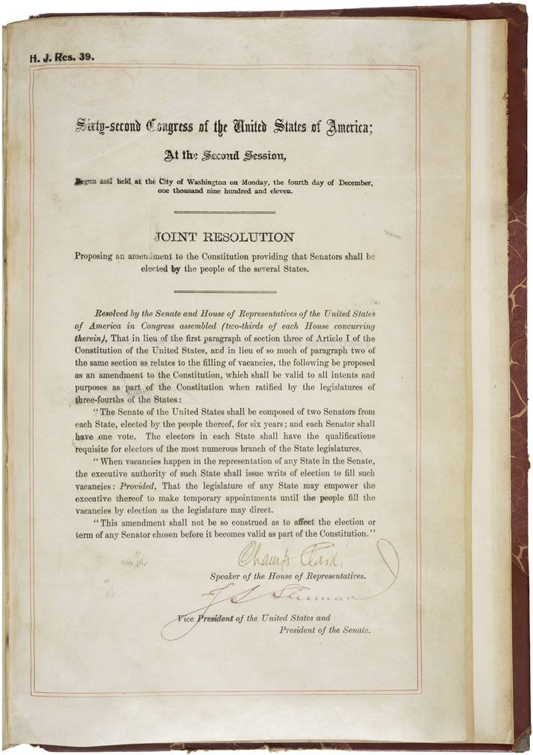
17th Amendment — Direct Election of Senators (1913) · U.S. Congress (NARA) · 1913
Source: Wikimedia Commons · https://commons.wikimedia.org/wiki/File:17th_Amendment_to_the_U.S._Constitution-_Direct_Election_of_U.S._Senators_(1913)_(5553720882).jpg Public domain — U.S. federal record (NARA) https://commons.wikimedia.org/wiki/File:17th_Amendment_to_the_U.S._Constitution-_Direct_Election_of_U.S._Senators_(1913)_(5553720882).jpg
HIPPO — analyze the source (prompt) | Your analysis
H — Historical context: what was happening when this was created?
I — Intended audience: who was meant to see or obey it?
P — Purpose: why was it created?
P — Point of view: whose perspective does it reflect?
O — Outside connection: how does it connect to this standard?
SUPPORT OPTION
Sentence frame: This source shows ______ because it ______, which reveals ______.
CONFIDENCE CHECK-IN
Rate your understanding of this standard (1–4): ______ One thing to revisit: ____________________

Activity 6 — Core Application: Practice Quiz — GC.10 ⏱ ~8 min
RESPONSE CHOICE
Commit to an answer by marking it, saying it, or explaining it aloud before checking. Answer key is in the Teacher Guide (kept separate).
[DOK 1 · item u3-gc10-dok1-1 · pre-field-test]
How long is one term for a U.S. Senator?
A. Two years
B. Four years
C. Six years
D. Life
[DOK 2 · item u1-gc10-dok2-tc · pre-field-test]
What key change did the 17th Amendment make to the Senate?
A. Senators are now elected directly by the people instead of by state legislatures
B. Senators now serve two-year terms instead of six
C. The number of senators per state increased to three
D. The Senate lost its power to confirm appointments

STRETCH — think like a test-writer (open to all)
Write your OWN DOK-3 question for this standard, then a one-sentence answer key. Use the supports below — everyone can do this.
HOW TO WRITE A DOK-3 QUESTION (supports)
DOK-3 = strategic thinking: the reader must analyze, compare, evaluate, or justify using evidence — and there should be more than one defensible answer (not a fact you can just look up).
Sentence starters: “Why did ______ lead to ______?” · “Which mattered more — ______ or ______ — and why?” · “What is the BEST evidence that ______?” · “Evaluate whether ______.” · “Defend or challenge: ______.”
Frame: [Analyze / Evaluate / Justify] + [something from THIS standard] + “using evidence.”
Quick check: does my question make the reader THINK and use evidence? If yes, it’s DOK-3.
Your DOK-3 question | Your answer key (one sentence)

Activity 7 — Constructed Response (CER) — GC.10 ⏱ ~15 min
BIG-QUESTION ORGANIZER (before you write) — How does Congress represent the people — and where do its powers begin and end?
Plan your argument here, then use it to write your claim, evidence, and reasoning below.
Plan your argument | Your quick notes (from this standard)
My claim (answer the prompt)
Evidence 1 (a source or fact)
Reasoning (why it proves the claim)
CONSTRUCTED RESPONSE (CER) — builds SSP.04 Argumentation
Claim + Evidence + Reasoning: Was the 17th Amendment a good change — should the people or state legislatures choose senators? Defend your claim with evidence.
Part | Write here
Claim
Evidence (two specifics)
Reasoning
SELF-CHECK against the CER rubric (see Toolkit)
Before submitting: Is my claim defensible? Do I have TWO specific pieces of evidence? Does my reasoning explain HOW the evidence proves the claim?

UDL Access, Choice & Reflection — GC.10
UDL ACCESS & MTSS SUPPORT (this standard)
UDL 3.0 (CAST, 2024): read-aloud on request · key terms glossed (EN/ES) · respond in writing, speech, or a labeled diagram · large-print & screen-reader friendly. Same learning target for everyone; supports vary the means, not the ceiling.
MTSS: Tier 1 — this core lesson for all · Tier 2 — small-group reteach of this standard using its Cornell cues + graphic organizer, then re-check · Tier 3 — intensive 1:1 with concrete→representational→abstract scaffolding, progress-monitored to the same standard.
SHOW WHAT YOU KNOW — YOUR WAY (same CER rubric, same standard)
Build your Claim–Evidence–Reasoning in whichever mode lets you think best — the standard and the CER rubric are identical for every mode; the mode changes how you SHOW it, never what you are held to:
WRITE it · SAY it aloud and record it (audio or video) · DRAW and label a diagram that makes the argument · BUILD a model or artifact and caption its claim, evidence, and reasoning.
You may ask for a word processor, speech-to-text, a scribe, or a sentence/argument frame — these change how you produce, not the standard you meet.
CHOICE & VOICE — you decide how to go deeper (pick ONE)
You choose your path to show this standard — every option meets the same target:
DEFEND a term: pick the vocabulary word that matters most and argue why in 2–3 sentences. · CONNECT it: pick a current event, your community, or your own life and explain how this standard shows up there. · TAKE A SIDE: pick one debatable question and argue your position with evidence.
Your pick is yours — bring what matters to you into the work.
REFLECT & CONNECT — how your thinking grew, and whose view you weighed
Reflect (self-awareness): What did you believe about this topic BEFORE, and what changed AFTER? Name one thing to revisit.
Consider another view (empathy): Name one person or group who might see this standard differently than you; state their view fairly in one sentence — even if you disagree.
Norm (restorative): we critique ideas, not people; we assume good faith; we make room for every voice.

Standard GC.11 — Census, Redistricting & Baker v. Carr
TN Academic Standard GC.11: Describe the census and its role in redistricting and reapportionment, including the role of Baker v. Carr. (T)
LEARNING TARGETS — I can…
• I can I can describe the census and its role in reapportionment and redistricting, including the significance of Baker v. Carr..
Lenses for this standard: Tennessee (T)
CORE PATH — the same for every student
Every student works this standard at the same rigor: analyze the sources and vocabulary, then demonstrate learning on the Practice Quiz and CER. UDL and MTSS give you flexible ways in — they never lower the bar. Check yourself against the learning targets on the Cornell Notes page.
★ Tennessee Connection
A Tennessee case named in this standard: Baker v. Carr (1962) began with Charles Baker, a voter from Shelby County (Memphis). Tennessee's districts — unchanged since 1901 — had made a Memphis vote worth about one-eighth of a rural vote, and the ruling opened the door to 'one person, one vote.'
SET YOUR GOAL (self-direction)
My goal for this standard — what will I be able to do, and how will I show it?

HOOK — think before you dig in
A vote in Memphis once counted for one-eighth of a vote in the countryside — legally. A Tennessean sued, and changed the country. How?

ACTIVATE — what do you already know or wonder?
Jot what you already know or want to find out about this standard. You’ll come back to it.

Activity 1 — Vocabulary (Part A: Reference / Word Bank) — GC.11 ⏱ ~10 min
Use this word bank throughout the standard. The Spanish column supports access, not translation of assessment.
Term | Student-friendly meaning | Spanish
Census | The count of the U.S. population taken every ten years, used to apportion House seats and federal funds. | censo
Redistricting | The redrawing of the boundaries of legislative districts, usually after each census, to reflect population changes. | redistribución de distritos
Gerrymandering | Drawing district lines to give one party or group an unfair advantage — changing who wins without changing any votes. | manipulación de distritos
LANGUAGE SUPPORT
Pronunciations: Census (SEN-sus); Redistricting (ree-DIS-trik-ting); Gerrymandering (JAIR-ee-man-der-ing).

VOCABULARY SELF-CHECK · Knowledge Rating
Rate each term NOW in pencil, then again at the END — growth is the goal; no penalty for “never seen it.”
Term | 1 · never seen it | 2 · heard it | 3 · can use it | 4 · can teach it
Census
Redistricting
Gerrymandering
MAKE IT YOURS (RESPONSE CHOICE): choose ONE term above and show you own it — write a sentence, sketch it, or give a real-world example.

QUICK WRITE
Which of these terms do you think will matter MOST for this standard, and why? You’ll revisit this at the end.

Activity 2 — Vocabulary Studio (Frayer-inspired) — GC.11 ⏱ ~7 min
RESPONSE CHOICE
Complete each studio by writing, speaking, or diagramming.

PRIORITY TERM 1 Redistricting · ES: redistribución de distritos
Word-bank meaning to build on: The redrawing of the boundaries of legislative districts, usually after each census, to reflect population changes.
Definition (in your own words) | Characteristics
Examples | Non-examples
Use it to explain
Write one sentence that uses “Redistricting” to explain this standard.

PRIORITY TERM 2 Gerrymandering · ES: manipulación de distritos
Word-bank meaning to build on: Drawing district lines to give one party or group an unfair advantage — changing who wins without changing any votes.
Definition (in your own words) | Characteristics
Examples | Non-examples
Use it to explain
Write one sentence that uses “Gerrymandering” to explain this standard.

CONNECT THE TERMS (UDL · build understanding)
How do these priority terms fit together? Write or sketch how one leads to or affects another.

Activity 3 — Direct Teaching Cornell Notes — GC.11 ⏱ ~20 min
Name: ______________________ Class / Period: __________ Date: __________
GC.11 — Census, Redistricting & Baker v. Carr • Lean Student Deck slides 2–8 • direct-teaching slides 4–6
Your learning targets are on this standard’s opening page — take notes that help you meet them.
Guiding cues | My notes — write your notes here
Key idea of this standard?
One source that supports it?
One effect on representation or lawmaking?
Key terms →
Keep taking notes — lines run the full width of the page:

DOODLE ZONE — draw your thinking (UDL · another way in)
Need another way in? Sketch the key idea, a quick timeline, or how the pieces connect. Words optional.

Cornell Notes — keep going, then process & check — GC.11
MORE NOTES / DIAGRAMS
Continue your notes here, add a quick sketch, or map how the ideas connect.

Key terms to list
Census · Redistricting · Gerrymandering
Summary — In your own words (2–3 sentences)
PROGRESS CHECK · one question
Why was Baker v. Carr (1962) so important for representation?
A. It abolished the census
B. It made gerrymandering a federal crime
C. It ended the Senate's six-year terms
D. It ruled that federal courts could hear redistricting cases, opening the door to 'one person, one vote'
Commit before you move on — mark it, say it, or explain it aloud.
CHECK YOURSELF — how am I doing?
Which learning targets (on this standard’s opening page) can you now meet? Tick the number; circle any you still need help with.
☐ 1
My 12–15 word headline for this standard

Guided Support for the Cornell Notes — GC.11
These scaffolds support ONLY the Cornell notes — use them to take and process those notes. Optional and easy to set aside; not a separate assignment or a label.
Key vocabulary | What it means
Census | The count of the U.S. population taken every ten years, used to apportion House seats and federal funds.
Redistricting | The redrawing of the boundaries of legislative districts, usually after each census, to reflect population changes.
Gerrymandering | Drawing district lines to give one party or group an unfair advantage — changing who wins without changing any votes.
Break it into steps:
1) Name one cause or effect. 2) Give one piece of evidence. 3) Write one sentence explaining the link.
Sentence frame
One key cause/effect of census, redistricting & baker v. carr was ______, shown by ______, which mattered because ______.
Modeled example (one worked note — yours will differ)
A key idea of census, redistricting & baker v. carr was Census: The count of the U.S. population taken every ten years, used to apportion House seats and federal funds.
GUIDED NOTE REHEARSAL LAB
Rehearse the cause→effect chain below, then transfer it to your Cornell notes.
Step | Rehearse it here
Name it
Evidence
Explain
Headline
TRANSFER CHECK — move one rehearsed idea onto the front notes

Light Support for the Cornell Notes — GC.11
A lighter scaffold for the SAME Cornell notes. Try the notes first; reach for this only if you need it.
Key vocabulary | Finish the idea — “This term means …”
Census
Redistricting
Gerrymandering
Guiding questions — answer on the lines below (or in your front notes):
• How does the census connect to apportionment and redistricting?
• What did the Court decide in Baker v. Carr, and which amendment did it rely on?
• How can gerrymandering change an election's outcome without changing any votes?

WHICH CUE STILL NEEDS WORK?
Circle the Cornell cue from the front page you still need help with, and tell your teacher so we can go over it.
LIGHT PROCESSING LAB
Answer one guiding question from above in a full sentence, in your own words.

Activity 4 — Close Read — GC.11 ⏱ ~15 min
Reading type: Government Hack-authored instructional synthesis. This is not a primary source. Builds SSP.03 (synthesize) and SSP.05 (historical awareness).
CORE PATH
Every ten years the Constitution requires a census — a full count of the population. That count drives apportionment (how the 435 House seats are split among the states) and redistricting (redrawing district lines within each state). Because district lines decide which voters are grouped together, whoever draws them holds real power; drawing them to favor one side is called gerrymandering. For decades some states, including Tennessee, simply refused to redraw districts as people moved to cities — so a rural vote could be worth many times an urban one. In Baker v. Carr (1962), the Supreme Court ruled that federal courts could hear such cases under the 14th Amendment. That decision opened the door to 'one person, one vote,' the principle that districts must hold roughly equal populations.
LANGUAGE SUPPORT
Key terms to know first: Census, Redistricting. Read once for the gist, then again for evidence.
Text-dependent questions (answer in the Evidence Lab below or aloud):
1. How does the census connect to apportionment and redistricting?
2. What did the Court decide in Baker v. Carr, and which amendment did it rely on?
3. How can gerrymandering change an election's outcome without changing any votes?
RESPONSE CHOICE: answer any question by writing in the Evidence Lab, saying/recording it, or diagramming it.
CLOSE-READ EVIDENCE LAB
Log evidence from the passage below.
Question / claim | Exact passage evidence | What the evidence shows

SPACED RETRIEVAL — quick recall (no notes)
Pull it up cold to strengthen memory, then check your notes.
Recall prompt | Your answer (from memory)
One key term or fact from THIS standard
One thing you learned EARLIER in this unit or course
How the two connect

Activity 5 — Primary Source / Data Analysis — GC.11 ⏱ ~15 min
Primary source (cartoon) — analyze it with HIPPO. Builds SSP.01–SSP.02.
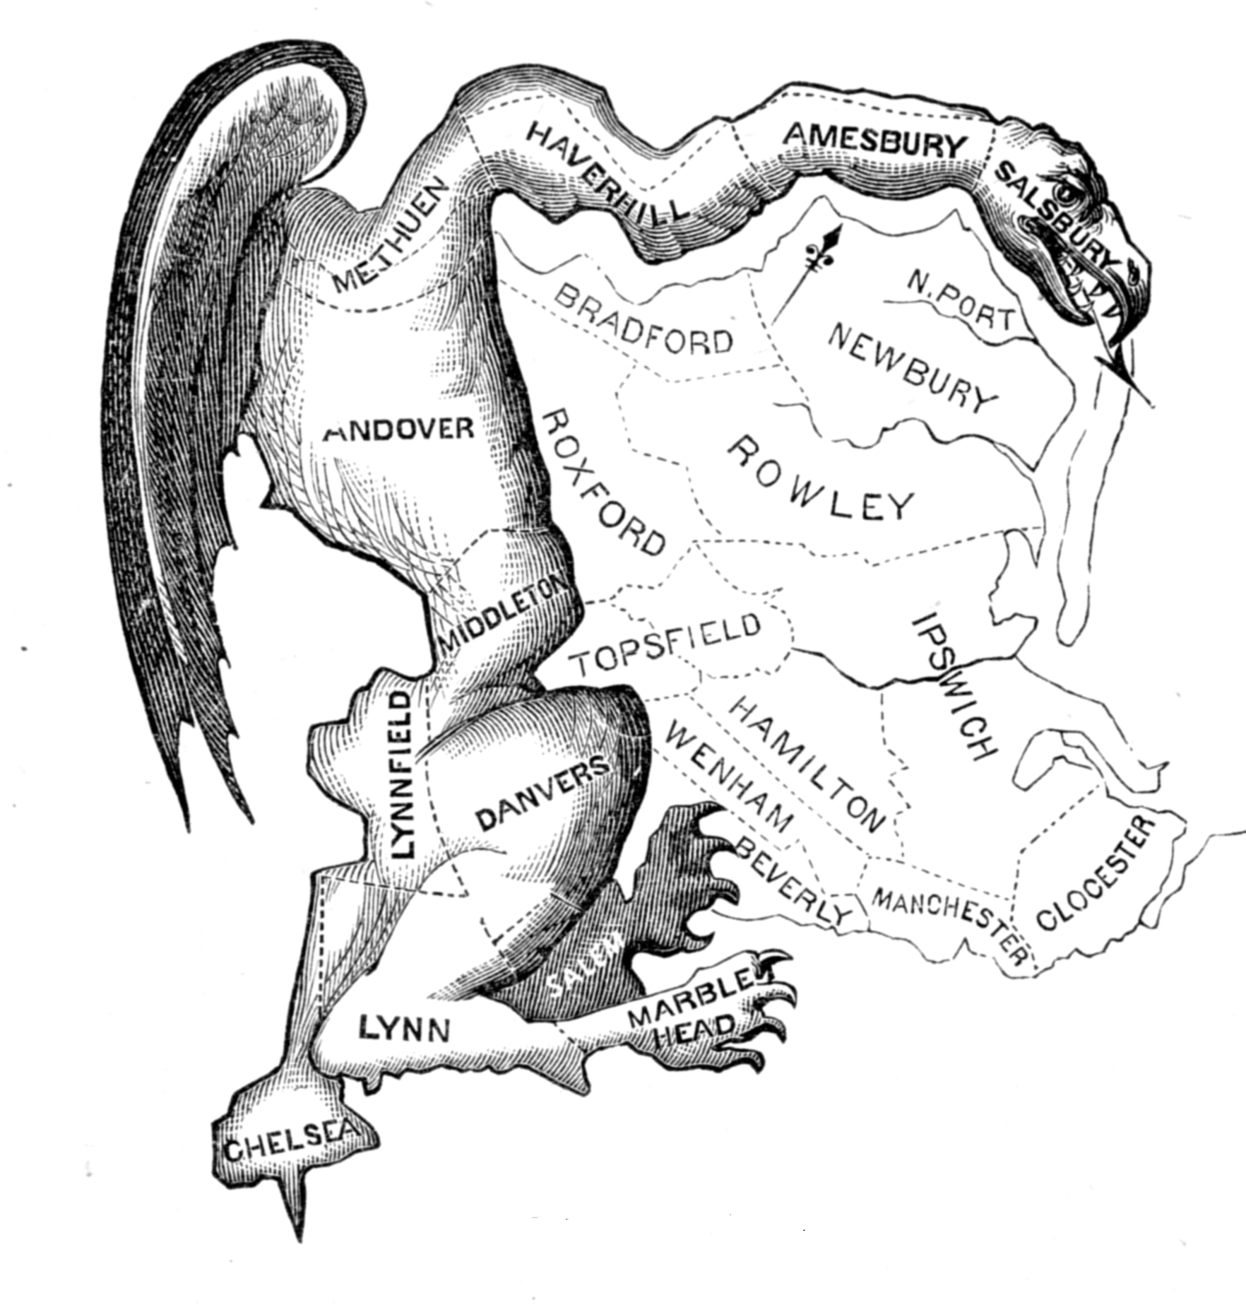
The Gerry-Mander · Elkanah Tisdale · 1812
Source: Wikimedia Commons · https://commons.wikimedia.org/wiki/File:The_Gerry-Mander.png Public domain — published 1812 https://commons.wikimedia.org/wiki/File:The_Gerry-Mander.png
HIPPO — analyze the source (prompt) | Your analysis
H — Historical context: what was happening when this was created?
I — Intended audience: who was meant to see or obey it?
P — Purpose: why was it created?
P — Point of view: whose perspective does it reflect?
O — Outside connection: how does it connect to this standard?
SUPPORT OPTION
Sentence frame: This source shows ______ because it ______, which reveals ______.
CONFIDENCE CHECK-IN
Rate your understanding of this standard (1–4): ______ One thing to revisit: ____________________

Activity 6 — Core Application: Practice Quiz — GC.11 ⏱ ~8 min
RESPONSE CHOICE
Commit to an answer by marking it, saying it, or explaining it aloud before checking. Answer key is in the Teacher Guide (kept separate).
[DOK 1 · item u3-gc11-dok1-1 · pre-field-test]
How often is the U.S. census taken?
A. Every year
B. Every four years
C. Every ten years
D. Only once
[DOK 3 · item u1-gc11-dok3-tc · pre-field-test]
Why was Baker v. Carr (1962) so important for representation?
A. It abolished the census
B. It made gerrymandering a federal crime
C. It ended the Senate's six-year terms
D. It ruled that federal courts could hear redistricting cases, opening the door to 'one person, one vote'

STRETCH — think like a test-writer (open to all)
Write your OWN DOK-3 question for this standard, then a one-sentence answer key. Use the supports below — everyone can do this.
HOW TO WRITE A DOK-3 QUESTION (supports)
DOK-3 = strategic thinking: the reader must analyze, compare, evaluate, or justify using evidence — and there should be more than one defensible answer (not a fact you can just look up).
Sentence starters: “Why did ______ lead to ______?” · “Which mattered more — ______ or ______ — and why?” · “What is the BEST evidence that ______?” · “Evaluate whether ______.” · “Defend or challenge: ______.”
Frame: [Analyze / Evaluate / Justify] + [something from THIS standard] + “using evidence.”
Quick check: does my question make the reader THINK and use evidence? If yes, it’s DOK-3.
Your DOK-3 question | Your answer key (one sentence)

Activity 7 — Constructed Response (CER) — GC.11 ⏱ ~15 min
BIG-QUESTION ORGANIZER (before you write) — How does Congress represent the people — and where do its powers begin and end?
Plan your argument here, then use it to write your claim, evidence, and reasoning below.
Plan your argument | Your quick notes (from this standard)
My claim (answer the prompt)
Evidence 1 (a source or fact)
Reasoning (why it proves the claim)
CONSTRUCTED RESPONSE (CER) — builds SSP.04 Argumentation
Claim + Evidence + Reasoning: Should courts or legislatures control how district lines are drawn? Defend your claim with evidence, including Baker v. Carr.
Part | Write here
Claim
Evidence (two specifics)
Reasoning
SELF-CHECK against the CER rubric (see Toolkit)
Before submitting: Is my claim defensible? Do I have TWO specific pieces of evidence? Does my reasoning explain HOW the evidence proves the claim?

UDL Access, Choice & Reflection — GC.11
UDL ACCESS & MTSS SUPPORT (this standard)
UDL 3.0 (CAST, 2024): read-aloud on request · key terms glossed (EN/ES) · respond in writing, speech, or a labeled diagram · large-print & screen-reader friendly. Same learning target for everyone; supports vary the means, not the ceiling.
MTSS: Tier 1 — this core lesson for all · Tier 2 — small-group reteach of this standard using its Cornell cues + graphic organizer, then re-check · Tier 3 — intensive 1:1 with concrete→representational→abstract scaffolding, progress-monitored to the same standard.
SHOW WHAT YOU KNOW — YOUR WAY (same CER rubric, same standard)
Build your Claim–Evidence–Reasoning in whichever mode lets you think best — the standard and the CER rubric are identical for every mode; the mode changes how you SHOW it, never what you are held to:
WRITE it · SAY it aloud and record it (audio or video) · DRAW and label a diagram that makes the argument · BUILD a model or artifact and caption its claim, evidence, and reasoning.
You may ask for a word processor, speech-to-text, a scribe, or a sentence/argument frame — these change how you produce, not the standard you meet.
CHOICE & VOICE — you decide how to go deeper (pick ONE)
You choose your path to show this standard — every option meets the same target:
DEFEND a term: pick the vocabulary word that matters most and argue why in 2–3 sentences. · CONNECT it: pick a current event, your community, or your own life and explain how this standard shows up there. · TAKE A SIDE: pick one debatable question and argue your position with evidence.
Your pick is yours — bring what matters to you into the work.
REFLECT & CONNECT — how your thinking grew, and whose view you weighed
Reflect (self-awareness): What did you believe about this topic BEFORE, and what changed AFTER? Name one thing to revisit.
Consider another view (empathy): Name one person or group who might see this standard differently than you; state their view fairly in one sentence — even if you disagree.
Norm (restorative): we critique ideas, not people; we assume good faith; we make room for every voice.

Standard GC.12 — Leadership of Congress
TN Academic Standard GC.12: Identify leadership positions of the legislative branch, including: Majority and Minority leaders; President pro tempore; role of the vice president; Speaker of the House. (—)
LEARNING TARGETS — I can…
• I can I can identify the leadership positions in both houses of Congress and explain how each is chosen..
Lenses for this standard: Civic Structure
CORE PATH — the same for every student
Every student works this standard at the same rigor: analyze the sources and vocabulary, then demonstrate learning on the Practice Quiz and CER. UDL and MTSS give you flexible ways in — they never lower the bar. Check yourself against the learning targets on the Cornell Notes page.
SET YOUR GOAL (self-direction)
My goal for this standard — what will I be able to do, and how will I show it?

HOOK — think before you dig in
One person decides which bills the House will even vote on. Who holds that gatekeeper's gavel — and how did they get it?

ACTIVATE — what do you already know or wonder?
Jot what you already know or want to find out about this standard. You’ll come back to it.

PREVIEW & PREDICT
Which learning target will be hardest, and why? Connect it to the unit’s big question: How does Congress represent the people — and where do its powers begin and end?

Activity 1 — Vocabulary (Part A: Reference / Word Bank) — GC.12 ⏱ ~10 min
Use this word bank throughout the standard. The Spanish column supports access, not translation of assessment.
Term | Student-friendly meaning | Spanish
Speaker of the House | The leader of the House of Representatives, chosen by the majority party; sets the House agenda and is second in line to the presidency. | presidente de la Cámara
President pro tempore | The senator who presides over the Senate in the Vice President's absence, traditionally the longest-serving member of the majority party. | presidente pro tempore
Majority & Minority Leaders | The elected floor leaders of each party in each chamber, who guide their party's strategy and schedule. | líderes de mayoría y minoría
LANGUAGE SUPPORT
Pronunciations: Speaker of the House (SPEE-ker); President pro tempore (PREZ-ih-dent proh TEM-por-ay); Majority & Minority Leaders (muh-JOR-ih-tee).

VOCABULARY SELF-CHECK · Knowledge Rating
Rate each term NOW in pencil, then again at the END — growth is the goal; no penalty for “never seen it.”
Term | 1 · never seen it | 2 · heard it | 3 · can use it | 4 · can teach it
Speaker of the House
President pro tempore
Majority & Minority Leaders
MAKE IT YOURS (RESPONSE CHOICE): choose ONE term above and show you own it — write a sentence, sketch it, or give a real-world example.

QUICK WRITE
Which of these terms do you think will matter MOST for this standard, and why? You’ll revisit this at the end.

Activity 2 — Vocabulary Studio (Frayer-inspired) — GC.12 ⏱ ~7 min
RESPONSE CHOICE
Complete each studio by writing, speaking, or diagramming.

PRIORITY TERM 1 Speaker of the House · ES: presidente de la Cámara
Word-bank meaning to build on: The leader of the House of Representatives, chosen by the majority party; sets the House agenda and is second in line to the presidency.
Definition (in your own words) | Characteristics
Examples | Non-examples
Use it to explain
Write one sentence that uses “Speaker of the House” to explain this standard.

PRIORITY TERM 2 President pro tempore · ES: presidente pro tempore
Word-bank meaning to build on: The senator who presides over the Senate in the Vice President's absence, traditionally the longest-serving member of the majority party.
Definition (in your own words) | Characteristics
Examples | Non-examples
Use it to explain
Write one sentence that uses “President pro tempore” to explain this standard.

CONNECT THE TERMS (UDL · build understanding)
How do these priority terms fit together? Write or sketch how one leads to or affects another.

Activity 3 — Direct Teaching Cornell Notes — GC.12 ⏱ ~20 min
Name: ______________________ Class / Period: __________ Date: __________
GC.12 — Leadership of Congress • Lean Student Deck slides 2–8 • direct-teaching slides 4–6
Your learning targets are on this standard’s opening page — take notes that help you meet them.
Guiding cues | My notes — write your notes here
Key idea of this standard?
One source that supports it?
One effect on representation or lawmaking?
Key terms →
Keep taking notes — lines run the full width of the page:

DOODLE ZONE — draw your thinking (UDL · another way in)
Need another way in? Sketch the key idea, a quick timeline, or how the pieces connect. Words optional.

Cornell Notes — keep going, then process & check — GC.12
MORE NOTES / DIAGRAMS
Continue your notes here, add a quick sketch, or map how the ideas connect.

Key terms to list
Speaker of the House · President pro tempore · Majority & Minority Leaders
Summary — In your own words (2–3 sentences)
PROGRESS CHECK · one question
Who leads the House of Representatives and sets its agenda?
A. The President pro tempore
B. The Speaker of the House
C. The Vice President
D. The Chief Justice
Commit before you move on — mark it, say it, or explain it aloud.
CHECK YOURSELF — how am I doing?
Which learning targets (on this standard’s opening page) can you now meet? Tick the number; circle any you still need help with.
☐ 1
My 12–15 word headline for this standard

Guided Support for the Cornell Notes — GC.12
These scaffolds support ONLY the Cornell notes — use them to take and process those notes. Optional and easy to set aside; not a separate assignment or a label.
Key vocabulary | What it means
Speaker of the House | The leader of the House of Representatives, chosen by the majority party; sets the House agenda and is second in line to the presidency.
President pro tempore | The senator who presides over the Senate in the Vice President's absence, traditionally the longest-serving member of the majority party.
Majority & Minority Leaders | The elected floor leaders of each party in each chamber, who guide their party's strategy and schedule.
Break it into steps:
1) Name one cause or effect. 2) Give one piece of evidence. 3) Write one sentence explaining the link.
Sentence frame
One key cause/effect of leadership of congress was ______, shown by ______, which mattered because ______.
Modeled example (one worked note — yours will differ)
A key idea of leadership of congress was Speaker of the House: The leader of the House of Representatives, chosen by the majority party; sets the House agenda and is second in line to the presidency.
GUIDED NOTE REHEARSAL LAB
Rehearse the cause→effect chain below, then transfer it to your Cornell notes.
Step | Rehearse it here
Name it
Evidence
Explain
Headline
TRANSFER CHECK — move one rehearsed idea onto the front notes

Light Support for the Cornell Notes — GC.12
A lighter scaffold for the SAME Cornell notes. Try the notes first; reach for this only if you need it.
Key vocabulary | Finish the idea — “This term means …”
Speaker of the House
President pro tempore
Majority & Minority Leaders
Guiding questions — answer on the lines below (or in your front notes):
• Which leadership post does the Constitution name for the House, and who chooses it?
• What is the Vice President's role in the Senate, and when does it matter most?
• How do majority and minority leaders shape what Congress accomplishes?

WHICH CUE STILL NEEDS WORK?
Circle the Cornell cue from the front page you still need help with, and tell your teacher so we can go over it.
LIGHT PROCESSING LAB
Answer one guiding question from above in a full sentence, in your own words.

Activity 4 — Close Read — GC.12 ⏱ ~15 min
Reading type: Government Hack-authored instructional synthesis. This is not a primary source. Builds SSP.03 (synthesize) and SSP.05 (historical awareness).
CORE PATH
Each chamber of Congress runs on party leadership. In the House, the majority party chooses the Speaker of the House — named in the Constitution, the Speaker leads the chamber, controls the agenda, and stands second in line to the presidency. In the Senate, the Constitution makes the Vice President the President of the Senate, who presides but votes only to break a tie; when the VP is absent, the President pro tempore (usually the longest-serving majority senator) presides. In both chambers, each party elects a Majority Leader and a Minority Leader to guide strategy and scheduling, assisted by 'whips' who count votes. Leadership decides which bills move and which stall, so knowing who holds these posts explains a great deal about what Congress does.
LANGUAGE SUPPORT
Key terms to know first: Speaker of the House, President pro tempore. Read once for the gist, then again for evidence.
Text-dependent questions (answer in the Evidence Lab below or aloud):
1. Which leadership post does the Constitution name for the House, and who chooses it?
2. What is the Vice President's role in the Senate, and when does it matter most?
3. How do majority and minority leaders shape what Congress accomplishes?
RESPONSE CHOICE: answer any question by writing in the Evidence Lab, saying/recording it, or diagramming it.
CLOSE-READ EVIDENCE LAB
Log evidence from the passage below.
Question / claim | Exact passage evidence | What the evidence shows

SPACED RETRIEVAL — quick recall (no notes)
Pull it up cold to strengthen memory, then check your notes.
Recall prompt | Your answer (from memory)
One key term or fact from THIS standard
One thing you learned EARLIER in this unit or course
How the two connect

Activity 5 — Primary Source / Data Analysis — GC.12 ⏱ ~15 min
Primary source (photo) — analyze it with HIPPO. Builds SSP.01–SSP.02.
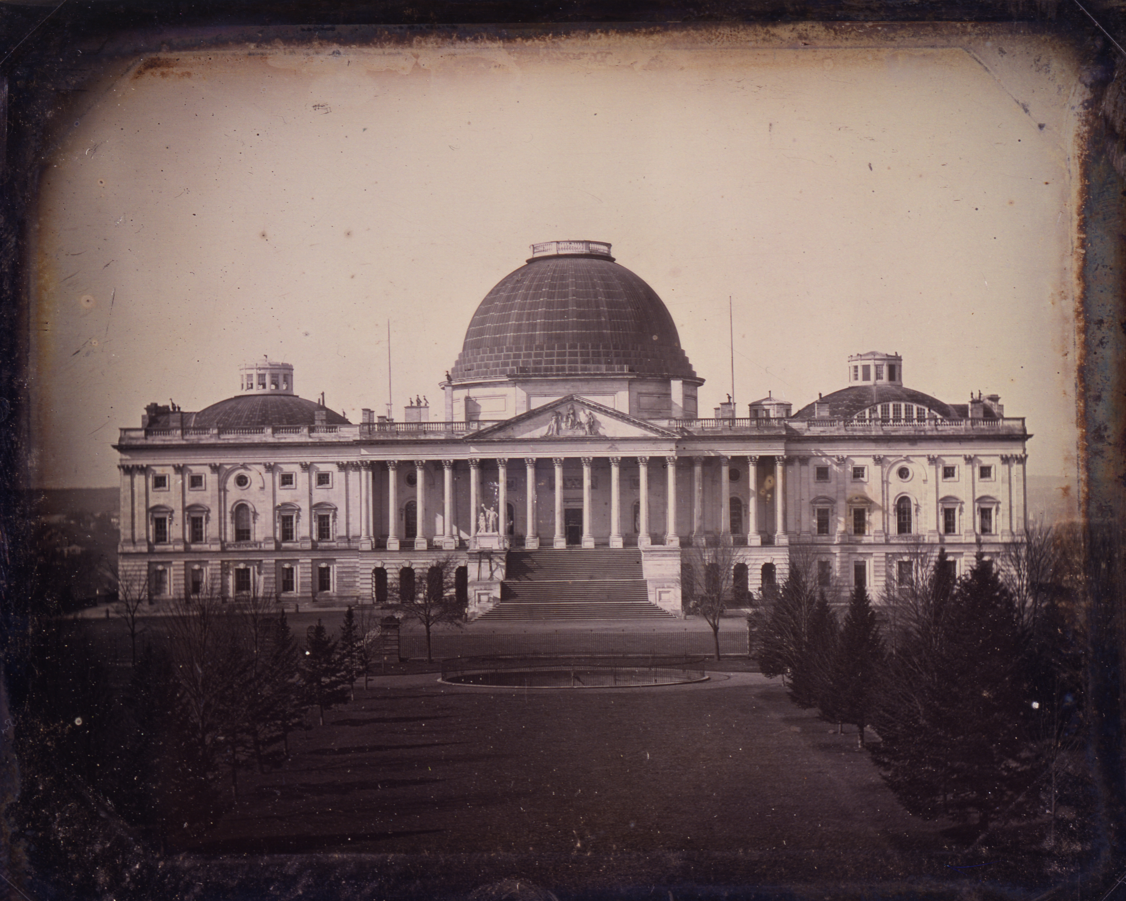
United States Capitol, c.1846 (Plumbe daguerreotype) · John Plumbe Jr. · c.1846
Source: Wikimedia Commons · https://commons.wikimedia.org/wiki/File:United_States_Capitol,_circa_1846,_by_John_Plumbe.jpg Public domain — 1846 (pre-1929) https://commons.wikimedia.org/wiki/File:United_States_Capitol,_circa_1846,_by_John_Plumbe.jpg
HIPPO — analyze the source (prompt) | Your analysis
H — Historical context: what was happening when this was created?
I — Intended audience: who was meant to see or obey it?
P — Purpose: why was it created?
P — Point of view: whose perspective does it reflect?
O — Outside connection: how does it connect to this standard?
SUPPORT OPTION
Sentence frame: This source shows ______ because it ______, which reveals ______.
CONFIDENCE CHECK-IN
Rate your understanding of this standard (1–4): ______ One thing to revisit: ____________________

Activity 6 — Core Application: Practice Quiz — GC.12 ⏱ ~8 min
RESPONSE CHOICE
Commit to an answer by marking it, saying it, or explaining it aloud before checking. Answer key is in the Teacher Guide (kept separate).
[DOK 1 · item u3-gc12-dok1-1 · pre-field-test]
The Vice President's main power in the Senate is to:
A. Write all bills
B. Break a tie vote
C. Appoint senators
D. Veto laws
[DOK 2 · item u1-gc12-dok2-tc · pre-field-test]
Who leads the House of Representatives and sets its agenda?
A. The President pro tempore
B. The Speaker of the House
C. The Vice President
D. The Chief Justice

STRETCH — think like a test-writer (open to all)
Write your OWN DOK-3 question for this standard, then a one-sentence answer key. Use the supports below — everyone can do this.
HOW TO WRITE A DOK-3 QUESTION (supports)
DOK-3 = strategic thinking: the reader must analyze, compare, evaluate, or justify using evidence — and there should be more than one defensible answer (not a fact you can just look up).
Sentence starters: “Why did ______ lead to ______?” · “Which mattered more — ______ or ______ — and why?” · “What is the BEST evidence that ______?” · “Evaluate whether ______.” · “Defend or challenge: ______.”
Frame: [Analyze / Evaluate / Justify] + [something from THIS standard] + “using evidence.”
Quick check: does my question make the reader THINK and use evidence? If yes, it’s DOK-3.
Your DOK-3 question | Your answer key (one sentence)

Activity 7 — Constructed Response (CER) — GC.12 ⏱ ~15 min
BIG-QUESTION ORGANIZER (before you write) — How does Congress represent the people — and where do its powers begin and end?
Plan your argument here, then use it to write your claim, evidence, and reasoning below.
Plan your argument | Your quick notes (from this standard)
My claim (answer the prompt)
Evidence 1 (a source or fact)
Reasoning (why it proves the claim)
CONSTRUCTED RESPONSE (CER) — builds SSP.04 Argumentation
Claim + Evidence + Reasoning: Which congressional leadership position has the most influence over what becomes law? Defend your claim with evidence.
Part | Write here
Claim
Evidence (two specifics)
Reasoning
SELF-CHECK against the CER rubric (see Toolkit)
Before submitting: Is my claim defensible? Do I have TWO specific pieces of evidence? Does my reasoning explain HOW the evidence proves the claim?

UDL Access, Choice & Reflection — GC.12
UDL ACCESS & MTSS SUPPORT (this standard)
UDL 3.0 (CAST, 2024): read-aloud on request · key terms glossed (EN/ES) · respond in writing, speech, or a labeled diagram · large-print & screen-reader friendly. Same learning target for everyone; supports vary the means, not the ceiling.
MTSS: Tier 1 — this core lesson for all · Tier 2 — small-group reteach of this standard using its Cornell cues + graphic organizer, then re-check · Tier 3 — intensive 1:1 with concrete→representational→abstract scaffolding, progress-monitored to the same standard.
SHOW WHAT YOU KNOW — YOUR WAY (same CER rubric, same standard)
Build your Claim–Evidence–Reasoning in whichever mode lets you think best — the standard and the CER rubric are identical for every mode; the mode changes how you SHOW it, never what you are held to:
WRITE it · SAY it aloud and record it (audio or video) · DRAW and label a diagram that makes the argument · BUILD a model or artifact and caption its claim, evidence, and reasoning.
You may ask for a word processor, speech-to-text, a scribe, or a sentence/argument frame — these change how you produce, not the standard you meet.
CHOICE & VOICE — you decide how to go deeper (pick ONE)
You choose your path to show this standard — every option meets the same target:
DEFEND a term: pick the vocabulary word that matters most and argue why in 2–3 sentences. · CONNECT it: pick a current event, your community, or your own life and explain how this standard shows up there. · TAKE A SIDE: pick one debatable question and argue your position with evidence.
Your pick is yours — bring what matters to you into the work.
REFLECT & CONNECT — how your thinking grew, and whose view you weighed
Reflect (self-awareness): What did you believe about this topic BEFORE, and what changed AFTER? Name one thing to revisit.
Consider another view (empathy): Name one person or group who might see this standard differently than you; state their view fairly in one sentence — even if you disagree.
Norm (restorative): we critique ideas, not people; we assume good faith; we make room for every voice.

Standard GC.13 — How a Bill Becomes a Law
TN Academic Standard GC.13: Describe the process of how a bill becomes a law. (—)
LEARNING TARGETS — I can…
• I can I can describe how a bill becomes a law, including the differences between the House and Senate processes..
Lenses for this standard: Civic Structure
CORE PATH — the same for every student
Every student works this standard at the same rigor: analyze the sources and vocabulary, then demonstrate learning on the Practice Quiz and CER. UDL and MTSS give you flexible ways in — they never lower the bar. Check yourself against the learning targets on the Cornell Notes page.
SET YOUR GOAL (self-direction)
My goal for this standard — what will I be able to do, and how will I show it?

HOOK — think before you dig in
Thousands of bills are introduced each year; only a few hundred become law. What kills the rest — and why did the Framers make it so hard?

ACTIVATE — what do you already know or wonder?
Jot what you already know or want to find out about this standard. You’ll come back to it.

PREVIEW & PREDICT
Which learning target will be hardest, and why? Connect it to the unit’s big question: How does Congress represent the people — and where do its powers begin and end?

Activity 1 — Vocabulary (Part A: Reference / Word Bank) — GC.13 ⏱ ~10 min
Use this word bank throughout the standard. The Spanish column supports access, not translation of assessment.
Term | Student-friendly meaning | Spanish
Filibuster | A Senate tactic of extended debate used to delay or block a vote on a bill. | obstruccionismo
Cloture | A Senate vote (usually 60 senators) to end a filibuster and force a final vote on a bill. | clausura del debate
Veto | The President's power to reject a bill passed by Congress; Congress can override a veto with a two-thirds vote of both houses. | veto
LANGUAGE SUPPORT
Pronunciations: Filibuster (FIL-ih-bus-ter); Cloture (KLOH-cher); Veto (VEE-toh).

VOCABULARY SELF-CHECK · Knowledge Rating
Rate each term NOW in pencil, then again at the END — growth is the goal; no penalty for “never seen it.”
Term | 1 · never seen it | 2 · heard it | 3 · can use it | 4 · can teach it
Filibuster
Cloture
Veto
MAKE IT YOURS (RESPONSE CHOICE): choose ONE term above and show you own it — write a sentence, sketch it, or give a real-world example.

QUICK WRITE
Which of these terms do you think will matter MOST for this standard, and why? You’ll revisit this at the end.

Activity 2 — Vocabulary Studio (Frayer-inspired) — GC.13 ⏱ ~7 min
RESPONSE CHOICE
Complete each studio by writing, speaking, or diagramming.

PRIORITY TERM 1 Filibuster · ES: obstruccionismo
Word-bank meaning to build on: A Senate tactic of extended debate used to delay or block a vote on a bill.
Definition (in your own words) | Characteristics
Examples | Non-examples
Use it to explain
Write one sentence that uses “Filibuster” to explain this standard.

PRIORITY TERM 2 Cloture · ES: clausura del debate
Word-bank meaning to build on: A Senate vote (usually 60 senators) to end a filibuster and force a final vote on a bill.
Definition (in your own words) | Characteristics
Examples | Non-examples
Use it to explain
Write one sentence that uses “Cloture” to explain this standard.

CONNECT THE TERMS (UDL · build understanding)
How do these priority terms fit together? Write or sketch how one leads to or affects another.

Activity 3 — Direct Teaching Cornell Notes — GC.13 ⏱ ~20 min
Name: ______________________ Class / Period: __________ Date: __________
GC.13 — How a Bill Becomes a Law • Lean Student Deck slides 2–8 • direct-teaching slides 4–6
Your learning targets are on this standard’s opening page — take notes that help you meet them.
Guiding cues | My notes — write your notes here
Key idea of this standard?
One source that supports it?
One effect on representation or lawmaking?
Key terms →
Keep taking notes — lines run the full width of the page:

DOODLE ZONE — draw your thinking (UDL · another way in)
Need another way in? Sketch the key idea, a quick timeline, or how the pieces connect. Words optional.

Cornell Notes — keep going, then process & check — GC.13
MORE NOTES / DIAGRAMS
Continue your notes here, add a quick sketch, or map how the ideas connect.

Key terms to list
Filibuster · Cloture · Veto
Summary — In your own words (2–3 sentences)
PROGRESS CHECK · one question
A Senate tactic of unlimited debate used to block a bill is a:
A. Cloture
B. Veto
C. Filibuster
D. Quorum
Commit before you move on — mark it, say it, or explain it aloud.
CHECK YOURSELF — how am I doing?
Which learning targets (on this standard’s opening page) can you now meet? Tick the number; circle any you still need help with.
☐ 1
My 12–15 word headline for this standard

Guided Support for the Cornell Notes — GC.13
These scaffolds support ONLY the Cornell notes — use them to take and process those notes. Optional and easy to set aside; not a separate assignment or a label.
Key vocabulary | What it means
Filibuster | A Senate tactic of extended debate used to delay or block a vote on a bill.
Cloture | A Senate vote (usually 60 senators) to end a filibuster and force a final vote on a bill.
Veto | The President's power to reject a bill passed by Congress; Congress can override a veto with a two-thirds vote of both houses.
Break it into steps:
1) Name one cause or effect. 2) Give one piece of evidence. 3) Write one sentence explaining the link.
Sentence frame
One key cause/effect of how a bill becomes a law was ______, shown by ______, which mattered because ______.
Modeled example (one worked note — yours will differ)
A key idea of how a bill becomes a law was Filibuster: A Senate tactic of extended debate used to delay or block a vote on a bill.
GUIDED NOTE REHEARSAL LAB
Rehearse the cause→effect chain below, then transfer it to your Cornell notes.
Step | Rehearse it here
Name it
Evidence
Explain
Headline
TRANSFER CHECK — move one rehearsed idea onto the front notes

Light Support for the Cornell Notes — GC.13
A lighter scaffold for the SAME Cornell notes. Try the notes first; reach for this only if you need it.
Key vocabulary | Finish the idea — “This term means …”
Filibuster
Cloture
Veto
Guiding questions — answer on the lines below (or in your front notes):
• According to Article I, Section 7, what must happen to a bill after both houses pass it?
• How do the House and Senate differ in how they debate a bill?
• What is a filibuster, and how can the Senate end one?

WHICH CUE STILL NEEDS WORK?
Circle the Cornell cue from the front page you still need help with, and tell your teacher so we can go over it.
LIGHT PROCESSING LAB
Answer one guiding question from above in a full sentence, in your own words.

Activity 4 — Close Read — GC.13 ⏱ ~15 min
Reading type: Government Hack-authored instructional synthesis. This is not a primary source. Builds SSP.03 (synthesize) and SSP.05 (historical awareness).
CORE PATH
A bill's path to becoming law is a gauntlet by design. A member introduces the bill; it goes to committee, where most bills die; if it survives, it reaches the floor. Here the chambers differ: the House Rules Committee sets strict limits on debate, so the House moves quickly, while the Senate allows extended debate — the filibuster — which a minority can use to stall a bill unless 60 senators vote for cloture to end it. Both chambers must pass identical text, often after a conference committee reconciles differences. Then, as Article I, Section 7 requires, the bill is 'presented to the President,' who may sign it into law or veto it. Congress can override a veto with a two-thirds vote of both houses. Each of these steps is a check — a chance to stop, slow, or improve a law before it binds the whole country.
LANGUAGE SUPPORT
Key terms to know first: Filibuster, Cloture. Read once for the gist, then again for evidence.
Text-dependent questions (answer in the Evidence Lab below or aloud):
1. According to Article I, Section 7, what must happen to a bill after both houses pass it?
2. How do the House and Senate differ in how they debate a bill?
3. What is a filibuster, and how can the Senate end one?
RESPONSE CHOICE: answer any question by writing in the Evidence Lab, saying/recording it, or diagramming it.
CLOSE-READ EVIDENCE LAB
Log evidence from the passage below.
Question / claim | Exact passage evidence | What the evidence shows

SPACED RETRIEVAL — quick recall (no notes)
Pull it up cold to strengthen memory, then check your notes.
Recall prompt | Your answer (from memory)
One key term or fact from THIS standard
One thing you learned EARLIER in this unit or course
How the two connect

Activity 5 — Primary Source / Data Analysis — GC.13 ⏱ ~15 min
Primary source (photo) — analyze it with HIPPO. Builds SSP.01–SSP.02.
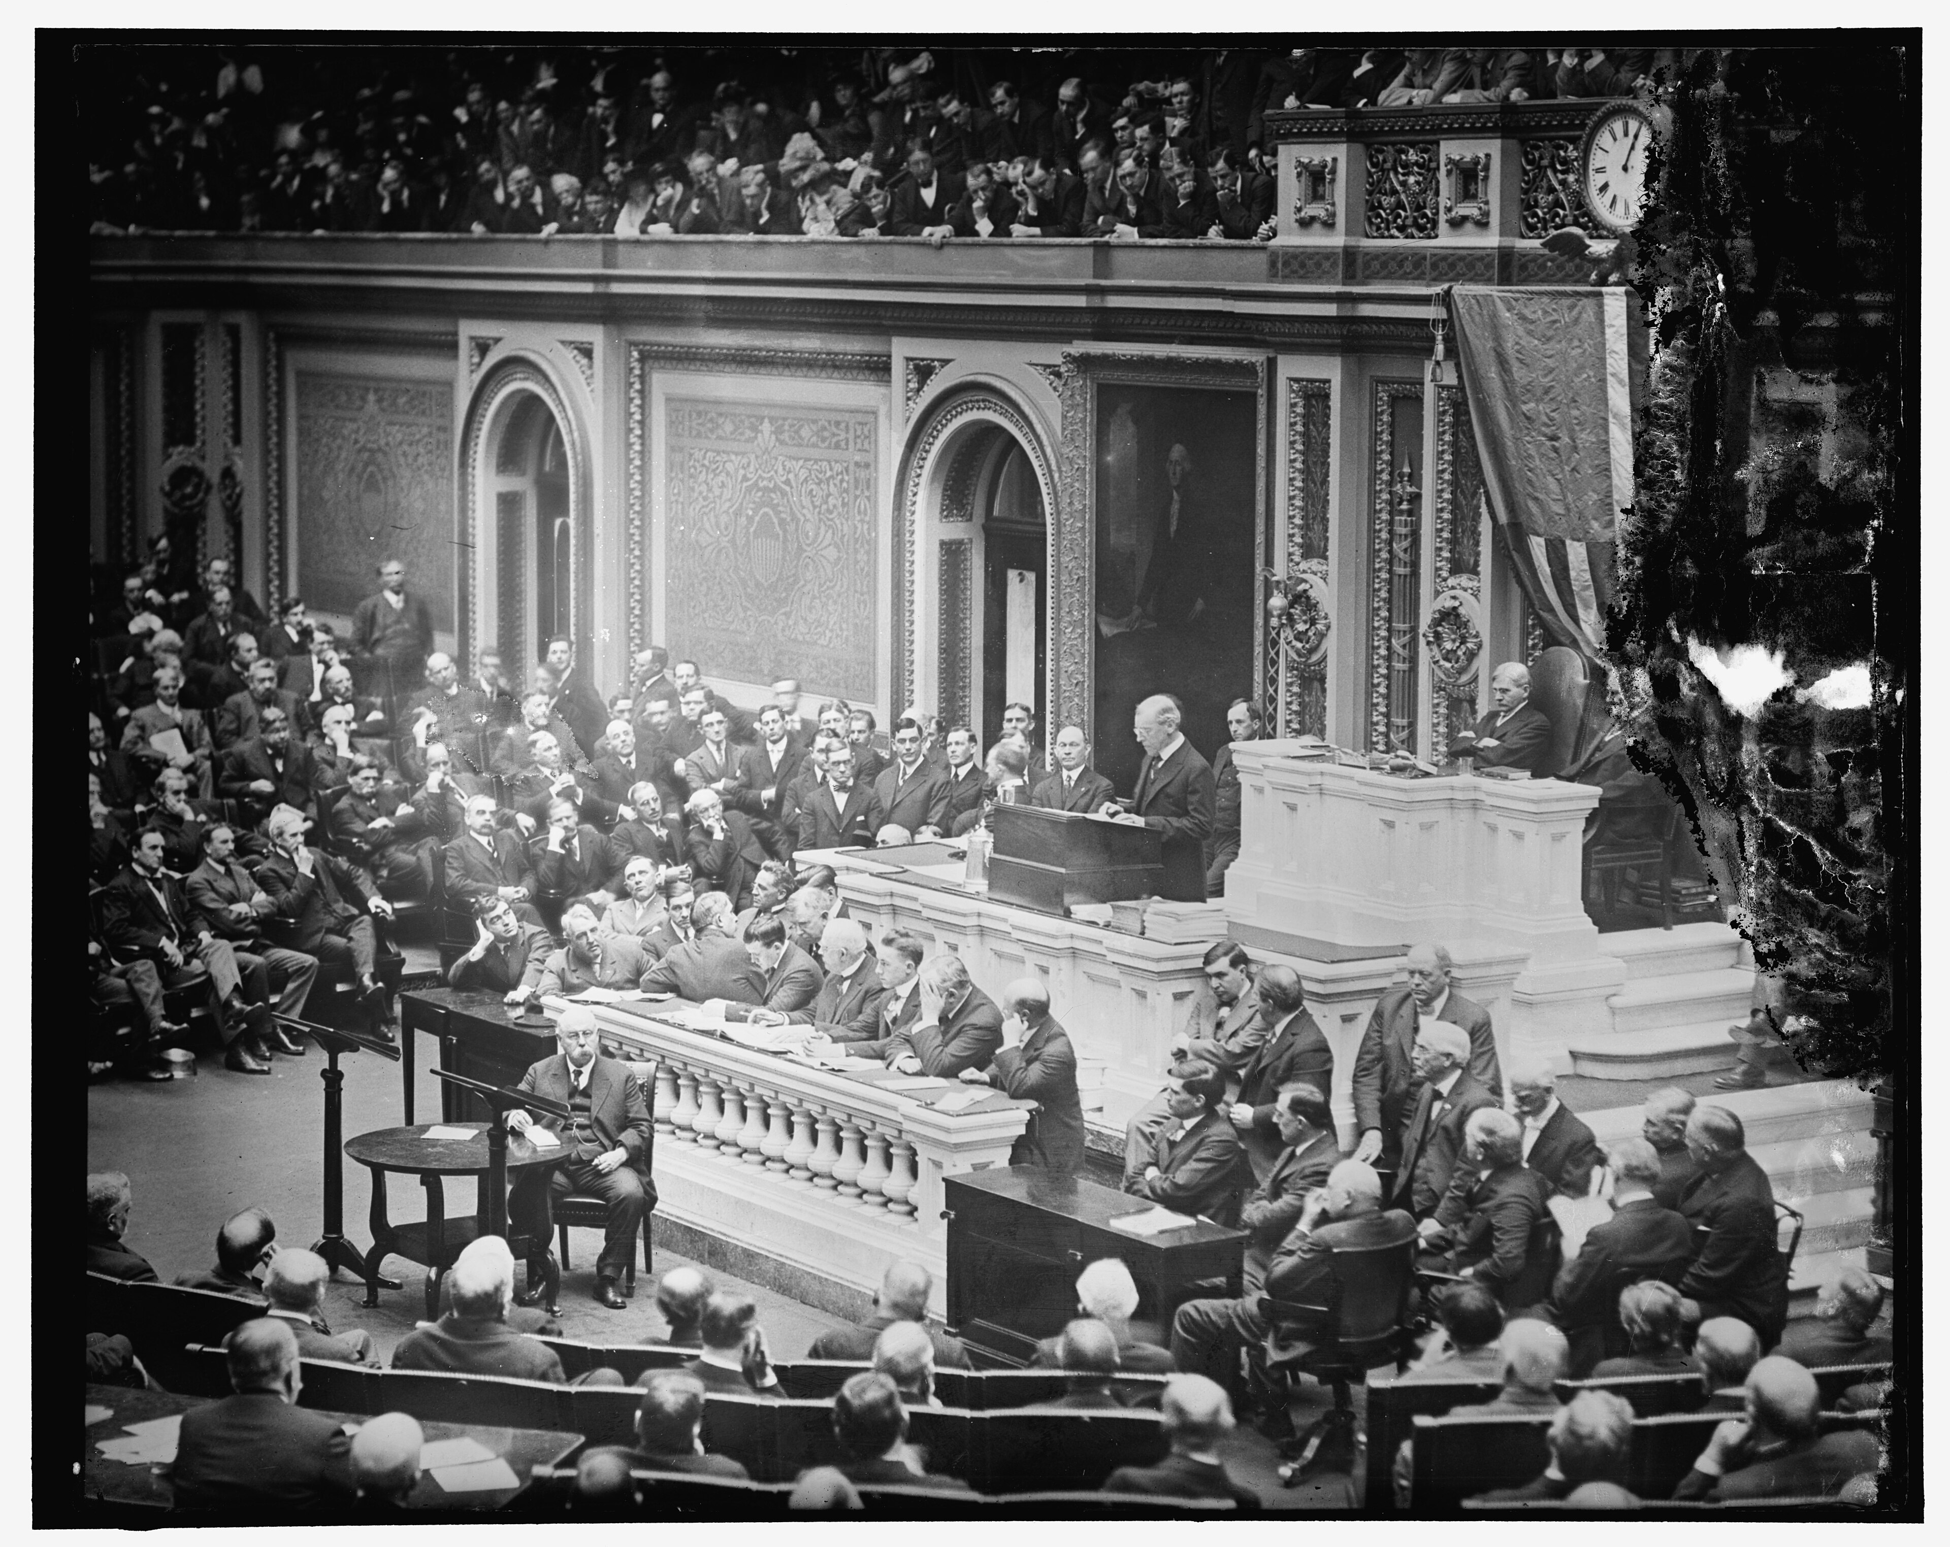
Congress in session (pre-1929) — bill/legislative process · U.S. Government · 1920s
Source: Wikimedia Commons · https://commons.wikimedia.org/wiki/Category:Joint_sessions_of_the_United_States_Congress VERIFY — pick a pre-1929 file (PD). NOTE: Mike Wirth 'How a Bill Becomes Law' diagram is CC-BY 3.0, NOT public domain https://commons.wikimedia.org/wiki/Category:Joint_sessions_of_the_United_States_Congress
HIPPO — analyze the source (prompt) | Your analysis
H — Historical context: what was happening when this was created?
I — Intended audience: who was meant to see or obey it?
P — Purpose: why was it created?
P — Point of view: whose perspective does it reflect?
O — Outside connection: how does it connect to this standard?
SUPPORT OPTION
Sentence frame: This source shows ______ because it ______, which reveals ______.
CONFIDENCE CHECK-IN
Rate your understanding of this standard (1–4): ______ One thing to revisit: ____________________

Activity 6 — Core Application: Practice Quiz — GC.13 ⏱ ~8 min
RESPONSE CHOICE
Commit to an answer by marking it, saying it, or explaining it aloud before checking. Answer key is in the Teacher Guide (kept separate).
[DOK 1 · item u3-gc13-dok1-1 · pre-field-test]
Congress can override a presidential veto with a vote of:
A. A simple majority of the House only
B. Two-thirds of both houses
C. The Supreme Court
D. Three-fourths of the states
[DOK 2 · item u1-gc13-dok2-tc · pre-field-test]
A Senate tactic of unlimited debate used to block a bill is a:
A. Cloture
B. Veto
C. Filibuster
D. Quorum

STRETCH — think like a test-writer (open to all)
Write your OWN DOK-3 question for this standard, then a one-sentence answer key. Use the supports below — everyone can do this.
HOW TO WRITE A DOK-3 QUESTION (supports)
DOK-3 = strategic thinking: the reader must analyze, compare, evaluate, or justify using evidence — and there should be more than one defensible answer (not a fact you can just look up).
Sentence starters: “Why did ______ lead to ______?” · “Which mattered more — ______ or ______ — and why?” · “What is the BEST evidence that ______?” · “Evaluate whether ______.” · “Defend or challenge: ______.”
Frame: [Analyze / Evaluate / Justify] + [something from THIS standard] + “using evidence.”
Quick check: does my question make the reader THINK and use evidence? If yes, it’s DOK-3.
Your DOK-3 question | Your answer key (one sentence)

Activity 7 — Constructed Response (CER) — GC.13 ⏱ ~15 min
BIG-QUESTION ORGANIZER (before you write) — How does Congress represent the people — and where do its powers begin and end?
Plan your argument here, then use it to write your claim, evidence, and reasoning below.
Plan your argument | Your quick notes (from this standard)
My claim (answer the prompt)
Evidence 1 (a source or fact)
Reasoning (why it proves the claim)
CONSTRUCTED RESPONSE (CER) — builds SSP.04 Argumentation
Claim + Evidence + Reasoning: Is it too hard for a bill to become a law, or is the difficulty a feature? Defend your claim with evidence from the process.
Part | Write here
Claim
Evidence (two specifics)
Reasoning
SELF-CHECK against the CER rubric (see Toolkit)
Before submitting: Is my claim defensible? Do I have TWO specific pieces of evidence? Does my reasoning explain HOW the evidence proves the claim?

UDL Access, Choice & Reflection — GC.13
UDL ACCESS & MTSS SUPPORT (this standard)
UDL 3.0 (CAST, 2024): read-aloud on request · key terms glossed (EN/ES) · respond in writing, speech, or a labeled diagram · large-print & screen-reader friendly. Same learning target for everyone; supports vary the means, not the ceiling.
MTSS: Tier 1 — this core lesson for all · Tier 2 — small-group reteach of this standard using its Cornell cues + graphic organizer, then re-check · Tier 3 — intensive 1:1 with concrete→representational→abstract scaffolding, progress-monitored to the same standard.
SHOW WHAT YOU KNOW — YOUR WAY (same CER rubric, same standard)
Build your Claim–Evidence–Reasoning in whichever mode lets you think best — the standard and the CER rubric are identical for every mode; the mode changes how you SHOW it, never what you are held to:
WRITE it · SAY it aloud and record it (audio or video) · DRAW and label a diagram that makes the argument · BUILD a model or artifact and caption its claim, evidence, and reasoning.
You may ask for a word processor, speech-to-text, a scribe, or a sentence/argument frame — these change how you produce, not the standard you meet.
CHOICE & VOICE — you decide how to go deeper (pick ONE)
You choose your path to show this standard — every option meets the same target:
DEFEND a term: pick the vocabulary word that matters most and argue why in 2–3 sentences. · CONNECT it: pick a current event, your community, or your own life and explain how this standard shows up there. · TAKE A SIDE: pick one debatable question and argue your position with evidence.
Your pick is yours — bring what matters to you into the work.
REFLECT & CONNECT — how your thinking grew, and whose view you weighed
Reflect (self-awareness): What did you believe about this topic BEFORE, and what changed AFTER? Name one thing to revisit.
Consider another view (empathy): Name one person or group who might see this standard differently than you; state their view fairly in one sentence — even if you disagree.
Norm (restorative): we critique ideas, not people; we assume good faith; we make room for every voice.

Standard GC.14 — Tennessee's Delegation to Congress
TN Academic Standard GC.14: Identify the Tennessee representatives and senators to the U.S. Congress. (T)
LEARNING TARGETS — I can…
• I can I can identify who represents Tennessee in the U.S. Congress and locate my own congressional district..
Lenses for this standard: Tennessee (T)
CORE PATH — the same for every student
Every student works this standard at the same rigor: analyze the sources and vocabulary, then demonstrate learning on the Practice Quiz and CER. UDL and MTSS give you flexible ways in — they never lower the bar. Check yourself against the learning targets on the Cornell Notes page.
★ Tennessee Connection
This standard is Tennessee: it asks you to name your own members of Congress. Tennessee sends two U.S. Senators who represent the whole state, plus a House delegation set by population — find the ones who represent you.
SET YOUR GOAL (self-direction)
My goal for this standard — what will I be able to do, and how will I show it?

HOOK — think before you dig in
Two people in Washington are paid to answer to you personally — plus one more for your neighborhood. Do you know their names?

ACTIVATE — what do you already know or wonder?
Jot what you already know or want to find out about this standard. You’ll come back to it.

Activity 1 — Vocabulary (Part A: Reference / Word Bank) — GC.14 ⏱ ~10 min
Use this word bank throughout the standard. The Spanish column supports access, not translation of assessment.
Term | Student-friendly meaning | Spanish
Congressional District | A geographic area whose voters elect one member of the U.S. House of Representatives; Tennessee is divided into several. | distrito congresional
Delegation | The full group of a state's members of Congress — its U.S. representatives plus its two U.S. senators. | delegación
Constituent | A person who lives in the district or state a legislator represents, and whom the legislator is elected to serve. | elector / representado
LANGUAGE SUPPORT
Pronunciations: Congressional District (kun-GRESH-un-ul); Delegation (del-ih-GAY-shun); Constituent (kun-STITCH-oo-ent).

VOCABULARY SELF-CHECK · Knowledge Rating
Rate each term NOW in pencil, then again at the END — growth is the goal; no penalty for “never seen it.”
Term | 1 · never seen it | 2 · heard it | 3 · can use it | 4 · can teach it
Congressional District
Delegation
Constituent
MAKE IT YOURS (RESPONSE CHOICE): choose ONE term above and show you own it — write a sentence, sketch it, or give a real-world example.

QUICK WRITE
Which of these terms do you think will matter MOST for this standard, and why? You’ll revisit this at the end.

Activity 2 — Vocabulary Studio (Frayer-inspired) — GC.14 ⏱ ~7 min
RESPONSE CHOICE
Complete each studio by writing, speaking, or diagramming.

PRIORITY TERM 1 Delegation · ES: delegación
Word-bank meaning to build on: The full group of a state's members of Congress — its U.S. representatives plus its two U.S. senators.
Definition (in your own words) | Characteristics
Examples | Non-examples
Use it to explain
Write one sentence that uses “Delegation” to explain this standard.

PRIORITY TERM 2 Constituent · ES: elector / representado
Word-bank meaning to build on: A person who lives in the district or state a legislator represents, and whom the legislator is elected to serve.
Definition (in your own words) | Characteristics
Examples | Non-examples
Use it to explain
Write one sentence that uses “Constituent” to explain this standard.

CONNECT THE TERMS (UDL · build understanding)
How do these priority terms fit together? Write or sketch how one leads to or affects another.

Activity 3 — Direct Teaching Cornell Notes — GC.14 ⏱ ~20 min
Name: ______________________ Class / Period: __________ Date: __________
GC.14 — Tennessee's Delegation to Congress • Lean Student Deck slides 2–8 • direct-teaching slides 4–6
Your learning targets are on this standard’s opening page — take notes that help you meet them.
Guiding cues | My notes — write your notes here
Key idea of this standard?
One source that supports it?
One effect on representation or lawmaking?
Key terms →
Keep taking notes — lines run the full width of the page:

DOODLE ZONE — draw your thinking (UDL · another way in)
Need another way in? Sketch the key idea, a quick timeline, or how the pieces connect. Words optional.

Cornell Notes — keep going, then process & check — GC.14
MORE NOTES / DIAGRAMS
Continue your notes here, add a quick sketch, or map how the ideas connect.

Key terms to list
Congressional District · Delegation · Constituent
Summary — In your own words (2–3 sentences)
PROGRESS CHECK · one question
How many U.S. Senators does Tennessee — like every state — send to Congress?
A. Two
B. One per congressional district
C. Based on its population
D. Ten
Commit before you move on — mark it, say it, or explain it aloud.
CHECK YOURSELF — how am I doing?
Which learning targets (on this standard’s opening page) can you now meet? Tick the number; circle any you still need help with.
☐ 1
My 12–15 word headline for this standard

Guided Support for the Cornell Notes — GC.14
These scaffolds support ONLY the Cornell notes — use them to take and process those notes. Optional and easy to set aside; not a separate assignment or a label.
Key vocabulary | What it means
Congressional District | A geographic area whose voters elect one member of the U.S. House of Representatives; Tennessee is divided into several.
Delegation | The full group of a state's members of Congress — its U.S. representatives plus its two U.S. senators.
Constituent | A person who lives in the district or state a legislator represents, and whom the legislator is elected to serve.
Break it into steps:
1) Name one cause or effect. 2) Give one piece of evidence. 3) Write one sentence explaining the link.
Sentence frame
One key cause/effect of tennessee's delegation to congress was ______, shown by ______, which mattered because ______.
Modeled example (one worked note — yours will differ)
A key idea of tennessee's delegation to congress was Congressional District: A geographic area whose voters elect one member of the U.S. House of Representatives; Tennessee is divided into several.
GUIDED NOTE REHEARSAL LAB
Rehearse the cause→effect chain below, then transfer it to your Cornell notes.
Step | Rehearse it here
Name it
Evidence
Explain
Headline
TRANSFER CHECK — move one rehearsed idea onto the front notes

Light Support for the Cornell Notes — GC.14
A lighter scaffold for the SAME Cornell notes. Try the notes first; reach for this only if you need it.
Key vocabulary | Finish the idea — “This term means …”
Congressional District
Delegation
Constituent
Guiding questions — answer on the lines below (or in your front notes):
• How does the Constitution decide how many senators and representatives Tennessee has?
• What is the difference between a senator's constituents and a representative's constituents?
• Why is knowing your own district the first step to contacting your representative?

WHICH CUE STILL NEEDS WORK?
Circle the Cornell cue from the front page you still need help with, and tell your teacher so we can go over it.
LIGHT PROCESSING LAB
Answer one guiding question from above in a full sentence, in your own words.

Activity 4 — Close Read — GC.14 ⏱ ~15 min
Reading type: Government Hack-authored instructional synthesis. This is not a primary source. Builds SSP.03 (synthesize) and SSP.05 (historical awareness).
CORE PATH
Every state's voice in Congress has two parts. Tennessee, like every state, elects two U.S. Senators who represent the whole state. It also elects several U.S. Representatives — the exact number set by population through apportionment — each speaking for one congressional district. Together these members are Tennessee's delegation. The people who live in a member's district or state are that member's constituents, and a core job of any legislator is to answer to them: holding town halls, casting votes, and helping with federal problems. Knowing who your representatives are — and which district you live in — is the first step to being heard, because a legislator's office exists to serve the people back home.
LANGUAGE SUPPORT
Key terms to know first: Congressional District, Delegation. Read once for the gist, then again for evidence.
Text-dependent questions (answer in the Evidence Lab below or aloud):
1. How does the Constitution decide how many senators and representatives Tennessee has?
2. What is the difference between a senator's constituents and a representative's constituents?
3. Why is knowing your own district the first step to contacting your representative?
RESPONSE CHOICE: answer any question by writing in the Evidence Lab, saying/recording it, or diagramming it.
CLOSE-READ EVIDENCE LAB
Log evidence from the passage below.
Question / claim | Exact passage evidence | What the evidence shows

SPACED RETRIEVAL — quick recall (no notes)
Pull it up cold to strengthen memory, then check your notes.
Recall prompt | Your answer (from memory)
One key term or fact from THIS standard
One thing you learned EARLIER in this unit or course
How the two connect

Activity 5 — Primary Source / Data Analysis — GC.14 ⏱ ~15 min
Primary source (emblem) — analyze it with HIPPO. Builds SSP.01–SSP.02.

Seal of Tennessee · State of Tennessee · 1802 design
Source: Wikimedia Commons · https://commons.wikimedia.org/wiki/File:Seal_of_Tennessee.svg Public domain — U.S. state government insignia https://commons.wikimedia.org/wiki/File:Seal_of_Tennessee.svg
HIPPO — analyze the source (prompt) | Your analysis
H — Historical context: what was happening when this was created?
I — Intended audience: who was meant to see or obey it?
P — Purpose: why was it created?
P — Point of view: whose perspective does it reflect?
O — Outside connection: how does it connect to this standard?
SUPPORT OPTION
Sentence frame: This source shows ______ because it ______, which reveals ______.
CONFIDENCE CHECK-IN
Rate your understanding of this standard (1–4): ______ One thing to revisit: ____________________

Activity 6 — Core Application: Practice Quiz — GC.14 ⏱ ~8 min
RESPONSE CHOICE
Commit to an answer by marking it, saying it, or explaining it aloud before checking. Answer key is in the Teacher Guide (kept separate).
[DOK 1 · item u3-gc14-dok1-1 · pre-field-test]
A person a legislator is elected to represent is called a:
A. Constituent
B. Delegate
C. Lobbyist
D. Justice
[DOK 2 · item u1-gc14-dok2-tc · pre-field-test]
How many U.S. Senators does Tennessee — like every state — send to Congress?
A. Two
B. One per congressional district
C. Based on its population
D. Ten

STRETCH — think like a test-writer (open to all)
Write your OWN DOK-3 question for this standard, then a one-sentence answer key. Use the supports below — everyone can do this.
HOW TO WRITE A DOK-3 QUESTION (supports)
DOK-3 = strategic thinking: the reader must analyze, compare, evaluate, or justify using evidence — and there should be more than one defensible answer (not a fact you can just look up).
Sentence starters: “Why did ______ lead to ______?” · “Which mattered more — ______ or ______ — and why?” · “What is the BEST evidence that ______?” · “Evaluate whether ______.” · “Defend or challenge: ______.”
Frame: [Analyze / Evaluate / Justify] + [something from THIS standard] + “using evidence.”
Quick check: does my question make the reader THINK and use evidence? If yes, it’s DOK-3.
Your DOK-3 question | Your answer key (one sentence)

Activity 7 — Constructed Response (CER) — GC.14 ⏱ ~15 min
BIG-QUESTION ORGANIZER (before you write) — How does Congress represent the people — and where do its powers begin and end?
Plan your argument here, then use it to write your claim, evidence, and reasoning below.
Plan your argument | Your quick notes (from this standard)
My claim (answer the prompt)
Evidence 1 (a source or fact)
Reasoning (why it proves the claim)
CONSTRUCTED RESPONSE (CER) — builds SSP.04 Argumentation
Claim + Evidence + Reasoning: Does a senator who represents an entire state, or a representative who represents one district, better serve your interests? Defend your claim.
Part | Write here
Claim
Evidence (two specifics)
Reasoning
SELF-CHECK against the CER rubric (see Toolkit)
Before submitting: Is my claim defensible? Do I have TWO specific pieces of evidence? Does my reasoning explain HOW the evidence proves the claim?

UDL Access, Choice & Reflection — GC.14
UDL ACCESS & MTSS SUPPORT (this standard)
UDL 3.0 (CAST, 2024): read-aloud on request · key terms glossed (EN/ES) · respond in writing, speech, or a labeled diagram · large-print & screen-reader friendly. Same learning target for everyone; supports vary the means, not the ceiling.
MTSS: Tier 1 — this core lesson for all · Tier 2 — small-group reteach of this standard using its Cornell cues + graphic organizer, then re-check · Tier 3 — intensive 1:1 with concrete→representational→abstract scaffolding, progress-monitored to the same standard.
SHOW WHAT YOU KNOW — YOUR WAY (same CER rubric, same standard)
Build your Claim–Evidence–Reasoning in whichever mode lets you think best — the standard and the CER rubric are identical for every mode; the mode changes how you SHOW it, never what you are held to:
WRITE it · SAY it aloud and record it (audio or video) · DRAW and label a diagram that makes the argument · BUILD a model or artifact and caption its claim, evidence, and reasoning.
You may ask for a word processor, speech-to-text, a scribe, or a sentence/argument frame — these change how you produce, not the standard you meet.
CHOICE & VOICE — you decide how to go deeper (pick ONE)
You choose your path to show this standard — every option meets the same target:
DEFEND a term: pick the vocabulary word that matters most and argue why in 2–3 sentences. · CONNECT it: pick a current event, your community, or your own life and explain how this standard shows up there. · TAKE A SIDE: pick one debatable question and argue your position with evidence.
Your pick is yours — bring what matters to you into the work.
REFLECT & CONNECT — how your thinking grew, and whose view you weighed
Reflect (self-awareness): What did you believe about this topic BEFORE, and what changed AFTER? Name one thing to revisit.
Consider another view (empathy): Name one person or group who might see this standard differently than you; state their view fairly in one sentence — even if you disagree.
Norm (restorative): we critique ideas, not people; we assume good faith; we make room for every voice.

Standard GC.15 — The Powers of Congress
TN Academic Standard GC.15: Describe the powers of U.S. Congress, including: appropriations; commerce; confirmations; declaration of war; implied powers; Necessary and proper clause. (H)
LEARNING TARGETS — I can…
• I can I can describe the enumerated and implied powers of Congress, including the Necessary and Proper Clause and McCulloch v. Maryland..
Lenses for this standard: History (H)
CORE PATH — the same for every student
Every student works this standard at the same rigor: analyze the sources and vocabulary, then demonstrate learning on the Practice Quiz and CER. UDL and MTSS give you flexible ways in — they never lower the bar. Check yourself against the learning targets on the Cornell Notes page.
SET YOUR GOAL (self-direction)
My goal for this standard — what will I be able to do, and how will I show it?

HOOK — think before you dig in
The Constitution never says Congress can create an air force, a national bank, or the interstate highways — yet it did all three. Where does that power come from?

ACTIVATE — what do you already know or wonder?
Jot what you already know or want to find out about this standard. You’ll come back to it.

PREVIEW & PREDICT
Which learning target will be hardest, and why? Connect it to the unit’s big question: How does Congress represent the people — and where do its powers begin and end?

Activity 1 — Vocabulary (Part A: Reference / Word Bank) — GC.15 ⏱ ~10 min
Use this word bank throughout the standard. The Spanish column supports access, not translation of assessment.
Term | Student-friendly meaning | Spanish
Enumerated Powers | The powers specifically listed for Congress in the Constitution, such as taxing, borrowing, regulating commerce, and declaring war. | poderes enumerados
Implied Powers | Powers not listed but reasonably needed to carry out the enumerated powers, justified by the Necessary and Proper Clause. | poderes implícitos
Necessary & Proper Clause | The 'Elastic Clause' (Art. I, §8) letting Congress make all laws needed to carry out its powers — the basis of implied powers. | cláusula necesaria y apropiada
LANGUAGE SUPPORT
Pronunciations: Enumerated Powers (ee-NOO-mer-ay-ted); Implied Powers (im-PLYD); Necessary & Proper Clause (NESS-uh-sair-ee).

VOCABULARY SELF-CHECK · Knowledge Rating
Rate each term NOW in pencil, then again at the END — growth is the goal; no penalty for “never seen it.”
Term | 1 · never seen it | 2 · heard it | 3 · can use it | 4 · can teach it
Enumerated Powers
Implied Powers
Necessary & Proper Clause
MAKE IT YOURS (RESPONSE CHOICE): choose ONE term above and show you own it — write a sentence, sketch it, or give a real-world example.

QUICK WRITE
Which of these terms do you think will matter MOST for this standard, and why? You’ll revisit this at the end.

Activity 2 — Vocabulary Studio (Frayer-inspired) — GC.15 ⏱ ~7 min
RESPONSE CHOICE
Complete each studio by writing, speaking, or diagramming.

PRIORITY TERM 1 Enumerated Powers · ES: poderes enumerados
Word-bank meaning to build on: The powers specifically listed for Congress in the Constitution, such as taxing, borrowing, regulating commerce, and declaring war.
Definition (in your own words) | Characteristics
Examples | Non-examples
Use it to explain
Write one sentence that uses “Enumerated Powers” to explain this standard.

PRIORITY TERM 2 Implied Powers · ES: poderes implícitos
Word-bank meaning to build on: Powers not listed but reasonably needed to carry out the enumerated powers, justified by the Necessary and Proper Clause.
Definition (in your own words) | Characteristics
Examples | Non-examples
Use it to explain
Write one sentence that uses “Implied Powers” to explain this standard.

CONNECT THE TERMS (UDL · build understanding)
How do these priority terms fit together? Write or sketch how one leads to or affects another.

Activity 3 — Direct Teaching Cornell Notes — GC.15 ⏱ ~20 min
Name: ______________________ Class / Period: __________ Date: __________
GC.15 — The Powers of Congress • Lean Student Deck slides 2–8 • direct-teaching slides 4–6
Your learning targets are on this standard’s opening page — take notes that help you meet them.
Guiding cues | My notes — write your notes here
Key idea of this standard?
One source that supports it?
One effect on representation or lawmaking?
Key terms →
Keep taking notes — lines run the full width of the page:

DOODLE ZONE — draw your thinking (UDL · another way in)
Need another way in? Sketch the key idea, a quick timeline, or how the pieces connect. Words optional.

Cornell Notes — keep going, then process & check — GC.15
MORE NOTES / DIAGRAMS
Continue your notes here, add a quick sketch, or map how the ideas connect.

Key terms to list
Enumerated Powers · Implied Powers · Necessary & Proper Clause
Summary — In your own words (2–3 sentences)
PROGRESS CHECK · one question
How did McCulloch v. Maryland (1819) affect the powers of Congress?
A. It abolished the Necessary and Proper Clause
B. It limited Congress to only the powers explicitly listed
C. It gave the states power to tax the federal government
D. It upheld broad implied powers under the Necessary and Proper Clause
Commit before you move on — mark it, say it, or explain it aloud.
CHECK YOURSELF — how am I doing?
Which learning targets (on this standard’s opening page) can you now meet? Tick the number; circle any you still need help with.
☐ 1
My 12–15 word headline for this standard

Guided Support for the Cornell Notes — GC.15
These scaffolds support ONLY the Cornell notes — use them to take and process those notes. Optional and easy to set aside; not a separate assignment or a label.
Key vocabulary | What it means
Enumerated Powers | The powers specifically listed for Congress in the Constitution, such as taxing, borrowing, regulating commerce, and declaring war.
Implied Powers | Powers not listed but reasonably needed to carry out the enumerated powers, justified by the Necessary and Proper Clause.
Necessary & Proper Clause | The 'Elastic Clause' (Art. I, §8) letting Congress make all laws needed to carry out its powers — the basis of implied powers.
Break it into steps:
1) Name one cause or effect. 2) Give one piece of evidence. 3) Write one sentence explaining the link.
Sentence frame
One key cause/effect of the powers of congress was ______, shown by ______, which mattered because ______.
Modeled example (one worked note — yours will differ)
A key idea of the powers of congress was Enumerated Powers: The powers specifically listed for Congress in the Constitution, such as taxing, borrowing, regulating commerce, and declaring war.
GUIDED NOTE REHEARSAL LAB
Rehearse the cause→effect chain below, then transfer it to your Cornell notes.
Step | Rehearse it here
Name it
Evidence
Explain
Headline
TRANSFER CHECK — move one rehearsed idea onto the front notes

Light Support for the Cornell Notes — GC.15
A lighter scaffold for the SAME Cornell notes. Try the notes first; reach for this only if you need it.
Key vocabulary | Finish the idea — “This term means …”
Enumerated Powers
Implied Powers
Necessary & Proper Clause
Guiding questions — answer on the lines below (or in your front notes):
• What is the difference between an enumerated and an implied power of Congress?
• How does the Necessary and Proper Clause create implied powers?
• How did Marshall's opinion in McCulloch v. Maryland expand what Congress can do?

WHICH CUE STILL NEEDS WORK?
Circle the Cornell cue from the front page you still need help with, and tell your teacher so we can go over it.
LIGHT PROCESSING LAB
Answer one guiding question from above in a full sentence, in your own words.

Activity 4 — Close Read — GC.15 ⏱ ~15 min
Reading type: Government Hack-authored instructional synthesis. This is not a primary source. Builds SSP.03 (synthesize) and SSP.05 (historical awareness).
CORE PATH
Congress's powers come in two kinds. Its enumerated powers are the ones the Constitution lists in Article I, Section 8 — to tax and spend (appropriations), to borrow, to regulate commerce, to declare war, to coin money, and to issue patents and copyrights, among others. The Senate also confirms many presidential appointments. But the Framers could not list every power Congress might need, so they added the Necessary and Proper Clause — the 'Elastic Clause' — allowing Congress to make all laws needed to carry out its listed powers. These are its implied powers. In McCulloch v. Maryland (1819), Chief Justice John Marshall upheld this broad reading: 'let the end be legitimate… and all means which are appropriate… are constitutional.' Marshall also warned that 'the power to tax involves the power to destroy,' ruling that a state could not tax the national bank. The case cemented both implied powers and national supremacy.
LANGUAGE SUPPORT
Key terms to know first: Enumerated Powers, Implied Powers. Read once for the gist, then again for evidence.
Text-dependent questions (answer in the Evidence Lab below or aloud):
1. What is the difference between an enumerated and an implied power of Congress?
2. How does the Necessary and Proper Clause create implied powers?
3. How did Marshall's opinion in McCulloch v. Maryland expand what Congress can do?
RESPONSE CHOICE: answer any question by writing in the Evidence Lab, saying/recording it, or diagramming it.
CLOSE-READ EVIDENCE LAB
Log evidence from the passage below.
Question / claim | Exact passage evidence | What the evidence shows

SPACED RETRIEVAL — quick recall (no notes)
Pull it up cold to strengthen memory, then check your notes.
Recall prompt | Your answer (from memory)
One key term or fact from THIS standard
One thing you learned EARLIER in this unit or course
How the two connect

Activity 5 — Primary Source / Data Analysis — GC.15 ⏱ ~15 min
Primary source (portrait) — analyze it with HIPPO. Builds SSP.01–SSP.02.
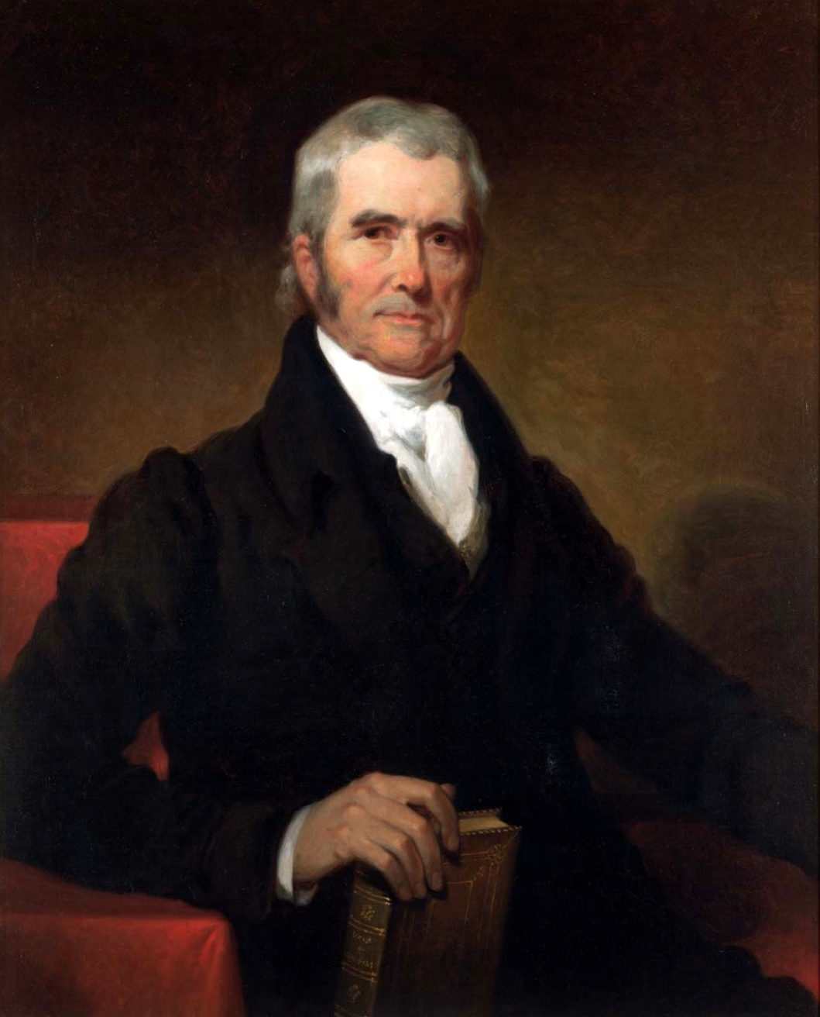
Chief Justice John Marshall (McCulloch v. Maryland) · (artist unconfirmed) · 19th c.
Source: Wikimedia Commons · https://commons.wikimedia.org/wiki/File:Chief_Justice_John_Marshall.jpg Public domain — portrait pre-1929 (Marshall d.1835) https://commons.wikimedia.org/wiki/File:Chief_Justice_John_Marshall.jpg
HIPPO — analyze the source (prompt) | Your analysis
H — Historical context: what was happening when this was created?
I — Intended audience: who was meant to see or obey it?
P — Purpose: why was it created?
P — Point of view: whose perspective does it reflect?
O — Outside connection: how does it connect to this standard?
SUPPORT OPTION
Sentence frame: This source shows ______ because it ______, which reveals ______.
CONFIDENCE CHECK-IN
Rate your understanding of this standard (1–4): ______ One thing to revisit: ____________________

Activity 6 — Core Application: Practice Quiz — GC.15 ⏱ ~8 min
RESPONSE CHOICE
Commit to an answer by marking it, saying it, or explaining it aloud before checking. Answer key is in the Teacher Guide (kept separate).
[DOK 1 · item u3-gc15-dok1-1 · pre-field-test]
The 'Elastic Clause' that stretches Congress's powers is also called the:
A. Supremacy Clause
B. Commerce Clause
C. Necessary and Proper Clause
D. Due Process Clause
[DOK 3 · item u1-gc15-dok3-tc · pre-field-test]
How did McCulloch v. Maryland (1819) affect the powers of Congress?
A. It abolished the Necessary and Proper Clause
B. It limited Congress to only the powers explicitly listed
C. It gave the states power to tax the federal government
D. It upheld broad implied powers under the Necessary and Proper Clause

STRETCH — think like a test-writer (open to all)
Write your OWN DOK-3 question for this standard, then a one-sentence answer key. Use the supports below — everyone can do this.
HOW TO WRITE A DOK-3 QUESTION (supports)
DOK-3 = strategic thinking: the reader must analyze, compare, evaluate, or justify using evidence — and there should be more than one defensible answer (not a fact you can just look up).
Sentence starters: “Why did ______ lead to ______?” · “Which mattered more — ______ or ______ — and why?” · “What is the BEST evidence that ______?” · “Evaluate whether ______.” · “Defend or challenge: ______.”
Frame: [Analyze / Evaluate / Justify] + [something from THIS standard] + “using evidence.”
Quick check: does my question make the reader THINK and use evidence? If yes, it’s DOK-3.
Your DOK-3 question | Your answer key (one sentence)

Activity 7 — Constructed Response (CER) — GC.15 ⏱ ~15 min
BIG-QUESTION ORGANIZER (before you write) — How does Congress represent the people — and where do its powers begin and end?
Plan your argument here, then use it to write your claim, evidence, and reasoning below.
Plan your argument | Your quick notes (from this standard)
My claim (answer the prompt)
Evidence 1 (a source or fact)
Reasoning (why it proves the claim)
CONSTRUCTED RESPONSE (CER) — builds SSP.04 Argumentation
Claim + Evidence + Reasoning: Do the implied powers make Congress too strong, or are they necessary for it to govern? Defend your claim using the Constitution and McCulloch v. Maryland.
Part | Write here
Claim
Evidence (two specifics)
Reasoning
SELF-CHECK against the CER rubric (see Toolkit)
Before submitting: Is my claim defensible? Do I have TWO specific pieces of evidence? Does my reasoning explain HOW the evidence proves the claim?

UDL Access, Choice & Reflection — GC.15
UDL ACCESS & MTSS SUPPORT (this standard)
UDL 3.0 (CAST, 2024): read-aloud on request · key terms glossed (EN/ES) · respond in writing, speech, or a labeled diagram · large-print & screen-reader friendly. Same learning target for everyone; supports vary the means, not the ceiling.
MTSS: Tier 1 — this core lesson for all · Tier 2 — small-group reteach of this standard using its Cornell cues + graphic organizer, then re-check · Tier 3 — intensive 1:1 with concrete→representational→abstract scaffolding, progress-monitored to the same standard.
SHOW WHAT YOU KNOW — YOUR WAY (same CER rubric, same standard)
Build your Claim–Evidence–Reasoning in whichever mode lets you think best — the standard and the CER rubric are identical for every mode; the mode changes how you SHOW it, never what you are held to:
WRITE it · SAY it aloud and record it (audio or video) · DRAW and label a diagram that makes the argument · BUILD a model or artifact and caption its claim, evidence, and reasoning.
You may ask for a word processor, speech-to-text, a scribe, or a sentence/argument frame — these change how you produce, not the standard you meet.
CHOICE & VOICE — you decide how to go deeper (pick ONE)
You choose your path to show this standard — every option meets the same target:
DEFEND a term: pick the vocabulary word that matters most and argue why in 2–3 sentences. · CONNECT it: pick a current event, your community, or your own life and explain how this standard shows up there. · TAKE A SIDE: pick one debatable question and argue your position with evidence.
Your pick is yours — bring what matters to you into the work.
REFLECT & CONNECT — how your thinking grew, and whose view you weighed
Reflect (self-awareness): What did you believe about this topic BEFORE, and what changed AFTER? Name one thing to revisit.
Consider another view (empathy): Name one person or group who might see this standard differently than you; state their view fairly in one sentence — even if you disagree.
Norm (restorative): we critique ideas, not people; we assume good faith; we make room for every voice.

Your Tennessee Connection
★ TENNESSEE CONNECTION
One person, one vote started in Tennessee. Charles Baker, a voter from Shelby County (Memphis), sued because the state had not redrawn its legislative districts since 1901 — leaving a Memphis vote worth about one-eighth of a rural vote. In Baker v. Carr (1962) the Supreme Court ruled that federal courts could hear redistricting cases, opening the door to the 'one person, one vote' standard (GC.11).
Reflect (RESPONSE CHOICE): How does a Tennessee connection change the way you understand a national idea? Answer by writing, recording, or diagramming.

Tennessee Civics Investigation
Tennessee's own unequal districts sparked a national rule. Investigate your current Tennessee state legislative district or U.S. House district — who represents it, and roughly how many people live there — and record what you find.
Prompt | Your findings
A Tennessee example connected to this unit
One source I could check (library, TN Secretary of State, TSLA, a representative’s office)
How it connects to a standard in this unit
One question I still have

Progress Tracker & Cumulative Review
Track your Progress Check result for each standard and note one thing to revisit.
Standard | Progress Check (✓ / reteach) | One thing to revisit
GC.35
GC.10
GC.11
GC.12
GC.13
GC.14
GC.15

Optional Extension Bank (higher-DOK, open to all)
Any student may choose an extension. These are EXTENSION, not a track.
GC.35: Should the President be required to be a natural-born citizen? Defend your claim with evidence from the Constitution.
GC.10: Was the 17th Amendment a good change — should the people or state legislatures choose senators? Defend your claim with evidence.
GC.11: Should courts or legislatures control how district lines are drawn? Defend your claim with evidence, including Baker v. Carr.
GC.12: Which congressional leadership position has the most influence over what becomes law? Defend your claim with evidence.
GC.13: Is it too hard for a bill to become a law, or is the difficulty a feature? Defend your claim with evidence from the process.
GC.14: Does a senator who represents an entire state, or a representative who represents one district, better serve your interests? Defend your claim.
GC.15: Do the implied powers make Congress too strong, or are they necessary for it to govern? Defend your claim using the Constitution and McCulloch v. Maryland.

Reusable Toolkit & Source Library

Written Response Rubric (CER)
Level | Claim | Evidence | Reasoning
4 — Strong | Precise, defensible | 2+ accurate, specific | Explains how evidence proves the claim
3 — Proficient | Clear | 2 accurate | Explains the link
2 — Developing | General | 1 accurate | Partial link
1 — Beginning | Unclear/missing | Missing/inaccurate | No reasoning

Source Library — full citations & clickable links
GC.35 — Citizenship & Naturalization
U.S. Constitution, Article I, Section 8. Constitutional Convention, 1787. U.S. National Archives. Public domain. https://www.archives.gov/founding-docs/constitution-transcript
U.S. Constitution, Amendment XIV, Section 1. 39th U.S. Congress, 1868. U.S. National Archives. Public domain. https://www.archives.gov/founding-docs/amendments-11-27
GC.10 — Article I & the 17th Amendment
U.S. Constitution, Amendment XVII. 62nd U.S. Congress, 1913. U.S. National Archives. Public domain. https://www.archives.gov/founding-docs/amendments-11-27
U.S. Constitution, Article I, Section 2. Constitutional Convention, 1787. U.S. National Archives. Public domain. https://www.archives.gov/founding-docs/constitution-transcript
GC.11 — Census, Redistricting & Baker v. Carr
Baker v. Carr, 369 U.S. 186. U.S. Supreme Court, 1962. U.S. Reports (Justia). Public domain. https://supreme.justia.com/cases/federal/us/369/186/
U.S. Constitution, Article I, Section 2. Constitutional Convention, 1787. U.S. National Archives. Public domain. https://www.archives.gov/founding-docs/constitution-transcript
GC.12 — Leadership of Congress
U.S. Constitution, Article I, Section 2. Constitutional Convention, 1787. U.S. National Archives. Public domain. https://www.archives.gov/founding-docs/constitution-transcript
U.S. Constitution, Article I, Section 3. Constitutional Convention, 1787. U.S. National Archives. Public domain. https://www.archives.gov/founding-docs/constitution-transcript
GC.13 — How a Bill Becomes a Law
U.S. Constitution, Article I, Section 7. Constitutional Convention, 1787. U.S. National Archives. Public domain. https://www.archives.gov/founding-docs/constitution-transcript
U.S. Constitution, Article I, Section 7 (override). Constitutional Convention, 1787. U.S. National Archives. Public domain. https://www.archives.gov/founding-docs/constitution-transcript
GC.14 — Tennessee's Delegation to Congress
U.S. Constitution, Article I, Section 2. Constitutional Convention, 1787. U.S. National Archives. Public domain. https://www.archives.gov/founding-docs/constitution-transcript
U.S. Constitution, Amendment XVII. 62nd U.S. Congress, 1913. U.S. National Archives. Public domain. https://www.archives.gov/founding-docs/amendments-11-27
GC.15 — The Powers of Congress
U.S. Constitution, Article I, Section 8. Constitutional Convention, 1787. U.S. National Archives. Public domain. https://www.archives.gov/founding-docs/constitution-transcript
McCulloch v. Maryland, 17 U.S. 316. Chief Justice John Marshall, 1819. U.S. Reports (Justia). Public domain. https://supreme.justia.com/cases/federal/us/17/316/

Who Gets Represented? Perspectives on Congress
This section examines how representation is built and contested: which places and people a legislature counts, and who draws the lines. It is Government Hack–authored instructional synthesis grounded in this unit's sourced record — not a primary source.

Large vs. Small States
The Great Compromise gave every state two senators but seats the House by population — a bargain carried straight from the Constitutional Convention (connects to GC.10, GC.04).

Urban vs. Rural Voters
For decades Tennessee's unequal districts made a rural vote worth many times an urban one, until Baker v. Carr forced 'one person, one vote' (GC.11).

Majority vs. Minority Power
Senate rules like the filibuster let a minority slow or block the majority; House rules move faster — the same bill can face very different odds (GC.13).

Who Draws the Lines
Whoever controls redistricting can shape outcomes through gerrymandering, changing who wins without changing a single vote (GC.11).

Unit Reflection
Return to the unit’s big question: How does Congress represent the people — and where do its powers begin and end? Write a final claim with two pieces of evidence from different standards.
Part | Write here
My claim
Evidence 1 (standard: ___)
Evidence 2 (standard: ___)
Why it matters today

