1787 · 1803 · 1837 • UNITED STATES GOVERNMENT & CIVICS (GC) • COURSE STANDARD EDITION
GOVERNMENT HACK™
TROOPTOTEACHER TECHNOLOGIES
UNIT 5
The Judicial Branch
COURSE STANDARD EDITION
GC.19–GC.22 • Tennessee U.S. Government & Civics Standards • Grades 9–12
★ TENNESSEE CONNECTION
Tennessee has sat on the nation's highest bench. John Catron, who had served as Chief Justice of Tennessee's own Supreme Court, was appointed to the U.S. Supreme Court in 1837 and served until his death in Nashville in 1865 — the first Tennessean to help decide what the Constitution means (GC.20).
One common workbook designed for learner variability. Every student works toward the same Tennessee standards; supports vary the means, not the goal or the ceiling.
Release-Ready · Pilot Edition
© 2026 TroopToTeacher Technologies LLC. All rights reserved. ISBN: [to be assigned]

Copyright, Ownership & Framework
Government Hack™ — Unit 5: The Judicial Branch, Course Standard Edition.
© 2026 TroopToTeacher Technologies LLC. All rights reserved. This workbook is proprietary; reproduction or redistribution outside a licensed classroom is prohibited.
Source integrity. Every primary source in this unit is public-domain and cited to its holding repository (National Archives, Library of Congress). See the Source Library.
Reading provenance (district-clear). Close-Read passages are labeled “Government Hack-authored instructional synthesis” — they build on the standard record and are not presented as primary sources.
Framework stack. This workbook anchors to Tennessee U.S. Government & Civics standards GC.19–GC.22 and the Social Studies Practices (SSP.01–SSP.06), and is designed on CAST UDL 3.0 and an MTSS support model.
Pacing. Each standard is built for one 45-minute class period. Each activity shows a ⏱ ~ minutes estimate at its heading. There is more here than one period holds — your teacher chooses which activities you do in class; the rest may become warm-ups, stations, or homework.

Table of Contents

Tennessee Standards & SSP Crosswalk
Each standard below is taught to the full Course Standard expectation; the Social Studies Practices are embedded in every activity cycle.
Standard | Focus | Student Deck slides
GC.19 | Article III & Judicial Power | 2–8
GC.20 | Selecting & Confirming Justices | 2–8
GC.21 | Judicial Review & Marbury v. Madison | 2–8
GC.22 | Deciding What Is Constitutional | 2–8

Social Studies Practices (SSP.01–SSP.06)
SSP.01 Gather/evaluate sources · SSP.02 Critically examine a primary source · SSP.03 Synthesize evidence · SSP.04 Construct/communicate argument · SSP.05 Develop historical awareness · SSP.06 Chronological/spatial reasoning. Each Close Read, Primary Source/Data, and CER activity names the practices it builds.

Accessibility, UDL & Accommodations Matrix
One firm learning goal per standard; flexible, universal means. Supports are available by design and never lower the goal. They work alongside — never in place of — required IEP or 504 accommodations.
Universal support | What it is | Where it appears
CORE PATH | Essential instruction every student completes | Every activity
LANGUAGE SUPPORT | Vocabulary, pronunciation, Spanish cognates | Word Bank, Guided/Light Backs
RESPONSE CHOICE | Write, say/record, or diagram | Every activity
SUPPORT OPTION | Optional scaffold that keeps the goal | Guided Support Back, Primary Source
PROGRESS CHECK | Quick DOK-2/3 check to guide reteach/extend | Cornell Notes, Practice Quiz
EXTENSION | Deeper challenge once the goal is met | Extension Bank, CER

How CAST UDL 3.0 is visible in this workbook
Multiple means of Engagement (response choice, relevance via Tennessee Connection), Representation (Word Bank, pronunciation, Spanish, Close-Read supports), and Action & Expression (write/say/diagram, Frayer, CER). No fixed-track labels appear.

My Support Plan (optional — you choose)
Supports are available by design. Check the ones you might try; you can change your mind any time.
Support I might use | When it would help me
Word Bank + Spanish column
Guided or Light Support Back
Response choice (say/record or diagram)
Sentence frames / Rehearsal Lab

How to Use This Workbook
Each standard runs the same seven-activity cycle: (1) Vocabulary Word Bank, (2) Vocabulary Studio, (3) Direct-Teaching Cornell Notes with optional Guided and Light Support Backs, (4) Close Read, (5) Primary Source / Data Analysis, (6) Core Application Practice Quiz, (7) Constructed Response (CER). Work the CORE PATH; reach for SUPPORT OPTIONS as needed.

Label legend — these appear throughout every standard cycle
Label | Meaning
CORE PATH | The essential instruction every student completes.
SUPPORT OPTION | An optional scaffold that keeps the goal, not lowers it.
LANGUAGE SUPPORT | Vocabulary, pronunciation, and Spanish cognates for access.
RESPONSE CHOICE | Show learning by writing, saying/recording, or diagramming.
PROGRESS CHECK | A quick DOK-2/3 check that guides reteach or extend.
EXTENSION | A deeper challenge once the goal is met.

Before You Begin — Set Your Goal
This unit asks one big question: How can unelected judges check the other branches — and what limits their power? Set a goal, then note what you already know.
Prompt | Your response
My goal for this unit is…
One thing I already know about this era…
One question I want answered…

Standard GC.19 — Article III & Judicial Power
TN Academic Standard GC.19: Analyze Article III of the U.S. Constitution as it relates to judicial power, including the length of terms and the jurisdiction of the U.S. Supreme Court. (—)
LEARNING TARGETS — I can…
• I can I can analyze Article III — the judicial power, the tenure of judges, and the jurisdiction of the Supreme Court..
Lenses for this standard: Civic Structure
CORE PATH — the same for every student
Every student works this standard at the same rigor: analyze the sources and vocabulary, then demonstrate learning on the Practice Quiz and CER. UDL and MTSS give you flexible ways in — they never lower the bar. Check yourself against the learning targets on the Cornell Notes page.
SET YOUR GOAL (self-direction)
My goal for this standard — what will I be able to do, and how will I show it?

HOOK — think before you dig in
These nine officials never face an election, can't be fired for their rulings, and keep their jobs for life. Why would a democracy design a branch like that?

ACTIVATE — what do you already know or wonder?
Jot what you already know or want to find out about this standard. You’ll come back to it.

PREVIEW & PREDICT
Which learning target will be hardest, and why? Connect it to the unit’s big question: How can unelected judges check the other branches — and what limits their power?

Activity 1 — Vocabulary (Part A: Reference / Word Bank) — GC.19 ⏱ ~10 min
Use this word bank throughout the standard. The Spanish column supports access, not translation of assessment.
Term | Student-friendly meaning | Spanish
Jurisdiction | The authority of a court to hear and decide a case; the Supreme Court has both original and appellate jurisdiction under Article III. | jurisdicción
Life Tenure (Good Behaviour) | Federal judges hold office 'during good Behaviour' — effectively for life — so they can decide cases free from political pressure. | cargo vitalicio (buena conducta)
Appellate Jurisdiction | The authority of a higher court to review and revise the decision of a lower court; most Supreme Court cases arrive this way. | jurisdicción de apelación
LANGUAGE SUPPORT
Pronunciations: Jurisdiction (joor-is-DIK-shun); Life Tenure (Good Behaviour) (lyfe TEN-yer); Appellate Jurisdiction (uh-PEL-it).

VOCABULARY SELF-CHECK · Knowledge Rating
Rate each term NOW in pencil, then again at the END — growth is the goal; no penalty for “never seen it.”
Term | 1 · never seen it | 2 · heard it | 3 · can use it | 4 · can teach it
Jurisdiction
Life Tenure (Good Behaviour)
Appellate Jurisdiction
MAKE IT YOURS (RESPONSE CHOICE): choose ONE term above and show you own it — write a sentence, sketch it, or give a real-world example.

QUICK WRITE
Which of these terms do you think will matter MOST for this standard, and why? You’ll revisit this at the end.

Activity 2 — Vocabulary Studio (Frayer-inspired) — GC.19 ⏱ ~7 min
RESPONSE CHOICE
Complete each studio by writing, speaking, or diagramming.

PRIORITY TERM 1 Jurisdiction · ES: jurisdicción
Word-bank meaning to build on: The authority of a court to hear and decide a case; the Supreme Court has both original and appellate jurisdiction under Article III.
Definition (in your own words) | Characteristics
Examples | Non-examples
Use it to explain
Write one sentence that uses “Jurisdiction” to explain this standard.

PRIORITY TERM 2 Appellate Jurisdiction · ES: jurisdicción de apelación
Word-bank meaning to build on: The authority of a higher court to review and revise the decision of a lower court; most Supreme Court cases arrive this way.
Definition (in your own words) | Characteristics
Examples | Non-examples
Use it to explain
Write one sentence that uses “Appellate Jurisdiction” to explain this standard.

CONNECT THE TERMS (UDL · build understanding)
How do these priority terms fit together? Write or sketch how one leads to or affects another.

Activity 3 — Direct Teaching Cornell Notes — GC.19 ⏱ ~20 min
Name: ______________________ Class / Period: __________ Date: __________
GC.19 — Article III & Judicial Power • Lean Student Deck slides 2–8 • direct-teaching slides 4–6
Your learning targets are on this standard’s opening page — take notes that help you meet them.
Guiding cues | My notes — write your notes here
Key idea of this standard?
One source that supports it?
One check the courts provide?
Key terms →
Keep taking notes — lines run the full width of the page:

DOODLE ZONE — draw your thinking (UDL · another way in)
Need another way in? Sketch the key idea, a quick timeline, or how the pieces connect. Words optional.

Cornell Notes — keep going, then process & check — GC.19
MORE NOTES / DIAGRAMS
Continue your notes here, add a quick sketch, or map how the ideas connect.

Key terms to list
Jurisdiction · Life Tenure (Good Behaviour) · Appellate Jurisdiction
Summary — In your own words (2–3 sentences)
PROGRESS CHECK · one question
Why does the Constitution give federal judges their offices 'during good Behaviour' — effectively for life?
A. So they can decide cases free from political pressure
B. Because judges cannot be removed for any reason
C. So the President can replace them every four years
D. Because judges must also serve in Congress
Commit before you move on — mark it, say it, or explain it aloud.
CHECK YOURSELF — how am I doing?
Which learning targets (on this standard’s opening page) can you now meet? Tick the number; circle any you still need help with.
☐ 1
My 12–15 word headline for this standard

Guided Support for the Cornell Notes — GC.19
These scaffolds support ONLY the Cornell notes — use them to take and process those notes. Optional and easy to set aside; not a separate assignment or a label.
Key vocabulary | What it means
Jurisdiction | The authority of a court to hear and decide a case; the Supreme Court has both original and appellate jurisdiction under Article III.
Life Tenure (Good Behaviour) | Federal judges hold office 'during good Behaviour' — effectively for life — so they can decide cases free from political pressure.
Appellate Jurisdiction | The authority of a higher court to review and revise the decision of a lower court; most Supreme Court cases arrive this way.
Break it into steps:
1) Name one cause or effect. 2) Give one piece of evidence. 3) Write one sentence explaining the link.
Sentence frame
One key cause/effect of article iii & judicial power was ______, shown by ______, which mattered because ______.
Modeled example (one worked note — yours will differ)
A key idea of article iii & judicial power was Jurisdiction: The authority of a court to hear and decide a case; the Supreme Court has both original and appellate jurisdiction under Article III.
GUIDED NOTE REHEARSAL LAB
Rehearse the cause→effect chain below, then transfer it to your Cornell notes.
Step | Rehearse it here
Name it
Evidence
Explain
Headline
TRANSFER CHECK — move one rehearsed idea onto the front notes

Light Support for the Cornell Notes — GC.19
A lighter scaffold for the SAME Cornell notes. Try the notes first; reach for this only if you need it.
Key vocabulary | Finish the idea — “This term means …”
Jurisdiction
Life Tenure (Good Behaviour)
Appellate Jurisdiction
Guiding questions — answer on the lines below (or in your front notes):
• What does Article III vest in 'one supreme Court,' and who creates the lower courts?
• How does 'good Behaviour' tenure protect judicial independence?
• What is the difference between original and appellate jurisdiction?

WHICH CUE STILL NEEDS WORK?
Circle the Cornell cue from the front page you still need help with, and tell your teacher so we can go over it.
LIGHT PROCESSING LAB
Answer one guiding question from above in a full sentence, in your own words.

Activity 4 — Close Read — GC.19 ⏱ ~15 min
Reading type: Government Hack-authored instructional synthesis. This is not a primary source. Builds SSP.03 (synthesize) and SSP.05 (historical awareness).
CORE PATH
Article III creates the judicial branch in a single sentence and leaves the rest to Congress: it vests 'the judicial Power' in 'one supreme Court' and lets Congress create the lower federal courts. To protect judicial independence, judges hold their offices 'during good Behaviour' — effectively for life — and their pay cannot be cut, so they can decide cases without fear of politics. Article III also defines the courts' jurisdiction, the authority to hear a case. The Supreme Court has original jurisdiction (a case starts there) in a few situations, but most cases reach it through appellate jurisdiction — an appeal from a lower court. A federal judge is removed only by impeachment, which is rare. The design trades democratic control for independence: judges answer to the Constitution, not to the voters.
LANGUAGE SUPPORT
Key terms to know first: Jurisdiction, Life Tenure (Good Behaviour). Read once for the gist, then again for evidence.
Text-dependent questions (answer in the Evidence Lab below or aloud):
1. What does Article III vest in 'one supreme Court,' and who creates the lower courts?
2. How does 'good Behaviour' tenure protect judicial independence?
3. What is the difference between original and appellate jurisdiction?
RESPONSE CHOICE: answer any question by writing in the Evidence Lab, saying/recording it, or diagramming it.
CLOSE-READ EVIDENCE LAB
Log evidence from the passage below.
Question / claim | Exact passage evidence | What the evidence shows

SPACED RETRIEVAL — quick recall (no notes)
Pull it up cold to strengthen memory, then check your notes.
Recall prompt | Your answer (from memory)
One key term or fact from THIS standard
One thing you learned EARLIER in this unit or course
How the two connect

Activity 5 — Primary Source / Data Analysis — GC.19 ⏱ ~15 min
Primary source (document) — analyze it with HIPPO. Builds SSP.01–SSP.02.
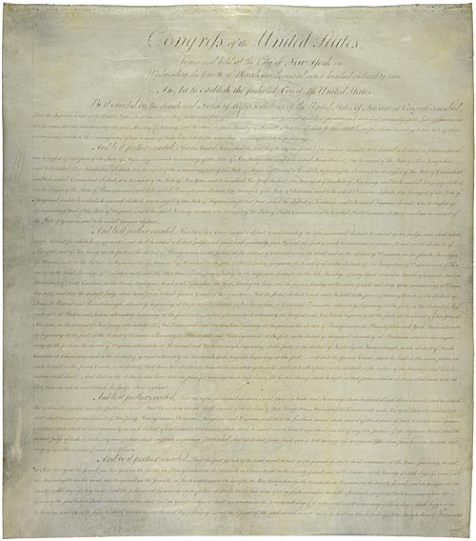
Judiciary Act of 1789 · 1st U.S. Congress · 1789
Source: Wikimedia Commons · https://commons.wikimedia.org/wiki/File:Judiciary_Act_of_1789.jpg Public domain — U.S. federal statute, 1789 https://commons.wikimedia.org/wiki/File:Judiciary_Act_of_1789.jpg
HIPPO — analyze the source (prompt) | Your analysis
H — Historical context: what was happening when this was created?
I — Intended audience: who was meant to see or obey it?
P — Purpose: why was it created?
P — Point of view: whose perspective does it reflect?
O — Outside connection: how does it connect to this standard?
SUPPORT OPTION
Sentence frame: This source shows ______ because it ______, which reveals ______.
CONFIDENCE CHECK-IN
Rate your understanding of this standard (1–4): ______ One thing to revisit: ____________________

Activity 6 — Core Application: Practice Quiz — GC.19 ⏱ ~8 min
RESPONSE CHOICE
Commit to an answer by marking it, saying it, or explaining it aloud before checking. Answer key is in the Teacher Guide (kept separate).
[DOK 1 · item u5-gc19-dok1-1 · pre-field-test]
Federal judges can be removed from office only by:
A. A national election
B. Impeachment
C. The President alone
D. A state legislature
[DOK 2 · item u1-gc19-dok2-tc · pre-field-test]
Why does the Constitution give federal judges their offices 'during good Behaviour' — effectively for life?
A. So they can decide cases free from political pressure
B. Because judges cannot be removed for any reason
C. So the President can replace them every four years
D. Because judges must also serve in Congress

STRETCH — think like a test-writer (open to all)
Write your OWN DOK-3 question for this standard, then a one-sentence answer key. Use the supports below — everyone can do this.
HOW TO WRITE A DOK-3 QUESTION (supports)
DOK-3 = strategic thinking: the reader must analyze, compare, evaluate, or justify using evidence — and there should be more than one defensible answer (not a fact you can just look up).
Sentence starters: “Why did ______ lead to ______?” · “Which mattered more — ______ or ______ — and why?” · “What is the BEST evidence that ______?” · “Evaluate whether ______.” · “Defend or challenge: ______.”
Frame: [Analyze / Evaluate / Justify] + [something from THIS standard] + “using evidence.”
Quick check: does my question make the reader THINK and use evidence? If yes, it’s DOK-3.
Your DOK-3 question | Your answer key (one sentence)

Activity 7 — Constructed Response (CER) — GC.19 ⏱ ~15 min
BIG-QUESTION ORGANIZER (before you write) — How can unelected judges check the other branches — and what limits their power?
Plan your argument here, then use it to write your claim, evidence, and reasoning below.
Plan your argument | Your quick notes (from this standard)
My claim (answer the prompt)
Evidence 1 (a source or fact)
Reasoning (why it proves the claim)
CONSTRUCTED RESPONSE (CER) — builds SSP.04 Argumentation
Claim + Evidence + Reasoning: Is life tenure for federal judges a strength or a danger for democracy? Defend your claim with evidence.
Part | Write here
Claim
Evidence (two specifics)
Reasoning
SELF-CHECK against the CER rubric (see Toolkit)
Before submitting: Is my claim defensible? Do I have TWO specific pieces of evidence? Does my reasoning explain HOW the evidence proves the claim?

UDL Access, Choice & Reflection — GC.19
UDL ACCESS & MTSS SUPPORT (this standard)
UDL 3.0 (CAST, 2024): read-aloud on request · key terms glossed (EN/ES) · respond in writing, speech, or a labeled diagram · large-print & screen-reader friendly. Same learning target for everyone; supports vary the means, not the ceiling.
MTSS: Tier 1 — this core lesson for all · Tier 2 — small-group reteach of this standard using its Cornell cues + graphic organizer, then re-check · Tier 3 — intensive 1:1 with concrete→representational→abstract scaffolding, progress-monitored to the same standard.
SHOW WHAT YOU KNOW — YOUR WAY (same CER rubric, same standard)
Build your Claim–Evidence–Reasoning in whichever mode lets you think best — the standard and the CER rubric are identical for every mode; the mode changes how you SHOW it, never what you are held to:
WRITE it · SAY it aloud and record it (audio or video) · DRAW and label a diagram that makes the argument · BUILD a model or artifact and caption its claim, evidence, and reasoning.
You may ask for a word processor, speech-to-text, a scribe, or a sentence/argument frame — these change how you produce, not the standard you meet.
CHOICE & VOICE — you decide how to go deeper (pick ONE)
You choose your path to show this standard — every option meets the same target:
DEFEND a term: pick the vocabulary word that matters most and argue why in 2–3 sentences. · CONNECT it: pick a current event, your community, or your own life and explain how this standard shows up there. · TAKE A SIDE: pick one debatable question and argue your position with evidence.
Your pick is yours — bring what matters to you into the work.
REFLECT & CONNECT — how your thinking grew, and whose view you weighed
Reflect (self-awareness): What did you believe about this topic BEFORE, and what changed AFTER? Name one thing to revisit.
Consider another view (empathy): Name one person or group who might see this standard differently than you; state their view fairly in one sentence — even if you disagree.
Norm (restorative): we critique ideas, not people; we assume good faith; we make room for every voice.

Standard GC.20 — Selecting & Confirming Justices
TN Academic Standard GC.20: Explain the processes of selection and confirmation of Supreme Court justices. (—)
LEARNING TARGETS — I can…
• I can I can explain how a Supreme Court justice is nominated by the President and confirmed by the Senate..
Lenses for this standard: Civic Structure
CORE PATH — the same for every student
Every student works this standard at the same rigor: analyze the sources and vocabulary, then demonstrate learning on the Practice Quiz and CER. UDL and MTSS give you flexible ways in — they never lower the bar. Check yourself against the learning targets on the Cornell Notes page.
SET YOUR GOAL (self-direction)
My goal for this standard — what will I be able to do, and how will I show it?

HOOK — think before you dig in
A single choice can steer the Constitution for forty years. That's why one open seat can freeze all of Washington. How does someone actually get the robe?

ACTIVATE — what do you already know or wonder?
Jot what you already know or want to find out about this standard. You’ll come back to it.

PREVIEW & PREDICT
Which learning target will be hardest, and why? Connect it to the unit’s big question: How can unelected judges check the other branches — and what limits their power?

Activity 1 — Vocabulary (Part A: Reference / Word Bank) — GC.20 ⏱ ~10 min
Use this word bank throughout the standard. The Spanish column supports access, not translation of assessment.
Term | Student-friendly meaning | Spanish
Nomination | The President's naming of a person to fill a Supreme Court vacancy; the first step in seating a justice. | nominación
Confirmation | The Senate's approval of a nominee by majority vote, after a Judiciary Committee hearing — the 'Advice and Consent' required by the Constitution. | confirmación
Senate Judiciary Committee | The Senate committee that holds hearings and questions a Supreme Court nominee before the full Senate votes. | Comité Judicial del Senado
LANGUAGE SUPPORT
Pronunciations: Nomination (nom-ih-NAY-shun); Confirmation (kon-fer-MAY-shun); Senate Judiciary Committee (joo-DISH-ee-air-ee).

VOCABULARY SELF-CHECK · Knowledge Rating
Rate each term NOW in pencil, then again at the END — growth is the goal; no penalty for “never seen it.”
Term | 1 · never seen it | 2 · heard it | 3 · can use it | 4 · can teach it
Nomination
Confirmation
Senate Judiciary Committee
MAKE IT YOURS (RESPONSE CHOICE): choose ONE term above and show you own it — write a sentence, sketch it, or give a real-world example.

QUICK WRITE
Which of these terms do you think will matter MOST for this standard, and why? You’ll revisit this at the end.

Activity 2 — Vocabulary Studio (Frayer-inspired) — GC.20 ⏱ ~7 min
RESPONSE CHOICE
Complete each studio by writing, speaking, or diagramming.

PRIORITY TERM 1 Nomination · ES: nominación
Word-bank meaning to build on: The President's naming of a person to fill a Supreme Court vacancy; the first step in seating a justice.
Definition (in your own words) | Characteristics
Examples | Non-examples
Use it to explain
Write one sentence that uses “Nomination” to explain this standard.

PRIORITY TERM 2 Confirmation · ES: confirmación
Word-bank meaning to build on: The Senate's approval of a nominee by majority vote, after a Judiciary Committee hearing — the 'Advice and Consent' required by the Constitution.
Definition (in your own words) | Characteristics
Examples | Non-examples
Use it to explain
Write one sentence that uses “Confirmation” to explain this standard.

CONNECT THE TERMS (UDL · build understanding)
How do these priority terms fit together? Write or sketch how one leads to or affects another.

Activity 3 — Direct Teaching Cornell Notes — GC.20 ⏱ ~20 min
Name: ______________________ Class / Period: __________ Date: __________
GC.20 — Selecting & Confirming Justices • Lean Student Deck slides 2–8 • direct-teaching slides 4–6
Your learning targets are on this standard’s opening page — take notes that help you meet them.
Guiding cues | My notes — write your notes here
Key idea of this standard?
One source that supports it?
One check the courts provide?
Key terms →
Keep taking notes — lines run the full width of the page:

DOODLE ZONE — draw your thinking (UDL · another way in)
Need another way in? Sketch the key idea, a quick timeline, or how the pieces connect. Words optional.

Cornell Notes — keep going, then process & check — GC.20
MORE NOTES / DIAGRAMS
Continue your notes here, add a quick sketch, or map how the ideas connect.

Key terms to list
Nomination · Confirmation · Senate Judiciary Committee
Summary — In your own words (2–3 sentences)
PROGRESS CHECK · one question
Which two parts of government share the power to seat a new Supreme Court justice?
A. The House and the Senate
B. The President and the Supreme Court
C. The President nominates and the Senate confirms
D. The states and the Supreme Court
Commit before you move on — mark it, say it, or explain it aloud.
CHECK YOURSELF — how am I doing?
Which learning targets (on this standard’s opening page) can you now meet? Tick the number; circle any you still need help with.
☐ 1
My 12–15 word headline for this standard

Guided Support for the Cornell Notes — GC.20
These scaffolds support ONLY the Cornell notes — use them to take and process those notes. Optional and easy to set aside; not a separate assignment or a label.
Key vocabulary | What it means
Nomination | The President's naming of a person to fill a Supreme Court vacancy; the first step in seating a justice.
Confirmation | The Senate's approval of a nominee by majority vote, after a Judiciary Committee hearing — the 'Advice and Consent' required by the Constitution.
Senate Judiciary Committee | The Senate committee that holds hearings and questions a Supreme Court nominee before the full Senate votes.
Break it into steps:
1) Name one cause or effect. 2) Give one piece of evidence. 3) Write one sentence explaining the link.
Sentence frame
One key cause/effect of selecting & confirming justices was ______, shown by ______, which mattered because ______.
Modeled example (one worked note — yours will differ)
A key idea of selecting & confirming justices was Nomination: The President's naming of a person to fill a Supreme Court vacancy; the first step in seating a justice.
GUIDED NOTE REHEARSAL LAB
Rehearse the cause→effect chain below, then transfer it to your Cornell notes.
Step | Rehearse it here
Name it
Evidence
Explain
Headline
TRANSFER CHECK — move one rehearsed idea onto the front notes

Light Support for the Cornell Notes — GC.20
A lighter scaffold for the SAME Cornell notes. Try the notes first; reach for this only if you need it.
Key vocabulary | Finish the idea — “This term means …”
Nomination
Confirmation
Senate Judiciary Committee
Guiding questions — answer on the lines below (or in your front notes):
• What are the two steps to seat a Supreme Court justice, and who controls each?
• What does the Senate Judiciary Committee do before the full Senate votes?
• Why are confirmations so high-stakes, given how long a justice can serve?

WHICH CUE STILL NEEDS WORK?
Circle the Cornell cue from the front page you still need help with, and tell your teacher so we can go over it.
LIGHT PROCESSING LAB
Answer one guiding question from above in a full sentence, in your own words.

Activity 4 — Close Read — GC.20 ⏱ ~15 min
Reading type: Government Hack-authored instructional synthesis. This is not a primary source. Builds SSP.03 (synthesize) and SSP.05 (historical awareness).
CORE PATH
No one reaches the Supreme Court alone. When a seat opens, the President nominates a candidate — the first step. The nomination then goes to the Senate, which holds the power of 'Advice and Consent.' The Senate Judiciary Committee holds public hearings, questioning the nominee about their record and judicial philosophy, then recommends the nominee to the full Senate, which confirms by a majority vote. Because a justice serves 'during good Behaviour' — often for decades — a single appointment can shape the law long after the President who made it has left office. That high stakes has turned confirmations into some of the most closely watched political contests in Washington. The process is a deliberate check: the President chooses, but only the Senate can seat.
LANGUAGE SUPPORT
Key terms to know first: Nomination, Confirmation. Read once for the gist, then again for evidence.
Text-dependent questions (answer in the Evidence Lab below or aloud):
1. What are the two steps to seat a Supreme Court justice, and who controls each?
2. What does the Senate Judiciary Committee do before the full Senate votes?
3. Why are confirmations so high-stakes, given how long a justice can serve?
RESPONSE CHOICE: answer any question by writing in the Evidence Lab, saying/recording it, or diagramming it.
CLOSE-READ EVIDENCE LAB
Log evidence from the passage below.
Question / claim | Exact passage evidence | What the evidence shows

SPACED RETRIEVAL — quick recall (no notes)
Pull it up cold to strengthen memory, then check your notes.
Recall prompt | Your answer (from memory)
One key term or fact from THIS standard
One thing you learned EARLIER in this unit or course
How the two connect

Activity 5 — Primary Source / Data Analysis — GC.20 ⏱ ~15 min
Primary source (portrait) — analyze it with HIPPO. Builds SSP.01–SSP.02.
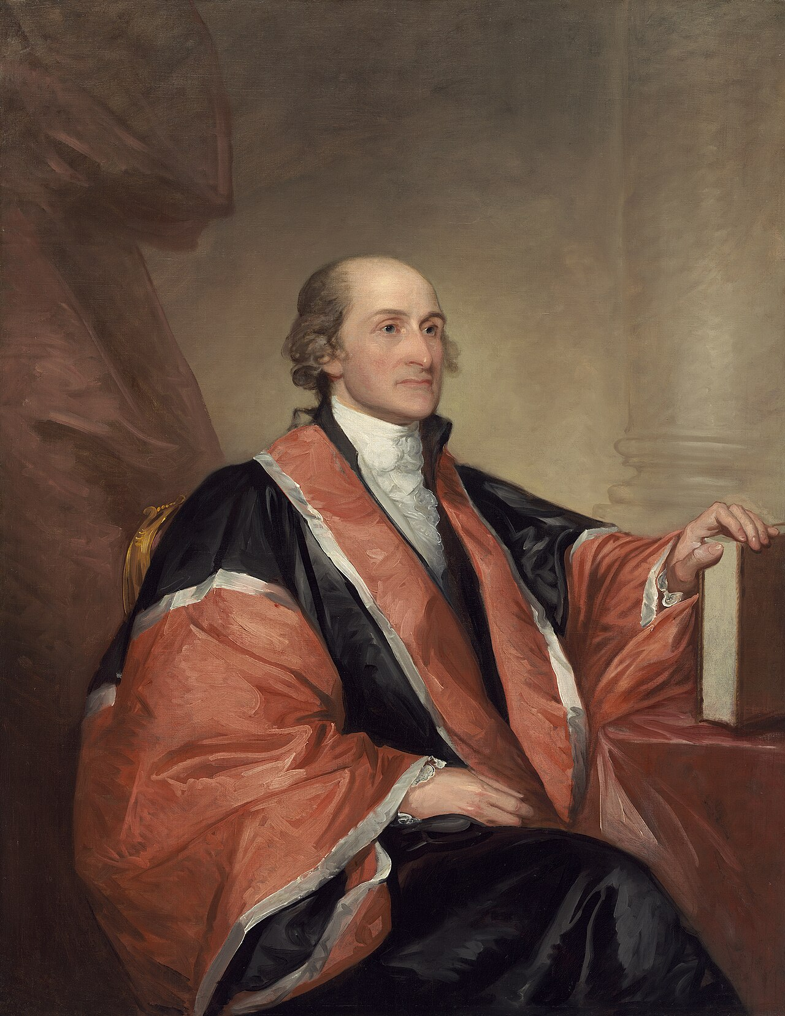
John Jay · Gilbert Stuart · 1794
Source: Wikimedia Commons · https://commons.wikimedia.org/wiki/File:Gilbert_Stuart,_John_Jay,_1794,_NGA_75023.jpg Public domain — pre-1929; National Gallery of Art https://commons.wikimedia.org/wiki/File:Gilbert_Stuart,_John_Jay,_1794,_NGA_75023.jpg
HIPPO — analyze the source (prompt) | Your analysis
H — Historical context: what was happening when this was created?
I — Intended audience: who was meant to see or obey it?
P — Purpose: why was it created?
P — Point of view: whose perspective does it reflect?
O — Outside connection: how does it connect to this standard?
SUPPORT OPTION
Sentence frame: This source shows ______ because it ______, which reveals ______.
CONFIDENCE CHECK-IN
Rate your understanding of this standard (1–4): ______ One thing to revisit: ____________________

Activity 6 — Core Application: Practice Quiz — GC.20 ⏱ ~8 min
RESPONSE CHOICE
Commit to an answer by marking it, saying it, or explaining it aloud before checking. Answer key is in the Teacher Guide (kept separate).
[DOK 1 · item u5-gc20-dok1-1 · pre-field-test]
After the President nominates a Supreme Court justice, who must confirm the nominee?
A. The House
B. The Senate
C. The states
D. The current justices
[DOK 2 · item u1-gc20-dok2-tc · pre-field-test]
Which two parts of government share the power to seat a new Supreme Court justice?
A. The House and the Senate
B. The President and the Supreme Court
C. The President nominates and the Senate confirms
D. The states and the Supreme Court

STRETCH — think like a test-writer (open to all)
Write your OWN DOK-3 question for this standard, then a one-sentence answer key. Use the supports below — everyone can do this.
HOW TO WRITE A DOK-3 QUESTION (supports)
DOK-3 = strategic thinking: the reader must analyze, compare, evaluate, or justify using evidence — and there should be more than one defensible answer (not a fact you can just look up).
Sentence starters: “Why did ______ lead to ______?” · “Which mattered more — ______ or ______ — and why?” · “What is the BEST evidence that ______?” · “Evaluate whether ______.” · “Defend or challenge: ______.”
Frame: [Analyze / Evaluate / Justify] + [something from THIS standard] + “using evidence.”
Quick check: does my question make the reader THINK and use evidence? If yes, it’s DOK-3.
Your DOK-3 question | Your answer key (one sentence)

Activity 7 — Constructed Response (CER) — GC.20 ⏱ ~15 min
BIG-QUESTION ORGANIZER (before you write) — How can unelected judges check the other branches — and what limits their power?
Plan your argument here, then use it to write your claim, evidence, and reasoning below.
Plan your argument | Your quick notes (from this standard)
My claim (answer the prompt)
Evidence 1 (a source or fact)
Reasoning (why it proves the claim)
CONSTRUCTED RESPONSE (CER) — builds SSP.04 Argumentation
Claim + Evidence + Reasoning: Should Supreme Court confirmations require a simple majority, or a larger supermajority of the Senate? Defend your claim.
Part | Write here
Claim
Evidence (two specifics)
Reasoning
SELF-CHECK against the CER rubric (see Toolkit)
Before submitting: Is my claim defensible? Do I have TWO specific pieces of evidence? Does my reasoning explain HOW the evidence proves the claim?

UDL Access, Choice & Reflection — GC.20
UDL ACCESS & MTSS SUPPORT (this standard)
UDL 3.0 (CAST, 2024): read-aloud on request · key terms glossed (EN/ES) · respond in writing, speech, or a labeled diagram · large-print & screen-reader friendly. Same learning target for everyone; supports vary the means, not the ceiling.
MTSS: Tier 1 — this core lesson for all · Tier 2 — small-group reteach of this standard using its Cornell cues + graphic organizer, then re-check · Tier 3 — intensive 1:1 with concrete→representational→abstract scaffolding, progress-monitored to the same standard.
SHOW WHAT YOU KNOW — YOUR WAY (same CER rubric, same standard)
Build your Claim–Evidence–Reasoning in whichever mode lets you think best — the standard and the CER rubric are identical for every mode; the mode changes how you SHOW it, never what you are held to:
WRITE it · SAY it aloud and record it (audio or video) · DRAW and label a diagram that makes the argument · BUILD a model or artifact and caption its claim, evidence, and reasoning.
You may ask for a word processor, speech-to-text, a scribe, or a sentence/argument frame — these change how you produce, not the standard you meet.
CHOICE & VOICE — you decide how to go deeper (pick ONE)
You choose your path to show this standard — every option meets the same target:
DEFEND a term: pick the vocabulary word that matters most and argue why in 2–3 sentences. · CONNECT it: pick a current event, your community, or your own life and explain how this standard shows up there. · TAKE A SIDE: pick one debatable question and argue your position with evidence.
Your pick is yours — bring what matters to you into the work.
REFLECT & CONNECT — how your thinking grew, and whose view you weighed
Reflect (self-awareness): What did you believe about this topic BEFORE, and what changed AFTER? Name one thing to revisit.
Consider another view (empathy): Name one person or group who might see this standard differently than you; state their view fairly in one sentence — even if you disagree.
Norm (restorative): we critique ideas, not people; we assume good faith; we make room for every voice.

Standard GC.21 — Judicial Review & Marbury v. Madison
TN Academic Standard GC.21: Explain the process of judicial review established by Marbury v. Madison. (H, T)
LEARNING TARGETS — I can…
• I can I can explain judicial review and how Marbury v. Madison (1803) established it..
Lenses for this standard: History (H) · Tennessee (T)
CORE PATH — the same for every student
Every student works this standard at the same rigor: analyze the sources and vocabulary, then demonstrate learning on the Practice Quiz and CER. UDL and MTSS give you flexible ways in — they never lower the bar. Check yourself against the learning targets on the Cornell Notes page.
SET YOUR GOAL (self-direction)
My goal for this standard — what will I be able to do, and how will I show it?

HOOK — think before you dig in
The Constitution never says the courts can cancel a law — so how did nine judges claim the power to overrule Congress? One 1803 case answered it forever.

ACTIVATE — what do you already know or wonder?
Jot what you already know or want to find out about this standard. You’ll come back to it.

PREVIEW & PREDICT
Which learning target will be hardest, and why? Connect it to the unit’s big question: How can unelected judges check the other branches — and what limits their power?

Activity 1 — Vocabulary (Part A: Reference / Word Bank) — GC.21 ⏱ ~10 min
Use this word bank throughout the standard. The Spanish column supports access, not translation of assessment.
Term | Student-friendly meaning | Spanish
Judicial Review | The power of the courts to declare a law or government action unconstitutional and therefore void — established by Marbury v. Madison. | revisión judicial
Unconstitutional | Conflicting with the Constitution; a law found unconstitutional cannot be enforced. | inconstitucional
Precedent | A court decision that guides how similar cases are decided in the future; Marbury set the precedent of judicial review. | precedente
LANGUAGE SUPPORT
Pronunciations: Judicial Review (joo-DISH-ul ree-VYOO); Unconstitutional (un-kon-stih-TOO-shun-ul); Precedent (PRESS-ih-dent).

VOCABULARY SELF-CHECK · Knowledge Rating
Rate each term NOW in pencil, then again at the END — growth is the goal; no penalty for “never seen it.”
Term | 1 · never seen it | 2 · heard it | 3 · can use it | 4 · can teach it
Judicial Review
Unconstitutional
Precedent
MAKE IT YOURS (RESPONSE CHOICE): choose ONE term above and show you own it — write a sentence, sketch it, or give a real-world example.

QUICK WRITE
Which of these terms do you think will matter MOST for this standard, and why? You’ll revisit this at the end.

Activity 2 — Vocabulary Studio (Frayer-inspired) — GC.21 ⏱ ~7 min
RESPONSE CHOICE
Complete each studio by writing, speaking, or diagramming.

PRIORITY TERM 1 Judicial Review · ES: revisión judicial
Word-bank meaning to build on: The power of the courts to declare a law or government action unconstitutional and therefore void — established by Marbury v. Madison.
Definition (in your own words) | Characteristics
Examples | Non-examples
Use it to explain
Write one sentence that uses “Judicial Review” to explain this standard.

PRIORITY TERM 2 Precedent · ES: precedente
Word-bank meaning to build on: A court decision that guides how similar cases are decided in the future; Marbury set the precedent of judicial review.
Definition (in your own words) | Characteristics
Examples | Non-examples
Use it to explain
Write one sentence that uses “Precedent” to explain this standard.

CONNECT THE TERMS (UDL · build understanding)
How do these priority terms fit together? Write or sketch how one leads to or affects another.

Activity 3 — Direct Teaching Cornell Notes — GC.21 ⏱ ~20 min
Name: ______________________ Class / Period: __________ Date: __________
GC.21 — Judicial Review & Marbury v. Madison • Lean Student Deck slides 2–8 • direct-teaching slides 4–6
Your learning targets are on this standard’s opening page — take notes that help you meet them.
Guiding cues | My notes — write your notes here
Key idea of this standard?
One source that supports it?
One check the courts provide?
Key terms →
Keep taking notes — lines run the full width of the page:

DOODLE ZONE — draw your thinking (UDL · another way in)
Need another way in? Sketch the key idea, a quick timeline, or how the pieces connect. Words optional.

Cornell Notes — keep going, then process & check — GC.21
MORE NOTES / DIAGRAMS
Continue your notes here, add a quick sketch, or map how the ideas connect.

Key terms to list
Judicial Review · Unconstitutional · Precedent
Summary — In your own words (2–3 sentences)
PROGRESS CHECK · one question
What power did Marbury v. Madison (1803) establish for the courts?
A. The power to elect the President
B. Judicial review — the power to declare a law unconstitutional and void
C. The power to collect taxes
D. The power to declare war
Commit before you move on — mark it, say it, or explain it aloud.
CHECK YOURSELF — how am I doing?
Which learning targets (on this standard’s opening page) can you now meet? Tick the number; circle any you still need help with.
☐ 1
My 12–15 word headline for this standard

Guided Support for the Cornell Notes — GC.21
These scaffolds support ONLY the Cornell notes — use them to take and process those notes. Optional and easy to set aside; not a separate assignment or a label.
Key vocabulary | What it means
Judicial Review | The power of the courts to declare a law or government action unconstitutional and therefore void — established by Marbury v. Madison.
Unconstitutional | Conflicting with the Constitution; a law found unconstitutional cannot be enforced.
Precedent | A court decision that guides how similar cases are decided in the future; Marbury set the precedent of judicial review.
Break it into steps:
1) Name one cause or effect. 2) Give one piece of evidence. 3) Write one sentence explaining the link.
Sentence frame
One key cause/effect of judicial review & marbury v. madison was ______, shown by ______, which mattered because ______.
Modeled example (one worked note — yours will differ)
A key idea of judicial review & marbury v. madison was Judicial Review: The power of the courts to declare a law or government action unconstitutional and therefore void — established by Marbury v. Madison.
GUIDED NOTE REHEARSAL LAB
Rehearse the cause→effect chain below, then transfer it to your Cornell notes.
Step | Rehearse it here
Name it
Evidence
Explain
Headline
TRANSFER CHECK — move one rehearsed idea onto the front notes

Light Support for the Cornell Notes — GC.21
A lighter scaffold for the SAME Cornell notes. Try the notes first; reach for this only if you need it.
Key vocabulary | Finish the idea — “This term means …”
Judicial Review
Unconstitutional
Precedent
Guiding questions — answer on the lines below (or in your front notes):
• According to Marshall, whose job is it 'to say what the law is'?
• Why does Marshall conclude that a law conflicting with the Constitution must be void?
• How did Marbury v. Madison change the power of the judicial branch?

WHICH CUE STILL NEEDS WORK?
Circle the Cornell cue from the front page you still need help with, and tell your teacher so we can go over it.
LIGHT PROCESSING LAB
Answer one guiding question from above in a full sentence, in your own words.

Activity 4 — Close Read — GC.21 ⏱ ~15 min
Reading type: Government Hack-authored instructional synthesis. This is not a primary source. Builds SSP.03 (synthesize) and SSP.05 (historical awareness).
CORE PATH
The Constitution never explicitly says the courts can strike down a law — the Supreme Court claimed that power itself, in Marbury v. Madison (1803). In a dispute over a last-minute judicial appointment, Chief Justice John Marshall reasoned that when a law conflicts with the Constitution, the Constitution must win, because it is the supreme law. 'It is emphatically the province and duty of the judicial department to say what the law is,' he wrote, and 'a law repugnant to the constitution is void.' With that, Marshall established judicial review — the power of courts to declare laws and government actions unconstitutional. It made the judiciary a true check on the other branches and set the precedent that still governs how the Court operates. A branch that controls neither the army nor the budget gained the last word on what the Constitution means.
LANGUAGE SUPPORT
Key terms to know first: Judicial Review, Unconstitutional. Read once for the gist, then again for evidence.
Text-dependent questions (answer in the Evidence Lab below or aloud):
1. According to Marshall, whose job is it 'to say what the law is'?
2. Why does Marshall conclude that a law conflicting with the Constitution must be void?
3. How did Marbury v. Madison change the power of the judicial branch?
RESPONSE CHOICE: answer any question by writing in the Evidence Lab, saying/recording it, or diagramming it.
CLOSE-READ EVIDENCE LAB
Log evidence from the passage below.
Question / claim | Exact passage evidence | What the evidence shows

SPACED RETRIEVAL — quick recall (no notes)
Pull it up cold to strengthen memory, then check your notes.
Recall prompt | Your answer (from memory)
One key term or fact from THIS standard
One thing you learned EARLIER in this unit or course
How the two connect

Activity 5 — Primary Source / Data Analysis — GC.21 ⏱ ~15 min
Primary source (portrait) — analyze it with HIPPO. Builds SSP.01–SSP.02.
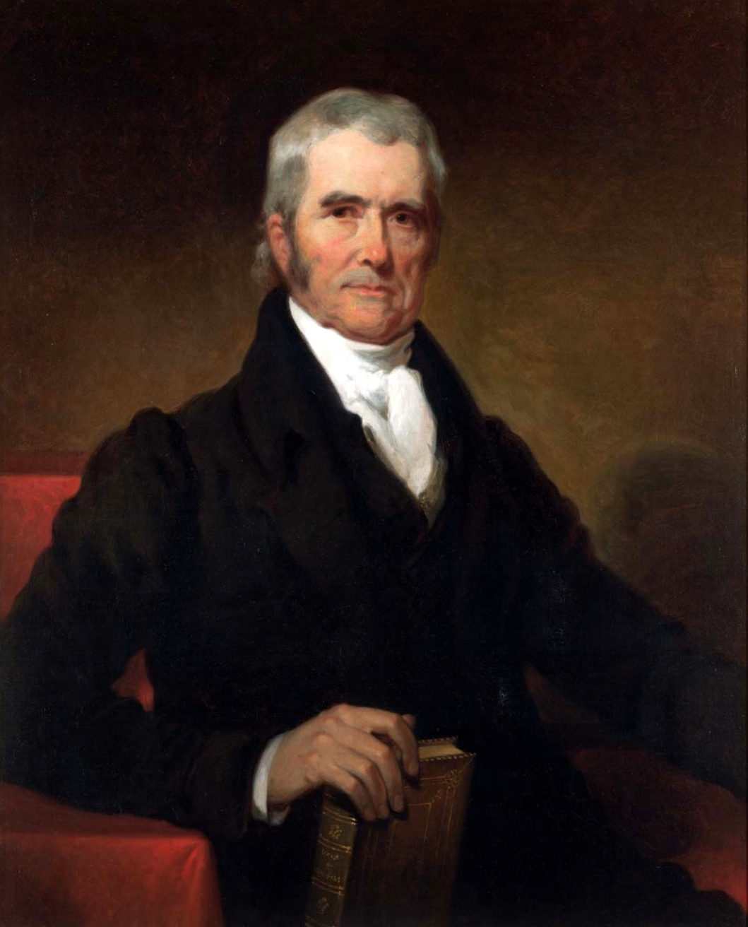
Chief Justice John Marshall (judicial review / Marbury) · (artist unconfirmed) · 19th c.
Source: Wikimedia Commons · https://commons.wikimedia.org/wiki/File:Chief_Justice_John_Marshall.jpg Public domain — portrait pre-1929 (Marshall d.1835) https://commons.wikimedia.org/wiki/File:Chief_Justice_John_Marshall.jpg
HIPPO — analyze the source (prompt) | Your analysis
H — Historical context: what was happening when this was created?
I — Intended audience: who was meant to see or obey it?
P — Purpose: why was it created?
P — Point of view: whose perspective does it reflect?
O — Outside connection: how does it connect to this standard?
SUPPORT OPTION
Sentence frame: This source shows ______ because it ______, which reveals ______.
CONFIDENCE CHECK-IN
Rate your understanding of this standard (1–4): ______ One thing to revisit: ____________________

Activity 6 — Core Application: Practice Quiz — GC.21 ⏱ ~8 min
RESPONSE CHOICE
Commit to an answer by marking it, saying it, or explaining it aloud before checking. Answer key is in the Teacher Guide (kept separate).
[DOK 1 · item u5-gc21-dok1-1 · pre-field-test]
The 1803 case that established judicial review was:
A. McCulloch v. Maryland
B. Baker v. Carr
C. Marbury v. Madison
D. Plessy v. Ferguson
[DOK 3 · item u1-gc21-dok3-tc · pre-field-test]
What power did Marbury v. Madison (1803) establish for the courts?
A. The power to elect the President
B. Judicial review — the power to declare a law unconstitutional and void
C. The power to collect taxes
D. The power to declare war

STRETCH — think like a test-writer (open to all)
Write your OWN DOK-3 question for this standard, then a one-sentence answer key. Use the supports below — everyone can do this.
HOW TO WRITE A DOK-3 QUESTION (supports)
DOK-3 = strategic thinking: the reader must analyze, compare, evaluate, or justify using evidence — and there should be more than one defensible answer (not a fact you can just look up).
Sentence starters: “Why did ______ lead to ______?” · “Which mattered more — ______ or ______ — and why?” · “What is the BEST evidence that ______?” · “Evaluate whether ______.” · “Defend or challenge: ______.”
Frame: [Analyze / Evaluate / Justify] + [something from THIS standard] + “using evidence.”
Quick check: does my question make the reader THINK and use evidence? If yes, it’s DOK-3.
Your DOK-3 question | Your answer key (one sentence)

Activity 7 — Constructed Response (CER) — GC.21 ⏱ ~15 min
BIG-QUESTION ORGANIZER (before you write) — How can unelected judges check the other branches — and what limits their power?
Plan your argument here, then use it to write your claim, evidence, and reasoning below.
Plan your argument | Your quick notes (from this standard)
My claim (answer the prompt)
Evidence 1 (a source or fact)
Reasoning (why it proves the claim)
CONSTRUCTED RESPONSE (CER) — builds SSP.04 Argumentation
Claim + Evidence + Reasoning: Was Marshall right to claim the power of judicial review, even though the Constitution does not list it? Defend your claim with evidence from the opinion.
Part | Write here
Claim
Evidence (two specifics)
Reasoning
SELF-CHECK against the CER rubric (see Toolkit)
Before submitting: Is my claim defensible? Do I have TWO specific pieces of evidence? Does my reasoning explain HOW the evidence proves the claim?

UDL Access, Choice & Reflection — GC.21
UDL ACCESS & MTSS SUPPORT (this standard)
UDL 3.0 (CAST, 2024): read-aloud on request · key terms glossed (EN/ES) · respond in writing, speech, or a labeled diagram · large-print & screen-reader friendly. Same learning target for everyone; supports vary the means, not the ceiling.
MTSS: Tier 1 — this core lesson for all · Tier 2 — small-group reteach of this standard using its Cornell cues + graphic organizer, then re-check · Tier 3 — intensive 1:1 with concrete→representational→abstract scaffolding, progress-monitored to the same standard.
SHOW WHAT YOU KNOW — YOUR WAY (same CER rubric, same standard)
Build your Claim–Evidence–Reasoning in whichever mode lets you think best — the standard and the CER rubric are identical for every mode; the mode changes how you SHOW it, never what you are held to:
WRITE it · SAY it aloud and record it (audio or video) · DRAW and label a diagram that makes the argument · BUILD a model or artifact and caption its claim, evidence, and reasoning.
You may ask for a word processor, speech-to-text, a scribe, or a sentence/argument frame — these change how you produce, not the standard you meet.
CHOICE & VOICE — you decide how to go deeper (pick ONE)
You choose your path to show this standard — every option meets the same target:
DEFEND a term: pick the vocabulary word that matters most and argue why in 2–3 sentences. · CONNECT it: pick a current event, your community, or your own life and explain how this standard shows up there. · TAKE A SIDE: pick one debatable question and argue your position with evidence.
Your pick is yours — bring what matters to you into the work.
REFLECT & CONNECT — how your thinking grew, and whose view you weighed
Reflect (self-awareness): What did you believe about this topic BEFORE, and what changed AFTER? Name one thing to revisit.
Consider another view (empathy): Name one person or group who might see this standard differently than you; state their view fairly in one sentence — even if you disagree.
Norm (restorative): we critique ideas, not people; we assume good faith; we make room for every voice.

Standard GC.22 — Deciding What Is Constitutional
TN Academic Standard GC.22: Describe the Supreme Court's role in determining the constitutionality of laws and acts of the legislative and executive branches. (T)
LEARNING TARGETS — I can…
• I can I can describe how the Supreme Court decides constitutionality, and explain judicial activism and restraint..
Lenses for this standard: Tennessee (T)
CORE PATH — the same for every student
Every student works this standard at the same rigor: analyze the sources and vocabulary, then demonstrate learning on the Practice Quiz and CER. UDL and MTSS give you flexible ways in — they never lower the bar. Check yourself against the learning targets on the Cornell Notes page.
SET YOUR GOAL (self-direction)
My goal for this standard — what will I be able to do, and how will I show it?

HOOK — think before you dig in
Thousands of cases ask the Supreme Court for a hearing each year; it takes only about 60. Who decides which — and how boldly should they rule once they do?

ACTIVATE — what do you already know or wonder?
Jot what you already know or want to find out about this standard. You’ll come back to it.

PREVIEW & PREDICT
Which learning target will be hardest, and why? Connect it to the unit’s big question: How can unelected judges check the other branches — and what limits their power?

Activity 1 — Vocabulary (Part A: Reference / Word Bank) — GC.22 ⏱ ~10 min
Use this word bank throughout the standard. The Spanish column supports access, not translation of assessment.
Term | Student-friendly meaning | Spanish
Writ of Certiorari | An order by which the Supreme Court agrees to hear a case; it takes the 'rule of four' — four of the nine justices — to grant it. | auto de avocación (certiorari)
Judicial Activism | An approach in which judges are more willing to strike down laws or set new policy, often reading the Constitution as a 'living document.' | activismo judicial
Judicial Restraint | An approach in which judges defer to the elected branches and to precedent, interpreting the Constitution narrowly by its 'original intent.' | moderación judicial
LANGUAGE SUPPORT
Pronunciations: Writ of Certiorari (sur-shee-uh-RAIR-ee); Judicial Activism (AK-tiv-iz-um); Judicial Restraint (ree-STRAYNT).

VOCABULARY SELF-CHECK · Knowledge Rating
Rate each term NOW in pencil, then again at the END — growth is the goal; no penalty for “never seen it.”
Term | 1 · never seen it | 2 · heard it | 3 · can use it | 4 · can teach it
Writ of Certiorari
Judicial Activism
Judicial Restraint
MAKE IT YOURS (RESPONSE CHOICE): choose ONE term above and show you own it — write a sentence, sketch it, or give a real-world example.

QUICK WRITE
Which of these terms do you think will matter MOST for this standard, and why? You’ll revisit this at the end.

Activity 2 — Vocabulary Studio (Frayer-inspired) — GC.22 ⏱ ~7 min
RESPONSE CHOICE
Complete each studio by writing, speaking, or diagramming.

PRIORITY TERM 1 Judicial Activism · ES: activismo judicial
Word-bank meaning to build on: An approach in which judges are more willing to strike down laws or set new policy, often reading the Constitution as a 'living document.'
Definition (in your own words) | Characteristics
Examples | Non-examples
Use it to explain
Write one sentence that uses “Judicial Activism” to explain this standard.

PRIORITY TERM 2 Judicial Restraint · ES: moderación judicial
Word-bank meaning to build on: An approach in which judges defer to the elected branches and to precedent, interpreting the Constitution narrowly by its 'original intent.'
Definition (in your own words) | Characteristics
Examples | Non-examples
Use it to explain
Write one sentence that uses “Judicial Restraint” to explain this standard.

CONNECT THE TERMS (UDL · build understanding)
How do these priority terms fit together? Write or sketch how one leads to or affects another.

Activity 3 — Direct Teaching Cornell Notes — GC.22 ⏱ ~20 min
Name: ______________________ Class / Period: __________ Date: __________
GC.22 — Deciding What Is Constitutional • Lean Student Deck slides 2–8 • direct-teaching slides 4–6
Your learning targets are on this standard’s opening page — take notes that help you meet them.
Guiding cues | My notes — write your notes here
Key idea of this standard?
One source that supports it?
One check the courts provide?
Key terms →
Keep taking notes — lines run the full width of the page:

DOODLE ZONE — draw your thinking (UDL · another way in)
Need another way in? Sketch the key idea, a quick timeline, or how the pieces connect. Words optional.

Cornell Notes — keep going, then process & check — GC.22
MORE NOTES / DIAGRAMS
Continue your notes here, add a quick sketch, or map how the ideas connect.

Key terms to list
Writ of Certiorari · Judicial Activism · Judicial Restraint
Summary — In your own words (2–3 sentences)
PROGRESS CHECK · one question
How do judicial activism and judicial restraint differ?
A. Activism means judges never rule; restraint means they rule on everything
B. Activism applies only to state courts; restraint only to federal courts
C. They are two names for the same approach
D. Activism is a greater willingness to strike down laws or set new policy; restraint defers to the elected branches and precedent
Commit before you move on — mark it, say it, or explain it aloud.
CHECK YOURSELF — how am I doing?
Which learning targets (on this standard’s opening page) can you now meet? Tick the number; circle any you still need help with.
☐ 1
My 12–15 word headline for this standard

Guided Support for the Cornell Notes — GC.22
These scaffolds support ONLY the Cornell notes — use them to take and process those notes. Optional and easy to set aside; not a separate assignment or a label.
Key vocabulary | What it means
Writ of Certiorari | An order by which the Supreme Court agrees to hear a case; it takes the 'rule of four' — four of the nine justices — to grant it.
Judicial Activism | An approach in which judges are more willing to strike down laws or set new policy, often reading the Constitution as a 'living document.'
Judicial Restraint | An approach in which judges defer to the elected branches and to precedent, interpreting the Constitution narrowly by its 'original intent.'
Break it into steps:
1) Name one cause or effect. 2) Give one piece of evidence. 3) Write one sentence explaining the link.
Sentence frame
One key cause/effect of deciding what is constitutional was ______, shown by ______, which mattered because ______.
Modeled example (one worked note — yours will differ)
A key idea of deciding what is constitutional was Writ of Certiorari: An order by which the Supreme Court agrees to hear a case; it takes the 'rule of four' — four of the nine justices — to grant it.
GUIDED NOTE REHEARSAL LAB
Rehearse the cause→effect chain below, then transfer it to your Cornell notes.
Step | Rehearse it here
Name it
Evidence
Explain
Headline
TRANSFER CHECK — move one rehearsed idea onto the front notes

Light Support for the Cornell Notes — GC.22
A lighter scaffold for the SAME Cornell notes. Try the notes first; reach for this only if you need it.
Key vocabulary | Finish the idea — “This term means …”
Writ of Certiorari
Judicial Activism
Judicial Restraint
Guiding questions — answer on the lines below (or in your front notes):
• How does a case actually reach the Supreme Court (cert and the 'rule of four')?
• Contrast judicial activism and judicial restraint using an example of each.
• How does the Supremacy Clause support the Court's power to strike down conflicting laws?

WHICH CUE STILL NEEDS WORK?
Circle the Cornell cue from the front page you still need help with, and tell your teacher so we can go over it.
LIGHT PROCESSING LAB
Answer one guiding question from above in a full sentence, in your own words.

Activity 4 — Close Read — GC.22 ⏱ ~15 min
Reading type: Government Hack-authored instructional synthesis. This is not a primary source. Builds SSP.03 (synthesize) and SSP.05 (historical awareness).
CORE PATH
Because Marbury established judicial review, the Supreme Court is the final judge of whether a law or executive act is constitutional. Getting there is selective: after losing in lower courts, a party petitions for a writ of certiorari, and it takes the 'rule of four' — four of the nine justices — for the Court to take the case. When the Court rules, it does not just settle that dispute; it sets precedent for the whole country. How boldly the Court should use this power is contested. Judges who practice judicial activism are more willing to strike down laws or set new policy, often treating the Constitution as a 'living document' that adapts to the times. Judges who practice judicial restraint defer to the elected branches and to precedent, reading the Constitution by its 'original intent.' The Warren, Burger, Rehnquist, and Roberts Courts are often placed along this spectrum. As Marshall put it, 'the constitution controls any legislative act repugnant to it' — but reasonable people still argue over what the Constitution requires.
LANGUAGE SUPPORT
Key terms to know first: Writ of Certiorari, Judicial Activism. Read once for the gist, then again for evidence.
Text-dependent questions (answer in the Evidence Lab below or aloud):
1. How does a case actually reach the Supreme Court (cert and the 'rule of four')?
2. Contrast judicial activism and judicial restraint using an example of each.
3. How does the Supremacy Clause support the Court's power to strike down conflicting laws?
RESPONSE CHOICE: answer any question by writing in the Evidence Lab, saying/recording it, or diagramming it.
CLOSE-READ EVIDENCE LAB
Log evidence from the passage below.
Question / claim | Exact passage evidence | What the evidence shows

SPACED RETRIEVAL — quick recall (no notes)
Pull it up cold to strengthen memory, then check your notes.
Recall prompt | Your answer (from memory)
One key term or fact from THIS standard
One thing you learned EARLIER in this unit or course
How the two connect

Activity 5 — Primary Source / Data Analysis — GC.22 ⏱ ~15 min
Primary source (photo) — analyze it with HIPPO. Builds SSP.01–SSP.02.
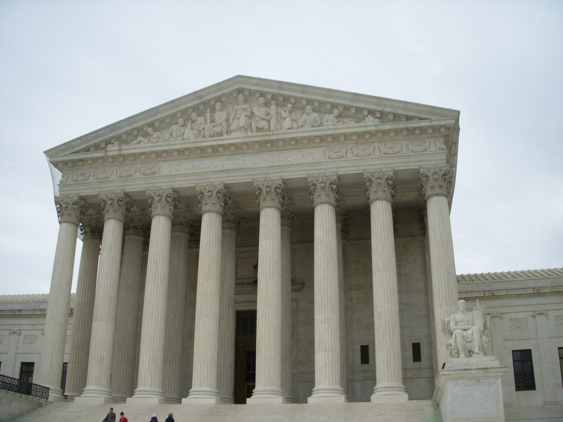
U.S. Supreme Court Building · Ken Hammond (USDA) · modern
Source: Wikimedia Commons · https://commons.wikimedia.org/wiki/File:Supreme_Court.jpg Public domain — U.S. federal (USDA) work https://commons.wikimedia.org/wiki/File:Supreme_Court.jpg
HIPPO — analyze the source (prompt) | Your analysis
H — Historical context: what was happening when this was created?
I — Intended audience: who was meant to see or obey it?
P — Purpose: why was it created?
P — Point of view: whose perspective does it reflect?
O — Outside connection: how does it connect to this standard?
SUPPORT OPTION
Sentence frame: This source shows ______ because it ______, which reveals ______.
CONFIDENCE CHECK-IN
Rate your understanding of this standard (1–4): ______ One thing to revisit: ____________________

Activity 6 — Core Application: Practice Quiz — GC.22 ⏱ ~8 min
RESPONSE CHOICE
Commit to an answer by marking it, saying it, or explaining it aloud before checking. Answer key is in the Teacher Guide (kept separate).
[DOK 1 · item u5-gc22-dok1-1 · pre-field-test]
The number of justices needed to agree to hear a case (grant certiorari) is:
A. Four
B. Five
C. Six
D. Nine
[DOK 3 · item u1-gc22-dok3-tc · pre-field-test]
How do judicial activism and judicial restraint differ?
A. Activism means judges never rule; restraint means they rule on everything
B. Activism applies only to state courts; restraint only to federal courts
C. They are two names for the same approach
D. Activism is a greater willingness to strike down laws or set new policy; restraint defers to the elected branches and precedent

STRETCH — think like a test-writer (open to all)
Write your OWN DOK-3 question for this standard, then a one-sentence answer key. Use the supports below — everyone can do this.
HOW TO WRITE A DOK-3 QUESTION (supports)
DOK-3 = strategic thinking: the reader must analyze, compare, evaluate, or justify using evidence — and there should be more than one defensible answer (not a fact you can just look up).
Sentence starters: “Why did ______ lead to ______?” · “Which mattered more — ______ or ______ — and why?” · “What is the BEST evidence that ______?” · “Evaluate whether ______.” · “Defend or challenge: ______.”
Frame: [Analyze / Evaluate / Justify] + [something from THIS standard] + “using evidence.”
Quick check: does my question make the reader THINK and use evidence? If yes, it’s DOK-3.
Your DOK-3 question | Your answer key (one sentence)

Activity 7 — Constructed Response (CER) — GC.22 ⏱ ~15 min
BIG-QUESTION ORGANIZER (before you write) — How can unelected judges check the other branches — and what limits their power?
Plan your argument here, then use it to write your claim, evidence, and reasoning below.
Plan your argument | Your quick notes (from this standard)
My claim (answer the prompt)
Evidence 1 (a source or fact)
Reasoning (why it proves the claim)
CONSTRUCTED RESPONSE (CER) — builds SSP.04 Argumentation
Claim + Evidence + Reasoning: Should the Supreme Court favor judicial activism (a 'living Constitution') or judicial restraint ('original intent')? Defend your claim with a court-case example.
Part | Write here
Claim
Evidence (two specifics)
Reasoning
SELF-CHECK against the CER rubric (see Toolkit)
Before submitting: Is my claim defensible? Do I have TWO specific pieces of evidence? Does my reasoning explain HOW the evidence proves the claim?

UDL Access, Choice & Reflection — GC.22
UDL ACCESS & MTSS SUPPORT (this standard)
UDL 3.0 (CAST, 2024): read-aloud on request · key terms glossed (EN/ES) · respond in writing, speech, or a labeled diagram · large-print & screen-reader friendly. Same learning target for everyone; supports vary the means, not the ceiling.
MTSS: Tier 1 — this core lesson for all · Tier 2 — small-group reteach of this standard using its Cornell cues + graphic organizer, then re-check · Tier 3 — intensive 1:1 with concrete→representational→abstract scaffolding, progress-monitored to the same standard.
SHOW WHAT YOU KNOW — YOUR WAY (same CER rubric, same standard)
Build your Claim–Evidence–Reasoning in whichever mode lets you think best — the standard and the CER rubric are identical for every mode; the mode changes how you SHOW it, never what you are held to:
WRITE it · SAY it aloud and record it (audio or video) · DRAW and label a diagram that makes the argument · BUILD a model or artifact and caption its claim, evidence, and reasoning.
You may ask for a word processor, speech-to-text, a scribe, or a sentence/argument frame — these change how you produce, not the standard you meet.
CHOICE & VOICE — you decide how to go deeper (pick ONE)
You choose your path to show this standard — every option meets the same target:
DEFEND a term: pick the vocabulary word that matters most and argue why in 2–3 sentences. · CONNECT it: pick a current event, your community, or your own life and explain how this standard shows up there. · TAKE A SIDE: pick one debatable question and argue your position with evidence.
Your pick is yours — bring what matters to you into the work.
REFLECT & CONNECT — how your thinking grew, and whose view you weighed
Reflect (self-awareness): What did you believe about this topic BEFORE, and what changed AFTER? Name one thing to revisit.
Consider another view (empathy): Name one person or group who might see this standard differently than you; state their view fairly in one sentence — even if you disagree.
Norm (restorative): we critique ideas, not people; we assume good faith; we make room for every voice.

Your Tennessee Connection
★ TENNESSEE CONNECTION
Tennessee has sat on the nation's highest bench. John Catron, who had served as Chief Justice of Tennessee's own Supreme Court, was appointed to the U.S. Supreme Court in 1837 and served until his death in Nashville in 1865 — the first Tennessean to help decide what the Constitution means (GC.20).
Reflect (RESPONSE CHOICE): How does a Tennessee connection change the way you understand a national idea? Answer by writing, recording, or diagramming.

Tennessee Civics Investigation
A Tennessean once helped shape the U.S. Supreme Court. Investigate the current Tennessee Supreme Court — name one current justice and one type of case it hears — and record what you find with a source.
Prompt | Your findings
A Tennessee example connected to this unit
One source I could check (library, TN Secretary of State, TSLA, a representative’s office)
How it connects to a standard in this unit
One question I still have

Progress Tracker & Cumulative Review
Track your Progress Check result for each standard and note one thing to revisit.
Standard | Progress Check (✓ / reteach) | One thing to revisit
GC.19
GC.20
GC.21
GC.22

Optional Extension Bank (higher-DOK, open to all)
Any student may choose an extension. These are EXTENSION, not a track.
GC.19: Is life tenure for federal judges a strength or a danger for democracy? Defend your claim with evidence.
GC.20: Should Supreme Court confirmations require a simple majority, or a larger supermajority of the Senate? Defend your claim.
GC.21: Was Marshall right to claim the power of judicial review, even though the Constitution does not list it? Defend your claim with evidence from the opinion.
GC.22: Should the Supreme Court favor judicial activism (a 'living Constitution') or judicial restraint ('original intent')? Defend your claim with a court-case example.

Reusable Toolkit & Source Library

Written Response Rubric (CER)
Level | Claim | Evidence | Reasoning
4 — Strong | Precise, defensible | 2+ accurate, specific | Explains how evidence proves the claim
3 — Proficient | Clear | 2 accurate | Explains the link
2 — Developing | General | 1 accurate | Partial link
1 — Beginning | Unclear/missing | Missing/inaccurate | No reasoning

Source Library — full citations & clickable links
GC.19 — Article III & Judicial Power
U.S. Constitution, Article III, Section 1. Constitutional Convention, 1787. U.S. National Archives. Public domain. https://www.archives.gov/founding-docs/constitution-transcript
U.S. Constitution, Article III, Section 2. Constitutional Convention, 1787. U.S. National Archives. Public domain. https://www.archives.gov/founding-docs/constitution-transcript
GC.20 — Selecting & Confirming Justices
U.S. Constitution, Article II, Section 2. Constitutional Convention, 1787. U.S. National Archives. Public domain. https://www.archives.gov/founding-docs/constitution-transcript
U.S. Constitution, Article III, Section 1. Constitutional Convention, 1787. U.S. National Archives. Public domain. https://www.archives.gov/founding-docs/constitution-transcript
GC.21 — Judicial Review & Marbury v. Madison
Marbury v. Madison, 5 U.S. 137. Chief Justice John Marshall, 1803. U.S. Reports (Justia). Public domain. https://supreme.justia.com/cases/federal/us/5/137/
Marbury v. Madison, 5 U.S. 137 (holding). Chief Justice John Marshall, 1803. U.S. Reports (Justia). Public domain. https://supreme.justia.com/cases/federal/us/5/137/
GC.22 — Deciding What Is Constitutional
Marbury v. Madison, 5 U.S. 137. Chief Justice John Marshall, 1803. U.S. Reports (Justia). Public domain. https://supreme.justia.com/cases/federal/us/5/137/
U.S. Constitution, Article VI (Supremacy Clause). Constitutional Convention, 1787. U.S. National Archives. Public domain. https://www.archives.gov/founding-docs/constitution-transcript

Who Guards the Constitution? Perspectives on Judicial Power
This section weighs the paradox of an unelected branch with the power to overturn the elected ones: a guardian of rights to some, a check that can overreach to others. It is Government Hack–authored instructional synthesis grounded in this unit's sourced record — not a primary source.

The Guardian of Rights
Because justices are not elected and serve for life, the Court can protect minority rights and the Constitution even when the majority objects (GC.21, GC.22).

The Countermajoritarian Worry
Others argue that letting nine unelected judges overturn laws passed by elected representatives is in tension with democracy (GC.21).

Activism vs. Restraint
Should judges read the Constitution as a 'living document' that adapts, or interpret the 'original intent' of the Framers? The debate shapes every major ruling (GC.22).

The Appointment Fight
Because a justice can serve for decades, the President's nomination and the Senate's confirmation have become high-stakes political battles (GC.20).

Unit Reflection
Return to the unit’s big question: How can unelected judges check the other branches — and what limits their power? Write a final claim with two pieces of evidence from different standards.
Part | Write here
My claim
Evidence 1 (standard: ___)
Evidence 2 (standard: ___)
Why it matters today

