Government Hack™
COURSE STANDARD · PLATINUM EDITION

CIVIL
LIBERTIES
1791 · 1925 · 1954
Unit 6 · High-School U.S. Government & Civics · Standards-Aligned
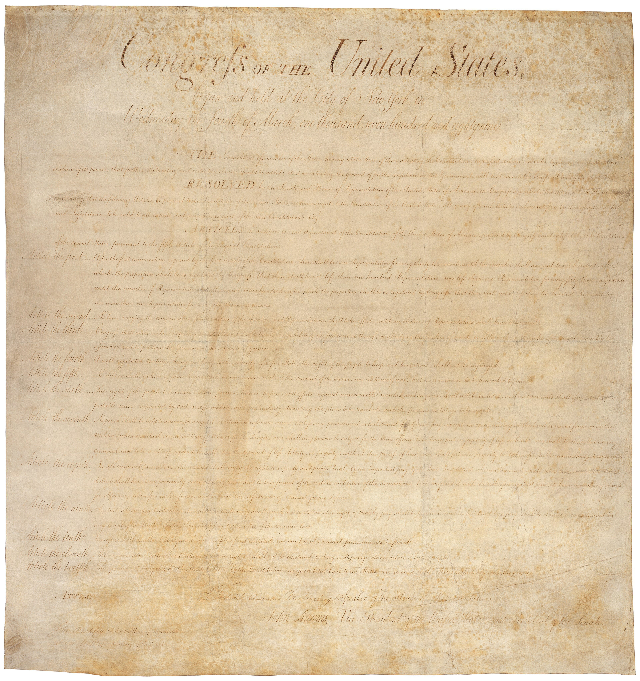
STUDENT WORKBOOK

UDL 3.0 | MTSS | CER | Cornell | HIPPO | DOK
Universal Design for Learning · Multi-Tiered Supports · Evidence-Based Writing
Student Edition
TroopToTeacher Technologies LLC

Government Hack™ Unit 6 — Civil Liberties STUDENT WORKBOOK · TroopToTeacher Technologies LLC
SPINE
Perfect-bound. At 90 pages on 60-lb (90 gsm) white offset the spine is ≈ 0.203 in (5.2 mm) — wide enough to print the spine text above. Recompute if the page count or paper changes (white 60-lb ≈ 0.002252 in/page).

Government Hack™
The workbook that teaches every learner — without lowering the bar.
Unit 6 — Civil Liberties · Student Edition
WHAT MAKES THIS WORKBOOK DIFFERENT

◆ Built on UDL 3.0 (CAST). Every activity offers multiple means of engagement, representation, and action — word banks, sentence frames, visuals, and choice built in, so the rigor stays the same for every learner.
◆ MTSS tiers on every page. Core instruction with layered Guided and Light Support, plus a formative Exit Ticket for each standard and a “What’s Next” reteach path in the Teacher Edition.
◆ Writes like a historian — CER. A 6-point Claim–Evidence–Reasoning rubric runs through the whole course, with scaffolded organizers and lined response space.
◆ Real primary sources, cited. Photographs, political cartoons, and maps from the Library of Congress and National Archives — analyzed with the HIPPO routine — every source documented to Chicago style.
◆ Cornell notes paired to the slide deck. Structured note pages capture the direct-teaching slides, with retrieval checks and doodle zones for visual learners.
◆ Standards-aligned & TCAP-ready. DOK-balanced checks and a companion Assessment Book with two parallel forms, keyed to the standards and reporting categories.
INSIDE THIS UNIT — each standard

GC.23 The First Amendment in Court
GC.24 The Second Amendment in Court
GC.25 Rights of the Accused (4th–8th Amendments)
GC.26 The 14th Amendment — Equal Protection & Due Process
GC.27 Rights for the Underserved
Part of the Government Hack™ Course Standard series — a complete, standards-aligned system: Student Workbook · Teacher Edition · Student & Teacher Slide Decks · Graphic Organizer Toolkit · Unit Assessment Book.
TroopToTeacher Technologies LLC  Government Hack™ · Course Standard (Platinum) Edition · Student Edition  © 2026 TroopToTeacher Technologies LLC. All rights reserved. Government Hack™ is a trademark of TroopToTeacher Technologies LLC. No part of this book may be reproduced without written permission, except as licensed for classroom use.  www.trooptoteacher.com · Printed in the U.S.A. · First Edition | ISBN barcode  ISBN 978-X-XXXXX-XXX-X  placeholder — replace at print

PRINT & ONLINE-LISTING SPEC
An internal handoff sheet for your printer and your storefront listing — not part of the printed book.
Title (listing) | Government Hack™ — Unit 1: Civil Liberties · Student Workbook
Series | Government Hack™ Course Standard (Platinum) Edition
Publisher / Author | TroopToTeacher Technologies LLC
Trim size | 8.5 × 11 in (US Letter)
Interior | 90 pages, black-and-white, 60-lb (90 gsm) white offset
Binding & spine | Perfect-bound; spine ≈ 0.203 in (5.2 mm). Print spine text.
Cover stock | 10-pt or 12-pt C1S gloss/matte laminate; full color
Bleed | Add 0.125 in bleed on all outside edges before print (this concept is at trim).
Copyright | © 2026 TroopToTeacher Technologies LLC. All rights reserved.
ISBN | Assign one ISBN per format (paperback / PDF); place barcode in the back-cover box.
Age / grade | Grades 9–12 · U.S. Government & Civics
Categories | Education › Teaching Methods & Materials › Social Science; Study Aids › History
Keywords | U.S. Government & Civics workbook, high school civics, UDL curriculum, MTSS, CER writing, primary source analysis, Cornell notes, standards-aligned, U.S. Constitution, Bill of Rights, TCAP review
BACK-COVER BLURB (for your storefront)
Government Hack™ turns a full unit of high-school U.S. Government & Civics into one student-ready workbook that reaches every learner without lowering the bar. Built on Universal Design for Learning (UDL 3.0) and Multi-Tiered Systems of Support (MTSS), each of each standard moves from a core lesson to Cornell notes paired with the slide deck, real cited public-domain primary sources analyzed with HIPPO, evidence-based writing on a 6-point CER rubric, and a formative Exit Ticket with a built-in reteach path. Standards-aligned, DOK-balanced, and TCAP-ready — with a companion Assessment Book of two parallel forms. Unit 1 covers the Civil Liberties.

