1791 · 1925 · 1954 • UNITED STATES GOVERNMENT & CIVICS (GC) • COURSE STANDARD EDITION
GOVERNMENT HACK™
TROOPTOTEACHER TECHNOLOGIES
UNIT 6
Civil Liberties
COURSE STANDARD EDITION
GC.23–GC.27 • Tennessee U.S. Government & Civics Standards • Grades 9–12
★ TENNESSEE CONNECTION
One of the most famous civil-liberties trials in American history happened in Tennessee. In State of Tennessee v. Scopes (1925), a Dayton teacher named John Scopes was tried under the Butler Act for teaching evolution — the first U.S. law to ban it. The ACLU defended the case as a fight for academic freedom and free speech; Scopes was convicted, but the Tennessee Supreme Court later reversed the conviction on a technicality (GC.23).
One common workbook designed for learner variability. Every student works toward the same Tennessee standards; supports vary the means, not the goal or the ceiling.
Release-Ready · Pilot Edition
© 2026 TroopToTeacher Technologies LLC. All rights reserved. ISBN: [to be assigned]

Copyright, Ownership & Framework
Government Hack™ — Unit 6: Civil Liberties, Course Standard Edition.
© 2026 TroopToTeacher Technologies LLC. All rights reserved. This workbook is proprietary; reproduction or redistribution outside a licensed classroom is prohibited.
Source integrity. Every primary source in this unit is public-domain and cited to its holding repository (National Archives, Library of Congress). See the Source Library.
Reading provenance (district-clear). Close-Read passages are labeled “Government Hack-authored instructional synthesis” — they build on the standard record and are not presented as primary sources.
Framework stack. This workbook anchors to Tennessee U.S. Government & Civics standards GC.23–GC.27 and the Social Studies Practices (SSP.01–SSP.06), and is designed on CAST UDL 3.0 and an MTSS support model.
Pacing. Each standard is built for one 45-minute class period. Each activity shows a ⏱ ~ minutes estimate at its heading. There is more here than one period holds — your teacher chooses which activities you do in class; the rest may become warm-ups, stations, or homework.

Table of Contents

Tennessee Standards & SSP Crosswalk
Each standard below is taught to the full Course Standard expectation; the Social Studies Practices are embedded in every activity cycle.
Standard | Focus | Student Deck slides
GC.23 | The First Amendment in Court | 2–8
GC.24 | The Second Amendment in Court | 2–8
GC.25 | Rights of the Accused (4th–8th Amendments) | 2–8
GC.26 | The 14th Amendment — Equal Protection & Due Process | 2–8
GC.27 | Rights for the Underserved | 2–8

Social Studies Practices (SSP.01–SSP.06)
SSP.01 Gather/evaluate sources · SSP.02 Critically examine a primary source · SSP.03 Synthesize evidence · SSP.04 Construct/communicate argument · SSP.05 Develop historical awareness · SSP.06 Chronological/spatial reasoning. Each Close Read, Primary Source/Data, and CER activity names the practices it builds.

Accessibility, UDL & Accommodations Matrix
One firm learning goal per standard; flexible, universal means. Supports are available by design and never lower the goal. They work alongside — never in place of — required IEP or 504 accommodations.
Universal support | What it is | Where it appears
CORE PATH | Essential instruction every student completes | Every activity
LANGUAGE SUPPORT | Vocabulary, pronunciation, Spanish cognates | Word Bank, Guided/Light Backs
RESPONSE CHOICE | Write, say/record, or diagram | Every activity
SUPPORT OPTION | Optional scaffold that keeps the goal | Guided Support Back, Primary Source
PROGRESS CHECK | Quick DOK-2/3 check to guide reteach/extend | Cornell Notes, Practice Quiz
EXTENSION | Deeper challenge once the goal is met | Extension Bank, CER

How CAST UDL 3.0 is visible in this workbook
Multiple means of Engagement (response choice, relevance via Tennessee Connection), Representation (Word Bank, pronunciation, Spanish, Close-Read supports), and Action & Expression (write/say/diagram, Frayer, CER). No fixed-track labels appear.

My Support Plan (optional — you choose)
Supports are available by design. Check the ones you might try; you can change your mind any time.
Support I might use | When it would help me
Word Bank + Spanish column
Guided or Light Support Back
Response choice (say/record or diagram)
Sentence frames / Rehearsal Lab

How to Use This Workbook
Each standard runs the same seven-activity cycle: (1) Vocabulary Word Bank, (2) Vocabulary Studio, (3) Direct-Teaching Cornell Notes with optional Guided and Light Support Backs, (4) Close Read, (5) Primary Source / Data Analysis, (6) Core Application Practice Quiz, (7) Constructed Response (CER). Work the CORE PATH; reach for SUPPORT OPTIONS as needed.

Label legend — these appear throughout every standard cycle
Label | Meaning
CORE PATH | The essential instruction every student completes.
SUPPORT OPTION | An optional scaffold that keeps the goal, not lowers it.
LANGUAGE SUPPORT | Vocabulary, pronunciation, and Spanish cognates for access.
RESPONSE CHOICE | Show learning by writing, saying/recording, or diagramming.
PROGRESS CHECK | A quick DOK-2/3 check that guides reteach or extend.
EXTENSION | A deeper challenge once the goal is met.

Before You Begin — Set Your Goal
This unit asks one big question: How do the courts decide where your rights end and the government's power begins? Set a goal, then note what you already know.
Prompt | Your response
My goal for this unit is…
One thing I already know about this era…
One question I want answered…

Standard GC.23 — The First Amendment in Court
TN Academic Standard GC.23: Evaluate the Supreme Court's interpretations of the freedoms articulated in the 1st Amendment, including: Schenck v. United States; Engel v. Vitale; Tinker v. Des Moines; Lemon v. Kurtzman; New York Times v. United States; Miller v. California; Texas v. Johnson. (H, T)
LEARNING TARGETS — I can…
• I can I can evaluate how the Supreme Court has interpreted the First Amendment freedoms..
Lenses for this standard: History (H) · Tennessee (T)
CORE PATH — the same for every student
Every student works this standard at the same rigor: analyze the sources and vocabulary, then demonstrate learning on the Practice Quiz and CER. UDL and MTSS give you flexible ways in — they never lower the bar. Check yourself against the learning targets on the Cornell Notes page.
SET YOUR GOAL (self-direction)
My goal for this standard — what will I be able to do, and how will I show it?

HOOK — think before you dig in
A silent armband, a burning flag, a banned book, a school prayer — the same 45 words protect or limit each one. Where does your freedom to express end?

ACTIVATE — what do you already know or wonder?
Jot what you already know or want to find out about this standard. You’ll come back to it.

PREVIEW & PREDICT
Which learning target will be hardest, and why? Connect it to the unit’s big question: How do the courts decide where your rights end and the government's power begins?

Activity 1 — Vocabulary (Part A: Reference / Word Bank) — GC.23 ⏱ ~10 min
Use this word bank throughout the standard. The Spanish column supports access, not translation of assessment.
Term | Student-friendly meaning | Spanish
Clear and Present Danger | The test from Schenck v. United States (1919) allowing limits on speech that creates a real, immediate danger — such as falsely shouting fire in a crowded theater. | peligro claro y presente
Establishment Clause | The First Amendment ban on the government establishing or favoring a religion, central to Engel v. Vitale and Lemon v. Kurtzman. | cláusula de establecimiento
Symbolic Speech | Actions that express an idea — like wearing an armband (Tinker) or burning a flag (Texas v. Johnson) — that the First Amendment can protect. | expresión simbólica
LANGUAGE SUPPORT
Pronunciations: Clear and Present Danger (kleer and PREZ-ent DAYN-jer); Establishment Clause (es-TAB-lish-ment); Symbolic Speech (sim-BOL-ik).

VOCABULARY SELF-CHECK · Knowledge Rating
Rate each term NOW in pencil, then again at the END — growth is the goal; no penalty for “never seen it.”
Term | 1 · never seen it | 2 · heard it | 3 · can use it | 4 · can teach it
Clear and Present Danger
Establishment Clause
Symbolic Speech
MAKE IT YOURS (RESPONSE CHOICE): choose ONE term above and show you own it — write a sentence, sketch it, or give a real-world example.

QUICK WRITE
Which of these terms do you think will matter MOST for this standard, and why? You’ll revisit this at the end.

Activity 2 — Vocabulary Studio (Frayer-inspired) — GC.23 ⏱ ~7 min
RESPONSE CHOICE
Complete each studio by writing, speaking, or diagramming.

PRIORITY TERM 1 Symbolic Speech · ES: expresión simbólica
Word-bank meaning to build on: Actions that express an idea — like wearing an armband (Tinker) or burning a flag (Texas v. Johnson) — that the First Amendment can protect.
Definition (in your own words) | Characteristics
Examples | Non-examples
Use it to explain
Write one sentence that uses “Symbolic Speech” to explain this standard.

PRIORITY TERM 2 Establishment Clause · ES: cláusula de establecimiento
Word-bank meaning to build on: The First Amendment ban on the government establishing or favoring a religion, central to Engel v. Vitale and Lemon v. Kurtzman.
Definition (in your own words) | Characteristics
Examples | Non-examples
Use it to explain
Write one sentence that uses “Establishment Clause” to explain this standard.

CONNECT THE TERMS (UDL · build understanding)
How do these priority terms fit together? Write or sketch how one leads to or affects another.

Activity 3 — Direct Teaching Cornell Notes — GC.23 ⏱ ~20 min
Name: ______________________ Class / Period: __________ Date: __________
GC.23 — The First Amendment in Court • Lean Student Deck slides 2–8 • direct-teaching slides 4–6
Your learning targets are on this standard’s opening page — take notes that help you meet them.
Guiding cues | My notes — write your notes here
Key idea of this standard?
One amendment or case that supports it?
One real situation it applies to?
Key terms →
Keep taking notes — lines run the full width of the page:

DOODLE ZONE — draw your thinking (UDL · another way in)
Need another way in? Sketch the key idea, a quick timeline, or how the pieces connect. Words optional.

Cornell Notes — keep going, then process & check — GC.23
MORE NOTES / DIAGRAMS
Continue your notes here, add a quick sketch, or map how the ideas connect.

Key terms to list
Clear and Present Danger · Establishment Clause · Symbolic Speech
Summary — In your own words (2–3 sentences)
PROGRESS CHECK · one question
What did the Supreme Court decide in Tinker v. Des Moines (1969)?
A. Schools may ban any student speech they dislike
B. Students keep their free-speech rights at school, unless the speech substantially disrupts
C. The First Amendment does not apply to students
D. Only teachers, not students, have free-speech rights
Commit before you move on — mark it, say it, or explain it aloud.
CHECK YOURSELF — how am I doing?
Which learning targets (on this standard’s opening page) can you now meet? Tick the number; circle any you still need help with.
☐ 1
My 12–15 word headline for this standard

Guided Support for the Cornell Notes — GC.23
These scaffolds support ONLY the Cornell notes — use them to take and process those notes. Optional and easy to set aside; not a separate assignment or a label.
Key vocabulary | What it means
Clear and Present Danger | The test from Schenck v. United States (1919) allowing limits on speech that creates a real, immediate danger — such as falsely shouting fire in a crowded theater.
Establishment Clause | The First Amendment ban on the government establishing or favoring a religion, central to Engel v. Vitale and Lemon v. Kurtzman.
Symbolic Speech | Actions that express an idea — like wearing an armband (Tinker) or burning a flag (Texas v. Johnson) — that the First Amendment can protect.
Break it into steps:
1) Name one cause or effect. 2) Give one piece of evidence. 3) Write one sentence explaining the link.
Sentence frame
One key cause/effect of the first amendment in court was ______, shown by ______, which mattered because ______.
Modeled example (one worked note — yours will differ)
A key idea of the first amendment in court was Clear and Present Danger: The test from Schenck v. United States (1919) allowing limits on speech that creates a real, immediate danger — such as falsely shouting fire in a crowded theater.
GUIDED NOTE REHEARSAL LAB
Rehearse the cause→effect chain below, then transfer it to your Cornell notes.
Step | Rehearse it here
Name it
Evidence
Explain
Headline
TRANSFER CHECK — move one rehearsed idea onto the front notes

Light Support for the Cornell Notes — GC.23
A lighter scaffold for the SAME Cornell notes. Try the notes first; reach for this only if you need it.
Key vocabulary | Finish the idea — “This term means …”
Clear and Present Danger
Establishment Clause
Symbolic Speech
Guiding questions — answer on the lines below (or in your front notes):
• According to Tinker, do students have free-speech rights at school? What is the limit?
• How do Engel v. Vitale and Lemon v. Kurtzman apply the Establishment Clause?
• How can burning a flag (Texas v. Johnson) be protected 'speech'?

WHICH CUE STILL NEEDS WORK?
Circle the Cornell cue from the front page you still need help with, and tell your teacher so we can go over it.
LIGHT PROCESSING LAB
Answer one guiding question from above in a full sentence, in your own words.

Activity 4 — Close Read — GC.23 ⏱ ~15 min
Reading type: Government Hack-authored instructional synthesis. This is not a primary source. Builds SSP.03 (synthesize) and SSP.05 (historical awareness).
CORE PATH
The First Amendment protects speech, press, religion, assembly, and petition — but not without limits, and the Supreme Court draws the lines case by case. On speech, Schenck v. United States (1919) allowed limits on words that create a 'clear and present danger,' while Tinker v. Des Moines (1969) protected students' symbolic speech, ruling they do not 'shed their constitutional rights… at the schoolhouse gate,' and Texas v. Johnson (1989) protected even flag burning as symbolic speech. On religion, Engel v. Vitale (1962) barred official school prayer and Lemon v. Kurtzman (1971) set a test for church–state separation, both under the Establishment Clause. On press, New York Times v. United States (1971) blocked the government from stopping publication of the Pentagon Papers (no 'prior restraint'), and Miller v. California (1973) defined the narrow limits of obscenity. Together these cases show a Court constantly balancing individual liberty against government interest.
LANGUAGE SUPPORT
Key terms to know first: Clear and Present Danger, Establishment Clause. Read once for the gist, then again for evidence.
Text-dependent questions (answer in the Evidence Lab below or aloud):
1. According to Tinker, do students have free-speech rights at school? What is the limit?
2. How do Engel v. Vitale and Lemon v. Kurtzman apply the Establishment Clause?
3. How can burning a flag (Texas v. Johnson) be protected 'speech'?
RESPONSE CHOICE: answer any question by writing in the Evidence Lab, saying/recording it, or diagramming it.
CLOSE-READ EVIDENCE LAB
Log evidence from the passage below.
Question / claim | Exact passage evidence | What the evidence shows

SPACED RETRIEVAL — quick recall (no notes)
Pull it up cold to strengthen memory, then check your notes.
Recall prompt | Your answer (from memory)
One key term or fact from THIS standard
One thing you learned EARLIER in this unit or course
How the two connect

Activity 5 — Primary Source / Data Analysis — GC.23 ⏱ ~15 min
Primary source (document) — analyze it with HIPPO. Builds SSP.01–SSP.02.
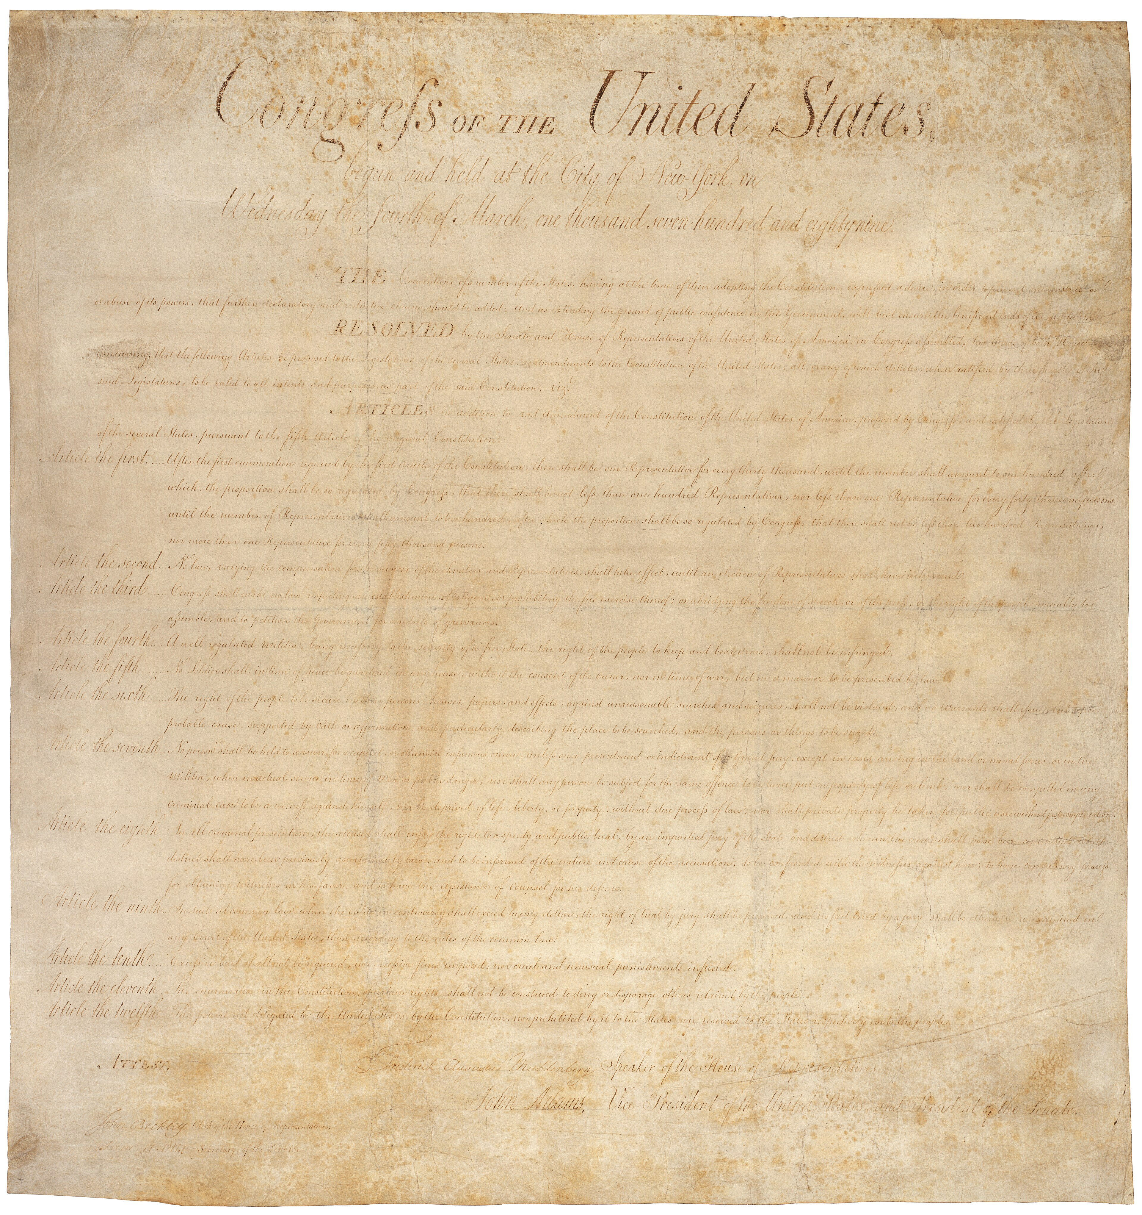
Bill of Rights (First Amendment detail) · 1st U.S. Congress (NARA) · 1789
Source: Wikimedia Commons · https://commons.wikimedia.org/wiki/File:Bill_of_Rights_Pg1of1_AC.jpg Public domain — U.S. gov document; NARA scan https://commons.wikimedia.org/wiki/File:Bill_of_Rights_Pg1of1_AC.jpg
HIPPO — analyze the source (prompt) | Your analysis
H — Historical context: what was happening when this was created?
I — Intended audience: who was meant to see or obey it?
P — Purpose: why was it created?
P — Point of view: whose perspective does it reflect?
O — Outside connection: how does it connect to this standard?
SUPPORT OPTION
Sentence frame: This source shows ______ because it ______, which reveals ______.
CONFIDENCE CHECK-IN
Rate your understanding of this standard (1–4): ______ One thing to revisit: ____________________

Activity 6 — Core Application: Practice Quiz — GC.23 ⏱ ~8 min
RESPONSE CHOICE
Commit to an answer by marking it, saying it, or explaining it aloud before checking. Answer key is in the Teacher Guide (kept separate).
[DOK 1 · item u6-gc23-dok1-1 · pre-field-test]
The 'clear and present danger' test comes from which case?
A. Tinker v. Des Moines
B. Schenck v. United States
C. Engel v. Vitale
D. Texas v. Johnson
[DOK 3 · item u1-gc23-dok3-tc · pre-field-test]
What did the Supreme Court decide in Tinker v. Des Moines (1969)?
A. Schools may ban any student speech they dislike
B. Students keep their free-speech rights at school, unless the speech substantially disrupts
C. The First Amendment does not apply to students
D. Only teachers, not students, have free-speech rights

STRETCH — think like a test-writer (open to all)
Write your OWN DOK-3 question for this standard, then a one-sentence answer key. Use the supports below — everyone can do this.
HOW TO WRITE A DOK-3 QUESTION (supports)
DOK-3 = strategic thinking: the reader must analyze, compare, evaluate, or justify using evidence — and there should be more than one defensible answer (not a fact you can just look up).
Sentence starters: “Why did ______ lead to ______?” · “Which mattered more — ______ or ______ — and why?” · “What is the BEST evidence that ______?” · “Evaluate whether ______.” · “Defend or challenge: ______.”
Frame: [Analyze / Evaluate / Justify] + [something from THIS standard] + “using evidence.”
Quick check: does my question make the reader THINK and use evidence? If yes, it’s DOK-3.
Your DOK-3 question | Your answer key (one sentence)

Activity 7 — Constructed Response (CER) — GC.23 ⏱ ~15 min
BIG-QUESTION ORGANIZER (before you write) — How do the courts decide where your rights end and the government's power begins?
Plan your argument here, then use it to write your claim, evidence, and reasoning below.
Plan your argument | Your quick notes (from this standard)
My claim (answer the prompt)
Evidence 1 (a source or fact)
Reasoning (why it proves the claim)
CONSTRUCTED RESPONSE (CER) — builds SSP.04 Argumentation
Claim + Evidence + Reasoning: Should student speech be more limited than adult speech? Defend your claim using Tinker and one other case.
Part | Write here
Claim
Evidence (two specifics)
Reasoning
SELF-CHECK against the CER rubric (see Toolkit)
Before submitting: Is my claim defensible? Do I have TWO specific pieces of evidence? Does my reasoning explain HOW the evidence proves the claim?

UDL Access, Choice & Reflection — GC.23
UDL ACCESS & MTSS SUPPORT (this standard)
UDL 3.0 (CAST, 2024): read-aloud on request · key terms glossed (EN/ES) · respond in writing, speech, or a labeled diagram · large-print & screen-reader friendly. Same learning target for everyone; supports vary the means, not the ceiling.
MTSS: Tier 1 — this core lesson for all · Tier 2 — small-group reteach of this standard using its Cornell cues + graphic organizer, then re-check · Tier 3 — intensive 1:1 with concrete→representational→abstract scaffolding, progress-monitored to the same standard.
SHOW WHAT YOU KNOW — YOUR WAY (same CER rubric, same standard)
Build your Claim–Evidence–Reasoning in whichever mode lets you think best — the standard and the CER rubric are identical for every mode; the mode changes how you SHOW it, never what you are held to:
WRITE it · SAY it aloud and record it (audio or video) · DRAW and label a diagram that makes the argument · BUILD a model or artifact and caption its claim, evidence, and reasoning.
You may ask for a word processor, speech-to-text, a scribe, or a sentence/argument frame — these change how you produce, not the standard you meet.
CHOICE & VOICE — you decide how to go deeper (pick ONE)
You choose your path to show this standard — every option meets the same target:
DEFEND a term: pick the vocabulary word that matters most and argue why in 2–3 sentences. · CONNECT it: pick a current event, your community, or your own life and explain how this standard shows up there. · TAKE A SIDE: pick one debatable question and argue your position with evidence.
Your pick is yours — bring what matters to you into the work.
REFLECT & CONNECT — how your thinking grew, and whose view you weighed
Reflect (self-awareness): What did you believe about this topic BEFORE, and what changed AFTER? Name one thing to revisit.
Consider another view (empathy): Name one person or group who might see this standard differently than you; state their view fairly in one sentence — even if you disagree.
Norm (restorative): we critique ideas, not people; we assume good faith; we make room for every voice.

Standard GC.24 — The Second Amendment in Court
TN Academic Standard GC.24: Explain the 2nd Amendment and evaluate its various interpretations. (T)
LEARNING TARGETS — I can…
• I can I can explain the Second Amendment and evaluate how the Supreme Court has interpreted it..
Lenses for this standard: Tennessee (T)
CORE PATH — the same for every student
Every student works this standard at the same rigor: analyze the sources and vocabulary, then demonstrate learning on the Practice Quiz and CER. UDL and MTSS give you flexible ways in — they never lower the bar. Check yourself against the learning targets on the Cornell Notes page.
SET YOUR GOAL (self-direction)
My goal for this standard — what will I be able to do, and how will I show it?

HOOK — think before you dig in
One sentence, written in 1791, still splits the country: is the right to 'keep and bear Arms' yours as a person, or only as part of a militia? The Court finally answered in 2008.

ACTIVATE — what do you already know or wonder?
Jot what you already know or want to find out about this standard. You’ll come back to it.

PREVIEW & PREDICT
Which learning target will be hardest, and why? Connect it to the unit’s big question: How do the courts decide where your rights end and the government's power begins?

Activity 1 — Vocabulary (Part A: Reference / Word Bank) — GC.24 ⏱ ~10 min
Use this word bank throughout the standard. The Spanish column supports access, not translation of assessment.
Term | Student-friendly meaning | Spanish
Second Amendment | The amendment protecting 'the right of the people to keep and bear Arms,' whose meaning has been debated between an individual right and a militia-based right. | Segunda Enmienda
Individual Right | A right held by each person, not only by a group; District of Columbia v. Heller (2008) read the Second Amendment as an individual right. | derecho individual
Incorporation | Applying a Bill of Rights protection to the states through the 14th Amendment; McDonald v. Chicago (2010) incorporated the Second Amendment. | incorporación
LANGUAGE SUPPORT
Pronunciations: Second Amendment (SEK-und uh-MEND-ment); Individual Right (in-dih-VIJ-oo-ul); Incorporation (in-kor-por-AY-shun).

VOCABULARY SELF-CHECK · Knowledge Rating
Rate each term NOW in pencil, then again at the END — growth is the goal; no penalty for “never seen it.”
Term | 1 · never seen it | 2 · heard it | 3 · can use it | 4 · can teach it
Second Amendment
Individual Right
Incorporation
MAKE IT YOURS (RESPONSE CHOICE): choose ONE term above and show you own it — write a sentence, sketch it, or give a real-world example.

QUICK WRITE
Which of these terms do you think will matter MOST for this standard, and why? You’ll revisit this at the end.

Activity 2 — Vocabulary Studio (Frayer-inspired) — GC.24 ⏱ ~7 min
RESPONSE CHOICE
Complete each studio by writing, speaking, or diagramming.

PRIORITY TERM 1 Individual Right · ES: derecho individual
Word-bank meaning to build on: A right held by each person, not only by a group; District of Columbia v. Heller (2008) read the Second Amendment as an individual right.
Definition (in your own words) | Characteristics
Examples | Non-examples
Use it to explain
Write one sentence that uses “Individual Right” to explain this standard.

PRIORITY TERM 2 Incorporation · ES: incorporación
Word-bank meaning to build on: Applying a Bill of Rights protection to the states through the 14th Amendment; McDonald v. Chicago (2010) incorporated the Second Amendment.
Definition (in your own words) | Characteristics
Examples | Non-examples
Use it to explain
Write one sentence that uses “Incorporation” to explain this standard.

CONNECT THE TERMS (UDL · build understanding)
How do these priority terms fit together? Write or sketch how one leads to or affects another.

Activity 3 — Direct Teaching Cornell Notes — GC.24 ⏱ ~20 min
Name: ______________________ Class / Period: __________ Date: __________
GC.24 — The Second Amendment in Court • Lean Student Deck slides 2–8 • direct-teaching slides 4–6
Your learning targets are on this standard’s opening page — take notes that help you meet them.
Guiding cues | My notes — write your notes here
Key idea of this standard?
One amendment or case that supports it?
One real situation it applies to?
Key terms →
Keep taking notes — lines run the full width of the page:

DOODLE ZONE — draw your thinking (UDL · another way in)
Need another way in? Sketch the key idea, a quick timeline, or how the pieces connect. Words optional.

Cornell Notes — keep going, then process & check — GC.24
MORE NOTES / DIAGRAMS
Continue your notes here, add a quick sketch, or map how the ideas connect.

Key terms to list
Second Amendment · Individual Right · Incorporation
Summary — In your own words (2–3 sentences)
PROGRESS CHECK · one question
What did District of Columbia v. Heller (2008) decide about the Second Amendment?
A. That only the military may own weapons
B. That the amendment applies only to the federal government forever
C. That states may ban all firearms
D. That the Second Amendment protects an individual right to keep and bear arms
Commit before you move on — mark it, say it, or explain it aloud.
CHECK YOURSELF — how am I doing?
Which learning targets (on this standard’s opening page) can you now meet? Tick the number; circle any you still need help with.
☐ 1
My 12–15 word headline for this standard

Guided Support for the Cornell Notes — GC.24
These scaffolds support ONLY the Cornell notes — use them to take and process those notes. Optional and easy to set aside; not a separate assignment or a label.
Key vocabulary | What it means
Second Amendment | The amendment protecting 'the right of the people to keep and bear Arms,' whose meaning has been debated between an individual right and a militia-based right.
Individual Right | A right held by each person, not only by a group; District of Columbia v. Heller (2008) read the Second Amendment as an individual right.
Incorporation | Applying a Bill of Rights protection to the states through the 14th Amendment; McDonald v. Chicago (2010) incorporated the Second Amendment.
Break it into steps:
1) Name one cause or effect. 2) Give one piece of evidence. 3) Write one sentence explaining the link.
Sentence frame
One key cause/effect of the second amendment in court was ______, shown by ______, which mattered because ______.
Modeled example (one worked note — yours will differ)
A key idea of the second amendment in court was Second Amendment: The amendment protecting 'the right of the people to keep and bear Arms,' whose meaning has been debated between an individual right and a militia-based right.
GUIDED NOTE REHEARSAL LAB
Rehearse the cause→effect chain below, then transfer it to your Cornell notes.
Step | Rehearse it here
Name it
Evidence
Explain
Headline
TRANSFER CHECK — move one rehearsed idea onto the front notes

Light Support for the Cornell Notes — GC.24
A lighter scaffold for the SAME Cornell notes. Try the notes first; reach for this only if you need it.
Key vocabulary | Finish the idea — “This term means …”
Second Amendment
Individual Right
Incorporation
Guiding questions — answer on the lines below (or in your front notes):
• What are the two competing readings of the Second Amendment's text?
• What did Heller decide, and how did McDonald extend it to the states?
• The Court said the right is 'not unlimited' — what kinds of regulation might still be allowed?

WHICH CUE STILL NEEDS WORK?
Circle the Cornell cue from the front page you still need help with, and tell your teacher so we can go over it.
LIGHT PROCESSING LAB
Answer one guiding question from above in a full sentence, in your own words.

Activity 4 — Close Read — GC.24 ⏱ ~15 min
Reading type: Government Hack-authored instructional synthesis. This is not a primary source. Builds SSP.03 (synthesize) and SSP.05 (historical awareness).
CORE PATH
The Second Amendment's single sentence has produced one of the country's longest debates: does 'the right of the people to keep and bear Arms' belong to individuals, or only to a 'well regulated Militia'? For most of American history the question stayed unsettled. In District of Columbia v. Heller (2008), the Supreme Court held that the amendment protects an individual right to keep and bear arms for lawful purposes such as self-defense, striking down a strict handgun ban in the federal district. Two years later, McDonald v. Chicago (2010) applied that right to the states through incorporation under the 14th Amendment. The Court also made clear the right is not unlimited — governments may still regulate who may carry, where, and how. The debate over where to draw those lines continues in legislatures and courts today.
LANGUAGE SUPPORT
Key terms to know first: Second Amendment, Individual Right. Read once for the gist, then again for evidence.
Text-dependent questions (answer in the Evidence Lab below or aloud):
1. What are the two competing readings of the Second Amendment's text?
2. What did Heller decide, and how did McDonald extend it to the states?
3. The Court said the right is 'not unlimited' — what kinds of regulation might still be allowed?
RESPONSE CHOICE: answer any question by writing in the Evidence Lab, saying/recording it, or diagramming it.
CLOSE-READ EVIDENCE LAB
Log evidence from the passage below.
Question / claim | Exact passage evidence | What the evidence shows

SPACED RETRIEVAL — quick recall (no notes)
Pull it up cold to strengthen memory, then check your notes.
Recall prompt | Your answer (from memory)
One key term or fact from THIS standard
One thing you learned EARLIER in this unit or course
How the two connect

Activity 5 — Primary Source / Data Analysis — GC.24 ⏱ ~15 min
Primary source (document) — analyze it with HIPPO. Builds SSP.01–SSP.02.
Second Amendment (document detail) · 1st U.S. Congress (NARA) · 1789
Source: Wikimedia Commons · https://commons.wikimedia.org/wiki/File:SecondAmendentoftheUnitedStatesConstitution.jpg Public domain — U.S. gov document; NARA scan https://commons.wikimedia.org/wiki/File:SecondAmendentoftheUnitedStatesConstitution.jpg
HIPPO — analyze the source (prompt) | Your analysis
H — Historical context: what was happening when this was created?
I — Intended audience: who was meant to see or obey it?
P — Purpose: why was it created?
P — Point of view: whose perspective does it reflect?
O — Outside connection: how does it connect to this standard?
SUPPORT OPTION
Sentence frame: This source shows ______ because it ______, which reveals ______.
CONFIDENCE CHECK-IN
Rate your understanding of this standard (1–4): ______ One thing to revisit: ____________________

Activity 6 — Core Application: Practice Quiz — GC.24 ⏱ ~8 min
RESPONSE CHOICE
Commit to an answer by marking it, saying it, or explaining it aloud before checking. Answer key is in the Teacher Guide (kept separate).
[DOK 1 · item u6-gc24-dok1-1 · pre-field-test]
Which case applied the Second Amendment to the states?
A. McDonald v. Chicago
B. Miranda v. Arizona
C. Engel v. Vitale
D. Plessy v. Ferguson
[DOK 2 · item u1-gc24-dok2-tc · pre-field-test]
What did District of Columbia v. Heller (2008) decide about the Second Amendment?
A. That only the military may own weapons
B. That the amendment applies only to the federal government forever
C. That states may ban all firearms
D. That the Second Amendment protects an individual right to keep and bear arms

STRETCH — think like a test-writer (open to all)
Write your OWN DOK-3 question for this standard, then a one-sentence answer key. Use the supports below — everyone can do this.
HOW TO WRITE A DOK-3 QUESTION (supports)
DOK-3 = strategic thinking: the reader must analyze, compare, evaluate, or justify using evidence — and there should be more than one defensible answer (not a fact you can just look up).
Sentence starters: “Why did ______ lead to ______?” · “Which mattered more — ______ or ______ — and why?” · “What is the BEST evidence that ______?” · “Evaluate whether ______.” · “Defend or challenge: ______.”
Frame: [Analyze / Evaluate / Justify] + [something from THIS standard] + “using evidence.”
Quick check: does my question make the reader THINK and use evidence? If yes, it’s DOK-3.
Your DOK-3 question | Your answer key (one sentence)

Activity 7 — Constructed Response (CER) — GC.24 ⏱ ~15 min
BIG-QUESTION ORGANIZER (before you write) — How do the courts decide where your rights end and the government's power begins?
Plan your argument here, then use it to write your claim, evidence, and reasoning below.
Plan your argument | Your quick notes (from this standard)
My claim (answer the prompt)
Evidence 1 (a source or fact)
Reasoning (why it proves the claim)
CONSTRUCTED RESPONSE (CER) — builds SSP.04 Argumentation
Claim + Evidence + Reasoning: Does the Second Amendment protect an individual right, a militia right, or both? Defend your claim using the text and Heller.
Part | Write here
Claim
Evidence (two specifics)
Reasoning
SELF-CHECK against the CER rubric (see Toolkit)
Before submitting: Is my claim defensible? Do I have TWO specific pieces of evidence? Does my reasoning explain HOW the evidence proves the claim?

UDL Access, Choice & Reflection — GC.24
UDL ACCESS & MTSS SUPPORT (this standard)
UDL 3.0 (CAST, 2024): read-aloud on request · key terms glossed (EN/ES) · respond in writing, speech, or a labeled diagram · large-print & screen-reader friendly. Same learning target for everyone; supports vary the means, not the ceiling.
MTSS: Tier 1 — this core lesson for all · Tier 2 — small-group reteach of this standard using its Cornell cues + graphic organizer, then re-check · Tier 3 — intensive 1:1 with concrete→representational→abstract scaffolding, progress-monitored to the same standard.
SHOW WHAT YOU KNOW — YOUR WAY (same CER rubric, same standard)
Build your Claim–Evidence–Reasoning in whichever mode lets you think best — the standard and the CER rubric are identical for every mode; the mode changes how you SHOW it, never what you are held to:
WRITE it · SAY it aloud and record it (audio or video) · DRAW and label a diagram that makes the argument · BUILD a model or artifact and caption its claim, evidence, and reasoning.
You may ask for a word processor, speech-to-text, a scribe, or a sentence/argument frame — these change how you produce, not the standard you meet.
CHOICE & VOICE — you decide how to go deeper (pick ONE)
You choose your path to show this standard — every option meets the same target:
DEFEND a term: pick the vocabulary word that matters most and argue why in 2–3 sentences. · CONNECT it: pick a current event, your community, or your own life and explain how this standard shows up there. · TAKE A SIDE: pick one debatable question and argue your position with evidence.
Your pick is yours — bring what matters to you into the work.
REFLECT & CONNECT — how your thinking grew, and whose view you weighed
Reflect (self-awareness): What did you believe about this topic BEFORE, and what changed AFTER? Name one thing to revisit.
Consider another view (empathy): Name one person or group who might see this standard differently than you; state their view fairly in one sentence — even if you disagree.
Norm (restorative): we critique ideas, not people; we assume good faith; we make room for every voice.

Standard GC.25 — Rights of the Accused (4th–8th Amendments)
TN Academic Standard GC.25: Evaluate the Supreme Court's interpretations of freedoms in the 4th through 8th Amendments, including: Mapp v. Ohio; Gideon v. Wainwright; Miranda v. Arizona. (H, T)
LEARNING TARGETS — I can…
• I can I can evaluate how the Supreme Court has protected the rights of the accused under the 4th through 8th Amendments..
Lenses for this standard: History (H) · Tennessee (T)
CORE PATH — the same for every student
Every student works this standard at the same rigor: analyze the sources and vocabulary, then demonstrate learning on the Practice Quiz and CER. UDL and MTSS give you flexible ways in — they never lower the bar. Check yourself against the learning targets on the Cornell Notes page.
SET YOUR GOAL (self-direction)
My goal for this standard — what will I be able to do, and how will I show it?

HOOK — think before you dig in
'You have the right to remain silent.' You've heard it a hundred times on TV — but a real person had to fight to the Supreme Court to make it law. Which rights protect the accused?

ACTIVATE — what do you already know or wonder?
Jot what you already know or want to find out about this standard. You’ll come back to it.

PREVIEW & PREDICT
Which learning target will be hardest, and why? Connect it to the unit’s big question: How do the courts decide where your rights end and the government's power begins?

Activity 1 — Vocabulary (Part A: Reference / Word Bank) — GC.25 ⏱ ~10 min
Use this word bank throughout the standard. The Spanish column supports access, not translation of assessment.
Term | Student-friendly meaning | Spanish
Exclusionary Rule | The rule from Mapp v. Ohio (1961) that evidence obtained by an illegal search cannot be used in court — enforcing the 4th Amendment. | regla de exclusión
Right to Counsel | The 6th Amendment right to a lawyer; Gideon v. Wainwright (1963) required the state to provide one to defendants who cannot afford it. | derecho a un abogado
Miranda Rights | The warnings police must give before questioning — the right to remain silent and to an attorney — from Miranda v. Arizona (1966). | derechos Miranda
LANGUAGE SUPPORT
Pronunciations: Exclusionary Rule (eks-KLOO-zhun-air-ee); Right to Counsel (KOWN-sel); Miranda Rights (muh-RAN-duh).

VOCABULARY SELF-CHECK · Knowledge Rating
Rate each term NOW in pencil, then again at the END — growth is the goal; no penalty for “never seen it.”
Term | 1 · never seen it | 2 · heard it | 3 · can use it | 4 · can teach it
Exclusionary Rule
Right to Counsel
Miranda Rights
MAKE IT YOURS (RESPONSE CHOICE): choose ONE term above and show you own it — write a sentence, sketch it, or give a real-world example.

QUICK WRITE
Which of these terms do you think will matter MOST for this standard, and why? You’ll revisit this at the end.

Activity 2 — Vocabulary Studio (Frayer-inspired) — GC.25 ⏱ ~7 min
RESPONSE CHOICE
Complete each studio by writing, speaking, or diagramming.

PRIORITY TERM 1 Exclusionary Rule · ES: regla de exclusión
Word-bank meaning to build on: The rule from Mapp v. Ohio (1961) that evidence obtained by an illegal search cannot be used in court — enforcing the 4th Amendment.
Definition (in your own words) | Characteristics
Examples | Non-examples
Use it to explain
Write one sentence that uses “Exclusionary Rule” to explain this standard.

PRIORITY TERM 2 Miranda Rights · ES: derechos Miranda
Word-bank meaning to build on: The warnings police must give before questioning — the right to remain silent and to an attorney — from Miranda v. Arizona (1966).
Definition (in your own words) | Characteristics
Examples | Non-examples
Use it to explain
Write one sentence that uses “Miranda Rights” to explain this standard.

CONNECT THE TERMS (UDL · build understanding)
How do these priority terms fit together? Write or sketch how one leads to or affects another.

Activity 3 — Direct Teaching Cornell Notes — GC.25 ⏱ ~20 min
Name: ______________________ Class / Period: __________ Date: __________
GC.25 — Rights of the Accused (4th–8th Amendments) • Lean Student Deck slides 2–8 • direct-teaching slides 4–6
Your learning targets are on this standard’s opening page — take notes that help you meet them.
Guiding cues | My notes — write your notes here
Key idea of this standard?
One amendment or case that supports it?
One real situation it applies to?
Key terms →
Keep taking notes — lines run the full width of the page:

DOODLE ZONE — draw your thinking (UDL · another way in)
Need another way in? Sketch the key idea, a quick timeline, or how the pieces connect. Words optional.

Cornell Notes — keep going, then process & check — GC.25
MORE NOTES / DIAGRAMS
Continue your notes here, add a quick sketch, or map how the ideas connect.

Key terms to list
Exclusionary Rule · Right to Counsel · Miranda Rights
Summary — In your own words (2–3 sentences)
PROGRESS CHECK · one question
What right did Gideon v. Wainwright (1963) guarantee?
A. The state must provide a lawyer to a defendant who cannot afford one
B. Police may search a home without a warrant
C. A suspect must answer all police questions
D. Trials may be held in secret
Commit before you move on — mark it, say it, or explain it aloud.
CHECK YOURSELF — how am I doing?
Which learning targets (on this standard’s opening page) can you now meet? Tick the number; circle any you still need help with.
☐ 1
My 12–15 word headline for this standard

Guided Support for the Cornell Notes — GC.25
These scaffolds support ONLY the Cornell notes — use them to take and process those notes. Optional and easy to set aside; not a separate assignment or a label.
Key vocabulary | What it means
Exclusionary Rule | The rule from Mapp v. Ohio (1961) that evidence obtained by an illegal search cannot be used in court — enforcing the 4th Amendment.
Right to Counsel | The 6th Amendment right to a lawyer; Gideon v. Wainwright (1963) required the state to provide one to defendants who cannot afford it.
Miranda Rights | The warnings police must give before questioning — the right to remain silent and to an attorney — from Miranda v. Arizona (1966).
Break it into steps:
1) Name one cause or effect. 2) Give one piece of evidence. 3) Write one sentence explaining the link.
Sentence frame
One key cause/effect of rights of the accused (4th–8th amendments) was ______, shown by ______, which mattered because ______.
Modeled example (one worked note — yours will differ)
A key idea of rights of the accused (4th–8th amendments) was Exclusionary Rule: The rule from Mapp v. Ohio (1961) that evidence obtained by an illegal search cannot be used in court — enforcing the 4th Amendment.
GUIDED NOTE REHEARSAL LAB
Rehearse the cause→effect chain below, then transfer it to your Cornell notes.
Step | Rehearse it here
Name it
Evidence
Explain
Headline
TRANSFER CHECK — move one rehearsed idea onto the front notes

Light Support for the Cornell Notes — GC.25
A lighter scaffold for the SAME Cornell notes. Try the notes first; reach for this only if you need it.
Key vocabulary | Finish the idea — “This term means …”
Exclusionary Rule
Right to Counsel
Miranda Rights
Guiding questions — answer on the lines below (or in your front notes):
• What is the exclusionary rule, and which amendment does it enforce (Mapp)?
• What did Gideon guarantee, and to whom?
• Why must police read 'Miranda rights,' and which amendment protects it?

WHICH CUE STILL NEEDS WORK?
Circle the Cornell cue from the front page you still need help with, and tell your teacher so we can go over it.
LIGHT PROCESSING LAB
Answer one guiding question from above in a full sentence, in your own words.

Activity 4 — Close Read — GC.25 ⏱ ~15 min
Reading type: Government Hack-authored instructional synthesis. This is not a primary source. Builds SSP.03 (synthesize) and SSP.05 (historical awareness).
CORE PATH
The 4th through 8th Amendments protect people accused of crimes, and three landmark cases put those protections into practice. Mapp v. Ohio (1961) enforced the 4th Amendment's ban on unreasonable searches with the exclusionary rule: evidence found through an illegal search cannot be used in court. Gideon v. Wainwright (1963) enforced the 6th Amendment's right to counsel, holding that 'any person haled into court, who is too poor to hire a lawyer, cannot be assured a fair trial unless counsel is provided for him' — so states must provide attorneys to those who cannot afford one. Miranda v. Arizona (1966) enforced the 5th Amendment right against self-incrimination, requiring police to warn suspects of their right to remain silent and to a lawyer — the 'Miranda rights.' Together these rulings show the Court applying the Bill of Rights to protect the individual against the power of the state.
LANGUAGE SUPPORT
Key terms to know first: Exclusionary Rule, Right to Counsel. Read once for the gist, then again for evidence.
Text-dependent questions (answer in the Evidence Lab below or aloud):
1. What is the exclusionary rule, and which amendment does it enforce (Mapp)?
2. What did Gideon guarantee, and to whom?
3. Why must police read 'Miranda rights,' and which amendment protects it?
RESPONSE CHOICE: answer any question by writing in the Evidence Lab, saying/recording it, or diagramming it.
CLOSE-READ EVIDENCE LAB
Log evidence from the passage below.
Question / claim | Exact passage evidence | What the evidence shows

SPACED RETRIEVAL — quick recall (no notes)
Pull it up cold to strengthen memory, then check your notes.
Recall prompt | Your answer (from memory)
One key term or fact from THIS standard
One thing you learned EARLIER in this unit or course
How the two connect

Activity 5 — Primary Source / Data Analysis — GC.25 ⏱ ~15 min
Primary source (document) — analyze it with HIPPO. Builds SSP.01–SSP.02.
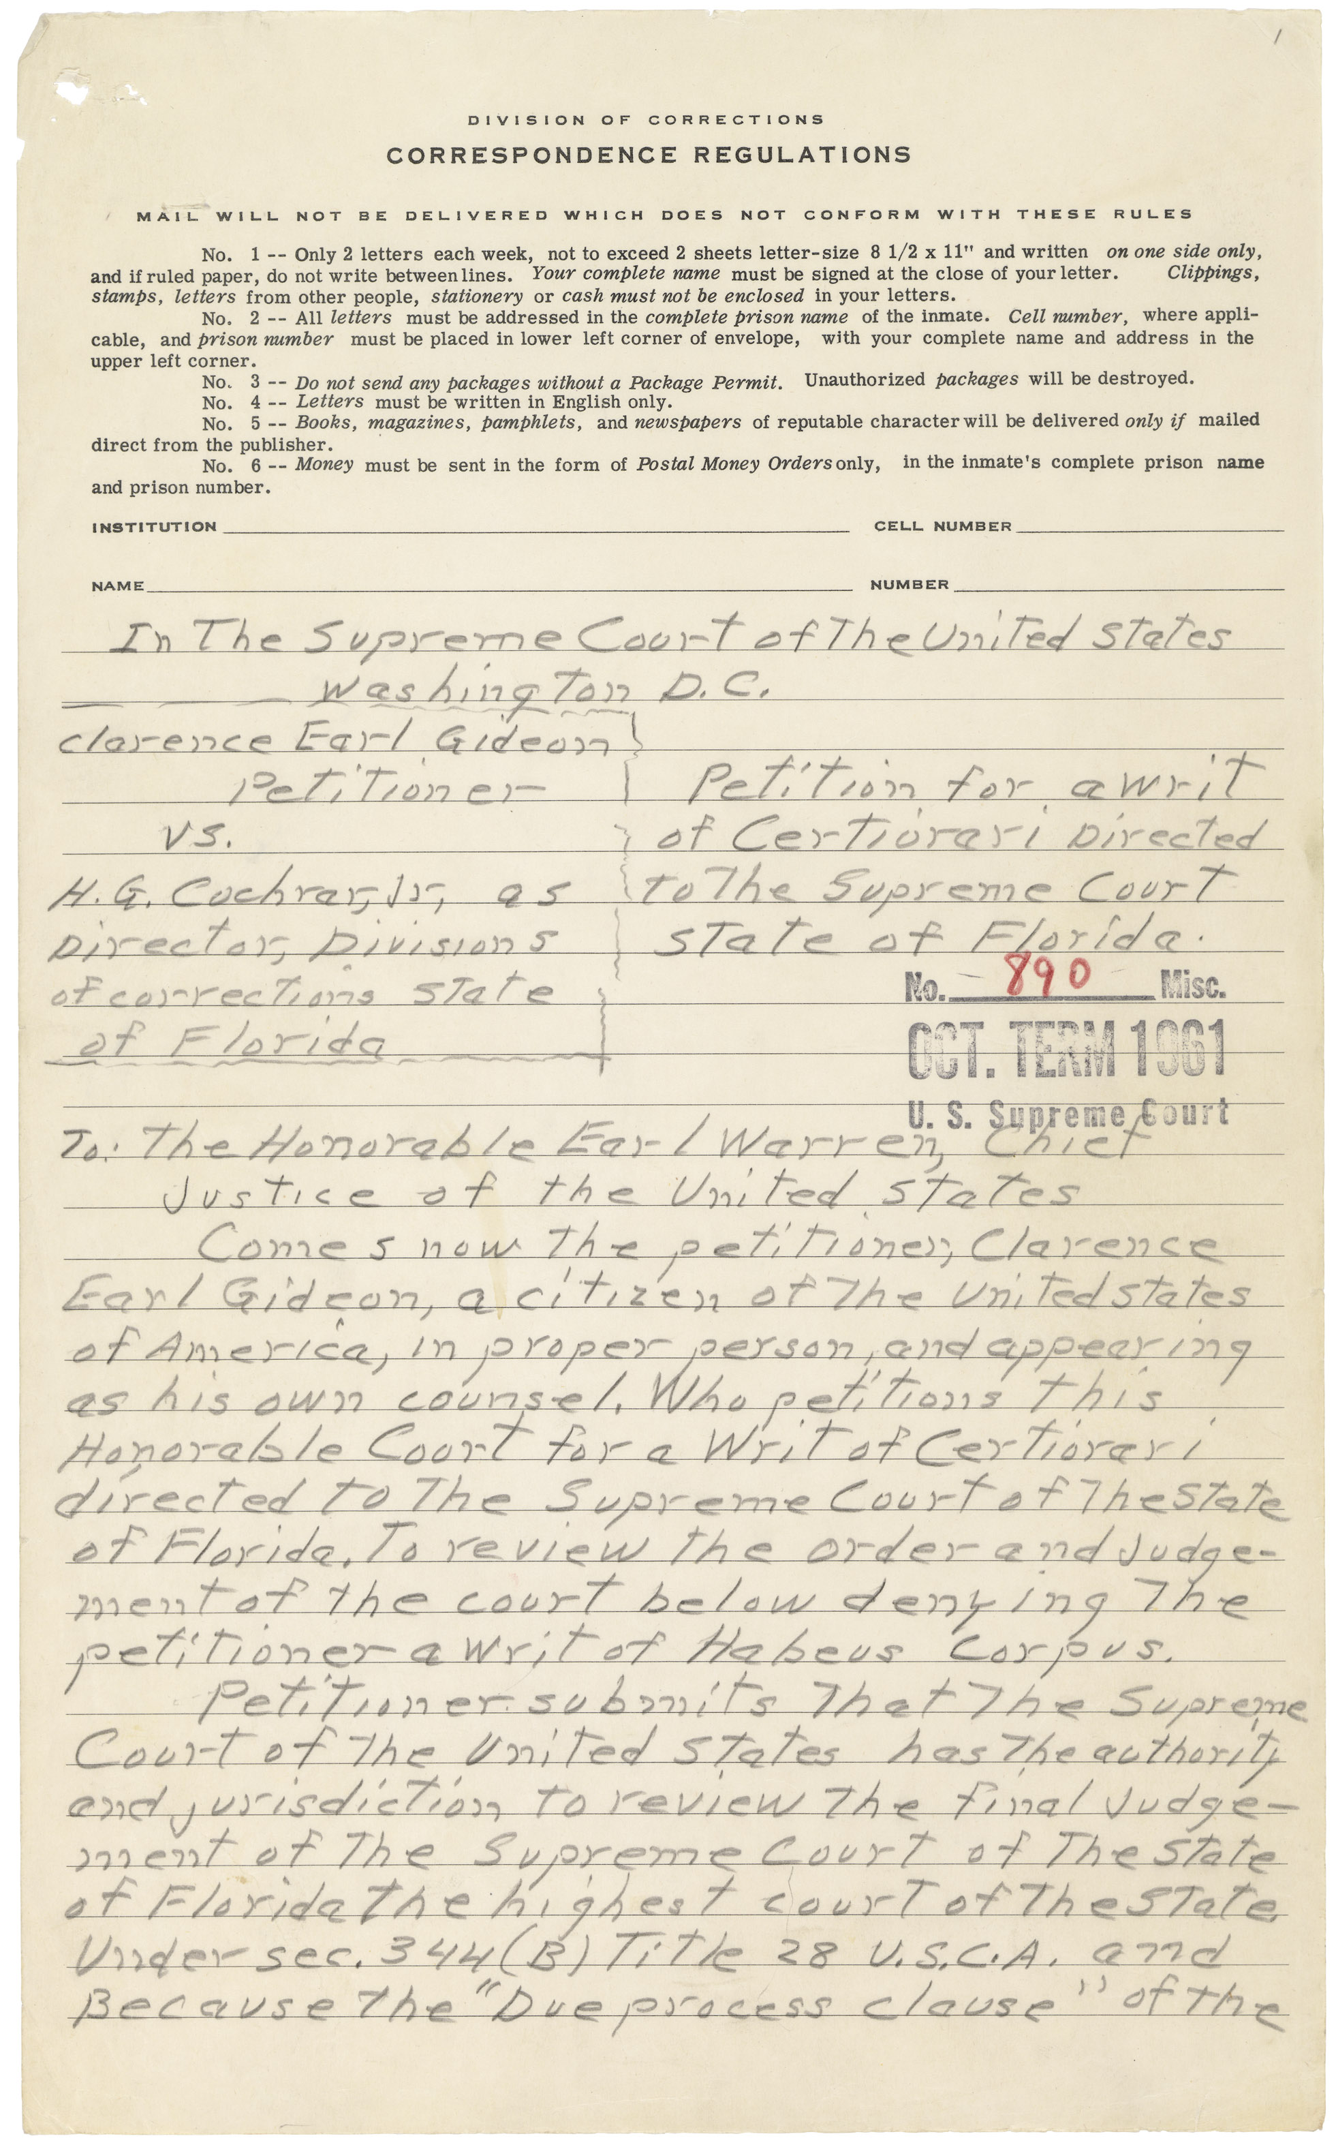
Clarence Gideon's handwritten cert. petition · Clarence Earl Gideon (NARA RG 267) · 1962
Source: Wikimedia Commons · https://commons.wikimedia.org/wiki/File:Gideon_petition_for_certiorari.jpg Public domain — U.S. federal court record (NARA) https://commons.wikimedia.org/wiki/File:Gideon_petition_for_certiorari.jpg
HIPPO — analyze the source (prompt) | Your analysis
H — Historical context: what was happening when this was created?
I — Intended audience: who was meant to see or obey it?
P — Purpose: why was it created?
P — Point of view: whose perspective does it reflect?
O — Outside connection: how does it connect to this standard?
SUPPORT OPTION
Sentence frame: This source shows ______ because it ______, which reveals ______.
CONFIDENCE CHECK-IN
Rate your understanding of this standard (1–4): ______ One thing to revisit: ____________________

Activity 6 — Core Application: Practice Quiz — GC.25 ⏱ ~8 min
RESPONSE CHOICE
Commit to an answer by marking it, saying it, or explaining it aloud before checking. Answer key is in the Teacher Guide (kept separate).
[DOK 1 · item u6-gc25-dok1-1 · pre-field-test]
The requirement that police warn suspects of the right to remain silent comes from:
A. Mapp v. Ohio
B. Gideon v. Wainwright
C. Miranda v. Arizona
D. Brown v. Board of Education
[DOK 2 · item u1-gc25-dok2-tc · pre-field-test]
What right did Gideon v. Wainwright (1963) guarantee?
A. The state must provide a lawyer to a defendant who cannot afford one
B. Police may search a home without a warrant
C. A suspect must answer all police questions
D. Trials may be held in secret

STRETCH — think like a test-writer (open to all)
Write your OWN DOK-3 question for this standard, then a one-sentence answer key. Use the supports below — everyone can do this.
HOW TO WRITE A DOK-3 QUESTION (supports)
DOK-3 = strategic thinking: the reader must analyze, compare, evaluate, or justify using evidence — and there should be more than one defensible answer (not a fact you can just look up).
Sentence starters: “Why did ______ lead to ______?” · “Which mattered more — ______ or ______ — and why?” · “What is the BEST evidence that ______?” · “Evaluate whether ______.” · “Defend or challenge: ______.”
Frame: [Analyze / Evaluate / Justify] + [something from THIS standard] + “using evidence.”
Quick check: does my question make the reader THINK and use evidence? If yes, it’s DOK-3.
Your DOK-3 question | Your answer key (one sentence)

Activity 7 — Constructed Response (CER) — GC.25 ⏱ ~15 min
BIG-QUESTION ORGANIZER (before you write) — How do the courts decide where your rights end and the government's power begins?
Plan your argument here, then use it to write your claim, evidence, and reasoning below.
Plan your argument | Your quick notes (from this standard)
My claim (answer the prompt)
Evidence 1 (a source or fact)
Reasoning (why it proves the claim)
CONSTRUCTED RESPONSE (CER) — builds SSP.04 Argumentation
Claim + Evidence + Reasoning: Do the rights of the accused protect the innocent or shield the guilty? Defend your claim using Gideon and one other case.
Part | Write here
Claim
Evidence (two specifics)
Reasoning
SELF-CHECK against the CER rubric (see Toolkit)
Before submitting: Is my claim defensible? Do I have TWO specific pieces of evidence? Does my reasoning explain HOW the evidence proves the claim?

UDL Access, Choice & Reflection — GC.25
UDL ACCESS & MTSS SUPPORT (this standard)
UDL 3.0 (CAST, 2024): read-aloud on request · key terms glossed (EN/ES) · respond in writing, speech, or a labeled diagram · large-print & screen-reader friendly. Same learning target for everyone; supports vary the means, not the ceiling.
MTSS: Tier 1 — this core lesson for all · Tier 2 — small-group reteach of this standard using its Cornell cues + graphic organizer, then re-check · Tier 3 — intensive 1:1 with concrete→representational→abstract scaffolding, progress-monitored to the same standard.
SHOW WHAT YOU KNOW — YOUR WAY (same CER rubric, same standard)
Build your Claim–Evidence–Reasoning in whichever mode lets you think best — the standard and the CER rubric are identical for every mode; the mode changes how you SHOW it, never what you are held to:
WRITE it · SAY it aloud and record it (audio or video) · DRAW and label a diagram that makes the argument · BUILD a model or artifact and caption its claim, evidence, and reasoning.
You may ask for a word processor, speech-to-text, a scribe, or a sentence/argument frame — these change how you produce, not the standard you meet.
CHOICE & VOICE — you decide how to go deeper (pick ONE)
You choose your path to show this standard — every option meets the same target:
DEFEND a term: pick the vocabulary word that matters most and argue why in 2–3 sentences. · CONNECT it: pick a current event, your community, or your own life and explain how this standard shows up there. · TAKE A SIDE: pick one debatable question and argue your position with evidence.
Your pick is yours — bring what matters to you into the work.
REFLECT & CONNECT — how your thinking grew, and whose view you weighed
Reflect (self-awareness): What did you believe about this topic BEFORE, and what changed AFTER? Name one thing to revisit.
Consider another view (empathy): Name one person or group who might see this standard differently than you; state their view fairly in one sentence — even if you disagree.
Norm (restorative): we critique ideas, not people; we assume good faith; we make room for every voice.

Standard GC.26 — The 14th Amendment — Equal Protection & Due Process
TN Academic Standard GC.26: Evaluate the Supreme Court's interpretations of the freedoms in the 14th Amendment, equal protection, and due process clauses, including: Plessy v. Ferguson; Gitlow v. New York; Brown v. Board of Education; Obergefell v. Hodges. (—)
LEARNING TARGETS — I can…
• I can I can evaluate how the Supreme Court has interpreted the 14th Amendment's equal protection and due process clauses..
Lenses for this standard: Equal Protection
CORE PATH — the same for every student
Every student works this standard at the same rigor: analyze the sources and vocabulary, then demonstrate learning on the Practice Quiz and CER. UDL and MTSS give you flexible ways in — they never lower the bar. Check yourself against the learning targets on the Cornell Notes page.
SET YOUR GOAL (self-direction)
My goal for this standard — what will I be able to do, and how will I show it?

HOOK — think before you dig in
The same 14th Amendment once allowed 'separate but equal' — and later ended it. How can the identical words mean opposite things fifty years apart?

ACTIVATE — what do you already know or wonder?
Jot what you already know or want to find out about this standard. You’ll come back to it.

PREVIEW & PREDICT
Which learning target will be hardest, and why? Connect it to the unit’s big question: How do the courts decide where your rights end and the government's power begins?

Activity 1 — Vocabulary (Part A: Reference / Word Bank) — GC.26 ⏱ ~10 min
Use this word bank throughout the standard. The Spanish column supports access, not translation of assessment.
Term | Student-friendly meaning | Spanish
Equal Protection Clause | The 14th Amendment guarantee that no state may 'deny to any person… the equal protection of the laws' — the basis of Brown v. Board. | cláusula de igual protección
Due Process | The 14th Amendment guarantee that government must follow fair procedures and respect basic rights before taking a person's life, liberty, or property. | debido proceso
Incorporation Doctrine | The principle that the 14th Amendment applies most Bill of Rights protections to the states; Gitlow v. New York (1925) was an early step. | doctrina de incorporación
LANGUAGE SUPPORT
Pronunciations: Equal Protection Clause (EE-kwul pro-TEK-shun); Due Process (doo PROSS-ess); Incorporation Doctrine (in-kor-por-AY-shun).

VOCABULARY SELF-CHECK · Knowledge Rating
Rate each term NOW in pencil, then again at the END — growth is the goal; no penalty for “never seen it.”
Term | 1 · never seen it | 2 · heard it | 3 · can use it | 4 · can teach it
Equal Protection Clause
Due Process
Incorporation Doctrine
MAKE IT YOURS (RESPONSE CHOICE): choose ONE term above and show you own it — write a sentence, sketch it, or give a real-world example.

QUICK WRITE
Which of these terms do you think will matter MOST for this standard, and why? You’ll revisit this at the end.

Activity 2 — Vocabulary Studio (Frayer-inspired) — GC.26 ⏱ ~7 min
RESPONSE CHOICE
Complete each studio by writing, speaking, or diagramming.

PRIORITY TERM 1 Equal Protection Clause · ES: cláusula de igual protección
Word-bank meaning to build on: The 14th Amendment guarantee that no state may 'deny to any person… the equal protection of the laws' — the basis of Brown v. Board.
Definition (in your own words) | Characteristics
Examples | Non-examples
Use it to explain
Write one sentence that uses “Equal Protection Clause” to explain this standard.

PRIORITY TERM 2 Incorporation Doctrine · ES: doctrina de incorporación
Word-bank meaning to build on: The principle that the 14th Amendment applies most Bill of Rights protections to the states; Gitlow v. New York (1925) was an early step.
Definition (in your own words) | Characteristics
Examples | Non-examples
Use it to explain
Write one sentence that uses “Incorporation Doctrine” to explain this standard.

CONNECT THE TERMS (UDL · build understanding)
How do these priority terms fit together? Write or sketch how one leads to or affects another.

Activity 3 — Direct Teaching Cornell Notes — GC.26 ⏱ ~20 min
Name: ______________________ Class / Period: __________ Date: __________
GC.26 — The 14th Amendment — Equal Protection & Due Process • Lean Student Deck slides 2–8 • direct-teaching slides 4–6
Your learning targets are on this standard’s opening page — take notes that help you meet them.
Guiding cues | My notes — write your notes here
Key idea of this standard?
One amendment or case that supports it?
One real situation it applies to?
Key terms →
Keep taking notes — lines run the full width of the page:

DOODLE ZONE — draw your thinking (UDL · another way in)
Need another way in? Sketch the key idea, a quick timeline, or how the pieces connect. Words optional.

Cornell Notes — keep going, then process & check — GC.26
MORE NOTES / DIAGRAMS
Continue your notes here, add a quick sketch, or map how the ideas connect.

Key terms to list
Equal Protection Clause · Due Process · Incorporation Doctrine
Summary — In your own words (2–3 sentences)
PROGRESS CHECK · one question
How did Brown v. Board of Education (1954) change the meaning of the Equal Protection Clause?
A. It upheld 'separate but equal' from Plessy
B. It ended the 14th Amendment
C. It ruled that 'separate educational facilities are inherently unequal,' overturning school segregation
D. It applied only to colleges, not public schools
Commit before you move on — mark it, say it, or explain it aloud.
CHECK YOURSELF — how am I doing?
Which learning targets (on this standard’s opening page) can you now meet? Tick the number; circle any you still need help with.
☐ 1
My 12–15 word headline for this standard

Guided Support for the Cornell Notes — GC.26
These scaffolds support ONLY the Cornell notes — use them to take and process those notes. Optional and easy to set aside; not a separate assignment or a label.
Key vocabulary | What it means
Equal Protection Clause | The 14th Amendment guarantee that no state may 'deny to any person… the equal protection of the laws' — the basis of Brown v. Board.
Due Process | The 14th Amendment guarantee that government must follow fair procedures and respect basic rights before taking a person's life, liberty, or property.
Incorporation Doctrine | The principle that the 14th Amendment applies most Bill of Rights protections to the states; Gitlow v. New York (1925) was an early step.
Break it into steps:
1) Name one cause or effect. 2) Give one piece of evidence. 3) Write one sentence explaining the link.
Sentence frame
One key cause/effect of the 14th amendment — equal protection & due process was ______, shown by ______, which mattered because ______.
Modeled example (one worked note — yours will differ)
A key idea of the 14th amendment — equal protection & due process was Equal Protection Clause: The 14th Amendment guarantee that no state may 'deny to any person… the equal protection of the laws' — the basis of Brown v. Board.
GUIDED NOTE REHEARSAL LAB
Rehearse the cause→effect chain below, then transfer it to your Cornell notes.
Step | Rehearse it here
Name it
Evidence
Explain
Headline
TRANSFER CHECK — move one rehearsed idea onto the front notes

Light Support for the Cornell Notes — GC.26
A lighter scaffold for the SAME Cornell notes. Try the notes first; reach for this only if you need it.
Key vocabulary | Finish the idea — “This term means …”
Equal Protection Clause
Due Process
Incorporation Doctrine
Guiding questions — answer on the lines below (or in your front notes):
• What two guarantees does the 14th Amendment's Section 1 make to 'any person'?
• How did Brown v. Board change the rule set by Plessy v. Ferguson?
• What does 'incorporation' mean, and how did Gitlow start it?

WHICH CUE STILL NEEDS WORK?
Circle the Cornell cue from the front page you still need help with, and tell your teacher so we can go over it.
LIGHT PROCESSING LAB
Answer one guiding question from above in a full sentence, in your own words.

Activity 4 — Close Read — GC.26 ⏱ ~15 min
Reading type: Government Hack-authored instructional synthesis. This is not a primary source. Builds SSP.03 (synthesize) and SSP.05 (historical awareness).
CORE PATH
The 14th Amendment (1868) transformed the Constitution by promising that no state may deny any person 'due process of law' or 'the equal protection of the laws.' Its meaning has been fought over ever since. In Plessy v. Ferguson (1896) the Court allowed 'separate but equal' segregation — a reading that stood for decades. Gitlow v. New York (1925) began 'incorporation,' using the 14th Amendment's due process clause to apply Bill of Rights protections to the states. Then Brown v. Board of Education (1954) reversed Plessy, holding that 'separate educational facilities are inherently unequal' and violate equal protection. Decades later, Obergefell v. Hodges (2015) held that the due process and equal protection clauses protect the right to marry for same-sex couples. Across these cases, the same two clauses have been read in dramatically different ways — proof that the Constitution's meaning is decided by people, over time.
LANGUAGE SUPPORT
Key terms to know first: Equal Protection Clause, Due Process. Read once for the gist, then again for evidence.
Text-dependent questions (answer in the Evidence Lab below or aloud):
1. What two guarantees does the 14th Amendment's Section 1 make to 'any person'?
2. How did Brown v. Board change the rule set by Plessy v. Ferguson?
3. What does 'incorporation' mean, and how did Gitlow start it?
RESPONSE CHOICE: answer any question by writing in the Evidence Lab, saying/recording it, or diagramming it.
CLOSE-READ EVIDENCE LAB
Log evidence from the passage below.
Question / claim | Exact passage evidence | What the evidence shows

SPACED RETRIEVAL — quick recall (no notes)
Pull it up cold to strengthen memory, then check your notes.
Recall prompt | Your answer (from memory)
One key term or fact from THIS standard
One thing you learned EARLIER in this unit or course
How the two connect

Activity 5 — Primary Source / Data Analysis — GC.26 ⏱ ~15 min
Primary source (document) — analyze it with HIPPO. Builds SSP.01–SSP.02.
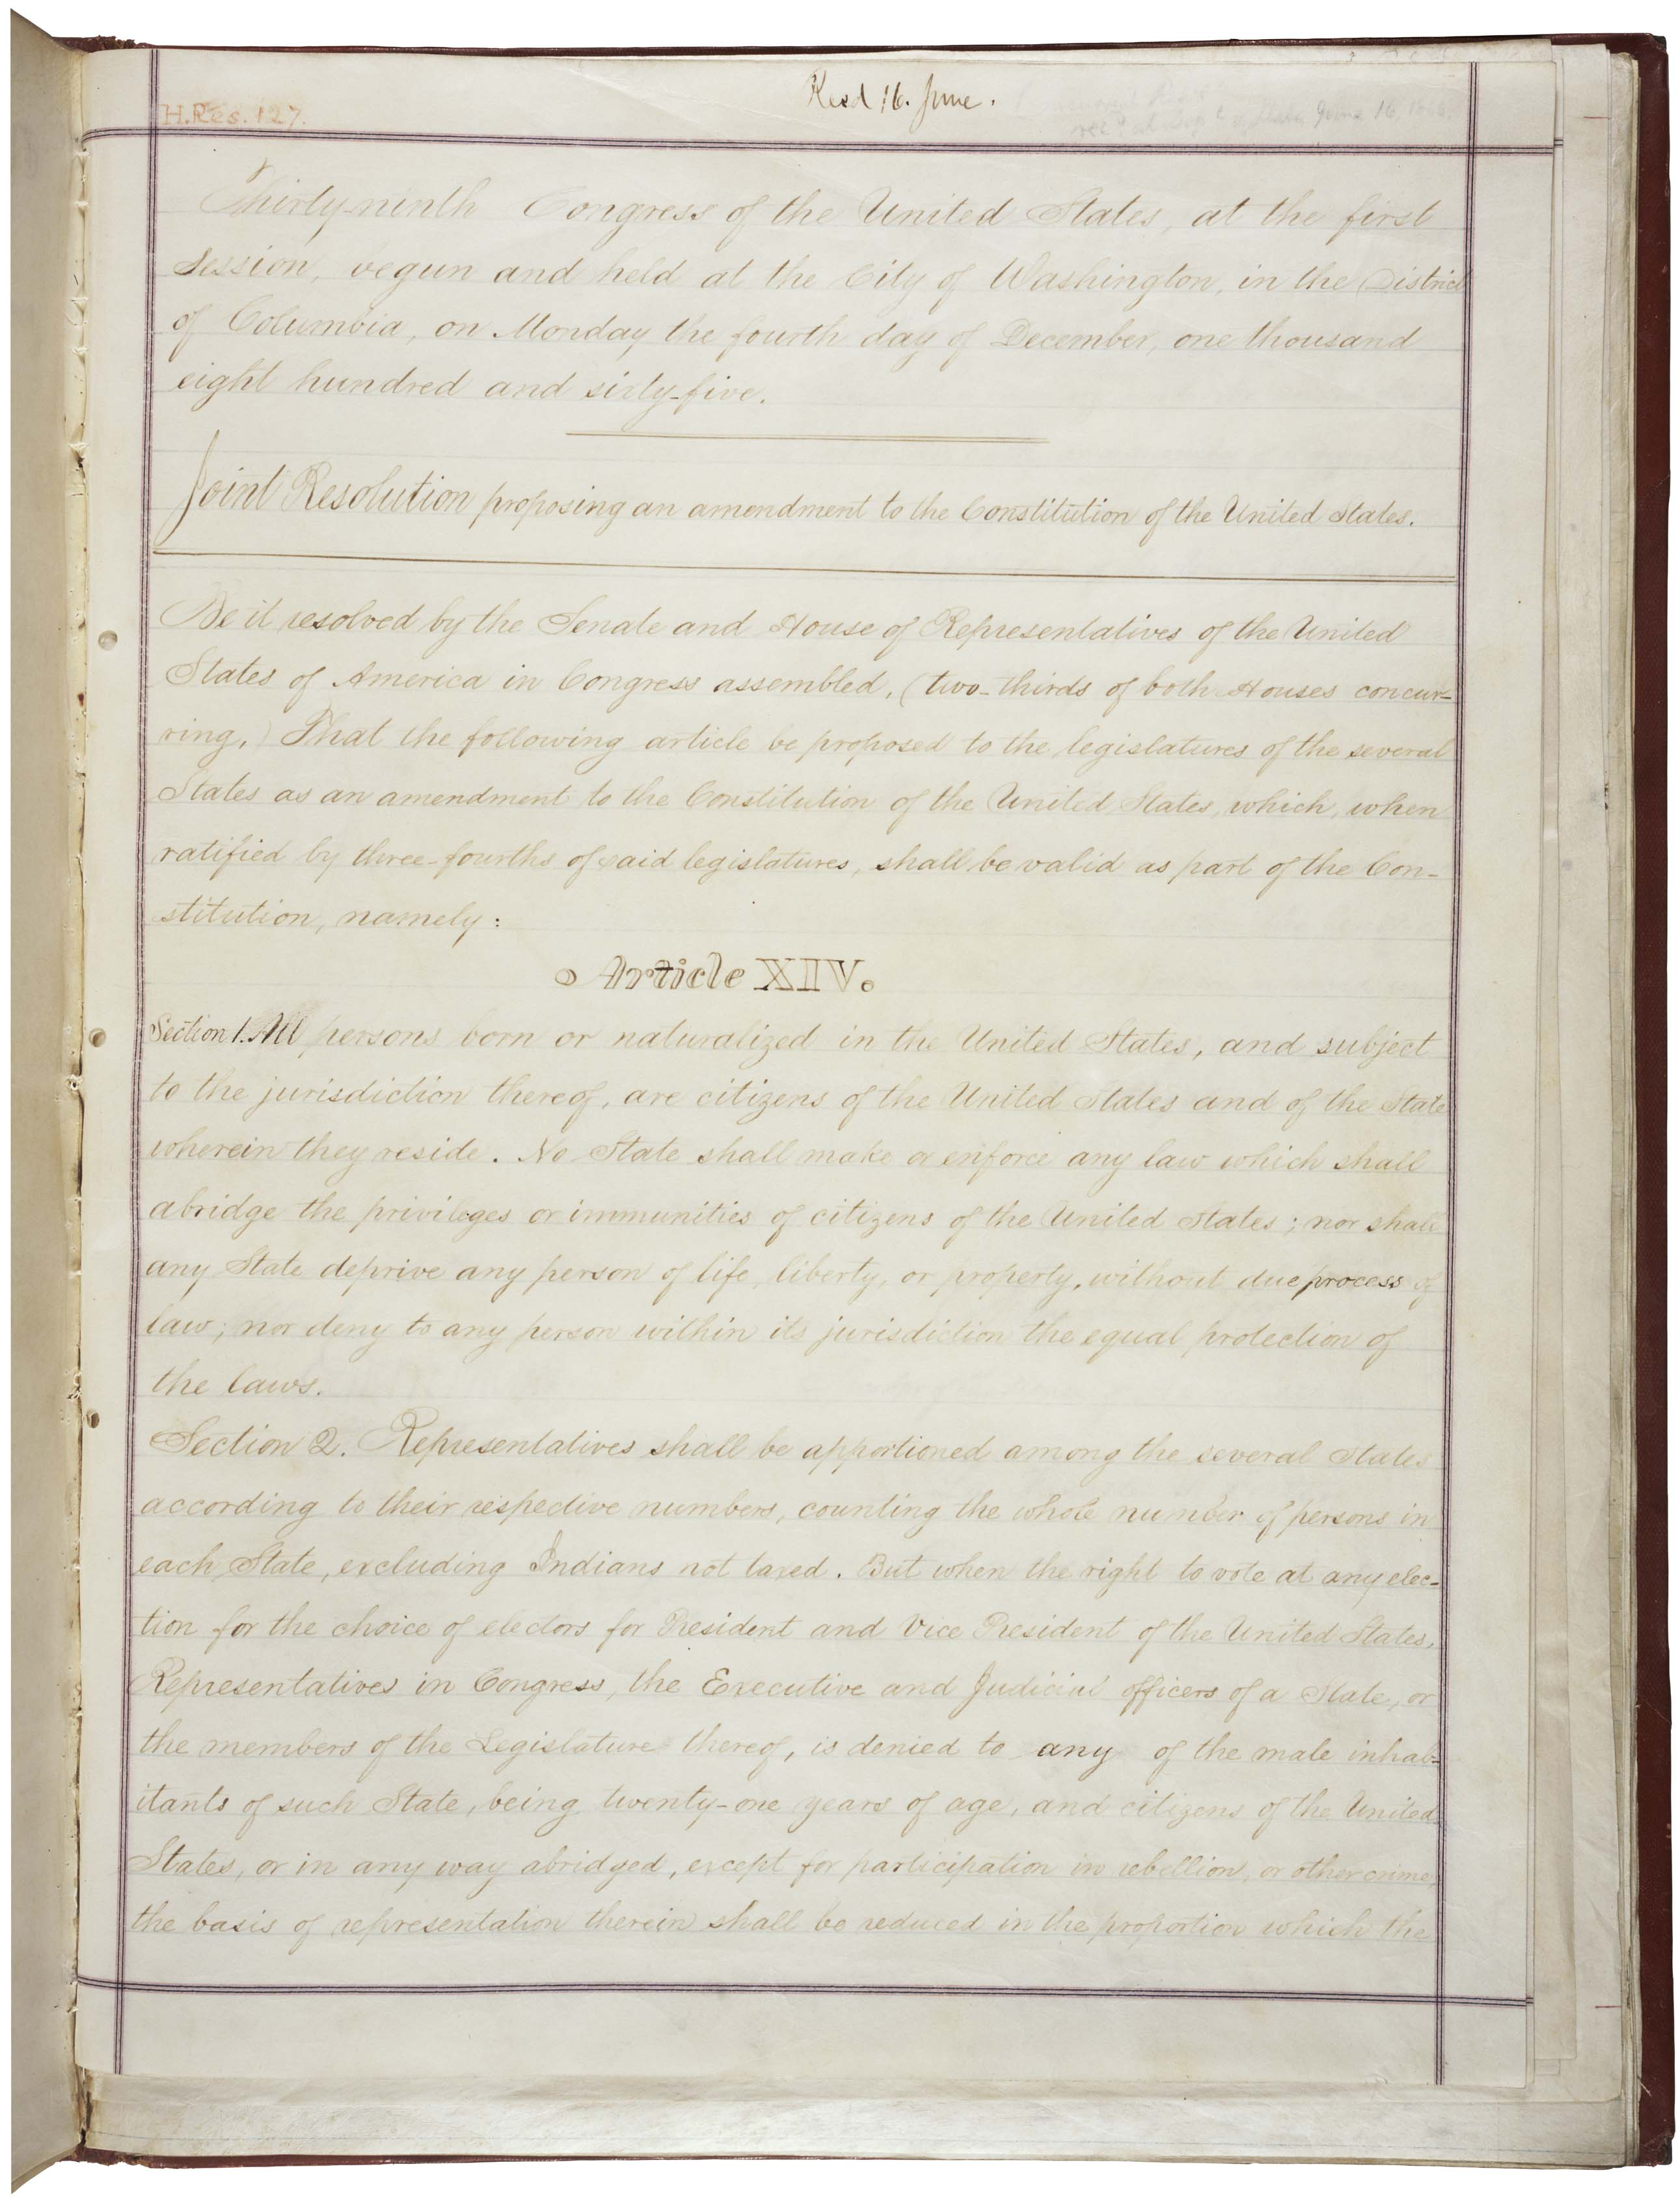
14th Amendment (engrossed, page 1) · 39th U.S. Congress (NARA) · 1868
Source: Wikimedia Commons · https://commons.wikimedia.org/wiki/File:14th_Amendment_Pg1of2_AC.jpg Public domain — U.S. gov document; NARA scan https://commons.wikimedia.org/wiki/File:14th_Amendment_Pg1of2_AC.jpg
HIPPO — analyze the source (prompt) | Your analysis
H — Historical context: what was happening when this was created?
I — Intended audience: who was meant to see or obey it?
P — Purpose: why was it created?
P — Point of view: whose perspective does it reflect?
O — Outside connection: how does it connect to this standard?
SUPPORT OPTION
Sentence frame: This source shows ______ because it ______, which reveals ______.
CONFIDENCE CHECK-IN
Rate your understanding of this standard (1–4): ______ One thing to revisit: ____________________

Activity 6 — Core Application: Practice Quiz — GC.26 ⏱ ~8 min
RESPONSE CHOICE
Commit to an answer by marking it, saying it, or explaining it aloud before checking. Answer key is in the Teacher Guide (kept separate).
[DOK 1 · item u6-gc26-dok1-1 · pre-field-test]
Which case overturned the 'separate but equal' doctrine?
A. Plessy v. Ferguson
B. Brown v. Board of Education
C. Gitlow v. New York
D. Schenck v. United States
[DOK 3 · item u1-gc26-dok3-tc · pre-field-test]
How did Brown v. Board of Education (1954) change the meaning of the Equal Protection Clause?
A. It upheld 'separate but equal' from Plessy
B. It ended the 14th Amendment
C. It ruled that 'separate educational facilities are inherently unequal,' overturning school segregation
D. It applied only to colleges, not public schools

STRETCH — think like a test-writer (open to all)
Write your OWN DOK-3 question for this standard, then a one-sentence answer key. Use the supports below — everyone can do this.
HOW TO WRITE A DOK-3 QUESTION (supports)
DOK-3 = strategic thinking: the reader must analyze, compare, evaluate, or justify using evidence — and there should be more than one defensible answer (not a fact you can just look up).
Sentence starters: “Why did ______ lead to ______?” · “Which mattered more — ______ or ______ — and why?” · “What is the BEST evidence that ______?” · “Evaluate whether ______.” · “Defend or challenge: ______.”
Frame: [Analyze / Evaluate / Justify] + [something from THIS standard] + “using evidence.”
Quick check: does my question make the reader THINK and use evidence? If yes, it’s DOK-3.
Your DOK-3 question | Your answer key (one sentence)

Activity 7 — Constructed Response (CER) — GC.26 ⏱ ~15 min
BIG-QUESTION ORGANIZER (before you write) — How do the courts decide where your rights end and the government's power begins?
Plan your argument here, then use it to write your claim, evidence, and reasoning below.
Plan your argument | Your quick notes (from this standard)
My claim (answer the prompt)
Evidence 1 (a source or fact)
Reasoning (why it proves the claim)
CONSTRUCTED RESPONSE (CER) — builds SSP.04 Argumentation
Claim + Evidence + Reasoning: How can the same Equal Protection Clause justify both Plessy (1896) and Brown (1954)? Defend a claim about how constitutional meaning changes.
Part | Write here
Claim
Evidence (two specifics)
Reasoning
SELF-CHECK against the CER rubric (see Toolkit)
Before submitting: Is my claim defensible? Do I have TWO specific pieces of evidence? Does my reasoning explain HOW the evidence proves the claim?

UDL Access, Choice & Reflection — GC.26
UDL ACCESS & MTSS SUPPORT (this standard)
UDL 3.0 (CAST, 2024): read-aloud on request · key terms glossed (EN/ES) · respond in writing, speech, or a labeled diagram · large-print & screen-reader friendly. Same learning target for everyone; supports vary the means, not the ceiling.
MTSS: Tier 1 — this core lesson for all · Tier 2 — small-group reteach of this standard using its Cornell cues + graphic organizer, then re-check · Tier 3 — intensive 1:1 with concrete→representational→abstract scaffolding, progress-monitored to the same standard.
SHOW WHAT YOU KNOW — YOUR WAY (same CER rubric, same standard)
Build your Claim–Evidence–Reasoning in whichever mode lets you think best — the standard and the CER rubric are identical for every mode; the mode changes how you SHOW it, never what you are held to:
WRITE it · SAY it aloud and record it (audio or video) · DRAW and label a diagram that makes the argument · BUILD a model or artifact and caption its claim, evidence, and reasoning.
You may ask for a word processor, speech-to-text, a scribe, or a sentence/argument frame — these change how you produce, not the standard you meet.
CHOICE & VOICE — you decide how to go deeper (pick ONE)
You choose your path to show this standard — every option meets the same target:
DEFEND a term: pick the vocabulary word that matters most and argue why in 2–3 sentences. · CONNECT it: pick a current event, your community, or your own life and explain how this standard shows up there. · TAKE A SIDE: pick one debatable question and argue your position with evidence.
Your pick is yours — bring what matters to you into the work.
REFLECT & CONNECT — how your thinking grew, and whose view you weighed
Reflect (self-awareness): What did you believe about this topic BEFORE, and what changed AFTER? Name one thing to revisit.
Consider another view (empathy): Name one person or group who might see this standard differently than you; state their view fairly in one sentence — even if you disagree.
Norm (restorative): we critique ideas, not people; we assume good faith; we make room for every voice.

Standard GC.27 — Rights for the Underserved
TN Academic Standard GC.27: Identify and explain legislation and legal precedents that established rights for the underserved, including Title IX and the Americans with Disabilities Act. (H, T)
LEARNING TARGETS — I can…
• I can I can identify legislation and legal precedents that expanded rights for underserved groups, including Title IX and the ADA..
Lenses for this standard: History (H) · Tennessee (T)
CORE PATH — the same for every student
Every student works this standard at the same rigor: analyze the sources and vocabulary, then demonstrate learning on the Practice Quiz and CER. UDL and MTSS give you flexible ways in — they never lower the bar. Check yourself against the learning targets on the Cornell Notes page.
SET YOUR GOAL (self-direction)
My goal for this standard — what will I be able to do, and how will I show it?

HOOK — think before you dig in
A law barely two sentences long transformed school sports for millions of girls. What other laws quietly widened the circle of who counts as equal?

ACTIVATE — what do you already know or wonder?
Jot what you already know or want to find out about this standard. You’ll come back to it.

PREVIEW & PREDICT
Which learning target will be hardest, and why? Connect it to the unit’s big question: How do the courts decide where your rights end and the government's power begins?

Activity 1 — Vocabulary (Part A: Reference / Word Bank) — GC.27 ⏱ ~10 min
Use this word bank throughout the standard. The Spanish column supports access, not translation of assessment.
Term | Student-friendly meaning | Spanish
Title IX | A 1972 federal law barring sex discrimination in any education program that receives federal funds — landmark for equal opportunity, including in school athletics. | Título IX
Americans with Disabilities Act (ADA) | A 1990 federal law prohibiting discrimination against people with disabilities and requiring reasonable accommodations in employment, public services, and public places. | Ley de Estadounidenses con Discapacidades
Precedent | An earlier law or court decision that guides later ones; civil-rights precedents built on one another to widen who is protected. | precedente
LANGUAGE SUPPORT
Pronunciations: Title IX (TY-tul nine); Americans with Disabilities Act (ADA) (uh-BIL-ih-teez); Precedent (PRESS-ih-dent).

VOCABULARY SELF-CHECK · Knowledge Rating
Rate each term NOW in pencil, then again at the END — growth is the goal; no penalty for “never seen it.”
Term | 1 · never seen it | 2 · heard it | 3 · can use it | 4 · can teach it
Title IX
Americans with Disabilities Act (ADA)
Precedent
MAKE IT YOURS (RESPONSE CHOICE): choose ONE term above and show you own it — write a sentence, sketch it, or give a real-world example.

QUICK WRITE
Which of these terms do you think will matter MOST for this standard, and why? You’ll revisit this at the end.

Activity 2 — Vocabulary Studio (Frayer-inspired) — GC.27 ⏱ ~7 min
RESPONSE CHOICE
Complete each studio by writing, speaking, or diagramming.

PRIORITY TERM 1 Title IX · ES: Título IX
Word-bank meaning to build on: A 1972 federal law barring sex discrimination in any education program that receives federal funds — landmark for equal opportunity, including in school athletics.
Definition (in your own words) | Characteristics
Examples | Non-examples
Use it to explain
Write one sentence that uses “Title IX” to explain this standard.

PRIORITY TERM 2 Americans with Disabilities Act (ADA) · ES: Ley de Estadounidenses con Discapacidades
Word-bank meaning to build on: A 1990 federal law prohibiting discrimination against people with disabilities and requiring reasonable accommodations in employment, public services, and public places.
Definition (in your own words) | Characteristics
Examples | Non-examples
Use it to explain
Write one sentence that uses “Americans with Disabilities Act (ADA)” to explain this standard.

CONNECT THE TERMS (UDL · build understanding)
How do these priority terms fit together? Write or sketch how one leads to or affects another.

Activity 3 — Direct Teaching Cornell Notes — GC.27 ⏱ ~20 min
Name: ______________________ Class / Period: __________ Date: __________
GC.27 — Rights for the Underserved • Lean Student Deck slides 2–8 • direct-teaching slides 4–6
Your learning targets are on this standard’s opening page — take notes that help you meet them.
Guiding cues | My notes — write your notes here
Key idea of this standard?
One amendment or case that supports it?
One real situation it applies to?
Key terms →
Keep taking notes — lines run the full width of the page:

DOODLE ZONE — draw your thinking (UDL · another way in)
Need another way in? Sketch the key idea, a quick timeline, or how the pieces connect. Words optional.

Cornell Notes — keep going, then process & check — GC.27
MORE NOTES / DIAGRAMS
Continue your notes here, add a quick sketch, or map how the ideas connect.

Key terms to list
Title IX · Americans with Disabilities Act (ADA) · Precedent
Summary — In your own words (2–3 sentences)
PROGRESS CHECK · one question
What does Title IX (1972) prohibit?
A. Discrimination based on sex in federally funded education programs
B. All private-school tuition
C. The teaching of history
D. Voting by people under 21
Commit before you move on — mark it, say it, or explain it aloud.
CHECK YOURSELF — how am I doing?
Which learning targets (on this standard’s opening page) can you now meet? Tick the number; circle any you still need help with.
☐ 1
My 12–15 word headline for this standard

Guided Support for the Cornell Notes — GC.27
These scaffolds support ONLY the Cornell notes — use them to take and process those notes. Optional and easy to set aside; not a separate assignment or a label.
Key vocabulary | What it means
Title IX | A 1972 federal law barring sex discrimination in any education program that receives federal funds — landmark for equal opportunity, including in school athletics.
Americans with Disabilities Act (ADA) | A 1990 federal law prohibiting discrimination against people with disabilities and requiring reasonable accommodations in employment, public services, and public places.
Precedent | An earlier law or court decision that guides later ones; civil-rights precedents built on one another to widen who is protected.
Break it into steps:
1) Name one cause or effect. 2) Give one piece of evidence. 3) Write one sentence explaining the link.
Sentence frame
One key cause/effect of rights for the underserved was ______, shown by ______, which mattered because ______.
Modeled example (one worked note — yours will differ)
A key idea of rights for the underserved was Title IX: A 1972 federal law barring sex discrimination in any education program that receives federal funds — landmark for equal opportunity, including in school athletics.
GUIDED NOTE REHEARSAL LAB
Rehearse the cause→effect chain below, then transfer it to your Cornell notes.
Step | Rehearse it here
Name it
Evidence
Explain
Headline
TRANSFER CHECK — move one rehearsed idea onto the front notes

Light Support for the Cornell Notes — GC.27
A lighter scaffold for the SAME Cornell notes. Try the notes first; reach for this only if you need it.
Key vocabulary | Finish the idea — “This term means …”
Title IX
Americans with Disabilities Act (ADA)
Precedent
Guiding questions — answer on the lines below (or in your front notes):
• What does Title IX guarantee, and where does it apply?
• What protections does the Americans with Disabilities Act provide?
• Why is Korematsu v. United States remembered as a warning, not a model?

WHICH CUE STILL NEEDS WORK?
Circle the Cornell cue from the front page you still need help with, and tell your teacher so we can go over it.
LIGHT PROCESSING LAB
Answer one guiding question from above in a full sentence, in your own words.

Activity 4 — Close Read — GC.27 ⏱ ~15 min
Reading type: Government Hack-authored instructional synthesis. This is not a primary source. Builds SSP.03 (synthesize) and SSP.05 (historical awareness).
CORE PATH
The Constitution's promise of equal protection has been extended over time by laws and court decisions that reached groups long left out. Title IX of the Education Amendments of 1972 declared that 'no person… shall, on the basis of sex, be excluded from participation in… any education program or activity receiving Federal financial assistance' — reshaping opportunity in schools, including athletics. The Americans with Disabilities Act (1990) barred discrimination against people with disabilities and required reasonable accommodations in jobs, public services, and public places. Court cases added both progress and cautionary lessons: Korematsu v. United States (1944) upheld the wartime incarceration of Japanese Americans — now widely condemned — while later rulings like Adarand Constructors v. Peña (1995) shaped how the government may address past discrimination. Together, these laws and cases show the 'expanding circle' of American rights — and how hard-won and contested each step has been.
LANGUAGE SUPPORT
Key terms to know first: Title IX, Americans with Disabilities Act (ADA). Read once for the gist, then again for evidence.
Text-dependent questions (answer in the Evidence Lab below or aloud):
1. What does Title IX guarantee, and where does it apply?
2. What protections does the Americans with Disabilities Act provide?
3. Why is Korematsu v. United States remembered as a warning, not a model?
RESPONSE CHOICE: answer any question by writing in the Evidence Lab, saying/recording it, or diagramming it.
CLOSE-READ EVIDENCE LAB
Log evidence from the passage below.
Question / claim | Exact passage evidence | What the evidence shows

SPACED RETRIEVAL — quick recall (no notes)
Pull it up cold to strengthen memory, then check your notes.
Recall prompt | Your answer (from memory)
One key term or fact from THIS standard
One thing you learned EARLIER in this unit or course
How the two connect

Activity 5 — Primary Source / Data Analysis — GC.27 ⏱ ~15 min
Primary source (photo) — analyze it with HIPPO. Builds SSP.01–SSP.02.
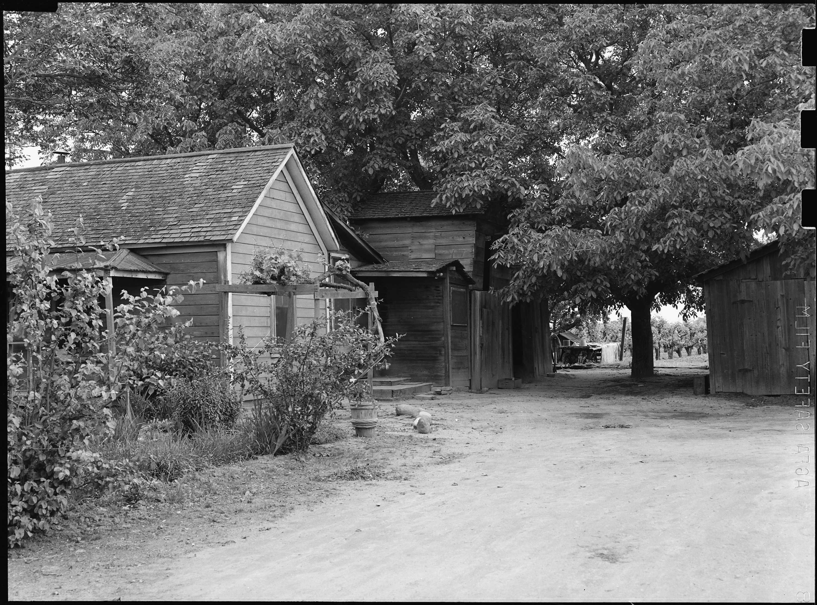
Japanese-American incarceration, Lodi CA (WRA) · Dorothea Lange (WRA) · 1942
Source: Wikimedia Commons · https://commons.wikimedia.org/wiki/File:Lodi,_California._A_family_of_Japanese_ancestry_lived_in_this_house_and_operated_the_surrounding_vi_._._._-_NARA_-_537623.jpg Public domain — U.S. federal (WRA) photograph https://commons.wikimedia.org/wiki/File:Lodi,_California._A_family_of_Japanese_ancestry_lived_in_this_house_and_operated_the_surrounding_vi_._._._-_NARA_-_537623.jpg
HIPPO — analyze the source (prompt) | Your analysis
H — Historical context: what was happening when this was created?
I — Intended audience: who was meant to see or obey it?
P — Purpose: why was it created?
P — Point of view: whose perspective does it reflect?
O — Outside connection: how does it connect to this standard?
SUPPORT OPTION
Sentence frame: This source shows ______ because it ______, which reveals ______.
CONFIDENCE CHECK-IN
Rate your understanding of this standard (1–4): ______ One thing to revisit: ____________________

Activity 6 — Core Application: Practice Quiz — GC.27 ⏱ ~8 min
RESPONSE CHOICE
Commit to an answer by marking it, saying it, or explaining it aloud before checking. Answer key is in the Teacher Guide (kept separate).
[DOK 1 · item u6-gc27-dok1-1 · pre-field-test]
The 1990 law protecting people with disabilities is the:
A. Title IX
B. Americans with Disabilities Act
C. Voting Rights Act
D. Butler Act
[DOK 2 · item u1-gc27-dok2-tc · pre-field-test]
What does Title IX (1972) prohibit?
A. Discrimination based on sex in federally funded education programs
B. All private-school tuition
C. The teaching of history
D. Voting by people under 21

STRETCH — think like a test-writer (open to all)
Write your OWN DOK-3 question for this standard, then a one-sentence answer key. Use the supports below — everyone can do this.
HOW TO WRITE A DOK-3 QUESTION (supports)
DOK-3 = strategic thinking: the reader must analyze, compare, evaluate, or justify using evidence — and there should be more than one defensible answer (not a fact you can just look up).
Sentence starters: “Why did ______ lead to ______?” · “Which mattered more — ______ or ______ — and why?” · “What is the BEST evidence that ______?” · “Evaluate whether ______.” · “Defend or challenge: ______.”
Frame: [Analyze / Evaluate / Justify] + [something from THIS standard] + “using evidence.”
Quick check: does my question make the reader THINK and use evidence? If yes, it’s DOK-3.
Your DOK-3 question | Your answer key (one sentence)

Activity 7 — Constructed Response (CER) — GC.27 ⏱ ~15 min
BIG-QUESTION ORGANIZER (before you write) — How do the courts decide where your rights end and the government's power begins?
Plan your argument here, then use it to write your claim, evidence, and reasoning below.
Plan your argument | Your quick notes (from this standard)
My claim (answer the prompt)
Evidence 1 (a source or fact)
Reasoning (why it proves the claim)
CONSTRUCTED RESPONSE (CER) — builds SSP.04 Argumentation
Claim + Evidence + Reasoning: Which did more to expand rights for underserved groups — legislation like Title IX and the ADA, or Supreme Court rulings? Defend your claim with evidence.
Part | Write here
Claim
Evidence (two specifics)
Reasoning
SELF-CHECK against the CER rubric (see Toolkit)
Before submitting: Is my claim defensible? Do I have TWO specific pieces of evidence? Does my reasoning explain HOW the evidence proves the claim?

UDL Access, Choice & Reflection — GC.27
UDL ACCESS & MTSS SUPPORT (this standard)
UDL 3.0 (CAST, 2024): read-aloud on request · key terms glossed (EN/ES) · respond in writing, speech, or a labeled diagram · large-print & screen-reader friendly. Same learning target for everyone; supports vary the means, not the ceiling.
MTSS: Tier 1 — this core lesson for all · Tier 2 — small-group reteach of this standard using its Cornell cues + graphic organizer, then re-check · Tier 3 — intensive 1:1 with concrete→representational→abstract scaffolding, progress-monitored to the same standard.
SHOW WHAT YOU KNOW — YOUR WAY (same CER rubric, same standard)
Build your Claim–Evidence–Reasoning in whichever mode lets you think best — the standard and the CER rubric are identical for every mode; the mode changes how you SHOW it, never what you are held to:
WRITE it · SAY it aloud and record it (audio or video) · DRAW and label a diagram that makes the argument · BUILD a model or artifact and caption its claim, evidence, and reasoning.
You may ask for a word processor, speech-to-text, a scribe, or a sentence/argument frame — these change how you produce, not the standard you meet.
CHOICE & VOICE — you decide how to go deeper (pick ONE)
You choose your path to show this standard — every option meets the same target:
DEFEND a term: pick the vocabulary word that matters most and argue why in 2–3 sentences. · CONNECT it: pick a current event, your community, or your own life and explain how this standard shows up there. · TAKE A SIDE: pick one debatable question and argue your position with evidence.
Your pick is yours — bring what matters to you into the work.
REFLECT & CONNECT — how your thinking grew, and whose view you weighed
Reflect (self-awareness): What did you believe about this topic BEFORE, and what changed AFTER? Name one thing to revisit.
Consider another view (empathy): Name one person or group who might see this standard differently than you; state their view fairly in one sentence — even if you disagree.
Norm (restorative): we critique ideas, not people; we assume good faith; we make room for every voice.

Your Tennessee Connection
★ TENNESSEE CONNECTION
One of the most famous civil-liberties trials in American history happened in Tennessee. In State of Tennessee v. Scopes (1925), a Dayton teacher named John Scopes was tried under the Butler Act for teaching evolution — the first U.S. law to ban it. The ACLU defended the case as a fight for academic freedom and free speech; Scopes was convicted, but the Tennessee Supreme Court later reversed the conviction on a technicality (GC.23).
Reflect (RESPONSE CHOICE): How does a Tennessee connection change the way you understand a national idea? Answer by writing, recording, or diagramming.

Tennessee Civics Investigation
Tennessee was the stage for a landmark free-speech and academic-freedom fight. Investigate one right protected by the First Amendment and one way it is debated in schools today, and record what you find with a source.
Prompt | Your findings
A Tennessee example connected to this unit
One source I could check (library, TN Secretary of State, TSLA, a representative’s office)
How it connects to a standard in this unit
One question I still have

Progress Tracker & Cumulative Review
Track your Progress Check result for each standard and note one thing to revisit.
Standard | Progress Check (✓ / reteach) | One thing to revisit
GC.23
GC.24
GC.25
GC.26
GC.27

Optional Extension Bank (higher-DOK, open to all)
Any student may choose an extension. These are EXTENSION, not a track.
GC.23: Should student speech be more limited than adult speech? Defend your claim using Tinker and one other case.
GC.24: Does the Second Amendment protect an individual right, a militia right, or both? Defend your claim using the text and Heller.
GC.25: Do the rights of the accused protect the innocent or shield the guilty? Defend your claim using Gideon and one other case.
GC.26: How can the same Equal Protection Clause justify both Plessy (1896) and Brown (1954)? Defend a claim about how constitutional meaning changes.
GC.27: Which did more to expand rights for underserved groups — legislation like Title IX and the ADA, or Supreme Court rulings? Defend your claim with evidence.

Reusable Toolkit & Source Library

Written Response Rubric (CER)
Level | Claim | Evidence | Reasoning
4 — Strong | Precise, defensible | 2+ accurate, specific | Explains how evidence proves the claim
3 — Proficient | Clear | 2 accurate | Explains the link
2 — Developing | General | 1 accurate | Partial link
1 — Beginning | Unclear/missing | Missing/inaccurate | No reasoning

Source Library — full citations & clickable links
GC.23 — The First Amendment in Court
U.S. Constitution, Amendment I. 1st U.S. Congress, 1791. U.S. National Archives. Public domain. https://www.archives.gov/founding-docs/bill-of-rights-transcript
Tinker v. Des Moines, 393 U.S. 503. Justice Abe Fortas, 1969. U.S. Reports (Justia). Public domain. https://supreme.justia.com/cases/federal/us/393/503/
GC.24 — The Second Amendment in Court
U.S. Constitution, Amendment II. 1st U.S. Congress, 1791. U.S. National Archives. Public domain. https://www.archives.gov/founding-docs/bill-of-rights-transcript
District of Columbia v. Heller, 554 U.S. 570. Justice Antonin Scalia, 2008. U.S. Reports (Justia). Public domain. https://supreme.justia.com/cases/federal/us/554/570/
GC.25 — Rights of the Accused (4th–8th Amendments)
U.S. Constitution, Amendment VI. 1st U.S. Congress, 1791. U.S. National Archives. Public domain. https://www.archives.gov/founding-docs/bill-of-rights-transcript
Gideon v. Wainwright, 372 U.S. 335. Justice Hugo Black, 1963. U.S. Reports (Justia). Public domain. https://supreme.justia.com/cases/federal/us/372/335/
GC.26 — The 14th Amendment — Equal Protection & Due Process
U.S. Constitution, Amendment XIV, Section 1. 39th U.S. Congress, 1868. U.S. National Archives. Public domain. https://www.archives.gov/founding-docs/amendments-11-27
Brown v. Board of Education, 347 U.S. 483. Chief Justice Earl Warren, 1954. U.S. Reports (Justia). Public domain. https://supreme.justia.com/cases/federal/us/347/483/
GC.27 — Rights for the Underserved
Title IX, Education Amendments of 1972. U.S. Congress, 1972. U.S. Code, 20 U.S.C. § 1681. Public domain. https://uscode.house.gov/view.xhtml?req=granuleid:USC-prelim-title20-section1681
U.S. Constitution, Amendment XIV, Section 1. 39th U.S. Congress, 1868. U.S. National Archives. Public domain. https://www.archives.gov/founding-docs/amendments-11-27

Whose Liberty? Perspectives on Rights
This section traces how the meaning of the Bill of Rights has been fought over case by case — expanded for some, contested by others, and applied to the states over time. It is Government Hack–authored instructional synthesis grounded in this unit's sourced record — not a primary source.

The Individual vs. the State
Nearly every case here pits one person's liberty — to speak, protest, worship, remain silent, or be treated equally — against a government's claim of order or authority (GC.23–GC.26).

Incorporation
Through the 14th Amendment, the Supreme Court gradually applied the Bill of Rights to the states, so protections once binding only the federal government now bind all governments (GC.26).

The Expanding Circle
Legislation and rulings extended rights to groups long left out — by race, sex, and disability — through Brown, Title IX, the ADA, and more (GC.26, GC.27).

Security vs. Liberty
Cases from Schenck to Korematsu show the Court sometimes narrowing rights in the name of security — a tension every generation revisits (GC.23, GC.27).

Unit Reflection
Return to the unit’s big question: How do the courts decide where your rights end and the government's power begins? Write a final claim with two pieces of evidence from different standards.
Part | Write here
My claim
Evidence 1 (standard: ___)
Evidence 2 (standard: ___)
Why it matters today

