1776 — 2026 • AMERICA'S 250TH ANNIVERSARY • SEMIQUINCENTENNIAL EDITION
U.S. HISTORY HACK™
TROOPTOTEACHER TECHNOLOGIES

UNIT 8
A Nation in Transition, 1950s–1963
COURSE STANDARD EDITION
US.71 – US.77 • 7 Tennessee U.S. History Standards • Grades 9–12
TENNESSEE CONNECTION
Memphis music • Sun Studio & Stax • the first Holiday Inn • Oak Ridge science — state-specific history no national publisher builds for your classroom.

One common workbook designed for learner variability. Every student works toward the same Tennessee standards; supports vary the means, not the goal or the ceiling.
ISBN: [to be assigned]

Copyright, Ownership & Framework

U.S. History Hack™ — Unit 8: A Nation in Transition, 1950s–1963 (Course Standard Edition).
© 2026 TroopToTeacher Technologies LLC. All rights reserved. Published by TroopToTeacher Technologies LLC. Licensed for single-classroom use; do not redistribute. ISBN: [to be assigned].
Source integrity. Every primary-source excerpt, image, poster, and map in this workbook is a public-domain or openly licensed document, cited in full with a clickable link to its hosting archive. Pearson, McGraw Hill, and Savvas are category references only; none of their content appears here. Drafting tool: Perplexity Computer. Author and publisher of record: TroopToTeacher Technologies LLC.
Framework stack. This workbook anchors to the Tennessee U.S. History academic standards (US.71–US.77) and Social Studies Practices (SSP.01–SSP.06) first; it uses Common Core literacy practices (RH/WHST) only as cross-subject evidence of rigor (not marketed as Common Core alignment, per T.C.A. § 49-6-2202); and it reflects AP U.S. History, the C3 Framework, and the Inquiry Design Model. Accessibility and differentiation follow CAST Universal Design for Learning Guidelines 3.0 (2024) and WIDA English language development expectations.
Accommodations guardrail. The flexible supports in this workbook are designed for all learners. They work alongside — never in place of — the accommodations and modifications required by a student's IEP or 504 plan.
CAST (2024). Universal Design for Learning Guidelines version 3.0. Lynnfield, MA: Author. https://udlguidelines.cast.org/

Table of Contents

This is an editable Word edition. To show live page numbers, right-click the contents field below and choose “Update Field,” or in Word use References → Update Table.
Right-click and choose ‘Update Field’ to build the table of contents with live page numbers.

Tennessee Standards & SSP Crosswalk
Honest Full / Context labels. Every standard in this unit is taught to Full coverage.

Std | Verbatim TN standard | Coverage
US.71 | Analyze the impact of prosperity and consumerism in the 1950s, including the growth of white-collar jobs, the 'suburban ideal,' the impact of the G.I. Bill, and the increased reliance on foreign oil. | Full
US.72 | Explain the impact of the baby boomer generation on the American economy and culture. | Full
US.73 | Describe domestic developments during President Dwight D. Eisenhower's administration, including advances in medicine and the creation of the Interstate Highway System. | Full
US.74 | Describe the growing influence of the automobile on American society, including the growth of suburbia, fast food chains, and the hotel industry. | Full
US.75 | Analyze the increasing impact of television and mass media on the American home, politics, and economy. | Full
US.76 | Describe the emergence of a youth culture, including beatniks and the progression of popular music (from swing to rhythm and blues to rock 'n' roll), and the impact of Tennessee on the music industry, including the influence of B.B. King, Elvis Presley, Stax Records, and Sun Studio. | Full
US.77 | Analyze the goals and achievements of President John F. Kennedy's New Frontier, including the Peace Corps, the space program, and early civil rights initiatives. | Full

Social Studies Practices (SSP.01–SSP.06)
SSP | Practice | Where
SSP.01 | Gather, analyze, and evaluate information from primary and secondary sources. | Close Read + HIPP (all 7)
SSP.02 | Critically examine a primary or secondary source to determine relevance, point of view, bias, and context. | HIPP / OPTIC sourcing (all 7)
SSP.03 | Synthesize data from multiple sources and identify multiple points of view to formulate an informed opinion. | Other Perspectives + CER L3
SSP.04 | Construct and communicate arguments citing supporting evidence to demonstrate and defend an informed position. | Constructed Response (all 7)
SSP.05 | Develop historical awareness by sequencing events chronologically and recognizing cause and effect. | Cornell Notes + Timeline
SSP.06 | Analyze the relationship between geography, economics, and society across time and place. | Vocabulary + Tennessee Connection

Accessibility, UDL & Accommodations Matrix
How this one workbook designs for learner variability (CAST UDL 3.0).

This workbook was consolidated from four separate legacy editions into a single Course Standard Edition. The supports that used to be siloed in a ‘Support,’ ‘EL,’ ‘Honors,’ or ‘Modified’ book are now built in for every learner as flexible options. Supports work alongside, never in place of, a student's legally required IEP or 504 accommodations.
Learner need | Built-in support | UDL 3.0 | Where
Students with disabilities (SWD) | Core Path route, chunked directions, models, response choice, self-check Progress Checks | 4.1, 8.2 | Every standard cycle
EL / multilingual learners (WIDA) | Language Support box: key-word glosses, sentence frame, Talk-First; Spanish cognates in vocabulary | 2.3, 2.1 | Cornell, Close Read, HIPP, CFU
504 / IEP accommodations | Reduced-choice (2-option) quiz format, extended-response frames, oral-rehearsal option | 4.1, 5.2 | Practice Quiz, CER
Readers who need lower text load | Core close-read passage at plain reading level with predict-first prompt | 2.2, 3.1 | Close Read (all 7)
Advanced / high-readiness | Elevated close-read passage + DOK-4 Extension Challenge, open to all | 8.2, 6.5 | Extension Bank, Challenge Bank
Choice & agency | Response Choice (write, speak, draw, or annotate) and tiered CER levels | 7.1, 5.1 | Vocabulary, CER, reflection

How CAST UDL 3.0 is visible in this workbook
Engagement (the WHY). Choice of CER level and response mode (7.1), a clear ‘I can’ goal and Core Path on every standard (8.1), Talk-First collaboration (8.3), and a joyful review-game close (7.3).
Representation (the WHAT). A Word Bank plus a Frayer Vocabulary Studio and Spanish cognates (2.3, 2.1), a visual OPTIC document and a text HIPPO document per standard (2.5), and Cornell Notes + Timeline to build background knowledge (3.1).
Action & Expression (the HOW). Reduced-choice quiz format as an access option (4.1), sentence frames and graduated CER scaffolds (5.3), and Progress Checks that build self-monitoring (6.4).
Digital & Printable Use
This editable Word edition can be posted to an LMS, projected, or opened with a screen reader. Image captions include plain-language descriptions that double as alt text.

Review & Reinforcement
Spaced review is a curriculum-layer responsibility. This unit provides a Cumulative Review, Progress Trackers, and review games; ongoing spaced practice should be planned across the course.

Supports are available by design and do not replace legally required IEP/504 accommodations. Framework: CAST (2024). Universal Design for Learning Guidelines version 3.0. https://udlguidelines.cast.org/

How to Use This Workbook

This workbook is designed for learner variability. Every student works toward the same Tennessee standards, while the workbook offers flexible ways to engage with content, understand information, and show learning. Look for Core Path, Support Option, Language Support, Response Choice, Progress Check, and Extension labels. These options are available by design; they support access without lowering the learning goal.
Within an MTSS framework, Core Path materials support whole-class instruction, Support Options provide targeted practice, and Progress Checks help teachers decide when additional instruction or extension is needed.

Label legend — these appear throughout every standard cycle:
Label | What it means
CORE PATH | The default route every learner follows toward the standard.
SUPPORT OPTION | Optional targeted practice or scaffolding — available to anyone.
LANGUAGE SUPPORT | Key-word glosses, a sentence frame, and a Talk-First prompt.
RESPONSE CHOICE | Choose how you show learning; the standard stays the same.
PROGRESS CHECK | A quick self-check so you and your teacher can decide next steps.
EXTENSION | A deeper, higher-DOK challenge open to every learner.
Big Question for the unit: How did prosperity, technology, and new ideas transform the United States between the 1950s and 1963 — and who shared in that transformation?

Unit Vocabulary Overview
Every required term for US.71–US.77 in one place. Each standard also has its own Word Bank and Vocabulary Studio.

LANGUAGE SUPPORT
Many academic words share roots with Spanish. Watch for cognates. Sentence frame: This word means ______. An example is ______.

Term | Meaning (in context) | Std
consumerism (cognate: consumismo) | the buying of goods and services in ever-greater amounts | US.71
suburb (cognate: suburbio) | a residential area outside a city | US.71
G.I. Bill | 1944 law giving veterans help with college, job training, and home loans | US.71
white-collar job | office or professional work rather than manual labor | US.71
Levittown | a famous mass-produced postwar suburb | US.71
foreign oil (cognate: petróleo) | petroleum imported from other countries | US.71
Baby Boom | the sharp rise in U.S. births from 1946 to 1964 | US.72
baby boomer | a person born during the Baby Boom | US.72
demographics (cognate: demografía) | the study of a population's makeup and changes | US.72
demand (cognate: demanda) | the desire and ability of consumers to buy goods | US.72
generation (cognate: generación) | people born around the same time | US.72
suburban growth | the rapid expansion of neighborhoods outside cities | US.72
Interstate Highway System | the national network of high-speed roads begun in 1956 | US.73
polio vaccine (cognate: vacuna) | the Salk vaccine that prevented poliomyelitis | US.73
infrastructure (cognate: infraestructura) | the basic physical systems of a country, like roads | US.73
mobility (cognate: movilidad) | the ability to move freely and easily | US.73
public health | the health of a whole population | US.73
commerce (cognate: comercio) | the buying and selling of goods; trade | US.73
suburbia | the world of suburbs and suburban living | US.74
fast food chain | a group of quick-service restaurants under one brand | US.74
motel (cognate: motel) | a roadside hotel built for motorists | US.74
franchise (cognate: franquicia) | a business licensed to use a company's brand and system | US.74
commuter | a person who travels between home and work | US.74
car culture | a way of life built around automobiles | US.74
television (cognate: televisión) | a device that receives broadcast picture and sound | US.75
mass media | communication that reaches very large audiences | US.75
advertising | paid messages that promote products | US.75
public opinion (cognate: opinión pública) | the views held by the general population | US.75
broadcast | to transmit a program by radio or TV | US.75
consumer culture | a society organized around buying goods | US.75
youth culture | the distinct styles and values of young people | US.76
beatniks | 1950s nonconformists in art, poetry, and jazz | US.76
rhythm and blues | African American music that shaped rock 'n' roll | US.76
rock 'n' roll | a new 1950s music style blending blues, country, and R&B | US.76
Sun Studio | the Memphis studio that launched early rock 'n' roll | US.76
Stax Records | the Memphis label that shaped soul and R&B | US.76
New Frontier | Kennedy's program of domestic and foreign goals | US.77
Peace Corps | volunteers Kennedy sent to help developing nations | US.77
civil rights (cognate: derechos civiles) | the rights of citizens to political and social equality | US.77
space program | the U.S. effort to explore space and reach the Moon | US.77
idealism (cognate: idealismo) | the pursuit of high or noble goals | US.77
frontier (cognate: frontera) | the edge of the known or settled world; a new challenge | US.77

Standard US.71 — Prosperity and Consumerism in the 1950s
TN Academic Standard US.71: Analyze the impact of prosperity and consumerism in the 1950s, including the growth of white-collar jobs, the 'suburban ideal,' the impact of the G.I. Bill, and the increased reliance on foreign oil.
I can… analyze the relationship between prosperity, consumerism, and 1950s society • evaluate the growth of white-collar jobs • examine the rise of the 'suburban ideal' (e.g., Levittown) • explain the significance of the G.I. Bill and reliance on foreign oil.
CORE PATH
If short on time: Vocabulary → Direct Teaching Cornell Notes → Close Read → Primary Source → Quiz + CER. This standard emphasizes SSP.01 and SSP.04.

Vocabulary comes next (Activity 1, two parts): a Reference / Word Bank and a Vocabulary Studio.

Activity 1 — Vocabulary (Part A: Reference / Word Bank) — US.71
Use this word bank throughout the standard. Meanings are student-friendly; Spanish cognates or translations are given where they exist.
Term | Student-friendly meaning | Spanish
consumerism | the buying of goods and services in ever-greater amounts | consumismo
suburb | a residential area outside a city | suburbio
G.I. Bill | 1944 law giving veterans help with college, job training, and home loans | —
white-collar job | office or professional work rather than manual labor | —
Levittown | a famous mass-produced postwar suburb | —
foreign oil | petroleum imported from other countries | petróleo
LANGUAGE SUPPORT
Watch for Spanish cognates in the right column — words that look and mean nearly the same in both languages. Sentence frame: This word means ______. An example is ______.

RESPONSE CHOICE
How to show you understand a term (response contract). The core requirement is an accurate meaning plus a historical connection. You may show additional understanding in the way that fits the term — a sentence, an example or non-example, a labeled drawing, an analogy, or by rehearsing it out loud before you write. You do not have to use every mode.

Activity 1 — Vocabulary (Part B: Vocabulary Studio) — US.71
RESPONSE CHOICE
Choose or accept TWO priority terms from the word bank (your teacher may assign them). For each, complete the organizer below. Meaning + historical connection are required; the other boxes are your space to show understanding the way that works best for the term.

Priority term: consumerism (Spanish cognate/translation: consumismo)
Word-bank meaning to build on: the buying of goods and services in ever-greater amounts.
In my own words  Core requirement: an accurate meaning. | Characteristics / historical context  When/where it mattered in the 1950s–1963.
Example or non-example  A real case — or something it is NOT. | Visual / symbol  Draw a small symbol; labels welcome (art is not graded).
Use it to explain history — core requirement: connect the term to a real 1950s–1963 development in one or two sentences.

Priority term: suburb (Spanish cognate/translation: suburbio)
Word-bank meaning to build on: a residential area outside a city.
In my own words  Core requirement: an accurate meaning. | Characteristics / historical context  When/where it mattered in the 1950s–1963.
Example or non-example  A real case — or something it is NOT. | Visual / symbol  Draw a small symbol; labels welcome (art is not graded).
Use it to explain history — core requirement: connect the term to a real 1950s–1963 development in one or two sentences.

PROGRESS CHECK
Which of your two terms do you understand best, and which one do you still want to practice? Circle it in the word bank on the previous page.

Direct Teaching Cornell Notes — US.71
Name: ____________________ Class / Period: ____________ Date: ____________
US.71 — Prosperity and Consumerism in the 1950s · Lean Deck slides 1–6 · US71-L01
Learning target: I can explain how postwar prosperity and consumerism reshaped daily life in the 1950s — and who was left out.
Essential question / success criterion: Who benefited from 1950s prosperity, and who bore the costs?

Guiding cues | My notes (Lean Deck slides 1–6)
What made the postwar economy boom? | Lean slide 2: Direct Instruction: postwar boom & consumerism
How did jobs shift (factory → office)?
How did the G.I. Bill build the suburbs?
Who was left out of the prosperity?
Key terms to listen for: consumerism · suburb · G.I. Bill · white-collar job · Levittown
Summary — In your own words, what is the most important idea from this standard?

PROGRESS CHECK
Confidence: ★ Strong ● Okay △ Shaky ○ Lost
One idea I understood: ______________________________________
One question I still have: ___________________________________
Optional support tools on reverse. Follow along on the Lean Deck (slides 1–6) — posted in Schoology.

Optional Support — Guided Support — US.71 (US71-L01 reverse · use only if helpful)
This is an optional support tool, not a label. Anyone may use it, and it is meant to fade as you gain independence. It works alongside — never in place of — any IEP or 504 accommodations you are entitled to.
Key vocabulary
Term | What it means | Spanish
consumerism | the buying of goods and services in ever-greater amounts | consumismo
suburb | a residential area outside a city | suburbio
G.I. Bill | 1944 law giving veterans help with college, job training, and home loans | —
white-collar job | office or professional work rather than manual labor | —
Levittown | a famous mass-produced postwar suburb | —
foreign oil | petroleum imported from other countries | petróleo
Break it into steps
1) List two ways life got better.
2) List one group left behind.
3) Write one sentence linking prosperity to the suburbs.
Sentence frame: The G.I. Bill changed American society by providing veterans with ___, which led to ___ in the American middle class.

Modeled example (one worked note — yours will differ): Cue: How did the G.I. Bill build suburbs? Note: The 1944 G.I. Bill paid for veterans' college and low-cost home loans, so millions bought homes in new suburbs like Levittown — growing the middle class (but often excluding Black families).

Optional Support — Light Support — US.71 (US71-L01 reverse · use only if helpful)
This is an optional support tool, not a label. Anyone may use it, and it is meant to fade as you gain independence. It works alongside — never in place of — any IEP or 504 accommodations you are entitled to.
Key vocabulary
Term | Hint (finish the idea as you listen)
consumerism | the buying of goods …
suburb | a residential area outside …
G.I. Bill | 1944 law giving veterans …
white-collar job | office or professional work …
Levittown | a famous mass-produced postwar …
foreign oil | petroleum imported from other …
Break it into steps
1) List two ways life got better.
2) List one group left behind.
3) Write one sentence linking prosperity to the suburbs.
Guiding questions (answer in your notes on the front)
• What made the postwar economy boom?
• How did jobs shift (factory → office)?
• How did the G.I. Bill build the suburbs?
• Who was left out of the prosperity?
Try the note first. If you need more, ask for the Guided Support version.

Activity 3 — Close Read — US.71
CORE PATH
The Suburban Dream. After World War II, the United States entered a time of great prosperity. Returning soldiers got help from the GI Bill, which paid for college and made it easier to buy homes. Millions of families moved to the suburbs — new neighborhoods of affordable, mass-produced houses outside cities, like Levittown. A growing middle class bought cars, appliances, and televisions, fueling a culture of consumerism. But the prosperity was not shared equally. Discrimination often kept African Americans and other minorities out of the new suburbs and good jobs. The 1950s boom lifted many families, but it left others behind.
Predict first: before you read, guess who this helped and who it left out. Check your guess after reading.

LANGUAGE SUPPORT
Key words: prosperity = wealth and success; suburb = a residential area outside a city
Sentence frame: 1950s prosperity did not reach everyone because ______.
Talk first: What did the GI Bill do?

SUPPORT OPTION
Read an elevated version (any learner may choose this): The 1950s brought a wave of prosperity. Returning veterans, aided by the G.I. Bill, could afford college and low-cost home loans, fueling a booming middle class. More Americans took white-collar jobs in offices and management rather than factories, and rising incomes drove a culture of consumerism centered on cars, appliances, and televisions. Families poured into new suburbs. Mass-produced communities like Levittown offered affordable homes outside the cities, and the 'suburban ideal' — a house, a car, and a yard — became a symbol of American success. The growth of suburbs reshaped where and how Americans lived. Prosperity had costs and limits. The suburban boom increased reliance on the automobile and on foreign oil, and not everyone shared in the good times — many minorities were excluded from suburbs and the best jobs. Still, the decade fixed an image of middle-class abundance in the national imagination.

Text-dependent questions — answer using evidence from the passage:
1. According to the passage, what did the GI Bill help veterans do?

2. Where did millions of families move? Find the sentence that tells you.

3. Who was often left out of the prosperity? Cite evidence from the text.

RESPONSE CHOICE
Show your answer to question 3 the way that works best for you: write it in the lines above, say it aloud to a partner using the Talk-First prompt, or annotate the passage and point to your evidence. The standard is the same in every mode.

Activity 4 — Primary Sources — US.71
Document A (visual primary source — analyze with OPTIC):
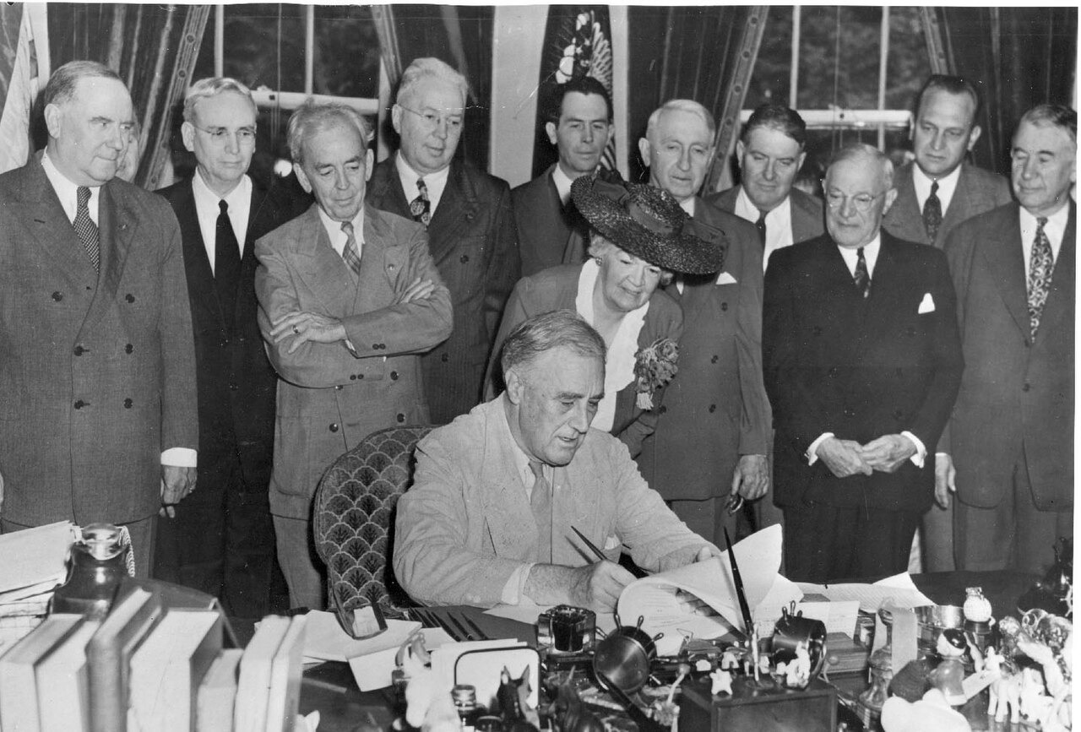
President Roosevelt Signs the G.I. Bill of Rights (June 22, 1944). Medium: photograph. President Franklin D. Roosevelt signs the G.I. Bill into law on June 22, 1944, as members of Congress look on. The law sent millions of returning veterans to college and helped them buy homes, building the postwar middle class. Source: U.S. Federal Government. National Archives and Records Administration, via Wikimedia Commons. Public domain (17 U.S.C. § 105). https://commons.wikimedia.org/wiki/File:GI_Bill_signing.jpg
OPTIC step | Your analysis
O — Overview | In one sentence, what is happening in this image?
P — Parts | List two specific details (people, objects, setting).
T — Title / Text | What do the caption and any words tell you?
I — Interrelationships | How do the parts connect to the standard's big idea?
C — Conclusion | What does this source argue about the era?

Document B (text primary source — analyze with HIPPO) — US.71
“Any person who served in the active military or naval service... shall be entitled to vocational rehabilitation... The Administrator shall pay the educational institution... tuition, fees, books, and supplies. Each eligible person shall be entitled to a subsistence allowance... while pursuing a full-time course of instruction.”

Source: U.S. Congress, “Servicemen's Readjustment Act (G.I. Bill),” 1944. National Archives. Rights: Public domain. https://www.archives.gov/milestone-documents/servicemens-readjustment-act
H-I-P-P-O | Prompt
Historical context | What was happening when this was written?
Intended audience | Who was meant to read or hear it?
Purpose | Why was it created?
Point of view | Whose perspective does it show?
Outside connection | How does it link to the standard?
SUPPORT OPTION
Other perspectives: whose interests did this source serve, and whose experience does it leave out? Name one group and one thing they might have seen differently. (Empathy check: how might that group have felt about the change described?)

Activity 5 — Practice Quiz — US.71
RESPONSE CHOICE
Choose your answer format. Full form (A–D): circle the best of four choices. Support form (A–B): use the two-choice version printed under each question — it keeps the correct answer and one strong distractor. Reduced choices are an access format; the standard and the question are the same.

1. How did the G.I. Bill benefit returning World War II veterans? [DOK 1 · item q-us71-dok1-1]
A. It required all veterans to serve additional years in military reserves
B. It gave veterans free land in Western territories to establish farms
C. It provided education funding, home loans, and job training benefits
D. It provided lifetime government employment to all discharged soldiers
Support form (A–B): A. It provided education funding, home loans, and job training benefits / B. It required all veterans to serve additional years in military reserves
2. How did U.S. dependence on foreign oil affect the American economy and suburban lifestyle of the 1950s? [DOK 2 · item U8-DOK2-0014]
A. Foreign oil dependence had no impact on American daily life because the U.S. was entirely self-sufficient in oil production during the 1950s
B. High oil import costs caused widespread fuel shortages throughout the 1950s, limiting automobile ownership to wealthy Americans
C. Cheap imported oil kept gasoline prices low, enabling the widespread automobile use and suburban sprawl that defined 1950s American life
D. The United States banned all oil imports during the 1950s to protect the domestic petroleum industry
Support form (A–B): A. Foreign oil dependence had no impact on American daily life because the U.S. was entirely self-sufficient in oil production during the 1950s / B. Cheap imported oil kept gasoline prices low, enabling the widespread automobile use and suburban sprawl that defined 1950s American life
3. Levittown, New York, built in the late 1940s and 1950s, was one of the first large-scale planned suburban communities. A historian argues that Levittown simultaneously represented opportunity and exclusion. Which evidence best supports both sides of this argument? [DOK 3 · item dok3-gen-u8-004]
A. Levittown offered affordable housing to veterans but required buyers to pay full price without financing options.
B. Levittown received federal mortgage backing available to all veterans equally, yet local zoning kept lots unaffordably large.
C. Levittown provided low-cost homes to thousands of working-class families but lacked schools and community spaces for a decade.
D. Levittown offered affordable homeownership to white working-class families while using racially restrictive covenants to exclude Black Americans.
Support form (A–B): A. Levittown offered affordable homeownership to white working-class families while using racially restrictive covenants to exclude Black Americans. / B. Levittown offered affordable housing to veterans but required buyers to pay full price without financing options.
Explain your thinking: choose ONE question and explain why your answer is correct using evidence from the unit.

Items from the History Hack canonical question bank (pre-field-test; classroom formative, not a secure TCAP form). Answer key and rationales are in the Teacher Guide.
PROGRESS CHECK
Before you check answers — how sure are you? Circle one:
★ I've got this ● Mostly △ Still shaky ○ Lost
If you circled Still shaky or Lost, write one thing to ask your teacher:

Activity 6 — Constructed Response (CER) — US.71
RESPONSE CHOICE
Choose your challenge. Pick ONE prompt and answer with a full CER (Claim, Evidence, Reasoning). Higher levels earn more challenge points — aim as high as you can.

LEVEL 1 — Build It: Name ONE feature of 1950s prosperity and give one piece of evidence about who it benefited.
LEVEL 2 — Stretch It: Did 1950s prosperity benefit all Americans equally? Make a claim, support it with at least two pieces of evidence, and explain your reasoning.
LEVEL 3 — Master It: The 1950s are remembered as a golden age of suburbs and consumer goods, yet many Americans were left out. Using evidence from this standard, evaluate how widely that prosperity was shared, and explain whose experience the 'golden age' image leaves out.
SUPPORT OPTION
Sentence frames — use these to build your answer:
• Claim: I believe that ______ because ______.
• Evidence: One piece of evidence from the unit is ______. This shows ______.
• Reasoning: This matters because ______. It connects to the big question by ______.

I chose Level ____. My CER response:

EXTENSION
Level 4 — Go Further (open to everyone). Evaluate: 1950s prosperity is often remembered nostalgically. Argue who was included and who was excluded, and what that reveals about how eras are remembered. Full prompt and space in the Challenge Bank appendix.

Back to the Big Question. How did prosperity, technology, and new ideas transform the United States between the 1950s and 1963 — and who shared in that transformation? In one sentence, what is your answer now?

Standard US.72 — The Baby Boom
TN Academic Standard US.72: Explain the impact of the baby boomer generation on the American economy and culture.
I can… define the Baby Boom • analyze the economic effects of the baby boomer generation • describe the cultural influence of the baby boomers on American society.
CORE PATH
If short on time: Vocabulary → Direct Teaching Cornell Notes → Close Read → Primary Source → Quiz + CER. This standard emphasizes SSP.06 and SSP.04.

Vocabulary comes next (Activity 1, two parts): a Reference / Word Bank and a Vocabulary Studio.

Activity 1 — Vocabulary (Part A: Reference / Word Bank) — US.72
Use this word bank throughout the standard. Meanings are student-friendly; Spanish cognates or translations are given where they exist.
Term | Student-friendly meaning | Spanish
Baby Boom | the sharp rise in U.S. births from 1946 to 1964 | —
baby boomer | a person born during the Baby Boom | —
demographics | the study of a population's makeup and changes | demografía
demand | the desire and ability of consumers to buy goods | demanda
generation | people born around the same time | generación
suburban growth | the rapid expansion of neighborhoods outside cities | —
LANGUAGE SUPPORT
Watch for Spanish cognates in the right column — words that look and mean nearly the same in both languages. Sentence frame: This word means ______. An example is ______.

RESPONSE CHOICE
How to show you understand a term (response contract). The core requirement is an accurate meaning plus a historical connection. You may show additional understanding in the way that fits the term — a sentence, an example or non-example, a labeled drawing, an analogy, or by rehearsing it out loud before you write. You do not have to use every mode.

Activity 1 — Vocabulary (Part B: Vocabulary Studio) — US.72
RESPONSE CHOICE
Choose or accept TWO priority terms from the word bank (your teacher may assign them). For each, complete the organizer below. Meaning + historical connection are required; the other boxes are your space to show understanding the way that works best for the term.

Priority term: Baby Boom
Word-bank meaning to build on: the sharp rise in U.S. births from 1946 to 1964.
In my own words  Core requirement: an accurate meaning. | Characteristics / historical context  When/where it mattered in the 1950s–1963.
Example or non-example  A real case — or something it is NOT. | Visual / symbol  Draw a small symbol; labels welcome (art is not graded).
Use it to explain history — core requirement: connect the term to a real 1950s–1963 development in one or two sentences.

Priority term: baby boomer
Word-bank meaning to build on: a person born during the Baby Boom.
In my own words  Core requirement: an accurate meaning. | Characteristics / historical context  When/where it mattered in the 1950s–1963.
Example or non-example  A real case — or something it is NOT. | Visual / symbol  Draw a small symbol; labels welcome (art is not graded).
Use it to explain history — core requirement: connect the term to a real 1950s–1963 development in one or two sentences.

PROGRESS CHECK
Which of your two terms do you understand best, and which one do you still want to practice? Circle it in the word bank on the previous page.

Direct Teaching Cornell Notes — US.72
Name: ____________________ Class / Period: ____________ Date: ____________
US.72 — The Baby Boom · Lean Deck slides 7–12 · US72-L02
Learning target: I can describe the Baby Boom and explain how a generation's size reshaped the economy and society.
Essential question / success criterion: How can the size of one generation change a whole country?

Guiding cues | My notes (Lean Deck slides 7–12)
What was the Baby Boom? | Lean slide 8: Direct Instruction: the Baby Boom
How did boomers reshape the economy?
Why did their numbers give them power?
What lasting effects did they have?
Key terms to listen for: Baby Boom · baby boomer · demographics · generation
Summary — In your own words, what is the most important idea from this standard?

PROGRESS CHECK
Confidence: ★ Strong ● Okay △ Shaky ○ Lost
One idea I understood: ______________________________________
One question I still have: ___________________________________
Optional support tools on reverse. Follow along on the Lean Deck (slides 7–12) — posted in Schoology.

Optional Support — Guided Support — US.72 (US72-L02 reverse · use only if helpful)
This is an optional support tool, not a label. Anyone may use it, and it is meant to fade as you gain independence. It works alongside — never in place of — any IEP or 504 accommodations you are entitled to.
Key vocabulary
Term | What it means | Spanish
Baby Boom | the sharp rise in U.S. births from 1946 to 1964 | —
baby boomer | a person born during the Baby Boom | —
demographics | the study of a population's makeup and changes | demografía
demand | the desire and ability of consumers to buy goods | demanda
generation | people born around the same time | generación
suburban growth | the rapid expansion of neighborhoods outside cities | —
Break it into steps
1) Define the Baby Boom in your words.
2) Name one industry it grew.
3) Explain one lasting effect.
Sentence frame: The baby boom generation grew because ___, and it changed the American economy by ___.

Modeled example (one worked note — yours will differ): Cue: How did boomers reshape the economy? Note: 76 million births (1946–1964) created huge demand for baby products, schools, and later houses — industries grew to serve the largest generation in U.S. history.

Optional Support — Light Support — US.72 (US72-L02 reverse · use only if helpful)
This is an optional support tool, not a label. Anyone may use it, and it is meant to fade as you gain independence. It works alongside — never in place of — any IEP or 504 accommodations you are entitled to.
Key vocabulary
Term | Hint (finish the idea as you listen)
Baby Boom | the sharp rise in …
baby boomer | a person born during …
demographics | the study of a …
demand | the desire and ability …
generation | people born around the …
suburban growth | the rapid expansion of …
Break it into steps
1) Define the Baby Boom in your words.
2) Name one industry it grew.
3) Explain one lasting effect.
Guiding questions (answer in your notes on the front)
• What was the Baby Boom?
• How did boomers reshape the economy?
• Why did their numbers give them power?
• What lasting effects did they have?
Try the note first. If you need more, ask for the Guided Support version.

Activity 3 — Close Read — US.72
CORE PATH
A Generation Is Born. After the war, the United States saw a huge jump in the number of babies born. This 'baby boom' lasted from the late 1940s into the 1960s, creating an enormous new generation. Returning veterans, prosperity, and confidence in the future all encouraged families to have more children. The result reshaped the country. The baby boom strained schools, which had to expand quickly, and created huge new demand for homes, toys, and goods. The 'baby boomers' would shape American culture and the economy for decades to come.
Predict first: before you read, guess who this helped and who it left out. Check your guess after reading.

LANGUAGE SUPPORT
Key words: baby boom = a sharp rise in births; generation = people born around the same time
Sentence frame: The baby boom changed America by ______.
Talk first: What caused the baby boom?

SUPPORT OPTION
Read an elevated version (any learner may choose this): After World War II, returning soldiers, postwar prosperity, and optimism led to a sharp rise in births — the Baby Boom, lasting roughly from 1946 to 1964. The sheer size of this generation of baby boomers reshaped American life as it grew. Economically, the boom created enormous demand. New families needed homes, schools, and goods, fueling suburban growth and a booming consumer economy. Industries that served children — from toys to baby food to television programming — expanded rapidly to meet the new market. Culturally, the boomers' size gave them lasting influence. As they grew, they shaped schools, then youth culture, then the workforce and politics. The demographics of the baby boom rippled through American society for the rest of the century, affecting everything from housing to entertainment.

Text-dependent questions — answer using evidence from the passage:
1. According to the passage, what was the baby boom?

2. What caused it? Find the sentence that explains the cause.

3. Name one way it strained American society, using evidence.

RESPONSE CHOICE
Show your answer to question 3 the way that works best for you: write it in the lines above, say it aloud to a partner using the Talk-First prompt, or annotate the passage and point to your evidence. The standard is the same in every mode.

Activity 4 — Primary Sources — US.72
Document A (visual primary source — analyze with OPTIC):
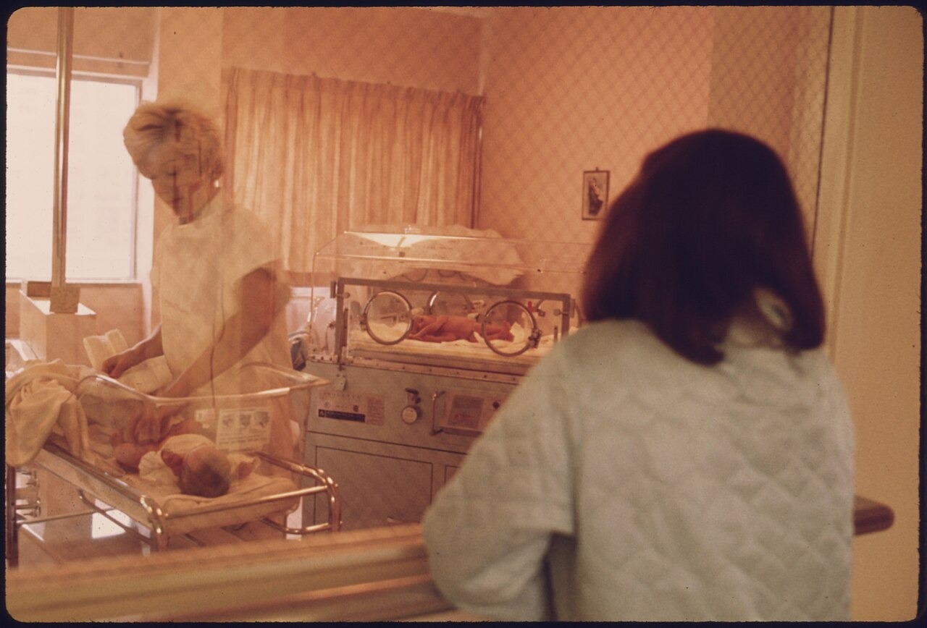
New Mother Views Infant in Nursery, Loretto Hospital, New Ulm, Minnesota (c. 1959). Medium: photograph. A new mother looks through the nursery window at Loretto Hospital in New Ulm, Minnesota, c. 1959. The rows of bassinets illustrate the baby boom — about 76 million births between 1946 and 1964. Source: U.S. Federal Government (NARA, NAID 558170), via Wikimedia Commons. Public domain (17 U.S.C. § 105). https://commons.wikimedia.org/wiki/File:A_NEW_MOTHER_VIEWS_HER_CHILD_IN_THE_NURSERY_OF_LORETTO_HOSPITAL_IN_NEW_ULM,_MINNESOTA._THERE_ARE_TWO_HOSPITALS_IN_THE..._-_NARA_-_558170.jpg
OPTIC step | Your analysis
O — Overview | In one sentence, what is happening in this image?
P — Parts | List two specific details (people, objects, setting).
T — Title / Text | What do the caption and any words tell you?
I — Interrelationships | How do the parts connect to the standard's big idea?
C — Conclusion | What does this source argue about the era?

Document B (text primary source — analyze with HIPPO) — US.72
“The birth rate has reached unprecedented levels since the end of World War II. Between 1946 and 1954, approximately 29 million babies were born in the United States, compared to 24 million in the preceding eight years. This surge in population is creating increased demand for schools, housing, and consumer goods.”

Source: U.S. Census Bureau, “Census Bureau Population Report,” 1955. U.S. Census Bureau. Rights: Public domain. https://www.census.gov/history/
H-I-P-P-O | Prompt
Historical context | What was happening when this was written?
Intended audience | Who was meant to read or hear it?
Purpose | Why was it created?
Point of view | Whose perspective does it show?
Outside connection | How does it link to the standard?
SUPPORT OPTION
Other perspectives: whose interests did this source serve, and whose experience does it leave out? Name one group and one thing they might have seen differently. (Empathy check: how might that group have felt about the change described?)

Activity 5 — Practice Quiz — US.72
RESPONSE CHOICE
Choose your answer format. Full form (A–D): circle the best of four choices. Support form (A–B): use the two-choice version printed under each question — it keeps the correct answer and one strong distractor. Reduced choices are an access format; the standard and the question are the same.

1. What was the "baby boom"? [DOK 1 · item q-us72-dok1-1]
A. A government program that encouraged families to have fewer children
B. A dramatic increase in birth rates after World War II ended in 1945
C. A wave of immigration that doubled the U.S. population in one decade
D. A decline in population caused by the economic effects of the Cold War
Support form (A–B): A. A government program that encouraged families to have fewer children / B. A dramatic increase in birth rates after World War II ended in 1945
2. How did the baby boom generation's size influence American consumer markets during the 1950s and 1960s? [DOK 2 · item U8-DOK2-0023]
A. Businesses largely ignored the youth market because young people had no disposable income in the postwar era
B. The government strictly regulated advertising to children, preventing businesses from targeting young consumers
C. Baby boomers reduced consumer spending because their large numbers strained family budgets, leaving little money for discretionary purchases
D. The large number of children and teenagers created profitable markets for toys, clothing, music, and entertainment specifically designed to appeal to young consumers
Support form (A–B): A. The large number of children and teenagers created profitable markets for toys, clothing, music, and entertainment specifically designed to appeal to young consumers / B. Businesses largely ignored the youth market because young people had no disposable income in the postwar era
3. The baby boom generation became the largest cohort of college students in American history when they reached university age in the mid-1960s. Which of the following best explains the cultural consequence of this mass higher education? [DOK 3 · item dok3-gen-u8-014]
A. Mass enrollment in universities made young Americans politically passive, as academic study replaced civic engagement.
B. So many Americans held college degrees by 1970 that bachelor's degrees became economically worthless, pushing graduates into manual labor.
C. University expansion primarily impacted American culture by creating the campus newspaper industry, which became the main source of news for young adults.
D. Concentrating millions of young adults in universities created spaces for organizing, critical thinking, and shared identity that fueled the counterculture and student activism.
Support form (A–B): A. Mass enrollment in universities made young Americans politically passive, as academic study replaced civic engagement. / B. Concentrating millions of young adults in universities created spaces for organizing, critical thinking, and shared identity that fueled the counterculture and student activism.
Explain your thinking: choose ONE question and explain why your answer is correct using evidence from the unit.

Items from the History Hack canonical question bank (pre-field-test; classroom formative, not a secure TCAP form). Answer key and rationales are in the Teacher Guide.
PROGRESS CHECK
Before you check answers — how sure are you? Circle one:
★ I've got this ● Mostly △ Still shaky ○ Lost
If you circled Still shaky or Lost, write one thing to ask your teacher:

Activity 6 — Constructed Response (CER) — US.72
RESPONSE CHOICE
Choose your challenge. Pick ONE prompt and answer with a full CER (Claim, Evidence, Reasoning). Higher levels earn more challenge points — aim as high as you can.

LEVEL 1 — Build It: Name ONE effect of the baby boom and give one piece of evidence for it.
LEVEL 2 — Stretch It: Did the baby boom shape the American economy or American culture more profoundly? Make a claim, support it with at least two pieces of evidence, and explain your reasoning.
LEVEL 3 — Master It: The baby boom reshaped schools, housing, spending, and family life all at once. Using evidence from this standard, evaluate whether its economic effects or its cultural effects ran deeper, and explain how a single demographic wave could transform the nation for decades.
SUPPORT OPTION
Sentence frames — use these to build your answer:
• Claim: I believe that ______ because ______.
• Evidence: One piece of evidence from the unit is ______. This shows ______.
• Reasoning: This matters because ______. It connects to the big question by ______.

I chose Level ____. My CER response:

EXTENSION
Level 4 — Go Further (open to everyone). Analyze: Trace how a single demographic event — the baby boom — rippled through schools, housing, and the economy for decades. Argue which effect proved most lasting. Full prompt and space in the Challenge Bank appendix.

Back to the Big Question. How did prosperity, technology, and new ideas transform the United States between the 1950s and 1963 — and who shared in that transformation? In one sentence, what is your answer now?

Standard US.73 — Eisenhower's Domestic Developments
TN Academic Standard US.73: Describe domestic developments during President Dwight D. Eisenhower's administration, including advances in medicine and the creation of the Interstate Highway System.
I can… explain the impact of medical advances during Eisenhower's presidency (e.g., the polio vaccine) • analyze the importance and effects of the Interstate Highway System.
CORE PATH
If short on time: Vocabulary → Direct Teaching Cornell Notes → Close Read → Primary Source → Quiz + CER. This standard emphasizes SSP.01 and SSP.06.

Vocabulary comes next (Activity 1, two parts): a Reference / Word Bank and a Vocabulary Studio.

Activity 1 — Vocabulary (Part A: Reference / Word Bank) — US.73
Use this word bank throughout the standard. Meanings are student-friendly; Spanish cognates or translations are given where they exist.
Term | Student-friendly meaning | Spanish
Interstate Highway System | the national network of high-speed roads begun in 1956 | —
polio vaccine | the Salk vaccine that prevented poliomyelitis | vacuna
infrastructure | the basic physical systems of a country, like roads | infraestructura
mobility | the ability to move freely and easily | movilidad
public health | the health of a whole population | —
commerce | the buying and selling of goods; trade | comercio
LANGUAGE SUPPORT
Watch for Spanish cognates in the right column — words that look and mean nearly the same in both languages. Sentence frame: This word means ______. An example is ______.

RESPONSE CHOICE
How to show you understand a term (response contract). The core requirement is an accurate meaning plus a historical connection. You may show additional understanding in the way that fits the term — a sentence, an example or non-example, a labeled drawing, an analogy, or by rehearsing it out loud before you write. You do not have to use every mode.

Activity 1 — Vocabulary (Part B: Vocabulary Studio) — US.73
RESPONSE CHOICE
Choose or accept TWO priority terms from the word bank (your teacher may assign them). For each, complete the organizer below. Meaning + historical connection are required; the other boxes are your space to show understanding the way that works best for the term.

Priority term: Interstate Highway System
Word-bank meaning to build on: the national network of high-speed roads begun in 1956.
In my own words  Core requirement: an accurate meaning. | Characteristics / historical context  When/where it mattered in the 1950s–1963.
Example or non-example  A real case — or something it is NOT. | Visual / symbol  Draw a small symbol; labels welcome (art is not graded).
Use it to explain history — core requirement: connect the term to a real 1950s–1963 development in one or two sentences.

Priority term: polio vaccine (Spanish cognate/translation: vacuna)
Word-bank meaning to build on: the Salk vaccine that prevented poliomyelitis.
In my own words  Core requirement: an accurate meaning. | Characteristics / historical context  When/where it mattered in the 1950s–1963.
Example or non-example  A real case — or something it is NOT. | Visual / symbol  Draw a small symbol; labels welcome (art is not graded).
Use it to explain history — core requirement: connect the term to a real 1950s–1963 development in one or two sentences.

PROGRESS CHECK
Which of your two terms do you understand best, and which one do you still want to practice? Circle it in the word bank on the previous page.

Direct Teaching Cornell Notes — US.73
Name: ____________________ Class / Period: ____________ Date: ____________
US.73 — Eisenhower's Domestic Developments · Lean Deck slides 13–18 · US73-L03
Learning target: I can explain how Eisenhower-era developments — the Salk vaccine and the Interstate Highway System — changed American life.
Essential question / success criterion: How did public health and highways transform postwar America?

Guiding cues | My notes (Lean Deck slides 13–18)
What did the Salk vaccine change? | Lean slide 14: Direct Instruction: Salk vaccine & Interstate Highways
What did the Interstate Highway System do?
How did highways reshape where people lived?
What unintended costs came with them?
Key terms to listen for: Interstate Highway System · polio vaccine · infrastructure · public health
Summary — In your own words, what is the most important idea from this standard?

PROGRESS CHECK
Confidence: ★ Strong ● Okay △ Shaky ○ Lost
One idea I understood: ______________________________________
One question I still have: ___________________________________
Optional support tools on reverse. Follow along on the Lean Deck (slides 13–18) — posted in Schoology.

Optional Support — Guided Support — US.73 (US73-L03 reverse · use only if helpful)
This is an optional support tool, not a label. Anyone may use it, and it is meant to fade as you gain independence. It works alongside — never in place of — any IEP or 504 accommodations you are entitled to.
Key vocabulary
Term | What it means | Spanish
Interstate Highway System | the national network of high-speed roads begun in 1956 | —
polio vaccine | the Salk vaccine that prevented poliomyelitis | vacuna
infrastructure | the basic physical systems of a country, like roads | infraestructura
mobility | the ability to move freely and easily | movilidad
public health | the health of a whole population | —
commerce | the buying and selling of goods; trade | comercio
Break it into steps
1) Name the two big developments.
2) Tell what each one changed.
3) Note one unintended cost.
Sentence frame: President Eisenhower’s Interstate Highway System was significant because it ___, even though it also caused ___.

Modeled example (one worked note — yours will differ): Cue: What did the Interstate Highway System do? Note: Eisenhower's 1956 highway act built a national road network for defense and commerce — speeding travel and trade but enabling suburban sprawl and bypassing small towns.

Optional Support — Light Support — US.73 (US73-L03 reverse · use only if helpful)
This is an optional support tool, not a label. Anyone may use it, and it is meant to fade as you gain independence. It works alongside — never in place of — any IEP or 504 accommodations you are entitled to.
Key vocabulary
Term | Hint (finish the idea as you listen)
Interstate Highway System | the national network of …
polio vaccine | the Salk vaccine that …
infrastructure | the basic physical systems …
mobility | the ability to move …
public health | the health of a …
commerce | the buying and selling …
Break it into steps
1) Name the two big developments.
2) Tell what each one changed.
3) Note one unintended cost.
Guiding questions (answer in your notes on the front)
• What did the Salk vaccine change?
• What did the Interstate Highway System do?
• How did highways reshape where people lived?
• What unintended costs came with them?
Try the note first. If you need more, ask for the Guided Support version.

Activity 3 — Close Read — US.73
CORE PATH
Roads and Cures. The 1950s, under President Eisenhower, brought major advances that improved daily life. In 1956, the government launched the Interstate Highway System, building thousands of miles of roads that connected the whole nation. These highways made travel and shipping faster and helped suburbs and businesses grow. They reshaped how Americans traveled and where they lived. Medicine advanced too. The Salk vaccine helped conquer polio, a disease that had paralyzed many children. Together, better roads and better medicine transformed postwar American life.
Predict first: before you read, guess who this helped and who it left out. Check your guess after reading.

LANGUAGE SUPPORT
Key words: interstate = a national highway; vaccine = a medicine that prevents disease
Sentence frame: The Interstate Highway System changed American life by ______.
Talk first: What did the Salk vaccine do?

SUPPORT OPTION
Read an elevated version (any learner may choose this): Under President Eisenhower, the federal government undertook one of the largest public works projects in history: the Interstate Highway System. Begun in 1956 and justified partly by Cold War defense needs, the network of high-speed roads transformed travel, sped commerce, and accelerated the growth of suburbs and automobile culture. The decade also brought breakthroughs in public health. Polio, a disease that had paralyzed thousands of children, was conquered by Jonas Salk's vaccine, introduced in the mid-1950s. Mass vaccination campaigns dramatically reduced the disease, easing one of the era's deepest fears. These developments reshaped daily life. Highways increased Americans' mobility and tied the nation's economy together, while medical advances lengthened and improved lives. Together they reflected the optimism and growing federal role of the postwar years.

Text-dependent questions — answer using evidence from the passage:
1. According to the passage, what did the Interstate Highway System do?

2. What did the Salk vaccine accomplish? Find the sentence.

3. How did these two developments reflect the era, using evidence?

RESPONSE CHOICE
Show your answer to question 3 the way that works best for you: write it in the lines above, say it aloud to a partner using the Talk-First prompt, or annotate the passage and point to your evidence. The standard is the same in every mode.

Activity 4 — Primary Sources — US.73
Document A (visual primary source — analyze with OPTIC):
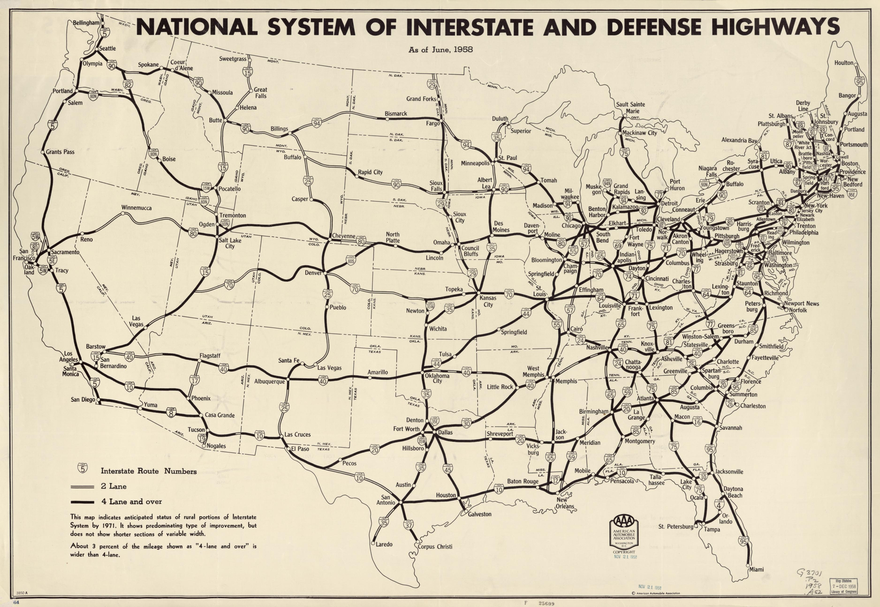
Interstate Highway System Plan Map (1958). Medium: map. A late-1950s planning map of the National System of Interstate and Defense Highways, showing the network of routes designed to connect the entire country. Congress authorized about 41,000 miles of interstate under the 1956 Act. Source: U.S. Bureau of Public Roads / U.S. Department of Transportation. Public domain (17 U.S.C. § 105). https://commons.wikimedia.org/wiki/Category:Maps_of_the_Interstate_Highway_System
OPTIC step | Your analysis
O — Overview | In one sentence, what is happening in this image?
P — Parts | List two specific details (people, objects, setting).
T — Title / Text | What do the caption and any words tell you?
I — Interrelationships | How do the parts connect to the standard's big idea?
C — Conclusion | What does this source argue about the era?

Document B (text primary source — analyze with HIPPO) — US.73
“It is hereby declared to be essential to the national interest to provide for the early completion of the 'National System of Interstate and Defense Highways'... The total mileage of routes shall be approximately forty-one thousand miles... designed to accommodate traffic projected for the year 1975.”

Source: U.S. Congress, “Federal-Aid Highway Act of 1956,” 1956. Library of Congress. Rights: Public domain. https://www.loc.gov/law/help/statutes-at-large/84th-congress/session-2/c84s2ch462.pdf
H-I-P-P-O | Prompt
Historical context | What was happening when this was written?
Intended audience | Who was meant to read or hear it?
Purpose | Why was it created?
Point of view | Whose perspective does it show?
Outside connection | How does it link to the standard?
SUPPORT OPTION
Other perspectives: whose interests did this source serve, and whose experience does it leave out? Name one group and one thing they might have seen differently. (Empathy check: how might that group have felt about the change described?)

Activity 5 — Practice Quiz — US.73
RESPONSE CHOICE
Choose your answer format. Full form (A–D): circle the best of four choices. Support form (A–B): use the two-choice version printed under each question — it keeps the correct answer and one strong distractor. Reduced choices are an access format; the standard and the question are the same.

1. What major infrastructure project was created during the Eisenhower administration? [DOK 1 · item q-us73-dok1-1]
A. The Interstate Highway System connecting cities across the nation
B. Jonas Salk's polio vaccine eliminated a feared childhood disease
C. Polio cases dropped sharply, reducing fear of seasonal outbreaks
D. Improving civilian transportation while supporting national defense logistics
Support form (A–B): A. The Interstate Highway System connecting cities across the nation / B. Jonas Salk's polio vaccine eliminated a feared childhood disease
2. How did advances in medicine and public health during the Eisenhower era affect American society? [DOK 2 · item U8-DOK2-0025]
A. Medical advances had little impact because most Americans still relied on traditional home remedies rather than professional medical care
B. Developments such as the Salk polio vaccine reduced childhood disease mortality, improved average life expectancy, and increased public confidence in scientific medicine
C. Medical advances during the 1950s were limited to military hospitals and were not available to the general public until the 1970s
D. The Eisenhower administration nationalized all hospitals, making medical care universally free for American citizens
Support form (A–B): A. Medical advances had little impact because most Americans still relied on traditional home remedies rather than professional medical care / B. Developments such as the Salk polio vaccine reduced childhood disease mortality, improved average life expectancy, and increased public confidence in scientific medicine
3. The Salk polio vaccine, introduced in 1955, was one of the most celebrated medical achievements in American history. Which of the following best explains why its development was considered a specifically American cultural triumph as well as a scientific one? [DOK 3 · item dok3-gen-u8-022]
A. It was funded by millions of ordinary Americans through the March of Dimes, making it a democratic collective achievement that showed American scientific leadership in the Cold War.
B. The vaccine was developed at government expense but kept secret from the public until the Cold War ended.
C. Jonas Salk refused to patent the vaccine and donated the formula to the Soviet Union as a Cold War gesture of scientific goodwill.
D. The United States beat the Soviet Union in a publicly acknowledged vaccine race, proving American scientific superiority in the Cold War competition.
Support form (A–B): A. It was funded by millions of ordinary Americans through the March of Dimes, making it a democratic collective achievement that showed American scientific leadership in the Cold War. / B. The vaccine was developed at government expense but kept secret from the public until the Cold War ended.
Explain your thinking: choose ONE question and explain why your answer is correct using evidence from the unit.

Items from the History Hack canonical question bank (pre-field-test; classroom formative, not a secure TCAP form). Answer key and rationales are in the Teacher Guide.
PROGRESS CHECK
Before you check answers — how sure are you? Circle one:
★ I've got this ● Mostly △ Still shaky ○ Lost
If you circled Still shaky or Lost, write one thing to ask your teacher:

Activity 6 — Constructed Response (CER) — US.73
RESPONSE CHOICE
Choose your challenge. Pick ONE prompt and answer with a full CER (Claim, Evidence, Reasoning). Higher levels earn more challenge points — aim as high as you can.

LEVEL 1 — Build It: Name ONE Eisenhower-era domestic development (such as the interstate highways or medical advances) and give one piece of evidence about its impact.
LEVEL 2 — Stretch It: Which Eisenhower-era development — the interstate highways or medical advances — had the greater long-term impact? Make a claim, support it with at least two pieces of evidence, and explain your reasoning.
LEVEL 3 — Master It: Eisenhower-era investments in highways and medicine still shape American life today. Using evidence from this standard, evaluate which produced the greater long-term impact, and explain how a project's effects can grow far beyond what its creators first intended.
SUPPORT OPTION
Sentence frames — use these to build your answer:
• Claim: I believe that ______ because ______.
• Evidence: One piece of evidence from the unit is ______. This shows ______.
• Reasoning: This matters because ______. It connects to the big question by ______.

I chose Level ____. My CER response:

EXTENSION
Level 4 — Go Further (open to everyone). Compare: Weigh the interstate highways against the polio vaccine as Eisenhower-era achievements, distinguishing measurable human impact from structural transformation. Full prompt and space in the Challenge Bank appendix.

Back to the Big Question. How did prosperity, technology, and new ideas transform the United States between the 1950s and 1963 — and who shared in that transformation? In one sentence, what is your answer now?

Standard US.74 — The Automobile and American Society
TN Academic Standard US.74: Describe the growing influence of the automobile on American society, including the growth of suburbia, fast food chains, and the hotel industry.
I can… describe the automobile's influence on American lifestyle and transportation • analyze the growth of suburbia and its connection to automobiles • evaluate the automobile's impact on fast food chains and the hotel industry.
CORE PATH
If short on time: Vocabulary → Direct Teaching Cornell Notes → Close Read → Primary Source → Quiz + CER. This standard emphasizes SSP.06 and SSP.01.

Vocabulary comes next (Activity 1, two parts): a Reference / Word Bank and a Vocabulary Studio.

Activity 1 — Vocabulary (Part A: Reference / Word Bank) — US.74
Use this word bank throughout the standard. Meanings are student-friendly; Spanish cognates or translations are given where they exist.
Term | Student-friendly meaning | Spanish
suburbia | the world of suburbs and suburban living | —
fast food chain | a group of quick-service restaurants under one brand | —
motel | a roadside hotel built for motorists | motel
franchise | a business licensed to use a company's brand and system | franquicia
commuter | a person who travels between home and work | —
car culture | a way of life built around automobiles | —
LANGUAGE SUPPORT
Watch for Spanish cognates in the right column — words that look and mean nearly the same in both languages. Sentence frame: This word means ______. An example is ______.

RESPONSE CHOICE
How to show you understand a term (response contract). The core requirement is an accurate meaning plus a historical connection. You may show additional understanding in the way that fits the term — a sentence, an example or non-example, a labeled drawing, an analogy, or by rehearsing it out loud before you write. You do not have to use every mode.

Activity 1 — Vocabulary (Part B: Vocabulary Studio) — US.74
RESPONSE CHOICE
Choose or accept TWO priority terms from the word bank (your teacher may assign them). For each, complete the organizer below. Meaning + historical connection are required; the other boxes are your space to show understanding the way that works best for the term.

Priority term: suburbia
Word-bank meaning to build on: the world of suburbs and suburban living.
In my own words  Core requirement: an accurate meaning. | Characteristics / historical context  When/where it mattered in the 1950s–1963.
Example or non-example  A real case — or something it is NOT. | Visual / symbol  Draw a small symbol; labels welcome (art is not graded).
Use it to explain history — core requirement: connect the term to a real 1950s–1963 development in one or two sentences.

Priority term: fast food chain
Word-bank meaning to build on: a group of quick-service restaurants under one brand.
In my own words  Core requirement: an accurate meaning. | Characteristics / historical context  When/where it mattered in the 1950s–1963.
Example or non-example  A real case — or something it is NOT. | Visual / symbol  Draw a small symbol; labels welcome (art is not graded).
Use it to explain history — core requirement: connect the term to a real 1950s–1963 development in one or two sentences.

PROGRESS CHECK
Which of your two terms do you understand best, and which one do you still want to practice? Circle it in the word bank on the previous page.

Direct Teaching Cornell Notes — US.74
Name: ____________________ Class / Period: ____________ Date: ____________
US.74 — The Automobile and American Society · Lean Deck slides 19–24 · US74-L04
Learning target: I can analyze how the automobile reshaped where Americans lived, worked, shopped, and traveled.
Essential question / success criterion: How did the car make modern suburban life possible — and at what cost?

Guiding cues | My notes (Lean Deck slides 19–24)
How did the car change where people lived? | Lean slide 20: Direct Instruction: the automobile & suburbia
What new businesses did it create?
How did it change work and travel?
What were the costs of car culture?
Key terms to listen for: suburbia · fast food chain · franchise · car culture
Summary — In your own words, what is the most important idea from this standard?

PROGRESS CHECK
Confidence: ★ Strong ● Okay △ Shaky ○ Lost
One idea I understood: ______________________________________
One question I still have: ___________________________________
Optional support tools on reverse. Follow along on the Lean Deck (slides 19–24) — posted in Schoology.

Optional Support — Guided Support — US.74 (US74-L04 reverse · use only if helpful)
This is an optional support tool, not a label. Anyone may use it, and it is meant to fade as you gain independence. It works alongside — never in place of — any IEP or 504 accommodations you are entitled to.
Key vocabulary
Term | What it means | Spanish
suburbia | the world of suburbs and suburban living | —
fast food chain | a group of quick-service restaurants under one brand | —
motel | a roadside hotel built for motorists | motel
franchise | a business licensed to use a company's brand and system | franquicia
commuter | a person who travels between home and work | —
car culture | a way of life built around automobiles | —
Break it into steps
1) Name two things the car changed.
2) Name one new business type.
3) State one cost of car culture.
Sentence frame: The automobile changed American business and culture by creating ___ and encouraging Americans to ___.

Modeled example (one worked note — yours will differ): Cue: What new businesses did the car create? Note: Automobiles gave rise to fast-food chains, motels, drive-ins, and franchises along highways — reshaping how Americans ate, shopped, and traveled.

Optional Support — Light Support — US.74 (US74-L04 reverse · use only if helpful)
This is an optional support tool, not a label. Anyone may use it, and it is meant to fade as you gain independence. It works alongside — never in place of — any IEP or 504 accommodations you are entitled to.
Key vocabulary
Term | Hint (finish the idea as you listen)
suburbia | the world of suburbs …
fast food chain | a group of quick-service …
motel | a roadside hotel built …
franchise | a business licensed to …
commuter | a person who travels …
car culture | a way of life …
Break it into steps
1) Name two things the car changed.
2) Name one new business type.
3) State one cost of car culture.
Guiding questions (answer in your notes on the front)
• How did the car change where people lived?
• What new businesses did it create?
• How did it change work and travel?
• What were the costs of car culture?
Try the note first. If you need more, ask for the Guided Support version.

Activity 3 — Close Read — US.74
CORE PATH
A Nation on Wheels. The automobile became central to American life in the 1950s. As more families owned cars, they could live far from work and travel freely. This made the suburbs possible. Car culture created whole new businesses. Motels, drive-in restaurants and movies, gas stations, and shopping centers sprang up to serve drivers. The car changed both where Americans lived and how business worked. It tied together the suburban lifestyle, the highways, and a booming economy built around the automobile.
Predict first: before you read, guess who this helped and who it left out. Check your guess after reading.

LANGUAGE SUPPORT
Key words: automobile = a car; commute = to travel to work
Sentence frame: The car made the suburbs possible because ______.
Talk first: Name one business that grew with car culture.

SUPPORT OPTION
Read an elevated version (any learner may choose this): By the 1950s, the automobile was central to American life. Cars let families live in suburbia and commute to city jobs, accelerating the suburban boom. As more Americans drove, an entire car culture grew up around the road. New businesses rose to serve drivers. Fast food chains like McDonald's used the franchise model to serve quick, standardized meals to travelers and busy families. The hotel and motel industry expanded along the highways, with roadside motels built specifically for motorists on long trips. The car reshaped the landscape itself. Highways, parking lots, drive-ins, and shopping centers spread across the country. The automobile changed not only how Americans traveled, but where they lived, how they ate, and how their communities were built.

Text-dependent questions — answer using evidence from the passage:
1. According to the passage, what did the automobile make possible?

2. Name one business that grew with car culture. Find the sentence.

3. How did the car reshape the landscape, using evidence?

RESPONSE CHOICE
Show your answer to question 3 the way that works best for you: write it in the lines above, say it aloud to a partner using the Talk-First prompt, or annotate the passage and point to your evidence. The standard is the same in every mode.

Activity 4 — Primary Sources — US.74
Document A (visual primary source — analyze with OPTIC):
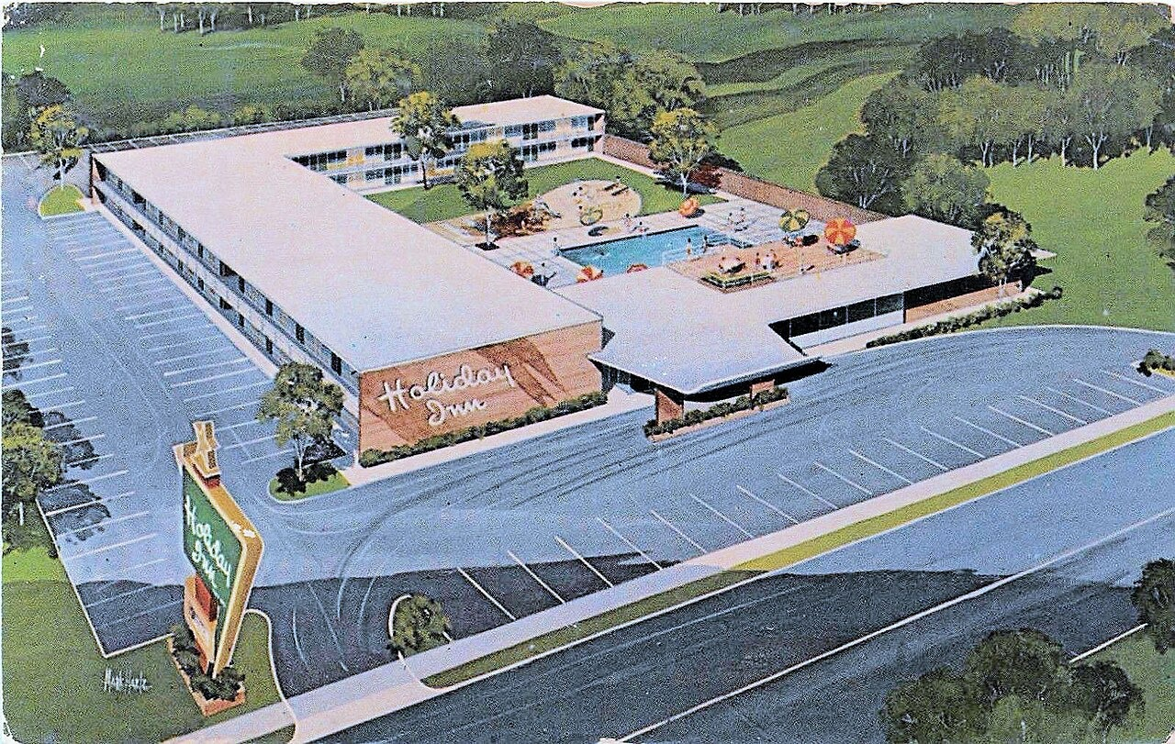
Holiday Inn Postcard, Allentown, Pennsylvania (1957). Medium: advertisement (postcard). A 1957 postcard advertises a Holiday Inn motel in Allentown, Pennsylvania. Kemmons Wilson opened the first Holiday Inn in Memphis, Tennessee, in 1952; the chain spread rapidly along the new interstate highways. Source: Unknown. Via Wikimedia Commons. Public domain (PD-US-no-notice). https://commons.wikimedia.org/wiki/File:1957_-_Holiday_Inn_Postcard_-_Allentown_PA.jpg
OPTIC step | Your analysis
O — Overview | In one sentence, what is happening in this image?
P — Parts | List two specific details (people, objects, setting).
T — Title / Text | What do the caption and any words tell you?
I — Interrelationships | How do the parts connect to the standard's big idea?
C — Conclusion | What does this source argue about the era?

Document B (text primary source — analyze with HIPPO) — US.74
“The American family is on the move! Last year, over 80 million Americans traveled by automobile for vacation. Holiday Inn meets this demand with standardized accommodations along major highways. Every Holiday Inn offers: free parking, air conditioning, swimming pools, and rooms designed for the traveling family.”

Source: Holiday Inn of America, “Holiday Inn Franchise Prospectus,” 1957. Library of Congress. Rights: Public domain. https://www.loc.gov/collections/general-collections/
H-I-P-P-O | Prompt
Historical context | What was happening when this was written?
Intended audience | Who was meant to read or hear it?
Purpose | Why was it created?
Point of view | Whose perspective does it show?
Outside connection | How does it link to the standard?
SUPPORT OPTION
Other perspectives: whose interests did this source serve, and whose experience does it leave out? Name one group and one thing they might have seen differently. (Empathy check: how might that group have felt about the change described?)

Activity 5 — Practice Quiz — US.74
RESPONSE CHOICE
Choose your answer format. Full form (A–D): circle the best of four choices. Support form (A–B): use the two-choice version printed under each question — it keeps the correct answer and one strong distractor. Reduced choices are an access format; the standard and the question are the same.

1. How did the automobile influence the growth of American suburbs in the 1950s? [DOK 1 · item q-us74-dok1-1]
A. Cars became too expensive for most families to purchase and maintain
B. Cars allowed workers to live far from cities and commute to their jobs
C. Public transportation replaced automobiles in most suburban communities
D. Automobiles were only available to wealthy urban families in the 1950s
Support form (A–B): A. Cars became too expensive for most families to purchase and maintain / B. Cars allowed workers to live far from cities and commute to their jobs
2. Which pattern best describes how automobile culture changed American eating habits during the 1950s? [DOK 2 · item U8-DOK2-0032]
A. Drive-in restaurants and fast food chains offered quick, standardized, affordable meals to car-driving families, transforming American dining habits
B. The automobile had no effect on American diets because all food continued to be prepared at home throughout the 1950s
C. Car culture led Americans to eat exclusively at formal restaurants as a symbol of newfound affluence
D. Drive-in restaurants were only popular in rural communities and never achieved mainstream acceptance
Support form (A–B): A. Drive-in restaurants and fast food chains offered quick, standardized, affordable meals to car-driving families, transforming American dining habits / B. The automobile had no effect on American diets because all food continued to be prepared at home throughout the 1950s
3. The rise of the American suburb was inseparable from the rise of the automobile. Which of the following best explains why this connection created a self-reinforcing cycle that was difficult to reverse? [DOK 3 · item dok3-gen-u8-032]
A. Suburbs became so politically powerful that they could block any legislation promoting public transportation alternatives to automobiles
B. Suburban families typically owned only one car, motivating strong political support for public transit as an essential backup option
C. Automobile makers successfully lobbied for zoning laws banning all forms of public mass transit from newly developed suburban residential areas
D. Low-density suburban design required cars for basic mobility, reduced transit investment, and made each new development more car-dependent — a self-reinforcing cycle
Support form (A–B): A. Suburbs became so politically powerful that they could block any legislation promoting public transportation alternatives to automobiles / B. Low-density suburban design required cars for basic mobility, reduced transit investment, and made each new development more car-dependent — a self-reinforcing cycle
Explain your thinking: choose ONE question and explain why your answer is correct using evidence from the unit.

Items from the History Hack canonical question bank (pre-field-test; classroom formative, not a secure TCAP form). Answer key and rationales are in the Teacher Guide.
PROGRESS CHECK
Before you check answers — how sure are you? Circle one:
★ I've got this ● Mostly △ Still shaky ○ Lost
If you circled Still shaky or Lost, write one thing to ask your teacher:

Activity 6 — Constructed Response (CER) — US.74
RESPONSE CHOICE
Choose your challenge. Pick ONE prompt and answer with a full CER (Claim, Evidence, Reasoning). Higher levels earn more challenge points — aim as high as you can.

LEVEL 1 — Build It: Name ONE way the automobile changed American life in this era and give one piece of evidence for it.
LEVEL 2 — Stretch It: Was the automobile's greatest impact on where Americans lived or on how American business developed? Make a claim, support it with at least two pieces of evidence, and explain your reasoning.
LEVEL 3 — Master It: The automobile reshaped both the map of American settlement and the structure of its economy. Using evidence from this standard, evaluate whether its deepest mark was on where people lived or on how business grew, and explain why those two changes were hard to separate as suburbs and highways spread.
SUPPORT OPTION
Sentence frames — use these to build your answer:
• Claim: I believe that ______ because ______.
• Evidence: One piece of evidence from the unit is ______. This shows ______.
• Reasoning: This matters because ______. It connects to the big question by ______.

I chose Level ____. My CER response:

EXTENSION
Level 4 — Go Further (open to everyone). Analyze: The automobile reshaped geography and business simultaneously. Argue which change was the cause and which was the effect, using evidence. Full prompt and space in the Challenge Bank appendix.

Back to the Big Question. How did prosperity, technology, and new ideas transform the United States between the 1950s and 1963 — and who shared in that transformation? In one sentence, what is your answer now?

Standard US.75 — Television and Mass Media
TN Academic Standard US.75: Analyze the increasing impact of television and mass media on the American home, politics, and economy.
I can… analyze television's role in shaping home life and family dynamics • evaluate media's impact on politics and public opinion • examine the relationship between media, advertising, and the economy.
CORE PATH
If short on time: Vocabulary → Direct Teaching Cornell Notes → Close Read → Primary Source → Quiz + CER. This standard emphasizes SSP.01 and SSP.04.

Vocabulary comes next (Activity 1, two parts): a Reference / Word Bank and a Vocabulary Studio.

Activity 1 — Vocabulary (Part A: Reference / Word Bank) — US.75
Use this word bank throughout the standard. Meanings are student-friendly; Spanish cognates or translations are given where they exist.
Term | Student-friendly meaning | Spanish
television | a device that receives broadcast picture and sound | televisión
mass media | communication that reaches very large audiences | —
advertising | paid messages that promote products | —
public opinion | the views held by the general population | opinión pública
broadcast | to transmit a program by radio or TV | —
consumer culture | a society organized around buying goods | —
LANGUAGE SUPPORT
Watch for Spanish cognates in the right column — words that look and mean nearly the same in both languages. Sentence frame: This word means ______. An example is ______.

RESPONSE CHOICE
How to show you understand a term (response contract). The core requirement is an accurate meaning plus a historical connection. You may show additional understanding in the way that fits the term — a sentence, an example or non-example, a labeled drawing, an analogy, or by rehearsing it out loud before you write. You do not have to use every mode.

Activity 1 — Vocabulary (Part B: Vocabulary Studio) — US.75
RESPONSE CHOICE
Choose or accept TWO priority terms from the word bank (your teacher may assign them). For each, complete the organizer below. Meaning + historical connection are required; the other boxes are your space to show understanding the way that works best for the term.

Priority term: television (Spanish cognate/translation: televisión)
Word-bank meaning to build on: a device that receives broadcast picture and sound.
In my own words  Core requirement: an accurate meaning. | Characteristics / historical context  When/where it mattered in the 1950s–1963.
Example or non-example  A real case — or something it is NOT. | Visual / symbol  Draw a small symbol; labels welcome (art is not graded).
Use it to explain history — core requirement: connect the term to a real 1950s–1963 development in one or two sentences.

Priority term: mass media
Word-bank meaning to build on: communication that reaches very large audiences.
In my own words  Core requirement: an accurate meaning. | Characteristics / historical context  When/where it mattered in the 1950s–1963.
Example or non-example  A real case — or something it is NOT. | Visual / symbol  Draw a small symbol; labels welcome (art is not graded).
Use it to explain history — core requirement: connect the term to a real 1950s–1963 development in one or two sentences.

PROGRESS CHECK
Which of your two terms do you understand best, and which one do you still want to practice? Circle it in the word bank on the previous page.

Direct Teaching Cornell Notes — US.75
Name: ____________________ Class / Period: ____________ Date: ____________
US.75 — Television and Mass Media · Lean Deck slides 25–30 · US75-L05
Learning target: I can explain how television and mass media changed American homes, politics, and consumer culture.
Essential question / success criterion: How did television change what Americans saw, bought, and believed?

Guiding cues | My notes (Lean Deck slides 25–30)
How did TV change the American home? | Lean slide 26: Direct Instruction: TV & mass media
How did it change politics?
How did advertising shape consumers?
What did TV standardize across the country?
Key terms to listen for: television · mass media · advertising · public opinion
Summary — In your own words, what is the most important idea from this standard?

PROGRESS CHECK
Confidence: ★ Strong ● Okay △ Shaky ○ Lost
One idea I understood: ______________________________________
One question I still have: ___________________________________
Optional support tools on reverse. Follow along on the Lean Deck (slides 25–30) — posted in Schoology.

Optional Support — Guided Support — US.75 (US75-L05 reverse · use only if helpful)
This is an optional support tool, not a label. Anyone may use it, and it is meant to fade as you gain independence. It works alongside — never in place of — any IEP or 504 accommodations you are entitled to.
Key vocabulary
Term | What it means | Spanish
television | a device that receives broadcast picture and sound | televisión
mass media | communication that reaches very large audiences | —
advertising | paid messages that promote products | —
public opinion | the views held by the general population | opinión pública
broadcast | to transmit a program by radio or TV | —
consumer culture | a society organized around buying goods | —
Break it into steps
1) Name one home change from TV.
2) Name one political change.
3) Explain one advertising effect.
Sentence frame: Television changed American homes by ___, and it changed politics by making ___ as important as a candidate’s ideas.

Modeled example (one worked note — yours will differ): Cue: How did TV change politics? Note: By 1960 most homes had a TV; the Kennedy–Nixon debates showed that image and appearance could sway voters — politics became visual and national.

Optional Support — Light Support — US.75 (US75-L05 reverse · use only if helpful)
This is an optional support tool, not a label. Anyone may use it, and it is meant to fade as you gain independence. It works alongside — never in place of — any IEP or 504 accommodations you are entitled to.
Key vocabulary
Term | Hint (finish the idea as you listen)
television | a device that receives …
mass media | communication that reaches very …
advertising | paid messages that promote …
public opinion | the views held by …
broadcast | to transmit a program …
consumer culture | a society organized around …
Break it into steps
1) Name one home change from TV.
2) Name one political change.
3) Explain one advertising effect.
Guiding questions (answer in your notes on the front)
• How did TV change the American home?
• How did it change politics?
• How did advertising shape consumers?
• What did TV standardize across the country?
Try the note first. If you need more, ask for the Guided Support version.

Activity 3 — Close Read — US.75
CORE PATH
The Living Room Window. In the 1950s, television spread quickly into American homes. Soon most families had a TV, and it became the center of evening life. Television created a shared national culture. Americans everywhere watched the same shows, saw the same news, and were reached by the same advertising, which fueled consumer spending. TV also changed politics. In the 1960 debates between Kennedy and Nixon, viewers judged the candidates partly on how they looked on screen. Television gave Americans a new 'living room window' on the world.
Predict first: before you read, guess who this helped and who it left out. Check your guess after reading.

LANGUAGE SUPPORT
Key words: television = TV; advertising = ads that sell products
Sentence frame: Television changed politics by ______.
Talk first: What did the 1960 debates show?

SUPPORT OPTION
Read an elevated version (any learner may choose this): In the 1950s, television spread into almost every American home and quickly became the dominant form of mass media. Families gathered around the set in the evening, and shared programs created a common national culture much as radio had a generation earlier. Television reshaped politics. Candidates now had to appeal to viewers, and image mattered as never before — a shift dramatized in the famous Kennedy–Nixon debates. By bringing news and events directly into homes, TV gave media new power to shape public opinion. Television also transformed the economy. Programs were paid for by advertising, and commercials urged Americans to buy the latest products, fueling the era's consumer culture. The new medium tied home life, politics, and the economy together in powerful new ways.

Text-dependent questions — answer using evidence from the passage:
1. According to the passage, what did television become the center of?

2. How did TV change politics? Find the sentence.

3. How did advertising connect TV to the economy, using evidence?

RESPONSE CHOICE
Show your answer to question 3 the way that works best for you: write it in the lines above, say it aloud to a partner using the Talk-First prompt, or annotate the passage and point to your evidence. The standard is the same in every mode.

Activity 4 — Primary Sources — US.75
Document A (visual primary source — analyze with OPTIC):
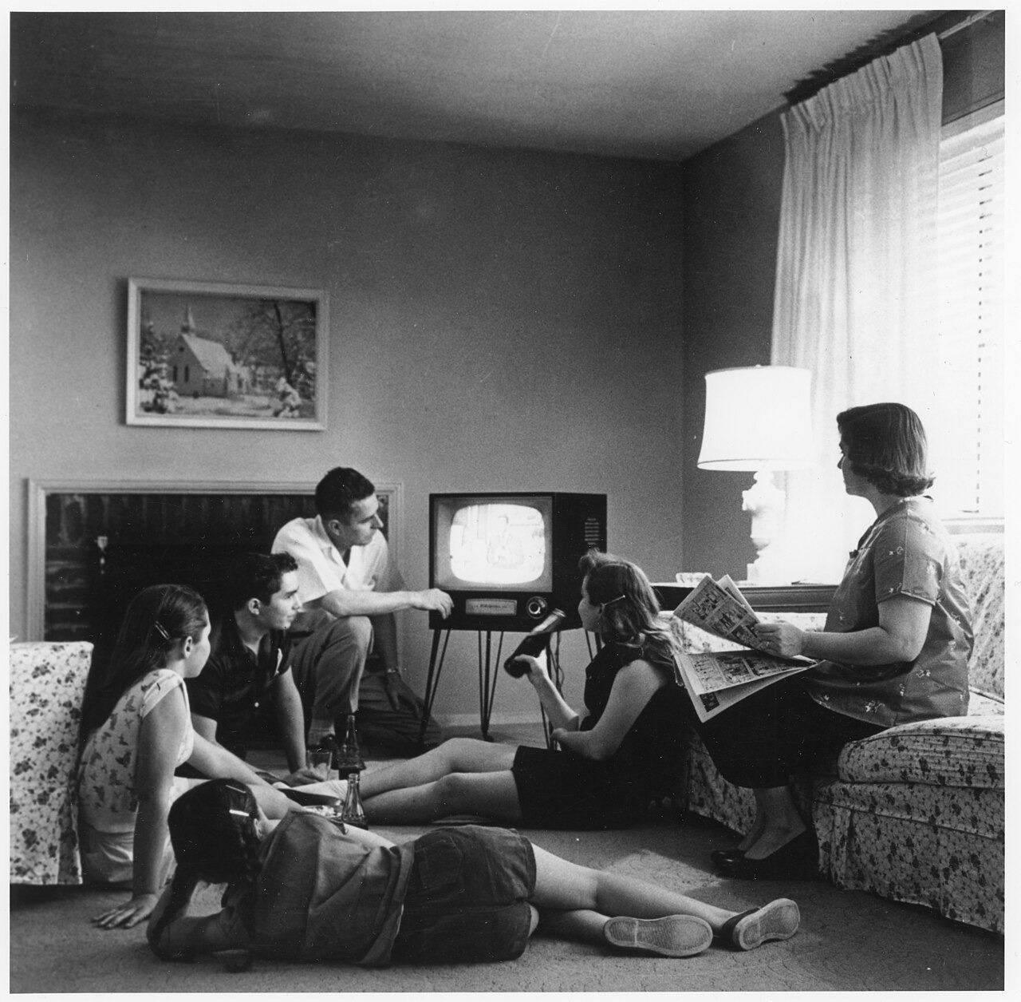
Family Watching Television in Their Home (c. 1958). Medium: photograph. An American family gathers around a television set in their living room, c. 1958. TV ownership jumped from about 9 percent of homes in 1950 to nearly 90 percent by 1960, making television the center of family evenings. Source: Evert F. Baumgardner, National Archives and Records Administration, via Wikimedia Commons. Public domain (17 U.S.C. § 105). https://commons.wikimedia.org/wiki/File:Family_watching_television_1958.jpg
OPTIC step | Your analysis
O — Overview | In one sentence, what is happening in this image?
P — Parts | List two specific details (people, objects, setting).
T — Title / Text | What do the caption and any words tell you?
I — Interrelationships | How do the parts connect to the standard's big idea?
C — Conclusion | What does this source argue about the era?

Document B (text primary source — analyze with HIPPO) — US.75
“Those who heard the debates on radio thought Nixon had won. But those who watched on television thought Kennedy had won. Nixon, recovering from illness, appeared pale, tired, and sweating under the studio lights. Kennedy, tanned and rested, projected youth, vigor, and confidence. Television had changed politics.”

Source: Theodore White, journalist, “Television and the 1960 Election,” 1961. John F. Kennedy Presidential Library. Rights: Public domain. https://www.jfklibrary.org/learn/about-jfk/jfk-in-history/campaign-of-1960
H-I-P-P-O | Prompt
Historical context | What was happening when this was written?
Intended audience | Who was meant to read or hear it?
Purpose | Why was it created?
Point of view | Whose perspective does it show?
Outside connection | How does it link to the standard?
SUPPORT OPTION
Other perspectives: whose interests did this source serve, and whose experience does it leave out? Name one group and one thing they might have seen differently. (Empathy check: how might that group have felt about the change described?)

Activity 5 — Practice Quiz — US.75
RESPONSE CHOICE
Choose your answer format. Full form (A–D): circle the best of four choices. Support form (A–B): use the two-choice version printed under each question — it keeps the correct answer and one strong distractor. Reduced choices are an access format; the standard and the question are the same.

1. How did television change American homes in the 1950s? [DOK 1 · item q-us75-dok1-1]
A. Television was banned from homes and only available in public spaces
B. Very few American families could afford to purchase television sets
C. TV became the center of family entertainment and a source of news
D. Radio remained far more popular than television throughout the decade
Support form (A–B): A. TV became the center of family entertainment and a source of news / B. Television was banned from homes and only available in public spaces
2. How did television advertising change the American economy during the 1950s? [DOK 2 · item U8-DOK2-0038]
A. Television advertising was prohibited by the federal government to prevent commercial exploitation of the public airwaves
B. Television advertising had no measurable impact on consumer behavior because viewers consistently ignored commercials
C. Television advertising created a powerful new channel for reaching mass audiences, accelerating consumer demand for branded products and transforming marketing practices across American industry
D. Television advertising was available only to small local businesses since national corporations continued to rely exclusively on newspaper advertising
Support form (A–B): A. Television advertising was prohibited by the federal government to prevent commercial exploitation of the public airwaves / B. Television advertising created a powerful new channel for reaching mass audiences, accelerating consumer demand for branded products and transforming marketing practices across American industry
3. The 1960 Kennedy-Nixon presidential debates are often cited as the first election significantly decided by television. Which of the following best evaluates this claim using available evidence? [DOK 3 · item dok3-gen-u8-042]
A. The claim is unsupported because both Kennedy and Nixon performed equally well on radio and television according to polls taken immediately after the debate
B. Radio listeners thought Nixon won while TV viewers favored Kennedy — showing visual performance independently shaped voter perception beyond the debate's policy content
C. The claim is fully proven: Kennedy's superior television appearance was the single decisive reason he won the 1960 presidential election
D. False because Kennedy and Nixon discussed identical policy positions, making visual presentation irrelevant to voters' decisions
Support form (A–B): A. Radio listeners thought Nixon won while TV viewers favored Kennedy — showing visual performance independently shaped voter perception beyond the debate's policy content / B. The claim is unsupported because both Kennedy and Nixon performed equally well on radio and television according to polls taken immediately after the debate
Explain your thinking: choose ONE question and explain why your answer is correct using evidence from the unit.

Items from the History Hack canonical question bank (pre-field-test; classroom formative, not a secure TCAP form). Answer key and rationales are in the Teacher Guide.
PROGRESS CHECK
Before you check answers — how sure are you? Circle one:
★ I've got this ● Mostly △ Still shaky ○ Lost
If you circled Still shaky or Lost, write one thing to ask your teacher:

Activity 6 — Constructed Response (CER) — US.75
RESPONSE CHOICE
Choose your challenge. Pick ONE prompt and answer with a full CER (Claim, Evidence, Reasoning). Higher levels earn more challenge points — aim as high as you can.

LEVEL 1 — Build It: Name ONE way television changed American life and give one piece of evidence for it.
LEVEL 2 — Stretch It: Did television have a greater impact on American politics or on the American economy? Make a claim, support it with at least two pieces of evidence, and explain your reasoning.
LEVEL 3 — Master It: Television reshaped how Americans bought products and how they judged their leaders. Using evidence from this standard, evaluate whether its larger impact was political or economic, and explain how a single technology in the living room could change both the marketplace and the voting booth.
SUPPORT OPTION
Sentence frames — use these to build your answer:
• Claim: I believe that ______ because ______.
• Evidence: One piece of evidence from the unit is ______. This shows ______.
• Reasoning: This matters because ______. It connects to the big question by ______.

I chose Level ____. My CER response:

EXTENSION
Level 4 — Go Further (open to everyone). Evaluate: The 1960 debates are said to mark when image overtook substance in politics. Assess whether television improved or degraded democratic decision-making. Full prompt and space in the Challenge Bank appendix.

Back to the Big Question. How did prosperity, technology, and new ideas transform the United States between the 1950s and 1963 — and who shared in that transformation? In one sentence, what is your answer now?

Standard US.76 — Youth Culture and Tennessee's Music
TN Academic Standard US.76: Describe the emergence of a youth culture, including beatniks and the progression of popular music (from swing to rhythm and blues to rock 'n' roll), and the impact of Tennessee on the music industry, including the influence of B.B. King, Elvis Presley, Stax Records, and Sun Studio.
I can… describe the emergence of a 1950s youth culture, including beatniks • trace the progression of popular music from swing to R&B to rock 'n' roll • explain Tennessee's impact on the music industry (B.B. King, Elvis Presley, Stax, Sun Studio).
CORE PATH
If short on time: Vocabulary → Direct Teaching Cornell Notes → Close Read → Primary Source → Quiz + CER. This standard emphasizes SSP.03 and SSP.06.

Vocabulary comes next (Activity 1, two parts): a Reference / Word Bank and a Vocabulary Studio.

Activity 1 — Vocabulary (Part A: Reference / Word Bank) — US.76
Use this word bank throughout the standard. Meanings are student-friendly; Spanish cognates or translations are given where they exist.
Term | Student-friendly meaning | Spanish
youth culture | the distinct styles and values of young people | —
beatniks | 1950s nonconformists in art, poetry, and jazz | —
rhythm and blues | African American music that shaped rock 'n' roll | —
rock 'n' roll | a new 1950s music style blending blues, country, and R&B | —
Sun Studio | the Memphis studio that launched early rock 'n' roll | —
Stax Records | the Memphis label that shaped soul and R&B | —
LANGUAGE SUPPORT
Watch for Spanish cognates in the right column — words that look and mean nearly the same in both languages. Sentence frame: This word means ______. An example is ______.

RESPONSE CHOICE
How to show you understand a term (response contract). The core requirement is an accurate meaning plus a historical connection. You may show additional understanding in the way that fits the term — a sentence, an example or non-example, a labeled drawing, an analogy, or by rehearsing it out loud before you write. You do not have to use every mode.

Activity 1 — Vocabulary (Part B: Vocabulary Studio) — US.76
RESPONSE CHOICE
Choose or accept TWO priority terms from the word bank (your teacher may assign them). For each, complete the organizer below. Meaning + historical connection are required; the other boxes are your space to show understanding the way that works best for the term.

Priority term: youth culture
Word-bank meaning to build on: the distinct styles and values of young people.
In my own words  Core requirement: an accurate meaning. | Characteristics / historical context  When/where it mattered in the 1950s–1963.
Example or non-example  A real case — or something it is NOT. | Visual / symbol  Draw a small symbol; labels welcome (art is not graded).
Use it to explain history — core requirement: connect the term to a real 1950s–1963 development in one or two sentences.

Priority term: beatniks
Word-bank meaning to build on: 1950s nonconformists in art, poetry, and jazz.
In my own words  Core requirement: an accurate meaning. | Characteristics / historical context  When/where it mattered in the 1950s–1963.
Example or non-example  A real case — or something it is NOT. | Visual / symbol  Draw a small symbol; labels welcome (art is not graded).
Use it to explain history — core requirement: connect the term to a real 1950s–1963 development in one or two sentences.

PROGRESS CHECK
Which of your two terms do you understand best, and which one do you still want to practice? Circle it in the word bank on the previous page.

Direct Teaching Cornell Notes — US.76
Name: ____________________ Class / Period: ____________ Date: ____________
US.76 — Youth Culture and Tennessee's Music · Lean Deck slides 31–36 · US76-L06
Learning target: I can explain how youth culture and Tennessee's music (Sun Studio, Stax, Memphis) shaped postwar America.
Essential question / success criterion: Why did Tennessee become a birthplace of rock 'n' roll and R&B?

Guiding cues | My notes (Lean Deck slides 31–36)
What was 1950s youth culture? | Lean slide 32: Direct Instruction: youth culture & TN music
How did R&B become rock 'n' roll?
Why was Memphis (Sun, Stax) important?
How did TN music cross old boundaries?
Key terms to listen for: youth culture · rhythm and blues · rock 'n' roll · Sun Studio · Stax Records
Summary — In your own words, what is the most important idea from this standard?

PROGRESS CHECK
Confidence: ★ Strong ● Okay △ Shaky ○ Lost
One idea I understood: ______________________________________
One question I still have: ___________________________________
Optional support tools on reverse. Follow along on the Lean Deck (slides 31–36) — posted in Schoology.

Optional Support — Guided Support — US.76 (US76-L06 reverse · use only if helpful)
This is an optional support tool, not a label. Anyone may use it, and it is meant to fade as you gain independence. It works alongside — never in place of — any IEP or 504 accommodations you are entitled to.
Key vocabulary
Term | What it means | Spanish
youth culture | the distinct styles and values of young people | —
beatniks | 1950s nonconformists in art, poetry, and jazz | —
rhythm and blues | African American music that shaped rock 'n' roll | —
rock 'n' roll | a new 1950s music style blending blues, country, and R&B | —
Sun Studio | the Memphis studio that launched early rock 'n' roll | —
Stax Records | the Memphis label that shaped soul and R&B | —
Break it into steps
1) Describe youth culture in one line.
2) Name one Memphis studio and artist.
3) Explain one boundary the music crossed.
Sentence frame: Tennessee’s Sun Studio and Stax Records were important because they ___, which helped ___ in 1950s America.

Modeled example (one worked note — yours will differ): Cue: Why was Memphis important to music? Note: Sun Studio and Stax Records in Memphis blended R&B and country into rock 'n' roll, launching artists like Elvis and crossing racial boundaries in popular music.

Optional Support — Light Support — US.76 (US76-L06 reverse · use only if helpful)
This is an optional support tool, not a label. Anyone may use it, and it is meant to fade as you gain independence. It works alongside — never in place of — any IEP or 504 accommodations you are entitled to.
Key vocabulary
Term | Hint (finish the idea as you listen)
youth culture | the distinct styles and …
beatniks | 1950s nonconformists in art …
rhythm and blues | African American music that …
rock 'n' roll | a new 1950s music …
Sun Studio | the Memphis studio that …
Stax Records | the Memphis label that …
Break it into steps
1) Describe youth culture in one line.
2) Name one Memphis studio and artist.
3) Explain one boundary the music crossed.
Guiding questions (answer in your notes on the front)
• What was 1950s youth culture?
• How did R&B become rock 'n' roll?
• Why was Memphis (Sun, Stax) important?
• How did TN music cross old boundaries?
Try the note first. If you need more, ask for the Guided Support version.

Activity 3 — Close Read — US.76
CORE PATH
The Sound of a New Generation. In the 1950s, a new sound transformed American music: rock and roll. It blended rhythm and blues, country, and gospel into something exciting and new for a young generation. Tennessee was at the center of this revolution. In Memphis, Sun Studio recorded early stars, including Elvis Presley, and helped launch rock and roll. Later, Memphis labels like Stax shaped soul and R&B. Through its studios and artists, Tennessee helped create and spread new musical styles across the country. The state became one of the most important homes of American popular music.
Predict first: before you read, guess who this helped and who it left out. Check your guess after reading.

LANGUAGE SUPPORT
Key words: rock and roll = a new 1950s music style; studio = a place to record music
Sentence frame: Tennessee shaped music by ______.
Talk first: What was Sun Studio?

SUPPORT OPTION
Read an elevated version (any learner may choose this): As the postwar economy gave teenagers money and free time, a distinct youth culture emerged. Some young people, the beatniks, rejected mainstream conformity through poetry, jazz, and a restless search for meaning. Most simply embraced new styles, fashions, and above all, new music. Popular music evolved rapidly. The big-band swing of earlier years gave way to rhythm and blues, rooted in African American musical traditions, which in turn helped give birth to rock 'n' roll — a blend of blues, country, and R&B that became the anthem of the young. Tennessee stood at the center of this revolution. In Memphis, Sun Studio launched the careers of rock 'n' roll pioneers, including Elvis Presley, and blues legend B.B. King shaped the genre. Stax Records made Memphis a capital of soul and R&B. Through these artists and studios, Tennessee helped define American popular music.

Text-dependent questions — answer using evidence from the passage:
1. According to the passage, what did rock 'n' roll blend together?

2. Which Tennessee city was at the center of the music revolution? Find the sentence.

3. How did Tennessee help define American music, using evidence?

RESPONSE CHOICE
Show your answer to question 3 the way that works best for you: write it in the lines above, say it aloud to a partner using the Talk-First prompt, or annotate the passage and point to your evidence. The standard is the same in every mode.

Activity 4 — Primary Sources — US.76
Document A (visual primary source — analyze with OPTIC):
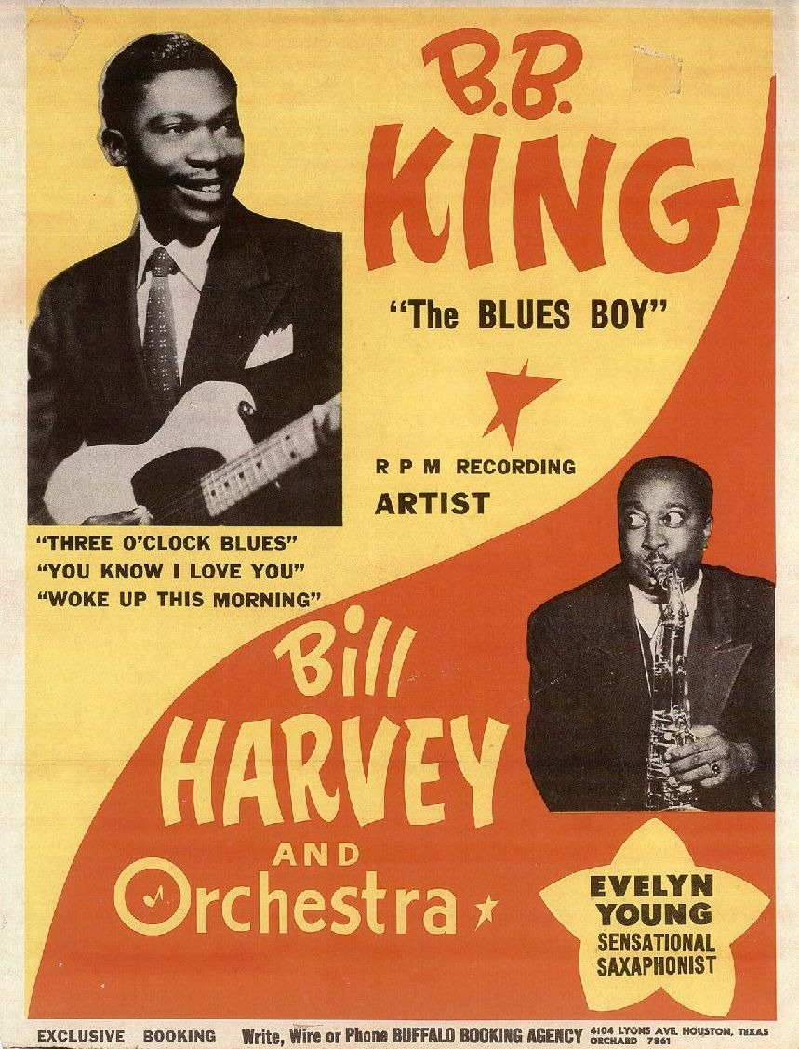
B.B. King and Bill Harvey Orchestra Promotional Poster (1950s). Medium: poster. A 1950s poster advertises blues guitarist B.B. King with the Bill Harvey Orchestra. King rose to fame in Memphis and broadcast on WDIA, the first U.S. radio station programmed for Black audiences, shaping the sound that became rock 'n' roll. Source: Unknown. University of Houston Digital Collections, via Wikimedia Commons. Public Domain Mark 1.0. https://commons.wikimedia.org/wiki/File:Poster_of_B.B._King_and_Bill_Harvey_(saxophonist)_and_Orchestra,_featuring_photos_of_B.B._King_holding_his_guitar_and_Evelyn_Young_playing_saxaphone._-_8049g557h_files_92a57ed3-1d17-4a52-bda9-53dd48145101.jpg
OPTIC step | Your analysis
O — Overview | In one sentence, what is happening in this image?
P — Parts | List two specific details (people, objects, setting).
T — Title / Text | What do the caption and any words tell you?
I — Interrelationships | How do the parts connect to the standard's big idea?
C — Conclusion | What does this source argue about the era?

Document B (text primary source — analyze with HIPPO) — US.76
“Beale Street in Memphis is where I learned my trade. The blues was born here, in the Mississippi Delta and right here on Beale. Now they call this new music 'rock and roll,' but it's got the blues running through its veins. Every young white singer coming through Sun Studio, they're learning from us.”

Source: Memphis Press-Scimitar, “B.B. King Interview,” 1956. Library of Congress. Rights: Public domain. https://www.loc.gov/collections/national-jukebox/
H-I-P-P-O | Prompt
Historical context | What was happening when this was written?
Intended audience | Who was meant to read or hear it?
Purpose | Why was it created?
Point of view | Whose perspective does it show?
Outside connection | How does it link to the standard?
SUPPORT OPTION
Other perspectives: whose interests did this source serve, and whose experience does it leave out? Name one group and one thing they might have seen differently. (Empathy check: how might that group have felt about the change described?)

Activity 5 — Practice Quiz — US.76
RESPONSE CHOICE
Choose your answer format. Full form (A–D): circle the best of four choices. Support form (A–B): use the two-choice version printed under each question — it keeps the correct answer and one strong distractor. Reduced choices are an access format; the standard and the question are the same.

1. What was the significance of Elvis Presley and Sun Studio in Memphis, Tennessee? [DOK 1 · item q-us76-dok1-1]
A. They helped launch rock 'n' roll by blending Black and white musical styles
B. It blended Black and white musical traditions, challenging racial boundaries
C. Memphis and Nashville became major centers for blues, rock, and country
D. Rock 'n' roll, beatniks, and teen rebellion challenged 1950s conformity
Support form (A–B): A. It blended Black and white musical traditions, challenging racial boundaries / B. They helped launch rock 'n' roll by blending Black and white musical styles
2. How did the transition from swing music to rhythm and blues and then to rock and roll reflect broader social changes in American society during the 1950s? [DOK 2 · item U8-DOK2-0045]
A. The shift reflected purely musical preferences with no connection to race, class, or generational identity
B. The shift from swing to rock and roll was directed by the federal government as part of a cultural unity campaign
C. Rock and roll merged African American rhythm and blues with country influences, crossing racial barriers and challenging segregation among youth
D. Rock and roll emerged exclusively in Northern cities and was unknown in the South until the 1970s
Support form (A–B): A. Rock and roll merged African American rhythm and blues with country influences, crossing racial barriers and challenging segregation among youth / B. The shift reflected purely musical preferences with no connection to race, class, or generational identity
3. B.B. King's career and musical style are considered foundational to the development of rock 'n' roll. Which of the following best explains the nature of his influence and the barriers he faced despite that influence? [DOK 3 · item dok3-gen-u8-054]
A. B.B. King had no influence on rock 'n' roll because he exclusively played country music throughout his career.
B. B.B. King's success was evidence that the music industry was fully integrated and that Black musicians faced no barriers to commercial success in the 1950s.
C. B.B. King was the most commercially successful musician in America in the 1950s, earning more than any white artist through his mainstream record sales.
D. B.B. King's innovations were foundational to rock 'n' roll, yet segregation confined him to 'race record' markets while white artists popularized and profited from music derived from his style
Support form (A–B): A. B.B. King had no influence on rock 'n' roll because he exclusively played country music throughout his career. / B. B.B. King's innovations were foundational to rock 'n' roll, yet segregation confined him to 'race record' markets while white artists popularized and profited from music derived from his style
Explain your thinking: choose ONE question and explain why your answer is correct using evidence from the unit.

Items from the History Hack canonical question bank (pre-field-test; classroom formative, not a secure TCAP form). Answer key and rationales are in the Teacher Guide.
PROGRESS CHECK
Before you check answers — how sure are you? Circle one:
★ I've got this ● Mostly △ Still shaky ○ Lost
If you circled Still shaky or Lost, write one thing to ask your teacher:

Activity 6 — Constructed Response (CER) — US.76
RESPONSE CHOICE
Choose your challenge. Pick ONE prompt and answer with a full CER (Claim, Evidence, Reasoning). Higher levels earn more challenge points — aim as high as you can.

LEVEL 1 — Build It: Name ONE way Tennessee shaped American popular music in the 1950s and give one piece of evidence for it.
LEVEL 2 — Stretch It: How did Tennessee shape American popular music in the 1950s? Make a claim, support it with at least two pieces of evidence, and explain your reasoning.
LEVEL 3 — Master It: The rock 'n' roll and rhythm-and-blues recorded in Tennessee in the 1950s grew from Black musical traditions and reached a national, racially mixed youth audience. Using evidence from this standard, evaluate how Tennessee became a center of this new youth culture, and explain whose contributions made it possible.
SUPPORT OPTION
Sentence frames — use these to build your answer:
• Claim: I believe that ______ because ______.
• Evidence: One piece of evidence from the unit is ______. This shows ______.
• Reasoning: This matters because ______. It connects to the big question by ______.

I chose Level ____. My CER response:

EXTENSION
Level 4 — Go Further (open to everyone). Synthesize: Rock and roll fused Black and white musical traditions during segregation. Analyze what this cultural blending reveals about America in the 1950s. Full prompt and space in the Challenge Bank appendix.

Back to the Big Question. How did prosperity, technology, and new ideas transform the United States between the 1950s and 1963 — and who shared in that transformation? In one sentence, what is your answer now?

Standard US.77 — Kennedy's New Frontier
TN Academic Standard US.77: Analyze the goals and achievements of President John F. Kennedy's New Frontier, including the Peace Corps, the space program, and early civil rights initiatives.
I can… describe the goals of Kennedy's New Frontier • explain the Peace Corps and the space program • analyze Kennedy's early civil rights initiatives.
CORE PATH
If short on time: Vocabulary → Direct Teaching Cornell Notes → Close Read → Primary Source → Quiz + CER. This standard emphasizes SSP.04 and SSP.03.

Vocabulary comes next (Activity 1, two parts): a Reference / Word Bank and a Vocabulary Studio.

Activity 1 — Vocabulary (Part A: Reference / Word Bank) — US.77
Use this word bank throughout the standard. Meanings are student-friendly; Spanish cognates or translations are given where they exist.
Term | Student-friendly meaning | Spanish
New Frontier | Kennedy's program of domestic and foreign goals | —
Peace Corps | volunteers Kennedy sent to help developing nations | —
civil rights | the rights of citizens to political and social equality | derechos civiles
space program | the U.S. effort to explore space and reach the Moon | —
idealism | the pursuit of high or noble goals | idealismo
frontier | the edge of the known or settled world; a new challenge | frontera
LANGUAGE SUPPORT
Watch for Spanish cognates in the right column — words that look and mean nearly the same in both languages. Sentence frame: This word means ______. An example is ______.

RESPONSE CHOICE
How to show you understand a term (response contract). The core requirement is an accurate meaning plus a historical connection. You may show additional understanding in the way that fits the term — a sentence, an example or non-example, a labeled drawing, an analogy, or by rehearsing it out loud before you write. You do not have to use every mode.

Activity 1 — Vocabulary (Part B: Vocabulary Studio) — US.77
RESPONSE CHOICE
Choose or accept TWO priority terms from the word bank (your teacher may assign them). For each, complete the organizer below. Meaning + historical connection are required; the other boxes are your space to show understanding the way that works best for the term.

Priority term: New Frontier
Word-bank meaning to build on: Kennedy's program of domestic and foreign goals.
In my own words  Core requirement: an accurate meaning. | Characteristics / historical context  When/where it mattered in the 1950s–1963.
Example or non-example  A real case — or something it is NOT. | Visual / symbol  Draw a small symbol; labels welcome (art is not graded).
Use it to explain history — core requirement: connect the term to a real 1950s–1963 development in one or two sentences.

Priority term: Peace Corps
Word-bank meaning to build on: volunteers Kennedy sent to help developing nations.
In my own words  Core requirement: an accurate meaning. | Characteristics / historical context  When/where it mattered in the 1950s–1963.
Example or non-example  A real case — or something it is NOT. | Visual / symbol  Draw a small symbol; labels welcome (art is not graded).
Use it to explain history — core requirement: connect the term to a real 1950s–1963 development in one or two sentences.

PROGRESS CHECK
Which of your two terms do you understand best, and which one do you still want to practice? Circle it in the word bank on the previous page.

Direct Teaching Cornell Notes — US.77
Name: ____________________ Class / Period: ____________ Date: ____________
US.77 — Kennedy's New Frontier · Lean Deck slides 37–42 · US77-L07
Learning target: I can describe Kennedy's New Frontier and its goals at home and abroad.
Essential question / success criterion: What did Kennedy's New Frontier try to change in America and the world?

Guiding cues | My notes (Lean Deck slides 37–42)
What was the New Frontier? | Lean slide 38: Direct Instruction: Kennedy's New Frontier
What were its goals at home?
What were its goals abroad (Peace Corps, space)?
How did it reflect Kennedy's idealism?
Key terms to listen for: New Frontier · Peace Corps · space program · idealism
Summary — In your own words, what is the most important idea from this standard?

PROGRESS CHECK
Confidence: ★ Strong ● Okay △ Shaky ○ Lost
One idea I understood: ______________________________________
One question I still have: ___________________________________
Optional support tools on reverse. Follow along on the Lean Deck (slides 37–42) — posted in Schoology.

Optional Support — Guided Support — US.77 (US77-L07 reverse · use only if helpful)
This is an optional support tool, not a label. Anyone may use it, and it is meant to fade as you gain independence. It works alongside — never in place of — any IEP or 504 accommodations you are entitled to.
Key vocabulary
Term | What it means | Spanish
New Frontier | Kennedy's program of domestic and foreign goals | —
Peace Corps | volunteers Kennedy sent to help developing nations | —
civil rights | the rights of citizens to political and social equality | derechos civiles
space program | the U.S. effort to explore space and reach the Moon | —
idealism | the pursuit of high or noble goals | idealismo
frontier | the edge of the known or settled world; a new challenge | frontera
Break it into steps
1) Define the New Frontier.
2) Name one home goal.
3) Name one goal abroad.
Sentence frame: The New Frontier was a set of programs to ___, and Kennedy created the Peace Corps because ___.

Modeled example (one worked note — yours will differ): Cue: What were the New Frontier's goals abroad? Note: Kennedy created the Peace Corps and committed the U.S. to reaching the Moon — projecting American idealism and competing with the USSR in the Cold War.

Optional Support — Light Support — US.77 (US77-L07 reverse · use only if helpful)
This is an optional support tool, not a label. Anyone may use it, and it is meant to fade as you gain independence. It works alongside — never in place of — any IEP or 504 accommodations you are entitled to.
Key vocabulary
Term | Hint (finish the idea as you listen)
New Frontier | Kennedy's program of domestic …
Peace Corps | volunteers Kennedy sent to …
civil rights | the rights of citizens …
space program | the U.S. effort to …
idealism | the pursuit of high …
frontier | the edge of the …
Break it into steps
1) Define the New Frontier.
2) Name one home goal.
3) Name one goal abroad.
Guiding questions (answer in your notes on the front)
• What was the New Frontier?
• What were its goals at home?
• What were its goals abroad (Peace Corps, space)?
• How did it reflect Kennedy's idealism?
Try the note first. If you need more, ask for the Guided Support version.

Activity 3 — Close Read — US.77
CORE PATH
A New Frontier. When John F. Kennedy became president in 1961, he called his program the New Frontier. It promised bold action both at home and around the world. At home, Kennedy spoke of fighting poverty and advancing civil rights. Abroad, he created the Peace Corps, sending volunteers to help in developing nations, and pushed the goal of landing on the Moon. Kennedy mixed youthful idealism with the hard realities of the Cold War. His New Frontier cast the United States as a confident leader of the free world, facing challenges at home and abroad.
Predict first: before you read, guess who this helped and who it left out. Check your guess after reading.

LANGUAGE SUPPORT
Key words: New Frontier = Kennedy's program; Peace Corps = volunteers sent to help abroad
Sentence frame: The New Frontier focused on ______.
Talk first: What was the Peace Corps?

SUPPORT OPTION
Read an elevated version (any learner may choose this): When John F. Kennedy became president in 1961, he called Americans to a 'New Frontier' of challenges — a program of goals in education, the economy, civil rights, and beyond. Young and energetic, he urged citizens to serve their country and to tackle bold problems. His New Frontier reached around the world and into space. Kennedy created the Peace Corps, sending American volunteers to help in developing nations, an expression of Cold War idealism and service. He pledged to advance civil rights and to end racial discrimination, though much of that work fell to his successor. Perhaps his boldest goal was in space: Kennedy committed the nation to landing a man on the moon before the decade's end. Though he did not live to see it, his challenge inspired the effort that fulfilled it in 1969. The New Frontier captured an era of idealism and ambition.

Text-dependent questions — answer using evidence from the passage:
1. According to the passage, what did Kennedy call his program?

2. Name one goal of the New Frontier abroad. Find the sentence.

3. How did Kennedy mix idealism and Cold War realities, using evidence?

RESPONSE CHOICE
Show your answer to question 3 the way that works best for you: write it in the lines above, say it aloud to a partner using the Talk-First prompt, or annotate the passage and point to your evidence. The standard is the same in every mode.

Activity 4 — Primary Sources — US.77
Document A (visual primary source — analyze with OPTIC):
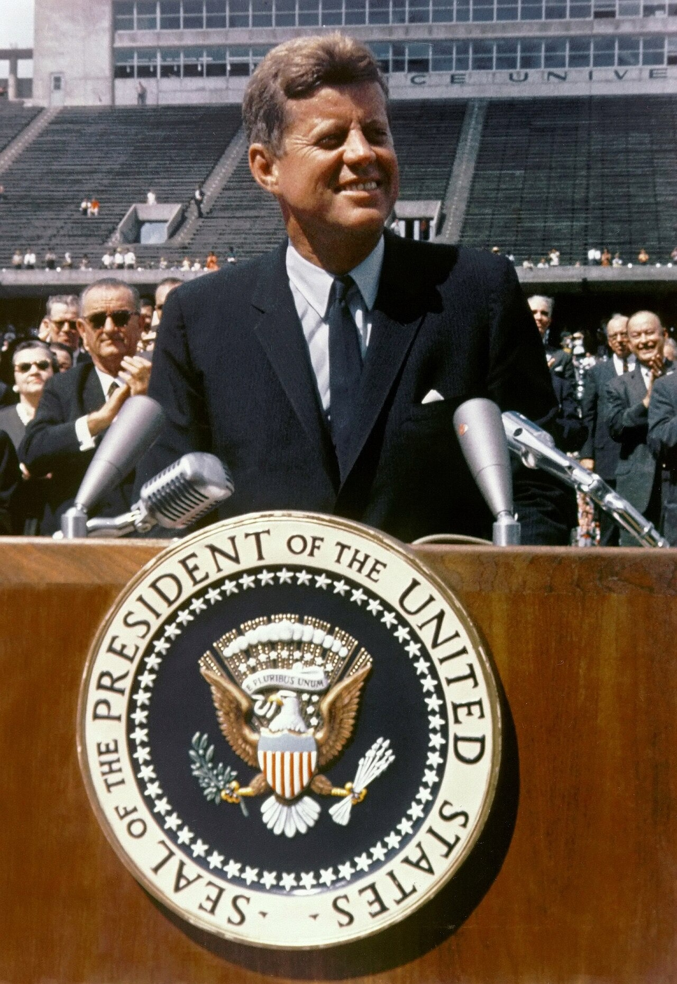
President Kennedy Speaks at Rice University on the Space Effort (September 12, 1962). Medium: photograph. President John F. Kennedy addresses roughly 40,000 people at Rice University's stadium in Houston, September 12, 1962. In this speech he declared the nation would 'choose to go to the Moon,' rallying support for the space program. Source: NASA (69-HC-1245), via Wikimedia Commons. Public domain (17 U.S.C. § 105). https://commons.wikimedia.org/wiki/File:John_F._Kennedy_speaks_at_Rice_University.jpg
OPTIC step | Your analysis
O — Overview | In one sentence, what is happening in this image?
P — Parts | List two specific details (people, objects, setting).
T — Title / Text | What do the caption and any words tell you?
I — Interrelationships | How do the parts connect to the standard's big idea?
C — Conclusion | What does this source argue about the era?

Document B (text primary source — analyze with HIPPO) — US.77
“I recommend to the Congress the establishment of a permanent Peace Corps — a pool of trained American men and women sent overseas by the U.S. Government to help foreign countries meet their urgent needs for skilled manpower... Life in the Peace Corps will not be easy... But if the life will not be easy, it will be rich and satisfying.”

Source: President John F. Kennedy, “Special Message to Congress on the Peace Corps,” March 1, 1961. John F. Kennedy Presidential Library. Rights: Public domain. https://www.jfklibrary.org/asset-viewer/archives/JFKPOF/034/JFKPOF-034-002
H-I-P-P-O | Prompt
Historical context | What was happening when this was written?
Intended audience | Who was meant to read or hear it?
Purpose | Why was it created?
Point of view | Whose perspective does it show?
Outside connection | How does it link to the standard?
SUPPORT OPTION
Other perspectives: whose interests did this source serve, and whose experience does it leave out? Name one group and one thing they might have seen differently. (Empathy check: how might that group have felt about the change described?)

Activity 5 — Practice Quiz — US.77
RESPONSE CHOICE
Choose your answer format. Full form (A–D): circle the best of four choices. Support form (A–B): use the two-choice version printed under each question — it keeps the correct answer and one strong distractor. Reduced choices are an access format; the standard and the question are the same.

1. What was President Kennedy's "New Frontier" program? [DOK 1 · item q-us77-dok1-1]
A. Domestic agenda to improve education, end discrimination, and reach the moon
B. A domestic agenda to improve education, end discrimination, and advance science
C. Landing on the moon would demonstrate American technological superiority
D. Send American volunteers to developing nations to provide assistance
Support form (A–B): A. Domestic agenda to improve education, end discrimination, and reach the moon / B. A domestic agenda to improve education, end discrimination, and advance science
2. How did the Peace Corps, established by Kennedy in 1961, reflect the goals of the New Frontier? [DOK 2 · item U8-DOK2-0052]
A. The Peace Corps was a military organization designed to train soldiers for counterinsurgency operations in developing nations
B. The Peace Corps embodied the New Frontier's call to service, sending volunteers to developing nations to advance economic development and goodwill as peaceful Cold War competition
C. The Peace Corps was established to provide employment for American workers during a recession rather than to assist foreign countries
D. The Peace Corps focused exclusively on rebuilding European nations still recovering from the devastation of World War II
Support form (A–B): A. The Peace Corps was a military organization designed to train soldiers for counterinsurgency operations in developing nations / B. The Peace Corps embodied the New Frontier's call to service, sending volunteers to developing nations to advance economic development and goodwill as peaceful Cold War competition
3. Kennedy's 1961 moon mission commitment — 'We choose to go to the moon in this decade' — was made at a moment when the United States was behind the Soviet Union in the space race. Which of the following best explains the strategic reasoning behind this specific, ambitious timeline? [DOK 3 · item dok3-gen-u8-063]
A. Kennedy chose the moon mission because the United States already had overwhelming superiority in space technology and the mission was a low-risk way to demonstrate established American leadership.
B. Kennedy's primary motivation was economic — the moon mission would stimulate the American economy through defense contracts, with the Cold War competition being a secondary justification.
C. By choosing a destination where neither nation had yet achieved any milestone, Kennedy reset the competition to a level playing field while committing a specific deadline that would sustain public funding and national focus across administrations.
D. Kennedy publicly proposed that the United States and Soviet Union collaborate on the moon mission, reasoning that joint achievement would be more impressive than competitive victory.
Support form (A–B): A. By choosing a destination where neither nation had yet achieved any milestone, Kennedy reset the competition to a level playing field while committing a specific deadline that would sustain public funding and national focus across administrations. / B. Kennedy chose the moon mission because the United States already had overwhelming superiority in space technology and the mission was a low-risk way to demonstrate established American leadership.
Explain your thinking: choose ONE question and explain why your answer is correct using evidence from the unit.

Items from the History Hack canonical question bank (pre-field-test; classroom formative, not a secure TCAP form). Answer key and rationales are in the Teacher Guide.
PROGRESS CHECK
Before you check answers — how sure are you? Circle one:
★ I've got this ● Mostly △ Still shaky ○ Lost
If you circled Still shaky or Lost, write one thing to ask your teacher:

Activity 6 — Constructed Response (CER) — US.77
RESPONSE CHOICE
Choose your challenge. Pick ONE prompt and answer with a full CER (Claim, Evidence, Reasoning). Higher levels earn more challenge points — aim as high as you can.

LEVEL 1 — Build It: Name ONE goal of Kennedy's New Frontier and give one piece of evidence about it.
LEVEL 2 — Stretch It: Was the New Frontier mainly about challenges at home or about America's role in the world? Make a claim, support it with at least two pieces of evidence, and explain your reasoning.
LEVEL 3 — Master It: Kennedy's New Frontier promised action on domestic problems and bold leadership abroad at the same time. Using evidence from this standard, evaluate which focus defined it more, and explain how Cold War pressures could pull a president's attention away from the domestic agenda he campaigned on.
SUPPORT OPTION
Sentence frames — use these to build your answer:
• Claim: I believe that ______ because ______.
• Evidence: One piece of evidence from the unit is ______. This shows ______.
• Reasoning: This matters because ______. It connects to the big question by ______.

I chose Level ____. My CER response:

EXTENSION
Level 4 — Go Further (open to everyone). Evaluate: Kennedy's New Frontier blended idealism and Cold War strategy. Argue whether its domestic or international vision better defined his presidency. Full prompt and space in the Challenge Bank appendix.

Back to the Big Question. How did prosperity, technology, and new ideas transform the United States between the 1950s and 1963 — and who shared in that transformation? In one sentence, what is your answer now?

Your Tennessee Connection
A U.S. History Hack™ signature feature — local history no national publisher builds for you.
Tennessee sits at the heart of this era. In Memphis, Sun Studio and Beale Street shaped the birth of rock 'n' roll and gave the nation B.B. King and Elvis Presley, while Stax Records made the city a capital of soul. Kemmons Wilson opened the first Holiday Inn in Memphis in 1952, launching the roadside-motel industry that spread along the new interstate highways. Oak Ridge, built for the wartime Manhattan Project, remained a center of federal science and postwar prosperity. As you finish this unit, connect these national stories back to your own Tennessee county.

B.B. King and Bill Harvey Orchestra Promotional Poster (1950s). A 1950s poster advertises blues guitarist B.B. King with the Bill Harvey Orchestra. King rose to fame in Memphis and broadcast on WDIA, the first U.S. radio station programmed for Black audiences, shaping the sound that became rock 'n' roll. https://commons.wikimedia.org/wiki/File:Poster_of_B.B._King_and_Bill_Harvey_(saxophonist)_and_Orchestra,_featuring_photos_of_B.B._King_holding_his_guitar_and_Evelyn_Young_playing_saxaphone._-_8049g557h_files_92a57ed3-1d17-4a52-bda9-53dd48145101.jpg
RESPONSE CHOICE
Choose ONE 1950s–1963 change from this unit (music, highways, television, suburbs, or the space effort). Research or interview a family or community member about how that change reached YOUR Tennessee county. Write 3–4 sentences with at least one specific local detail.

LANGUAGE SUPPORT
Sentence frame: In my county, the change of ______ can still be seen in ______. Talk first: Which 1950s–1963 change do you notice most where you live?

Progress Tracker & Cumulative Review
Standard | I can explain it | Evidence I used
US.71 Prosperity and Consumerism in the 1950s | ★ / ● / △
US.72 The Baby Boom | ★ / ● / △
US.73 Eisenhower's Domestic Developments | ★ / ● / △
US.74 The Automobile and American Society | ★ / ● / △
US.75 Television and Mass Media | ★ / ● / △
US.76 Youth Culture and Tennessee's Music | ★ / ● / △
US.77 Kennedy's New Frontier | ★ / ● / △
PROGRESS CHECK
Before you check answers — how sure are you? Circle one:
★ I've got this ● Mostly △ Still shaky ○ Lost
If you circled Still shaky or Lost, write one thing to ask your teacher:

Looking Back — Cumulative Review (SSP.05). Put these Unit 8 milestones in order and, for each, write one sentence on why it mattered: G.I. Bill • baby boom • Interstate Highway System • Salk vaccine • Sun Studio • Kennedy–Nixon TV debates • Peace Corps • Rice Moon speech.

Review Games
EXTENSION
Word Search — Unit 8 key terms. Find and circle: SUBURB • GIBILL • POLIO • INTERSTATE • TELEVISION • MEMPHIS • ELVIS • PEACECORPS • FRONTIER • CONSUMERISM.

S | U | B | U | R | B | X | P | M | E
G | I | B | I | L | L | O | O | E | L
I | N | T | E | R | S | T | A | T | E
T | E | L | E | V | I | S | I | O | N
M | E | M | P | H | I | S | Z | P | V
C | O | N | S | U | M | E | R | I | S
P | E | A | C | E | C | O | R | P | S
F | R | O | N | T | I | E | R | O | X
Q | P | O | L | I | O | K | J | L | W
E | L | V | I | S | T | H | G | I | F
PROGRESS CHECK
Mastery Badge. When you can explain all seven standards with evidence, color in the badge and sign it. This is your Unit 8 proof of learning.

Optional Extension Bank
Elevated close-read passages for any learner who opts in (UDL 8.2, 6.5). The standard is unchanged.
US.71 — The Suburban Dream (elevated). The 1950s brought a wave of prosperity. Returning veterans, aided by the G.I. Bill, could afford college and low-cost home loans, fueling a booming middle class. More Americans took white-collar jobs in offices and management rather than factories, and rising incomes drove a culture of consumerism centered on cars, appliances, and televisions. Families poured into new suburbs. Mass-produced communities like Levittown offered affordable homes outside the cities, and the 'suburban ideal' — a house, a car, and a yard — became a symbol of American success. The growth of suburbs reshaped where and how Americans lived. Prosperity had costs and limits. The suburban boom increased reliance on the automobile and on foreign oil, and not everyone shared in the good times — many minorities were excluded from suburbs and the best jobs. Still, the decade fixed an image of middle-class abundance in the national imagination.
Elevated task: Who was often left out of the prosperity? Cite evidence from the text.

US.72 — A Generation Is Born (elevated). After World War II, returning soldiers, postwar prosperity, and optimism led to a sharp rise in births — the Baby Boom, lasting roughly from 1946 to 1964. The sheer size of this generation of baby boomers reshaped American life as it grew. Economically, the boom created enormous demand. New families needed homes, schools, and goods, fueling suburban growth and a booming consumer economy. Industries that served children — from toys to baby food to television programming — expanded rapidly to meet the new market. Culturally, the boomers' size gave them lasting influence. As they grew, they shaped schools, then youth culture, then the workforce and politics. The demographics of the baby boom rippled through American society for the rest of the century, affecting everything from housing to entertainment.
Elevated task: Name one way it strained American society, using evidence.

US.73 — Roads and Cures (elevated). Under President Eisenhower, the federal government undertook one of the largest public works projects in history: the Interstate Highway System. Begun in 1956 and justified partly by Cold War defense needs, the network of high-speed roads transformed travel, sped commerce, and accelerated the growth of suburbs and automobile culture. The decade also brought breakthroughs in public health. Polio, a disease that had paralyzed thousands of children, was conquered by Jonas Salk's vaccine, introduced in the mid-1950s. Mass vaccination campaigns dramatically reduced the disease, easing one of the era's deepest fears. These developments reshaped daily life. Highways increased Americans' mobility and tied the nation's economy together, while medical advances lengthened and improved lives. Together they reflected the optimism and growing federal role of the postwar years.
Elevated task: How did these two developments reflect the era, using evidence?

US.74 — A Nation on Wheels (elevated). By the 1950s, the automobile was central to American life. Cars let families live in suburbia and commute to city jobs, accelerating the suburban boom. As more Americans drove, an entire car culture grew up around the road. New businesses rose to serve drivers. Fast food chains like McDonald's used the franchise model to serve quick, standardized meals to travelers and busy families. The hotel and motel industry expanded along the highways, with roadside motels built specifically for motorists on long trips. The car reshaped the landscape itself. Highways, parking lots, drive-ins, and shopping centers spread across the country. The automobile changed not only how Americans traveled, but where they lived, how they ate, and how their communities were built.
Elevated task: How did the car reshape the landscape, using evidence?

US.75 — The Living Room Window (elevated). In the 1950s, television spread into almost every American home and quickly became the dominant form of mass media. Families gathered around the set in the evening, and shared programs created a common national culture much as radio had a generation earlier. Television reshaped politics. Candidates now had to appeal to viewers, and image mattered as never before — a shift dramatized in the famous Kennedy–Nixon debates. By bringing news and events directly into homes, TV gave media new power to shape public opinion. Television also transformed the economy. Programs were paid for by advertising, and commercials urged Americans to buy the latest products, fueling the era's consumer culture. The new medium tied home life, politics, and the economy together in powerful new ways.
Elevated task: How did advertising connect TV to the economy, using evidence?

US.76 — The Sound of a New Generation (elevated). As the postwar economy gave teenagers money and free time, a distinct youth culture emerged. Some young people, the beatniks, rejected mainstream conformity through poetry, jazz, and a restless search for meaning. Most simply embraced new styles, fashions, and above all, new music. Popular music evolved rapidly. The big-band swing of earlier years gave way to rhythm and blues, rooted in African American musical traditions, which in turn helped give birth to rock 'n' roll — a blend of blues, country, and R&B that became the anthem of the young. Tennessee stood at the center of this revolution. In Memphis, Sun Studio launched the careers of rock 'n' roll pioneers, including Elvis Presley, and blues legend B.B. King shaped the genre. Stax Records made Memphis a capital of soul and R&B. Through these artists and studios, Tennessee helped define American popular music.
Elevated task: How did Tennessee help define American music, using evidence?

US.77 — A New Frontier (elevated). When John F. Kennedy became president in 1961, he called Americans to a 'New Frontier' of challenges — a program of goals in education, the economy, civil rights, and beyond. Young and energetic, he urged citizens to serve their country and to tackle bold problems. His New Frontier reached around the world and into space. Kennedy created the Peace Corps, sending American volunteers to help in developing nations, an expression of Cold War idealism and service. He pledged to advance civil rights and to end racial discrimination, though much of that work fell to his successor. Perhaps his boldest goal was in space: Kennedy committed the nation to landing a man on the moon before the decade's end. Though he did not live to see it, his challenge inspired the effort that fulfilled it in 1969. The New Frontier captured an era of idealism and ambition.
Elevated task: How did Kennedy mix idealism and Cold War realities, using evidence?

Challenge Bank (DOK 4)
Every standard's Level-4 ‘Go Further’ prompt, open to all learners.
US.71 — Prosperity and Consumerism in the 1950s. Evaluate: 1950s prosperity is often remembered nostalgically. Argue who was included and who was excluded, and what that reveals about how eras are remembered.
10 pts • 20 min • DOK 4 • SSP.04

US.72 — The Baby Boom. Analyze: Trace how a single demographic event — the baby boom — rippled through schools, housing, and the economy for decades. Argue which effect proved most lasting.
10 pts • 20 min • DOK 4 • SSP.04

US.73 — Eisenhower's Domestic Developments. Compare: Weigh the interstate highways against the polio vaccine as Eisenhower-era achievements, distinguishing measurable human impact from structural transformation.
10 pts • 20 min • DOK 4 • SSP.04

US.74 — The Automobile and American Society. Analyze: The automobile reshaped geography and business simultaneously. Argue which change was the cause and which was the effect, using evidence.
10 pts • 20 min • DOK 4 • SSP.04

US.75 — Television and Mass Media. Evaluate: The 1960 debates are said to mark when image overtook substance in politics. Assess whether television improved or degraded democratic decision-making.
10 pts • 20 min • DOK 4 • SSP.04

US.76 — Youth Culture and Tennessee's Music. Synthesize: Rock and roll fused Black and white musical traditions during segregation. Analyze what this cultural blending reveals about America in the 1950s.
10 pts • 20 min • DOK 4 • SSP.04

US.77 — Kennedy's New Frontier. Evaluate: Kennedy's New Frontier blended idealism and Cold War strategy. Argue whether its domestic or international vision better defined his presidency.
10 pts • 20 min • DOK 4 • SSP.04

Reusable Toolkit & Source Library
How to Annotate a Text or Source. 1) Read once for gist. 2) Reread and mark: circle key terms, underline the main claim, box dates and names, and write a 3-word summary in the margin of each paragraph. 3) Star the single most important sentence and be ready to say why.
Written Response Rubric (CER).
Part | Full (3) | Developing (2) | Beginning (1)
Claim | Clear, arguable claim answers the prompt | Claim present but vague | No clear claim
Evidence | 2+ specific, accurate pieces from sources | 1 piece or partly accurate | Little/no evidence
Reasoning | Explains how evidence proves the claim | Some explanation | Evidence unexplained
Source Library — full citations & clickable links. Every source used in this unit is public domain; each entry links to its hosting archive.
US.71. U.S. Congress, “Servicemen's Readjustment Act (G.I. Bill),” 1944 (National Archives, Public domain). https://www.archives.gov/milestone-documents/servicemens-readjustment-act
Image: President Roosevelt Signs the G.I. Bill of Rights, June 22, 1944 (photograph; public domain). https://commons.wikimedia.org/wiki/File:GI_Bill_signing.jpg
US.72. U.S. Census Bureau, “Census Bureau Population Report,” 1955 (U.S. Census Bureau, Public domain). https://www.census.gov/history/
Image: New Mother Views Infant in Nursery, Loretto Hospital, New Ulm, Minnesota, c. 1959 (photograph; public domain). https://commons.wikimedia.org/wiki/File:A_NEW_MOTHER_VIEWS_HER_CHILD_IN_THE_NURSERY_OF_LORETTO_HOSPITAL_IN_NEW_ULM,_MINNESOTA._THERE_ARE_TWO_HOSPITALS_IN_THE..._-_NARA_-_558170.jpg
US.73. U.S. Congress, “Federal-Aid Highway Act of 1956,” 1956 (Library of Congress, Public domain). https://www.loc.gov/law/help/statutes-at-large/84th-congress/session-2/c84s2ch462.pdf
Image: Interstate Highway System Plan Map, 1958 (map; public domain). https://commons.wikimedia.org/wiki/Category:Maps_of_the_Interstate_Highway_System
US.74. Holiday Inn of America, “Holiday Inn Franchise Prospectus,” 1957 (Library of Congress, Public domain). https://www.loc.gov/collections/general-collections/
Image: Holiday Inn Postcard, Allentown, Pennsylvania, 1957 (advertisement (postcard); public domain). https://commons.wikimedia.org/wiki/File:1957_-_Holiday_Inn_Postcard_-_Allentown_PA.jpg
US.75. Theodore White, journalist, “Television and the 1960 Election,” 1961 (John F. Kennedy Presidential Library, Public domain). https://www.jfklibrary.org/learn/about-jfk/jfk-in-history/campaign-of-1960
Image: Family Watching Television in Their Home, c. 1958 (photograph; public domain). https://commons.wikimedia.org/wiki/File:Family_watching_television_1958.jpg
US.76. Memphis Press-Scimitar, “B.B. King Interview,” 1956 (Library of Congress, Public domain). https://www.loc.gov/collections/national-jukebox/
Image: B.B. King and Bill Harvey Orchestra Promotional Poster, 1950s (poster; public domain). https://commons.wikimedia.org/wiki/File:Poster_of_B.B._King_and_Bill_Harvey_(saxophonist)_and_Orchestra,_featuring_photos_of_B.B._King_holding_his_guitar_and_Evelyn_Young_playing_saxaphone._-_8049g557h_files_92a57ed3-1d17-4a52-bda9-53dd48145101.jpg
US.77. President John F. Kennedy, “Special Message to Congress on the Peace Corps,” March 1, 1961 (John F. Kennedy Presidential Library, Public domain). https://www.jfklibrary.org/asset-viewer/archives/JFKPOF/034/JFKPOF-034-002
Image: President Kennedy Speaks at Rice University on the Space Effort, September 12, 1962 (photograph; public domain). https://commons.wikimedia.org/wiki/File:John_F._Kennedy_speaks_at_Rice_University.jpg

