1776 - 2026 • AMERICA'S 250TH ANNIVERSARY • SEMIQUINCENTENNIAL EDITION
U.S. HISTORY HACK™
TROOPTOTEACHER TECHNOLOGIES
UNIT 1
The Rise of Industrialization, 1877–1900
COURSE STANDARD EDITION
US.01 – US.07 • 7 Tennessee U.S. History Standards • Grades 9–12
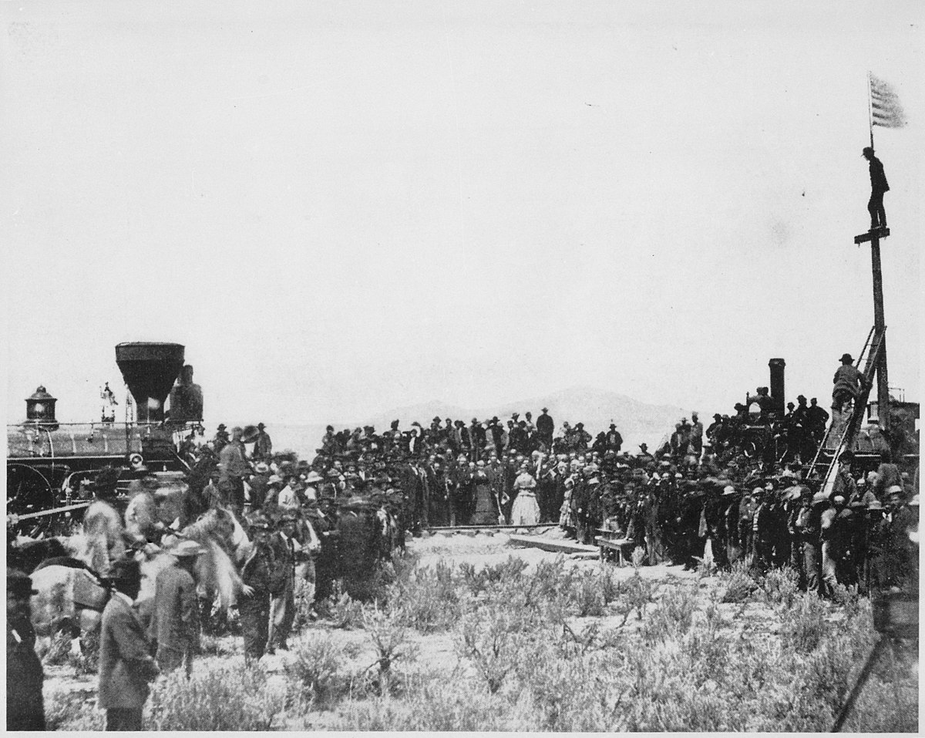
The Golden Spike ceremony completing the Transcontinental Railroad, Promontory Summit, Utah, May 10, 1869.
Source: Andrew J. Russell / U.S. National Archives. Public domain.
TENNESSEE CONNECTION · WILLIAMSON COUNTY & GEORGE JORDAN
A hometown hero connects our county to the westward expansion of this unit (US.01–US.02). George Jordan of Triune in Williamson County served with the 9th U.S. Cavalry — the “Buffalo Soldiers” — on the western frontier, and earned the Medal of Honor for his defense of Fort Tularosa (1880) and Carrizo Canyon (1881). His story ties the settlement of the West, the railroads, and the federal government’s campaigns against Native nations to the people of our own community.
One common workbook designed for learner variability. Every student works toward the same Tennessee standards; supports vary the means, not the goal or the ceiling.
Release-Ready · Pilot Edition
© 2026 TroopToTeacher Technologies LLC. All rights reserved. ISBN: [to be assigned]

Copyright, Ownership & Framework
U.S. History Hack™ — Unit 1: The Rise of Industrialization (1877–1900), Course Standard Edition.
© 2026 TroopToTeacher Technologies LLC. All rights reserved. This workbook is proprietary; reproduction or redistribution outside a licensed classroom is prohibited.
Source integrity. Every primary source in this unit is public-domain and cited to its holding repository (National Archives, Library of Congress, HathiTrust). See the Source Library.
Reading provenance (district-clear). Close-Read passages are labeled “History Hack-authored instructional synthesis” — they build on the standard record and are not presented as primary sources.
Framework stack. This workbook anchors to Tennessee U.S. History standards US.01–US.07 and the Social Studies Practices (SSP.01–SSP.06), and is designed on CAST UDL 3.0 and an MTSS support model.
Pacing. Each standard is built for one 45-minute class period. Each activity shows a ⏱ ~ minutes estimate at its heading. There is more here than one period holds — your teacher chooses which activities you do in class; the rest may become warm-ups, stations, or homework.

Table of Contents

Tennessee Standards & SSP Crosswalk
Each standard below is taught to the full Course Standard expectation; the Social Studies Practices are embedded in every activity cycle.
Standard | Focus | Lenses
US.01 | Homestead Act and Transcontinental Railroad | History · Geography
US.02 | Federal Policies Toward American Indians | History · Culture · Geography
US.03 | Compromise of 1877, Jim Crow & Plessy v. Ferguson | Culture · History · Politics/Government · Tennessee Connection
US.04 | Gilded Age Politics and Economics | Economics · Politics/Government · History
US.05 | Inventions & Innovations of Business Leaders & Entrepreneurs | Economics · History
US.06 | Industrial Centers and Urbanization | Geography · Economics
US.07 | Immigration: Old vs. New Immigrants | History · Geography · Culture

Social Studies Practices (SSP.01–SSP.06)
SSP.01 Gather/evaluate sources · SSP.02 Critically examine a primary source · SSP.03 Synthesize evidence · SSP.04 Construct/communicate argument · SSP.05 Develop historical awareness · SSP.06 Chronological/spatial reasoning. Each Close Read, Primary Source/Data, and CER activity names the practices it builds.

Accessibility, UDL & Accommodations Matrix
One firm learning goal per standard; flexible, universal means. Supports are available by design and never lower the goal. They work alongside — never in place of — required IEP or 504 accommodations.
Universal support | What it is | Where it appears
CORE PATH | Essential instruction every student completes | Every activity
LANGUAGE SUPPORT | Vocabulary, pronunciation, Spanish cognates | Word Bank, Guided/Light Backs
RESPONSE CHOICE | Write, say/record, or diagram | Every activity
SUPPORT OPTION | Optional scaffold that keeps the goal | Guided Support Back, Primary Source
PROGRESS CHECK | Quick DOK-2/3 check to guide reteach/extend | Cornell Notes, Practice Quiz
EXTENSION | Deeper challenge once the goal is met | Extension Bank, CER

How CAST UDL 3.0 is visible in this workbook
Multiple means of Engagement (response choice, relevance via Tennessee Connection), Representation (Word Bank, pronunciation, Spanish, Close-Read supports), and Action & Expression (write/say/diagram, Frayer, CER). No fixed-track labels appear.

My Support Plan (optional — you choose)
Supports are available by design. Check the ones you might try; you can change your mind any time.
Support I might use | When it would help me
Word Bank + Spanish column
Guided or Light Support Back
Response choice (say/record or diagram)
Sentence frames / Rehearsal Lab

How to Use This Workbook
Each standard runs the same seven-activity cycle: (1) Vocabulary Word Bank, (2) Vocabulary Studio, (3) Direct-Teaching Cornell Notes with optional Guided and Light Support Backs, (4) Close Read, (5) Primary Source / Data Analysis, (6) Core Application Practice Quiz, (7) Constructed Response (CER). Work the CORE PATH; reach for SUPPORT OPTIONS as needed.

Label legend — these appear throughout every standard cycle
Label | Meaning
CORE PATH | The essential instruction every student completes.
SUPPORT OPTION | An optional scaffold that keeps the goal, not lowers it.
LANGUAGE SUPPORT | Vocabulary, pronunciation, and Spanish cognates for access.
RESPONSE CHOICE | Show learning by writing, saying/recording, or diagramming.
PROGRESS CHECK | A quick DOK-2/3 check that guides reteach or extend.
EXTENSION | A deeper challenge once the goal is met.

Before You Begin — Set Your Goal
This unit asks one big question: as the United States industrialized, who benefited and who bore the costs? Set a goal, then note what you already know.
Prompt | Your response
My goal for this unit is…
One thing I already know about this era…
One question I want answered…

Standard US.01 — Homestead Act and Transcontinental Railroad
TN Academic Standard US.01: Explain how the Homestead Act and the Transcontinental Railroad impacted the settlement of the West.
LEARNING TARGETS — I can…
• I can explain how the Homestead Act and the Transcontinental Railroad impacted the settlement of the West, including their effects on American Indians, immigrants, and settlers.
Lenses for this standard: History · Geography
CORE PATH — the same for every student
Same rigor for everyone: analyze the sources and vocabulary, then show what you learned on the Practice Quiz and the CER.
UDL and MTSS give you flexible ways in — they never lower the bar.
Check yourself against the learning targets on the Cornell Notes page.
★ Tennessee Connection
George Jordan of Williamson County, Tennessee, was a Buffalo Soldier who received the Medal of Honor for distinguished service during westward expansion.
SET YOUR GOAL (self-direction)
My goal for this standard — what will I be able to do, and how will I show it?

HOOK — think before you dig in
Homestead Act and Transcontinental Railroad: Explain how the Homestead Act and the Transcontinental Railroad impacted the settlement of the West. Who gained, who was left out — and why does it still matter?

ACTIVATE — what do you already know or wonder?
Jot what you already know or want to find out about this standard. You’ll come back to it.

PREVIEW & PREDICT
Which learning target will be hardest, and why? Connect it to the unit’s big question: who shared in the boom, and who was left out or pushed back?

Activity 1 — Vocabulary (Part A: Reference / Word Bank) — US.01 ⏱ ~10 min
Use this word bank throughout the standard. The Spanish column supports access, not translation of assessment.
Term | Student-friendly meaning | Spanish
Homestead Act | An 1862 law that provided 160 acres of public land to settlers who agreed to live on and improve the land for five years, encouraging westward expansion. | Ley de Homestead
Transcontinental Railroad | A continuous railroad line completed in 1869 that connected the eastern United States with the Pacific coast, revolutionizing transportation and commerce. | Ferrocarril Transcontinental
Westward Expansion | The 19th-century movement of settlers, railroads, and U.S. authority across the continent toward the Pacific, encouraged by free land and new transportation. | Expansión hacia el Oeste
Manifest Destiny | The widely held 1800s belief that the United States was destined to expand across the entire continent, used to justify the displacement of American Indians. | Destino Manifiesto
Land Grant | A gift of public land from the government — to railroad companies or settlers — used to fund and accelerate western settlement. | Concesión de Tierras
Reservation | An area of land set aside by the federal government for American Indian tribes, frequently far from their ancestral homelands. | Reservación
LANGUAGE SUPPORT
Pronunciations: Homestead Act (HOHM-sted); Transcontinental Railroad (tranz-kon-tih-NEN-tul RAYL-rohd); Westward Expansion (WEST-werd ek-SPAN-shun); Manifest Destiny (MAN-ih-fest DES-tih-nee); Land Grant (LAND grant); Reservation (rez-er-VAY-shun).
VOCABULARY SELF-CHECK · Knowledge Rating
Rate each term NOW in pencil, then again at the END — growth is the goal; no penalty for “never seen it.”
Term | 1 · never seen it | 2 · heard it | 3 · can use it | 4 · can teach it
Homestead Act
Transcontinental Railroad
Westward Expansion
Manifest Destiny
Land Grant
Reservation
MAKE IT YOURS (RESPONSE CHOICE): choose ONE term above and show you own it — write a sentence, sketch it, or give a real-world example.

Activity 2 — Vocabulary Studio (Frayer-inspired) — US.01 ⏱ ~7 min
RESPONSE CHOICE
Complete each studio by writing, speaking, or diagramming.

PRIORITY TERM 1 Homestead Act · ES: Ley de Homestead
Word-bank meaning to build on: An 1862 law that provided 160 acres of public land to settlers who agreed to live on and improve the land for five years, encouraging westward expansion.
Definition (in your own words) | Characteristics
Examples | Non-examples
Use it to explain
Write one sentence that uses “Homestead Act” to explain this standard.

PRIORITY TERM 2 Transcontinental Railroad · ES: Ferrocarril Transcontinental
Word-bank meaning to build on: A continuous railroad line completed in 1869 that connected the eastern United States with the Pacific coast, revolutionizing transportation and commerce.
Definition (in your own words) | Characteristics
Examples | Non-examples
Use it to explain
Write one sentence that uses “Transcontinental Railroad” to explain this standard.

CONNECT THE TERMS (UDL · build understanding)
How do these priority terms fit together? Write or sketch how one leads to or affects another.

Activity 3 — Direct Teaching Cornell Notes — US.01 ⏱ ~20 min
Name: ______________________ Class / Period: __________ Date: __________
US.01 — Homestead Act and Transcontinental Railroad • These notes capture the direct-teaching content and the Close Read for this standard.
Your learning targets are on this standard’s opening page — take notes that help you meet them.
Cues (tied to your learning targets) | My notes
The Homestead Act (1862)
The Transcontinental Railroad (1869)
Who Built It
The Cost to Native Nations
Key terms →
DOODLE ZONE — draw your thinking (UDL · another way in)
Need another way in? Sketch the key idea, a quick timeline, or how the pieces connect. Words optional.

Cornell Notes — keep going, then process & check — US.01
MORE NOTES / DIAGRAMS
Continue your notes here, add a quick sketch, or map how the ideas connect.

Key terms to list
Homestead Act · Transcontinental Railroad · Westward Expansion · Manifest Destiny · Land Grant · Reservation
Summary — In your own words (2–3 sentences)
PROGRESS CHECK · one question
Analyze the relationship between the Homestead Act and the decline of American Indian territories. What was the primary cause-and-effect relationship?
A. Free land incentivized settlers to claim territory that had been promised to American Indians
B. The Act directly funded military campaigns against tribes, but the historical record tells a more complex story
C. American Indians voluntarily sold their land to homesteaders
D. The Act only affected lands that had never been occupied, but this oversimplifies the complex factors at work
Commit before you move on — mark it, say it, or explain it aloud.
CHECK YOURSELF — how am I doing?
Which learning targets (on this standard’s opening page) can you now meet? Tick the number; circle any you still need help with.
☐ 1
My 12–15 word headline for this standard

Activity 4 — Close Read — US.01 ⏱ ~15 min
Reading type: History Hack-authored instructional synthesis. This is not a primary source. Builds SSP.03 (synthesize) and SSP.05 (historical awareness).
CORE PATH — read one chunk at a time
Sequence the expansion of the United States
The Homestead Act of 1862 offered 160 acres of free land to settlers who would farm it for five years. Combined with the completion of the Transcontinental Railroad in 1869, these policies accelerated westward expansion as part of Manifest Destiny—the belief that Americans were destined to spread across the continent. The Union Pacific built westward from Omaha while the Central Pacific built eastward from Sacramento, meeting at Promontory Summit, Utah.
Impact on Western Settlement
The Transcontinental Railroad dramatically reduced travel time from months to days, opening the West to settlement, commerce, and resource extraction. Towns sprang up along rail lines, and agricultural products could now reach eastern markets efficiently. However, this expansion came at tremendous cost to American Indian nations whose lands were taken and whose way of life was destroyed.
Impact on American Indians, Immigrants, and Settlers
Western expansion devastated American Indian communities through forced relocations, broken treaties, and the near-extinction of buffalo herds they depended upon. Immigrants, particularly Chinese workers who built much of the Central Pacific, faced discrimination despite their crucial contributions. The "Buffalo Soldiers"—African American cavalry regiments—served on the frontier, including George Jordan of Williamson County, Tennessee, who received the Medal of Honor for his service.
LANGUAGE SUPPORT
Key terms to know first: Homestead Act, Transcontinental Railroad. Read once for the gist, then again for evidence.
CLOSE-READ EVIDENCE LAB — for each question: quote the EVIDENCE from the passage above, then write YOUR ANSWER (or answer aloud / diagram it).
Text-dependent question | Evidence from the passage | Your answer (what it shows)
What is the main idea of the “Sequence the expansion of the United States” section, and what evidence supports it?
What is the main idea of the “Impact on Western Settlement” section, and what evidence supports it?
What is the main idea of the “Impact on American Indians, Immigrants, and Settlers” section, and what evidence supports it?

Geographer’s Lens — US.01 ⏱ ~12 min
Geographers don’t just find places — they explain how WHERE shapes WHAT happens. Work these like a geographer. Built on the Five Themes of Geography · C3 Dimension 2 · SSP.06 (spatial reasoning).
THE PLACES — then explain why geography put them there
The transcontinental railroad and the Homestead Act reshaped the American West. Locate the railroad route and the lands opened to settlement, then explain how geography drove westward expansion — and what it cost the Native nations already living there.
Place | Where | What happened (given) | Why HERE? (your analysis)
Omaha, Nebraska | Great Plains | eastern terminus — the Union Pacific built west from here
Promontory Summit, Utah | Great Basin | 1869 — the golden spike joined the Union Pacific and Central Pacific
Sacramento, California | West Coast | western terminus — the Central Pacific built east from here
The Great Plains | Interior West | Homestead Act opened 160-acre plots to settlers; the buffalo and Native nations were pushed out
Indian Territory (Oklahoma) | Southern Plains | where the federal government forced many displaced Native nations
MOVEMENT & REGION — what’s the spatial pattern?
In 1–2 sentences: is this a movement, a cluster, or a whole region? Name the direction or shape it takes on a map.

GEOGRAPHY AS A FORCE — how did location shape the outcome?
How did geography change WHAT happened — who was affected, how far or fast it spread, or who was left out? Use one place above as your evidence.

READ IT LIKE A SOURCE — RESPONSE CHOICE
A map is a source with a point of view. Show your thinking your way — write it, OR sketch a quick arrows-and-labels diagram: what would a map of this make CLEAR, and what would it HIDE or leave out?

Activity 5 — Primary Source / Data Analysis — US.01 ⏱ ~15 min
Primary source (photograph) — analyze it with HIPPO. Builds SSP.01–SSP.02.
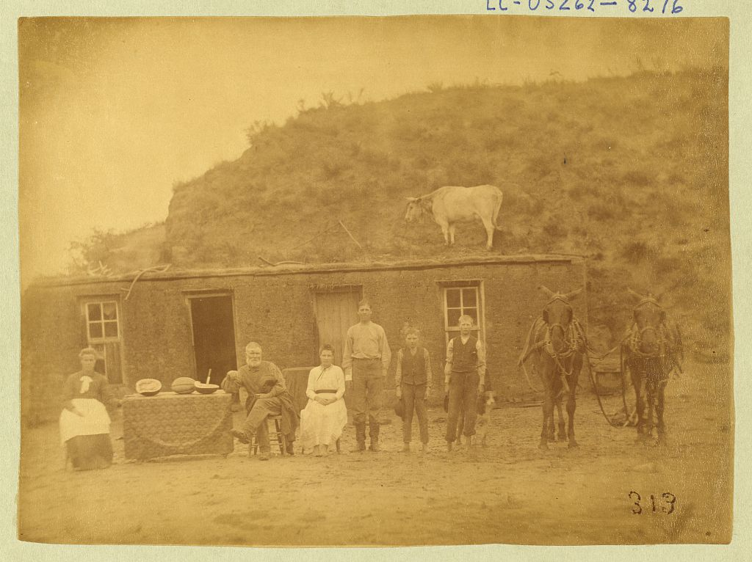
Sylvester Rawding Family in Front of Sod House, North of Sargent, Custer County, Nebraska · Solomon D. Butcher · 1886
Source: Butcher, Solomon D. Sylvester Rawding Family in Front of Sod House, North of Sargent, Custer County, Nebraska. 1886. Photograph. Library of Congress Prints and Photographs Division, LOT 3026, digital ID LC-DIG-ppmsca-08372. https://www.loc.gov/pictures/item/2005693378/. Public Domain — No Known Restrictions on Publication https://www.loc.gov/rr/print/195_copr.html
HIPPO — analyze the source (prompt) | Your analysis
H — Historical context: what was happening when this was created?
I — Intended audience: who was meant to see or obey it?
P — Purpose: why was it created?
P — Point of view: whose perspective does it reflect?
O — Outside connection: how does it connect to this standard?
SUPPORT OPTION
Sentence frame: This source shows ______ because it ______, which reveals ______.
CONFIDENCE CHECK-IN
Rate your understanding of this standard (1–4): ______ One thing to revisit: ____________________

Activity 6 — Core Application: Practice Quiz — US.01 ⏱ ~8 min
RESPONSE CHOICE
Commit to an answer by marking it, saying it, or explaining it aloud before checking. Answer key is in the Teacher Guide (kept separate).
[DOK 2 · item US.01-Q02 · pre-field-test]
Which statement best explains how the Transcontinental Railroad facilitated western expansion?
A. It reduced travel time from months to days and enabled efficient movement of settlers, goods, and resources across the continent
B. It was built exclusively by American workers, providing jobs for tens of thousands of unemployed citizens
C. It eliminated the need for wagon trains and stagecoaches almost overnight, ending earlier overland travel
D. It provided direct access to gold mines in California
[DOK 2 · item US.01-Q04 · pre-field-test]
Which of the following best describes a direct impact of the Homestead Act of 1862 on settlement patterns in the American West?
A. It restricted western migration by requiring settlers to purchase land at market prices from the federal government
B. It encouraged settlement by offering 160 acres of public land to citizens who agreed to farm it for five years
C. It redirected migration to the Pacific Coast by offering free land only in Oregon and Washington territories
D. It promoted settlement exclusively among formerly enslaved people as part of Reconstruction land redistribution
[DOK 3 · item u1-us01-dok3-tc · pre-field-test]
Analyze the relationship between the Homestead Act and the decline of American Indian territories. What was the primary cause-and-effect relationship?
A. Free land incentivized settlers to claim territory that had been promised to American Indians
B. The Act directly funded military campaigns against tribes, but the historical record tells a more complex story
C. American Indians voluntarily sold their land to homesteaders
D. The Act only affected lands that had never been occupied, but this oversimplifies the complex factors at work

Activity 7 — Constructed Response (CER) — US.01 ⏱ ~15 min
BIG-QUESTION ORGANIZER — as America industrialized, who built the new economy, who profited, and who paid the price?
Jot quick notes from THIS standard: Who benefited? · Who bore the costs? · Who decided?

CONSTRUCTED RESPONSE (CER) — builds SSP.04 Argumentation
Claim + Evidence + Reasoning: Using this standard, take a position on the central question — explain how the Homestead Act and the Transcontinental Railroad impacted the settlement of the West, including their effects on American Indians, immigrants, and settlers? Support your claim with two pieces of evidence from the passage and explain your reasoning.
Part | Write here
Claim
Evidence (two specifics)
Reasoning
SELF-CHECK (CER rubric — see Toolkit)
Is my claim defensible? · TWO specific pieces of evidence? · Does my reasoning explain HOW the evidence proves the claim?
EXIT TICKET — before you leave [item us01-q2 · DOK 2 · pre-field-test]
How did the Transcontinental Railroad connect to the concept of Manifest Destiny?
A. It proved that railroads were more efficient than ships
B. It was built primarily to transport military troops
C. It physically connected the nation and enabled rapid westward expansion
D. It was designed solely for transporting gold from California
Show what you know (your choice): mark the best answer, say it, or explain it — then rate how sure you are: ☐ Not yet ☐ Getting there ☐ Got it
Answer key and next steps are in the Teacher Guide.

Standard US.02 — Federal Policies Toward American Indians
TN Academic Standard US.02: Examine federal policies toward American Indians, including the movement to reservations, assimilation, boarding schools, and the Dawes Act.
LEARNING TARGETS — I can…
• I can examine federal policies toward American Indians, including the movement to reservations, assimilation, boarding schools, and the Dawes Act.
Lenses for this standard: History · Culture · Geography
CORE PATH — the same for every student
Same rigor for everyone: analyze the sources and vocabulary, then show what you learned on the Practice Quiz and the CER.
UDL and MTSS give you flexible ways in — they never lower the bar.
Check yourself against the learning targets on the Cornell Notes page.
★ Tennessee Connection
The Cherokee, Chickasaw, and other tribes had deep historical roots in Tennessee before the Indian Removal Act of 1830 forced their relocation along the Trail of Tears, which began at Ross's Landing (now Chattanooga). Federal reservation policies continued this pattern of displacement that started on Tennessee soil.
SET YOUR GOAL (self-direction)
My goal for this standard — what will I be able to do, and how will I show it?

HOOK — think before you dig in
Federal Policies Toward American Indians: Examine federal policies toward American Indians, including the movement to reservations, assimilation, boarding schools, and the Dawes Act. Who gained, who was left out — and why does it still matter?

ACTIVATE — what do you already know or wonder?
Jot what you already know or want to find out about this standard. You’ll come back to it.

PREVIEW & PREDICT
Which learning target will be hardest, and why? Connect it to the unit’s big question: who shared in the boom, and who was left out or pushed back?

Activity 1 — Vocabulary (Part A: Reference / Word Bank) — US.02 ⏱ ~10 min
Use this word bank throughout the standard. The Spanish column supports access, not translation of assessment.
Term | Student-friendly meaning | Spanish
Reservation System | Federal policy that confined Native American tribes to designated areas of land, often far from their ancestral territories, as part of efforts to control indigenous populations and open land for white settlement. | Sistema de Reservaciones
Assimilation | Federal policy aimed at forcing Native Americans to abandon their traditional cultures and adopt European-American ways of life, including language, religion, and customs. | Asimilación
Dawes Act | An 1887 law that divided tribal lands into individual allotments for Native American families, aiming to break up reservations and assimilate Native Americans into mainstream American culture. It resulted in… | Ley Dawes
Allotment | The division of communal tribal land into small individual plots under the Dawes Act, which opened "surplus" land to white settlers and caused massive Native land loss. | Asignación de Parcelas
Boarding School | Off-reservation schools, such as Carlisle, where Native children were forced to abandon their languages, names, and cultures to be "assimilated" into white society. | Internado
Sovereignty | The right of a tribe or nation to govern itself; federal Indian policy in this era steadily eroded tribal sovereignty. | Soberanía
LANGUAGE SUPPORT
Pronunciations: Assimilation (uh-sim-ih-LAY-shun); Dawes Act (DAWZ).
VOCABULARY SELF-CHECK · Knowledge Rating
Rate each term NOW in pencil, then again at the END — growth is the goal; no penalty for “never seen it.”
Term | 1 · never seen it | 2 · heard it | 3 · can use it | 4 · can teach it
Reservation System
Assimilation
Dawes Act
Allotment
Boarding School
Sovereignty
MAKE IT YOURS (RESPONSE CHOICE): choose ONE term above and show you own it — write a sentence, sketch it, or give a real-world example.

Activity 2 — Vocabulary Studio (Frayer-inspired) — US.02 ⏱ ~7 min
RESPONSE CHOICE
Complete each studio by writing, speaking, or diagramming.

PRIORITY TERM 1 Reservation System · ES: Sistema de Reservaciones
Word-bank meaning to build on: Federal policy that confined Native American tribes to designated areas of land, often far from their ancestral territories, as part of efforts to control indigenous populations and open land for white settlement.
Definition (in your own words) | Characteristics
Examples | Non-examples
Use it to explain
Write one sentence that uses “Reservation System” to explain this standard.

PRIORITY TERM 2 Assimilation · ES: Asimilación
Word-bank meaning to build on: Federal policy aimed at forcing Native Americans to abandon their traditional cultures and adopt European-American ways of life, including language, religion, and customs.
Definition (in your own words) | Characteristics
Examples | Non-examples
Use it to explain
Write one sentence that uses “Assimilation” to explain this standard.

CONNECT THE TERMS (UDL · build understanding)
How do these priority terms fit together? Write or sketch how one leads to or affects another.

Activity 3 — Direct Teaching Cornell Notes — US.02 ⏱ ~20 min
Name: ______________________ Class / Period: __________ Date: __________
US.02 — Federal Policies Toward American Indians • These notes capture the direct-teaching content and the Close Read for this standard.
Your learning targets are on this standard’s opening page — take notes that help you meet them.
Cues (tied to your learning targets) | My notes
Movement to Reservations
Assimilation & Boarding Schools
The Dawes Act & Its Impact
Key terms →
DOODLE ZONE — draw your thinking (UDL · another way in)
Need another way in? Sketch the key idea, a quick timeline, or how the pieces connect. Words optional.

Cornell Notes — keep going, then process & check — US.02
MORE NOTES / DIAGRAMS
Continue your notes here, add a quick sketch, or map how the ideas connect.

Key terms to list
Reservation System · Assimilation · Dawes Act · Allotment · Boarding School · Sovereignty
Summary — In your own words (2–3 sentences)
PROGRESS CHECK · one question
Analyze the relationship between government assimilation policies and the destruction of American Indian cultural identity.
A. Assimilation policies had minimal cultural impact, which does not align with the documented historical record
B. Policies systematically targeted language, religion, and family structures to eliminate tribal identities
C. American Indians voluntarily abandoned their cultures, which does not align with the documented historical record
D. Cultural destruction was an unintended consequence, although this view has been largely discredited by scholars
Commit before you move on — mark it, say it, or explain it aloud.
CHECK YOURSELF — how am I doing?
Which learning targets (on this standard’s opening page) can you now meet? Tick the number; circle any you still need help with.
☐ 1
My 12–15 word headline for this standard

Activity 4 — Close Read — US.02 ⏱ ~15 min
Reading type: History Hack-authored instructional synthesis. This is not a primary source. Builds SSP.03 (synthesize) and SSP.05 (historical awareness).
CORE PATH — read one chunk at a time
Movement to Reservations
Following the Civil War, the federal government intensified efforts to confine American Indian nations to reservations—designated territories far smaller than their traditional homelands. This policy aimed to open land for white settlement and eliminate perceived obstacles to westward expansion. Tribes were forced to sign treaties under duress, often surrendering millions of acres.
Assimilation and Boarding Schools
The government pursued forced assimilation, attempting to destroy American Indian cultures and replace them with Euro-American ways. Boarding schools like Carlisle Indian Industrial School operated under the motto "Kill the Indian, save the man." Children were taken from families, forbidden to speak their languages or practice traditions, and subjected to harsh discipline. This cultural genocide had devastating, generational impacts.
The Dawes Act and Its Impact
The Dawes Act of 1887 divided tribal lands into individual allotments, supposedly to encourage farming and "civilize" American Indians. However, the true effect was catastrophic: tribal landholdings shrank from 138 million acres in 1887 to 48 million by 1934. "Surplus" lands were sold to white settlers, and many allotted lands were lost through taxation, fraud, or forced sales. The Act destroyed communal land ownership central to many tribal cultures.
LANGUAGE SUPPORT
Key terms to know first: Reservation System, Assimilation. Read once for the gist, then again for evidence.
CLOSE-READ EVIDENCE LAB — for each question: quote the EVIDENCE from the passage above, then write YOUR ANSWER (or answer aloud / diagram it).
Text-dependent question | Evidence from the passage | Your answer (what it shows)
What is the main idea of the “Movement to Reservations” section, and what evidence supports it?
What is the main idea of the “Assimilation and Boarding Schools” section, and what evidence supports it?
What is the main idea of the “The Dawes Act and Its Impact” section, and what evidence supports it?

Activity 5 — Primary Source / Data Analysis — US.02 ⏱ ~15 min
Primary source (photograph) — analyze it with HIPPO. Builds SSP.01–SSP.02.
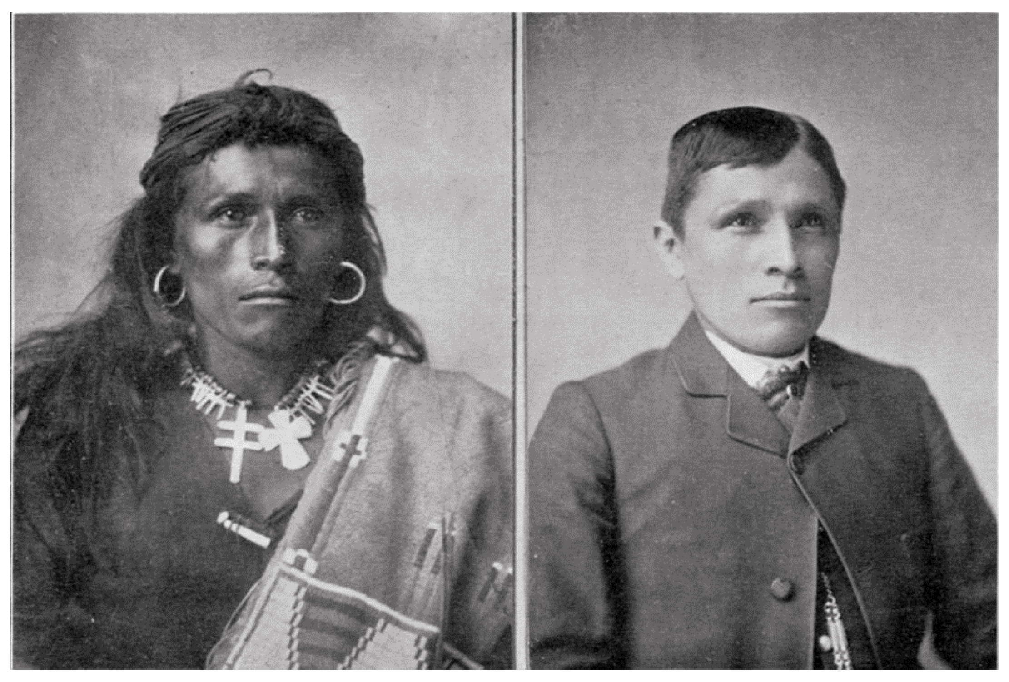
Tom Torlino, Navajo, Before and After · John N. Choate · 1882 and 1885
Source: Choate, John N. Tom Torlino, Navajo, Before and After. 1882 and 1885. Photographs. Richard Henry Pratt Papers (WA MSS S-1174), Beinecke Rare Book and Manuscript Library, Yale University. Public-domain scan via Wikimedia Commons, https://commons.wikimedia.org/wiki/File:Tom_Torlino_Navajo_before_and_after_circa_1882.jpg. Public Domain — U.S. Copyright Expired (pre-1929 publication) https://commons.wikimedia.org/wiki/File:Tom_Torlino_Navajo_before_and_after_circa_1882.jpg
HIPPO — analyze the source (prompt) | Your analysis
H — Historical context: what was happening when this was created?
I — Intended audience: who was meant to see or obey it?
P — Purpose: why was it created?
P — Point of view: whose perspective does it reflect?
O — Outside connection: how does it connect to this standard?
SUPPORT OPTION
Sentence frame: This source shows ______ because it ______, which reveals ______.
CONFIDENCE CHECK-IN
Rate your understanding of this standard (1–4): ______ One thing to revisit: ____________________

Activity 6 — Core Application: Practice Quiz — US.02 ⏱ ~8 min
RESPONSE CHOICE
Commit to an answer by marking it, saying it, or explaining it aloud before checking. Answer key is in the Teacher Guide (kept separate).
[DOK 2 · item US.01-Q07 · pre-field-test]
How did western expansion in the 1860s–1880s affect American Indians and European immigrants differently?
A. American Indians lost land and sovereignty through forced removal and treaty violations, while European immigrants gained economic opportunities and land ownership
B. Both groups benefited equally from new economic opportunities created by railroad expansion and land grants
C. European immigrants were confined to reservations while American Indians moved freely onto former frontier lands
D. Both groups experienced forced relocation, but American Indians eventually received citizenship rights earlier than European immigrants
[DOK 2 · item US.02-Q02 · pre-field-test]
Which statement best describes the federal government\'s assimilation policy toward American Indians in the late 19th century?
A. The government focused exclusively on military conquest without
B. The government aimed to eliminate American Indian cultural practices
C. The government promoted cultural exchange between American Indians
D. The government sought to preserve traditional American Indian languages and cultural practices on reservations
[DOK 3 · item u1-us02-dok3-tc · pre-field-test]
Analyze the relationship between government assimilation policies and the destruction of American Indian cultural identity.
A. Assimilation policies had minimal cultural impact, which does not align with the documented historical record
B. Policies systematically targeted language, religion, and family structures to eliminate tribal identities
C. American Indians voluntarily abandoned their cultures, which does not align with the documented historical record
D. Cultural destruction was an unintended consequence, although this view has been largely discredited by scholars

Activity 7 — Constructed Response (CER) — US.02 ⏱ ~15 min
BIG-QUESTION ORGANIZER — as America industrialized, who built the new economy, who profited, and who paid the price?
Jot quick notes from THIS standard: Who benefited? · Who bore the costs? · Who decided?

CONSTRUCTED RESPONSE (CER) — builds SSP.04 Argumentation
Claim + Evidence + Reasoning: Using this standard, take a position on the central question — examine federal policies toward American Indians, including the movement to reservations, assimilation, boarding schools, and the Dawes Act? Support your claim with two pieces of evidence from the passage and explain your reasoning.
Part | Write here
Claim
Evidence (two specifics)
Reasoning
SELF-CHECK (CER rubric — see Toolkit)
Is my claim defensible? · TWO specific pieces of evidence? · Does my reasoning explain HOW the evidence proves the claim?
EXIT TICKET — before you leave [item us02-q2 · DOK 2 · pre-field-test]
How did the Dawes Act affect tribal land ownership?
A. It increased tribal lands by 90 million acres
B. It had no significant effect on land ownership
C. It consolidated tribal lands into larger reservations
D. It reduced tribal lands from 138 million to 48 million acres
Show what you know (your choice): mark the best answer, say it, or explain it — then rate how sure you are: ☐ Not yet ☐ Getting there ☐ Got it
Answer key and next steps are in the Teacher Guide.

Standard US.03 — Compromise of 1877, Jim Crow & Plessy v. Ferguson
TN Academic Standard US.03: Explain the impact of the Compromise of 1877, including Jim Crow laws, lynching, disenfranchisement methods, the efforts of Benjamin "Pap" Singleton and the Exodusters, and the Plessy v. Ferguson decision. (TCA)
LEARNING TARGETS — I can…
• I can explain the impact of the Compromise of 1877, including Jim Crow laws, lynching, disenfranchisement methods, the efforts of Pap Singleton and the Exodusters, and the Plessy v. Ferguson decision.
Lenses for this standard: Culture · History · Politics/Government · Tennessee Connection
CORE PATH — the same for every student
Same rigor for everyone: analyze the sources and vocabulary, then show what you learned on the Practice Quiz and the CER.
UDL and MTSS give you flexible ways in — they never lower the bar.
Check yourself against the learning targets on the Cornell Notes page.
★ Tennessee Connection
Tennessee experienced significant Jim Crow segregation, with state laws mandating separate facilities and schools. Ida B. Wells, born in Holly Springs, MS, lived and worked in Memphis before her anti-lynching crusade gained national prominence.
SET YOUR GOAL (self-direction)
My goal for this standard — what will I be able to do, and how will I show it?

HOOK — think before you dig in
Compromise of 1877, Jim Crow & Plessy v. Ferguson: Explain the impact of the Compromise of 1877, including Jim Crow laws, lynching, disenfranchisement methods, the efforts of Benjamin "Pap" Singleton and the Exodusters, and the Plessy v. Ferguson decision. (TCA). Who gained, who was left out — and why does it still matter?

ACTIVATE — what do you already know or wonder?
Jot what you already know or want to find out about this standard. You’ll come back to it.

PREVIEW & PREDICT
Which learning target will be hardest, and why? Connect it to the unit’s big question: who shared in the boom, and who was left out or pushed back?

Activity 1 — Vocabulary (Part A: Reference / Word Bank) — US.03 ⏱ ~10 min
Use this word bank throughout the standard. The Spanish column supports access, not translation of assessment.
Term | Student-friendly meaning | Spanish
Compromise of 1877 | An informal agreement that resolved the disputed 1876 presidential election, resulting in Rutherford B. Hayes becoming president in exchange for removing federal troops from the South, effectively ending… | Compromiso de 1877
Jim Crow Laws | State and local laws enacted primarily in the Southern states between 1877 and the 1960s that enforced racial segregation and denied African Americans their constitutional rights. | Leyes de Jim Crow
Disenfranchisement | The systematic denial of voting rights through methods such as poll taxes, literacy tests, grandfather clauses, and violence, primarily targeting African American voters. | Privación del Derecho al Voto
Plessy v. Ferguson | An 1896 Supreme Court decision that upheld racial segregation under the doctrine of "separate but equal," legitimizing Jim Crow laws for nearly 60 years. | Plessy contra Ferguson
Exodusters | African Americans who migrated from the South to Kansas and other western states in the late 1870s, seeking to escape racial violence and economic oppression. Led by figures like Benjamin "Pap" Singleton. | Exodusters (colonos negros)
LANGUAGE SUPPORT
Pronunciations: Disenfranchisement (dis-en-FRAN-chyz-ment).
VOCABULARY SELF-CHECK · Knowledge Rating
Rate each term NOW in pencil, then again at the END — growth is the goal; no penalty for “never seen it.”
Term | 1 · never seen it | 2 · heard it | 3 · can use it | 4 · can teach it
Compromise of 1877
Jim Crow Laws
Disenfranchisement
Plessy v. Ferguson
Exodusters
MAKE IT YOURS (RESPONSE CHOICE): choose ONE term above and show you own it — write a sentence, sketch it, or give a real-world example.

Activity 2 — Vocabulary Studio (Frayer-inspired) — US.03 ⏱ ~7 min
RESPONSE CHOICE
Complete each studio by writing, speaking, or diagramming.

PRIORITY TERM 1 Compromise of 1877 · ES: Compromiso de 1877
Word-bank meaning to build on: An informal agreement that resolved the disputed 1876 presidential election, resulting in Rutherford B. Hayes becoming president in exchange for removing federal troops from the South, effectively ending…
Definition (in your own words) | Characteristics
Examples | Non-examples
Use it to explain
Write one sentence that uses “Compromise of 1877” to explain this standard.

PRIORITY TERM 2 Jim Crow Laws · ES: Leyes de Jim Crow
Word-bank meaning to build on: State and local laws enacted primarily in the Southern states between 1877 and the 1960s that enforced racial segregation and denied African Americans their constitutional rights.
Definition (in your own words) | Characteristics
Examples | Non-examples
Use it to explain
Write one sentence that uses “Jim Crow Laws” to explain this standard.

CONNECT THE TERMS (UDL · build understanding)
How do these priority terms fit together? Write or sketch how one leads to or affects another.

Activity 3 — Direct Teaching Cornell Notes — US.03 ⏱ ~20 min
Name: ______________________ Class / Period: __________ Date: __________
US.03 — Compromise of 1877, Jim Crow & Plessy v. Ferguson • These notes capture the direct-teaching content and the Close Read for this standard.
Your learning targets are on this standard’s opening page — take notes that help you meet them.
Cues (tied to your learning targets) | My notes
The Election of 1876 & End of Reconstruction
Jim Crow, Lynching & Disenfranchisement
Pap Singleton & the Exodusters
Plessy v. Ferguson
Key terms →
DOODLE ZONE — draw your thinking (UDL · another way in)
Need another way in? Sketch the key idea, a quick timeline, or how the pieces connect. Words optional.

Cornell Notes — keep going, then process & check — US.03
MORE NOTES / DIAGRAMS
Continue your notes here, add a quick sketch, or map how the ideas connect.

Key terms to list
Compromise of 1877 · Jim Crow Laws · Disenfranchisement · Plessy v. Ferguson · Exodusters
Summary — In your own words (2–3 sentences)
PROGRESS CHECK · one question
Evaluate the impact of Plessy v. Ferguson on American society and race relations.
A. It had minimal lasting impact on segregation, despite limited evidence supporting this interpretation
B. It was immediately overturned by Congress, which contradicts the primary source evidence from this era
C. It provided legal justification for sixty years of segregation, limiting opportunities and reinforcing white supremacy
D. It only applied to railroad cars and had no broader significance, which does not align with the documented historical record
Commit before you move on — mark it, say it, or explain it aloud.
CHECK YOURSELF — how am I doing?
Which learning targets (on this standard’s opening page) can you now meet? Tick the number; circle any you still need help with.
☐ 1
My 12–15 word headline for this standard

Activity 4 — Close Read — US.03 ⏱ ~15 min
Reading type: History Hack-authored instructional synthesis. This is not a primary source. Builds SSP.03 (synthesize) and SSP.05 (historical awareness).
CORE PATH — read one chunk at a time
The Election of 1876 and End of Reconstruction
The disputed 1876 presidential election between Republican Rutherford B. Hayes and Democrat Samuel Tilden led to the Compromise of 1877. In exchange for the presidency, Hayes agreed to withdraw federal troops from the South, effectively ending Reconstruction. This abandonment left African Americans without federal protection against increasingly hostile state governments.
Jim Crow Laws, Lynching, and Disenfranchisement
With federal protection gone, Southern states implemented Jim Crow laws enforcing racial segregation in all aspects of life. African Americans faced systematic disenfranchisement through poll taxes, literacy tests, grandfather clauses, and white primaries. Those who resisted faced terrorism, including lynching—public murders that went unpunished and were often celebrated by white communities.
Pap Singleton and the Exodusters
Benjamin "Pap" Singleton, a formerly enslaved man, organized the migration of thousands of African Americans from the South to Kansas in 1879. These "Exodusters" sought to escape violence and oppression, establishing communities like Nicodemus, Kansas. While conditions in Kansas were often harsh, the Exoduster movement represented African American agency and resistance to Jim Crow terror.
Plessy v. Ferguson and "Separate But Equal"
The 1896 Supreme Court decision in Plessy v. Ferguson established the "separate but equal" doctrine, ruling that racial segregation was constitutional as long as facilities were supposedly equal. In practice, facilities for African Americans were grossly inferior. This decision legitimized Jim Crow segregation for nearly sixty years until Brown v. Board of Education (1954).
Key terms first: Compromise of 1877, Jim Crow Laws. Read once for the gist, then again for evidence.
CLOSE-READ EVIDENCE LAB — for each question: quote the EVIDENCE from the passage above, then write YOUR ANSWER (or answer aloud / diagram it).
Text-dependent question | Evidence from the passage | Your answer (what it shows)
What is the main idea of the “The Election of 1876 and End of Reconstruction” section, and what evidence supports it?
What is the main idea of the “Jim Crow Laws, Lynching, and Disenfranchisement” section, and what evidence supports it?
What is the main idea of the “Pap Singleton and the Exodusters” section, and what evidence supports it?

Activity 5 — Primary Source / Data Analysis — US.03 ⏱ ~15 min
Primary source (political cartoon) — analyze it with HIPPO. Builds SSP.01–SSP.02.
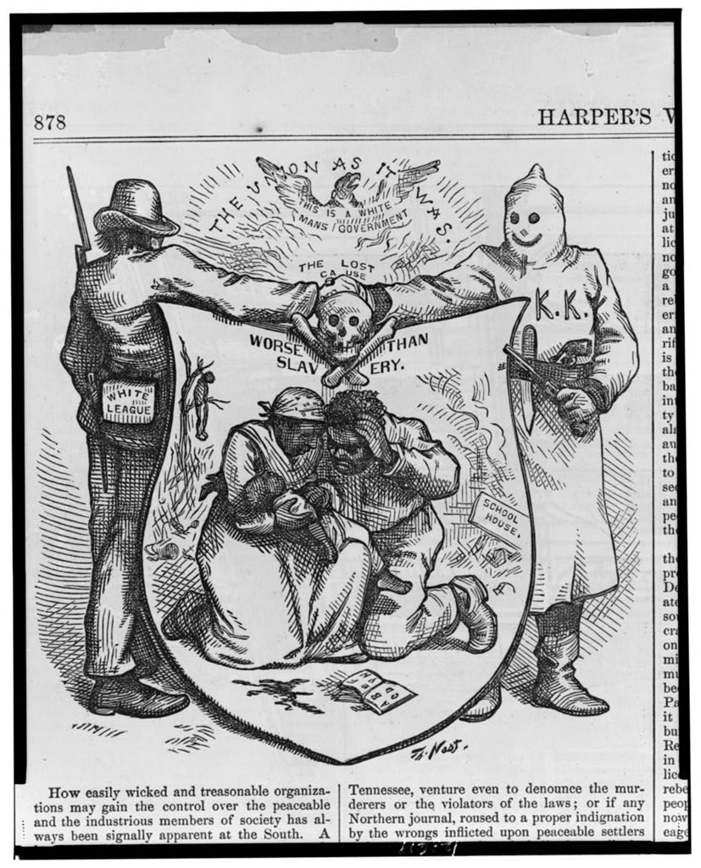
The Union as It Was — The Lost Cause, Worse Than Slavery · Thomas Nast · 1874
Source: Nast, Thomas. "The Union as It Was — The Lost Cause, Worse Than Slavery." Harper's Weekly, October 24, 1874. Library of Congress Prints and Photographs Division, digital ID LC-USZ62-128619. https://www.loc.gov/pictures/item/2001696840/. Public Domain — No Known Restrictions on Publication https://www.loc.gov/rr/print/195_copr.html
HIPPO — analyze the source (prompt) | Your analysis
H — Historical context: what was happening when this was created?
I — Intended audience: who was meant to see or obey it?
P — Purpose: why was it created?
P — Point of view: whose perspective does it reflect?
O — Outside connection: how does it connect to this standard?
SUPPORT OPTION
Sentence frame: This source shows ______ because it ______, which reveals ______.
CONFIDENCE CHECK-IN
Rate your understanding of this standard (1–4): ______ One thing to revisit: ____________________

Activity 6 — Core Application: Practice Quiz — US.03 ⏱ ~8 min
RESPONSE CHOICE
Commit to an answer by marking it, saying it, or explaining it aloud before checking. Answer key is in the Teacher Guide (kept separate).
[DOK 2 · item us03-q3 · pre-field-test]
Why did Pap Singleton organize the Exoduster migration to Kansas?
A. To escape Jim Crow violence and oppression in the South
B. Kansas offered free land through the Homestead Act exclusively to African Americans
C. The federal government mandated relocation
D. Kansas had already abolished all forms of discrimination
[DOK 2 · item US.03-Q04 · pre-field-test]
Which of the following best explains how the Compromise of 1877 contributed to the end of Reconstruction?
A. It gave Southern states greater congressional representation in exchange for ratifying the 14th Amendment
B. It resolved the disputed 1876 presidential election by awarding the presidency to Hayes in exchange for withdrawing federal troops from the South
C. It established the Freedmen's Bureau as a permanent federal agency to protect formerly enslaved people
D. It required Southern states to hold new elections supervised by Northern military commanders before rejoining the Union
[DOK 3 · item u1-us03-dok3-tc · pre-field-test]
Evaluate the impact of Plessy v. Ferguson on American society and race relations.
A. It had minimal lasting impact on segregation, despite limited evidence supporting this interpretation
B. It was immediately overturned by Congress, which contradicts the primary source evidence from this era
C. It provided legal justification for sixty years of segregation, limiting opportunities and reinforcing white supremacy
D. It only applied to railroad cars and had no broader significance, which does not align with the documented historical record

Activity 7 — Constructed Response (CER) — US.03 ⏱ ~15 min
BIG-QUESTION ORGANIZER — as America industrialized, who built the new economy, who profited, and who paid the price?
Jot quick notes from THIS standard: Who benefited? · Who bore the costs? · Who decided?

CONSTRUCTED RESPONSE (CER) — builds SSP.04 Argumentation
Claim + Evidence + Reasoning: Using this standard, take a position on the central question — explain the impact of the Compromise of 1877, including Jim Crow laws, lynching, disenfranchisement methods, the efforts of Pap Singleton and the Exodusters, and the Plessy v. Ferguson decision? Support your claim with two pieces of evidence from the passage and explain your reasoning.
Part | Write here
Claim
Evidence (two specifics)
Reasoning
SELF-CHECK (CER rubric — see Toolkit)
Is my claim defensible? · TWO specific pieces of evidence? · Does my reasoning explain HOW the evidence proves the claim?
EXIT TICKET — before you leave [item us03-q2 · DOK 2 · pre-field-test]
How did Southern states use disenfranchisement methods to circumvent the 15th Amendment?
A. They used poll taxes, literacy tests, and grandfather clauses that appeared race-neutral but targeted Black voters
B. They openly violated the Constitution without consequences, which ignores key developments that shaped the outcome
C. They amended the 15th Amendment at the state level, although historical sources do not support this conclusion
D. They only targeted immigrant voters, not African Americans, although historical sources do not support this conclusion
Show what you know (your choice): mark the best answer, say it, or explain it — then rate how sure you are: ☐ Not yet ☐ Getting there ☐ Got it
Answer key and next steps are in the Teacher Guide.

Standard US.04 — Gilded Age Politics and Economics
TN Academic Standard US.04: Analyze the causes and consequences of Gilded Age politics and economics as well as the significance of the rise of political machines, major scandals, civil service reform, and the economic difference between farmers, wage earners, and industrial capitalists, including: Boss Tweed, Thomas Nast, Credit Mobilier, Spoils system and President James A. Garfield's assassination, Pendleton Act, Interstate Commerce Act.
LEARNING TARGETS — I can…
• I can analyze the causes and consequences of Gilded Age politics and economics, including political machines, major scandals, civil service reform, and economic differences between farmers, wage earners, and industrial capitalists.
Lenses for this standard: Economics · Politics/Government · History
CORE PATH — the same for every student
Same rigor for everyone: analyze the sources and vocabulary, then show what you learned on the Practice Quiz and the CER.
UDL and MTSS give you flexible ways in — they never lower the bar.
Check yourself against the learning targets on the Cornell Notes page.
★ Tennessee Connection
Tennessee politics during the Gilded Age reflected national patterns of corruption and reform. Memphis boss Edward Hull Crump built one of the South's most powerful political machines, dominating Memphis and Shelby County politics from the early 1900s through the 1950s.
SET YOUR GOAL (self-direction)
My goal for this standard — what will I be able to do, and how will I show it?

HOOK — think before you dig in
Gilded Age Politics and Economics: Analyze the causes and consequences of Gilded Age politics and economics as well as the significance of the rise of political machines, major scandals, civil service reform, and the economic difference between farmers, wage earners, and industrial capitalists, including: Boss Tweed, Thomas Nast, Credit Mobilier, Spoils system and President James A. Garfield's assassination, Pendleton Act, Interstate Commerce Act. Who gained, who was left out — and why does it still matter?

ACTIVATE — what do you already know or wonder?
Jot what you already know or want to find out about this standard. You’ll come back to it.

PREVIEW & PREDICT
Which learning target will be hardest, and why? Connect it to the unit’s big question: who shared in the boom, and who was left out or pushed back?

Activity 1 — Vocabulary (Part A: Reference / Word Bank) — US.04 ⏱ ~10 min
Use this word bank throughout the standard. The Spanish column supports access, not translation of assessment.
Term | Student-friendly meaning | Spanish
Gilded Age | The period from roughly 1870 to 1900 characterized by rapid economic growth, industrialization, and extreme wealth inequality. Named by Mark Twain to suggest that a thin layer of prosperity covered deep social… | Edad Dorada
Political Machines | Corrupt organizations that controlled city politics through patronage, bribery, and vote manipulation, often providing services to immigrants in exchange for political support. | Máquinas Políticas
Spoils System | The practice of rewarding political supporters with government jobs regardless of qualifications, based on the principle "to the victor belong the spoils." | Sistema de Botín
Boss Tweed | William M. Tweed, leader of New York City's Tammany Hall political machine, who controlled city politics and stole millions through kickbacks and corruption in the 1860s-1870s. | Jefe Tweed
Thomas Nast | A political cartoonist whose illustrations exposed Boss Tweed's corruption and helped bring down the Tammany Hall machine, demonstrating the power of the press. | Thomas Nast
Pendleton Act | An 1883 federal law that established the Civil Service Commission and required government jobs to be awarded based on merit through competitive examinations rather than political connections. | Ley Pendleton
LANGUAGE SUPPORT
Use the Spanish column in the Word Bank above to access these terms — cognates and translations support understanding, not translation of assessment.
VOCABULARY SELF-CHECK · Knowledge Rating
Rate each term NOW in pencil, then again at the END — growth is the goal; no penalty for “never seen it.”
Term | 1 · never seen it | 2 · heard it | 3 · can use it | 4 · can teach it
Gilded Age
Political Machines
Spoils System
Boss Tweed
Thomas Nast
Pendleton Act
MAKE IT YOURS (RESPONSE CHOICE): choose ONE term above and show you own it — write a sentence, sketch it, or give a real-world example.

Activity 2 — Vocabulary Studio (Frayer-inspired) — US.04 ⏱ ~7 min
RESPONSE CHOICE
Complete each studio by writing, speaking, or diagramming.

PRIORITY TERM 1 Gilded Age · ES: Edad Dorada
Word-bank meaning to build on: The period from roughly 1870 to 1900 characterized by rapid economic growth, industrialization, and extreme wealth inequality. Named by Mark Twain to suggest that a thin layer of prosperity covered deep social…
Definition (in your own words) | Characteristics
Examples | Non-examples
Use it to explain
Write one sentence that uses “Gilded Age” to explain this standard.

PRIORITY TERM 2 Political Machines · ES: Máquinas Políticas
Word-bank meaning to build on: Corrupt organizations that controlled city politics through patronage, bribery, and vote manipulation, often providing services to immigrants in exchange for political support.
Definition (in your own words) | Characteristics
Examples | Non-examples
Use it to explain
Write one sentence that uses “Political Machines” to explain this standard.

CONNECT THE TERMS (UDL · build understanding)
How do these priority terms fit together? Write or sketch how one leads to or affects another.

Activity 3 — Direct Teaching Cornell Notes — US.04 ⏱ ~20 min
Name: ______________________ Class / Period: __________ Date: __________
US.04 — Gilded Age Politics and Economics • These notes capture the direct-teaching content and the Close Read for this standard.
Your learning targets are on this standard’s opening page — take notes that help you meet them.
Cues (tied to your learning targets) | My notes
Political Machines & Boss Tweed
Scandals & the Spoils System
Civil Service & Economic Reform
Economic Disparity
Key terms →
DOODLE ZONE — draw your thinking (UDL · another way in)
Need another way in? Sketch the key idea, a quick timeline, or how the pieces connect. Words optional.

Cornell Notes — keep going, then process & check — US.04
MORE NOTES / DIAGRAMS
Continue your notes here, add a quick sketch, or map how the ideas connect.

Key terms to list
Gilded Age · Political Machines · Spoils System · Boss Tweed · Thomas Nast · Pendleton Act
Summary — In your own words (2–3 sentences)
PROGRESS CHECK · one question
Analyze the economic relationship between farmers, railroads, and industrial capitalists during the Gilded Age.
A. All three groups prospered equally from industrialization, which contradicts the primary source evidence from this era
B. Railroads favored farmers over industrial interests, which represents a common misconception about the period
C. The government ensured fair treatment for all economic groups, which does not align with the documented historical record
D. Farmers were exploited by high railroad rates while capitalists accumulated wealth, creating vast economic disparity
Commit before you move on — mark it, say it, or explain it aloud.
CHECK YOURSELF — how am I doing?
Which learning targets (on this standard’s opening page) can you now meet? Tick the number; circle any you still need help with.
☐ 1
My 12–15 word headline for this standard

Activity 4 — Close Read — US.04 ⏱ ~15 min
Reading type: History Hack-authored instructional synthesis. This is not a primary source. Builds SSP.03 (synthesize) and SSP.05 (historical awareness).
CORE PATH — read one chunk at a time
Political Machines and Boss Tweed
The Gilded Age (1870s-1900) saw the rise of powerful political machines that controlled city governments through patronage and corruption. Boss Tweed's Tammany Hall in New York City epitomized this system, funneling millions in public funds to Tweed and his associates. Political cartoonist Thomas Nast exposed Tweed's corruption through devastating illustrations in Harper's Weekly.
Major Scandals and the Spoils System
The era was marked by corruption at all levels. The Crédit Mobilier scandal revealed that railroad executives and congressmen had profited enormously from fraudulent construction contracts. The spoils system—giving government jobs to political supporters regardless of qualification—reached its peak. President James Garfield's assassination by a disappointed office-seeker in 1881 finally prompted reform.
Civil Service Reform
Garfield's assassination led to the Pendleton Civil Service Act of 1883, which established merit-based hiring for federal positions through competitive examinations. This began the long process of professionalizing government service, though political influence remained significant in many positions.
Economic Disparity
The Gilded Age saw extreme wealth concentration among industrial capitalists while farmers struggled with falling crop prices, high railroad shipping rates, and debt. Wage earners faced dangerous working conditions, long hours, and low pay. The Interstate Commerce Act of 1887 attempted to regulate railroad rates, representing early federal intervention in the economy.
Key terms first: Gilded Age, Political Machines. Read once for the gist, then again for evidence.
CLOSE-READ EVIDENCE LAB — for each question: quote the EVIDENCE from the passage above, then write YOUR ANSWER (or answer aloud / diagram it).
Text-dependent question | Evidence from the passage | Your answer (what it shows)
What is the main idea of the “Political Machines and Boss Tweed” section, and what evidence supports it?
What is the main idea of the “Major Scandals and the Spoils System” section, and what evidence supports it?
What is the main idea of the “Civil Service Reform” section, and what evidence supports it?

Activity 5 — Primary Source / Data Analysis — US.04 ⏱ ~15 min
Primary source (political cartoon) — analyze it with HIPPO. Builds SSP.01–SSP.02.
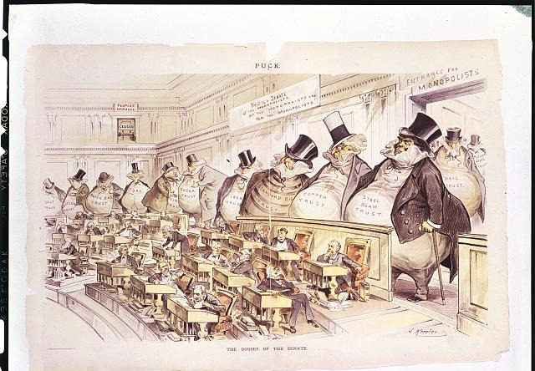
The Bosses of the Senate · Joseph Keppler · 1889
Source: Keppler, Joseph. "The Bosses of the Senate." Puck, January 23, 1889. Library of Congress Prints and Photographs Division, call number Illus. in AP101.P7 1889 (Case X). https://www.loc.gov/pictures/item/2002718861/. Public Domain — No Known Restrictions on Publication https://www.loc.gov/rr/print/195_copr.html
HIPPO — analyze the source (prompt) | Your analysis
H — Historical context: what was happening when this was created?
I — Intended audience: who was meant to see or obey it?
P — Purpose: why was it created?
P — Point of view: whose perspective does it reflect?
O — Outside connection: how does it connect to this standard?
SUPPORT OPTION
Sentence frame: This source shows ______ because it ______, which reveals ______.
CONFIDENCE CHECK-IN
Rate your understanding of this standard (1–4): ______ One thing to revisit: ____________________

Activity 6 — Core Application: Practice Quiz — US.04 ⏱ ~8 min
RESPONSE CHOICE
Commit to an answer by marking it, saying it, or explaining it aloud before checking. Answer key is in the Teacher Guide (kept separate).
[DOK 2 · item US.04-Q03 · pre-field-test]
Thomas Nast\'s political cartoons were significant during the Gilded Age because they:
A. Exposed political corruption and influenced public opinion against
B. Supported the policies of political machines like Tammany Hall
C. Promoted the expansion of the spoils system in government hiring
D. Encouraged immigrants to participate more actively in politics
[DOK 2 · item US.02-X021 · pre-field-test]
A Gilded Age industrialist who purchases competing companies in the same industry to gain market control is using which business strategy?
A. Vertical integration, because the company is expanding its control over different stages of its supply chain
B. Horizontal integration, because the company is buying rivals at the same stage of production to reduce competition
C. Trust-busting, because the company is reorganizing the industry to prevent monopolistic practices
D. Scientific management, because the company is applying efficiency principles to industrial organization
[DOK 3 · item u1-us04-dok3-tc · pre-field-test]
Analyze the economic relationship between farmers, railroads, and industrial capitalists during the Gilded Age.
A. All three groups prospered equally from industrialization, which contradicts the primary source evidence from this era
B. Railroads favored farmers over industrial interests, which represents a common misconception about the period
C. The government ensured fair treatment for all economic groups, which does not align with the documented historical record
D. Farmers were exploited by high railroad rates while capitalists accumulated wealth, creating vast economic disparity

Activity 7 — Constructed Response (CER) — US.04 ⏱ ~15 min
BIG-QUESTION ORGANIZER — as America industrialized, who built the new economy, who profited, and who paid the price?
Jot quick notes from THIS standard: Who benefited? · Who bore the costs? · Who decided?

CONSTRUCTED RESPONSE (CER) — builds SSP.04 Argumentation
Claim + Evidence + Reasoning: Using this standard, take a position on the central question — analyze the causes and consequences of Gilded Age politics and economics, including political machines, major scandals, civil service reform, and economic differences between farmers, wage earners, and industrial capitalists? Support your claim with two pieces of evidence from the passage and explain your reasoning.
Part | Write here
Claim
Evidence (two specifics)
Reasoning
SELF-CHECK (CER rubric — see Toolkit)
Is my claim defensible? · TWO specific pieces of evidence? · Does my reasoning explain HOW the evidence proves the claim?
EXIT TICKET — before you leave [item us04-q2 · DOK 2 · pre-field-test]
What event directly led to the passage of the Pendleton Civil Service Act?
A. The Crédit Mobilier scandal
B. President Garfield's assassination by a disappointed office-seeker
C. Boss Tweed's conviction, which ignores key developments that shaped the outcome
D. A Supreme Court ruling on patronage
Show what you know (your choice): mark the best answer, say it, or explain it — then rate how sure you are: ☐ Not yet ☐ Getting there ☐ Got it
Answer key and next steps are in the Teacher Guide.

Standard US.05 — Inventions & Innovations of Business Leaders & Entrepreneurs
TN Academic Standard US.05: Describe the changes in American life that resulted from the inventions and innovations of business leaders and entrepreneurs of the period, including: Alexander Graham Bell, Henry Bessemer, Andrew Carnegie, Thomas Edison, J.P. Morgan, John D. Rockefeller, Nikola Tesla, Cornelius Vanderbilt, Madam C.J. Walker, George Washington Carver.
LEARNING TARGETS — I can…
• I can describe the changes in American life that resulted from the inventions and innovations of business leaders and entrepreneurs of the period, including Alexander Graham Bell, Andrew Carnegie, Thomas Edison, John D. Rockefeller, Madam C.J. Walker, and George Washington Carver.
Lenses for this standard: Economics · History
CORE PATH — the same for every student
Same rigor for everyone: analyze the sources and vocabulary, then show what you learned on the Practice Quiz and the CER.
UDL and MTSS give you flexible ways in — they never lower the bar.
Check yourself against the learning targets on the Cornell Notes page.
★ Tennessee Connection
Tennessee played a role in the era's innovation boom. The L&N Railroad connected Nashville and Chattanooga to national markets, and Chattanooga became an iron and steel center nicknamed the 'Dynamo of Dixie.' Jack Daniel's distillery in Lynchburg (est. 1866) became one of Tennessee's most recognizable brands.
SET YOUR GOAL (self-direction)
My goal for this standard — what will I be able to do, and how will I show it?

HOOK — think before you dig in
Inventions & Innovations of Business Leaders & Entrepreneurs: Describe the changes in American life that resulted from the inventions and innovations of business leaders and entrepreneurs of the period, including: Alexander Graham Bell, Henry Bessemer, Andrew Carnegie, Thomas Edison, J.P. Morgan, John D. Rockefeller, Nikola Tesla, Cornelius Vanderbilt, Madam C.J. Walker, George Washington Carver. Who gained, who was left out — and why does it still matter?

ACTIVATE — what do you already know or wonder?
Jot what you already know or want to find out about this standard. You’ll come back to it.

PREVIEW & PREDICT
Which learning target will be hardest, and why? Connect it to the unit’s big question: who shared in the boom, and who was left out or pushed back?

Activity 1 — Vocabulary (Part A: Reference / Word Bank) — US.05 ⏱ ~10 min
Use this word bank throughout the standard. The Spanish column supports access, not translation of assessment.
Term | Student-friendly meaning | Spanish
Robber Barons/Captains of Industry | Wealthy industrialists of the late 1800s who built massive business empires. Critics called them "robber barons" for ruthless practices; supporters called them "captains of industry" for economic growth. | Barones Ladrones/Capitanes de Industria
Vertical Integration | A business strategy where a company controls all stages of production, from raw materials to finished product, as practiced by Andrew Carnegie in the steel industry. | Integración Vertical
Horizontal Integration | A business strategy where a company buys out competitors in the same industry to reduce competition and control prices, as practiced by John D. Rockefeller in oil. | Integración Horizontal
Monopoly | Complete control of a product or service by a single company, eliminating competition and allowing the company to set prices. | Monopolio
Trust | A legal arrangement where stockholders in several companies transferred their shares to a single board of trustees, creating a monopoly while appearing to remain separate companies. | Trust (Fideicomiso)
Bessemer Process | An efficient method of making steel by blowing air through molten iron, developed by Henry Bessemer, that made mass production of steel possible and revolutionized construction and manufacturing. | Proceso Bessemer
LANGUAGE SUPPORT
Pronunciations: Vertical Integration (VUR-tih-kul in-teh-GRAY-shun); Monopoly (muh-NOP-uh-lee).
VOCABULARY SELF-CHECK · Knowledge Rating
Rate each term NOW in pencil, then again at the END — growth is the goal; no penalty for “never seen it.”
Term | 1 · never seen it | 2 · heard it | 3 · can use it | 4 · can teach it
Robber Barons/Captains of Industry
Vertical Integration
Horizontal Integration
Monopoly
Trust
Bessemer Process
MAKE IT YOURS (RESPONSE CHOICE): choose ONE term above and show you own it — write a sentence, sketch it, or give a real-world example.

Activity 2 — Vocabulary Studio (Frayer-inspired) — US.05 ⏱ ~7 min
RESPONSE CHOICE
Complete each studio by writing, speaking, or diagramming.

PRIORITY TERM 1 Robber Barons/Captains of Industry · ES: Barones Ladrones/Capitanes de Industria
Word-bank meaning to build on: Wealthy industrialists of the late 1800s who built massive business empires. Critics called them "robber barons" for ruthless practices; supporters called them "captains of industry" for economic growth.
Definition (in your own words) | Characteristics
Examples | Non-examples
Use it to explain
Write one sentence that uses “Robber Barons/Captains of Industry” to explain this standard.

PRIORITY TERM 2 Vertical Integration · ES: Integración Vertical
Word-bank meaning to build on: A business strategy where a company controls all stages of production, from raw materials to finished product, as practiced by Andrew Carnegie in the steel industry.
Definition (in your own words) | Characteristics
Examples | Non-examples
Use it to explain
Write one sentence that uses “Vertical Integration” to explain this standard.

CONNECT THE TERMS (UDL · build understanding)
How do these priority terms fit together? Write or sketch how one leads to or affects another.

Activity 3 — Direct Teaching Cornell Notes — US.05 ⏱ ~20 min
Name: ______________________ Class / Period: __________ Date: __________
US.05 — Inventions & Innovations of Business Leaders & Entrepreneurs • These notes capture the direct-teaching content and the Close Read for this standard.
Your learning targets are on this standard’s opening page — take notes that help you meet them.
Cues (tied to your learning targets) | My notes
Technological Innovations
Industrial Titans
African American Entrepreneurs
Key terms →
DOODLE ZONE — draw your thinking (UDL · another way in)
Need another way in? Sketch the key idea, a quick timeline, or how the pieces connect. Words optional.

Cornell Notes — keep going, then process & check — US.05
MORE NOTES / DIAGRAMS
Continue your notes here, add a quick sketch, or map how the ideas connect.

Key terms to list
Robber Barons/Captains of Industry · Vertical Integration · Horizontal Integration · Monopoly · Trust · Bessemer Process
Summary — In your own words (2–3 sentences)
PROGRESS CHECK · one question
Analyze the significance of Madam C.J. Walker's success in the context of her era.
A. She became the first female self-made millionaire despite facing both racial and gender discrimination
B. Her success was typical for women entrepreneurs of the time, but this oversimplifies the complex factors at work
C. She succeeded primarily due to government assistance programs, which does not reflect the consensus among historians
D. Her business had minimal economic or social impact, which represents a common misconception about the period
Commit before you move on — mark it, say it, or explain it aloud.
CHECK YOURSELF — how am I doing?
Which learning targets (on this standard’s opening page) can you now meet? Tick the number; circle any you still need help with.
☐ 1
My 12–15 word headline for this standard

Activity 4 — Close Read — US.05 ⏱ ~15 min
Reading type: History Hack-authored instructional synthesis. This is not a primary source. Builds SSP.03 (synthesize) and SSP.05 (historical awareness).
CORE PATH — read one chunk at a time
Technological Innovations
The late 19th century saw transformative inventions that reshaped American life. Alexander Graham Bell's telephone (1876) revolutionized communication. Thomas Edison's electrical systems and light bulb brought power to homes and factories. Nikola Tesla's alternating current system enabled long-distance electrical transmission. Henry Bessemer's steel process made skyscrapers and modern infrastructure possible.
Industrial Titans
Andrew Carnegie built a steel empire through vertical integration, controlling every step from iron mines to finished products. John D. Rockefeller's Standard Oil pioneered horizontal integration, buying out competitors to dominate the oil industry. J.P. Morgan wielded enormous financial power, reorganizing railroads and creating U.S. Steel. Cornelius Vanderbilt consolidated railroad networks, enabling national commerce.
African American Entrepreneurs
Despite facing discrimination, African American entrepreneurs made significant contributions. Madam C.J. Walker became America's first female self-made millionaire through her hair care products, employing thousands of Black women. George Washington Carver's agricultural research at Tuskegee Institute developed hundreds of products from peanuts and sweet potatoes, helping diversify Southern agriculture.
LANGUAGE SUPPORT
Key terms to know first: Robber Barons/Captains of Industry, Vertical Integration. Read once for the gist, then again for evidence.
CLOSE-READ EVIDENCE LAB — for each question: quote the EVIDENCE from the passage above, then write YOUR ANSWER (or answer aloud / diagram it).
Text-dependent question | Evidence from the passage | Your answer (what it shows)
What is the main idea of the “Technological Innovations” section, and what evidence supports it?
What is the main idea of the “Industrial Titans” section, and what evidence supports it?
What is the main idea of the “African American Entrepreneurs” section, and what evidence supports it?

Activity 5 — Primary Source / Data Analysis — US.05 ⏱ ~15 min
Primary source (political cartoon) — analyze it with HIPPO. Builds SSP.01–SSP.02.
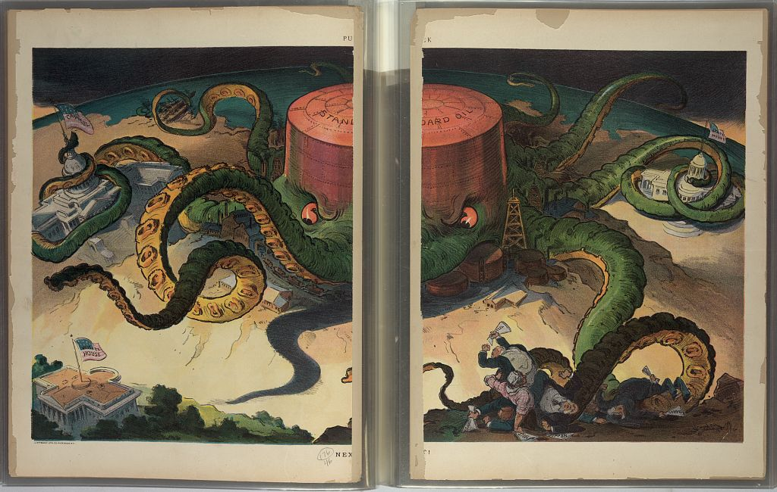
Next! · Udo J. Keppler · 1904
Source: Keppler, Udo J. "Next!" Puck 56, no. 1436 (September 7, 1904). Library of Congress Prints and Photographs Division, digital ID LC-DIG-ppmsca-25884. https://www.loc.gov/pictures/item/2001695241/. Public Domain — No Known Restrictions on Publication https://www.loc.gov/rr/print/195_copr.html
HIPPO — analyze the source (prompt) | Your analysis
H — Historical context: what was happening when this was created?
I — Intended audience: who was meant to see or obey it?
P — Purpose: why was it created?
P — Point of view: whose perspective does it reflect?
O — Outside connection: how does it connect to this standard?
SUPPORT OPTION
Sentence frame: This source shows ______ because it ______, which reveals ______.
CONFIDENCE CHECK-IN
Rate your understanding of this standard (1–4): ______ One thing to revisit: ____________________

Activity 6 — Core Application: Practice Quiz — US.05 ⏱ ~8 min
RESPONSE CHOICE
Commit to an answer by marking it, saying it, or explaining it aloud before checking. Answer key is in the Teacher Guide (kept separate).
[DOK 2 · item US.05-Q02 · pre-field-test]
Madam C.J. Walker\'s business innovations were significant because they:
A. Demonstrated that women and African Americans could build successful
B. Established the foundation for modern pharmaceutical companies
C. Created the first franchise business model in American history
D. Introduced the first mass-produced cosmetics to American markets
[DOK 2 · item US.05-Q03 · pre-field-test]
J.P. Morgan\'s role in American business was primarily as:
A. An inventor who created new manufacturing technologies
B. A financier who organized and consolidated major industries
C. A transportation entrepreneur who built railroad networks
D. An oil refinery owner who controlled petroleum distribution
[DOK 3 · item u1-us05-dok3-tc · pre-field-test]
Analyze the significance of Madam C.J. Walker's success in the context of her era.
A. She became the first female self-made millionaire despite facing both racial and gender discrimination
B. Her success was typical for women entrepreneurs of the time, but this oversimplifies the complex factors at work
C. She succeeded primarily due to government assistance programs, which does not reflect the consensus among historians
D. Her business had minimal economic or social impact, which represents a common misconception about the period

Activity 7 — Constructed Response (CER) — US.05 ⏱ ~15 min
BIG-QUESTION ORGANIZER — as America industrialized, who built the new economy, who profited, and who paid the price?
Jot quick notes from THIS standard: Who benefited? · Who bore the costs? · Who decided?

CONSTRUCTED RESPONSE (CER) — builds SSP.04 Argumentation
Claim + Evidence + Reasoning: Using this standard, take a position on the central question — describe the changes in American life that resulted from the inventions and innovations of business leaders and entrepreneurs of the period, including Alexander Graham Bell, Andrew Carnegie, Thomas Edison, John D. Rockefeller, Madam C.J. Walker, and George Washington Carver? Support your claim with two pieces of evidence from the passage and explain your reasoning.
Part | Write here
Claim
Evidence (two specifics)
Reasoning
SELF-CHECK (CER rubric — see Toolkit)
Is my claim defensible? · TWO specific pieces of evidence? · Does my reasoning explain HOW the evidence proves the claim?
EXIT TICKET — before you leave [item us05-q2 · DOK 2 · pre-field-test]
How did John D. Rockefeller achieve dominance in the oil industry?
A. Through vertical integration of production stages
B. Through government monopoly grants
C. Through horizontal integration, buying out competitors
D. Through technological innovation in drilling
Show what you know (your choice): mark the best answer, say it, or explain it — then rate how sure you are: ☐ Not yet ☐ Getting there ☐ Got it
Answer key and next steps are in the Teacher Guide.

Standard US.06 — Industrial Centers and Urbanization
TN Academic Standard US.06: Locate the following major industrial centers, and describe how industrialization influenced the movement of people from rural to urban areas: Boston, Chicago, New York City, Pittsburgh, San Francisco.
LEARNING TARGETS — I can…
• I can locate major industrial centers and describe how industrialization influenced the movement of people from rural to urban areas.
Lenses for this standard: Geography · Economics
CORE PATH — the same for every student
Same rigor for everyone: analyze the sources and vocabulary, then show what you learned on the Practice Quiz and the CER.
UDL and MTSS give you flexible ways in — they never lower the bar.
Check yourself against the learning targets on the Cornell Notes page.
★ Tennessee Connection
Chattanooga emerged as a major industrial center due to its strategic railroad connections, earning the nickname 'Dynamo of Dixie' for its iron foundries and manufacturing. Memphis grew as a cotton trading hub, and Nashville developed a publishing and printing industry that would make it the 'Athens of the South.'
SET YOUR GOAL (self-direction)
My goal for this standard — what will I be able to do, and how will I show it?

HOOK — think before you dig in
Industrial Centers and Urbanization: Locate the following major industrial centers, and describe how industrialization influenced the movement of people from rural to urban areas: Boston, Chicago, New York City, Pittsburgh, San Francisco. Who gained, who was left out — and why does it still matter?

ACTIVATE — what do you already know or wonder?
Jot what you already know or want to find out about this standard. You’ll come back to it.

PREVIEW & PREDICT
Which learning target will be hardest, and why? Connect it to the unit’s big question: who shared in the boom, and who was left out or pushed back?

Activity 1 — Vocabulary (Part A: Reference / Word Bank) — US.06 ⏱ ~10 min
Use this word bank throughout the standard. The Spanish column supports access, not translation of assessment.
Term | Student-friendly meaning | Spanish
Urbanization | The rapid growth of cities due to industrialization and mass migration, transforming America from a predominantly rural to urban society. | Urbanización
Granger Movement | A farmers' organization founded in 1867 that advocated for railroad regulation and fought against monopolistic practices that harmed farmers through high shipping rates. | Movimiento Granger
Populism | A political movement in the 1890s representing farmers and workers who sought government regulation of railroads, graduated income tax, and the free coinage of silver to combat economic inequality. | Populismo
Interstate Commerce Act | An 1887 federal law that created the Interstate Commerce Commission to regulate railroad rates and practices, representing the first federal regulatory agency. | Ley de Comercio Interestatal
Tenement | A crowded, often unsafe urban apartment building where many poor and immigrant families lived during rapid industrial-era city growth. | Vivienda de Vecindad
Industrialization | The shift from an economy based on farming and handcraft to one based on large factories, machines, and mass production. | Industrialización
LANGUAGE SUPPORT
Pronunciations: Urbanization (ur-bun-ih-ZAY-shun); Tenement (TEN-uh-ment).
VOCABULARY SELF-CHECK · Knowledge Rating
Rate each term NOW in pencil, then again at the END — growth is the goal; no penalty for “never seen it.”
Term | 1 · never seen it | 2 · heard it | 3 · can use it | 4 · can teach it
Urbanization
Granger Movement
Populism
Interstate Commerce Act
Tenement
Industrialization
MAKE IT YOURS (RESPONSE CHOICE): choose ONE term above and show you own it — write a sentence, sketch it, or give a real-world example.

Activity 2 — Vocabulary Studio (Frayer-inspired) — US.06 ⏱ ~7 min
RESPONSE CHOICE
Complete each studio by writing, speaking, or diagramming.

PRIORITY TERM 1 Urbanization · ES: Urbanización
Word-bank meaning to build on: The rapid growth of cities due to industrialization and mass migration, transforming America from a predominantly rural to urban society.
Definition (in your own words) | Characteristics
Examples | Non-examples
Use it to explain
Write one sentence that uses “Urbanization” to explain this standard.

PRIORITY TERM 2 Granger Movement · ES: Movimiento Granger
Word-bank meaning to build on: A farmers' organization founded in 1867 that advocated for railroad regulation and fought against monopolistic practices that harmed farmers through high shipping rates.
Definition (in your own words) | Characteristics
Examples | Non-examples
Use it to explain
Write one sentence that uses “Granger Movement” to explain this standard.

CONNECT THE TERMS (UDL · build understanding)
How do these priority terms fit together? Write or sketch how one leads to or affects another.

Activity 3 — Direct Teaching Cornell Notes — US.06 ⏱ ~20 min
Name: ______________________ Class / Period: __________ Date: __________
US.06 — Industrial Centers and Urbanization • These notes capture the direct-teaching content and the Close Read for this standard.
Your learning targets are on this standard’s opening page — take notes that help you meet them.
Cues (tied to your learning targets) | My notes
Major Industrial Centers
Rural-to-Urban Migration
Costs of Rapid Growth
Key terms →
DOODLE ZONE — draw your thinking (UDL · another way in)
Need another way in? Sketch the key idea, a quick timeline, or how the pieces connect. Words optional.

Cornell Notes — keep going, then process & check — US.06
MORE NOTES / DIAGRAMS
Continue your notes here, add a quick sketch, or map how the ideas connect.

Key terms to list
Urbanization · Granger Movement · Populism · Interstate Commerce Act · Tenement · Industrialization
Summary — In your own words (2–3 sentences)
PROGRESS CHECK · one question
Analyze the relationship between Chicago's geographic location and its industrial development.
A. Geography had little impact on Chicago's growth, which ignores key developments that shaped the outcome
B. Its position as a railroad hub connecting eastern factories with western resources made it ideal for meatpacking and trade
C. Chicago grew primarily due to government subsidies, but this fails to account for the broader historical context
D. Lake Michigan was the only factor in Chicago's development, but the historical record tells a more complex story
Commit before you move on — mark it, say it, or explain it aloud.
CHECK YOURSELF — how am I doing?
Which learning targets (on this standard’s opening page) can you now meet? Tick the number; circle any you still need help with.
☐ 1
My 12–15 word headline for this standard

Activity 4 — Close Read — US.06 ⏱ ~15 min
Reading type: History Hack-authored instructional synthesis. This is not a primary source. Builds SSP.03 (synthesize) and SSP.05 (historical awareness).
CORE PATH — read one chunk at a time
Major Industrial Centers
Industrialization concentrated in cities with geographic advantages. Pittsburgh became the steel capital due to access to coal, iron ore, and rivers. Chicago emerged as a railroad hub and meatpacking center. New York City dominated finance and trade through its port. Boston led in textiles and manufacturing. San Francisco served as the gateway to Pacific trade and western resources.
Rural-to-Urban Migration
Industrialization drew millions from farms to cities seeking factory jobs. The promise of wages attracted both native-born Americans and immigrants. Cities grew explosively—Chicago's population increased from 30,000 in 1850 to over 1 million by 1890. This rapid growth created overcrowded tenements, inadequate sanitation, and new social challenges.
Geographic Factors in Industrial Location
Industries located based on access to raw materials, transportation, markets, and labor. Steel mills clustered near coal and iron deposits. Textile mills used water power and later concentrated near ports for cotton imports. Meatpacking centered in Chicago due to railroad connections to cattle ranges and eastern markets. These patterns shaped regional development for generations.
LANGUAGE SUPPORT
Key terms to know first: Urbanization, Granger Movement. Read once for the gist, then again for evidence.
CLOSE-READ EVIDENCE LAB — for each question: quote the EVIDENCE from the passage above, then write YOUR ANSWER (or answer aloud / diagram it).
Text-dependent question | Evidence from the passage | Your answer (what it shows)
What is the main idea of the “Major Industrial Centers” section, and what evidence supports it?
What is the main idea of the “Rural-to-Urban Migration” section, and what evidence supports it?
What is the main idea of the “Geographic Factors in Industrial Location” section, and what evidence supports it?

Activity 5 — Primary Source / Data Analysis — US.06 ⏱ ~15 min
Primary source (photograph) — analyze it with HIPPO. Builds SSP.01–SSP.02.
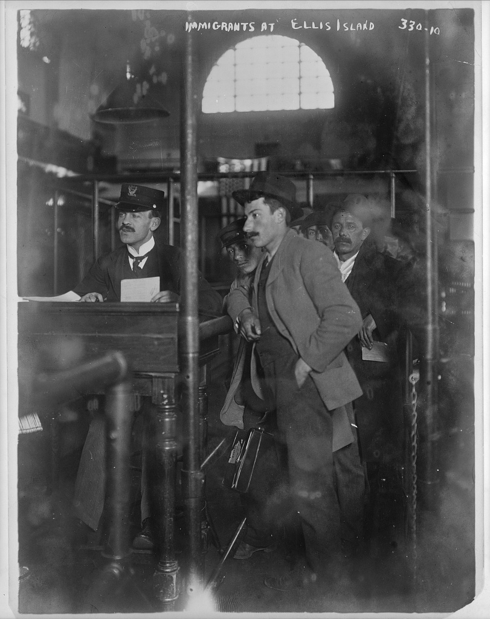
Inspection Room, Ellis Island, New York · Detroit Publishing Company · c. 1910–1920
Source: Detroit Publishing Company. Inspection Room, Ellis Island, New York. Ca. 1910–1920. Photograph. Library of Congress Prints and Photographs Division, Detroit Publishing Company photograph collection, digital ID LC-DIG-det-4a24564. https://www.loc.gov/pictures/item/2016812423/. Public Domain — No Known Restrictions on Publication https://www.loc.gov/rr/print/195_copr.html
HIPPO — analyze the source (prompt) | Your analysis
H — Historical context: what was happening when this was created?
I — Intended audience: who was meant to see or obey it?
P — Purpose: why was it created?
P — Point of view: whose perspective does it reflect?
O — Outside connection: how does it connect to this standard?
SUPPORT OPTION
Sentence frame: This source shows ______ because it ______, which reveals ______.
CONFIDENCE CHECK-IN
Rate your understanding of this standard (1–4): ______ One thing to revisit: ____________________

Activity 6 — Core Application: Practice Quiz — US.06 ⏱ ~8 min
RESPONSE CHOICE
Commit to an answer by marking it, saying it, or explaining it aloud before checking. Answer key is in the Teacher Guide (kept separate).
[DOK 2 · item US.02-Q03 · pre-field-test]
The primary purpose of American Indian boarding schools like Carlisle Industrial School was to:
A. Remove children from tribal influences and teach them Euro-American language, dress, religion, and labor habits to force assimilation
B. Provide advanced academic education while preserving tribal languages and customs
C. Train American Indian students for leadership roles within their
D. Offer vocational training that complemented traditional American Indian skills and economies
[DOK 2 · item US.06-Q02 · pre-field-test]
Which geographic factor best explains Chicago\'s emergence as a major industrial center?
A. Its mountainous terrain provided abundant water power for manufacturing operations
B. Its position at the southern tip of Lake Michigan made it a natural hub connecting eastern rail lines with western agricultural resources
C. Its location on the Atlantic coast provided easy access to European markets and immigrant labor
D. Its proximity to Texas oil fields provided cheap energy for industrial production
[DOK 3 · item u1-us06-dok3-tc · pre-field-test]
Analyze the relationship between Chicago's geographic location and its industrial development.
A. Geography had little impact on Chicago's growth, which ignores key developments that shaped the outcome
B. Its position as a railroad hub connecting eastern factories with western resources made it ideal for meatpacking and trade
C. Chicago grew primarily due to government subsidies, but this fails to account for the broader historical context
D. Lake Michigan was the only factor in Chicago's development, but the historical record tells a more complex story

Activity 7 — Constructed Response (CER) — US.06 ⏱ ~15 min
BIG-QUESTION ORGANIZER — as America industrialized, who built the new economy, who profited, and who paid the price?
Jot quick notes from THIS standard: Who benefited? · Who bore the costs? · Who decided?

CONSTRUCTED RESPONSE (CER) — builds SSP.04 Argumentation
Claim + Evidence + Reasoning: Using this standard, take a position on the central question — locate major industrial centers and describe how industrialization influenced the movement of people from rural to urban areas? Support your claim with two pieces of evidence from the passage and explain your reasoning.
Part | Write here
Claim
Evidence (two specifics)
Reasoning
SELF-CHECK (CER rubric — see Toolkit)
Is my claim defensible? · TWO specific pieces of evidence? · Does my reasoning explain HOW the evidence proves the claim?
EXIT TICKET — before you leave [item us06-q2 · DOK 2 · pre-field-test]
How did industrialization change population distribution in America?
A. Population remained stable in both rural and urban areas
B. People migrated from cities to farms
C. Only immigrants moved to cities
D. Massive rural-to-urban migration occurred as people sought factory jobs
Show what you know (your choice): mark the best answer, say it, or explain it — then rate how sure you are: ☐ Not yet ☐ Getting there ☐ Got it
Answer key and next steps are in the Teacher Guide.

Standard US.07 — Immigration: Old vs. New Immigrants
TN Academic Standard US.07: Describe the differences between "old" and "new" immigrants, analyze the assimilation process for "new" immigrants, and determine the impacts of increased migration on American society, including: Angel Island, Ellis Island, Push and pull factors, Ethnic clusters, Jane Addams, Competition for jobs, Rise of nativism, Jacob Riis, Chinese Exclusion Act and Gentleman's Agreement.
LEARNING TARGETS — I can…
• I can describe the differences between "old" and "new" immigrants, analyze the assimilation process for "new" immigrants, and determine the impacts of increased migration on American society.
Lenses for this standard: History · Geography · Culture
CORE PATH — the same for every student
Same rigor for everyone: analyze the sources and vocabulary, then show what you learned on the Practice Quiz and the CER.
UDL and MTSS give you flexible ways in — they never lower the bar.
Check yourself against the learning targets on the Cornell Notes page.
★ Tennessee Connection
While Tennessee did not receive the same volume of immigrants as Northern cities, Memphis attracted Irish and German immigrants in the mid-1800s, and Italian immigrants settled in Memphis's 'Pinch District.' Nashville's immigrant communities contributed to the city's growth as a commercial center.
SET YOUR GOAL (self-direction)
My goal for this standard — what will I be able to do, and how will I show it?

HOOK — think before you dig in
Immigration: Old vs. New Immigrants: Describe the differences between "old" and "new" immigrants, analyze the assimilation process for "new" immigrants, and determine the impacts of increased migration on American society, including: Angel Island, Ellis Island, Push and pull factors, Ethnic clusters, Jane Addams, Competition for jobs, Rise of nativism, Jacob Riis, Chinese Exclusion Act and Gentleman's Agreement. Who gained, who was left out — and why does it still matter?

ACTIVATE — what do you already know or wonder?
Jot what you already know or want to find out about this standard. You’ll come back to it.

PREVIEW & PREDICT
Which learning target will be hardest, and why? Connect it to the unit’s big question: who shared in the boom, and who was left out or pushed back?

Activity 1 — Vocabulary (Part A: Reference / Word Bank) — US.07 ⏱ ~10 min
Use this word bank throughout the standard. The Spanish column supports access, not translation of assessment.
Term | Student-friendly meaning | Spanish
Old Immigrants | Immigrants who came to the United States primarily from Northern and Western Europe (England, Ireland, Germany, Scandinavia) before 1880, often Protestant and more easily assimilated. | Viejos Inmigrantes
New Immigrants | Immigrants who came to the United States primarily from Southern and Eastern Europe (Italy, Poland, Russia) and Asia after 1880, often Catholic, Jewish, or Orthodox Christian, facing greater discrimination. | Nuevos Inmigrantes
Ellis Island | The primary immigration processing station in New York Harbor from 1892 to 1954, where over 12 million immigrants entered the United States, primarily from Europe. | Isla Ellis
Angel Island | The immigration station in San Francisco Bay from 1910 to 1940 that primarily processed Asian immigrants, especially Chinese, who faced lengthy detentions and harsh interrogations. | Isla Ángel
Push-Pull Factors | Push factors (poverty, persecution, lack of opportunity) drove people to leave their homelands, while pull factors (jobs, freedom, land) attracted them to America. | Factores de Empuje y Atracción
Ethnic Clusters | Neighborhoods where immigrants from the same country or region settled together, maintaining their language, culture, and traditions while adapting to American life. | Grupos Étnicos
LANGUAGE SUPPORT
Use the Spanish column in the Word Bank above to access these terms — cognates and translations support understanding, not translation of assessment.
VOCABULARY SELF-CHECK · Knowledge Rating
Rate each term NOW in pencil, then again at the END — growth is the goal; no penalty for “never seen it.”
Term | 1 · never seen it | 2 · heard it | 3 · can use it | 4 · can teach it
Old Immigrants
New Immigrants
Ellis Island
Angel Island
Push-Pull Factors
Ethnic Clusters
MAKE IT YOURS (RESPONSE CHOICE): choose ONE term above and show you own it — write a sentence, sketch it, or give a real-world example.

Activity 2 — Vocabulary Studio (Frayer-inspired) — US.07 ⏱ ~7 min
RESPONSE CHOICE
Complete each studio by writing, speaking, or diagramming.

PRIORITY TERM 1 Old Immigrants · ES: Viejos Inmigrantes
Word-bank meaning to build on: Immigrants who came to the United States primarily from Northern and Western Europe (England, Ireland, Germany, Scandinavia) before 1880, often Protestant and more easily assimilated.
Definition (in your own words) | Characteristics
Examples | Non-examples
Use it to explain
Write one sentence that uses “Old Immigrants” to explain this standard.

PRIORITY TERM 2 New Immigrants · ES: Nuevos Inmigrantes
Word-bank meaning to build on: Immigrants who came to the United States primarily from Southern and Eastern Europe (Italy, Poland, Russia) and Asia after 1880, often Catholic, Jewish, or Orthodox Christian, facing greater discrimination.
Definition (in your own words) | Characteristics
Examples | Non-examples
Use it to explain
Write one sentence that uses “New Immigrants” to explain this standard.

CONNECT THE TERMS (UDL · build understanding)
How do these priority terms fit together? Write or sketch how one leads to or affects another.

Activity 3 — Direct Teaching Cornell Notes — US.07 ⏱ ~20 min
Name: ______________________ Class / Period: __________ Date: __________
US.07 — Immigration: Old vs. New Immigrants • These notes capture the direct-teaching content and the Close Read for this standard.
Your learning targets are on this standard’s opening page — take notes that help you meet them.
Cues (tied to your learning targets) | My notes
Old vs. New Immigrants
Entry Points & Assimilation
Push & Pull Factors
Nativism & Restriction
Key terms →
DOODLE ZONE — draw your thinking (UDL · another way in)
Need another way in? Sketch the key idea, a quick timeline, or how the pieces connect. Words optional.

Cornell Notes — keep going, then process & check — US.07
MORE NOTES / DIAGRAMS
Continue your notes here, add a quick sketch, or map how the ideas connect.

Key terms to list
Old Immigrants · New Immigrants · Ellis Island · Angel Island · Push-Pull Factors · Ethnic Clusters
Summary — In your own words (2–3 sentences)
PROGRESS CHECK · one question
Analyze the role of Jane Addams and settlement houses in the immigrant experience.
A. Settlement houses forced immigrants to abandon their cultures, although this view has been largely discredited by scholars
B. Settlement houses were primarily religious conversion centers, which ignores key developments that shaped the outcome
C. They provided services and community while helping immigrants navigate American society without erasing cultural identity
D. They had minimal impact on immigrant communities, which represents a common misconception about the period
Commit before you move on — mark it, say it, or explain it aloud.
CHECK YOURSELF — how am I doing?
Which learning targets (on this standard’s opening page) can you now meet? Tick the number; circle any you still need help with.
☐ 1
My 12–15 word headline for this standard

Activity 4 — Close Read — US.07 ⏱ ~15 min
Reading type: History Hack-authored instructional synthesis. This is not a primary source. Builds SSP.03 (synthesize) and SSP.05 (historical awareness).
CORE PATH — read one chunk at a time
Old and New Immigrants
"Old" immigrants (pre-1880) came primarily from Northern and Western Europe—Britain, Ireland, Germany, Scandinavia. They often spoke English or related languages and were predominantly Protestant. "New" immigrants (1880-1920) came from Southern and Eastern Europe—Italy, Poland, Russia, Greece—as well as Asia. They brought different languages, religions (Catholic, Orthodox, Jewish), and customs that many Americans viewed with suspicion.
Entry Points and the Assimilation Process
Ellis Island in New York Harbor processed millions of European immigrants, while Angel Island in San Francisco served Asian immigrants with far more restrictive procedures. New immigrants faced difficult assimilation: language barriers, discrimination, and unfamiliar customs. Jane Addams's Hull House in Chicago pioneered settlement houses that helped immigrants learn English, navigate American systems, and maintain cultural connections.
Push and Pull Factors
Push factors drove people from their homelands: religious persecution (especially of Jews in Russia), poverty, political upheaval, and lack of opportunity. Pull factors attracted them to America: economic opportunity, religious freedom, land availability, and established immigrant communities. Letters from successful immigrants encouraged others to follow.
Nativism and Restriction
The rise of nativism—hostility toward immigrants—led to restrictive legislation. The Chinese Exclusion Act of 1882 banned Chinese immigration for ten years (repeatedly renewed until 1943). The Gentleman's Agreement of 1907 limited Japanese immigration. Jacob Riis's photographs and writings, including "How the Other Half Lives," exposed immigrant living conditions, prompting both sympathy and nativist fears.
Key terms first: Old Immigrants, New Immigrants. Read once for the gist, then again for evidence.
CLOSE-READ EVIDENCE LAB — for each question: quote the EVIDENCE from the passage above, then write YOUR ANSWER (or answer aloud / diagram it).
Text-dependent question | Evidence from the passage | Your answer (what it shows)
What is the main idea of the “Old and New Immigrants” section, and what evidence supports it?
What is the main idea of the “Entry Points and the Assimilation Process” section, and what evidence supports it?
What is the main idea of the “Push and Pull Factors” section, and what evidence supports it?

Activity 5 — Primary Source / Data Analysis — US.07 ⏱ ~15 min
Primary source (photograph) — analyze it with HIPPO. Builds SSP.01–SSP.02.
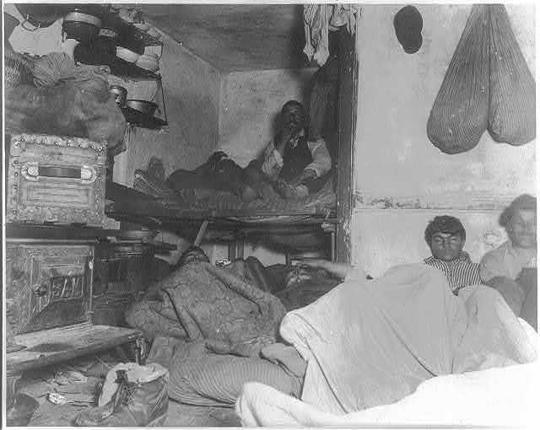
Five Cents a Spot — Unauthorized Immigrant Lodgings in a Bayard Street Tenement · Jacob A. Riis · 1889
Source: Riis, Jacob A. Five Cents a Spot — Unauthorized Immigrant Lodgings in a Bayard Street Tenement. 1889. Photograph. Library of Congress Prints and Photographs Division, LOT 6300, digital ID cph 3a18572. https://www.loc.gov/pictures/item/2002710259/. Public Domain — No Known Restrictions on Publication https://www.loc.gov/rr/print/195_copr.html
HIPPO — analyze the source (prompt) | Your analysis
H — Historical context: what was happening when this was created?
I — Intended audience: who was meant to see or obey it?
P — Purpose: why was it created?
P — Point of view: whose perspective does it reflect?
O — Outside connection: how does it connect to this standard?
SUPPORT OPTION
Sentence frame: This source shows ______ because it ______, which reveals ______.
CONFIDENCE CHECK-IN
Rate your understanding of this standard (1–4): ______ One thing to revisit: ____________________

Activity 6 — Core Application: Practice Quiz — US.07 ⏱ ~8 min
RESPONSE CHOICE
Commit to an answer by marking it, saying it, or explaining it aloud before checking. Answer key is in the Teacher Guide (kept separate).
[DOK 2 · item US.01-Q07 · pre-field-test]
How did western expansion in the 1860s–1880s affect American Indians and European immigrants differently?
A. American Indians lost land and sovereignty through forced removal and treaty violations, while European immigrants gained economic opportunities and land ownership
B. Both groups benefited equally from new economic opportunities created by railroad expansion and land grants
C. European immigrants were confined to reservations while American Indians moved freely onto former frontier lands
D. Both groups experienced forced relocation, but American Indians eventually received citizenship rights earlier than European immigrants
[DOK 2 · item US.07-Q02 · pre-field-test]
Angel Island served as an immigration station primarily for immigrants from:
A. Italy and Poland
B. China and other Asian countries
C. Mexico and Central America
D. Ireland and Germany
[DOK 3 · item u1-us07-dok3-tc · pre-field-test]
Analyze the role of Jane Addams and settlement houses in the immigrant experience.
A. Settlement houses forced immigrants to abandon their cultures, although this view has been largely discredited by scholars
B. Settlement houses were primarily religious conversion centers, which ignores key developments that shaped the outcome
C. They provided services and community while helping immigrants navigate American society without erasing cultural identity
D. They had minimal impact on immigrant communities, which represents a common misconception about the period

Activity 7 — Constructed Response (CER) — US.07 ⏱ ~15 min
BIG-QUESTION ORGANIZER — as America industrialized, who built the new economy, who profited, and who paid the price?
Jot quick notes from THIS standard: Who benefited? · Who bore the costs? · Who decided?

CONSTRUCTED RESPONSE (CER) — builds SSP.04 Argumentation
Claim + Evidence + Reasoning: Using this standard, take a position on the central question — describe the differences between "old" and "new" immigrants, analyze the assimilation process for "new" immigrants, and determine the impacts of increased migration on American society? Support your claim with two pieces of evidence from the passage and explain your reasoning.
Part | Write here
Claim
Evidence (two specifics)
Reasoning
SELF-CHECK (CER rubric — see Toolkit)
Is my claim defensible? · TWO specific pieces of evidence? · Does my reasoning explain HOW the evidence proves the claim?
EXIT TICKET — before you leave [item us07-q2 · DOK 2 · pre-field-test]
How did the experience at Angel Island differ from Ellis Island?
A. Angel Island had far more restrictive procedures, particularly targeting Asian immigrants
B. Angel Island processed immigrants more quickly, which does not reflect the consensus among historians
C. Ellis Island was only for wealthy immigrants, but the historical record tells a more complex story
D. There was no significant difference between the two, which does not reflect the consensus among historians
Show what you know (your choice): mark the best answer, say it, or explain it — then rate how sure you are: ☐ Not yet ☐ Getting there ☐ Got it
Answer key and next steps are in the Teacher Guide.

Your Tennessee Connection
TENNESSEE CONNECTION · WILLIAMSON COUNTY & THE BUFFALO SOLDIERS
Our own county is woven into the story of the industrializing nation. George Jordan of Triune, in Williamson County, is the only Medal of Honor recipient from the county. He served with the 9th U.S. Cavalry — the “Buffalo Soldiers,” regiments of Black soldiers who patrolled the western frontier — and was honored for his defense of Fort Tularosa, New Mexico (1880) and Carrizo Canyon (1881) (US.01–US.02). Tennessee itself industrialized fast in these decades: railroads, coal mining on the Cumberland Plateau, and iron and textile mills reshaped the state’s economy — even as the convict-lease system and Jim Crow (US.03) shaped who benefited and who bore the costs.
Reflect (RESPONSE CHOICE): How does a local story change the way you understand a national event? Answer by writing, recording, or diagramming.

Local History Investigation
Industrialization touched Tennessee directly — railroads, coal mines, iron works, and textile mills, and the people who worked them. Investigate one local connection and record what you find.
Prompt | Your findings
A person, place, or industry from this era near me
One source I could check (library, TSLA, family, museum)
Who benefited / who bore the costs, locally
One question I still have

Progress Tracker & Cumulative Review
Track your Progress Check result for each standard and note one thing to revisit.
Standard | Progress Check (✓ / reteach) | One thing to revisit
US.01
US.02
US.03
US.04
US.05
US.06
US.07

Optional Extension Bank (higher-DOK, open to all)
Any student may choose an extension. These are EXTENSION, not a track.
US.01: Using this standard, take a position on the central question — explain how the Homestead Act and the Transcontinental Railroad impacted the settlement of the West, including their effects on American Indians, immigrants, and settlers? Support your claim with two pieces of evidence from the passage and explain your reasoning.
US.02: Using this standard, take a position on the central question — examine federal policies toward American Indians, including the movement to reservations, assimilation, boarding schools, and the Dawes Act? Support your claim with two pieces of evidence from the passage and explain your reasoning.
US.03: Using this standard, take a position on the central question — explain the impact of the Compromise of 1877, including Jim Crow laws, lynching, disenfranchisement methods, the efforts of Pap Singleton and the Exodusters, and the Plessy v. Ferguson decision? Support your claim with two pieces of evidence from the passage and explain your reasoning.
US.04: Using this standard, take a position on the central question — analyze the causes and consequences of Gilded Age politics and economics, including political machines, major scandals, civil service reform, and economic differences between farmers, wage earners, and industrial capitalists? Support your claim with two pieces of evidence from the passage and explain your reasoning.
US.05: Using this standard, take a position on the central question — describe the changes in American life that resulted from the inventions and innovations of business leaders and entrepreneurs of the period, including Alexander Graham Bell, Andrew Carnegie, Thomas Edison, John D. Rockefeller, Madam C.J. Walker, and George Washington Carver? Support your claim with two pieces of evidence from the passage and explain your reasoning.
US.06: Using this standard, take a position on the central question — locate major industrial centers and describe how industrialization influenced the movement of people from rural to urban areas? Support your claim with two pieces of evidence from the passage and explain your reasoning.
US.07: Using this standard, take a position on the central question — describe the differences between "old" and "new" immigrants, analyze the assimilation process for "new" immigrants, and determine the impacts of increased migration on American society? Support your claim with two pieces of evidence from the passage and explain your reasoning.

Think Like a Test-Writer (unit review — open to all)
You met a quick “think like a test-writer” prompt in every standard. Here is the full how-to, once, plus room to write your best questions for the whole unit.
HOW TO WRITE A DOK-3 QUESTION
DOK-3 = strategic thinking: the reader must analyze, compare, evaluate, or justify using evidence — and there should be more than one defensible answer (not a fact you can just look up).
Sentence starters: “Why did ______ lead to ______?” · “Which mattered more — ______ or ______ — and why?” · “What is the BEST evidence that ______?” · “Evaluate whether ______.” · “Defend or challenge: ______.”
Frame: [Analyze / Evaluate / Justify] + [something from this unit] + “using evidence.”
Quick check: does my question make the reader THINK and use evidence? If yes, it’s DOK-3.
Standard | Your DOK-3 question | Your answer key (one sentence)

Reusable Toolkit & Source Library

Written Response Rubric (CER)
Level | Claim | Evidence | Reasoning
4 — Strong | Precise, defensible | 2+ accurate, specific | Explains how evidence proves the claim
3 — Proficient | Clear | 2 accurate | Explains the link
2 — Developing | General | 1 accurate | Partial link
1 — Beginning | Unclear/missing | Missing/inaccurate | No reasoning

Source Library — full citations & clickable links
US.01 — Homestead Act and Transcontinental Railroad
Homestead Act. U.S. Congress, May 20, 1862 (12 Stat. 392). United States Congress. "An Act to Secure Homesteads to Actual Settlers on the Public Domain (Homestead Act)." 1862. National Archives, https://www.archives.gov. Public domain. https://www.archives.gov/milestone-documents/homestead-act
Pacific Railway Act. U.S. Congress, July 1, 1862 (12 Stat. 489). United States Congress. "Pacific Railway Act." 1862. National Archives, https://www.archives.gov/milestone-documents/pacific-railway-act.. Public domain. https://www.archives.gov/milestone-documents/pacific-railway-act
US.02 — Federal Policies Toward American Indians
Dawes General Allotment Act. U.S. Congress, February 8, 1887 (24 Stat. 388). United States Congress. "Dawes General Allotment Act." 1887. National Archives, https://www.archives.gov/milestone-documents/dawes-act.. Public domain. https://www.archives.gov/milestone-documents/dawes-act
Indian Boarding School Regulations. Office of Indian Affairs (Annual Report of the Commissioner of Indian Affairs, 1890), 1890. Bureau of Indian Affairs. "Indian Boarding School Regulations." 1890. Carlisle Indian School Digital Resource Center, carlisleindian.dickinson.edu/teach/rules-i. Public domain. https://carlisleindian.dickinson.edu/teach/rules-indian-schools
US.03 — Compromise of 1877, Jim Crow & Plessy v. Ferguson
Plessy v. Ferguson Decision. Supreme Court of the United States, May 18, 1896 (163 U.S. 537). Supreme Court of the United States. "Plessy v. Ferguson, 163 U.S. 537." 1896. Library of Congress, www.loc.gov/item/usrep163537/.. Public domain. https://www.loc.gov/item/usrep163537/
Benjamin "Pap" Singleton Testimony. Benjamin "Pap" Singleton, 1880. Singleton, Benjamin "Pap." "Testimony before the Senate Select Committee." 1880. U.S. Senate Historical Office, www.senate.gov/artandhistory/history/resources/p. Public domain. https://www.senate.gov/artandhistory/history/resources/pdf/SingletonTestimony.pdf
US.04 — Gilded Age Politics and Economics
Pendleton Civil Service Reform Act. U.S. Congress, January 16, 1883. United States Congress. "Pendleton Civil Service Reform Act." 1883. National Archives, https://www.archives.gov/milestone-documents/pendleton-act.. Public domain. https://www.archives.gov/milestone-documents/pendleton-act
Bryce, The American Commonwealth — On the Political 'Boss'. James Bryce, 1888. Bryce, James. The American Commonwealth. Macmillan, 1888. Project Gutenberg, www.gutenberg.org/ebooks/57869.. Public domain. https://www.gutenberg.org/ebooks/57869
US.05 — Inventions & Innovations of Business Leaders & Entrepreneurs
The Gospel of Wealth. Andrew Carnegie, 1889. Carnegie, Andrew. "The Gospel of Wealth." 1889. Carnegie Corporation of New York, www.carnegie.org/about/our-history/gospelofwealth/.. Public domain. https://www.carnegie.org/about/our-history/gospelofwealth/
Newspaper Article on Madam C.J. Walker. The Freeman (Indianapolis), 1911. "Madam C. J. Walker." The Freeman, 1911. Library of Congress, www.loc.gov/collections/african-american-perspectives-rare-books/.. Public domain. https://www.loc.gov/collections/african-american-perspectives-rare-books/
US.06 — Industrial Centers and Urbanization
How the Other Half Lives. Jacob Riis, 1890. Riis, Jacob. "How the Other Half Lives." 1890. Library of Congress, www.loc.gov/item/71184754/.. Public domain. https://www.loc.gov/item/71184754/
Italian Immigrant Folk Saying. Widely attributed to anonymous Italian immigrants, c. late 1800s. "Italian Immigrant Folk Saying." Widely attributed, c. late 1800s. Commonly cited in immigration history resources. See Library of Congress Immigration resource. Public domain. https://www.loc.gov/teachers/classroommaterials/presentationsandactivities/presentations/immigration/
US.07 — Immigration: Old vs. New Immigrants
Chinese Exclusion Act. U.S. Congress, May 6, 1882 (22 Stat. 58). United States Congress. "Chinese Exclusion Act." 1882. National Archives, https://www.archives.gov/milestone-documents/chinese-exclusion-act.. Public domain. https://www.archives.gov/milestone-documents/chinese-exclusion-act
Twenty Years at Hull-House. Jane Addams, 1910. Addams, Jane. "Twenty Years at Hull-House." 1910. University of Pennsylvania Digital Library, digital.library.upenn.edu/women/addams/hullhouse/hullhouse.html.. Public domain. https://digital.library.upenn.edu/women/addams/hullhouse/hullhouse.html

The Rise of Industrialization — Four Threads
This section connects the threads of the era: how the nation settled a continent, abandoned Reconstruction, built an industrial economy, and became a land of cities and immigrants — and who benefited and who bore the costs. It is History Hack-authored instructional synthesis grounded in this unit’s sourced record — not a primary source.

Taming a Continent
The transcontinental railroad, the Homestead Act, and a flood of settlers transformed the West into farms, ranches, and mining towns (US.01) — a conquest that came at devastating cost to the Native nations who were forced onto reservations by federal policy (US.02).

A Promise Abandoned
Reconstruction ended with the Compromise of 1877, and Southern states built the Jim Crow system — segregation, disenfranchisement, and the “separate but equal” doctrine upheld in Plessy v. Ferguson — that would stand for generations (US.03).

An Industrial Colossus
New inventions, cheap steel, oil, and new ways of organizing business (trusts and vertical integration) built an industrial economy of staggering scale and immense private fortunes — the Gilded Age, its wealth shadowed by corruption and inequality (US.04, US.05).

A Nation of Cities and Newcomers
Industry pulled millions into booming, crowded cities and drew a new wave of immigrants from southern and eastern Europe and Asia, remaking American society (US.06, US.07) — even as tenement poverty and nativist backlash revealed the era’s costs.

Unit Reflection
Return to the unit’s big question: as America industrialized, who built the new economy, who profited, and who paid the price? Write a final claim with two pieces of evidence from different standards.
Part | Write here
My claim
Evidence 1 (standard: ___)
Evidence 2 (standard: ___)
Why it matters today

