U.S. HISTORY HACK™
COURSE STANDARD · PLATINUM EDITION

MODERN
AMERICA
1965–2016
Unit 10 · High-School U.S. History · Standards-Aligned
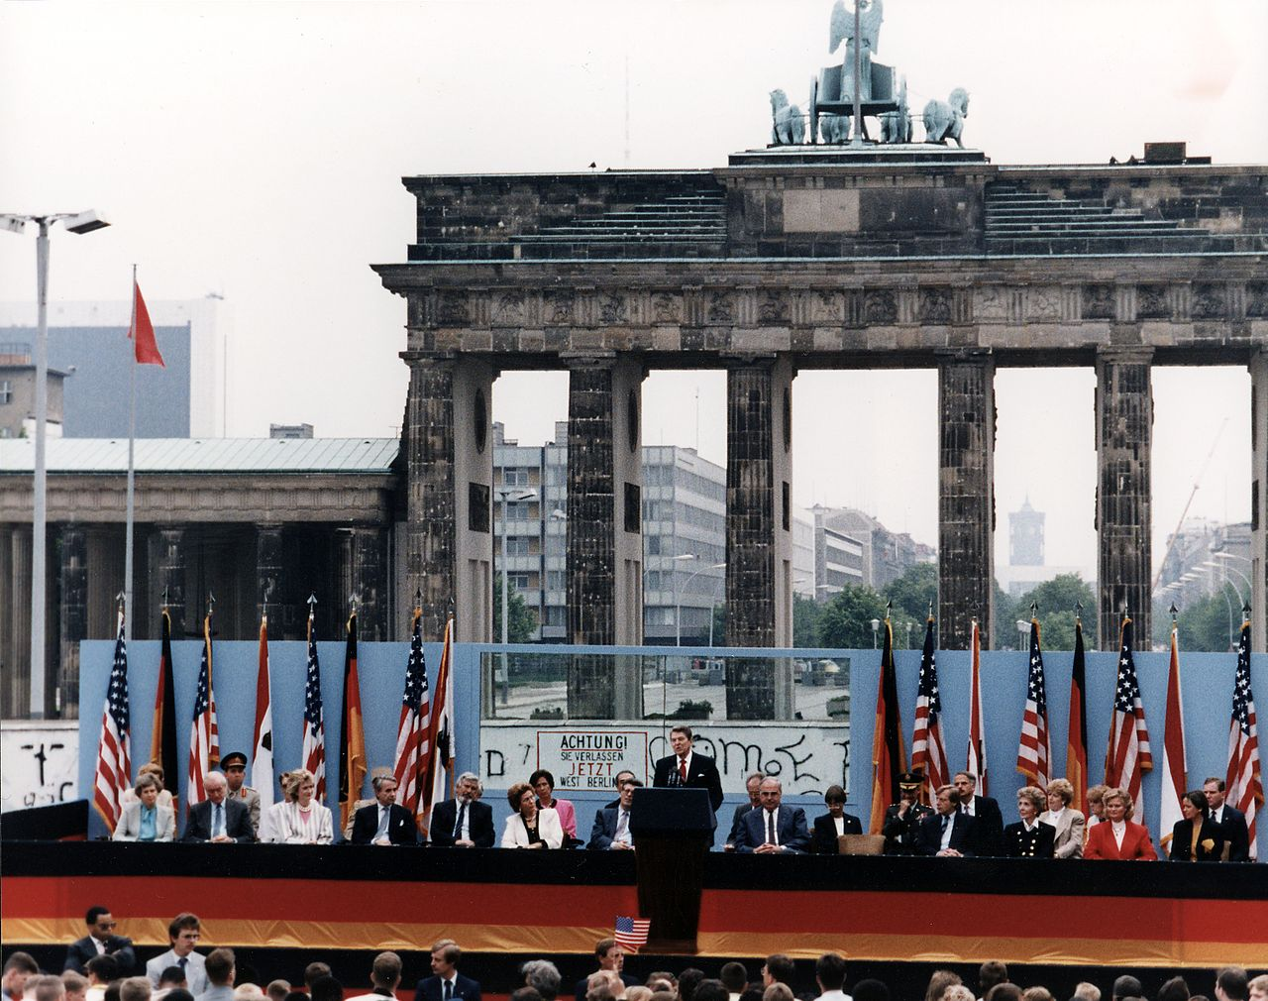
Reagan at the Brandenburg Gate, 1987 · Reagan Library / U.S. National Archives · Public domain
STUDENT WORKBOOK

UDL 3.0 | MTSS | CER | Cornell | HIPPO | DOK
Universal Design for Learning · Multi-Tiered Supports · Evidence-Based Writing
Student Edition
TroopToTeacher Technologies LLC

U.S. HISTORY HACK™ Unit 10 — Modern America (1965–2016) STUDENT WORKBOOK · TroopToTeacher Technologies LLC
SPINE
Perfect-bound. At 133 pages on 60-lb (90 gsm) white offset the spine is ≈ 0.3 in (7.6 mm) — wide enough to print the spine text above. Recompute if the page count or paper changes (white 60-lb ≈ 0.002252 in/page).

U.S. HISTORY HACK™
The workbook that teaches every learner — without lowering the bar.
Unit 10 — Modern America (1965–2016) · Student Edition
WHAT MAKES THIS WORKBOOK DIFFERENT

◆ Built on UDL 3.0 (CAST). Every activity offers multiple means of engagement, representation, and action — word banks, sentence frames, visuals, and choice built in, so the rigor stays the same for every learner.
◆ MTSS tiers on every page. Core instruction with layered Guided and Light Support, plus a formative Exit Ticket for each standard and a “What’s Next” reteach path in the Teacher Edition.
◆ Writes like a historian — CER. A 6-point Claim–Evidence–Reasoning rubric runs through the whole course, with scaffolded organizers and lined response space.
◆ Real primary sources, cited. Photographs, political cartoons, and maps from the Library of Congress and National Archives — analyzed with the HIPPO routine — every source documented to Chicago style.
◆ Cornell notes paired to the slide deck. Structured note pages capture the direct-teaching slides, with retrieval checks and doodle zones for visual learners.
◆ Standards-aligned & TCAP-ready. DOK-balanced checks and a companion Assessment Book with two parallel forms, keyed to the standards and reporting categories.
INSIDE THIS UNIT — the thirteen standards

US.83 Johnson's Great Society Programs
US.84 Social Activism and Counterculture
US.85 Nixon Administration Achievements
US.86 Watergate Scandal
US.87 Emergence of Environmentalism
US.88 Carter Administration Events
US.89 Reagan Administration Significance
US.90 George H.W. Bush Administration
US.91 Clinton Administration Events
US.92 September 11th Impact
US.93 Increasing Role of Women and Minorities
US.94 Communication Methods Evolution
US.95 Obama Administration Achievements and Setbacks
Part of the U.S. History Hack™ Course Standard series — a complete, standards-aligned system: Student Workbook · Teacher Edition · Student & Teacher Slide Decks · Graphic Organizer Toolkit · Unit Assessment Book.
TroopToTeacher Technologies LLC  U.S. History Hack™ · Course Standard (Platinum) Edition · Student Edition  © 2026 TroopToTeacher Technologies LLC. All rights reserved. U.S. History Hack™ is a trademark of TroopToTeacher Technologies LLC. No part of this book may be reproduced without written permission, except as licensed for classroom use.  www.trooptoteacher.com · Printed in the U.S.A. · First Edition | ISBN barcode  ISBN 978-X-XXXXX-XXX-X  placeholder — replace at print

PRINT & ONLINE-LISTING SPEC
An internal handoff sheet for your printer and your storefront listing — not part of the printed book.
Title (listing) | U.S. History Hack™ — Unit 10: Modern America (1965–2016) · Student Workbook
Series | U.S. History Hack™ Course Standard (Platinum) Edition
Publisher / Author | TroopToTeacher Technologies LLC
Trim size | 8.5 × 11 in (US Letter)
Interior | 133 pages, black-and-white, 60-lb (90 gsm) white offset
Binding & spine | Perfect-bound; spine ≈ 0.3 in (7.6 mm). Print spine text.
Cover stock | 10-pt or 12-pt C1S gloss/matte laminate; full color
Bleed | Add 0.125 in bleed on all outside edges before print (this concept is at trim).
Copyright | © 2026 TroopToTeacher Technologies LLC. All rights reserved.
ISBN | Assign one ISBN per format (paperback / PDF); place barcode in the back-cover box.
Age / grade | Grades 9–12 · U.S. History
Categories | Education › Teaching Methods & Materials › Social Science; Study Aids › History
Keywords | U.S. history workbook, high school history, UDL curriculum, MTSS, CER writing, primary source analysis, Cornell notes, standards-aligned, modern America, Great Society, Watergate, Reagan, end of the Cold War, September 11, Obama, information age, environmentalism, standards-aligned, TCAP review
BACK-COVER BLURB (for your storefront)
U.S. History Hack™ turns a full unit of high-school U.S. History into one student-ready workbook that reaches every learner without lowering the bar. Built on Universal Design for Learning (UDL 3.0) and Multi-Tiered Systems of Support (MTSS), each of the thirteen standards moves from a core lesson to Cornell notes paired with the slide deck, real Library-of-Congress primary sources analyzed with HIPPO, evidence-based writing on a 6-point CER rubric, and a formative Exit Ticket with a built-in reteach path. Standards-aligned, DOK-balanced, and TCAP-ready — with a companion Assessment Book of two parallel forms. Unit 10 covers Modern America, 1965–2016.

