U.S. HISTORY HACK™
COURSE STANDARD · PLATINUM EDITION

MODERN
AMERICA
1965–2016
Unit 10 · High-School U.S. History · Standards-Aligned
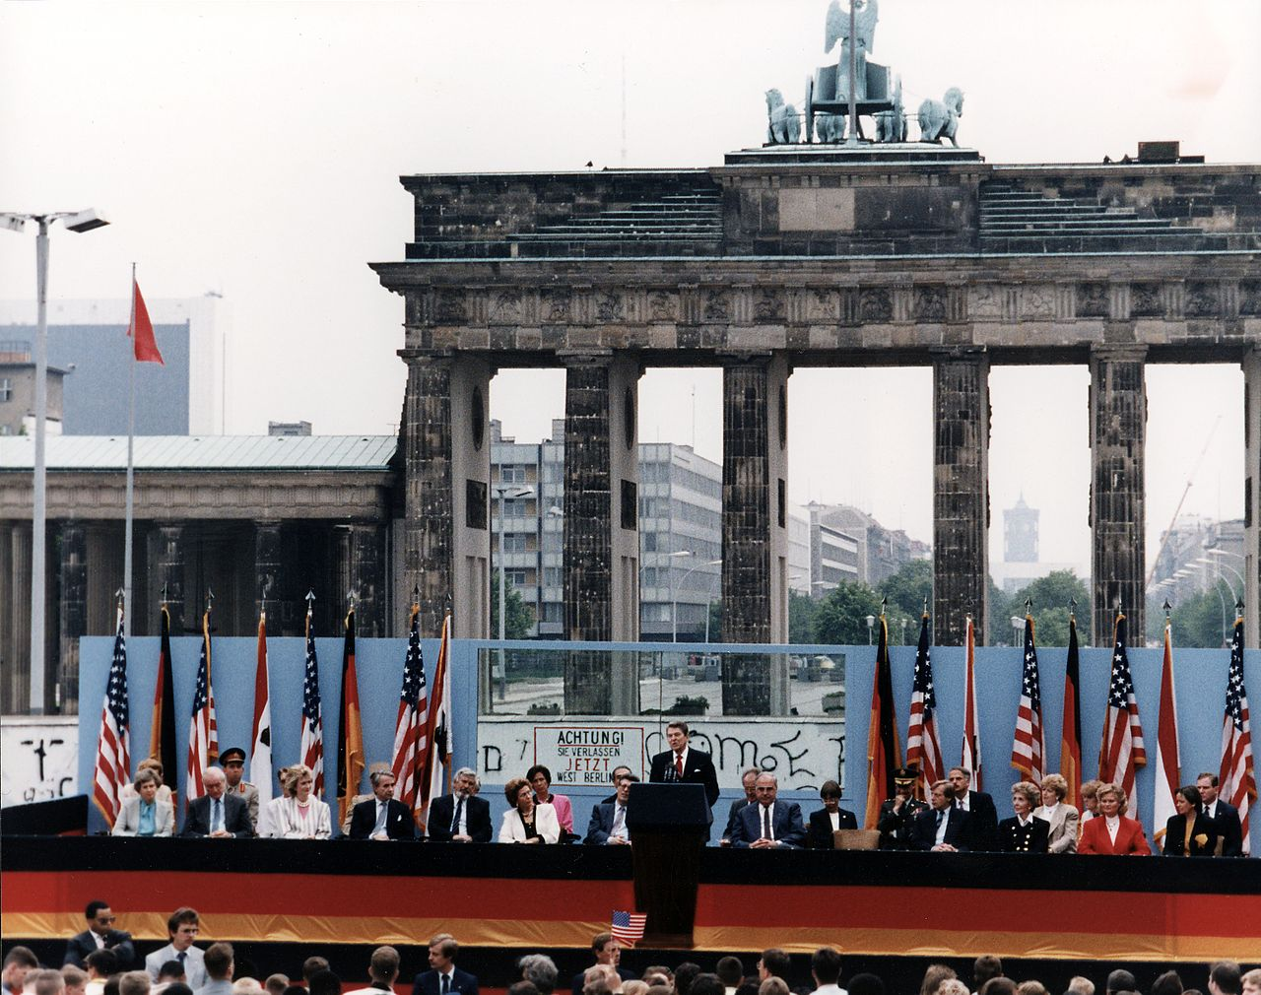
Reagan at the Brandenburg Gate, 1987 · Reagan Library / U.S. National Archives · Public domain
TEACHER EDITION

UDL 3.0 | MTSS | CER | Cornell | HIPPO | DOK
Universal Design for Learning · Multi-Tiered Supports · Evidence-Based Writing
TroopToTeacher Technologies LLC

U.S. HISTORY HACK™ Unit 10 — Modern America (1965–2016) TEACHER EDITION · TroopToTeacher Technologies LLC
SPINE
Saddle-stitch. At 16 pages the folded spine is only ≈ 0.036 in (0.9 mm) — too thin to print spine text; bind saddle-stitch (no printed spine). To get a printable spine, perfect-bind at ≥ ~48 pages, or combine thin teacher books into one volume. The spine panel above is provided for when this title is perfect-bound.

U.S. HISTORY HACK™
Everything you need to teach the unit — with the supports already built in.
Unit 10 — Modern America (1965–2016) · Teacher Edition
WHAT’S IN THE TEACHER EDITION

◆ One standard, one period. A pacing map with honest per-activity time estimates and a menu — you choose what fills the 45 minutes; the rest become bell-ringers, stations, or homework.
◆ The MTSS decision cycle. Progress-monitor → identify barrier → select support → reteach → recheck → extend, with scaffold-fading guidance that never displaces IEP/504 accommodations.
◆ Crosswalks that pass review. Standards & SSP crosswalk and a dimension-coverage crosswalk (C·E·G·H·P·T), plus a district review evidence snapshot.
◆ The 6-point CER rubric. The same evidence-based-writing rubric used across the course, ready to score.
◆ Answer keys — teacher-side only. Practice-quiz keys with rationales and exit-ticket keys with “What’s Next” reteach routing, kept separate from student copies.
◆ Deck + Cornell workflow. How the Lean Student and Full Teacher decks pair with the workbook’s Cornell notes and primary-source analysis.
INSIDE THIS UNIT — the thirteen standards

US.83 Johnson's Great Society Programs
US.84 Social Activism and Counterculture
US.85 Nixon Administration Achievements
US.86 Watergate Scandal
US.87 Emergence of Environmentalism
US.88 Carter Administration Events
US.89 Reagan Administration Significance
US.90 George H.W. Bush Administration
US.91 Clinton Administration Events
US.92 September 11th Impact
US.93 Increasing Role of Women and Minorities
US.94 Communication Methods Evolution
US.95 Obama Administration Achievements and Setbacks
Part of the U.S. History Hack™ Course Standard series — a complete, standards-aligned system: Student Workbook · Teacher Edition · Student & Teacher Slide Decks · Graphic Organizer Toolkit · Unit Assessment Book.
TroopToTeacher Technologies LLC  U.S. History Hack™ · Course Standard (Platinum) Edition · Teacher Edition  © 2026 TroopToTeacher Technologies LLC. All rights reserved. U.S. History Hack™ is a trademark of TroopToTeacher Technologies LLC. No part of this book may be reproduced without written permission, except as licensed for classroom use.  www.trooptoteacher.com · Printed in the U.S.A. · First Edition | ISBN barcode  ISBN 978-X-XXXXX-XXX-X  placeholder — replace at print

PRINT & ONLINE-LISTING SPEC
An internal handoff sheet for your printer and your storefront listing — not part of the printed book.
Title (listing) | U.S. History Hack™ — Unit 10: Modern America · Teacher How-to-Use & MTSS Guide
Series | U.S. History Hack™ Course Standard (Platinum) Edition
Publisher / Author | TroopToTeacher Technologies LLC
Trim size | 8.5 × 11 in (US Letter)
Interior | 16 pages, black-and-white, 60-lb (90 gsm) white offset
Binding & spine | Saddle-stitch (no printed spine) at 16 pp; spine ≈ 0.036 in only. Perfect-bind at ≥ ~48 pp for a printable spine.
Cover stock | 10-pt or 12-pt C1S gloss/matte laminate; full color
Bleed | Add 0.125 in bleed on all outside edges before print (this concept is at trim).
Copyright | © 2026 TroopToTeacher Technologies LLC. All rights reserved.
ISBN | Assign one ISBN per format (paperback / PDF); place barcode in the back-cover box.
Age / grade | Grades 9–12 · U.S. History
Categories | Education › Teaching Methods & Materials › Social Science; Study Aids › History
Keywords | teacher edition, lesson plans, MTSS, UDL, CER rubric, social studies practices, standards crosswalk, pacing guide, U.S. history, answer key
BACK-COVER BLURB (for your storefront)
The Teacher Edition for U.S. History Hack™ Unit 10 gives you the full teaching system: a one-standard-one-period pacing map with honest activity time estimates, the MTSS decision cycle, standards/SSP and dimension crosswalks, the 6-point CER rubric, teacher-side answer keys with reteach routing, and the deck-plus-Cornell workflow. Designed on UDL 3.0 so the rigor stays the same for every learner.

