1776 - 2026 • AMERICA'S 250TH ANNIVERSARY • SEMIQUINCENTENNIAL EDITION
U.S. HISTORY HACK™
TROOPTOTEACHER TECHNOLOGIES
UNIT 10
Modern America, 1965–2016
COURSE STANDARD EDITION
US.83 – US.95 • 13 Tennessee U.S. History Standards • Grades 9–12
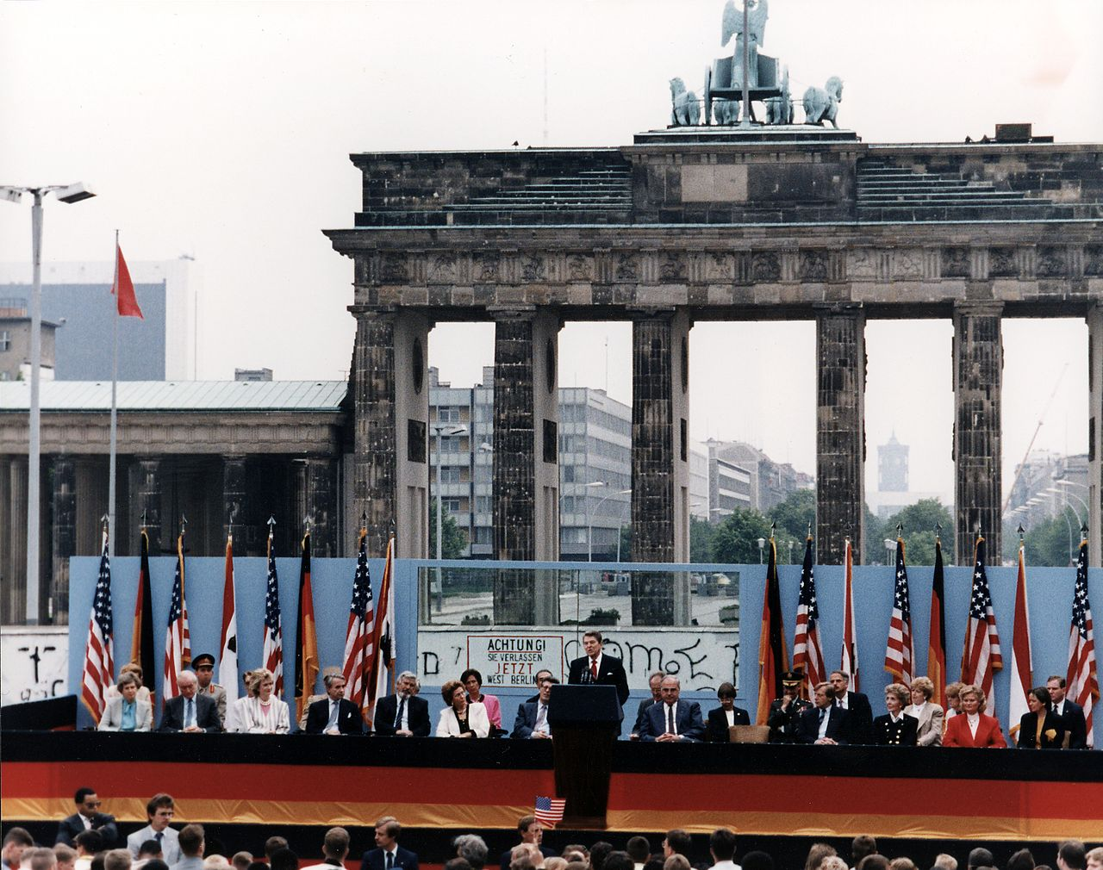
President Ronald Reagan at the Brandenburg Gate, West Berlin — “Mr. Gorbachev, tear down this wall!” June 12, 1987.
Source: Ronald Reagan Presidential Library / U.S. National Archives. Public domain.
TENNESSEE CONNECTION · BAKER, GORE & GIG CITY
Tennesseans shaped the modern era. Senator Howard Baker of Tennessee asked the defining Watergate question — “What did the President know, and when did he know it?” — then served as Ronald Reagan’s Chief of Staff (US.86, US.89). Al Gore of Carthage championed the “information superhighway” as Vice President and won the Nobel Peace Prize for climate advocacy (US.91, US.94). Fort Campbell’s 101st Airborne deployed to the Persian Gulf and, after 9/11, to Afghanistan (US.90, US.92). In 2010, Chattanooga — “Gig City” — launched the nation’s first citywide gigabit internet (US.94).
One common workbook designed for learner variability. Every student works toward the same Tennessee standards; supports vary the means, not the goal or the ceiling.
Release-Ready · Pilot Edition © 2026 TroopToTeacher Technologies LLC · ISBN: [to be assigned]

Copyright, Ownership & Framework
U.S. History Hack™ — Unit 10: Modern America (1965–2016), Course Standard Edition.
© 2026 TroopToTeacher Technologies LLC. All rights reserved. This workbook is proprietary; reproduction or redistribution outside a licensed classroom is prohibited.
Source integrity. Every primary source in this unit is public-domain and cited to its holding repository (National Archives, Library of Congress, HathiTrust). See the Source Library.
Reading provenance (district-clear). Close-Read passages are labeled “History Hack-authored instructional synthesis” — they build on the standard record and are not presented as primary sources.
Framework stack. This workbook anchors to Tennessee U.S. History standards US.83–US.95 and the Social Studies Practices (SSP.01–SSP.06), and is designed on CAST UDL 3.0 and an MTSS support model.
Pacing. Each standard is built for one 45-minute class period. Each activity shows a ⏱ ~ minutes estimate at its heading. There is more here than one period holds — your teacher chooses which activities you do in class; the rest may become warm-ups, stations, or homework.

Table of Contents
Copyright, Ownership & Framework 2
Table of Contents 3
Tennessee Standards & SSP Crosswalk 6
Social Studies Practices (SSP.01–SSP.06) 6
Accessibility, UDL & Accommodations Matrix 7
How CAST UDL 3.0 is visible in this workbook 7
My Support Plan (optional — you choose) 7
How to Use This Workbook 8
Label legend — these appear throughout every standard cycle 8
Before You Begin — Set Your Goal 8
Standard US.83 — Johnson's Great Society Programs 9
Activity 1 — Vocabulary (Part A: Reference / Word Bank) — US.83 ⏱ ~10 min 10
Activity 2 — Vocabulary Studio (Frayer-inspired) — US.83 ⏱ ~7 min 11
Activity 3 — Direct Teaching Cornell Notes — US.83 ⏱ ~20 min 12
Cornell Notes — keep going, then process & check — US.83 13
Activity 4 — Close Read — US.83 ⏱ ~15 min 14
Activity 5 — Primary Source / Data Analysis — US.83 ⏱ ~15 min 15
Activity 6 — Core Application: Practice Quiz — US.83 ⏱ ~8 min 16
Activity 7 — Constructed Response (CER) — US.83 ⏱ ~15 min 17
Standard US.84 — Social Activism and Counterculture 18
Activity 1 — Vocabulary (Part A: Reference / Word Bank) — US.84 ⏱ ~10 min 19
Activity 2 — Vocabulary Studio (Frayer-inspired) — US.84 ⏱ ~7 min 20
Activity 3 — Direct Teaching Cornell Notes — US.84 ⏱ ~20 min 21
Cornell Notes — keep going, then process & check — US.84 22
Activity 4 — Close Read — US.84 ⏱ ~15 min 23
Activity 5 — Primary Source / Data Analysis — US.84 ⏱ ~15 min 24
Activity 6 — Core Application: Practice Quiz — US.84 ⏱ ~8 min 25
Activity 7 — Constructed Response (CER) — US.84 ⏱ ~15 min 26
Standard US.85 — Nixon Administration Achievements 27
Activity 1 — Vocabulary (Part A: Reference / Word Bank) — US.85 ⏱ ~10 min 28
Activity 2 — Vocabulary Studio (Frayer-inspired) — US.85 ⏱ ~7 min 29
Activity 3 — Direct Teaching Cornell Notes — US.85 ⏱ ~20 min 30
Cornell Notes — keep going, then process & check — US.85 31
Activity 4 — Close Read — US.85 ⏱ ~15 min 32
Activity 5 — Primary Source / Data Analysis — US.85 ⏱ ~15 min 33
Activity 6 — Core Application: Practice Quiz — US.85 ⏱ ~8 min 34
Activity 7 — Constructed Response (CER) — US.85 ⏱ ~15 min 35
Standard US.86 — Watergate Scandal 36
Activity 1 — Vocabulary (Part A: Reference / Word Bank) — US.86 ⏱ ~10 min 37
Activity 2 — Vocabulary Studio (Frayer-inspired) — US.86 ⏱ ~7 min 38
Activity 3 — Direct Teaching Cornell Notes — US.86 ⏱ ~20 min 39
Cornell Notes — keep going, then process & check — US.86 40
Activity 4 — Close Read — US.86 ⏱ ~15 min 41
Activity 5 — Primary Source / Data Analysis — US.86 ⏱ ~15 min 42
Activity 6 — Core Application: Practice Quiz — US.86 ⏱ ~8 min 43
Activity 7 — Constructed Response (CER) — US.86 ⏱ ~15 min 44
Standard US.87 — Emergence of Environmentalism 45
Activity 1 — Vocabulary (Part A: Reference / Word Bank) — US.87 ⏱ ~10 min 46
Activity 2 — Vocabulary Studio (Frayer-inspired) — US.87 ⏱ ~7 min 47
Activity 3 — Direct Teaching Cornell Notes — US.87 ⏱ ~20 min 48
Cornell Notes — keep going, then process & check — US.87 49
Activity 4 — Close Read — US.87 ⏱ ~15 min 50
Activity 5 — Primary Source / Data Analysis — US.87 ⏱ ~15 min 51
Activity 6 — Core Application: Practice Quiz — US.87 ⏱ ~8 min 52
Activity 7 — Constructed Response (CER) — US.87 ⏱ ~15 min 53
Standard US.88 — Carter Administration Events 54
Activity 1 — Vocabulary (Part A: Reference / Word Bank) — US.88 ⏱ ~10 min 55
Activity 2 — Vocabulary Studio (Frayer-inspired) — US.88 ⏱ ~7 min 56
Activity 3 — Direct Teaching Cornell Notes — US.88 ⏱ ~20 min 57
Cornell Notes — keep going, then process & check — US.88 58
Activity 4 — Close Read — US.88 ⏱ ~15 min 59
Activity 5 — Primary Source / Data Analysis — US.88 ⏱ ~15 min 60
Activity 6 — Core Application: Practice Quiz — US.88 ⏱ ~8 min 61
Activity 7 — Constructed Response (CER) — US.88 ⏱ ~15 min 62
Standard US.89 — Reagan Administration Significance 63
Activity 1 — Vocabulary (Part A: Reference / Word Bank) — US.89 ⏱ ~10 min 64
Activity 2 — Vocabulary Studio (Frayer-inspired) — US.89 ⏱ ~7 min 65
Activity 3 — Direct Teaching Cornell Notes — US.89 ⏱ ~20 min 66
Cornell Notes — keep going, then process & check — US.89 67
Activity 4 — Close Read — US.89 ⏱ ~15 min 68
Activity 5 — Primary Source / Data Analysis — US.89 ⏱ ~15 min 69
Activity 6 — Core Application: Practice Quiz — US.89 ⏱ ~8 min 70
Activity 7 — Constructed Response (CER) — US.89 ⏱ ~15 min 71
Standard US.90 — George H.W. Bush Administration 72
Activity 1 — Vocabulary (Part A: Reference / Word Bank) — US.90 ⏱ ~10 min 73
Activity 2 — Vocabulary Studio (Frayer-inspired) — US.90 ⏱ ~7 min 74
Activity 3 — Direct Teaching Cornell Notes — US.90 ⏱ ~20 min 75
Cornell Notes — keep going, then process & check — US.90 76
Activity 4 — Close Read — US.90 ⏱ ~15 min 77
Geographer’s Lens — US.90 ⏱ ~12 min 78
Activity 5 — Primary Source / Data Analysis — US.90 ⏱ ~15 min 79
Activity 6 — Core Application: Practice Quiz — US.90 ⏱ ~8 min 80
Activity 7 — Constructed Response (CER) — US.90 ⏱ ~15 min 81
Standard US.91 — Clinton Administration Events 82
Activity 1 — Vocabulary (Part A: Reference / Word Bank) — US.91 ⏱ ~10 min 83
Activity 2 — Vocabulary Studio (Frayer-inspired) — US.91 ⏱ ~7 min 84
Activity 3 — Direct Teaching Cornell Notes — US.91 ⏱ ~20 min 85
Cornell Notes — keep going, then process & check — US.91 86
Activity 4 — Close Read — US.91 ⏱ ~15 min 87
Activity 5 — Primary Source / Data Analysis — US.91 ⏱ ~15 min 88
Activity 6 — Core Application: Practice Quiz — US.91 ⏱ ~8 min 89
Activity 7 — Constructed Response (CER) — US.91 ⏱ ~15 min 90
Standard US.92 — September 11th Impact 91
Activity 1 — Vocabulary (Part A: Reference / Word Bank) — US.92 ⏱ ~10 min 92
Activity 2 — Vocabulary Studio (Frayer-inspired) — US.92 ⏱ ~7 min 93
Activity 3 — Direct Teaching Cornell Notes — US.92 ⏱ ~20 min 94
Cornell Notes — keep going, then process & check — US.92 95
Activity 4 — Close Read — US.92 ⏱ ~15 min 96
Geographer’s Lens — US.92 ⏱ ~12 min 97
Activity 5 — Primary Source / Data Analysis — US.92 ⏱ ~15 min 98
Activity 6 — Core Application: Practice Quiz — US.92 ⏱ ~8 min 99
Activity 7 — Constructed Response (CER) — US.92 ⏱ ~15 min 100
Standard US.93 — Increasing Role of Women and Minorities 101
Activity 1 — Vocabulary (Part A: Reference / Word Bank) — US.93 ⏱ ~10 min 102
Activity 2 — Vocabulary Studio (Frayer-inspired) — US.93 ⏱ ~7 min 103
Activity 3 — Direct Teaching Cornell Notes — US.93 ⏱ ~20 min 104
Cornell Notes — keep going, then process & check — US.93 105
Activity 4 — Close Read — US.93 ⏱ ~15 min 106
Activity 5 — Primary Source / Data Analysis — US.93 ⏱ ~15 min 107
Activity 6 — Core Application: Practice Quiz — US.93 ⏱ ~8 min 108
Activity 7 — Constructed Response (CER) — US.93 ⏱ ~15 min 109
Standard US.94 — Communication Methods Evolution 110
Activity 1 — Vocabulary (Part A: Reference / Word Bank) — US.94 ⏱ ~10 min 111
Activity 2 — Vocabulary Studio (Frayer-inspired) — US.94 ⏱ ~7 min 112
Activity 3 — Direct Teaching Cornell Notes — US.94 ⏱ ~20 min 113
Cornell Notes — keep going, then process & check — US.94 114
Activity 4 — Close Read — US.94 ⏱ ~15 min 115
Activity 5 — Primary Source / Data Analysis — US.94 ⏱ ~15 min 116
Activity 6 — Core Application: Practice Quiz — US.94 ⏱ ~8 min 117
Activity 7 — Constructed Response (CER) — US.94 ⏱ ~15 min 118
Standard US.95 — Obama Administration Achievements and Setbacks 119
Activity 1 — Vocabulary (Part A: Reference / Word Bank) — US.95 ⏱ ~10 min 120
Activity 2 — Vocabulary Studio (Frayer-inspired) — US.95 ⏱ ~7 min 121
Activity 3 — Direct Teaching Cornell Notes — US.95 ⏱ ~20 min 122
Cornell Notes — keep going, then process & check — US.95 123
Activity 4 — Close Read — US.95 ⏱ ~15 min 124
Activity 5 — Primary Source / Data Analysis — US.95 ⏱ ~15 min 125
Activity 6 — Core Application: Practice Quiz — US.95 ⏱ ~8 min 126
Activity 7 — Constructed Response (CER) — US.95 ⏱ ~15 min 127
Your Tennessee Connection 127
Local History Investigation 128
Progress Tracker & Cumulative Review 128
Optional Extension Bank (higher-DOK, open to all) 129
Think Like a Test-Writer (unit review — open to all) 130
Reusable Toolkit & Source Library 131
Written Response Rubric (CER) 131
Source Library — full citations & clickable links 131
The Making of Modern America — Four Threads 133
A New Domestic Order 133
A Crisis of Trust 133
Conservative Resurgence & the Cold War’s End 133
A New Century’s Challenges 133
Unit Reflection 133

Tennessee Standards & SSP Crosswalk
Each standard below is taught to the full Course Standard expectation; the Social Studies Practices are embedded in every activity cycle.
Standard | Focus | Lenses
US.83 | Johnson's Great Society Programs | Politics/Government · Economics · Culture
US.84 | Social Activism and Counterculture | Culture · History
US.85 | Nixon Administration Achievements | Politics/Government · History · Economics
US.86 | Watergate Scandal | Politics/Government · Culture · History
US.87 | Emergence of Environmentalism | Culture · Economics · History
US.88 | Carter Administration Events | Politics/Government · History · Economics
US.89 | Reagan Administration Significance | Politics/Government · Economics · History
US.90 | George H.W. Bush Administration | Politics/Government · History · Geography
US.91 | Clinton Administration Events | Politics/Government · Economics · History
US.92 | September 11th Impact | History · Politics/Government · Culture
US.93 | Increasing Role of Women and Minorities | Culture · History · Politics/Government · Tennessee Connection
US.94 | Communication Methods Evolution | History · Economics
US.95 | Obama Administration Achievements and Setbacks | Politics/Government · History · Economics

Social Studies Practices (SSP.01–SSP.06)
SSP.01 Gather/evaluate sources · SSP.02 Critically examine a primary source · SSP.03 Synthesize evidence · SSP.04 Construct/communicate argument · SSP.05 Develop historical awareness · SSP.06 Chronological/spatial reasoning. Each Close Read, Primary Source/Data, and CER activity names the practices it builds.

Accessibility, UDL & Accommodations Matrix
One firm learning goal per standard; flexible, universal means. Supports are available by design and never lower the goal. They work alongside — never in place of — required IEP or 504 accommodations.
Universal support | What it is | Where it appears
CORE PATH | Essential instruction every student completes | Every activity
LANGUAGE SUPPORT | Vocabulary, pronunciation, Spanish cognates | Word Bank, Guided/Light Backs
RESPONSE CHOICE | Write, say/record, or diagram | Every activity
SUPPORT OPTION | Optional scaffold that keeps the goal | Guided Support Back, Primary Source
PROGRESS CHECK | Quick DOK-2/3 check to guide reteach/extend | Cornell Notes, Practice Quiz
EXTENSION | Deeper challenge once the goal is met | Extension Bank, CER

How CAST UDL 3.0 is visible in this workbook
Multiple means of Engagement (response choice, relevance via Tennessee Connection), Representation (Word Bank, pronunciation, Spanish, Close-Read supports), and Action & Expression (write/say/diagram, Frayer, CER). No fixed-track labels appear.

My Support Plan (optional — you choose)
Supports are available by design. Check the ones you might try; you can change your mind any time.
Support I might use | When it would help me
Word Bank + Spanish column
Guided or Light Support Back
Response choice (say/record or diagram)
Sentence frames / Rehearsal Lab

How to Use This Workbook
Each standard runs the same seven-activity cycle: (1) Vocabulary Word Bank, (2) Vocabulary Studio, (3) Direct-Teaching Cornell Notes with optional Guided and Light Support Backs, (4) Close Read, (5) Primary Source / Data Analysis, (6) Core Application Practice Quiz, (7) Constructed Response (CER). Work the CORE PATH; reach for SUPPORT OPTIONS as needed.

Label legend — these appear throughout every standard cycle
Label | Meaning
CORE PATH | The essential instruction every student completes.
SUPPORT OPTION | An optional scaffold that keeps the goal, not lowers it.
LANGUAGE SUPPORT | Vocabulary, pronunciation, and Spanish cognates for access.
RESPONSE CHOICE | Show learning by writing, saying/recording, or diagramming.
PROGRESS CHECK | A quick DOK-2/3 check that guides reteach or extend.
EXTENSION | A deeper challenge once the goal is met.

Before You Begin — Set Your Goal
This unit asks one big question: as the United States industrialized, who benefited and who bore the costs? Set a goal, then note what you already know.
Prompt | Your response
My goal for this unit is…
One thing I already know about this era…
One question I want answered…

Standard US.83 — Johnson's Great Society Programs
TN Academic Standard US.83: Evaluate the impact of President Lyndon Johnson's Great Society programs, including: Medicare, urban renewal, and the War on Poverty.
LEARNING TARGETS — I can…
• I can evaluate the impact of President Lyndon Johnson's Great Society programs, including Medicare, urban renewal, and the War on Poverty.
Lenses for this standard: Politics/Government · Economics · Culture
CORE PATH — the same for every student
Same rigor for everyone: analyze the sources and vocabulary, then show what you learned on the Practice Quiz and the CER.
UDL and MTSS give you flexible ways in — they never lower the bar.
Check yourself against the learning targets on the Cornell Notes page.
★ Tennessee Connection
President Johnson's Great Society programs had outsized impact in Tennessee. The Appalachian Regional Commission invested heavily in eastern Tennessee's infrastructure and education. Medicare transformed healthcare access for Tennessee's elderly population, and Head Start programs expanded across the state's rural communities.
SET YOUR GOAL (self-direction)
My goal for this standard — what will I be able to do, and how will I show it?

HOOK — think before you dig in
Johnson's Great Society Programs: Evaluate the impact of President Lyndon Johnson's Great Society programs, including: Medicare, urban renewal, and the War on Poverty. Who gained, who was left out — and why does it still matter?

ACTIVATE — what do you already know or wonder?
Jot what you already know or want to find out about this standard. You’ll come back to it.

PREVIEW & PREDICT
Which learning target will be hardest, and why? Connect it to the unit’s big question: how did people change the law and the nation, and what did it cost?

Activity 1 — Vocabulary (Part A: Reference / Word Bank) — US.83 ⏱ ~10 min
Use this word bank throughout the standard. The Spanish column supports access, not translation of assessment.
Term | Student-friendly meaning | Spanish
Great Society | President Lyndon B. Johnson's 1960s domestic program to end poverty and racial injustice and expand education, health care, and civil rights. | Gran Sociedad
War on Poverty | LBJ's set of Great Society programs — including Head Start and Job Corps — created in 1964 to reduce poverty in the United States. | Guerra contra la Pobreza
Medicare and Medicaid | Federal health-insurance programs created in 1965: Medicare for Americans 65 and older, Medicaid for low-income families. | Medicare y Medicaid
Head Start | A 1965 Great Society program providing early childhood education, health, and nutrition services to low-income children. | Head Start (Programa Preescolar)
Urban Renewal | Federal programs that cleared and rebuilt city neighborhoods; often displaced poor and minority residents despite new housing and highways. | Renovación Urbana
Voting Rights Act of 1965 | A Great Society law that banned literacy tests and other barriers used to deny African Americans the right to vote. | Ley de Derecho al Voto de 1965
LANGUAGE SUPPORT
Pronunciations: Great Society (grayt soh-SY-eh-tee); War on Poverty (wor on POV-er-tee); Medicare and Medicaid (MED-ih-kair and MED-ih-kaid); Head Start (hed START); Urban Renewal (UR-bin ree-NOO-ul); Voting Rights Act of 1965 (VOH-ting ryts akt).

VOCABULARY SELF-CHECK · Knowledge Rating
Rate each term NOW in pencil, then again at the END — growth is the goal; no penalty for “never seen it.”
Term | 1 · never seen it | 2 · heard it | 3 · can use it | 4 · can teach it
Great Society
War on Poverty
Medicare and Medicaid
Head Start
Urban Renewal
Voting Rights Act of 1965
MAKE IT YOURS (RESPONSE CHOICE): choose ONE term above and show you own it — write a sentence, sketch it, or give a real-world example.

Activity 2 — Vocabulary Studio (Frayer-inspired) — US.83 ⏱ ~7 min
RESPONSE CHOICE
Complete each studio by writing, speaking, or diagramming.

PRIORITY TERM 1 Great Society · ES: Gran Sociedad
Word-bank meaning to build on: President Lyndon B. Johnson's 1960s domestic program to end poverty and racial injustice and expand education, health care, and civil rights.
Definition (in your own words) | Characteristics
Examples | Non-examples
Use it to explain
Write one sentence that uses “Great Society” to explain this standard.

PRIORITY TERM 2 War on Poverty · ES: Guerra contra la Pobreza
Word-bank meaning to build on: LBJ's set of Great Society programs — including Head Start and Job Corps — created in 1964 to reduce poverty in the United States.
Definition (in your own words) | Characteristics
Examples | Non-examples
Use it to explain
Write one sentence that uses “War on Poverty” to explain this standard.

CONNECT THE TERMS (UDL · build understanding)
How do these priority terms fit together? Write or sketch how one leads to or affects another.

Activity 3 — Direct Teaching Cornell Notes — US.83 ⏱ ~20 min
Name: ______________________ Class / Period: __________ Date: __________
US.83 — Johnson's Great Society Programs • These notes capture the direct-teaching content and the Close Read for this standard.
Your learning targets are on this standard’s opening page — take notes that help you meet them.
Cues (tied to your learning targets) | My notes
What does the passage say about great Society Programs Overview?
What does the passage say about medicare's Effect on Healthcare?
What does the passage say about urban Renewal Consequences?
Key terms →
DOODLE ZONE — draw your thinking (UDL · another way in)
Need another way in? Sketch the key idea, a quick timeline, or how the pieces connect. Words optional.

Cornell Notes — keep going, then process & check — US.83
MORE NOTES / DIAGRAMS
Continue your notes here, add a quick sketch, or map how the ideas connect.

Key terms to list
Great Society · War on Poverty · Medicare and Medicaid · Head Start · Urban Renewal · Voting Rights Act of 1965
Summary — In your own words (2–3 sentences)
PROGRESS CHECK · one question
How did Medicare transform healthcare access for elderly Americans, and what challenges did it create?
A. It provided health insurance for seniors who previously faced discrimination, reducing bankruptcies, but costs escalated beyond projections, creating fiscal challenges
B. Medicare had no significant impact on elderly healthcare, although this overlooks critical economic and social factors when examined alongside the available primary and secondary sources
C. Medicare only covered wealthy Americans, which contradicts the primary source evidence from this era, which does not align with the documented historical record
D. The program was eliminated after one year due to lack of support, which contradicts the primary source evidence from this era, but closer analysis reveals a more complicated historical reality
Commit before you move on — mark it, say it, or explain it aloud.
CHECK YOURSELF — how am I doing?
Which learning targets (on this standard’s opening page) can you now meet? Tick the number; circle any you still need help with.
☐ 1
My 12–15 word headline for this standard

Activity 4 — Close Read — US.83 ⏱ ~15 min
Reading type: History Hack-authored instructional synthesis. This is not a primary source. Builds SSP.03 (synthesize) and SSP.05 (historical awareness).
CORE PATH — read one chunk at a time
Great Society Programs Overview
President Johnson's Great Society (1964-1969) created an ambitious domestic agenda aimed at eliminating poverty and racial injustice. Key programs included: Medicare (health insurance for Americans over 65), Medicaid (health coverage for low-income families), Head Start (early childhood education for disadvantaged children), VISTA (Volunteers in Service to America—domestic Peace Corps), Elementary and Secondary Education Act (federal funding for schools), Urban Renewal (federal programs to rebuild inner cities), and the War on Poverty (comprehensive anti-poverty initiative).
Medicare's Effect on Healthcare
Medicare dramatically improved healthcare access for elderly Americans, who previously faced insurance discrimination due to age and pre-existing conditions. It reduced medical bankruptcies among seniors and established the principle of government-guaranteed healthcare. However, costs escalated beyond projections, creating long-term fiscal challenges and debates about healthcare spending that continue today.
Urban Renewal Consequences
Urban renewal projects often displaced low-income, predominantly minority communities to build highways, shopping centers, and middle-class housing. While intended to eliminate "slums," these programs frequently destroyed established neighborhoods, disrupted social networks, and contributed to racial segregation by concentrating displaced residents in public housing projects.
War on Poverty Effectiveness
The poverty rate fell from 22.4% in 1959 to 12.6% in 1970, suggesting initial success. Programs like Head Start and food stamps provided crucial support. However, poverty rates plateaued in the 1970s, and critics argued that welfare dependency increased. The initiative's mixed results sparked ongoing debates about government's role in addressing inequality.
Key terms first: Great Society, War on Poverty. Read once for the gist, then again for evidence.
CLOSE-READ EVIDENCE LAB — for each question: quote the EVIDENCE from the passage above, then write YOUR ANSWER (or answer aloud / diagram it).
Text-dependent question | Evidence from the passage | Your answer (what it shows)
What is the main idea of the “Great Society Programs Overview” section, and what evidence supports it?
What is the main idea of the “Medicare's Effect on Healthcare” section, and what evidence supports it?
What is the main idea of the “Urban Renewal Consequences” section, and what evidence supports it?

Activity 5 — Primary Source / Data Analysis — US.83 ⏱ ~15 min
Primary source (photograph) — analyze it with HIPPO. Builds SSP.01–SSP.02.
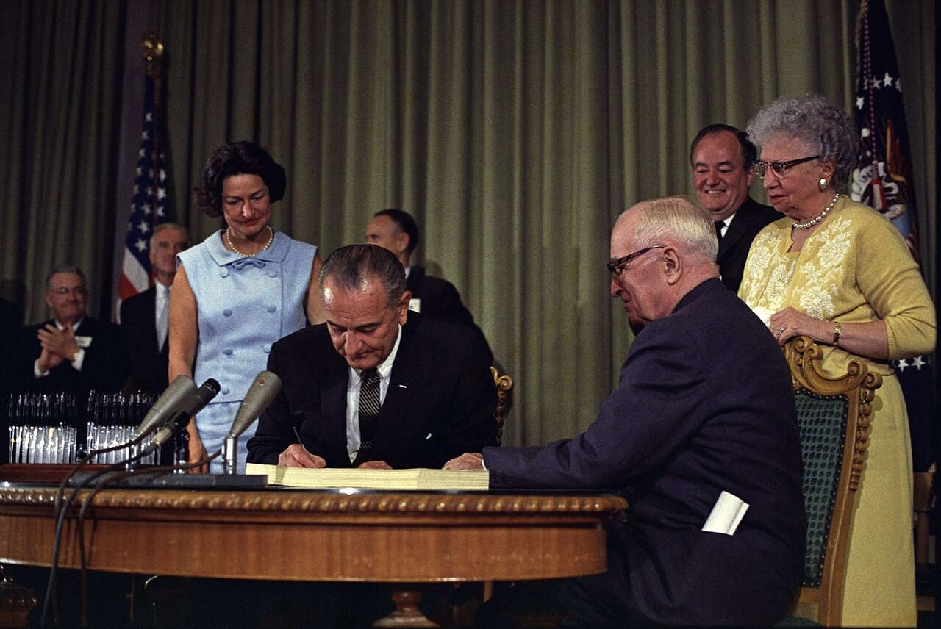
President Johnson Signs the Medicare Bill, Harry S. Truman Library (July 30, 1965) · White House Press Office · 1965
Source: White House Press Office. "President Johnson Signs the Medicare Bill, Harry S. Truman Library." 30 July 1965. LBJ Presidential Library, Austin, TX, via Wikimedia Commons, commons.wikimedia.org/wiki/File:Lyndon_Johnson_signing_Medicare_bill,_with_Harry_Truman,_July_30,_1965.jpg. Public Domain https://commons.wikimedia.org/wiki/File:Lyndon_Johnson_signing_Medicare_bill,_with_Harry_Truman,_July_30,_1965.jpg
HIPPO — analyze the source (prompt) | Your analysis
H — Historical context: what was happening when this was created?
I — Intended audience: who was meant to see or obey it?
P — Purpose: why was it created?
P — Point of view: whose perspective does it reflect?
O — Outside connection: how does it connect to this standard?
SUPPORT OPTION
Sentence frame: This source shows ______ because it ______, which reveals ______.
CONFIDENCE CHECK-IN
Rate your understanding of this standard (1–4): ______ One thing to revisit: ____________________

Activity 6 — Core Application: Practice Quiz — US.83 ⏱ ~8 min
RESPONSE CHOICE
Commit to an answer by marking it, saying it, or explaining it aloud before checking. Answer key is in the Teacher Guide (kept separate).
[DOK 2 · item q-us91-3 · pre-field-test]
How did welfare reform under Clinton change government assistance programs?
A. It replaced welfare with time-limited assistance and work requirements
B. Sustained economic expansion, low unemployment, and a technology boom
C. It eliminated most tariffs between the United States, Canada, and Mexico
D. Perjury and obstruction of justice related to testimony about his conduct
[DOK 2 · item q-passage-us83-1 · pre-field-test]
Based on the passage, what did President Johnson identify as the foundation of the Great Society?
A. Building military strength and expanding international alliance systems
B. Using America's abundance and liberty to end poverty and injustice
C. Reducing federal government spending and returning power to states
D. Protecting states' rights and limiting federal involvement in society
[DOK 3 · item u1-us83-dok3-tc · pre-field-test]
How did Medicare transform healthcare access for elderly Americans, and what challenges did it create?
A. It provided health insurance for seniors who previously faced discrimination, reducing bankruptcies, but costs escalated beyond projections, creating fiscal challenges
B. Medicare had no significant impact on elderly healthcare, although this overlooks critical economic and social factors when examined alongside the available primary and secondary sources
C. Medicare only covered wealthy Americans, which contradicts the primary source evidence from this era, which does not align with the documented historical record
D. The program was eliminated after one year due to lack of support, which contradicts the primary source evidence from this era, but closer analysis reveals a more complicated historical reality

Activity 7 — Constructed Response (CER) — US.83 ⏱ ~15 min
BIG-QUESTION ORGANIZER — how did Americans fight to make the promise of equality real, and what did it take to change the law and the nation?
Jot quick notes from THIS standard: Who benefited? · Who bore the costs? · Who decided?

CONSTRUCTED RESPONSE (CER) — builds SSP.04 Argumentation
Claim + Evidence + Reasoning: Using this standard, take a position on the central question — evaluate the impact of President Lyndon Johnson's Great Society programs, including Medicare, urban renewal, and the War on Poverty? Support your claim with two pieces of evidence from the passage and explain your reasoning.
Part | Write here
Claim
Evidence (two specifics)
Reasoning
SELF-CHECK (CER rubric — see Toolkit)
Is my claim defensible? · TWO specific pieces of evidence? · Does my reasoning explain HOW the evidence proves the claim?
EXIT TICKET — before you leave [item us83-q1 · DOK 2 · pre-field-test]
What were the main goals and programs of Johnson's Great Society, and how did they aim to address poverty and inequality?
A. The Great Society focused exclusively on military spending and foreign policy, yet the available evidence points to a different conclusion
B. The Great Society reduced all federal spending on social programs, although this overlooks critical economic and social factors
C. It created programs like Medicare, Medicaid, Head Start, and the War on Poverty to eliminate poverty and racial injustice through government intervention
D. It was primarily a tax cut program for wealthy Americans, although this view has been largely discredited by scholars
Show what you know (your choice): mark the best answer, say it, or explain it — then rate how sure you are: ☐ Not yet ☐ Getting there ☐ Got it
Answer key and next steps are in the Teacher Guide.

Standard US.84 — Social Activism and Counterculture
TN Academic Standard US.84: Analyze different points of view that reflect the rise of social activism and the growth of counterculture, including generation gap, hippies, and Woodstock.
LEARNING TARGETS — I can…
• I can analyze different points of view that reflect the rise of social activism and the growth of counterculture, including the generation gap, hippies, and Woodstock.
Lenses for this standard: Culture · History
CORE PATH — the same for every student
Same rigor for everyone: analyze the sources and vocabulary, then show what you learned on the Practice Quiz and the CER.
UDL and MTSS give you flexible ways in — they never lower the bar.
Check yourself against the learning targets on the Cornell Notes page.
★ Tennessee Connection
Tennessee experienced social change and counterculture in distinct ways. Nashville's vibrant music scene embraced countercultural influences, and Vanderbilt University became a center for student activism. The Highlander Research and Education Center continued training social justice activists throughout this era.
SET YOUR GOAL (self-direction)
My goal for this standard — what will I be able to do, and how will I show it?

HOOK — think before you dig in
Social Activism and Counterculture: Analyze different points of view that reflect the rise of social activism and the growth of counterculture, including generation gap, hippies, and Woodstock. Who gained, who was left out — and why does it still matter?

ACTIVATE — what do you already know or wonder?
Jot what you already know or want to find out about this standard. You’ll come back to it.

PREVIEW & PREDICT
Which learning target will be hardest, and why? Connect it to the unit’s big question: how did people change the law and the nation, and what did it cost?

Activity 1 — Vocabulary (Part A: Reference / Word Bank) — US.84 ⏱ ~10 min
Use this word bank throughout the standard. The Spanish column supports access, not translation of assessment.
Term | Student-friendly meaning | Spanish
Counterculture | A 1960s youth movement that rejected mainstream values, embracing new music, dress, and views on peace, freedom, and social change. | Contracultura
Generation Gap | The sharp differences in values, politics, and culture between 1960s youth and their parents' generation. | Brecha Generacional
Hippie Movement | A counterculture group of the 1960s that promoted peace, love, communal living, and opposition to the Vietnam War. | Movimiento Hippie
Woodstock | A 1969 music festival in New York that drew 400,000 people and became a symbol of the counterculture and antiwar spirit. | Woodstock
Antiwar Movement | Widespread 1960s-70s protests, especially on college campuses, against U.S. involvement in the Vietnam War. | Movimiento contra la Guerra
New Left | A 1960s political movement of young activists who pushed for civil rights, free speech, and an end to the Vietnam War. | Nueva Izquierda
LANGUAGE SUPPORT
Pronunciations: Counterculture (KOWN-ter-kul-cher); Generation Gap (jen-er-AY-shun gap); Hippie Movement (HIP-ee MOOV-ment); Woodstock (WOOD-stok); Antiwar Movement (AN-tee-wor MOOV-ment); New Left (noo LEFT).

VOCABULARY SELF-CHECK · Knowledge Rating
Rate each term NOW in pencil, then again at the END — growth is the goal; no penalty for “never seen it.”
Term | 1 · never seen it | 2 · heard it | 3 · can use it | 4 · can teach it
Counterculture
Generation Gap
Hippie Movement
Woodstock
Antiwar Movement
New Left
MAKE IT YOURS (RESPONSE CHOICE): choose ONE term above and show you own it — write a sentence, sketch it, or give a real-world example.

Activity 2 — Vocabulary Studio (Frayer-inspired) — US.84 ⏱ ~7 min
RESPONSE CHOICE
Complete each studio by writing, speaking, or diagramming.

PRIORITY TERM 1 Counterculture · ES: Contracultura
Word-bank meaning to build on: A 1960s youth movement that rejected mainstream values, embracing new music, dress, and views on peace, freedom, and social change.
Definition (in your own words) | Characteristics
Examples | Non-examples
Use it to explain
Write one sentence that uses “Counterculture” to explain this standard.

PRIORITY TERM 2 Generation Gap · ES: Brecha Generacional
Word-bank meaning to build on: The sharp differences in values, politics, and culture between 1960s youth and their parents' generation.
Definition (in your own words) | Characteristics
Examples | Non-examples
Use it to explain
Write one sentence that uses “Generation Gap” to explain this standard.

CONNECT THE TERMS (UDL · build understanding)
How do these priority terms fit together? Write or sketch how one leads to or affects another.

Activity 3 — Direct Teaching Cornell Notes — US.84 ⏱ ~20 min
Name: ______________________ Class / Period: __________ Date: __________
US.84 — Social Activism and Counterculture • These notes capture the direct-teaching content and the Close Read for this standard.
Your learning targets are on this standard’s opening page — take notes that help you meet them.
Cues (tied to your learning targets) | My notes
What does the passage say about different Viewpoints on Social Activism?
What does the passage say about the Generation Gap?
What does the passage say about the Hippie Movement?
Key terms →
DOODLE ZONE — draw your thinking (UDL · another way in)
Need another way in? Sketch the key idea, a quick timeline, or how the pieces connect. Words optional.

Cornell Notes — keep going, then process & check — US.84
MORE NOTES / DIAGRAMS
Continue your notes here, add a quick sketch, or map how the ideas connect.

Key terms to list
Counterculture · Generation Gap · Hippie Movement · Woodstock · Antiwar Movement · New Left
Summary — In your own words (2–3 sentences)
PROGRESS CHECK · one question
How did the hippie movement challenge mainstream American values?
A. Hippies supported traditional American values, which contradicts the primary source evidence from this era, but the historical evidence paints a more nuanced picture
B. They rejected materialism, conformity, and militarism while embracing alternative lifestyles, peace, environmental awareness, and communal living
C. The hippie movement had no significant cultural impact, which does not align with the documented historical record
D. Hippies focused exclusively on political reform, although this view has been largely discredited by scholars
Commit before you move on — mark it, say it, or explain it aloud.
CHECK YOURSELF — how am I doing?
Which learning targets (on this standard’s opening page) can you now meet? Tick the number; circle any you still need help with.
☐ 1
My 12–15 word headline for this standard

Activity 4 — Close Read — US.84 ⏱ ~15 min
Reading type: History Hack-authored instructional synthesis. This is not a primary source. Builds SSP.03 (synthesize) and SSP.05 (historical awareness).
CORE PATH — read one chunk at a time
Different Viewpoints on Social Activism
Supporters saw activism as necessary democratic participation addressing social injustices like civil rights, poverty, and unjust wars. Critics viewed protesters as unpatriotic radicals undermining American institutions, values, and military morale. This divide reflected fundamental disagreements about patriotism, authority, and social change.
The Generation Gap
The gap reflected fundamental differences between older Americans who experienced the Depression and World War II and younger Americans questioning authority, traditional values, and foreign policy. Younger Americans who had grown up in postwar prosperity felt freer to challenge the establishment their parents had built and defended.
The Hippie Movement
Hippies rejected materialism, embraced peace and love, experimented with drugs, and created alternative communities. They opposed the Vietnam War and promoted environmental awareness, influencing music, fashion, and social attitudes. Their lifestyle challenged middle-class conformity and sparked both admiration and outrage.
Woodstock's Significance
The 1969 music festival symbolized counterculture values of peace, music, and community. Despite logistical problems—rain, inadequate facilities, massive crowds—it demonstrated young Americans' desire for alternative social arrangements. Woodstock became an iconic moment of 1960s idealism, even as the decade's optimism soon gave way to disillusionment.
Key terms first: Counterculture, Generation Gap. Read once for the gist, then again for evidence.
CLOSE-READ EVIDENCE LAB — for each question: quote the EVIDENCE from the passage above, then write YOUR ANSWER (or answer aloud / diagram it).
Text-dependent question | Evidence from the passage | Your answer (what it shows)
What is the main idea of the “Different Viewpoints on Social Activism” section, and what evidence supports it?
What is the main idea of the “The Generation Gap” section, and what evidence supports it?
What is the main idea of the “The Hippie Movement” section, and what evidence supports it?

Activity 5 — Primary Source / Data Analysis — US.84 ⏱ ~15 min
Primary source (photograph) — analyze it with HIPPO. Builds SSP.01–SSP.02.
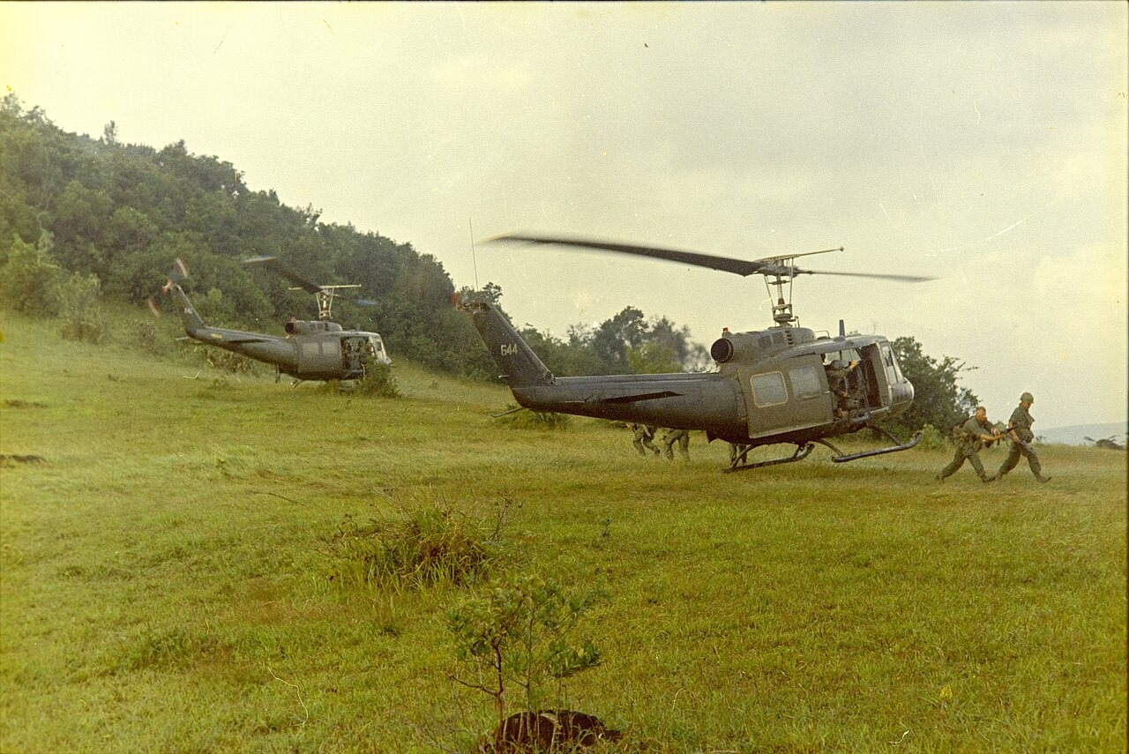
4th Infantry Division Helicopter Assault, Quang Ngai Province, Vietnam (1967) · SP5 Robert C. Lafoon, Department of the Army Special Photo Office (DASPO) · 1967
Source: Lafoon, SP5 Robert C., U.S. Army DASPO. "4th Infantry Division Helicopter Assault, Quang Ngai Province, Vietnam." 1967. National Archives and Records Administration (NARA 111-CCV-569-CC44324), via Wikimedia Commons, commons.wikimedia.org/wiki/File:NARA_111-CCV-569-CC44324_4th_Infantry_Division_helicopter_assault_from_UH-1_1967.jpg. Public Domain https://commons.wikimedia.org/wiki/File:NARA_111-CCV-569-CC44324_4th_Infantry_Division_helicopter_assault_from_UH-1_1967.jpg
HIPPO — analyze the source (prompt) | Your analysis
H — Historical context: what was happening when this was created?
I — Intended audience: who was meant to see or obey it?
P — Purpose: why was it created?
P — Point of view: whose perspective does it reflect?
O — Outside connection: how does it connect to this standard?
SUPPORT OPTION
Sentence frame: This source shows ______ because it ______, which reveals ______.
CONFIDENCE CHECK-IN
Rate your understanding of this standard (1–4): ______ One thing to revisit: ____________________

Activity 6 — Core Application: Practice Quiz — US.84 ⏱ ~8 min
RESPONSE CHOICE
Commit to an answer by marking it, saying it, or explaining it aloud before checking. Answer key is in the Teacher Guide (kept separate).
[DOK 2 · item us84-q2 · pre-field-test]
What caused the "generation gap" between older and younger Americans in the 1960s?
A. Older Americans shaped by Depression and WWII valued authority and conformity while younger Americans raised in prosperity questioned traditional values and institutions
B. The generation gap was solely about music preferences, although this view has been largely discredited by scholars despite the fact that multiple contemporary sources contradict this
C. There was no significant generational divide, despite the fact that multiple sources contradict this view, which does not align with the documented historical record
D. Younger Americans were more conservative than their parents, which represents a common misconception about the period, which contradicts the primary source evidence from this era
[DOK 2 · item q-us94-3 · pre-field-test]
What impact has social media had on American political and social life?
A. From landline phones and letters to smartphones, email, and social media
B. It changed how people connect, share information, and engage in politics
C. It put computing, communication, and internet access in everyone's pocket
D. It revolutionized commerce, communication, information, and social life
[DOK 3 · item u1-us84-dok3-tc · pre-field-test]
How did the hippie movement challenge mainstream American values?
A. Hippies supported traditional American values, which contradicts the primary source evidence from this era, but the historical evidence paints a more nuanced picture
B. They rejected materialism, conformity, and militarism while embracing alternative lifestyles, peace, environmental awareness, and communal living
C. The hippie movement had no significant cultural impact, which does not align with the documented historical record
D. Hippies focused exclusively on political reform, although this view has been largely discredited by scholars

Activity 7 — Constructed Response (CER) — US.84 ⏱ ~15 min
BIG-QUESTION ORGANIZER — how did Americans fight to make the promise of equality real, and what did it take to change the law and the nation?
Jot quick notes from THIS standard: Who benefited? · Who bore the costs? · Who decided?

CONSTRUCTED RESPONSE (CER) — builds SSP.04 Argumentation
Claim + Evidence + Reasoning: Using this standard, take a position on the central question — analyze different points of view that reflect the rise of social activism and the growth of counterculture, including the generation gap, hippies, and Woodstock? Support your claim with two pieces of evidence from the passage and explain your reasoning.
Part | Write here
Claim
Evidence (two specifics)
Reasoning
SELF-CHECK (CER rubric — see Toolkit)
Is my claim defensible? · TWO specific pieces of evidence? · Does my reasoning explain HOW the evidence proves the claim?
EXIT TICKET — before you leave [item us84-q1 · DOK 2 · pre-field-test]
How did supporters and critics differ in their views of 1960s social activism?
A. Everyone supported social activism equally, although this view has been largely discredited by scholars, which does not align with the documented historical record
B. Critics were exclusively older Americans, yet the available evidence points to a different conclusion, which represents a common misconception about this historical period
C. There was no significant disagreement about activism, yet the available evidence points to a different conclusion and oversimplifies the complex factors at work during this period
D. Supporters saw activism as democratic participation addressing injustice while critics viewed protesters as unpatriotic radicals undermining American values
Show what you know (your choice): mark the best answer, say it, or explain it — then rate how sure you are: ☐ Not yet ☐ Getting there ☐ Got it
Answer key and next steps are in the Teacher Guide.

Standard US.85 — Nixon Administration Achievements
TN Academic Standard US.85: Explain significant achievements of President Richard Nixon's administration, including his appeal to the "silent majority" and his major foreign policy actions.
LEARNING TARGETS — I can…
• I can explain significant achievements of President Richard Nixon's administration, including his appeal to the "silent majority" and his major foreign policy actions.
Lenses for this standard: Politics/Government · History · Economics
CORE PATH — the same for every student
Same rigor for everyone: analyze the sources and vocabulary, then show what you learned on the Practice Quiz and the CER.
UDL and MTSS give you flexible ways in — they never lower the bar.
Check yourself against the learning targets on the Cornell Notes page.
★ Tennessee Connection
Tennessee Senator Howard Baker served as Senate Minority Leader and played a key role during the Watergate hearings with his famous question: 'What did the President know, and when did he know it?'
SET YOUR GOAL (self-direction)
My goal for this standard — what will I be able to do, and how will I show it?

HOOK — think before you dig in
Nixon Administration Achievements: Explain significant achievements of President Richard Nixon's administration, including his appeal to the "silent majority" and his major foreign policy actions. Who gained, who was left out — and why does it still matter?

ACTIVATE — what do you already know or wonder?
Jot what you already know or want to find out about this standard. You’ll come back to it.

PREVIEW & PREDICT
Which learning target will be hardest, and why? Connect it to the unit’s big question: how did people change the law and the nation, and what did it cost?

Activity 1 — Vocabulary (Part A: Reference / Word Bank) — US.85 ⏱ ~10 min
Use this word bank throughout the standard. The Spanish column supports access, not translation of assessment.
Term | Student-friendly meaning | Spanish
Silent Majority | President Nixon's term for the many Americans who quietly supported his policies but did not join loud public protests. | Mayoría Silenciosa
Détente | Nixon's policy of easing Cold War tensions with the Soviet Union and China through diplomacy and treaties. | Distensión
Nixon Visits China | Nixon's historic 1972 trip that reopened U.S. relations with Communist China after more than 20 years of hostility. | Visita de Nixon a China
SALT I | The 1972 Strategic Arms Limitation Talks treaty that limited U.S. and Soviet nuclear missiles, a key result of détente. | SALT I (Tratado de Armas)
Revenue Sharing | A Nixon program returning federal tax money to state and local governments to spend on their own priorities. | Distribución de Ingresos Federales
Environmental Protection Agency (EPA) | A federal agency created under Nixon in 1970 to write and enforce laws protecting air, water, and land. | Agencia de Protección Ambiental
LANGUAGE SUPPORT
Pronunciations: Silent Majority (SY-lent muh-JOR-ih-tee); Détente (day-TAHNT); Nixon Visits China (NIK-sun VIZ-its CHY-nuh); SALT I (salt WUN); Revenue Sharing (REV-en-yoo SHAIR-ing); Environmental Protection Agency (EPA) (en-vy-run-MEN-tul pro-TEK-shun).

VOCABULARY SELF-CHECK · Knowledge Rating
Rate each term NOW in pencil, then again at the END — growth is the goal; no penalty for “never seen it.”
Term | 1 · never seen it | 2 · heard it | 3 · can use it | 4 · can teach it
Silent Majority
Détente
Nixon Visits China
SALT I
Revenue Sharing
Environmental Protection Agency (EPA)
MAKE IT YOURS (RESPONSE CHOICE): choose ONE term above and show you own it — write a sentence, sketch it, or give a real-world example.

Activity 2 — Vocabulary Studio (Frayer-inspired) — US.85 ⏱ ~7 min
RESPONSE CHOICE
Complete each studio by writing, speaking, or diagramming.

PRIORITY TERM 1 Silent Majority · ES: Mayoría Silenciosa
Word-bank meaning to build on: President Nixon's term for the many Americans who quietly supported his policies but did not join loud public protests.
Definition (in your own words) | Characteristics
Examples | Non-examples
Use it to explain
Write one sentence that uses “Silent Majority” to explain this standard.

PRIORITY TERM 2 Détente · ES: Distensión
Word-bank meaning to build on: Nixon's policy of easing Cold War tensions with the Soviet Union and China through diplomacy and treaties.
Definition (in your own words) | Characteristics
Examples | Non-examples
Use it to explain
Write one sentence that uses “Détente” to explain this standard.

CONNECT THE TERMS (UDL · build understanding)
How do these priority terms fit together? Write or sketch how one leads to or affects another.

Activity 3 — Direct Teaching Cornell Notes — US.85 ⏱ ~20 min
Name: ______________________ Class / Period: __________ Date: __________
US.85 — Nixon Administration Achievements • These notes capture the direct-teaching content and the Close Read for this standard.
Your learning targets are on this standard’s opening page — take notes that help you meet them.
Cues (tied to your learning targets) | My notes
What does the passage say about significant Achievements?
What does the passage say about the "Silent Majority" Concept?
What does the passage say about major Foreign Policy Initiatives?
Key terms →
DOODLE ZONE — draw your thinking (UDL · another way in)
Need another way in? Sketch the key idea, a quick timeline, or how the pieces connect. Words optional.

Cornell Notes — keep going, then process & check — US.85
MORE NOTES / DIAGRAMS
Continue your notes here, add a quick sketch, or map how the ideas connect.

Key terms to list
Silent Majority · Détente · Nixon Visits China · SALT I · Revenue Sharing · Environmental Protection Agency (EPA)
Summary — In your own words (2–3 sentences)
PROGRESS CHECK · one question
How did Nixon's "Silent Majority" strategy reshape American political campaigns and voter appeals?
A. The Silent Majority strategy had no lasting political impact, which represents a common misconception about the period despite the fact that multiple contemporary sources contradict this
B. Nixon only appealed to wealthy voters, which ignores key developments that shaped the outcome and does not reflect the scholarly consensus on this topic
C. It appealed to middle-class voters frustrated with protests and counterculture, winning working-class Democrats and reshaping Republican electoral strategy for decades
D. The strategy focused exclusively on young voters, though this interpretation lacks supporting historical evidence when examined alongside the available primary and secondary sources
Commit before you move on — mark it, say it, or explain it aloud.
CHECK YOURSELF — how am I doing?
Which learning targets (on this standard’s opening page) can you now meet? Tick the number; circle any you still need help with.
☐ 1
My 12–15 word headline for this standard

Activity 4 — Close Read — US.85 ⏱ ~15 min
Reading type: History Hack-authored instructional synthesis. This is not a primary source. Builds SSP.03 (synthesize) and SSP.05 (historical awareness).
CORE PATH — read one chunk at a time
Significant Achievements
Nixon's achievements spanned multiple areas. Foreign Policy: Détente with the Soviet Union, opening relations with China, and the SALT I Treaty. Domestic Policy: Environmental Protection Agency creation, Title IX passage for gender equality in education, and desegregation enforcement. Economic Policy: Wage and price controls (temporary) and ending the gold standard. Social Policy: Lowered voting age to 18 through the 26th Amendment.
The "Silent Majority" Concept
Nixon appealed to Americans who didn't participate in protests but supported traditional values and law and order. This strategy targeted middle-class voters frustrated with civil rights demonstrations, antiwar protests, and counterculture movements. It helped Nixon win working-class Democratic voters and reshape Republican electoral strategy for decades, creating a coalition that would dominate American politics.
Major Foreign Policy Initiatives
China Opening: Secret diplomacy led to Nixon's historic 1972 China visit, establishing diplomatic relations and strategically isolating the Soviet Union. Détente: Reduced tensions with the USSR through arms control negotiations and increased trade. Vietnam: Vietnamization policy gradually withdrew American troops while maintaining support for South Vietnam, though the country ultimately fell in 1975.
LANGUAGE SUPPORT
Key terms to know first: Silent Majority, Détente. Read once for the gist, then again for evidence.
CLOSE-READ EVIDENCE LAB — for each question: quote the EVIDENCE from the passage above, then write YOUR ANSWER (or answer aloud / diagram it).
Text-dependent question | Evidence from the passage | Your answer (what it shows)
What is the main idea of the “Significant Achievements” section, and what evidence supports it?
What is the main idea of the “The "Silent Majority" Concept” section, and what evidence supports it?
What is the main idea of the “Major Foreign Policy Initiatives” section, and what evidence supports it?

Activity 5 — Primary Source / Data Analysis — US.85 ⏱ ~15 min
Primary source (photograph) — analyze it with HIPPO. Builds SSP.01–SSP.02.
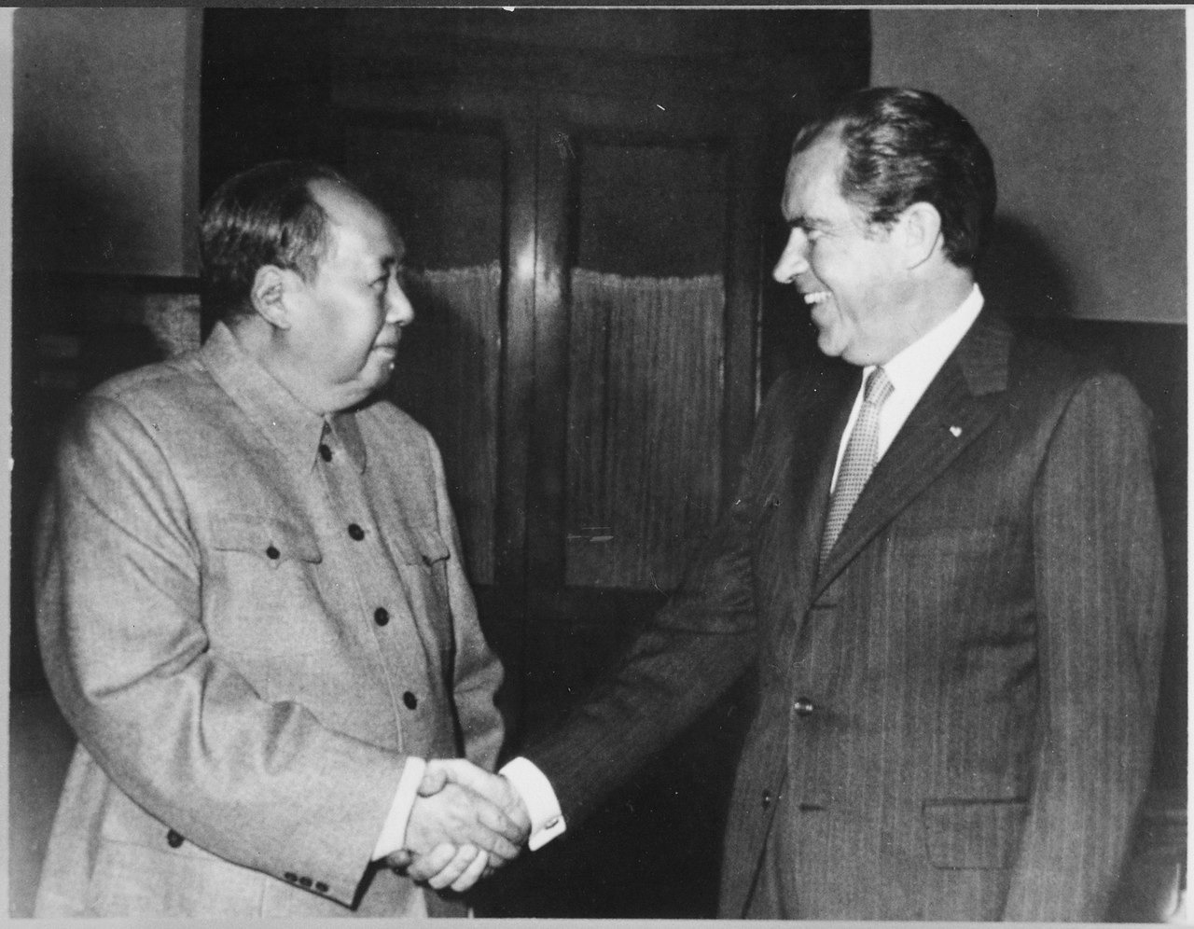
President Nixon Meets with Chairman Mao Zedong, Beijing (February 21, 1972) · Nixon White House Photographic Office · February 21, 1972
Source: Nixon White House Photographic Office. "President Nixon Meets with Chairman Mao Zedong, Beijing." 21 Feb. 1972. National Archives and Records Administration (NARA 194759), via Wikimedia Commons, commons.wikimedia.org/wiki/File:President_Nixon_meets_with_China%27s_Communist_Party_Leader,_Mao_Tse-_Tung,_02-29-1972_-_NARA_-_194759.tif. Public Domain https://commons.wikimedia.org/wiki/File:President_Nixon_meets_with_China%27s_Communist_Party_Leader,_Mao_Tse-_Tung,_02-29-1972_-_NARA_-_194759.tif
HIPPO — analyze the source (prompt) | Your analysis
H — Historical context: what was happening when this was created?
I — Intended audience: who was meant to see or obey it?
P — Purpose: why was it created?
P — Point of view: whose perspective does it reflect?
O — Outside connection: how does it connect to this standard?
SUPPORT OPTION
Sentence frame: This source shows ______ because it ______, which reveals ______.
CONFIDENCE CHECK-IN
Rate your understanding of this standard (1–4): ______ One thing to revisit: ____________________

Activity 6 — Core Application: Practice Quiz — US.85 ⏱ ~8 min
RESPONSE CHOICE
Commit to an answer by marking it, saying it, or explaining it aloud before checking. Answer key is in the Teacher Guide (kept separate).
[DOK 2 · item q-us86-3 · pre-field-test]
Why was President Ford's pardon of Nixon controversial among the American public?
A. Many citizens believed Nixon should face criminal prosecution for crimes
B. The Supreme Court ruled the pardon was unconstitutional but unenforceable
C. The pardon was issued without congressional approval as required by law
D. Nixon publicly rejected the pardon and demanded a trial for innocence
[DOK 2 · item q-us86-5 · pre-field-test]
What important constitutional principle did the Supreme Court establish in United States v. Nixon?
A. He resigned from office before the House could vote on impeachment
B. The president is not above the law and must comply with court orders
C. It demonstrated how the press could serve as a check on government
D. A break-in at Democratic headquarters and a presidential cover-up
[DOK 3 · item u1-us85-dok3-tc · pre-field-test]
How did Nixon's "Silent Majority" strategy reshape American political campaigns and voter appeals?
A. The Silent Majority strategy had no lasting political impact, which represents a common misconception about the period despite the fact that multiple contemporary sources contradict this
B. Nixon only appealed to wealthy voters, which ignores key developments that shaped the outcome and does not reflect the scholarly consensus on this topic
C. It appealed to middle-class voters frustrated with protests and counterculture, winning working-class Democrats and reshaping Republican electoral strategy for decades
D. The strategy focused exclusively on young voters, though this interpretation lacks supporting historical evidence when examined alongside the available primary and secondary sources

Activity 7 — Constructed Response (CER) — US.85 ⏱ ~15 min
BIG-QUESTION ORGANIZER — how did Americans fight to make the promise of equality real, and what did it take to change the law and the nation?
Jot quick notes from THIS standard: Who benefited? · Who bore the costs? · Who decided?

CONSTRUCTED RESPONSE (CER) — builds SSP.04 Argumentation
Claim + Evidence + Reasoning: Using this standard, take a position on the central question — explain significant achievements of President Richard Nixon's administration, including his appeal to the "silent majority" and his major foreign policy actions? Support your claim with two pieces of evidence from the passage and explain your reasoning.
Part | Write here
Claim
Evidence (two specifics)
Reasoning
SELF-CHECK (CER rubric — see Toolkit)
Is my claim defensible? · TWO specific pieces of evidence? · Does my reasoning explain HOW the evidence proves the claim?
EXIT TICKET — before you leave [item us85-q1 · DOK 2 · pre-field-test]
What were Nixon's most significant domestic and foreign policy achievements during his presidency?
A. He created the EPA, opened relations with China, pursued détente with the USSR, and signed SALT I, while domestically supporting Title IX and the 26th Amendment
B. Nixon had no significant achievements due to Watergate, although this overlooks critical economic and social factors despite the fact that multiple contemporary sources contradict this
C. Nixon focused exclusively on the Vietnam War, although historical sources do not support this conclusion, and this view has been largely revised by modern historical research
D. His only achievement was ending the gold standard, which contradicts the primary source evidence from this era when examined alongside the available primary and secondary sources
Show what you know (your choice): mark the best answer, say it, or explain it — then rate how sure you are: ☐ Not yet ☐ Getting there ☐ Got it
Answer key and next steps are in the Teacher Guide.

Standard US.86 — Watergate Scandal
TN Academic Standard US.86: Examine the Watergate scandal, including: Background of the break-in, Changing role of media and journalism, Controversy surrounding President Gerald Ford's pardon, Legacy of distrust, United States v. Nixon.
LEARNING TARGETS — I can…
• I can examine the Watergate scandal, including the background of the break-in, the changing role of media, President Ford's pardon controversy, the legacy of distrust, and United States v. Nixon.
Lenses for this standard: Politics/Government · Culture · History
CORE PATH — the same for every student
Same rigor for everyone: analyze the sources and vocabulary, then show what you learned on the Practice Quiz and the CER.
UDL and MTSS give you flexible ways in — they never lower the bar.
Check yourself against the learning targets on the Cornell Notes page.
★ Tennessee Connection
Senator Howard Baker of Tennessee served as vice chairman of the Senate Watergate Committee. His persistent questioning during televised hearings made him a national figure and demonstrated Tennessee's role in this constitutional crisis.
SET YOUR GOAL (self-direction)
My goal for this standard — what will I be able to do, and how will I show it?

HOOK — think before you dig in
Watergate Scandal: Examine the Watergate scandal, including: Background of the break-in, Changing role of media and journalism, Controversy surrounding President Gerald Ford's pardon, Legacy of distrust, United States v. Nixon. Who gained, who was left out — and why does it still matter?

ACTIVATE — what do you already know or wonder?
Jot what you already know or want to find out about this standard. You’ll come back to it.

PREVIEW & PREDICT
Which learning target will be hardest, and why? Connect it to the unit’s big question: how did people change the law and the nation, and what did it cost?

Activity 1 — Vocabulary (Part A: Reference / Word Bank) — US.86 ⏱ ~10 min
Use this word bank throughout the standard. The Spanish column supports access, not translation of assessment.
Term | Student-friendly meaning | Spanish
Watergate Scandal | A political scandal beginning with a 1972 break-in at Democratic headquarters that exposed abuses of power and forced Nixon to resign in 1974. | Escándalo de Watergate
United States v. Nixon | A 1974 Supreme Court ruling that the president is not above the law and must release the Watergate tapes. | Estados Unidos vs. Nixon
Executive Privilege | A president's claimed right to keep some communications secret — rejected by the Court in the Watergate tapes case. | Privilegio Ejecutivo
Ford's Pardon of Nixon | President Gerald Ford's 1974 decision to pardon Nixon for any crimes, a choice that deepened public distrust of government. | Indulto de Ford a Nixon
Impeachment | The constitutional process for charging a president with serious wrongdoing; Nixon resigned before the House could impeach him. | Juicio Político
Investigative Journalism | In-depth reporting — like the Washington Post's Watergate coverage — that uncovers hidden wrongdoing by those in power. | Periodismo de Investigación
LANGUAGE SUPPORT
Pronunciations: Watergate Scandal (WAW-ter-gayt SKAN-dul); United States v. Nixon (yoo-NY-ted stayts VER-sus NIK-sun); Executive Privilege (eg-ZEK-yoo-tiv PRIV-ul-ij); Ford's Pardon of Nixon (fordz PAR-dun); Impeachment (im-PEECH-ment); Investigative Journalism (in-VES-tih-gay-tiv JUR-nul-izm).

VOCABULARY SELF-CHECK · Knowledge Rating
Rate each term NOW in pencil, then again at the END — growth is the goal; no penalty for “never seen it.”
Term | 1 · never seen it | 2 · heard it | 3 · can use it | 4 · can teach it
Watergate Scandal
United States v. Nixon
Executive Privilege
Ford's Pardon of Nixon
Impeachment
Investigative Journalism
MAKE IT YOURS (RESPONSE CHOICE): choose ONE term above and show you own it — write a sentence, sketch it, or give a real-world example.

Activity 2 — Vocabulary Studio (Frayer-inspired) — US.86 ⏱ ~7 min
RESPONSE CHOICE
Complete each studio by writing, speaking, or diagramming.

PRIORITY TERM 1 Watergate Scandal · ES: Escándalo de Watergate
Word-bank meaning to build on: A political scandal beginning with a 1972 break-in at Democratic headquarters that exposed abuses of power and forced Nixon to resign in 1974.
Definition (in your own words) | Characteristics
Examples | Non-examples
Use it to explain
Write one sentence that uses “Watergate Scandal” to explain this standard.

PRIORITY TERM 2 United States v. Nixon · ES: Estados Unidos vs. Nixon
Word-bank meaning to build on: A 1974 Supreme Court ruling that the president is not above the law and must release the Watergate tapes.
Definition (in your own words) | Characteristics
Examples | Non-examples
Use it to explain
Write one sentence that uses “United States v. Nixon” to explain this standard.

CONNECT THE TERMS (UDL · build understanding)
How do these priority terms fit together? Write or sketch how one leads to or affects another.

Activity 3 — Direct Teaching Cornell Notes — US.86 ⏱ ~20 min
Name: ______________________ Class / Period: __________ Date: __________
US.86 — Watergate Scandal • These notes capture the direct-teaching content and the Close Read for this standard.
Your learning targets are on this standard’s opening page — take notes that help you meet them.
Cues (tied to your learning targets) | My notes
What does the passage say about the Break-in Circumstances?
What does the passage say about media's Changing Role?
What does the passage say about united States v. Nixon?
Key terms →
DOODLE ZONE — draw your thinking (UDL · another way in)
Need another way in? Sketch the key idea, a quick timeline, or how the pieces connect. Words optional.

Cornell Notes — keep going, then process & check — US.86
MORE NOTES / DIAGRAMS
Continue your notes here, add a quick sketch, or map how the ideas connect.

Key terms to list
Watergate Scandal · United States v. Nixon · Executive Privilege · Ford's Pardon of Nixon · Impeachment · Investigative Journalism
Summary — In your own words (2–3 sentences)
PROGRESS CHECK · one question
How did investigative journalism during Watergate change the relationship between media and government?
A. Media coverage had no significant impact on Watergate, which ignores key developments that shaped the outcome and fails to account for key developments in the broader context
B. The media supported Nixon throughout the scandal, but the historical record tells a more complex story when examined alongside the available primary and secondary sources
C. Journalism became less important after Watergate, which does not align with the documented historical record despite the fact that multiple contemporary sources contradict this
D. Woodward and Bernstein's persistent investigation demonstrated media's power to hold government accountable, establishing investigative journalism as crucial to democracy
Commit before you move on — mark it, say it, or explain it aloud.
CHECK YOURSELF — how am I doing?
Which learning targets (on this standard’s opening page) can you now meet? Tick the number; circle any you still need help with.
☐ 1
My 12–15 word headline for this standard

Activity 4 — Close Read — US.86 ⏱ ~15 min
Reading type: History Hack-authored instructional synthesis. This is not a primary source. Builds SSP.03 (synthesize) and SSP.05 (historical awareness).
CORE PATH — read one chunk at a time
The Break-in Circumstances
On June 17, 1972, five men were arrested breaking into Democratic National Committee headquarters at the Watergate complex. Initial investigations revealed connections to Nixon's reelection campaign (CREEP) and White House officials, suggesting political espionage rather than simple burglary. The cover-up that followed would prove more damaging than the original crime.
Media's Changing Role
Washington Post reporters Bob Woodward and Carl Bernstein conducted persistent investigative journalism, following money trails and cultivating sources (including "Deep Throat," later revealed as FBI Deputy Director Mark Felt). Television coverage brought congressional hearings into American homes, demonstrating media's power to hold government accountable and establishing investigative journalism as a crucial democratic institution.
United States v. Nixon
The Supreme Court unanimously ruled that executive privilege couldn't override judicial subpoenas for criminal proceedings. Nixon had to surrender White House tapes to prosecutors. This landmark decision established limits on presidential power and affirmed that no one, including the president, is above the law—a fundamental principle of American constitutional government.
Ford's Pardon and Legacy of Distrust
President Ford's unconditional pardon of Nixon (September 1974) sparked outrage among Americans seeking accountability. Supporters argued it was necessary to heal the nation; critics claimed it established double standards of justice. Watergate fundamentally altered Americans' relationship with government, creating lasting cynicism. Public trust fell from 73% in 1958 to 36% by 1974, influencing political culture for generations.
Key terms first: Watergate Scandal, United States v. Nixon. Read once for the gist, then again for evidence.
CLOSE-READ EVIDENCE LAB — for each question: quote the EVIDENCE from the passage above, then write YOUR ANSWER (or answer aloud / diagram it).
Text-dependent question | Evidence from the passage | Your answer (what it shows)
What is the main idea of the “The Break-in Circumstances” section, and what evidence supports it?
What is the main idea of the “Media's Changing Role” section, and what evidence supports it?
What is the main idea of the “United States v. Nixon” section, and what evidence supports it?

Activity 5 — Primary Source / Data Analysis — US.86 ⏱ ~15 min
Primary source (photograph) — analyze it with HIPPO. Builds SSP.01–SSP.02.
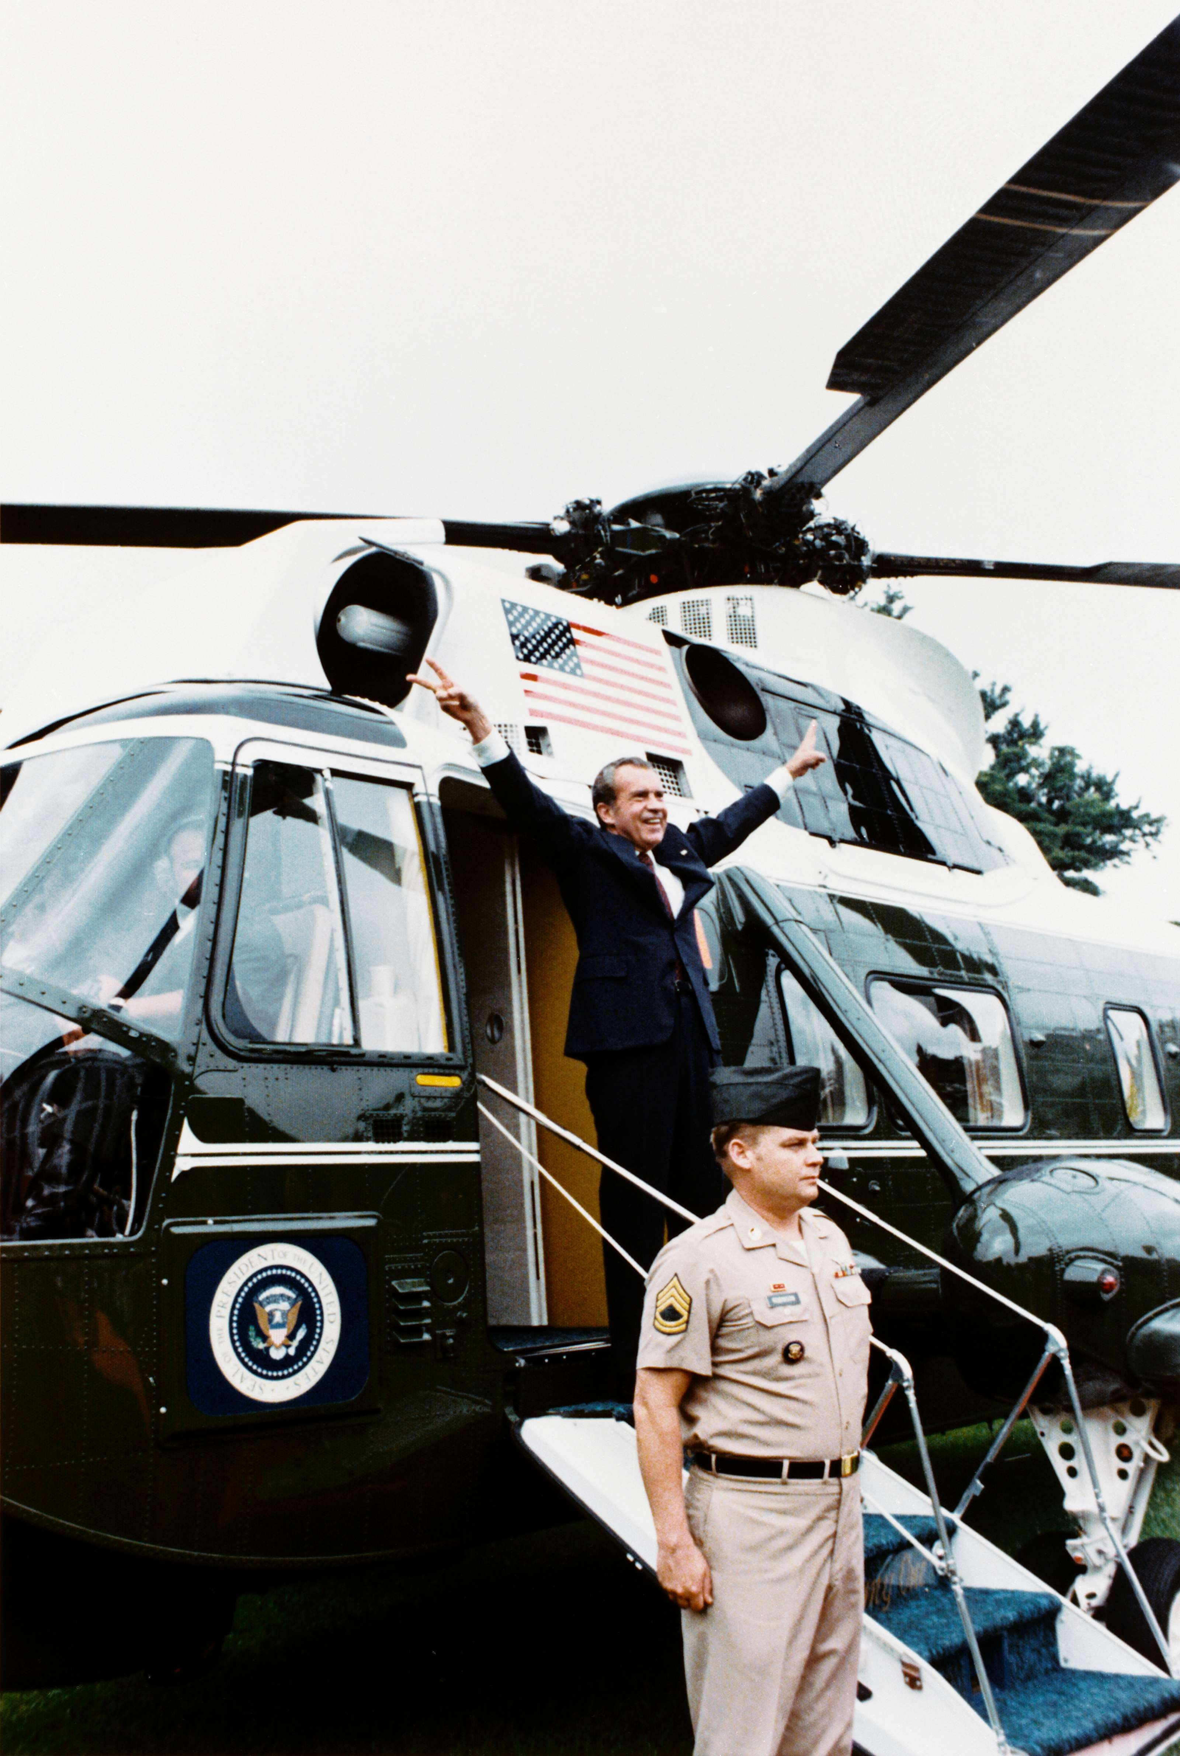
President Nixon Departing the White House After Resignation (August 9, 1974) · Ollie Atkins, White House Chief Photographer · August 9, 1974
Source: Atkins, Ollie. "President Nixon Departing the White House After Resignation." 9 Aug. 1974. Executive Office of the President / White House, via Wikimedia Commons, commons.wikimedia.org/wiki/File:Nixon-depart.png. Public Domain https://commons.wikimedia.org/wiki/File:Nixon-depart.png
HIPPO — analyze the source (prompt) | Your analysis
H — Historical context: what was happening when this was created?
I — Intended audience: who was meant to see or obey it?
P — Purpose: why was it created?
P — Point of view: whose perspective does it reflect?
O — Outside connection: how does it connect to this standard?
SUPPORT OPTION
Sentence frame: This source shows ______ because it ______, which reveals ______.
CONFIDENCE CHECK-IN
Rate your understanding of this standard (1–4): ______ One thing to revisit: ____________________

Activity 6 — Core Application: Practice Quiz — US.86 ⏱ ~8 min
RESPONSE CHOICE
Commit to an answer by marking it, saying it, or explaining it aloud before checking. Answer key is in the Teacher Guide (kept separate).
[DOK 2 · item q-us86-4 · pre-field-test]
How did the Watergate scandal influence the role of investigative journalism?
A. It demonstrated how the press could serve as a check on government
B. It led Congress to pass laws restricting media coverage of politics
C. It caused newspapers to avoid investigating political scandals entirely
D. It reduced public trust in journalism and decreased newspaper sales
[DOK 2 · item q-us86-add-4 · pre-field-test]
How did Watergate change Americans' relationship with their government?
A. It ruled that the president must comply with subpoenas and is not above the law
B. It created a lasting legacy of distrust in government and political institutions
C. A break-in at Democratic headquarters and Nixon's cover-up that led to his resignation
D. He believed putting the interests of America first required his departure
[DOK 3 · item u1-us86-dok3-tc · pre-field-test]
How did investigative journalism during Watergate change the relationship between media and government?
A. Media coverage had no significant impact on Watergate, which ignores key developments that shaped the outcome and fails to account for key developments in the broader context
B. The media supported Nixon throughout the scandal, but the historical record tells a more complex story when examined alongside the available primary and secondary sources
C. Journalism became less important after Watergate, which does not align with the documented historical record despite the fact that multiple contemporary sources contradict this
D. Woodward and Bernstein's persistent investigation demonstrated media's power to hold government accountable, establishing investigative journalism as crucial to democracy

Activity 7 — Constructed Response (CER) — US.86 ⏱ ~15 min
BIG-QUESTION ORGANIZER — how did Americans fight to make the promise of equality real, and what did it take to change the law and the nation?
Jot quick notes from THIS standard: Who benefited? · Who bore the costs? · Who decided?

CONSTRUCTED RESPONSE (CER) — builds SSP.04 Argumentation
Claim + Evidence + Reasoning: Using this standard, take a position on the central question — examine the Watergate scandal, including the background of the break-in, the changing role of media, President Ford's pardon controversy, the legacy of distrust, and United States v. Nixon? Support your claim with two pieces of evidence from the passage and explain your reasoning.
Part | Write here
Claim
Evidence (two specifics)
Reasoning
SELF-CHECK (CER rubric — see Toolkit)
Is my claim defensible? · TWO specific pieces of evidence? · Does my reasoning explain HOW the evidence proves the claim?
EXIT TICKET — before you leave [item us86-q1 · DOK 2 · pre-field-test]
What evidence connected the Watergate break-in to President Nixon's administration?
A. No evidence ever connected Nixon to Watergate, although this view has been largely discredited by scholars
B. Investigations revealed connections between the burglars, CREEP, and White House officials, with Nixon caught on tape discussing the cover-up
C. Only one low-level staffer was involved, despite the fact that multiple sources contradict this view, but the historical evidence paints a more nuanced picture
D. The break-in was conducted by Democratic operatives, but this fails to account for the broader historical context
Show what you know (your choice): mark the best answer, say it, or explain it — then rate how sure you are: ☐ Not yet ☐ Getting there ☐ Got it
Answer key and next steps are in the Teacher Guide.

Standard US.87 — Emergence of Environmentalism
TN Academic Standard US.87: Explain the emergence of environmentalism, including the creation of the Environmental Protection Agency and disasters such as Love Canal and Three Mile Island.
LEARNING TARGETS — I can…
• I can explain the emergence of environmentalism, including the creation of the Environmental Protection Agency and disasters such as Love Canal and Three Mile Island.
Lenses for this standard: Culture · Economics · History
CORE PATH — the same for every student
Same rigor for everyone: analyze the sources and vocabulary, then show what you learned on the Practice Quiz and the CER.
UDL and MTSS give you flexible ways in — they never lower the bar.
Check yourself against the learning targets on the Cornell Notes page.
★ Tennessee Connection
Tennessee was at the center of environmental debates. The Tellico Dam controversy (1970s) pitted the TVA against environmentalists trying to protect the endangered snail darter fish, leading to a landmark Supreme Court case (TVA v. Hill, 1978) and congressional intervention. This case became a defining moment in the Endangered Species Act's history.
SET YOUR GOAL (self-direction)
My goal for this standard — what will I be able to do, and how will I show it?

HOOK — think before you dig in
Emergence of Environmentalism: Explain the emergence of environmentalism, including the creation of the Environmental Protection Agency and disasters such as Love Canal and Three Mile Island. Who gained, who was left out — and why does it still matter?

ACTIVATE — what do you already know or wonder?
Jot what you already know or want to find out about this standard. You’ll come back to it.

PREVIEW & PREDICT
Which learning target will be hardest, and why? Connect it to the unit’s big question: how did people change the law and the nation, and what did it cost?

Activity 1 — Vocabulary (Part A: Reference / Word Bank) — US.87 ⏱ ~10 min
Use this word bank throughout the standard. The Spanish column supports access, not translation of assessment.
Term | Student-friendly meaning | Spanish
Environmentalism | A movement that grew in the 1960s-70s to protect nature and public health from pollution and industrial harm. | Ambientalismo
Environmental Protection Agency (EPA) | The federal agency created in 1970 to set and enforce standards for clean air, water, and land. | Agencia de Protección Ambiental
Earth Day | First held April 22, 1970, a nationwide event that raised public awareness and support for protecting the environment. | Día de la Tierra
Love Canal | A New York neighborhood built on buried toxic waste; its 1978 health crisis spurred federal cleanup laws like Superfund. | Love Canal
Three Mile Island | A 1979 partial nuclear meltdown in Pennsylvania that heightened fears about nuclear power safety. | Three Mile Island
Clean Air Act | A landmark law (expanded 1970) authorizing the federal government to limit air pollution from industry and vehicles. | Ley de Aire Limpio
LANGUAGE SUPPORT
Pronunciations: Environmentalism (en-vy-run-MEN-tul-izm); Environmental Protection Agency (EPA) (en-vy-run-MEN-tul pro-TEK-shun); Earth Day (URTH day); Love Canal (luv kuh-NAL); Three Mile Island (three myl EYE-lund); Clean Air Act (kleen AIR akt).

VOCABULARY SELF-CHECK · Knowledge Rating
Rate each term NOW in pencil, then again at the END — growth is the goal; no penalty for “never seen it.”
Term | 1 · never seen it | 2 · heard it | 3 · can use it | 4 · can teach it
Environmentalism
Environmental Protection Agency (EPA)
Earth Day
Love Canal
Three Mile Island
Clean Air Act
MAKE IT YOURS (RESPONSE CHOICE): choose ONE term above and show you own it — write a sentence, sketch it, or give a real-world example.

Activity 2 — Vocabulary Studio (Frayer-inspired) — US.87 ⏱ ~7 min
RESPONSE CHOICE
Complete each studio by writing, speaking, or diagramming.

PRIORITY TERM 1 Environmentalism · ES: Ambientalismo
Word-bank meaning to build on: A movement that grew in the 1960s-70s to protect nature and public health from pollution and industrial harm.
Definition (in your own words) | Characteristics
Examples | Non-examples
Use it to explain
Write one sentence that uses “Environmentalism” to explain this standard.

PRIORITY TERM 2 Environmental Protection Agency (EPA) · ES: Agencia de Protección Ambiental
Word-bank meaning to build on: The federal agency created in 1970 to set and enforce standards for clean air, water, and land.
Definition (in your own words) | Characteristics
Examples | Non-examples
Use it to explain
Write one sentence that uses “Environmental Protection Agency (EPA)” to explain this standard.

CONNECT THE TERMS (UDL · build understanding)
How do these priority terms fit together? Write or sketch how one leads to or affects another.

Activity 3 — Direct Teaching Cornell Notes — US.87 ⏱ ~20 min
Name: ______________________ Class / Period: __________ Date: __________
US.87 — Emergence of Environmentalism • These notes capture the direct-teaching content and the Close Read for this standard.
Your learning targets are on this standard’s opening page — take notes that help you meet them.
Cues (tied to your learning targets) | My notes
What does the passage say about factors Leading to the Environmental Movement?
What does the passage say about ePA's Purpose and Functions?
What does the passage say about love Canal Disaster?
Key terms →
DOODLE ZONE — draw your thinking (UDL · another way in)
Need another way in? Sketch the key idea, a quick timeline, or how the pieces connect. Words optional.

Cornell Notes — keep going, then process & check — US.87
MORE NOTES / DIAGRAMS
Continue your notes here, add a quick sketch, or map how the ideas connect.

Key terms to list
Environmentalism · Environmental Protection Agency (EPA) · Earth Day · Love Canal · Three Mile Island · Clean Air Act
Summary — In your own words (2–3 sentences)
PROGRESS CHECK · one question
What lessons did Love Canal and Three Mile Island teach Americans about industrial and nuclear safety?
A. Love Canal showed toxic waste dangers leading to Superfund, while Three Mile Island raised nuclear safety fears that halted reactor construction
B. These incidents had no lasting policy impact, but this oversimplifies the complex factors at work and oversimplifies the complex factors at work during this period
C. Both incidents proved industrial practices were completely safe, which does not align with the documented historical record
D. Only Love Canal affected environmental policy, although this overlooks critical economic and social factors
Commit before you move on — mark it, say it, or explain it aloud.
CHECK YOURSELF — how am I doing?
Which learning targets (on this standard’s opening page) can you now meet? Tick the number; circle any you still need help with.
☐ 1
My 12–15 word headline for this standard

Activity 4 — Close Read — US.87 ⏱ ~15 min
Reading type: History Hack-authored instructional synthesis. This is not a primary source. Builds SSP.03 (synthesize) and SSP.05 (historical awareness).
CORE PATH — read one chunk at a time
Factors Leading to the Environmental Movement
Several factors sparked environmental awareness: Rachel Carson's "Silent Spring" (1962) exposed pesticide dangers and their ecological impact. Visible pollution plagued cities with smog, rivers with contamination, and coastlines with oil spills. Earth Day 1970 brought massive public demonstrations supporting environmental protection. Growing scientific understanding of ecological interconnections raised alarm about long-term consequences.
EPA's Purpose and Functions
Created in 1970, the Environmental Protection Agency consolidated federal environmental responsibilities. Functions include setting pollution standards, enforcing environmental laws, conducting research, and regulating toxic substances. The EPA marked the federal government's commitment to environmental protection as a national priority, establishing America's framework for environmental regulation.
Love Canal Disaster
In Niagara Falls, New York, a school and homes were built on a former chemical waste dump. By the 1970s, residents experienced high rates of birth defects and cancer. The federal government relocated 239 families and declared the area uninhabitable. This disaster led to the Superfund program for cleaning up toxic waste sites, demonstrating the long-term consequences of industrial pollution.
Three Mile Island Accident
The 1979 nuclear accident in Pennsylvania involved partial reactor meltdown, radiation release, and evacuation recommendations. While health impacts were limited, the incident heightened public fears about nuclear power safety, effectively ending nuclear plant construction in the United States for decades and strengthening arguments for alternative energy sources.
Key terms first: Environmentalism, Environmental Protection Agency (EPA). Read once for the gist, then again for evidence.
CLOSE-READ EVIDENCE LAB — for each question: quote the EVIDENCE from the passage above, then write YOUR ANSWER (or answer aloud / diagram it).
Text-dependent question | Evidence from the passage | Your answer (what it shows)
What is the main idea of the “Factors Leading to the Environmental Movement” section, and what evidence supports it?
What is the main idea of the “EPA's Purpose and Functions” section, and what evidence supports it?
What is the main idea of the “Love Canal Disaster” section, and what evidence supports it?

Activity 5 — Primary Source / Data Analysis — US.87 ⏱ ~15 min
Primary source (photograph) — analyze it with HIPPO. Builds SSP.01–SSP.02.
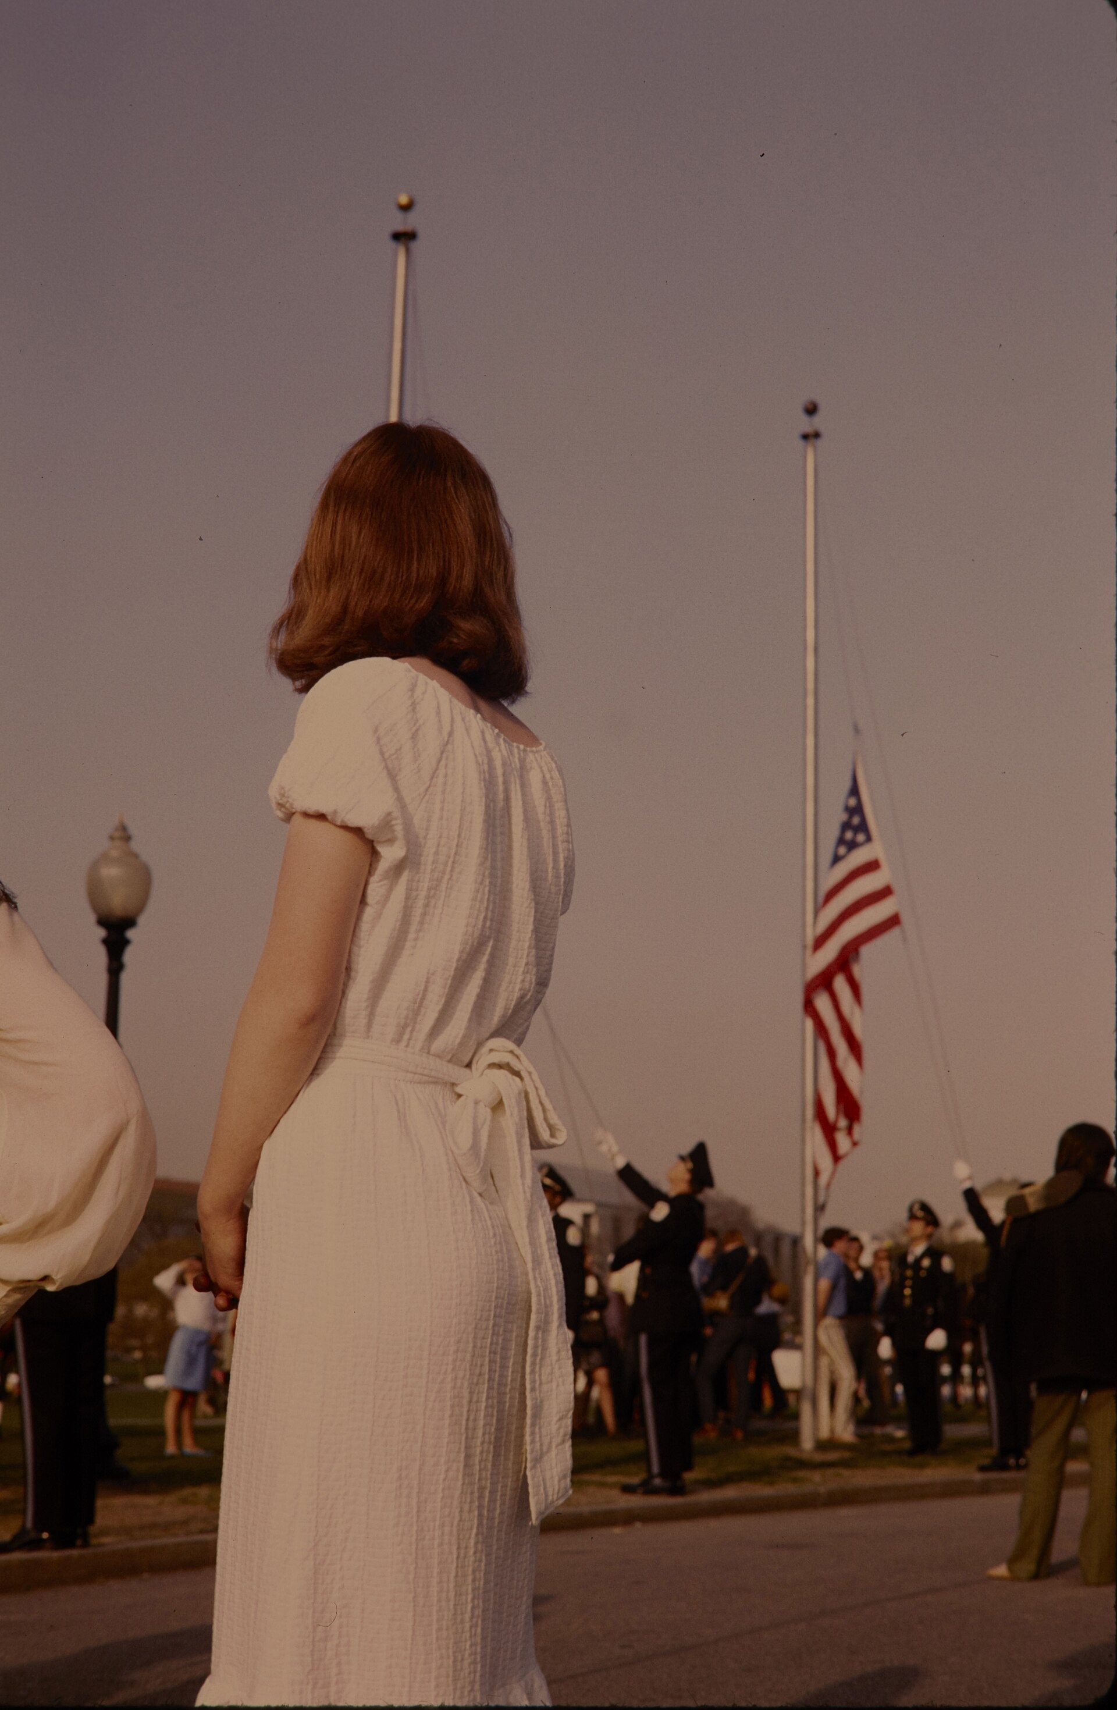
Earth Day Flag Ceremony at the Washington Monument, National Capital Region (April 22, 1970) · Cecil W. Stoughton, U.S. National Park Service · April 22, 1970
Source: Stoughton, Cecil W., U.S. National Park Service. "Earth Day Flag Ceremony at the Washington Monument." 22 Apr. 1970. U.S. National Park Service (NPGallery), via Wikimedia Commons, commons.wikimedia.org/wiki/File:Demonstrations._Flag_raising_at_the_National_Capital_Region_Earth_Day_flag_ceremony_at_the_Washington_Monument._(b478598b4bb140b6a4ff6e61b7a0226c).jpg. Public Domain https://commons.wikimedia.org/wiki/File:Demonstrations._Flag_raising_at_the_National_Capital_Region_Earth_Day_flag_ceremony_at_the_Washington_Monument._(b478598b4bb140b6a4ff6e61b7a0226c).jpg
HIPPO — analyze the source (prompt) | Your analysis
H — Historical context: what was happening when this was created?
I — Intended audience: who was meant to see or obey it?
P — Purpose: why was it created?
P — Point of view: whose perspective does it reflect?
O — Outside connection: how does it connect to this standard?
SUPPORT OPTION
Sentence frame: This source shows ______ because it ______, which reveals ______.
CONFIDENCE CHECK-IN
Rate your understanding of this standard (1–4): ______ One thing to revisit: ____________________

Activity 6 — Core Application: Practice Quiz — US.87 ⏱ ~8 min
RESPONSE CHOICE
Commit to an answer by marking it, saying it, or explaining it aloud before checking. Answer key is in the Teacher Guide (kept separate).
[DOK 2 · item us87-q2 · pre-field-test]
How did the creation of the EPA change the federal government's role in environmental protection?
A. It consolidated federal environmental responsibilities, established pollution standards, and made environmental protection a national priority
B. The EPA had no significant impact on environmental policy, which does not align with the documented historical record
C. The EPA only advised state governments, although this overlooks critical economic and social factors, but the historical evidence paints a more nuanced picture
D. Environmental protection remained entirely a state responsibility, but this oversimplifies the complex factors at work
[DOK 2 · item q-us87-4 · pre-field-test]
Which factors contributed to the emergence of the modern environmental movement?
A. Discovery of new oil reserves and expansion of industrial manufacturing
B. Growing pollution awareness, Rachel Carson's writings, and disasters
C. Government campaigns promoting unlimited economic growth nationwide
D. Declining interest in conservation and reduced national park funding
[DOK 3 · item u1-us87-dok3-tc · pre-field-test]
What lessons did Love Canal and Three Mile Island teach Americans about industrial and nuclear safety?
A. Love Canal showed toxic waste dangers leading to Superfund, while Three Mile Island raised nuclear safety fears that halted reactor construction
B. These incidents had no lasting policy impact, but this oversimplifies the complex factors at work and oversimplifies the complex factors at work during this period
C. Both incidents proved industrial practices were completely safe, which does not align with the documented historical record
D. Only Love Canal affected environmental policy, although this overlooks critical economic and social factors

Activity 7 — Constructed Response (CER) — US.87 ⏱ ~15 min
BIG-QUESTION ORGANIZER — how did Americans fight to make the promise of equality real, and what did it take to change the law and the nation?
Jot quick notes from THIS standard: Who benefited? · Who bore the costs? · Who decided?

CONSTRUCTED RESPONSE (CER) — builds SSP.04 Argumentation
Claim + Evidence + Reasoning: Using this standard, take a position on the central question — explain the emergence of environmentalism, including the creation of the Environmental Protection Agency and disasters such as Love Canal and Three Mile Island? Support your claim with two pieces of evidence from the passage and explain your reasoning.
Part | Write here
Claim
Evidence (two specifics)
Reasoning
SELF-CHECK (CER rubric — see Toolkit)
Is my claim defensible? · TWO specific pieces of evidence? · Does my reasoning explain HOW the evidence proves the claim?
EXIT TICKET — before you leave [item us87-q1 · DOK 2 · pre-field-test]
What factors led to the rise of the environmental movement in the 1960s and 1970s?
A. The environmental movement had no clear causes, yet the available evidence points to a different conclusion, which contradicts the primary source evidence from this era
B. Only government officials supported environmentalism, which does not align with the documented historical record
C. Carson's "Silent Spring," visible pollution, scientific research, and Earth Day demonstrations combined to create widespread environmental awareness
D. Economic growth eliminated environmental concerns, yet the available evidence points to a different conclusion and does not reflect the scholarly consensus on this topic
Show what you know (your choice): mark the best answer, say it, or explain it — then rate how sure you are: ☐ Not yet ☐ Getting there ☐ Got it
Answer key and next steps are in the Teacher Guide.

Standard US.88 — Carter Administration Events
TN Academic Standard US.88: Identify and explain the significant events of President Jimmy Carter's administration, including: Poor economy, Panama Canal Treaty, Camp David Accords, Energy crisis, Iran Hostage Crisis.
LEARNING TARGETS — I can…
• I can identify and explain the significant events of President Jimmy Carter's administration, including the poor economy, Panama Canal Treaty, Camp David Accords, energy crisis, and Iran Hostage Crisis.
Lenses for this standard: Politics/Government · History · Economics
CORE PATH — the same for every student
Same rigor for everyone: analyze the sources and vocabulary, then show what you learned on the Practice Quiz and the CER.
UDL and MTSS give you flexible ways in — they never lower the bar.
Check yourself against the learning targets on the Cornell Notes page.
★ Tennessee Connection
During the Carter administration, Tennessee Senator Howard Baker served as Senate Minority Leader and was a key Republican voice. Jake Butcher, a Tennessee banker, ran for governor and later hosted the 1982 World's Fair in Knoxville — one of the last major World's Fairs held in the United States.
SET YOUR GOAL (self-direction)
My goal for this standard — what will I be able to do, and how will I show it?

HOOK — think before you dig in
Carter Administration Events: Identify and explain the significant events of President Jimmy Carter's administration, including: Poor economy, Panama Canal Treaty, Camp David Accords, Energy crisis, Iran Hostage Crisis. Who gained, who was left out — and why does it still matter?

ACTIVATE — what do you already know or wonder?
Jot what you already know or want to find out about this standard. You’ll come back to it.

PREVIEW & PREDICT
Which learning target will be hardest, and why? Connect it to the unit’s big question: how did people change the law and the nation, and what did it cost?

Activity 1 — Vocabulary (Part A: Reference / Word Bank) — US.88 ⏱ ~10 min
Use this word bank throughout the standard. The Spanish column supports access, not translation of assessment.
Term | Student-friendly meaning | Spanish
Stagflation | An unusual 1970s economy combining high inflation, high unemployment, and slow growth at the same time. | Estanflación
Energy Crisis | 1970s fuel shortages and soaring gas prices, worsened by an OPEC oil embargo, that strained the U.S. economy. | Crisis Energética
Camp David Accords | A 1978 peace agreement between Egypt and Israel brokered by President Carter, a major diplomatic success. | Acuerdos de Camp David
Panama Canal Treaty | Carter-era treaties (1977) agreeing to hand control of the Panama Canal over to Panama by the year 2000. | Tratado del Canal de Panamá
Iran Hostage Crisis | The 1979-81 seizure of 52 Americans at the U.S. embassy in Iran for 444 days, which damaged Carter's presidency. | Crisis de los Rehenes en Irán
Human Rights Diplomacy | Carter's foreign policy of pressuring other nations to respect their citizens' basic rights. | Diplomacia de Derechos Humanos
LANGUAGE SUPPORT
Pronunciations: Stagflation (stag-FLAY-shun); Energy Crisis (EN-er-jee KRY-sis); Camp David Accords (kamp DAY-vid uh-KORDZ); Panama Canal Treaty (PAN-uh-mah kuh-NAL); Iran Hostage Crisis (ih-RAN HOS-tij KRY-sis); Human Rights Diplomacy (HYOO-mun ryts dih-PLOH-muh-see).

VOCABULARY SELF-CHECK · Knowledge Rating
Rate each term NOW in pencil, then again at the END — growth is the goal; no penalty for “never seen it.”
Term | 1 · never seen it | 2 · heard it | 3 · can use it | 4 · can teach it
Stagflation
Energy Crisis
Camp David Accords
Panama Canal Treaty
Iran Hostage Crisis
Human Rights Diplomacy
MAKE IT YOURS (RESPONSE CHOICE): choose ONE term above and show you own it — write a sentence, sketch it, or give a real-world example.

Activity 2 — Vocabulary Studio (Frayer-inspired) — US.88 ⏱ ~7 min
RESPONSE CHOICE
Complete each studio by writing, speaking, or diagramming.

PRIORITY TERM 1 Stagflation · ES: Estanflación
Word-bank meaning to build on: An unusual 1970s economy combining high inflation, high unemployment, and slow growth at the same time.
Definition (in your own words) | Characteristics
Examples | Non-examples
Use it to explain
Write one sentence that uses “Stagflation” to explain this standard.

PRIORITY TERM 2 Energy Crisis · ES: Crisis Energética
Word-bank meaning to build on: 1970s fuel shortages and soaring gas prices, worsened by an OPEC oil embargo, that strained the U.S. economy.
Definition (in your own words) | Characteristics
Examples | Non-examples
Use it to explain
Write one sentence that uses “Energy Crisis” to explain this standard.

CONNECT THE TERMS (UDL · build understanding)
How do these priority terms fit together? Write or sketch how one leads to or affects another.

Activity 3 — Direct Teaching Cornell Notes — US.88 ⏱ ~20 min
Name: ______________________ Class / Period: __________ Date: __________
US.88 — Carter Administration Events • These notes capture the direct-teaching content and the Close Read for this standard.
Your learning targets are on this standard’s opening page — take notes that help you meet them.
Cues (tied to your learning targets) | My notes
What does the passage say about economic Difficulties?
What does the passage say about energy Crisis Implications?
What does the passage say about panama Canal Treaty?
Key terms →
DOODLE ZONE — draw your thinking (UDL · another way in)
Need another way in? Sketch the key idea, a quick timeline, or how the pieces connect. Words optional.

Cornell Notes — keep going, then process & check — US.88
MORE NOTES / DIAGRAMS
Continue your notes here, add a quick sketch, or map how the ideas connect.

Key terms to list
Stagflation · Energy Crisis · Camp David Accords · Panama Canal Treaty · Iran Hostage Crisis · Human Rights Diplomacy
Summary — In your own words (2–3 sentences)
PROGRESS CHECK · one question
What economic challenges did President Carter face, and why were his solutions unsuccessful?
A. Carter faced no significant economic challenges, although this overlooks critical economic and social factors, and this view has been largely revised by modern historical research
B. Stagflation combined high inflation and unemployment; his voluntary guidelines and monetary tightening proved insufficient against these complex, interconnected problems
C. The economy thrived during Carter's presidency, although historical sources do not support this conclusion and oversimplifies the complex factors at work during this period
D. Carter's policies immediately solved all economic problems, although this overlooks critical economic and social factors, which ignores significant political and cultural developments of the era
Commit before you move on — mark it, say it, or explain it aloud.
CHECK YOURSELF — how am I doing?
Which learning targets (on this standard’s opening page) can you now meet? Tick the number; circle any you still need help with.
☐ 1
My 12–15 word headline for this standard

Activity 4 — Close Read — US.88 ⏱ ~15 min
Reading type: History Hack-authored instructional synthesis. This is not a primary source. Builds SSP.03 (synthesize) and SSP.05 (historical awareness).
CORE PATH — read one chunk at a time
Economic Difficulties
Carter faced "stagflation"—simultaneous high inflation (13.5% by 1980) and unemployment (7.6%). Energy costs soared, interest rates reached 20%, and economic growth stagnated. Carter's response included voluntary wage-price guidelines and Federal Reserve monetary tightening, but these measures proved insufficient to solve the complex economic crisis.
Energy Crisis Implications
Two oil crises (1973-74, 1979) created gas shortages, long lines at stations, and economic disruption. Carter promoted energy conservation, created the Department of Energy, and called for reduced dependence on foreign oil. However, public frustration with gas lines and heating oil costs damaged his political standing and raised questions about American vulnerability to foreign energy suppliers.
Panama Canal Treaty
The 1977 treaties gradually transferred canal control to Panama by 1999, ending American colonial presence in Central America. While strategically sound (the canal was becoming militarily obsolete), the treaties faced fierce domestic opposition from conservatives who viewed them as signs of American weakness and retreat from global commitments.
Iran Hostage Crisis
After the Shah's overthrow in 1979, Iranian revolutionaries seized the U.S. Embassy, holding 52 Americans hostage for 444 days. Carter's failed rescue mission and inability to secure release dominated his presidency's final year, contributing to perceptions of American weakness and his 1980 electoral defeat to Ronald Reagan.
Camp David Accords
Carter mediated 13 days of negotiations between Egypt's Sadat and Israel's Begin, producing a framework for Middle East peace. Egypt recognized Israel and regained the Sinai Peninsula, while Israel withdrew from occupied Egyptian territory. This represented the first Arab-Israeli peace agreement and Carter's greatest foreign policy achievement.
Key terms first: Stagflation, Energy Crisis. Read once for the gist, then again for evidence.
CLOSE-READ EVIDENCE LAB — for each question: quote the EVIDENCE from the passage above, then write YOUR ANSWER (or answer aloud / diagram it).
Text-dependent question | Evidence from the passage | Your answer (what it shows)
What is the main idea of the “Economic Difficulties” section, and what evidence supports it?
What is the main idea of the “Energy Crisis Implications” section, and what evidence supports it?
What is the main idea of the “Panama Canal Treaty” section, and what evidence supports it?

Activity 5 — Primary Source / Data Analysis — US.88 ⏱ ~15 min
Primary source (photograph) — analyze it with HIPPO. Builds SSP.01–SSP.02.
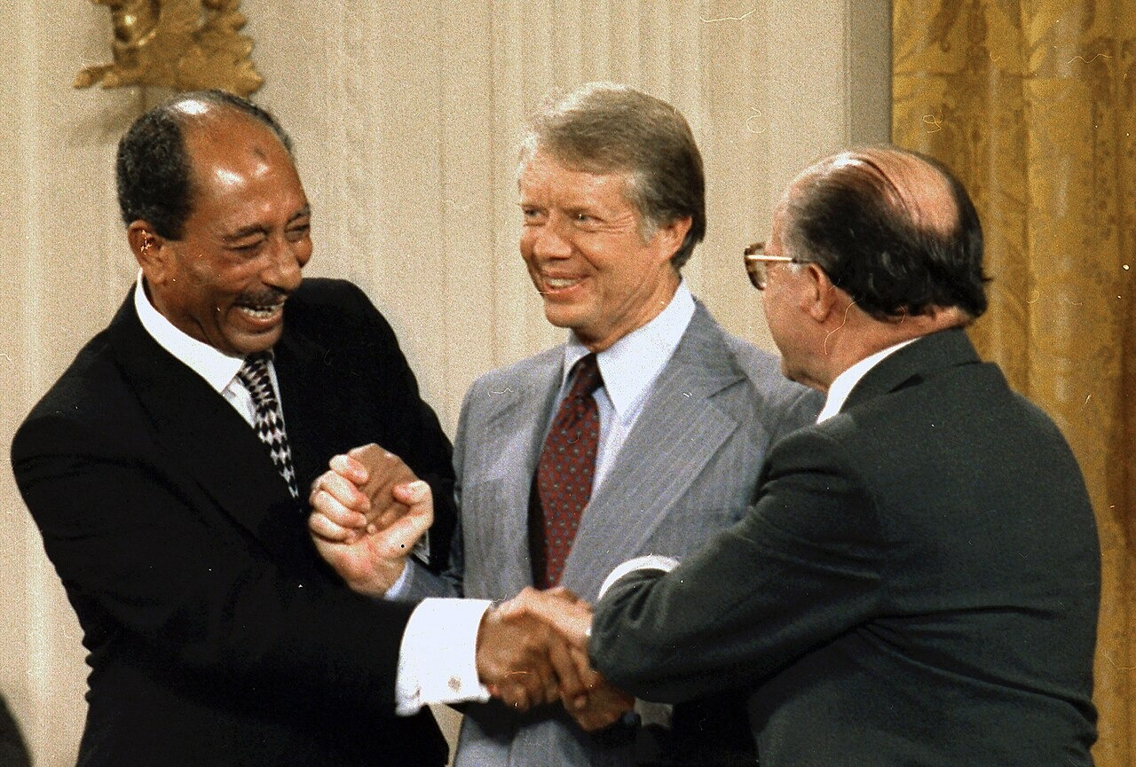
Sadat, Carter, and Begin at Camp David Accords Signing Ceremony (September 17, 1978) · Unknown; U.S. National Archives and Records Administration · September 17, 1978
Source: U.S. National Archives and Records Administration. "Sadat, Carter, and Begin at Camp David Accords Signing Ceremony." 17 Sept. 1978. National Archives and Records Administration, via Wikimedia Commons, commons.wikimedia.org/wiki/File:Anwar_Sadat_Jimmy_Carter_Menachem_Begin_sign_Camp_David_Accords-1978_(cropped).jpg. Public Domain https://commons.wikimedia.org/wiki/File:Anwar_Sadat_Jimmy_Carter_Menachem_Begin_sign_Camp_David_Accords-1978_(cropped).jpg
HIPPO — analyze the source (prompt) | Your analysis
H — Historical context: what was happening when this was created?
I — Intended audience: who was meant to see or obey it?
P — Purpose: why was it created?
P — Point of view: whose perspective does it reflect?
O — Outside connection: how does it connect to this standard?
SUPPORT OPTION
Sentence frame: This source shows ______ because it ______, which reveals ______.
CONFIDENCE CHECK-IN
Rate your understanding of this standard (1–4): ______ One thing to revisit: ____________________

Activity 6 — Core Application: Practice Quiz — US.88 ⏱ ~8 min
RESPONSE CHOICE
Commit to an answer by marking it, saying it, or explaining it aloud before checking. Answer key is in the Teacher Guide (kept separate).
[DOK 2 · item q-us88-4 · pre-field-test]
What was significant about the Panama Canal Treaty signed during Carter's presidency?
A. It agreed to gradually transfer control of the canal to Panama
B. It closed the canal to international shipping for security reasons
C. It expanded permanent United States control over the Canal Zone
D. It transferred canal ownership to an international governing body
[DOK 2 · item q-us88-add-2 · pre-field-test]
What was the Iran Hostage Crisis and how did it affect Carter's presidency?
A. Long gas lines, high energy prices, and a national debate about energy independence
B. Iranian militants held 52 Americans for 444 days, undermining Carter's presidency
C. A peace agreement between Egypt and Israel brokered by President Carter
D. He brokered the first peace agreement between Israel and an Arab nation
[DOK 3 · item u1-us88-dok3-tc · pre-field-test]
What economic challenges did President Carter face, and why were his solutions unsuccessful?
A. Carter faced no significant economic challenges, although this overlooks critical economic and social factors, and this view has been largely revised by modern historical research
B. Stagflation combined high inflation and unemployment; his voluntary guidelines and monetary tightening proved insufficient against these complex, interconnected problems
C. The economy thrived during Carter's presidency, although historical sources do not support this conclusion and oversimplifies the complex factors at work during this period
D. Carter's policies immediately solved all economic problems, although this overlooks critical economic and social factors, which ignores significant political and cultural developments of the era

Activity 7 — Constructed Response (CER) — US.88 ⏱ ~15 min
BIG-QUESTION ORGANIZER — how did Americans fight to make the promise of equality real, and what did it take to change the law and the nation?
Jot quick notes from THIS standard: Who benefited? · Who bore the costs? · Who decided?

CONSTRUCTED RESPONSE (CER) — builds SSP.04 Argumentation
Claim + Evidence + Reasoning: Using this standard, take a position on the central question — identify and explain the significant events of President Jimmy Carter's administration, including the poor economy, Panama Canal Treaty, Camp David Accords, energy crisis, and Iran Hostage Crisis? Support your claim with two pieces of evidence from the passage and explain your reasoning.
Part | Write here
Claim
Evidence (two specifics)
Reasoning
SELF-CHECK (CER rubric — see Toolkit)
Is my claim defensible? · TWO specific pieces of evidence? · Does my reasoning explain HOW the evidence proves the claim?
EXIT TICKET — before you leave [item us88-q2 · DOK 2 · pre-field-test]
How did the energy crises of the 1970s change American attitudes toward foreign oil dependence?
A. The energy crises had no effect on American attitudes, but this oversimplifies the complex factors at work
B. Americans became more dependent on foreign oil, despite the fact that multiple sources contradict this view
C. The crises only affected industrial users, although historical sources do not support this conclusion, but the historical evidence paints a more nuanced picture
D. Gas shortages and price spikes revealed American vulnerability to foreign suppliers, sparking calls for energy independence and conservation
Show what you know (your choice): mark the best answer, say it, or explain it — then rate how sure you are: ☐ Not yet ☐ Getting there ☐ Got it
Answer key and next steps are in the Teacher Guide.

Standard US.89 — Reagan Administration Significance
TN Academic Standard US.89: Analyze the significance of President Ronald Reagan's administration, including: Revitalization of national pride, Reaganomics, Iran-Contra affair, "War on Drugs", Strategic Defense Initiative, AIDS epidemic.
LEARNING TARGETS — I can…
• I can analyze the significance of President Ronald Reagan's administration, including the revitalization of national pride, Reaganomics, Iran-Contra affair, "War on Drugs," Strategic Defense Initiative, and the AIDS epidemic.
Lenses for this standard: Politics/Government · Economics · History
CORE PATH — the same for every student
Same rigor for everyone: analyze the sources and vocabulary, then show what you learned on the Practice Quiz and the CER.
UDL and MTSS give you flexible ways in — they never lower the bar.
Check yourself against the learning targets on the Cornell Notes page.
★ Tennessee Connection
Tennessee Senator Howard Baker served as Ronald Reagan's Chief of Staff (1987-1988). Lamar Alexander served as Reagan's Secretary of Education and later as Tennessee Governor, implementing education reform.
SET YOUR GOAL (self-direction)
My goal for this standard — what will I be able to do, and how will I show it?

HOOK — think before you dig in
Reagan Administration Significance: Analyze the significance of President Ronald Reagan's administration, including: Revitalization of national pride, Reaganomics, Iran-Contra affair, "War on Drugs", Strategic Defense Initiative, AIDS epidemic. Who gained, who was left out — and why does it still matter?

ACTIVATE — what do you already know or wonder?
Jot what you already know or want to find out about this standard. You’ll come back to it.

PREVIEW & PREDICT
Which learning target will be hardest, and why? Connect it to the unit’s big question: how did people change the law and the nation, and what did it cost?

Activity 1 — Vocabulary (Part A: Reference / Word Bank) — US.89 ⏱ ~10 min
Use this word bank throughout the standard. The Spanish column supports access, not translation of assessment.
Term | Student-friendly meaning | Spanish
Reaganomics | President Reagan's economic plan of tax cuts, reduced regulation, and lower domestic spending to spur growth (supply-side economics). | Reaganomía
Supply-Side Economics | The theory behind Reaganomics that cutting taxes on businesses and the wealthy encourages investment and benefits the whole economy. | Economía de la Oferta
Strategic Defense Initiative | Reagan's proposed 1983 space-based missile-defense system, nicknamed 'Star Wars,' to intercept Soviet nuclear attacks. | Iniciativa de Defensa Estratégica
Iran-Contra Affair | A 1980s scandal in which officials secretly sold arms to Iran and used the money to fund rebels in Nicaragua. | Caso Irán-Contra
War on Drugs | Expanded 1980s federal efforts to stop drug use and trafficking through tougher laws and enforcement. | Guerra contra las Drogas
AIDS Epidemic | The public-health crisis of the 1980s from a deadly new disease; the government's slow response drew wide criticism. | Epidemia del SIDA
LANGUAGE SUPPORT
Pronunciations: Reaganomics (ray-gun-OM-iks); Supply-Side Economics (suh-PLY syd ee-kuh-NOM-iks); Strategic Defense Initiative (struh-TEE-jik dee-FENS); Iran-Contra Affair (ih-RAN KON-truh uh-FAIR); War on Drugs (wor on DRUGZ); AIDS Epidemic (aydz ep-ih-DEM-ik).

VOCABULARY SELF-CHECK · Knowledge Rating
Rate each term NOW in pencil, then again at the END — growth is the goal; no penalty for “never seen it.”
Term | 1 · never seen it | 2 · heard it | 3 · can use it | 4 · can teach it
Reaganomics
Supply-Side Economics
Strategic Defense Initiative
Iran-Contra Affair
War on Drugs
AIDS Epidemic
MAKE IT YOURS (RESPONSE CHOICE): choose ONE term above and show you own it — write a sentence, sketch it, or give a real-world example.

Activity 2 — Vocabulary Studio (Frayer-inspired) — US.89 ⏱ ~7 min
RESPONSE CHOICE
Complete each studio by writing, speaking, or diagramming.

PRIORITY TERM 1 Reaganomics · ES: Reaganomía
Word-bank meaning to build on: President Reagan's economic plan of tax cuts, reduced regulation, and lower domestic spending to spur growth (supply-side economics).
Definition (in your own words) | Characteristics
Examples | Non-examples
Use it to explain
Write one sentence that uses “Reaganomics” to explain this standard.

PRIORITY TERM 2 Supply-Side Economics · ES: Economía de la Oferta
Word-bank meaning to build on: The theory behind Reaganomics that cutting taxes on businesses and the wealthy encourages investment and benefits the whole economy.
Definition (in your own words) | Characteristics
Examples | Non-examples
Use it to explain
Write one sentence that uses “Supply-Side Economics” to explain this standard.

CONNECT THE TERMS (UDL · build understanding)
How do these priority terms fit together? Write or sketch how one leads to or affects another.

Activity 3 — Direct Teaching Cornell Notes — US.89 ⏱ ~20 min
Name: ______________________ Class / Period: __________ Date: __________
US.89 — Reagan Administration Significance • These notes capture the direct-teaching content and the Close Read for this standard.
Your learning targets are on this standard’s opening page — take notes that help you meet them.
Cues (tied to your learning targets) | My notes
What does the passage say about strategies for Enhancing National Pride?
What does the passage say about reaganomics Principles and Impacts?
What does the passage say about strategic Defense Initiative?
Key terms →
DOODLE ZONE — draw your thinking (UDL · another way in)
Need another way in? Sketch the key idea, a quick timeline, or how the pieces connect. Words optional.

Cornell Notes — keep going, then process & check — US.89
MORE NOTES / DIAGRAMS
Continue your notes here, add a quick sketch, or map how the ideas connect.

Key terms to list
Reaganomics · Supply-Side Economics · Strategic Defense Initiative · Iran-Contra Affair · War on Drugs · AIDS Epidemic
Summary — In your own words (2–3 sentences)
PROGRESS CHECK · one question
Analyze the economic principles of Reaganomics and evaluate their impact on different groups of Americans.
A. Reaganomics affected all Americans equally, which does not align with the documented historical record, but contemporary accounts and primary sources suggest otherwise
B. Reaganomics eliminated all economic inequality, although historical sources do not support this conclusion and does not reflect the scholarly consensus on this topic
C. Supply-side tax cuts and deregulation promoted growth but increased inequality—wealthy Americans benefited most while social program cuts affected the poor
D. Only poor Americans benefited from Reagan's policies, but this fails to account for the broader historical context, which does not align with the documented historical record
Commit before you move on — mark it, say it, or explain it aloud.
CHECK YOURSELF — how am I doing?
Which learning targets (on this standard’s opening page) can you now meet? Tick the number; circle any you still need help with.
☐ 1
My 12–15 word headline for this standard

Activity 4 — Close Read — US.89 ⏱ ~15 min
Reading type: History Hack-authored instructional synthesis. This is not a primary source. Builds SSP.03 (synthesize) and SSP.05 (historical awareness).
CORE PATH — read one chunk at a time
Strategies for Enhancing National Pride
Reagan restored American confidence through optimistic rhetoric ("Morning in America"), military buildup demonstrating strength, and successful foreign interventions (Grenada). His communication skills and personal charisma helped Americans feel proud of their country again after Vietnam, Watergate, and the Iran hostage crisis had damaged national morale.
Reaganomics Principles and Impacts
Principles: Supply-side economics emphasizing tax cuts, deregulation, and reduced government spending (except defense). Impacts: Economic growth resumed and inflation fell, but income inequality increased and federal deficits soared. Tax cuts primarily benefited wealthy Americans, while social program cuts affected the poor, creating debates about fairness that continue today.
Strategic Defense Initiative
"Star Wars" proposed a space-based missile defense system to protect against nuclear attack. Reagan believed this would make nuclear weapons "impotent and obsolete" while demonstrating American technological superiority. Critics argued it was technologically unfeasible and destabilizing to arms control, though some credit it with pressuring the Soviet Union.
Iran-Contra Affair
The Reagan administration secretly sold arms to Iran to fund Nicaraguan Contras, violating congressional prohibitions. When exposed, it revealed illegal activities, damaged Reagan's credibility, and led to criminal convictions of several officials. The scandal raised questions about presidential knowledge and adherence to constitutional limits on executive power.
AIDS Epidemic Response
Reagan's delayed and inadequate response to AIDS reflected social prejudices and conservative values. The administration initially ignored the crisis, providing minimal funding for research or prevention. This delayed response contributed to the epidemic's spread and thousands of preventable deaths, creating lasting criticism of Reagan's public health leadership.
Key terms first: Reaganomics, Supply-Side Economics. Read once for the gist, then again for evidence.
CLOSE-READ EVIDENCE LAB — for each question: quote the EVIDENCE from the passage above, then write YOUR ANSWER (or answer aloud / diagram it).
Text-dependent question | Evidence from the passage | Your answer (what it shows)
What is the main idea of the “Strategies for Enhancing National Pride” section, and what evidence supports it?
What is the main idea of the “Reaganomics Principles and Impacts” section, and what evidence supports it?
What is the main idea of the “Strategic Defense Initiative” section, and what evidence supports it?

Activity 5 — Primary Source / Data Analysis — US.89 ⏱ ~15 min
Primary source (photograph) — analyze it with HIPPO. Builds SSP.01–SSP.02.
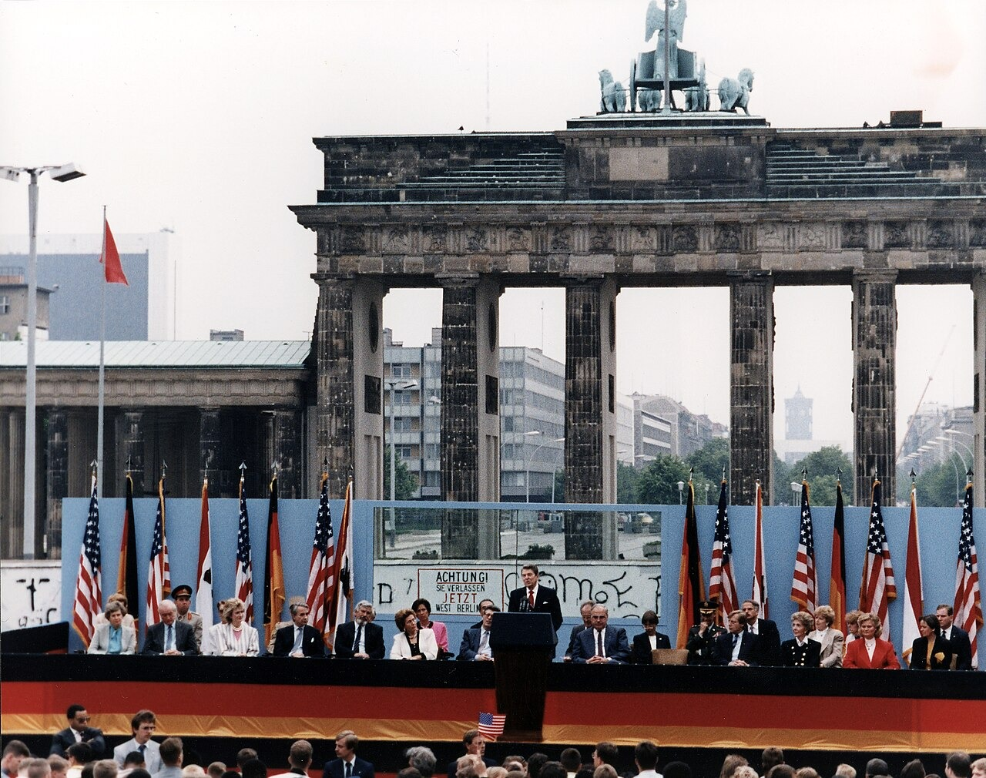
President Reagan Speech at the Berlin Wall, Brandenburg Gate (June 12, 1987) · Reagan White House Photographic Office · June 12, 1987
Source: Reagan White House Photographic Office. "President Reagan Speech at the Berlin Wall, Brandenburg Gate." 12 June 1987. National Archives and Records Administration (NARA 198585), via Wikimedia Commons, commons.wikimedia.org/wiki/File:President_Reagan_giving_a_speech_at_the_Berlin_Wall,_Brandenburg_Gate,_Federal_Republic_of_Germany._June_12,_1987.jpg. Public Domain https://commons.wikimedia.org/wiki/File:President_Reagan_giving_a_speech_at_the_Berlin_Wall,_Brandenburg_Gate,_Federal_Republic_of_Germany._June_12,_1987.jpg
HIPPO — analyze the source (prompt) | Your analysis
H — Historical context: what was happening when this was created?
I — Intended audience: who was meant to see or obey it?
P — Purpose: why was it created?
P — Point of view: whose perspective does it reflect?
O — Outside connection: how does it connect to this standard?
SUPPORT OPTION
Sentence frame: This source shows ______ because it ______, which reveals ______.
CONFIDENCE CHECK-IN
Rate your understanding of this standard (1–4): ______ One thing to revisit: ____________________

Activity 6 — Core Application: Practice Quiz — US.89 ⏱ ~8 min
RESPONSE CHOICE
Commit to an answer by marking it, saying it, or explaining it aloud before checking. Answer key is in the Teacher Guide (kept separate).
[DOK 2 · item us89-q3 · pre-field-test]
What was the Strategic Defense Initiative, and why did it generate controversy?
A. "Star Wars" proposed space-based missile defense; critics questioned its feasibility and worried it would destabilize arms control, while supporters saw it as leverage against the Soviets
B. SDI was a diplomatic initiative with no critics, but this oversimplifies the complex factors at work, but the historical evidence paints a more nuanced picture
C. SDI was fully deployed during Reagan's presidency, though this interpretation lacks supporting historical evidence and fails to account for key developments in the broader context
D. The initiative focused on conventional weapons only, although historical sources do not support this conclusion despite the fact that multiple contemporary sources contradict this
[DOK 2 · item q-us87-add-1 · pre-field-test]
What was the significance of Rachel Carson's book "Silent Spring"?
A. Toxic waste buried under a neighborhood caused illness, leading to Superfund legislation
B. It documented the harmful effects of pesticides and helped launch the environmental movement
C. It allowed politicians to communicate directly with voters and enabled grassroots organizing
D. Many believed Nixon should face trial, and the pardon may have cost Ford the 1976 election
[DOK 3 · item u1-us89-dok3-tc · pre-field-test]
Analyze the economic principles of Reaganomics and evaluate their impact on different groups of Americans.
A. Reaganomics affected all Americans equally, which does not align with the documented historical record, but contemporary accounts and primary sources suggest otherwise
B. Reaganomics eliminated all economic inequality, although historical sources do not support this conclusion and does not reflect the scholarly consensus on this topic
C. Supply-side tax cuts and deregulation promoted growth but increased inequality—wealthy Americans benefited most while social program cuts affected the poor
D. Only poor Americans benefited from Reagan's policies, but this fails to account for the broader historical context, which does not align with the documented historical record

Activity 7 — Constructed Response (CER) — US.89 ⏱ ~15 min
BIG-QUESTION ORGANIZER — how did Americans fight to make the promise of equality real, and what did it take to change the law and the nation?
Jot quick notes from THIS standard: Who benefited? · Who bore the costs? · Who decided?

CONSTRUCTED RESPONSE (CER) — builds SSP.04 Argumentation
Claim + Evidence + Reasoning: Using this standard, take a position on the central question — analyze the significance of President Ronald Reagan's administration, including the revitalization of national pride, Reaganomics, Iran-Contra affair, "War on Drugs," Strategic Defense Initiative, and the AIDS epidemic? Support your claim with two pieces of evidence from the passage and explain your reasoning.
Part | Write here
Claim
Evidence (two specifics)
Reasoning
SELF-CHECK (CER rubric — see Toolkit)
Is my claim defensible? · TWO specific pieces of evidence? · Does my reasoning explain HOW the evidence proves the claim?
EXIT TICKET — before you leave [item us89-q1 · DOK 2 · pre-field-test]
How did Reagan restore American confidence after the challenges of the 1970s?
A. His optimistic rhetoric, military buildup, and personal charisma helped Americans feel proud again after Vietnam, Watergate, and the Iran hostage crisis
B. Reagan had no effect on American morale, but contemporary accounts suggest a different explanation, although historical sources do not support this conclusion
C. Reagan focused only on economic issues, which represents a common misconception about the period, which represents a common misconception about this historical period
D. American confidence declined during his presidency, which represents a common misconception about the period and oversimplifies the complex factors at work during this period
Show what you know (your choice): mark the best answer, say it, or explain it — then rate how sure you are: ☐ Not yet ☐ Getting there ☐ Got it
Answer key and next steps are in the Teacher Guide.

Standard US.90 — George H.W. Bush Administration
TN Academic Standard US.90: Describe the significant events of President George H.W. Bush's administration, including the invasion of Panama and the Gulf War.
LEARNING TARGETS — I can…
• I can describe the significant events of President George H.W. Bush's administration, including the invasion of Panama and the Gulf War.
Lenses for this standard: Politics/Government · History · Geography
CORE PATH — the same for every student
Same rigor for everyone: analyze the sources and vocabulary, then show what you learned on the Practice Quiz and the CER.
UDL and MTSS give you flexible ways in — they never lower the bar.
Check yourself against the learning targets on the Cornell Notes page.
★ Tennessee Connection
During the Bush administration, Tennessee Senator Al Gore ran as the Democratic vice presidential nominee in 1988 before becoming Bill Clinton's running mate in 1992. Tennessee's Fort Campbell deployed troops to the Gulf War as part of Operation Desert Storm.
SET YOUR GOAL (self-direction)
My goal for this standard — what will I be able to do, and how will I show it?

HOOK — think before you dig in
George H.W. Bush Administration: Describe the significant events of President George H.W. Bush's administration, including the invasion of Panama and the Gulf War. Who gained, who was left out — and why does it still matter?

ACTIVATE — what do you already know or wonder?
Jot what you already know or want to find out about this standard. You’ll come back to it.

PREVIEW & PREDICT
Which learning target will be hardest, and why? Connect it to the unit’s big question: how did people change the law and the nation, and what did it cost?

Activity 1 — Vocabulary (Part A: Reference / Word Bank) — US.90 ⏱ ~10 min
Use this word bank throughout the standard. The Spanish column supports access, not translation of assessment.
Term | Student-friendly meaning | Spanish
Persian Gulf War | A 1991 U.S.-led coalition war that drove Iraqi forces out of Kuwait after Iraq's 1990 invasion. | Guerra del Golfo Pérsico
Operation Desert Storm | The 1991 military campaign that quickly liberated Kuwait from Iraqi occupation. | Operación Tormenta del Desierto
Fall of the Berlin Wall | The 1989 opening of the wall dividing East and West Berlin, a symbol of the Cold War's end. | Caída del Muro de Berlín
Collapse of the Soviet Union | The 1991 breakup of the USSR into independent nations, ending the Cold War. | Colapso de la Unión Soviética
Panama Invasion | The 1989 U.S. military action that removed Panamanian dictator Manuel Noriega from power. | Invasión de Panamá
Americans with Disabilities Act | A 1990 law signed by President Bush banning discrimination against people with disabilities. | Ley de Estadounidenses con Discapacidades
LANGUAGE SUPPORT
Pronunciations: Persian Gulf War (PER-zhun gulf WOR); Operation Desert Storm (op-er-AY-shun DEZ-ert storm); Fall of the Berlin Wall (fawl of ber-LIN WAWL); Collapse of the Soviet Union (kuh-LAPS of SOH-vee-et); Panama Invasion (PAN-uh-mah in-VAY-zhun); Americans with Disabilities Act (uh-MER-ih-kunz with dis-uh-BIL-ih-teez).

VOCABULARY SELF-CHECK · Knowledge Rating
Rate each term NOW in pencil, then again at the END — growth is the goal; no penalty for “never seen it.”
Term | 1 · never seen it | 2 · heard it | 3 · can use it | 4 · can teach it
Persian Gulf War
Operation Desert Storm
Fall of the Berlin Wall
Collapse of the Soviet Union
Panama Invasion
Americans with Disabilities Act
MAKE IT YOURS (RESPONSE CHOICE): choose ONE term above and show you own it — write a sentence, sketch it, or give a real-world example.

Activity 2 — Vocabulary Studio (Frayer-inspired) — US.90 ⏱ ~7 min
RESPONSE CHOICE
Complete each studio by writing, speaking, or diagramming.

PRIORITY TERM 1 Persian Gulf War · ES: Guerra del Golfo Pérsico
Word-bank meaning to build on: A 1991 U.S.-led coalition war that drove Iraqi forces out of Kuwait after Iraq's 1990 invasion.
Definition (in your own words) | Characteristics
Examples | Non-examples
Use it to explain
Write one sentence that uses “Persian Gulf War” to explain this standard.

PRIORITY TERM 2 Operation Desert Storm · ES: Operación Tormenta del Desierto
Word-bank meaning to build on: The 1991 military campaign that quickly liberated Kuwait from Iraqi occupation.
Definition (in your own words) | Characteristics
Examples | Non-examples
Use it to explain
Write one sentence that uses “Operation Desert Storm” to explain this standard.

CONNECT THE TERMS (UDL · build understanding)
How do these priority terms fit together? Write or sketch how one leads to or affects another.

Activity 3 — Direct Teaching Cornell Notes — US.90 ⏱ ~20 min
Name: ______________________ Class / Period: __________ Date: __________
US.90 — George H.W. Bush Administration • These notes capture the direct-teaching content and the Close Read for this standard.
Your learning targets are on this standard’s opening page — take notes that help you meet them.
Cues (tied to your learning targets) | My notes
What does the passage say about panama Invasion?
What does the passage say about gulf War Context and Outcomes?
What does the passage say about fall of Berlin Wall and Soviet Collapse (Honors)?
Key terms →
DOODLE ZONE — draw your thinking (UDL · another way in)
Need another way in? Sketch the key idea, a quick timeline, or how the pieces connect. Words optional.

Cornell Notes — keep going, then process & check — US.90
MORE NOTES / DIAGRAMS
Continue your notes here, add a quick sketch, or map how the ideas connect.

Key terms to list
Persian Gulf War · Operation Desert Storm · Fall of the Berlin Wall · Collapse of the Soviet Union · Panama Invasion · Americans with Disabilities Act
Summary — In your own words (2–3 sentences)
PROGRESS CHECK · one question
How did Bush build international support for the Gulf War, and why was the military campaign successful?
A. The U.S. acted alone without international support, although this overlooks critical economic and social factors, which represents a common misconception about this historical period
B. The Gulf War lasted several years, despite limited evidence supporting this interpretation despite the fact that multiple contemporary sources contradict this
C. Coalition forces suffered heavy casualties, but this fails to account for the broader historical context, which represents a common misconception about this historical period
D. Bush assembled a UN-authorized coalition that quickly liberated Kuwait, demonstrating effective diplomacy, military superiority, and successful multilateral action
Commit before you move on — mark it, say it, or explain it aloud.
CHECK YOURSELF — how am I doing?
Which learning targets (on this standard’s opening page) can you now meet? Tick the number; circle any you still need help with.
☐ 1
My 12–15 word headline for this standard

Activity 4 — Close Read — US.90 ⏱ ~15 min
Reading type: History Hack-authored instructional synthesis. This is not a primary source. Builds SSP.03 (synthesize) and SSP.05 (historical awareness).
CORE PATH — read one chunk at a time
Panama Invasion
Operation Just Cause (1989) removed dictator Manuel Noriega, who had been indicted for drug trafficking and was threatening American citizens. The invasion demonstrated post-Cold War American willingness to use military force for law enforcement and humanitarian purposes, establishing precedents for future interventions.
Gulf War Context and Outcomes
When Iraq invaded Kuwait (1990), Bush assembled an international coalition and obtained UN authorization for military action. Operation Desert Storm (1991) quickly liberated Kuwait with minimal coalition casualties, demonstrating American military superiority, effective international diplomacy, and the potential for multilateral action in the post-Cold War world.
Fall of Berlin Wall and Soviet Collapse (Honors)
The Berlin Wall's fall (1989) symbolized communism's collapse and the Cold War's end. Bush managed this transition carefully, avoiding triumphalism that might provoke Soviet hardliners while supporting German reunification. The Soviet Union's dissolution (1991) left America as the world's sole superpower, creating new global responsibilities and challenges for American foreign policy.
LANGUAGE SUPPORT
Key terms to know first: Persian Gulf War, Operation Desert Storm. Read once for the gist, then again for evidence.
CLOSE-READ EVIDENCE LAB — for each question: quote the EVIDENCE from the passage above, then write YOUR ANSWER (or answer aloud / diagram it).
Text-dependent question | Evidence from the passage | Your answer (what it shows)
What is the main idea of the “Panama Invasion” section, and what evidence supports it?
What is the main idea of the “Gulf War Context and Outcomes” section, and what evidence supports it?
What is the main idea of the “Fall of Berlin Wall and Soviet Collapse (Honors)” section, and what evidence supports it?

Geographer’s Lens — US.90 ⏱ ~12 min
Geographers don’t just find places — they explain how WHERE shapes WHAT happens. Work these like a geographer. Built on the Five Themes of Geography · C3 Dimension 2 · SSP.06 (spatial reasoning).
THE PLACES — then explain why geography put them there
The Cold War ended on the map, not just in speeches. As the Soviet bloc collapsed and the U.S. led a coalition in the Persian Gulf, geography decided who was freed, who was invaded, and where American power went next. Locate each place, then explain how its geography shaped the event.
Place | Where | What happened (given) | Why HERE? (your analysis)
Berlin, Germany | Central Europe | Nov. 1989 — the Berlin Wall falls; the divided city reunites as the Cold War thaws
Eastern Europe (Poland, Hungary, Czechoslovakia) | Soviet bloc | 1989 — mostly peaceful revolutions end communist rule across the region
Soviet Union → Russia | Eurasia | 1991 — the USSR dissolves into 15 independent republics; the Cold War ends
Kuwait & Iraq | Persian Gulf | 1990–91 — Iraq invades Kuwait; a U.S.-led coalition drives it out in the Gulf War
Saudi Arabia | Persian Gulf | Staging ground for Operation Desert Shield/Storm; oil geography shapes the coalition
MOVEMENT & REGION — what’s the spatial pattern?
In 1–2 sentences: is this a movement, a cluster, or a whole region? Name the direction or shape it takes on a map.

GEOGRAPHY AS A FORCE — how did location shape the outcome?
How did geography change WHAT happened — who was affected, how far or fast it spread, or who was left out? Use one place above as your evidence.

READ IT LIKE A SOURCE — RESPONSE CHOICE
A map is a source with a point of view. Show your thinking your way — write it, OR sketch a quick arrows-and-labels diagram: what would a map of this make CLEAR, and what would it HIDE or leave out?

Activity 5 — Primary Source / Data Analysis — US.90 ⏱ ~15 min
Primary source (photograph) — analyze it with HIPPO. Builds SSP.01–SSP.02.
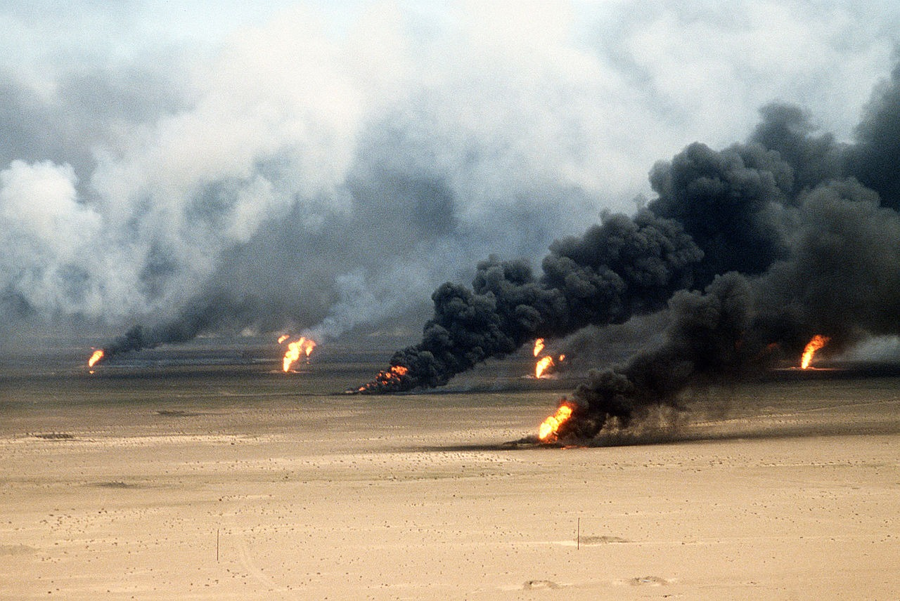
Kuwait Oil-Field Fires During Operation Desert Storm (1991) · Tech. Sgt. David McLeod, U.S. Air Force · 1991
Source: McLeod, Tech. Sgt. David, U.S. Air Force. "Kuwait Oil-Field Fires During Operation Desert Storm." 1991. U.S. Department of Defense, via Wikimedia Commons, commons.wikimedia.org/wiki/File:Operation_Desert_Storm_22.jpg. Public Domain https://commons.wikimedia.org/wiki/File:Operation_Desert_Storm_22.jpg
HIPPO — analyze the source (prompt) | Your analysis
H — Historical context: what was happening when this was created?
I — Intended audience: who was meant to see or obey it?
P — Purpose: why was it created?
P — Point of view: whose perspective does it reflect?
O — Outside connection: how does it connect to this standard?
SUPPORT OPTION
Sentence frame: This source shows ______ because it ______, which reveals ______.
CONFIDENCE CHECK-IN
Rate your understanding of this standard (1–4): ______ One thing to revisit: ____________________

Activity 6 — Core Application: Practice Quiz — US.90 ⏱ ~8 min
RESPONSE CHOICE
Commit to an answer by marking it, saying it, or explaining it aloud before checking. Answer key is in the Teacher Guide (kept separate).
[DOK 2 · item q-us90-2 · pre-field-test]
Why did President Bush order the invasion of Panama in Operation Just Cause (1989)?
A. To capture dictator Manuel Noriega who was indicted for drug trafficking
B. The U.S. overthrew dictator Manuel Noriega on drug trafficking charges
C. A U.S.-led coalition liberated Kuwait after Iraq's military invasion
D. A "new world order" based on international cooperation and values
[DOK 2 · item q-us92-2 · pre-field-test]
How did President George W. Bush respond to the September 11 terrorist attacks?
A. Claims that Iraq possessed weapons of mass destruction and terrorism ties
B. He launched the War on Terror, including military action against Taliban
C. Expanded government surveillance powers to investigate potential terrorism
D. It would continue until every terrorist group of global reach was defeated
[DOK 3 · item u1-us90-dok3-tc · pre-field-test]
How did Bush build international support for the Gulf War, and why was the military campaign successful?
A. The U.S. acted alone without international support, although this overlooks critical economic and social factors, which represents a common misconception about this historical period
B. The Gulf War lasted several years, despite limited evidence supporting this interpretation despite the fact that multiple contemporary sources contradict this
C. Coalition forces suffered heavy casualties, but this fails to account for the broader historical context, which represents a common misconception about this historical period
D. Bush assembled a UN-authorized coalition that quickly liberated Kuwait, demonstrating effective diplomacy, military superiority, and successful multilateral action

Activity 7 — Constructed Response (CER) — US.90 ⏱ ~15 min
BIG-QUESTION ORGANIZER — how did Americans fight to make the promise of equality real, and what did it take to change the law and the nation?
Jot quick notes from THIS standard: Who benefited? · Who bore the costs? · Who decided?

CONSTRUCTED RESPONSE (CER) — builds SSP.04 Argumentation
Claim + Evidence + Reasoning: Using this standard, take a position on the central question — describe the significant events of President George H.W. Bush's administration, including the invasion of Panama and the Gulf War? Support your claim with two pieces of evidence from the passage and explain your reasoning.
Part | Write here
Claim
Evidence (two specifics)
Reasoning
SELF-CHECK (CER rubric — see Toolkit)
Is my claim defensible? · TWO specific pieces of evidence? · Does my reasoning explain HOW the evidence proves the claim?
EXIT TICKET — before you leave [item us90-q1 · DOK 2 · pre-field-test]
Why did President Bush order the invasion of Panama, and what did it accomplish?
A. The Panama invasion had no clear purpose, yet the available evidence points to a different conclusion, but contemporary accounts and primary sources suggest otherwise
B. It removed drug-trafficking dictator Noriega and protected American citizens, demonstrating post-Cold War willingness to use force for law enforcement
C. Panama invaded the United States first, although historical sources do not support this conclusion, and this view has been largely revised by modern historical research
D. The invasion was ordered by Congress alone, yet the available evidence points to a different conclusion, although historical sources do not support this conclusion
Show what you know (your choice): mark the best answer, say it, or explain it — then rate how sure you are: ☐ Not yet ☐ Getting there ☐ Got it
Answer key and next steps are in the Teacher Guide.

Standard US.91 — Clinton Administration Events
TN Academic Standard US.91: Summarize the events of President Bill Clinton's administration, including: Welfare-to-work, Balanced budget, NAFTA, Scandals and subsequent impeachment hearings.
LEARNING TARGETS — I can…
• I can summarize the events of President Bill Clinton's administration, including welfare-to-work, balanced budget, NAFTA, and scandals and subsequent impeachment hearings.
Lenses for this standard: Politics/Government · Economics · History
CORE PATH — the same for every student
Same rigor for everyone: analyze the sources and vocabulary, then show what you learned on the Practice Quiz and the CER.
UDL and MTSS give you flexible ways in — they never lower the bar.
Check yourself against the learning targets on the Cornell Notes page.
★ Tennessee Connection
Vice President Al Gore of Carthage, Tennessee, played a significant role in the Clinton administration, particularly in technology policy and the development of the 'information superhighway.' Gore later won the Nobel Peace Prize for environmental advocacy.
SET YOUR GOAL (self-direction)
My goal for this standard — what will I be able to do, and how will I show it?

HOOK — think before you dig in
Clinton Administration Events: Summarize the events of President Bill Clinton's administration, including: Welfare-to-work, Balanced budget, NAFTA, Scandals and subsequent impeachment hearings. Who gained, who was left out — and why does it still matter?

ACTIVATE — what do you already know or wonder?
Jot what you already know or want to find out about this standard. You’ll come back to it.

PREVIEW & PREDICT
Which learning target will be hardest, and why? Connect it to the unit’s big question: how did people change the law and the nation, and what did it cost?

Activity 1 — Vocabulary (Part A: Reference / Word Bank) — US.91 ⏱ ~10 min
Use this word bank throughout the standard. The Spanish column supports access, not translation of assessment.
Term | Student-friendly meaning | Spanish
NAFTA | The 1994 North American Free Trade Agreement removing most trade barriers among the U.S., Canada, and Mexico. | TLCAN
Welfare-to-Work Reform | A 1996 Clinton-era law that limited welfare benefits and required recipients to find work. | Reforma de Asistencia Social
Balanced Budget | A federal budget in which spending does not exceed revenue; achieved in the late 1990s under Clinton. | Presupuesto Equilibrado
Clinton Impeachment | The 1998 House impeachment of President Clinton for perjury and obstruction; the Senate acquitted him in 1999. | Juicio Político a Clinton
Contract with America | A 1994 Republican campaign plan led by Newt Gingrich promising smaller government and balanced budgets. | Contrato con América
Dot-com Boom | The late-1990s surge in internet-based businesses and stock values, which later crashed in 2000-01. | Auge de las Puntocom
LANGUAGE SUPPORT
Pronunciations: NAFTA (NAF-tuh); Welfare-to-Work Reform (WEL-fair to wurk ree-FORM); Balanced Budget (BAL-unst BUJ-it); Clinton Impeachment (KLIN-tun im-PEECH-ment); Contract with America (KON-trakt with uh-MER-ih-kuh); Dot-com Boom (dot-KOM boom).

VOCABULARY SELF-CHECK · Knowledge Rating
Rate each term NOW in pencil, then again at the END — growth is the goal; no penalty for “never seen it.”
Term | 1 · never seen it | 2 · heard it | 3 · can use it | 4 · can teach it
NAFTA
Welfare-to-Work Reform
Balanced Budget
Clinton Impeachment
Contract with America
Dot-com Boom
MAKE IT YOURS (RESPONSE CHOICE): choose ONE term above and show you own it — write a sentence, sketch it, or give a real-world example.

Activity 2 — Vocabulary Studio (Frayer-inspired) — US.91 ⏱ ~7 min
RESPONSE CHOICE
Complete each studio by writing, speaking, or diagramming.

PRIORITY TERM 1 NAFTA · ES: TLCAN
Word-bank meaning to build on: The 1994 North American Free Trade Agreement removing most trade barriers among the U.S., Canada, and Mexico.
Definition (in your own words) | Characteristics
Examples | Non-examples
Use it to explain
Write one sentence that uses “NAFTA” to explain this standard.

PRIORITY TERM 2 Welfare-to-Work Reform · ES: Reforma de Asistencia Social
Word-bank meaning to build on: A 1996 Clinton-era law that limited welfare benefits and required recipients to find work.
Definition (in your own words) | Characteristics
Examples | Non-examples
Use it to explain
Write one sentence that uses “Welfare-to-Work Reform” to explain this standard.

CONNECT THE TERMS (UDL · build understanding)
How do these priority terms fit together? Write or sketch how one leads to or affects another.

Activity 3 — Direct Teaching Cornell Notes — US.91 ⏱ ~20 min
Name: ______________________ Class / Period: __________ Date: __________
US.91 — Clinton Administration Events • These notes capture the direct-teaching content and the Close Read for this standard.
Your learning targets are on this standard’s opening page — take notes that help you meet them.
Cues (tied to your learning targets) | My notes
What does the passage say about nAFTA Goals and Outcomes?
What does the passage say about welfare-to-Work Transition?
What does the passage say about scandals and Impeachment?
Key terms →
DOODLE ZONE — draw your thinking (UDL · another way in)
Need another way in? Sketch the key idea, a quick timeline, or how the pieces connect. Words optional.

Cornell Notes — keep going, then process & check — US.91
MORE NOTES / DIAGRAMS
Continue your notes here, add a quick sketch, or map how the ideas connect.

Key terms to list
NAFTA · Welfare-to-Work Reform · Balanced Budget · Clinton Impeachment · Contract with America · Dot-com Boom
Summary — In your own words (2–3 sentences)
PROGRESS CHECK · one question
What were the goals of NAFTA, and how did it affect American workers and the economy?
A. It eliminated trade barriers to boost economic growth, but while trade increased, manufacturing job losses to Mexico created ongoing debates about globalization's costs
B. NAFTA had no significant economic effects, but this fails to account for the broader historical context, but contemporary accounts and primary sources suggest otherwise
C. NAFTA only affected agricultural trade, yet the available evidence points to a different conclusion despite the fact that multiple contemporary sources contradict this
D. All American workers benefited equally from NAFTA, which ignores key developments that shaped the outcome, but contemporary accounts and primary sources suggest otherwise
Commit before you move on — mark it, say it, or explain it aloud.
CHECK YOURSELF — how am I doing?
Which learning targets (on this standard’s opening page) can you now meet? Tick the number; circle any you still need help with.
☐ 1
My 12–15 word headline for this standard

Activity 4 — Close Read — US.91 ⏱ ~15 min
Reading type: History Hack-authored instructional synthesis. This is not a primary source. Builds SSP.03 (synthesize) and SSP.05 (historical awareness).
CORE PATH — read one chunk at a time
NAFTA Goals and Outcomes
The North American Free Trade Agreement (1994) eliminated trade barriers between the U.S., Canada, and Mexico. Supporters argued it would increase trade and economic growth. Critics claimed it would cost American jobs and exploit Mexican workers. Results were mixed—trade increased significantly, but manufacturing jobs moved to Mexico, intensifying debates about globalization.
Welfare-to-Work Transition
The 1996 Personal Responsibility and Work Opportunity Act replaced Aid to Families with Dependent Children (AFDC) with Temporary Assistance for Needy Families (TANF). The new system required work or job training and imposed time limits on benefits. Welfare rolls declined dramatically, but poverty reduction was limited, raising questions about whether people left poverty or just left welfare.
Scandals and Impeachment
Clinton faced multiple scandals, including Whitewater real estate investments and sexual harassment allegations. The Monica Lewinsky affair led to impeachment charges for perjury and obstruction of justice. The House impeached Clinton, but the Senate acquitted him, reflecting partisan divisions and debates about whether personal conduct should determine political consequences.
Balanced Budget Significance
Clinton achieved the first balanced federal budget since 1969, aided by economic growth, tax increases on high earners, and spending restraint. Budget surpluses in the late 1990s reduced national debt and demonstrated fiscal responsibility, though this achievement proved temporary as surpluses disappeared under subsequent administrations.
Key terms first: NAFTA, Welfare-to-Work Reform. Read once for the gist, then again for evidence.
CLOSE-READ EVIDENCE LAB — for each question: quote the EVIDENCE from the passage above, then write YOUR ANSWER (or answer aloud / diagram it).
Text-dependent question | Evidence from the passage | Your answer (what it shows)
What is the main idea of the “NAFTA Goals and Outcomes” section, and what evidence supports it?
What is the main idea of the “Welfare-to-Work Transition” section, and what evidence supports it?
What is the main idea of the “Scandals and Impeachment” section, and what evidence supports it?

Activity 5 — Primary Source / Data Analysis — US.91 ⏱ ~15 min
Primary source (photograph) — analyze it with HIPPO. Builds SSP.01–SSP.02.
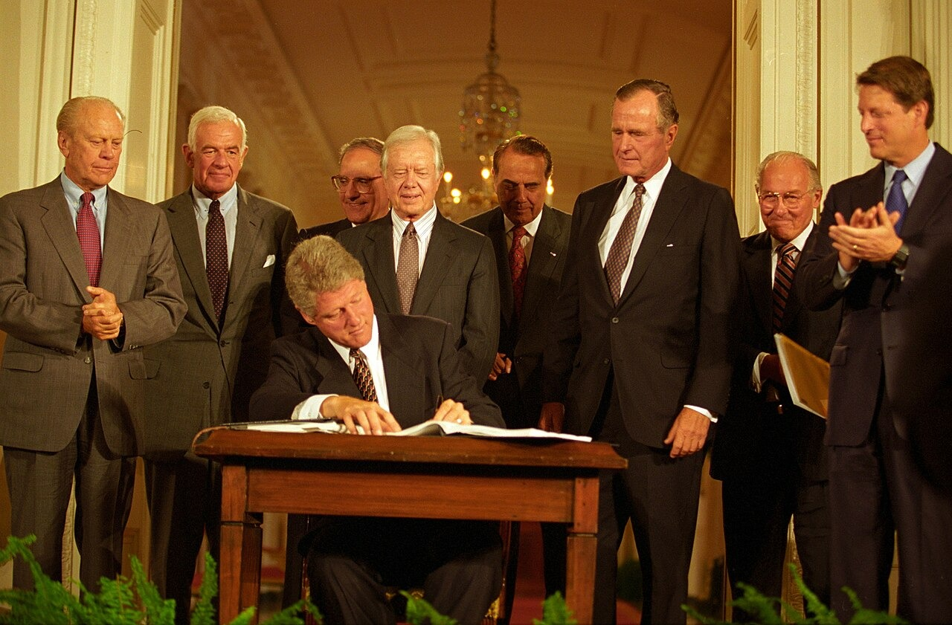
President Clinton Signs NAFTA Supplemental Agreements with Former Presidents and Congressional Leaders (September 14, 1993) · Ralph Alswang, White House Photographic Office · September 14, 1993
Source: Alswang, Ralph, White House Photographic Office. "President Clinton Signs NAFTA Supplemental Agreements." 14 Sept. 1993. Clinton White House / Executive Office of the President, via Wikimedia Commons, commons.wikimedia.org/wiki/File:President_Bill_Clinton_signs_NAFTA.jpg. Public Domain https://commons.wikimedia.org/wiki/File:President_Bill_Clinton_signs_NAFTA.jpg
HIPPO — analyze the source (prompt) | Your analysis
H — Historical context: what was happening when this was created?
I — Intended audience: who was meant to see or obey it?
P — Purpose: why was it created?
P — Point of view: whose perspective does it reflect?
O — Outside connection: how does it connect to this standard?
SUPPORT OPTION
Sentence frame: This source shows ______ because it ______, which reveals ______.
CONFIDENCE CHECK-IN
Rate your understanding of this standard (1–4): ______ One thing to revisit: ____________________

Activity 6 — Core Application: Practice Quiz — US.91 ⏱ ~8 min
RESPONSE CHOICE
Commit to an answer by marking it, saying it, or explaining it aloud before checking. Answer key is in the Teacher Guide (kept separate).
[DOK 2 · item us91-q3 · pre-field-test]
What scandals led to Clinton's impeachment, and why did the Senate acquit him?
A. The House impeached him for perjury and obstruction in the Lewinsky affair, but the Senate acquitted him along partisan lines, lacking the two-thirds majority for removal
B. Clinton was never impeached, yet the available evidence points to a different conclusion, but the historical evidence paints a more nuanced picture
C. Clinton was removed from office, despite limited evidence supporting this interpretation, although historical sources do not support this conclusion
D. The impeachment was related to foreign policy, although this overlooks critical economic and social factors and oversimplifies the complex factors at work during this period
[DOK 2 · item q-us91-3 · pre-field-test]
How did welfare reform under Clinton change government assistance programs?
A. Sustained economic expansion, low unemployment, and a technology boom
B. It replaced welfare with time-limited assistance and work requirements
C. It eliminated most tariffs between the United States, Canada, and Mexico
D. Perjury and obstruction of justice related to testimony about his conduct
[DOK 3 · item u1-us91-dok3-tc · pre-field-test]
What were the goals of NAFTA, and how did it affect American workers and the economy?
A. It eliminated trade barriers to boost economic growth, but while trade increased, manufacturing job losses to Mexico created ongoing debates about globalization's costs
B. NAFTA had no significant economic effects, but this fails to account for the broader historical context, but contemporary accounts and primary sources suggest otherwise
C. NAFTA only affected agricultural trade, yet the available evidence points to a different conclusion despite the fact that multiple contemporary sources contradict this
D. All American workers benefited equally from NAFTA, which ignores key developments that shaped the outcome, but contemporary accounts and primary sources suggest otherwise

Activity 7 — Constructed Response (CER) — US.91 ⏱ ~15 min
BIG-QUESTION ORGANIZER — how did Americans fight to make the promise of equality real, and what did it take to change the law and the nation?
Jot quick notes from THIS standard: Who benefited? · Who bore the costs? · Who decided?

CONSTRUCTED RESPONSE (CER) — builds SSP.04 Argumentation
Claim + Evidence + Reasoning: Using this standard, take a position on the central question — summarize the events of President Bill Clinton's administration, including welfare-to-work, balanced budget, NAFTA, and scandals and subsequent impeachment hearings? Support your claim with two pieces of evidence from the passage and explain your reasoning.
Part | Write here
Claim
Evidence (two specifics)
Reasoning
SELF-CHECK (CER rubric — see Toolkit)
Is my claim defensible? · TWO specific pieces of evidence? · Does my reasoning explain HOW the evidence proves the claim?
EXIT TICKET — before you leave [item us91-q2 · DOK 2 · pre-field-test]
How did welfare reform change the relationship between government assistance and work requirements?
A. Welfare reform eliminated all government assistance, which ignores key developments that shaped the outcome
B. Welfare reform removed all work requirements, despite limited evidence supporting this interpretation, which contradicts the primary source evidence from this era
C. TANF replaced AFDC with work requirements and time limits, dramatically reducing welfare rolls while raising questions about poverty reduction
D. The changes only affected elderly recipients, but this oversimplifies the complex factors at work and does not reflect the scholarly consensus on this topic
Show what you know (your choice): mark the best answer, say it, or explain it — then rate how sure you are: ☐ Not yet ☐ Getting there ☐ Got it
Answer key and next steps are in the Teacher Guide.

Standard US.92 — September 11th Impact
TN Academic Standard US.92: Describe the impact of the September 11, 2001 terrorist attacks on the World Trade Center and the Pentagon, including: the response of President George W. Bush, wars in Afghanistan and Iraq, and continued efforts to combat terrorism globally.
LEARNING TARGETS — I can…
• I can describe the impact of the September 11, 2001 terrorist attacks on the World Trade Center and the Pentagon, including the response of President George W. Bush, wars in Afghanistan and Iraq, and continued efforts to combat terrorism globally.
Lenses for this standard: History · Politics/Government · Culture
CORE PATH — the same for every student
Same rigor for everyone: analyze the sources and vocabulary, then show what you learned on the Practice Quiz and the CER.
UDL and MTSS give you flexible ways in — they never lower the bar.
Check yourself against the learning targets on the Cornell Notes page.
★ Tennessee Connection
Tennessee responded to the September 11 attacks with significant military mobilization. Fort Campbell's 101st Airborne Division was among the first conventional forces deployed to Afghanistan in Operation Enduring Freedom. Tennessee also enhanced security at key facilities including the Oak Ridge nuclear complex and Nashville's critical infrastructure.
SET YOUR GOAL (self-direction)
My goal for this standard — what will I be able to do, and how will I show it?

HOOK — think before you dig in
September 11th Impact: Describe the impact of the September 11, 2001 terrorist attacks on the World Trade Center and the Pentagon, including: the response of President George W. Bush, wars in Afghanistan and Iraq, and continued efforts to combat terrorism globally. Who gained, who was left out — and why does it still matter?

ACTIVATE — what do you already know or wonder?
Jot what you already know or want to find out about this standard. You’ll come back to it.

PREVIEW & PREDICT
Which learning target will be hardest, and why? Connect it to the unit’s big question: how did people change the law and the nation, and what did it cost?

Activity 1 — Vocabulary (Part A: Reference / Word Bank) — US.92 ⏱ ~10 min
Use this word bank throughout the standard. The Spanish column supports access, not translation of assessment.
Term | Student-friendly meaning | Spanish
September 11, 2001 Attacks | Coordinated al-Qaeda terrorist attacks that destroyed the World Trade Center and struck the Pentagon, killing nearly 3,000 people. | Ataques del 11 de Septiembre
War on Terror | The U.S. global campaign after 9/11 to defeat terrorist groups and the nations that harbored them. | Guerra contra el Terrorismo
USA PATRIOT Act | A 2001 law expanding government surveillance powers to prevent terrorism, criticized by some as a threat to civil liberties. | Ley Patriota
Department of Homeland Security | A federal department created in 2002 to coordinate protection of the U.S. against terrorism and disasters. | Departamento de Seguridad Nacional
War in Afghanistan | The U.S. war begun in 2001 to remove the Taliban and destroy al-Qaeda bases after the 9/11 attacks. | Guerra en Afganistán
Iraq War | The 2003 U.S.-led invasion that toppled Saddam Hussein, launched on claims of weapons of mass destruction. | Guerra de Irak
LANGUAGE SUPPORT
Pronunciations: September 11, 2001 Attacks (sep-TEM-ber ee-LEV-en uh-TAKS); War on Terror (wor on TER-er); USA PATRIOT Act (yoo-es-AY PAY-tree-ut akt); Department of Homeland Security (dee-PART-ment of HOHM-land); War in Afghanistan (wor in af-GAN-ih-stan); Iraq War (ih-RAK wor).

VOCABULARY SELF-CHECK · Knowledge Rating
Rate each term NOW in pencil, then again at the END — growth is the goal; no penalty for “never seen it.”
Term | 1 · never seen it | 2 · heard it | 3 · can use it | 4 · can teach it
September 11, 2001 Attacks
War on Terror
USA PATRIOT Act
Department of Homeland Security
War in Afghanistan
Iraq War
MAKE IT YOURS (RESPONSE CHOICE): choose ONE term above and show you own it — write a sentence, sketch it, or give a real-world example.

Activity 2 — Vocabulary Studio (Frayer-inspired) — US.92 ⏱ ~7 min
RESPONSE CHOICE
Complete each studio by writing, speaking, or diagramming.

PRIORITY TERM 1 September 11, 2001 Attacks · ES: Ataques del 11 de Septiembre
Word-bank meaning to build on: Coordinated al-Qaeda terrorist attacks that destroyed the World Trade Center and struck the Pentagon, killing nearly 3,000 people.
Definition (in your own words) | Characteristics
Examples | Non-examples
Use it to explain
Write one sentence that uses “September 11, 2001 Attacks” to explain this standard.

PRIORITY TERM 2 War on Terror · ES: Guerra contra el Terrorismo
Word-bank meaning to build on: The U.S. global campaign after 9/11 to defeat terrorist groups and the nations that harbored them.
Definition (in your own words) | Characteristics
Examples | Non-examples
Use it to explain
Write one sentence that uses “War on Terror” to explain this standard.

CONNECT THE TERMS (UDL · build understanding)
How do these priority terms fit together? Write or sketch how one leads to or affects another.

Activity 3 — Direct Teaching Cornell Notes — US.92 ⏱ ~20 min
Name: ______________________ Class / Period: __________ Date: __________
US.92 — September 11th Impact • These notes capture the direct-teaching content and the Close Read for this standard.
Your learning targets are on this standard’s opening page — take notes that help you meet them.
Cues (tied to your learning targets) | My notes
What does the passage say about bush's Domestic and International Response?
What does the passage say about afghanistan War?
What does the passage say about iraq War?
Key terms →
DOODLE ZONE — draw your thinking (UDL · another way in)
Need another way in? Sketch the key idea, a quick timeline, or how the pieces connect. Words optional.

Cornell Notes — keep going, then process & check — US.92
MORE NOTES / DIAGRAMS
Continue your notes here, add a quick sketch, or map how the ideas connect.

Key terms to list
September 11, 2001 Attacks · War on Terror · USA PATRIOT Act · Department of Homeland Security · War in Afghanistan · Iraq War
Summary — In your own words (2–3 sentences)
PROGRESS CHECK · one question
What were the reasons for military action in Afghanistan and Iraq, and what were the consequences of each war?
A. Both wars achieved their stated objectives quickly, yet the available evidence points to a different conclusion and oversimplifies the complex factors at work during this period
B. Afghanistan targeted al-Qaeda and Taliban with initial success but became America's longest war; Iraq was based on WMD claims that proved false, creating instability
C. Neither war had significant consequences, which does not reflect the consensus among historians, which represents a common misconception about this historical period
D. Both wars were completed within one year, although this view has been largely discredited by scholars when examined alongside the available primary and secondary sources
Commit before you move on — mark it, say it, or explain it aloud.
CHECK YOURSELF — how am I doing?
Which learning targets (on this standard’s opening page) can you now meet? Tick the number; circle any you still need help with.
☐ 1
My 12–15 word headline for this standard

Activity 4 — Close Read — US.92 ⏱ ~15 min
Reading type: History Hack-authored instructional synthesis. This is not a primary source. Builds SSP.03 (synthesize) and SSP.05 (historical awareness).
CORE PATH — read one chunk at a time
Bush's Domestic and International Response
Domestic: Created Department of Homeland Security, passed USA PATRIOT Act expanding surveillance powers, increased airport security, and launched domestic surveillance programs. International: Declared "War on Terror," demanded Taliban surrender Osama bin Laden, and assembled international coalition for Afghanistan invasion to destroy al-Qaeda and remove the Taliban.
Afghanistan War
Justified as self-defense against al-Qaeda and Taliban harboring terrorists, the Afghanistan invasion initially succeeded in removing Taliban from power. However, it evolved into the longest war in American history with limited success in nation-building. Questions persisted about exit strategies and whether military force could transform Afghan society.
Iraq War
Bush claimed Saddam Hussein possessed weapons of mass destruction and supported terrorism. The invasion succeeded militarily but created regional instability, sectarian violence, and damaged American credibility when WMD claims proved false. The war raised fundamental questions about intelligence, justification for preemptive war, and occupation strategies.
Global Counter-terrorism Efforts
The "War on Terror" included military operations in multiple countries, intelligence sharing with allies, financial tracking of terrorist organizations, and diplomatic pressure on nations supporting terrorism. Success in preventing major attacks on American soil was offset by concerns about civil liberties, international law violations, and whether military approaches address terrorism's root causes.
Key terms first: September 11, 2001 Attacks, War on Terror. Read once for the gist, then again for evidence.
CLOSE-READ EVIDENCE LAB — for each question: quote the EVIDENCE from the passage above, then write YOUR ANSWER (or answer aloud / diagram it).
Text-dependent question | Evidence from the passage | Your answer (what it shows)
What is the main idea of the “Bush's Domestic and International Response” section, and what evidence supports it?
What is the main idea of the “Afghanistan War” section, and what evidence supports it?
What is the main idea of the “Iraq War” section, and what evidence supports it?

Geographer’s Lens — US.92 ⏱ ~12 min
Geographers don’t just find places — they explain how WHERE shapes WHAT happens. Work these like a geographer. Built on the Five Themes of Geography · C3 Dimension 2 · SSP.06 (spatial reasoning).
THE PLACES — then explain why geography put them there
The September 11, 2001 attacks struck three separate places on one morning — each chosen for what it symbolized and where it stood. Locate the three sites, then explain how geography shaped both the attacks and the nation's response.
Place | Where | What happened (given) | Why HERE? (your analysis)
World Trade Center, New York City | Northeast — financial capital | Two hijacked jets destroy the Twin Towers, symbol of U.S. economic power
The Pentagon, Arlington, Virginia | Washington, D.C. area | A third jet strikes the headquarters of the U.S. military
Shanksville, Pennsylvania | Rural Appalachia | United 93 crashes after passengers fight back, short of its Washington target
MOVEMENT & REGION — what’s the spatial pattern?
In 1–2 sentences: is this a movement, a cluster, or a whole region? Name the direction or shape it takes on a map.

GEOGRAPHY AS A FORCE — how did location shape the outcome?
How did geography change WHAT happened — who was affected, how far or fast it spread, or who was left out? Use one place above as your evidence.

READ IT LIKE A SOURCE — RESPONSE CHOICE
A map is a source with a point of view. Show your thinking your way — write it, OR sketch a quick arrows-and-labels diagram: what would a map of this make CLEAR, and what would it HIDE or leave out?

Activity 5 — Primary Source / Data Analysis — US.92 ⏱ ~15 min
Primary source (photograph) — analyze it with HIPPO. Builds SSP.01–SSP.02.
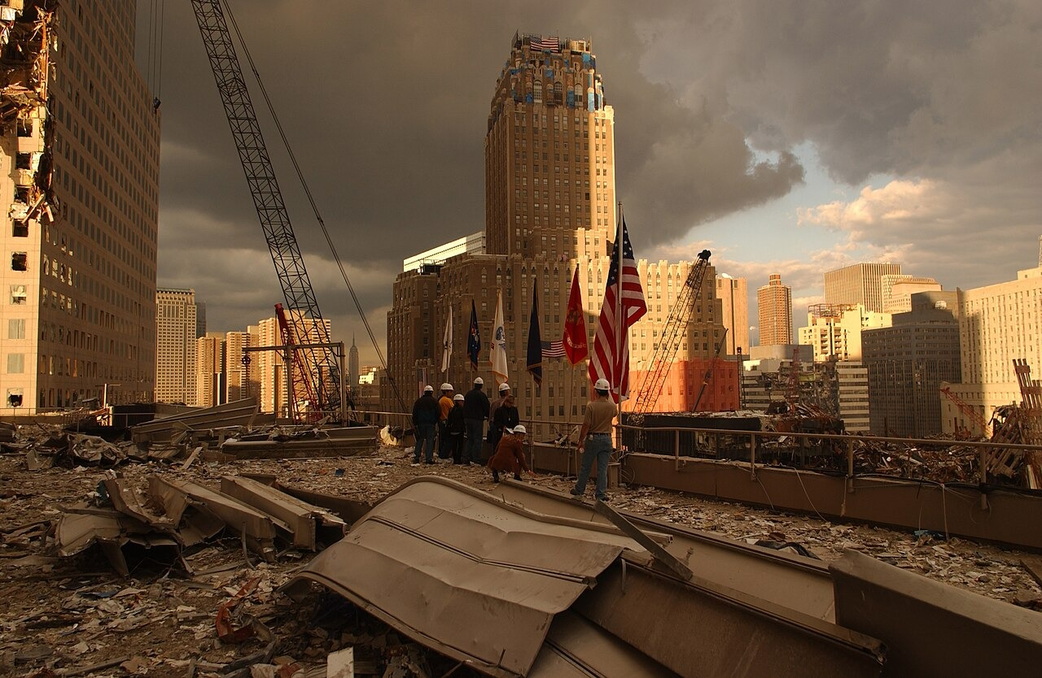
World Trade Center Ground Zero Debris, New York City (September 28, 2001) · Andrea Booher, FEMA News Photo · September 28, 2001
Source: Booher, Andrea, FEMA News Photo. "World Trade Center Ground Zero Debris, New York City." 28 Sept. 2001. Federal Emergency Management Agency (FEMA 5399), via Wikimedia Commons, commons.wikimedia.org/wiki/File:FEMA_-_5399_-_Photograph_by_Andrea_Booher_taken_on_09-28-2001_in_New_York.jpg. Public Domain https://commons.wikimedia.org/wiki/File:FEMA_-_5399_-_Photograph_by_Andrea_Booher_taken_on_09-28-2001_in_New_York.jpg
HIPPO — analyze the source (prompt) | Your analysis
H — Historical context: what was happening when this was created?
I — Intended audience: who was meant to see or obey it?
P — Purpose: why was it created?
P — Point of view: whose perspective does it reflect?
O — Outside connection: how does it connect to this standard?
SUPPORT OPTION
Sentence frame: This source shows ______ because it ______, which reveals ______.
CONFIDENCE CHECK-IN
Rate your understanding of this standard (1–4): ______ One thing to revisit: ____________________

Activity 6 — Core Application: Practice Quiz — US.92 ⏱ ~8 min
RESPONSE CHOICE
Commit to an answer by marking it, saying it, or explaining it aloud before checking. Answer key is in the Teacher Guide (kept separate).
[DOK 2 · item q-us92-2 · pre-field-test]
How did President George W. Bush respond to the September 11 terrorist attacks?
A. He launched the War on Terror, including military action against Taliban
B. Claims that Iraq possessed weapons of mass destruction and terrorism ties
C. Expanded government surveillance powers to investigate potential terrorism
D. It would continue until every terrorist group of global reach was defeated
[DOK 2 · item us-89-x027 · pre-field-test]
The Authorization for Use of Military Force (AUMF) passed September 18, 2001 authorized the president to use force against:
A. Al-Qaeda exclusively, with any expanded target list requiring additional congressional authorization
B. Al-Qaeda, the Taliban, and associated forces — a broad authorization later applied to operations well beyond Afghanistan
C. Afghanistan and any state that provided material support to the September 11 hijackers
D. Any organization with demonstrated hostile intent toward American citizens or interests worldwide
[DOK 3 · item u1-us92-dok3-tc · pre-field-test]
What were the reasons for military action in Afghanistan and Iraq, and what were the consequences of each war?
A. Both wars achieved their stated objectives quickly, yet the available evidence points to a different conclusion and oversimplifies the complex factors at work during this period
B. Afghanistan targeted al-Qaeda and Taliban with initial success but became America's longest war; Iraq was based on WMD claims that proved false, creating instability
C. Neither war had significant consequences, which does not reflect the consensus among historians, which represents a common misconception about this historical period
D. Both wars were completed within one year, although this view has been largely discredited by scholars when examined alongside the available primary and secondary sources

Activity 7 — Constructed Response (CER) — US.92 ⏱ ~15 min
BIG-QUESTION ORGANIZER — how did Americans fight to make the promise of equality real, and what did it take to change the law and the nation?
Jot quick notes from THIS standard: Who benefited? · Who bore the costs? · Who decided?

CONSTRUCTED RESPONSE (CER) — builds SSP.04 Argumentation
Claim + Evidence + Reasoning: Using this standard, take a position on the central question — describe the impact of the September 11, 2001 terrorist attacks on the World Trade Center and the Pentagon, including the response of President George W. Bush, wars in Afghanistan and Iraq, and continued efforts to combat terrorism globally? Support your claim with two pieces of evidence from the passage and explain your reasoning.
Part | Write here
Claim
Evidence (two specifics)
Reasoning
SELF-CHECK (CER rubric — see Toolkit)
Is my claim defensible? · TWO specific pieces of evidence? · Does my reasoning explain HOW the evidence proves the claim?
EXIT TICKET — before you leave [item us92-q1 · DOK 2 · pre-field-test]
How did President Bush respond to the September 11th attacks both domestically and internationally?
A. Bush took no significant action after 9/11, despite limited evidence supporting this interpretation, which does not align with the documented historical record
B. Only domestic security measures were implemented, despite the fact that multiple sources contradict this view, though this interpretation lacks supporting historical evidence
C. The response focused exclusively on diplomacy, although this view has been largely discredited by scholars, which represents a common misconception about this historical period
D. Domestically he created Homeland Security and expanded surveillance; internationally he declared the War on Terror and invaded Afghanistan to destroy al-Qaeda
Show what you know (your choice): mark the best answer, say it, or explain it — then rate how sure you are: ☐ Not yet ☐ Getting there ☐ Got it
Answer key and next steps are in the Teacher Guide.

Standard US.93 — Increasing Role of Women and Minorities
TN Academic Standard US.93: Describe the increasing role of women and minorities in the American military, politics, and economy, including: Hillary Clinton, Sandra Day O'Connor, Nancy Pelosi, Colin Powell, Condoleezza Rice. (TCA)
LEARNING TARGETS — I can…
• I can describe the increasing role of women and minorities in the American military, politics, and economy, including Hillary Clinton, Sandra Day O'Connor, Nancy Pelosi, Colin Powell, and Condoleezza Rice.
Lenses for this standard: Culture · History · Politics/Government · Tennessee Connection
CORE PATH — the same for every student
Same rigor for everyone: analyze the sources and vocabulary, then show what you learned on the Practice Quiz and the CER.
UDL and MTSS give you flexible ways in — they never lower the bar.
Check yourself against the learning targets on the Cornell Notes page.
★ Tennessee Connection
Tennessee has seen growing diversity in leadership. Harold Ford Jr. represented Memphis in Congress as one of the youngest African American congressmen. Marsha Blackburn became Tennessee's first female U.S. Senator (2019). The state's military installations, including Fort Campbell, have been at the forefront of integrating women into combat roles.
SET YOUR GOAL (self-direction)
My goal for this standard — what will I be able to do, and how will I show it?

HOOK — think before you dig in
Increasing Role of Women and Minorities: Describe the increasing role of women and minorities in the American military, politics, and economy, including: Hillary Clinton, Sandra Day O'Connor, Nancy Pelosi, Colin Powell, Condoleezza Rice. (TCA). Who gained, who was left out — and why does it still matter?

ACTIVATE — what do you already know or wonder?
Jot what you already know or want to find out about this standard. You’ll come back to it.

PREVIEW & PREDICT
Which learning target will be hardest, and why? Connect it to the unit’s big question: how did people change the law and the nation, and what did it cost?

Activity 1 — Vocabulary (Part A: Reference / Word Bank) — US.93 ⏱ ~10 min
Use this word bank throughout the standard. The Spanish column supports access, not translation of assessment.
Term | Student-friendly meaning | Spanish
Sandra Day O'Connor | The first woman to serve on the U.S. Supreme Court, appointed in 1981. | Sandra Day O'Connor
Colin Powell | The first African American U.S. Secretary of State (2001) and Chairman of the Joint Chiefs of Staff. | Colin Powell
Condoleezza Rice | The first African American woman U.S. Secretary of State (2005), a key foreign-policy leader. | Condoleezza Rice
Hillary Clinton | U.S. Senator, Secretary of State, and the first woman to win a major party's presidential nomination (2016). | Hillary Clinton
Nancy Pelosi | The first woman elected Speaker of the U.S. House of Representatives (2007). | Nancy Pelosi
Glass Ceiling | An invisible barrier that has kept women and minorities from reaching the highest positions in business and government. | Techo de Cristal
LANGUAGE SUPPORT
Pronunciations: Sandra Day O'Connor (SAN-druh day oh-KON-er); Colin Powell (KOH-lin POW-ul); Condoleezza Rice (kon-duh-LEE-zuh RYS); Hillary Clinton (HIL-uh-ree KLIN-tun); Nancy Pelosi (NAN-see puh-LOH-see); Glass Ceiling (glas SEE-ling).

VOCABULARY SELF-CHECK · Knowledge Rating
Rate each term NOW in pencil, then again at the END — growth is the goal; no penalty for “never seen it.”
Term | 1 · never seen it | 2 · heard it | 3 · can use it | 4 · can teach it
Sandra Day O'Connor
Colin Powell
Condoleezza Rice
Hillary Clinton
Nancy Pelosi
Glass Ceiling
MAKE IT YOURS (RESPONSE CHOICE): choose ONE term above and show you own it — write a sentence, sketch it, or give a real-world example.

Activity 2 — Vocabulary Studio (Frayer-inspired) — US.93 ⏱ ~7 min
RESPONSE CHOICE
Complete each studio by writing, speaking, or diagramming.

PRIORITY TERM 1 Sandra Day O'Connor · ES: Sandra Day O'Connor
Word-bank meaning to build on: The first woman to serve on the U.S. Supreme Court, appointed in 1981.
Definition (in your own words) | Characteristics
Examples | Non-examples
Use it to explain
Write one sentence that uses “Sandra Day O'Connor” to explain this standard.

PRIORITY TERM 2 Colin Powell · ES: Colin Powell
Word-bank meaning to build on: The first African American U.S. Secretary of State (2001) and Chairman of the Joint Chiefs of Staff.
Definition (in your own words) | Characteristics
Examples | Non-examples
Use it to explain
Write one sentence that uses “Colin Powell” to explain this standard.

CONNECT THE TERMS (UDL · build understanding)
How do these priority terms fit together? Write or sketch how one leads to or affects another.

Activity 3 — Direct Teaching Cornell Notes — US.93 ⏱ ~20 min
Name: ______________________ Class / Period: __________ Date: __________
US.93 — Increasing Role of Women and Minorities • These notes capture the direct-teaching content and the Close Read for this standard.
Your learning targets are on this standard’s opening page — take notes that help you meet them.
Cues (tied to your learning targets) | My notes
What does the passage say about hillary Clinton's Contributions?
What does the passage say about colin Powell's Leadership?
What does the passage say about sandra Day O'Connor's Pioneering Impact?
Key terms →
DOODLE ZONE — draw your thinking (UDL · another way in)
Need another way in? Sketch the key idea, a quick timeline, or how the pieces connect. Words optional.

Cornell Notes — keep going, then process & check — US.93
MORE NOTES / DIAGRAMS
Continue your notes here, add a quick sketch, or map how the ideas connect.

Key terms to list
Sandra Day O'Connor · Colin Powell · Condoleezza Rice · Hillary Clinton · Nancy Pelosi · Glass Ceiling
Summary — In your own words (2–3 sentences)
PROGRESS CHECK · one question
Analyze how these leaders' achievements reflected broader changes in American society regarding gender and racial equality.
A. These individual achievements had no broader social significance, despite limited evidence supporting this interpretation, which does not align with the documented historical record
B. Racial and gender equality was fully achieved through their service, despite the fact that multiple sources contradict this view
C. Their success in previously exclusive positions demonstrated expanding opportunities while also revealing continuing barriers and debates about representation
D. Only one of these leaders faced discrimination, despite limited evidence supporting this interpretation when examined alongside the available primary and secondary sources
Commit before you move on — mark it, say it, or explain it aloud.
CHECK YOURSELF — how am I doing?
Which learning targets (on this standard’s opening page) can you now meet? Tick the number; circle any you still need help with.
☐ 1
My 12–15 word headline for this standard

Activity 4 — Close Read — US.93 ⏱ ~15 min
Reading type: History Hack-authored instructional synthesis. This is not a primary source. Builds SSP.03 (synthesize) and SSP.05 (historical awareness).
CORE PATH — read one chunk at a time
Hillary Clinton's Contributions
First Lady (1993-2001), U.S. Senator from New York (2001-2009), Secretary of State (2009-2013), and first woman nominated for president by a major party (2016). She advocated for healthcare reform, women's rights, and children's issues while breaking gender barriers in American politics at the highest levels.
Colin Powell's Leadership
First Black Chairman of Joint Chiefs of Staff (1989-1993), oversaw Gulf War success, served as Secretary of State (2001-2005). His military leadership and diplomatic service demonstrated minority advancement in national security positions while maintaining broad public respect across political lines.
Sandra Day O'Connor's Pioneering Impact
First woman Supreme Court Justice (1981-2006), appointed by Reagan. Her moderate conservative positions often provided swing votes on crucial cases. She opened the door for women in the legal profession's highest position and demonstrated that gender need not determine judicial philosophy.
Condoleezza Rice's Foreign Policy Role
First Black woman National Security Advisor (2001-2005) and Secretary of State (2005-2009). Her expertise in Soviet/Russian affairs and close relationship with President Bush made her influential in post-9/11 foreign policy, particularly regarding Iraq and democracy promotion.
Nancy Pelosi's Political Leadership
First woman Speaker of the House (2007-2011, 2019-2023), highest-ranking woman in American government. She led Democratic opposition to Bush policies, shepherded Obama's legislative agenda including healthcare reform, and managed Trump's impeachment proceedings, demonstrating women's leadership in legislative politics.
Key terms first: Sandra Day O'Connor, Colin Powell. Read once for the gist, then again for evidence.
CLOSE-READ EVIDENCE LAB — for each question: quote the EVIDENCE from the passage above, then write YOUR ANSWER (or answer aloud / diagram it).
Text-dependent question | Evidence from the passage | Your answer (what it shows)
What is the main idea of the “Hillary Clinton's Contributions” section, and what evidence supports it?
What is the main idea of the “Colin Powell's Leadership” section, and what evidence supports it?
What is the main idea of the “Sandra Day O'Connor's Pioneering Impact” section, and what evidence supports it?

Activity 5 — Primary Source / Data Analysis — US.93 ⏱ ~15 min
Primary source (photograph) — analyze it with HIPPO. Builds SSP.01–SSP.02.
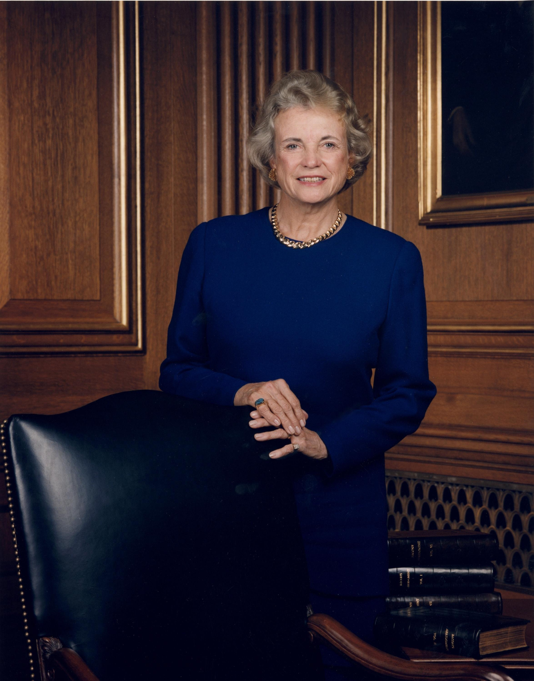
Sandra Day O'Connor Official Portrait, Associate Justice of the U.S. Supreme Court (c. 1994) · Unknown; U.S. federal government · 1994
Source: U.S. Supreme Court. "Sandra Day O'Connor Official Portrait." c. 1994. U.S. Supreme Court / U.S. federal government, via Wikimedia Commons, commons.wikimedia.org/wiki/File:Sandra_Day_O%27Connor_Official_Portrait.jpg. Public Domain https://commons.wikimedia.org/wiki/File:Sandra_Day_O%27Connor_Official_Portrait.jpg
HIPPO — analyze the source (prompt) | Your analysis
H — Historical context: what was happening when this was created?
I — Intended audience: who was meant to see or obey it?
P — Purpose: why was it created?
P — Point of view: whose perspective does it reflect?
O — Outside connection: how does it connect to this standard?
SUPPORT OPTION
Sentence frame: This source shows ______ because it ______, which reveals ______.
CONFIDENCE CHECK-IN
Rate your understanding of this standard (1–4): ______ One thing to revisit: ____________________

Activity 6 — Core Application: Practice Quiz — US.93 ⏱ ~8 min
RESPONSE CHOICE
Commit to an answer by marking it, saying it, or explaining it aloud before checking. Answer key is in the Teacher Guide (kept separate).
[DOK 2 · item us93-q2 · pre-field-test]
What significance did Colin Powell's military and diplomatic leadership have for minority advancement?
A. As the first Black Chairman of Joint Chiefs and Secretary of State, he demonstrated minority advancement in national security while earning bipartisan respect
B. Powell's positions had no broader significance, which contradicts the primary source evidence from this era, although this overlooks critical economic and social factors involved
C. Powell served only in advisory roles, which contradicts the primary source evidence from this era and oversimplifies the complex factors at work during this period
D. His appointments were opposed by most Americans, but contemporary accounts suggest a different explanation, though this interpretation lacks supporting historical evidence
[DOK 2 · item us93-q3 · pre-field-test]
How did Sandra Day O'Connor's Supreme Court service change opportunities for women in law?
A. O'Connor's appointment had no broader impact, but this fails to account for the broader historical context
B. As the first woman Justice, she proved women could serve at the highest judicial level and often cast decisive swing votes on major cases
C. She served for only one term, which contradicts the primary source evidence from this era, but contemporary accounts and primary sources suggest otherwise
D. O'Connor was a liberal activist judge, but this oversimplifies the complex factors at work, but closer analysis reveals a more complicated historical reality
[DOK 3 · item u1-us93-dok3-tc · pre-field-test]
Analyze how these leaders' achievements reflected broader changes in American society regarding gender and racial equality.
A. These individual achievements had no broader social significance, despite limited evidence supporting this interpretation, which does not align with the documented historical record
B. Racial and gender equality was fully achieved through their service, despite the fact that multiple sources contradict this view
C. Their success in previously exclusive positions demonstrated expanding opportunities while also revealing continuing barriers and debates about representation
D. Only one of these leaders faced discrimination, despite limited evidence supporting this interpretation when examined alongside the available primary and secondary sources

Activity 7 — Constructed Response (CER) — US.93 ⏱ ~15 min
BIG-QUESTION ORGANIZER — how did Americans fight to make the promise of equality real, and what did it take to change the law and the nation?
Jot quick notes from THIS standard: Who benefited? · Who bore the costs? · Who decided?

CONSTRUCTED RESPONSE (CER) — builds SSP.04 Argumentation
Claim + Evidence + Reasoning: Using this standard, take a position on the central question — describe the increasing role of women and minorities in the American military, politics, and economy, including Hillary Clinton, Sandra Day O'Connor, Nancy Pelosi, Colin Powell, and Condoleezza Rice? Support your claim with two pieces of evidence from the passage and explain your reasoning.
Part | Write here
Claim
Evidence (two specifics)
Reasoning
SELF-CHECK (CER rubric — see Toolkit)
Is my claim defensible? · TWO specific pieces of evidence? · Does my reasoning explain HOW the evidence proves the claim?
EXIT TICKET — before you leave [item us93-q1 · DOK 2 · pre-field-test]
How did Hillary Clinton break barriers for women in American politics throughout her career?
A. She served as Senator, Secretary of State, and became the first woman nominated for president by a major party, breaking barriers at multiple levels
B. Clinton held no significant political positions, although this view has been largely discredited by scholars and does not reflect the scholarly consensus on this topic
C. She focused only on state-level politics, although this view has been largely discredited by scholars, but closer analysis reveals a more complicated historical reality
D. Clinton avoided controversial positions, despite limited evidence supporting this interpretation, and this view has been largely revised by modern historical research
Show what you know (your choice): mark the best answer, say it, or explain it — then rate how sure you are: ☐ Not yet ☐ Getting there ☐ Got it
Answer key and next steps are in the Teacher Guide.

Standard US.94 — Communication Methods Evolution
TN Academic Standard US.94: Compare and contrast commonly used methods of communication from 1970 to today, and analyze the impact they have had on society.
LEARNING TARGETS — I can…
• I can compare and contrast commonly used methods of communication from 1970 to today, and analyze the impact they have had on society.
Lenses for this standard: History · Economics
CORE PATH — the same for every student
Same rigor for everyone: analyze the sources and vocabulary, then show what you learned on the Practice Quiz and the CER.
UDL and MTSS give you flexible ways in — they never lower the bar.
Check yourself against the learning targets on the Cornell Notes page.
★ Tennessee Connection
Tennessee has been part of the communications revolution. The Chattanooga Electric Power Board launched the first citywide 1-gigabit-per-second internet service in the United States in 2010, making Chattanooga ('Gig City') a model for municipal broadband. Nashville became a growing tech hub attracting major companies.
SET YOUR GOAL (self-direction)
My goal for this standard — what will I be able to do, and how will I show it?

HOOK — think before you dig in
Communication Methods Evolution: Compare and contrast commonly used methods of communication from 1970 to today, and analyze the impact they have had on society. Who gained, who was left out — and why does it still matter?

ACTIVATE — what do you already know or wonder?
Jot what you already know or want to find out about this standard. You’ll come back to it.

PREVIEW & PREDICT
Which learning target will be hardest, and why? Connect it to the unit’s big question: how did people change the law and the nation, and what did it cost?

Activity 1 — Vocabulary (Part A: Reference / Word Bank) — US.94 ⏱ ~10 min
Use this word bank throughout the standard. The Spanish column supports access, not translation of assessment.
Term | Student-friendly meaning | Spanish
Internet Revolution | The rapid late-20th-century spread of the internet, transforming how people communicate, work, and access information. | Revolución de Internet
World Wide Web | A system of linked web pages, opened to the public in the 1990s, that made the internet easy to use. | Red Informática Mundial
Personal Computer | An affordable home computer that became common in the 1980s-90s, changing work, school, and daily life. | Computadora Personal
Social Media | Online platforms of the 2000s that let people share content and connect instantly around the world. | Redes Sociales
Smartphone | A mobile phone with internet and computer features, widespread after 2007, that put communication in every pocket. | Teléfono Inteligente
Digital Divide | The gap between those who have reliable access to computers and the internet and those who do not. | Brecha Digital
LANGUAGE SUPPORT
Pronunciations: Internet Revolution (IN-ter-net rev-uh-LOO-shun); World Wide Web (wurld wyd WEB); Personal Computer (PER-sun-ul kum-PYOO-ter); Social Media (SOH-shul MEE-dee-uh); Smartphone (SMART-fohn); Digital Divide (DIJ-ih-tul dih-VYD).

VOCABULARY SELF-CHECK · Knowledge Rating
Rate each term NOW in pencil, then again at the END — growth is the goal; no penalty for “never seen it.”
Term | 1 · never seen it | 2 · heard it | 3 · can use it | 4 · can teach it
Internet Revolution
World Wide Web
Personal Computer
Social Media
Smartphone
Digital Divide
MAKE IT YOURS (RESPONSE CHOICE): choose ONE term above and show you own it — write a sentence, sketch it, or give a real-world example.

Activity 2 — Vocabulary Studio (Frayer-inspired) — US.94 ⏱ ~7 min
RESPONSE CHOICE
Complete each studio by writing, speaking, or diagramming.

PRIORITY TERM 1 Internet Revolution · ES: Revolución de Internet
Word-bank meaning to build on: The rapid late-20th-century spread of the internet, transforming how people communicate, work, and access information.
Definition (in your own words) | Characteristics
Examples | Non-examples
Use it to explain
Write one sentence that uses “Internet Revolution” to explain this standard.

PRIORITY TERM 2 World Wide Web · ES: Red Informática Mundial
Word-bank meaning to build on: A system of linked web pages, opened to the public in the 1990s, that made the internet easy to use.
Definition (in your own words) | Characteristics
Examples | Non-examples
Use it to explain
Write one sentence that uses “World Wide Web” to explain this standard.

CONNECT THE TERMS (UDL · build understanding)
How do these priority terms fit together? Write or sketch how one leads to or affects another.

Activity 3 — Direct Teaching Cornell Notes — US.94 ⏱ ~20 min
Name: ______________________ Class / Period: __________ Date: __________
US.94 — Communication Methods Evolution • These notes capture the direct-teaching content and the Close Read for this standard.
Your learning targets are on this standard’s opening page — take notes that help you meet them.
Cues (tied to your learning targets) | My notes
What does the passage say about 1970s Communication Technologies?
What does the passage say about present-Day Communication Methods?
What does the passage say about comparing Characteristics and Limitations?
Key terms →
DOODLE ZONE — draw your thinking (UDL · another way in)
Need another way in? Sketch the key idea, a quick timeline, or how the pieces connect. Words optional.

Cornell Notes — keep going, then process & check — US.94
MORE NOTES / DIAGRAMS
Continue your notes here, add a quick sketch, or map how the ideas connect.

Key terms to list
Internet Revolution · World Wide Web · Personal Computer · Social Media · Smartphone · Digital Divide
Summary — In your own words (2–3 sentences)
PROGRESS CHECK · one question
How have modern communication technologies changed the way Americans interact with each other and their government?
A. Modern technology has not changed communication patterns, which does not align with the documented historical record
B. Americans communicate less today than in the 1970s, which does not reflect the consensus among historians and does not reflect the scholarly consensus on this topic
C. Only young people use modern communication technology, which represents a common misconception about the period
D. Smartphones, social media, and internet enable instant global communication, transforming how citizens engage with politics, news, and each other
Commit before you move on — mark it, say it, or explain it aloud.
CHECK YOURSELF — how am I doing?
Which learning targets (on this standard’s opening page) can you now meet? Tick the number; circle any you still need help with.
☐ 1
My 12–15 word headline for this standard

Activity 4 — Close Read — US.94 ⏱ ~15 min
Reading type: History Hack-authored instructional synthesis. This is not a primary source. Builds SSP.03 (synthesize) and SSP.05 (historical awareness).
CORE PATH — read one chunk at a time
1970s Communication Technologies
Landline telephones were the primary voice communication method. Television, dominated by three major networks, provided news and entertainment. Radio remained important for music and local news. Newspapers were the primary source for detailed news coverage. Mail served as the standard written communication method. Communication was slower, more deliberate, and geographically constrained.
Present-Day Communication Methods
Smartphones integrate voice, text, internet, and multimedia capabilities. Social media platforms like Facebook, Twitter, and Instagram enable instant global communication. Email is the primary business and formal communication method. Video conferencing through Zoom and similar platforms allows face-to-face remote communication. Streaming services have replaced traditional television viewing patterns.
Comparing Characteristics and Limitations
1970s advantages: More face-to-face interaction, deeper news analysis, less information overload. 1970s limitations: Slower communication, limited information access, geographic barriers. Present advantages: Instant global communication, unlimited information access, multimedia capabilities. Present limitations: Information overload, privacy concerns, reduced attention spans, cybersecurity threats.
Societal Impact
Communication evolution has transformed culture (global connectivity, viral content), economy (e-commerce, remote work), governance (social media campaigns, digital democracy), and relationships (online dating, long-distance connections, but also reduced face-to-face interaction and increased isolation). These changes continue to reshape American society in profound ways.
Key terms first: Internet Revolution, World Wide Web. Read once for the gist, then again for evidence.
CLOSE-READ EVIDENCE LAB — for each question: quote the EVIDENCE from the passage above, then write YOUR ANSWER (or answer aloud / diagram it).
Text-dependent question | Evidence from the passage | Your answer (what it shows)
What is the main idea of the “1970s Communication Technologies” section, and what evidence supports it?
What is the main idea of the “Present-Day Communication Methods” section, and what evidence supports it?
What is the main idea of the “Comparing Characteristics and Limitations” section, and what evidence supports it?

Activity 5 — Primary Source / Data Analysis — US.94 ⏱ ~15 min
Primary source (photograph) — analyze it with HIPPO. Builds SSP.01–SSP.02.

IBM Personal Computer Model 5150 with Manuals (1981) · FA2010 (photographer); rights holder released into public domain · 1981 (photographed c. 2011)
Source: FA2010 (photographer). "IBM Personal Computer Model 5150 with Manuals." c. 2011. Museum für Angewandte Kunst, Frankfurt am Main, via Wikimedia Commons, commons.wikimedia.org/wiki/File:IBM_PC_1981_makffm.jpg. Public Domain https://commons.wikimedia.org/wiki/File:IBM_PC_1981_makffm.jpg
HIPPO — analyze the source (prompt) | Your analysis
H — Historical context: what was happening when this was created?
I — Intended audience: who was meant to see or obey it?
P — Purpose: why was it created?
P — Point of view: whose perspective does it reflect?
O — Outside connection: how does it connect to this standard?
SUPPORT OPTION
Sentence frame: This source shows ______ because it ______, which reveals ______.
CONFIDENCE CHECK-IN
Rate your understanding of this standard (1–4): ______ One thing to revisit: ____________________

Activity 6 — Core Application: Practice Quiz — US.94 ⏱ ~8 min
RESPONSE CHOICE
Commit to an answer by marking it, saying it, or explaining it aloud before checking. Answer key is in the Teacher Guide (kept separate).
[DOK 2 · item q-us94-2 · pre-field-test]
How did communication technology evolve from 1970 to the present day?
A. From landline phones and letters to smartphones, email, and social media
B. Only businesses and governments adopted new communication technologies
C. Communication methods remained largely unchanged during this entire period
D. Traditional postal mail became the dominant form of personal communication
[DOK 2 · item q-us94-4 · pre-field-test]
How did the smartphone revolution beginning in 2007 change American daily life?
A. From landline phones and letters to smartphones, email, and social media
B. It put computing, communication, and internet access in everyone's pocket
C. It changed how people connect, share information, and engage in politics
D. It revolutionized commerce, communication, information, and social life
[DOK 3 · item u1-us94-dok3-tc · pre-field-test]
How have modern communication technologies changed the way Americans interact with each other and their government?
A. Modern technology has not changed communication patterns, which does not align with the documented historical record
B. Americans communicate less today than in the 1970s, which does not reflect the consensus among historians and does not reflect the scholarly consensus on this topic
C. Only young people use modern communication technology, which represents a common misconception about the period
D. Smartphones, social media, and internet enable instant global communication, transforming how citizens engage with politics, news, and each other

Activity 7 — Constructed Response (CER) — US.94 ⏱ ~15 min
BIG-QUESTION ORGANIZER — how did Americans fight to make the promise of equality real, and what did it take to change the law and the nation?
Jot quick notes from THIS standard: Who benefited? · Who bore the costs? · Who decided?

CONSTRUCTED RESPONSE (CER) — builds SSP.04 Argumentation
Claim + Evidence + Reasoning: Using this standard, take a position on the central question — compare and contrast commonly used methods of communication from 1970 to today, and analyze the impact they have had on society? Support your claim with two pieces of evidence from the passage and explain your reasoning.
Part | Write here
Claim
Evidence (two specifics)
Reasoning
SELF-CHECK (CER rubric — see Toolkit)
Is my claim defensible? · TWO specific pieces of evidence? · Does my reasoning explain HOW the evidence proves the claim?
EXIT TICKET — before you leave [item us94-q1 · DOK 2 · pre-field-test]
What were the primary methods of communication in the 1970s, and how did they shape daily life?
A. The 1970s had the same communication technology as today, despite the fact that multiple sources contradict this view
B. Landlines, three TV networks, radio, newspapers, and mail dominated; communication was slower, more deliberate, and geographically limited
C. Smartphones were common in the 1970s, which does not align with the documented historical record, although historical sources do not support this conclusion
D. Communication technology had no effect on daily life, which ignores key developments that shaped the outcome
Show what you know (your choice): mark the best answer, say it, or explain it — then rate how sure you are: ☐ Not yet ☐ Getting there ☐ Got it
Answer key and next steps are in the Teacher Guide.

Standard US.95 — Obama Administration Achievements and Setbacks
TN Academic Standard US.95: Describe the achievements and setbacks of President Barack Obama's administration.
LEARNING TARGETS — I can…
• I can describe the achievements and setbacks of President Barack Obama's administration.
Lenses for this standard: Politics/Government · History · Economics
CORE PATH — the same for every student
Same rigor for everyone: analyze the sources and vocabulary, then show what you learned on the Practice Quiz and the CER.
UDL and MTSS give you flexible ways in — they never lower the bar.
Check yourself against the learning targets on the Cornell Notes page.
★ Tennessee Connection
Tennessee was a key state in the political landscape during Obama's presidency. Senator Lamar Alexander and Senator Bob Corker represented the state, playing significant roles in Senate debates on healthcare, trade, and foreign policy.
SET YOUR GOAL (self-direction)
My goal for this standard — what will I be able to do, and how will I show it?

HOOK — think before you dig in
Obama Administration Achievements and Setbacks: Describe the achievements and setbacks of President Barack Obama's administration. Who gained, who was left out — and why does it still matter?

ACTIVATE — what do you already know or wonder?
Jot what you already know or want to find out about this standard. You’ll come back to it.

PREVIEW & PREDICT
Which learning target will be hardest, and why? Connect it to the unit’s big question: how did people change the law and the nation, and what did it cost?

Activity 1 — Vocabulary (Part A: Reference / Word Bank) — US.95 ⏱ ~10 min
Use this word bank throughout the standard. The Spanish column supports access, not translation of assessment.
Term | Student-friendly meaning | Spanish
Affordable Care Act | President Obama's 2010 health-care law ('Obamacare') expanding insurance coverage to millions of Americans. | Ley de Cuidado de Salud Asequible
Great Recession | The severe 2007-09 economic downturn — the worst since the Great Depression — marked by a housing and banking crisis. | Gran Recesión
American Recovery and Reinvestment Act | A 2009 stimulus law that used federal spending and tax cuts to fight the Great Recession. | Ley de Recuperación y Reinversión
First African American President | Barack Obama, elected in 2008, whose presidency was a historic milestone in U.S. history. | Primer Presidente Afroamericano
Death of Osama bin Laden | The 2011 U.S. special-forces raid that killed the al-Qaeda leader behind the 9/11 attacks. | Muerte de Osama bin Laden
Partisan Gridlock | Sharp division between Democrats and Republicans that blocked lawmaking during much of Obama's presidency. | Estancamiento Partidista
LANGUAGE SUPPORT
Pronunciations: Affordable Care Act (uh-FOR-duh-bul KAIR akt); Great Recession (grayt ree-SESH-un); American Recovery and Reinvestment Act (uh-MER-ih-kun ree-KUV-er-ee); First African American President (furst AF-rih-kun uh-MER-ih-kun); Death of Osama bin Laden (deth of oh-SAH-muh bin LAH-den); Partisan Gridlock (PAR-tih-zun GRID-lok).

VOCABULARY SELF-CHECK · Knowledge Rating
Rate each term NOW in pencil, then again at the END — growth is the goal; no penalty for “never seen it.”
Term | 1 · never seen it | 2 · heard it | 3 · can use it | 4 · can teach it
Affordable Care Act
Great Recession
American Recovery and Reinvestment Act
First African American President
Death of Osama bin Laden
Partisan Gridlock
MAKE IT YOURS (RESPONSE CHOICE): choose ONE term above and show you own it — write a sentence, sketch it, or give a real-world example.

Activity 2 — Vocabulary Studio (Frayer-inspired) — US.95 ⏱ ~7 min
RESPONSE CHOICE
Complete each studio by writing, speaking, or diagramming.

PRIORITY TERM 1 Affordable Care Act · ES: Ley de Cuidado de Salud Asequible
Word-bank meaning to build on: President Obama's 2010 health-care law ('Obamacare') expanding insurance coverage to millions of Americans.
Definition (in your own words) | Characteristics
Examples | Non-examples
Use it to explain
Write one sentence that uses “Affordable Care Act” to explain this standard.

PRIORITY TERM 2 Great Recession · ES: Gran Recesión
Word-bank meaning to build on: The severe 2007-09 economic downturn — the worst since the Great Depression — marked by a housing and banking crisis.
Definition (in your own words) | Characteristics
Examples | Non-examples
Use it to explain
Write one sentence that uses “Great Recession” to explain this standard.

CONNECT THE TERMS (UDL · build understanding)
How do these priority terms fit together? Write or sketch how one leads to or affects another.

Activity 3 — Direct Teaching Cornell Notes — US.95 ⏱ ~20 min
Name: ______________________ Class / Period: __________ Date: __________
US.95 — Obama Administration Achievements and Setbacks • These notes capture the direct-teaching content and the Close Read for this standard.
Your learning targets are on this standard’s opening page — take notes that help you meet them.
Cues (tied to your learning targets) | My notes
What does the passage say about major Achievements?
What does the passage say about significant Setbacks?
What does the passage say about partisan Conflicts?
Key terms →
DOODLE ZONE — draw your thinking (UDL · another way in)
Need another way in? Sketch the key idea, a quick timeline, or how the pieces connect. Words optional.

Cornell Notes — keep going, then process & check — US.95
MORE NOTES / DIAGRAMS
Continue your notes here, add a quick sketch, or map how the ideas connect.

Key terms to list
Affordable Care Act · Great Recession · American Recovery and Reinvestment Act · First African American President · Death of Osama bin Laden · Partisan Gridlock
Summary — In your own words (2–3 sentences)
PROGRESS CHECK · one question
How did Republican opposition limit Obama's ability to implement his agenda after 2010?
A. After 2010 midterm losses, Republican control of Congress led to legislative gridlock, government shutdowns, and blocking of Supreme Court nominations
B. Republicans fully supported Obama's agenda, which represents a common misconception about the period, though this interpretation lacks supporting historical evidence
C. Obama's agenda was unaffected by opposition, but this oversimplifies the complex factors at work, which represents a common misconception about this historical period
D. Democrats controlled Congress throughout his presidency, but this oversimplifies the complex factors at work, although historical sources do not support this conclusion
Commit before you move on — mark it, say it, or explain it aloud.
CHECK YOURSELF — how am I doing?
Which learning targets (on this standard’s opening page) can you now meet? Tick the number; circle any you still need help with.
☐ 1
My 12–15 word headline for this standard

Activity 4 — Close Read — US.95 ⏱ ~15 min
Reading type: History Hack-authored instructional synthesis. This is not a primary source. Builds SSP.03 (synthesize) and SSP.05 (historical awareness).
CORE PATH — read one chunk at a time
Major Achievements
Healthcare: Affordable Care Act (Obamacare) expanded health insurance to millions of uninsured Americans. Economic Recovery: American Recovery and Reinvestment Act helped end Great Recession, with unemployment falling from 10% to 4.7%. Foreign Policy: Paris Climate Agreement, Iran nuclear deal, normalized relations with Cuba, and killing of Osama bin Laden. Social Progress: Marriage equality advancement and DACA program for young immigrants.
Significant Setbacks
Legislative battles: Republican opposition limited Obama's agenda after 2010 midterm losses, leading to government shutdowns and debt ceiling crises. Foreign policy challenges: Syrian civil war response, ISIS emergence, Russian aggression in Ukraine, and the Benghazi attack created difficult situations without clear solutions.
Partisan Conflicts
Obama faced unprecedented Republican obstruction, including blocking his Supreme Court nomination of Merrick Garland for nearly a year. Racial tensions persisted despite—and sometimes because of—having the first Black president. His presidency demonstrated both the possibilities and limitations of presidential power in an increasingly polarized political environment.
LANGUAGE SUPPORT
Key terms to know first: Affordable Care Act, Great Recession. Read once for the gist, then again for evidence.
CLOSE-READ EVIDENCE LAB — for each question: quote the EVIDENCE from the passage above, then write YOUR ANSWER (or answer aloud / diagram it).
Text-dependent question | Evidence from the passage | Your answer (what it shows)
What is the main idea of the “Major Achievements” section, and what evidence supports it?
What is the main idea of the “Significant Setbacks” section, and what evidence supports it?
What is the main idea of the “Partisan Conflicts” section, and what evidence supports it?

Activity 5 — Primary Source / Data Analysis — US.95 ⏱ ~15 min
Primary source (photograph) — analyze it with HIPPO. Builds SSP.01–SSP.02.
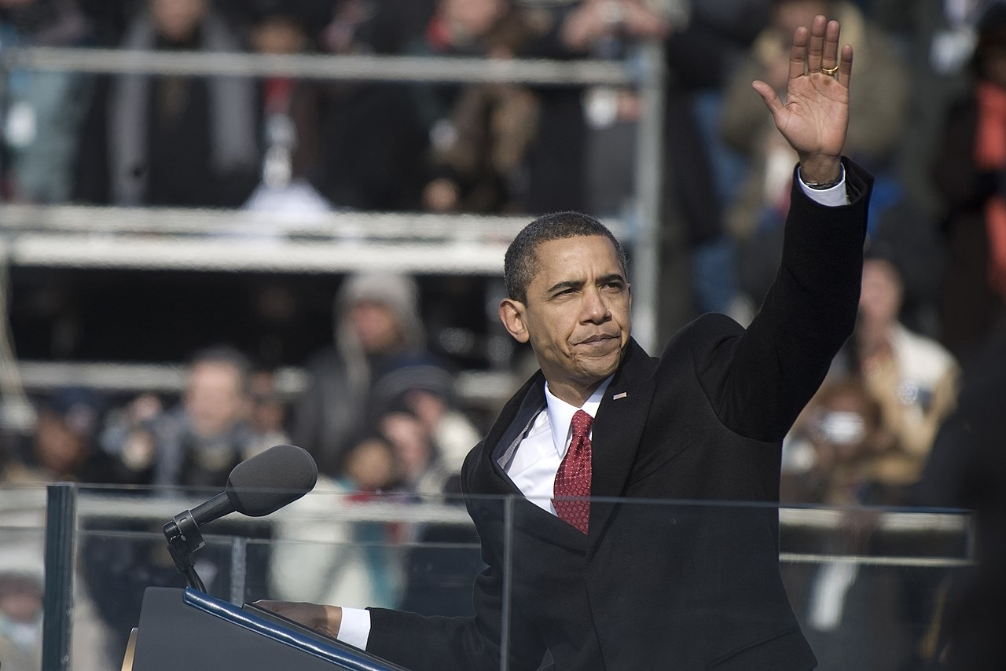
President Barack Obama After Inaugural Address, U.S. Capitol (January 20, 2009) · U.S. Navy (photo 090120-N-0696M-327) · January 20, 2009
Source: U.S. Navy. "President Barack Obama After Inaugural Address, U.S. Capitol." 20 Jan. 2009. U.S. Department of Defense / U.S. Navy (090120-N-0696M-327), via Wikimedia Commons, commons.wikimedia.org/wiki/File:Barack_Obama_after_inaugural_address_1-20-09_hires_090120-N-0696M-327a.jpg. Public Domain https://commons.wikimedia.org/wiki/File:Barack_Obama_after_inaugural_address_1-20-09_hires_090120-N-0696M-327a.jpg
HIPPO — analyze the source (prompt) | Your analysis
H — Historical context: what was happening when this was created?
I — Intended audience: who was meant to see or obey it?
P — Purpose: why was it created?
P — Point of view: whose perspective does it reflect?
O — Outside connection: how does it connect to this standard?
SUPPORT OPTION
Sentence frame: This source shows ______ because it ______, which reveals ______.
CONFIDENCE CHECK-IN
Rate your understanding of this standard (1–4): ______ One thing to revisit: ____________________

Activity 6 — Core Application: Practice Quiz — US.95 ⏱ ~8 min
RESPONSE CHOICE
Commit to an answer by marking it, saying it, or explaining it aloud before checking. Answer key is in the Teacher Guide (kept separate).
[DOK 2 · item us-95-q07 · pre-field-test]
Obama's landmark nuclear agreement with Iran (Joint Comprehensive Plan of Action, 2015) was designed to:
A. Limit Iran's uranium enrichment in exchange for sanctions relief, delaying nuclear weapons development
B. Permanently eliminate all Iranian nuclear facilities, including civilian power reactors
C. Provide Iran with civilian nuclear reactor technology under international supervision
D. Establish a formal security and defense partnership between the United States and Iran
[DOK 2 · item us-89-x018 · pre-field-test]
The Obama administration's extensive use of drone strikes in Pakistan, Yemen, and Somalia was controversial because:
A. The strikes were conducted in secret, preventing Congress from exercising its constitutional oversight authority
B. Drones caused frequent civilian casualties and raised due process concerns when targeting American citizens abroad
C. Congress had not passed a specific authorization to use force in Pakistan, Yemen, or Somalia
D. The strikes were conducted without host-country consent, violating established norms of state sovereignty
[DOK 3 · item u1-us95-dok3-tc · pre-field-test]
How did Republican opposition limit Obama's ability to implement his agenda after 2010?
A. After 2010 midterm losses, Republican control of Congress led to legislative gridlock, government shutdowns, and blocking of Supreme Court nominations
B. Republicans fully supported Obama's agenda, which represents a common misconception about the period, though this interpretation lacks supporting historical evidence
C. Obama's agenda was unaffected by opposition, but this oversimplifies the complex factors at work, which represents a common misconception about this historical period
D. Democrats controlled Congress throughout his presidency, but this oversimplifies the complex factors at work, although historical sources do not support this conclusion

Activity 7 — Constructed Response (CER) — US.95 ⏱ ~15 min
BIG-QUESTION ORGANIZER — how did Americans fight to make the promise of equality real, and what did it take to change the law and the nation?
Jot quick notes from THIS standard: Who benefited? · Who bore the costs? · Who decided?

CONSTRUCTED RESPONSE (CER) — builds SSP.04 Argumentation
Claim + Evidence + Reasoning: Using this standard, take a position on the central question — describe the achievements and setbacks of President Barack Obama's administration? Support your claim with two pieces of evidence from the passage and explain your reasoning.
Part | Write here
Claim
Evidence (two specifics)
Reasoning
SELF-CHECK (CER rubric — see Toolkit)
Is my claim defensible? · TWO specific pieces of evidence? · Does my reasoning explain HOW the evidence proves the claim?
EXIT TICKET — before you leave [item us95-q1 · DOK 2 · pre-field-test]
What were President Obama's major domestic achievements, particularly in healthcare and economic recovery?
A. Obama had no significant domestic achievements, which does not align with the documented historical record and oversimplifies the complex factors at work during this period
B. Obama's policies worsened the economic crisis, despite the fact that multiple sources contradict this view when examined alongside the available primary and secondary sources
C. The Affordable Care Act expanded health coverage to millions while the Recovery Act helped end the Great Recession, reducing unemployment from 10% to 4.7%
D. Healthcare reform was never attempted, though this interpretation lacks supporting historical evidence, but contemporary accounts and primary sources suggest otherwise
Show what you know (your choice): mark the best answer, say it, or explain it — then rate how sure you are: ☐ Not yet ☐ Getting there ☐ Got it
Answer key and next steps are in the Teacher Guide.

Your Tennessee Connection
TENNESSEE CONNECTION · TENNESSEANS IN THE MODERN ERA
Tennessee shaped the modern era at every turn. Senator Howard Baker of Tennessee asked the defining Watergate question — “What did the President know, and when did he know it?” — as vice chairman of the Senate Watergate Committee, then served as Ronald Reagan’s Chief of Staff (US.85, US.86, US.89). The Great Society reached deep into the state: the Appalachian Regional Commission rebuilt East Tennessee infrastructure, and Medicare and Head Start expanded statewide (US.83). The Tellico Dam fight over the snail darter produced the landmark TVA v. Hill environmental ruling (US.87). Al Gore of Carthage championed the “information superhighway” and climate action (US.91, US.94); Fort Campbell’s 101st Airborne deployed to the Gulf War and to Afghanistan after 9/11 (US.90, US.92); and in 2010 Chattanooga — “Gig City” — launched the nation’s first citywide gigabit internet (US.94).
Reflect (RESPONSE CHOICE): How does a local story change the way you understand a national event? Answer by writing, recording, or diagramming.

Local History Investigation
The modern era reached every Tennessee community — through federal programs, new technology, military service, and changing industries. Investigate one local connection and record what you find.
Prompt | Your findings
A person, place, or industry from this era near me
One source I could check (library, TSLA, family, museum)
Who benefited / who bore the costs, locally
One question I still have

Progress Tracker & Cumulative Review
Track your Progress Check result for each standard and note one thing to revisit.
Standard | Progress Check (✓ / reteach) | One thing to revisit
US.83
US.84
US.85
US.86
US.87
US.88
US.89
US.90
US.91
US.92
US.93
US.94
US.95

Optional Extension Bank (higher-DOK, open to all)
Any student may choose an extension. These are EXTENSION, not a track.
US.83: Using this standard, take a position on the central question — evaluate the impact of President Lyndon Johnson's Great Society programs, including Medicare, urban renewal, and the War on Poverty? Support your claim with two pieces of evidence from the passage and explain your reasoning.
US.84: Using this standard, take a position on the central question — analyze different points of view that reflect the rise of social activism and the growth of counterculture, including the generation gap, hippies, and Woodstock? Support your claim with two pieces of evidence from the passage and explain your reasoning.
US.85: Using this standard, take a position on the central question — explain significant achievements of President Richard Nixon's administration, including his appeal to the "silent majority" and his major foreign policy actions? Support your claim with two pieces of evidence from the passage and explain your reasoning.
US.86: Using this standard, take a position on the central question — examine the Watergate scandal, including the background of the break-in, the changing role of media, President Ford's pardon controversy, the legacy of distrust, and United States v. Nixon? Support your claim with two pieces of evidence from the passage and explain your reasoning.
US.87: Using this standard, take a position on the central question — explain the emergence of environmentalism, including the creation of the Environmental Protection Agency and disasters such as Love Canal and Three Mile Island? Support your claim with two pieces of evidence from the passage and explain your reasoning.
US.88: Using this standard, take a position on the central question — identify and explain the significant events of President Jimmy Carter's administration, including the poor economy, Panama Canal Treaty, Camp David Accords, energy crisis, and Iran Hostage Crisis? Support your claim with two pieces of evidence from the passage and explain your reasoning.
US.89: Using this standard, take a position on the central question — analyze the significance of President Ronald Reagan's administration, including the revitalization of national pride, Reaganomics, Iran-Contra affair, "War on Drugs," Strategic Defense Initiative, and the AIDS epidemic? Support your claim with two pieces of evidence from the passage and explain your reasoning.
US.90: Using this standard, take a position on the central question — describe the significant events of President George H.W. Bush's administration, including the invasion of Panama and the Gulf War? Support your claim with two pieces of evidence from the passage and explain your reasoning.
US.91: Using this standard, take a position on the central question — summarize the events of President Bill Clinton's administration, including welfare-to-work, balanced budget, NAFTA, and scandals and subsequent impeachment hearings? Support your claim with two pieces of evidence from the passage and explain your reasoning.
US.92: Using this standard, take a position on the central question — describe the impact of the September 11, 2001 terrorist attacks on the World Trade Center and the Pentagon, including the response of President George W. Bush, wars in Afghanistan and Iraq, and continued efforts to combat terrorism globally? Support your claim with two pieces of evidence from the passage and explain your reasoning.
US.93: Using this standard, take a position on the central question — describe the increasing role of women and minorities in the American military, politics, and economy, including Hillary Clinton, Sandra Day O'Connor, Nancy Pelosi, Colin Powell, and Condoleezza Rice? Support your claim with two pieces of evidence from the passage and explain your reasoning.
US.94: Using this standard, take a position on the central question — compare and contrast commonly used methods of communication from 1970 to today, and analyze the impact they have had on society? Support your claim with two pieces of evidence from the passage and explain your reasoning.
US.95: Using this standard, take a position on the central question — describe the achievements and setbacks of President Barack Obama's administration? Support your claim with two pieces of evidence from the passage and explain your reasoning.

Think Like a Test-Writer (unit review — open to all)
You met a quick “think like a test-writer” prompt in every standard. Here is the full how-to, once, plus room to write your best questions for the whole unit.
HOW TO WRITE A DOK-3 QUESTION
DOK-3 = strategic thinking: the reader must analyze, compare, evaluate, or justify using evidence — and there should be more than one defensible answer (not a fact you can just look up).
Sentence starters: “Why did ______ lead to ______?” · “Which mattered more — ______ or ______ — and why?” · “What is the BEST evidence that ______?” · “Evaluate whether ______.” · “Defend or challenge: ______.”
Frame: [Analyze / Evaluate / Justify] + [something from this unit] + “using evidence.”
Quick check: does my question make the reader THINK and use evidence? If yes, it’s DOK-3.
Standard | Your DOK-3 question | Your answer key (one sentence)

Reusable Toolkit & Source Library

Written Response Rubric (CER)
Level | Claim | Evidence | Reasoning
4 — Strong | Precise, defensible | 2+ accurate, specific | Explains how evidence proves the claim
3 — Proficient | Clear | 2 accurate | Explains the link
2 — Developing | General | 1 accurate | Partial link
1 — Beginning | Unclear/missing | Missing/inaccurate | No reasoning

Source Library — full citations & clickable links
US.83 — Johnson's Great Society Programs
Great Society Speech. President Lyndon B. Johnson, May 22, 1964. Johnson, President Lyndon B.. "Great Society Speech." May 22, 1964. Miller Center, University of Virginia, millercenter.org/the-presidency/presidential-speeches. Public domain. https://millercenter.org/the-presidency/presidential-speeches/may-22-1964-remarks-university-michigan
War on Poverty Message to Congress. President Lyndon B. Johnson, March 16, 1964. Johnson, President Lyndon B.. "War on Poverty Message to Congress." March 16, 1964. Miller Center, University of Virginia, millercenter.org/the-presidency/presi. Public domain. https://millercenter.org/the-presidency/presidential-speeches/march-16-1964-special-message-congress-war-poverty
US.84 — Social Activism and Counterculture
Gulf of Tonkin Resolution. U.S. Congress, August 7, 1964. U.S. Congress. "Gulf of Tonkin Resolution." August 7, 1964. National Archives, https://www.archives.gov/milestone-documents/tonkin-gulf-resolution.. Public domain. https://www.archives.gov/milestone-documents/tonkin-gulf-resolution
Letter from Vietnam. U.S. Army Specialist 4th Class Richard Cantale, 1968. Cantale, U.S. Army Specialist 4th Class Richard. "Letter from Vietnam." 1968. Library of Congress, www.loc.gov/collections/veterans-history-project/.. Public domain. https://www.loc.gov/collections/veterans-history-project/
US.85 — Nixon Administration Achievements
Silent Majority Speech. President Richard Nixon, November 3, 1969. Nixon, President Richard. "Silent Majority Speech." November 3, 1969. Richard Nixon Presidential Library, www.nixonlibrary.gov/silent-majority.. Public domain. https://www.nixonlibrary.gov/silent-majority
Toast at State Dinner in Beijing. President Richard Nixon, February 21, 1972. Nixon, President Richard. "Toast at State Dinner in Beijing." February 21, 1972. Richard Nixon Presidential Library, www.nixonlibrary.gov/china.. Public domain. https://www.nixonlibrary.gov/china
US.86 — Watergate Scandal
Resignation Speech. President Richard Nixon, August 8, 1974. Nixon, President Richard. "Resignation Speech." August 8, 1974. National Archives, https://www.archives.gov/exhibits/american_originals/nixon2.html.. Public domain. https://www.archives.gov/exhibits/american_originals/nixon2.html
White House Tape Transcript (The Smoking Gun). President Nixon and H.R. Haldeman, June 23, 1972. Haldeman, President Nixon and H.R.. "White House Tape Transcript (The Smoking Gun)." June 23, 1972. Richard Nixon Presidential Library, www.nixonlibrary.gov/wat. Public domain. https://www.nixonlibrary.gov/watergate
US.87 — Emergence of Environmentalism
EPA Establishment Message. President Richard Nixon, July 9, 1970. Nixon, President Richard. "EPA Establishment Message." July 9, 1970. Richard Nixon Presidential Library, www.nixonlibrary.gov/epa.. Public domain. https://www.nixonlibrary.gov/epa
Silent Spring. Rachel Carson, 1962. Carson, Rachel. "Silent Spring." 1962. Library of Congress, www.loc.gov/item/62019451/.. Public domain. https://www.loc.gov/item/62019451/
US.88 — Carter Administration Events
Camp David Accords Signing Statement. President Jimmy Carter, September 17, 1978. Carter, President Jimmy. "Camp David Accords Signing Statement." September 17, 1978. Jimmy Carter Presidential Library, www.jimmycarterlibrary.gov/research/camp. Public domain. https://www.jimmycarterlibrary.gov/research/camp_david_accords
Crisis of Confidence Speech. President Jimmy Carter, July 15, 1979. Carter, President Jimmy. "Crisis of Confidence Speech." July 15, 1979. Miller Center, University of Virginia, millercenter.org/the-presidency/presidential-speec. Public domain. https://millercenter.org/the-presidency/presidential-speeches/july-15-1979-crisis-confidence-speech
US.89 — Reagan Administration Significance
First Inaugural Address. President Ronald Reagan, January 20, 1981. Reagan, President Ronald. "First Inaugural Address." January 20, 1981. Ronald Reagan Presidential Library, www.reaganlibrary.gov/archives/speech/inaugural-addre. Public domain. https://www.reaganlibrary.gov/archives/speech/inaugural-address-1981
Berlin Wall Speech. President Ronald Reagan, June 12, 1987. Reagan, President Ronald. "Berlin Wall Speech." June 12, 1987. Ronald Reagan Presidential Library, www.reaganlibrary.gov/archives/speech/remarks-east-west-relat. Public domain. https://www.reaganlibrary.gov/archives/speech/remarks-east-west-relations-brandenburg-gate-west-berlin-germany
US.90 — George H.W. Bush Administration
Address on the Gulf War. President George H.W. Bush, January 16, 1991. Bush, President George H.W.. "Address on the Gulf War." January 16, 1991. Miller Center, University of Virginia, millercenter.org/the-presidency/presidential-sp. Public domain. https://millercenter.org/the-presidency/presidential-speeches/january-16-1991-address-nation-operation-desert-storm
Address on the End of the Cold War. President George H.W. Bush, December 25, 1991. Bush, President George H.W.. "Address on the End of the Cold War." December 25, 1991. Miller Center, University of Virginia, millercenter.org/the-presidency/pre. Public domain. https://millercenter.org/the-presidency/presidential-speeches/december-25-1991-address-nation-collapse-soviet-union
US.91 — Clinton Administration Events
NAFTA Signing Statement. President Bill Clinton, December 8, 1993. Clinton, President Bill. "NAFTA Signing Statement." December 8, 1993. Library of Congress, www.loc.gov/item/2016879745/.. Public domain. https://www.loc.gov/item/2016879745/
State of the Union Address. President Bill Clinton, January 23, 1996. Clinton, President Bill. "State of the Union Address." January 23, 1996. Miller Center, University of Virginia, millercenter.org/the-presidency/presidential-spe. Public domain. https://millercenter.org/the-presidency/presidential-speeches/january-23-1996-state-union-address
US.92 — September 11th Impact
Address to the Nation. President George W. Bush, September 11, 2001. Bush, President George W.. "Address to the Nation." September 11, 2001. Library of Congress, www.loc.gov/item/2002736689/.. Public domain. https://www.loc.gov/item/2002736689/
Authorization for Use of Military Force. U.S. Congress, September 18, 2001. U.S. Congress. "Authorization for Use of Military Force." September 18, 2001. Library of Congress, www.congress.gov/107/plaws/publ40/PLAW-107publ40.htm.. Public domain. https://www.congress.gov/107/plaws/publ40/PLAW-107publ40.htm
US.93 — Increasing Role of Women and Minorities
Sandra Day O'Connor Confirmation Statement. Sandra Day O'Connor, September 1981. O'Connor, Sandra Day. "Sandra Day O'Connor Confirmation Statement." September 1981. Library of Congress, www.loc.gov/item/2010712045/.. Public domain. https://www.loc.gov/item/2010712045/
Secretary of State Nomination Acceptance. Colin Powell, December 16, 2000. Powell, Colin. "Secretary of State Nomination Acceptance." December 16, 2000. Library of Congress, www.loc.gov/collections/general-collections/.. Public domain. https://www.loc.gov/collections/general-collections/
US.94 — Communication Methods Evolution
The Internet and Society. Pew Research Center, 2005. Center, Pew Research. "The Internet and Society." 2005. Library of Congress, www.loc.gov/collections/general-collections/.. Public domain. https://www.loc.gov/collections/general-collections/
Letter to a Friend. Anonymous American, 1975. American, Anonymous. "Letter to a Friend." 1975. Library of Congress, www.loc.gov/collections/veterans-history-project/.. Public domain. https://www.loc.gov/collections/veterans-history-project/
US.95 — Obama Administration Achievements and Setbacks
First Inaugural Address. President Barack Obama, January 20, 2009. Obama, President Barack. "First Inaugural Address." January 20, 2009. Ronald Reagan Presidential Library, www.reaganlibrary.gov/archives/speech/inaugural-addres. Public domain. https://www.reaganlibrary.gov/archives/speech/inaugural-address-1981
Affordable Care Act Signing Statement. President Barack Obama, March 23, 2010. Obama, President Barack. "Affordable Care Act Signing Statement." March 23, 2010. Library of Congress, www.loc.gov/item/2010704523/.. Public domain. https://www.loc.gov/item/2010704523/

The Making of Modern America — Four Threads
This section connects the threads of the era: between the 1960s and today, Americans remade the role of government, weathered crises of trust and economy, ended the Cold War, and confronted a new century. It is History Hack-authored instructional synthesis grounded in this unit’s sourced record — not a primary source.

A New Domestic Order
Johnson’s Great Society vastly expanded the federal safety net — Medicare, Medicaid, the War on Poverty, and federal aid to schools (US.83) — while a youth counterculture and new activist movements challenged authority and widened the meaning of rights (US.84).

A Crisis of Trust
Vietnam and then the Watergate scandal shattered public faith in government: Nixon’s achievements abroad were eclipsed by a cover-up that forced his resignation (US.85–US.86), and Carter inherited stagflation, an energy crisis, and the Iran hostage crisis (US.88).

Conservative Resurgence & the Cold War’s End
Reagan cut taxes, expanded defense, and pressed the Soviet Union (US.89); under Reagan and George H.W. Bush the Berlin Wall fell and the USSR dissolved, and a U.S.-led coalition won the Gulf War (US.90). Clinton then governed a booming, globalizing, increasingly digital economy (US.91, US.94).

A New Century’s Challenges
The September 11 attacks launched a long war on terror and reshaped security at home (US.92); a more diverse nation saw women and minorities rise to the highest offices, culminating in Obama’s presidency (US.93, US.95); and environmental awareness grew throughout the era (US.87).

Unit Reflection
Return to the unit’s big question: how did Americans remake government, the economy, and the nation’s place in the world between the 1960s and today — and what did it cost? Write a final claim with two pieces of evidence from different standards.
Part | Write here
My claim
Evidence 1 (standard: ___)
Evidence 2 (standard: ___)
Why it matters today

