U.S. HISTORY HACK™
COURSE STANDARD · PLATINUM EDITION

IMPERIALISM &
WORLD WAR I
1890–1920
Unit 3 · High-School U.S. History · Standards-Aligned
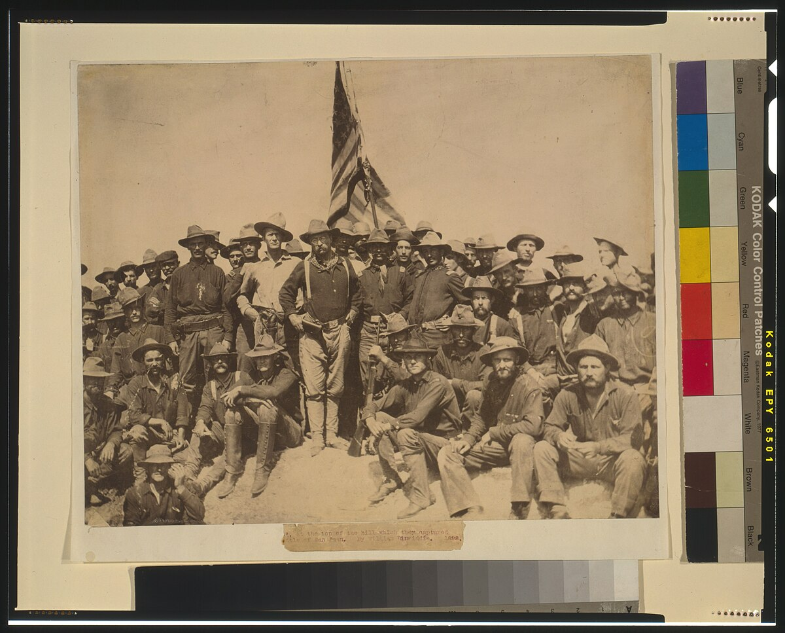
Col. Theodore Roosevelt and the Rough Riders, San Juan Heights, 1898 · Library of Congress · Public domain
GRAPHIC ORGANIZER TOOLKIT

UDL 3.0 | MTSS | CER | Cornell | HIPPO | DOK
Universal Design for Learning · Multi-Tiered Supports · Evidence-Based Writing
Teacher Edition
TroopToTeacher Technologies LLC

U.S. HISTORY HACK™ Unit 3 — Imperialism and World War I (1890–1920) GRAPHIC ORGANIZER TOOLKIT · TroopToTeacher Technologies LLC
SPINE
Saddle-stitch. At 39 pages the folded spine is only ≈ 0.088 in (2.2 mm) — too thin to print spine text; bind saddle-stitch (no printed spine). To get a printable spine, perfect-bind at ≥ ~48 pages, or combine thin teacher books into one volume. The spine panel above is provided for when this title is perfect-bound.

U.S. HISTORY HACK™
Reproducible thinking tools — blank and labeled, ready to print.
Unit 3 — Imperialism and World War I (1890–1920) · Teacher Edition
WHAT’S IN THE TOOLKIT

◆ The organizers the course runs on. Frayer, CER, HIPPO, Cornell, cause–effect, timeline, T-chart, Venn, and more — on brand and classroom-ready.
◆ Blank and labeled versions. A blank for open use and a guided/labeled version for scaffolding — pick by learner need.
◆ UDL response choice. Students write, diagram, or map their thinking — multiple means of action and expression by design.
◆ A quick-use guide. When and how to reach for each organizer, tied to the workbook activities.
◆ Reproducible for your class. Print as needed for licensed classroom use.
◆ Consistent across the course. The same tools students meet in every unit, so routines transfer.
INSIDE THIS UNIT — the nine standards

US.19 Causes of American Imperialism
US.20 Interventionists vs Non-Interventionists
US.21 Spanish-American War & Imperialism Outcomes
US.22 Diplomatic Policies: Big Stick, Dollar, and Moral Diplomacy
US.23 Causes of World War I & U.S. Neutrality
US.24 Reasons for American Entry into World War I
US.25 Key Figures and Developments in World War I
US.26 World War I Home Front
US.27 Wilson's Fourteen Points and League of Nations
Part of the U.S. History Hack™ Course Standard series — a complete, standards-aligned system: Student Workbook · Teacher Edition · Student & Teacher Slide Decks · Graphic Organizer Toolkit · Unit Assessment Book.
TroopToTeacher Technologies LLC  U.S. History Hack™ · Course Standard (Platinum) Edition · Teacher Edition  © 2026 TroopToTeacher Technologies LLC. All rights reserved. U.S. History Hack™ is a trademark of TroopToTeacher Technologies LLC. No part of this book may be reproduced without written permission, except as licensed for classroom use.  www.trooptoteacher.com · Printed in the U.S.A. · First Edition | ISBN barcode  ISBN 978-X-XXXXX-XXX-X  placeholder — replace at print

PRINT & ONLINE-LISTING SPEC
An internal handoff sheet for your printer and your storefront listing — not part of the printed book.
Title (listing) | U.S. History Hack™ — Unit 3 · Teacher Graphic Organizer Toolkit
Series | U.S. History Hack™ Course Standard (Platinum) Edition
Publisher / Author | TroopToTeacher Technologies LLC
Trim size | 8.5 × 11 in (US Letter)
Interior | 39 pages, black-and-white, 60-lb (90 gsm) white offset
Binding & spine | Saddle-stitch (no printed spine) at 39 pp; spine ≈ 0.088 in only. Perfect-bind at ≥ ~48 pp for a printable spine.
Cover stock | 10-pt or 12-pt C1S gloss/matte laminate; full color
Bleed | Add 0.125 in bleed on all outside edges before print (this concept is at trim).
Copyright | © 2026 TroopToTeacher Technologies LLC. All rights reserved.
ISBN | Assign one ISBN per format (paperback / PDF); place barcode in the back-cover box.
Age / grade | Grades 9–12 · U.S. History
Categories | Education › Teaching Methods & Materials › Social Science; Study Aids › History
Keywords | graphic organizers, Frayer, CER, HIPPO, Cornell notes, cause and effect, timeline, UDL, reproducible, social studies
BACK-COVER BLURB (for your storefront)
The Graphic Organizer Toolkit collects the reproducible thinking tools the course runs on — Frayer, CER, HIPPO, Cornell, cause–effect, timeline, T-chart, Venn, and more — each in a blank and a labeled version, with a quick-use guide. Built on UDL so students can write, diagram, or map their thinking. Print as needed for your classroom.

