U.S. HISTORY HACK™
COURSE STANDARD · PLATINUM EDITION

THE ROARING
TWENTIES
1920–1929
Unit 4 · High-School U.S. History · Standards-Aligned
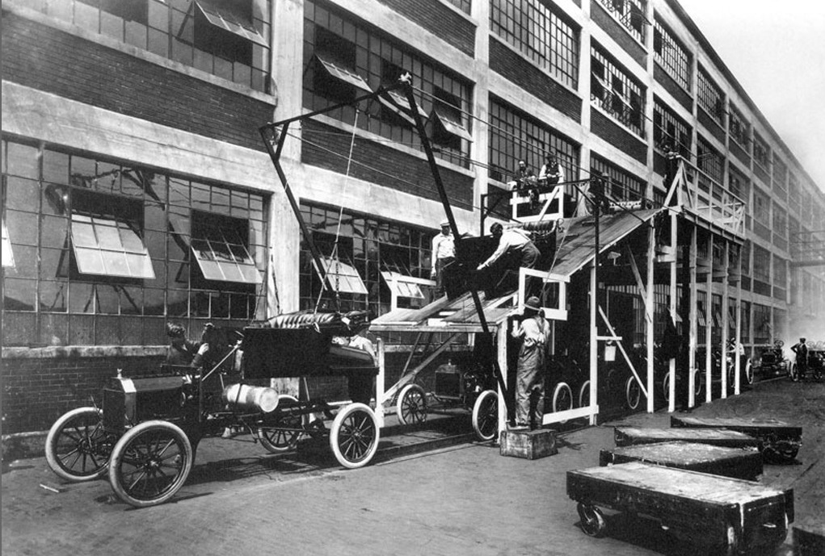
A Ford assembly line in the era of mass production, early 1900s · Public domain
STUDENT WORKBOOK

UDL 3.0 | MTSS | CER | Cornell | HIPPO | DOK
Universal Design for Learning · Multi-Tiered Supports · Evidence-Based Writing
Student Edition
TroopToTeacher Technologies LLC

U.S. HISTORY HACK™ Unit 4 — The 1920s (1920–1929) STUDENT WORKBOOK · TroopToTeacher Technologies LLC
SPINE
Perfect-bound. At 115 pages on 60-lb (90 gsm) white offset the spine is ≈ 0.259 in (6.6 mm) — wide enough to print the spine text above. Recompute if the page count or paper changes (white 60-lb ≈ 0.002252 in/page).

U.S. HISTORY HACK™
The workbook that teaches every learner — without lowering the bar.
Unit 4 — The 1920s (1920–1929) · Student Edition
WHAT MAKES THIS WORKBOOK DIFFERENT

◆ Built on UDL 3.0 (CAST). Every activity offers multiple means of engagement, representation, and action — word banks, sentence frames, visuals, and choice built in, so the rigor stays the same for every learner.
◆ MTSS tiers on every page. Core instruction with layered Guided and Light Support, plus a formative Exit Ticket for each standard and a “What’s Next” reteach path in the Teacher Edition.
◆ Writes like a historian — CER. A 6-point Claim–Evidence–Reasoning rubric runs through the whole course, with scaffolded organizers and lined response space.
◆ Real primary sources, cited. Photographs, political cartoons, and maps from the Library of Congress and National Archives — analyzed with the HIPPO routine — every source documented to Chicago style.
◆ Cornell notes paired to the slide deck. Structured note pages capture the direct-teaching slides, with retrieval checks and doodle zones for visual learners.
◆ Standards-aligned & TCAP-ready. DOK-balanced checks and a companion Assessment Book with two parallel forms, keyed to the standards and reporting categories.
INSIDE THIS UNIT — the eleven standards

US.28 The Great Migration
US.29 Radio, Movies, and Popular Culture
US.30 Grand Ole Opry, Blues & Country Music
US.31 New Technologies: Air Travel and Electricity
US.32 Henry Ford, the Automobile & Mass Production
US.33 The Harlem Renaissance
US.34 Women in the 1920s: Flappers & Social Changes
US.35 Civil Liberties: Red Scare, KKK & NAACP
US.36 The Scopes Trial
US.37 Prohibition & Its Impact on American Society
US.38 Credit, Consumerism & Financial Speculation
Part of the U.S. History Hack™ Course Standard series — a complete, standards-aligned system: Student Workbook · Teacher Edition · Student & Teacher Slide Decks · Graphic Organizer Toolkit · Unit Assessment Book.
TroopToTeacher Technologies LLC  U.S. History Hack™ · Course Standard (Platinum) Edition · Student Edition  © 2026 TroopToTeacher Technologies LLC. All rights reserved. U.S. History Hack™ is a trademark of TroopToTeacher Technologies LLC. No part of this book may be reproduced without written permission, except as licensed for classroom use.  www.trooptoteacher.com · Printed in the U.S.A. · First Edition | ISBN barcode  ISBN 978-X-XXXXX-XXX-X  placeholder — replace at print

PRINT & ONLINE-LISTING SPEC
An internal handoff sheet for your printer and your storefront listing — not part of the printed book.
Title (listing) | U.S. History Hack™ — Unit 4: The 1920s (1920–1929) · Student Workbook
Series | U.S. History Hack™ Course Standard (Platinum) Edition
Publisher / Author | TroopToTeacher Technologies LLC
Trim size | 8.5 × 11 in (US Letter)
Interior | 115 pages, black-and-white, 60-lb (90 gsm) white offset
Binding & spine | Perfect-bound; spine ≈ 0.259 in (6.6 mm). Print spine text.
Cover stock | 10-pt or 12-pt C1S gloss/matte laminate; full color
Bleed | Add 0.125 in bleed on all outside edges before print (this concept is at trim).
Copyright | © 2026 TroopToTeacher Technologies LLC. All rights reserved.
ISBN | Assign one ISBN per format (paperback / PDF); place barcode in the back-cover box.
Age / grade | Grades 9–12 · U.S. History
Categories | Education › Teaching Methods & Materials › Social Science; Study Aids › History
Keywords | U.S. history workbook, high school history, UDL curriculum, MTSS, CER writing, primary source analysis, Cornell notes, standards-aligned, the 1920s, Roaring Twenties, Harlem Renaissance, Great Migration, Prohibition, Scopes Trial, Jazz Age, standards-aligned, TCAP review
BACK-COVER BLURB (for your storefront)
U.S. History Hack™ turns a full unit of high-school U.S. History into one student-ready workbook that reaches every learner without lowering the bar. Built on Universal Design for Learning (UDL 3.0) and Multi-Tiered Systems of Support (MTSS), each of the eleven standards moves from a core lesson to Cornell notes paired with the slide deck, real Library-of-Congress primary sources analyzed with HIPPO, evidence-based writing on a 6-point CER rubric, and a formative Exit Ticket with a built-in reteach path. Standards-aligned, DOK-balanced, and TCAP-ready — with a companion Assessment Book of two parallel forms. Unit 4 covers The 1920s, 1920–1929.

