1776 - 2026 • AMERICA'S 250TH ANNIVERSARY • SEMIQUINCENTENNIAL EDITION
U.S. HISTORY HACK™
TROOPTOTEACHER TECHNOLOGIES
UNIT 4
The 1920s, 1920–1929
COURSE STANDARD EDITION
US.28 – US.38 • 11 Tennessee U.S. History Standards • Grades 9–12
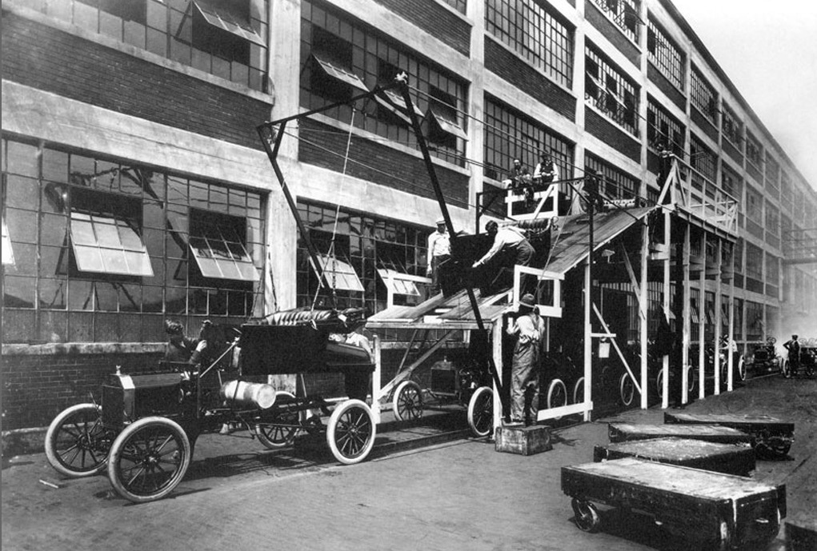
Automobiles on a Ford assembly line during the era of mass production, early twentieth century.
Source: Public domain.
TENNESSEE CONNECTION · THE SCOPES TRIAL & THE GRAND OLE OPRY
Two of the decade’s biggest stories happened in Tennessee in 1925. In Dayton, the Scopes “Monkey Trial” (US.36) put teacher John Scopes on trial for teaching evolution — Clarence Darrow vs. William Jennings Bryan — in a case broadcast to the nation. That same year in Nashville, WSM radio launched what became the Grand Ole Opry (US.30), making the city the home of country music.
One common workbook designed for learner variability. Every student works toward the same Tennessee standards; supports vary the means, not the goal or the ceiling.
Release-Ready · Pilot Edition
© 2026 TroopToTeacher Technologies LLC. All rights reserved. ISBN: [to be assigned]

Copyright, Ownership & Framework
U.S. History Hack™ — Unit 4: The 1920s (1920–1929), Course Standard Edition.
© 2026 TroopToTeacher Technologies LLC. All rights reserved. This workbook is proprietary; reproduction or redistribution outside a licensed classroom is prohibited.
Source integrity. Every primary source in this unit is public-domain and cited to its holding repository (National Archives, Library of Congress, HathiTrust). See the Source Library.
Reading provenance (district-clear). Close-Read passages are labeled “History Hack-authored instructional synthesis” — they build on the standard record and are not presented as primary sources.
Framework stack. This workbook anchors to Tennessee U.S. History standards US.28–US.38 and the Social Studies Practices (SSP.01–SSP.06), and is designed on CAST UDL 3.0 and an MTSS support model.
Pacing. Each standard is built for one 45-minute class period. Each activity shows a ⏱ ~ minutes estimate at its heading. There is more here than one period holds — your teacher chooses which activities you do in class; the rest may become warm-ups, stations, or homework.

Table of Contents

Tennessee Standards & SSP Crosswalk
Each standard below is taught to the full Course Standard expectation; the Social Studies Practices are embedded in every activity cycle.
Standard | Focus | Lenses
US.28 | The Great Migration | History · Geography · Economics · Tennessee Connection
US.29 | Radio, Movies, and Popular Culture | History · Economics
US.30 | Grand Ole Opry, Blues & Country Music | History · Geography · Tennessee Connection
US.31 | New Technologies: Air Travel and Electricity | Economics · History
US.32 | Henry Ford, the Automobile & Mass Production | Economics · History
US.33 | The Harlem Renaissance | History · Culture · Tennessee Connection
US.34 | Women in the 1920s: Flappers & Social Changes | History · Culture · Economics
US.35 | Civil Liberties: Red Scare, KKK & NAACP | Culture · Politics/Government · History · Tennessee Connection
US.36 | The Scopes Trial | History · Culture
US.37 | Prohibition & Its Impact on American Society | Culture · History · Economics
US.38 | Credit, Consumerism & Financial Speculation | Economics · History

Social Studies Practices (SSP.01–SSP.06)
SSP.01 Gather/evaluate sources · SSP.02 Critically examine a primary source · SSP.03 Synthesize evidence · SSP.04 Construct/communicate argument · SSP.05 Develop historical awareness · SSP.06 Chronological/spatial reasoning. Each Close Read, Primary Source/Data, and CER activity names the practices it builds.

Accessibility, UDL & Accommodations Matrix
One firm learning goal per standard; flexible, universal means. Supports are available by design and never lower the goal. They work alongside — never in place of — required IEP or 504 accommodations.
Universal support | What it is | Where it appears
CORE PATH | Essential instruction every student completes | Every activity
LANGUAGE SUPPORT | Vocabulary, pronunciation, Spanish cognates | Word Bank, Guided/Light Backs
RESPONSE CHOICE | Write, say/record, or diagram | Every activity
SUPPORT OPTION | Optional scaffold that keeps the goal | Guided Support Back, Primary Source
PROGRESS CHECK | Quick DOK-2/3 check to guide reteach/extend | Cornell Notes, Practice Quiz
EXTENSION | Deeper challenge once the goal is met | Extension Bank, CER

How CAST UDL 3.0 is visible in this workbook
Multiple means of Engagement (response choice, relevance via Tennessee Connection), Representation (Word Bank, pronunciation, Spanish, Close-Read supports), and Action & Expression (write/say/diagram, Frayer, CER). No fixed-track labels appear.

My Support Plan (optional — you choose)
Supports are available by design. Check the ones you might try; you can change your mind any time.
Support I might use | When it would help me
Word Bank + Spanish column
Guided or Light Support Back
Response choice (say/record or diagram)
Sentence frames / Rehearsal Lab

How to Use This Workbook
Each standard runs the same seven-activity cycle: (1) Vocabulary Word Bank, (2) Vocabulary Studio, (3) Direct-Teaching Cornell Notes with optional Guided and Light Support Backs, (4) Close Read, (5) Primary Source / Data Analysis, (6) Core Application Practice Quiz, (7) Constructed Response (CER). Work the CORE PATH; reach for SUPPORT OPTIONS as needed.

Label legend — these appear throughout every standard cycle
Label | Meaning
CORE PATH | The essential instruction every student completes.
SUPPORT OPTION | An optional scaffold that keeps the goal, not lowers it.
LANGUAGE SUPPORT | Vocabulary, pronunciation, and Spanish cognates for access.
RESPONSE CHOICE | Show learning by writing, saying/recording, or diagramming.
PROGRESS CHECK | A quick DOK-2/3 check that guides reteach or extend.
EXTENSION | A deeper challenge once the goal is met.

Before You Begin — Set Your Goal
This unit asks one big question: as the United States industrialized, who benefited and who bore the costs? Set a goal, then note what you already know.
Prompt | Your response
My goal for this unit is…
One thing I already know about this era…
One question I want answered…

Standard US.28 — The Great Migration
TN Academic Standard US.28: Analyze the impact of the Great Migration of African Americans that began in the post-World War I era from the rural South to the industrial regions of the Northeast and Midwest. (TCA)
LEARNING TARGETS — I can…
• I can analyze the impact of the Great Migration of African Americans from the rural South to the industrial regions of the Northeast and Midwest in the post-World War I era.
Lenses for this standard: History · Geography · Economics · Tennessee Connection
CORE PATH — the same for every student
Same rigor for everyone: analyze the sources and vocabulary, then show what you learned on the Practice Quiz and the CER.
UDL and MTSS give you flexible ways in — they never lower the bar.
Check yourself against the learning targets on the Cornell Notes page.
★ Tennessee Connection
Memphis and Nashville were key departure points for African Americans migrating northward during the Great Migration. Tennessee's Black communities, particularly in West Tennessee, saw significant population shifts to cities like Chicago, Detroit, and St. Louis.
SET YOUR GOAL (self-direction)
My goal for this standard — what will I be able to do, and how will I show it?

HOOK — think before you dig in
The Great Migration: Analyze the impact of the Great Migration of African Americans that began in the post-World War I era from the rural South to the industrial regions of the Northeast and Midwest. (TCA). Who gained, who was left out — and why does it still matter?

ACTIVATE — what do you already know or wonder?
Jot what you already know or want to find out about this standard. You’ll come back to it.

PREVIEW & PREDICT
Which learning target will be hardest, and why? Connect it to the unit’s big question: who shared in the boom, and who was left out or pushed back?

Activity 1 — Vocabulary (Part A: Reference / Word Bank) — US.28 ⏱ ~10 min
Use this word bank throughout the standard. The Spanish column supports access, not translation of assessment.
Term | Student-friendly meaning | Spanish
Great Migration | The mass movement of over 6 million African Americans from the rural South to urban areas in the North and Midwest between 1916 and 1970, driven by economic opportunity and escape from Jim Crow segregation. | Gran Migración
First Red Scare | A period of intense fear of communism and radical political activity following World War I (1919-1920), leading to deportations, arrests, and violations of civil liberties. | Primer Susto Rojo
Radio Broadcasting | The transmission of audio content over radio waves that revolutionized communication in the 1920s, creating mass media, national advertising, and shared popular culture. | Radiodifusión
Harlem Renaissance | A 1920s cultural movement centered in Harlem, New York, where African American artists, writers, musicians, and intellectuals celebrated Black culture and identity through art, literature, and music. | Renacimiento de Harlem
Automobile Impact | The widespread adoption of cars in the 1920s transformed American society, creating suburbs, highways, tourism, and related industries like gas stations, motels, and drive-in restaurants. | Impacto del Automóvil
LANGUAGE SUPPORT
Pronunciations: Great Migration (grayt my-GRAY-shun).
VOCABULARY SELF-CHECK · Knowledge Rating
Rate each term NOW in pencil, then again at the END — growth is the goal; no penalty for “never seen it.”
Term | 1 · never seen it | 2 · heard it | 3 · can use it | 4 · can teach it
Great Migration
First Red Scare
Radio Broadcasting
Harlem Renaissance
Automobile Impact
MAKE IT YOURS (RESPONSE CHOICE): choose ONE term above and show you own it — write a sentence, sketch it, or give a real-world example.

Activity 2 — Vocabulary Studio (Frayer-inspired) — US.28 ⏱ ~7 min
RESPONSE CHOICE
Complete each studio by writing, speaking, or diagramming.

PRIORITY TERM 1 Great Migration · ES: Gran Migración
Word-bank meaning to build on: The mass movement of over 6 million African Americans from the rural South to urban areas in the North and Midwest between 1916 and 1970, driven by economic opportunity and escape from Jim Crow segregation.
Definition (in your own words) | Characteristics
Examples | Non-examples
Use it to explain
Write one sentence that uses “Great Migration” to explain this standard.

PRIORITY TERM 2 First Red Scare · ES: Primer Susto Rojo
Word-bank meaning to build on: A period of intense fear of communism and radical political activity following World War I (1919-1920), leading to deportations, arrests, and violations of civil liberties.
Definition (in your own words) | Characteristics
Examples | Non-examples
Use it to explain
Write one sentence that uses “First Red Scare” to explain this standard.

CONNECT THE TERMS (UDL · build understanding)
How do these priority terms fit together? Write or sketch how one leads to or affects another.

Activity 3 — Direct Teaching Cornell Notes — US.28 ⏱ ~20 min
Name: ______________________ Class / Period: __________ Date: __________
US.28 — The Great Migration • These notes capture the direct-teaching content and the Close Read for this standard.
Your learning targets are on this standard’s opening page — take notes that help you meet them.
Cues (tied to your learning targets) | My notes
What does the passage say about push Factors: Reasons to Leave the South?
What does the passage say about pull Factors: Attractions of the North?
What does the passage say about economic Opportunities Comparison?
Key terms →
DOODLE ZONE — draw your thinking (UDL · another way in)
Need another way in? Sketch the key idea, a quick timeline, or how the pieces connect. Words optional.

Cornell Notes — keep going, then process & check — US.28
MORE NOTES / DIAGRAMS
Continue your notes here, add a quick sketch, or map how the ideas connect.

Key terms to list
Great Migration · First Red Scare · Radio Broadcasting · Harlem Renaissance · Automobile Impact
Summary — In your own words (2–3 sentences)
PROGRESS CHECK · one question
What social and cultural changes occurred in both Southern communities that lost population and Northern cities that gained it?
A. Southern communities lost population and economic vitality while Northern cities saw neighborhood formation, business district growth, cultural flowering like the Harlem Renaissance, but also new racial tensions
B. Neither region experienced significant changes, but contemporary accounts suggest a different explanation, though this interpretation lacks supporting historical evidence, although this overlooks critical economic and social factors involved
C. Only Northern cities experienced changes, yet the available evidence points to a different conclusion, which contradicts the primary source evidence from this era despite the fact that multiple contemporary sources contradict this
D. Southern communities grew stronger after migration, although historical sources do not support this conclusion and oversimplifies the complex factors at work during this period, though this interpretation lacks supporting historical evidence
Commit before you move on — mark it, say it, or explain it aloud.
CHECK YOURSELF — how am I doing?
Which learning targets (on this standard’s opening page) can you now meet? Tick the number; circle any you still need help with.
☐ 1
My 12–15 word headline for this standard

Activity 4 — Close Read — US.28 ⏱ ~15 min
Reading type: History Hack-authored instructional synthesis. This is not a primary source. Builds SSP.03 (synthesize) and SSP.05 (historical awareness).
CORE PATH — read one chunk at a time
Push Factors: Reasons to Leave the South
Jim Crow laws enforced legal segregation and disenfranchisement, restricting opportunities for African Americans. The sharecropping system kept them in poverty through economic exploitation. Racial violence including lynchings, KKK terrorism, and legal injustice created dangerous conditions. Inferior segregated schools limited educational advancement, while the boll weevil destroyed cotton crops, reducing farm jobs.
Pull Factors: Attractions of the North
World War I created labor shortages in Northern factories, opening industrial jobs with significantly higher wages—average $1,000+ annually versus $300 in the South. Northern cities offered better schools and colleges, the ability to vote and participate in politics, less legally enforced segregation, and better housing, healthcare, and cultural opportunities.
Economic Opportunities Comparison
In the South, African Americans were limited to sharecropping, domestic service, and agricultural labor. Northern cities offered factory work in steel mills, meatpacking, and railroads, plus domestic service, factory positions, and clerical work for women. Northern cities also allowed African American entrepreneurship and professional services.
Social and Cultural Changes
Southern communities lost significant working-age population, affecting agricultural production and weakening traditional networks. Northern cities like Chicago, Detroit, and New York saw massive population growth, creation of African American neighborhoods and business districts, and the cultural flowering that led to the Harlem Renaissance. Social tensions arose from competition for jobs and housing.
Long-term Implications
The Great Migration transformed America from rural to urban society. Concentrated African American voters in Northern cities increased political influence. Urban communities provided the base for future civil rights organizing. The migration created an African American middle class and spread jazz, blues, literature, and art from concentrated urban communities. Approximately 6 million African Americans migrated between 1910-1970.
Key terms first: Great Migration, First Red Scare. Read once for the gist, then again for evidence.
CLOSE-READ EVIDENCE LAB — for each question: quote the EVIDENCE from the passage above, then write YOUR ANSWER (or answer aloud / diagram it).
Text-dependent question | Evidence from the passage | Your answer (what it shows)
What is the main idea of the “Push Factors: Reasons to Leave the South” section, and what evidence supports it?
What is the main idea of the “Pull Factors: Attractions of the North” section, and what evidence supports it?

Geographer’s Lens — US.28 ⏱ ~12 min
Geographers don’t just find places — they explain how WHERE shapes WHAT happens. Work these like a geographer. Built on the Five Themes of Geography · C3 Dimension 2 · SSP.06 (spatial reasoning).
THE PLACES — then explain why geography put them there
The Great Migration moved millions of Black Americans out of the rural South to Northern and Midwestern cities. Use the list below to map where people left and where they went, then explain the pattern.
Place | Where | What happened (given) | Why HERE? (your analysis)
Rural South (Mississippi, Alabama, Georgia) | The South | origin — sharecropping, Jim Crow, and racial violence
Chicago | Illinois | destination — meatpacking and factory jobs
Detroit | Michigan | destination — automobile-industry jobs
Harlem / New York City | New York | destination — center of the Harlem Renaissance
Cleveland | Ohio | destination — industrial jobs
MOVEMENT & REGION — what’s the spatial pattern?
In 1–2 sentences: is this a movement, a cluster, or a whole region? Name the direction or shape it takes on a map.

GEOGRAPHY AS A FORCE — how did location shape the outcome?
How did geography change WHAT happened — who was affected, how far or fast it spread, or who was left out? Use one place above as your evidence.

READ IT LIKE A SOURCE — RESPONSE CHOICE
A map is a source with a point of view. Show your thinking your way — write it, OR sketch a quick arrows-and-labels diagram: what would a map of this make CLEAR, and what would it HIDE or leave out?

Activity 5 — Primary Source / Data Analysis — US.28 ⏱ ~15 min
Primary source (photograph) — analyze it with HIPPO. Builds SSP.01–SSP.02.
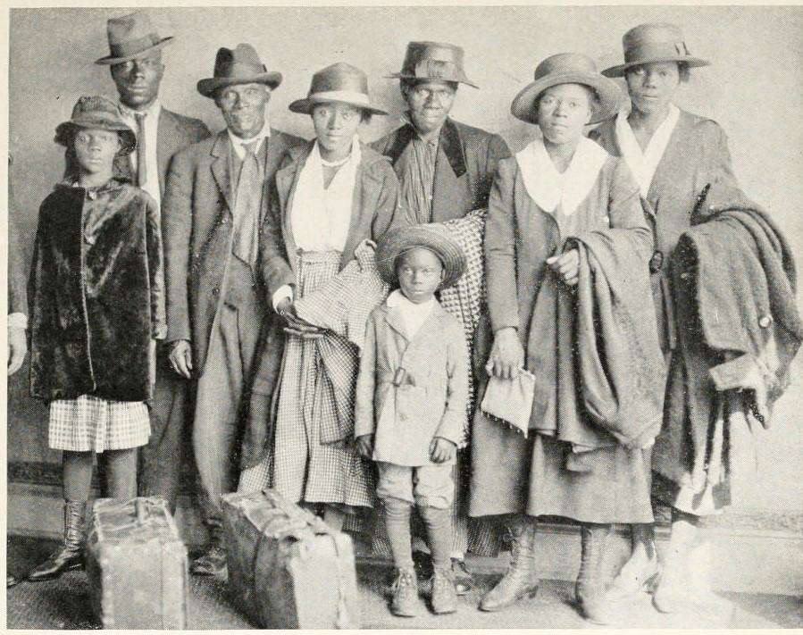
Family newly arrived in Chicago from the South · Chicago Commission on Race Relations · c1920
Source: Chicago Commission on Race Relations. "Family Newly Arrived from the South." The Negro in Chicago: A Study of Race Relations and a Race Riot. Chicago: University of Chicago Press, 1922. https://archive.org/details/negroinchicagost00chic. Public Domain — No Known Restrictions on Publication https://archive.org/details/negroinchicagost00chic
HIPPO — analyze the source (prompt) | Your analysis
H — Historical context: what was happening when this was created?
I — Intended audience: who was meant to see or obey it?
P — Purpose: why was it created?
P — Point of view: whose perspective does it reflect?
O — Outside connection: how does it connect to this standard?
SUPPORT OPTION
Sentence frame: This source shows ______ because it ______, which reveals ______.
CONFIDENCE CHECK-IN
Rate your understanding of this standard (1–4): ______ One thing to revisit: ____________________

Activity 6 — Core Application: Practice Quiz — US.28 ⏱ ~8 min
RESPONSE CHOICE
Commit to an answer by marking it, saying it, or explaining it aloud before checking. Answer key is in the Teacher Guide (kept separate).
[DOK 2 · item us30-q2 · pre-field-test]
How did economic opportunities in Northern cities compare to those available in the rural South?
A. Northern industrial wages averaged $1,000+ annually versus $300 in the South, with factory jobs, business opportunities, and professional careers available that were closed to African Americans in the segregated South
B. Economic opportunities were identical in both regions, which does not align with the documented historical record when examined alongside the available primary and secondary sources, which does not align with the documented historical record
C. The South offered better economic opportunities, but contemporary accounts suggest a different explanation, which represents a common misconception about this historical period, which does not align with the documented historical record
D. There were no jobs available in Northern cities, but this oversimplifies the complex factors at work, which contradicts the primary source evidence from this era, which does not align with the documented historical record
[DOK 2 · item q-us30-dok2-1 · pre-field-test]
What were push factors that caused the Great Migration?
A. Created economic independence and served the needs of segregated Black communities
B. Jim Crow segregation, racial violence, and limited economic opportunity in farming
C. Published train schedules, job listings, and stories about Northern opportunities
D. They reflected the experiences and struggles of rural and working-class Americans
[DOK 3 · item u1-us28-dok3-tc · pre-field-test]
What social and cultural changes occurred in both Southern communities that lost population and Northern cities that gained it?
A. Southern communities lost population and economic vitality while Northern cities saw neighborhood formation, business district growth, cultural flowering like the Harlem Renaissance, but also new racial tensions
B. Neither region experienced significant changes, but contemporary accounts suggest a different explanation, though this interpretation lacks supporting historical evidence, although this overlooks critical economic and social factors involved
C. Only Northern cities experienced changes, yet the available evidence points to a different conclusion, which contradicts the primary source evidence from this era despite the fact that multiple contemporary sources contradict this
D. Southern communities grew stronger after migration, although historical sources do not support this conclusion and oversimplifies the complex factors at work during this period, though this interpretation lacks supporting historical evidence

Activity 7 — Constructed Response (CER) — US.28 ⏱ ~15 min
BIG-QUESTION ORGANIZER — in the 1920s, who shared in the boom and the new freedoms, and who was left out or pushed back?
Jot quick notes from THIS standard: Who benefited? · Who bore the costs? · Who decided?

CONSTRUCTED RESPONSE (CER) — builds SSP.04 Argumentation
Claim + Evidence + Reasoning: Using this standard, take a position on the central question — analyze the impact of the Great Migration of African Americans from the rural South to the industrial regions of the Northeast and Midwest in the post-World War I era? Support your claim with two pieces of evidence from the passage and explain your reasoning.
Part | Write here
Claim
Evidence (two specifics)
Reasoning
SELF-CHECK (CER rubric — see Toolkit)
Is my claim defensible? · TWO specific pieces of evidence? · Does my reasoning explain HOW the evidence proves the claim?
EXIT TICKET — before you leave [item us30-q1 · DOK 2 · pre-field-test]
What push factors drove African Americans to leave the rural South, and what pull factors attracted them to Northern industrial cities?
A. Economic prosperity in the South kept most African Americans there, but this oversimplifies the complex factors at work despite the fact that multiple contemporary sources contradict this
B. African Americans migrated primarily for climate reasons, but this fails to account for the broader historical context despite the fact that multiple contemporary sources contradict this
C. Push factors included Jim Crow laws, sharecropping poverty, racial violence, and limited education; pull factors included industrial jobs, higher wages, voting rights, and less legal segregation
D. The migration was forced by government relocation programs, yet the available evidence points to a different conclusion, but closer analysis reveals a more complicated historical reality
Show what you know (your choice): mark the best answer, say it, or explain it — then rate how sure you are: ☐ Not yet ☐ Getting there ☐ Got it
Answer key and next steps are in the Teacher Guide.

Standard US.29 — Radio, Movies, and Popular Culture
TN Academic Standard US.29: Describe the growth and effects that radio and movies played in the emergence of popular culture, such as advertising, celebrities, news, and entertainment.
LEARNING TARGETS — I can…
• I can describe the growth and effects that radio and movies played in the emergence of popular culture, such as advertising, celebrities, news, and entertainment.
Lenses for this standard: History · Economics
CORE PATH — the same for every student
Same rigor for everyone: analyze the sources and vocabulary, then show what you learned on the Practice Quiz and the CER.
UDL and MTSS give you flexible ways in — they never lower the bar.
Check yourself against the learning targets on the Cornell Notes page.
★ Tennessee Connection
Tennessee was at the center of the radio revolution. WSM Radio launched in Nashville in 1925, and its 'Grand Ole Opry' became the longest-running radio program in American history. Memphis radio station WDIA (1948) was the first station in the nation programmed entirely for African American audiences.
SET YOUR GOAL (self-direction)
My goal for this standard — what will I be able to do, and how will I show it?

HOOK — think before you dig in
Radio, Movies, and Popular Culture: Describe the growth and effects that radio and movies played in the emergence of popular culture, such as advertising, celebrities, news, and entertainment. Who gained, who was left out — and why does it still matter?

ACTIVATE — what do you already know or wonder?
Jot what you already know or want to find out about this standard. You’ll come back to it.

PREVIEW & PREDICT
Which learning target will be hardest, and why? Connect it to the unit’s big question: who shared in the boom, and who was left out or pushed back?

Activity 1 — Vocabulary (Part A: Reference / Word Bank) — US.29 ⏱ ~10 min
Use this word bank throughout the standard. The Spanish column supports access, not translation of assessment.
Term | Student-friendly meaning | Spanish
Radio Broadcasting | The transmission of audio content over radio waves that revolutionized communication in the 1920s, creating mass media, national advertising, and shared popular culture. | Radiodifusión
Motion Pictures | Silent and "talkie" films that became America's most popular entertainment in the 1920s, creating celebrity culture and Hollywood as the film capital of the world. | Imágenes en Movimiento
Commercial Aviation | The development of airplane technology and air travel in the 1920s, highlighted by Charles Lindbergh's 1927 solo transatlantic flight, which captured public imagination and demonstrated aviation's potential. | Aviación Comercial
Consumerism | A culture of increased purchasing of consumer goods, driven in the 1920s by mass production, national advertising, and installment credit. | Consumismo
Grand Ole Opry | A weekly country music radio show that began in Nashville in 1925, becoming the longest-running radio broadcast in U.S. history and establishing Nashville as country music's capital. | Grand Ole Opry
Electrification | The spread of electrical power throughout America in the 1920s, transforming daily life with electric appliances, lighting, and machinery in homes and factories. | Electrificación
LANGUAGE SUPPORT
Pronunciations: Consumerism (kun-SOO-mer-iz-um); Grand Ole Opry (grand ohl AH-pree); Electrification (ee-lek-truh-fih-KAY-shun).
VOCABULARY SELF-CHECK · Knowledge Rating
Rate each term NOW in pencil, then again at the END — growth is the goal; no penalty for “never seen it.”
Term | 1 · never seen it | 2 · heard it | 3 · can use it | 4 · can teach it
Radio Broadcasting
Motion Pictures
Commercial Aviation
Consumerism
Grand Ole Opry
Electrification
MAKE IT YOURS (RESPONSE CHOICE): choose ONE term above and show you own it — write a sentence, sketch it, or give a real-world example.

Activity 2 — Vocabulary Studio (Frayer-inspired) — US.29 ⏱ ~7 min
RESPONSE CHOICE
Complete each studio by writing, speaking, or diagramming.

PRIORITY TERM 1 Radio Broadcasting · ES: Radiodifusión
Word-bank meaning to build on: The transmission of audio content over radio waves that revolutionized communication in the 1920s, creating mass media, national advertising, and shared popular culture.
Definition (in your own words) | Characteristics
Examples | Non-examples
Use it to explain
Write one sentence that uses “Radio Broadcasting” to explain this standard.

PRIORITY TERM 2 Motion Pictures · ES: Imágenes en Movimiento
Word-bank meaning to build on: Silent and "talkie" films that became America's most popular entertainment in the 1920s, creating celebrity culture and Hollywood as the film capital of the world.
Definition (in your own words) | Characteristics
Examples | Non-examples
Use it to explain
Write one sentence that uses “Motion Pictures” to explain this standard.

CONNECT THE TERMS (UDL · build understanding)
How do these priority terms fit together? Write or sketch how one leads to or affects another.

Activity 3 — Direct Teaching Cornell Notes — US.29 ⏱ ~20 min
Name: ______________________ Class / Period: __________ Date: __________
US.29 — Radio, Movies, and Popular Culture • These notes capture the direct-teaching content and the Close Read for this standard.
Your learning targets are on this standard’s opening page — take notes that help you meet them.
Cues (tied to your learning targets) | My notes
What does the passage say about radio's Impact on Popular Culture?
What does the passage say about film Industry Growth?
What does the passage say about charlie Chaplin (1889-1977)?
Key terms →
DOODLE ZONE — draw your thinking (UDL · another way in)
Need another way in? Sketch the key idea, a quick timeline, or how the pieces connect. Words optional.

Cornell Notes — keep going, then process & check — US.29
MORE NOTES / DIAGRAMS
Continue your notes here, add a quick sketch, or map how the ideas connect.

Key terms to list
Radio Broadcasting · Motion Pictures · Commercial Aviation · Consumerism · Grand Ole Opry · Electrification
Summary — In your own words (2–3 sentences)
PROGRESS CHECK · one question
Analyze how mass media in the 1920s created modern American popular culture and consumer society.
A. Mass media had no impact on consumption patterns, which does not reflect the consensus among historians, although historical sources do not support this conclusion
B. Radio and film advertising promoted consumer products to millions, celebrities modeled lifestyles and endorsed products, and shared entertainment created national markets for standardized goods
C. Consumer culture existed before mass media, although historical sources do not support this conclusion, though this interpretation lacks supporting historical evidence
D. Only wealthy Americans participated in consumer culture, although this overlooks critical economic and social factors, which does not align with the documented historical record
Commit before you move on — mark it, say it, or explain it aloud.
CHECK YOURSELF — how am I doing?
Which learning targets (on this standard’s opening page) can you now meet? Tick the number; circle any you still need help with.
☐ 1
My 12–15 word headline for this standard

Activity 4 — Close Read — US.29 ⏱ ~15 min
Reading type: History Hack-authored instructional synthesis. This is not a primary source. Builds SSP.03 (synthesize) and SSP.05 (historical awareness).
CORE PATH — read one chunk at a time
Radio's Impact on Popular Culture
Radio became the first medium to reach the entire nation simultaneously. Ownership grew from 60,000 sets in 1922 to 10 million by 1929. Programming included music, news, sports, comedy shows, and serialized dramas. Radio created shared experiences across geographic and cultural boundaries, gave birth to consumer culture through commercialized advertising, and changed political campaigns as politicians could reach voters directly.
Film Industry Growth
Silent films made stars like Charlie Chaplin, Mary Pickford, and Rudolph Valentino global celebrities. Elaborate movie palaces made moviegoing a glamorous experience. Hollywood emerged as the entertainment capital, creating the "dream factory" mythology. By 1929, 50 million Americans attended movies weekly. The "talkies" revolution began in 1927 with "The Jazz Singer," which introduced sound films.
Charlie Chaplin (1889-1977)
Chaplin created "The Tramp"—an iconic character with bowler hat, cane, and mustache. He pioneered physical comedy and film techniques, achieving global appeal since silent films crossed language barriers. His character represented the common man struggling against modern industrial society. He founded United Artists studio and created social commentary films like "Modern Times."
Charles Lindbergh (1902-1974)
"Lucky Lindy" completed the first solo nonstop transatlantic flight on May 20-21, 1927. He became a media sensation with ticker-tape parades, endorsements, and constant press coverage. As an aviation pioneer, he promoted commercial aviation and technological progress. Lindbergh embodied American ingenuity and adventurous spirit, becoming a national hero through newspapers, radio, and newsreels.
Babe Ruth (1895-1948)
The "Sultan of Swat" transformed baseball from a pitching game to a hitting game. His 60 home runs in 1927 captivated national attention. His larger-than-life personality with a flamboyant lifestyle made him a cultural icon. Radio coverage brought baseball games to millions of fans, and Ruth became the first athlete to capitalize on celebrity for endorsements. Yankee Stadium was called "The House that Ruth Built."
Key terms first: Radio Broadcasting, Motion Pictures. Read once for the gist, then again for evidence.
CLOSE-READ EVIDENCE LAB — for each question: quote the EVIDENCE from the passage above, then write YOUR ANSWER (or answer aloud / diagram it).
Text-dependent question | Evidence from the passage | Your answer (what it shows)
What is the main idea of the “Radio's Impact on Popular Culture” section, and what evidence supports it?
What is the main idea of the “Film Industry Growth” section, and what evidence supports it?

Activity 5 — Primary Source / Data Analysis — US.29 ⏱ ~15 min
Primary source (photograph) — analyze it with HIPPO. Builds SSP.01–SSP.02.
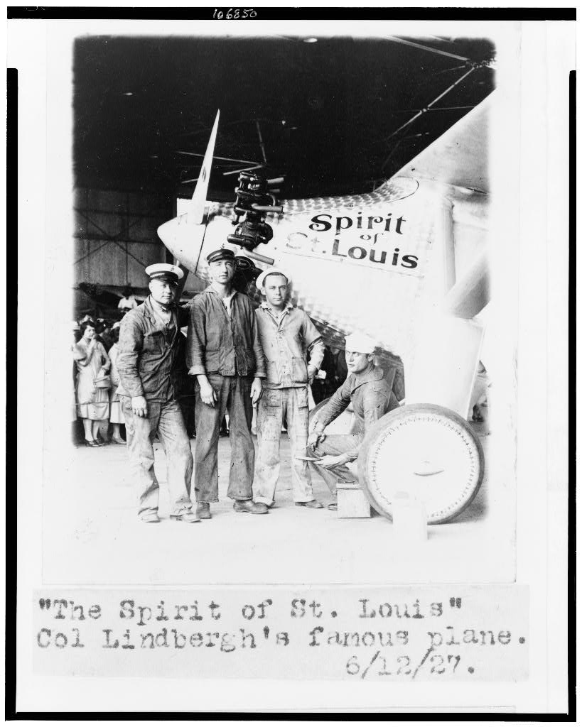
The "Spirit of St. Louis," Col. Lindbergh's plane · Library of Congress, Prints and Photographs Division · 1927
Source: "The Spirit of St. Louis, Col. Lindbergh's Famous Plane." Photograph. 1927. Library of Congress, Prints and Photographs Division, Washington, D.C. https://www.loc.gov/item/92520351/. Public Domain — No Known Restrictions on Publication https://www.loc.gov/item/92520351/
HIPPO — analyze the source (prompt) | Your analysis
H — Historical context: what was happening when this was created?
I — Intended audience: who was meant to see or obey it?
P — Purpose: why was it created?
P — Point of view: whose perspective does it reflect?
O — Outside connection: how does it connect to this standard?
SUPPORT OPTION
Sentence frame: This source shows ______ because it ______, which reveals ______.
CONFIDENCE CHECK-IN
Rate your understanding of this standard (1–4): ______ One thing to revisit: ____________________

Activity 6 — Core Application: Practice Quiz — US.29 ⏱ ~8 min
RESPONSE CHOICE
Commit to an answer by marking it, saying it, or explaining it aloud before checking. Answer key is in the Teacher Guide (kept separate).
[DOK 2 · item us31-q2 · pre-field-test]
What role did the film industry and movie theaters play in creating shared cultural experiences across America?
A. With 50 million weekly attendees by 1929, movies created common cultural references, glamorous shared experiences in movie palaces, and national heroes through the Hollywood star system
B. Movies were only popular in large cities, but this fails to account for the broader historical context, though this interpretation lacks supporting historical evidence
C. Movie theaters replaced radio as the primary entertainment, which contradicts the primary source evidence from this era, although historical sources do not support this conclusion
D. Films had no cultural impact outside entertainment, but the historical record tells a more complex story, but closer analysis reveals a more complicated historical reality
[DOK 2 · item us31-q3 · pre-field-test]
How did celebrities like Charlie Chaplin, Charles Lindbergh, and Babe Ruth become national heroes and cultural icons?
A. Celebrity culture did not exist in the 1920s, but contemporary accounts suggest a different explanation, and this view has been largely revised by modern historical research
B. Mass media (films, radio, newspapers) spread their achievements nationally, while their talents and personalities embodied American values like ingenuity, individualism, and success
C. They were only famous in their home cities, which represents a common misconception about the period, which represents a common misconception about this historical period
D. Government promotion created their celebrity status, but this fails to account for the broader historical context, which contradicts the primary source evidence from this era
[DOK 3 · item u1-us29-dok3-tc · pre-field-test]
Analyze how mass media in the 1920s created modern American popular culture and consumer society.
A. Mass media had no impact on consumption patterns, which does not reflect the consensus among historians, although historical sources do not support this conclusion
B. Radio and film advertising promoted consumer products to millions, celebrities modeled lifestyles and endorsed products, and shared entertainment created national markets for standardized goods
C. Consumer culture existed before mass media, although historical sources do not support this conclusion, though this interpretation lacks supporting historical evidence
D. Only wealthy Americans participated in consumer culture, although this overlooks critical economic and social factors, which does not align with the documented historical record

Activity 7 — Constructed Response (CER) — US.29 ⏱ ~15 min
BIG-QUESTION ORGANIZER — in the 1920s, who shared in the boom and the new freedoms, and who was left out or pushed back?
Jot quick notes from THIS standard: Who benefited? · Who bore the costs? · Who decided?

CONSTRUCTED RESPONSE (CER) — builds SSP.04 Argumentation
Claim + Evidence + Reasoning: Using this standard, take a position on the central question — describe the growth and effects that radio and movies played in the emergence of popular culture, such as advertising, celebrities, news, and entertainment? Support your claim with two pieces of evidence from the passage and explain your reasoning.
Part | Write here
Claim
Evidence (two specifics)
Reasoning
SELF-CHECK (CER rubric — see Toolkit)
Is my claim defensible? · TWO specific pieces of evidence? · Does my reasoning explain HOW the evidence proves the claim?
EXIT TICKET — before you leave [item us31-q1 · DOK 2 · pre-field-test]
How did radio transform American society by creating the first truly national mass communication medium?
A. Radio had limited reach in the 1920s, although this view has been largely discredited by scholars, but closer analysis reveals a more complicated historical reality, but the historical evidence paints a more nuanced picture
B. Radio only played music, though this interpretation lacks supporting historical evidence, though this interpretation lacks supporting historical evidence and oversimplifies the complex factors at work during this period
C. Radio was too expensive for most Americans, although this view has been largely discredited by scholars, which represents a common misconception about this historical period
D. Radio reached millions simultaneously, creating shared experiences across geographic boundaries, promoting consumer culture through advertising, and allowing politicians to speak directly to voters
Show what you know (your choice): mark the best answer, say it, or explain it — then rate how sure you are: ☐ Not yet ☐ Getting there ☐ Got it
Answer key and next steps are in the Teacher Guide.

Standard US.30 — Grand Ole Opry, Blues & Country Music
TN Academic Standard US.30: Examine how the use of the radio helped grow the popularity of country and blues music, including the rise of the Grand Ole Opry, W.C. Handy, and Bessie Smith. (TCA)
LEARNING TARGETS — I can…
• I can examine how the use of the radio helped grow the popularity of country and blues music, including the rise of the Grand Ole Opry, W.C. Handy, and Bessie Smith.
Lenses for this standard: History · Geography · Tennessee Connection
CORE PATH — the same for every student
Same rigor for everyone: analyze the sources and vocabulary, then show what you learned on the Practice Quiz and the CER.
UDL and MTSS give you flexible ways in — they never lower the bar.
Check yourself against the learning targets on the Cornell Notes page.
★ Tennessee Connection
Nashville became the epicenter of country music with the founding of the Grand Ole Opry (WSM Radio, 1925) and later the rise of Music Row. Memphis's Beale Street was a cradle of blues music, and Sun Records would later launch rock and roll.
SET YOUR GOAL (self-direction)
My goal for this standard — what will I be able to do, and how will I show it?

HOOK — think before you dig in
Grand Ole Opry, Blues & Country Music: Examine how the use of the radio helped grow the popularity of country and blues music, including the rise of the Grand Ole Opry, W.C. Handy, and Bessie Smith. (TCA). Who gained, who was left out — and why does it still matter?

ACTIVATE — what do you already know or wonder?
Jot what you already know or want to find out about this standard. You’ll come back to it.

PREVIEW & PREDICT
Which learning target will be hardest, and why? Connect it to the unit’s big question: who shared in the boom, and who was left out or pushed back?

Activity 1 — Vocabulary (Part A: Reference / Word Bank) — US.30 ⏱ ~10 min
Use this word bank throughout the standard. The Spanish column supports access, not translation of assessment.
Term | Student-friendly meaning | Spanish
Grand Ole Opry | A weekly country music radio show that began in Nashville in 1925, becoming the longest-running radio broadcast in U.S. history and establishing Nashville as country music's capital. | Grand Ole Opry
W.C. Handy | Known as the "Father of the Blues," a musician and composer who published the first blues compositions and helped bring blues music from rural areas to mainstream audiences. | W.C. Handy
Bessie Smith | The "Empress of the Blues," the most popular female blues singer of the 1920s whose powerful voice and emotional performances influenced generations of musicians. | Bessie Smith
Radio Broadcasting | The transmission of audio content over radio waves that revolutionized communication in the 1920s, creating mass media, national advertising, and shared popular culture. | Radiodifusión
Harlem Renaissance | A 1920s cultural movement centered in Harlem, New York, where African American artists, writers, musicians, and intellectuals celebrated Black culture and identity through art, literature, and music. | Renacimiento de Harlem
Motion Pictures | Silent and "talkie" films that became America's most popular entertainment in the 1920s, creating celebrity culture and Hollywood as the film capital of the world. | Imágenes en Movimiento
LANGUAGE SUPPORT
Pronunciations: Grand Ole Opry (grand ohl AH-pree); W.C. Handy (double-yoo see HAN-dee); Bessie Smith (BESS-ee smith).
VOCABULARY SELF-CHECK · Knowledge Rating
Rate each term NOW in pencil, then again at the END — growth is the goal; no penalty for “never seen it.”
Term | 1 · never seen it | 2 · heard it | 3 · can use it | 4 · can teach it
Grand Ole Opry
W.C. Handy
Bessie Smith
Radio Broadcasting
Harlem Renaissance
Motion Pictures
MAKE IT YOURS (RESPONSE CHOICE): choose ONE term above and show you own it — write a sentence, sketch it, or give a real-world example.

Activity 2 — Vocabulary Studio (Frayer-inspired) — US.30 ⏱ ~7 min
RESPONSE CHOICE
Complete each studio by writing, speaking, or diagramming.

PRIORITY TERM 1 Grand Ole Opry · ES: Grand Ole Opry
Word-bank meaning to build on: A weekly country music radio show that began in Nashville in 1925, becoming the longest-running radio broadcast in U.S. history and establishing Nashville as country music's capital.
Definition (in your own words) | Characteristics
Examples | Non-examples
Use it to explain
Write one sentence that uses “Grand Ole Opry” to explain this standard.

PRIORITY TERM 2 W.C. Handy · ES: W.C. Handy
Word-bank meaning to build on: Known as the "Father of the Blues," a musician and composer who published the first blues compositions and helped bring blues music from rural areas to mainstream audiences.
Definition (in your own words) | Characteristics
Examples | Non-examples
Use it to explain
Write one sentence that uses “W.C. Handy” to explain this standard.

CONNECT THE TERMS (UDL · build understanding)
How do these priority terms fit together? Write or sketch how one leads to or affects another.

Activity 3 — Direct Teaching Cornell Notes — US.30 ⏱ ~20 min
Name: ______________________ Class / Period: __________ Date: __________
US.30 — Grand Ole Opry, Blues & Country Music • These notes capture the direct-teaching content and the Close Read for this standard.
Your learning targets are on this standard’s opening page — take notes that help you meet them.
Cues (tied to your learning targets) | My notes
What does the passage say about country Music Roots?
What does the passage say about blues Music Evolution?
What does the passage say about the Grand Ole Opry?
Key terms →
DOODLE ZONE — draw your thinking (UDL · another way in)
Need another way in? Sketch the key idea, a quick timeline, or how the pieces connect. Words optional.

Cornell Notes — keep going, then process & check — US.30
MORE NOTES / DIAGRAMS
Continue your notes here, add a quick sketch, or map how the ideas connect.

Key terms to list
Grand Ole Opry · W.C. Handy · Bessie Smith · Radio Broadcasting · Harlem Renaissance · Motion Pictures
Summary — In your own words (2–3 sentences)
PROGRESS CHECK · one question
Analyze how country and blues music reflected and influenced American cultural values and regional identity.
A. Music had no connection to cultural values, which represents a common misconception about the period, but the historical evidence paints a more nuanced picture and oversimplifies the complex factors at work during this period
B. Only wealthy Americans appreciated these genres, although historical sources do not support this conclusion, though this interpretation lacks supporting historical evidence and oversimplifies the complex factors at work during this period
C. Country celebrated rural, traditional, and religious values while blues expressed resilience and emotional depth; both preserved regional heritage, provided cultural identity for marginalized communities, and influenced mainstream American music
D. Country and blues had identical cultural messages, which does not reflect the consensus among historians and oversimplifies the complex factors at work during this period despite the fact that multiple contemporary sources contradict this
Commit before you move on — mark it, say it, or explain it aloud.
CHECK YOURSELF — how am I doing?
Which learning targets (on this standard’s opening page) can you now meet? Tick the number; circle any you still need help with.
☐ 1
My 12–15 word headline for this standard

Activity 4 — Close Read — US.30 ⏱ ~15 min
Reading type: History Hack-authored instructional synthesis. This is not a primary source. Builds SSP.03 (synthesize) and SSP.05 (historical awareness).
CORE PATH — read one chunk at a time
Country Music Roots
Country music originated from rural Southern folk traditions, Scottish-Irish ballads, and gospel music. Instruments included fiddle, banjo, guitar, harmonica, and later steel guitar. Themes centered on rural life, family, religion, hardship, and traditional values. Regional variations included Appalachian mountain music, Western swing, and honky-tonk. The 1920s recording industry brought rural music to national audiences.
Blues Music Evolution
Blues evolved from African American work songs, field hollers, spirituals, and African musical traditions. The Mississippi Delta was the birthplace of Delta blues with its distinctive guitar style. Urban blues developed as African Americans migrated to cities like Chicago. The standard 12-bar structure became the foundation for popular music. Themes addressed love, loss, hardship, and resilience.
The Grand Ole Opry
Beginning as "WSM Barn Dance" in Nashville on November 28, 1925, it was created and hosted by George D. Hay, the "Solemn Old Judge." It became the "Grand Ole Opry" in 1927. Saturday night live radio broadcasts reached millions across America, making Nashville the center of country music. The Opry preserved and promoted traditional American folk music, launched countless careers, and drew tourists to Nashville. The Ryman Auditorium hosted the Opry from 1943-1974.
W.C. Handy (1873-1958): Father of the Blues
W.C. Handy was the first to publish blues compositions for mainstream audiences. His "Memphis Blues" (1912) was the first published blues composition, and "St. Louis Blues" (1914) became a blues standard recorded by countless artists. A trained musician who studied European classical music, Handy combined African American folk traditions with formal musical notation. He founded Handy Brothers Music Company and proved African American music could achieve commercial success.
Bessie Smith (1894-1937): Empress of the Blues
Bessie Smith was the most popular and influential blues singer of the 1920s. Her Columbia Records contract made her the highest-paid Black performer of her era. Her powerful voice featured emotional depth and perfect pitch on songs like "Downhearted Blues" and "St. Louis Blues." She earned up to $2,000 per week during peak years, broke racial barriers, and performed for integrated audiences. Her influence extended to generations of singers including Billie Holiday and Janis Joplin.
Key terms first: Grand Ole Opry, W.C. Handy. Read once for the gist, then again for evidence.
CLOSE-READ EVIDENCE LAB — for each question: quote the EVIDENCE from the passage above, then write YOUR ANSWER (or answer aloud / diagram it).
Text-dependent question | Evidence from the passage | Your answer (what it shows)
What is the main idea of the “Country Music Roots” section, and what evidence supports it?
What is the main idea of the “Blues Music Evolution” section, and what evidence supports it?

Geographer’s Lens — US.30 ⏱ ~12 min
Geographers don’t just find places — they explain how WHERE shapes WHAT happens. Work these like a geographer. Built on the Five Themes of Geography · C3 Dimension 2 · SSP.06 (spatial reasoning).
MOVEMENT & REGION — what’s the spatial pattern?
In 1–2 sentences: is this a movement, a cluster, or a whole region? Name the direction or shape it takes on a map.

GEOGRAPHY AS A FORCE — how did location shape the outcome?
How did geography change WHAT happened — who was affected, how far or fast it spread, or who was left out? Use one place above as your evidence.

READ IT LIKE A SOURCE — RESPONSE CHOICE
A map is a source with a point of view. Show your thinking your way — write it, OR sketch a quick arrows-and-labels diagram: what would a map of this make CLEAR, and what would it HIDE or leave out?

Activity 5 — Primary Source / Data Analysis — US.30 ⏱ ~15 min
Primary source (photograph) — analyze it with HIPPO. Builds SSP.01–SSP.02.
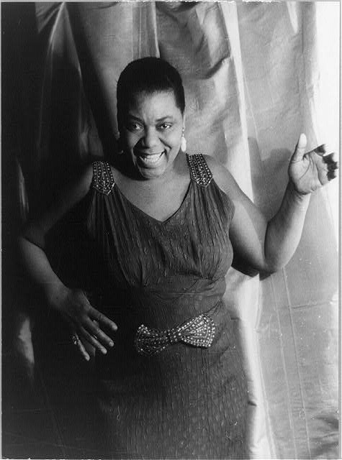
Bessie Smith, "Empress of the Blues" · Carl Van Vechten / Library of Congress, Prints and Photographs Division · c1936
Source: "Bessie Smith." Photograph. Library of Congress, Prints and Photographs Division, Washington, D.C. https://www.loc.gov/item/2004663577/. Public Domain — No Known Restrictions on Publication https://www.loc.gov/item/2004663577/
HIPPO — analyze the source (prompt) | Your analysis
H — Historical context: what was happening when this was created?
I — Intended audience: who was meant to see or obey it?
P — Purpose: why was it created?
P — Point of view: whose perspective does it reflect?
O — Outside connection: how does it connect to this standard?
SUPPORT OPTION
Sentence frame: This source shows ______ because it ______, which reveals ______.
CONFIDENCE CHECK-IN
Rate your understanding of this standard (1–4): ______ One thing to revisit: ____________________

Activity 6 — Core Application: Practice Quiz — US.30 ⏱ ~8 min
RESPONSE CHOICE
Commit to an answer by marking it, saying it, or explaining it aloud before checking. Answer key is in the Teacher Guide (kept separate).
[DOK 2 · item us32-q2 · pre-field-test]
What role did the Grand Ole Opry play in making Nashville the center of country music and promoting the genre nationally?
A. Beginning in 1925, its live Saturday radio broadcasts reached millions nationwide, launched careers, preserved folk traditions, and established Nashville as "Music City"
B. The Grand Ole Opry had limited influence, although historical sources do not support this conclusion, which does not align with the documented historical record
C. The Opry only broadcast locally, although this overlooks critical economic and social factors, which represents a common misconception about this historical period
D. Country music was already centered in Nashville before the Opry, though this interpretation lacks supporting historical evidence, which contradicts the primary source evidence from this era
[DOK 2 · item us32-q3 · pre-field-test]
How did W.C. Handy and Bessie Smith contribute to the development and popularization of blues music?
A. They had minimal impact on blues development, which does not reflect the consensus among historians, which represents a common misconception about this historical period, and this view has been largely revised by modern historical research
B. Handy published the first blues compositions for mainstream audiences and proved blues could be commercially successful; Smith became the highest-paid Black performer, breaking barriers and inspiring generations of singers
C. They only performed for local audiences, which represents a common misconception about the period, which represents a common misconception about this historical period, but contemporary accounts and primary sources suggest otherwise
D. Handy and Smith invented the blues genre, which does not align with the documented historical record, which represents a common misconception about this historical period when examined alongside the available primary and secondary sources
[DOK 3 · item u1-us30-dok3-tc · pre-field-test]
Analyze how country and blues music reflected and influenced American cultural values and regional identity.
A. Music had no connection to cultural values, which represents a common misconception about the period, but the historical evidence paints a more nuanced picture and oversimplifies the complex factors at work during this period
B. Only wealthy Americans appreciated these genres, although historical sources do not support this conclusion, though this interpretation lacks supporting historical evidence and oversimplifies the complex factors at work during this period
C. Country celebrated rural, traditional, and religious values while blues expressed resilience and emotional depth; both preserved regional heritage, provided cultural identity for marginalized communities, and influenced mainstream American music
D. Country and blues had identical cultural messages, which does not reflect the consensus among historians and oversimplifies the complex factors at work during this period despite the fact that multiple contemporary sources contradict this

Activity 7 — Constructed Response (CER) — US.30 ⏱ ~15 min
BIG-QUESTION ORGANIZER — in the 1920s, who shared in the boom and the new freedoms, and who was left out or pushed back?
Jot quick notes from THIS standard: Who benefited? · Who bore the costs? · Who decided?

CONSTRUCTED RESPONSE (CER) — builds SSP.04 Argumentation
Claim + Evidence + Reasoning: Using this standard, take a position on the central question — examine how the use of the radio helped grow the popularity of country and blues music, including the rise of the Grand Ole Opry, W.C. Handy, and Bessie Smith? Support your claim with two pieces of evidence from the passage and explain your reasoning.
Part | Write here
Claim
Evidence (two specifics)
Reasoning
SELF-CHECK (CER rubric — see Toolkit)
Is my claim defensible? · TWO specific pieces of evidence? · Does my reasoning explain HOW the evidence proves the claim?
EXIT TICKET — before you leave [item us32-q1 · DOK 2 · pre-field-test]
How did country and blues music develop from rural folk traditions into popular American musical genres?
A. Country evolved from Scottish-Irish ballads and gospel, blues from African American work songs and spirituals; 1920s recording technology and radio brought both to national audiences
B. Country and blues were created by professional composers, although historical sources do not support this conclusion and does not reflect the scholarly consensus on this topic
C. These genres originated in Northern cities, but this fails to account for the broader historical context, which contradicts the primary source evidence from this era
D. Country and blues developed independently without folk roots, yet the available evidence points to a different conclusion, which represents a common misconception about this historical period
Show what you know (your choice): mark the best answer, say it, or explain it — then rate how sure you are: ☐ Not yet ☐ Getting there ☐ Got it
Answer key and next steps are in the Teacher Guide.

Standard US.31 — New Technologies: Air Travel and Electricity
TN Academic Standard US.31: Describe the impact of new technologies of the era, including the advent of air travel and spread of electricity.
LEARNING TARGETS — I can…
• I can describe the impact of new technologies of the era, including the advent of air travel and spread of electricity.
Lenses for this standard: Economics · History
CORE PATH — the same for every student
Same rigor for everyone: analyze the sources and vocabulary, then show what you learned on the Practice Quiz and the CER.
UDL and MTSS give you flexible ways in — they never lower the bar.
Check yourself against the learning targets on the Cornell Notes page.
★ Tennessee Connection
The rural-urban electrification gap wouldn't be addressed until New Deal programs like TVA brought electricity to underserved areas.
SET YOUR GOAL (self-direction)
My goal for this standard — what will I be able to do, and how will I show it?

HOOK — think before you dig in
New Technologies: Air Travel and Electricity: Describe the impact of new technologies of the era, including the advent of air travel and spread of electricity. Who gained, who was left out — and why does it still matter?

ACTIVATE — what do you already know or wonder?
Jot what you already know or want to find out about this standard. You’ll come back to it.

PREVIEW & PREDICT
Which learning target will be hardest, and why? Connect it to the unit’s big question: who shared in the boom, and who was left out or pushed back?

Activity 1 — Vocabulary (Part A: Reference / Word Bank) — US.31 ⏱ ~10 min
Use this word bank throughout the standard. The Spanish column supports access, not translation of assessment.
Term | Student-friendly meaning | Spanish
Commercial Aviation | The development of airplane technology and air travel in the 1920s, highlighted by Charles Lindbergh's 1927 solo transatlantic flight, which captured public imagination and demonstrated aviation's potential. | Aviación Comercial
Electrification | The spread of electrical power throughout America in the 1920s, transforming daily life with electric appliances, lighting, and machinery in homes and factories. | Electrificación
Automobile Impact | The widespread adoption of cars in the 1920s transformed American society, creating suburbs, highways, tourism, and related industries like gas stations, motels, and drive-in restaurants. | Impacto del Automóvil
Assembly Line | A manufacturing method where workers remain stationary while products move past them on a conveyor belt, with each worker performing one specific task, dramatically increasing efficiency. | Línea de Ensamblaje
Consumerism | A culture of increased purchasing of consumer goods, driven in the 1920s by mass production, national advertising, and installment credit. | Consumismo
Radio Broadcasting | The transmission of audio content over radio waves that revolutionized communication in the 1920s, creating mass media, national advertising, and shared popular culture. | Radiodifusión
LANGUAGE SUPPORT
Pronunciations: Electrification (ee-lek-truh-fih-KAY-shun); Consumerism (kun-SOO-mer-iz-um).
VOCABULARY SELF-CHECK · Knowledge Rating
Rate each term NOW in pencil, then again at the END — growth is the goal; no penalty for “never seen it.”
Term | 1 · never seen it | 2 · heard it | 3 · can use it | 4 · can teach it
Commercial Aviation
Electrification
Automobile Impact
Assembly Line
Consumerism
Radio Broadcasting
MAKE IT YOURS (RESPONSE CHOICE): choose ONE term above and show you own it — write a sentence, sketch it, or give a real-world example.

Activity 2 — Vocabulary Studio (Frayer-inspired) — US.31 ⏱ ~7 min
RESPONSE CHOICE
Complete each studio by writing, speaking, or diagramming.

PRIORITY TERM 1 Commercial Aviation · ES: Aviación Comercial
Word-bank meaning to build on: The development of airplane technology and air travel in the 1920s, highlighted by Charles Lindbergh's 1927 solo transatlantic flight, which captured public imagination and demonstrated aviation's potential.
Definition (in your own words) | Characteristics
Examples | Non-examples
Use it to explain
Write one sentence that uses “Commercial Aviation” to explain this standard.

PRIORITY TERM 2 Electrification · ES: Electrificación
Word-bank meaning to build on: The spread of electrical power throughout America in the 1920s, transforming daily life with electric appliances, lighting, and machinery in homes and factories.
Definition (in your own words) | Characteristics
Examples | Non-examples
Use it to explain
Write one sentence that uses “Electrification” to explain this standard.

CONNECT THE TERMS (UDL · build understanding)
How do these priority terms fit together? Write or sketch how one leads to or affects another.

Activity 3 — Direct Teaching Cornell Notes — US.31 ⏱ ~20 min
Name: ______________________ Class / Period: __________ Date: __________
US.31 — New Technologies: Air Travel and Electricity • These notes capture the direct-teaching content and the Close Read for this standard.
Your learning targets are on this standard’s opening page — take notes that help you meet them.
Cues (tied to your learning targets) | My notes
What does the passage say about early Aviation Development?
What does the passage say about aviation's Revolutionary Impact?
What does the passage say about spread of Electricity: Urban Transformation?
Key terms →
DOODLE ZONE — draw your thinking (UDL · another way in)
Need another way in? Sketch the key idea, a quick timeline, or how the pieces connect. Words optional.

Cornell Notes — keep going, then process & check — US.31
MORE NOTES / DIAGRAMS
Continue your notes here, add a quick sketch, or map how the ideas connect.

Key terms to list
Commercial Aviation · Electrification · Automobile Impact · Assembly Line · Consumerism · Radio Broadcasting
Summary — In your own words (2–3 sentences)
PROGRESS CHECK · one question
Evaluate whether technological innovations of the 1920s improved quality of life for all Americans or primarily benefited certain groups.
A. All Americans benefited equally from new technologies, but this fails to account for the broader historical context when examined alongside the available primary and secondary sources
B. Technology only benefited the wealthy, despite the fact that multiple sources contradict this view, although historical sources do not support this conclusion
C. Rural Americans benefited more than urban residents, which does not align with the documented historical record, although historical sources do not support this conclusion
D. Urban, middle-class Americans benefited most from electricity and appliances, while rural areas lacked electrification and many workers faced job displacement from mechanization
Commit before you move on — mark it, say it, or explain it aloud.
CHECK YOURSELF — how am I doing?
Which learning targets (on this standard’s opening page) can you now meet? Tick the number; circle any you still need help with.
☐ 1
My 12–15 word headline for this standard

Activity 4 — Close Read — US.31 ⏱ ~15 min
Reading type: History Hack-authored instructional synthesis. This is not a primary source. Builds SSP.03 (synthesize) and SSP.05 (historical awareness).
CORE PATH — read one chunk at a time
Early Aviation Development
The Wright Brothers achieved the first powered flight at Kitty Hawk, North Carolina in 1903. World War I accelerated aircraft development and pilot training. The Post Office began regular airmail routes in 1918, and first passenger airlines were established in the early 1920s. Charles Lindbergh's solo transatlantic flight in 1927 captured public imagination and promoted commercial aviation.
Aviation's Revolutionary Impact
Air travel reduced cross-country travel time from days to hours and connected previously isolated regions to the national economy. Commercial passenger miles increased from 6,000 in 1926 to 173,000 in 1929. Aviation created new industries and employment opportunities, facilitated global business and diplomatic relations, and enhanced national defense capabilities. Infrastructure including airports and navigation systems developed rapidly.
Spread of Electricity: Urban Transformation
By 1930, 85% of urban homes had electricity, with power generation increasing from 6 billion kilowatt-hours in 1902 to 117 billion in 1929. Electric streetlights improved safety and extended business hours. Electric trolleys and subways revolutionized urban mobility. Electric elevators made skyscrapers practical. Electric signs, movie theaters, and amusement parks transformed urban entertainment.
Household and Industrial Transformation
Electric household appliances—vacuum cleaners, washing machines, electric irons, and refrigerators—reduced domestic labor and improved living conditions. In manufacturing, electric motors increased productivity and allowed flexible factory layouts. New industries emerged in electrical equipment manufacturing, power generation, and appliance production. Electric lighting improved workplace safety and extended productive hours.
Rural Electrification Gap
Only 10% of rural homes had electricity by 1930 due to cost and distance. This limited rural access to modern conveniences and productivity improvements. Where available, electric-powered farm equipment improved agricultural efficiency. The rural-urban electrification gap wouldn't be addressed until New Deal programs like TVA brought electricity to underserved areas.
Key terms first: Commercial Aviation, Electrification. Read once for the gist, then again for evidence.
CLOSE-READ EVIDENCE LAB — for each question: quote the EVIDENCE from the passage above, then write YOUR ANSWER (or answer aloud / diagram it).
Text-dependent question | Evidence from the passage | Your answer (what it shows)
What is the main idea of the “Early Aviation Development” section, and what evidence supports it?
What is the main idea of the “Aviation's Revolutionary Impact” section, and what evidence supports it?

Activity 5 — Primary Source / Data Analysis — US.31 ⏱ ~15 min
Document (text primary source — analyze with HIPPO). Builds SSP.01–SSP.02.
LINDBERGH TRANSATLANTIC FLIGHT NEWS REPORT
“LINDBERGH DOES IT! TO PARIS IN 33½ HOURS. Flies 1,000 Miles Through Snow and Sleet; Cheering French Ones Carry Him Off Field. Captain Charles A. Lindbergh accomplished the greatest feat of a solitary man in the records of the human race yes”
Source: New York Times, May 22, 1927. Times, New York. "Lindbergh Transatlantic Flight News Report." May 22, 1927. Library of Congress, www.loc.gov/collections/charles-a-lindbergh/.. Public domain. https://www.loc.gov/collections/charles-a-lindbergh/
HIPPO — analyze the source (prompt) | Your analysis
H — Historical context: what was happening when this was created?
I — Intended audience: who was meant to see or obey it?
P — Purpose: why was it created?
P — Point of view: whose perspective does it reflect?
O — Outside connection: how does it connect to this standard?
SUPPORT OPTION
Sentence frame: This source shows ______ because it ______, which reveals ______.

EXTEND & RE-ENGAGE (open to all)
Push past the document — corroborate, contextualize, and judge its meaning.
Historian move | Your response
Corroborate — what other source would confirm or complicate this one?
Contextualize — what was happening at the time that explains it?
So what? — why does this source still matter?
CONFIDENCE CHECK-IN
Rate your understanding of this standard (1–4): ______ One thing to revisit: ____________________

Activity 6 — Core Application: Practice Quiz — US.31 ⏱ ~8 min
RESPONSE CHOICE
Commit to an answer by marking it, saying it, or explaining it aloud before checking. Answer key is in the Teacher Guide (kept separate).
[DOK 2 · item us33-q2 · pre-field-test]
What was the impact of electrical power expansion on urban and rural communities during the 1920s?
A. 85% of urban homes were electrified by 1930, transforming city life with lighting, transportation, and appliances, but only 10% of rural homes had electricity, creating a significant urban-rural divide
B. Electricity was equally available everywhere, which represents a common misconception about the period, but closer analysis reveals a more complicated historical reality and does not reflect the scholarly consensus on this topic
C. Rural areas had more electricity than cities, which does not reflect the consensus among historians when examined alongside the available primary and secondary sources, which contradicts the primary source evidence from this era
D. Electricity had no significant impact on daily life, yet the available evidence points to a different conclusion and oversimplifies the complex factors at work during this period
[DOK 2 · item us33-q3 · pre-field-test]
How did new technologies like radio, household appliances, and automobiles transform daily life and social relationships?
A. New technologies had little effect on daily life, which does not reflect the consensus among historians and does not reflect the scholarly consensus on this topic, but contemporary accounts and primary sources suggest otherwise
B. Radio created shared cultural experiences, appliances reduced domestic labor and improved living conditions, and automobiles enabled mobility and suburban growth, fundamentally changing work, leisure, and family patterns
C. Only wealthy families could afford new technologies, but the historical record tells a more complex story, but the historical evidence paints a more nuanced picture when examined alongside the available primary and secondary sources
D. Technologies were primarily used in factories, but contemporary accounts suggest a different explanation and oversimplifies the complex factors at work during this period, but closer analysis reveals a more complicated historical reality
[DOK 3 · item u1-us31-dok3-tc · pre-field-test]
Evaluate whether technological innovations of the 1920s improved quality of life for all Americans or primarily benefited certain groups.
A. All Americans benefited equally from new technologies, but this fails to account for the broader historical context when examined alongside the available primary and secondary sources
B. Technology only benefited the wealthy, despite the fact that multiple sources contradict this view, although historical sources do not support this conclusion
C. Rural Americans benefited more than urban residents, which does not align with the documented historical record, although historical sources do not support this conclusion
D. Urban, middle-class Americans benefited most from electricity and appliances, while rural areas lacked electrification and many workers faced job displacement from mechanization

Activity 7 — Constructed Response (CER) — US.31 ⏱ ~15 min
BIG-QUESTION ORGANIZER — in the 1920s, who shared in the boom and the new freedoms, and who was left out or pushed back?
Jot quick notes from THIS standard: Who benefited? · Who bore the costs? · Who decided?

CONSTRUCTED RESPONSE (CER) — builds SSP.04 Argumentation
Claim + Evidence + Reasoning: Using this standard, take a position on the central question — describe the impact of new technologies of the era, including the advent of air travel and spread of electricity? Support your claim with two pieces of evidence from the passage and explain your reasoning.
Part | Write here
Claim
Evidence (two specifics)
Reasoning
SELF-CHECK (CER rubric — see Toolkit)
Is my claim defensible? · TWO specific pieces of evidence? · Does my reasoning explain HOW the evidence proves the claim?
EXIT TICKET — before you leave [item us33-q1 · DOK 2 · pre-field-test]
How did the advent of commercial air travel revolutionize transportation and connect distant regions of America?
A. Air travel had minimal impact in the 1920s, but this fails to account for the broader historical context when examined alongside the available primary and secondary sources
B. Aviation reduced travel time from days to hours, connected isolated regions to national markets, created new industries, and Lindbergh's 1927 flight captured public imagination for commercial aviation
C. Only the military used aircraft, although historical sources do not support this conclusion, which represents a common misconception about this historical period, though this interpretation lacks supporting historical evidence
D. Air travel was slower than trains, yet the available evidence points to a different conclusion despite the fact that multiple contemporary sources contradict this, which contradicts the primary source evidence from this era
Show what you know (your choice): mark the best answer, say it, or explain it — then rate how sure you are: ☐ Not yet ☐ Getting there ☐ Got it
Answer key and next steps are in the Teacher Guide.

Standard US.32 — Henry Ford, the Automobile & Mass Production
TN Academic Standard US.32: Describe the impact of Henry T. Ford, the automobile, and the mass production of automobiles on the American economy and society.
LEARNING TARGETS — I can…
• I can describe the impact of Henry Ford, the automobile, and the mass production of automobiles on the American economy and society.
Lenses for this standard: Economics · History
CORE PATH — the same for every student
Same rigor for everyone: analyze the sources and vocabulary, then show what you learned on the Practice Quiz and the CER.
UDL and MTSS give you flexible ways in — they never lower the bar.
Check yourself against the learning targets on the Cornell Notes page.
★ Tennessee Connection
The automobile revolution transformed Tennessee. By the 1920s, road-building campaigns connected Tennessee's cities, and the Dixie Highway linked Tennessee to Florida tourism. Nashville and Memphis became automobile distribution centers, and the state's economy shifted as rural Tennesseans gained access to urban markets.
SET YOUR GOAL (self-direction)
My goal for this standard — what will I be able to do, and how will I show it?

HOOK — think before you dig in
Henry Ford, the Automobile & Mass Production: Describe the impact of Henry T. Ford, the automobile, and the mass production of automobiles on the American economy and society. Who gained, who was left out — and why does it still matter?

ACTIVATE — what do you already know or wonder?
Jot what you already know or want to find out about this standard. You’ll come back to it.

PREVIEW & PREDICT
Which learning target will be hardest, and why? Connect it to the unit’s big question: who shared in the boom, and who was left out or pushed back?

Activity 1 — Vocabulary (Part A: Reference / Word Bank) — US.32 ⏱ ~10 min
Use this word bank throughout the standard. The Spanish column supports access, not translation of assessment.
Term | Student-friendly meaning | Spanish
Henry Ford | Automobile manufacturer who revolutionized production with the assembly line, making the Model T affordable for average Americans and transforming society. | Henry Ford
Assembly Line | A manufacturing method where workers remain stationary while products move past them on a conveyor belt, with each worker performing one specific task, dramatically increasing efficiency. | Línea de Ensamblaje
Automobile Impact | The widespread adoption of cars in the 1920s transformed American society, creating suburbs, highways, tourism, and related industries like gas stations, motels, and drive-in restaurants. | Impacto del Automóvil
Buying on Credit | The practice of purchasing goods with borrowed money repaid over time in installments, which fueled 1920s consumer spending. | Compra a Crédito
Consumerism | A culture of increased purchasing of consumer goods, driven in the 1920s by mass production, national advertising, and installment credit. | Consumismo
Electrification | The spread of electrical power throughout America in the 1920s, transforming daily life with electric appliances, lighting, and machinery in homes and factories. | Electrificación
LANGUAGE SUPPORT
Pronunciations: Henry Ford (HEN-ree ford); Consumerism (kun-SOO-mer-iz-um); Electrification (ee-lek-truh-fih-KAY-shun).
VOCABULARY SELF-CHECK · Knowledge Rating
Rate each term NOW in pencil, then again at the END — growth is the goal; no penalty for “never seen it.”
Term | 1 · never seen it | 2 · heard it | 3 · can use it | 4 · can teach it
Henry Ford
Assembly Line
Automobile Impact
Buying on Credit
Consumerism
Electrification
MAKE IT YOURS (RESPONSE CHOICE): choose ONE term above and show you own it — write a sentence, sketch it, or give a real-world example.

Activity 2 — Vocabulary Studio (Frayer-inspired) — US.32 ⏱ ~7 min
RESPONSE CHOICE
Complete each studio by writing, speaking, or diagramming.

PRIORITY TERM 1 Henry Ford · ES: Henry Ford
Word-bank meaning to build on: Automobile manufacturer who revolutionized production with the assembly line, making the Model T affordable for average Americans and transforming society.
Definition (in your own words) | Characteristics
Examples | Non-examples
Use it to explain
Write one sentence that uses “Henry Ford” to explain this standard.

PRIORITY TERM 2 Assembly Line · ES: Línea de Ensamblaje
Word-bank meaning to build on: A manufacturing method where workers remain stationary while products move past them on a conveyor belt, with each worker performing one specific task, dramatically increasing efficiency.
Definition (in your own words) | Characteristics
Examples | Non-examples
Use it to explain
Write one sentence that uses “Assembly Line” to explain this standard.

CONNECT THE TERMS (UDL · build understanding)
How do these priority terms fit together? Write or sketch how one leads to or affects another.

Activity 3 — Direct Teaching Cornell Notes — US.32 ⏱ ~20 min
Name: ______________________ Class / Period: __________ Date: __________
US.32 — Henry Ford, the Automobile & Mass Production • These notes capture the direct-teaching content and the Close Read for this standard.
Your learning targets are on this standard’s opening page — take notes that help you meet them.
Cues (tied to your learning targets) | My notes
What does the passage say about henry Ford's Revolutionary Role?
What does the passage say about economic Impact on Manufacturing?
What does the passage say about impact on Labor Practices?
Key terms →
DOODLE ZONE — draw your thinking (UDL · another way in)
Need another way in? Sketch the key idea, a quick timeline, or how the pieces connect. Words optional.

Cornell Notes — keep going, then process & check — US.32
MORE NOTES / DIAGRAMS
Continue your notes here, add a quick sketch, or map how the ideas connect.

Key terms to list
Henry Ford · Assembly Line · Automobile Impact · Buying on Credit · Consumerism · Electrification
Summary — In your own words (2–3 sentences)
PROGRESS CHECK · one question
Analyze whether Ford's contributions to American economy and society were more positive or negative overall.
A. Ford's innovations brought affordable transportation, higher wages, and economic growth, but also repetitive assembly work, anti-union policies, and American dependence on fossil fuels and automobile infrastructure
B. Ford's contributions were entirely positive, yet the available evidence points to a different conclusion, but closer analysis reveals a more complicated historical reality, although historical sources do not support this conclusion
C. Ford's contributions were entirely negative, but this oversimplifies the complex factors at work, although this overlooks critical economic and social factors involved, which ignores significant political and cultural developments of the era
D. Ford had no significant impact on American society, yet the available evidence points to a different conclusion, but the historical evidence paints a more nuanced picture despite the fact that multiple contemporary sources contradict this
Commit before you move on — mark it, say it, or explain it aloud.
CHECK YOURSELF — how am I doing?
Which learning targets (on this standard’s opening page) can you now meet? Tick the number; circle any you still need help with.
☐ 1
My 12–15 word headline for this standard

Activity 4 — Close Read — US.32 ⏱ ~15 min
Reading type: History Hack-authored instructional synthesis. This is not a primary source. Builds SSP.03 (synthesize) and SSP.05 (historical awareness).
CORE PATH — read one chunk at a time
Henry Ford's Revolutionary Role
Ford founded the Ford Motor Company in 1903 with the goal of building affordable cars for average Americans. The Model T (1908-1927), nicknamed "Tin Lizzie," became America's first mass-produced automobile. Ford's assembly line (1913) used moving conveyor belts, interchangeable parts, and division of labor to revolutionize manufacturing. These innovations reduced Model T assembly time from 12 hours to 93 minutes.
Economic Impact on Manufacturing
The assembly line became the standard for mass production industries, dramatically increasing productivity. Ford reduced Model T prices from $825 (1908) to $290 (1925), making automobiles affordable for middle-class consumers. By 1927, Ford had produced 15 million Model Ts and controlled 50% of the automobile market. His methods spread to other industries, establishing U.S. industrial leadership.
Impact on Labor Practices
Ford's $5 Day (1914) doubled typical industrial wages to reduce turnover and increase productivity. He reduced the workday from 9-10 hours to 8 hours. These innovations cut employee turnover from 370% to 16% and created a workforce that could afford to buy the products they made. However, assembly line work was repetitive, and Ford strongly resisted unionization.
Societal Transformation
Automobiles gave Americans unprecedented personal mobility, ending rural isolation and enabling suburban development. Cars changed dating and courtship patterns, providing privacy and mobility for young people. Sunday drives and family vacations became popular activities. Automobile ownership became a measure of social success and enabled new patterns of work, shopping, and leisure.
Supporting Industries and Infrastructure
The automobile industry drove expansion of steel, rubber, glass, and petroleum industries. Gas stations, repair shops, motels, and auto parts stores proliferated. Massive road construction programs transformed the American landscape. Detroit became "Motor City," attracting workers nationwide. The automobile industry directly and indirectly employed millions of Americans.
Key terms first: Henry Ford, Assembly Line. Read once for the gist, then again for evidence.
CLOSE-READ EVIDENCE LAB — for each question: quote the EVIDENCE from the passage above, then write YOUR ANSWER (or answer aloud / diagram it).
Text-dependent question | Evidence from the passage | Your answer (what it shows)
What is the main idea of the “Henry Ford's Revolutionary Role” section, and what evidence supports it?
What is the main idea of the “Economic Impact on Manufacturing” section, and what evidence supports it?

Activity 5 — Primary Source / Data Analysis — US.32 ⏱ ~15 min
Primary source (photograph) — analyze it with HIPPO. Builds SSP.01–SSP.02.
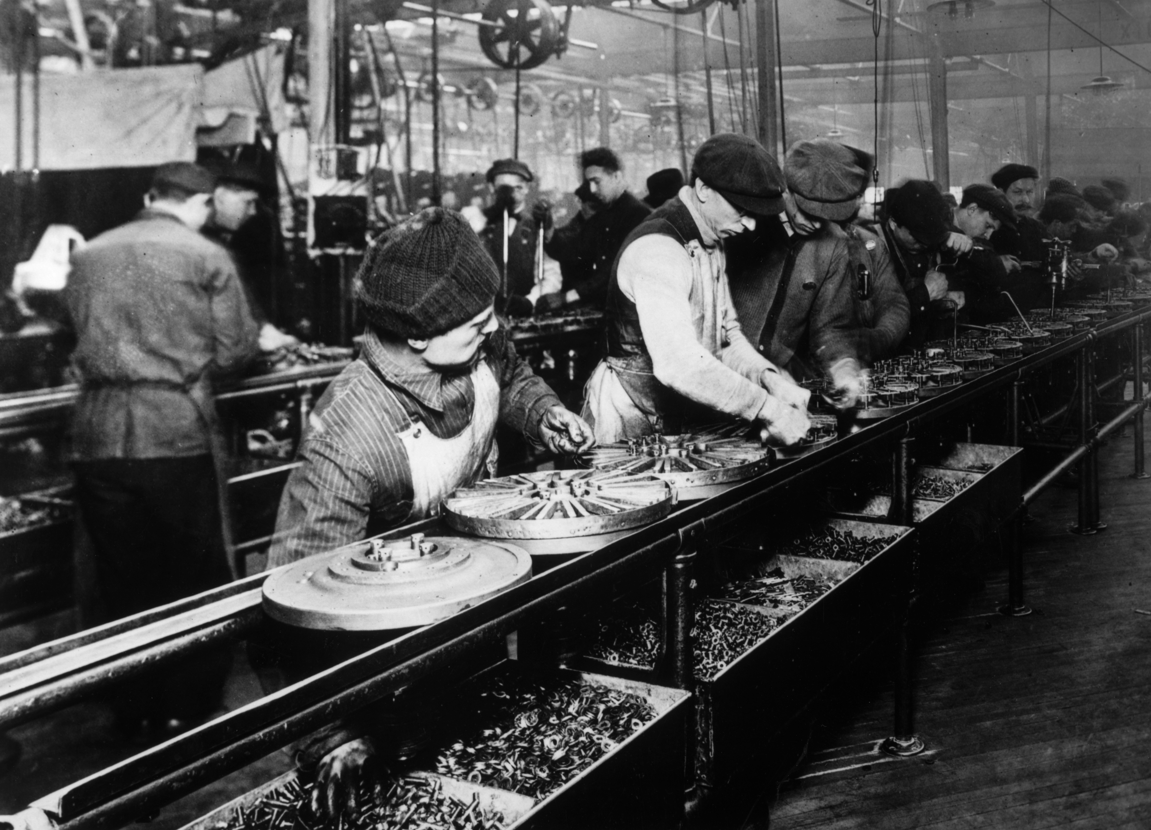
Ford Motor Company moving assembly line · Ford Motor Company · 1913
Source: "Ford Assembly Line, 1913." Photograph. Ford Motor Company, 1913. Wikimedia Commons. https://commons.wikimedia.org/wiki/File:Ford_assembly_line_-_1913.jpg. Public Domain — No Known Restrictions on Publication https://commons.wikimedia.org/wiki/File:Ford_assembly_line_-_1913.jpg
HIPPO — analyze the source (prompt) | Your analysis
H — Historical context: what was happening when this was created?
I — Intended audience: who was meant to see or obey it?
P — Purpose: why was it created?
P — Point of view: whose perspective does it reflect?
O — Outside connection: how does it connect to this standard?
SUPPORT OPTION
Sentence frame: This source shows ______ because it ______, which reveals ______.
CONFIDENCE CHECK-IN
Rate your understanding of this standard (1–4): ______ One thing to revisit: ____________________

Activity 6 — Core Application: Practice Quiz — US.32 ⏱ ~8 min
RESPONSE CHOICE
Commit to an answer by marking it, saying it, or explaining it aloud before checking. Answer key is in the Teacher Guide (kept separate).
[DOK 2 · item us34-q2 · pre-field-test]
What economic impacts did Ford's innovations have on workers, consumers, and American industry?
A. The $5 Day doubled wages and reduced turnover; mass production cut Model T prices 65%, making cars affordable for millions; and Ford's methods spread throughout industry, driving economic growth
B. Ford's methods had limited economic impact, but the historical record tells a more complex story, which ignores significant political and cultural developments of the era
C. Workers' wages decreased under Ford, which does not align with the documented historical record despite the fact that multiple contemporary sources contradict this, although historical sources do not support this conclusion
D. Only wealthy consumers could afford Model Ts, but the historical record tells a more complex story and oversimplifies the complex factors at work during this period, but the historical evidence paints a more nuanced picture
[DOK 2 · item us34-q3 · pre-field-test]
How did widespread automobile ownership transform American society, family life, and communities?
A. Automobiles had minimal social impact, though this interpretation lacks supporting historical evidence, but closer analysis reveals a more complicated historical reality
B. Cars enabled suburban growth, changed dating and family patterns, ended rural isolation, created new industries and jobs, and made mobility central to American identity and lifestyle
C. Only urban residents benefited from automobiles, yet the available evidence points to a different conclusion, but contemporary accounts and primary sources suggest otherwise
D. Automobiles weakened American communities, but this oversimplifies the complex factors at work and fails to account for key developments in the broader context
[DOK 3 · item u1-us32-dok3-tc · pre-field-test]
Analyze whether Ford's contributions to American economy and society were more positive or negative overall.
A. Ford's innovations brought affordable transportation, higher wages, and economic growth, but also repetitive assembly work, anti-union policies, and American dependence on fossil fuels and automobile infrastructure
B. Ford's contributions were entirely positive, yet the available evidence points to a different conclusion, but closer analysis reveals a more complicated historical reality, although historical sources do not support this conclusion
C. Ford's contributions were entirely negative, but this oversimplifies the complex factors at work, although this overlooks critical economic and social factors involved, which ignores significant political and cultural developments of the era
D. Ford had no significant impact on American society, yet the available evidence points to a different conclusion, but the historical evidence paints a more nuanced picture despite the fact that multiple contemporary sources contradict this

Activity 7 — Constructed Response (CER) — US.32 ⏱ ~15 min
BIG-QUESTION ORGANIZER — in the 1920s, who shared in the boom and the new freedoms, and who was left out or pushed back?
Jot quick notes from THIS standard: Who benefited? · Who bore the costs? · Who decided?

CONSTRUCTED RESPONSE (CER) — builds SSP.04 Argumentation
Claim + Evidence + Reasoning: Using this standard, take a position on the central question — describe the impact of Henry Ford, the automobile, and the mass production of automobiles on the American economy and society? Support your claim with two pieces of evidence from the passage and explain your reasoning.
Part | Write here
Claim
Evidence (two specifics)
Reasoning
SELF-CHECK (CER rubric — see Toolkit)
Is my claim defensible? · TWO specific pieces of evidence? · Does my reasoning explain HOW the evidence proves the claim?
EXIT TICKET — before you leave [item us34-q1 · DOK 2 · pre-field-test]
How did Henry Ford revolutionize manufacturing through the assembly line and mass production methods?
A. Ford made only minor improvements to manufacturing, which represents a common misconception about the period despite the fact that multiple contemporary sources contradict this
B. Assembly lines existed before Ford, but this oversimplifies the complex factors at work, although historical sources do not support this conclusion and fails to account for key developments in the broader context
C. Ford's assembly line used moving conveyor belts, interchangeable parts, and specialized labor to reduce Model T assembly from 12 hours to 93 minutes, establishing mass production as the industrial standard
D. Ford focused only on product quality, not production speed, despite the fact that multiple sources contradict this view, which represents a common misconception about this historical period
Show what you know (your choice): mark the best answer, say it, or explain it — then rate how sure you are: ☐ Not yet ☐ Getting there ☐ Got it
Answer key and next steps are in the Teacher Guide.

Standard US.33 — The Harlem Renaissance
TN Academic Standard US.33: Analyze the impact of the Harlem Renaissance and its important figures on American culture, including: Louis Armstrong, Duke Ellington, Langston Hughes, Zora Neale Hurston, James Weldon Johnson. (TCA)
LEARNING TARGETS — I can…
• I can analyze the impact of the Harlem Renaissance and its important figures on American culture, including Louis Armstrong, Duke Ellington, Langston Hughes, Zora Neale Hurston, and James Weldon Johnson.
Lenses for this standard: History · Culture · Tennessee Connection
CORE PATH — the same for every student
Same rigor for everyone: analyze the sources and vocabulary, then show what you learned on the Practice Quiz and the CER.
UDL and MTSS give you flexible ways in — they never lower the bar.
Check yourself against the learning targets on the Cornell Notes page.
★ Tennessee Connection
While centered in New York, the Harlem Renaissance had deep Tennessee roots. Fisk University in Nashville was a major intellectual center for African American culture. Fisk's Jubilee Singers had pioneered the performance of spirituals decades earlier, and Harlem Renaissance writers including Arna Bontemps (a Fisk graduate) maintained connections to Nashville's Black intellectual community.
SET YOUR GOAL (self-direction)
My goal for this standard — what will I be able to do, and how will I show it?

HOOK — think before you dig in
The Harlem Renaissance: Analyze the impact of the Harlem Renaissance and its important figures on American culture, including: Louis Armstrong, Duke Ellington, Langston Hughes, Zora Neale Hurston, James Weldon Johnson. (TCA). Who gained, who was left out — and why does it still matter?

ACTIVATE — what do you already know or wonder?
Jot what you already know or want to find out about this standard. You’ll come back to it.

PREVIEW & PREDICT
Which learning target will be hardest, and why? Connect it to the unit’s big question: who shared in the boom, and who was left out or pushed back?

Activity 1 — Vocabulary (Part A: Reference / Word Bank) — US.33 ⏱ ~10 min
Use this word bank throughout the standard. The Spanish column supports access, not translation of assessment.
Term | Student-friendly meaning | Spanish
Harlem Renaissance | A 1920s cultural movement centered in Harlem, New York, where African American artists, writers, musicians, and intellectuals celebrated Black culture and identity through art, literature, and music. | Renacimiento de Harlem
Louis Armstrong | A revolutionary jazz trumpeter and singer from New Orleans who became one of the most influential musicians of the 20th century, pioneering improvisational jazz and scat singing. | Louis Armstrong
Duke Ellington | A prolific jazz composer, pianist, and bandleader who led his orchestra for nearly 50 years, creating sophisticated jazz compositions that elevated the genre to high art. | Duke Ellington
Langston Hughes | A leading poet, novelist, and playwright of the Harlem Renaissance who wrote powerfully about the Black experience in America, using jazz rhythms and everyday language. | Langston Hughes
Zora Neale Hurston | An anthropologist, folklorist, and novelist who celebrated Southern Black culture and dialect in her masterpiece "Their Eyes Were Watching God." | Zora Neale Hurston
James Weldon Johnson | A writer, diplomat, and civil rights activist who wrote "Lift Every Voice and Sing" (known as the Black National Anthem) and led the NAACP. | James Weldon Johnson
LANGUAGE SUPPORT
Pronunciations: Louis Armstrong (LOO-ee ARM-strong); Duke Ellington (dook EL-ing-tun); Langston Hughes (LANG-stun hyooz); Zora Neale Hurston (ZOR-uh neel HUR-stun); James Weldon Johnson (jaymz WEL-dun JON-sun).
VOCABULARY SELF-CHECK · Knowledge Rating
Rate each term NOW in pencil, then again at the END — growth is the goal; no penalty for “never seen it.”
Term | 1 · never seen it | 2 · heard it | 3 · can use it | 4 · can teach it
Harlem Renaissance
Louis Armstrong
Duke Ellington
Langston Hughes
Zora Neale Hurston
James Weldon Johnson
MAKE IT YOURS (RESPONSE CHOICE): choose ONE term above and show you own it — write a sentence, sketch it, or give a real-world example.

Activity 2 — Vocabulary Studio (Frayer-inspired) — US.33 ⏱ ~7 min
RESPONSE CHOICE
Complete each studio by writing, speaking, or diagramming.

PRIORITY TERM 1 Harlem Renaissance · ES: Renacimiento de Harlem
Word-bank meaning to build on: A 1920s cultural movement centered in Harlem, New York, where African American artists, writers, musicians, and intellectuals celebrated Black culture and identity through art, literature, and music.
Definition (in your own words) | Characteristics
Examples | Non-examples
Use it to explain
Write one sentence that uses “Harlem Renaissance” to explain this standard.

PRIORITY TERM 2 Louis Armstrong · ES: Louis Armstrong
Word-bank meaning to build on: A revolutionary jazz trumpeter and singer from New Orleans who became one of the most influential musicians of the 20th century, pioneering improvisational jazz and scat singing.
Definition (in your own words) | Characteristics
Examples | Non-examples
Use it to explain
Write one sentence that uses “Louis Armstrong” to explain this standard.

CONNECT THE TERMS (UDL · build understanding)
How do these priority terms fit together? Write or sketch how one leads to or affects another.

Activity 3 — Direct Teaching Cornell Notes — US.33 ⏱ ~20 min
Name: ______________________ Class / Period: __________ Date: __________
US.33 — The Harlem Renaissance • These notes capture the direct-teaching content and the Close Read for this standard.
Your learning targets are on this standard’s opening page — take notes that help you meet them.
Cues (tied to your learning targets) | My notes
What does the passage say about historical Context and Characteristics?
What does the passage say about impact on African American Arts?
What does the passage say about louis Armstrong (1901-1971)?
Key terms →
DOODLE ZONE — draw your thinking (UDL · another way in)
Need another way in? Sketch the key idea, a quick timeline, or how the pieces connect. Words optional.

Cornell Notes — keep going, then process & check — US.33
MORE NOTES / DIAGRAMS
Continue your notes here, add a quick sketch, or map how the ideas connect.

Key terms to list
Harlem Renaissance · Louis Armstrong · Duke Ellington · Langston Hughes · Zora Neale Hurston · James Weldon Johnson
Summary — In your own words (2–3 sentences)
PROGRESS CHECK · one question
Analyze how the Harlem Renaissance challenged racial stereotypes and influenced American culture beyond the 1920s.
A. The Renaissance had no lasting cultural impact, though this interpretation lacks supporting historical evidence and does not reflect the scholarly consensus on this topic, though this interpretation lacks supporting historical evidence
B. The Renaissance demonstrated African American intellectual and artistic capabilities, challenged stereotypes through achievement, established jazz as American art, influenced the Civil Rights Movement, and continues to inspire artists today
C. The Renaissance ended racism in America, although this overlooks critical economic and social factors, although this overlooks critical economic and social factors involved, although historical sources do not support this conclusion
D. Its influence was limited to Harlem, although this overlooks critical economic and social factors, but contemporary accounts and primary sources suggest otherwise, which contradicts the primary source evidence from this era
Commit before you move on — mark it, say it, or explain it aloud.
CHECK YOURSELF — how am I doing?
Which learning targets (on this standard’s opening page) can you now meet? Tick the number; circle any you still need help with.
☐ 1
My 12–15 word headline for this standard

Activity 4 — Close Read — US.33 ⏱ ~15 min
Reading type: History Hack-authored instructional synthesis. This is not a primary source. Builds SSP.03 (synthesize) and SSP.05 (historical awareness).
CORE PATH — read one chunk at a time
Historical Context and Characteristics
The Harlem Renaissance (approximately 1918-1937, peak in 1920s) was centered in Harlem, Manhattan. The Great Migration created concentrated urban African American communities. Post-WWI, Black veterans returned with new expectations. The "New Negro Movement" promoted pride in African American identity. Key venues included the Cotton Club, Apollo Theater, and Schomburg Center. Crisis and Opportunity magazines showcased new talent.
Impact on African American Arts
The Renaissance produced an explosion of creativity in literature, music, visual arts, and theater. New poetry forms expressed African American experience and pride. Realistic novels challenged stereotypes. Artists like Aaron Douglas created distinctive African American visual styles. Plays explored Black themes, and musical theater shows like "Shuffle Along" brought Black performers to Broadway.
Louis Armstrong (1901-1971)
Armstrong transformed jazz from ensemble music to a soloist-centered art form. His revolutionary trumpet technique and improvisational skills redefined the genre. He pioneered scat singing and recorded influential sessions with his Hot Five and Hot Seven groups. His charismatic personality made jazz accessible to mainstream audiences, and he became a cultural ambassador spreading American jazz internationally.
Duke Ellington (1899-1974)
Ellington led a sophisticated orchestra for over 50 years, composing over 1,000 works including "Mood Indigo" and "Sophisticated Lady." His Cotton Club residency (1927-1931) made him nationally famous. A master of orchestration who blended jazz with classical music, Ellington elevated jazz to serious art form status. He insisted on dignity and respect for African American musicians.
Langston Hughes and Zora Neale Hurston
Hughes (1902-1967) captured African American experience in poetry collections like "The Weary Blues" (1926), incorporating jazz rhythms and vernacular language. His "Dream Deferred" questioned American equality. Hurston (1891-1960) wrote the masterpiece "Their Eyes Were Watching God" (1937), collected African American folklore, and created strong female protagonists. Both used authentic voice to celebrate Black culture while challenging discrimination.
Key terms first: Harlem Renaissance, Louis Armstrong. Read once for the gist, then again for evidence.
CLOSE-READ EVIDENCE LAB — for each question: quote the EVIDENCE from the passage above, then write YOUR ANSWER (or answer aloud / diagram it).
Text-dependent question | Evidence from the passage | Your answer (what it shows)
What is the main idea of the “Historical Context and Characteristics” section, and what evidence supports it?
What is the main idea of the “Impact on African American Arts” section, and what evidence supports it?

Activity 5 — Primary Source / Data Analysis — US.33 ⏱ ~15 min
Primary source (photograph) — analyze it with HIPPO. Builds SSP.01–SSP.02.
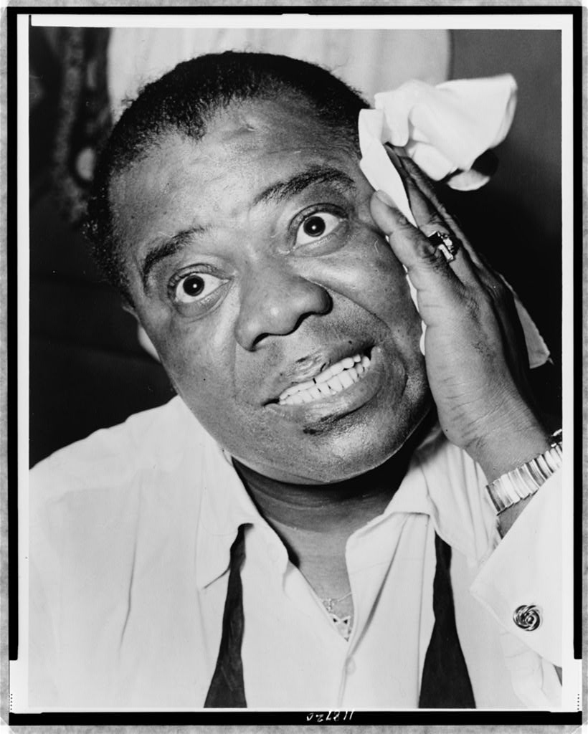
Louis Armstrong · Library of Congress, Prints and Photographs Division · c1920s-1930s
Source: "Louis Armstrong." Photograph. Library of Congress, Prints and Photographs Division, Washington, D.C. https://www.loc.gov/item/97518323/. Public Domain — No Known Restrictions on Publication https://www.loc.gov/item/97518323/
HIPPO — analyze the source (prompt) | Your analysis
H — Historical context: what was happening when this was created?
I — Intended audience: who was meant to see or obey it?
P — Purpose: why was it created?
P — Point of view: whose perspective does it reflect?
O — Outside connection: how does it connect to this standard?
SUPPORT OPTION
Sentence frame: This source shows ______ because it ______, which reveals ______.
CONFIDENCE CHECK-IN
Rate your understanding of this standard (1–4): ______ One thing to revisit: ____________________

Activity 6 — Core Application: Practice Quiz — US.33 ⏱ ~8 min
RESPONSE CHOICE
Commit to an answer by marking it, saying it, or explaining it aloud before checking. Answer key is in the Teacher Guide (kept separate).
[DOK 2 · item us35-q2 · pre-field-test]
How did musicians like Louis Armstrong and Duke Ellington transform jazz into a distinctly American art form?
A. Armstrong revolutionized jazz with solo improvisation and scat singing while Ellington's sophisticated compositions elevated jazz to serious art, both making it globally recognized as America's unique musical contribution
B. Armstrong and Ellington had minimal impact on jazz, although historical sources do not support this conclusion, though this interpretation lacks supporting historical evidence, which contradicts the primary source evidence from this era
C. Jazz was already fully developed before them, yet the available evidence points to a different conclusion, and this view has been largely revised by modern historical research, which does not align with the documented historical record
D. They only performed for African American audiences, despite the fact that multiple sources contradict this view, which ignores significant political and cultural developments of the era and oversimplifies the complex factors at work during this period
[DOK 2 · item us35-q3 · pre-field-test]
What contributions did writers like Langston Hughes and Zora Neale Hurston make to American literature and African American identity?
A. Their work had limited literary significance, despite limited evidence supporting this interpretation, and this view has been largely revised by modern historical research, but contemporary accounts and primary sources suggest otherwise
B. Hughes captured African American experience through jazz-influenced poetry and social commentary, while Hurston preserved folk traditions and created strong female characters, both using authentic voice to celebrate Black culture
C. They wrote only for academic audiences, which does not align with the documented historical record, which contradicts the primary source evidence from this era and fails to account for key developments in the broader context
D. Their work focused exclusively on protest, which contradicts the primary source evidence from this era, but closer analysis reveals a more complicated historical reality, which represents a common misconception about this historical period
[DOK 3 · item u1-us33-dok3-tc · pre-field-test]
Analyze how the Harlem Renaissance challenged racial stereotypes and influenced American culture beyond the 1920s.
A. The Renaissance had no lasting cultural impact, though this interpretation lacks supporting historical evidence and does not reflect the scholarly consensus on this topic, though this interpretation lacks supporting historical evidence
B. The Renaissance demonstrated African American intellectual and artistic capabilities, challenged stereotypes through achievement, established jazz as American art, influenced the Civil Rights Movement, and continues to inspire artists today
C. The Renaissance ended racism in America, although this overlooks critical economic and social factors, although this overlooks critical economic and social factors involved, although historical sources do not support this conclusion
D. Its influence was limited to Harlem, although this overlooks critical economic and social factors, but contemporary accounts and primary sources suggest otherwise, which contradicts the primary source evidence from this era

Activity 7 — Constructed Response (CER) — US.33 ⏱ ~15 min
BIG-QUESTION ORGANIZER — in the 1920s, who shared in the boom and the new freedoms, and who was left out or pushed back?
Jot quick notes from THIS standard: Who benefited? · Who bore the costs? · Who decided?

CONSTRUCTED RESPONSE (CER) — builds SSP.04 Argumentation
Claim + Evidence + Reasoning: Using this standard, take a position on the central question — analyze the impact of the Harlem Renaissance and its important figures on American culture, including Louis Armstrong, Duke Ellington, Langston Hughes, Zora Neale Hurston, and James Weldon Johnson? Support your claim with two pieces of evidence from the passage and explain your reasoning.
Part | Write here
Claim
Evidence (two specifics)
Reasoning
SELF-CHECK (CER rubric — see Toolkit)
Is my claim defensible? · TWO specific pieces of evidence? · Does my reasoning explain HOW the evidence proves the claim?
EXIT TICKET — before you leave [item us35-q1 · DOK 2 · pre-field-test]
What factors led to the emergence of the Harlem Renaissance as a major cultural movement in the 1920s?
A. The Renaissance began without any particular causes, which represents a common misconception about the period when examined alongside the available primary and secondary sources
B. The government sponsored the Harlem Renaissance, despite the fact that multiple sources contradict this view, though this interpretation lacks supporting historical evidence and does not reflect the scholarly consensus on this topic
C. The Renaissance was limited to music, although historical sources do not support this conclusion, but closer analysis reveals a more complicated historical reality, although this overlooks critical economic and social factors involved
D. The Great Migration concentrated African American talent in urban communities, post-WWI expectations for equality increased, and venues, publications, and patrons provided platforms for creative expression
Show what you know (your choice): mark the best answer, say it, or explain it — then rate how sure you are: ☐ Not yet ☐ Getting there ☐ Got it
Answer key and next steps are in the Teacher Guide.

Standard US.34 — Women in the 1920s: Flappers & Social Changes
TN Academic Standard US.34: Describe changes and limitations in the social and economic status of women during this era, including flappers, birth control, clerical and office jobs, and the rise of women's colleges.
LEARNING TARGETS — I can…
• I can describe changes and limitations in the social and economic status of women during this era, including flappers, birth control, clerical and office jobs, and the rise of women's colleges.
Lenses for this standard: History · Culture · Economics
CORE PATH — the same for every student
Same rigor for everyone: analyze the sources and vocabulary, then show what you learned on the Practice Quiz and the CER.
UDL and MTSS give you flexible ways in — they never lower the bar.
Check yourself against the learning targets on the Cornell Notes page.
SET YOUR GOAL (self-direction)
My goal for this standard — what will I be able to do, and how will I show it?

HOOK — think before you dig in
Women in the 1920s: Flappers & Social Changes: Describe changes and limitations in the social and economic status of women during this era, including flappers, birth control, clerical and office jobs, and the rise of women's colleges. Who gained, who was left out — and why does it still matter?

ACTIVATE — what do you already know or wonder?
Jot what you already know or want to find out about this standard. You’ll come back to it.

PREVIEW & PREDICT
Which learning target will be hardest, and why? Connect it to the unit’s big question: who shared in the boom, and who was left out or pushed back?

Activity 1 — Vocabulary (Part A: Reference / Word Bank) — US.34 ⏱ ~10 min
Use this word bank throughout the standard. The Spanish column supports access, not translation of assessment.
Term | Student-friendly meaning | Spanish
Flappers | Young women in the 1920s who challenged traditional gender norms by wearing short skirts and bobbed hair, dancing, drinking, smoking, and asserting independence. | Flappers
Birth Control Movement | Led by Margaret Sanger, the campaign to legalize contraception and provide women reproductive choice, facing opposition from religious and conservative groups. | Movimiento de Control de Natalidad
Women in the Workforce | The 1920s saw increased female employment in clerical and office jobs, though women still faced discrimination, lower wages, and were often expected to leave work upon marriage. | Mujeres en la Fuerza Laboral
Consumerism | A culture of increased purchasing of consumer goods, driven in the 1920s by mass production, national advertising, and installment credit. | Consumismo
Automobile Impact | The widespread adoption of cars in the 1920s transformed American society, creating suburbs, highways, tourism, and related industries like gas stations, motels, and drive-in restaurants. | Impacto del Automóvil
Motion Pictures | Silent and "talkie" films that became America's most popular entertainment in the 1920s, creating celebrity culture and Hollywood as the film capital of the world. | Imágenes en Movimiento
LANGUAGE SUPPORT
Pronunciations: Flappers (FLAP-erz); Consumerism (kun-SOO-mer-iz-um).
VOCABULARY SELF-CHECK · Knowledge Rating
Rate each term NOW in pencil, then again at the END — growth is the goal; no penalty for “never seen it.”
Term | 1 · never seen it | 2 · heard it | 3 · can use it | 4 · can teach it
Flappers
Birth Control Movement
Women in the Workforce
Consumerism
Automobile Impact
Motion Pictures
MAKE IT YOURS (RESPONSE CHOICE): choose ONE term above and show you own it — write a sentence, sketch it, or give a real-world example.

Activity 2 — Vocabulary Studio (Frayer-inspired) — US.34 ⏱ ~7 min
RESPONSE CHOICE
Complete each studio by writing, speaking, or diagramming.

PRIORITY TERM 1 Flappers · ES: Flappers
Word-bank meaning to build on: Young women in the 1920s who challenged traditional gender norms by wearing short skirts and bobbed hair, dancing, drinking, smoking, and asserting independence.
Definition (in your own words) | Characteristics
Examples | Non-examples
Use it to explain
Write one sentence that uses “Flappers” to explain this standard.

PRIORITY TERM 2 Birth Control Movement · ES: Movimiento de Control de Natalidad
Word-bank meaning to build on: Led by Margaret Sanger, the campaign to legalize contraception and provide women reproductive choice, facing opposition from religious and conservative groups.
Definition (in your own words) | Characteristics
Examples | Non-examples
Use it to explain
Write one sentence that uses “Birth Control Movement” to explain this standard.

CONNECT THE TERMS (UDL · build understanding)
How do these priority terms fit together? Write or sketch how one leads to or affects another.

Activity 3 — Direct Teaching Cornell Notes — US.34 ⏱ ~20 min
Name: ______________________ Class / Period: __________ Date: __________
US.34 — Women in the 1920s: Flappers & Social Changes • These notes capture the direct-teaching content and the Close Read for this standard.
Your learning targets are on this standard’s opening page — take notes that help you meet them.
Cues (tied to your learning targets) | My notes
What does the passage say about flappers and Cultural Significance?
What does the passage say about birth Control and Reproductive Rights?
What does the passage say about clerical and Office Jobs?
Key terms →
DOODLE ZONE — draw your thinking (UDL · another way in)
Need another way in? Sketch the key idea, a quick timeline, or how the pieces connect. Words optional.

Cornell Notes — keep going, then process & check — US.34
MORE NOTES / DIAGRAMS
Continue your notes here, add a quick sketch, or map how the ideas connect.

Key terms to list
Flappers · Birth Control Movement · Women in the Workforce · Consumerism · Automobile Impact · Motion Pictures
Summary — In your own words (2–3 sentences)
PROGRESS CHECK · one question
Evaluate whether the social and economic changes of the 1920s fundamentally improved women's status or were primarily superficial.
A. Changes completely transformed women's status, although historical sources do not support this conclusion, although this overlooks critical economic and social factors involved, which does not align with the documented historical record
B. No meaningful changes occurred for women, although historical sources do not support this conclusion and does not reflect the scholarly consensus on this topic, which does not align with the documented historical record
C. While voting rights, education access, and work opportunities expanded, persistent pay inequality, limited advancement, marriage bars, and traditional expectations meant fundamental gender inequality continued
D. Only rural women experienced significant changes, although this overlooks critical economic and social factors, but contemporary accounts and primary sources suggest otherwise and fails to account for key developments in the broader context
Commit before you move on — mark it, say it, or explain it aloud.
CHECK YOURSELF — how am I doing?
Which learning targets (on this standard’s opening page) can you now meet? Tick the number; circle any you still need help with.
☐ 1
My 12–15 word headline for this standard

Activity 4 — Close Read — US.34 ⏱ ~15 min
Reading type: History Hack-authored instructional synthesis. This is not a primary source. Builds SSP.03 (synthesize) and SSP.05 (historical awareness).
CORE PATH — read one chunk at a time
Flappers and Cultural Significance
Flappers were young, modern women who rejected Victorian values. Their characteristics included short "bob" haircuts, short skirts, makeup, and fashionable clothing. They smoked, drank, danced, dated unchaperoned, and spoke frankly about sexuality. Flappers emphasized individual choice over family duty, exercised newly won voting rights, and became targets of advertising. They sparked debates about morality and family values.
Birth Control and Reproductive Rights
Margaret Sanger founded the American Birth Control League (predecessor to Planned Parenthood), opened the first birth control clinic in Brooklyn (1916), and was arrested multiple times for distributing contraceptive information. Average family size decreased from 7 children (1800) to 3 children (1930). Birth control gave women more control over their bodies, improved maternal health, and allowed women to pursue education and careers.
Clerical and Office Jobs
The service economy created millions of clerical positions. Women in clerical work increased from 75,000 (1900) to 1.4 million (1930). Jobs included secretaries, stenographers, typists, telephone operators, and bookkeepers. Office work paid better than factory or domestic work and offered cleaner, safer conditions. However, women faced lower pay than men, limited advancement, and "marriage bars" requiring women to quit when they married.
Rise of Women's Colleges
The Seven Sisters and other women's colleges provided education equivalent to men's institutions. Programs prepared women for teaching, nursing, social work, and business careers. Female professors served as role models, and alumni networks helped graduates find employment. Women's colleges challenged assumptions about female intellectual capabilities and produced leaders in progressive reform movements.
Limitations and Contradictions
Despite changes, most women remained in traditional roles. A "glass ceiling" limited advancement to executive positions. Pay inequality persisted with women earning significantly less for similar work. Flapper culture was primarily urban and middle-class. Conservative backlash criticized modern women as immoral. Most professional schools still excluded women, and marriage often ended careers.
Key terms first: Flappers, Birth Control Movement. Read once for the gist, then again for evidence.
CLOSE-READ EVIDENCE LAB — for each question: quote the EVIDENCE from the passage above, then write YOUR ANSWER (or answer aloud / diagram it).
Text-dependent question | Evidence from the passage | Your answer (what it shows)
What is the main idea of the “Flappers and Cultural Significance” section, and what evidence supports it?
What is the main idea of the “Birth Control and Reproductive Rights” section, and what evidence supports it?

Activity 5 — Primary Source / Data Analysis — US.34 ⏱ ~15 min
Primary source (photograph) — analyze it with HIPPO. Builds SSP.01–SSP.02.
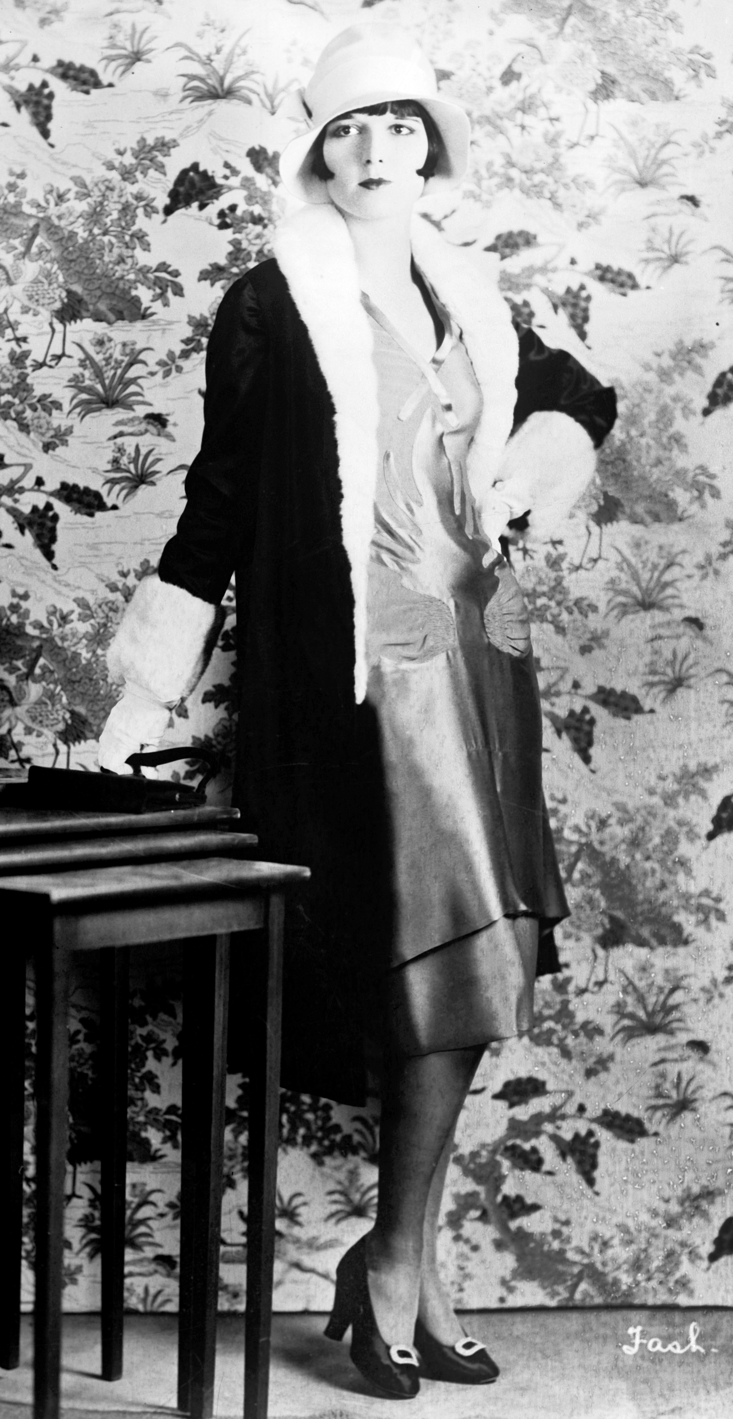
A flapper girl · Turner, C. W., photographer · c1922
Source: Turner, C. W., photographer. A flapper girl. c1922. Photographic print. Library of Congress, Prints and Photographs Division, Washington, D.C., SSF - Clothing and Dress -- 1922 [item] [P&P], LC-USZ62-38343. https://www.loc.gov/pictures/item/2012645724/. Public Domain — No Known Restrictions on Publication https://www.loc.gov/pictures/item/2012645724/
HIPPO — analyze the source (prompt) | Your analysis
H — Historical context: what was happening when this was created?
I — Intended audience: who was meant to see or obey it?
P — Purpose: why was it created?
P — Point of view: whose perspective does it reflect?
O — Outside connection: how does it connect to this standard?
SUPPORT OPTION
Sentence frame: This source shows ______ because it ______, which reveals ______.
CONFIDENCE CHECK-IN
Rate your understanding of this standard (1–4): ______ One thing to revisit: ____________________

Activity 6 — Core Application: Practice Quiz — US.34 ⏱ ~8 min
RESPONSE CHOICE
Commit to an answer by marking it, saying it, or explaining it aloud before checking. Answer key is in the Teacher Guide (kept separate).
[DOK 2 · item us36-q2 · pre-field-test]
What impact did increased access to birth control have on women's lives and family planning decisions?
A. Birth control enabled women to control family size (average dropped from 7 to 3 children), improve maternal health, pursue education and careers, and gain greater autonomy over their bodies and futures
B. Birth control had no significant impact, but contemporary accounts suggest a different explanation despite the fact that multiple contemporary sources contradict this and does not reflect the scholarly consensus on this topic
C. Birth control was universally accepted, despite the fact that multiple sources contradict this view and oversimplifies the complex factors at work during this period, which does not align with the documented historical record
D. Only wealthy women had access to birth control, yet the available evidence points to a different conclusion, although this overlooks critical economic and social factors involved
[DOK 2 · item us36-q3 · pre-field-test]
How did expansion of clerical and office jobs provide new economic opportunities for women?
A. Office jobs provided no advantages for women, which represents a common misconception about the period, which contradicts the primary source evidence from this era, but the historical evidence paints a more nuanced picture
B. Women in clerical work grew from 75,000 to 1.4 million, offering better pay than domestic or factory work, cleaner conditions, and some economic independence, though pay inequality and "marriage bars" limited advancement
C. Women already dominated office work before the 1920s, although this overlooks critical economic and social factors, though this interpretation lacks supporting historical evidence, and this view has been largely revised by modern historical research
D. Office jobs paid less than factory work, but this oversimplifies the complex factors at work, but closer analysis reveals a more complicated historical reality when examined alongside the available primary and secondary sources
[DOK 3 · item u1-us34-dok3-tc · pre-field-test]
Evaluate whether the social and economic changes of the 1920s fundamentally improved women's status or were primarily superficial.
A. Changes completely transformed women's status, although historical sources do not support this conclusion, although this overlooks critical economic and social factors involved, which does not align with the documented historical record
B. No meaningful changes occurred for women, although historical sources do not support this conclusion and does not reflect the scholarly consensus on this topic, which does not align with the documented historical record
C. While voting rights, education access, and work opportunities expanded, persistent pay inequality, limited advancement, marriage bars, and traditional expectations meant fundamental gender inequality continued
D. Only rural women experienced significant changes, although this overlooks critical economic and social factors, but contemporary accounts and primary sources suggest otherwise and fails to account for key developments in the broader context

Activity 7 — Constructed Response (CER) — US.34 ⏱ ~15 min
BIG-QUESTION ORGANIZER — in the 1920s, who shared in the boom and the new freedoms, and who was left out or pushed back?
Jot quick notes from THIS standard: Who benefited? · Who bore the costs? · Who decided?

CONSTRUCTED RESPONSE (CER) — builds SSP.04 Argumentation
Claim + Evidence + Reasoning: Using this standard, take a position on the central question — describe changes and limitations in the social and economic status of women during this era, including flappers, birth control, clerical and office jobs, and the rise of women's colleges? Support your claim with two pieces of evidence from the passage and explain your reasoning.
Part | Write here
Claim
Evidence (two specifics)
Reasoning
SELF-CHECK (CER rubric — see Toolkit)
Is my claim defensible? · TWO specific pieces of evidence? · Does my reasoning explain HOW the evidence proves the claim?
EXIT TICKET — before you leave [item us36-q1 · DOK 2 · pre-field-test]
How did the "flapper" represent changing attitudes toward women's roles, behavior, and independence in the 1920s?
A. Flappers rejected Victorian ideals through fashion, behavior, and attitudes—wearing short skirts, smoking, dancing, dating freely, and asserting independence in personal and economic choices
B. Flappers represented traditional Victorian values, which does not align with the documented historical record and oversimplifies the complex factors at work during this period
C. Flappers were a small, insignificant group, although this view has been largely discredited by scholars, but contemporary accounts and primary sources suggest otherwise
D. Flapper culture was accepted by all Americans, despite the fact that multiple sources contradict this view, although this overlooks critical economic and social factors involved
Show what you know (your choice): mark the best answer, say it, or explain it — then rate how sure you are: ☐ Not yet ☐ Getting there ☐ Got it
Answer key and next steps are in the Teacher Guide.

Standard US.35 — Civil Liberties: Red Scare, KKK & NAACP
TN Academic Standard US.35: Examine challenges and advancements related to the push for civil liberties, including: First Red Scare, Immigration Quota Acts of the 1920s, Resurgence of the Ku Klux Klan, Black Wall Street and Tulsa Massacre, Rise of the NAACP, Efforts of Ida B. Wells-Barnett, Emergence of Garveyism. (TCA)
LEARNING TARGETS — I can…
• I can examine challenges and advancements related to the push for civil liberties, including the First Red Scare, Immigration Quota Acts, resurgence of the KKK, Black Wall Street and Tulsa Massacre, rise of the NAACP, Ida B. Wells-Barnett, and Garveyism.
Lenses for this standard: Culture · Politics/Government · History · Tennessee Connection
CORE PATH — the same for every student
Same rigor for everyone: analyze the sources and vocabulary, then show what you learned on the Practice Quiz and the CER.
UDL and MTSS give you flexible ways in — they never lower the bar.
Check yourself against the learning targets on the Cornell Notes page.
★ Tennessee Connection
The Ku Klux Klan was originally founded in Pulaski, Tennessee, in 1865 by former Confederate soldiers. The KKK's resurgence in the 1920s was felt across Tennessee, with Klan chapters active in Nashville, Knoxville, and Memphis. The NAACP organized counter-efforts, and Tennessee became a battleground for civil liberties.
SET YOUR GOAL (self-direction)
My goal for this standard — what will I be able to do, and how will I show it?

HOOK — think before you dig in
Civil Liberties: Red Scare, KKK & NAACP: Examine challenges and advancements related to the push for civil liberties, including: First Red Scare, Immigration Quota Acts of the 1920s, Resurgence of the Ku Klux Klan, Black Wall Street and Tulsa Massacre, Rise of the NAACP, Efforts of Ida B. Wells-Barnett, Emergence of Garveyism. (TCA). Who gained, who was left out — and why does it still matter?

ACTIVATE — what do you already know or wonder?
Jot what you already know or want to find out about this standard. You’ll come back to it.

PREVIEW & PREDICT
Which learning target will be hardest, and why? Connect it to the unit’s big question: who shared in the boom, and who was left out or pushed back?

Activity 1 — Vocabulary (Part A: Reference / Word Bank) — US.35 ⏱ ~10 min
Use this word bank throughout the standard. The Spanish column supports access, not translation of assessment.
Term | Student-friendly meaning | Spanish
First Red Scare | A period of intense fear of communism and radical political activity following World War I (1919-1920), leading to deportations, arrests, and violations of civil liberties. | Primer Susto Rojo
Immigration Quota Acts | The 1921 and 1924 laws that drastically limited immigration, especially from Southern and Eastern Europe, Asia, and Africa, based on racist national origins formulas. | Leyes de Cuotas de Inmigración
KKK Resurgence | The Ku Klux Klan's revival in the 1920s, expanding beyond the South to target not just African Americans but also Catholics, Jews, immigrants, and others, reaching 4-5 million members. | Resurgimiento del KKK
Tulsa Race Massacre | The May 31-June 1, 1921 attack on Tulsa's prosperous Black Greenwood district ("Black Wall Street") by white mobs, killing an estimated 300 Black residents and destroying 1,200 homes and businesses. | Masacre Racial de Tulsa
Ida B. Wells-Barnett | An investigative journalist and civil rights activist who led anti-lynching crusades, exposing the truth about racial violence through fearless reporting and organizing. | Ida B. Wells-Barnett
Garveyism | Marcus Garvey's movement promoting Black pride, economic independence, and pan-African unity, advocating for African Americans to build their own businesses and even return to Africa. | Garveyismo
LANGUAGE SUPPORT
Pronunciations: Tulsa Race Massacre (TUL-suh rays MASS-uh-ker); Ida B. Wells-Barnett (EYE-duh bee wellz BAR-net); Garveyism (GAR-vee-iz-um).
VOCABULARY SELF-CHECK · Knowledge Rating
Rate each term NOW in pencil, then again at the END — growth is the goal; no penalty for “never seen it.”
Term | 1 · never seen it | 2 · heard it | 3 · can use it | 4 · can teach it
First Red Scare
Immigration Quota Acts
KKK Resurgence
Tulsa Race Massacre
Ida B. Wells-Barnett
Garveyism
MAKE IT YOURS (RESPONSE CHOICE): choose ONE term above and show you own it — write a sentence, sketch it, or give a real-world example.

Activity 2 — Vocabulary Studio (Frayer-inspired) — US.35 ⏱ ~7 min
RESPONSE CHOICE
Complete each studio by writing, speaking, or diagramming.

PRIORITY TERM 1 First Red Scare · ES: Primer Susto Rojo
Word-bank meaning to build on: A period of intense fear of communism and radical political activity following World War I (1919-1920), leading to deportations, arrests, and violations of civil liberties.
Definition (in your own words) | Characteristics
Examples | Non-examples
Use it to explain
Write one sentence that uses “First Red Scare” to explain this standard.

PRIORITY TERM 2 Immigration Quota Acts · ES: Leyes de Cuotas de Inmigración
Word-bank meaning to build on: The 1921 and 1924 laws that drastically limited immigration, especially from Southern and Eastern Europe, Asia, and Africa, based on racist national origins formulas.
Definition (in your own words) | Characteristics
Examples | Non-examples
Use it to explain
Write one sentence that uses “Immigration Quota Acts” to explain this standard.

CONNECT THE TERMS (UDL · build understanding)
How do these priority terms fit together? Write or sketch how one leads to or affects another.

Activity 3 — Direct Teaching Cornell Notes — US.35 ⏱ ~20 min
Name: ______________________ Class / Period: __________ Date: __________
US.35 — Civil Liberties: Red Scare, KKK & NAACP • These notes capture the direct-teaching content and the Close Read for this standard.
Your learning targets are on this standard’s opening page — take notes that help you meet them.
Cues (tied to your learning targets) | My notes
What does the passage say about first Red Scare (1919-1920)?
What does the passage say about immigration Quota Acts of the 1920s?
What does the passage say about resurgence of the Ku Klux Klan?
Key terms →
DOODLE ZONE — draw your thinking (UDL · another way in)
Need another way in? Sketch the key idea, a quick timeline, or how the pieces connect. Words optional.

Cornell Notes — keep going, then process & check — US.35
MORE NOTES / DIAGRAMS
Continue your notes here, add a quick sketch, or map how the ideas connect.

Key terms to list
First Red Scare · Immigration Quota Acts · KKK Resurgence · Tulsa Race Massacre · Ida B. Wells-Barnett · Garveyism
Summary — In your own words (2–3 sentences)
PROGRESS CHECK · one question
Compare the different approaches of Ida B. Wells, Marcus Garvey, and the NAACP in fighting for African American rights.
A. All three used identical approaches, which does not align with the documented historical record, but contemporary accounts and primary sources suggest otherwise and does not reflect the scholarly consensus on this topic, which does not align with the documented historical record
B. None of these figures had significant impact, but this oversimplifies the complex factors at work, which does not align with the documented historical record, but contemporary accounts and primary sources suggest otherwise, which represents a common misconception about this historical period
C. They all opposed civil rights, but this oversimplifies the complex factors at work when examined alongside the available primary and secondary sources, which represents a common misconception about this historical period and fails to account for key developments in the broader context
D. Wells used investigative journalism to expose lynching; Garvey promoted Black nationalism, economic self-sufficiency, and separatism; NAACP pursued integration through legal challenges—representing diverse strategies from documentation to separation to integration
Commit before you move on — mark it, say it, or explain it aloud.
CHECK YOURSELF — how am I doing?
Which learning targets (on this standard’s opening page) can you now meet? Tick the number; circle any you still need help with.
☐ 1
My 12–15 word headline for this standard

Activity 4 — Close Read — US.35 ⏱ ~15 min
Reading type: History Hack-authored instructional synthesis. This is not a primary source. Builds SSP.03 (synthesize) and SSP.05 (historical awareness).
CORE PATH — read one chunk at a time
First Red Scare (1919-1920)
Fear of communist revolution spreading from Russia combined with labor strikes and anarchist bombings created hysteria. Attorney General Palmer authorized raids on suspected radicals, arresting over 6,000 people, many without warrants. Hundreds of immigrants were deported without due process. Socialist publications were banned, and meetings disrupted. Constitutional rights including free speech and due process were violated in the name of security.
Immigration Quota Acts of the 1920s
The Emergency Quota Act (1921) limited immigration to 3% of each nationality present in 1910. The National Origins Act (1924) reduced this to 2% based on 1890 census, favoring Northern and Western Europeans while completely banning Asian immigration. Total annual immigration was capped at 150,000. These laws dramatically altered American demographics and separated many families.
Resurgence of the Ku Klux Klan
The film "Birth of a Nation" (1915) romanticized the original KKK and inspired revival. The new Klan opposed Catholics, Jews, and immigrants in addition to African Americans, extending beyond the South to Midwest and West. Peak membership reached 4-5 million in the mid-1920s. The KKK engaged in violence, influenced elections, and promoted economic boycotts before scandals caused decline by 1930.
Ida B. Wells (1862-1931)
Wells documented and publicized lynching statistics through investigative journalism. Her work "Southern Horrors" (1892) exposed myths about lynching. She spoke internationally to build pressure against racial violence and co-founded the NAACP. Wells advocated for both civil rights and women's suffrage despite facing death threats and character attacks for her militant stance.
Garveyism and the NAACP
Marcus Garvey founded the Universal Negro Improvement Association promoting Black nationalism, Pan-Africanism, economic self-sufficiency, and "Back to Africa" movement. UNIA reached 2-4 million members. The NAACP, co-founded by W.E.B. Du Bois, pursued integration through legal challenges and political lobbying. Membership grew from 9,000 (1917) to 100,000 (1930). These organizations represented different strategies—separation versus integration—for advancing African American rights.
Key terms first: First Red Scare, Immigration Quota Acts. Read once for the gist, then again for evidence.
CLOSE-READ EVIDENCE LAB — for each question: quote the EVIDENCE from the passage above, then write YOUR ANSWER (or answer aloud / diagram it).
Text-dependent question | Evidence from the passage | Your answer (what it shows)
What is the main idea of the “First Red Scare (1919-1920)” section, and what evidence supports it?
What is the main idea of the “Immigration Quota Acts of the 1920s” section, and what evidence supports it?

Activity 5 — Primary Source / Data Analysis — US.35 ⏱ ~15 min
Primary source (photograph) — analyze it with HIPPO. Builds SSP.01–SSP.02.
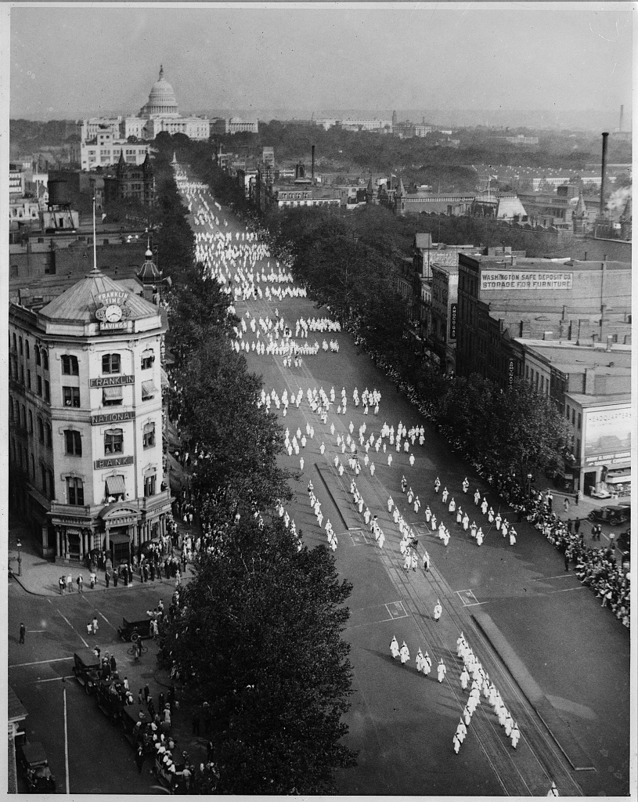
Ku Klux Klan parade, Washington, D.C. · National Photo Company / Library of Congress, Prints and Photographs Division · 1926
Source: "Ku Klux Klan Parade, Washington, D.C." Photograph. September 13, 1926. Library of Congress, Prints and Photographs Division, Washington, D.C. https://www.loc.gov/item/93513529/. Public Domain — No Known Restrictions on Publication https://www.loc.gov/item/93513529/
HIPPO — analyze the source (prompt) | Your analysis
H — Historical context: what was happening when this was created?
I — Intended audience: who was meant to see or obey it?
P — Purpose: why was it created?
P — Point of view: whose perspective does it reflect?
O — Outside connection: how does it connect to this standard?
SUPPORT OPTION
Sentence frame: This source shows ______ because it ______, which reveals ______.
CONFIDENCE CHECK-IN
Rate your understanding of this standard (1–4): ______ One thing to revisit: ____________________

Activity 6 — Core Application: Practice Quiz — US.35 ⏱ ~8 min
RESPONSE CHOICE
Commit to an answer by marking it, saying it, or explaining it aloud before checking. Answer key is in the Teacher Guide (kept separate).
[DOK 2 · item us37-q2 · pre-field-test]
What were the goals and effects of the 1920s Immigration Quota Acts in limiting immigration?
A. The acts aimed to preserve Northern European dominance by using discriminatory quotas based on 1890 census, banning Asian immigration, and reducing total immigration from 800,000 to 150,000 annually
B. The quota acts had no effect on immigration, which contradicts the primary source evidence from this era, which contradicts the primary source evidence from this era and does not reflect the scholarly consensus on this topic
C. The acts increased immigration diversity, despite the fact that multiple sources contradict this view, but contemporary accounts and primary sources suggest otherwise, which does not align with the documented historical record
D. All countries received equal immigration quotas, although this view has been largely discredited by scholars, but contemporary accounts and primary sources suggest otherwise
[DOK 2 · item us37-q3 · pre-field-test]
Why did the Ku Klux Klan experience a resurgence in the 1920s, and what impact did it have on American society?
A. The KKK had no significant presence in the 1920s, although historical sources do not support this conclusion and fails to account for key developments in the broader context, but the historical evidence paints a more nuanced picture
B. The new KKK expanded targets to Catholics, Jews, and immigrants, reached 4-5 million members nationwide, influenced elections, promoted violence, and reflected widespread nativist and racist sentiments before scandals caused decline
C. The KKK only operated in the South, which does not align with the documented historical record despite the fact that multiple contemporary sources contradict this, though this interpretation lacks supporting historical evidence
D. The KKK focused only on African Americans, but contemporary accounts suggest a different explanation and oversimplifies the complex factors at work during this period, which ignores significant political and cultural developments of the era
[DOK 3 · item u1-us35-dok3-tc · pre-field-test]
Compare the different approaches of Ida B. Wells, Marcus Garvey, and the NAACP in fighting for African American rights.
A. All three used identical approaches, which does not align with the documented historical record, but contemporary accounts and primary sources suggest otherwise and does not reflect the scholarly consensus on this topic, which does not align with the documented historical record
B. None of these figures had significant impact, but this oversimplifies the complex factors at work, which does not align with the documented historical record, but contemporary accounts and primary sources suggest otherwise, which represents a common misconception about this historical period
C. They all opposed civil rights, but this oversimplifies the complex factors at work when examined alongside the available primary and secondary sources, which represents a common misconception about this historical period and fails to account for key developments in the broader context
D. Wells used investigative journalism to expose lynching; Garvey promoted Black nationalism, economic self-sufficiency, and separatism; NAACP pursued integration through legal challenges—representing diverse strategies from documentation to separation to integration

Activity 7 — Constructed Response (CER) — US.35 ⏱ ~15 min
BIG-QUESTION ORGANIZER — in the 1920s, who shared in the boom and the new freedoms, and who was left out or pushed back?
Jot quick notes from THIS standard: Who benefited? · Who bore the costs? · Who decided?

CONSTRUCTED RESPONSE (CER) — builds SSP.04 Argumentation
Claim + Evidence + Reasoning: Using this standard, take a position on the central question — examine challenges and advancements related to the push for civil liberties, including the First Red Scare, Immigration Quota Acts, resurgence of the KKK, Black Wall Street and Tulsa Massacre, rise of the NAACP, Ida B. Wells-Barnett, and Garveyism? Support your claim with two pieces of evidence from the passage and explain your reasoning.
Part | Write here
Claim
Evidence (two specifics)
Reasoning
SELF-CHECK (CER rubric — see Toolkit)
Is my claim defensible? · TWO specific pieces of evidence? · Does my reasoning explain HOW the evidence proves the claim?
EXIT TICKET — before you leave [item us37-q1 · DOK 2 · pre-field-test]
How did the First Red Scare violate civil liberties and create an atmosphere of fear and suspicion?
A. The Red Scare had minimal impact on civil liberties, which ignores key developments that shaped the outcome, but contemporary accounts and primary sources suggest otherwise, but the historical evidence paints a more nuanced picture
B. Palmer Raids arrested over 6,000 without warrants, deported immigrants without due process, banned socialist publications, and created an atmosphere of fear that suppressed free speech and political dissent
C. Civil liberties were protected during the Red Scare, which does not reflect the consensus among historians and does not reflect the scholarly consensus on this topic when examined alongside the available primary and secondary sources
D. Only communist party members were affected, which contradicts the primary source evidence from this era and fails to account for key developments in the broader context, although historical sources do not support this conclusion
Show what you know (your choice): mark the best answer, say it, or explain it — then rate how sure you are: ☐ Not yet ☐ Getting there ☐ Got it
Answer key and next steps are in the Teacher Guide.

Standard US.36 — The Scopes Trial
TN Academic Standard US.36: Describe the Scopes Trial of 1925, including the major figures (i.e., John Scopes, William Jennings Bryan, and Clarence Darrow), two sides of the controversy (i.e., fundamentalism and modernism), the outcome, and the legacy.
LEARNING TARGETS — I can…
• I can describe the Scopes Trial of 1925, including the major figures, the two sides of the controversy (fundamentalism and modernism), the outcome, and the legacy.
Lenses for this standard: History · Culture
CORE PATH — the same for every student
Same rigor for everyone: analyze the sources and vocabulary, then show what you learned on the Practice Quiz and the CER.
UDL and MTSS give you flexible ways in — they never lower the bar.
Check yourself against the learning targets on the Cornell Notes page.
★ Tennessee Connection
The Scopes Trial took place in Dayton, Tennessee, in July 1925. John Scopes, a high school teacher, was prosecuted for teaching evolution. The trial featured William Jennings Bryan for the prosecution and Clarence Darrow for the defense, drawing national media attention.
SET YOUR GOAL (self-direction)
My goal for this standard — what will I be able to do, and how will I show it?

HOOK — think before you dig in
The Scopes Trial: Describe the Scopes Trial of 1925, including the major figures (i.e., John Scopes, William Jennings Bryan, and Clarence Darrow), two sides of the controversy (i.e., fundamentalism and modernism), the outcome, and the legacy. Who gained, who was left out — and why does it still matter?

ACTIVATE — what do you already know or wonder?
Jot what you already know or want to find out about this standard. You’ll come back to it.

PREVIEW & PREDICT
Which learning target will be hardest, and why? Connect it to the unit’s big question: who shared in the boom, and who was left out or pushed back?

Activity 1 — Vocabulary (Part A: Reference / Word Bank) — US.36 ⏱ ~10 min
Use this word bank throughout the standard. The Spanish column supports access, not translation of assessment.
Term | Student-friendly meaning | Spanish
Scopes Trial | The 1925 "Monkey Trial" in Dayton, Tennessee, where teacher John Scopes was prosecuted for teaching evolution, symbolizing the clash between modernism and fundamentalism. | Juicio de Scopes
Fundamentalism | A religious movement emphasizing literal interpretation of the Bible, traditional values, and opposition to modernist ideas like evolution, gaining strength in the 1920s. | Fundamentalismo
Modernism | A cultural movement embracing science, reason, and social change, including acceptance of evolution, urban lifestyles, and challenges to traditional religious and moral values. | Modernismo
Grand Ole Opry | A weekly country music radio show that began in Nashville in 1925, becoming the longest-running radio broadcast in U.S. history and establishing Nashville as country music's capital. | Grand Ole Opry
First Red Scare | A period of intense fear of communism and radical political activity following World War I (1919-1920), leading to deportations, arrests, and violations of civil liberties. | Primer Susto Rojo
Immigration Quota Acts | The 1921 and 1924 laws that drastically limited immigration, especially from Southern and Eastern Europe, Asia, and Africa, based on racist national origins formulas. | Leyes de Cuotas de Inmigración
LANGUAGE SUPPORT
Pronunciations: Fundamentalism (fun-duh-MEN-tuh-liz-um); Modernism (MOD-ern-iz-um); Grand Ole Opry (grand ohl AH-pree).
VOCABULARY SELF-CHECK · Knowledge Rating
Rate each term NOW in pencil, then again at the END — growth is the goal; no penalty for “never seen it.”
Term | 1 · never seen it | 2 · heard it | 3 · can use it | 4 · can teach it
Scopes Trial
Fundamentalism
Modernism
Grand Ole Opry
First Red Scare
Immigration Quota Acts
MAKE IT YOURS (RESPONSE CHOICE): choose ONE term above and show you own it — write a sentence, sketch it, or give a real-world example.

Activity 2 — Vocabulary Studio (Frayer-inspired) — US.36 ⏱ ~7 min
RESPONSE CHOICE
Complete each studio by writing, speaking, or diagramming.

PRIORITY TERM 1 Scopes Trial · ES: Juicio de Scopes
Word-bank meaning to build on: The 1925 "Monkey Trial" in Dayton, Tennessee, where teacher John Scopes was prosecuted for teaching evolution, symbolizing the clash between modernism and fundamentalism.
Definition (in your own words) | Characteristics
Examples | Non-examples
Use it to explain
Write one sentence that uses “Scopes Trial” to explain this standard.

PRIORITY TERM 2 Fundamentalism · ES: Fundamentalismo
Word-bank meaning to build on: A religious movement emphasizing literal interpretation of the Bible, traditional values, and opposition to modernist ideas like evolution, gaining strength in the 1920s.
Definition (in your own words) | Characteristics
Examples | Non-examples
Use it to explain
Write one sentence that uses “Fundamentalism” to explain this standard.

CONNECT THE TERMS (UDL · build understanding)
How do these priority terms fit together? Write or sketch how one leads to or affects another.

Activity 3 — Direct Teaching Cornell Notes — US.36 ⏱ ~20 min
Name: ______________________ Class / Period: __________ Date: __________
US.36 — The Scopes Trial • These notes capture the direct-teaching content and the Close Read for this standard.
Your learning targets are on this standard’s opening page — take notes that help you meet them.
Cues (tied to your learning targets) | My notes
What does the passage say about major Figures and Their Roles?
What does the passage say about arguments Against Evolution (Prosecution)?
What does the passage say about arguments For Evolution (Defense)?
Key terms →
DOODLE ZONE — draw your thinking (UDL · another way in)
Need another way in? Sketch the key idea, a quick timeline, or how the pieces connect. Words optional.

Cornell Notes — keep going, then process & check — US.36
MORE NOTES / DIAGRAMS
Continue your notes here, add a quick sketch, or map how the ideas connect.

Key terms to list
Scopes Trial · Fundamentalism · Modernism · Grand Ole Opry · First Red Scare · Immigration Quota Acts
Summary — In your own words (2–3 sentences)
PROGRESS CHECK · one question
How did the confrontation between William Jennings Bryan and Clarence Darrow symbolize broader cultural conflicts in 1920s America?
A. Bryan represented traditional, rural, religious America defending Biblical authority while Darrow represented modern, urban, secular America promoting scientific thinking—symbolizing the era's urban-rural and tradition-modernity divides
B. Bryan and Darrow had similar viewpoints, which ignores key developments that shaped the outcome and oversimplifies the complex factors at work during this period despite the fact that multiple contemporary sources contradict this
C. The confrontation was purely legal, not cultural, but the historical record tells a more complex story, though this interpretation lacks supporting historical evidence, but contemporary accounts and primary sources suggest otherwise
D. Neither figure was significant to the trial, although this overlooks critical economic and social factors, which does not align with the documented historical record, and this view has been largely revised by modern historical research
Commit before you move on — mark it, say it, or explain it aloud.
CHECK YOURSELF — how am I doing?
Which learning targets (on this standard’s opening page) can you now meet? Tick the number; circle any you still need help with.
☐ 1
My 12–15 word headline for this standard

Activity 4 — Close Read — US.36 ⏱ ~15 min
Reading type: History Hack-authored instructional synthesis. This is not a primary source. Builds SSP.03 (synthesize) and SSP.05 (historical awareness).
CORE PATH — read one chunk at a time
Major Figures and Their Roles
John T. Scopes was a 24-year-old high school teacher in Dayton, Tennessee who volunteered to test the Butler Act. William Jennings Bryan, three-time presidential candidate and fundamentalist champion, led the prosecution. Clarence Darrow, famous criminal lawyer and religious skeptic, led the defense. Judge John Raulston favored the prosecution. H.L. Mencken covered the trial for national audiences, coining the term "Monkey Trial."
Arguments Against Evolution (Prosecution)
The prosecution argued that the Bible is the literal word of God and scientifically accurate. They claimed evolution undermined religious faith and moral behavior. They asserted that parents and taxpayers should control school curriculum. Traditional religious values were deemed necessary for social order, and schools should teach established truth, not controversial theories.
Arguments For Evolution (Defense)
The defense argued that evolution was supported by overwhelming scientific evidence. Teachers should be free to teach accepted scientific theories. Separation of church and state prohibited establishing religious doctrine in schools. Students needed modern scientific education to compete. Many Christians already accepted evolution as God's method of creation.
Trial Outcome and Immediate Impact
Scopes was convicted and fined $100, though the conviction was later overturned on a technicality. The Butler Act remained in effect until 1967. Darrow's cross-examination of Bryan exposed inconsistencies in Biblical literalism. The trial became a media circus broadcast on radio. Afterward, publishers removed evolution from textbooks, and many teachers avoided the subject for decades.
Long-term Legacy
The Scopes Trial became a symbol of science versus religion conflict. It established templates for ongoing debates about curriculum control and academic freedom. The trial portrayed religious conservatives as anti-intellectual, reinforcing regional stereotypes about the South. It foreshadowed later Supreme Court cases on religion in schools and inspired cultural works including "Inherit the Wind."
Key terms first: Scopes Trial, Fundamentalism. Read once for the gist, then again for evidence.
CLOSE-READ EVIDENCE LAB — for each question: quote the EVIDENCE from the passage above, then write YOUR ANSWER (or answer aloud / diagram it).
Text-dependent question | Evidence from the passage | Your answer (what it shows)
What is the main idea of the “Major Figures and Their Roles” section, and what evidence supports it?
What is the main idea of the “Arguments Against Evolution (Prosecution)” section, and what evidence supports it?

Activity 5 — Primary Source / Data Analysis — US.36 ⏱ ~15 min
Primary source (photograph) — analyze it with HIPPO. Builds SSP.01–SSP.02.
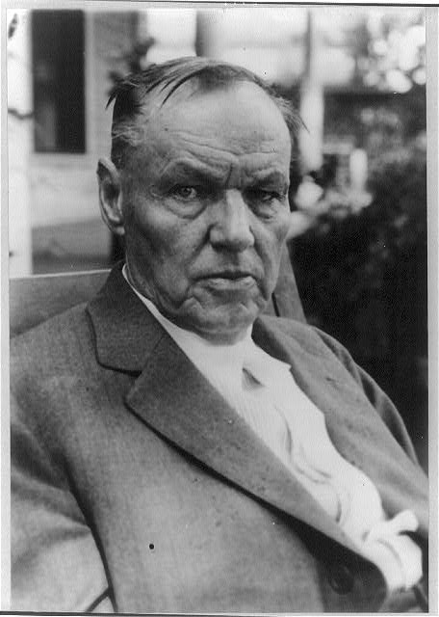
Clarence Darrow at the Scopes Trial, Dayton, Tennessee · Library of Congress, Prints and Photographs Division · 1925
Source: "Clarence Darrow." Photograph. 1925. Library of Congress, Prints and Photographs Division, Washington, D.C. https://www.loc.gov/item/2005687216/. Public Domain — No Known Restrictions on Publication https://www.loc.gov/item/2005687216/
HIPPO — analyze the source (prompt) | Your analysis
H — Historical context: what was happening when this was created?
I — Intended audience: who was meant to see or obey it?
P — Purpose: why was it created?
P — Point of view: whose perspective does it reflect?
O — Outside connection: how does it connect to this standard?
SUPPORT OPTION
Sentence frame: This source shows ______ because it ______, which reveals ______.
CONFIDENCE CHECK-IN
Rate your understanding of this standard (1–4): ______ One thing to revisit: ____________________

Activity 6 — Core Application: Practice Quiz — US.36 ⏱ ~8 min
RESPONSE CHOICE
Commit to an answer by marking it, saying it, or explaining it aloud before checking. Answer key is in the Teacher Guide (kept separate).
[DOK 2 · item us38-q3 · pre-field-test]
What was the outcome of the trial, and how did it affect science education and public discourse?
A. Scopes was convicted but later overturned on technicality; the Butler Act remained until 1967; textbooks removed evolution; teachers avoided the topic for decades; the trial became enduring symbol of science-religion conflict
B. The trial had no lasting effects, yet the available evidence points to a different conclusion, although historical sources do not support this conclusion, which contradicts the primary source evidence from this era
C. Evolution was immediately accepted nationwide, but the historical record tells a more complex story, though this interpretation lacks supporting historical evidence, which does not align with the documented historical record
D. The trial ended all debate about teaching evolution, although historical sources do not support this conclusion, but contemporary accounts and primary sources suggest otherwise, although historical sources do not support this conclusion
[DOK 2 · item q-us38-dok2-1 · pre-field-test]
What did the Scopes Trial reveal about American society?
A. Universal acceptance of evolutionary theory by all religious and scientific communities
B. Deep cultural divide between traditional religious values and modern scientific thought
C. Complete decline of religious belief and church attendance throughout American society
D. Decisive legal victory for fundamentalist views that permanently banned evolution teaching
[DOK 3 · item u1-us36-dok3-tc · pre-field-test]
How did the confrontation between William Jennings Bryan and Clarence Darrow symbolize broader cultural conflicts in 1920s America?
A. Bryan represented traditional, rural, religious America defending Biblical authority while Darrow represented modern, urban, secular America promoting scientific thinking—symbolizing the era's urban-rural and tradition-modernity divides
B. Bryan and Darrow had similar viewpoints, which ignores key developments that shaped the outcome and oversimplifies the complex factors at work during this period despite the fact that multiple contemporary sources contradict this
C. The confrontation was purely legal, not cultural, but the historical record tells a more complex story, though this interpretation lacks supporting historical evidence, but contemporary accounts and primary sources suggest otherwise
D. Neither figure was significant to the trial, although this overlooks critical economic and social factors, which does not align with the documented historical record, and this view has been largely revised by modern historical research

Activity 7 — Constructed Response (CER) — US.36 ⏱ ~15 min
BIG-QUESTION ORGANIZER — in the 1920s, who shared in the boom and the new freedoms, and who was left out or pushed back?
Jot quick notes from THIS standard: Who benefited? · Who bore the costs? · Who decided?

CONSTRUCTED RESPONSE (CER) — builds SSP.04 Argumentation
Claim + Evidence + Reasoning: Using this standard, take a position on the central question — describe the Scopes Trial of 1925, including the major figures, the two sides of the controversy (fundamentalism and modernism), the outcome, and the legacy? Support your claim with two pieces of evidence from the passage and explain your reasoning.
Part | Write here
Claim
Evidence (two specifics)
Reasoning
SELF-CHECK (CER rubric — see Toolkit)
Is my claim defensible? · TWO specific pieces of evidence? · Does my reasoning explain HOW the evidence proves the claim?
EXIT TICKET — before you leave [item us38-q1 · DOK 2 · pre-field-test]
What were the main arguments for and against teaching evolution in public schools during the Scopes Trial?
A. Both sides agreed on educational standards, despite limited evidence supporting this interpretation, but contemporary accounts and primary sources suggest otherwise, which contradicts the primary source evidence from this era
B. The trial was only about Scopes' teaching credentials, although this overlooks critical economic and social factors despite the fact that multiple contemporary sources contradict this, which does not align with the documented historical record
C. Prosecution argued the Bible was literally true and evolution undermined morality; defense argued evolution was scientifically proven, teachers needed academic freedom, and religious doctrine shouldn't control public schools
D. Neither side presented substantive arguments, although historical sources do not support this conclusion, but closer analysis reveals a more complicated historical reality, which represents a common misconception about this historical period
Show what you know (your choice): mark the best answer, say it, or explain it — then rate how sure you are: ☐ Not yet ☐ Getting there ☐ Got it
Answer key and next steps are in the Teacher Guide.

Standard US.37 — Prohibition & Its Impact on American Society
TN Academic Standard US.37: Describe the impacts of Prohibition on American society, including: the rise of organized crime, bootlegging, and speakeasies.
LEARNING TARGETS — I can…
• I can describe the impacts of Prohibition on American society, including the rise of organized crime, bootlegging, and speakeasies.
Lenses for this standard: Culture · History · Economics
CORE PATH — the same for every student
Same rigor for everyone: analyze the sources and vocabulary, then show what you learned on the Practice Quiz and the CER.
UDL and MTSS give you flexible ways in — they never lower the bar.
Check yourself against the learning targets on the Cornell Notes page.
★ Tennessee Connection
Tennessee enacted statewide prohibition in 1909, a full decade before the 18th Amendment. During the national Prohibition era, Tennessee's mountainous terrain became a haven for moonshiners, and bootlegging was widespread in rural areas. Memphis, with its river access, was a hub for illegal alcohol distribution.
SET YOUR GOAL (self-direction)
My goal for this standard — what will I be able to do, and how will I show it?

HOOK — think before you dig in
Prohibition & Its Impact on American Society: Describe the impacts of Prohibition on American society, including: the rise of organized crime, bootlegging, and speakeasies. Who gained, who was left out — and why does it still matter?

ACTIVATE — what do you already know or wonder?
Jot what you already know or want to find out about this standard. You’ll come back to it.

PREVIEW & PREDICT
Which learning target will be hardest, and why? Connect it to the unit’s big question: who shared in the boom, and who was left out or pushed back?

Activity 1 — Vocabulary (Part A: Reference / Word Bank) — US.37 ⏱ ~10 min
Use this word bank throughout the standard. The Spanish column supports access, not translation of assessment.
Term | Student-friendly meaning | Spanish
Prohibition | The nationwide constitutional ban on the manufacture, sale, and transport of alcoholic beverages, in effect from 1920 to 1933 under the 18th Amendment. | Prohibición
Organized Crime | Structured criminal enterprises that expanded dramatically during Prohibition by controlling the illegal liquor trade, led by figures such as Al Capone in Chicago. | Crimen Organizado
Bootlegging | The illegal production, smuggling, and distribution of alcohol during Prohibition. | Contrabando de Alcohol
Speakeasy | An illicit establishment that sold alcoholic beverages during Prohibition, often hidden behind ordinary storefronts. | Bar Clandestino
First Red Scare | A period of intense fear of communism and radical political activity following World War I (1919-1920), leading to deportations, arrests, and violations of civil liberties. | Primer Susto Rojo
Consumerism | A culture of increased purchasing of consumer goods, driven in the 1920s by mass production, national advertising, and installment credit. | Consumismo
LANGUAGE SUPPORT
Pronunciations: Prohibition (proh-uh-BISH-un); Bootlegging (BOOT-leg-ing); Speakeasy (SPEEK-ee-zee); Consumerism (kun-SOO-mer-iz-um).
VOCABULARY SELF-CHECK · Knowledge Rating
Rate each term NOW in pencil, then again at the END — growth is the goal; no penalty for “never seen it.”
Term | 1 · never seen it | 2 · heard it | 3 · can use it | 4 · can teach it
Prohibition
Organized Crime
Bootlegging
Speakeasy
First Red Scare
Consumerism
MAKE IT YOURS (RESPONSE CHOICE): choose ONE term above and show you own it — write a sentence, sketch it, or give a real-world example.

Activity 2 — Vocabulary Studio (Frayer-inspired) — US.37 ⏱ ~7 min
RESPONSE CHOICE
Complete each studio by writing, speaking, or diagramming.

PRIORITY TERM 1 Prohibition · ES: Prohibición
Word-bank meaning to build on: The nationwide constitutional ban on the manufacture, sale, and transport of alcoholic beverages, in effect from 1920 to 1933 under the 18th Amendment.
Definition (in your own words) | Characteristics
Examples | Non-examples
Use it to explain
Write one sentence that uses “Prohibition” to explain this standard.

PRIORITY TERM 2 Organized Crime · ES: Crimen Organizado
Word-bank meaning to build on: Structured criminal enterprises that expanded dramatically during Prohibition by controlling the illegal liquor trade, led by figures such as Al Capone in Chicago.
Definition (in your own words) | Characteristics
Examples | Non-examples
Use it to explain
Write one sentence that uses “Organized Crime” to explain this standard.

CONNECT THE TERMS (UDL · build understanding)
How do these priority terms fit together? Write or sketch how one leads to or affects another.

Activity 3 — Direct Teaching Cornell Notes — US.37 ⏱ ~20 min
Name: ______________________ Class / Period: __________ Date: __________
US.37 — Prohibition & Its Impact on American Society • These notes capture the direct-teaching content and the Close Read for this standard.
Your learning targets are on this standard’s opening page — take notes that help you meet them.
Cues (tied to your learning targets) | My notes
What does the passage say about implementation and Intended Effects?
What does the passage say about rise of Organized Crime?
What does the passage say about bootlegging Methods and Consequences?
Key terms →
DOODLE ZONE — draw your thinking (UDL · another way in)
Need another way in? Sketch the key idea, a quick timeline, or how the pieces connect. Words optional.

Cornell Notes — keep going, then process & check — US.37
MORE NOTES / DIAGRAMS
Continue your notes here, add a quick sketch, or map how the ideas connect.

Key terms to list
Prohibition · Organized Crime · Bootlegging · Speakeasy · First Red Scare · Consumerism
Summary — In your own words (2–3 sentences)
PROGRESS CHECK · one question
Evaluate whether Prohibition caused more harm than good to American society.
A. Prohibition was clearly beneficial overall, despite the fact that multiple sources contradict this view, although this overlooks critical economic and social factors involved, which represents a common misconception about this historical period
B. Prohibition created organized crime, caused deaths from poisonous alcohol, corrupted officials, overwhelmed law enforcement, and undermined respect for law while failing to stop drinking—its harms far outweighed any benefits
C. Prohibition had no significant effects, which represents a common misconception about the period, which contradicts the primary source evidence from this era, though this interpretation lacks supporting historical evidence
D. Prohibition successfully reduced alcohol consumption, though this interpretation lacks supporting historical evidence, though this interpretation lacks supporting historical evidence, and this view has been largely revised by modern historical research
Commit before you move on — mark it, say it, or explain it aloud.
CHECK YOURSELF — how am I doing?
Which learning targets (on this standard’s opening page) can you now meet? Tick the number; circle any you still need help with.
☐ 1
My 12–15 word headline for this standard

Activity 4 — Close Read — US.37 ⏱ ~15 min
Reading type: History Hack-authored instructional synthesis. This is not a primary source. Builds SSP.03 (synthesize) and SSP.05 (historical awareness).
CORE PATH — read one chunk at a time
Implementation and Intended Effects
The 18th Amendment (1919) prohibited manufacture, sale, and transportation of alcohol. The Volstead Act defined "intoxicating liquors" as containing over 0.5% alcohol. The temperance movement, religious groups, and progressive reformers supported Prohibition to reduce crime, improve health, strengthen families, and increase worker productivity. Only 1,500 federal agents were available for enforcement.
Rise of Organized Crime
Illegal alcohol created enormous profits with relatively low risk. Al Capone controlled Chicago operations with an estimated $60 million annual income. Organized crime bribed police, judges, and politicians. Gang warfare including the St. Valentine's Day Massacre (1929) demonstrated violence. Criminal organizations developed national networks and diversified into gambling and other illegal activities.
Bootlegging Methods and Consequences
Alcohol was produced through home distillation ("bathtub gin"), stolen and redistilled industrial alcohol, smuggling from Canada and Caribbean, and abuse of medicinal and religious exemptions. Rumrunners, cars, and trucks distributed illegal alcohol. Poisonous industrial alcohol killed thousands. Widespread bribery undermined law enforcement, and only 5% of illegal alcohol was estimated to be intercepted.
Speakeasies and Social Culture
Speakeasies were secret bars in basements and disguised establishments, often requiring passwords for entry. They featured jazz music, dancing, and diverse clientele mixing social classes and sometimes races. Women drank publicly in unprecedented numbers. Speakeasies promoted flapper culture and created modern nightclub atmosphere. They represented open defiance of Prohibition law.
End of Prohibition
The Great Depression made alcohol tax revenue attractive. Public opinion blamed Prohibition for organized crime. Obvious enforcement failure undermined the law. The 21st Amendment (1933) repealed Prohibition, returning alcohol regulation to states. Criminal networks established during Prohibition persisted for decades, and the experiment demonstrated limitations of legislating moral behavior.
Key terms first: Prohibition, Organized Crime. Read once for the gist, then again for evidence.
CLOSE-READ EVIDENCE LAB — for each question: quote the EVIDENCE from the passage above, then write YOUR ANSWER (or answer aloud / diagram it).
Text-dependent question | Evidence from the passage | Your answer (what it shows)
What is the main idea of the “Implementation and Intended Effects” section, and what evidence supports it?
What is the main idea of the “Rise of Organized Crime” section, and what evidence supports it?

Activity 5 — Primary Source / Data Analysis — US.37 ⏱ ~15 min
Primary source (political cartoon) — analyze it with HIPPO. Builds SSP.01–SSP.02.
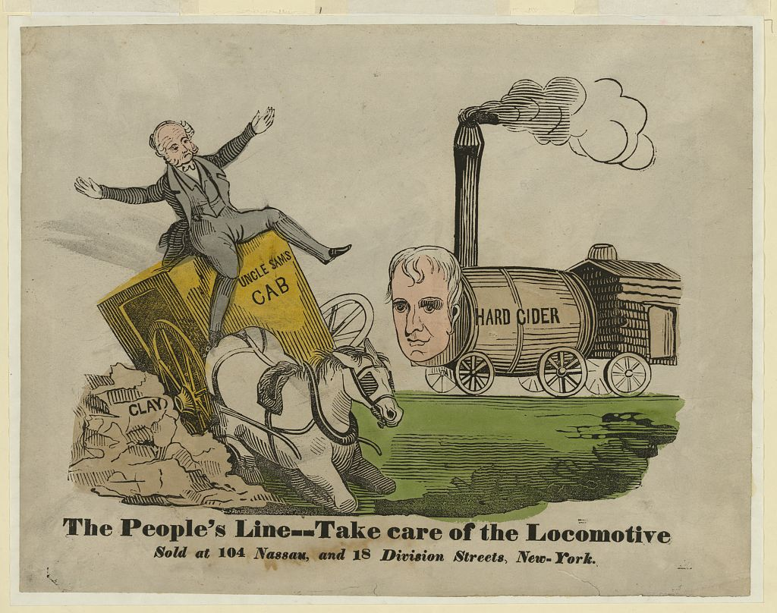
A camel got his head in, and then -- ! · Pease, Lute, 1869-1963, artist · [between 1917 and 1920]
Source: Pease, Lute. "A camel got his head in, and then -- !" Drawing. Between 1917 and 1920. Cartoon Drawings (Library of Congress). Library of Congress Prints and Photographs Division, Washington, D.C. https://www.loc.gov/pictures/item/2016683882/. Public Domain — No Known Restrictions on Publication https://www.loc.gov/rr/print/195_copr.html
HIPPO — analyze the source (prompt) | Your analysis
H — Historical context: what was happening when this was created?
I — Intended audience: who was meant to see or obey it?
P — Purpose: why was it created?
P — Point of view: whose perspective does it reflect?
O — Outside connection: how does it connect to this standard?
SUPPORT OPTION
Sentence frame: This source shows ______ because it ______, which reveals ______.
CONFIDENCE CHECK-IN
Rate your understanding of this standard (1–4): ______ One thing to revisit: ____________________

Activity 6 — Core Application: Practice Quiz — US.37 ⏱ ~8 min
RESPONSE CHOICE
Commit to an answer by marking it, saying it, or explaining it aloud before checking. Answer key is in the Teacher Guide (kept separate).
[DOK 2 · item us37a-q2 · pre-field-test]
How did Prohibition lead to the rise of organized crime and figures like Al Capone?
A. The illegal alcohol trade offered enormous profits, and criminals like Capone built empires through smuggling, bribery of officials, and violence, developing nationwide networks and diversifying into other criminal activities
B. Organized crime existed before Prohibition without change, which represents a common misconception about the period, which represents a common misconception about this historical period and oversimplifies the complex factors at work during this period
C. Law enforcement effectively prevented organized crime, which does not reflect the consensus among historians when examined alongside the available primary and secondary sources and does not reflect the scholarly consensus on this topic
D. Only small-time criminals participated in illegal alcohol trade, which represents a common misconception about the period when examined alongside the available primary and secondary sources, but contemporary accounts and primary sources suggest otherwise
[DOK 2 · item us37a-q3 · pre-field-test]
What role did bootlegging and speakeasies play in undermining Prohibition and changing social culture?
A. Bootlegging was rare and speakeasies were uncommon, although historical sources do not support this conclusion, which contradicts the primary source evidence from this era, though this interpretation lacks supporting historical evidence
B. Widespread bootlegging demonstrated Prohibition's unenforcability while speakeasies created new social spaces where women drank publicly, classes mixed, jazz thrived, and open law-breaking became socially acceptable
C. Speakeasies only served wealthy customers, but the historical record tells a more complex story, which represents a common misconception about this historical period, though this interpretation lacks supporting historical evidence
D. Bootlegging was limited to rural areas, but this oversimplifies the complex factors at work and oversimplifies the complex factors at work during this period, though this interpretation lacks supporting historical evidence
[DOK 3 · item u1-us37-dok3-tc · pre-field-test]
Evaluate whether Prohibition caused more harm than good to American society.
A. Prohibition was clearly beneficial overall, despite the fact that multiple sources contradict this view, although this overlooks critical economic and social factors involved, which represents a common misconception about this historical period
B. Prohibition created organized crime, caused deaths from poisonous alcohol, corrupted officials, overwhelmed law enforcement, and undermined respect for law while failing to stop drinking—its harms far outweighed any benefits
C. Prohibition had no significant effects, which represents a common misconception about the period, which contradicts the primary source evidence from this era, though this interpretation lacks supporting historical evidence
D. Prohibition successfully reduced alcohol consumption, though this interpretation lacks supporting historical evidence, though this interpretation lacks supporting historical evidence, and this view has been largely revised by modern historical research

Activity 7 — Constructed Response (CER) — US.37 ⏱ ~15 min
BIG-QUESTION ORGANIZER — in the 1920s, who shared in the boom and the new freedoms, and who was left out or pushed back?
Jot quick notes from THIS standard: Who benefited? · Who bore the costs? · Who decided?

CONSTRUCTED RESPONSE (CER) — builds SSP.04 Argumentation
Claim + Evidence + Reasoning: Using this standard, take a position on the central question — describe the impacts of Prohibition on American society, including the rise of organized crime, bootlegging, and speakeasies? Support your claim with two pieces of evidence from the passage and explain your reasoning.
Part | Write here
Claim
Evidence (two specifics)
Reasoning
SELF-CHECK (CER rubric — see Toolkit)
Is my claim defensible? · TWO specific pieces of evidence? · Does my reasoning explain HOW the evidence proves the claim?
EXIT TICKET — before you leave [item us37a-q1 · DOK 2 · pre-field-test]
What were the intended goals of Prohibition, and why did it fail to achieve these objectives?
A. Prohibition achieved all its goals, although this overlooks critical economic and social factors, although this overlooks critical economic and social factors involved, but the historical evidence paints a more nuanced picture
B. Prohibition had no specific goals, although this overlooks critical economic and social factors, which represents a common misconception about this historical period, although this overlooks critical economic and social factors involved
C. The failure was due to lack of public support before passage, but contemporary accounts suggest a different explanation, and this view has been largely revised by modern historical research and does not reflect the scholarly consensus on this topic
D. Goals included reducing crime, improving health, and strengthening families, but Prohibition instead increased crime through illegal trade, overwhelmed limited enforcement, and created disrespect for law while alcohol consumption continued
Show what you know (your choice): mark the best answer, say it, or explain it — then rate how sure you are: ☐ Not yet ☐ Getting there ☐ Got it
Answer key and next steps are in the Teacher Guide.

Standard US.38 — Credit, Consumerism & Financial Speculation
TN Academic Standard US.38: Analyze the changes in the economy and culture of the U.S. as a result of credit expansion, consumerism, and financial speculation.
LEARNING TARGETS — I can…
• I can analyze the changes in the economy and culture of the United States as a result of credit expansion, consumerism, and financial speculation.
Lenses for this standard: Economics · History
CORE PATH — the same for every student
Same rigor for everyone: analyze the sources and vocabulary, then show what you learned on the Practice Quiz and the CER.
UDL and MTSS give you flexible ways in — they never lower the bar.
Check yourself against the learning targets on the Cornell Notes page.
SET YOUR GOAL (self-direction)
My goal for this standard — what will I be able to do, and how will I show it?

HOOK — think before you dig in
Credit, Consumerism & Financial Speculation: Analyze the changes in the economy and culture of the U.S. as a result of credit expansion, consumerism, and financial speculation. Who gained, who was left out — and why does it still matter?

ACTIVATE — what do you already know or wonder?
Jot what you already know or want to find out about this standard. You’ll come back to it.

PREVIEW & PREDICT
Which learning target will be hardest, and why? Connect it to the unit’s big question: who shared in the boom, and who was left out or pushed back?

Activity 1 — Vocabulary (Part A: Reference / Word Bank) — US.38 ⏱ ~10 min
Use this word bank throughout the standard. The Spanish column supports access, not translation of assessment.
Term | Student-friendly meaning | Spanish
Buying on Credit | The practice of purchasing goods with borrowed money repaid over time in installments, which fueled 1920s consumer spending. | Compra a Crédito
Consumerism | A culture of increased purchasing of consumer goods, driven in the 1920s by mass production, national advertising, and installment credit. | Consumismo
Stock Speculation | The practice of buying stocks - frequently on margin with borrowed money - in the hope of selling at a higher price for quick profit. | Especulación Bursátil
Automobile Impact | The widespread adoption of cars in the 1920s transformed American society, creating suburbs, highways, tourism, and related industries like gas stations, motels, and drive-in restaurants. | Impacto del Automóvil
Assembly Line | A manufacturing method where workers remain stationary while products move past them on a conveyor belt, with each worker performing one specific task, dramatically increasing efficiency. | Línea de Ensamblaje
Motion Pictures | Silent and "talkie" films that became America's most popular entertainment in the 1920s, creating celebrity culture and Hollywood as the film capital of the world. | Imágenes en Movimiento
LANGUAGE SUPPORT
Pronunciations: Consumerism (kun-SOO-mer-iz-um).
VOCABULARY SELF-CHECK · Knowledge Rating
Rate each term NOW in pencil, then again at the END — growth is the goal; no penalty for “never seen it.”
Term | 1 · never seen it | 2 · heard it | 3 · can use it | 4 · can teach it
Buying on Credit
Consumerism
Stock Speculation
Automobile Impact
Assembly Line
Motion Pictures
MAKE IT YOURS (RESPONSE CHOICE): choose ONE term above and show you own it — write a sentence, sketch it, or give a real-world example.

Activity 2 — Vocabulary Studio (Frayer-inspired) — US.38 ⏱ ~7 min
RESPONSE CHOICE
Complete each studio by writing, speaking, or diagramming.

PRIORITY TERM 1 Buying on Credit · ES: Compra a Crédito
Word-bank meaning to build on: The practice of purchasing goods with borrowed money repaid over time in installments, which fueled 1920s consumer spending.
Definition (in your own words) | Characteristics
Examples | Non-examples
Use it to explain
Write one sentence that uses “Buying on Credit” to explain this standard.

PRIORITY TERM 2 Consumerism · ES: Consumismo
Word-bank meaning to build on: A culture of increased purchasing of consumer goods, driven in the 1920s by mass production, national advertising, and installment credit.
Definition (in your own words) | Characteristics
Examples | Non-examples
Use it to explain
Write one sentence that uses “Consumerism” to explain this standard.

CONNECT THE TERMS (UDL · build understanding)
How do these priority terms fit together? Write or sketch how one leads to or affects another.

Activity 3 — Direct Teaching Cornell Notes — US.38 ⏱ ~20 min
Name: ______________________ Class / Period: __________ Date: __________
US.38 — Credit, Consumerism & Financial Speculation • These notes capture the direct-teaching content and the Close Read for this standard.
Your learning targets are on this standard’s opening page — take notes that help you meet them.
Cues (tied to your learning targets) | My notes
What does the passage say about credit Expansion and Economic Growth?
What does the passage say about consumerism and Cultural Change?
What does the passage say about financial Speculation?
Key terms →
DOODLE ZONE — draw your thinking (UDL · another way in)
Need another way in? Sketch the key idea, a quick timeline, or how the pieces connect. Words optional.

Cornell Notes — keep going, then process & check — US.38
MORE NOTES / DIAGRAMS
Continue your notes here, add a quick sketch, or map how the ideas connect.

Key terms to list
Buying on Credit · Consumerism · Stock Speculation · Automobile Impact · Assembly Line · Motion Pictures
Summary — In your own words (2–3 sentences)
PROGRESS CHECK · one question
Analyze how credit expansion, consumerism, and speculation worked together to create both prosperity and economic vulnerability.
A. These factors were unrelated, although this overlooks critical economic and social factors, but the historical evidence paints a more nuanced picture and oversimplifies the complex factors at work during this period
B. These factors created only prosperity, not vulnerability, but the historical record tells a more complex story and fails to account for key developments in the broader context, although historical sources do not support this conclusion
C. Credit enabled consumption and speculation, which drove production and stock prices higher, encouraging more lending in a cycle that created apparent prosperity while building unsustainable debt and inflated asset values that would collapse
D. Economic vulnerability came from foreign sources, which ignores key developments that shaped the outcome and does not reflect the scholarly consensus on this topic, which does not align with the documented historical record
Commit before you move on — mark it, say it, or explain it aloud.
CHECK YOURSELF — how am I doing?
Which learning targets (on this standard’s opening page) can you now meet? Tick the number; circle any you still need help with.
☐ 1
My 12–15 word headline for this standard

Activity 4 — Close Read — US.38 ⏱ ~15 min
Reading type: History Hack-authored instructional synthesis. This is not a primary source. Builds SSP.03 (synthesize) and SSP.05 (historical awareness).
CORE PATH — read one chunk at a time
Credit Expansion and Economic Growth
Installment buying ("buy now, pay later") made expensive goods affordable. Consumer debt increased from $3.3 billion (1920) to $7.6 billion (1929). By 1929, 75% of cars were purchased on credit. Banks and retailers offered loans for automobiles, appliances, and homes. Credit-driven demand increased production and employment, but also accumulated unsustainable debt levels.
Consumerism and Cultural Change
Purchasing goods became central to American identity and status. Mass production made standardized products available to broad populations. Advertising created brand loyalty through emotional appeals rather than just product information. Lifestyle marketing sold products as means to achieve desired lifestyles. Success became increasingly measured by possessions rather than character.
Financial Speculation
Investors could buy stocks with as little as 10% down payment (buying on margin). Speculation fever meant ordinary Americans invested life savings in the stock market. Stock prices rose far beyond companies' actual worth, creating an investment bubble. Margin requirements meant small price declines triggered forced selling that accelerated market drops.
Interconnections Creating Vulnerability
Credit enabled consumer purchases and stock investments, driving production and corporate profits higher. Rising asset values encouraged more lending. This cycle created an unsustainable bubble. Warning signs included overproduction, income inequality limiting purchasing power, and debt levels beyond what the economy could support.
Technology and Advertising Impact
Radio and magazines enabled national advertising campaigns that used psychological appeals. Household appliances—refrigerators, washing machines, vacuum cleaners—changed domestic life. Automobiles made middle-class families mobile. These technologies, promoted through advertising, created consumer expectations and desires that drove purchasing and economic growth.
Key terms first: Buying on Credit, Consumerism. Read once for the gist, then again for evidence.
CLOSE-READ EVIDENCE LAB — for each question: quote the EVIDENCE from the passage above, then write YOUR ANSWER (or answer aloud / diagram it).
Text-dependent question | Evidence from the passage | Your answer (what it shows)
What is the main idea of the “Credit Expansion and Economic Growth” section, and what evidence supports it?
What is the main idea of the “Consumerism and Cultural Change” section, and what evidence supports it?
What is the main idea of the “Financial Speculation” section, and what evidence supports it?

Activity 5 — Primary Source / Data Analysis — US.38 ⏱ ~15 min
Document (text primary source — analyze with HIPPO). Builds SSP.01–SSP.02.
GENERAL MOTORS INSTALLMENT PLAN ADVERTISEMENT
“Why wait? Drive the car you want NOW and pay for it as you ride. GMAC Time Payment Plan makes it possible for every family to enjoy the benefits of automobile ownership. A small down payment puts you behind the wheel today. Easy monthly pay”
Source: General Motors Acceptance Corporation, 1926. General Motors Acceptance Corporation. "General Motors Installment Plan Advertisement." 1926. Library of Congress, www.loc.gov/collections/general-collections/.. Public domain. https://www.loc.gov/collections/general-collections/
HIPPO — analyze the source (prompt) | Your analysis
H — Historical context: what was happening when this was created?
I — Intended audience: who was meant to see or obey it?
P — Purpose: why was it created?
P — Point of view: whose perspective does it reflect?
O — Outside connection: how does it connect to this standard?
SUPPORT OPTION
Sentence frame: This source shows ______ because it ______, which reveals ______.

EXTEND & RE-ENGAGE (open to all)
Push past the document — corroborate, contextualize, and judge its meaning.
Historian move | Your response
Corroborate — what other source would confirm or complicate this one?
Contextualize — what was happening at the time that explains it?
So what? — why does this source still matter?
CONFIDENCE CHECK-IN
Rate your understanding of this standard (1–4): ______ One thing to revisit: ____________________

Activity 6 — Core Application: Practice Quiz — US.38 ⏱ ~8 min
RESPONSE CHOICE
Commit to an answer by marking it, saying it, or explaining it aloud before checking. Answer key is in the Teacher Guide (kept separate).
[DOK 2 · item us38a-q2 · pre-field-test]
What role did consumerism play in shaping American culture and values during the 1920s?
A. Consumerism made purchasing central to American identity, created brand loyalty through advertising, shifted success measures from character to possessions, and established material acquisition as a path to happiness
B. Consumerism had no cultural impact, which does not align with the documented historical record and oversimplifies the complex factors at work during this period, and this view has been largely revised by modern historical research
C. Americans rejected consumer culture, which contradicts the primary source evidence from this era, although this overlooks critical economic and social factors involved, which does not align with the documented historical record
D. Consumerism was limited to urban areas, although this view has been largely discredited by scholars when examined alongside the available primary and secondary sources, but contemporary accounts and primary sources suggest otherwise
[DOK 2 · item us38a-q3 · pre-field-test]
How did financial speculation in the stock market create economic instability?
A. Stock speculation was carefully regulated, but the historical record tells a more complex story, but the historical evidence paints a more nuanced picture, but closer analysis reveals a more complicated historical reality
B. Buying on margin with only 10% down inflated stock prices beyond real value, and when prices dropped, margin calls forced panic selling that accelerated market decline, creating conditions for collapse
C. Only wealthy investors participated in speculation, although historical sources do not support this conclusion, and this view has been largely revised by modern historical research
D. Speculation had no effect on market stability, which does not reflect the consensus among historians, which does not align with the documented historical record, but the historical evidence paints a more nuanced picture
[DOK 3 · item u1-us38-dok3-tc · pre-field-test]
Analyze how credit expansion, consumerism, and speculation worked together to create both prosperity and economic vulnerability.
A. These factors were unrelated, although this overlooks critical economic and social factors, but the historical evidence paints a more nuanced picture and oversimplifies the complex factors at work during this period
B. These factors created only prosperity, not vulnerability, but the historical record tells a more complex story and fails to account for key developments in the broader context, although historical sources do not support this conclusion
C. Credit enabled consumption and speculation, which drove production and stock prices higher, encouraging more lending in a cycle that created apparent prosperity while building unsustainable debt and inflated asset values that would collapse
D. Economic vulnerability came from foreign sources, which ignores key developments that shaped the outcome and does not reflect the scholarly consensus on this topic, which does not align with the documented historical record

Activity 7 — Constructed Response (CER) — US.38 ⏱ ~15 min
BIG-QUESTION ORGANIZER — in the 1920s, who shared in the boom and the new freedoms, and who was left out or pushed back?
Jot quick notes from THIS standard: Who benefited? · Who bore the costs? · Who decided?

CONSTRUCTED RESPONSE (CER) — builds SSP.04 Argumentation
Claim + Evidence + Reasoning: Using this standard, take a position on the central question — analyze the changes in the economy and culture of the United States as a result of credit expansion, consumerism, and financial speculation? Support your claim with two pieces of evidence from the passage and explain your reasoning.
Part | Write here
Claim
Evidence (two specifics)
Reasoning
SELF-CHECK (CER rubric — see Toolkit)
Is my claim defensible? · TWO specific pieces of evidence? · Does my reasoning explain HOW the evidence proves the claim?
EXIT TICKET — before you leave [item us38a-q1 · DOK 2 · pre-field-test]
How did credit expansion and installment buying change American purchasing patterns and economic behavior?
A. Installment buying made expensive goods affordable, with consumer debt doubling and 75% of cars purchased on credit by 1929, fundamentally changing how Americans acquired goods while accumulating unsustainable debt
B. Credit had minimal impact on consumer behavior, but the historical record tells a more complex story, which represents a common misconception about this historical period and does not reflect the scholarly consensus on this topic
C. Americans avoided using credit in the 1920s, which does not align with the documented historical record despite the fact that multiple contemporary sources contradict this, and this view has been largely revised by modern historical research
D. Credit was only available to wealthy consumers, despite limited evidence supporting this interpretation, which contradicts the primary source evidence from this era, but the historical evidence paints a more nuanced picture
Show what you know (your choice): mark the best answer, say it, or explain it — then rate how sure you are: ☐ Not yet ☐ Getting there ☐ Got it
Answer key and next steps are in the Teacher Guide.

Your Tennessee Connection
TENNESSEE CONNECTION · THE SCOPES TRIAL & THE GRAND OLE OPRY
Tennessee sat at the center of the 1920s. In the summer of 1925, the little town of Dayton hosted the Scopes “Monkey Trial” (US.36): high-school teacher John Scopes was tried for teaching evolution in violation of the state’s Butler Act, with Clarence Darrow defending and William Jennings Bryan prosecuting. It became the first American trial broadcast live on national radio — the era’s clash between science and religion, and between modern cities and rural tradition, played out in a Tennessee courtroom. That same year, WSM radio in Nashville began the barn-dance program that became the Grand Ole Opry (US.30), and Nashville grew into the home of country music while Memphis’s Beale Street shaped the blues.
Reflect (RESPONSE CHOICE): How does a local story change the way you understand a national event? Answer by writing, recording, or diagramming.

Local History Investigation
Industrialization touched Tennessee too — railroads, mines, mills, and the people who worked them. Investigate one local connection and record what you find.
Prompt | Your findings
A person, place, or industry from this era near me
One source I could check (library, TSLA, family, museum)
Who benefited / who bore the costs, locally
One question I still have

Progress Tracker & Cumulative Review
Track your Progress Check result for each standard and note one thing to revisit.
Standard | Progress Check (✓ / reteach) | One thing to revisit
US.28
US.29
US.30
US.31
US.32
US.33
US.34
US.35
US.36
US.37
US.38

Optional Extension Bank (higher-DOK, open to all)
Any student may choose an extension. These are EXTENSION, not a track.
US.28: Using this standard, take a position on the central question — analyze the impact of the Great Migration of African Americans from the rural South to the industrial regions of the Northeast and Midwest in the post-World War I era? Support your claim with two pieces of evidence from the passage and explain your reasoning.
US.29: Using this standard, take a position on the central question — describe the growth and effects that radio and movies played in the emergence of popular culture, such as advertising, celebrities, news, and entertainment? Support your claim with two pieces of evidence from the passage and explain your reasoning.
US.30: Using this standard, take a position on the central question — examine how the use of the radio helped grow the popularity of country and blues music, including the rise of the Grand Ole Opry, W.C. Handy, and Bessie Smith? Support your claim with two pieces of evidence from the passage and explain your reasoning.
US.31: Using this standard, take a position on the central question — describe the impact of new technologies of the era, including the advent of air travel and spread of electricity? Support your claim with two pieces of evidence from the passage and explain your reasoning.
US.32: Using this standard, take a position on the central question — describe the impact of Henry Ford, the automobile, and the mass production of automobiles on the American economy and society? Support your claim with two pieces of evidence from the passage and explain your reasoning.
US.33: Using this standard, take a position on the central question — analyze the impact of the Harlem Renaissance and its important figures on American culture, including Louis Armstrong, Duke Ellington, Langston Hughes, Zora Neale Hurston, and James Weldon Johnson? Support your claim with two pieces of evidence from the passage and explain your reasoning.
US.34: Using this standard, take a position on the central question — describe changes and limitations in the social and economic status of women during this era, including flappers, birth control, clerical and office jobs, and the rise of women's colleges? Support your claim with two pieces of evidence from the passage and explain your reasoning.
US.35: Using this standard, take a position on the central question — examine challenges and advancements related to the push for civil liberties, including the First Red Scare, Immigration Quota Acts, resurgence of the KKK, Black Wall Street and Tulsa Massacre, rise of the NAACP, Ida B. Wells-Barnett, and Garveyism? Support your claim with two pieces of evidence from the passage and explain your reasoning.
US.36: Using this standard, take a position on the central question — describe the Scopes Trial of 1925, including the major figures, the two sides of the controversy (fundamentalism and modernism), the outcome, and the legacy? Support your claim with two pieces of evidence from the passage and explain your reasoning.
US.37: Using this standard, take a position on the central question — describe the impacts of Prohibition on American society, including the rise of organized crime, bootlegging, and speakeasies? Support your claim with two pieces of evidence from the passage and explain your reasoning.
US.38: Using this standard, take a position on the central question — analyze the changes in the economy and culture of the United States as a result of credit expansion, consumerism, and financial speculation? Support your claim with two pieces of evidence from the passage and explain your reasoning.

Think Like a Test-Writer (unit review — open to all)
You met a quick “think like a test-writer” prompt in every standard. Here is the full how-to, once, plus room to write your best questions for the whole unit.
HOW TO WRITE A DOK-3 QUESTION
DOK-3 = strategic thinking: the reader must analyze, compare, evaluate, or justify using evidence — and there should be more than one defensible answer (not a fact you can just look up).
Sentence starters: “Why did ______ lead to ______?” · “Which mattered more — ______ or ______ — and why?” · “What is the BEST evidence that ______?” · “Evaluate whether ______.” · “Defend or challenge: ______.”
Frame: [Analyze / Evaluate / Justify] + [something from this unit] + “using evidence.”
Quick check: does my question make the reader THINK and use evidence? If yes, it’s DOK-3.
Standard | Your DOK-3 question | Your answer key (one sentence)

Reusable Toolkit & Source Library

Written Response Rubric (CER)
Level | Claim | Evidence | Reasoning
4 — Strong | Precise, defensible | 2+ accurate, specific | Explains how evidence proves the claim
3 — Proficient | Clear | 2 accurate | Explains the link
2 — Developing | General | 1 accurate | Partial link
1 — Beginning | Unclear/missing | Missing/inaccurate | No reasoning

Source Library — full citations & clickable links
US.28 — The Great Migration
Letter from African American Migrant to Chicago Defender. Anonymous Southern Migrant, 1917. Migrant, Anonymous Southern. "Letter from African American Migrant to Chicago Defender." 1917. Library of Congress, www.loc.gov/collections/national-association. Public domain. https://www.loc.gov/collections/national-association-for-the-advancement-of-colored-people/
Chicago Defender Editorial. The Chicago Defender, 1917. The Chicago Defender. "Chicago Defender Editorial." 1917. Library of Congress, www.loc.gov/collections/chronicling-america/.. Public domain. https://www.loc.gov/collections/chronicling-america/
US.29 — Radio, Movies, and Popular Culture
Radio Broadcast Introduction. NBC Radio Network, 1927. NBC Radio Network. "Radio Broadcast Introduction." 1927. Library of Congress, www.loc.gov/collections/national-broadcasting-company/.. Public domain. https://www.loc.gov/collections/national-broadcasting-company/
Motion Picture Magazine Article. Photoplay Magazine, 1925. Photoplay Magazine. "Motion Picture Magazine Article." 1925. Library of Congress, www.loc.gov/collections/early-motion-pictures/.. Public domain. https://www.loc.gov/collections/early-motion-pictures/
US.30 — Grand Ole Opry, Blues & Country Music
WSM Barn Dance Radio Announcement. WSM Radio Nashville, 1925. WSM Radio Nashville. "WSM Barn Dance Radio Announcement." 1925. Library of Congress, www.loc.gov/collections/national-jukebox/.. Public domain. https://www.loc.gov/collections/national-jukebox/
W.C. Handy Autobiography Excerpt. W.C. Handy, 1941. Handy, W.C.. "W.C. Handy Autobiography Excerpt." 1941. Library of Congress, www.loc.gov/item/41020233/.. Public domain. https://www.loc.gov/item/41020233/
US.31 — New Technologies: Air Travel and Electricity
Lindbergh Transatlantic Flight News Report. New York Times, May 22, 1927. Times, New York. "Lindbergh Transatlantic Flight News Report." May 22, 1927. Library of Congress, www.loc.gov/collections/charles-a-lindbergh/.. Public domain. https://www.loc.gov/collections/charles-a-lindbergh/
Rural Electrification Survey. U.S. Census Bureau, 1929. U.S. Census Bureau. "Rural Electrification Survey." 1929. Library of Congress, www.loc.gov/collections/federal-writers-project/.. Public domain. https://www.loc.gov/collections/federal-writers-project/
US.32 — Henry Ford, the Automobile & Mass Production
Ford Motor Company Assembly Line Description. Ford Motor Company, 1913. Ford Motor Company. "Ford Motor Company Assembly Line Description." 1913. The Henry Ford, www.thehenryford.org/collections-and-research/digital-resources/.. Public domain. https://www.thehenryford.org/collections-and-research/digital-resources/
Ford $5 Day Announcement. Henry Ford, January 5, 1914. Ford, Henry. "Ford $5 Day Announcement." January 5, 1914. The Henry Ford, www.thehenryford.org/collections-and-research/digital-resources/.. Public domain. https://www.thehenryford.org/collections-and-research/digital-resources/
US.33 — The Harlem Renaissance
The Negro Speaks of Rivers. Langston Hughes, 1921. Hughes, Langston. "The Negro Speaks of Rivers." 1921. Library of Congress, www.loc.gov/item/2004664586/.. Public domain. https://www.loc.gov/item/2004664586/
The Negro Artist and the Racial Mountain. Langston Hughes, 1926. Hughes, Langston. "The Negro Artist and the Racial Mountain." 1926. Library of Congress, www.loc.gov/item/2004664586/.. Public domain. https://www.loc.gov/item/2004664586/
US.34 — Women in the 1920s: Flappers & Social Changes
Flapper Magazine Defense Article. Ellen Welles Page, 1922. Page, Ellen Welles. "Flapper Magazine Defense Article." 1922. Library of Congress, www.loc.gov/collections/general-collections/.. Public domain. https://www.loc.gov/collections/general-collections/
Margaret Sanger on Birth Control. Margaret Sanger, 1920. Sanger, Margaret. "Margaret Sanger on Birth Control." 1920. Library of Congress, www.loc.gov/collections/margaret-sanger-papers/.. Public domain. https://www.loc.gov/collections/margaret-sanger-papers/
US.35 — Civil Liberties: Red Scare, KKK & NAACP
Attorney General Palmer on the Red Scare. A. Mitchell Palmer, U.S. Attorney General, 1920. A. Mitchell Palmer, U.S. Attorney General. "Attorney General Palmer on the Red Scare." 1920. Library of Congress, www.loc.gov/item/18015046/.. Public domain. https://www.loc.gov/item/18015046/
Immigration Act of 1924. U.S. Congress, 1924. U.S. Congress. "Immigration Act of 1924." 1924. Library of Congress, www.loc.gov/law/help/statutes-at-large/68th-congress/session-1/c68s1ch190.pdf.. Public domain. https://www.loc.gov/law/help/statutes-at-large/68th-congress/session-1/c68s1ch190.pdf
US.36 — The Scopes Trial
Tennessee Butler Act. Tennessee General Assembly, 1925. Assembly, Tennessee General. "Tennessee Butler Act." 1925. Library of Congress, www.loc.gov/item/2021668558/.. Public domain. https://www.loc.gov/item/2021668558/
William Jennings Bryan Closing Argument. William Jennings Bryan, 1925. Bryan, William Jennings. "William Jennings Bryan Closing Argument." 1925. Library of Congress, www.loc.gov/collections/clarence-darrow/.. Public domain. https://www.loc.gov/collections/clarence-darrow/
US.37 — Prohibition & Its Impact on American Society
18th Amendment to the Constitution. U.S. Constitution, 1919. U.S. Constitution. "18th Amendment to the Constitution." 1919. Constitution Annotated, Library of Congress, constitution.congress.gov/browse/amendment-18/.. Public domain. https://constitution.congress.gov/browse/amendment-18/
Wickersham Commission Report on Prohibition. National Commission on Law Observance and Enforcement, 1931. Enforcement, National Commission on Law Observance and. "Wickersham Commission Report on Prohibition." 1931. Library of Congress, www.loc.gov/item/31026369/.. Public domain. https://www.loc.gov/item/31026369/
US.38 — Credit, Consumerism & Financial Speculation
General Motors Installment Plan Advertisement. General Motors Acceptance Corporation, 1926. General Motors Acceptance Corporation. "General Motors Installment Plan Advertisement." 1926. Library of Congress, www.loc.gov/collections/general-collections/.. Public domain. https://www.loc.gov/collections/general-collections/
Stock Market Investment Guide. Merrill Lynch, 1928. Lynch, Merrill. "Stock Market Investment Guide." 1928. Library of Congress, www.loc.gov/collections/general-collections/.. Public domain. https://www.loc.gov/collections/general-collections/

The Roaring Twenties — Who Roared, and Who Was Left Out?
This section complicates the “Roaring Twenties” narrative: who shared in the boom and the new freedoms, and who was left out or pushed back. It is History Hack-authored instructional synthesis grounded in this unit’s sourced record — not a primary source.

Migration & the Harlem Renaissance
Millions of Black Americans left the Jim Crow South for Northern and Midwestern cities in the Great Migration (US.28), building the Harlem Renaissance’s outpouring of music, literature, and art (US.33) — even while facing discrimination, housing segregation, and violence.

A New Consumer Culture
Cars, radio, movies, aviation, and electricity remade daily life (US.29, US.31, US.32); buying on installment credit fueled a consumer boom (US.38). The prosperity reached urban and white Americans far more than farmers, and Black and immigrant workers.

Changing Roles for Women
The 19th Amendment and new social freedoms reshaped women’s public lives — the “flapper” became a symbol of the decade (US.34) — though the changes reached some women much more than others.

Fear and Backlash
The boom came with reaction: the Red Scare and Palmer Raids, the Sacco-Vanzetti case, and a revived Ku Klux Klan (US.35); Prohibition and the bootlegging it spawned (US.37); and the Scopes Trial’s clash over evolution, science, and religion (US.36).
Residual note (known follow-up): sourced visuals and named Key-Figure entries for these histories remain pending.

Unit Reflection
Return to the unit’s big question: in the 1920s, who shared in the boom and the new freedoms, and who was left out or pushed back? Write a final claim with two pieces of evidence from different standards.
Part | Write here
My claim
Evidence 1 (standard: ___)
Evidence 2 (standard: ___)
Why it matters today

