U.S. HISTORY HACK™
COURSE STANDARD · PLATINUM EDITION

THE GREAT
DEPRESSION
1929–1941
Unit 5 · High-School U.S. History · Standards-Aligned
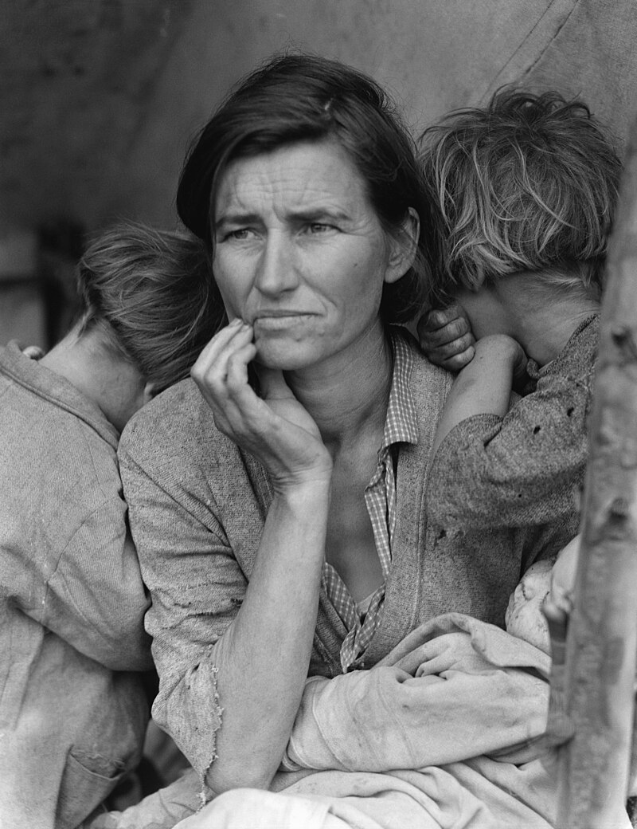
Dorothea Lange, “Migrant Mother,” California, 1936 · Farm Security Administration / Library of Congress · Public domain
ASSESSMENT BOOK

UDL 3.0 | MTSS | CER | Cornell | HIPPO | DOK
Universal Design for Learning · Multi-Tiered Supports · Evidence-Based Writing
Teacher Edition
TroopToTeacher Technologies LLC

U.S. HISTORY HACK™ Unit 5 — The Great Depression & New Deal (1929–1941) ASSESSMENT BOOK · TroopToTeacher Technologies LLC
SPINE
Saddle-stitch. At 16 pages the folded spine is only ≈ 0.036 in (0.9 mm) — too thin to print spine text; bind saddle-stitch (no printed spine). To get a printable spine, perfect-bind at ≥ ~48 pages, or combine thin teacher books into one volume. The spine panel above is provided for when this title is perfect-bound.

U.S. HISTORY HACK™
Formative + summative, parallel forms, keyed and ready to reteach.
Unit 5 — The Great Depression & New Deal (1929–1941) · Teacher Edition
WHAT’S IN THE ASSESSMENT BOOK

◆ A checkpoint per standard. Short, DOK-balanced formative checks for progress monitoring across US.01–US.07.
◆ Two parallel summative forms. Form A and Form B for pre/post or retakes, built for minimal overlap.
◆ Keyed with item analysis. Correct answer, DOK, reporting category, and distractor-based routing — teacher-side only.
◆ Reteach built in. Each item maps to a “What’s Next” move tied to the workbook’s Cornell notes and Guided Support.
◆ From a real item bank. Every item is pulled from the History Hack question bank; positions de-biased and synced across surfaces.
◆ Honest calibration status. Items are classroom-formative and pre-field-test — the first cycle of use is what calibrates them.
INSIDE THIS UNIT — the eleven standards

US.39 Causes of the Great Depression
US.40 The Dust Bowl
US.41 Impact of the Great Depression on the American People
US.42 Herbert Hoover's Response
US.43 FDR's New Deal Programs
US.44 Effects and Controversies of New Deal Policies
Part of the U.S. History Hack™ Course Standard series — a complete, standards-aligned system: Student Workbook · Teacher Edition · Student & Teacher Slide Decks · Graphic Organizer Toolkit · Unit Assessment Book.
TroopToTeacher Technologies LLC  U.S. History Hack™ · Course Standard (Platinum) Edition · Teacher Edition  © 2026 TroopToTeacher Technologies LLC. All rights reserved. U.S. History Hack™ is a trademark of TroopToTeacher Technologies LLC. No part of this book may be reproduced without written permission, except as licensed for classroom use.  www.trooptoteacher.com · Printed in the U.S.A. · First Edition | ISBN barcode  ISBN 978-X-XXXXX-XXX-X  placeholder — replace at print

PRINT & ONLINE-LISTING SPEC
An internal handoff sheet for your printer and your storefront listing — not part of the printed book.
Title (listing) | U.S. History Hack™ — Unit 5: The Great Depression & New Deal · Assessment Book (Teacher)
Series | U.S. History Hack™ Course Standard (Platinum) Edition
Publisher / Author | TroopToTeacher Technologies LLC
Trim size | 8.5 × 11 in (US Letter)
Interior | 16 pages, black-and-white, 60-lb (90 gsm) white offset
Binding & spine | Saddle-stitch (no printed spine) at 16 pp; spine ≈ 0.036 in only. Perfect-bind at ≥ ~48 pp for a printable spine.
Cover stock | 10-pt or 12-pt C1S gloss/matte laminate; full color
Bleed | Add 0.125 in bleed on all outside edges before print (this concept is at trim).
Copyright | © 2026 TroopToTeacher Technologies LLC. All rights reserved.
ISBN | Assign one ISBN per format (paperback / PDF); place barcode in the back-cover box.
Age / grade | Grades 9–12 · U.S. History
Categories | Education › Teaching Methods & Materials › Social Science; Study Aids › History
Keywords | assessment, formative, summative, parallel forms, item analysis, reteach, DOK, reporting category, U.S. history, TCAP
BACK-COVER BLURB (for your storefront)
The Unit 5 Assessment Book gives you a formative checkpoint for each standard, two parallel summative forms (A and B) for pre/post or retakes, and a full teacher answer key with item analysis and reteach routing. Every item is drawn from the History Hack question bank, de-biased, and labeled classroom-formative · pre-field-test. Reproduce the student sections; keep the key section for yourself.

