1776 - 2026 • AMERICA'S 250TH ANNIVERSARY • SEMIQUINCENTENNIAL EDITION
U.S. HISTORY HACK™
TROOPTOTEACHER TECHNOLOGIES
UNIT 5
The Great Depression & New Deal, 1929–1941
COURSE STANDARD EDITION
US.39 – US.44 • 6 Tennessee U.S. History Standards • Grades 9–12
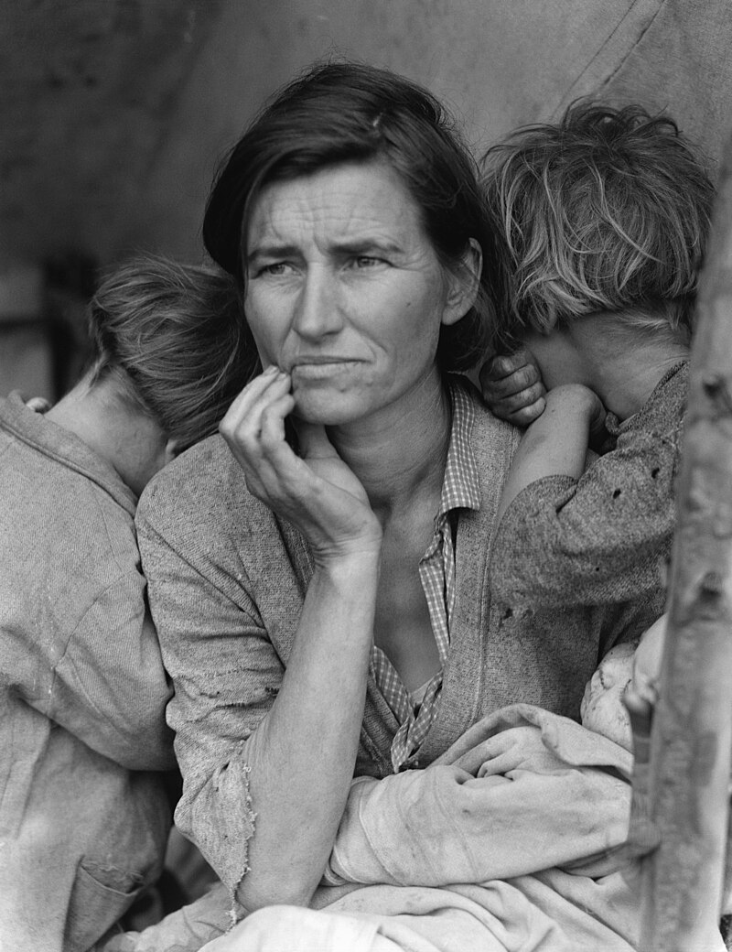
Dorothea Lange, “Migrant Mother” — a destitute pea-picker and her children, Nipomo, California, 1936.
Source: Dorothea Lange, Farm Security Administration / Library of Congress. Public domain.
TENNESSEE CONNECTION · THE TENNESSEE VALLEY AUTHORITY
No New Deal program changed Tennessee more than the Tennessee Valley Authority (US.43). Created in 1933, the TVA built a chain of dams along the Tennessee River — beginning with Norris Dam — to control floods, generate cheap electricity, and put thousands to work. For the first time it brought electric power to rural farms and reshaped the valley’s whole economy. Civilian Conservation Corps camps across the state planted forests and built parks (US.43), even as bank failures and unemployment hit Tennessee hard.
One common workbook designed for learner variability. Every student works toward the same Tennessee standards; supports vary the means, not the goal or the ceiling.
Release-Ready · Pilot Edition
© 2026 TroopToTeacher Technologies LLC. All rights reserved. ISBN: [to be assigned]

Copyright, Ownership & Framework
U.S. History Hack™ — Unit 5: The Great Depression & New Deal (1929–1941), Course Standard Edition.
© 2026 TroopToTeacher Technologies LLC. All rights reserved. This workbook is proprietary; reproduction or redistribution outside a licensed classroom is prohibited.
Source integrity. Every primary source in this unit is public-domain and cited to its holding repository (National Archives, Library of Congress, HathiTrust). See the Source Library.
Reading provenance (district-clear). Close-Read passages are labeled “History Hack-authored instructional synthesis” — they build on the standard record and are not presented as primary sources.
Framework stack. This workbook anchors to Tennessee U.S. History standards US.39–US.44 and the Social Studies Practices (SSP.01–SSP.06), and is designed on CAST UDL 3.0 and an MTSS support model.
Pacing. Each standard is built for one 45-minute class period. Each activity shows a ⏱ ~ minutes estimate at its heading. There is more here than one period holds — your teacher chooses which activities you do in class; the rest may become warm-ups, stations, or homework.

Table of Contents

Tennessee Standards & SSP Crosswalk
Each standard below is taught to the full Course Standard expectation; the Social Studies Practices are embedded in every activity cycle.
Standard | Focus | Lenses
US.39 | Causes of the Great Depression | Economics · History
US.40 | The Dust Bowl | Geography · Economics · History
US.41 | Impact of the Great Depression on the American People | Economics · History
US.42 | Herbert Hoover's Response | Politics/Government · Economics · History
US.43 | FDR's New Deal Programs | Politics/Government · Economics · History
US.44 | Effects and Controversies of New Deal Policies | Economics · Politics/Government · Culture

Social Studies Practices (SSP.01–SSP.06)
SSP.01 Gather/evaluate sources · SSP.02 Critically examine a primary source · SSP.03 Synthesize evidence · SSP.04 Construct/communicate argument · SSP.05 Develop historical awareness · SSP.06 Chronological/spatial reasoning. Each Close Read, Primary Source/Data, and CER activity names the practices it builds.

Accessibility, UDL & Accommodations Matrix
One firm learning goal per standard; flexible, universal means. Supports are available by design and never lower the goal. They work alongside — never in place of — required IEP or 504 accommodations.
Universal support | What it is | Where it appears
CORE PATH | Essential instruction every student completes | Every activity
LANGUAGE SUPPORT | Vocabulary, pronunciation, Spanish cognates | Word Bank, Guided/Light Backs
RESPONSE CHOICE | Write, say/record, or diagram | Every activity
SUPPORT OPTION | Optional scaffold that keeps the goal | Guided Support Back, Primary Source
PROGRESS CHECK | Quick DOK-2/3 check to guide reteach/extend | Cornell Notes, Practice Quiz
EXTENSION | Deeper challenge once the goal is met | Extension Bank, CER

How CAST UDL 3.0 is visible in this workbook
Multiple means of Engagement (response choice, relevance via Tennessee Connection), Representation (Word Bank, pronunciation, Spanish, Close-Read supports), and Action & Expression (write/say/diagram, Frayer, CER). No fixed-track labels appear.

My Support Plan (optional — you choose)
Supports are available by design. Check the ones you might try; you can change your mind any time.
Support I might use | When it would help me
Word Bank + Spanish column
Guided or Light Support Back
Response choice (say/record or diagram)
Sentence frames / Rehearsal Lab

How to Use This Workbook
Each standard runs the same seven-activity cycle: (1) Vocabulary Word Bank, (2) Vocabulary Studio, (3) Direct-Teaching Cornell Notes with optional Guided and Light Support Backs, (4) Close Read, (5) Primary Source / Data Analysis, (6) Core Application Practice Quiz, (7) Constructed Response (CER). Work the CORE PATH; reach for SUPPORT OPTIONS as needed.

Label legend — these appear throughout every standard cycle
Label | Meaning
CORE PATH | The essential instruction every student completes.
SUPPORT OPTION | An optional scaffold that keeps the goal, not lowers it.
LANGUAGE SUPPORT | Vocabulary, pronunciation, and Spanish cognates for access.
RESPONSE CHOICE | Show learning by writing, saying/recording, or diagramming.
PROGRESS CHECK | A quick DOK-2/3 check that guides reteach or extend.
EXTENSION | A deeper challenge once the goal is met.

Before You Begin — Set Your Goal
This unit asks one big question: as the United States industrialized, who benefited and who bore the costs? Set a goal, then note what you already know.
Prompt | Your response
My goal for this unit is…
One thing I already know about this era…
One question I want answered…

Standard US.39 — Causes of the Great Depression
TN Academic Standard US.39: Analyze the causes of the Great Depression, including: bank failures, buying on margin, crash of the stock market, excess consumerism, high tariffs, laissez-faire politics, overextension of credit, overproduction in agriculture & manufacturing, rising unemployment.
LEARNING TARGETS — I can…
• I can analyze the causes of the Great Depression, including bank failures, buying on margin, the stock market crash, overproduction, high tariffs, laissez-faire politics, and rising unemployment.
Lenses for this standard: Economics · History
CORE PATH — the same for every student
Same rigor for everyone: analyze the sources and vocabulary, then show what you learned on the Practice Quiz and the CER.
UDL and MTSS give you flexible ways in — they never lower the bar.
Check yourself against the learning targets on the Cornell Notes page.
★ Tennessee Connection
Tennessee was hit hard by the Great Depression. The Caldwell and Company financial empire, based in Nashville and once the largest investment banking house in the South, collapsed spectacularly in November 1930, wiping out the savings of thousands of Tennesseans and triggering a cascade of bank failures across the region.
SET YOUR GOAL (self-direction)
My goal for this standard — what will I be able to do, and how will I show it?

HOOK — think before you dig in
Causes of the Great Depression: Analyze the causes of the Great Depression, including: bank failures, buying on margin, crash of the stock market, excess consumerism, high tariffs, laissez-faire politics, overextension of credit, overproduction in agriculture & manufacturing, rising unemployment. Who gained, who was left out — and why does it still matter?

ACTIVATE — what do you already know or wonder?
Jot what you already know or want to find out about this standard. You’ll come back to it.

PREVIEW & PREDICT
Which learning target will be hardest, and why? Connect it to the unit’s big question: who shared in the boom, and who was left out or pushed back?

Activity 1 — Vocabulary (Part A: Reference / Word Bank) — US.39 ⏱ ~10 min
Use this word bank throughout the standard. The Spanish column supports access, not translation of assessment.
Term | Student-friendly meaning | Spanish
Great Depression | The worst economic downturn in American history, lasting from 1929 to the early 1940s, characterized by massive unemployment, bank failures, business closures, and widespread poverty. | Gran Depresión
Stock Market Crash of 1929 | The sudden collapse of stock prices in October 1929 ("Black Tuesday"), triggered by speculation, overproduction, and panic selling, which signaled the start of the Great Depression. | Crash del Mercado de Valores de 1929
Buying on Margin | The practice of purchasing stocks by borrowing money (paying only 10% down), which created a speculative bubble that burst when stock prices fell and investors couldn't repay loans. | Comprar con Margen
Bank Failures | The collapse of thousands of banks during the Great Depression when depositors rushed to withdraw their money (bank runs), causing banks to fail because deposits weren't insured. | Quiebras Bancarias
Mass Unemployment | During the Great Depression, unemployment reached 25% at its peak in 1933, with 15 million Americans out of work, creating widespread poverty and desperation. | Desempleo Masivo
Herbert Hoover | The 31st U.S. President (1929-1933) who believed in limited government intervention and "rugged individualism," initially opposing direct federal relief for Depression victims. | Herbert Hoover
LANGUAGE SUPPORT
Pronunciations: Great Depression (grayt dee-PRESH-un); Stock Market Crash of 1929 (stok MAR-ket krash); Buying on Margin (BY-ing on MAR-jin); Bank Failures (bank FAYL-yerz); Mass Unemployment (mass un-em-PLOY-ment); Herbert Hoover (HUR-bert HOO-ver).
VOCABULARY SELF-CHECK · Knowledge Rating
Rate each term NOW in pencil, then again at the END — growth is the goal; no penalty for “never seen it.”
Term | 1 · never seen it | 2 · heard it | 3 · can use it | 4 · can teach it
Great Depression
Stock Market Crash of 1929
Buying on Margin
Bank Failures
Mass Unemployment
Herbert Hoover
MAKE IT YOURS (RESPONSE CHOICE): choose ONE term above and show you own it — write a sentence, sketch it, or give a real-world example.

Activity 2 — Vocabulary Studio (Frayer-inspired) — US.39 ⏱ ~7 min
RESPONSE CHOICE
Complete each studio by writing, speaking, or diagramming.

PRIORITY TERM 1 Great Depression · ES: Gran Depresión
Word-bank meaning to build on: The worst economic downturn in American history, lasting from 1929 to the early 1940s, characterized by massive unemployment, bank failures, business closures, and widespread poverty.
Definition (in your own words) | Characteristics
Examples | Non-examples
Use it to explain
Write one sentence that uses “Great Depression” to explain this standard.

PRIORITY TERM 2 Stock Market Crash of 1929 · ES: Crash del Mercado de Valores de 1929
Word-bank meaning to build on: The sudden collapse of stock prices in October 1929 ("Black Tuesday"), triggered by speculation, overproduction, and panic selling, which signaled the start of the Great Depression.
Definition (in your own words) | Characteristics
Examples | Non-examples
Use it to explain
Write one sentence that uses “Stock Market Crash of 1929” to explain this standard.

CONNECT THE TERMS (UDL · build understanding)
How do these priority terms fit together? Write or sketch how one leads to or affects another.

Activity 3 — Direct Teaching Cornell Notes — US.39 ⏱ ~20 min
Name: ______________________ Class / Period: __________ Date: __________
US.39 — Causes of the Great Depression • These notes capture the direct-teaching content and the Close Read for this standard.
Your learning targets are on this standard’s opening page — take notes that help you meet them.
Cues (tied to your learning targets) | My notes
What does the passage say about bank Failures and the Banking Crisis?
What does the passage say about buying on Margin and Stock Market Crash?
What does the passage say about overproduction and Credit Overextension?
Key terms →
DOODLE ZONE — draw your thinking (UDL · another way in)
Need another way in? Sketch the key idea, a quick timeline, or how the pieces connect. Words optional.

Cornell Notes — keep going, then process & check — US.39
MORE NOTES / DIAGRAMS
Continue your notes here, add a quick sketch, or map how the ideas connect.

Key terms to list
Great Depression · Stock Market Crash of 1929 · Buying on Margin · Bank Failures · Mass Unemployment · Herbert Hoover
Summary — In your own words (2–3 sentences)
PROGRESS CHECK · one question
How did bank failures create a cascade effect that deepened the Great Depression?
A. Failed banks couldn't make loans, destroyed confidence, triggered more bank runs, and reduced money supply by one-third, contracting economic activity
B. Bank failures had minimal impact on the economy, but contemporary accounts suggest a different explanation, which does not align with the documented historical record
C. The government quickly replaced failed banks, but the historical record tells a more complex story, but closer analysis reveals a more complicated historical reality
D. Only rural banks experienced failures, though this interpretation lacks supporting historical evidence despite the fact that multiple contemporary sources contradict this
Commit before you move on — mark it, say it, or explain it aloud.
CHECK YOURSELF — how am I doing?
Which learning targets (on this standard’s opening page) can you now meet? Tick the number; circle any you still need help with.
☐ 1
My 12–15 word headline for this standard

Activity 4 — Close Read — US.39 ⏱ ~15 min
Reading type: History Hack-authored instructional synthesis. This is not a primary source. Builds SSP.03 (synthesize) and SSP.05 (historical awareness).
CORE PATH — read one chunk at a time
Bank Failures and the Banking Crisis
Bank runs occurred when panicked depositors withdrew money simultaneously, causing banks to collapse. With no FDIC insurance, depositors lost life savings when banks failed. Over 9,000 banks failed between 1929-1933, and the cascading effect destroyed confidence, leading to more bank runs. Failed banks couldn't make loans, reducing economic activity and contracting the money supply by one-third.
Buying on Margin and Stock Market Crash
Buying on margin meant purchasing stocks with borrowed money, paying only 10% upfront. This created artificial demand that inflated stock prices beyond real value. When the market crashed on Black Thursday (October 24, 1929) and Black Tuesday (October 29, 1929), $30 billion in stock value was lost in the first week. Margin calls forced investors to sell, driving prices down further in a devastating spiral.
Overproduction and Credit Overextension
Factories could produce more than consumers could buy, while income inequality meant most Americans couldn't afford mass-produced goods. Agricultural overproduction drove farm prices down 60% between 1920-1932. Meanwhile, Americans borrowed heavily for cars, appliances, and homes. When incomes fell, loan defaults triggered bank failures and more defaults in a cascading crisis.
Laissez-Faire Politics and High Tariffs
Republican administrations believed government shouldn't interfere in the economy, delaying decisive action. The Smoot-Hawley Tariff (1930) raised tariffs on thousands of imports, triggering international retaliation. Global trade declined 25% between 1929-1932. This economic nationalism prevented coordinated international response and worsened the worldwide crisis.
Rising Unemployment
Unemployment rose from 3.2% in 1929 to 23.6% in 1932, leaving 12-15 million Americans jobless. Many remained unemployed for years, not just months. The unemployed couldn't purchase goods, reduced tax revenue, and created social problems including family breakdown, homelessness, and malnutrition. Each factor reinforced others in a devastating downward spiral.
Key terms first: Great Depression, Stock Market Crash of 1929. Read once for the gist, then again for evidence.
CLOSE-READ EVIDENCE LAB — for each question: quote the EVIDENCE from the passage above, then write YOUR ANSWER (or answer aloud / diagram it).
Text-dependent question | Evidence from the passage | Your answer (what it shows)
What is the main idea of the “Bank Failures and the Banking Crisis” section, and what evidence supports it?
What is the main idea of the “Buying on Margin and Stock Market Crash” section, and what evidence supports it?

Activity 5 — Primary Source / Data Analysis — US.39 ⏱ ~15 min
Primary source (photograph) — analyze it with HIPPO. Builds SSP.01–SSP.02.
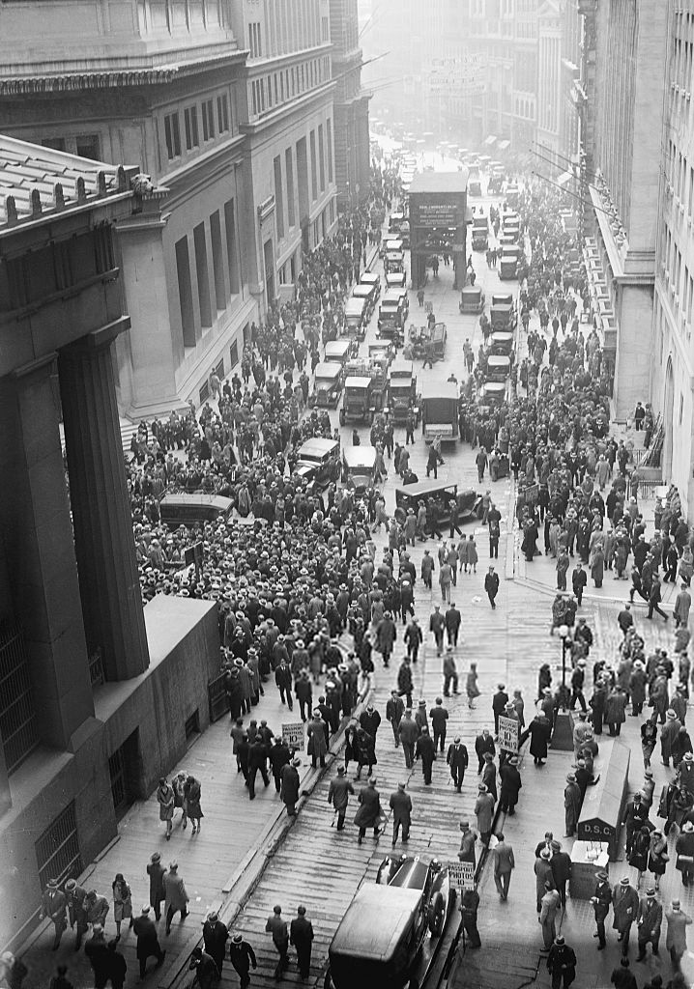
Crowd Outside the New York Stock Exchange, Black Tuesday (October 29, 1929) · Unknown / U.S. Government · October 29, 1929
Source: "Crowd Outside the New York Stock Exchange, October 29, 1929." Wikimedia Commons, commons.wikimedia.org/wiki/File:Crowd_outside_nyse.jpg. Public Domain — No Known Restrictions on Publication https://commons.wikimedia.org/wiki/File:Crowd_outside_nyse.jpg
HIPPO — analyze the source (prompt) | Your analysis
H — Historical context: what was happening when this was created?
I — Intended audience: who was meant to see or obey it?
P — Purpose: why was it created?
P — Point of view: whose perspective does it reflect?
O — Outside connection: how does it connect to this standard?
SUPPORT OPTION
Sentence frame: This source shows ______ because it ______, which reveals ______.
CONFIDENCE CHECK-IN
Rate your understanding of this standard (1–4): ______ One thing to revisit: ____________________

Activity 6 — Core Application: Practice Quiz — US.39 ⏱ ~8 min
RESPONSE CHOICE
Commit to an answer by marking it, saying it, or explaining it aloud before checking. Answer key is in the Teacher Guide (kept separate).
[DOK 2 · item us39-q3 · pre-field-test]
How did overproduction in agriculture and manufacturing contribute to the economic collapse?
A. Factories produced more than consumers could afford to buy, leading to inventory buildup, price collapse, production cuts, and layoffs while farm prices fell 60%
B. Overproduction actually helped the economy by lowering prices, but contemporary accounts suggest a different explanation and fails to account for key developments in the broader context
C. There was no overproduction during this period, which contradicts the primary source evidence from this era and does not reflect the scholarly consensus on this topic
D. Manufacturing overproduction was offset by agricultural shortages, which does not reflect the consensus among historians, although historical sources do not support this conclusion
[DOK 2 · item q-us41-dok1-7 · pre-field-test]
What role did consumer confidence play in the Great Depression?
A. WWI war debts, U.S. loan recalls, protective tariffs created worldwide economic collapse
B. Fear caused people to stop spending, which reduced demand and deepened economic collapse
C. Excessive debt left consumers unable to maintain spending when their incomes suddenly fell
D. Factories produced more goods than consumers could buy, causing prices and profits to fall
[DOK 3 · item u1-us39-dok3-tc · pre-field-test]
How did bank failures create a cascade effect that deepened the Great Depression?
A. Failed banks couldn't make loans, destroyed confidence, triggered more bank runs, and reduced money supply by one-third, contracting economic activity
B. Bank failures had minimal impact on the economy, but contemporary accounts suggest a different explanation, which does not align with the documented historical record
C. The government quickly replaced failed banks, but the historical record tells a more complex story, but closer analysis reveals a more complicated historical reality
D. Only rural banks experienced failures, though this interpretation lacks supporting historical evidence despite the fact that multiple contemporary sources contradict this

Activity 7 — Constructed Response (CER) — US.39 ⏱ ~15 min
BIG-QUESTION ORGANIZER — how did the Great Depression change what Americans expected from their government, and who did the New Deal help or leave out?
Jot quick notes from THIS standard: Who was hurt? · Who was helped? · Who decided?

CONSTRUCTED RESPONSE (CER) — builds SSP.04 Argumentation
Claim + Evidence + Reasoning: Using this standard, take a position on the central question — analyze the causes of the Great Depression, including bank failures, buying on margin, the stock market crash, overproduction, high tariffs, laissez-faire politics, and rising unemployment? Support your claim with two pieces of evidence from the passage and explain your reasoning.
Part | Write here
Claim
Evidence (two specifics)
Reasoning
SELF-CHECK (CER rubric — see Toolkit)
Is my claim defensible? · TWO specific pieces of evidence? · Does my reasoning explain HOW the evidence proves the claim?
EXIT TICKET — before you leave [item us39-q2 · DOK 2 · pre-field-test]
What role did "buying on margin" and overextension of credit play in creating economic instability?
A. Margin buying had no connection to the crash, despite limited evidence supporting this interpretation and oversimplifies the complex factors at work during this period
B. Credit was carefully regulated in the 1920s, which represents a common misconception about the period, but contemporary accounts and primary sources suggest otherwise
C. Margin buying inflated stock prices artificially, and when prices fell, margin calls forced panic selling that accelerated the collapse while widespread consumer debt created defaults
D. Only wealthy investors bought on margin, which contradicts the primary source evidence from this era, which does not align with the documented historical record
Show what you know (your choice): mark the best answer, say it, or explain it — then rate how sure you are: ☐ Not yet ☐ Getting there ☐ Got it
Answer key and next steps are in the Teacher Guide.

Standard US.40 — The Dust Bowl
TN Academic Standard US.40: Analyze the causes of the Dust Bowl, and explain the social, geographic, and economic impacts.
LEARNING TARGETS — I can…
• I can analyze the causes of the Dust Bowl, and explain the social, geographic, and economic impacts.
Lenses for this standard: Geography · Economics · History
CORE PATH — the same for every student
Same rigor for everyone: analyze the sources and vocabulary, then show what you learned on the Practice Quiz and the CER.
UDL and MTSS give you flexible ways in — they never lower the bar.
Check yourself against the learning targets on the Cornell Notes page.
★ Tennessee Connection
While Tennessee was not in the Dust Bowl's core region, the state experienced severe soil erosion and agricultural decline during the 1930s. The Tennessee Valley Authority (TVA), created in 1933, addressed these environmental challenges through reforestation, soil conservation, and flood control across the Tennessee River watershed.
SET YOUR GOAL (self-direction)
My goal for this standard — what will I be able to do, and how will I show it?

HOOK — think before you dig in
The Dust Bowl: Analyze the causes of the Dust Bowl, and explain the social, geographic, and economic impacts. Who gained, who was left out — and why does it still matter?

ACTIVATE — what do you already know or wonder?
Jot what you already know or want to find out about this standard. You’ll come back to it.

PREVIEW & PREDICT
Which learning target will be hardest, and why? Connect it to the unit’s big question: who shared in the boom, and who was left out or pushed back?

Activity 1 — Vocabulary (Part A: Reference / Word Bank) — US.40 ⏱ ~10 min
Use this word bank throughout the standard. The Spanish column supports access, not translation of assessment.
Term | Student-friendly meaning | Spanish
Dust Bowl | A severe drought and ecological disaster in the Great Plains during the 1930s, caused by drought and poor farming practices, creating massive dust storms that destroyed farms and forced migration. | Cuenca de Polvo
Okies | Derogatory term for migrant farmers from Oklahoma, Texas, Arkansas, and Missouri who fled the Dust Bowl to seek work in California, often facing discrimination and poverty. | Okies
Bank Failures | The collapse of thousands of banks during the Great Depression when depositors rushed to withdraw their money (bank runs), causing banks to fail because deposits weren't insured. | Quiebras Bancarias
Great Depression | The worst economic downturn in American history, lasting from 1929 to the early 1940s, characterized by massive unemployment, bank failures, business closures, and widespread poverty. | Gran Depresión
Mass Unemployment | During the Great Depression, unemployment reached 25% at its peak in 1933, with 15 million Americans out of work, creating widespread poverty and desperation. | Desempleo Masivo
Hoovervilles | Shantytown settlements of homeless people during the Depression, named mockingly after President Herbert Hoover, who was blamed for the economic crisis. | Hoovervilles
LANGUAGE SUPPORT
Pronunciations: Dust Bowl (dust bohl); Okies (OH-keez); Bank Failures (bank FAYL-yerz); Great Depression (grayt dee-PRESH-un); Mass Unemployment (mass un-em-PLOY-ment); Hoovervilles (HOO-ver-vilz).
VOCABULARY SELF-CHECK · Knowledge Rating
Rate each term NOW in pencil, then again at the END — growth is the goal; no penalty for “never seen it.”
Term | 1 · never seen it | 2 · heard it | 3 · can use it | 4 · can teach it
Dust Bowl
Okies
Bank Failures
Great Depression
Mass Unemployment
Hoovervilles
MAKE IT YOURS (RESPONSE CHOICE): choose ONE term above and show you own it — write a sentence, sketch it, or give a real-world example.

Activity 2 — Vocabulary Studio (Frayer-inspired) — US.40 ⏱ ~7 min
RESPONSE CHOICE
Complete each studio by writing, speaking, or diagramming.

PRIORITY TERM 1 Dust Bowl · ES: Cuenca de Polvo
Word-bank meaning to build on: A severe drought and ecological disaster in the Great Plains during the 1930s, caused by drought and poor farming practices, creating massive dust storms that destroyed farms and forced migration.
Definition (in your own words) | Characteristics
Examples | Non-examples
Use it to explain
Write one sentence that uses “Dust Bowl” to explain this standard.

PRIORITY TERM 2 Okies · ES: Okies
Word-bank meaning to build on: Derogatory term for migrant farmers from Oklahoma, Texas, Arkansas, and Missouri who fled the Dust Bowl to seek work in California, often facing discrimination and poverty.
Definition (in your own words) | Characteristics
Examples | Non-examples
Use it to explain
Write one sentence that uses “Okies” to explain this standard.

CONNECT THE TERMS (UDL · build understanding)
How do these priority terms fit together? Write or sketch how one leads to or affects another.

Activity 3 — Direct Teaching Cornell Notes — US.40 ⏱ ~20 min
Name: ______________________ Class / Period: __________ Date: __________
US.40 — The Dust Bowl • These notes capture the direct-teaching content and the Close Read for this standard.
Your learning targets are on this standard’s opening page — take notes that help you meet them.
Cues (tied to your learning targets) | My notes
What does the passage say about causes: Over-farming and Agricultural Practices?
What does the passage say about causes: Severe Drought?
What does the passage say about social Impacts: Migration and Displacement?
Key terms →
DOODLE ZONE — draw your thinking (UDL · another way in)
Need another way in? Sketch the key idea, a quick timeline, or how the pieces connect. Words optional.

Cornell Notes — keep going, then process & check — US.40
MORE NOTES / DIAGRAMS
Continue your notes here, add a quick sketch, or map how the ideas connect.

Key terms to list
Dust Bowl · Okies · Bank Failures · Great Depression · Mass Unemployment · Hoovervilles
Summary — In your own words (2–3 sentences)
PROGRESS CHECK · one question
What were the long-term environmental and economic consequences of the Dust Bowl for the Great Plains?
A. The region recovered quickly within a few years, despite the fact that multiple sources contradict this view, but the historical evidence paints a more nuanced picture
B. 75% of topsoil was lost, farm income fell 60%, thousands of farms foreclosed, native ecosystems were damaged, and some areas took decades to recover
C. There were no long-term consequences, but this fails to account for the broader historical context, which represents a common misconception about this historical period
D. The Dust Bowl improved soil quality, despite limited evidence supporting this interpretation when examined alongside the available primary and secondary sources
Commit before you move on — mark it, say it, or explain it aloud.
CHECK YOURSELF — how am I doing?
Which learning targets (on this standard’s opening page) can you now meet? Tick the number; circle any you still need help with.
☐ 1
My 12–15 word headline for this standard

Activity 4 — Close Read — US.40 ⏱ ~15 min
Reading type: History Hack-authored instructional synthesis. This is not a primary source. Builds SSP.03 (synthesize) and SSP.05 (historical awareness).
CORE PATH — read one chunk at a time
Causes: Over-farming and Agricultural Practices
Farmers plowed up native prairie grasses that held soil in place. High wheat prices during WWI encouraged extensive farming, and tractors allowed farmers to plow larger areas more quickly. Monoculture planting depleted soil nutrients and structure. Farmers didn't practice crop rotation or soil conservation, leaving the land vulnerable to erosion.
Causes: Severe Drought
Severe drought began in 1931 and lasted through 1939. Precipitation dropped 40% below normal levels, and record high temperatures increased evaporation. Strong winds picked up loose topsoil from the damaged prairie. The drought was part of a natural climate cycle, but human activity made its effects catastrophic.
Social Impacts: Migration and Displacement
3.5 million people left Great Plains states as "Dust Bowl refugees." Called "Okies" regardless of origin, over 200,000 migrants moved to California seeking agricultural work via Route 66. Migration split families, depopulated rural communities, closed schools and churches, and created social tensions as migrants faced discrimination and hostility in destination areas.
Geographic and Environmental Impacts
75% of topsoil was blown away from affected areas. "Black blizzards" carried soil as far as Washington D.C., with dust storms reducing visibility to near zero. 100 million acres across Texas, Oklahoma, Kansas, Colorado, and New Mexico were affected. Some areas required decades to restore productivity, and the native prairie ecosystem was severely damaged.
Economic Impacts
Wheat production fell 40% in affected areas. Cattle died from dust and lack of feed. Banks foreclosed on thousands of farms as agricultural income fell 60%. Rural businesses dependent on agriculture collapsed. Local governments lost tax base as property values plummeted, and economic rebuilding took decades.
Key terms first: Dust Bowl, Okies. Read once for the gist, then again for evidence.
CLOSE-READ EVIDENCE LAB — for each question: quote the EVIDENCE from the passage above, then write YOUR ANSWER (or answer aloud / diagram it).
Text-dependent question | Evidence from the passage | Your answer (what it shows)
What is the main idea of the “Causes: Over-farming and Agricultural Practices” section, and what evidence supports it?
What is the main idea of the “Causes: Severe Drought” section, and what evidence supports it?
What is the main idea of the “Social Impacts: Migration and Displacement” section, and what evidence supports it?

Geographer’s Lens — US.40 ⏱ ~12 min
Geographers don’t just find places — they explain how WHERE shapes WHAT happens. Work these like a geographer. Built on the Five Themes of Geography · C3 Dimension 2 · SSP.06 (spatial reasoning).
THE PLACES — then explain why geography put them there
The Dust Bowl was a geographic disaster: drought, wind, and over-plowed land turned the southern Great Plains to dust and drove hundreds of thousands west. Locate the region and the migration route, then explain how geography caused the crisis and shaped where people fled.
Place | Where | What happened (given) | Why HERE? (your analysis)
Oklahoma Panhandle | Southern Great Plains | epicenter — drought and dust storms ruined farms; 'Okies' fled west
Texas Panhandle & western Kansas | Southern Great Plains | over-plowed wheat land turned to blowing dust
Eastern Colorado & New Mexico | Great Plains | outer edge of the Dust Bowl damage
Route 66 | Plains → West | the migration road migrants followed toward California
California (Central Valley) | West Coast | destination — migrants sought farm work but met hardship and prejudice
MOVEMENT & REGION — what’s the spatial pattern?
In 1–2 sentences: is this a movement, a cluster, or a whole region? Name the direction or shape it takes on a map.

GEOGRAPHY AS A FORCE — how did location shape the outcome?
How did geography change WHAT happened — who was affected, how far or fast it spread, or who was left out? Use one place above as your evidence.

READ IT LIKE A SOURCE — RESPONSE CHOICE
A map is a source with a point of view. Show your thinking your way — write it, OR sketch a quick arrows-and-labels diagram: what would a map of this make CLEAR, and what would it HIDE or leave out?

Activity 5 — Primary Source / Data Analysis — US.40 ⏱ ~15 min
Primary source (photograph) — analyze it with HIPPO. Builds SSP.01–SSP.02.
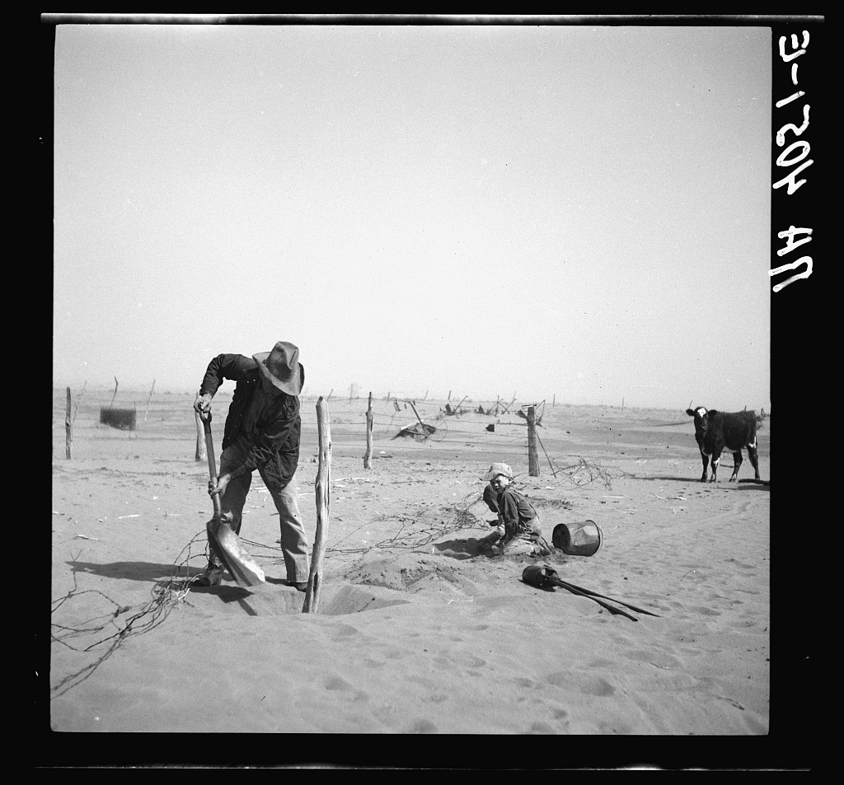
Dust Bowl Farmer Raising Fence to Keep It from Being Buried Under Drifting Sand, Cimarron County, Oklahoma (1936) · Arthur Rothstein / Farm Security Administration (FSA) · 1936
Source: Rothstein, Arthur. "Dust Bowl Farmer Raising Fence, Cimarron County, Oklahoma." 1936. Library of Congress, Prints and Photographs Division, Farm Security Administration/OWI Collection, www.loc.gov/pictures/item/2017760334/. Public Domain — No Known Restrictions on Publication https://www.loc.gov/pictures/item/2017760334/
HIPPO — analyze the source (prompt) | Your analysis
H — Historical context: what was happening when this was created?
I — Intended audience: who was meant to see or obey it?
P — Purpose: why was it created?
P — Point of view: whose perspective does it reflect?
O — Outside connection: how does it connect to this standard?
SUPPORT OPTION
Sentence frame: This source shows ______ because it ______, which reveals ______.
CONFIDENCE CHECK-IN
Rate your understanding of this standard (1–4): ______ One thing to revisit: ____________________

Activity 6 — Core Application: Practice Quiz — US.40 ⏱ ~8 min
RESPONSE CHOICE
Commit to an answer by marking it, saying it, or explaining it aloud before checking. Answer key is in the Teacher Guide (kept separate).
[DOK 2 · item us40-q2 · pre-field-test]
How did the Dust Bowl force massive migration and reshape American demographics?
A. 3.5 million people fled the Great Plains, with over 200,000 "Okies" migrating to California via Route 66, depopulating rural communities and creating tensions in destination areas
B. Most people stayed on their farms despite conditions, which contradicts the primary source evidence from this era, which ignores significant political and cultural developments of the era
C. Migration was limited to a few hundred families, which represents a common misconception about the period and fails to account for key developments in the broader context
D. People only moved to nearby towns, which contradicts the primary source evidence from this era, but contemporary accounts and primary sources suggest otherwise
[DOK 2 · item q-us42-dok1-1 · pre-field-test]
What caused the Dust Bowl?
A. Soil conservation programs promoting contour plowing and shelterbelts
B. Severe drought combined with overplowing that destroyed the topsoil
C. Hundreds of thousands of "Okies" migrated westward to California
D. Overplowing destroyed native grasses that held topsoil in place
[DOK 3 · item u1-us40-dok3-tc · pre-field-test]
What were the long-term environmental and economic consequences of the Dust Bowl for the Great Plains?
A. The region recovered quickly within a few years, despite the fact that multiple sources contradict this view, but the historical evidence paints a more nuanced picture
B. 75% of topsoil was lost, farm income fell 60%, thousands of farms foreclosed, native ecosystems were damaged, and some areas took decades to recover
C. There were no long-term consequences, but this fails to account for the broader historical context, which represents a common misconception about this historical period
D. The Dust Bowl improved soil quality, despite limited evidence supporting this interpretation when examined alongside the available primary and secondary sources

Activity 7 — Constructed Response (CER) — US.40 ⏱ ~15 min
BIG-QUESTION ORGANIZER — how did the Great Depression change what Americans expected from their government, and who did the New Deal help or leave out?
Jot quick notes from THIS standard: Who was hurt? · Who was helped? · Who decided?

CONSTRUCTED RESPONSE (CER) — builds SSP.04 Argumentation
Claim + Evidence + Reasoning: Using this standard, take a position on the central question — analyze the causes of the Dust Bowl, and explain the social, geographic, and economic impacts? Support your claim with two pieces of evidence from the passage and explain your reasoning.
Part | Write here
Claim
Evidence (two specifics)
Reasoning
SELF-CHECK (CER rubric — see Toolkit)
Is my claim defensible? · TWO specific pieces of evidence? · Does my reasoning explain HOW the evidence proves the claim?
EXIT TICKET — before you leave [item us40-q1 · DOK 2 · pre-field-test]
What combination of human farming practices and natural weather patterns created the Dust Bowl?
A. The Dust Bowl was entirely caused by natural drought, although historical sources do not support this conclusion, which does not align with the documented historical record
B. Modern farming techniques prevented soil erosion, but this oversimplifies the complex factors at work, which does not align with the documented historical record
C. The Dust Bowl only affected a small local area, which does not reflect the consensus among historians, which does not align with the documented historical record
D. Farmers plowed up native grasses, practiced monoculture without conservation, and severe drought combined with strong winds eroded the exposed topsoil
Show what you know (your choice): mark the best answer, say it, or explain it — then rate how sure you are: ☐ Not yet ☐ Getting there ☐ Got it
Answer key and next steps are in the Teacher Guide.

Standard US.41 — Impact of the Great Depression on the American People
TN Academic Standard US.41: Describe the impact of the Great Depression on the American people, including mass unemployment, migration, and Hoovervilles.
LEARNING TARGETS — I can…
• I can describe the impact of the Great Depression on the American people, including mass unemployment, migration, and Hoovervilles.
Lenses for this standard: Economics · History
CORE PATH — the same for every student
Same rigor for everyone: analyze the sources and vocabulary, then show what you learned on the Practice Quiz and the CER.
UDL and MTSS give you flexible ways in — they never lower the bar.
Check yourself against the learning targets on the Cornell Notes page.
★ Tennessee Connection
The Great Depression devastated Tennessee. By 1933, unemployment in Memphis exceeded 30%, and rural Tennessee families faced extreme poverty. Sharecroppers in West Tennessee were among the hardest hit. The Highlander Folk School in Monteagle trained labor organizers to help Tennessee workers during the crisis.
SET YOUR GOAL (self-direction)
My goal for this standard — what will I be able to do, and how will I show it?

HOOK — think before you dig in
Impact of the Great Depression on the American People: Describe the impact of the Great Depression on the American people, including mass unemployment, migration, and Hoovervilles. Who gained, who was left out — and why does it still matter?

ACTIVATE — what do you already know or wonder?
Jot what you already know or want to find out about this standard. You’ll come back to it.

PREVIEW & PREDICT
Which learning target will be hardest, and why? Connect it to the unit’s big question: who shared in the boom, and who was left out or pushed back?

Activity 1 — Vocabulary (Part A: Reference / Word Bank) — US.41 ⏱ ~10 min
Use this word bank throughout the standard. The Spanish column supports access, not translation of assessment.
Term | Student-friendly meaning | Spanish
Mass Unemployment | During the Great Depression, unemployment reached 25% at its peak in 1933, with 15 million Americans out of work, creating widespread poverty and desperation. | Desempleo Masivo
Hoovervilles | Shantytown settlements of homeless people during the Depression, named mockingly after President Herbert Hoover, who was blamed for the economic crisis. | Hoovervilles
Okies | Derogatory term for migrant farmers from Oklahoma, Texas, Arkansas, and Missouri who fled the Dust Bowl to seek work in California, often facing discrimination and poverty. | Okies
Great Depression | The worst economic downturn in American history, lasting from 1929 to the early 1940s, characterized by massive unemployment, bank failures, business closures, and widespread poverty. | Gran Depresión
Dust Bowl | A severe drought and ecological disaster in the Great Plains during the 1930s, caused by drought and poor farming practices, creating massive dust storms that destroyed farms and forced migration. | Cuenca de Polvo
Bank Failures | The collapse of thousands of banks during the Great Depression when depositors rushed to withdraw their money (bank runs), causing banks to fail because deposits weren't insured. | Quiebras Bancarias
LANGUAGE SUPPORT
Pronunciations: Mass Unemployment (mass un-em-PLOY-ment); Hoovervilles (HOO-ver-vilz); Okies (OH-keez); Great Depression (grayt dee-PRESH-un); Dust Bowl (dust bohl); Bank Failures (bank FAYL-yerz).
VOCABULARY SELF-CHECK · Knowledge Rating
Rate each term NOW in pencil, then again at the END — growth is the goal; no penalty for “never seen it.”
Term | 1 · never seen it | 2 · heard it | 3 · can use it | 4 · can teach it
Mass Unemployment
Hoovervilles
Okies
Great Depression
Dust Bowl
Bank Failures
MAKE IT YOURS (RESPONSE CHOICE): choose ONE term above and show you own it — write a sentence, sketch it, or give a real-world example.

Activity 2 — Vocabulary Studio (Frayer-inspired) — US.41 ⏱ ~7 min
RESPONSE CHOICE
Complete each studio by writing, speaking, or diagramming.

PRIORITY TERM 1 Mass Unemployment · ES: Desempleo Masivo
Word-bank meaning to build on: During the Great Depression, unemployment reached 25% at its peak in 1933, with 15 million Americans out of work, creating widespread poverty and desperation.
Definition (in your own words) | Characteristics
Examples | Non-examples
Use it to explain
Write one sentence that uses “Mass Unemployment” to explain this standard.

PRIORITY TERM 2 Hoovervilles · ES: Hoovervilles
Word-bank meaning to build on: Shantytown settlements of homeless people during the Depression, named mockingly after President Herbert Hoover, who was blamed for the economic crisis.
Definition (in your own words) | Characteristics
Examples | Non-examples
Use it to explain
Write one sentence that uses “Hoovervilles” to explain this standard.

CONNECT THE TERMS (UDL · build understanding)
How do these priority terms fit together? Write or sketch how one leads to or affects another.

Activity 3 — Direct Teaching Cornell Notes — US.41 ⏱ ~20 min
Name: ______________________ Class / Period: __________ Date: __________
US.41 — Impact of the Great Depression on the American People • These notes capture the direct-teaching content and the Close Read for this standard.
Your learning targets are on this standard’s opening page — take notes that help you meet them.
Cues (tied to your learning targets) | My notes
What does the passage say about mass Unemployment?
What does the passage say about effects on Families and Communities?
What does the passage say about internal Migration?
Key terms →
DOODLE ZONE — draw your thinking (UDL · another way in)
Need another way in? Sketch the key idea, a quick timeline, or how the pieces connect. Words optional.

Cornell Notes — keep going, then process & check — US.41
MORE NOTES / DIAGRAMS
Continue your notes here, add a quick sketch, or map how the ideas connect.

Key terms to list
Mass Unemployment · Hoovervilles · Okies · Great Depression · Dust Bowl · Bank Failures
Summary — In your own words (2–3 sentences)
PROGRESS CHECK · one question
Analyze how the Great Depression changed traditional social structures and relationships in American society.
A. Social structures remained unchanged during the Depression, but the historical record tells a more complex story, though this interpretation lacks supporting historical evidence
B. Only wealthy Americans experienced social changes, despite limited evidence supporting this interpretation, although this overlooks critical economic and social factors involved
C. The Depression disrupted class mobility, shifted gender roles as women worked, increased mutual aid and political participation, and created lasting trauma that changed expectations about government's role
D. Social changes were temporary and reversed by 1935, despite limited evidence supporting this interpretation, but the historical evidence paints a more nuanced picture, which does not align with the documented historical record
Commit before you move on — mark it, say it, or explain it aloud.
CHECK YOURSELF — how am I doing?
Which learning targets (on this standard’s opening page) can you now meet? Tick the number; circle any you still need help with.
☐ 1
My 12–15 word headline for this standard

Activity 4 — Close Read — US.41 ⏱ ~15 min
Reading type: History Hack-authored instructional synthesis. This is not a primary source. Builds SSP.03 (synthesize) and SSP.05 (historical awareness).
CORE PATH — read one chunk at a time
Mass Unemployment
Unemployment peaked at 25% in 1933, with 12-15 million Americans jobless. Many remained unemployed for 2-3 years or longer, while youth unemployment reached 50%. Effects included psychological damage, health problems, skill deterioration, and loss of self-esteem. Families faced role reversal as women and children sometimes became breadwinners while men lost their traditional provider role.
Effects on Families and Communities
Family stress led to increased divorce and desertion. Children left school to work, delayed marriage and family formation. Multiple generations lived together to share expenses. Families relied on mutual aid, growing gardens, bartering, and help from churches and charities. Social isolation from shame and embarrassment caused withdrawal from community life.
Internal Migration
Americans moved seeking better opportunities: rural to urban, South to North (continuing the Great Migration), and Plains to California. People followed family networks to find work, moved with agricultural seasons, and sought jobs at government projects. Migrants faced discrimination, competition for scarce jobs, overcrowded housing, and cultural adjustment challenges.
Hoovervilles
Hoovervilles were makeshift shanty towns built by homeless people using cardboard, tin, and wood scraps. Named sarcastically after President Hoover, they appeared on city outskirts, in parks, and under bridges. Residents organized self-governance, shared resources, and tried to maintain normal family life despite lacking running water, electricity, and sanitation. The largest, in Central Park, housed 15,000 people.
Social Structure Changes
Many middle-class families fell into poverty while wealth became more concentrated. Traditional paths to advancement were disrupted. Gender roles shifted as women entered the workforce. Community mutual aid increased, and political participation grew. The collective trauma affected an entire generation, shaking faith in the American Dream and capitalism.
Key terms first: Mass Unemployment, Hoovervilles. Read once for the gist, then again for evidence.
CLOSE-READ EVIDENCE LAB — for each question: quote the EVIDENCE from the passage above, then write YOUR ANSWER (or answer aloud / diagram it).
Text-dependent question | Evidence from the passage | Your answer (what it shows)
What is the main idea of the “Mass Unemployment” section, and what evidence supports it?
What is the main idea of the “Effects on Families and Communities” section, and what evidence supports it?

Activity 5 — Primary Source / Data Analysis — US.41 ⏱ ~15 min
Primary source (photograph) — analyze it with HIPPO. Builds SSP.01–SSP.02.
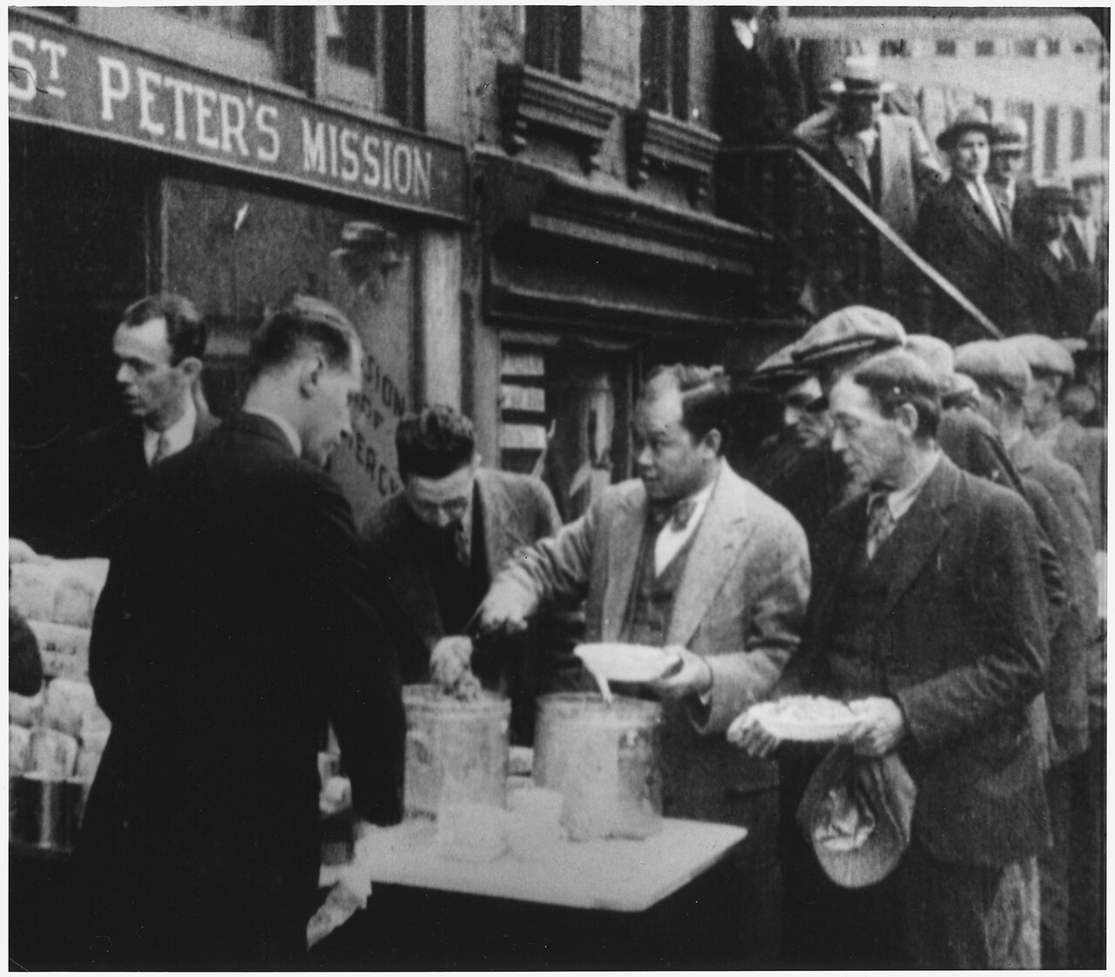
Depression Breadlines: Long Line of People Waiting to Be Fed, New York City (c. 1930s) · Unknown / National Archives (NARA) · c. 1930–1935
Source: "Depression: Breadlines — Long Line of People Waiting to Be Fed, New York City." c. 1930–1935. National Archives (NARA), via Wikimedia Commons, commons.wikimedia.org/wiki/File:Depression,_Breadlines-long_line_of_people_waiting_to_be_fed,_New_York_City,_in_the_absence_of_substantial_government..._-_NARA_-_195524.tif. Public Domain — No Known Restrictions on Publication https://commons.wikimedia.org/wiki/File:Depression,_Breadlines-long_line_of_people_waiting_to_be_fed,_New_York_City,_in_the_absence_of_substantial_government..._-_NARA_-_195524.tif
HIPPO — analyze the source (prompt) | Your analysis
H — Historical context: what was happening when this was created?
I — Intended audience: who was meant to see or obey it?
P — Purpose: why was it created?
P — Point of view: whose perspective does it reflect?
O — Outside connection: how does it connect to this standard?
SUPPORT OPTION
Sentence frame: This source shows ______ because it ______, which reveals ______.
CONFIDENCE CHECK-IN
Rate your understanding of this standard (1–4): ______ One thing to revisit: ____________________

Activity 6 — Core Application: Practice Quiz — US.41 ⏱ ~8 min
RESPONSE CHOICE
Commit to an answer by marking it, saying it, or explaining it aloud before checking. Answer key is in the Teacher Guide (kept separate).
[DOK 2 · item us41-q2 · pre-field-test]
What factors drove internal migration during the 1930s, and where did people go seeking opportunities?
A. Job seekers, displaced farmers, and Dust Bowl refugees moved rural to urban, South to North, and Plains to California, following family networks and government projects
B. People did not migrate during the Depression, but this fails to account for the broader historical context, and this view has been largely revised by modern historical research
C. Migration was limited to wealthy families, which ignores key developments that shaped the outcome, but the historical evidence paints a more nuanced picture
D. All migration was from cities to farms, which does not align with the documented historical record and oversimplifies the complex factors at work during this period
[DOK 2 · item us41-q3 · pre-field-test]
What were Hoovervilles, and what did they reveal about the extent of American poverty?
A. Hoovervilles were government-built housing projects, although this view has been largely discredited by scholars and oversimplifies the complex factors at work during this period
B. They were makeshift shanty towns named sarcastically after Hoover, revealing widespread homelessness, government failure, and the depth of poverty affecting millions of Americans
C. Hoovervilles existed only in rural areas, but the historical record tells a more complex story, and this view has been largely revised by modern historical research
D. They were well-organized communities with modern amenities, but contemporary accounts suggest a different explanation and does not reflect the scholarly consensus on this topic
[DOK 3 · item u1-us41-dok3-tc · pre-field-test]
Analyze how the Great Depression changed traditional social structures and relationships in American society.
A. Social structures remained unchanged during the Depression, but the historical record tells a more complex story, though this interpretation lacks supporting historical evidence
B. Only wealthy Americans experienced social changes, despite limited evidence supporting this interpretation, although this overlooks critical economic and social factors involved
C. The Depression disrupted class mobility, shifted gender roles as women worked, increased mutual aid and political participation, and created lasting trauma that changed expectations about government's role
D. Social changes were temporary and reversed by 1935, despite limited evidence supporting this interpretation, but the historical evidence paints a more nuanced picture, which does not align with the documented historical record

Activity 7 — Constructed Response (CER) — US.41 ⏱ ~15 min
BIG-QUESTION ORGANIZER — how did the Great Depression change what Americans expected from their government, and who did the New Deal help or leave out?
Jot quick notes from THIS standard: Who was hurt? · Who was helped? · Who decided?

CONSTRUCTED RESPONSE (CER) — builds SSP.04 Argumentation
Claim + Evidence + Reasoning: Using this standard, take a position on the central question — describe the impact of the Great Depression on the American people, including mass unemployment, migration, and Hoovervilles? Support your claim with two pieces of evidence from the passage and explain your reasoning.
Part | Write here
Claim
Evidence (two specifics)
Reasoning
SELF-CHECK (CER rubric — see Toolkit)
Is my claim defensible? · TWO specific pieces of evidence? · Does my reasoning explain HOW the evidence proves the claim?
EXIT TICKET — before you leave [item us41-q1 · DOK 2 · pre-field-test]
How did mass unemployment during the Great Depression affect individuals, families, and communities?
A. With 25% unemployment, families faced psychological trauma, role reversals, increased divorce, child labor, and relied on mutual aid while communities experienced population loss and service decline
B. Unemployment had limited social effects, but this fails to account for the broader historical context, and this view has been largely revised by modern historical research
C. Government programs immediately solved unemployment, but the historical record tells a more complex story, though this interpretation lacks supporting historical evidence
D. Only industrial workers experienced unemployment, despite the fact that multiple sources contradict this view, and this view has been largely revised by modern historical research
Show what you know (your choice): mark the best answer, say it, or explain it — then rate how sure you are: ☐ Not yet ☐ Getting there ☐ Got it
Answer key and next steps are in the Teacher Guide.

Standard US.42 — Herbert Hoover's Response
TN Academic Standard US.42: Describe the steps taken by President Herbert Hoover to address the depression, including his: philosophy of "Rugged Individualism", public works projects, the Reconstruction Finance Corporation, and response to the "Bonus Army".
LEARNING TARGETS — I can…
• I can describe the steps taken by President Herbert Hoover to address the depression, including his philosophy of "Rugged Individualism," public works projects, the Reconstruction Finance Corporation, and response to the "Bonus Army.".
Lenses for this standard: Politics/Government · Economics · History
CORE PATH — the same for every student
Same rigor for everyone: analyze the sources and vocabulary, then show what you learned on the Practice Quiz and the CER.
UDL and MTSS give you flexible ways in — they never lower the bar.
Check yourself against the learning targets on the Cornell Notes page.
★ Tennessee Connection
Hoover's limited response to the Depression was felt acutely in Tennessee, where the collapse of Caldwell and Company (Nashville's largest investment bank) in 1930 had already devastated the state's finances. Tennesseans overwhelmingly supported Franklin Roosevelt in the 1932 election, seeking more aggressive federal intervention.
SET YOUR GOAL (self-direction)
My goal for this standard — what will I be able to do, and how will I show it?

HOOK — think before you dig in
Herbert Hoover's Response: Describe the steps taken by President Herbert Hoover to address the depression, including his: philosophy of "Rugged Individualism", public works projects, the Reconstruction Finance Corporation, and response to the "Bonus Army". Who gained, who was left out — and why does it still matter?

ACTIVATE — what do you already know or wonder?
Jot what you already know or want to find out about this standard. You’ll come back to it.

PREVIEW & PREDICT
Which learning target will be hardest, and why? Connect it to the unit’s big question: who shared in the boom, and who was left out or pushed back?

Activity 1 — Vocabulary (Part A: Reference / Word Bank) — US.42 ⏱ ~10 min
Use this word bank throughout the standard. The Spanish column supports access, not translation of assessment.
Term | Student-friendly meaning | Spanish
Herbert Hoover | The 31st U.S. President (1929-1933) who believed in limited government intervention and "rugged individualism," initially opposing direct federal relief for Depression victims. | Herbert Hoover
Rugged Individualism | Hoover's philosophy that individuals should succeed through their own efforts without government handouts, emphasizing self-reliance and private charity over federal aid. | Individualismo Robusto
Bonus Army | Veterans who marched on Washington D.C. in 1932 demanding early payment of WWI bonuses. Hoover ordered the military to violently disperse them, damaging his reputation. | Ejército del Bono
Reconstruction Finance Corporation (RFC) | A federal agency created under Hoover in 1932 that lent money to banks, railroads, and businesses to prevent further collapse. | Corporacion Financiera de Reconstruccion (RFC)
Hoovervilles | Shantytown settlements of homeless people during the Depression, named mockingly after President Herbert Hoover, who was blamed for the economic crisis. | Hoovervilles
Mass Unemployment | During the Great Depression, unemployment reached 25% at its peak in 1933, with 15 million Americans out of work, creating widespread poverty and desperation. | Desempleo Masivo
LANGUAGE SUPPORT
Pronunciations: Herbert Hoover (HUR-bert HOO-ver); Rugged Individualism (RUG-ed in-dih-VIJ-oo-uh-liz-um); Bonus Army (BOH-nus AR-mee); Reconstruction Finance Corporation (RFC) (ree-kun-STRUK-shun fy-NANS); Hoovervilles (HOO-ver-vilz); Mass Unemployment (mass un-em-PLOY-ment).
VOCABULARY SELF-CHECK · Knowledge Rating
Rate each term NOW in pencil, then again at the END — growth is the goal; no penalty for “never seen it.”
Term | 1 · never seen it | 2 · heard it | 3 · can use it | 4 · can teach it
Herbert Hoover
Rugged Individualism
Bonus Army
Reconstruction Finance Corporation (RFC)
Hoovervilles
Mass Unemployment
MAKE IT YOURS (RESPONSE CHOICE): choose ONE term above and show you own it — write a sentence, sketch it, or give a real-world example.

Activity 2 — Vocabulary Studio (Frayer-inspired) — US.42 ⏱ ~7 min
RESPONSE CHOICE
Complete each studio by writing, speaking, or diagramming.

PRIORITY TERM 1 Herbert Hoover · ES: Herbert Hoover
Word-bank meaning to build on: The 31st U.S. President (1929-1933) who believed in limited government intervention and "rugged individualism," initially opposing direct federal relief for Depression victims.
Definition (in your own words) | Characteristics
Examples | Non-examples
Use it to explain
Write one sentence that uses “Herbert Hoover” to explain this standard.

PRIORITY TERM 2 Rugged Individualism · ES: Individualismo Robusto
Word-bank meaning to build on: Hoover's philosophy that individuals should succeed through their own efforts without government handouts, emphasizing self-reliance and private charity over federal aid.
Definition (in your own words) | Characteristics
Examples | Non-examples
Use it to explain
Write one sentence that uses “Rugged Individualism” to explain this standard.

CONNECT THE TERMS (UDL · build understanding)
How do these priority terms fit together? Write or sketch how one leads to or affects another.

Activity 3 — Direct Teaching Cornell Notes — US.42 ⏱ ~20 min
Name: ______________________ Class / Period: __________ Date: __________
US.42 — Herbert Hoover's Response • These notes capture the direct-teaching content and the Close Read for this standard.
Your learning targets are on this standard’s opening page — take notes that help you meet them.
Cues (tied to your learning targets) | My notes
What does the passage say about philosophy of "Rugged Individualism"?
What does the passage say about public Works Projects?
What does the passage say about reconstruction Finance Corporation (RFC)?
Key terms →
DOODLE ZONE — draw your thinking (UDL · another way in)
Need another way in? Sketch the key idea, a quick timeline, or how the pieces connect. Words optional.

Cornell Notes — keep going, then process & check — US.42
MORE NOTES / DIAGRAMS
Continue your notes here, add a quick sketch, or map how the ideas connect.

Key terms to list
Herbert Hoover · Rugged Individualism · Bonus Army · Reconstruction Finance Corporation (RFC) · Hoovervilles · Mass Unemployment
Summary — In your own words (2–3 sentences)
PROGRESS CHECK · one question
Evaluate how Hoover's handling of the Bonus Army protest damaged his presidency and political reputation.
A. The Bonus Army had no political impact, though this interpretation lacks supporting historical evidence, but the historical evidence paints a more nuanced picture
B. The public supported Hoover's handling of the protest, but this oversimplifies the complex factors at work, which ignores significant political and cultural developments of the era
C. The Bonus Army helped Hoover win reelection, which does not reflect the consensus among historians, but the historical evidence paints a more nuanced picture
D. Images of the Army using tanks and tear gas against veterans and families shocked Americans, reinforced perceptions of Hoover as uncaring, and contributed to his 1932 defeat
Commit before you move on — mark it, say it, or explain it aloud.
CHECK YOURSELF — how am I doing?
Which learning targets (on this standard’s opening page) can you now meet? Tick the number; circle any you still need help with.
☐ 1
My 12–15 word headline for this standard

Activity 4 — Close Read — US.42 ⏱ ~15 min
Reading type: History Hack-authored instructional synthesis. This is not a primary source. Builds SSP.03 (synthesize) and SSP.05 (historical awareness).
CORE PATH — read one chunk at a time
Philosophy of "Rugged Individualism"
Hoover believed individuals should solve their own problems without government help, that federal government shouldn't interfere in economic affairs, and that voluntary cooperation was preferable to government programs. He argued direct federal relief violated constitutional principles and would destroy individual initiative and character. This philosophy shaped his limited response to the Depression.
Public Works Projects
Hoover authorized the Boulder Dam (Hoover Dam), employing 5,000 workers at peak. He expanded federal building construction, highway programs, and harbor improvements. The Emergency Relief and Construction Act (1932) authorized $2 billion for public works. However, these projects were too small in scale, took years to begin, and couldn't significantly impact national unemployment.
Reconstruction Finance Corporation (RFC)
Created in January 1932 with $2 billion in lending authority, the RFC was based on "trickle-down" theory—help banks and businesses, and benefits would reach workers. It provided emergency loans to failing banks, railroads, and large corporations. While it helped stabilize some financial institutions, critics saw it as helping wealthy while ignoring common people. Its scale was inadequate for the crisis.
Response to the Bonus Army
17,000 WWI veterans marched to Washington in 1932 demanding early payment of bonus certificates payable in 1945. After Congress rejected the bonus bill, veterans camped peacefully. When police tried to evict them, violence erupted. Hoover ordered the Army to restore order, but General MacArthur exceeded orders, using tanks and tear gas against veterans and their families.
Political Consequences
The Bonus Army incident severely damaged Hoover's reputation. Images of the Army attacking veterans shocked Americans and reinforced perceptions that Hoover didn't care about ordinary people. Combined with his philosophy against direct relief, these events contributed heavily to his defeat in the 1932 election, clearing the way for FDR and the New Deal.
Key terms first: Herbert Hoover, Rugged Individualism. Read once for the gist, then again for evidence.
CLOSE-READ EVIDENCE LAB — for each question: quote the EVIDENCE from the passage above, then write YOUR ANSWER (or answer aloud / diagram it).
Text-dependent question | Evidence from the passage | Your answer (what it shows)
What is the main idea of the “Philosophy of "Rugged Individualism"” section, and what evidence supports it?
What is the main idea of the “Public Works Projects” section, and what evidence supports it?

Activity 5 — Primary Source / Data Analysis — US.42 ⏱ ~15 min
Primary source (photograph) — analyze it with HIPPO. Builds SSP.01–SSP.02.
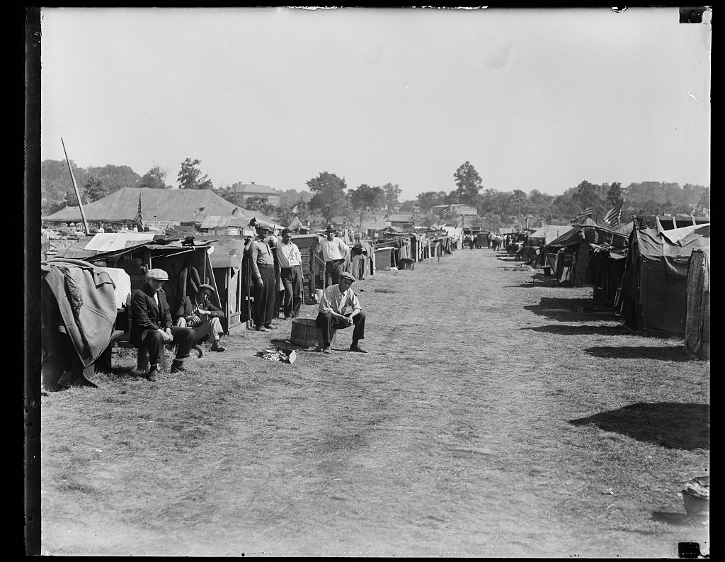
[Bonus Army Camp, Anacostia, Washington, D.C.] (1932) · Harris & Ewing / Library of Congress, Prints & Photographs Division (Harris & Ewing Collection) · 1932
Source: Harris & Ewing. "Bonus Army Camp, Anacostia, Washington, D.C." 1932. Library of Congress, Prints and Photographs Division, Harris & Ewing Collection, www.loc.gov/item/2016879659/. Public Domain — No Known Restrictions on Publication https://www.loc.gov/item/2016879659/
HIPPO — analyze the source (prompt) | Your analysis
H — Historical context: what was happening when this was created?
I — Intended audience: who was meant to see or obey it?
P — Purpose: why was it created?
P — Point of view: whose perspective does it reflect?
O — Outside connection: how does it connect to this standard?
SUPPORT OPTION
Sentence frame: This source shows ______ because it ______, which reveals ______.
CONFIDENCE CHECK-IN
Rate your understanding of this standard (1–4): ______ One thing to revisit: ____________________

Activity 6 — Core Application: Practice Quiz — US.42 ⏱ ~8 min
RESPONSE CHOICE
Commit to an answer by marking it, saying it, or explaining it aloud before checking. Answer key is in the Teacher Guide (kept separate).
[DOK 2 · item us42-q2 · pre-field-test]
What public works projects did Hoover initiate, and why were they insufficient to address the economic crisis?
A. Projects like Hoover Dam provided some jobs, but were too small in scale, took years to begin, concentrated in specific regions, and couldn't significantly reduce national unemployment
B. Hoover initiated no public works projects, which represents a common misconception about the period and fails to account for key developments in the broader context
C. His public works completely solved unemployment, but this fails to account for the broader historical context, though this interpretation lacks supporting historical evidence
D. Public works projects were larger than New Deal programs, which ignores key developments that shaped the outcome, which represents a common misconception about this historical period
[DOK 2 · item us42-q3 · pre-field-test]
How did the Reconstruction Finance Corporation represent Hoover's "trickle-down" approach to economic recovery?
A. The RFC provided direct relief to unemployed workers, though this interpretation lacks supporting historical evidence, which contradicts the primary source evidence from this era
B. The RFC lent money to banks and large corporations, assuming benefits would eventually reach ordinary workers—a top-down approach that critics said helped the wealthy while ignoring the poor
C. The RFC was a small, insignificant program, but this oversimplifies the complex factors at work, which contradicts the primary source evidence from this era, which does not align with the documented historical record
D. Hoover opposed the RFC, which contradicts the primary source evidence from this era, which ignores significant political and cultural developments of the era, which contradicts the primary source evidence from this era
[DOK 3 · item u1-us42-dok3-tc · pre-field-test]
Evaluate how Hoover's handling of the Bonus Army protest damaged his presidency and political reputation.
A. The Bonus Army had no political impact, though this interpretation lacks supporting historical evidence, but the historical evidence paints a more nuanced picture
B. The public supported Hoover's handling of the protest, but this oversimplifies the complex factors at work, which ignores significant political and cultural developments of the era
C. The Bonus Army helped Hoover win reelection, which does not reflect the consensus among historians, but the historical evidence paints a more nuanced picture
D. Images of the Army using tanks and tear gas against veterans and families shocked Americans, reinforced perceptions of Hoover as uncaring, and contributed to his 1932 defeat

Activity 7 — Constructed Response (CER) — US.42 ⏱ ~15 min
BIG-QUESTION ORGANIZER — how did the Great Depression change what Americans expected from their government, and who did the New Deal help or leave out?
Jot quick notes from THIS standard: Who was hurt? · Who was helped? · Who decided?

CONSTRUCTED RESPONSE (CER) — builds SSP.04 Argumentation
Claim + Evidence + Reasoning: Using this standard, take a position on the central question — describe the steps taken by President Herbert Hoover to address the depression, including his philosophy of "Rugged Individualism," public works projects, the Reconstruction Finance Corporation, and response to the "Bonus Army."? Support your claim with two pieces of evidence from the passage and explain your reasoning.
Part | Write here
Claim
Evidence (two specifics)
Reasoning
SELF-CHECK (CER rubric — see Toolkit)
Is my claim defensible? · TWO specific pieces of evidence? · Does my reasoning explain HOW the evidence proves the claim?
EXIT TICKET — before you leave [item us42-q1 · DOK 2 · pre-field-test]
How did President Hoover's philosophy of "Rugged Individualism" shape his response to the Great Depression?
A. It led to aggressive government intervention, but the historical record tells a more complex story and fails to account for key developments in the broader context
B. His belief that individuals should solve problems without government help led to limited federal response, reliance on voluntary cooperation, and opposition to direct relief programs
C. He immediately provided direct payments to unemployed workers, but this oversimplifies the complex factors at work and does not reflect the scholarly consensus on this topic
D. Rugged individualism had no impact on his policies, although historical sources do not support this conclusion, which contradicts the primary source evidence from this era
Show what you know (your choice): mark the best answer, say it, or explain it — then rate how sure you are: ☐ Not yet ☐ Getting there ☐ Got it
Answer key and next steps are in the Teacher Guide.

Standard US.43 — FDR's New Deal Programs
TN Academic Standard US.43: Analyze the impact of the relief, recovery, and reform efforts of President Franklin D. Roosevelt's New Deal programs, including: Agricultural Adjustment Act, Civilian Conservation Corps, Fair Labor Standards Act, FDIC, National Recovery Administration, Securities and Exchange Commission, Social Security, TVA, Works Progress Administration.
LEARNING TARGETS — I can…
• I can analyze the impact of the relief, recovery, and reform efforts of FDR's New Deal programs, including the AAA, CCC, Fair Labor Standards Act, FDIC, NRA, SEC, Social Security, TVA, and WPA.
Lenses for this standard: Politics/Government · Economics · History
CORE PATH — the same for every student
Same rigor for everyone: analyze the sources and vocabulary, then show what you learned on the Practice Quiz and the CER.
UDL and MTSS give you flexible ways in — they never lower the bar.
Check yourself against the learning targets on the Cornell Notes page.
★ Tennessee Connection
The Tennessee Valley Authority (TVA), created in 1933, was one of the most impactful New Deal programs. TVA brought electricity, flood control, and economic development to the Tennessee Valley region, transforming one of the nation's poorest areas. Norris Dam was the first dam completed by TVA.
SET YOUR GOAL (self-direction)
My goal for this standard — what will I be able to do, and how will I show it?

HOOK — think before you dig in
FDR's New Deal Programs: Analyze the impact of the relief, recovery, and reform efforts of President Franklin D. Roosevelt's New Deal programs, including: Agricultural Adjustment Act, Civilian Conservation Corps, Fair Labor Standards Act, FDIC, National Recovery Administration, Securities and Exchange Commission, Social Security, TVA, Works Progress Administration. Who gained, who was left out — and why does it still matter?

ACTIVATE — what do you already know or wonder?
Jot what you already know or want to find out about this standard. You’ll come back to it.

PREVIEW & PREDICT
Which learning target will be hardest, and why? Connect it to the unit’s big question: who shared in the boom, and who was left out or pushed back?

Activity 1 — Vocabulary (Part A: Reference / Word Bank) — US.43 ⏱ ~10 min
Use this word bank throughout the standard. The Spanish column supports access, not translation of assessment.
Term | Student-friendly meaning | Spanish
Franklin D. Roosevelt (FDR) | The 32nd U.S. President (1933-1945) who led America through the Great Depression and World War II, implementing the New Deal and fundamentally expanding the federal government's role. | Franklin D. Roosevelt (FDR)
New Deal | FDR's comprehensive programs to provide relief, recovery, and reform during the Great Depression, fundamentally expanding federal government power and establishing the social safety net. | New Deal
Civilian Conservation Corps (CCC) | New Deal program that employed young men in conservation projects, building trails, planting trees, and developing parks, providing jobs for over 3 million young men. | Cuerpo Civil de Conservación (CCC)
Works Progress Administration (WPA) | The largest New Deal agency, employing 8.5 million Americans to build roads, bridges, schools, airports, and create art, music, and literature projects. | Administración de Progreso de Obras (WPA)
Tennessee Valley Authority (TVA) | Federal agency created to develop the Tennessee Valley region through hydroelectric dams, flood control, reforestation, and economic development, bringing electricity to rural areas. | Autoridad del Valle de Tennessee (TVA)
Social Security Act (1935) | Landmark New Deal legislation creating a federal system of old-age pensions, unemployment insurance, and aid for disabled and dependent children, forming America's social safety net. | Ley de Seguridad Social (1935)
LANGUAGE SUPPORT
Pronunciations: Franklin D. Roosevelt (FDR) (FRANK-lin ROH-zuh-velt); New Deal (noo deel); Civilian Conservation Corps (CCC) (sih-VIL-yun kon-ser-VAY-shun kor); Works Progress Administration (WPA) (werks PROG-res ad-min-ih-STRAY-shun); Tennessee Valley Authority (TVA) (ten-eh-SEE VAL-ee aw-THOR-ih-tee); Social Security Act (1935) (SOH-shul sih-KYOOR-ih-tee).
VOCABULARY SELF-CHECK · Knowledge Rating
Rate each term NOW in pencil, then again at the END — growth is the goal; no penalty for “never seen it.”
Term | 1 · never seen it | 2 · heard it | 3 · can use it | 4 · can teach it
Franklin D. Roosevelt (FDR)
New Deal
Civilian Conservation Corps (CCC)
Works Progress Administration (WPA)
Tennessee Valley Authority (TVA)
Social Security Act (1935)
MAKE IT YOURS (RESPONSE CHOICE): choose ONE term above and show you own it — write a sentence, sketch it, or give a real-world example.

Activity 2 — Vocabulary Studio (Frayer-inspired) — US.43 ⏱ ~7 min
RESPONSE CHOICE
Complete each studio by writing, speaking, or diagramming.

PRIORITY TERM 1 Franklin D. Roosevelt (FDR) · ES: Franklin D. Roosevelt (FDR)
Word-bank meaning to build on: The 32nd U.S. President (1933-1945) who led America through the Great Depression and World War II, implementing the New Deal and fundamentally expanding the federal government's role.
Definition (in your own words) | Characteristics
Examples | Non-examples
Use it to explain
Write one sentence that uses “Franklin D. Roosevelt (FDR)” to explain this standard.

PRIORITY TERM 2 New Deal · ES: New Deal
Word-bank meaning to build on: FDR's comprehensive programs to provide relief, recovery, and reform during the Great Depression, fundamentally expanding federal government power and establishing the social safety net.
Definition (in your own words) | Characteristics
Examples | Non-examples
Use it to explain
Write one sentence that uses “New Deal” to explain this standard.

CONNECT THE TERMS (UDL · build understanding)
How do these priority terms fit together? Write or sketch how one leads to or affects another.

Activity 3 — Direct Teaching Cornell Notes — US.43 ⏱ ~20 min
Name: ______________________ Class / Period: __________ Date: __________
US.43 — FDR's New Deal Programs • These notes capture the direct-teaching content and the Close Read for this standard.
Your learning targets are on this standard’s opening page — take notes that help you meet them.
Cues (tied to your learning targets) | My notes
What does the passage say about relief Programs: CCC and WPA?
What does the passage say about recovery Programs: AAA and NRA?
What does the passage say about reform Programs: Banking and Securities?
Key terms →
DOODLE ZONE — draw your thinking (UDL · another way in)
Need another way in? Sketch the key idea, a quick timeline, or how the pieces connect. Words optional.

Cornell Notes — keep going, then process & check — US.43
MORE NOTES / DIAGRAMS
Continue your notes here, add a quick sketch, or map how the ideas connect.

Key terms to list
Franklin D. Roosevelt (FDR) · New Deal · Civilian Conservation Corps (CCC) · Works Progress Administration (WPA) · Tennessee Valley Authority (TVA) · Social Security Act (1935)
Summary — In your own words (2–3 sentences)
PROGRESS CHECK · one question
Evaluate which New Deal programs had the most lasting impact on American society and why.
A. Social Security, FDIC, SEC, and TVA continue today—Social Security provides retirement income for millions, FDIC protects bank deposits, SEC regulates markets, and TVA still provides electricity to the Tennessee Valley
B. All New Deal programs ended after the Depression, which does not align with the documented historical record, which represents a common misconception about this historical period, but closer analysis reveals a more complicated historical reality
C. Only the CCC had lasting impact, despite limited evidence supporting this interpretation, which ignores significant political and cultural developments of the era, although this overlooks critical economic and social factors involved
D. New Deal programs were temporary emergency measures, although this overlooks critical economic and social factors, which represents a common misconception about this historical period, which does not align with the documented historical record
Commit before you move on — mark it, say it, or explain it aloud.
CHECK YOURSELF — how am I doing?
Which learning targets (on this standard’s opening page) can you now meet? Tick the number; circle any you still need help with.
☐ 1
My 12–15 word headline for this standard

Activity 4 — Close Read — US.43 ⏱ ~15 min
Reading type: History Hack-authored instructional synthesis. This is not a primary source. Builds SSP.03 (synthesize) and SSP.05 (historical awareness).
CORE PATH — read one chunk at a time
Relief Programs: CCC and WPA
The Civilian Conservation Corps (CCC, 1933) provided jobs for 250,000 unemployed young men aged 18-25 in rural work camps. Over 3 million participated, planting 3 billion trees and building park facilities. The Works Progress Administration (WPA, 1935) employed 8.5 million Americans building roads, bridges, schools, and airports. WPA also funded arts, writers, theater, and music projects.
Recovery Programs: AAA and NRA
The Agricultural Adjustment Act (AAA, 1933) paid farmers to reduce production, raising prices 50% by 1936 and doubling farm income. However, it displaced sharecroppers and was declared unconstitutional in 1936. The National Recovery Administration (NRA, 1933) created industry codes for wages and hours, guaranteeing workers' right to organize. It was also declared unconstitutional in 1935.
Reform Programs: Banking and Securities
The Federal Deposit Insurance Corporation (FDIC, 1933) guaranteed bank deposits, eliminating bank runs and restoring confidence. The Securities and Exchange Commission (SEC, 1934) regulated stock markets, required company disclosure, and prohibited fraud and manipulation. These reforms stabilized the financial system and restored investor confidence.
Reform Programs: Labor and Social Security
The Fair Labor Standards Act (FLSA, 1938) established the first national minimum wage (25 cents/hour), 40-hour work week, overtime pay, and prohibited child labor. The Social Security Act (1935) created old-age pensions, unemployment insurance, and aid for dependent children—establishing a permanent social safety net that continues today.
Tennessee Valley Authority (TVA)
TVA (1933) built 16 major dams on the Tennessee River for flood control, electricity generation, and navigation. It brought electricity to rural areas, attracted industry with cheap power, and dramatically improved living conditions in one of America's poorest regions. TVA demonstrated government's ability to promote comprehensive regional development and continues operating today.
Key terms first: Franklin D. Roosevelt (FDR), New Deal. Read once for the gist, then again for evidence.
CLOSE-READ EVIDENCE LAB — for each question: quote the EVIDENCE from the passage above, then write YOUR ANSWER (or answer aloud / diagram it).
Text-dependent question | Evidence from the passage | Your answer (what it shows)
What is the main idea of the “Relief Programs: CCC and WPA” section, and what evidence supports it?
What is the main idea of the “Recovery Programs: AAA and NRA” section, and what evidence supports it?
What is the main idea of the “Reform Programs: Banking and Securities” section, and what evidence supports it?

Activity 5 — Primary Source / Data Analysis — US.43 ⏱ ~15 min
Primary source (photograph) — analyze it with HIPPO. Builds SSP.01–SSP.02.
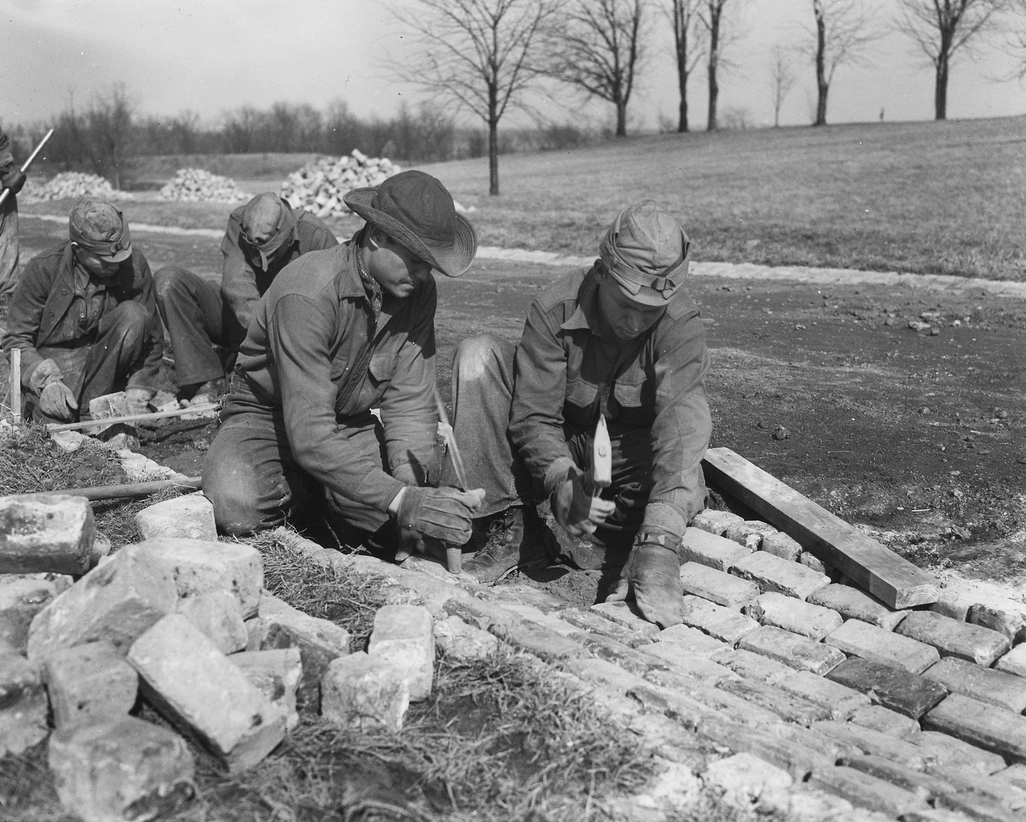
Civilian Conservation Corps Workers (c. 1933) · Unknown / National Archives (NARA) · c. 1933
Source: "Civilian Conservation Corps Workers." c. 1933. National Archives (NARA), via Wikimedia Commons, commons.wikimedia.org/wiki/File:Civilian_Conservation_Corps_-_NARA_-_195832.jpg. Public Domain — No Known Restrictions on Publication https://commons.wikimedia.org/wiki/File:Civilian_Conservation_Corps_-_NARA_-_195832.jpg
HIPPO — analyze the source (prompt) | Your analysis
H — Historical context: what was happening when this was created?
I — Intended audience: who was meant to see or obey it?
P — Purpose: why was it created?
P — Point of view: whose perspective does it reflect?
O — Outside connection: how does it connect to this standard?
SUPPORT OPTION
Sentence frame: This source shows ______ because it ______, which reveals ______.
CONFIDENCE CHECK-IN
Rate your understanding of this standard (1–4): ______ One thing to revisit: ____________________

Activity 6 — Core Application: Practice Quiz — US.43 ⏱ ~8 min
RESPONSE CHOICE
Commit to an answer by marking it, saying it, or explaining it aloud before checking. Answer key is in the Teacher Guide (kept separate).
[DOK 2 · item us43-q2 · pre-field-test]
What impact did programs like the CCC, WPA, and TVA have on employment and infrastructure development?
A. CCC employed 3 million in conservation, WPA employed 8.5 million building infrastructure nationwide, and TVA transformed the Tennessee Valley with dams, electricity, and regional development
B. These programs had minimal employment impact, which does not reflect the consensus among historians, but closer analysis reveals a more complicated historical reality
C. Only TVA created significant employment, but this fails to account for the broader historical context, which ignores significant political and cultural developments of the era
D. These programs focused on wealthy Americans, although this overlooks critical economic and social factors, although historical sources do not support this conclusion
[DOK 2 · item us43-q3 · pre-field-test]
How did New Deal financial reforms like the FDIC and SEC restore confidence in American economic institutions?
A. Financial reforms had no impact on public confidence, which represents a common misconception about the period, though this interpretation lacks supporting historical evidence
B. FDIC guaranteed deposits to eliminate bank runs, while SEC regulated stock markets and required transparency, together stabilizing the financial system and restoring investor confidence
C. These agencies were eliminated after the Depression, but the historical record tells a more complex story, and this view has been largely revised by modern historical research
D. Banks and stock markets remained unregulated, although historical sources do not support this conclusion, which contradicts the primary source evidence from this era
[DOK 3 · item u1-us43-dok3-tc · pre-field-test]
Evaluate which New Deal programs had the most lasting impact on American society and why.
A. Social Security, FDIC, SEC, and TVA continue today—Social Security provides retirement income for millions, FDIC protects bank deposits, SEC regulates markets, and TVA still provides electricity to the Tennessee Valley
B. All New Deal programs ended after the Depression, which does not align with the documented historical record, which represents a common misconception about this historical period, but closer analysis reveals a more complicated historical reality
C. Only the CCC had lasting impact, despite limited evidence supporting this interpretation, which ignores significant political and cultural developments of the era, although this overlooks critical economic and social factors involved
D. New Deal programs were temporary emergency measures, although this overlooks critical economic and social factors, which represents a common misconception about this historical period, which does not align with the documented historical record

Activity 7 — Constructed Response (CER) — US.43 ⏱ ~15 min
BIG-QUESTION ORGANIZER — how did the Great Depression change what Americans expected from their government, and who did the New Deal help or leave out?
Jot quick notes from THIS standard: Who was hurt? · Who was helped? · Who decided?

CONSTRUCTED RESPONSE (CER) — builds SSP.04 Argumentation
Claim + Evidence + Reasoning: Using this standard, take a position on the central question — analyze the impact of the relief, recovery, and reform efforts of FDR's New Deal programs, including the AAA, CCC, Fair Labor Standards Act, FDIC, NRA, SEC, Social Security, TVA, and WPA? Support your claim with two pieces of evidence from the passage and explain your reasoning.
Part | Write here
Claim
Evidence (two specifics)
Reasoning
SELF-CHECK (CER rubric — see Toolkit)
Is my claim defensible? · TWO specific pieces of evidence? · Does my reasoning explain HOW the evidence proves the claim?
EXIT TICKET — before you leave [item us43-q1 · DOK 2 · pre-field-test]
How did the "Three R's" (Relief, Recovery, Reform) organize Roosevelt's approach to ending the Great Depression?
A. FDR used only one approach throughout the New Deal, although this view has been largely discredited by scholars, although historical sources do not support this conclusion
B. The Three R's were unrelated programs, but contemporary accounts suggest a different explanation, which ignores significant political and cultural developments of the era
C. Relief provided immediate help to unemployed (CCC, WPA), Recovery programs restored economic activity (AAA, NRA), and Reform programs fixed underlying problems (FDIC, SEC, Social Security)
D. Roosevelt opposed the Three R's approach, which does not reflect the consensus among historians when examined alongside the available primary and secondary sources
Show what you know (your choice): mark the best answer, say it, or explain it — then rate how sure you are: ☐ Not yet ☐ Getting there ☐ Got it
Answer key and next steps are in the Teacher Guide.

Standard US.44 — Effects and Controversies of New Deal Policies
TN Academic Standard US.44: Analyze the effects of and the controversies arising from New Deal economic policies, including charges of socialism and President Franklin D. Roosevelt's "court packing" attempt.
LEARNING TARGETS — I can…
• I can analyze the effects of and the controversies arising from New Deal economic policies, including charges of socialism and FDR's "court packing" attempt.
Lenses for this standard: Economics · Politics/Government · Culture
CORE PATH — the same for every student
Same rigor for everyone: analyze the sources and vocabulary, then show what you learned on the Practice Quiz and the CER.
UDL and MTSS give you flexible ways in — they never lower the bar.
Check yourself against the learning targets on the Cornell Notes page.
★ Tennessee Connection
Many New Deal agencies and programs—Social Security, FDIC, SEC, TVA—continue operating today.
SET YOUR GOAL (self-direction)
My goal for this standard — what will I be able to do, and how will I show it?

HOOK — think before you dig in
Effects and Controversies of New Deal Policies: Analyze the effects of and the controversies arising from New Deal economic policies, including charges of socialism and President Franklin D. Roosevelt's "court packing" attempt. Who gained, who was left out — and why does it still matter?

ACTIVATE — what do you already know or wonder?
Jot what you already know or want to find out about this standard. You’ll come back to it.

PREVIEW & PREDICT
Which learning target will be hardest, and why? Connect it to the unit’s big question: who shared in the boom, and who was left out or pushed back?

Activity 1 — Vocabulary (Part A: Reference / Word Bank) — US.44 ⏱ ~10 min
Use this word bank throughout the standard. The Spanish column supports access, not translation of assessment.
Term | Student-friendly meaning | Spanish
Court Packing Plan | FDR's controversial 1937 proposal to add up to 6 justices to the Supreme Court after it struck down New Deal laws, seen as an attack on judicial independence. | Plan de Empaquetar la Corte
Socialism Accusations | Conservative critics charged that the New Deal was socialist or communist for expanding government power, though FDR argued he was saving capitalism from collapse. | Acusaciones de Socialismo
New Deal | FDR's comprehensive programs to provide relief, recovery, and reform during the Great Depression, fundamentally expanding federal government power and establishing the social safety net. | New Deal
Fair Labor Standards Act (1938) | Established the first federal minimum wage ($0.25/hour), maximum 40-hour work week, overtime pay, and banned child labor in interstate commerce. | Ley de Normas Justas de Trabajo (1938)
Securities and Exchange Commission (SEC) | Federal agency created to regulate the stock market, prevent fraud, and protect investors from the abuses that contributed to the 1929 crash. | Comisión de Valores y Bolsa (SEC)
Federal Deposit Insurance Corporation (FDIC) | New Deal agency that insures bank deposits up to $250,000, preventing bank runs by guaranteeing depositors won't lose their savings if banks fail. | Corporación Federal de Seguro de Depósitos (FDIC)
LANGUAGE SUPPORT
Pronunciations: Court Packing Plan (kort PAK-ing plan); Socialism Accusations (SOH-shuh-liz-um ak-yoo-ZAY-shunz); New Deal (noo deel); Fair Labor Standards Act (1938) (fair LAY-bor STAN-derdz); Securities and Exchange Commission (SEC) (sih-KYOOR-ih-teez and eks-CHAYNJ); Federal Deposit Insurance Corporation (FDIC) (FED-er-ul dee-POZ-it in-SHOOR-uns).
VOCABULARY SELF-CHECK · Knowledge Rating
Rate each term NOW in pencil, then again at the END — growth is the goal; no penalty for “never seen it.”
Term | 1 · never seen it | 2 · heard it | 3 · can use it | 4 · can teach it
Court Packing Plan
Socialism Accusations
New Deal
Fair Labor Standards Act (1938)
Securities and Exchange Commission (SEC)
Federal Deposit Insurance Corporation (FDIC)
MAKE IT YOURS (RESPONSE CHOICE): choose ONE term above and show you own it — write a sentence, sketch it, or give a real-world example.

Activity 2 — Vocabulary Studio (Frayer-inspired) — US.44 ⏱ ~7 min
RESPONSE CHOICE
Complete each studio by writing, speaking, or diagramming.

PRIORITY TERM 1 Court Packing Plan · ES: Plan de Empaquetar la Corte
Word-bank meaning to build on: FDR's controversial 1937 proposal to add up to 6 justices to the Supreme Court after it struck down New Deal laws, seen as an attack on judicial independence.
Definition (in your own words) | Characteristics
Examples | Non-examples
Use it to explain
Write one sentence that uses “Court Packing Plan” to explain this standard.

PRIORITY TERM 2 Socialism Accusations · ES: Acusaciones de Socialismo
Word-bank meaning to build on: Conservative critics charged that the New Deal was socialist or communist for expanding government power, though FDR argued he was saving capitalism from collapse.
Definition (in your own words) | Characteristics
Examples | Non-examples
Use it to explain
Write one sentence that uses “Socialism Accusations” to explain this standard.

CONNECT THE TERMS (UDL · build understanding)
How do these priority terms fit together? Write or sketch how one leads to or affects another.

Activity 3 — Direct Teaching Cornell Notes — US.44 ⏱ ~20 min
Name: ______________________ Class / Period: __________ Date: __________
US.44 — Effects and Controversies of New Deal Policies • These notes capture the direct-teaching content and the Close Read for this standard.
Your learning targets are on this standard’s opening page — take notes that help you meet them.
Cues (tied to your learning targets) | My notes
What does the passage say about economic Effects?
What does the passage say about long-term Structural Changes?
What does the passage say about charges of Socialism?
Key terms →
DOODLE ZONE — draw your thinking (UDL · another way in)
Need another way in? Sketch the key idea, a quick timeline, or how the pieces connect. Words optional.

Cornell Notes — keep going, then process & check — US.44
MORE NOTES / DIAGRAMS
Continue your notes here, add a quick sketch, or map how the ideas connect.

Key terms to list
Court Packing Plan · Socialism Accusations · New Deal · Fair Labor Standards Act (1938) · Securities and Exchange Commission (SEC) · Federal Deposit Insurance Corporation (FDIC)
Summary — In your own words (2–3 sentences)
PROGRESS CHECK · one question
Why did critics charge that New Deal programs represented "socialism," and how valid were these accusations?
A. Critics never used the term socialism, although this overlooks critical economic and social factors, although historical sources do not support this conclusion and oversimplifies the complex factors at work during this period
B. Critics argued increased regulation and redistribution resembled socialism, but New Deal largely preserved private ownership while reforming capitalism rather than establishing government ownership of industry
C. New Deal programs were identical to Soviet communism, which represents a common misconception about the period despite the fact that multiple contemporary sources contradict this
D. All business leaders supported the New Deal, despite limited evidence supporting this interpretation, but closer analysis reveals a more complicated historical reality when examined alongside the available primary and secondary sources
Commit before you move on — mark it, say it, or explain it aloud.
CHECK YOURSELF — how am I doing?
Which learning targets (on this standard’s opening page) can you now meet? Tick the number; circle any you still need help with.
☐ 1
My 12–15 word headline for this standard

Activity 4 — Close Read — US.44 ⏱ ~15 min
Reading type: History Hack-authored instructional synthesis. This is not a primary source. Builds SSP.03 (synthesize) and SSP.05 (historical awareness).
CORE PATH — read one chunk at a time
Economic Effects
Unemployment fell from 25% (1933) to 14% (1937), though rose again to 19% in 1938. Manufacturing output increased 60% between 1933-1937. Bank stability was restored through FDIC, farm income doubled, and $11 billion was invested in infrastructure. Government spending increased from 3% to 10% of GDP, fundamentally expanding the federal role in the economy.
Long-term Structural Changes
Power shifted from states to the federal government. Executive branch authority greatly expanded. Americans came to expect government would manage the economy. A new Democratic coalition of labor, minorities, and urban voters dominated politics for decades. Many New Deal agencies and programs—Social Security, FDIC, SEC, TVA—continue operating today.
Charges of Socialism
Critics argued New Deal programs expanded government control over the economy, redistributed income, and regulated private enterprise—resembling socialism. Business leaders claimed policies undermined free enterprise and property rights. However, New Deal reforms largely preserved private ownership while increasing regulation and social welfare, not establishing government ownership of industry.
Court-Packing Controversy
After the Supreme Court struck down the AAA and NRA as unconstitutional, FDR proposed adding up to six new justices for any justice over 70½ who didn't retire. He argued the Court was overloaded and blocking needed legislation. Critics saw it as threatening judicial independence and separation of powers. The plan failed in Congress but damaged FDR's political capital.
Differing Perspectives
Supporters argued New Deal measures stabilized banks, provided jobs, protected workers, and saved capitalism by reforming it. Opponents argued it overreached, expanded federal power dangerously, and threatened individual liberty. Most historians credit the New Deal with mitigating suffering and building lasting institutions, while noting WWII mobilization actually ended the Depression.
Key terms first: Court Packing Plan, Socialism Accusations. Read once for the gist, then again for evidence.
CLOSE-READ EVIDENCE LAB — for each question: quote the EVIDENCE from the passage above, then write YOUR ANSWER (or answer aloud / diagram it).
Text-dependent question | Evidence from the passage | Your answer (what it shows)
What is the main idea of the “Economic Effects” section, and what evidence supports it?
What is the main idea of the “Long-term Structural Changes” section, and what evidence supports it?
What is the main idea of the “Charges of Socialism” section, and what evidence supports it?

Activity 5 — Primary Source / Data Analysis — US.44 ⏱ ~15 min
Primary source (poster) — analyze it with HIPPO. Builds SSP.01–SSP.02.
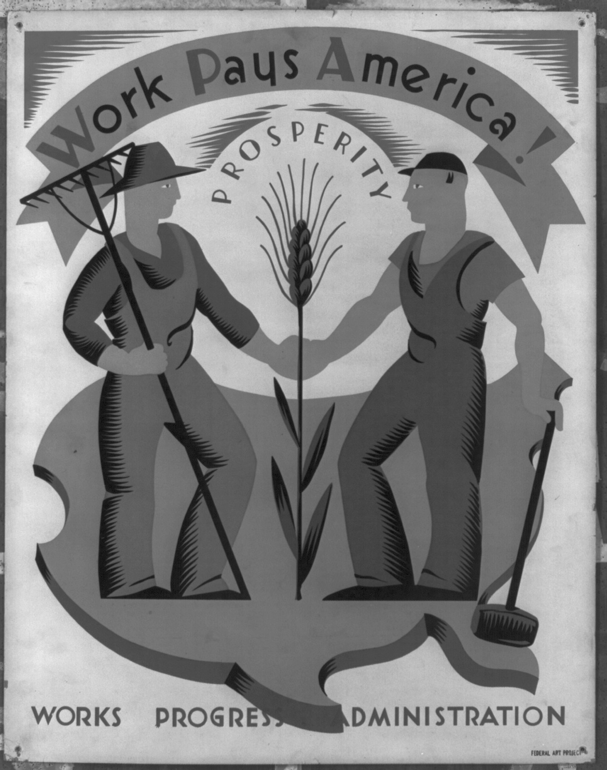
Work Pays America! Prosperity. (WPA Poster, c. 1936) · Federal Art Project / Works Progress Administration (WPA) · c. 1936
Source: Works Progress Administration, Federal Art Project. "Work Pays America! Prosperity." c. 1936. Library of Congress, Prints and Photographs Division, WPA Poster Collection, www.loc.gov/item/98518682/. Public Domain — No Known Restrictions on Publication https://www.loc.gov/item/98518682/
HIPPO — analyze the source (prompt) | Your analysis
H — Historical context: what was happening when this was created?
I — Intended audience: who was meant to see or obey it?
P — Purpose: why was it created?
P — Point of view: whose perspective does it reflect?
O — Outside connection: how does it connect to this standard?
SUPPORT OPTION
Sentence frame: This source shows ______ because it ______, which reveals ______.
CONFIDENCE CHECK-IN
Rate your understanding of this standard (1–4): ______ One thing to revisit: ____________________

Activity 6 — Core Application: Practice Quiz — US.44 ⏱ ~8 min
RESPONSE CHOICE
Commit to an answer by marking it, saying it, or explaining it aloud before checking. Answer key is in the Teacher Guide (kept separate).
[DOK 2 · item us44-q3 · pre-field-test]
What was Roosevelt's "court-packing" plan, and why did it create a constitutional crisis?
A. After the Court struck down New Deal laws, FDR proposed adding justices to get favorable rulings, threatening judicial independence and separation of powers before the plan failed in Congress
B. FDR proposed reducing the number of Supreme Court justices, but this fails to account for the broader historical context and oversimplifies the complex factors at work during this period
C. The court-packing plan passed easily, although this overlooks critical economic and social factors and oversimplifies the complex factors at work during this period
D. Congress proposed the plan, not Roosevelt, which does not reflect the consensus among historians when examined alongside the available primary and secondary sources
[DOK 2 · item q-us42-dok2-4 · pre-field-test]
What New Deal program specifically addressed Dust Bowl problems?
A. Authoritarian ideology with extreme nationalism, militarism, and dictatorial leadership
B. Soil Conservation Service taught sustainable farming practices and planted shelterbelts
C. Built dams for hydroelectric power and brought electricity to rural areas for first time
D. It emboldened Hitler, who broke the agreement and invaded Czechoslovakia within months
[DOK 3 · item u1-us44-dok3-tc · pre-field-test]
Why did critics charge that New Deal programs represented "socialism," and how valid were these accusations?
A. Critics never used the term socialism, although this overlooks critical economic and social factors, although historical sources do not support this conclusion and oversimplifies the complex factors at work during this period
B. Critics argued increased regulation and redistribution resembled socialism, but New Deal largely preserved private ownership while reforming capitalism rather than establishing government ownership of industry
C. New Deal programs were identical to Soviet communism, which represents a common misconception about the period despite the fact that multiple contemporary sources contradict this
D. All business leaders supported the New Deal, despite limited evidence supporting this interpretation, but closer analysis reveals a more complicated historical reality when examined alongside the available primary and secondary sources

Activity 7 — Constructed Response (CER) — US.44 ⏱ ~15 min
BIG-QUESTION ORGANIZER — how did the Great Depression change what Americans expected from their government, and who did the New Deal help or leave out?
Jot quick notes from THIS standard: Who was hurt? · Who was helped? · Who decided?

CONSTRUCTED RESPONSE (CER) — builds SSP.04 Argumentation
Claim + Evidence + Reasoning: Using this standard, take a position on the central question — analyze the effects of and the controversies arising from New Deal economic policies, including charges of socialism and FDR's "court packing" attempt? Support your claim with two pieces of evidence from the passage and explain your reasoning.
Part | Write here
Claim
Evidence (two specifics)
Reasoning
SELF-CHECK (CER rubric — see Toolkit)
Is my claim defensible? · TWO specific pieces of evidence? · Does my reasoning explain HOW the evidence proves the claim?
EXIT TICKET — before you leave [item us44-q1 · DOK 2 · pre-field-test]
What were the main economic effects of New Deal policies on employment, banking, and government spending?
A. New Deal policies had no measurable economic impact, though this interpretation lacks supporting historical evidence
B. The economy worsened under New Deal policies, although this view has been largely discredited by scholars
C. Only banking was affected by New Deal programs, though this interpretation lacks supporting historical evidence
D. Unemployment fell from 25% to 14%, bank runs ended with FDIC, manufacturing increased 60%, and government spending grew from 3% to 10% of GDP
Show what you know (your choice): mark the best answer, say it, or explain it — then rate how sure you are: ☐ Not yet ☐ Getting there ☐ Got it
Answer key and next steps are in the Teacher Guide.

Your Tennessee Connection
TENNESSEE CONNECTION · THE TENNESSEE VALLEY AUTHORITY
No New Deal program left a deeper mark on Tennessee than the Tennessee Valley Authority (US.43). Signed into law in 1933, the TVA built a chain of dams along the Tennessee River — starting with Norris Dam north of Knoxville — to tame the river’s floods, generate cheap public electricity, and put thousands of unemployed men to work. For the first time it wired rural Tennessee farms for electric power, remaking daily life and the valley’s economy. Civilian Conservation Corps camps across the state planted forests and built the parks Tennesseans still use (US.43). Yet the Depression’s hardships — failed banks, lost farms, and joblessness — hit Tennessee hard, and the TVA’s dams also flooded towns and displaced families, a reminder that even celebrated New Deal projects carried costs (US.44).
Reflect (RESPONSE CHOICE): How does a local story change the way you understand a national event? Answer by writing, recording, or diagramming.

Local History Investigation
The Great Depression and the New Deal reached every Tennessee community — through TVA dams and power lines, CCC and WPA jobs, bank failures, and displaced farmers. Investigate one local connection and record what you find.
Prompt | Your findings
A person, place, or industry from this era near me
One source I could check (library, TSLA, family, museum)
Who benefited / who bore the costs, locally
One question I still have

Progress Tracker & Cumulative Review
Track your Progress Check result for each standard and note one thing to revisit.
Standard | Progress Check (✓ / reteach) | One thing to revisit
US.39
US.40
US.41
US.42
US.43
US.44

Optional Extension Bank (higher-DOK, open to all)
Any student may choose an extension. These are EXTENSION, not a track.
US.39: Using this standard, take a position on the central question — analyze the causes of the Great Depression, including bank failures, buying on margin, the stock market crash, overproduction, high tariffs, laissez-faire politics, and rising unemployment? Support your claim with two pieces of evidence from the passage and explain your reasoning.
US.40: Using this standard, take a position on the central question — analyze the causes of the Dust Bowl, and explain the social, geographic, and economic impacts? Support your claim with two pieces of evidence from the passage and explain your reasoning.
US.41: Using this standard, take a position on the central question — describe the impact of the Great Depression on the American people, including mass unemployment, migration, and Hoovervilles? Support your claim with two pieces of evidence from the passage and explain your reasoning.
US.42: Using this standard, take a position on the central question — describe the steps taken by President Herbert Hoover to address the depression, including his philosophy of "Rugged Individualism," public works projects, the Reconstruction Finance Corporation, and response to the "Bonus Army."? Support your claim with two pieces of evidence from the passage and explain your reasoning.
US.43: Using this standard, take a position on the central question — analyze the impact of the relief, recovery, and reform efforts of FDR's New Deal programs, including the AAA, CCC, Fair Labor Standards Act, FDIC, NRA, SEC, Social Security, TVA, and WPA? Support your claim with two pieces of evidence from the passage and explain your reasoning.
US.44: Using this standard, take a position on the central question — analyze the effects of and the controversies arising from New Deal economic policies, including charges of socialism and FDR's "court packing" attempt? Support your claim with two pieces of evidence from the passage and explain your reasoning.

Think Like a Test-Writer (unit review — open to all)
You met a quick “think like a test-writer” prompt in every standard. Here is the full how-to, once, plus room to write your best questions for the whole unit.
HOW TO WRITE A DOK-3 QUESTION
DOK-3 = strategic thinking: the reader must analyze, compare, evaluate, or justify using evidence — and there should be more than one defensible answer (not a fact you can just look up).
Sentence starters: “Why did ______ lead to ______?” · “Which mattered more — ______ or ______ — and why?” · “What is the BEST evidence that ______?” · “Evaluate whether ______.” · “Defend or challenge: ______.”
Frame: [Analyze / Evaluate / Justify] + [something from this unit] + “using evidence.”
Quick check: does my question make the reader THINK and use evidence? If yes, it’s DOK-3.
Standard | Your DOK-3 question | Your answer key (one sentence)

Reusable Toolkit & Source Library

Written Response Rubric (CER)
Level | Claim | Evidence | Reasoning
4 — Strong | Precise, defensible | 2+ accurate, specific | Explains how evidence proves the claim
3 — Proficient | Clear | 2 accurate | Explains the link
2 — Developing | General | 1 accurate | Partial link
1 — Beginning | Unclear/missing | Missing/inaccurate | No reasoning

Source Library — full citations & clickable links
US.39 — Causes of the Great Depression
Stock Market Crash Newspaper Report. New York Times, October 30, 1929. Times, New York. "Stock Market Crash Newspaper Report." October 30, 1929. Library of Congress, www.loc.gov/collections/chronicling-america/.. Public domain. https://www.loc.gov/collections/chronicling-america/
Bank Failure Notice. Bank of United States, 1930. Bank of United States. "Bank Failure Notice." 1930. Federal Deposit Insurance Corporation, www.fdic.gov/analysis/historical/.. Public domain. https://www.fdic.gov/analysis/historical/
US.40 — The Dust Bowl
Dust Bowl Migrant Account. Oklahoma Farmer, 1936. Farmer, Oklahoma. "Dust Bowl Migrant Account." 1936. Library of Congress, www.loc.gov/collections/federal-writers-project/.. Public domain. https://www.loc.gov/collections/federal-writers-project/
Letter from Kansas Farm Woman. Caroline Henderson, June 1935. Henderson, Caroline. "Letter from Kansas Farm Woman." June 1935. Library of Congress, www.loc.gov/item/2018687273/.. Public domain. https://www.loc.gov/item/2018687273/
US.41 — Impact of the Great Depression on the American People
Hooverville Resident Account. Unemployed Factory Worker, 1932. Worker, Unemployed Factory. "Hooverville Resident Account." 1932. Library of Congress, www.loc.gov/collections/federal-writers-project/.. Public domain. https://www.loc.gov/collections/federal-writers-project/
Children's Bureau Report. U.S. Department of Labor, 1933. U.S. Department of Labor. "Children's Bureau Report." 1933. Library of Congress, www.loc.gov/collections/federal-writers-project/.. Public domain. https://www.loc.gov/collections/federal-writers-project/
US.42 — Herbert Hoover's Response
Rugged Individualism Speech. President Herbert Hoover, 1928. Hoover, President Herbert. "Rugged Individualism Speech." 1928. Miller Center, University of Virginia, millercenter.org/the-presidency/presidential-speeches/oct. Public domain. https://millercenter.org/the-presidency/presidential-speeches/october-22-1928-principles-and-ideals-united-states-government
Bonus Army Confrontation Report. Washington Evening Star, July 29, 1932. Star, Washington Evening. "Bonus Army Confrontation Report." July 29, 1932. Library of Congress, www.loc.gov/collections/chronicling-america/.. Public domain. https://www.loc.gov/collections/chronicling-america/
US.43 — FDR's New Deal Programs
Social Security Act. U.S. Congress, 1935. U.S. Congress. "Social Security Act." 1935. National Archives, https://www.archives.gov/milestone-documents/social-security-act.. Public domain. https://www.archives.gov/milestone-documents/social-security-act
TVA (Tennessee Valley Authority) Description. Franklin D. Roosevelt, 1933. Roosevelt, Franklin D.. "TVA (Tennessee Valley Authority) Description." 1933. National Archives, https://www.archives.gov/milestone-documents/tennessee-valley-a. Public domain. https://www.archives.gov/milestone-documents/tennessee-valley-authority-act
US.44 — Effects and Controversies of New Deal Policies
Court-Packing Plan Criticism. Senator Burton Wheeler, 1937. Wheeler, Senator Burton. "Court-Packing Plan Criticism." 1937. U.S. Senate Historical Office, www.senate.gov/artandhistory/history/common/generic/CourtPacking.h. Public domain. https://www.senate.gov/artandhistory/history/common/generic/CourtPacking.htm
Criticism of New Deal as Socialism. American Liberty League, 1935. League, American Liberty. "Criticism of New Deal as Socialism." 1935. Library of Congress, www.loc.gov/collections/general-collections/.. Public domain. https://www.loc.gov/collections/general-collections/

The Great Depression & New Deal — Four Threads
This section connects the threads of the era: how a booming economy collapsed, what the hardship looked like, how two presidents responded, and how the New Deal remade the role of government. It is History Hack-authored instructional synthesis grounded in this unit’s sourced record — not a primary source.

The Collapse
Overproduction, uneven wealth, reckless stock speculation, and buying on margin left the economy fragile; the October 1929 crash and a wave of bank failures plunged the nation into depression (US.39). On the southern Plains, drought and over-plowed land created the Dust Bowl, ruining farms and driving families west (US.40).

The Human Toll
Unemployment reached one in four workers. Hoovervilles, breadlines, and soup kitchens spread; the Bonus Army marched on Washington; and hunger and homelessness marked the depths of the crisis (US.41).

Two Responses
Hoover trusted voluntary action and limited federal aid, and the Depression deepened (US.42). Franklin Roosevelt answered with the New Deal — relief, recovery, and reform through a flurry of “alphabet agencies” (CCC, WPA, TVA, AAA) and fireside chats that restored confidence (US.43).

A Bigger Government — and Its Critics
The New Deal permanently expanded the federal government’s role and left lasting programs like Social Security. But it drew fire from critics on the left and right and clashed with the Supreme Court, raising debates about federal power that continue today (US.44).

Unit Reflection
Return to the unit’s big question: how did the Great Depression change what Americans expected from their government — and who did the New Deal help or leave out? Write a final claim with two pieces of evidence from different standards.
Part | Write here
My claim
Evidence 1 (standard: ___)
Evidence 2 (standard: ___)
Why it matters today

