U.S. HISTORY HACK™
COURSE STANDARD · PLATINUM EDITION

WORLD WAR
II
1939–1945
Unit 6 · High-School U.S. History · Standards-Aligned
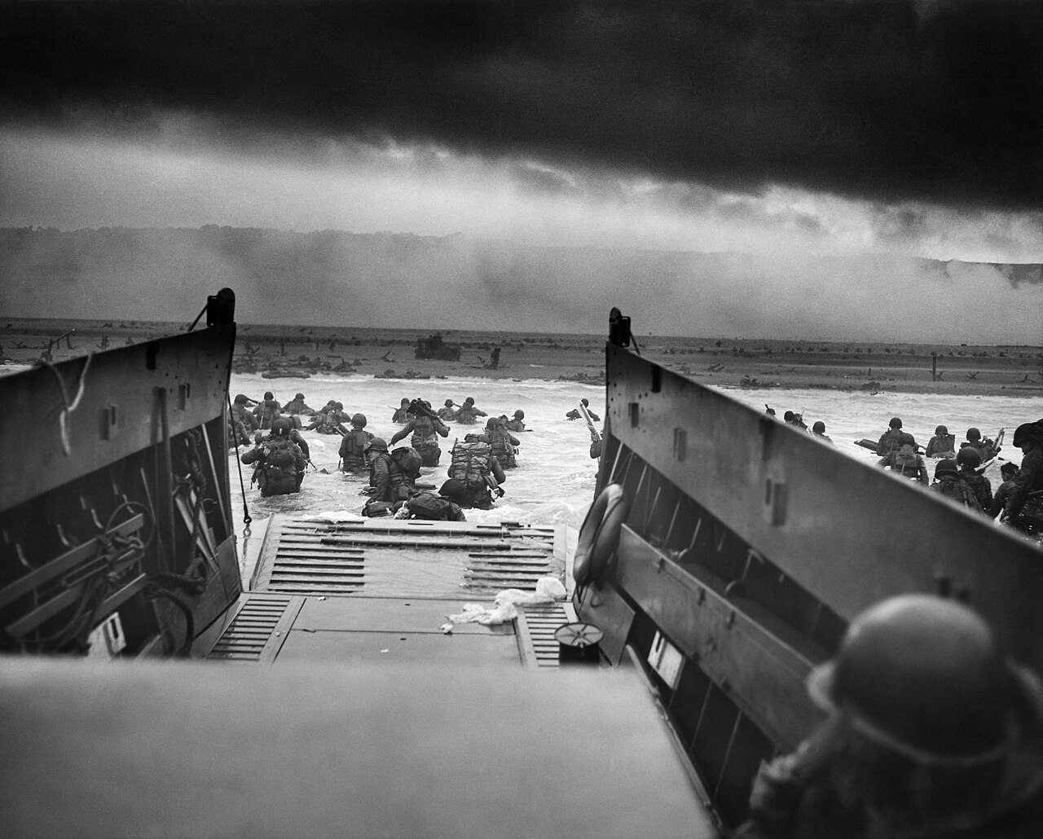
Into the Jaws of Death — U.S. troops wade ashore at Omaha Beach, Normandy, June 6, 1944 · U.S. Coast Guard · Public domain
GRAPHIC ORGANIZER TOOLKIT

UDL 3.0 | MTSS | CER | Cornell | HIPPO | DOK
Universal Design for Learning · Multi-Tiered Supports · Evidence-Based Writing
Teacher Edition
TroopToTeacher Technologies LLC

U.S. HISTORY HACK™ Unit 6 — World War II (1939–1945) GRAPHIC ORGANIZER TOOLKIT · TroopToTeacher Technologies LLC
SPINE
Perfect-bound. At 49 pages on 60-lb (90 gsm) white offset the spine is ≈ 0.11 in (2.8 mm) — wide enough to print the spine text above. Recompute if the page count or paper changes (white 60-lb ≈ 0.002252 in/page).

U.S. HISTORY HACK™
Reproducible thinking tools — blank and labeled, ready to print.
Unit 6 — World War II (1939–1945) · Teacher Edition
WHAT’S IN THE TOOLKIT

◆ The organizers the course runs on. Frayer, CER, HIPPO, Cornell, cause–effect, timeline, T-chart, Venn, and more — on brand and classroom-ready.
◆ Blank and labeled versions. A blank for open use and a guided/labeled version for scaffolding — pick by learner need.
◆ UDL response choice. Students write, diagram, or map their thinking — multiple means of action and expression by design.
◆ A quick-use guide. When and how to reach for each organizer, tied to the workbook activities.
◆ Reproducible for your class. Print as needed for licensed classroom use.
◆ Consistent across the course. The same tools students meet in every unit, so routines transfer.
INSIDE THIS UNIT — the fourteen standards

US.45 Rise and Spread of Fascism, Communism, and Totalitarianism
US.46 FDR's Response to World Crises
US.47 U.S. Response to the Holocaust
US.48 American Entry into World War II
US.49 WWII Leaders & Key Figures
US.50 Major WWII Battles: Midway, Iwo Jima, Okinawa & D-Day
US.51 Special Fighting Forces in WWII
US.52 Women in World War II
US.53 African Americans in WWII
US.54 Japanese American Internment & Korematsu
US.55 Home Front Mobilization
US.56 Manhattan Project & Atomic Bomb
US.57 Yalta and Potsdam Conferences
US.58 Founding of the United Nations & Cordell Hull
Part of the U.S. History Hack™ Course Standard series — a complete, standards-aligned system: Student Workbook · Teacher Edition · Student & Teacher Slide Decks · Graphic Organizer Toolkit · Unit Assessment Book.
TroopToTeacher Technologies LLC  U.S. History Hack™ · Course Standard (Platinum) Edition · Teacher Edition  © 2026 TroopToTeacher Technologies LLC. All rights reserved. U.S. History Hack™ is a trademark of TroopToTeacher Technologies LLC. No part of this book may be reproduced without written permission, except as licensed for classroom use.  www.trooptoteacher.com · Printed in the U.S.A. · First Edition | ISBN barcode  ISBN 978-X-XXXXX-XXX-X  placeholder — replace at print

PRINT & ONLINE-LISTING SPEC
An internal handoff sheet for your printer and your storefront listing — not part of the printed book.
Title (listing) | U.S. History Hack™ — Unit 6 · Teacher Graphic Organizer Toolkit
Series | U.S. History Hack™ Course Standard (Platinum) Edition
Publisher / Author | TroopToTeacher Technologies LLC
Trim size | 8.5 × 11 in (US Letter)
Interior | 49 pages, black-and-white, 60-lb (90 gsm) white offset
Binding & spine | Perfect-bound; spine ≈ 0.11 in (2.8 mm). Print spine text.
Cover stock | 10-pt or 12-pt C1S gloss/matte laminate; full color
Bleed | Add 0.125 in bleed on all outside edges before print (this concept is at trim).
Copyright | © 2026 TroopToTeacher Technologies LLC. All rights reserved.
ISBN | Assign one ISBN per format (paperback / PDF); place barcode in the back-cover box.
Age / grade | Grades 9–12 · U.S. History
Categories | Education › Teaching Methods & Materials › Social Science; Study Aids › History
Keywords | graphic organizers, Frayer, CER, HIPPO, Cornell notes, cause and effect, timeline, UDL, reproducible, social studies
BACK-COVER BLURB (for your storefront)
The Graphic Organizer Toolkit collects the reproducible thinking tools the course runs on — Frayer, CER, HIPPO, Cornell, cause–effect, timeline, T-chart, Venn, and more — each in a blank and a labeled version, with a quick-use guide. Built on UDL so students can write, diagram, or map their thinking. Print as needed for your classroom.

