U.S. HISTORY HACK™
COURSE STANDARD · PLATINUM EDITION

WORLD WAR
II
1939–1945
Unit 6 · High-School U.S. History · Standards-Aligned
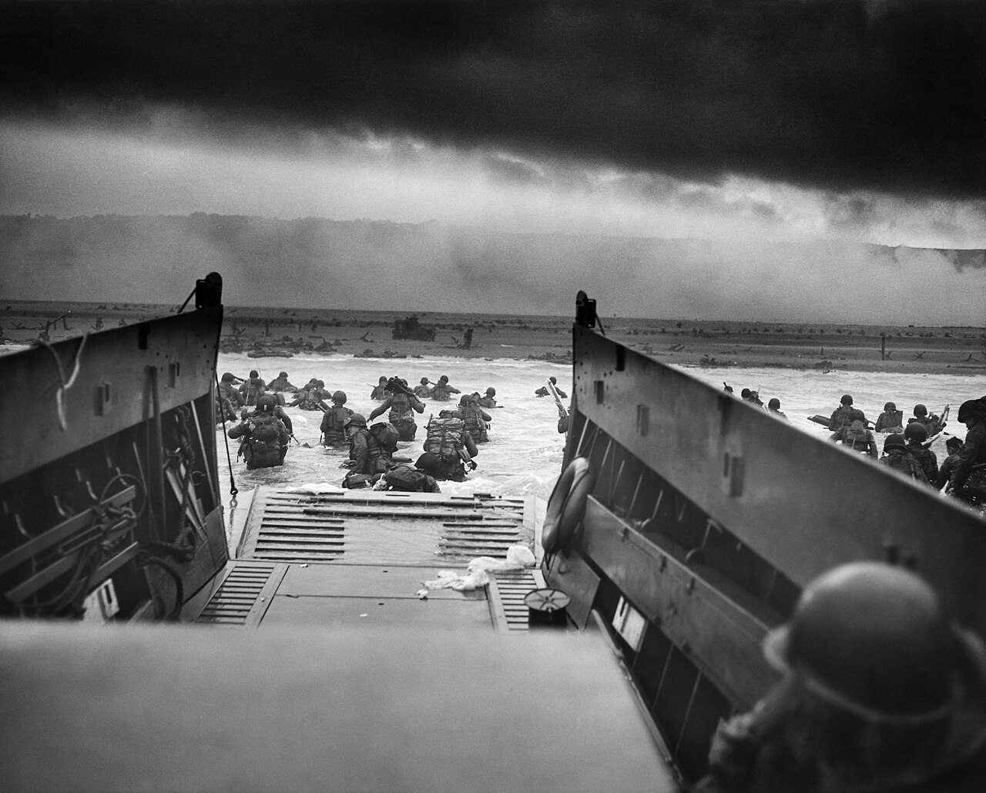
Into the Jaws of Death — U.S. troops wade ashore at Omaha Beach, Normandy, June 6, 1944 · U.S. Coast Guard · Public domain
STUDENT WORKBOOK

UDL 3.0 | MTSS | CER | Cornell | HIPPO | DOK
Universal Design for Learning · Multi-Tiered Supports · Evidence-Based Writing
Student Edition
TroopToTeacher Technologies LLC

U.S. HISTORY HACK™ Unit 6 — World War II (1939–1945) STUDENT WORKBOOK · TroopToTeacher Technologies LLC
SPINE
Perfect-bound. At 144 pages on 60-lb (90 gsm) white offset the spine is ≈ 0.324 in (8.2 mm) — wide enough to print the spine text above. Recompute if the page count or paper changes (white 60-lb ≈ 0.002252 in/page).

U.S. HISTORY HACK™
The workbook that teaches every learner — without lowering the bar.
Unit 6 — World War II (1939–1945) · Student Edition
WHAT MAKES THIS WORKBOOK DIFFERENT

◆ Built on UDL 3.0 (CAST). Every activity offers multiple means of engagement, representation, and action — word banks, sentence frames, visuals, and choice built in, so the rigor stays the same for every learner.
◆ MTSS tiers on every page. Core instruction with layered Guided and Light Support, plus a formative Exit Ticket for each standard and a “What’s Next” reteach path in the Teacher Edition.
◆ Writes like a historian — CER. A 6-point Claim–Evidence–Reasoning rubric runs through the whole course, with scaffolded organizers and lined response space.
◆ Real primary sources, cited. Photographs, political cartoons, and maps from the Library of Congress and National Archives — analyzed with the HIPPO routine — every source documented to Chicago style.
◆ Cornell notes paired to the slide deck. Structured note pages capture the direct-teaching slides, with retrieval checks and doodle zones for visual learners.
◆ Standards-aligned & TCAP-ready. DOK-balanced checks and a companion Assessment Book with two parallel forms, keyed to the standards and reporting categories.
INSIDE THIS UNIT — the fourteen standards

US.45 Rise and Spread of Fascism, Communism, and Totalitarianism
US.46 FDR's Response to World Crises
US.47 U.S. Response to the Holocaust
US.48 American Entry into World War II
US.49 WWII Leaders & Key Figures
US.50 Major WWII Battles: Midway, Iwo Jima, Okinawa & D-Day
US.51 Special Fighting Forces in WWII
US.52 Women in World War II
US.53 African Americans in WWII
US.54 Japanese American Internment & Korematsu
US.55 Home Front Mobilization
US.56 Manhattan Project & Atomic Bomb
US.57 Yalta and Potsdam Conferences
US.58 Founding of the United Nations & Cordell Hull
Part of the U.S. History Hack™ Course Standard series — a complete, standards-aligned system: Student Workbook · Teacher Edition · Student & Teacher Slide Decks · Graphic Organizer Toolkit · Unit Assessment Book.
TroopToTeacher Technologies LLC  U.S. History Hack™ · Course Standard (Platinum) Edition · Student Edition  © 2026 TroopToTeacher Technologies LLC. All rights reserved. U.S. History Hack™ is a trademark of TroopToTeacher Technologies LLC. No part of this book may be reproduced without written permission, except as licensed for classroom use.  www.trooptoteacher.com · Printed in the U.S.A. · First Edition | ISBN barcode  ISBN 978-X-XXXXX-XXX-X  placeholder — replace at print

PRINT & ONLINE-LISTING SPEC
An internal handoff sheet for your printer and your storefront listing — not part of the printed book.
Title (listing) | U.S. History Hack™ — Unit 6: World War II (1939–1945) · Student Workbook
Series | U.S. History Hack™ Course Standard (Platinum) Edition
Publisher / Author | TroopToTeacher Technologies LLC
Trim size | 8.5 × 11 in (US Letter)
Interior | 144 pages, black-and-white, 60-lb (90 gsm) white offset
Binding & spine | Perfect-bound; spine ≈ 0.324 in (8.2 mm). Print spine text.
Cover stock | 10-pt or 12-pt C1S gloss/matte laminate; full color
Bleed | Add 0.125 in bleed on all outside edges before print (this concept is at trim).
Copyright | © 2026 TroopToTeacher Technologies LLC. All rights reserved.
ISBN | Assign one ISBN per format (paperback / PDF); place barcode in the back-cover box.
Age / grade | Grades 9–12 · U.S. History
Categories | Education › Teaching Methods & Materials › Social Science; Study Aids › History
Keywords | U.S. history workbook, high school history, UDL curriculum, MTSS, CER writing, primary source analysis, Cornell notes, standards-aligned, World War II, WWII, Pearl Harbor, D-Day, Holocaust, Manhattan Project, Oak Ridge, home front, standards-aligned, TCAP review
BACK-COVER BLURB (for your storefront)
U.S. History Hack™ turns a full unit of high-school U.S. History into one student-ready workbook that reaches every learner without lowering the bar. Built on Universal Design for Learning (UDL 3.0) and Multi-Tiered Systems of Support (MTSS), each of the fourteen standards moves from a core lesson to Cornell notes paired with the slide deck, real Library-of-Congress primary sources analyzed with HIPPO, evidence-based writing on a 6-point CER rubric, and a formative Exit Ticket with a built-in reteach path. Standards-aligned, DOK-balanced, and TCAP-ready — with a companion Assessment Book of two parallel forms. Unit 6 covers World War II, 1939–1945.

