1776 - 2026 • AMERICA'S 250TH ANNIVERSARY • SEMIQUINCENTENNIAL EDITION
U.S. HISTORY HACK™
TROOPTOTEACHER TECHNOLOGIES
UNIT 6
World War II, 1939–1945
COURSE STANDARD EDITION
US.45 – US.58 • 14 Tennessee U.S. History Standards • Grades 9–12
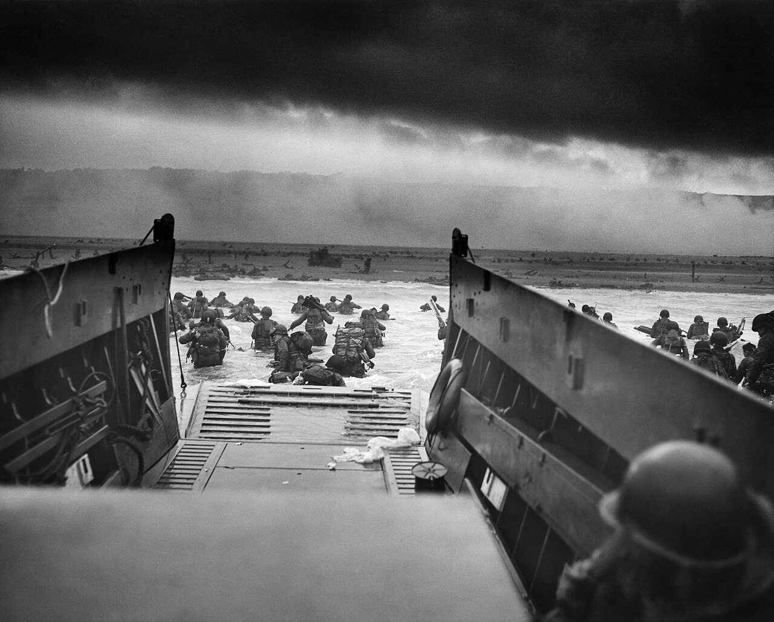
“Into the Jaws of Death” — U.S. troops wade ashore under fire at Omaha Beach, Normandy, on D-Day, June 6, 1944.
Source: Chief Photographer’s Mate Robert F. Sargent, U.S. Coast Guard / National Archives. Public domain.
TENNESSEE CONNECTION · OAK RIDGE, THE “SECRET CITY”
Tennessee helped build the atomic bomb. Oak Ridge — the “Secret City” — was a central site of the Manhattan Project (US.56), enriching the uranium used in the first atomic weapons. At its peak it held about 75,000 workers, many of whom never knew what they were making. Cordell Hull of Pickett County (US.58) helped found the United Nations, and Fort Campbell became home to the 101st Airborne (US.51).
One common workbook designed for learner variability. Every student works toward the same Tennessee standards; supports vary the means, not the goal or the ceiling.
Release-Ready · Pilot Edition
© 2026 TroopToTeacher Technologies LLC. All rights reserved. ISBN: [to be assigned]

Copyright, Ownership & Framework
U.S. History Hack™ — Unit 6: World War II (1939–1945), Course Standard Edition.
© 2026 TroopToTeacher Technologies LLC. All rights reserved. This workbook is proprietary; reproduction or redistribution outside a licensed classroom is prohibited.
Source integrity. Every primary source in this unit is public-domain and cited to its holding repository (National Archives, Library of Congress, HathiTrust). See the Source Library.
Reading provenance (district-clear). Close-Read passages are labeled “History Hack-authored instructional synthesis” — they build on the standard record and are not presented as primary sources.
Framework stack. This workbook anchors to Tennessee U.S. History standards US.45–US.58 and the Social Studies Practices (SSP.01–SSP.06), and is designed on CAST UDL 3.0 and an MTSS support model.
Pacing. Each standard is built for one 45-minute class period. Each activity shows a ⏱ ~ minutes estimate at its heading. There is more here than one period holds — your teacher chooses which activities you do in class; the rest may become warm-ups, stations, or homework.

Table of Contents

Tennessee Standards & SSP Crosswalk
Each standard below is taught to the full Course Standard expectation; the Social Studies Practices are embedded in every activity cycle.
Standard | Focus | Lenses
US.45 | Rise and Spread of Fascism, Communism, and Totalitarianism | History · Politics/Government
US.46 | FDR's Response to World Crises | Politics/Government · History
US.47 | U.S. Response to the Holocaust | History · Culture
US.48 | American Entry into World War II | History · Politics/Government
US.49 | WWII Leaders & Key Figures | History · Politics/Government
US.50 | Major WWII Battles: Midway, Iwo Jima, Okinawa & D-Day | History · Geography
US.51 | Special Fighting Forces in WWII | History · Culture
US.52 | Women in World War II | History · Economics · Culture
US.53 | African Americans in WWII | History · Culture · Economics · Tennessee Connection
US.54 | Japanese American Internment & Korematsu | Culture · History
US.55 | Home Front Mobilization | History · Economics
US.56 | Manhattan Project & Atomic Bomb | History · Geography
US.57 | Yalta and Potsdam Conferences | Politics/Government · History
US.58 | Founding of the United Nations & Cordell Hull | Politics/Government · Culture · History

Social Studies Practices (SSP.01–SSP.06)
SSP.01 Gather/evaluate sources · SSP.02 Critically examine a primary source · SSP.03 Synthesize evidence · SSP.04 Construct/communicate argument · SSP.05 Develop historical awareness · SSP.06 Chronological/spatial reasoning. Each Close Read, Primary Source/Data, and CER activity names the practices it builds.

Accessibility, UDL & Accommodations Matrix
One firm learning goal per standard; flexible, universal means. Supports are available by design and never lower the goal. They work alongside — never in place of — required IEP or 504 accommodations.
Universal support | What it is | Where it appears
CORE PATH | Essential instruction every student completes | Every activity
LANGUAGE SUPPORT | Vocabulary, pronunciation, Spanish cognates | Word Bank, Guided/Light Backs
RESPONSE CHOICE | Write, say/record, or diagram | Every activity
SUPPORT OPTION | Optional scaffold that keeps the goal | Guided Support Back, Primary Source
PROGRESS CHECK | Quick DOK-2/3 check to guide reteach/extend | Cornell Notes, Practice Quiz
EXTENSION | Deeper challenge once the goal is met | Extension Bank, CER

How CAST UDL 3.0 is visible in this workbook
Multiple means of Engagement (response choice, relevance via Tennessee Connection), Representation (Word Bank, pronunciation, Spanish, Close-Read supports), and Action & Expression (write/say/diagram, Frayer, CER). No fixed-track labels appear.

My Support Plan (optional — you choose)
Supports are available by design. Check the ones you might try; you can change your mind any time.
Support I might use | When it would help me
Word Bank + Spanish column
Guided or Light Support Back
Response choice (say/record or diagram)
Sentence frames / Rehearsal Lab

How to Use This Workbook
Each standard runs the same seven-activity cycle: (1) Vocabulary Word Bank, (2) Vocabulary Studio, (3) Direct-Teaching Cornell Notes with optional Guided and Light Support Backs, (4) Close Read, (5) Primary Source / Data Analysis, (6) Core Application Practice Quiz, (7) Constructed Response (CER). Work the CORE PATH; reach for SUPPORT OPTIONS as needed.

Label legend — these appear throughout every standard cycle
Label | Meaning
CORE PATH | The essential instruction every student completes.
SUPPORT OPTION | An optional scaffold that keeps the goal, not lowers it.
LANGUAGE SUPPORT | Vocabulary, pronunciation, and Spanish cognates for access.
RESPONSE CHOICE | Show learning by writing, saying/recording, or diagramming.
PROGRESS CHECK | A quick DOK-2/3 check that guides reteach or extend.
EXTENSION | A deeper challenge once the goal is met.

Before You Begin — Set Your Goal
This unit asks one big question: as the United States industrialized, who benefited and who bore the costs? Set a goal, then note what you already know.
Prompt | Your response
My goal for this unit is…
One thing I already know about this era…
One question I want answered…

Standard US.45 — Rise and Spread of Fascism, Communism, and Totalitarianism
TN Academic Standard US.45: Explain the rise and spread of fascism, communism, and totalitarianism internationally.
LEARNING TARGETS — I can…
• I can explain the rise and spread of fascism, communism, and totalitarianism internationally, including the key characteristics and leaders of each system.
Lenses for this standard: History · Politics/Government
CORE PATH — the same for every student
Same rigor for everyone: analyze the sources and vocabulary, then show what you learned on the Practice Quiz and the CER.
UDL and MTSS give you flexible ways in — they never lower the bar.
Check yourself against the learning targets on the Cornell Notes page.
SET YOUR GOAL (self-direction)
My goal for this standard — what will I be able to do, and how will I show it?

HOOK — think before you dig in
Rise and Spread of Fascism, Communism, and Totalitarianism: Explain the rise and spread of fascism, communism, and totalitarianism internationally. Who gained, who was left out — and why does it still matter?

ACTIVATE — what do you already know or wonder?
Jot what you already know or want to find out about this standard. You’ll come back to it.

PREVIEW & PREDICT
Which learning target will be hardest, and why? Connect it to the unit’s big question: how did the war change America at home and abroad, and who sacrificed even while excluded?

Activity 1 — Vocabulary (Part A: Reference / Word Bank) — US.45 ⏱ ~10 min
Use this word bank throughout the standard. The Spanish column supports access, not translation of assessment.
Term | Student-friendly meaning | Spanish
Fascism | An authoritarian political ideology that emphasizes extreme nationalism, militarism, totalitarian control, and a dictatorial leader. Suppresses opposition and glorifies the state above individual rights. | Fascismo
Totalitarianism | A system of government where the state controls every aspect of public and private life, using propaganda, secret police, and terror to eliminate opposition. | Totalitarismo
Communism | A political and economic system in which the state owns property and the means of production in the name of the working class; in the 20th century it took the form of one-party dictatorship under leaders like… | Comunismo
Adolf Hitler | Nazi dictator of Germany (1933-1945) who led Germany into World War II and orchestrated the Holocaust, resulting in the deaths of 6 million Jews and millions of others. | Adolf Hitler
Benito Mussolini | Fascist dictator of Italy (1922-1943) who created the first fascist state, formed the Axis alliance with Hitler, and led Italy into World War II. | Benito Mussolini
Joseph Stalin | Communist dictator of the Soviet Union (1924-1953) who ruled through terror, forced collectivization, and purges, resulting in millions of deaths. | Joseph Stalin
LANGUAGE SUPPORT
Pronunciations: Fascism (FASH-iz-um); Totalitarianism (toh-tal-ih-TAIR-ee-uh-niz-um); Communism (KOM-yoo-niz-um); Adolf Hitler (AY-dolf HIT-ler); Benito Mussolini (beh-NEE-toh moo-suh-LEE-nee); Joseph Stalin (JOH-zef STAH-lin).
VOCABULARY SELF-CHECK · Knowledge Rating
Rate each term NOW in pencil, then again at the END — growth is the goal; no penalty for “never seen it.”
Term | 1 · never seen it | 2 · heard it | 3 · can use it | 4 · can teach it
Fascism
Totalitarianism
Communism
Adolf Hitler
Benito Mussolini
Joseph Stalin
MAKE IT YOURS (RESPONSE CHOICE): choose ONE term above and show you own it — write a sentence, sketch it, or give a real-world example.

Activity 2 — Vocabulary Studio (Frayer-inspired) — US.45 ⏱ ~7 min
RESPONSE CHOICE
Complete each studio by writing, speaking, or diagramming.

PRIORITY TERM 1 Fascism · ES: Fascismo
Word-bank meaning to build on: An authoritarian political ideology that emphasizes extreme nationalism, militarism, totalitarian control, and a dictatorial leader. Suppresses opposition and glorifies the state above individual rights.
Definition (in your own words) | Characteristics
Examples | Non-examples
Use it to explain
Write one sentence that uses “Fascism” to explain this standard.

PRIORITY TERM 2 Totalitarianism · ES: Totalitarismo
Word-bank meaning to build on: A system of government where the state controls every aspect of public and private life, using propaganda, secret police, and terror to eliminate opposition.
Definition (in your own words) | Characteristics
Examples | Non-examples
Use it to explain
Write one sentence that uses “Totalitarianism” to explain this standard.

CONNECT THE TERMS (UDL · build understanding)
How do these priority terms fit together? Write or sketch how one leads to or affects another.

Activity 3 — Direct Teaching Cornell Notes — US.45 ⏱ ~20 min
Name: ______________________ Class / Period: __________ Date: __________
US.45 — Rise and Spread of Fascism, Communism, and Totalitarianism • These notes capture the direct-teaching content and the Close Read for this standard.
Your learning targets are on this standard’s opening page — take notes that help you meet them.
Cues (tied to your learning targets) | My notes
What does the passage say about key Characteristics of Fascism?
What does the passage say about fundamental Tenets of Communism?
What does the passage say about totalitarianism in Italy, Germany, and Soviet Union?
Key terms →
DOODLE ZONE — draw your thinking (UDL · another way in)
Need another way in? Sketch the key idea, a quick timeline, or how the pieces connect. Words optional.

Cornell Notes — keep going, then process & check — US.45
MORE NOTES / DIAGRAMS
Continue your notes here, add a quick sketch, or map how the ideas connect.

Key terms to list
Fascism · Totalitarianism · Communism · Adolf Hitler · Benito Mussolini · Joseph Stalin
Summary — In your own words (2–3 sentences)
PROGRESS CHECK · one question
How did economic crisis and political instability enable the rise of totalitarian regimes in Italy, Germany, and the Soviet Union?
A. The Great Depression, post-WWI disappointment, and political chaos created conditions where people accepted radical solutions and strong leaders promising stability
B. Economic prosperity led people to seek stronger government control, although this view has been largely discredited by scholars, which does not align with the documented historical record
C. Totalitarian regimes rose during periods of peace and prosperity, despite the fact that multiple sources contradict this view, which does not align with the documented historical record
D. Democratic governments actively promoted totalitarianism, which does not align with the documented historical record, but the historical evidence paints a more nuanced picture
Commit before you move on — mark it, say it, or explain it aloud.
CHECK YOURSELF — how am I doing?
Which learning targets (on this standard’s opening page) can you now meet? Tick the number; circle any you still need help with.
☐ 1
My 12–15 word headline for this standard

Activity 4 — Close Read — US.45 ⏱ ~15 min
Reading type: History Hack-authored instructional synthesis. This is not a primary source. Builds SSP.03 (synthesize) and SSP.05 (historical awareness).
CORE PATH — read one chunk at a time
Key Characteristics of Fascism
Fascism is characterized by ultranationalism (extreme devotion to nation above individual rights), authoritarian leadership with dictatorial power concentrated in a single leader (Führer, Duce), and militarism glorifying war and aggressive expansion. Fascists violently opposed communism and socialism, used mass mobilization through rallies and propaganda, and created a cult of personality around their leaders. They also scapegoated minority groups for national problems while maintaining a corporate state with government control of the economy.
Fundamental Tenets of Communism
Communism is based on class struggle as the driving force of history, requiring a proletarian revolution where the working class overthrows capitalism. It promotes collective ownership with state control of production and property, aiming for a classless society. Communists viewed their revolution as an international movement, led by a vanguard Communist Party governing on behalf of workers. The system relies on central planning where government directs all economic activity, and historically promoted atheism, opposing organized religion.
Totalitarianism in Italy, Germany, and Soviet Union
Totalitarianism is a political system where government exercises complete control over all public and private life. In Italy, Benito Mussolini ("Il Duce") established fascist dictatorship (1922-1943), using Blackshirts to intimidate opponents. In the Soviet Union, Joseph Stalin consolidated power after Lenin's death, implementing Five-Year Plans, forced collectivization causing famine, and the Great Purge eliminating millions. In Germany, Adolf Hitler ("Führer") established Nazi dictatorship (1933-1945), promoting Aryan supremacy and anti-Semitism, using the Gestapo secret police, and seeking "Lebensraum" through territorial expansion.
Factors Facilitating International Spread
Common factors enabling totalitarianism included the Great Depression creating conditions for radical solutions, political instability with weak democratic governments, social upheaval from war and revolution, charismatic leaders promising simple solutions, and mass communication enabling propaganda. The League of Nations' weakness, Western appeasement policies, and economic nationalism allowed aggression to go unchallenged. German rearmament, Italian conquest of Ethiopia, and Japanese expansion in Asia demonstrated international system breakdown.
Key terms first: Fascism, Totalitarianism. Read once for the gist, then again for evidence.
CLOSE-READ EVIDENCE LAB — for each question: quote the EVIDENCE from the passage above, then write YOUR ANSWER (or answer aloud / diagram it).
Text-dependent question | Evidence from the passage | Your answer (what it shows)
What is the main idea of the “Key Characteristics of Fascism” section, and what evidence supports it?
What is the main idea of the “Fundamental Tenets of Communism” section, and what evidence supports it?

Activity 5 — Primary Source / Data Analysis — US.45 ⏱ ~15 min
Primary source (photograph) — analyze it with HIPPO. Builds SSP.01–SSP.02.
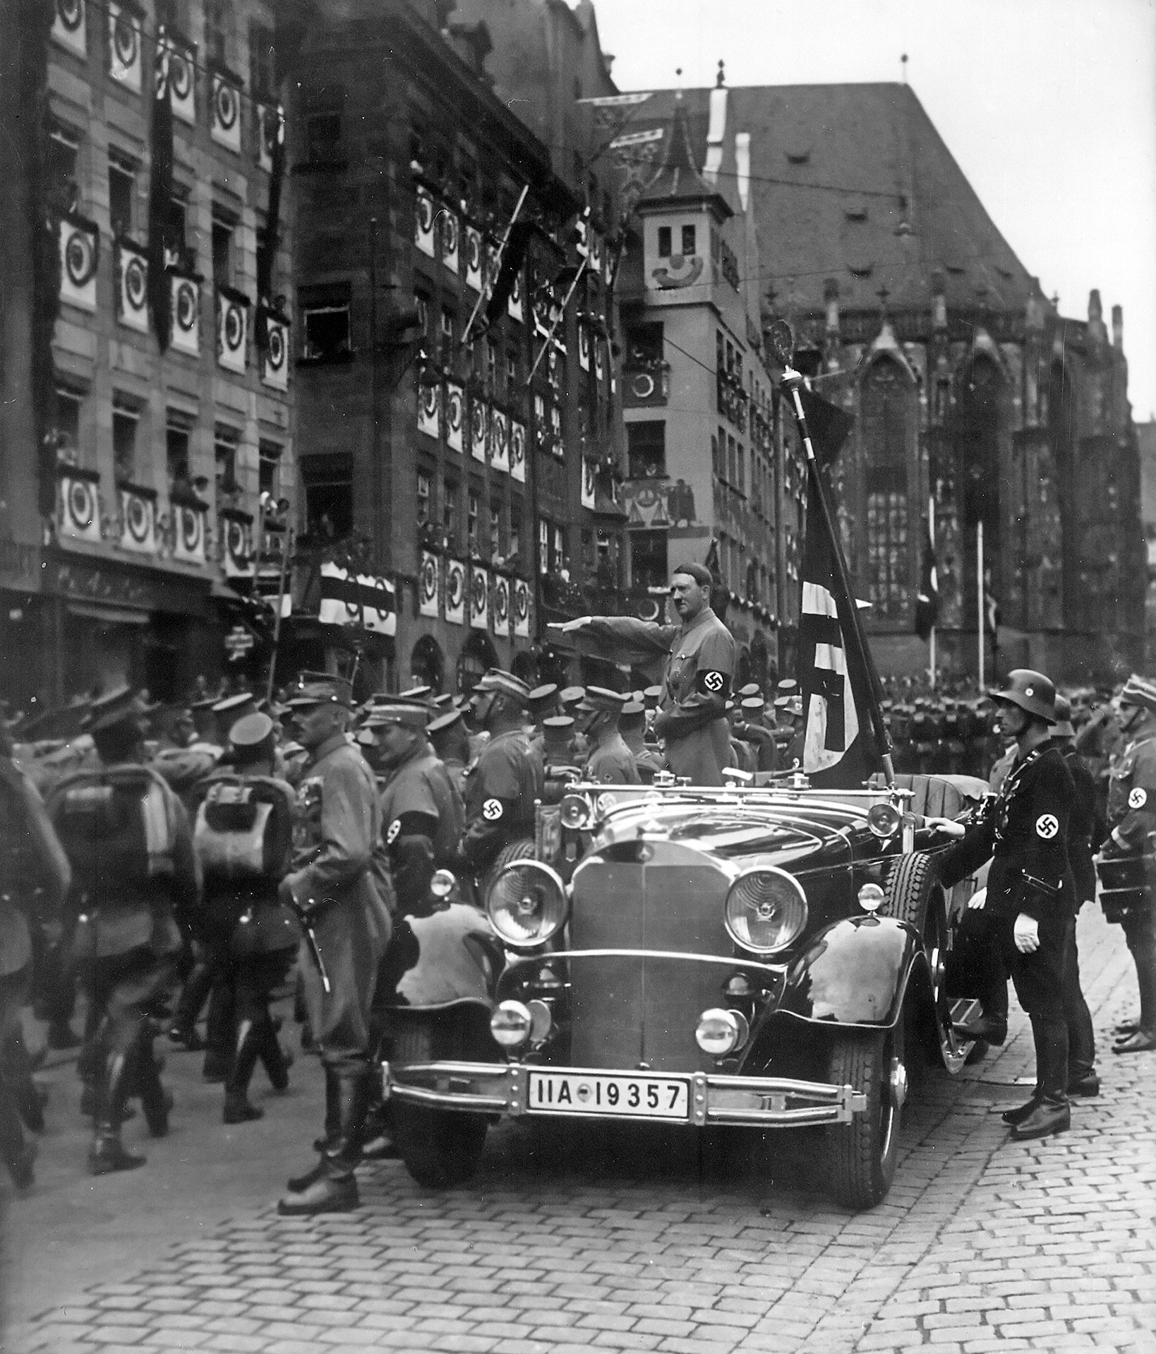
Reichsparteitag of the NSDAP in Nuremberg, SA troops march past Adolf Hitler, Sept. 1935 · Charles Russell (donor) / National Archives and Records Administration (NARA) · September 1935
Source: Russell, Charles. "Reichsparteitag of the NSDAP in Nuremberg, SA Troops March Past Adolf Hitler, Sept. 1935." September 1935. National Archives and Records Administration (NAID 558779), via Wikimedia Commons, commons.wikimedia.org/wiki/File:Reichsparteitag_of_the_NSDAP_in_Nuremberg,_SA_troops_march_past_Adolf_Hitler,_Sept._1935.jpg. Public Domain https://commons.wikimedia.org/wiki/File:Reichsparteitag_of_the_NSDAP_in_Nuremberg,_SA_troops_march_past_Adolf_Hitler,_Sept._1935.jpg
HIPPO — analyze the source (prompt) | Your analysis
H — Historical context: what was happening when this was created?
I — Intended audience: who was meant to see or obey it?
P — Purpose: why was it created?
P — Point of view: whose perspective does it reflect?
O — Outside connection: how does it connect to this standard?
SUPPORT OPTION
Sentence frame: This source shows ______ because it ______, which reveals ______.
CONFIDENCE CHECK-IN
Rate your understanding of this standard (1–4): ______ One thing to revisit: ____________________

Activity 6 — Core Application: Practice Quiz — US.45 ⏱ ~8 min
RESPONSE CHOICE
Commit to an answer by marking it, saying it, or explaining it aloud before checking. Answer key is in the Teacher Guide (kept separate).
[DOK 2 · item q-us45-dok2-1-b · pre-field-test]
How did the Treaty of Versailles contribute to the rise of Adolf Hitler and the Nazi Party in Germany?
A. It imposed harsh reparations and humiliation that fueled resentment Hitler exploited
B. Program providing part-time jobs for students so they could afford to stay in school
C. Americans should not let fear paralyze them; the nation will recover with bold action
D. Military leaders seized control, pursued aggressive expansion, and suppressed dissent
[DOK 2 · item q-us45-dok2-3-b · pre-field-test]
How did Japan's militarism in the 1930s reflect the international spread of totalitarianism?
A. Americans should not let fear paralyze them; the nation will recover with bold action
B. Military leaders seized control, pursued aggressive expansion, and suppressed dissent
C. Separated commercial and investment banking to reduce risky speculation with deposits
D. Whirlwind period where FDR pushed 15 major laws through Congress to combat Depression
[DOK 3 · item u1-us45-dok3-tc · pre-field-test]
How did economic crisis and political instability enable the rise of totalitarian regimes in Italy, Germany, and the Soviet Union?
A. The Great Depression, post-WWI disappointment, and political chaos created conditions where people accepted radical solutions and strong leaders promising stability
B. Economic prosperity led people to seek stronger government control, although this view has been largely discredited by scholars, which does not align with the documented historical record
C. Totalitarian regimes rose during periods of peace and prosperity, despite the fact that multiple sources contradict this view, which does not align with the documented historical record
D. Democratic governments actively promoted totalitarianism, which does not align with the documented historical record, but the historical evidence paints a more nuanced picture

Activity 7 — Constructed Response (CER) — US.45 ⏱ ~15 min
BIG-QUESTION ORGANIZER — in World War II, how did the war reshape America at home and its role in the world — and who sacrificed, even while being excluded?
Jot quick notes from THIS standard: Who benefited? · Who bore the costs? · Who decided?

CONSTRUCTED RESPONSE (CER) — builds SSP.04 Argumentation
Claim + Evidence + Reasoning: Using this standard, take a position on the central question — explain the rise and spread of fascism, communism, and totalitarianism internationally, including the key characteristics and leaders of each system? Support your claim with two pieces of evidence from the passage and explain your reasoning.
Part | Write here
Claim
Evidence (two specifics)
Reasoning
SELF-CHECK (CER rubric — see Toolkit)
Is my claim defensible? · TWO specific pieces of evidence? · Does my reasoning explain HOW the evidence proves the claim?
EXIT TICKET — before you leave [item us45-q1 · DOK 2 · pre-field-test]
What key characteristics distinguished fascism from other political systems in 1930s Europe?
A. Fascism promoted democracy and individual rights above national interests, though this interpretation lacks supporting historical evidence
B. Fascism emphasized collective ownership and classless society, but contemporary accounts suggest a different explanation
C. Fascism combined ultranationalism, authoritarian leadership, militarism, and scapegoating of minorities under a cult of personality
D. Fascism focused primarily on international cooperation and peace, although this overlooks critical economic and social factors
Show what you know (your choice): mark the best answer, say it, or explain it — then rate how sure you are: ☐ Not yet ☐ Getting there ☐ Got it
Answer key and next steps are in the Teacher Guide.

Standard US.46 — FDR's Response to World Crises
TN Academic Standard US.46: Explain President Franklin D. Roosevelt's response to world crises, including: The Quarantine Speech, the Four Freedoms speech, the Atlantic Charter, and the Lend-Lease Act.
LEARNING TARGETS — I can…
• I can explain President Franklin D. Roosevelt's response to world crises, including the Quarantine Speech, the Four Freedoms speech, the Atlantic Charter, and the Lend-Lease Act.
Lenses for this standard: Politics/Government · History
CORE PATH — the same for every student
Same rigor for everyone: analyze the sources and vocabulary, then show what you learned on the Practice Quiz and the CER.
UDL and MTSS give you flexible ways in — they never lower the bar.
Check yourself against the learning targets on the Cornell Notes page.
SET YOUR GOAL (self-direction)
My goal for this standard — what will I be able to do, and how will I show it?

HOOK — think before you dig in
FDR's Response to World Crises: Explain President Franklin D. Roosevelt's response to world crises, including: The Quarantine Speech, the Four Freedoms speech, the Atlantic Charter, and the Lend-Lease Act. Who gained, who was left out — and why does it still matter?

ACTIVATE — what do you already know or wonder?
Jot what you already know or want to find out about this standard. You’ll come back to it.

PREVIEW & PREDICT
Which learning target will be hardest, and why? Connect it to the unit’s big question: how did the war change America at home and abroad, and who sacrificed even while excluded?

Activity 1 — Vocabulary (Part A: Reference / Word Bank) — US.46 ⏱ ~10 min
Use this word bank throughout the standard. The Spanish column supports access, not translation of assessment.
Term | Student-friendly meaning | Spanish
Quarantine Speech | FDR's 1937 address proposing that peace-loving nations 'quarantine' aggressor states to halt the spread of international lawlessness. | Discurso de la Cuarentena
Four Freedoms Speech | FDR's 1941 speech defining American war aims: freedom of speech, freedom of worship, freedom from want, and freedom from fear. | Discurso de las Cuatro Libertades
Lend-Lease Act (1941) | U.S. program allowing the President to lend or lease war supplies to any nation deemed vital to American defense, primarily Britain and the Soviet Union. | Ley de Préstamo y Arriendo (1941)
Appeasement | Policy of making concessions to aggressive powers to avoid conflict. Britain's PM Chamberlain practiced appeasement with Hitler at the Munich Conference (1938), allowing Germany to annex the Sudetenland from… | Apaciguamiento
Axis Powers | Military alliance of Germany, Italy, and Japan during World War II. United by shared goals of territorial expansion, militarism, and opposition to democratic nations. | Potencias del Eje
Allied Powers | The World War II coalition led by the United States, Great Britain, and the Soviet Union that fought and defeated the Axis Powers. | Potencias Aliadas
LANGUAGE SUPPORT
Pronunciations: Quarantine Speech (KWOR-un-teen speech); Four Freedoms Speech (for FREE-dumz speech); Lend-Lease Act (1941) (lend lees akt); Appeasement (uh-PEEZ-ment); Axis Powers (AK-sis POW-erz); Allied Powers (AL-yd POW-erz).
VOCABULARY SELF-CHECK · Knowledge Rating
Rate each term NOW in pencil, then again at the END — growth is the goal; no penalty for “never seen it.”
Term | 1 · never seen it | 2 · heard it | 3 · can use it | 4 · can teach it
Quarantine Speech
Four Freedoms Speech
Lend-Lease Act (1941)
Appeasement
Axis Powers
Allied Powers
MAKE IT YOURS (RESPONSE CHOICE): choose ONE term above and show you own it — write a sentence, sketch it, or give a real-world example.

Activity 2 — Vocabulary Studio (Frayer-inspired) — US.46 ⏱ ~7 min
RESPONSE CHOICE
Complete each studio by writing, speaking, or diagramming.

PRIORITY TERM 1 Quarantine Speech · ES: Discurso de la Cuarentena
Word-bank meaning to build on: FDR's 1937 address proposing that peace-loving nations 'quarantine' aggressor states to halt the spread of international lawlessness.
Definition (in your own words) | Characteristics
Examples | Non-examples
Use it to explain
Write one sentence that uses “Quarantine Speech” to explain this standard.

PRIORITY TERM 2 Four Freedoms Speech · ES: Discurso de las Cuatro Libertades
Word-bank meaning to build on: FDR's 1941 speech defining American war aims: freedom of speech, freedom of worship, freedom from want, and freedom from fear.
Definition (in your own words) | Characteristics
Examples | Non-examples
Use it to explain
Write one sentence that uses “Four Freedoms Speech” to explain this standard.

CONNECT THE TERMS (UDL · build understanding)
How do these priority terms fit together? Write or sketch how one leads to or affects another.

Activity 3 — Direct Teaching Cornell Notes — US.46 ⏱ ~20 min
Name: ______________________ Class / Period: __________ Date: __________
US.46 — FDR's Response to World Crises • These notes capture the direct-teaching content and the Close Read for this standard.
Your learning targets are on this standard’s opening page — take notes that help you meet them.
Cues (tied to your learning targets) | My notes
What does the passage say about quarantine Speech (October 5, 1937)?
What does the passage say about four Freedoms Speech (January 6, 1941)?
What does the passage say about atlantic Charter (August 14, 1941)?
Key terms →
DOODLE ZONE — draw your thinking (UDL · another way in)
Need another way in? Sketch the key idea, a quick timeline, or how the pieces connect. Words optional.

Cornell Notes — keep going, then process & check — US.46
MORE NOTES / DIAGRAMS
Continue your notes here, add a quick sketch, or map how the ideas connect.

Key terms to list
Quarantine Speech · Four Freedoms Speech · Lend-Lease Act (1941) · Appeasement · Axis Powers · Allied Powers
Summary — In your own words (2–3 sentences)
PROGRESS CHECK · one question
How did the Atlantic Charter establish principles for the post-war international order?
A. It focused only on immediate military strategy, yet the available evidence points to a different conclusion, which contradicts the primary source evidence from this era
B. It established principles including self-determination, free trade, collective security, and disarmament that became the foundation for the United Nations and post-war international law
C. It divided the world into American and British spheres of influence, despite the fact that multiple sources contradict this view, but closer analysis reveals a more complicated historical reality
D. It had no lasting impact on international relations, though this interpretation lacks supporting historical evidence, although historical sources do not support this conclusion
Commit before you move on — mark it, say it, or explain it aloud.
CHECK YOURSELF — how am I doing?
Which learning targets (on this standard’s opening page) can you now meet? Tick the number; circle any you still need help with.
☐ 1
My 12–15 word headline for this standard

Activity 4 — Close Read — US.46 ⏱ ~15 min
Reading type: History Hack-authored instructional synthesis. This is not a primary source. Builds SSP.03 (synthesize) and SSP.05 (historical awareness).
CORE PATH — read one chunk at a time
Quarantine Speech (October 5, 1937)
As Japan invaded China and European tensions grew, Roosevelt faced strong isolationist sentiment reflected in the Neutrality Acts (1935-1937). In his Quarantine Speech, FDR compared aggressor nations to a disease requiring quarantine, suggesting peace-loving nations should cooperate against aggressors. This was the first major departure from strict isolationism, laying groundwork for later interventionist policies, though public reaction was mixed and no immediate policy changes resulted.
Four Freedoms Speech (January 6, 1941)
Roosevelt outlined four essential freedoms that should exist "everywhere in the world": Freedom of Speech and Expression, Freedom of Worship, Freedom from Want (economic security), and Freedom from Fear (reduction of armaments). These freedoms provided moral justification for U.S. involvement in war, defined what America would fight for, and outlined goals for post-war international order. The Four Freedoms contrasted democratic values with fascist oppression and later influenced the Universal Declaration of Human Rights.
Atlantic Charter (August 14, 1941)
Meeting secretly with Winston Churchill off Newfoundland, Roosevelt established war aims and post-war principles: no territorial aggrandizement, self-determination for peoples, economic cooperation and free trade, freedom of the seas, disarmament after war, and collective security through international organization. The Charter became the foundation for the United Nations, encouraged decolonization movements, and established precedents for international human rights law.
Lend-Lease Act (March 11, 1941)
The Lend-Lease Act allowed the U.S. to provide military equipment to Britain without requiring immediate payment, circumventing neutrality while making America the "Arsenal of Democracy." Eventually totaling $50 billion, aid went primarily to Britain (60%), Soviet Union (20%), and China. The program enabled British survival, supported Soviet resistance to German invasion, and stimulated U.S. industrial production while effectively ending true American neutrality.
Key terms first: Quarantine Speech, Four Freedoms Speech. Read once for the gist, then again for evidence.
CLOSE-READ EVIDENCE LAB — for each question: quote the EVIDENCE from the passage above, then write YOUR ANSWER (or answer aloud / diagram it).
Text-dependent question | Evidence from the passage | Your answer (what it shows)
What is the main idea of the “Quarantine Speech (October 5, 1937)” section, and what evidence supports it?
What is the main idea of the “Four Freedoms Speech (January 6, 1941)” section, and what evidence supports it?

Activity 5 — Primary Source / Data Analysis — US.46 ⏱ ~15 min
Document (text primary source — analyze with HIPPO). Builds SSP.01–SSP.02.
THE FOUR FREEDOMS SPEECH
“In the future days, which we seek to make secure, we look forward to a world founded upon four essential human freedoms. The first is freedom of speech and expression—everywhere in the world. The second is freedom of every person to worship”
Source: President Franklin D. Roosevelt, January 6, 1941. Roosevelt, President Franklin D.. "The Four Freedoms Speech." January 6, 1941. National Archives, https://www.archives.gov/milestone-documents/president-frankli. Public domain. https://www.archives.gov/milestone-documents/president-franklin-roosevelts-annual-message-to-congress
HIPPO — analyze the source (prompt) | Your analysis
H — Historical context: what was happening when this was created?
I — Intended audience: who was meant to see or obey it?
P — Purpose: why was it created?
P — Point of view: whose perspective does it reflect?
O — Outside connection: how does it connect to this standard?
SUPPORT OPTION
Sentence frame: This source shows ______ because it ______, which reveals ______.

EXTEND & RE-ENGAGE (open to all)
Push past the document — corroborate, contextualize, and judge its meaning.
Historian move | Your response
Corroborate — what other source would confirm or complicate this one?
Contextualize — what was happening at the time that explains it?
So what? — why does this source still matter?
CONFIDENCE CHECK-IN
Rate your understanding of this standard (1–4): ______ One thing to revisit: ____________________

Activity 6 — Core Application: Practice Quiz — US.46 ⏱ ~8 min
RESPONSE CHOICE
Commit to an answer by marking it, saying it, or explaining it aloud before checking. Answer key is in the Teacher Guide (kept separate).
[DOK 2 · item us46-q2 · pre-field-test]
What were the Four Freedoms, and how did they define American war aims and post-war goals?
A. Freedom of Speech, Freedom of Worship, Freedom from Want, and Freedom from Fear—universal principles that justified fighting fascism and shaped post-war international human rights
B. Economic policies for domestic recovery, but this fails to account for the broader historical context, and this view has been largely revised by modern historical research
C. Military strategies for defeating Germany, despite the fact that multiple sources contradict this view, which ignores significant political and cultural developments of the era
D. Immigration quotas for European refugees, which ignores key developments that shaped the outcome, and this view has been largely revised by modern historical research
[DOK 1 · item us-54-q04 · pre-field-test]
Martin Luther King Jr.'s 'Letter from Birmingham Jail' (1963) was written in response to —
A. President Kennedy's refusal to support civil rights legislation, which historians consider a secondary factor in this development
B. A public statement by eight white Alabama clergymen who called King's direct action campaign 'unwise and untimely'
C. Malcolm X's criticism of nonviolent strategy, which historians consider a secondary factor in this development
D. Congressional opposition to civil rights legislation, which historians consider a secondary factor in this development
[DOK 3 · item u1-us46-dok3-tc · pre-field-test]
How did the Atlantic Charter establish principles for the post-war international order?
A. It focused only on immediate military strategy, yet the available evidence points to a different conclusion, which contradicts the primary source evidence from this era
B. It established principles including self-determination, free trade, collective security, and disarmament that became the foundation for the United Nations and post-war international law
C. It divided the world into American and British spheres of influence, despite the fact that multiple sources contradict this view, but closer analysis reveals a more complicated historical reality
D. It had no lasting impact on international relations, though this interpretation lacks supporting historical evidence, although historical sources do not support this conclusion

Activity 7 — Constructed Response (CER) — US.46 ⏱ ~15 min
BIG-QUESTION ORGANIZER — in World War II, how did the war reshape America at home and its role in the world — and who sacrificed, even while being excluded?
Jot quick notes from THIS standard: Who benefited? · Who bore the costs? · Who decided?

CONSTRUCTED RESPONSE (CER) — builds SSP.04 Argumentation
Claim + Evidence + Reasoning: Using this standard, take a position on the central question — explain President Franklin D. Roosevelt's response to world crises, including the Quarantine Speech, the Four Freedoms speech, the Atlantic Charter, and the Lend-Lease Act? Support your claim with two pieces of evidence from the passage and explain your reasoning.
Part | Write here
Claim
Evidence (two specifics)
Reasoning
SELF-CHECK (CER rubric — see Toolkit)
Is my claim defensible? · TWO specific pieces of evidence? · Does my reasoning explain HOW the evidence proves the claim?
EXIT TICKET — before you leave [item us46-q1 · DOK 2 · pre-field-test]
How did Roosevelt's Quarantine Speech signal a shift away from American isolationism?
A. It declared immediate war on Germany and Japan, which contradicts the primary source evidence from this era and oversimplifies the complex factors at work during this period
B. It strengthened the Neutrality Acts, which does not align with the documented historical record, but contemporary accounts and primary sources suggest otherwise
C. It called for complete American withdrawal from world affairs, although historical sources do not support this conclusion, though this interpretation lacks supporting historical evidence
D. It suggested that peace-loving nations should cooperate against aggressors like quarantining a disease, marking the first major departure from strict isolationism
Show what you know (your choice): mark the best answer, say it, or explain it — then rate how sure you are: ☐ Not yet ☐ Getting there ☐ Got it
Answer key and next steps are in the Teacher Guide.

Standard US.47 — U.S. Response to the Holocaust
TN Academic Standard US.47: Analyze the response of the U.S. to the plight of European Jews before the start of the war, the U.S. liberation of concentration camps during the war, and the immigration of Holocaust survivors after the war.
LEARNING TARGETS — I can…
• I can analyze the response of the U.S. to the plight of European Jews before the war, the liberation of concentration camps during the war, and the immigration of Holocaust survivors after the war.
Lenses for this standard: History · Culture
CORE PATH — the same for every student
Same rigor for everyone: analyze the sources and vocabulary, then show what you learned on the Practice Quiz and the CER.
UDL and MTSS give you flexible ways in — they never lower the bar.
Check yourself against the learning targets on the Cornell Notes page.
SET YOUR GOAL (self-direction)
My goal for this standard — what will I be able to do, and how will I show it?

HOOK — think before you dig in
U.S. Response to the Holocaust: Analyze the response of the U.S. to the plight of European Jews before the start of the war, the U.S. liberation of concentration camps during the war, and the immigration of Holocaust survivors after the war. Who gained, who was left out — and why does it still matter?

ACTIVATE — what do you already know or wonder?
Jot what you already know or want to find out about this standard. You’ll come back to it.

PREVIEW & PREDICT
Which learning target will be hardest, and why? Connect it to the unit’s big question: how did the war change America at home and abroad, and who sacrificed even while excluded?

Activity 1 — Vocabulary (Part A: Reference / Word Bank) — US.47 ⏱ ~10 min
Use this word bank throughout the standard. The Spanish column supports access, not translation of assessment.
Term | Student-friendly meaning | Spanish
Holocaust | Nazi Germany's systematic genocide of 6 million Jews and millions of others (Roma, disabled, homosexuals, political opponents) during World War II. | Holocausto
Nuremberg Laws (1935) | Nazi racial laws that stripped Jews of German citizenship, banned intermarriage between Jews and non-Jews, and defined "Jewishness" by ancestry. They institutionalized anti-Semitic persecution. | Leyes de Nuremberg (1935)
Adolf Hitler | Nazi dictator of Germany (1933-1945) who led Germany into World War II and orchestrated the Holocaust, resulting in the deaths of 6 million Jews and millions of others. | Adolf Hitler
Totalitarianism | A system of government where the state controls every aspect of public and private life, using propaganda, secret police, and terror to eliminate opposition. | Totalitarismo
Appeasement | Policy of making concessions to aggressive powers to avoid conflict. Britain's PM Chamberlain practiced appeasement with Hitler at the Munich Conference (1938), allowing Germany to annex the Sudetenland from… | Apaciguamiento
Axis Powers | Military alliance of Germany, Italy, and Japan during World War II. United by shared goals of territorial expansion, militarism, and opposition to democratic nations. | Potencias del Eje
LANGUAGE SUPPORT
Pronunciations: Holocaust (HOL-uh-kawst); Nuremberg Laws (1935) (NOOR-em-berg lawz); Adolf Hitler (AY-dolf HIT-ler); Totalitarianism (toh-tal-ih-TAIR-ee-uh-niz-um); Appeasement (uh-PEEZ-ment); Axis Powers (AK-sis POW-erz).
VOCABULARY SELF-CHECK · Knowledge Rating
Rate each term NOW in pencil, then again at the END — growth is the goal; no penalty for “never seen it.”
Term | 1 · never seen it | 2 · heard it | 3 · can use it | 4 · can teach it
Holocaust
Nuremberg Laws (1935)
Adolf Hitler
Totalitarianism
Appeasement
Axis Powers
MAKE IT YOURS (RESPONSE CHOICE): choose ONE term above and show you own it — write a sentence, sketch it, or give a real-world example.

Activity 2 — Vocabulary Studio (Frayer-inspired) — US.47 ⏱ ~7 min
RESPONSE CHOICE
Complete each studio by writing, speaking, or diagramming.

PRIORITY TERM 1 Holocaust · ES: Holocausto
Word-bank meaning to build on: Nazi Germany's systematic genocide of 6 million Jews and millions of others (Roma, disabled, homosexuals, political opponents) during World War II.
Definition (in your own words) | Characteristics
Examples | Non-examples
Use it to explain
Write one sentence that uses “Holocaust” to explain this standard.

PRIORITY TERM 2 Nuremberg Laws (1935) · ES: Leyes de Nuremberg (1935)
Word-bank meaning to build on: Nazi racial laws that stripped Jews of German citizenship, banned intermarriage between Jews and non-Jews, and defined "Jewishness" by ancestry. They institutionalized anti-Semitic persecution.
Definition (in your own words) | Characteristics
Examples | Non-examples
Use it to explain
Write one sentence that uses “Nuremberg Laws (1935)” to explain this standard.

CONNECT THE TERMS (UDL · build understanding)
How do these priority terms fit together? Write or sketch how one leads to or affects another.

Activity 3 — Direct Teaching Cornell Notes — US.47 ⏱ ~20 min
Name: ______________________ Class / Period: __________ Date: __________
US.47 — U.S. Response to the Holocaust • These notes capture the direct-teaching content and the Close Read for this standard.
Your learning targets are on this standard’s opening page — take notes that help you meet them.
Cues (tied to your learning targets) | My notes
What does the passage say about u.S. Response Before the War?
What does the passage say about liberation of Concentration Camps?
What does the passage say about post-War Immigration of Holocaust Survivors?
Key terms →
DOODLE ZONE — draw your thinking (UDL · another way in)
Need another way in? Sketch the key idea, a quick timeline, or how the pieces connect. Words optional.

Cornell Notes — keep going, then process & check — US.47
MORE NOTES / DIAGRAMS
Continue your notes here, add a quick sketch, or map how the ideas connect.

Key terms to list
Holocaust · Nuremberg Laws (1935) · Adolf Hitler · Totalitarianism · Appeasement · Axis Powers
Summary — In your own words (2–3 sentences)
PROGRESS CHECK · one question
How did U.S. immigration restrictions and public attitudes limit American response to Jewish refugees before WWII?
A. The U.S. welcomed all Jewish refugees without restriction, which ignores key developments that shaped the outcome, but closer analysis reveals a more complicated historical reality
B. Only economic factors affected refugee policy, which does not reflect the consensus among historians and fails to account for key developments in the broader context
C. The National Origins Act quotas, consular obstruction, anti-Semitism, isolationism, and economic fears during the Depression combined to severely limit Jewish immigration
D. The U.S. had no immigration restrictions in the 1930s, but this oversimplifies the complex factors at work, although historical sources do not support this conclusion
Commit before you move on — mark it, say it, or explain it aloud.
CHECK YOURSELF — how am I doing?
Which learning targets (on this standard’s opening page) can you now meet? Tick the number; circle any you still need help with.
☐ 1
My 12–15 word headline for this standard

Activity 4 — Close Read — US.47 ⏱ ~15 min
Reading type: History Hack-authored instructional synthesis. This is not a primary source. Builds SSP.03 (synthesize) and SSP.05 (historical awareness).
CORE PATH — read one chunk at a time
U.S. Response Before the War
The National Origins Act (1924) limited immigration from Eastern and Southern Europe where most Jews lived. The quota system severely restricted Jewish immigration, and U.S. consuls often denied visas. The St. Louis incident (1939) saw a ship carrying 937 Jewish refugees turned away from U.S. ports. The Evian Conference (1938) failed to increase refugee admissions. American anti-Semitism, isolationism, economic concerns during the Depression, and security fears all limited response. The War Refugee Board wasn't created until 1944.
Liberation of Concentration Camps
Soviet forces liberated Majdanek (1944) and Auschwitz (1945), while U.S. forces liberated Buchenwald, Dachau, and Mauthausen. American soldiers were unprepared for the extent of Nazi atrocities. Military photographers documented evidence while medical personnel treated survivors. The Army provided food, medical care, and shelter, forced local German civilians to view camps, and established displaced persons camps. Liberation footage shocked the American public and provided evidence for the Nuremberg trials.
Post-War Immigration of Holocaust Survivors
The Displaced Persons Act (1948) initially admitted 205,000 displaced persons but gave preference to Baltic refugees over Jews. Amendments in 1950 expanded the program, eventually admitting about 80,000 Jewish survivors. Survivors faced bureaucratic delays, quota limitations, and anti-Semitic opposition. Jewish organizations provided financial and social support, helping survivors integrate into American society, rebuild careers, and preserve Holocaust memory through testimonies.
Moral and Ethical Implications (Honors)
Kristallnacht (November 9-10, 1938) was a coordinated Nazi attack on Jewish businesses and synagogues. The U.S. recalled its ambassador and extended tourist visas but maintained immigration quotas. This raises questions about whether the U.S. should have done more to help Jewish refugees, the responsibility of bystander nations during genocide, and the tension between moral obligations and national security concerns. These events contributed to the development of genocide prevention and international human rights law.
Key terms first: Holocaust, Nuremberg Laws (1935). Read once for the gist, then again for evidence.
CLOSE-READ EVIDENCE LAB — for each question: quote the EVIDENCE from the passage above, then write YOUR ANSWER (or answer aloud / diagram it).
Text-dependent question | Evidence from the passage | Your answer (what it shows)
What is the main idea of the “U.S. Response Before the War” section, and what evidence supports it?
What is the main idea of the “Liberation of Concentration Camps” section, and what evidence supports it?

Activity 5 — Primary Source / Data Analysis — US.47 ⏱ ~15 min
Primary source (photograph) — analyze it with HIPPO. Builds SSP.01–SSP.02.
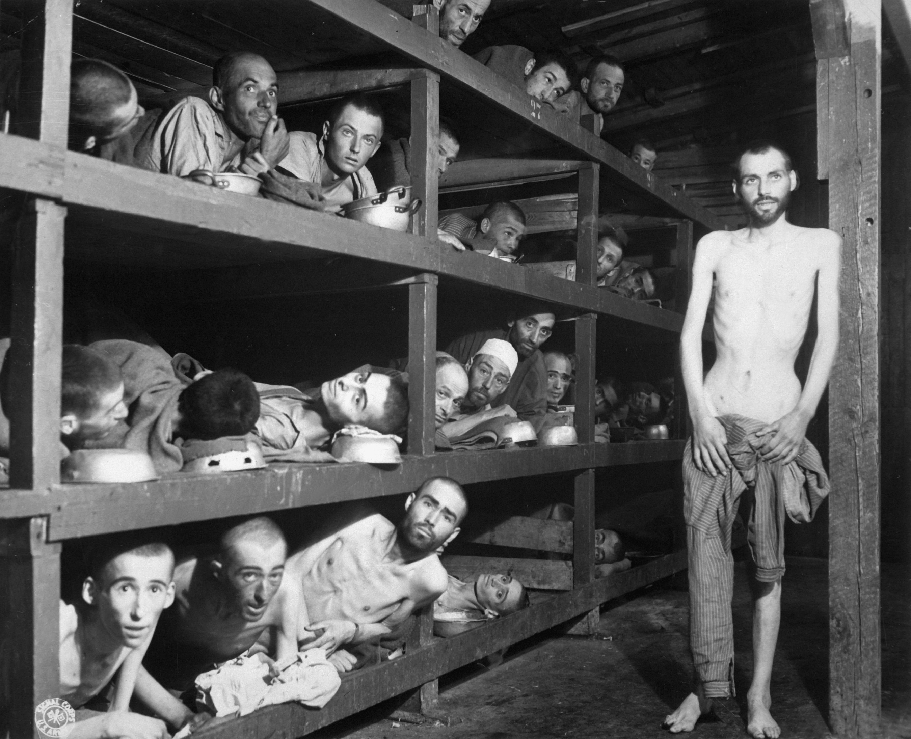
Buchenwald Slave Laborers Liberation (April 16, 1945) · Private H. Miller / U.S. Army Signal Corps · April 16, 1945
Source: Miller, H. "Buchenwald Slave Laborers Liberation." 16 Apr. 1945. U.S. Army Signal Corps / National Archives and Records Administration, via Wikimedia Commons, commons.wikimedia.org/wiki/File:Buchenwald_Slave_Laborers_Liberation.jpg. Public Domain https://commons.wikimedia.org/wiki/File:Buchenwald_Slave_Laborers_Liberation.jpg
HIPPO — analyze the source (prompt) | Your analysis
H — Historical context: what was happening when this was created?
I — Intended audience: who was meant to see or obey it?
P — Purpose: why was it created?
P — Point of view: whose perspective does it reflect?
O — Outside connection: how does it connect to this standard?
SUPPORT OPTION
Sentence frame: This source shows ______ because it ______, which reveals ______.
CONFIDENCE CHECK-IN
Rate your understanding of this standard (1–4): ______ One thing to revisit: ____________________

Activity 6 — Core Application: Practice Quiz — US.47 ⏱ ~8 min
RESPONSE CHOICE
Commit to an answer by marking it, saying it, or explaining it aloud before checking. Answer key is in the Teacher Guide (kept separate).
[DOK 2 · item q-us49-dok2-1 · pre-field-test]
How did the U.S. respond to the Holocaust before entering World War II?
A. Maintained strict immigration quotas and turned away refugee ships like St. Louis
B. Military alliance between fascist and militarist powers Italy, Germany, and Japan
C. Establish German racial supremacy and expand living space (Lebensraum) eastward
D. 1934 Nazi purge eliminating Hitler's political rivals and consolidating power
[DOK 2 · item q-us49-dok3-1 · pre-field-test]
Why did the U.S. and other nations fail to prevent the Holocaust?
A. Prison camps where Jews and others were detained, forced to labor, and systematically murdered
B. Immigration restrictions, anti-Semitism, disbelief of reports, and prioritizing military victory
C. November 1938 Nazi pogrom destroying Jewish businesses, synagogues, and killing 91 Jews
D. Walled section of Warsaw where Nazis confined over 400,000 Jews in terrible conditions
[DOK 3 · item u1-us47-dok3-tc · pre-field-test]
How did U.S. immigration restrictions and public attitudes limit American response to Jewish refugees before WWII?
A. The U.S. welcomed all Jewish refugees without restriction, which ignores key developments that shaped the outcome, but closer analysis reveals a more complicated historical reality
B. Only economic factors affected refugee policy, which does not reflect the consensus among historians and fails to account for key developments in the broader context
C. The National Origins Act quotas, consular obstruction, anti-Semitism, isolationism, and economic fears during the Depression combined to severely limit Jewish immigration
D. The U.S. had no immigration restrictions in the 1930s, but this oversimplifies the complex factors at work, although historical sources do not support this conclusion

Activity 7 — Constructed Response (CER) — US.47 ⏱ ~15 min
BIG-QUESTION ORGANIZER — in World War II, how did the war reshape America at home and its role in the world — and who sacrificed, even while being excluded?
Jot quick notes from THIS standard: Who benefited? · Who bore the costs? · Who decided?

CONSTRUCTED RESPONSE (CER) — builds SSP.04 Argumentation
Claim + Evidence + Reasoning: Using this standard, take a position on the central question — analyze the response of the U.S. to the plight of European Jews before the war, the liberation of concentration camps during the war, and the immigration of Holocaust survivors after the war? Support your claim with two pieces of evidence from the passage and explain your reasoning.
Part | Write here
Claim
Evidence (two specifics)
Reasoning
SELF-CHECK (CER rubric — see Toolkit)
Is my claim defensible? · TWO specific pieces of evidence? · Does my reasoning explain HOW the evidence proves the claim?
EXIT TICKET — before you leave [item us47-q3 · DOK 2 · pre-field-test]
How did American forces respond when they liberated Nazi concentration camps, and what impact did this have on public awareness?
A. Shocked soldiers provided immediate aid, documented evidence, and forced German civilians to view the camps; footage broadcast to America created lasting awareness and moral awakening
B. They had been prepared for what they found, which contradicts the primary source evidence from this era, but the historical evidence paints a more nuanced picture
C. Liberation had no impact on public awareness, which ignores key developments that shaped the outcome, which contradicts the primary source evidence from this era
D. American forces avoided the concentration camps, but contemporary accounts suggest a different explanation and oversimplifies the complex factors at work during this period
Show what you know (your choice): mark the best answer, say it, or explain it — then rate how sure you are: ☐ Not yet ☐ Getting there ☐ Got it
Answer key and next steps are in the Teacher Guide.

Standard US.48 — American Entry into World War II
TN Academic Standard US.48: Explain the reasons for American entry into World War II, including the attack on Pearl Harbor.
LEARNING TARGETS — I can…
• I can explain the reasons for American entry into World War II, including the attack on Pearl Harbor.
Lenses for this standard: History · Politics/Government
CORE PATH — the same for every student
Same rigor for everyone: analyze the sources and vocabulary, then show what you learned on the Practice Quiz and the CER.
UDL and MTSS give you flexible ways in — they never lower the bar.
Check yourself against the learning targets on the Cornell Notes page.
★ Tennessee Connection
After Pearl Harbor, Tennesseans enlisted in massive numbers, continuing the 'Volunteer State' tradition. Congressman Albert Gore Sr. of Carthage voted for the declaration of war and later served in the Army. Tennessee's industrial base rapidly converted to war production.
SET YOUR GOAL (self-direction)
My goal for this standard — what will I be able to do, and how will I show it?

HOOK — think before you dig in
American Entry into World War II: Explain the reasons for American entry into World War II, including the attack on Pearl Harbor. Who gained, who was left out — and why does it still matter?

ACTIVATE — what do you already know or wonder?
Jot what you already know or want to find out about this standard. You’ll come back to it.

PREVIEW & PREDICT
Which learning target will be hardest, and why? Connect it to the unit’s big question: how did the war change America at home and abroad, and who sacrificed even while excluded?

Activity 1 — Vocabulary (Part A: Reference / Word Bank) — US.48 ⏱ ~10 min
Use this word bank throughout the standard. The Spanish column supports access, not translation of assessment.
Term | Student-friendly meaning | Spanish
Pearl Harbor | Japan's surprise attack on the U.S. naval base in Hawaii on December 7, 1941, killing over 2,400 Americans and bringing the United States into World War II. | Pearl Harbor
Hideki Tojo | Japanese military leader and Prime Minister (1941-1944) who led Japan into World War II and authorized the attack on Pearl Harbor. | Hideki Tojo
Axis Powers | Military alliance of Germany, Italy, and Japan during World War II. United by shared goals of territorial expansion, militarism, and opposition to democratic nations. | Potencias del Eje
Allied Powers | The World War II coalition led by the United States, Great Britain, and the Soviet Union that fought and defeated the Axis Powers. | Potencias Aliadas
Lend-Lease Act (1941) | U.S. program allowing the President to lend or lease war supplies to any nation deemed vital to American defense, primarily Britain and the Soviet Union. | Ley de Préstamo y Arriendo (1941)
Nazi-Soviet Pact (1939) | Non-aggression agreement between Hitler and Stalin (August 1939) that shocked the world. Secret provisions divided Poland and Eastern Europe between Germany and the Soviet Union. | Pacto Nazi-Soviético (1939)
LANGUAGE SUPPORT
Pronunciations: Pearl Harbor (purl HAR-ber); Hideki Tojo (hee-DEH-kee TOH-joh); Axis Powers (AK-sis POW-erz); Allied Powers (AL-yd POW-erz); Lend-Lease Act (1941) (lend lees akt); Nazi-Soviet Pact (1939) (NOT-see SOH-vee-et pakt).
VOCABULARY SELF-CHECK · Knowledge Rating
Rate each term NOW in pencil, then again at the END — growth is the goal; no penalty for “never seen it.”
Term | 1 · never seen it | 2 · heard it | 3 · can use it | 4 · can teach it
Pearl Harbor
Hideki Tojo
Axis Powers
Allied Powers
Lend-Lease Act (1941)
Nazi-Soviet Pact (1939)
MAKE IT YOURS (RESPONSE CHOICE): choose ONE term above and show you own it — write a sentence, sketch it, or give a real-world example.

Activity 2 — Vocabulary Studio (Frayer-inspired) — US.48 ⏱ ~7 min
RESPONSE CHOICE
Complete each studio by writing, speaking, or diagramming.

PRIORITY TERM 1 Pearl Harbor · ES: Pearl Harbor
Word-bank meaning to build on: Japan's surprise attack on the U.S. naval base in Hawaii on December 7, 1941, killing over 2,400 Americans and bringing the United States into World War II.
Definition (in your own words) | Characteristics
Examples | Non-examples
Use it to explain
Write one sentence that uses “Pearl Harbor” to explain this standard.

PRIORITY TERM 2 Hideki Tojo · ES: Hideki Tojo
Word-bank meaning to build on: Japanese military leader and Prime Minister (1941-1944) who led Japan into World War II and authorized the attack on Pearl Harbor.
Definition (in your own words) | Characteristics
Examples | Non-examples
Use it to explain
Write one sentence that uses “Hideki Tojo” to explain this standard.

CONNECT THE TERMS (UDL · build understanding)
How do these priority terms fit together? Write or sketch how one leads to or affects another.

Activity 3 — Direct Teaching Cornell Notes — US.48 ⏱ ~20 min
Name: ______________________ Class / Period: __________ Date: __________
US.48 — American Entry into World War II • These notes capture the direct-teaching content and the Close Read for this standard.
Your learning targets are on this standard’s opening page — take notes that help you meet them.
Cues (tied to your learning targets) | My notes
What does the passage say about factors in the European Theater?
What does the passage say about factors in the Pacific Theater?
What does the passage say about attack on Pearl Harbor (December 7, 1941)?
Key terms →
DOODLE ZONE — draw your thinking (UDL · another way in)
Need another way in? Sketch the key idea, a quick timeline, or how the pieces connect. Words optional.

Cornell Notes — keep going, then process & check — US.48
MORE NOTES / DIAGRAMS
Continue your notes here, add a quick sketch, or map how the ideas connect.

Key terms to list
Pearl Harbor · Hideki Tojo · Axis Powers · Allied Powers · Lend-Lease Act (1941) · Nazi-Soviet Pact (1939)
Summary — In your own words (2–3 sentences)
PROGRESS CHECK · one question
How did the Pearl Harbor attack unite American public opinion and end isolationism?
A. Public opinion remained divided after Pearl Harbor, which contradicts the primary source evidence from this era, but the historical evidence paints a more nuanced picture
B. Isolationism continued throughout the war, but the historical record tells a more complex story and oversimplifies the complex factors at work during this period
C. Pearl Harbor had no effect on public opinion, but the historical record tells a more complex story and oversimplifies the complex factors at work during this period
D. The surprise attack shocked Americans, Roosevelt's "Date of Infamy" speech galvanized the nation, and Congress declared war with only one dissenting vote, destroying isolationist opposition
Commit before you move on — mark it, say it, or explain it aloud.
CHECK YOURSELF — how am I doing?
Which learning targets (on this standard’s opening page) can you now meet? Tick the number; circle any you still need help with.
☐ 1
My 12–15 word headline for this standard

Activity 4 — Close Read — US.48 ⏱ ~15 min
Reading type: History Hack-authored instructional synthesis. This is not a primary source. Builds SSP.03 (synthesize) and SSP.05 (historical awareness).
CORE PATH — read one chunk at a time
Factors in the European Theater
German U-boats attacked U.S. ships carrying Lend-Lease supplies, leading to an undeclared naval war with the U.S. Navy escorting convoys and engaging German submarines. The Atlantic Charter created moral and strategic partnership with Britain. The Destroyer Deal exchanged U.S. destroyers for British bases, and U.S. forces occupied Iceland to prevent German control. These actions increasingly moved America toward war despite isolationist opposition.
Factors in the Pacific Theater
Japan conquered much of China and Southeast Asia, threatening U.S. territories and interests. In response, the U.S. imposed economic sanctions including an oil embargo and froze Japanese assets (July 1941). The Hull Note demanded Japanese withdrawal from China and Indochina, but negotiations failed to resolve differences. Japan's military leaders saw war with America as inevitable given the economic pressure.
Attack on Pearl Harbor (December 7, 1941)
Japan planned to eliminate the U.S. Pacific Fleet to prevent interference with expansion. Six aircraft carriers launched 353 planes in two waves on Sunday morning when defenses were relaxed. The attack sank or damaged 8 battleships, destroyed 188 planes, and killed 2,403 Americans. Intelligence failures left U.S. forces completely unprepared. Roosevelt's "Date of Infamy" speech galvanized the nation, and Congress declared war with only one dissenting vote.
Consequences of American Entry
Pearl Harbor destroyed isolationist opposition and unified American public opinion. Germany and Italy declared war on the U.S. (December 11), making the conflict worldwide. Domestically, war ended the Great Depression and created full employment, while the government gained unprecedented powers. Internationally, U.S. entry provided resources necessary to defeat the Axis, established America as the dominant world power, and led to the creation of the United Nations.
Key terms first: Pearl Harbor, Hideki Tojo. Read once for the gist, then again for evidence.
CLOSE-READ EVIDENCE LAB — for each question: quote the EVIDENCE from the passage above, then write YOUR ANSWER (or answer aloud / diagram it).
Text-dependent question | Evidence from the passage | Your answer (what it shows)
What is the main idea of the “Factors in the European Theater” section, and what evidence supports it?
What is the main idea of the “Factors in the Pacific Theater” section, and what evidence supports it?
What is the main idea of the “Attack on Pearl Harbor (December 7, 1941)” section, and what evidence supports it?

Activity 5 — Primary Source / Data Analysis — US.48 ⏱ ~15 min
Primary source (photograph) — analyze it with HIPPO. Builds SSP.01–SSP.02.
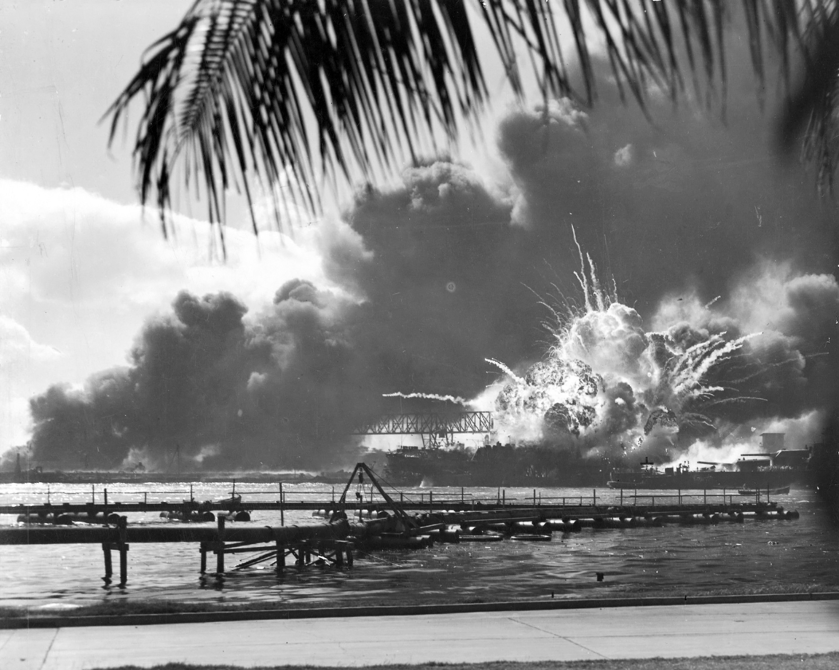
USS Shaw Exploding During the Japanese Raid on Pearl Harbor, T.H. (80-G-16871) · Unknown U.S. Navy photographer / U.S. Navy · December 7, 1941
Source: Unknown U.S. Navy photographer. "USS Shaw Exploding During the Japanese Raid on Pearl Harbor, T.H." 7 Dec. 1941. U.S. Navy / National Archives and Records Administration, via Wikimedia Commons, commons.wikimedia.org/wiki/File:USS_SHAW_exploding_Pearl_Harbor_Nara_80-G-16871_2.jpg. Public Domain https://commons.wikimedia.org/wiki/File:USS_SHAW_exploding_Pearl_Harbor_Nara_80-G-16871_2.jpg
HIPPO — analyze the source (prompt) | Your analysis
H — Historical context: what was happening when this was created?
I — Intended audience: who was meant to see or obey it?
P — Purpose: why was it created?
P — Point of view: whose perspective does it reflect?
O — Outside connection: how does it connect to this standard?
SUPPORT OPTION
Sentence frame: This source shows ______ because it ______, which reveals ______.
CONFIDENCE CHECK-IN
Rate your understanding of this standard (1–4): ______ One thing to revisit: ____________________

Activity 6 — Core Application: Practice Quiz — US.48 ⏱ ~8 min
RESPONSE CHOICE
Commit to an answer by marking it, saying it, or explaining it aloud before checking. Answer key is in the Teacher Guide (kept separate).
[DOK 2 · item us-49-x017 · pre-field-test]
China's entry into the Korean War in October 1950 transformed the conflict by —
A. Inflicting massive casualties near the Yalu River, reversing Allied advances and shifting American war aims from reunification to armistice
B. Immediately overwhelming and forcing the surrender of UN forces, compelling acceptance of Chinese armistice terms
C. Drawing the Soviet Union into direct military combat alongside Chinese and North Korean forces against the UN
D. Prompting the United Nations to formally authorize nuclear retaliation strikes against Chinese territory and forces
[DOK 2 · item U6-DOK2-0011 · pre-field-test]
How did women's large-scale entry into the workforce during World War II challenge traditional social expectations in the United States?
A. It permanently ended the expectation that women would return to domestic roles after the war
B. It demonstrated that women could perform industrial and technical jobs previously considered exclusively male, challenging gender-based occupational limits
C. It caused Congress to immediately pass equal pay legislation to ensure women earned the same wages as men
D. It led the military to commission women as officers with full command authority over male soldiers
[DOK 3 · item u1-us48-dok3-tc · pre-field-test]
How did the Pearl Harbor attack unite American public opinion and end isolationism?
A. Public opinion remained divided after Pearl Harbor, which contradicts the primary source evidence from this era, but the historical evidence paints a more nuanced picture
B. Isolationism continued throughout the war, but the historical record tells a more complex story and oversimplifies the complex factors at work during this period
C. Pearl Harbor had no effect on public opinion, but the historical record tells a more complex story and oversimplifies the complex factors at work during this period
D. The surprise attack shocked Americans, Roosevelt's "Date of Infamy" speech galvanized the nation, and Congress declared war with only one dissenting vote, destroying isolationist opposition

Activity 7 — Constructed Response (CER) — US.48 ⏱ ~15 min
BIG-QUESTION ORGANIZER — in World War II, how did the war reshape America at home and its role in the world — and who sacrificed, even while being excluded?
Jot quick notes from THIS standard: Who benefited? · Who bore the costs? · Who decided?

CONSTRUCTED RESPONSE (CER) — builds SSP.04 Argumentation
Claim + Evidence + Reasoning: Using this standard, take a position on the central question — explain the reasons for American entry into World War II, including the attack on Pearl Harbor? Support your claim with two pieces of evidence from the passage and explain your reasoning.
Part | Write here
Claim
Evidence (two specifics)
Reasoning
SELF-CHECK (CER rubric — see Toolkit)
Is my claim defensible? · TWO specific pieces of evidence? · Does my reasoning explain HOW the evidence proves the claim?
EXIT TICKET — before you leave [item us48-q1 · DOK 2 · pre-field-test]
What factors in both Europe and the Pacific pushed America toward war by 1941?
A. America had no interests in either region, but this oversimplifies the complex factors at work, but contemporary accounts and primary sources suggest otherwise
B. In Europe, U-boat attacks and Lend-Lease involvement; in the Pacific, Japanese expansion threatening U.S. interests, economic sanctions, and failed diplomacy all pushed toward conflict
C. Only European factors mattered, but this fails to account for the broader historical context, which represents a common misconception about this historical period
D. America actively sought war in both regions, despite the fact that multiple sources contradict this view and fails to account for key developments in the broader context
Show what you know (your choice): mark the best answer, say it, or explain it — then rate how sure you are: ☐ Not yet ☐ Getting there ☐ Got it
Answer key and next steps are in the Teacher Guide.

Standard US.49 — WWII Leaders & Key Figures
TN Academic Standard US.49: Identify the roles and the significant actions of the following individuals in World War II: Winston Churchill, Dwight D. Eisenhower, Adolf Hitler, Douglas MacArthur, George C. Marshall, Benito Mussolini, President Franklin D. Roosevelt, Joseph Stalin, Hideki Tojo, President Harry S. Truman.
LEARNING TARGETS — I can…
• I can identify the roles and the significant actions of key individuals in World War II, including Churchill, Eisenhower, Hitler, MacArthur, Marshall, Mussolini, FDR, Stalin, Tojo, and Truman.
Lenses for this standard: History · Politics/Government
CORE PATH — the same for every student
Same rigor for everyone: analyze the sources and vocabulary, then show what you learned on the Practice Quiz and the CER.
UDL and MTSS give you flexible ways in — they never lower the bar.
Check yourself against the learning targets on the Cornell Notes page.
★ Tennessee Connection
Tennessee contributed key military leaders to WWII. Lieutenant Alexander 'Sandy' Ninninger, though born in Georgia, trained at Fort Oglethorpe near Chattanooga and was the first Medal of Honor recipient of WWII. Thousands of officers trained at Tennessee military installations before deploying to both theaters.
SET YOUR GOAL (self-direction)
My goal for this standard — what will I be able to do, and how will I show it?

HOOK — think before you dig in
WWII Leaders & Key Figures: Identify the roles and the significant actions of the following individuals in World War II: Winston Churchill, Dwight D. Eisenhower, Adolf Hitler, Douglas MacArthur, George C. Marshall, Benito Mussolini, President Franklin D. Roosevelt, Joseph Stalin, Hideki Tojo, President Harry S. Truman. Who gained, who was left out — and why does it still matter?

ACTIVATE — what do you already know or wonder?
Jot what you already know or want to find out about this standard. You’ll come back to it.

PREVIEW & PREDICT
Which learning target will be hardest, and why? Connect it to the unit’s big question: how did the war change America at home and abroad, and who sacrificed even while excluded?

Activity 1 — Vocabulary (Part A: Reference / Word Bank) — US.49 ⏱ ~10 min
Use this word bank throughout the standard. The Spanish column supports access, not translation of assessment.
Term | Student-friendly meaning | Spanish
Dwight D. Eisenhower | Supreme Commander of Allied Forces in Europe who planned and led the D-Day invasion and coordinated Allied victory in Europe. Later became 34th President. | Dwight D. Eisenhower
Adolf Hitler | Nazi dictator of Germany (1933-1945) who led Germany into World War II and orchestrated the Holocaust, resulting in the deaths of 6 million Jews and millions of others. | Adolf Hitler
Joseph Stalin | Communist dictator of the Soviet Union (1924-1953) who ruled through terror, forced collectivization, and purges, resulting in millions of deaths. | Joseph Stalin
Hideki Tojo | Japanese military leader and Prime Minister (1941-1944) who led Japan into World War II and authorized the attack on Pearl Harbor. | Hideki Tojo
Allied Powers | The World War II coalition led by the United States, Great Britain, and the Soviet Union that fought and defeated the Axis Powers. | Potencias Aliadas
Axis Powers | Military alliance of Germany, Italy, and Japan during World War II. United by shared goals of territorial expansion, militarism, and opposition to democratic nations. | Potencias del Eje
LANGUAGE SUPPORT
Pronunciations: Dwight D. Eisenhower (dwyt EYE-zen-how-er); Adolf Hitler (AY-dolf HIT-ler); Joseph Stalin (JOH-zef STAH-lin); Hideki Tojo (hee-DEH-kee TOH-joh); Allied Powers (AL-yd POW-erz); Axis Powers (AK-sis POW-erz).
VOCABULARY SELF-CHECK · Knowledge Rating
Rate each term NOW in pencil, then again at the END — growth is the goal; no penalty for “never seen it.”
Term | 1 · never seen it | 2 · heard it | 3 · can use it | 4 · can teach it
Dwight D. Eisenhower
Adolf Hitler
Joseph Stalin
Hideki Tojo
Allied Powers
Axis Powers
MAKE IT YOURS (RESPONSE CHOICE): choose ONE term above and show you own it — write a sentence, sketch it, or give a real-world example.

Activity 2 — Vocabulary Studio (Frayer-inspired) — US.49 ⏱ ~7 min
RESPONSE CHOICE
Complete each studio by writing, speaking, or diagramming.

PRIORITY TERM 1 Dwight D. Eisenhower · ES: Dwight D. Eisenhower
Word-bank meaning to build on: Supreme Commander of Allied Forces in Europe who planned and led the D-Day invasion and coordinated Allied victory in Europe. Later became 34th President.
Definition (in your own words) | Characteristics
Examples | Non-examples
Use it to explain
Write one sentence that uses “Dwight D. Eisenhower” to explain this standard.

PRIORITY TERM 2 Adolf Hitler · ES: Adolf Hitler
Word-bank meaning to build on: Nazi dictator of Germany (1933-1945) who led Germany into World War II and orchestrated the Holocaust, resulting in the deaths of 6 million Jews and millions of others.
Definition (in your own words) | Characteristics
Examples | Non-examples
Use it to explain
Write one sentence that uses “Adolf Hitler” to explain this standard.

CONNECT THE TERMS (UDL · build understanding)
How do these priority terms fit together? Write or sketch how one leads to or affects another.

Activity 3 — Direct Teaching Cornell Notes — US.49 ⏱ ~20 min
Name: ______________________ Class / Period: __________ Date: __________
US.49 — WWII Leaders & Key Figures • These notes capture the direct-teaching content and the Close Read for this standard.
Your learning targets are on this standard’s opening page — take notes that help you meet them.
Cues (tied to your learning targets) | My notes
What does the passage say about allied Political Leaders?
What does the passage say about allied Military Leaders?
What does the passage say about axis Leaders?
Key terms →
DOODLE ZONE — draw your thinking (UDL · another way in)
Need another way in? Sketch the key idea, a quick timeline, or how the pieces connect. Words optional.

Cornell Notes — keep going, then process & check — US.49
MORE NOTES / DIAGRAMS
Continue your notes here, add a quick sketch, or map how the ideas connect.

Key terms to list
Dwight D. Eisenhower · Adolf Hitler · Joseph Stalin · Hideki Tojo · Allied Powers · Axis Powers
Summary — In your own words (2–3 sentences)
PROGRESS CHECK · one question
How did Allied leaders like Roosevelt, Churchill, and Stalin coordinate their war efforts despite different goals?
A. Through conferences at Tehran and Yalta, the "Europe First" strategy, and division of responsibilities, they maintained cooperation despite tensions over post-war Europe and different ideological systems
B. They never coordinated their efforts, which does not align with the documented historical record and oversimplifies the complex factors at work during this period despite the fact that multiple contemporary sources contradict this
C. Stalin made all decisions for the alliance, though this interpretation lacks supporting historical evidence, although this overlooks critical economic and social factors involved
D. They fought completely separate wars, although historical sources do not support this conclusion and oversimplifies the complex factors at work during this period when examined alongside the available primary and secondary sources
Commit before you move on — mark it, say it, or explain it aloud.
CHECK YOURSELF — how am I doing?
Which learning targets (on this standard’s opening page) can you now meet? Tick the number; circle any you still need help with.
☐ 1
My 12–15 word headline for this standard

Activity 4 — Close Read — US.49 ⏱ ~15 min
Reading type: History Hack-authored instructional synthesis. This is not a primary source. Builds SSP.03 (synthesize) and SSP.05 (historical awareness).
CORE PATH — read one chunk at a time
Allied Political Leaders
Winston Churchill served as British Prime Minister (1940-1945), inspiring British resistance during the Battle of Britain and partnering with FDR on the Atlantic Charter. Franklin D. Roosevelt led America as President, implementing Lend-Lease, maintaining the Grand Alliance with Churchill and Stalin, and supporting the "Europe First" strategy. Joseph Stalin defended the Soviet Union against German invasion, achieved victory at Stalingrad, and led the massive Soviet advance that captured Berlin. Harry S. Truman became President in 1945, making the atomic bomb decision and overseeing Japanese surrender.
Allied Military Leaders
Dwight D. Eisenhower served as Supreme Allied Commander in Europe, planning D-Day and successfully managing the multinational Allied command. Douglas MacArthur commanded Allied forces in the Southwest Pacific, developing the island-hopping strategy and accepting Japanese surrender aboard USS Missouri. George C. Marshall, as Army Chief of Staff, organized the expansion of the U.S. Army from 200,000 to 8 million, developed the "Europe First" strategy, and coordinated global logistics.
Axis Leaders
Adolf Hitler, as Führer of Nazi Germany, developed blitzkrieg tactics, launched Operation Barbarossa against the Soviet Union, and orchestrated the Holocaust before committing suicide as Berlin fell. Benito Mussolini established fascist Italy and formed the Axis alliance, but Italian military failures required German rescue before he was captured and executed by partisans. Hideki Tojo, Japanese Prime Minister, authorized the Pearl Harbor attack and led Japan's Pacific conquest before being executed as a war criminal.
Comparing Leadership Approaches
Churchill provided inspirational leadership through rhetoric and determination. Eisenhower excelled at diplomatic coalition management. Hitler's dictatorial style led to strategic mistakes like fighting a two-front war. MacArthur was dramatic and media-conscious. Marshall demonstrated exceptional organizational ability. Roosevelt and Churchill maintained a "special relationship" while managing the difficult alliance with Stalin. The contrast between Allied cooperation and Axis failures in coordination contributed significantly to the war's outcome.
Key terms first: Dwight D. Eisenhower, Adolf Hitler. Read once for the gist, then again for evidence.
CLOSE-READ EVIDENCE LAB — for each question: quote the EVIDENCE from the passage above, then write YOUR ANSWER (or answer aloud / diagram it).
Text-dependent question | Evidence from the passage | Your answer (what it shows)
What is the main idea of the “Allied Political Leaders” section, and what evidence supports it?
What is the main idea of the “Allied Military Leaders” section, and what evidence supports it?

Activity 5 — Primary Source / Data Analysis — US.49 ⏱ ~15 min
Document (text primary source — analyze with HIPPO). Builds SSP.01–SSP.02.
WE SHALL FIGHT ON THE BEACHES SPEECH
“We shall fight on the beaches, we shall fight on the landing grounds, we shall fight in the fields and in the streets, we shall fight in the hills; we shall never surrender, and even if, which I do not for a moment believe, this Island or a”
Source: Winston Churchill, June 4, 1940. Churchill, Winston. "We Shall Fight on the Beaches Speech." June 4, 1940. International Churchill Society, winstonchurchill.org/resources/speeches/1940-the-fine. Public domain. https://winstonchurchill.org/resources/speeches/1940-the-finest-hour/we-shall-fight-on-the-beaches/
HIPPO — analyze the source (prompt) | Your analysis
H — Historical context: what was happening when this was created?
I — Intended audience: who was meant to see or obey it?
P — Purpose: why was it created?
P — Point of view: whose perspective does it reflect?
O — Outside connection: how does it connect to this standard?
SUPPORT OPTION
Sentence frame: This source shows ______ because it ______, which reveals ______.

EXTEND & RE-ENGAGE (open to all)
Push past the document — corroborate, contextualize, and judge its meaning.
Historian move | Your response
Corroborate — what other source would confirm or complicate this one?
Contextualize — what was happening at the time that explains it?
So what? — why does this source still matter?
CONFIDENCE CHECK-IN
Rate your understanding of this standard (1–4): ______ One thing to revisit: ____________________

Activity 6 — Core Application: Practice Quiz — US.49 ⏱ ~8 min
RESPONSE CHOICE
Commit to an answer by marking it, saying it, or explaining it aloud before checking. Answer key is in the Teacher Guide (kept separate).
[DOK 2 · item q-us45-dok2-2-b · pre-field-test]
What methods did totalitarian leaders like Hitler, Mussolini, and Stalin share in maintaining power?
A. Propaganda, secret police, censorship, and elimination of political opposition
B. Insured bank deposits to prevent people from losing savings when banks failed
C. Group of university professors and policy experts who designed New Deal programs
D. Program that brought electricity to rural farms and homes for the first time
[DOK 2 · item q-us52-dok2-1 · pre-field-test]
How did WWII impact African Americans economically and socially?
A. African Americans were excluded from war industries and military service
B. Fair Employment opened defense jobs; segregated service led to 1948 integration
C. Economic conditions worsened with increased discrimination in defense employment nationwide
D. Military became more segregated with stricter racial separation policies enacted
[DOK 3 · item u1-us49-dok3-tc · pre-field-test]
How did Allied leaders like Roosevelt, Churchill, and Stalin coordinate their war efforts despite different goals?
A. Through conferences at Tehran and Yalta, the "Europe First" strategy, and division of responsibilities, they maintained cooperation despite tensions over post-war Europe and different ideological systems
B. They never coordinated their efforts, which does not align with the documented historical record and oversimplifies the complex factors at work during this period despite the fact that multiple contemporary sources contradict this
C. Stalin made all decisions for the alliance, though this interpretation lacks supporting historical evidence, although this overlooks critical economic and social factors involved
D. They fought completely separate wars, although historical sources do not support this conclusion and oversimplifies the complex factors at work during this period when examined alongside the available primary and secondary sources

Activity 7 — Constructed Response (CER) — US.49 ⏱ ~15 min
BIG-QUESTION ORGANIZER — in World War II, how did the war reshape America at home and its role in the world — and who sacrificed, even while being excluded?
Jot quick notes from THIS standard: Who benefited? · Who bore the costs? · Who decided?

CONSTRUCTED RESPONSE (CER) — builds SSP.04 Argumentation
Claim + Evidence + Reasoning: Using this standard, take a position on the central question — identify the roles and the significant actions of key individuals in World War II, including Churchill, Eisenhower, Hitler, MacArthur, Marshall, Mussolini, FDR, Stalin, Tojo, and Truman? Support your claim with two pieces of evidence from the passage and explain your reasoning.
Part | Write here
Claim
Evidence (two specifics)
Reasoning
SELF-CHECK (CER rubric — see Toolkit)
Is my claim defensible? · TWO specific pieces of evidence? · Does my reasoning explain HOW the evidence proves the claim?
EXIT TICKET — before you leave [item us49-q2 · DOK 2 · pre-field-test]
What military strategies did commanders like Eisenhower and MacArthur use to achieve victory?
A. They used identical strategies in all theaters, although historical sources do not support this conclusion, but the historical evidence paints a more nuanced picture
B. Neither commander developed effective strategies, though this interpretation lacks supporting historical evidence, although this overlooks critical economic and social factors involved
C. Eisenhower coordinated multinational forces for the massive D-Day invasion in Europe while MacArthur developed island-hopping to bypass Japanese strongholds in the Pacific
D. They focused only on defensive operations, but this oversimplifies the complex factors at work, which does not align with the documented historical record
Show what you know (your choice): mark the best answer, say it, or explain it — then rate how sure you are: ☐ Not yet ☐ Getting there ☐ Got it
Answer key and next steps are in the Teacher Guide.

Standard US.50 — Major WWII Battles: Midway, Iwo Jima, Okinawa & D-Day
TN Academic Standard US.50: Explain the role of geographic and military factors on the outcomes of battles in the Pacific and European theaters of war, including the Battles of Midway, Iwo Jima, Okinawa, and D-Day.
LEARNING TARGETS — I can…
• I can explain the role of geographic and military factors on the outcomes of battles in the Pacific and European theaters, including Midway, Iwo Jima, Okinawa, and D-Day.
Lenses for this standard: History · Geography
CORE PATH — the same for every student
Same rigor for everyone: analyze the sources and vocabulary, then show what you learned on the Practice Quiz and the CER.
UDL and MTSS give you flexible ways in — they never lower the bar.
Check yourself against the learning targets on the Cornell Notes page.
★ Tennessee Connection
Tennesseans served in every major battle of WWII. The 30th Infantry Division, with soldiers from Tennessee, fought from Normandy to the Elbe River. Camp Forrest near Tullahoma trained troops who fought at Normandy, Iwo Jima, and across the Pacific.
SET YOUR GOAL (self-direction)
My goal for this standard — what will I be able to do, and how will I show it?

HOOK — think before you dig in
Major WWII Battles: Midway, Iwo Jima, Okinawa & D-Day: Explain the role of geographic and military factors on the outcomes of battles in the Pacific and European theaters of war, including the Battles of Midway, Iwo Jima, Okinawa, and D-Day. Who gained, who was left out — and why does it still matter?

ACTIVATE — what do you already know or wonder?
Jot what you already know or want to find out about this standard. You’ll come back to it.

PREVIEW & PREDICT
Which learning target will be hardest, and why? Connect it to the unit’s big question: how did the war change America at home and abroad, and who sacrificed even while excluded?

Activity 1 — Vocabulary (Part A: Reference / Word Bank) — US.50 ⏱ ~10 min
Use this word bank throughout the standard. The Spanish column supports access, not translation of assessment.
Term | Student-friendly meaning | Spanish
D-Day (Normandy Invasion) | June 6, 1944 Allied invasion of Nazi-occupied France across the beaches of Normandy, the largest amphibious assault in history, turning point of the war in Europe. | Día D (Invasión de Normandía)
Battle of Midway | June 1942 decisive U.S. naval victory that stopped Japanese expansion in the Pacific and marked the turning point of the Pacific War. | Batalla de Midway
Battle of Iwo Jima | February-March 1945 brutal battle for a strategic Pacific island, famous for the iconic flag-raising photograph on Mount Suribachi. | Batalla de Iwo Jima
Battle of the Bulge | Germany's last major offensive (December 1944-January 1945) in the Ardennes forest, creating a "bulge" in Allied lines before being defeated. | Batalla de las Ardenas
Dwight D. Eisenhower | Supreme Commander of Allied Forces in Europe who planned and led the D-Day invasion and coordinated Allied victory in Europe. Later became 34th President. | Dwight D. Eisenhower
Allied Powers | The World War II coalition led by the United States, Great Britain, and the Soviet Union that fought and defeated the Axis Powers. | Potencias Aliadas
LANGUAGE SUPPORT
Pronunciations: D-Day (Normandy Invasion) (dee-day NOR-mun-dee); Battle of Midway (BAT-ul uv MID-way); Battle of Iwo Jima (BAT-ul uv EE-woh JEE-muh); Battle of the Bulge (BAT-ul uv thuh bulj); Dwight D. Eisenhower (dwyt EYE-zen-how-er); Allied Powers (AL-yd POW-erz).
VOCABULARY SELF-CHECK · Knowledge Rating
Rate each term NOW in pencil, then again at the END — growth is the goal; no penalty for “never seen it.”
Term | 1 · never seen it | 2 · heard it | 3 · can use it | 4 · can teach it
D-Day (Normandy Invasion)
Battle of Midway
Battle of Iwo Jima
Battle of the Bulge
Dwight D. Eisenhower
Allied Powers
MAKE IT YOURS (RESPONSE CHOICE): choose ONE term above and show you own it — write a sentence, sketch it, or give a real-world example.

Activity 2 — Vocabulary Studio (Frayer-inspired) — US.50 ⏱ ~7 min
RESPONSE CHOICE
Complete each studio by writing, speaking, or diagramming.

PRIORITY TERM 1 D-Day (Normandy Invasion) · ES: Día D (Invasión de Normandía)
Word-bank meaning to build on: June 6, 1944 Allied invasion of Nazi-occupied France across the beaches of Normandy, the largest amphibious assault in history, turning point of the war in Europe.
Definition (in your own words) | Characteristics
Examples | Non-examples
Use it to explain
Write one sentence that uses “D-Day (Normandy Invasion)” to explain this standard.

PRIORITY TERM 2 Battle of Midway · ES: Batalla de Midway
Word-bank meaning to build on: June 1942 decisive U.S. naval victory that stopped Japanese expansion in the Pacific and marked the turning point of the Pacific War.
Definition (in your own words) | Characteristics
Examples | Non-examples
Use it to explain
Write one sentence that uses “Battle of Midway” to explain this standard.

CONNECT THE TERMS (UDL · build understanding)
How do these priority terms fit together? Write or sketch how one leads to or affects another.

Activity 3 — Direct Teaching Cornell Notes — US.50 ⏱ ~20 min
Name: ______________________ Class / Period: __________ Date: __________
US.50 — Major WWII Battles: Midway, Iwo Jima, Okinawa & D-Day • These notes capture the direct-teaching content and the Close Read for this standard.
Your learning targets are on this standard’s opening page — take notes that help you meet them.
Cues (tied to your learning targets) | My notes
What does the passage say about battle of Midway (June 1942)?
What does the passage say about battle of Iwo Jima (February-March 1945)?
What does the passage say about battle of Okinawa (April-June 1945)?
Key terms →
DOODLE ZONE — draw your thinking (UDL · another way in)
Need another way in? Sketch the key idea, a quick timeline, or how the pieces connect. Words optional.

Cornell Notes — keep going, then process & check — US.50
MORE NOTES / DIAGRAMS
Continue your notes here, add a quick sketch, or map how the ideas connect.

Key terms to list
D-Day (Normandy Invasion) · Battle of Midway · Battle of Iwo Jima · Battle of the Bulge · Dwight D. Eisenhower · Allied Powers
Summary — In your own words (2–3 sentences)
PROGRESS CHECK · one question
How did geographic features of the Pacific islands affect American military strategy in battles like Midway and Iwo Jima?
A. Geography had no effect on Pacific strategy, though this interpretation lacks supporting historical evidence, although historical sources do not support this conclusion
B. Midway's central location made it strategically vital, while Iwo Jima's volcanic terrain created natural fortifications requiring costly direct assault to secure airfields needed for bombing Japan
C. All Pacific islands were geographically identical, which does not reflect the consensus among historians, but the historical evidence paints a more nuanced picture and does not reflect the scholarly consensus on this topic
D. American forces avoided geographic challenges entirely, which does not align with the documented historical record, and this view has been largely revised by modern historical research
Commit before you move on — mark it, say it, or explain it aloud.
CHECK YOURSELF — how am I doing?
Which learning targets (on this standard’s opening page) can you now meet? Tick the number; circle any you still need help with.
☐ 1
My 12–15 word headline for this standard

Activity 4 — Close Read — US.50 ⏱ ~15 min
Reading type: History Hack-authored instructional synthesis. This is not a primary source. Builds SSP.03 (synthesize) and SSP.05 (historical awareness).
CORE PATH — read one chunk at a time
Battle of Midway (June 1942)
Midway Atoll's strategic location in the central Pacific made it crucial for both Japanese expansion and American defense. U.S. codebreakers broke Japanese naval codes, revealing attack plans. American carriers ambushed the Japanese fleet, sinking four aircraft carriers and destroying Japan's offensive capability. This "Miracle at Midway" shifted the Pacific war's momentum permanently to the Allies, demonstrating the critical importance of intelligence in modern warfare.
Battle of Iwo Jima (February-March 1945)
Iwo Jima's volcanic terrain created natural fortifications that Japanese defenders exploited through an extensive tunnel system. The island's airfields were needed for emergency landings by B-29 bombers attacking Japan and for fighter escorts. Despite knowing the location of Japanese defenses, Marines suffered nearly 7,000 killed and 20,000 wounded in 36 days of fighting. The iconic flag raising on Mount Suribachi became a symbol of American determination.
Battle of Okinawa (April-June 1945)
Okinawa's proximity to Japan (340 miles) made it essential as a staging base for invasion. The 82-day battle was the bloodiest Pacific campaign, with over 12,000 Americans killed and 110,000 Japanese military deaths. Mass kamikaze attacks damaged or sank hundreds of ships. The horrific casualties influenced American decisions about invading Japan versus using atomic weapons, as projected invasion casualties ran into the hundreds of thousands.
D-Day: Normandy Invasion (June 6, 1944)
The Normandy coast was chosen for its beaches suitable for landing craft, proximity to English ports, and weaker defenses than Pas-de-Calais. Allied deception operations convinced Germans the main attack would come elsewhere. Despite heavy casualties at Omaha Beach, Allied forces established beachheads and broke through German defenses. The largest amphibious invasion in history required unprecedented coordination of land, sea, and air forces, opening the Western Front that would ultimately liberate Western Europe.
Key terms first: D-Day (Normandy Invasion), Battle of Midway. Read once for the gist, then again for evidence.
CLOSE-READ EVIDENCE LAB — for each question: quote the EVIDENCE from the passage above, then write YOUR ANSWER (or answer aloud / diagram it).
Text-dependent question | Evidence from the passage | Your answer (what it shows)
What is the main idea of the “Battle of Midway (June 1942)” section, and what evidence supports it?
What is the main idea of the “Battle of Iwo Jima (February-March 1945)” section, and what evidence supports it?

Geographer’s Lens — US.50 ⏱ ~12 min
Geographers don’t just find places — they explain how WHERE shapes WHAT happens. Work these like a geographer. Built on the Five Themes of Geography · C3 Dimension 2 · SSP.06 (spatial reasoning).
THE PLACES — then explain why geography put them there
World War II was fought across two enormous theaters. Use the list below to map the major battles in the Pacific and in Europe, then explain the island-hopping and second-front patterns.
Place | Where | What happened (given) | Why HERE? (your analysis)
Midway | Central Pacific | 1942 naval battle — the turning point in the Pacific
Iwo Jima | Pacific (near Japan) | 1945 island-hopping battle toward the Japanese mainland
Okinawa | Pacific (near Japan) | 1945 — the last major island before Japan
Normandy (D-Day) | France, Western Europe | 1944 Allied invasion — the second front in Europe
MOVEMENT & REGION — what’s the spatial pattern?
In 1–2 sentences: is this a movement, a cluster, or a whole region? Name the direction or shape it takes on a map.

GEOGRAPHY AS A FORCE — how did location shape the outcome?
How did geography change WHAT happened — who was affected, how far or fast it spread, or who was left out? Use one place above as your evidence.

READ IT LIKE A SOURCE — RESPONSE CHOICE
A map is a source with a point of view. Show your thinking your way — write it, OR sketch a quick arrows-and-labels diagram: what would a map of this make CLEAR, and what would it HIDE or leave out?

Activity 5 — Primary Source / Data Analysis — US.50 ⏱ ~15 min
Primary source (photograph) — analyze it with HIPPO. Builds SSP.01–SSP.02.
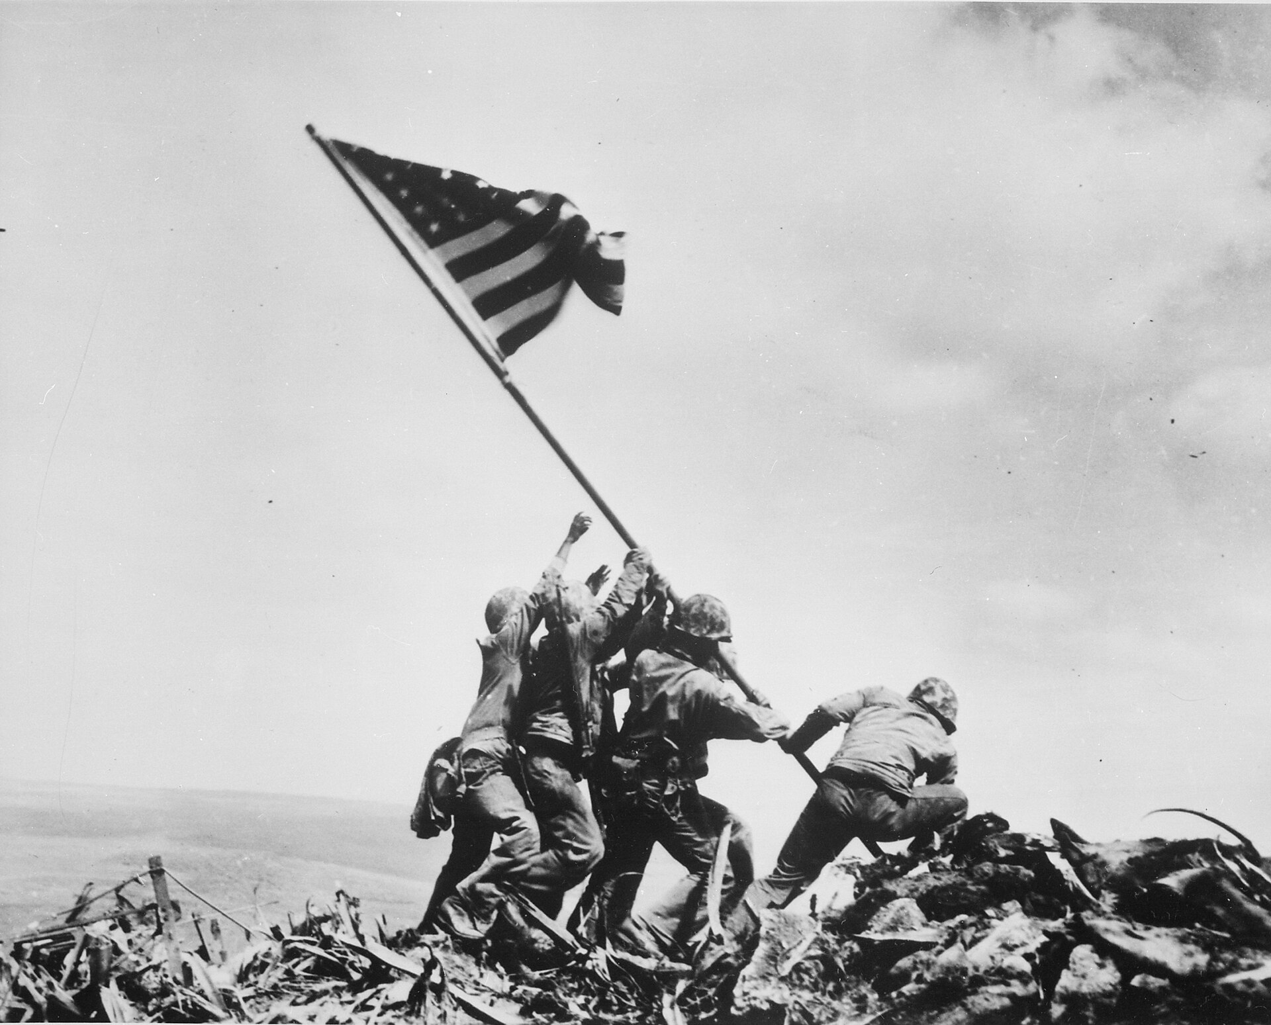
Raising the Flag on Iwo Jima (February 23, 1945) · Joe Rosenthal / Associated Press (remade from NARA File 520748) · February 23, 1945
Source: Rosenthal, Joe. "Raising the Flag on Iwo Jima." 23 Feb. 1945. Associated Press / National Archives and Records Administration, via Wikimedia Commons, commons.wikimedia.org/wiki/File:Raising_the_Flag_on_Iwo_Jima,_by_Joe_Rosenthal.jpg. Public Domain https://commons.wikimedia.org/wiki/File:Raising_the_Flag_on_Iwo_Jima,_by_Joe_Rosenthal.jpg
HIPPO — analyze the source (prompt) | Your analysis
H — Historical context: what was happening when this was created?
I — Intended audience: who was meant to see or obey it?
P — Purpose: why was it created?
P — Point of view: whose perspective does it reflect?
O — Outside connection: how does it connect to this standard?
SUPPORT OPTION
Sentence frame: This source shows ______ because it ______, which reveals ______.
CONFIDENCE CHECK-IN
Rate your understanding of this standard (1–4): ______ One thing to revisit: ____________________

Activity 6 — Core Application: Practice Quiz — US.50 ⏱ ~8 min
RESPONSE CHOICE
Commit to an answer by marking it, saying it, or explaining it aloud before checking. Answer key is in the Teacher Guide (kept separate).
[DOK 2 · item q-us50-dok2-1 · pre-field-test]
Why was the Battle of Midway significant in the Pacific War?
A. U.S. destroyed four carriers, halting Japanese expansion and shifting war momentum
B. June 6, 1944 Allied invasion of Normandy, the largest amphibious assault in history
C. First meeting of Big Three (Roosevelt, Churchill, Stalin) to coordinate war strategy
D. Longest continuous military campaign; Allied victory ensured supply lines to Britain
[DOK 2 · item q-us52-dok2-1 · pre-field-test]
How did WWII impact African Americans economically and socially?
A. African Americans were excluded from war industries and military service
B. Fair Employment opened defense jobs; segregated service led to 1948 integration
C. Economic conditions worsened with increased discrimination in defense employment nationwide
D. Military became more segregated with stricter racial separation policies enacted
[DOK 3 · item u1-us50-dok3-tc · pre-field-test]
How did geographic features of the Pacific islands affect American military strategy in battles like Midway and Iwo Jima?
A. Geography had no effect on Pacific strategy, though this interpretation lacks supporting historical evidence, although historical sources do not support this conclusion
B. Midway's central location made it strategically vital, while Iwo Jima's volcanic terrain created natural fortifications requiring costly direct assault to secure airfields needed for bombing Japan
C. All Pacific islands were geographically identical, which does not reflect the consensus among historians, but the historical evidence paints a more nuanced picture and does not reflect the scholarly consensus on this topic
D. American forces avoided geographic challenges entirely, which does not align with the documented historical record, and this view has been largely revised by modern historical research

Activity 7 — Constructed Response (CER) — US.50 ⏱ ~15 min
BIG-QUESTION ORGANIZER — in World War II, how did the war reshape America at home and its role in the world — and who sacrificed, even while being excluded?
Jot quick notes from THIS standard: Who benefited? · Who bore the costs? · Who decided?

CONSTRUCTED RESPONSE (CER) — builds SSP.04 Argumentation
Claim + Evidence + Reasoning: Using this standard, take a position on the central question — explain the role of geographic and military factors on the outcomes of battles in the Pacific and European theaters, including Midway, Iwo Jima, Okinawa, and D-Day? Support your claim with two pieces of evidence from the passage and explain your reasoning.
Part | Write here
Claim
Evidence (two specifics)
Reasoning
SELF-CHECK (CER rubric — see Toolkit)
Is my claim defensible? · TWO specific pieces of evidence? · Does my reasoning explain HOW the evidence proves the claim?
EXIT TICKET — before you leave [item us50-q2 · DOK 2 · pre-field-test]
What role did intelligence gathering and code-breaking play in Allied victories at Midway and D-Day?
A. Intelligence had no impact on these battles, despite limited evidence supporting this interpretation, which ignores significant political and cultural developments of the era
B. The Allies avoided using intelligence entirely, which contradicts the primary source evidence from this era, although this overlooks critical economic and social factors involved
C. Only the Axis powers used intelligence effectively, but this oversimplifies the complex factors at work, but contemporary accounts and primary sources suggest otherwise
D. Breaking Japanese codes revealed Midway attack plans enabling ambush, while deception operations convinced Germans the D-Day landing would come at Pas-de-Calais
Show what you know (your choice): mark the best answer, say it, or explain it — then rate how sure you are: ☐ Not yet ☐ Getting there ☐ Got it
Answer key and next steps are in the Teacher Guide.

Standard US.51 — Special Fighting Forces in WWII
TN Academic Standard US.51: Identify the roles and sacrifices of individual American soldiers, as well as the unique contributions of special fighting forces such as the Tuskegee Airmen, the 442nd Regimental Combat team, the 101st Airborne, and the Navajo Code Talkers.
LEARNING TARGETS — I can…
• I can identify the roles and sacrifices of individual American soldiers and the unique contributions of special fighting forces such as the Tuskegee Airmen, the 442nd Regimental Combat Team, the 101st Airborne, and the Navajo Code Talkers.
Lenses for this standard: History · Culture
CORE PATH — the same for every student
Same rigor for everyone: analyze the sources and vocabulary, then show what you learned on the Practice Quiz and the CER.
UDL and MTSS give you flexible ways in — they never lower the bar.
Check yourself against the learning targets on the Cornell Notes page.
★ Tennessee Connection
Tennessee's Fort Campbell, straddling the Tennessee-Kentucky border, became home to the 101st Airborne Division ('Screaming Eagles'), one of the most celebrated special fighting forces of WWII. The division's paratroopers jumped into Normandy on D-Day and fought through the Battle of the Bulge.
SET YOUR GOAL (self-direction)
My goal for this standard — what will I be able to do, and how will I show it?

HOOK — think before you dig in
Special Fighting Forces in WWII: Identify the roles and sacrifices of individual American soldiers, as well as the unique contributions of special fighting forces such as the Tuskegee Airmen, the 442nd Regimental Combat team, the 101st Airborne, and the Navajo Code Talkers. Who gained, who was left out — and why does it still matter?

ACTIVATE — what do you already know or wonder?
Jot what you already know or want to find out about this standard. You’ll come back to it.

PREVIEW & PREDICT
Which learning target will be hardest, and why? Connect it to the unit’s big question: how did the war change America at home and abroad, and who sacrificed even while excluded?

Activity 1 — Vocabulary (Part A: Reference / Word Bank) — US.51 ⏱ ~10 min
Use this word bank throughout the standard. The Spanish column supports access, not translation of assessment.
Term | Student-friendly meaning | Spanish
Tuskegee Airmen | First African American military pilots who fought in World War II, proving their skill despite facing racial discrimination and segregation. | Aviadores de Tuskegee
442nd Regimental Combat Team | All Japanese-American unit that became the most decorated unit in U.S. military history, fighting in Europe while their families were interned at home. | 442º Equipo de Combate Regimental
Navajo Code Talkers | Navajo Marines who used their native language to create an unbreakable code for military communications in the Pacific theater. | Descifradores de Código Navajo
Battle of Iwo Jima | February-March 1945 brutal battle for a strategic Pacific island, famous for the iconic flag-raising photograph on Mount Suribachi. | Batalla de Iwo Jima
Allied Powers | The World War II coalition led by the United States, Great Britain, and the Soviet Union that fought and defeated the Axis Powers. | Potencias Aliadas
Holocaust | Nazi Germany's systematic genocide of 6 million Jews and millions of others (Roma, disabled, homosexuals, political opponents) during World War II. | Holocausto
LANGUAGE SUPPORT
Pronunciations: Tuskegee Airmen (tus-KEE-gee AIR-men); 442nd Regimental Combat Team (for-for-tee-SEK-und rej-ih-MEN-tul); Navajo Code Talkers (NAV-uh-hoh kohd TAWK-erz); Battle of Iwo Jima (BAT-ul uv EE-woh JEE-muh); Allied Powers (AL-yd POW-erz); Holocaust (HOL-uh-kawst).
VOCABULARY SELF-CHECK · Knowledge Rating
Rate each term NOW in pencil, then again at the END — growth is the goal; no penalty for “never seen it.”
Term | 1 · never seen it | 2 · heard it | 3 · can use it | 4 · can teach it
Tuskegee Airmen
442nd Regimental Combat Team
Navajo Code Talkers
Battle of Iwo Jima
Allied Powers
Holocaust
MAKE IT YOURS (RESPONSE CHOICE): choose ONE term above and show you own it — write a sentence, sketch it, or give a real-world example.

Activity 2 — Vocabulary Studio (Frayer-inspired) — US.51 ⏱ ~7 min
RESPONSE CHOICE
Complete each studio by writing, speaking, or diagramming.

PRIORITY TERM 1 Tuskegee Airmen · ES: Aviadores de Tuskegee
Word-bank meaning to build on: First African American military pilots who fought in World War II, proving their skill despite facing racial discrimination and segregation.
Definition (in your own words) | Characteristics
Examples | Non-examples
Use it to explain
Write one sentence that uses “Tuskegee Airmen” to explain this standard.

PRIORITY TERM 2 442nd Regimental Combat Team · ES: 442º Equipo de Combate Regimental
Word-bank meaning to build on: All Japanese-American unit that became the most decorated unit in U.S. military history, fighting in Europe while their families were interned at home.
Definition (in your own words) | Characteristics
Examples | Non-examples
Use it to explain
Write one sentence that uses “442nd Regimental Combat Team” to explain this standard.

CONNECT THE TERMS (UDL · build understanding)
How do these priority terms fit together? Write or sketch how one leads to or affects another.

Activity 3 — Direct Teaching Cornell Notes — US.51 ⏱ ~20 min
Name: ______________________ Class / Period: __________ Date: __________
US.51 — Special Fighting Forces in WWII • These notes capture the direct-teaching content and the Close Read for this standard.
Your learning targets are on this standard’s opening page — take notes that help you meet them.
Cues (tied to your learning targets) | My notes
What does the passage say about tuskegee Airmen?
What does the passage say about 442nd Regimental Combat Team?
What does the passage say about 101st Airborne Division?
Key terms →
DOODLE ZONE — draw your thinking (UDL · another way in)
Need another way in? Sketch the key idea, a quick timeline, or how the pieces connect. Words optional.

Cornell Notes — keep going, then process & check — US.51
MORE NOTES / DIAGRAMS
Continue your notes here, add a quick sketch, or map how the ideas connect.

Key terms to list
Tuskegee Airmen · 442nd Regimental Combat Team · Navajo Code Talkers · Battle of Iwo Jima · Allied Powers · Holocaust
Summary — In your own words (2–3 sentences)
PROGRESS CHECK · one question
Why is the service of the 442nd Regimental Combat Team particularly significant given the internment of Japanese Americans?
A. Their service had no connection to internment policies, but the historical record tells a more complex story, and this view has been largely revised by modern historical research
B. The 442nd was composed of non-Japanese American soldiers, but this fails to account for the broader historical context, but the historical evidence paints a more nuanced picture
C. Japanese American soldiers volunteered to fight for a country that imprisoned their families, becoming the most decorated unit of their size while proving their loyalty despite profound injustice
D. They served only in the Pacific theater, but this fails to account for the broader historical context and does not reflect the scholarly consensus on this topic, which contradicts the primary source evidence from this era
Commit before you move on — mark it, say it, or explain it aloud.
CHECK YOURSELF — how am I doing?
Which learning targets (on this standard’s opening page) can you now meet? Tick the number; circle any you still need help with.
☐ 1
My 12–15 word headline for this standard

Activity 4 — Close Read — US.51 ⏱ ~15 min
Reading type: History Hack-authored instructional synthesis. This is not a primary source. Builds SSP.03 (synthesize) and SSP.05 (historical awareness).
CORE PATH — read one chunk at a time
Tuskegee Airmen
The Tuskegee Airmen were the first African American military aviators in the U.S. Armed Forces. Trained at Tuskegee Army Air Field in Alabama, the 332nd Fighter Group flew over 15,000 sorties in Europe and North Africa. They earned over 150 Distinguished Flying Crosses and a Presidential Unit Citation. Despite facing racism and segregation within the military, they compiled an outstanding combat record, helping to pave the way for the desegregation of the armed forces in 1948.
442nd Regimental Combat Team
The 442nd was composed almost entirely of Japanese American volunteers, many of whose families were confined in internment camps. Fighting in Europe, they became the most decorated unit of their size in U.S. military history, earning over 18,000 individual decorations including 21 Medals of Honor. Their motto "Go for Broke" reflected their determination to prove their loyalty to America despite the government's unjust treatment of their families.
101st Airborne Division
The "Screaming Eagles" of the 101st Airborne Division parachuted into Normandy on D-Day, June 6, 1944, securing key bridges and crossroads behind enemy lines to support the beach landings. They later defended Bastogne during the Battle of the Bulge, where Acting Commander General Anthony McAuliffe famously replied "Nuts!" to a German surrender demand. Their elite training and courage under fire made them one of the most celebrated units in American military history.
Navajo Code Talkers
Navajo Marines developed an unbreakable military code based on their native language, which had no written form and was virtually unknown outside the Navajo Nation. Code Talkers served in every major Marine operation in the Pacific from 1942-1945, transmitting battlefield communications that the Japanese never deciphered. Their contributions were so vital that commanders credited them with the success at Iwo Jima. Their service remained classified until 1968 and was formally recognized with Congressional Gold Medals in 2001.
Individual Sacrifice and Legacy
These special fighting forces demonstrated extraordinary courage while often fighting two wars—one against foreign enemies and another against discrimination at home. Their sacrifices challenged racial prejudices, proved that patriotism transcended race and ethnicity, and contributed to post-war civil rights advances. Veterans of these units became leaders in their communities and advocates for equality, using their military records to demand the rights they had fought to defend.
Key terms first: Tuskegee Airmen, 442nd Regimental Combat Team. Read once for the gist, then again for evidence.
CLOSE-READ EVIDENCE LAB — for each question: quote the EVIDENCE from the passage above, then write YOUR ANSWER (or answer aloud / diagram it).
Text-dependent question | Evidence from the passage | Your answer (what it shows)
What is the main idea of the “Tuskegee Airmen” section, and what evidence supports it?
What is the main idea of the “442nd Regimental Combat Team” section, and what evidence supports it?

Activity 5 — Primary Source / Data Analysis — US.51 ⏱ ~15 min
Primary source (photograph) — analyze it with HIPPO. Builds SSP.01–SSP.02.
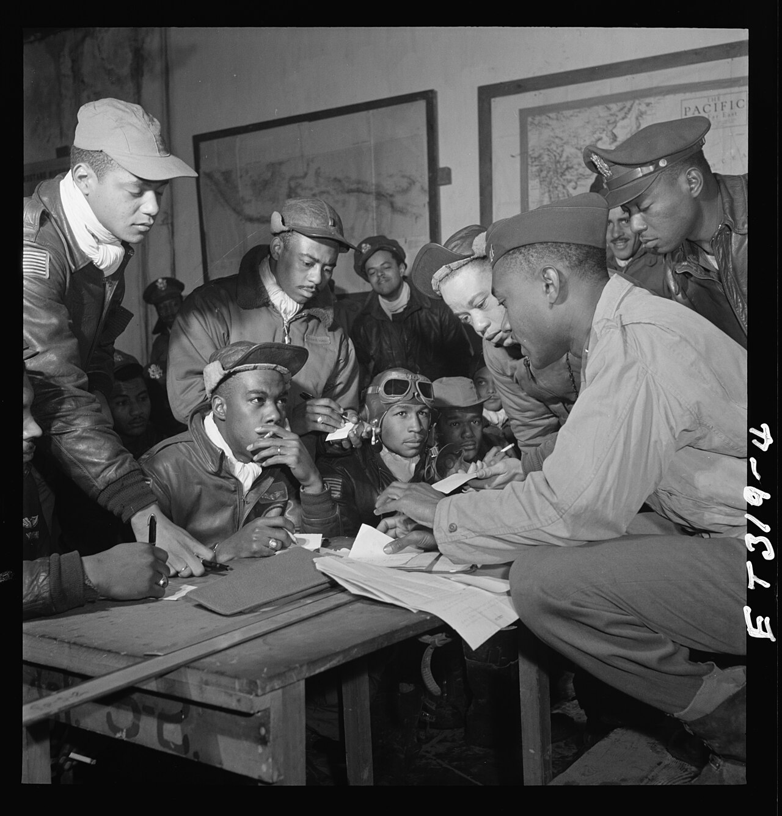
Tuskegee Airmen, 332nd Fighter Group, Ramitelli, Italy (March 1945) · Toni Frissell / Library of Congress, Toni Frissell Collection · March 1945
Source: Frissell, Toni. "Tuskegee Airmen, 332nd Fighter Group, Ramitelli, Italy." Mar. 1945. Library of Congress, Prints and Photographs Division, Toni Frissell Collection, commons.wikimedia.org/wiki/File:Tuskegee_airmen_2_original.jpg. Public Domain https://commons.wikimedia.org/wiki/File:Tuskegee_airmen_2_original.jpg
HIPPO — analyze the source (prompt) | Your analysis
H — Historical context: what was happening when this was created?
I — Intended audience: who was meant to see or obey it?
P — Purpose: why was it created?
P — Point of view: whose perspective does it reflect?
O — Outside connection: how does it connect to this standard?
SUPPORT OPTION
Sentence frame: This source shows ______ because it ______, which reveals ______.
CONFIDENCE CHECK-IN
Rate your understanding of this standard (1–4): ______ One thing to revisit: ____________________

Activity 6 — Core Application: Practice Quiz — US.51 ⏱ ~8 min
RESPONSE CHOICE
Commit to an answer by marking it, saying it, or explaining it aloud before checking. Answer key is in the Teacher Guide (kept separate).
[DOK 2 · item us51-q3 · pre-field-test]
How did the Navajo Code Talkers use their cultural heritage to create an unbreakable military communication system?
A. They developed a code based on the Navajo language, which had no written form and was unknown to the enemy, providing unbreakable battlefield communications throughout the Pacific war
B. The code was eventually broken by the Japanese, but the historical record tells a more complex story and does not reflect the scholarly consensus on this topic
C. They used standard military codes translated into Navajo, although this view has been largely discredited by scholars, but contemporary accounts and primary sources suggest otherwise
D. Code Talkers served only in a single battle, which ignores key developments that shaped the outcome, which ignores significant political and cultural developments of the era
[DOK 2 · item q-us52-dok2-1 · pre-field-test]
How did WWII impact African Americans economically and socially?
A. African Americans were excluded from war industries and military service
B. Fair Employment opened defense jobs; segregated service led to 1948 integration
C. Economic conditions worsened with increased discrimination in defense employment nationwide
D. Military became more segregated with stricter racial separation policies enacted
[DOK 3 · item u1-us51-dok3-tc · pre-field-test]
Why is the service of the 442nd Regimental Combat Team particularly significant given the internment of Japanese Americans?
A. Their service had no connection to internment policies, but the historical record tells a more complex story, and this view has been largely revised by modern historical research
B. The 442nd was composed of non-Japanese American soldiers, but this fails to account for the broader historical context, but the historical evidence paints a more nuanced picture
C. Japanese American soldiers volunteered to fight for a country that imprisoned their families, becoming the most decorated unit of their size while proving their loyalty despite profound injustice
D. They served only in the Pacific theater, but this fails to account for the broader historical context and does not reflect the scholarly consensus on this topic, which contradicts the primary source evidence from this era

Activity 7 — Constructed Response (CER) — US.51 ⏱ ~15 min
BIG-QUESTION ORGANIZER — in World War II, how did the war reshape America at home and its role in the world — and who sacrificed, even while being excluded?
Jot quick notes from THIS standard: Who benefited? · Who bore the costs? · Who decided?

CONSTRUCTED RESPONSE (CER) — builds SSP.04 Argumentation
Claim + Evidence + Reasoning: Using this standard, take a position on the central question — identify the roles and sacrifices of individual American soldiers and the unique contributions of special fighting forces such as the Tuskegee Airmen, the 442nd Regimental Combat Team, the 101st Airborne, and the Navajo Code Talkers? Support your claim with two pieces of evidence from the passage and explain your reasoning.
Part | Write here
Claim
Evidence (two specifics)
Reasoning
SELF-CHECK (CER rubric — see Toolkit)
Is my claim defensible? · TWO specific pieces of evidence? · Does my reasoning explain HOW the evidence proves the claim?
EXIT TICKET — before you leave [item us51-q1 · DOK 2 · pre-field-test]
What unique contributions did the Tuskegee Airmen make to the war effort, and how did their service challenge racial barriers?
A. They flew over 15,000 sorties, earned 150+ Distinguished Flying Crosses, and their outstanding record despite segregation helped pave the way for military desegregation
B. The Tuskegee Airmen had minimal impact on the war, which represents a common misconception about the period, which contradicts the primary source evidence from this era
C. They only served in non-combat roles, though this interpretation lacks supporting historical evidence, although historical sources do not support this conclusion
D. Their contributions were not recognized until the 21st century, but contemporary accounts suggest a different explanation, which does not align with the documented historical record
Show what you know (your choice): mark the best answer, say it, or explain it — then rate how sure you are: ☐ Not yet ☐ Getting there ☐ Got it
Answer key and next steps are in the Teacher Guide.

Standard US.52 — Women in World War II
TN Academic Standard US.52: Examine and explain the entry of large numbers of women into the workforce and armed forces during World War II and the subsequent impact on American society.
LEARNING TARGETS — I can…
• I can examine and explain the entry of large numbers of women into the workforce and armed forces during World War II and the subsequent impact on American society.
Lenses for this standard: History · Economics · Culture
CORE PATH — the same for every student
Same rigor for everyone: analyze the sources and vocabulary, then show what you learned on the Practice Quiz and the CER.
UDL and MTSS give you flexible ways in — they never lower the bar.
Check yourself against the learning targets on the Cornell Notes page.
★ Tennessee Connection
Tennessee women entered the workforce in unprecedented numbers during WWII. At Oak Ridge, women made up a significant portion of the workforce — many operating calutrons to enrich uranium without knowing the full nature of their work. Tennessee women also served in the WAC, WAVES, and as nurses overseas.
SET YOUR GOAL (self-direction)
My goal for this standard — what will I be able to do, and how will I show it?

HOOK — think before you dig in
Women in World War II: Examine and explain the entry of large numbers of women into the workforce and armed forces during World War II and the subsequent impact on American society. Who gained, who was left out — and why does it still matter?

ACTIVATE — what do you already know or wonder?
Jot what you already know or want to find out about this standard. You’ll come back to it.

PREVIEW & PREDICT
Which learning target will be hardest, and why? Connect it to the unit’s big question: how did the war change America at home and abroad, and who sacrificed even while excluded?

Activity 1 — Vocabulary (Part A: Reference / Word Bank) — US.52 ⏱ ~10 min
Use this word bank throughout the standard. The Spanish column supports access, not translation of assessment.
Term | Student-friendly meaning | Spanish
Rosie the Riveter | Cultural icon representing millions of American women who worked in factories and shipyards during World War II, filling jobs left by men who went to war. | Rosie la Remachadora
Tuskegee Airmen | First African American military pilots who fought in World War II, proving their skill despite facing racial discrimination and segregation. | Aviadores de Tuskegee
Rationing | Government-controlled limits on consumer goods during WWII to ensure adequate supplies for the military, requiring ration books and coupons. | Racionamiento
War Bonds | Government bonds sold to citizens to finance the war effort, promoted through massive publicity campaigns featuring celebrities and patriotic appeals. | Bonos de Guerra
Allied Powers | The World War II coalition led by the United States, Great Britain, and the Soviet Union that fought and defeated the Axis Powers. | Potencias Aliadas
442nd Regimental Combat Team | All Japanese-American unit that became the most decorated unit in U.S. military history, fighting in Europe while their families were interned at home. | 442º Equipo de Combate Regimental
LANGUAGE SUPPORT
Pronunciations: Rosie the Riveter (ROH-zee thuh RIV-eh-ter); Tuskegee Airmen (tus-KEE-gee AIR-men); Rationing (RASH-un-ing); War Bonds (wor bondz); Allied Powers (AL-yd POW-erz); 442nd Regimental Combat Team (for-for-tee-SEK-und rej-ih-MEN-tul).
VOCABULARY SELF-CHECK · Knowledge Rating
Rate each term NOW in pencil, then again at the END — growth is the goal; no penalty for “never seen it.”
Term | 1 · never seen it | 2 · heard it | 3 · can use it | 4 · can teach it
Rosie the Riveter
Tuskegee Airmen
Rationing
War Bonds
Allied Powers
442nd Regimental Combat Team
MAKE IT YOURS (RESPONSE CHOICE): choose ONE term above and show you own it — write a sentence, sketch it, or give a real-world example.

Activity 2 — Vocabulary Studio (Frayer-inspired) — US.52 ⏱ ~7 min
RESPONSE CHOICE
Complete each studio by writing, speaking, or diagramming.

PRIORITY TERM 1 Rosie the Riveter · ES: Rosie la Remachadora
Word-bank meaning to build on: Cultural icon representing millions of American women who worked in factories and shipyards during World War II, filling jobs left by men who went to war.
Definition (in your own words) | Characteristics
Examples | Non-examples
Use it to explain
Write one sentence that uses “Rosie the Riveter” to explain this standard.

PRIORITY TERM 2 Tuskegee Airmen · ES: Aviadores de Tuskegee
Word-bank meaning to build on: First African American military pilots who fought in World War II, proving their skill despite facing racial discrimination and segregation.
Definition (in your own words) | Characteristics
Examples | Non-examples
Use it to explain
Write one sentence that uses “Tuskegee Airmen” to explain this standard.

CONNECT THE TERMS (UDL · build understanding)
How do these priority terms fit together? Write or sketch how one leads to or affects another.

Activity 3 — Direct Teaching Cornell Notes — US.52 ⏱ ~20 min
Name: ______________________ Class / Period: __________ Date: __________
US.52 — Women in World War II • These notes capture the direct-teaching content and the Close Read for this standard.
Your learning targets are on this standard’s opening page — take notes that help you meet them.
Cues (tied to your learning targets) | My notes
What does the passage say about factors Leading to Women's Participation?
What does the passage say about challenges and Opportunities?
What does the passage say about impact on Production and Economy?
Key terms →
DOODLE ZONE — draw your thinking (UDL · another way in)
Need another way in? Sketch the key idea, a quick timeline, or how the pieces connect. Words optional.

Cornell Notes — keep going, then process & check — US.52
MORE NOTES / DIAGRAMS
Continue your notes here, add a quick sketch, or map how the ideas connect.

Key terms to list
Rosie the Riveter · Tuskegee Airmen · Rationing · War Bonds · Allied Powers · 442nd Regimental Combat Team
Summary — In your own words (2–3 sentences)
PROGRESS CHECK · one question
How did "Rosie the Riveter" symbolize both opportunities and challenges facing working women?
A. Rosie only represented challenges women faced, despite limited evidence supporting this interpretation, which does not align with the documented historical record
B. Rosie represented only wealthy women, which does not reflect the consensus among historians despite the fact that multiple contemporary sources contradict this and does not reflect the scholarly consensus on this topic
C. The symbol had no cultural significance, which contradicts the primary source evidence from this era, but closer analysis reveals a more complicated historical reality
D. Rosie symbolized women's capability and patriotic duty while obscuring challenges like lower pay, discrimination, inadequate childcare, and expectations to maintain domestic responsibilities
Commit before you move on — mark it, say it, or explain it aloud.
CHECK YOURSELF — how am I doing?
Which learning targets (on this standard’s opening page) can you now meet? Tick the number; circle any you still need help with.
☐ 1
My 12–15 word headline for this standard

Activity 4 — Close Read — US.52 ⏱ ~15 min
Reading type: History Hack-authored instructional synthesis. This is not a primary source. Builds SSP.03 (synthesize) and SSP.05 (historical awareness).
CORE PATH — read one chunk at a time
Factors Leading to Women's Participation
With 16 million men serving in the armed forces, a massive labor shortage emerged as war production required doubling the manufacturing workforce. Government campaigns like "Rosie the Riveter" recruited women, while economic necessity pushed many families to rely on women's income. Women in the workforce grew from 12 million (1940) to 20 million (1945), comprising 36% of the civilian workforce. Women made up 65% of aircraft industry workers by war's end.
Challenges and Opportunities
Women faced discrimination including lower pay (about 65% of men's wages), dangerous conditions, long hours, and inadequate facilities. Social challenges included limited childcare, expectations to maintain domestic duties, and criticism for abandoning traditional roles. However, women gained economic independence, learned technical skills, some achieved supervisory positions, and military service provided professional training in communications, mechanics, and aviation.
Impact on Production and Economy
Women built bombers, fighters, and transport planes; constructed Liberty ships; manufactured ammunition and explosives; and assembled radios and radar equipment. Women's entry helped achieve record production levels—296,000 aircraft, 86,000 tanks, 2.3 million trucks. This contribution was essential to Allied victory, demonstrating women's capabilities in technical and leadership roles previously reserved for men.
Long-term Effects on Society
After the war, many women were laid off to make room for returning veterans, and social pressure emphasized homemaking and motherhood. However, women's labor force participation never returned to pre-war levels. The experience provided foundation for the women's rights movement of the 1960s-70s, established precedents for equal employment opportunities, and created pathways for women in previously male professions. Military services became permanent parts of armed forces.
Key terms first: Rosie the Riveter, Tuskegee Airmen. Read once for the gist, then again for evidence.
CLOSE-READ EVIDENCE LAB — for each question: quote the EVIDENCE from the passage above, then write YOUR ANSWER (or answer aloud / diagram it).
Text-dependent question | Evidence from the passage | Your answer (what it shows)
What is the main idea of the “Factors Leading to Women's Participation” section, and what evidence supports it?
What is the main idea of the “Challenges and Opportunities” section, and what evidence supports it?
What is the main idea of the “Impact on Production and Economy” section, and what evidence supports it?

Activity 5 — Primary Source / Data Analysis — US.52 ⏱ ~15 min
Primary source (photograph) — analyze it with HIPPO. Builds SSP.01–SSP.02.
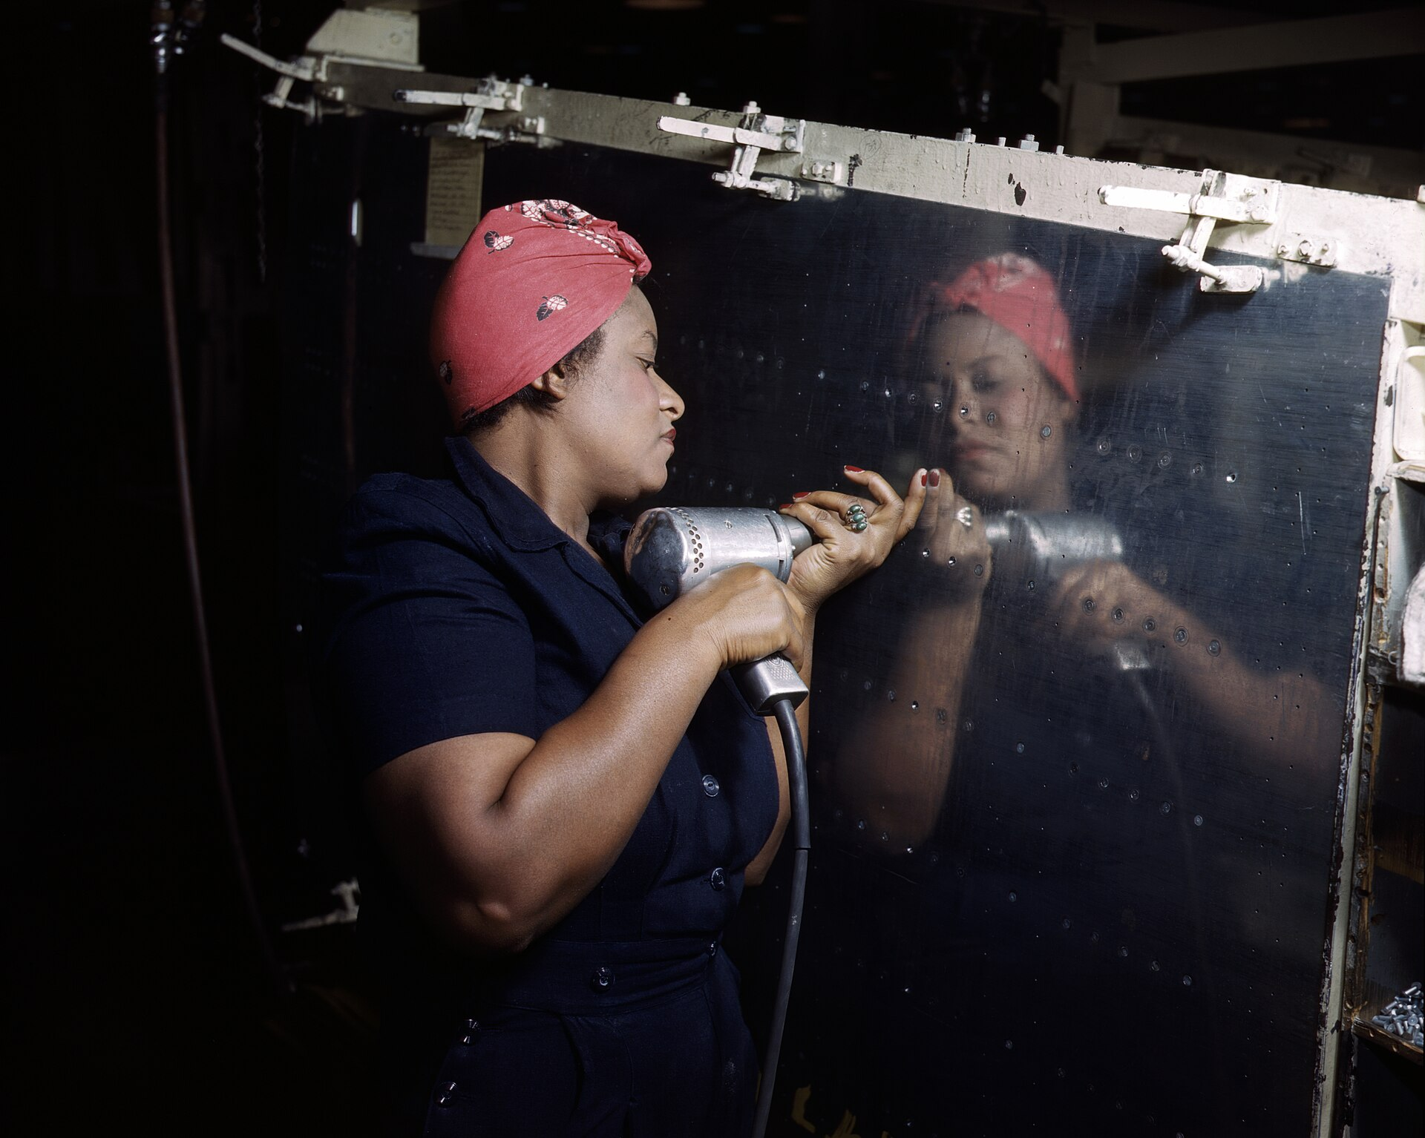
Operating a Hand Drill at Vultee-Nashville, Woman is Working on a ‘Vengeance’ Dive Bomber, Tennessee (February 1943) · Alfred T. Palmer / U.S. Office of War Information (OWI) / Farm Security Administration · February 1943
Source: Palmer, Alfred T. "Operating a Hand Drill at Vultee-Nashville, Woman Working on a Vengeance Dive Bomber, Tennessee." Feb. 1943. Library of Congress, Prints and Photographs Division, FSA/OWI Color Photographs Collection (LC-USW36-295), www.loc.gov/item/2017878540/. Public Domain https://www.loc.gov/item/2017878540/
HIPPO — analyze the source (prompt) | Your analysis
H — Historical context: what was happening when this was created?
I — Intended audience: who was meant to see or obey it?
P — Purpose: why was it created?
P — Point of view: whose perspective does it reflect?
O — Outside connection: how does it connect to this standard?
SUPPORT OPTION
Sentence frame: This source shows ______ because it ______, which reveals ______.
CONFIDENCE CHECK-IN
Rate your understanding of this standard (1–4): ______ One thing to revisit: ____________________

Activity 6 — Core Application: Practice Quiz — US.52 ⏱ ~8 min
RESPONSE CHOICE
Commit to an answer by marking it, saying it, or explaining it aloud before checking. Answer key is in the Teacher Guide (kept separate).
[DOK 2 · item q-us46-dok2-5 · pre-field-test]
How did the New Deal affect women's roles in society and government?
A. More women appointed to government positions; Eleanor Roosevelt championed women's issues
B. Made government responsible for economic security through regulation, insurance, and jobs
C. Government spending was not large enough; unemployment stayed high until WWII mobilization
D. Received some relief but faced discrimination; certain programs excluded them or paid less
[DOK 2 · item q-us53-dok2-1 · pre-field-test]
How did WWII change women's roles in American society?
A. Saw minimal changes with most continuing traditional household responsibilities exclusively
B. Entered workforce in record numbers, gained independence, and challenged gender roles
C. Were restricted to traditional domestic roles and prohibited from factory work
D. Worked primarily in clerical positions while men dominated war industries
[DOK 3 · item u1-us52-dok3-tc · pre-field-test]
How did "Rosie the Riveter" symbolize both opportunities and challenges facing working women?
A. Rosie only represented challenges women faced, despite limited evidence supporting this interpretation, which does not align with the documented historical record
B. Rosie represented only wealthy women, which does not reflect the consensus among historians despite the fact that multiple contemporary sources contradict this and does not reflect the scholarly consensus on this topic
C. The symbol had no cultural significance, which contradicts the primary source evidence from this era, but closer analysis reveals a more complicated historical reality
D. Rosie symbolized women's capability and patriotic duty while obscuring challenges like lower pay, discrimination, inadequate childcare, and expectations to maintain domestic responsibilities

Activity 7 — Constructed Response (CER) — US.52 ⏱ ~15 min
BIG-QUESTION ORGANIZER — in World War II, how did the war reshape America at home and its role in the world — and who sacrificed, even while being excluded?
Jot quick notes from THIS standard: Who benefited? · Who bore the costs? · Who decided?

CONSTRUCTED RESPONSE (CER) — builds SSP.04 Argumentation
Claim + Evidence + Reasoning: Using this standard, take a position on the central question — examine and explain the entry of large numbers of women into the workforce and armed forces during World War II and the subsequent impact on American society? Support your claim with two pieces of evidence from the passage and explain your reasoning.
Part | Write here
Claim
Evidence (two specifics)
Reasoning
SELF-CHECK (CER rubric — see Toolkit)
Is my claim defensible? · TWO specific pieces of evidence? · Does my reasoning explain HOW the evidence proves the claim?
EXIT TICKET — before you leave [item us52-q1 · DOK 2 · pre-field-test]
What factors led to the massive entry of women into the workforce and armed forces during WWII?
A. Women chose to work for personal fulfillment alone, but the historical record tells a more complex story, but the historical evidence paints a more nuanced picture and oversimplifies the complex factors at work during this period
B. The labor shortage from 16 million men in military service, government recruitment campaigns like "Rosie the Riveter," war production demands, and family economic necessity drove women into the workforce
C. Women were forced into work against their will, which contradicts the primary source evidence from this era, which ignores significant political and cultural developments of the era
D. Only a small number of women entered the workforce, yet the available evidence points to a different conclusion and fails to account for key developments in the broader context
Show what you know (your choice): mark the best answer, say it, or explain it — then rate how sure you are: ☐ Not yet ☐ Getting there ☐ Got it
Answer key and next steps are in the Teacher Guide.

Standard US.53 — African Americans in WWII
TN Academic Standard US.53: Examine the impact of World War II on economic and social conditions for African Americans, including the Fair Employment Practices Committee and the eventual integration of the armed forces by President Harry S. Truman. (TCA)
LEARNING TARGETS — I can…
• I can examine the impact of World War II on economic and social conditions for African Americans, including the Fair Employment Practices Committee and the eventual integration of the armed forces by President Truman.
Lenses for this standard: History · Culture · Economics · Tennessee Connection
CORE PATH — the same for every student
Same rigor for everyone: analyze the sources and vocabulary, then show what you learned on the Practice Quiz and the CER.
UDL and MTSS give you flexible ways in — they never lower the bar.
Check yourself against the learning targets on the Cornell Notes page.
★ Tennessee Connection
African Americans in Tennessee contributed significantly to the war effort despite facing segregation. The Fair Employment Practices Committee impacted Tennessee war industries, and African American soldiers from Tennessee served in segregated units. After the war, returning Black veterans became leaders in Tennessee's civil rights movement.
SET YOUR GOAL (self-direction)
My goal for this standard — what will I be able to do, and how will I show it?

HOOK — think before you dig in
African Americans in WWII: Examine the impact of World War II on economic and social conditions for African Americans, including the Fair Employment Practices Committee and the eventual integration of the armed forces by President Harry S. Truman. (TCA). Who gained, who was left out — and why does it still matter?

ACTIVATE — what do you already know or wonder?
Jot what you already know or want to find out about this standard. You’ll come back to it.

PREVIEW & PREDICT
Which learning target will be hardest, and why? Connect it to the unit’s big question: how did the war change America at home and abroad, and who sacrificed even while excluded?

Activity 1 — Vocabulary (Part A: Reference / Word Bank) — US.53 ⏱ ~10 min
Use this word bank throughout the standard. The Spanish column supports access, not translation of assessment.
Term | Student-friendly meaning | Spanish
Executive Order 8802 | The June 1941 order signed by President Roosevelt banning racial discrimination in the defense industry and creating the Fair Employment Practices Committee. | Orden Ejecutiva 8802
Double V Campaign | A World War II campaign led by the Black press calling for a 'Double Victory' - over fascism abroad and racial discrimination at home. | Campaña de la Doble V
Tuskegee Airmen | First African American military pilots who fought in World War II, proving their skill despite facing racial discrimination and segregation. | Aviadores de Tuskegee
Rosie the Riveter | Cultural icon representing millions of American women who worked in factories and shipyards during World War II, filling jobs left by men who went to war. | Rosie la Remachadora
Rationing | Government-controlled limits on consumer goods during WWII to ensure adequate supplies for the military, requiring ration books and coupons. | Racionamiento
War Bonds | Government bonds sold to citizens to finance the war effort, promoted through massive publicity campaigns featuring celebrities and patriotic appeals. | Bonos de Guerra
LANGUAGE SUPPORT
Pronunciations: Executive Order 8802 (eg-ZEK-yuh-tiv OR-der); Double V Campaign (DUB-ul vee kam-PAYN); Tuskegee Airmen (tus-KEE-gee AIR-men); Rosie the Riveter (ROH-zee thuh RIV-eh-ter); Rationing (RASH-un-ing); War Bonds (wor bondz).
VOCABULARY SELF-CHECK · Knowledge Rating
Rate each term NOW in pencil, then again at the END — growth is the goal; no penalty for “never seen it.”
Term | 1 · never seen it | 2 · heard it | 3 · can use it | 4 · can teach it
Executive Order 8802
Double V Campaign
Tuskegee Airmen
Rosie the Riveter
Rationing
War Bonds
MAKE IT YOURS (RESPONSE CHOICE): choose ONE term above and show you own it — write a sentence, sketch it, or give a real-world example.

Activity 2 — Vocabulary Studio (Frayer-inspired) — US.53 ⏱ ~7 min
RESPONSE CHOICE
Complete each studio by writing, speaking, or diagramming.

PRIORITY TERM 1 Executive Order 8802 · ES: Orden Ejecutiva 8802
Word-bank meaning to build on: The June 1941 order signed by President Roosevelt banning racial discrimination in the defense industry and creating the Fair Employment Practices Committee.
Definition (in your own words) | Characteristics
Examples | Non-examples
Use it to explain
Write one sentence that uses “Executive Order 8802” to explain this standard.

PRIORITY TERM 2 Double V Campaign · ES: Campaña de la Doble V
Word-bank meaning to build on: A World War II campaign led by the Black press calling for a 'Double Victory' - over fascism abroad and racial discrimination at home.
Definition (in your own words) | Characteristics
Examples | Non-examples
Use it to explain
Write one sentence that uses “Double V Campaign” to explain this standard.

CONNECT THE TERMS (UDL · build understanding)
How do these priority terms fit together? Write or sketch how one leads to or affects another.

Activity 3 — Direct Teaching Cornell Notes — US.53 ⏱ ~20 min
Name: ______________________ Class / Period: __________ Date: __________
US.53 — African Americans in WWII • These notes capture the direct-teaching content and the Close Read for this standard.
Your learning targets are on this standard’s opening page — take notes that help you meet them.
Cues (tied to your learning targets) | My notes
What does the passage say about second Great Migration and Economic Opportunities?
What does the passage say about double V Campaign and Wartime Experiences?
What does the passage say about fair Employment Practices Committee (FEPC)?
Key terms →
DOODLE ZONE — draw your thinking (UDL · another way in)
Need another way in? Sketch the key idea, a quick timeline, or how the pieces connect. Words optional.

Cornell Notes — keep going, then process & check — US.53
MORE NOTES / DIAGRAMS
Continue your notes here, add a quick sketch, or map how the ideas connect.

Key terms to list
Executive Order 8802 · Double V Campaign · Tuskegee Airmen · Rosie the Riveter · Rationing · War Bonds
Summary — In your own words (2–3 sentences)
PROGRESS CHECK · one question
What was the "Double V" campaign, and how did it connect the fight against fascism abroad with civil rights at home?
A. The Pittsburgh Courier's campaign demanded victory over fascism abroad and over racism at home, arguing that fighting for democracy overseas exposed the contradiction of denying democracy to Black Americans
B. It focused only on military victory, although this view has been largely discredited by scholars, which does not align with the documented historical record, which represents a common misconception about this historical period
C. It supported segregation, though this interpretation lacks supporting historical evidence, though this interpretation lacks supporting historical evidence, but closer analysis reveals a more complicated historical reality
D. It had no connection to civil rights, which ignores key developments that shaped the outcome, which represents a common misconception about this historical period, although historical sources do not support this conclusion
Commit before you move on — mark it, say it, or explain it aloud.
CHECK YOURSELF — how am I doing?
Which learning targets (on this standard’s opening page) can you now meet? Tick the number; circle any you still need help with.
☐ 1
My 12–15 word headline for this standard

Activity 4 — Close Read — US.53 ⏱ ~15 min
Reading type: History Hack-authored instructional synthesis. This is not a primary source. Builds SSP.03 (synthesize) and SSP.05 (historical awareness).
CORE PATH — read one chunk at a time
Second Great Migration and Economic Opportunities
1.5 million African Americans moved North and West during the 1940s to cities like Detroit, Chicago, and Los Angeles. Defense industries offered higher wages than Southern agriculture, and average Black family income doubled during the war. However, discrimination persisted—many employers refused to hire African Americans, job segregation confined Black workers to lowest-paying positions, and limited advancement opportunities existed.
Double V Campaign and Wartime Experiences
The Pittsburgh Courier promoted the "Double V" campaign—victory against fascism abroad and racism at home. One million African Americans served in segregated armed forces, facing prejudice and unequal treatment even while fighting for democracy. NAACP membership grew from 50,000 to 450,000 during the war. War rhetoric about democracy and freedom raised consciousness about civil rights contradictions in American society.
Fair Employment Practices Committee (FEPC)
A. Philip Randolph threatened a 100,000-person march on Washington, pressuring FDR to issue Executive Order 8802 (June 25, 1941) creating the FEPC. The committee investigated discrimination complaints from defense workers and held public hearings exposing discriminatory practices. Though it could only make recommendations without enforcement power, the FEPC established the principle of federal intervention in employment discrimination and laid groundwork for later civil rights agencies.
Integration of Armed Forces
Executive Order 9981 (1948) by President Truman ordered desegregation of the armed forces, citing merit and fairness. Implementation was gradual but historic, representing the first major federal civil rights action of the post-war era. The order built on WWII service records of units like the Tuskegee Airmen and 761st Tank Battalion, which had proven African American military capability. Military integration became a model for later civilian desegregation efforts.
Key terms first: Executive Order 8802, Double V Campaign. Read once for the gist, then again for evidence.
CLOSE-READ EVIDENCE LAB — for each question: quote the EVIDENCE from the passage above, then write YOUR ANSWER (or answer aloud / diagram it).
Text-dependent question | Evidence from the passage | Your answer (what it shows)
What is the main idea of the “Second Great Migration and Economic Opportunities” section, and what evidence supports it?
What is the main idea of the “Double V Campaign and Wartime Experiences” section, and what evidence supports it?
What is the main idea of the “Fair Employment Practices Committee (FEPC)” section, and what evidence supports it?

Activity 5 — Primary Source / Data Analysis — US.53 ⏱ ~15 min
Primary source (photograph) — analyze it with HIPPO. Builds SSP.01–SSP.02.
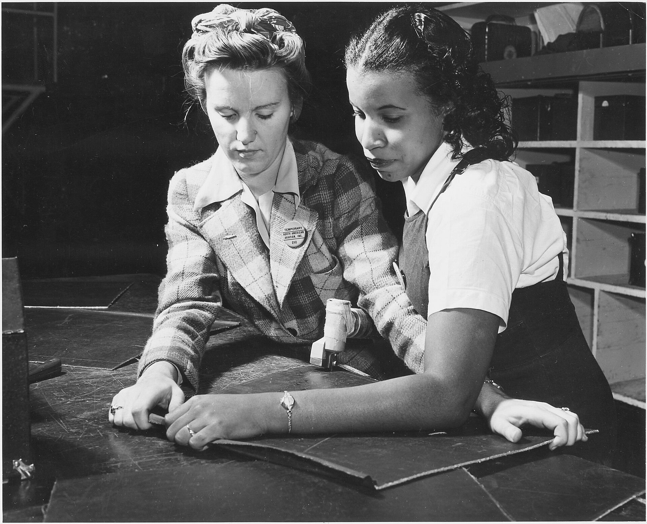
"White" & "Black" Work Side by Side — North American Aviation Co. Plant (c. 1942) · Unknown / U.S. Army Signal Corps / Office of War Information · c. 1942
Source: Unknown / U.S. Army Signal Corps. "'White' & 'Black' Work Side by Side — North American Aviation Co. Plant." c. 1942. National Archives and Records Administration (NAID 195477), via Wikimedia Commons, commons.wikimedia.org/wiki/File:%22White%22_%26_%22Black%22_work_side_by_side_-_North_American_Aviation_Co._Plant_-_NARA_-_195477.jpg. Public Domain https://commons.wikimedia.org/wiki/File:%22White%22_%26_%22Black%22_work_side_by_side_-_North_American_Aviation_Co._Plant_-_NARA_-_195477.jpg
HIPPO — analyze the source (prompt) | Your analysis
H — Historical context: what was happening when this was created?
I — Intended audience: who was meant to see or obey it?
P — Purpose: why was it created?
P — Point of view: whose perspective does it reflect?
O — Outside connection: how does it connect to this standard?
SUPPORT OPTION
Sentence frame: This source shows ______ because it ______, which reveals ______.
CONFIDENCE CHECK-IN
Rate your understanding of this standard (1–4): ______ One thing to revisit: ____________________

Activity 6 — Core Application: Practice Quiz — US.53 ⏱ ~8 min
RESPONSE CHOICE
Commit to an answer by marking it, saying it, or explaining it aloud before checking. Answer key is in the Teacher Guide (kept separate).
[DOK 2 · item q-us46-dok2-6 · pre-field-test]
How did African Americans benefit from and face discrimination in New Deal programs?
A. Received some relief but faced discrimination; certain programs excluded them or paid less
B. Received completely equal treatment alongside white Americans in all New Deal programs
C. Were completely banned from participating in all New Deal relief and recovery programs
D. Received significantly more benefits than white Americans as compensation for past injustice
[DOK 2 · item q-us52-dok2-1 · pre-field-test]
How did WWII impact African Americans economically and socially?
A. African Americans were excluded from war industries and military service
B. Fair Employment opened defense jobs; segregated service led to 1948 integration
C. Economic conditions worsened with increased discrimination in defense employment nationwide
D. Military became more segregated with stricter racial separation policies enacted
[DOK 3 · item u1-us53-dok3-tc · pre-field-test]
What was the "Double V" campaign, and how did it connect the fight against fascism abroad with civil rights at home?
A. The Pittsburgh Courier's campaign demanded victory over fascism abroad and over racism at home, arguing that fighting for democracy overseas exposed the contradiction of denying democracy to Black Americans
B. It focused only on military victory, although this view has been largely discredited by scholars, which does not align with the documented historical record, which represents a common misconception about this historical period
C. It supported segregation, though this interpretation lacks supporting historical evidence, though this interpretation lacks supporting historical evidence, but closer analysis reveals a more complicated historical reality
D. It had no connection to civil rights, which ignores key developments that shaped the outcome, which represents a common misconception about this historical period, although historical sources do not support this conclusion

Activity 7 — Constructed Response (CER) — US.53 ⏱ ~15 min
BIG-QUESTION ORGANIZER — in World War II, how did the war reshape America at home and its role in the world — and who sacrificed, even while being excluded?
Jot quick notes from THIS standard: Who benefited? · Who bore the costs? · Who decided?

CONSTRUCTED RESPONSE (CER) — builds SSP.04 Argumentation
Claim + Evidence + Reasoning: Using this standard, take a position on the central question — examine the impact of World War II on economic and social conditions for African Americans, including the Fair Employment Practices Committee and the eventual integration of the armed forces by President Truman? Support your claim with two pieces of evidence from the passage and explain your reasoning.
Part | Write here
Claim
Evidence (two specifics)
Reasoning
SELF-CHECK (CER rubric — see Toolkit)
Is my claim defensible? · TWO specific pieces of evidence? · Does my reasoning explain HOW the evidence proves the claim?
EXIT TICKET — before you leave [item us53-q1 · DOK 2 · pre-field-test]
How did WWII create new economic opportunities for African Americans through the Second Great Migration?
A. African Americans did not migrate during WWII, which represents a common misconception about the period, which represents a common misconception about this historical period
B. Economic conditions for African Americans worsened during the war, though this interpretation lacks supporting historical evidence, but closer analysis reveals a more complicated historical reality
C. 1.5 million African Americans moved to Northern and Western cities where defense industries offered higher wages, doubling average Black family income despite continued discrimination
D. Only Southern industries offered opportunities, although this overlooks critical economic and social factors, although historical sources do not support this conclusion
Show what you know (your choice): mark the best answer, say it, or explain it — then rate how sure you are: ☐ Not yet ☐ Getting there ☐ Got it
Answer key and next steps are in the Teacher Guide.

Standard US.54 — Japanese American Internment & Korematsu
TN Academic Standard US.54: Describe the constitutional issues and impact of the internment of Japanese Americans on the U.S., including the Fred Korematsu v. United States of America decision.
LEARNING TARGETS — I can…
• I can describe the constitutional issues and impact of the internment of Japanese Americans on the U.S., including the Fred Korematsu v. United States of America decision.
Lenses for this standard: Culture · History
CORE PATH — the same for every student
Same rigor for everyone: analyze the sources and vocabulary, then show what you learned on the Practice Quiz and the CER.
UDL and MTSS give you flexible ways in — they never lower the bar.
Check yourself against the learning targets on the Cornell Notes page.
SET YOUR GOAL (self-direction)
My goal for this standard — what will I be able to do, and how will I show it?

HOOK — think before you dig in
Japanese American Internment & Korematsu: Describe the constitutional issues and impact of the internment of Japanese Americans on the U.S., including the Fred Korematsu v. United States of America decision. Who gained, who was left out — and why does it still matter?

ACTIVATE — what do you already know or wonder?
Jot what you already know or want to find out about this standard. You’ll come back to it.

PREVIEW & PREDICT
Which learning target will be hardest, and why? Connect it to the unit’s big question: how did the war change America at home and abroad, and who sacrificed even while excluded?

Activity 1 — Vocabulary (Part A: Reference / Word Bank) — US.54 ⏱ ~10 min
Use this word bank throughout the standard. The Spanish column supports access, not translation of assessment.
Term | Student-friendly meaning | Spanish
Japanese Internment | The forced relocation and incarceration of 120,000 Japanese Americans (two-thirds U.S. citizens) in concentration camps during WWII, based on racial prejudice, not evidence of disloyalty. | Internamiento Japonés
Korematsu v. United States | 1944 Supreme Court decision upholding Japanese internment as a wartime necessity, later widely condemned as one of the Court's worst decisions. | Korematsu contra Estados Unidos
Executive Order 9066 | The February 1942 order signed by President Roosevelt authorizing the military to exclude and relocate Japanese Americans from the West Coast. | Orden Ejecutiva 9066
442nd Regimental Combat Team | All Japanese-American unit that became the most decorated unit in U.S. military history, fighting in Europe while their families were interned at home. | 442º Equipo de Combate Regimental
Pearl Harbor | Japan's surprise attack on the U.S. naval base in Hawaii on December 7, 1941, killing over 2,400 Americans and bringing the United States into World War II. | Pearl Harbor
Totalitarianism | A system of government where the state controls every aspect of public and private life, using propaganda, secret police, and terror to eliminate opposition. | Totalitarismo
LANGUAGE SUPPORT
Pronunciations: Japanese Internment (jap-uh-NEEZ in-TERN-ment); Korematsu v. United States (kor-eh-MAT-soo); Executive Order 9066 (eg-ZEK-yuh-tiv OR-der); 442nd Regimental Combat Team (for-for-tee-SEK-und rej-ih-MEN-tul); Pearl Harbor (purl HAR-ber); Totalitarianism (toh-tal-ih-TAIR-ee-uh-niz-um).
VOCABULARY SELF-CHECK · Knowledge Rating
Rate each term NOW in pencil, then again at the END — growth is the goal; no penalty for “never seen it.”
Term | 1 · never seen it | 2 · heard it | 3 · can use it | 4 · can teach it
Japanese Internment
Korematsu v. United States
Executive Order 9066
442nd Regimental Combat Team
Pearl Harbor
Totalitarianism
MAKE IT YOURS (RESPONSE CHOICE): choose ONE term above and show you own it — write a sentence, sketch it, or give a real-world example.

Activity 2 — Vocabulary Studio (Frayer-inspired) — US.54 ⏱ ~7 min
RESPONSE CHOICE
Complete each studio by writing, speaking, or diagramming.

PRIORITY TERM 1 Japanese Internment · ES: Internamiento Japonés
Word-bank meaning to build on: The forced relocation and incarceration of 120,000 Japanese Americans (two-thirds U.S. citizens) in concentration camps during WWII, based on racial prejudice, not evidence of disloyalty.
Definition (in your own words) | Characteristics
Examples | Non-examples
Use it to explain
Write one sentence that uses “Japanese Internment” to explain this standard.

PRIORITY TERM 2 Korematsu v. United States · ES: Korematsu contra Estados Unidos
Word-bank meaning to build on: 1944 Supreme Court decision upholding Japanese internment as a wartime necessity, later widely condemned as one of the Court's worst decisions.
Definition (in your own words) | Characteristics
Examples | Non-examples
Use it to explain
Write one sentence that uses “Korematsu v. United States” to explain this standard.

CONNECT THE TERMS (UDL · build understanding)
How do these priority terms fit together? Write or sketch how one leads to or affects another.

Activity 3 — Direct Teaching Cornell Notes — US.54 ⏱ ~20 min
Name: ______________________ Class / Period: __________ Date: __________
US.54 — Japanese American Internment & Korematsu • These notes capture the direct-teaching content and the Close Read for this standard.
Your learning targets are on this standard’s opening page — take notes that help you meet them.
Cues (tied to your learning targets) | My notes
What does the passage say about executive Order 9066 and Internment?
What does the passage say about constitutional Issues?
What does the passage say about korematsu v. United States (1944)?
Key terms →
DOODLE ZONE — draw your thinking (UDL · another way in)
Need another way in? Sketch the key idea, a quick timeline, or how the pieces connect. Words optional.

Cornell Notes — keep going, then process & check — US.54
MORE NOTES / DIAGRAMS
Continue your notes here, add a quick sketch, or map how the ideas connect.

Key terms to list
Japanese Internment · Korematsu v. United States · Executive Order 9066 · 442nd Regimental Combat Team · Pearl Harbor · Totalitarianism
Summary — In your own words (2–3 sentences)
PROGRESS CHECK · one question
How did Executive Order 9066 violate constitutional principles of due process and equal protection?
A. It followed all constitutional procedures, although historical sources do not support this conclusion, though this interpretation lacks supporting historical evidence, but the historical evidence paints a more nuanced picture
B. It denied due process by detaining people without individual hearings or evidence, and violated equal protection by targeting Japanese Americans while not similarly treating German or Italian Americans
C. It only affected non-citizens, but the historical record tells a more complex story, but closer analysis reveals a more complicated historical reality, although historical sources do not support this conclusion
D. The Constitution does not protect against internment, which does not align with the documented historical record, which ignores significant political and cultural developments of the era
Commit before you move on — mark it, say it, or explain it aloud.
CHECK YOURSELF — how am I doing?
Which learning targets (on this standard’s opening page) can you now meet? Tick the number; circle any you still need help with.
☐ 1
My 12–15 word headline for this standard

Activity 4 — Close Read — US.54 ⏱ ~15 min
Reading type: History Hack-authored instructional synthesis. This is not a primary source. Builds SSP.03 (synthesize) and SSP.05 (historical awareness).
CORE PATH — read one chunk at a time
Executive Order 9066 and Internment
Following Pearl Harbor, Executive Order 9066 (February 1942) authorized removal of persons from designated military areas, leading to internment of approximately 120,000 Japanese Americans—two-thirds of whom were U.S. citizens. Families were forced to abandon homes, businesses, and property, often selling possessions at severe losses. They were transported to remote internment camps surrounded by barbed wire and guard towers, losing their civil liberties based solely on ancestry.
Constitutional Issues
Internment violated fundamental constitutional principles: due process (no individual hearings or evidence of disloyalty), equal protection (restrictive racial classification treating all Japanese Americans as suspects), and arguably habeas corpus (detention without charges). No similar mass detention was imposed on German or Italian Americans, highlighting the racial basis of the policy. Civil liberties groups protested, but wartime hysteria and racism overcame constitutional protections.
Korematsu v. United States (1944)
Fred Korematsu refused to report for internment and was arrested. The Supreme Court upheld the exclusion order 6-3, ruling that wartime necessity justified the racial classification. Justice Frank Murphy's dissent called the decision "legalization of racism." The decision was widely criticized and formally repudiated decades later. In 1983, Korematsu's conviction was vacated after evidence emerged that the government had suppressed evidence contradicting military necessity claims.
Impact and Historical Lessons
Internees lost an estimated $400 million in property and suffered lasting psychological trauma. The Civil Liberties Act of 1988 formally apologized and provided $20,000 reparations to surviving internees. Historical lessons emphasize the danger of racial profiling during wartime, the importance of judicial review protecting civil liberties, and how fear can override constitutional protections. The internment serves as a cautionary example still invoked in contemporary civil liberties debates.
Key terms first: Japanese Internment, Korematsu v. United States. Read once for the gist, then again for evidence.
CLOSE-READ EVIDENCE LAB — for each question: quote the EVIDENCE from the passage above, then write YOUR ANSWER (or answer aloud / diagram it).
Text-dependent question | Evidence from the passage | Your answer (what it shows)
What is the main idea of the “Executive Order 9066 and Internment” section, and what evidence supports it?
What is the main idea of the “Constitutional Issues” section, and what evidence supports it?

Activity 5 — Primary Source / Data Analysis — US.54 ⏱ ~15 min
Primary source (photograph) — analyze it with HIPPO. Builds SSP.01–SSP.02.
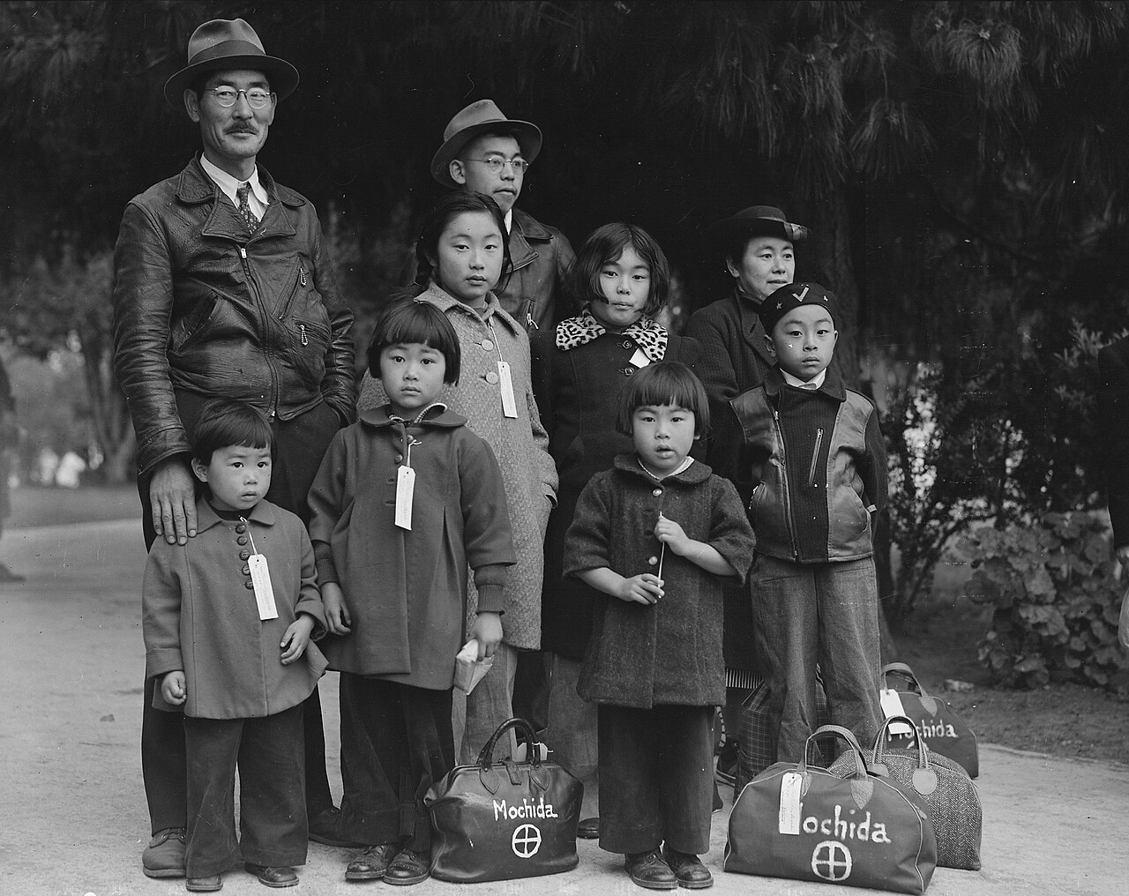
Photograph of Members of the Mochida Family Awaiting Evacuation Bus, Hayward, California (May 8, 1942) · Dorothea Lange / War Relocation Authority / National Archives and Records Administration · May 8, 1942
Source: Lange, Dorothea. "Photograph of Members of the Mochida Family Awaiting Evacuation Bus, Hayward, California." 8 May 1942. U.S. Department of the Interior, War Relocation Authority / National Archives and Records Administration (NAID 537505), via Wikimedia Commons, commons.wikimedia.org/wiki/File:Photograph_of_Members_of_the_Mochida_Family_Awaiting_Evacuation_-_NARA_-_537505.jpg. Public Domain https://commons.wikimedia.org/wiki/File:Photograph_of_Members_of_the_Mochida_Family_Awaiting_Evacuation_-_NARA_-_537505.jpg
HIPPO — analyze the source (prompt) | Your analysis
H — Historical context: what was happening when this was created?
I — Intended audience: who was meant to see or obey it?
P — Purpose: why was it created?
P — Point of view: whose perspective does it reflect?
O — Outside connection: how does it connect to this standard?
SUPPORT OPTION
Sentence frame: This source shows ______ because it ______, which reveals ______.
CONFIDENCE CHECK-IN
Rate your understanding of this standard (1–4): ______ One thing to revisit: ____________________

Activity 6 — Core Application: Practice Quiz — US.54 ⏱ ~8 min
RESPONSE CHOICE
Commit to an answer by marking it, saying it, or explaining it aloud before checking. Answer key is in the Teacher Guide (kept separate).
[DOK 2 · item q-us54-dok2-2 · pre-field-test]
What were conditions like in Japanese American internment camps?
A. Harsh: overcrowded barracks, inadequate sanitation, extreme weather, barbed wire, armed guards
B. Upheld internment based on race over constitutional rights; later overturned as based on lies
C. FDR's order authorizing military to relocate Japanese Americans to internment camps
D. Refused to report for internment; arrested and appealed to Supreme Court claiming constitutional violation
[DOK 2 · item us-58-x014 · pre-field-test]
The Supreme Court's Korematsu v. United States (1944) ruling upholding Japanese internment is significant because —
A. It was immediately overturned by the companion Endo decision that ordered the release of loyal Japanese Americans
B. It upheld the worst racial civil liberties violation of the 20th century, allowing national security claims to justify racial categorization
C. It was a 5-4 decision that narrowly failed to become a landmark expansion of constitutional civil liberties protections
D. It established strict constitutional protections against all forms of racial discrimination by the government
[DOK 3 · item u1-us54-dok3-tc · pre-field-test]
How did Executive Order 9066 violate constitutional principles of due process and equal protection?
A. It followed all constitutional procedures, although historical sources do not support this conclusion, though this interpretation lacks supporting historical evidence, but the historical evidence paints a more nuanced picture
B. It denied due process by detaining people without individual hearings or evidence, and violated equal protection by targeting Japanese Americans while not similarly treating German or Italian Americans
C. It only affected non-citizens, but the historical record tells a more complex story, but closer analysis reveals a more complicated historical reality, although historical sources do not support this conclusion
D. The Constitution does not protect against internment, which does not align with the documented historical record, which ignores significant political and cultural developments of the era

Activity 7 — Constructed Response (CER) — US.54 ⏱ ~15 min
BIG-QUESTION ORGANIZER — in World War II, how did the war reshape America at home and its role in the world — and who sacrificed, even while being excluded?
Jot quick notes from THIS standard: Who benefited? · Who bore the costs? · Who decided?

CONSTRUCTED RESPONSE (CER) — builds SSP.04 Argumentation
Claim + Evidence + Reasoning: Using this standard, take a position on the central question — describe the constitutional issues and impact of the internment of Japanese Americans on the U.S., including the Fred Korematsu v. United States of America decision? Support your claim with two pieces of evidence from the passage and explain your reasoning.
Part | Write here
Claim
Evidence (two specifics)
Reasoning
SELF-CHECK (CER rubric — see Toolkit)
Is my claim defensible? · TWO specific pieces of evidence? · Does my reasoning explain HOW the evidence proves the claim?
EXIT TICKET — before you leave [item us54-q1 · DOK 2 · pre-field-test]
What factors led to the decision to intern Japanese Americans after Pearl Harbor?
A. Evidence of widespread Japanese American disloyalty, yet the available evidence points to a different conclusion and does not reflect the scholarly consensus on this topic
B. Japanese Americans requested internment for protection, but this fails to account for the broader historical context, which ignores significant political and cultural developments of the era
C. Only non-citizens were interned, which ignores key developments that shaped the outcome, but the historical evidence paints a more nuanced picture, although historical sources do not support this conclusion
D. Wartime hysteria, racial prejudice, economic competition from Japanese American businesses, and exaggerated military necessity claims combined to overcome constitutional protections
Show what you know (your choice): mark the best answer, say it, or explain it — then rate how sure you are: ☐ Not yet ☐ Getting there ☐ Got it
Answer key and next steps are in the Teacher Guide.

Standard US.55 — Home Front Mobilization
TN Academic Standard US.55: Describe the war's impact on the home front, including: rationing, bond drives, propaganda, movement to cities and industrial centers, Bracero program, conversion of factories for wartime production, location of prisoner of war camps in Tennessee.
LEARNING TARGETS — I can…
• I can describe the war's impact on the home front, including rationing, bond drives, propaganda, movement to cities, the Bracero program, conversion of factories, and prisoner of war camps in Tennessee.
Lenses for this standard: History · Economics
CORE PATH — the same for every student
Same rigor for everyone: analyze the sources and vocabulary, then show what you learned on the Practice Quiz and the CER.
UDL and MTSS give you flexible ways in — they never lower the bar.
Check yourself against the learning targets on the Cornell Notes page.
★ Tennessee Connection
Tennessee was a major center for war production during WWII. Alcoa, Tennessee, produced aluminum for military aircraft, and Camp Forrest near Tullahoma served as a major Army training base. Women across the state joined the workforce in unprecedented numbers.
SET YOUR GOAL (self-direction)
My goal for this standard — what will I be able to do, and how will I show it?

HOOK — think before you dig in
Home Front Mobilization: Describe the war's impact on the home front, including: rationing, bond drives, propaganda, movement to cities and industrial centers, Bracero program, conversion of factories for wartime production, location of prisoner of war camps in Tennessee. Who gained, who was left out — and why does it still matter?

ACTIVATE — what do you already know or wonder?
Jot what you already know or want to find out about this standard. You’ll come back to it.

PREVIEW & PREDICT
Which learning target will be hardest, and why? Connect it to the unit’s big question: how did the war change America at home and abroad, and who sacrificed even while excluded?

Activity 1 — Vocabulary (Part A: Reference / Word Bank) — US.55 ⏱ ~10 min
Use this word bank throughout the standard. The Spanish column supports access, not translation of assessment.
Term | Student-friendly meaning | Spanish
Rationing | Government-controlled limits on consumer goods during WWII to ensure adequate supplies for the military, requiring ration books and coupons. | Racionamiento
War Bonds | Government bonds sold to citizens to finance the war effort, promoted through massive publicity campaigns featuring celebrities and patriotic appeals. | Bonos de Guerra
Rosie the Riveter | Cultural icon representing millions of American women who worked in factories and shipyards during World War II, filling jobs left by men who went to war. | Rosie la Remachadora
Manhattan Project | Top-secret U.S. program to develop the atomic bomb, involving sites at Oak Ridge (Tennessee), Los Alamos (New Mexico), and Hanford (Washington). | Proyecto Manhattan
Allied Powers | The World War II coalition led by the United States, Great Britain, and the Soviet Union that fought and defeated the Axis Powers. | Potencias Aliadas
Executive Order 8802 | The June 1941 order signed by President Roosevelt banning racial discrimination in the defense industry and creating the Fair Employment Practices Committee. | Orden Ejecutiva 8802
LANGUAGE SUPPORT
Pronunciations: Rationing (RASH-un-ing); War Bonds (wor bondz); Rosie the Riveter (ROH-zee thuh RIV-eh-ter); Manhattan Project (man-HAT-un PROJ-ekt); Allied Powers (AL-yd POW-erz); Executive Order 8802 (eg-ZEK-yuh-tiv OR-der).
VOCABULARY SELF-CHECK · Knowledge Rating
Rate each term NOW in pencil, then again at the END — growth is the goal; no penalty for “never seen it.”
Term | 1 · never seen it | 2 · heard it | 3 · can use it | 4 · can teach it
Rationing
War Bonds
Rosie the Riveter
Manhattan Project
Allied Powers
Executive Order 8802
MAKE IT YOURS (RESPONSE CHOICE): choose ONE term above and show you own it — write a sentence, sketch it, or give a real-world example.

Activity 2 — Vocabulary Studio (Frayer-inspired) — US.55 ⏱ ~7 min
RESPONSE CHOICE
Complete each studio by writing, speaking, or diagramming.

PRIORITY TERM 1 Rationing · ES: Racionamiento
Word-bank meaning to build on: Government-controlled limits on consumer goods during WWII to ensure adequate supplies for the military, requiring ration books and coupons.
Definition (in your own words) | Characteristics
Examples | Non-examples
Use it to explain
Write one sentence that uses “Rationing” to explain this standard.

PRIORITY TERM 2 War Bonds · ES: Bonos de Guerra
Word-bank meaning to build on: Government bonds sold to citizens to finance the war effort, promoted through massive publicity campaigns featuring celebrities and patriotic appeals.
Definition (in your own words) | Characteristics
Examples | Non-examples
Use it to explain
Write one sentence that uses “War Bonds” to explain this standard.

CONNECT THE TERMS (UDL · build understanding)
How do these priority terms fit together? Write or sketch how one leads to or affects another.

Activity 3 — Direct Teaching Cornell Notes — US.55 ⏱ ~20 min
Name: ______________________ Class / Period: __________ Date: __________
US.55 — Home Front Mobilization • These notes capture the direct-teaching content and the Close Read for this standard.
Your learning targets are on this standard’s opening page — take notes that help you meet them.
Cues (tied to your learning targets) | My notes
What does the passage say about rationing and Conservation?
What does the passage say about war Bonds and Propaganda?
What does the passage say about migration, Factory Conversion, and Bracero Program?
Key terms →
DOODLE ZONE — draw your thinking (UDL · another way in)
Need another way in? Sketch the key idea, a quick timeline, or how the pieces connect. Words optional.

Cornell Notes — keep going, then process & check — US.55
MORE NOTES / DIAGRAMS
Continue your notes here, add a quick sketch, or map how the ideas connect.

Key terms to list
Rationing · War Bonds · Rosie the Riveter · Manhattan Project · Allied Powers · Executive Order 8802
Summary — In your own words (2–3 sentences)
PROGRESS CHECK · one question
What role did propaganda play in maintaining civilian morale and support for the war effort?
A. Propaganda was not used during WWII, but this fails to account for the broader historical context, but contemporary accounts and primary sources suggest otherwise
B. Propaganda only targeted military personnel, yet the available evidence points to a different conclusion, but the historical evidence paints a more nuanced picture
C. The Office of War Information used films, posters, and radio to demonize enemies, celebrate American values, recruit workers, and build national unity through shared purpose and sacrifice
D. Propaganda undermined the war effort, but this fails to account for the broader historical context, but contemporary accounts and primary sources suggest otherwise
Commit before you move on — mark it, say it, or explain it aloud.
CHECK YOURSELF — how am I doing?
Which learning targets (on this standard’s opening page) can you now meet? Tick the number; circle any you still need help with.
☐ 1
My 12–15 word headline for this standard

Activity 4 — Close Read — US.55 ⏱ ~15 min
Reading type: History Hack-authored instructional synthesis. This is not a primary source. Builds SSP.03 (synthesize) and SSP.05 (historical awareness).
CORE PATH — read one chunk at a time
Rationing and Conservation
Ration books with coupons controlled civilian access to gasoline, tires, sugar, meat, coffee, and other commodities. This ensured military supplies while distributing scarce goods fairly. Victory gardens encouraged citizens to grow their own vegetables, while scrap drives collected metal, rubber, and other materials. These programs fostered civilian investment in the war effort and created shared sacrifice that built national unity.
War Bonds and Propaganda
Liberty and Victory bonds financed the war while giving civilians a direct stake in victory. Bond drives featured celebrities and patriotic appeals, raising billions of dollars. The Office of War Information coordinated propaganda through films, posters, and radio, boosting morale and labor recruitment. Propaganda portrayed the enemy as evil while celebrating American values and workers' contributions.
Migration, Factory Conversion, and Bracero Program
Millions migrated to defense industry centers, creating housing shortages and demographic shifts that reshaped American cities. Auto plants converted to tank and aircraft factories through rapid retooling that enabled massive production increases. The Bracero Program (1942) brought contract labor from Mexico to fill agricultural shortages, providing economic benefits while creating exploitation issues that would persist for decades.
Tennessee's Wartime Role
Tennessee hosted significant wartime facilities including POW camps that housed Axis prisoners, providing labor for local agriculture and industry. Camp Forrest and other installations trained troops and processed prisoners. Most significantly, Oak Ridge was secretly built to enrich uranium for the Manhattan Project, making Tennessee crucial to developing the atomic bomb. These facilities transformed Tennessee's economy and population.
Key terms first: Rationing, War Bonds. Read once for the gist, then again for evidence.
CLOSE-READ EVIDENCE LAB — for each question: quote the EVIDENCE from the passage above, then write YOUR ANSWER (or answer aloud / diagram it).
Text-dependent question | Evidence from the passage | Your answer (what it shows)
What is the main idea of the “Rationing and Conservation” section, and what evidence supports it?
What is the main idea of the “War Bonds and Propaganda” section, and what evidence supports it?
What is the main idea of the “Migration, Factory Conversion, and Bracero Program” section, and what evidence supports it?

Activity 5 — Primary Source / Data Analysis — US.55 ⏱ ~15 min
Document (text primary source — analyze with HIPPO). Builds SSP.01–SSP.02.
WAR RATION BOOK INSTRUCTIONS
“This book is your Government's guarantee of your fair share of goods made scarce by war. Price ceilings and rationing are the most fair way to distribute scarce goods. Misuse of rationing stamps is a crime punishable by fine or imprisonment”
Source: Office of Price Administration, 1943. Office of Price Administration. "War Ration Book Instructions." 1943. National Archives, www.archives.gov/education/lessons/wwii-rationing.. Public domain. https://www.archives.gov/education/lessons/wwii-rationing
HIPPO — analyze the source (prompt) | Your analysis
H — Historical context: what was happening when this was created?
I — Intended audience: who was meant to see or obey it?
P — Purpose: why was it created?
P — Point of view: whose perspective does it reflect?
O — Outside connection: how does it connect to this standard?
SUPPORT OPTION
Sentence frame: This source shows ______ because it ______, which reveals ______.

EXTEND & RE-ENGAGE (open to all)
Push past the document — corroborate, contextualize, and judge its meaning.
Historian move | Your response
Corroborate — what other source would confirm or complicate this one?
Contextualize — what was happening at the time that explains it?
So what? — why does this source still matter?
CONFIDENCE CHECK-IN
Rate your understanding of this standard (1–4): ______ One thing to revisit: ____________________

Activity 6 — Core Application: Practice Quiz — US.55 ⏱ ~8 min
RESPONSE CHOICE
Commit to an answer by marking it, saying it, or explaining it aloud before checking. Answer key is in the Teacher Guide (kept separate).
[DOK 2 · item q-us53-add-1 · pre-field-test]
How did the Double V campaign connect the war abroad to civil rights at home?
A. It linked victory over fascism overseas with demands for racial equality in the United States
B. Working full-time in factories while still managing household and childcare responsibilities
C. Many were pressured to leave jobs for returning servicemen, facing social pressure to return home
D. Entered workforce in record numbers, gained independence, and challenged gender roles
[DOK 2 · item us-45-q02 · pre-field-test]
During World War II, the U.S. government asked civilians to conserve resources through rationing, victory gardens, and buying war bonds. What was the PRIMARY purpose of these home front measures?
A. To repay war debts from World War I by raising revenue through bond sales
B. To redirect industrial and agricultural resources toward military production and reduce domestic consumption
C. To punish citizens who had supported isolationism before Pearl Harbor
D. To boost civilian morale by giving people a symbolic role in the war effort
[DOK 3 · item u1-us55-dok3-tc · pre-field-test]
What role did propaganda play in maintaining civilian morale and support for the war effort?
A. Propaganda was not used during WWII, but this fails to account for the broader historical context, but contemporary accounts and primary sources suggest otherwise
B. Propaganda only targeted military personnel, yet the available evidence points to a different conclusion, but the historical evidence paints a more nuanced picture
C. The Office of War Information used films, posters, and radio to demonize enemies, celebrate American values, recruit workers, and build national unity through shared purpose and sacrifice
D. Propaganda undermined the war effort, but this fails to account for the broader historical context, but contemporary accounts and primary sources suggest otherwise

Activity 7 — Constructed Response (CER) — US.55 ⏱ ~15 min
BIG-QUESTION ORGANIZER — in World War II, how did the war reshape America at home and its role in the world — and who sacrificed, even while being excluded?
Jot quick notes from THIS standard: Who benefited? · Who bore the costs? · Who decided?

CONSTRUCTED RESPONSE (CER) — builds SSP.04 Argumentation
Claim + Evidence + Reasoning: Using this standard, take a position on the central question — describe the war's impact on the home front, including rationing, bond drives, propaganda, movement to cities, the Bracero program, conversion of factories, and prisoner of war camps in Tennessee? Support your claim with two pieces of evidence from the passage and explain your reasoning.
Part | Write here
Claim
Evidence (two specifics)
Reasoning
SELF-CHECK (CER rubric — see Toolkit)
Is my claim defensible? · TWO specific pieces of evidence? · Does my reasoning explain HOW the evidence proves the claim?
EXIT TICKET — before you leave [item us55-q1 · DOK 2 · pre-field-test]
How did rationing, bond drives, and factory conversion mobilize American society for total war?
A. Rationing ensured military supplies and fair distribution, bonds financed the war while building civilian investment, and factory conversion transformed auto plants into war production facilities
B. These programs had minimal impact on civilian life, although historical sources do not support this conclusion, although this overlooks critical economic and social factors involved
C. Only military personnel were affected by these programs, which contradicts the primary source evidence from this era and does not reflect the scholarly consensus on this topic
D. Civilians were not involved in the war effort, though this interpretation lacks supporting historical evidence, which ignores significant political and cultural developments of the era
Show what you know (your choice): mark the best answer, say it, or explain it — then rate how sure you are: ☐ Not yet ☐ Getting there ☐ Got it
Answer key and next steps are in the Teacher Guide.

Standard US.56 — Manhattan Project & Atomic Bomb
TN Academic Standard US.56: Describe the Manhattan Project and explain the rationale for using the atomic bomb to end the war.
LEARNING TARGETS — I can…
• I can describe the Manhattan Project and explain the rationale for using the atomic bomb to end the war.
Lenses for this standard: History · Geography
CORE PATH — the same for every student
Same rigor for everyone: analyze the sources and vocabulary, then show what you learned on the Practice Quiz and the CER.
UDL and MTSS give you flexible ways in — they never lower the bar.
Check yourself against the learning targets on the Cornell Notes page.
★ Tennessee Connection
Oak Ridge, Tennessee — the 'Secret City' — was a central site for the Manhattan Project. At its peak, Oak Ridge employed over 75,000 workers enriching uranium for the atomic bomb. The city was built from scratch in 1942 and was not shown on any maps.
SET YOUR GOAL (self-direction)
My goal for this standard — what will I be able to do, and how will I show it?

HOOK — think before you dig in
Manhattan Project & Atomic Bomb: Describe the Manhattan Project and explain the rationale for using the atomic bomb to end the war. Who gained, who was left out — and why does it still matter?

ACTIVATE — what do you already know or wonder?
Jot what you already know or want to find out about this standard. You’ll come back to it.

PREVIEW & PREDICT
Which learning target will be hardest, and why? Connect it to the unit’s big question: how did the war change America at home and abroad, and who sacrificed even while excluded?

Activity 1 — Vocabulary (Part A: Reference / Word Bank) — US.56 ⏱ ~10 min
Use this word bank throughout the standard. The Spanish column supports access, not translation of assessment.
Term | Student-friendly meaning | Spanish
Manhattan Project | Top-secret U.S. program to develop the atomic bomb, involving sites at Oak Ridge (Tennessee), Los Alamos (New Mexico), and Hanford (Washington). | Proyecto Manhattan
Atomic Bomb | Nuclear weapons dropped on Hiroshima (August 6) and Nagasaki (August 9, 1945), killing over 200,000 people and forcing Japan's surrender, ending World War II. | Bomba Atómica
Battle of Iwo Jima | February-March 1945 brutal battle for a strategic Pacific island, famous for the iconic flag-raising photograph on Mount Suribachi. | Batalla de Iwo Jima
Allied Powers | The World War II coalition led by the United States, Great Britain, and the Soviet Union that fought and defeated the Axis Powers. | Potencias Aliadas
Hideki Tojo | Japanese military leader and Prime Minister (1941-1944) who led Japan into World War II and authorized the attack on Pearl Harbor. | Hideki Tojo
Pearl Harbor | Japan's surprise attack on the U.S. naval base in Hawaii on December 7, 1941, killing over 2,400 Americans and bringing the United States into World War II. | Pearl Harbor
LANGUAGE SUPPORT
Pronunciations: Manhattan Project (man-HAT-un PROJ-ekt); Atomic Bomb (uh-TOM-ik bom); Battle of Iwo Jima (BAT-ul uv EE-woh JEE-muh); Allied Powers (AL-yd POW-erz); Hideki Tojo (hee-DEH-kee TOH-joh); Pearl Harbor (purl HAR-ber).
VOCABULARY SELF-CHECK · Knowledge Rating
Rate each term NOW in pencil, then again at the END — growth is the goal; no penalty for “never seen it.”
Term | 1 · never seen it | 2 · heard it | 3 · can use it | 4 · can teach it
Manhattan Project
Atomic Bomb
Battle of Iwo Jima
Allied Powers
Hideki Tojo
Pearl Harbor
MAKE IT YOURS (RESPONSE CHOICE): choose ONE term above and show you own it — write a sentence, sketch it, or give a real-world example.

Activity 2 — Vocabulary Studio (Frayer-inspired) — US.56 ⏱ ~7 min
RESPONSE CHOICE
Complete each studio by writing, speaking, or diagramming.

PRIORITY TERM 1 Manhattan Project · ES: Proyecto Manhattan
Word-bank meaning to build on: Top-secret U.S. program to develop the atomic bomb, involving sites at Oak Ridge (Tennessee), Los Alamos (New Mexico), and Hanford (Washington).
Definition (in your own words) | Characteristics
Examples | Non-examples
Use it to explain
Write one sentence that uses “Manhattan Project” to explain this standard.

PRIORITY TERM 2 Atomic Bomb · ES: Bomba Atómica
Word-bank meaning to build on: Nuclear weapons dropped on Hiroshima (August 6) and Nagasaki (August 9, 1945), killing over 200,000 people and forcing Japan's surrender, ending World War II.
Definition (in your own words) | Characteristics
Examples | Non-examples
Use it to explain
Write one sentence that uses “Atomic Bomb” to explain this standard.

CONNECT THE TERMS (UDL · build understanding)
How do these priority terms fit together? Write or sketch how one leads to or affects another.

Activity 3 — Direct Teaching Cornell Notes — US.56 ⏱ ~20 min
Name: ______________________ Class / Period: __________ Date: __________
US.56 — Manhattan Project & Atomic Bomb • These notes capture the direct-teaching content and the Close Read for this standard.
Your learning targets are on this standard’s opening page — take notes that help you meet them.
Cues (tied to your learning targets) | My notes
What does the passage say about oak Ridge, Tennessee Selection?
What does the passage say about manhattan Project Overview?
What does the passage say about rationale for Using Atomic Weapons?
Key terms →
DOODLE ZONE — draw your thinking (UDL · another way in)
Need another way in? Sketch the key idea, a quick timeline, or how the pieces connect. Words optional.

Cornell Notes — keep going, then process & check — US.56
MORE NOTES / DIAGRAMS
Continue your notes here, add a quick sketch, or map how the ideas connect.

Key terms to list
Manhattan Project · Atomic Bomb · Battle of Iwo Jima · Allied Powers · Hideki Tojo · Pearl Harbor
Summary — In your own words (2–3 sentences)
PROGRESS CHECK · one question
What factors influenced President Truman's decision to use atomic weapons against Japan?
A. Truman made the decision without considering alternatives, which does not align with the documented historical record, although historical sources do not support this conclusion
B. Only military factors were considered, but this fails to account for the broader historical context, which represents a common misconception about this historical period
C. Truman opposed using the bombs, but this fails to account for the broader historical context, which does not align with the documented historical record
D. Projected invasion casualties based on Okinawa, desire to end the war quickly, demonstrating power to the Soviet Union, and Japanese refusal to surrender all influenced the decision
Commit before you move on — mark it, say it, or explain it aloud.
CHECK YOURSELF — how am I doing?
Which learning targets (on this standard’s opening page) can you now meet? Tick the number; circle any you still need help with.
☐ 1
My 12–15 word headline for this standard

Activity 4 — Close Read — US.56 ⏱ ~15 min
Reading type: History Hack-authored instructional synthesis. This is not a primary source. Builds SSP.03 (synthesize) and SSP.05 (historical awareness).
CORE PATH — read one chunk at a time
Oak Ridge, Tennessee Selection
Oak Ridge was selected for uranium enrichment because of its remote location providing security isolation, abundant electrical power from TVA, good transportation access, and available land. The "Secret City" grew to 75,000 residents, most unaware of their work's purpose. Oak Ridge produced enriched uranium for the "Little Boy" bomb dropped on Hiroshima, making Tennessee crucial to the atomic bomb's development.
Manhattan Project Overview
The secret multi-site program included Los Alamos (weapon design), Oak Ridge (uranium enrichment), and Hanford (plutonium production). Led by General Leslie Groves and scientist J. Robert Oppenheimer, the project employed over 125,000 people and cost nearly $2 billion. The Trinity test (July 16, 1945) successfully demonstrated the first nuclear explosion in New Mexico, proving the concept worked.
Rationale for Using Atomic Weapons
President Truman authorized atomic bombs to end the war quickly, avoiding a costly invasion of Japan projected to cause hundreds of thousands of American casualties based on Okinawa experience. Additional factors included forcing rapid Japanese surrender, demonstrating American power to the Soviet Union, and justifying the massive investment in the Manhattan Project. The bombs on Hiroshima (August 6) and Nagasaki (August 9) killed over 100,000 immediately, with more dying later from radiation.
Ethical Debate
Arguments for use included ending the war quickly, saving lives on both sides that invasion would cost, and Japanese refusal to surrender despite conventional bombing. Arguments against included the targeting of civilians, long-term radiation effects, potential alternatives like demonstration or modified surrender terms, and the precedent of nuclear warfare. This debate continues among historians and ethicists, with no consensus on whether the decision was justified.
Key terms first: Manhattan Project, Atomic Bomb. Read once for the gist, then again for evidence.
CLOSE-READ EVIDENCE LAB — for each question: quote the EVIDENCE from the passage above, then write YOUR ANSWER (or answer aloud / diagram it).
Text-dependent question | Evidence from the passage | Your answer (what it shows)
What is the main idea of the “Oak Ridge, Tennessee Selection” section, and what evidence supports it?
What is the main idea of the “Manhattan Project Overview” section, and what evidence supports it?
What is the main idea of the “Rationale for Using Atomic Weapons” section, and what evidence supports it?

Geographer’s Lens — US.56 ⏱ ~12 min
Geographers don’t just find places — they explain how WHERE shapes WHAT happens. Work these like a geographer. Built on the Five Themes of Geography · C3 Dimension 2 · SSP.06 (spatial reasoning).
THE PLACES — then explain why geography put them there
The atomic bomb was built and used across a handful of secret, far-flung sites. Use the list below to map them, then explain how geography kept the project secret and shaped the war's end.
Place | Where | What happened (given) | Why HERE? (your analysis)
Oak Ridge, Tennessee | East Tennessee | the 'Secret City' — enriched uranium for the bomb
Los Alamos, New Mexico | Desert Southwest | the lab where the bomb was designed (Oppenheimer)
Hanford, Washington | Pacific Northwest | produced plutonium for the 'Fat Man' bomb
Hiroshima, Japan | Japan | first atomic bomb dropped, August 6, 1945
Nagasaki, Japan | Japan | second atomic bomb dropped, August 9, 1945
MOVEMENT & REGION — what’s the spatial pattern?
In 1–2 sentences: is this a movement, a cluster, or a whole region? Name the direction or shape it takes on a map.

GEOGRAPHY AS A FORCE — how did location shape the outcome?
How did geography change WHAT happened — who was affected, how far or fast it spread, or who was left out? Use one place above as your evidence.

READ IT LIKE A SOURCE — RESPONSE CHOICE
A map is a source with a point of view. Show your thinking your way — write it, OR sketch a quick arrows-and-labels diagram: what would a map of this make CLEAR, and what would it HIDE or leave out?

Activity 5 — Primary Source / Data Analysis — US.56 ⏱ ~15 min
Primary source (photograph) — analyze it with HIPPO. Builds SSP.01–SSP.02.
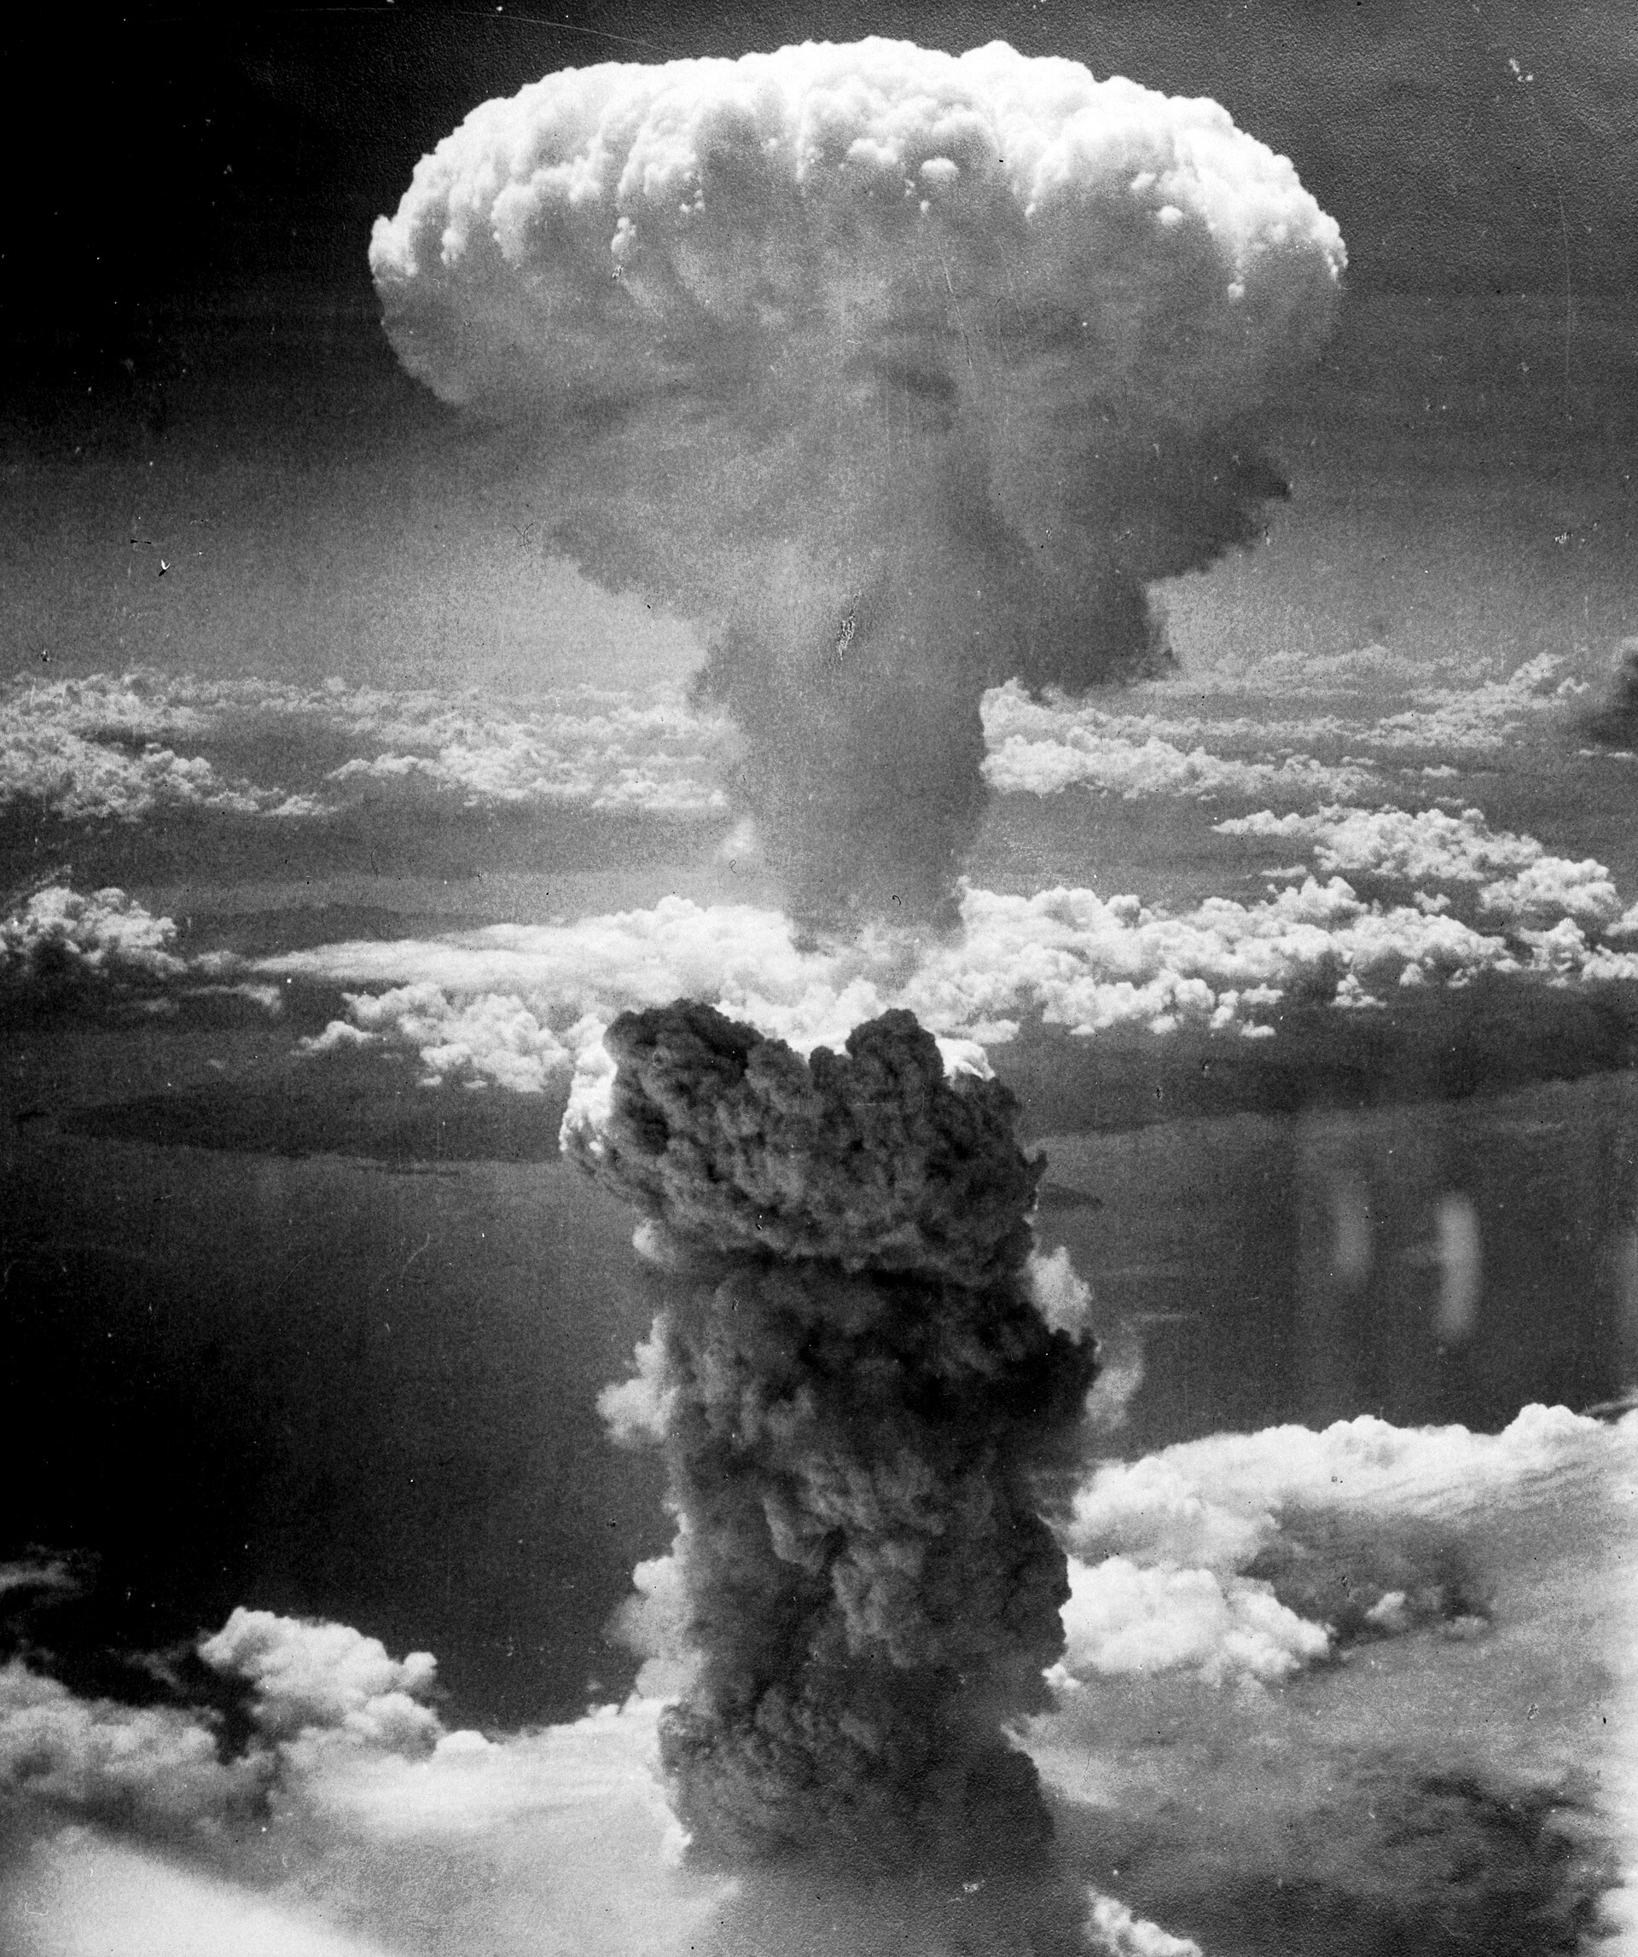
Mushroom Cloud above Nagasaki after Atomic Bombing, August 9, 1945 · Charles Levy / U.S. Army Air Forces / National Archives and Records Administration · August 9, 1945
Source: Levy, Charles. "Mushroom Cloud above Nagasaki after Atomic Bombing." 9 Aug. 1945. U.S. Army Air Forces / National Archives and Records Administration, via Wikimedia Commons, commons.wikimedia.org/wiki/File:Nagasakibomb.jpg. Public Domain https://commons.wikimedia.org/wiki/File:Nagasakibomb.jpg
HIPPO — analyze the source (prompt) | Your analysis
H — Historical context: what was happening when this was created?
I — Intended audience: who was meant to see or obey it?
P — Purpose: why was it created?
P — Point of view: whose perspective does it reflect?
O — Outside connection: how does it connect to this standard?
SUPPORT OPTION
Sentence frame: This source shows ______ because it ______, which reveals ______.
CONFIDENCE CHECK-IN
Rate your understanding of this standard (1–4): ______ One thing to revisit: ____________________

Activity 6 — Core Application: Practice Quiz — US.56 ⏱ ~8 min
RESPONSE CHOICE
Commit to an answer by marking it, saying it, or explaining it aloud before checking. Answer key is in the Teacher Guide (kept separate).
[DOK 2 · item q-us56-dok2-1 · pre-field-test]
How many people died from the atomic bombings of Hiroshima and Nagasaki?
A. Over 200,000 people, mostly civilians, died immediately or from radiation effects
B. Approximately 10,000 military personnel were killed but civilian casualties were minimal
C. Fewer than 5,000 people were harmed because most residents had already been evacuated
D. Between 20,000 and 30,000 people died primarily from the initial blast and fires
[DOK 2 · item us-47-q02 · pre-field-test]
President Truman's decision to use atomic bombs against Japan in August 1945 remains one of the most debated decisions in American history. Which of the following best represents the PRIMARY argument Truman's supporters use to justify the decision?
A. Japan had been the first nation to use chemical weapons in the war, making retaliation justified
B. A land invasion of Japan would have resulted in massive casualties on both sides; the bomb ended the war more quickly
C. Japan had refused to surrender unconditionally and was developing its own nuclear weapons program
D. The Soviet Union had already invaded Japan, and the bomb was needed to stop Soviet expansion
[DOK 3 · item u1-us56-dok3-tc · pre-field-test]
What factors influenced President Truman's decision to use atomic weapons against Japan?
A. Truman made the decision without considering alternatives, which does not align with the documented historical record, although historical sources do not support this conclusion
B. Only military factors were considered, but this fails to account for the broader historical context, which represents a common misconception about this historical period
C. Truman opposed using the bombs, but this fails to account for the broader historical context, which does not align with the documented historical record
D. Projected invasion casualties based on Okinawa, desire to end the war quickly, demonstrating power to the Soviet Union, and Japanese refusal to surrender all influenced the decision

Activity 7 — Constructed Response (CER) — US.56 ⏱ ~15 min
BIG-QUESTION ORGANIZER — in World War II, how did the war reshape America at home and its role in the world — and who sacrificed, even while being excluded?
Jot quick notes from THIS standard: Who benefited? · Who bore the costs? · Who decided?

CONSTRUCTED RESPONSE (CER) — builds SSP.04 Argumentation
Claim + Evidence + Reasoning: Using this standard, take a position on the central question — describe the Manhattan Project and explain the rationale for using the atomic bomb to end the war? Support your claim with two pieces of evidence from the passage and explain your reasoning.
Part | Write here
Claim
Evidence (two specifics)
Reasoning
SELF-CHECK (CER rubric — see Toolkit)
Is my claim defensible? · TWO specific pieces of evidence? · Does my reasoning explain HOW the evidence proves the claim?
EXIT TICKET — before you leave [item us56-q1 · DOK 2 · pre-field-test]
Why was Oak Ridge, Tennessee selected as a key site for the Manhattan Project?
A. Oak Ridge was chosen randomly, despite limited evidence supporting this interpretation, although this overlooks critical economic and social factors involved
B. Its remote location provided security, TVA provided abundant electricity for uranium enrichment, transportation was accessible, and land was available for the massive facilities needed
C. Oak Ridge was already a major industrial center, which does not reflect the consensus among historians, but closer analysis reveals a more complicated historical reality
D. Scientists preferred the climate, but contemporary accounts suggest a different explanation, although historical sources do not support this conclusion, but the historical evidence paints a more nuanced picture
Show what you know (your choice): mark the best answer, say it, or explain it — then rate how sure you are: ☐ Not yet ☐ Getting there ☐ Got it
Answer key and next steps are in the Teacher Guide.

Standard US.57 — Yalta and Potsdam Conferences
TN Academic Standard US.57: Explain the major outcomes of the Yalta and Potsdam Conferences.
LEARNING TARGETS — I can…
• I can explain the major outcomes of the Yalta and Potsdam Conferences.
Lenses for this standard: Politics/Government · History
CORE PATH — the same for every student
Same rigor for everyone: analyze the sources and vocabulary, then show what you learned on the Practice Quiz and the CER.
UDL and MTSS give you flexible ways in — they never lower the bar.
Check yourself against the learning targets on the Cornell Notes page.
SET YOUR GOAL (self-direction)
My goal for this standard — what will I be able to do, and how will I show it?

HOOK — think before you dig in
Yalta and Potsdam Conferences: Explain the major outcomes of the Yalta and Potsdam Conferences. Who gained, who was left out — and why does it still matter?

ACTIVATE — what do you already know or wonder?
Jot what you already know or want to find out about this standard. You’ll come back to it.

PREVIEW & PREDICT
Which learning target will be hardest, and why? Connect it to the unit’s big question: how did the war change America at home and abroad, and who sacrificed even while excluded?

Activity 1 — Vocabulary (Part A: Reference / Word Bank) — US.57 ⏱ ~10 min
Use this word bank throughout the standard. The Spanish column supports access, not translation of assessment.
Term | Student-friendly meaning | Spanish
Yalta Conference | February 1945 meeting of Roosevelt, Churchill, and Stalin to plan post-war Europe, dividing Germany and establishing spheres of influence. | Conferencia de Yalta
Potsdam Conference | July-August 1945 meeting of Truman, Churchill/Attlee, and Stalin finalizing plans for occupied Germany and issuing surrender terms to Japan. | Conferencia de Potsdam
Joseph Stalin | Communist dictator of the Soviet Union (1924-1953) who ruled through terror, forced collectivization, and purges, resulting in millions of deaths. | Joseph Stalin
Atomic Bomb | Nuclear weapons dropped on Hiroshima (August 6) and Nagasaki (August 9, 1945), killing over 200,000 people and forcing Japan's surrender, ending World War II. | Bomba Atómica
Allied Powers | The World War II coalition led by the United States, Great Britain, and the Soviet Union that fought and defeated the Axis Powers. | Potencias Aliadas
Axis Powers | Military alliance of Germany, Italy, and Japan during World War II. United by shared goals of territorial expansion, militarism, and opposition to democratic nations. | Potencias del Eje
LANGUAGE SUPPORT
Pronunciations: Yalta Conference (YAWL-tuh KON-fer-ens); Potsdam Conference (POTS-dam KON-fer-ens); Joseph Stalin (JOH-zef STAH-lin); Atomic Bomb (uh-TOM-ik bom); Allied Powers (AL-yd POW-erz); Axis Powers (AK-sis POW-erz).
VOCABULARY SELF-CHECK · Knowledge Rating
Rate each term NOW in pencil, then again at the END — growth is the goal; no penalty for “never seen it.”
Term | 1 · never seen it | 2 · heard it | 3 · can use it | 4 · can teach it
Yalta Conference
Potsdam Conference
Joseph Stalin
Atomic Bomb
Allied Powers
Axis Powers
MAKE IT YOURS (RESPONSE CHOICE): choose ONE term above and show you own it — write a sentence, sketch it, or give a real-world example.

Activity 2 — Vocabulary Studio (Frayer-inspired) — US.57 ⏱ ~7 min
RESPONSE CHOICE
Complete each studio by writing, speaking, or diagramming.

PRIORITY TERM 1 Yalta Conference · ES: Conferencia de Yalta
Word-bank meaning to build on: February 1945 meeting of Roosevelt, Churchill, and Stalin to plan post-war Europe, dividing Germany and establishing spheres of influence.
Definition (in your own words) | Characteristics
Examples | Non-examples
Use it to explain
Write one sentence that uses “Yalta Conference” to explain this standard.

PRIORITY TERM 2 Potsdam Conference · ES: Conferencia de Potsdam
Word-bank meaning to build on: July-August 1945 meeting of Truman, Churchill/Attlee, and Stalin finalizing plans for occupied Germany and issuing surrender terms to Japan.
Definition (in your own words) | Characteristics
Examples | Non-examples
Use it to explain
Write one sentence that uses “Potsdam Conference” to explain this standard.

CONNECT THE TERMS (UDL · build understanding)
How do these priority terms fit together? Write or sketch how one leads to or affects another.

Activity 3 — Direct Teaching Cornell Notes — US.57 ⏱ ~20 min
Name: ______________________ Class / Period: __________ Date: __________
US.57 — Yalta and Potsdam Conferences • These notes capture the direct-teaching content and the Close Read for this standard.
Your learning targets are on this standard’s opening page — take notes that help you meet them.
Cues (tied to your learning targets) | My notes
What does the passage say about yalta Conference (February 1945)?
What does the passage say about potsdam Conference (July-August 1945)?
What does the passage say about cold War Origins?
Key terms →
DOODLE ZONE — draw your thinking (UDL · another way in)
Need another way in? Sketch the key idea, a quick timeline, or how the pieces connect. Words optional.

Cornell Notes — keep going, then process & check — US.57
MORE NOTES / DIAGRAMS
Continue your notes here, add a quick sketch, or map how the ideas connect.

Key terms to list
Yalta Conference · Potsdam Conference · Joseph Stalin · Atomic Bomb · Allied Powers · Axis Powers
Summary — In your own words (2–3 sentences)
PROGRESS CHECK · one question
How did the Potsdam Conference reveal growing tensions between the United States and Soviet Union?
A. Disputes over Eastern European governments, German reparations, and differing visions for post-war Europe revealed fundamental disagreements that would define the Cold War
B. Potsdam showed complete Allied unity, though this interpretation lacks supporting historical evidence, which ignores significant political and cultural developments of the era
C. Only minor disagreements emerged, despite the fact that multiple sources contradict this view, which represents a common misconception about this historical period
D. The Soviet Union was excluded from Potsdam, though this interpretation lacks supporting historical evidence, though this interpretation lacks supporting historical evidence
Commit before you move on — mark it, say it, or explain it aloud.
CHECK YOURSELF — how am I doing?
Which learning targets (on this standard’s opening page) can you now meet? Tick the number; circle any you still need help with.
☐ 1
My 12–15 word headline for this standard

Activity 4 — Close Read — US.57 ⏱ ~15 min
Reading type: History Hack-authored instructional synthesis. This is not a primary source. Builds SSP.03 (synthesize) and SSP.05 (historical awareness).
CORE PATH — read one chunk at a time
Yalta Conference (February 1945)
Roosevelt, Churchill, and Stalin met as Allied victory approached. Major agreements included UN formation plans, division of Germany into occupation zones, and Soviet entry into the war against Japan. Controversially, Stalin promised "free elections" in liberated Eastern Europe—a promise he would break. The conference also addressed reparations from Germany and arrangements for post-war Poland. Roosevelt sought Soviet cooperation for the post-war order.
Potsdam Conference (July-August 1945)
Truman (replacing the deceased Roosevelt), Churchill (replaced mid-conference by Attlee), and Stalin met as Germany surrendered. The conference confirmed occupation zones, issued the Potsdam Declaration ultimatum to Japan demanding unconditional surrender, and agreed on German demilitarization and denazification. Tensions over Eastern Europe and reparations surfaced, revealing the growing divide between Soviet and Western visions for post-war Europe.
Cold War Origins
Disagreements over Eastern Europe proved irreconcilable. Stalin's interpretation of "free elections" meant communist-controlled governments, while the West expected genuine democratic choice. Soviet occupation of Eastern Europe created what Churchill would call the "Iron Curtain." German reparations disputes, with the Soviets stripping their zone of industrial equipment, deepened mistrust. These wartime conferences set the stage for the Cold War division of Europe.
Assessment of Allied Diplomacy
Critics argue Roosevelt conceded too much to Stalin at Yalta, though defenders note Soviet armies already occupied Eastern Europe and FDR sought Soviet help against Japan. Truman took a harder line at Potsdam but faced the same reality of Soviet military control. Whether better outcomes were possible remains debated—the fundamental conflict between Soviet security concerns and Western democratic values may have made Cold War inevitable regardless of conference diplomacy.
Key terms first: Yalta Conference, Potsdam Conference. Read once for the gist, then again for evidence.
CLOSE-READ EVIDENCE LAB — for each question: quote the EVIDENCE from the passage above, then write YOUR ANSWER (or answer aloud / diagram it).
Text-dependent question | Evidence from the passage | Your answer (what it shows)
What is the main idea of the “Yalta Conference (February 1945)” section, and what evidence supports it?
What is the main idea of the “Potsdam Conference (July-August 1945)” section, and what evidence supports it?
What is the main idea of the “Cold War Origins” section, and what evidence supports it?

Activity 5 — Primary Source / Data Analysis — US.57 ⏱ ~15 min
Primary source (photograph) — analyze it with HIPPO. Builds SSP.01–SSP.02.
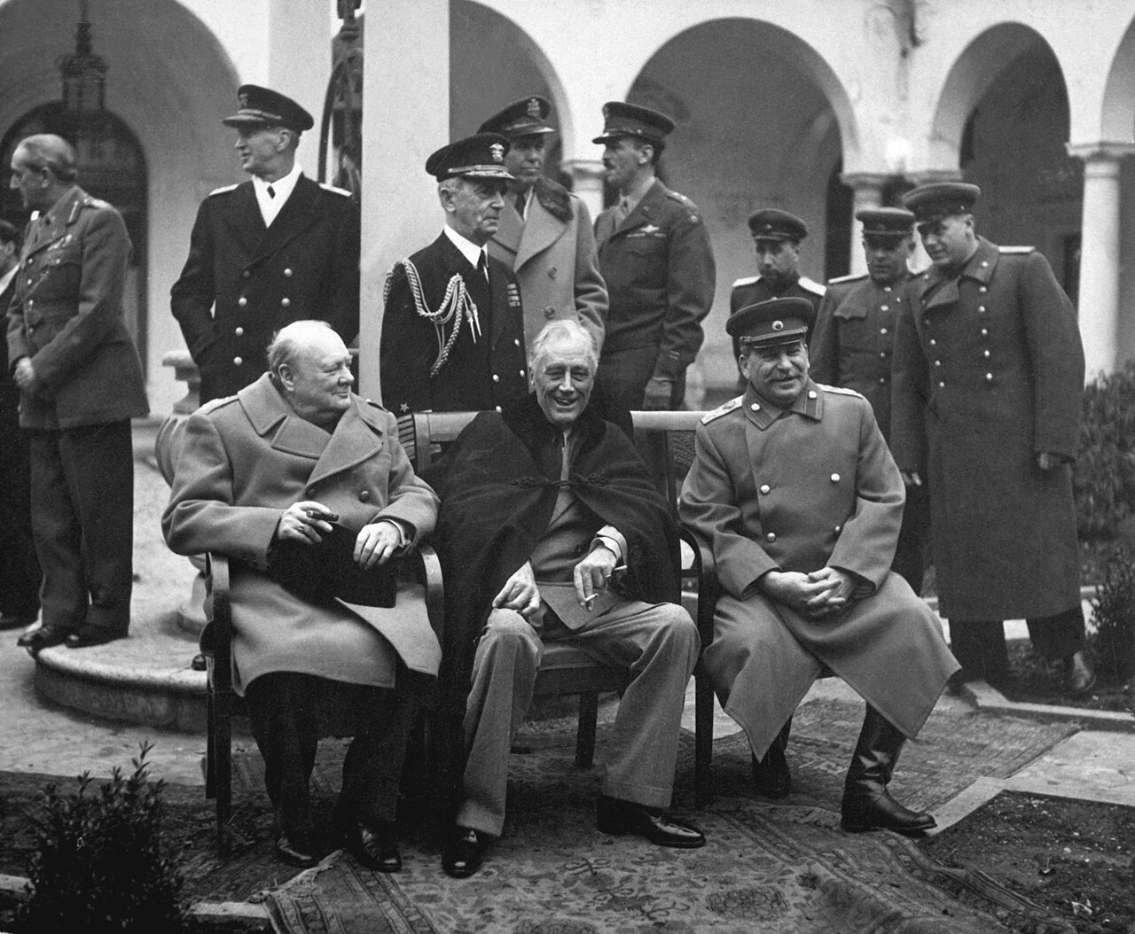
Yalta Conference, the Big Three: Churchill, Roosevelt, Stalin (February 1945) · U.S. Army Signal Corps / U.S. Federal Government · February 1945
Source: U.S. Army Signal Corps. "Yalta Conference, the Big Three: Churchill, Roosevelt, Stalin." Feb. 1945. National Archives and Records Administration, via Wikimedia Commons, commons.wikimedia.org/wiki/File:Yalta_Conference_(Churchill,_Roosevelt,_Stalin)_(B%26W).jpg. Public Domain https://commons.wikimedia.org/wiki/File:Yalta_Conference_(Churchill,_Roosevelt,_Stalin)_(B%26W).jpg
HIPPO — analyze the source (prompt) | Your analysis
H — Historical context: what was happening when this was created?
I — Intended audience: who was meant to see or obey it?
P — Purpose: why was it created?
P — Point of view: whose perspective does it reflect?
O — Outside connection: how does it connect to this standard?
SUPPORT OPTION
Sentence frame: This source shows ______ because it ______, which reveals ______.
CONFIDENCE CHECK-IN
Rate your understanding of this standard (1–4): ______ One thing to revisit: ____________________

Activity 6 — Core Application: Practice Quiz — US.57 ⏱ ~8 min
RESPONSE CHOICE
Commit to an answer by marking it, saying it, or explaining it aloud before checking. Answer key is in the Teacher Guide (kept separate).
[DOK 2 · item PS-0043 · pre-field-test]
Read the excerpt below.
"The leaders of the Allied powers — Churchill, Roosevelt, and Stalin — met at Yalta to determine the shape of the post-war world. Each came with different goals, and each left with only part of what he wanted." — Historian Robert Dallek, Franklin D. Roosevelt: A Political Life, 2017
Which of the following best describes a major decision made at the Yalta Conference (February 1945)?
A. Plans for dividing Germany into occupation zones, establishing the United Nations, and the Soviet Union's entry into the Pacific War.
B. The decision to use atomic bombs on Japan to force a rapid end to the Pacific War.
C. The Marshall Plan to provide economic aid to war-devastated European nations to prevent communist takeover.
D. The division of Korea at the 38th parallel into Soviet and American spheres of influence.
[DOK 2 · item PS-0091 · pre-field-test]
Read the excerpt below.
"At Tehran, at Yalta, and at Potsdam, we agreed to certain things with Stalin. He has honored none of them. Free elections in Poland, Czechoslovakia, Hungary — these promises have been broken." — Secretary of State James Byrnes, Speech, 1946
Which of the following best describes the Allied disagreement over postwar Eastern Europe referenced in this excerpt?
A. The Soviet Union withdrew its troops from Eastern Europe but then economically dominated the newly independent nations.
B. The Soviet Union broke its wartime promises of free elections by installing communist governments in Eastern European countries.
C. The Marshall Plan created resentment among Eastern European nations that the U.S. had excluded from economic aid.
D. Stalin returned all occupied territories to their prewar governments, then used economic pressure to bring them into the Soviet sphere.
[DOK 3 · item u1-us57-dok3-tc · pre-field-test]
How did the Potsdam Conference reveal growing tensions between the United States and Soviet Union?
A. Disputes over Eastern European governments, German reparations, and differing visions for post-war Europe revealed fundamental disagreements that would define the Cold War
B. Potsdam showed complete Allied unity, though this interpretation lacks supporting historical evidence, which ignores significant political and cultural developments of the era
C. Only minor disagreements emerged, despite the fact that multiple sources contradict this view, which represents a common misconception about this historical period
D. The Soviet Union was excluded from Potsdam, though this interpretation lacks supporting historical evidence, though this interpretation lacks supporting historical evidence

Activity 7 — Constructed Response (CER) — US.57 ⏱ ~15 min
BIG-QUESTION ORGANIZER — in World War II, how did the war reshape America at home and its role in the world — and who sacrificed, even while being excluded?
Jot quick notes from THIS standard: Who benefited? · Who bore the costs? · Who decided?

CONSTRUCTED RESPONSE (CER) — builds SSP.04 Argumentation
Claim + Evidence + Reasoning: Using this standard, take a position on the central question — explain the major outcomes of the Yalta and Potsdam Conferences? Support your claim with two pieces of evidence from the passage and explain your reasoning.
Part | Write here
Claim
Evidence (two specifics)
Reasoning
SELF-CHECK (CER rubric — see Toolkit)
Is my claim defensible? · TWO specific pieces of evidence? · Does my reasoning explain HOW the evidence proves the claim?
EXIT TICKET — before you leave [item us57-q1 · DOK 2 · pre-field-test]
What were the major agreements reached at the Yalta Conference regarding post-war Europe and the Pacific?
A. Yalta made no significant decisions, although this overlooks critical economic and social factors, and this view has been largely revised by modern historical research
B. Yalta only addressed Pacific issues, although this overlooks critical economic and social factors when examined alongside the available primary and secondary sources
C. UN formation, German occupation zones, Soviet entry against Japan, and promises of free elections in Eastern Europe were key agreements, though Soviet commitments on elections proved meaningless
D. The conference ended without agreement, which does not align with the documented historical record, and this view has been largely revised by modern historical research
Show what you know (your choice): mark the best answer, say it, or explain it — then rate how sure you are: ☐ Not yet ☐ Getting there ☐ Got it
Answer key and next steps are in the Teacher Guide.

Standard US.58 — Founding of the United Nations & Cordell Hull
TN Academic Standard US.58: Identify and explain the reasons for the founding of the United Nations, including the role of Cordell Hull.
LEARNING TARGETS — I can…
• I can identify and explain the reasons for the founding of the United Nations, including the role of Cordell Hull.
Lenses for this standard: Politics/Government · Culture · History
CORE PATH — the same for every student
Same rigor for everyone: analyze the sources and vocabulary, then show what you learned on the Practice Quiz and the CER.
UDL and MTSS give you flexible ways in — they never lower the bar.
Check yourself against the learning targets on the Cornell Notes page.
★ Tennessee Connection
Cordell Hull of Pickett County, Tennessee, served as Secretary of State (1933-1944) and was instrumental in founding the United Nations. He received the Nobel Peace Prize in 1945 for his role in establishing the UN.
SET YOUR GOAL (self-direction)
My goal for this standard — what will I be able to do, and how will I show it?

HOOK — think before you dig in
Founding of the United Nations & Cordell Hull: Identify and explain the reasons for the founding of the United Nations, including the role of Cordell Hull. Who gained, who was left out — and why does it still matter?

ACTIVATE — what do you already know or wonder?
Jot what you already know or want to find out about this standard. You’ll come back to it.

PREVIEW & PREDICT
Which learning target will be hardest, and why? Connect it to the unit’s big question: how did the war change America at home and abroad, and who sacrificed even while excluded?

Activity 1 — Vocabulary (Part A: Reference / Word Bank) — US.58 ⏱ ~10 min
Use this word bank throughout the standard. The Spanish column supports access, not translation of assessment.
Term | Student-friendly meaning | Spanish
United Nations | An international organization founded in 1945 by 50 nations to maintain global peace, security, and cooperation and to prevent another world war through collective diplomacy. | United Nations
Cordell Hull | U.S. Secretary of State under Franklin D. Roosevelt (1933-1944), awarded the 1945 Nobel Peace Prize for his role in creating the United Nations. | Cordell Hull
Yalta Conference | February 1945 meeting of Roosevelt, Churchill, and Stalin to plan post-war Europe, dividing Germany and establishing spheres of influence. | Conferencia de Yalta
Allied Powers | The World War II coalition led by the United States, Great Britain, and the Soviet Union that fought and defeated the Axis Powers. | Potencias Aliadas
Four Freedoms Speech | FDR's 1941 speech defining American war aims: freedom of speech, freedom of worship, freedom from want, and freedom from fear. | Discurso de las Cuatro Libertades
Holocaust | Nazi Germany's systematic genocide of 6 million Jews and millions of others (Roma, disabled, homosexuals, political opponents) during World War II. | Holocausto
LANGUAGE SUPPORT
Pronunciations: United Nations (yoo-NY-ted NAY-shunz); Cordell Hull (kor-DEL hul); Yalta Conference (YAWL-tuh KON-fer-ens); Allied Powers (AL-yd POW-erz); Four Freedoms Speech (for FREE-dumz speech); Holocaust (HOL-uh-kawst).
VOCABULARY SELF-CHECK · Knowledge Rating
Rate each term NOW in pencil, then again at the END — growth is the goal; no penalty for “never seen it.”
Term | 1 · never seen it | 2 · heard it | 3 · can use it | 4 · can teach it
United Nations
Cordell Hull
Yalta Conference
Allied Powers
Four Freedoms Speech
Holocaust
MAKE IT YOURS (RESPONSE CHOICE): choose ONE term above and show you own it — write a sentence, sketch it, or give a real-world example.

Activity 2 — Vocabulary Studio (Frayer-inspired) — US.58 ⏱ ~7 min
RESPONSE CHOICE
Complete each studio by writing, speaking, or diagramming.

PRIORITY TERM 1 United Nations · ES: United Nations
Word-bank meaning to build on: An international organization founded in 1945 by 50 nations to maintain global peace, security, and cooperation and to prevent another world war through collective diplomacy.
Definition (in your own words) | Characteristics
Examples | Non-examples
Use it to explain
Write one sentence that uses “United Nations” to explain this standard.

PRIORITY TERM 2 Cordell Hull · ES: Cordell Hull
Word-bank meaning to build on: U.S. Secretary of State under Franklin D. Roosevelt (1933-1944), awarded the 1945 Nobel Peace Prize for his role in creating the United Nations.
Definition (in your own words) | Characteristics
Examples | Non-examples
Use it to explain
Write one sentence that uses “Cordell Hull” to explain this standard.

CONNECT THE TERMS (UDL · build understanding)
How do these priority terms fit together? Write or sketch how one leads to or affects another.

Activity 3 — Direct Teaching Cornell Notes — US.58 ⏱ ~20 min
Name: ______________________ Class / Period: __________ Date: __________
US.58 — Founding of the United Nations & Cordell Hull • These notes capture the direct-teaching content and the Close Read for this standard.
Your learning targets are on this standard’s opening page — take notes that help you meet them.
Cues (tied to your learning targets) | My notes
What does the passage say about lessons from League of Nations Failure?
What does the passage say about cordell Hull's Role?
What does the passage say about uN Goals and Structure?
Key terms →
DOODLE ZONE — draw your thinking (UDL · another way in)
Need another way in? Sketch the key idea, a quick timeline, or how the pieces connect. Words optional.

Cornell Notes — keep going, then process & check — US.58
MORE NOTES / DIAGRAMS
Continue your notes here, add a quick sketch, or map how the ideas connect.

Key terms to list
United Nations · Cordell Hull · Yalta Conference · Allied Powers · Four Freedoms Speech · Holocaust
Summary — In your own words (2–3 sentences)
PROGRESS CHECK · one question
What were the main goals of the United Nations, and how did they reflect wartime experiences?
A. The UN had no connection to WWII experiences, although this view has been largely discredited by scholars, but closer analysis reveals a more complicated historical reality, but the historical evidence paints a more nuanced picture
B. Goals of maintaining peace, promoting human rights, enabling self-determination, and fostering cooperation directly addressed the failures that led to WWII—aggression, human rights violations, and economic nationalism
C. The UN focused only on trade issues, although this view has been largely discredited by scholars and does not reflect the scholarly consensus on this topic, which ignores significant political and cultural developments of the era
D. Wartime experiences were irrelevant to UN design, but this fails to account for the broader historical context, which represents a common misconception about this historical period, which contradicts the primary source evidence from this era
Commit before you move on — mark it, say it, or explain it aloud.
CHECK YOURSELF — how am I doing?
Which learning targets (on this standard’s opening page) can you now meet? Tick the number; circle any you still need help with.
☐ 1
My 12–15 word headline for this standard

Activity 4 — Close Read — US.58 ⏱ ~15 min
Reading type: History Hack-authored instructional synthesis. This is not a primary source. Builds SSP.03 (synthesize) and SSP.05 (historical awareness).
CORE PATH — read one chunk at a time
Lessons from League of Nations Failure
The League of Nations failed because the United States never joined, it lacked enforcement mechanisms, major powers could ignore it, and it couldn't prevent aggression by Germany, Italy, and Japan. Planners sought to avoid these weaknesses in a new organization. American participation would be essential, and the new organization needed stronger enforcement authority, particularly through the Security Council with major power veto and potential for military action.
Cordell Hull's Role
Cordell Hull, FDR's Secretary of State and a Tennessean, was instrumental in planning the United Nations. He advocated for international organization throughout the war, led U.S. delegation efforts in preliminary planning, and helped shape UN principles. His decades of work promoting international cooperation earned him the Nobel Peace Prize in 1945, making him one of Tennessee's most significant contributions to world history.
UN Goals and Structure
The United Nations was designed to maintain international peace and security through collective action, develop friendly relations among nations based on equal rights and self-determination, promote social progress and human rights, and facilitate international cooperation on economic and humanitarian issues. The Security Council with five permanent members (US, UK, France, China, USSR) had primary responsibility for peace and security, with veto power ensuring major power buy-in.
UN Legacy and Limitations
The UN successfully avoided the League's fate—American membership was secured, and the organization has survived. However, Cold War rivalry often paralyzed the Security Council through vetoes. The UN has been most effective in humanitarian work, peacekeeping in conflicts where major powers agree, and establishing international norms through declarations and treaties. Its limitations in preventing great power conflicts reflect the inherent challenges of international organization.
Key terms first: United Nations, Cordell Hull. Read once for the gist, then again for evidence.
CLOSE-READ EVIDENCE LAB — for each question: quote the EVIDENCE from the passage above, then write YOUR ANSWER (or answer aloud / diagram it).
Text-dependent question | Evidence from the passage | Your answer (what it shows)
What is the main idea of the “Lessons from League of Nations Failure” section, and what evidence supports it?
What is the main idea of the “Cordell Hull's Role” section, and what evidence supports it?
What is the main idea of the “UN Goals and Structure” section, and what evidence supports it?

Activity 5 — Primary Source / Data Analysis — US.58 ⏱ ~15 min
Primary source (photograph) — analyze it with HIPPO. Builds SSP.01–SSP.02.
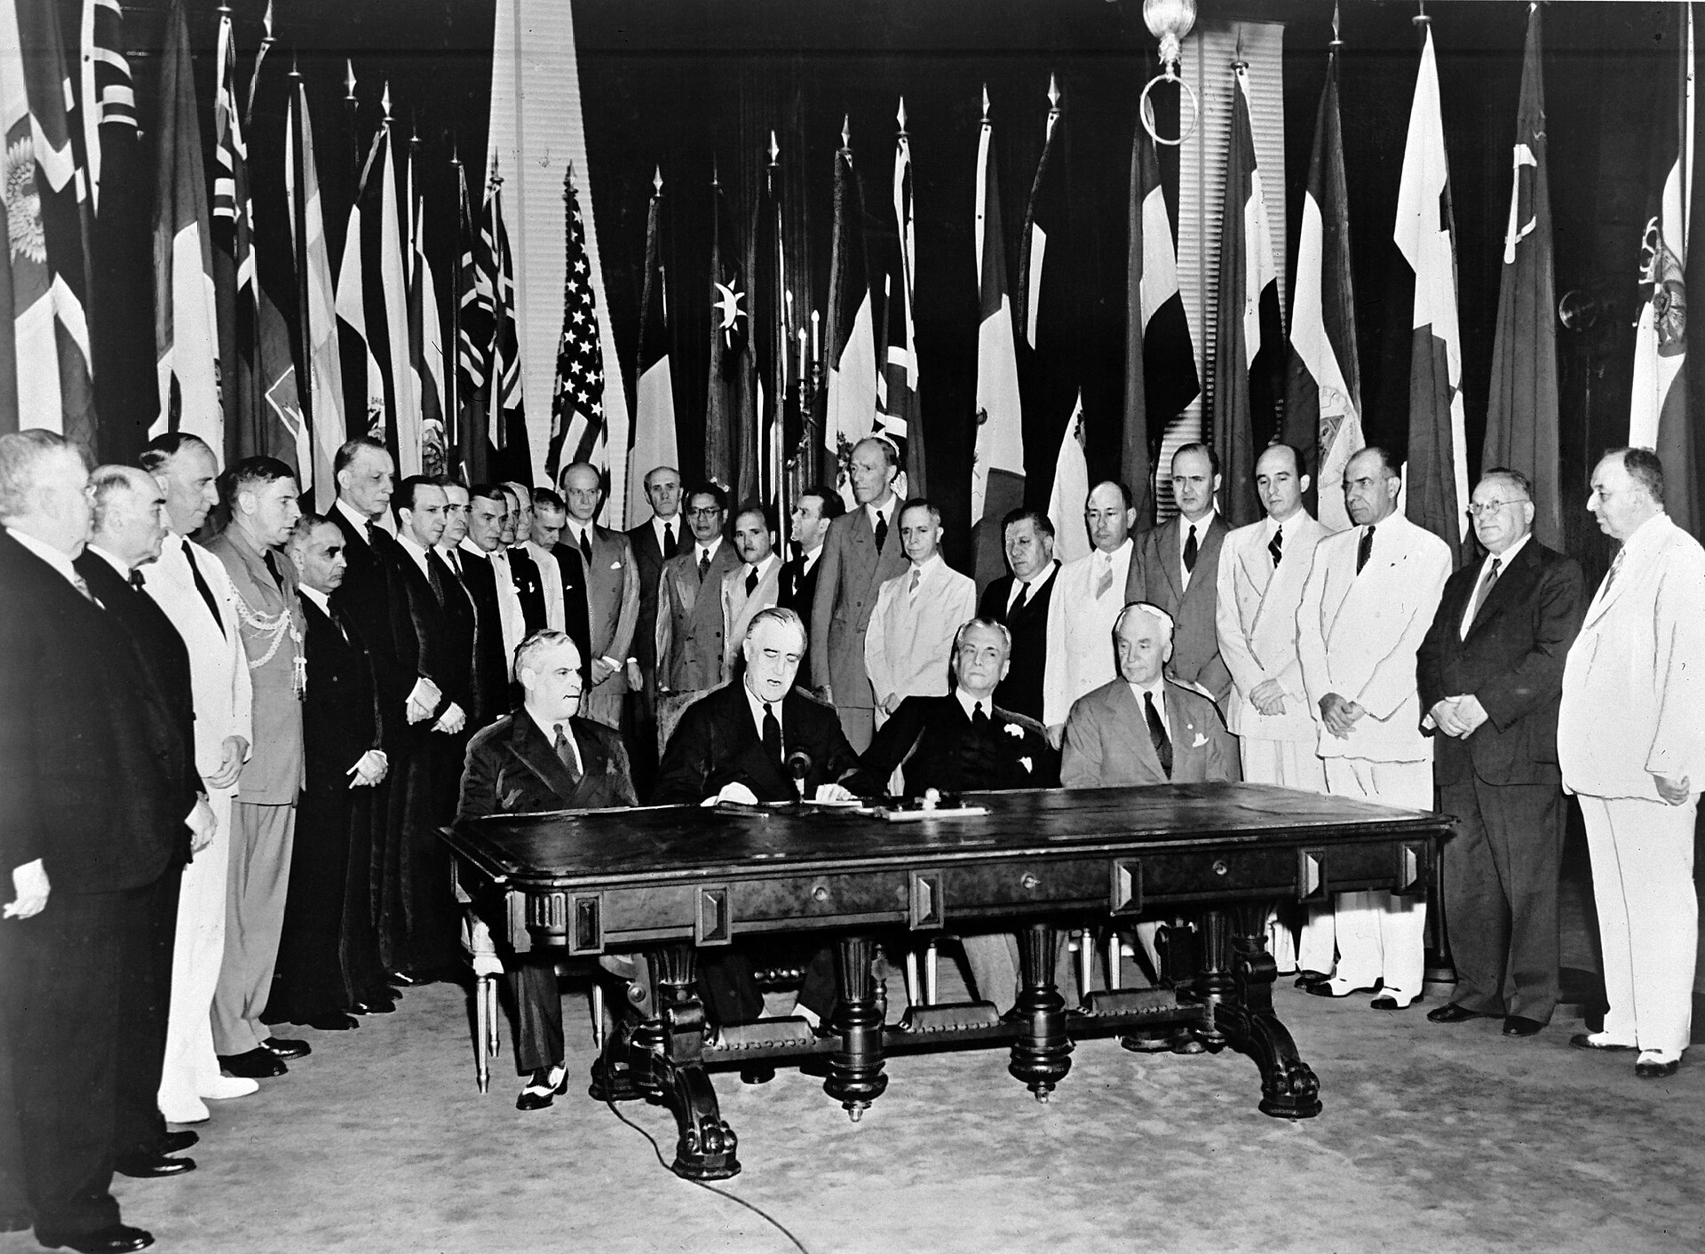
Signing of the Declaration by United Nations, Washington, D.C. (January 1, 1942) · Unknown photographer / United Nations · January 1, 1942
Source: Unknown photographer. "Signing of the Declaration by United Nations, Washington, D.C." 1 Jan. 1942. United Nations, via Wikimedia Commons, commons.wikimedia.org/wiki/File:Signing_Declaration_by_United_Nations.jpg. Public Domain https://commons.wikimedia.org/wiki/File:Signing_Declaration_by_United_Nations.jpg
HIPPO — analyze the source (prompt) | Your analysis
H — Historical context: what was happening when this was created?
I — Intended audience: who was meant to see or obey it?
P — Purpose: why was it created?
P — Point of view: whose perspective does it reflect?
O — Outside connection: how does it connect to this standard?
SUPPORT OPTION
Sentence frame: This source shows ______ because it ______, which reveals ______.
CONFIDENCE CHECK-IN
Rate your understanding of this standard (1–4): ______ One thing to revisit: ____________________

Activity 6 — Core Application: Practice Quiz — US.58 ⏱ ~8 min
RESPONSE CHOICE
Commit to an answer by marking it, saying it, or explaining it aloud before checking. Answer key is in the Teacher Guide (kept separate).
[DOK 2 · item us58-q2 · pre-field-test]
How did Secretary of State Cordell Hull contribute to the founding and principles of the UN?
A. The Tennessean advocated for international organization throughout the war, led U.S. planning efforts, helped shape UN principles, and earned the Nobel Peace Prize for his contributions
B. Hull opposed international organization, which does not reflect the consensus among historians and fails to account for key developments in the broader context
C. Hull had no role in UN formation, but this oversimplifies the complex factors at work, but contemporary accounts and primary sources suggest otherwise, which contradicts the primary source evidence from this era
D. Hull represented the Soviet Union, but contemporary accounts suggest a different explanation, though this interpretation lacks supporting historical evidence
[DOK 2 · item q-us58-dok2-u6-2 · pre-field-test]
How did the United Nations differ from the League of Nations?
A. The League of Nations was more effective at preventing armed conflicts
B. The UN included the U.S. and had stronger peacekeeping mechanisms
C. The UN had fewer member nations and less international authority
D. The UN focused solely on trade while the League addressed all issues
[DOK 3 · item u1-us58-dok3-tc · pre-field-test]
What were the main goals of the United Nations, and how did they reflect wartime experiences?
A. The UN had no connection to WWII experiences, although this view has been largely discredited by scholars, but closer analysis reveals a more complicated historical reality, but the historical evidence paints a more nuanced picture
B. Goals of maintaining peace, promoting human rights, enabling self-determination, and fostering cooperation directly addressed the failures that led to WWII—aggression, human rights violations, and economic nationalism
C. The UN focused only on trade issues, although this view has been largely discredited by scholars and does not reflect the scholarly consensus on this topic, which ignores significant political and cultural developments of the era
D. Wartime experiences were irrelevant to UN design, but this fails to account for the broader historical context, which represents a common misconception about this historical period, which contradicts the primary source evidence from this era

Activity 7 — Constructed Response (CER) — US.58 ⏱ ~15 min
BIG-QUESTION ORGANIZER — in World War II, how did the war reshape America at home and its role in the world — and who sacrificed, even while being excluded?
Jot quick notes from THIS standard: Who benefited? · Who bore the costs? · Who decided?

CONSTRUCTED RESPONSE (CER) — builds SSP.04 Argumentation
Claim + Evidence + Reasoning: Using this standard, take a position on the central question — identify and explain the reasons for the founding of the United Nations, including the role of Cordell Hull? Support your claim with two pieces of evidence from the passage and explain your reasoning.
Part | Write here
Claim
Evidence (two specifics)
Reasoning
SELF-CHECK (CER rubric — see Toolkit)
Is my claim defensible? · TWO specific pieces of evidence? · Does my reasoning explain HOW the evidence proves the claim?
EXIT TICKET — before you leave [item us58-q1 · DOK 2 · pre-field-test]
What lessons from the League of Nations' failure influenced the design of the United Nations?
A. The League was considered successful, but this oversimplifies the complex factors at work, which ignores significant political and cultural developments of the era and does not reflect the scholarly consensus on this topic
B. The UN copied the League's structure exactly, although this view has been largely discredited by scholars despite the fact that multiple contemporary sources contradict this, though this interpretation lacks supporting historical evidence
C. No lessons were learned from the League, but this fails to account for the broader historical context and fails to account for key developments in the broader context and oversimplifies the complex factors at work during this period
D. U.S. non-participation, weak enforcement, and inability to stop aggression led designers to ensure American membership, create the Security Council with enforcement authority, and give major powers veto to encourage participation
Show what you know (your choice): mark the best answer, say it, or explain it — then rate how sure you are: ☐ Not yet ☐ Getting there ☐ Got it
Answer key and next steps are in the Teacher Guide.

Your Tennessee Connection
TENNESSEE CONNECTION · OAK RIDGE, THE “SECRET CITY”
Tennessee was central to winning — and ending — World War II. In 1942 the federal government built Oak Ridge in the hills of East Tennessee as a secret site of the Manhattan Project (US.56). Its plants enriched the uranium used in the bomb dropped on Hiroshima. The town grew to about 75,000 people almost overnight, yet most workers — including thousands of women (US.52) — had no idea what they were building. Tennessee also sent its people to the war: Fort Campbell trained the 101st Airborne (US.51), Alcoa produced aluminum for warplanes (US.55), and Cordell Hull of Pickett County, Secretary of State, helped found the United Nations and won the Nobel Peace Prize (US.58).
Reflect (RESPONSE CHOICE): How does a local story change the way you understand a national event? Answer by writing, recording, or diagramming.

Local History Investigation
Industrialization touched Tennessee too — railroads, mines, mills, and the people who worked them. Investigate one local connection and record what you find.
Prompt | Your findings
A person, place, or industry from this era near me
One source I could check (library, TSLA, family, museum)
Who benefited / who bore the costs, locally
One question I still have

Progress Tracker & Cumulative Review
Track your Progress Check result for each standard and note one thing to revisit.
Standard | Progress Check (✓ / reteach) | One thing to revisit
US.45
US.46
US.47
US.48
US.49
US.50
US.51
US.52
US.53
US.54
US.55
US.56
US.57
US.58

Optional Extension Bank (higher-DOK, open to all)
Any student may choose an extension. These are EXTENSION, not a track.
US.45: Using this standard, take a position on the central question — explain the rise and spread of fascism, communism, and totalitarianism internationally, including the key characteristics and leaders of each system? Support your claim with two pieces of evidence from the passage and explain your reasoning.
US.46: Using this standard, take a position on the central question — explain President Franklin D. Roosevelt's response to world crises, including the Quarantine Speech, the Four Freedoms speech, the Atlantic Charter, and the Lend-Lease Act? Support your claim with two pieces of evidence from the passage and explain your reasoning.
US.47: Using this standard, take a position on the central question — analyze the response of the U.S. to the plight of European Jews before the war, the liberation of concentration camps during the war, and the immigration of Holocaust survivors after the war? Support your claim with two pieces of evidence from the passage and explain your reasoning.
US.48: Using this standard, take a position on the central question — explain the reasons for American entry into World War II, including the attack on Pearl Harbor? Support your claim with two pieces of evidence from the passage and explain your reasoning.
US.49: Using this standard, take a position on the central question — identify the roles and the significant actions of key individuals in World War II, including Churchill, Eisenhower, Hitler, MacArthur, Marshall, Mussolini, FDR, Stalin, Tojo, and Truman? Support your claim with two pieces of evidence from the passage and explain your reasoning.
US.50: Using this standard, take a position on the central question — explain the role of geographic and military factors on the outcomes of battles in the Pacific and European theaters, including Midway, Iwo Jima, Okinawa, and D-Day? Support your claim with two pieces of evidence from the passage and explain your reasoning.
US.51: Using this standard, take a position on the central question — identify the roles and sacrifices of individual American soldiers and the unique contributions of special fighting forces such as the Tuskegee Airmen, the 442nd Regimental Combat Team, the 101st Airborne, and the Navajo Code Talkers? Support your claim with two pieces of evidence from the passage and explain your reasoning.
US.52: Using this standard, take a position on the central question — examine and explain the entry of large numbers of women into the workforce and armed forces during World War II and the subsequent impact on American society? Support your claim with two pieces of evidence from the passage and explain your reasoning.
US.53: Using this standard, take a position on the central question — examine the impact of World War II on economic and social conditions for African Americans, including the Fair Employment Practices Committee and the eventual integration of the armed forces by President Truman? Support your claim with two pieces of evidence from the passage and explain your reasoning.
US.54: Using this standard, take a position on the central question — describe the constitutional issues and impact of the internment of Japanese Americans on the U.S., including the Fred Korematsu v. United States of America decision? Support your claim with two pieces of evidence from the passage and explain your reasoning.
US.55: Using this standard, take a position on the central question — describe the war's impact on the home front, including rationing, bond drives, propaganda, movement to cities, the Bracero program, conversion of factories, and prisoner of war camps in Tennessee? Support your claim with two pieces of evidence from the passage and explain your reasoning.
US.56: Using this standard, take a position on the central question — describe the Manhattan Project and explain the rationale for using the atomic bomb to end the war? Support your claim with two pieces of evidence from the passage and explain your reasoning.
US.57: Using this standard, take a position on the central question — explain the major outcomes of the Yalta and Potsdam Conferences? Support your claim with two pieces of evidence from the passage and explain your reasoning.
US.58: Using this standard, take a position on the central question — identify and explain the reasons for the founding of the United Nations, including the role of Cordell Hull? Support your claim with two pieces of evidence from the passage and explain your reasoning.

Think Like a Test-Writer (unit review — open to all)
You met a quick “think like a test-writer” prompt in every standard. Here is the full how-to, once, plus room to write your best questions for the whole unit.
HOW TO WRITE A DOK-3 QUESTION
DOK-3 = strategic thinking: the reader must analyze, compare, evaluate, or justify using evidence — and there should be more than one defensible answer (not a fact you can just look up).
Sentence starters: “Why did ______ lead to ______?” · “Which mattered more — ______ or ______ — and why?” · “What is the BEST evidence that ______?” · “Evaluate whether ______.” · “Defend or challenge: ______.”
Frame: [Analyze / Evaluate / Justify] + [something from this unit] + “using evidence.”
Quick check: does my question make the reader THINK and use evidence? If yes, it’s DOK-3.
Standard | Your DOK-3 question | Your answer key (one sentence)

Reusable Toolkit & Source Library

Written Response Rubric (CER)
Level | Claim | Evidence | Reasoning
4 — Strong | Precise, defensible | 2+ accurate, specific | Explains how evidence proves the claim
3 — Proficient | Clear | 2 accurate | Explains the link
2 — Developing | General | 1 accurate | Partial link
1 — Beginning | Unclear/missing | Missing/inaccurate | No reasoning

Source Library — full citations & clickable links
US.45 — Rise and Spread of Fascism, Communism, and Totalitarianism
The Doctrine of Fascism. Benito Mussolini, 1932. Mussolini, Benito. "The Doctrine of Fascism." 1932. Internet Archive, archive.org/details/doctrineoffascis00muss.. Public domain. https://archive.org/details/doctrineoffascis00muss
The Stalin Constitution of 1936 (Article 126). Government of the Union of Soviet Socialist Republics, December 5, 1936. Union of Soviet Socialist Republics. "Constitution (Fundamental Law) of the U.S.S.R., Article 126." 5 Dec. 1936. Avalon Project, Yale Law School, avalon.law.yal. Public domain. https://avalon.law.yale.edu/20th_century/ussr01.asp
US.46 — FDR's Response to World Crises
The Four Freedoms Speech. President Franklin D. Roosevelt, January 6, 1941. Roosevelt, President Franklin D.. "The Four Freedoms Speech." January 6, 1941. National Archives, https://www.archives.gov/milestone-documents/president-frankli. Public domain. https://www.archives.gov/milestone-documents/president-franklin-roosevelts-annual-message-to-congress
Lend-Lease Act Message to Congress. President Franklin D. Roosevelt, January 1941. Roosevelt, President Franklin D.. "Lend-Lease Act Message to Congress." January 1941. National Archives, https://www.archives.gov/milestone-documents/lend-lease. Public domain. https://www.archives.gov/milestone-documents/lend-lease-act
US.47 — U.S. Response to the Holocaust
Testimony of Holocaust Survivor. Elie Wiesel, 1945 (describing liberation). Wiesel, Elie. "Testimony of Holocaust Survivor." 1945 (describing liberation). United States Holocaust Memorial Museum, www.ushmm.org/collections/bibliography/e. Public domain. https://www.ushmm.org/collections/bibliography/elie-wiesel
Report to the Secretary on the Acquiescence of This Government in the Murder of the Jews. U.S. Treasury Department staff (Josiah DuBois and colleagues), January 1944. DuBois, Josiah, et al. "Report to the Secretary on the Acquiescence of This Government in the Murder of the Jews." Jan. 1944. Franklin D. Roosevelt Presidential. Public domain. https://www.fdrlibrary.org/holocaust
US.48 — American Entry into World War II
Day of Infamy Speech. President Franklin D. Roosevelt, December 8, 1941. Roosevelt, President Franklin D.. "Day of Infamy Speech." December 8, 1941. National Archives, https://www.archives.gov/legislative/features/day-of-infamy.. Public domain. https://www.archives.gov/legislative/features/day-of-infamy
Joint Resolution Declaring War Against Japan. United States Congress, December 8, 1941. United States Congress. "Joint Resolution Declaring That a State of War Exists Between the Imperial Government of Japan and the Government and the People of the. Public domain. https://www.archives.gov/milestone-documents/joint-resolution-declaration-of-war-against-japan
US.49 — WWII Leaders & Key Figures
We Shall Fight on the Beaches Speech. Winston Churchill, June 4, 1940. Churchill, Winston. "We Shall Fight on the Beaches Speech." June 4, 1940. International Churchill Society, winstonchurchill.org/resources/speeches/1940-the-fine. Public domain. https://winstonchurchill.org/resources/speeches/1940-the-finest-hour/we-shall-fight-on-the-beaches/
First Inaugural Address ("the only thing we have to fear"). President Franklin D. Roosevelt, March 4, 1933. Roosevelt, Franklin D. "First Inaugural Address." 4 Mar. 1933. Avalon Project, Yale Law School, avalon.law.yale.edu/20th_century/froos1.asp.. Public domain. https://avalon.law.yale.edu/20th_century/froos1.asp
US.50 — Major WWII Battles: Midway, Iwo Jima, Okinawa & D-Day
Order of the Day - D-Day. General Dwight D. Eisenhower, June 6, 1944. Eisenhower, General Dwight D.. "Order of the Day - D-Day." June 6, 1944. National Archives, www.archives.gov/historical-docs/todays-doc/?dod-date=606.. Public domain. https://www.archives.gov/historical-docs/todays-doc/?dod-date=606
Communiqué No. 1 from Supreme Headquarters (D-Day Landings). Supreme Headquarters Allied Expeditionary Force (SHAEF), June 6, 1944. Supreme Headquarters Allied Expeditionary Force. "Communiqué No. 1." 6 June 1944. Dwight D. Eisenhower Presidential Library, www.eisenhowerlibrary.gov.. Public domain. https://www.eisenhowerlibrary.gov/research/online-documents/d-day
US.51 — Special Fighting Forces in WWII
Tuskegee Airmen Commendation. U.S. Army Air Forces, 1945. U.S. Army Air Forces. "Tuskegee Airmen Commendation." 1945. National Archives, www.archives.gov/research/military/ww2/tuskegee-airmen.. Public domain. https://www.archives.gov/research/military/ww2/tuskegee-airmen
Executive Order 9981 — Desegregation of the Armed Forces. President Harry S. Truman, July 26, 1948. Truman, Harry S. "Executive Order 9981." 26 July 1948. National Archives, www.archives.gov.. Public domain. https://www.archives.gov/milestone-documents/executive-order-9981
US.52 — Women in World War II
War Production Board Poster Text. U.S. War Production Board, 1943. U.S. War Production Board. "War Production Board Poster Text." 1943. Library of Congress, www.loc.gov/collections/world-war-ii-posters/.. Public domain. https://www.loc.gov/collections/world-war-ii-posters/
Women in the War — We Can't Win Without Them (War Manpower Commission). U.S. War Manpower Commission / Office of War Information, 1943. U.S. War Manpower Commission. "Women in the War." 1943. National Archives, www.archives.gov.. Public domain. https://www.archives.gov/education/lessons/wwii-homefront
US.53 — African Americans in WWII
Executive Order 8802. President Franklin D. Roosevelt, June 25, 1941. Roosevelt, President Franklin D.. "Executive Order 8802." June 25, 1941. National Archives, https://www.archives.gov/milestone-documents/executive-order-8802.. Public domain. https://www.archives.gov/milestone-documents/executive-order-8802
The 'Double V' Campaign Editorial (Pittsburgh Courier). James G. Thompson, letter published in the Pittsburgh Courier, 1942. Thompson, James G. "Should I Sacrifice to Live 'Half-American'?" Pittsburgh Courier, 1942. Library of Congress, www.loc.gov.. Public domain. https://www.loc.gov/exhibitions/world-war-ii-on-the-american-home-front/
US.54 — Japanese American Internment & Korematsu
Executive Order 9066. President Franklin D. Roosevelt, February 19, 1942. Roosevelt, President Franklin D.. "Executive Order 9066." February 19, 1942. National Archives, https://www.archives.gov/milestone-documents/executive-order-906. Public domain. https://www.archives.gov/milestone-documents/executive-order-9066
Korematsu v. United States — Dissent of Justice Frank Murphy. Justice Frank Murphy, Supreme Court of the United States, December 18, 1944. Murphy, Frank. "Dissent, Korematsu v. United States, 323 U.S. 214." 18 Dec. 1944. Legal Information Institute, Cornell Law School, www.law.cornell.edu.. Public domain. https://www.law.cornell.edu/supremecourt/text/323/214
US.55 — Home Front Mobilization
War Ration Book Instructions. Office of Price Administration, 1943. Office of Price Administration. "War Ration Book Instructions." 1943. National Archives, www.archives.gov/education/lessons/wwii-rationing.. Public domain. https://www.archives.gov/education/lessons/wwii-rationing
Office of War Information Poster Text — "Plant a Victory Garden". U.S. Office of War Information, 1943. U.S. Office of War Information. "Plant a Victory Garden." 1943. National Archives, www.archives.gov.. Public domain. https://www.archives.gov/education/lessons/wwii-homefront
US.56 — Manhattan Project & Atomic Bomb
Statement on the Atomic Bomb. President Harry S. Truman, August 6, 1945. Truman, President Harry S.. "Statement on the Atomic Bomb." August 6, 1945. Harry S. Truman Presidential Library, www.trumanlibrary.gov/library/public-papers/93. Public domain. https://www.trumanlibrary.gov/library/public-papers/93/statement-president-announcing-use-bomb-hiroshima
Leaflet Dropped on Japanese Cities Before the Atomic Bombings. United States Army Air Forces (Office of War Information), August 1945. United States Army Air Forces. "Warning Leaflet (LeMay Leaflet) Dropped on Japan." Aug. 1945. Harry S. Truman Library and Museum, www.trumanlibrary.gov.. Public domain. https://www.trumanlibrary.gov/library/online-collections/decision-to-drop-atomic-bomb
US.57 — Yalta and Potsdam Conferences
Yalta Conference Communiqué. Roosevelt, Churchill, and Stalin, February 1945. Roosevelt, Churchill, and Stalin. "Yalta Conference Communiqué." February 1945. Avalon Project, Yale Law School, avalon.law.yale.edu/wwii/yalta.asp.. Public domain. https://avalon.law.yale.edu/wwii/yalta.asp
Potsdam Declaration — Terms for Japanese Surrender. United States, United Kingdom, and China, July 26, 1945. United States, United Kingdom, and China. "Potsdam Declaration." 26 July 1945. National Diet Library / Avalon Project, Yale Law School, avalon.law.yale.edu.. Public domain. https://avalon.law.yale.edu/20th_century/decade17.asp
US.58 — Founding of the United Nations & Cordell Hull
United Nations Charter Preamble. United Nations, June 26, 1945. United Nations. "United Nations Charter Preamble." June 26, 1945. United Nations, www.un.org/en/about-us/un-charter/preamble.. Public domain. https://www.un.org/en/about-us/un-charter/preamble
The Atlantic Charter. President Franklin D. Roosevelt and Prime Minister Winston Churchill, August 14, 1941. Roosevelt, Franklin D., and Winston Churchill. "The Atlantic Charter." 14 Aug. 1941. Avalon Project, Yale Law School, avalon.law.yale.edu/wwii/atlantic.asp.. Public domain. https://avalon.law.yale.edu/wwii/atlantic.asp

The Good War? — Who Fought, Who Sacrificed, Who Was Excluded
This section complicates the “Good War” narrative: the U.S. fought fascism abroad while denying rights to many of its own people at home. It is History Hack-authored instructional synthesis grounded in this unit’s sourced record — not a primary source.

Serving While Excluded
Black Americans fought under segregation and demanded a “Double V” — victory over fascism abroad and racism at home (US.53); the Tuskegee Airmen, Navajo Code Talkers, and the Japanese-American 442nd (US.51) served with distinction even as their communities faced discrimination.

A Freedom Denied at Home
While fighting for freedom, the U.S. forced about 120,000 Japanese Americans — most of them citizens — into internment camps under Executive Order 9066; the Supreme Court upheld it in Korematsu (US.54).

The Home Front & Women
Rationing, war bonds, and war production remade daily life (US.55); millions of women entered defense work — “Rosie the Riveter” (US.52) — including at Oak Ridge, though many lost those jobs when the war ended.

A New World Order — and the Bomb
The Manhattan Project ended the war with atomic weapons (US.56); Yalta and Potsdam (US.57) divided the postwar world; and the United Nations (US.58) was founded to prevent the next global war — even as the Holocaust (US.47) revealed how far totalitarianism had gone.
Residual note (known follow-up): sourced visuals and named Key-Figure entries for these histories remain pending.

Unit Reflection
Return to the unit’s big question: how did World War II reshape America at home and its role in the world — and who sacrificed for a freedom they were still denied? Write a final claim with two pieces of evidence from different standards.
Part | Write here
My claim
Evidence 1 (standard: ___)
Evidence 2 (standard: ___)
Why it matters today

