1776 - 2026 • AMERICA'S 250TH ANNIVERSARY • SEMIQUINCENTENNIAL EDITION
U.S. HISTORY HACK™
TROOPTOTEACHER TECHNOLOGIES
UNIT 8
Postwar America, 1945–1963
COURSE STANDARD EDITION
US.71 – US.77 • 7 Tennessee U.S. History Standards • Grades 9–12
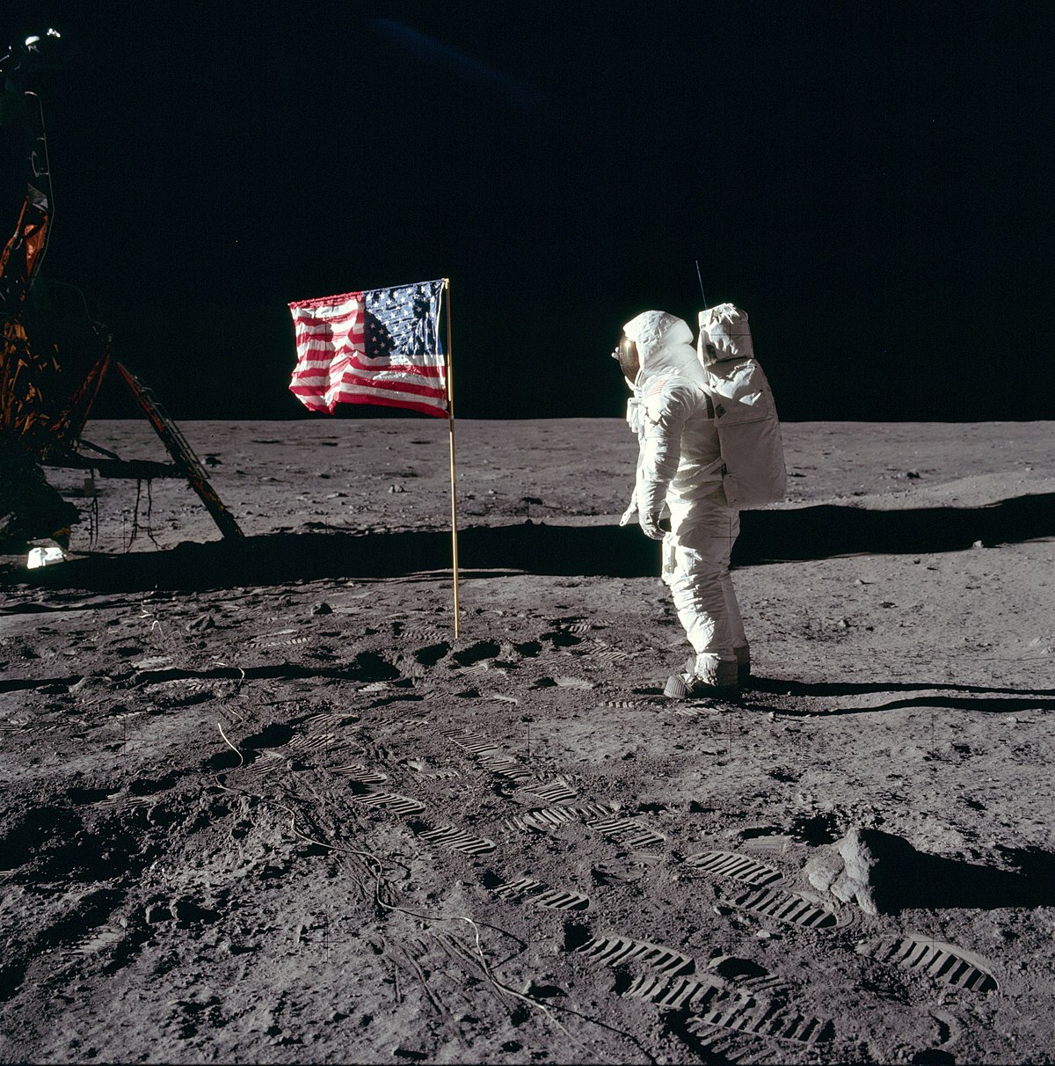
Astronaut Buzz Aldrin walks on the Moon during Apollo 11, July 20, 1969.
Source: Neil Armstrong / NASA. Public domain.
TENNESSEE CONNECTION · MEMPHIS & THE BIRTH OF ROCK ’N’ ROLL
Rock and roll was born in Tennessee. At Sun Records in Memphis, producer Sam Phillips recorded Elvis Presley, Johnny Cash, Carl Perkins, and Jerry Lee Lewis — blending blues and country into a sound that defined a generation of youth culture (US.76). Nashville’s WSM-TV carried the Grand Ole Opry into living rooms (US.75), while new interstates like I-40 reshaped the state (US.73–US.74).
One common workbook designed for learner variability. Every student works toward the same Tennessee standards; supports vary the means, not the goal or the ceiling.
Release-Ready · Pilot Edition
© 2026 TroopToTeacher Technologies LLC. All rights reserved. ISBN: [to be assigned]

Copyright, Ownership & Framework
U.S. History Hack™ — Unit 8: Postwar America (1945–1963), Course Standard Edition.
© 2026 TroopToTeacher Technologies LLC. All rights reserved. This workbook is proprietary; reproduction or redistribution outside a licensed classroom is prohibited.
Source integrity. Every primary source in this unit is public-domain and cited to its holding repository (National Archives, Library of Congress, HathiTrust). See the Source Library.
Reading provenance (district-clear). Close-Read passages are labeled “History Hack-authored instructional synthesis” — they build on the standard record and are not presented as primary sources.
Framework stack. This workbook anchors to Tennessee U.S. History standards US.71–US.77 and the Social Studies Practices (SSP.01–SSP.06), and is designed on CAST UDL 3.0 and an MTSS support model.
Pacing. Each standard is built for one 45-minute class period. Each activity shows a ⏱ ~ minutes estimate at its heading. There is more here than one period holds — your teacher chooses which activities you do in class; the rest may become warm-ups, stations, or homework.

Table of Contents
Copyright, Ownership & Framework 2
Table of Contents 3
Tennessee Standards & SSP Crosswalk 5
Social Studies Practices (SSP.01–SSP.06) 5
Accessibility, UDL & Accommodations Matrix 6
How CAST UDL 3.0 is visible in this workbook 6
My Support Plan (optional — you choose) 6
How to Use This Workbook 7
Label legend — these appear throughout every standard cycle 7
Before You Begin — Set Your Goal 7
Standard US.71 — 1950s Prosperity & Consumerism 8
Activity 1 — Vocabulary (Part A: Reference / Word Bank) — US.71 ⏱ ~10 min 9
Activity 2 — Vocabulary Studio (Frayer-inspired) — US.71 ⏱ ~7 min 10
Activity 3 — Direct Teaching Cornell Notes — US.71 ⏱ ~20 min 11
Cornell Notes — keep going, then process & check — US.71 12
Activity 4 — Close Read — US.71 ⏱ ~15 min 13
Activity 5 — Primary Source / Data Analysis — US.71 ⏱ ~15 min 14
Activity 6 — Core Application: Practice Quiz — US.71 ⏱ ~8 min 15
Activity 7 — Constructed Response (CER) — US.71 ⏱ ~15 min 16
Standard US.72 — Baby Boomer Generation Impact 17
Activity 1 — Vocabulary (Part A: Reference / Word Bank) — US.72 ⏱ ~10 min 18
Activity 2 — Vocabulary Studio (Frayer-inspired) — US.72 ⏱ ~7 min 19
Activity 3 — Direct Teaching Cornell Notes — US.72 ⏱ ~20 min 20
Cornell Notes — keep going, then process & check — US.72 21
Activity 4 — Close Read — US.72 ⏱ ~15 min 22
Activity 5 — Primary Source / Data Analysis — US.72 ⏱ ~15 min 23
Activity 6 — Core Application: Practice Quiz — US.72 ⏱ ~8 min 24
Activity 7 — Constructed Response (CER) — US.72 ⏱ ~15 min 25
Standard US.73 — Eisenhower Administration Developments 26
Activity 1 — Vocabulary (Part A: Reference / Word Bank) — US.73 ⏱ ~10 min 27
Activity 2 — Vocabulary Studio (Frayer-inspired) — US.73 ⏱ ~7 min 28
Activity 3 — Direct Teaching Cornell Notes — US.73 ⏱ ~20 min 29
Cornell Notes — keep going, then process & check — US.73 30
Activity 4 — Close Read — US.73 ⏱ ~15 min 31
Activity 5 — Primary Source / Data Analysis — US.73 ⏱ ~15 min 32
Activity 6 — Core Application: Practice Quiz — US.73 ⏱ ~8 min 33
Activity 7 — Constructed Response (CER) — US.73 ⏱ ~15 min 34
Standard US.74 — Automobile's Growing Influence 35
Activity 1 — Vocabulary (Part A: Reference / Word Bank) — US.74 ⏱ ~10 min 36
Activity 2 — Vocabulary Studio (Frayer-inspired) — US.74 ⏱ ~7 min 37
Activity 3 — Direct Teaching Cornell Notes — US.74 ⏱ ~20 min 38
Cornell Notes — keep going, then process & check — US.74 39
Activity 4 — Close Read — US.74 ⏱ ~15 min 40
Geographer’s Lens — US.74 ⏱ ~12 min 41
Activity 5 — Primary Source / Data Analysis — US.74 ⏱ ~15 min 42
Activity 6 — Core Application: Practice Quiz — US.74 ⏱ ~8 min 43
Activity 7 — Constructed Response (CER) — US.74 ⏱ ~15 min 44
Standard US.75 — Television and Mass Media Impact 45
Activity 1 — Vocabulary (Part A: Reference / Word Bank) — US.75 ⏱ ~10 min 46
Activity 2 — Vocabulary Studio (Frayer-inspired) — US.75 ⏱ ~7 min 47
Activity 3 — Direct Teaching Cornell Notes — US.75 ⏱ ~20 min 48
Cornell Notes — keep going, then process & check — US.75 49
Activity 4 — Close Read — US.75 ⏱ ~15 min 50
Activity 5 — Primary Source / Data Analysis — US.75 ⏱ ~15 min 51
Activity 6 — Core Application: Practice Quiz — US.75 ⏱ ~8 min 52
Activity 7 — Constructed Response (CER) — US.75 ⏱ ~15 min 53
Standard US.76 — Youth Culture and Tennessee Music 54
Activity 1 — Vocabulary (Part A: Reference / Word Bank) — US.76 ⏱ ~10 min 55
Activity 2 — Vocabulary Studio (Frayer-inspired) — US.76 ⏱ ~7 min 56
Activity 3 — Direct Teaching Cornell Notes — US.76 ⏱ ~20 min 57
Cornell Notes — keep going, then process & check — US.76 58
Activity 4 — Close Read — US.76 ⏱ ~15 min 59
Activity 5 — Primary Source / Data Analysis — US.76 ⏱ ~15 min 60
Activity 6 — Core Application: Practice Quiz — US.76 ⏱ ~8 min 61
Activity 7 — Constructed Response (CER) — US.76 ⏱ ~15 min 62
Standard US.77 — Kennedy's New Frontier 63
Activity 1 — Vocabulary (Part A: Reference / Word Bank) — US.77 ⏱ ~10 min 64
Activity 2 — Vocabulary Studio (Frayer-inspired) — US.77 ⏱ ~7 min 65
Activity 3 — Direct Teaching Cornell Notes — US.77 ⏱ ~20 min 66
Cornell Notes — keep going, then process & check — US.77 67
Activity 4 — Close Read — US.77 ⏱ ~15 min 68
Activity 5 — Primary Source / Data Analysis — US.77 ⏱ ~15 min 69
Activity 6 — Core Application: Practice Quiz — US.77 ⏱ ~8 min 70
Activity 7 — Constructed Response (CER) — US.77 ⏱ ~15 min 71
Your Tennessee Connection 71
Local History Investigation 72
Progress Tracker & Cumulative Review 72
Optional Extension Bank (higher-DOK, open to all) 73
Think Like a Test-Writer (unit review — open to all) 73
Reusable Toolkit & Source Library 74
Written Response Rubric (CER) 74
Source Library — full citations & clickable links 74
The Affluent Society — Who Shared the Boom, and Who Was Left Out 75
The Suburban Boom 75
Left Out of the Dream 75
A New Youth Culture 75
Conformity and Its Cracks 75
Unit Reflection 76

Tennessee Standards & SSP Crosswalk
Each standard below is taught to the full Course Standard expectation; the Social Studies Practices are embedded in every activity cycle.
Standard | Focus | Lenses
US.71 | 1950s Prosperity & Consumerism | Economics · History
US.72 | Baby Boomer Generation Impact | Economics · History
US.73 | Eisenhower Administration Developments | Politics/Government · History · Economics
US.74 | Automobile's Growing Influence | Economics · Geography · History
US.75 | Television and Mass Media Impact | History · Economics · Politics/Government
US.76 | Youth Culture and Tennessee Music | History · Culture · Tennessee Connection
US.77 | Kennedy's New Frontier | Politics/Government · Culture · Economics

Social Studies Practices (SSP.01–SSP.06)
SSP.01 Gather/evaluate sources · SSP.02 Critically examine a primary source · SSP.03 Synthesize evidence · SSP.04 Construct/communicate argument · SSP.05 Develop historical awareness · SSP.06 Chronological/spatial reasoning. Each Close Read, Primary Source/Data, and CER activity names the practices it builds.

Accessibility, UDL & Accommodations Matrix
One firm learning goal per standard; flexible, universal means. Supports are available by design and never lower the goal. They work alongside — never in place of — required IEP or 504 accommodations.
Universal support | What it is | Where it appears
CORE PATH | Essential instruction every student completes | Every activity
LANGUAGE SUPPORT | Vocabulary, pronunciation, Spanish cognates | Word Bank, Guided/Light Backs
RESPONSE CHOICE | Write, say/record, or diagram | Every activity
SUPPORT OPTION | Optional scaffold that keeps the goal | Guided Support Back, Primary Source
PROGRESS CHECK | Quick DOK-2/3 check to guide reteach/extend | Cornell Notes, Practice Quiz
EXTENSION | Deeper challenge once the goal is met | Extension Bank, CER

How CAST UDL 3.0 is visible in this workbook
Multiple means of Engagement (response choice, relevance via Tennessee Connection), Representation (Word Bank, pronunciation, Spanish, Close-Read supports), and Action & Expression (write/say/diagram, Frayer, CER). No fixed-track labels appear.

My Support Plan (optional — you choose)
Supports are available by design. Check the ones you might try; you can change your mind any time.
Support I might use | When it would help me
Word Bank + Spanish column
Guided or Light Support Back
Response choice (say/record or diagram)
Sentence frames / Rehearsal Lab

How to Use This Workbook
Each standard runs the same seven-activity cycle: (1) Vocabulary Word Bank, (2) Vocabulary Studio, (3) Direct-Teaching Cornell Notes with optional Guided and Light Support Backs, (4) Close Read, (5) Primary Source / Data Analysis, (6) Core Application Practice Quiz, (7) Constructed Response (CER). Work the CORE PATH; reach for SUPPORT OPTIONS as needed.

Label legend — these appear throughout every standard cycle
Label | Meaning
CORE PATH | The essential instruction every student completes.
SUPPORT OPTION | An optional scaffold that keeps the goal, not lowers it.
LANGUAGE SUPPORT | Vocabulary, pronunciation, and Spanish cognates for access.
RESPONSE CHOICE | Show learning by writing, saying/recording, or diagramming.
PROGRESS CHECK | A quick DOK-2/3 check that guides reteach or extend.
EXTENSION | A deeper challenge once the goal is met.

Before You Begin — Set Your Goal
This unit asks one big question: as the United States industrialized, who benefited and who bore the costs? Set a goal, then note what you already know.
Prompt | Your response
My goal for this unit is…
One thing I already know about this era…
One question I want answered…

Standard US.71 — 1950s Prosperity & Consumerism
TN Academic Standard US.71: Analyze the impact of prosperity and consumerism in the 1950s, including: the growth of white-collar jobs, the "suburban ideal", the impact of the G.I. Bill, and the increased reliance on foreign oil.
LEARNING TARGETS — I can…
• I can analyze the impact of prosperity and consumerism in the 1950s, including the growth of white-collar jobs, the "suburban ideal," the impact of the G.I. Bill, and the increased reliance on foreign oil.
Lenses for this standard: Economics · History
CORE PATH — the same for every student
Same rigor for everyone: analyze the sources and vocabulary, then show what you learned on the Practice Quiz and the CER.
UDL and MTSS give you flexible ways in — they never lower the bar.
Check yourself against the learning targets on the Cornell Notes page.
★ Tennessee Connection
Tennessee experienced the 1950s prosperity boom through suburban growth around Nashville, Memphis, and Knoxville. The completion of the interstate highway system through Tennessee connected the state to national markets and accelerated suburban development and consumer culture.
SET YOUR GOAL (self-direction)
My goal for this standard — what will I be able to do, and how will I show it?

HOOK — think before you dig in
1950s Prosperity & Consumerism: Analyze the impact of prosperity and consumerism in the 1950s, including: the growth of white-collar jobs, the "suburban ideal", the impact of the G.I. Bill, and the increased reliance on foreign oil. Who gained, who was left out — and why does it still matter?

ACTIVATE — what do you already know or wonder?
Jot what you already know or want to find out about this standard. You’ll come back to it.

PREVIEW & PREDICT
Which learning target will be hardest, and why? Connect it to the unit’s big question: who shared in the postwar prosperity, and who was left out?

Activity 1 — Vocabulary (Part A: Reference / Word Bank) — US.71 ⏱ ~10 min
Use this word bank throughout the standard. The Spanish column supports access, not translation of assessment.
Term | Student-friendly meaning | Spanish
White-Collar Jobs | Office and professional occupations (managers, salespeople, clerks) that grew rapidly in the 1950s, outnumbering factory workers for the first time. | Empleos de Cuello Blanco
Suburban Ideal | The 1950s American dream of owning a single-family home in the suburbs with a yard, garage, and modern appliances, drawing families out of cities. | Ideal Suburbano
G.I. Bill | The Servicemen’s Readjustment Act of 1944, which gave veterans college tuition, home loans, and job training, creating a massive new middle class. | Ley G.I.
Consumerism | The 1950s economic culture of buying goods beyond basic needs—televisions, cars, appliances, homes—driving growth and defining postwar life. | Consumismo
Levittown | The first mass-produced suburb, built by William Levitt on Long Island starting in 1947 using assembly-line techniques to build homes quickly and cheaply. | Levittown
Foreign Oil Dependence | America’s growing reliance on imported petroleum from the Middle East to fuel its car-centered economy, creating vulnerabilities in the 1970s. | Dependencia de Petróleo Extranjero
LANGUAGE SUPPORT
Pronunciations: White-Collar Jobs (KOL-er); Suburban Ideal (suh-BER-bin); G.I. Bill (jee-eye BIL); Consumerism (kun-SOO-mer-izm); Levittown (LEV-it-town); Foreign Oil Dependence (FOR-in oyl).

VOCABULARY SELF-CHECK · Knowledge Rating
Rate each term NOW in pencil, then again at the END — growth is the goal; no penalty for “never seen it.”
Term | 1 · never seen it | 2 · heard it | 3 · can use it | 4 · can teach it
White-Collar Jobs
Suburban Ideal
G.I. Bill
Consumerism
Levittown
Foreign Oil Dependence

Activity 2 — Vocabulary Studio (Frayer-inspired) — US.71 ⏱ ~7 min
RESPONSE CHOICE
Complete each studio by writing, speaking, or diagramming.

PRIORITY TERM 1 White-Collar Jobs · ES: Empleos de Cuello Blanco
Word-bank meaning to build on: Office and professional occupations (managers, salespeople, clerks) that grew rapidly in the 1950s, outnumbering factory workers for the first time.
Definition (in your own words) | Characteristics
Examples | Non-examples
Use it to explain
Write one sentence that uses “White-Collar Jobs” to explain this standard.

PRIORITY TERM 2 Suburban Ideal · ES: Ideal Suburbano
Word-bank meaning to build on: The 1950s American dream of owning a single-family home in the suburbs with a yard, garage, and modern appliances, drawing families out of cities.
Definition (in your own words) | Characteristics
Examples | Non-examples
Use it to explain
Write one sentence that uses “Suburban Ideal” to explain this standard.

CONNECT THE TERMS (UDL · build understanding)
How do these priority terms fit together? Write or sketch how one leads to or affects another.

Activity 3 — Direct Teaching Cornell Notes — US.71 ⏱ ~20 min
Name: ______________________ Class / Period: __________ Date: __________
US.71 — 1950s Prosperity & Consumerism • These notes capture the direct-teaching content and the Close Read for this standard.
Your learning targets are on this standard’s opening page — take notes that help you meet them.
Cues (tied to your learning targets) | My notes
What does the passage say about post-War Economic Boom?
What does the passage say about growth of White-Collar Jobs?
What does the passage say about the Suburban Ideal?
Key terms →
DOODLE ZONE — draw your thinking (UDL · another way in)
Need another way in? Sketch the key idea, a quick timeline, or how the pieces connect. Words optional.

Cornell Notes — keep going, then process & check — US.71
MORE NOTES / DIAGRAMS
Continue your notes here, add a quick sketch, or map how the ideas connect.

Key terms to list
White-Collar Jobs · Suburban Ideal · G.I. Bill · Consumerism · Levittown · Foreign Oil Dependence
Summary — In your own words (2–3 sentences)
PROGRESS CHECK · one question
How did the "suburban ideal" both fulfill and contradict the American Dream during the 1950s?
A. Suburbs offered homeownership and prosperity for white families, but restrictive covenants and redlining excluded minorities, creating segregated communities that contradicted democratic ideals of equality
B. Suburbs perfectly fulfilled the American Dream for all Americans, though this interpretation lacks supporting historical evidence when examined alongside the available primary and secondary sources
C. Suburban development had no racial dimensions, which does not align with the documented historical record when examined alongside the available primary and secondary sources, although historical sources do not support this conclusion
D. All Americans had equal access to suburban housing, but this fails to account for the broader historical context, which contradicts the primary source evidence from this era and does not reflect the scholarly consensus on this topic
Commit before you move on — mark it, say it, or explain it aloud.
CHECK YOURSELF — how am I doing?
Which learning targets (on this standard’s opening page) can you now meet? Tick the number; circle any you still need help with.
☐ 1
My 12–15 word headline for this standard

Activity 4 — Close Read — US.71 ⏱ ~15 min
Reading type: History Hack-authored instructional synthesis. This is not a primary source. Builds SSP.03 (synthesize) and SSP.05 (historical awareness).
CORE PATH — read one chunk at a time
Post-War Economic Boom
The 1950s saw unprecedented American prosperity. GDP grew from $200 billion (1940) to $500 billion (1960). Low unemployment, rising wages, and consumer spending drove economic expansion. The United States produced half of the world's manufactured goods and enjoyed the highest standard of living in history. This prosperity was fueled by pent-up consumer demand from wartime rationing, government spending, and technological innovation.
Growth of White-Collar Jobs
The American economy shifted from manufacturing to services and management. White-collar workers—office employees, managers, professionals, and salespeople—outnumbered blue-collar workers for the first time by 1956. Large corporations like IBM, General Electric, and AT&T offered stable employment with benefits, pensions, and opportunities for advancement. The "organization man" became a cultural archetype as corporate culture defined middle-class identity.
The Suburban Ideal
Suburban development exploded as developers like William Levitt built planned communities of affordable, mass-produced homes. Levittown, New York (1947) became the model for suburban development nationwide. Suburbs offered space, safety, good schools, and the American Dream of homeownership. However, restrictive covenants and redlining practices excluded African Americans and other minorities from most suburban communities, reinforcing racial segregation.
Impact of the G.I. Bill
The Servicemen's Readjustment Act of 1944 (G.I. Bill) transformed American society. It provided veterans with college tuition, vocational training, low-interest home loans, and unemployment benefits. By 1956, nearly 8 million veterans had used education benefits, doubling the college-educated population. G.I. Bill home loans fueled suburban growth, creating a massive new middle class. However, discriminatory implementation meant African American veterans received far fewer benefits.
Increased Reliance on Foreign Oil
America's car-centered suburban lifestyle dramatically increased oil consumption. Domestic oil production could not keep pace with demand, and the U.S. began importing increasing amounts of foreign oil, particularly from the Middle East. This growing dependence would later create economic vulnerability during the 1970s oil crises. The interstate highway system, suburban sprawl, and consumer culture all reinforced reliance on petroleum.
Key terms first: White-Collar Jobs, Suburban Ideal. Read once for the gist, then again for evidence.
CLOSE-READ EVIDENCE LAB — for each question: quote the EVIDENCE from the passage above, then write YOUR ANSWER (or answer aloud / diagram it).
Text-dependent question | Evidence from the passage | Your answer (what it shows)
What is the main idea of the “Post-War Economic Boom” section, and what evidence supports it?
What is the main idea of the “Growth of White-Collar Jobs” section, and what evidence supports it?

Activity 5 — Primary Source / Data Analysis — US.71 ⏱ ~15 min
Primary source (photograph) — analyze it with HIPPO. Builds SSP.01–SSP.02.
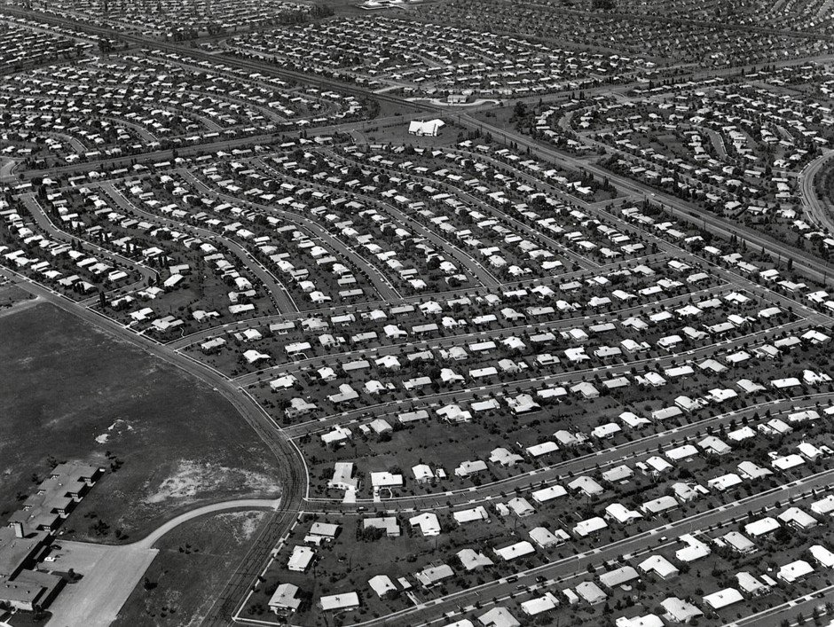
Aerial View of Levittown, Pennsylvania (c. 1959) · Unknown · c. 1959
Source: Unknown photographer. "Aerial View of Levittown, Pennsylvania." c. 1959. Via Wikimedia Commons, commons.wikimedia.org/wiki/File:LevittownPA.jpg. Public Domain https://commons.wikimedia.org/wiki/File:LevittownPA.jpg
HIPPO — analyze the source (prompt) | Your analysis
H — Historical context: what was happening when this was created?
I — Intended audience: who was meant to see or obey it?
P — Purpose: why was it created?
P — Point of view: whose perspective does it reflect?
O — Outside connection: how does it connect to this standard?
SUPPORT OPTION
Sentence frame: This source shows ______ because it ______, which reveals ______.
CONFIDENCE CHECK-IN
Rate your understanding of this standard (1–4): ______ One thing to revisit: ____________________

Activity 6 — Core Application: Practice Quiz — US.71 ⏱ ~8 min
RESPONSE CHOICE
Commit to an answer by marking it, saying it, or explaining it aloud before checking. Answer key is in the Teacher Guide (kept separate).
[DOK 2 · item us71-q2 · pre-field-test]
What factors drove the shift from manufacturing to white-collar employment during the 1950s?
A. Corporate growth, expanding service industries, and technological innovation created demand for managers, professionals, and office workers, with white-collar workers outnumbering blue-collar workers by 1956
B. Manufacturing jobs disappeared entirely, though this interpretation lacks supporting historical evidence, which represents a common misconception about this historical period, which does not align with the documented historical record
C. Workers preferred lower-paying office jobs, which ignores key developments that shaped the outcome and oversimplifies the complex factors at work during this period, but the historical evidence paints a more nuanced picture
D. The government mandated the shift to white-collar work, yet the available evidence points to a different conclusion, which contradicts the primary source evidence from this era
[DOK 2 · item us-72-x033 · pre-field-test]
The G.I. Bill (Servicemen's Readjustment Act of 1944) contributed most to postwar prosperity by —
A. Guaranteeing veterans lifetime government employment in the federal bureaucracy
B. Providing veterans with low-cost mortgages, college tuition, and business loans that expanded the middle class
C. Funding a massive public works program that built the interstate highway system
D. Establishing a federal health insurance program for all veterans and their families
[DOK 3 · item u1-us71-dok3-tc · pre-field-test]
How did the "suburban ideal" both fulfill and contradict the American Dream during the 1950s?
A. Suburbs offered homeownership and prosperity for white families, but restrictive covenants and redlining excluded minorities, creating segregated communities that contradicted democratic ideals of equality
B. Suburbs perfectly fulfilled the American Dream for all Americans, though this interpretation lacks supporting historical evidence when examined alongside the available primary and secondary sources
C. Suburban development had no racial dimensions, which does not align with the documented historical record when examined alongside the available primary and secondary sources, although historical sources do not support this conclusion
D. All Americans had equal access to suburban housing, but this fails to account for the broader historical context, which contradicts the primary source evidence from this era and does not reflect the scholarly consensus on this topic

Activity 7 — Constructed Response (CER) — US.71 ⏱ ~15 min
BIG-QUESTION ORGANIZER — in postwar America, who shared in the prosperity and the new consumer culture, and who was left out?
Jot quick notes from THIS standard: Who benefited? · Who bore the costs? · Who decided?

CONSTRUCTED RESPONSE (CER) — builds SSP.04 Argumentation
Claim + Evidence + Reasoning: Using this standard, take a position on the central question — analyze the impact of prosperity and consumerism in the 1950s, including the growth of white-collar jobs, the "suburban ideal," the impact of the G.I. Bill, and the increased reliance on foreign oil? Support your claim with two pieces of evidence from the passage and explain your reasoning.
Part | Write here
Claim
Evidence (two specifics)
Reasoning
SELF-CHECK (CER rubric — see Toolkit)
Is my claim defensible? · TWO specific pieces of evidence? · Does my reasoning explain HOW the evidence proves the claim?
EXIT TICKET — before you leave [item us71-q1 · DOK 2 · pre-field-test]
How did the G.I. Bill contribute to the growth of the American middle class and suburban development?
A. The G.I. Bill had minimal economic impact, but contemporary accounts suggest a different explanation, which represents a common misconception about this historical period, but the historical evidence paints a more nuanced picture
B. The G.I. Bill only provided unemployment benefits, although this view has been largely discredited by scholars, although this overlooks critical economic and social factors involved
C. It provided college tuition and low-interest home loans to nearly 8 million veterans, doubling the college-educated population and fueling suburban homeownership that created a massive new middle class
D. Only wealthy veterans could access G.I. Bill benefits, although this view has been largely discredited by scholars and fails to account for key developments in the broader context
Show what you know (your choice): mark the best answer, say it, or explain it — then rate how sure you are: ☐ Not yet ☐ Getting there ☐ Got it
Answer key and next steps are in the Teacher Guide.

Standard US.72 — Baby Boomer Generation Impact
TN Academic Standard US.72: Explain the impact of the baby boomer generation on the American economy and culture.
LEARNING TARGETS — I can…
• I can explain the impact of the baby boomer generation on the American economy and culture.
Lenses for this standard: Economics · History
CORE PATH — the same for every student
Same rigor for everyone: analyze the sources and vocabulary, then show what you learned on the Practice Quiz and the CER.
UDL and MTSS give you flexible ways in — they never lower the bar.
Check yourself against the learning targets on the Cornell Notes page.
★ Tennessee Connection
Tennessee felt the baby boom's impact through rapid suburban growth. Nashville's population surged, new schools were built across the state, and the University of Tennessee system expanded to accommodate boomer enrollment. Tennessee's music industry — centered in Nashville and Memphis — also boomed as young consumers drove record sales.
SET YOUR GOAL (self-direction)
My goal for this standard — what will I be able to do, and how will I show it?

HOOK — think before you dig in
Baby Boomer Generation Impact: Explain the impact of the baby boomer generation on the American economy and culture. Who gained, who was left out — and why does it still matter?

ACTIVATE — what do you already know or wonder?
Jot what you already know or want to find out about this standard. You’ll come back to it.

PREVIEW & PREDICT
Which learning target will be hardest, and why? Connect it to the unit’s big question: who shared in the postwar prosperity, and who was left out?

Activity 1 — Vocabulary (Part A: Reference / Word Bank) — US.72 ⏱ ~10 min
Use this word bank throughout the standard. The Spanish column supports access, not translation of assessment.
Term | Student-friendly meaning | Spanish
Baby Boom | The dramatic increase in birth rates from 1946–1964, when 76 million babies were born, transforming the American economy and culture as they grew up. | Explosión de Natalidad
Consumer Economy | An economy driven by high household spending on homes, cars, and appliances — powered in the 1950s by postwar prosperity and Baby Boom families. | Economía de Consumo
Suburbanization | The mass 1950s movement of families to newly built suburbs, driven by cheap housing, automobiles, and growing Baby Boom households. | Suburbanización
Youth Market | The large new consumer market of children and teenagers created by the Baby Boom, targeted by toy, music, food, and clothing industries. | Mercado Juvenil
Nuclear Family | The 1950s ideal household of a married couple and their children, celebrated in advertising and television as the American norm. | Familia Nuclear
Postwar Prosperity | The broad economic growth and rising standard of living the United States enjoyed after World War II. | Prosperidad de Posguerra
LANGUAGE SUPPORT
Pronunciations: Baby Boom (BAY-bee boom); Consumer Economy (kun-SOO-mer); Suburbanization (sub-ER-bun-ih-ZAY-shun); Youth Market (yooth); Nuclear Family (NOO-klee-er); Postwar Prosperity (POHST-wor).

VOCABULARY SELF-CHECK · Knowledge Rating
Rate each term NOW in pencil, then again at the END — growth is the goal; no penalty for “never seen it.”
Term | 1 · never seen it | 2 · heard it | 3 · can use it | 4 · can teach it
Baby Boom
Consumer Economy
Suburbanization
Youth Market
Nuclear Family
Postwar Prosperity

Activity 2 — Vocabulary Studio (Frayer-inspired) — US.72 ⏱ ~7 min
RESPONSE CHOICE
Complete each studio by writing, speaking, or diagramming.

PRIORITY TERM 1 Baby Boom · ES: Explosión de Natalidad
Word-bank meaning to build on: The dramatic increase in birth rates from 1946–1964, when 76 million babies were born, transforming the American economy and culture as they grew up.
Definition (in your own words) | Characteristics
Examples | Non-examples
Use it to explain
Write one sentence that uses “Baby Boom” to explain this standard.

PRIORITY TERM 2 Consumer Economy · ES: Economía de Consumo
Word-bank meaning to build on: An economy driven by high household spending on homes, cars, and appliances — powered in the 1950s by postwar prosperity and Baby Boom families.
Definition (in your own words) | Characteristics
Examples | Non-examples
Use it to explain
Write one sentence that uses “Consumer Economy” to explain this standard.

CONNECT THE TERMS (UDL · build understanding)
How do these priority terms fit together? Write or sketch how one leads to or affects another.

Activity 3 — Direct Teaching Cornell Notes — US.72 ⏱ ~20 min
Name: ______________________ Class / Period: __________ Date: __________
US.72 — Baby Boomer Generation Impact • These notes capture the direct-teaching content and the Close Read for this standard.
Your learning targets are on this standard’s opening page — take notes that help you meet them.
Cues (tied to your learning targets) | My notes
What does the passage say about what Was the Baby Boom??
What does the passage say about reshaping the American Economy?
What does the passage say about new Markets and Industries?
Key terms →
DOODLE ZONE — draw your thinking (UDL · another way in)
Need another way in? Sketch the key idea, a quick timeline, or how the pieces connect. Words optional.

Cornell Notes — keep going, then process & check — US.72
MORE NOTES / DIAGRAMS
Continue your notes here, add a quick sketch, or map how the ideas connect.

Key terms to list
Baby Boom · Consumer Economy · Suburbanization · Youth Market · Nuclear Family · Postwar Prosperity
Summary — In your own words (2–3 sentences)
PROGRESS CHECK · one question
How did baby boomers reshape American consumer culture and economic growth in the 1950s and 1960s?
A. They had no significant economic impact due to their young age, which does not align with the documented historical record
B. Their massive numbers created huge demand for consumer goods, driving manufacturing growth, retail expansion, and new youth-targeted industries
C. They primarily affected only the housing market, although historical sources do not support this conclusion
D. Consumer culture declined during the baby boom years, which does not reflect the consensus among historians
Commit before you move on — mark it, say it, or explain it aloud.
CHECK YOURSELF — how am I doing?
Which learning targets (on this standard’s opening page) can you now meet? Tick the number; circle any you still need help with.
☐ 1
My 12–15 word headline for this standard

Activity 4 — Close Read — US.72 ⏱ ~15 min
Reading type: History Hack-authored instructional synthesis. This is not a primary source. Builds SSP.03 (synthesize) and SSP.05 (historical awareness).
CORE PATH — read one chunk at a time
What Was the Baby Boom?
The Baby Boom was a dramatic increase in U.S. birth rates from 1946-1964, peaking in the late 1950s. Key factors included: returning WWII veterans starting families, economic prosperity allowing larger families, government policies like the G.I. Bill supporting homeownership, cultural emphasis on domesticity, and improved medical care reducing infant mortality.
Reshaping the American Economy
Baby boomers created massive demand for consumer goods—from baby products to toys, children's clothing, and eventually teenage items. This drove economic growth through increased manufacturing, retail expansion, and new industries. Companies began targeting youth markets, creating the foundation for modern consumer culture.
New Markets and Industries
The baby boom generation sparked entirely new markets: pediatric healthcare expanded, toy manufacturers thrived, children's clothing became a major industry, and education spending increased dramatically. As boomers aged into teenagers, industries catering to youth—music, fashion, entertainment—experienced explosive growth.
Long-Term Cultural Impact
Baby boomers shaped American culture for decades. Their sheer numbers gave them political and economic influence. They drove the 1960s counterculture movement, transformed marketing and advertising, and continue to influence policy debates about Social Security and healthcare as they age.
LANGUAGE SUPPORT
Key terms to know first: Baby Boom, Consumer Economy. Read once for the gist, then again for evidence.
CLOSE-READ EVIDENCE LAB — for each question: quote the EVIDENCE from the passage above, then write YOUR ANSWER (or answer aloud / diagram it).
Text-dependent question | Evidence from the passage | Your answer (what it shows)
What is the main idea of the “What Was the Baby Boom?” section, and what evidence supports it?
What is the main idea of the “Reshaping the American Economy” section, and what evidence supports it?
What is the main idea of the “New Markets and Industries” section, and what evidence supports it?

Activity 5 — Primary Source / Data Analysis — US.72 ⏱ ~15 min
Primary source (photograph) — analyze it with HIPPO. Builds SSP.01–SSP.02.
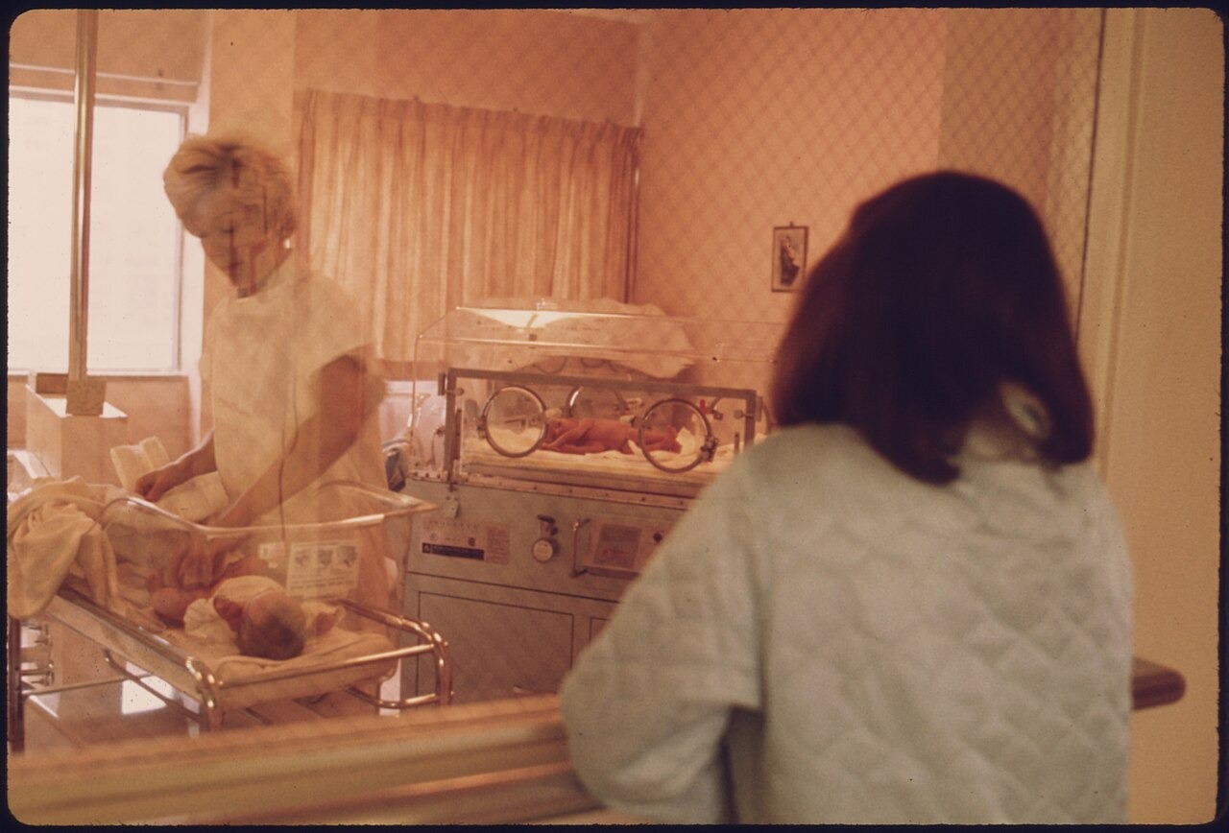
New Mother Views Infant in Nursery, Loretto Hospital, New Ulm, Minnesota (c. 1959) · U.S. Federal Government (NARA, NAID 558170) · c. 1959
Source: U.S. Federal Government. "A New Mother Views Her Child in the Nursery of Loretto Hospital in New Ulm, Minnesota." c. 1959. National Archives and Records Administration (NAID 558170), via Wikimedia Commons, commons.wikimedia.org/wiki/File:A_NEW_MOTHER_VIEWS_HER_CHILD_IN_THE_NURSERY_OF_LORETTO_HOSPITAL_IN_NEW_ULM,_MINNESOTA._THERE_ARE_TWO_HOSPITALS_IN_THE..._-_NARA_-_558170.jpg. Public Domain https://commons.wikimedia.org/wiki/File:A_NEW_MOTHER_VIEWS_HER_CHILD_IN_THE_NURSERY_OF_LORETTO_HOSPITAL_IN_NEW_ULM,_MINNESOTA._THERE_ARE_TWO_HOSPITALS_IN_THE..._-_NARA_-_558170.jpg
HIPPO — analyze the source (prompt) | Your analysis
H — Historical context: what was happening when this was created?
I — Intended audience: who was meant to see or obey it?
P — Purpose: why was it created?
P — Point of view: whose perspective does it reflect?
O — Outside connection: how does it connect to this standard?
SUPPORT OPTION
Sentence frame: This source shows ______ because it ______, which reveals ______.
CONFIDENCE CHECK-IN
Rate your understanding of this standard (1–4): ______ One thing to revisit: ____________________

Activity 6 — Core Application: Practice Quiz — US.72 ⏱ ~8 min
RESPONSE CHOICE
Commit to an answer by marking it, saying it, or explaining it aloud before checking. Answer key is in the Teacher Guide (kept separate).
[DOK 2 · item us72-q3 · pre-field-test]
What new markets and industries emerged to serve the growing youth population?
A. Pediatric healthcare, toy manufacturing, children's clothing, education, and youth entertainment industries all experienced explosive growth
B. Only the housing industry expanded, despite the fact that multiple sources contradict this view, though this interpretation lacks supporting historical evidence
C. No new industries developed during this period, but contemporary accounts suggest a different explanation
D. Only military-related industries expanded, but this fails to account for the broader historical context
[DOK 2 · item q-us72-dok2-1 · pre-field-test]
How did the baby boom generation impact the American economy and culture?
A. It caused severe economic depression due to overcrowded job markets
B. It drove demand for schools, housing, consumer goods, and new services
C. It had minimal impact because most baby boomers emigrated to Europe
D. It primarily strengthened rural agricultural communities across America
[DOK 3 · item u1-us72-dok3-tc · pre-field-test]
How did baby boomers reshape American consumer culture and economic growth in the 1950s and 1960s?
A. They had no significant economic impact due to their young age, which does not align with the documented historical record
B. Their massive numbers created huge demand for consumer goods, driving manufacturing growth, retail expansion, and new youth-targeted industries
C. They primarily affected only the housing market, although historical sources do not support this conclusion
D. Consumer culture declined during the baby boom years, which does not reflect the consensus among historians

Activity 7 — Constructed Response (CER) — US.72 ⏱ ~15 min
BIG-QUESTION ORGANIZER — in postwar America, who shared in the prosperity and the new consumer culture, and who was left out?
Jot quick notes from THIS standard: Who benefited? · Who bore the costs? · Who decided?

CONSTRUCTED RESPONSE (CER) — builds SSP.04 Argumentation
Claim + Evidence + Reasoning: Using this standard, take a position on the central question — explain the impact of the baby boomer generation on the American economy and culture? Support your claim with two pieces of evidence from the passage and explain your reasoning.
Part | Write here
Claim
Evidence (two specifics)
Reasoning
SELF-CHECK (CER rubric — see Toolkit)
Is my claim defensible? · TWO specific pieces of evidence? · Does my reasoning explain HOW the evidence proves the claim?
EXIT TICKET — before you leave [item us72-q1 · DOK 2 · pre-field-test]
What factors caused the dramatic increase in U.S. birth rates from 1946-1964 known as the Baby Boom?
A. Government mandates requiring larger families, although this view has been largely discredited by scholars
B. Immigration from European countries after the war, which does not align with the documented historical record
C. Declining living standards forcing families to have more children, although historical sources do not support this conclusion
D. Returning WWII veterans starting families, economic prosperity, G.I. Bill benefits, cultural emphasis on domesticity, and improved medical care
Show what you know (your choice): mark the best answer, say it, or explain it — then rate how sure you are: ☐ Not yet ☐ Getting there ☐ Got it
Answer key and next steps are in the Teacher Guide.

Standard US.73 — Eisenhower Administration Developments
TN Academic Standard US.73: Describe domestic developments during President Dwight D. Eisenhower's administration, including advances in medicine and the creation of the Interstate Highway System.
LEARNING TARGETS — I can…
• I can describe domestic developments during President Eisenhower's administration, including advances in medicine and the creation of the Interstate Highway System.
Lenses for this standard: Politics/Government · History · Economics
CORE PATH — the same for every student
Same rigor for everyone: analyze the sources and vocabulary, then show what you learned on the Practice Quiz and the CER.
UDL and MTSS give you flexible ways in — they never lower the bar.
Check yourself against the learning targets on the Cornell Notes page.
★ Tennessee Connection
Eisenhower's Interstate Highway Act transformed Tennessee. The construction of I-40, I-65, I-24, and I-75 through the state reshaped Tennessee's economy, connecting Nashville, Memphis, Chattanooga, and Knoxville to the national highway system and accelerating suburban development and trucking industries.
SET YOUR GOAL (self-direction)
My goal for this standard — what will I be able to do, and how will I show it?

HOOK — think before you dig in
Eisenhower Administration Developments: Describe domestic developments during President Dwight D. Eisenhower's administration, including advances in medicine and the creation of the Interstate Highway System. Who gained, who was left out — and why does it still matter?

ACTIVATE — what do you already know or wonder?
Jot what you already know or want to find out about this standard. You’ll come back to it.

PREVIEW & PREDICT
Which learning target will be hardest, and why? Connect it to the unit’s big question: who shared in the postwar prosperity, and who was left out?

Activity 1 — Vocabulary (Part A: Reference / Word Bank) — US.73 ⏱ ~10 min
Use this word bank throughout the standard. The Spanish column supports access, not translation of assessment.
Term | Student-friendly meaning | Spanish
Interstate Highway System | Massive 41,000-mile highway network authorized by President Eisenhower in 1956 that transformed American travel, commerce, and settlement patterns. | Sistema de Autopistas Interestatales
Polio Vaccine | The vaccine developed by Dr. Jonas Salk, announced safe in April 1955, that ended the epidemic that had paralyzed or killed thousands of children yearly. | Vacuna contra la Polio
Dwight D. Eisenhower | The 34th U.S. President (1953–1961) and former WWII general who ended the Korean War and launched the Interstate Highway System. | Dwight D. Eisenhower
Military-Industrial Complex | The close relationship between the armed forces and defense industries that Eisenhower warned about in his 1961 farewell address. | Complejo Militar-Industrial
Cold War Peace | Eisenhower's policy of avoiding direct war with the Soviet Union while containing communism through deterrence and diplomacy. | Paz de la Guerra Fría
Urban Decline | The weakening of inner cities as highways and suburbs pulled residents and businesses away — an unintended consequence of the Interstate system. | Declive Urbano
LANGUAGE SUPPORT
Pronunciations: Interstate Highway System (IN-ter-stayt HY-way); Dwight D. Eisenhower (EYE-zen-how-er); Military-Industrial Complex (MIL-ih-tair-ee); Cold War Peace (kohld wor); Urban Decline (UR-bin dih-KLYN).

VOCABULARY SELF-CHECK · Knowledge Rating
Rate each term NOW in pencil, then again at the END — growth is the goal; no penalty for “never seen it.”
Term | 1 · never seen it | 2 · heard it | 3 · can use it | 4 · can teach it
Interstate Highway System
Polio Vaccine
Dwight D. Eisenhower
Military-Industrial Complex
Cold War Peace
Urban Decline

Activity 2 — Vocabulary Studio (Frayer-inspired) — US.73 ⏱ ~7 min
RESPONSE CHOICE
Complete each studio by writing, speaking, or diagramming.

PRIORITY TERM 1 Interstate Highway System · ES: Sistema de Autopistas Interestatales
Word-bank meaning to build on: Massive 41,000-mile highway network authorized by President Eisenhower in 1956 that transformed American travel, commerce, and settlement patterns.
Definition (in your own words) | Characteristics
Examples | Non-examples
Use it to explain
Write one sentence that uses “Interstate Highway System” to explain this standard.

PRIORITY TERM 2 Polio Vaccine · ES: Vacuna contra la Polio
Word-bank meaning to build on: The vaccine developed by Dr. Jonas Salk, announced safe in April 1955, that ended the epidemic that had paralyzed or killed thousands of children yearly.
Definition (in your own words) | Characteristics
Examples | Non-examples
Use it to explain
Write one sentence that uses “Polio Vaccine” to explain this standard.

CONNECT THE TERMS (UDL · build understanding)
How do these priority terms fit together? Write or sketch how one leads to or affects another.

Activity 3 — Direct Teaching Cornell Notes — US.73 ⏱ ~20 min
Name: ______________________ Class / Period: __________ Date: __________
US.73 — Eisenhower Administration Developments • These notes capture the direct-teaching content and the Close Read for this standard.
Your learning targets are on this standard’s opening page — take notes that help you meet them.
Cues (tied to your learning targets) | My notes
What does the passage say about medical Breakthroughs: The Polio Vaccine?
What does the passage say about interstate Highway System: Economic Effects?
What does the passage say about interstate Highway System: Social Effects?
Key terms →
DOODLE ZONE — draw your thinking (UDL · another way in)
Need another way in? Sketch the key idea, a quick timeline, or how the pieces connect. Words optional.

Cornell Notes — keep going, then process & check — US.73
MORE NOTES / DIAGRAMS
Continue your notes here, add a quick sketch, or map how the ideas connect.

Key terms to list
Interstate Highway System · Polio Vaccine · Dwight D. Eisenhower · Military-Industrial Complex · Cold War Peace · Urban Decline
Summary — In your own words (2–3 sentences)
PROGRESS CHECK · one question
How did the Interstate Highway System contribute to suburban growth and urban decline?
A. Highways had no effect on population distribution, which contradicts the primary source evidence from this era, though this interpretation lacks supporting historical evidence
B. Highways strengthened urban centers, which contradicts the primary source evidence from this era, which does not align with the documented historical record
C. Highways enabled suburban commuting while bypassing small towns, dividing urban neighborhoods, and accelerating downtown decline as families moved to suburbs
D. Suburbs declined as highways made cities more accessible, yet the available evidence points to a different conclusion, which does not align with the documented historical record
Commit before you move on — mark it, say it, or explain it aloud.
CHECK YOURSELF — how am I doing?
Which learning targets (on this standard’s opening page) can you now meet? Tick the number; circle any you still need help with.
☐ 1
My 12–15 word headline for this standard

Activity 4 — Close Read — US.73 ⏱ ~15 min
Reading type: History Hack-authored instructional synthesis. This is not a primary source. Builds SSP.03 (synthesize) and SSP.05 (historical awareness).
CORE PATH — read one chunk at a time
Medical Breakthroughs: The Polio Vaccine
The 1955 Salk polio vaccine eliminated parents' fears of their children contracting this crippling disease. It demonstrated government's role in public health, restored confidence in medical science, and allowed children to safely attend schools and public spaces without fear of epidemic. Before the vaccine, polio paralyzed or killed thousands of Americans annually.
Interstate Highway System: Economic Effects
The Interstate Highway System created millions of construction jobs, enabled easier movement of goods across the country, and fueled growth in automobile-related industries including car manufacturing, gas stations, motels, and fast food restaurants. It became the largest public works project in American history.
Interstate Highway System: Social Effects
The highways enabled suburban expansion by allowing workers to commute longer distances. However, they also contributed to the decline of small towns bypassed by the new roads and accelerated urban decay as middle-class families moved to suburbs. Increased mobility transformed American family life and leisure activities.
Unintended Consequences
While highways brought economic benefits, they also divided urban neighborhoods—often minority communities—with massive road construction. Downtown areas lost shoppers to suburban malls, and public transportation systems declined as car ownership became essential for American life.
LANGUAGE SUPPORT
Key terms to know first: Interstate Highway System, Polio Vaccine. Read once for the gist, then again for evidence.
CLOSE-READ EVIDENCE LAB — for each question: quote the EVIDENCE from the passage above, then write YOUR ANSWER (or answer aloud / diagram it).
Text-dependent question | Evidence from the passage | Your answer (what it shows)
What is the main idea of the “Medical Breakthroughs: The Polio Vaccine” section, and what evidence supports it?
What is the main idea of the “Interstate Highway System: Economic Effects” section, and what evidence supports it?
What is the main idea of the “Interstate Highway System: Social Effects” section, and what evidence supports it?

Activity 5 — Primary Source / Data Analysis — US.73 ⏱ ~15 min
Primary source (photograph) — analyze it with HIPPO. Builds SSP.01–SSP.02.
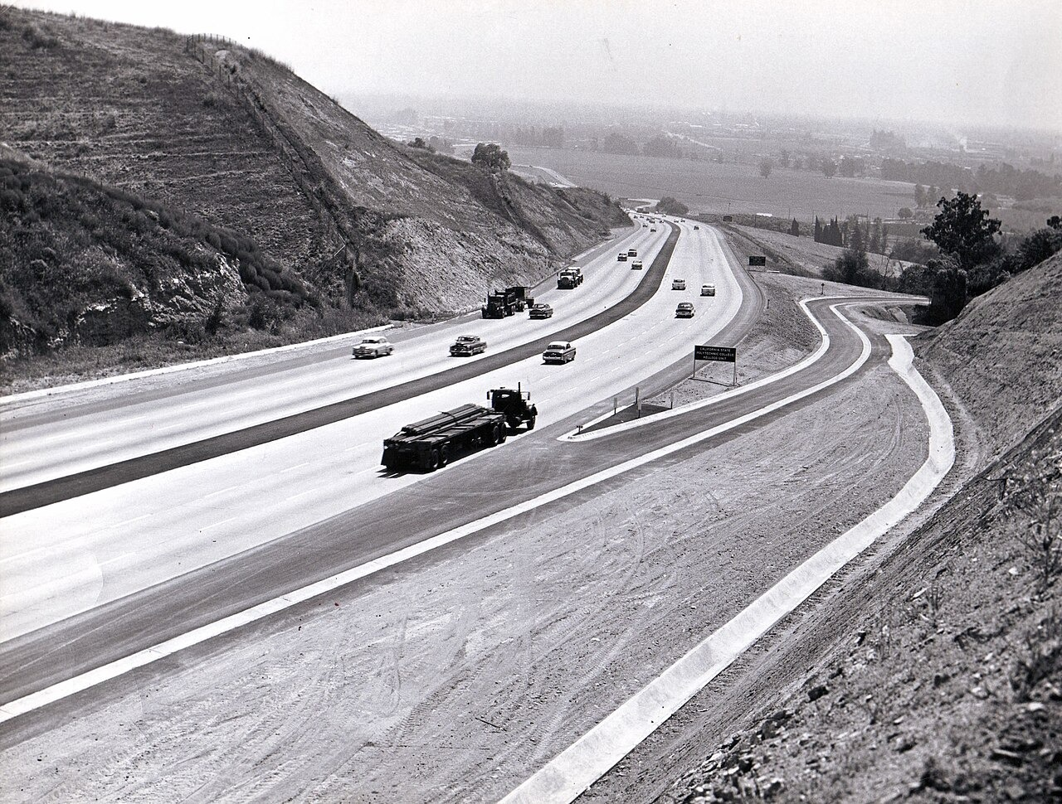
San Bernardino Freeway (I-10) Construction, Kelleg Hill, California (1957) · Federal Highway Administration / U.S. Department of Transportation · 1957
Source: Federal Highway Administration / U.S. Department of Transportation. "San Bernardino Freeway (I-10) Construction on Kelleg Hill, California." 1957. FHWA Interstate Photo Gallery, via Wikimedia Commons, commons.wikimedia.org/wiki/File:CA_51_I10_FHWA_1957_1663.jpg. Public Domain https://commons.wikimedia.org/wiki/File:CA_51_I10_FHWA_1957_1663.jpg
HIPPO — analyze the source (prompt) | Your analysis
H — Historical context: what was happening when this was created?
I — Intended audience: who was meant to see or obey it?
P — Purpose: why was it created?
P — Point of view: whose perspective does it reflect?
O — Outside connection: how does it connect to this standard?
SUPPORT OPTION
Sentence frame: This source shows ______ because it ______, which reveals ______.
CONFIDENCE CHECK-IN
Rate your understanding of this standard (1–4): ______ One thing to revisit: ____________________

Activity 6 — Core Application: Practice Quiz — US.73 ⏱ ~8 min
RESPONSE CHOICE
Commit to an answer by marking it, saying it, or explaining it aloud before checking. Answer key is in the Teacher Guide (kept separate).
[DOK 2 · item us73-q2 · pre-field-test]
What were the economic benefits of the Interstate Highway System for American commerce and industry?
A. It created construction jobs, enabled efficient goods movement, and fueled growth in auto manufacturing, gas stations, motels, and fast food industries
B. The highway system had no significant economic impact, although this view has been largely discredited by scholars, but the historical evidence paints a more nuanced picture
C. It only benefited rural agricultural communities, but the historical record tells a more complex story despite the fact that multiple contemporary sources contradict this
D. It decreased trade between states, but this fails to account for the broader historical context when examined alongside the available primary and secondary sources
[DOK 2 · item q-us73-add-3 · pre-field-test]
Which domestic objective helped Eisenhower justify the Interstate Highway System?
A. Jonas Salk's polio vaccine, which nearly eliminated a feared childhood disease
B. Improving civilian transportation while supporting national defense logistics
C. Expanded highways made daily commuting practical for more middle-class families
D. They paired infrastructure and health advances that increased productivity and mobility
[DOK 3 · item u1-us73-dok3-tc · pre-field-test]
How did the Interstate Highway System contribute to suburban growth and urban decline?
A. Highways had no effect on population distribution, which contradicts the primary source evidence from this era, though this interpretation lacks supporting historical evidence
B. Highways strengthened urban centers, which contradicts the primary source evidence from this era, which does not align with the documented historical record
C. Highways enabled suburban commuting while bypassing small towns, dividing urban neighborhoods, and accelerating downtown decline as families moved to suburbs
D. Suburbs declined as highways made cities more accessible, yet the available evidence points to a different conclusion, which does not align with the documented historical record

Activity 7 — Constructed Response (CER) — US.73 ⏱ ~15 min
BIG-QUESTION ORGANIZER — in postwar America, who shared in the prosperity and the new consumer culture, and who was left out?
Jot quick notes from THIS standard: Who benefited? · Who bore the costs? · Who decided?

CONSTRUCTED RESPONSE (CER) — builds SSP.04 Argumentation
Claim + Evidence + Reasoning: Using this standard, take a position on the central question — describe domestic developments during President Eisenhower's administration, including advances in medicine and the creation of the Interstate Highway System? Support your claim with two pieces of evidence from the passage and explain your reasoning.
Part | Write here
Claim
Evidence (two specifics)
Reasoning
SELF-CHECK (CER rubric — see Toolkit)
Is my claim defensible? · TWO specific pieces of evidence? · Does my reasoning explain HOW the evidence proves the claim?
EXIT TICKET — before you leave [item us73-q1 · DOK 2 · pre-field-test]
How did the Salk polio vaccine demonstrate government's role in public health and medical advancement?
A. Government funding and coordination of vaccine trials led to a breakthrough that eliminated a terrifying disease, showing public investment in medical research benefits all Americans
B. The government opposed vaccine development, though this interpretation lacks supporting historical evidence, but closer analysis reveals a more complicated historical reality
C. Private companies developed the vaccine without government involvement, but contemporary accounts suggest a different explanation, which represents a common misconception about this historical period
D. The vaccine was developed in another country, which does not reflect the consensus among historians, which contradicts the primary source evidence from this era
Show what you know (your choice): mark the best answer, say it, or explain it — then rate how sure you are: ☐ Not yet ☐ Getting there ☐ Got it
Answer key and next steps are in the Teacher Guide.

Standard US.74 — Automobile's Growing Influence
TN Academic Standard US.74: Describe the growing influence of the automobile on American society, including the growth of suburbia, fast food chains, and the hotel industry.
LEARNING TARGETS — I can…
• I can describe the growing influence of the automobile on American society, including the growth of suburbia, fast food chains, and the hotel industry.
Lenses for this standard: Economics · Geography · History
CORE PATH — the same for every student
Same rigor for everyone: analyze the sources and vocabulary, then show what you learned on the Practice Quiz and the CER.
UDL and MTSS give you flexible ways in — they never lower the bar.
Check yourself against the learning targets on the Cornell Notes page.
★ Tennessee Connection
The automobile transformed Tennessee. The construction of Interstate 40, running east-west across the entire state, and Interstate 65 through Nashville reshaped Tennessee's geography, enabling suburban sprawl and the decline of downtown commercial districts while creating new roadside businesses and truck stops.
SET YOUR GOAL (self-direction)
My goal for this standard — what will I be able to do, and how will I show it?

HOOK — think before you dig in
Automobile's Growing Influence: Describe the growing influence of the automobile on American society, including the growth of suburbia, fast food chains, and the hotel industry. Who gained, who was left out — and why does it still matter?

ACTIVATE — what do you already know or wonder?
Jot what you already know or want to find out about this standard. You’ll come back to it.

PREVIEW & PREDICT
Which learning target will be hardest, and why? Connect it to the unit’s big question: who shared in the postwar prosperity, and who was left out?

Activity 1 — Vocabulary (Part A: Reference / Word Bank) — US.74 ⏱ ~10 min
Use this word bank throughout the standard. The Spanish column supports access, not translation of assessment.
Term | Student-friendly meaning | Spanish
Suburban Ideal | The 1950s American dream of owning a single-family home in the suburbs with a yard, garage, and modern appliances, drawing families out of cities. | Ideal Suburbano
Interstate Highway System | Massive 41,000-mile highway network authorized by President Eisenhower in 1956 that transformed American travel, commerce, and settlement patterns. | Sistema de Autopistas Interestatales
Automobile Culture | The 1950s lifestyle centered on cars, which symbolized freedom and prosperity, reshaping cities, suburbs, and daily life across America. | Cultura del Automóvil
Fast Food Chains | Restaurant businesses like McDonald’s that used assembly-line prep and drive-through service to feed automobile travelers quickly and cheaply. | Cadenas de Comida Rápida
Motel/Hotel Chains | Standardized roadside lodging like Holiday Inn, founded 1952, built along highways to serve automobile travelers with predictable quality and amenities. | Cadenas de Moteles/Hoteles
Levittown | The first mass-produced suburb, built by William Levitt on Long Island starting in 1947 using assembly-line techniques to build homes quickly and cheaply. | Levittown
LANGUAGE SUPPORT
Pronunciations: Suburban Ideal (suh-BER-bin); Interstate Highway System (IN-ter-stayt HY-way); Automobile Culture (AW-tuh-moh-beel); Fast Food Chains (fast food); Motel/Hotel Chains (moh-TEL); Levittown (LEV-it-town).

VOCABULARY SELF-CHECK · Knowledge Rating
Rate each term NOW in pencil, then again at the END — growth is the goal; no penalty for “never seen it.”
Term | 1 · never seen it | 2 · heard it | 3 · can use it | 4 · can teach it
Suburban Ideal
Interstate Highway System
Automobile Culture
Fast Food Chains
Motel/Hotel Chains
Levittown

Activity 2 — Vocabulary Studio (Frayer-inspired) — US.74 ⏱ ~7 min
RESPONSE CHOICE
Complete each studio by writing, speaking, or diagramming.

PRIORITY TERM 1 Suburban Ideal · ES: Ideal Suburbano
Word-bank meaning to build on: The 1950s American dream of owning a single-family home in the suburbs with a yard, garage, and modern appliances, drawing families out of cities.
Definition (in your own words) | Characteristics
Examples | Non-examples
Use it to explain
Write one sentence that uses “Suburban Ideal” to explain this standard.

PRIORITY TERM 2 Interstate Highway System · ES: Sistema de Autopistas Interestatales
Word-bank meaning to build on: Massive 41,000-mile highway network authorized by President Eisenhower in 1956 that transformed American travel, commerce, and settlement patterns.
Definition (in your own words) | Characteristics
Examples | Non-examples
Use it to explain
Write one sentence that uses “Interstate Highway System” to explain this standard.

CONNECT THE TERMS (UDL · build understanding)
How do these priority terms fit together? Write or sketch how one leads to or affects another.

Activity 3 — Direct Teaching Cornell Notes — US.74 ⏱ ~20 min
Name: ______________________ Class / Period: __________ Date: __________
US.74 — Automobile's Growing Influence • These notes capture the direct-teaching content and the Close Read for this standard.
Your learning targets are on this standard’s opening page — take notes that help you meet them.
Cues (tied to your learning targets) | My notes
What does the passage say about transforming American Daily Life?
What does the passage say about connection to Suburban Growth?
What does the passage say about fast Food and Hospitality Industries?
Key terms →
DOODLE ZONE — draw your thinking (UDL · another way in)
Need another way in? Sketch the key idea, a quick timeline, or how the pieces connect. Words optional.

Cornell Notes — keep going, then process & check — US.74
MORE NOTES / DIAGRAMS
Continue your notes here, add a quick sketch, or map how the ideas connect.

Key terms to list
Suburban Ideal · Interstate Highway System · Automobile Culture · Fast Food Chains · Motel/Hotel Chains · Levittown
Summary — In your own words (2–3 sentences)
PROGRESS CHECK · one question
How did automobiles drive the expansion of fast food chains and the hotel industry?
A. Fast food and motels existed before car culture, though this interpretation lacks supporting historical evidence and does not reflect the scholarly consensus on this topic
B. The hospitality industry declined as car ownership increased, which does not align with the documented historical record
C. Fast food was only popular in urban areas, but this oversimplifies the complex factors at work, but the historical evidence paints a more nuanced picture
D. Car culture created demand for drive-in restaurants like McDonald's and roadside motels, spawning entirely new industries serving traveling Americans
Commit before you move on — mark it, say it, or explain it aloud.
CHECK YOURSELF — how am I doing?
Which learning targets (on this standard’s opening page) can you now meet? Tick the number; circle any you still need help with.
☐ 1
My 12–15 word headline for this standard

Activity 4 — Close Read — US.74 ⏱ ~15 min
Reading type: History Hack-authored instructional synthesis. This is not a primary source. Builds SSP.03 (synthesize) and SSP.05 (historical awareness).
CORE PATH — read one chunk at a time
Transforming American Daily Life
Cars provided unprecedented personal mobility, allowing Americans to live farther from work, shop at distant locations, and pursue leisure activities across wider areas. Family life became more mobile, dating patterns changed as teenagers gained independence, and the daily routine expanded beyond walking distance of home.
Connection to Suburban Growth
Cars made suburban living practical by allowing workers to commute to city jobs while living in residential communities. This enabled the suburban boom, as developers like William Levitt built planned communities (Levittown) designed around automobile access rather than public transportation. Suburbs featured wide streets, driveways, and garages as standard features.
Fast Food and Hospitality Industries
Car culture created demand for drive-in restaurants, leading to the fast food industry's birth. McDonald's, founded in 1940 and franchised in 1955, epitomized this trend. Motels (motor hotels) replaced traditional hotels along highways, and entire industries emerged to serve traveling Americans.
Broader Social Changes
Automobile ownership became a symbol of American freedom and prosperity. Drive-in movies, shopping centers with large parking lots, and car-dependent suburban neighborhoods transformed the American landscape. However, car dependence also created traffic congestion, air pollution, and urban sprawl.
LANGUAGE SUPPORT
Key terms to know first: Suburban Ideal, Interstate Highway System. Read once for the gist, then again for evidence.
CLOSE-READ EVIDENCE LAB — for each question: quote the EVIDENCE from the passage above, then write YOUR ANSWER (or answer aloud / diagram it).
Text-dependent question | Evidence from the passage | Your answer (what it shows)
What is the main idea of the “Transforming American Daily Life” section, and what evidence supports it?
What is the main idea of the “Connection to Suburban Growth” section, and what evidence supports it?
What is the main idea of the “Fast Food and Hospitality Industries” section, and what evidence supports it?

Geographer’s Lens — US.74 ⏱ ~12 min
Geographers don’t just find places — they explain how WHERE shapes WHAT happens. Work these like a geographer. Built on the Five Themes of Geography · C3 Dimension 2 · SSP.06 (spatial reasoning).
THE PLACES — then explain why geography put them there
The automobile and the new Interstate Highway System (1956) remade where and how Americans lived. Use the list below to map the change, then explain how highways created suburbs and pulled people out of city centers.
Place | Where | What happened (given) | Why HERE? (your analysis)
The Interstate Highway System | Nationwide | 1956 law — ~41,000 miles of new limited-access highways
I-40 across Tennessee | Memphis–Nashville–Knoxville | east-west interstate linking the state's big cities
New suburbs | Outside Nashville, Memphis, Knoxville | car-dependent communities that grew fast in the 1950s
Downtown city cores | City centers | lost residents and shops as families moved to the suburbs
Levittown | New York | the model mass-produced postwar suburb
MOVEMENT & REGION — what’s the spatial pattern?
In 1–2 sentences: is this a movement, a cluster, or a whole region? Name the direction or shape it takes on a map.

GEOGRAPHY AS A FORCE — how did location shape the outcome?
How did geography change WHAT happened — who was affected, how far or fast it spread, or who was left out? Use one place above as your evidence.

READ IT LIKE A SOURCE — RESPONSE CHOICE
A map is a source with a point of view. Show your thinking your way — write it, OR sketch a quick arrows-and-labels diagram: what would a map of this make CLEAR, and what would it HIDE or leave out?

Activity 5 — Primary Source / Data Analysis — US.74 ⏱ ~15 min
Primary source (photograph) — analyze it with HIPPO. Builds SSP.01–SSP.02.
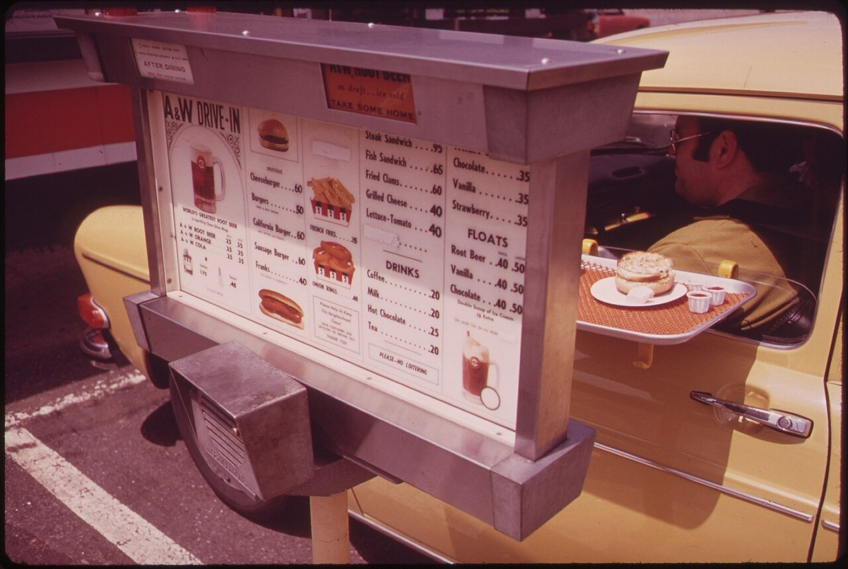
Drive-In Restaurant (NARA-547855) · Environmental Protection Agency / U.S. Federal Government · c. 1970–1975
Source: U.S. Environmental Protection Agency. "Drive-In Restaurant." c. 1970–1975. National Archives and Records Administration (NAID 547855), via Wikimedia Commons, commons.wikimedia.org/wiki/File:DRIVE-IN_RESTAURANT_-_NARA_-_547855.jpg. Public Domain https://commons.wikimedia.org/wiki/File:DRIVE-IN_RESTAURANT_-_NARA_-_547855.jpg
HIPPO — analyze the source (prompt) | Your analysis
H — Historical context: what was happening when this was created?
I — Intended audience: who was meant to see or obey it?
P — Purpose: why was it created?
P — Point of view: whose perspective does it reflect?
O — Outside connection: how does it connect to this standard?
SUPPORT OPTION
Sentence frame: This source shows ______ because it ______, which reveals ______.
CONFIDENCE CHECK-IN
Rate your understanding of this standard (1–4): ______ One thing to revisit: ____________________

Activity 6 — Core Application: Practice Quiz — US.74 ⏱ ~8 min
RESPONSE CHOICE
Commit to an answer by marking it, saying it, or explaining it aloud before checking. Answer key is in the Teacher Guide (kept separate).
[DOK 2 · item us74-q2 · pre-field-test]
What connection existed between car culture and the growth of suburbs like Levittown?
A. Cars made suburban living practical by enabling commutes to city jobs, leading developers like Levitt to build communities designed around automobile access with wide streets and garages
B. Suburbs developed independently of automobile ownership, but this fails to account for the broader historical context, although this overlooks critical economic and social factors involved
C. Suburbs were built before cars became common, despite limited evidence supporting this interpretation and oversimplifies the complex factors at work during this period
D. Car ownership declined as suburbs grew, which ignores key developments that shaped the outcome, but contemporary accounts and primary sources suggest otherwise
[DOK 2 · item q-us74-dok2-1 · pre-field-test]
How did the automobile transform American business and culture in the 1950s?
A. It reduced consumer spending because families saved money on transit
B. It created fast food chains, motels, shopping centers, and drive-ins
C. It eliminated the need for any new road construction across the nation
D. It primarily benefited the railroad industry by increasing train travel
[DOK 3 · item u1-us74-dok3-tc · pre-field-test]
How did automobiles drive the expansion of fast food chains and the hotel industry?
A. Fast food and motels existed before car culture, though this interpretation lacks supporting historical evidence and does not reflect the scholarly consensus on this topic
B. The hospitality industry declined as car ownership increased, which does not align with the documented historical record
C. Fast food was only popular in urban areas, but this oversimplifies the complex factors at work, but the historical evidence paints a more nuanced picture
D. Car culture created demand for drive-in restaurants like McDonald's and roadside motels, spawning entirely new industries serving traveling Americans

Activity 7 — Constructed Response (CER) — US.74 ⏱ ~15 min
BIG-QUESTION ORGANIZER — in postwar America, who shared in the prosperity and the new consumer culture, and who was left out?
Jot quick notes from THIS standard: Who benefited? · Who bore the costs? · Who decided?

CONSTRUCTED RESPONSE (CER) — builds SSP.04 Argumentation
Claim + Evidence + Reasoning: Using this standard, take a position on the central question — describe the growing influence of the automobile on American society, including the growth of suburbia, fast food chains, and the hotel industry? Support your claim with two pieces of evidence from the passage and explain your reasoning.
Part | Write here
Claim
Evidence (two specifics)
Reasoning
SELF-CHECK (CER rubric — see Toolkit)
Is my claim defensible? · TWO specific pieces of evidence? · Does my reasoning explain HOW the evidence proves the claim?
EXIT TICKET — before you leave [item us74-q1 · DOK 2 · pre-field-test]
How did widespread automobile ownership transform American daily life and family routines?
A. Cars had minimal impact on daily routines, which does not align with the documented historical record when examined alongside the available primary and secondary sources
B. Cars provided unprecedented mobility, allowing Americans to live farther from work, expanding shopping and leisure options, and giving teenagers new independence
C. Only wealthy Americans owned cars in the 1950s, but this fails to account for the broader historical context, though this interpretation lacks supporting historical evidence
D. Car ownership decreased family mobility, which represents a common misconception about the period, although this overlooks critical economic and social factors involved
Show what you know (your choice): mark the best answer, say it, or explain it — then rate how sure you are: ☐ Not yet ☐ Getting there ☐ Got it
Answer key and next steps are in the Teacher Guide.

Standard US.75 — Television and Mass Media Impact
TN Academic Standard US.75: Analyze the increasing impact of television and mass media on the American home, politics, and economy.
LEARNING TARGETS — I can…
• I can analyze the increasing impact of television and mass media on the American home, politics, and economy.
Lenses for this standard: History · Economics · Politics/Government
CORE PATH — the same for every student
Same rigor for everyone: analyze the sources and vocabulary, then show what you learned on the Practice Quiz and the CER.
UDL and MTSS give you flexible ways in — they never lower the bar.
Check yourself against the learning targets on the Cornell Notes page.
★ Tennessee Connection
Television transformed Tennessee culture and politics. WSM-TV in Nashville broadcast the Grand Ole Opry, helping country music reach a national television audience. Senator Estes Kefauver's televised crime hearings (1950-1951) demonstrated television's political power to Tennessee and the nation.
SET YOUR GOAL (self-direction)
My goal for this standard — what will I be able to do, and how will I show it?

HOOK — think before you dig in
Television and Mass Media Impact: Analyze the increasing impact of television and mass media on the American home, politics, and economy. Who gained, who was left out — and why does it still matter?

ACTIVATE — what do you already know or wonder?
Jot what you already know or want to find out about this standard. You’ll come back to it.

PREVIEW & PREDICT
Which learning target will be hardest, and why? Connect it to the unit’s big question: who shared in the postwar prosperity, and who was left out?

Activity 1 — Vocabulary (Part A: Reference / Word Bank) — US.75 ⏱ ~10 min
Use this word bank throughout the standard. The Spanish column supports access, not translation of assessment.
Term | Student-friendly meaning | Spanish
Television | The electronic medium that became the dominant form of American entertainment and information by the late 1950s, creating shared national experiences. | Televisión
Mass Media | Communication channels—TV, radio, newspapers, magazines—that reach large audiences at once; in the 1950s television became the most powerful medium. | Medios Masivos
Advertising | The rapidly growing 1950s industry that used television to shape consumer desires and sell products to mass audiences. | Publicidad
Consumer Culture | A society centered on buying goods; 1950s television and advertising encouraged Americans to define success through purchases. | Cultura de Consumo
Cultural Homogenization | The way national television gave Americans shared programs, products, and values, making regional cultures more alike. | Homogeneización Cultural
Nixon–Kennedy Debates | The first televised presidential debates (1960), which showed television's new power to shape politics and public opinion. | Debates Nixon–Kennedy
LANGUAGE SUPPORT
Pronunciations: Television (TEL-uh-vizh-un); Mass Media (mas MEE-dee-uh); Advertising (AD-ver-ty-zing); Consumer Culture (kun-SOO-mer); Cultural Homogenization (huh-mah-jen-ih-ZAY-shun); Nixon–Kennedy Debates (NIK-sun KEN-eh-dee).

VOCABULARY SELF-CHECK · Knowledge Rating
Rate each term NOW in pencil, then again at the END — growth is the goal; no penalty for “never seen it.”
Term | 1 · never seen it | 2 · heard it | 3 · can use it | 4 · can teach it
Television
Mass Media
Advertising
Consumer Culture
Cultural Homogenization
Nixon–Kennedy Debates

Activity 2 — Vocabulary Studio (Frayer-inspired) — US.75 ⏱ ~7 min
RESPONSE CHOICE
Complete each studio by writing, speaking, or diagramming.

PRIORITY TERM 1 Television · ES: Televisión
Word-bank meaning to build on: The electronic medium that became the dominant form of American entertainment and information by the late 1950s, creating shared national experiences.
Definition (in your own words) | Characteristics
Examples | Non-examples
Use it to explain
Write one sentence that uses “Television” to explain this standard.

PRIORITY TERM 2 Mass Media · ES: Medios Masivos
Word-bank meaning to build on: Communication channels—TV, radio, newspapers, magazines—that reach large audiences at once; in the 1950s television became the most powerful medium.
Definition (in your own words) | Characteristics
Examples | Non-examples
Use it to explain
Write one sentence that uses “Mass Media” to explain this standard.

CONNECT THE TERMS (UDL · build understanding)
How do these priority terms fit together? Write or sketch how one leads to or affects another.

Activity 3 — Direct Teaching Cornell Notes — US.75 ⏱ ~20 min
Name: ______________________ Class / Period: __________ Date: __________
US.75 — Television and Mass Media Impact • These notes capture the direct-teaching content and the Close Read for this standard.
Your learning targets are on this standard’s opening page — take notes that help you meet them.
Cues (tied to your learning targets) | My notes
What does the passage say about television Changes Family Life?
What does the passage say about television and Politics?
What does the passage say about advertising and Consumer Culture?
Key terms →
DOODLE ZONE — draw your thinking (UDL · another way in)
Need another way in? Sketch the key idea, a quick timeline, or how the pieces connect. Words optional.

Cornell Notes — keep going, then process & check — US.75
MORE NOTES / DIAGRAMS
Continue your notes here, add a quick sketch, or map how the ideas connect.

Key terms to list
Television · Mass Media · Advertising · Consumer Culture · Cultural Homogenization · Nixon–Kennedy Debates
Summary — In your own words (2–3 sentences)
PROGRESS CHECK · one question
What impact did the 1960 Kennedy-Nixon debates have on the role of television in politics?
A. The debates demonstrated TV's power to influence voters through visual appearance—radio listeners thought Nixon won, but TV viewers favored the telegenic Kennedy, transforming how candidates campaign
B. The debates had no significant impact on political campaigns, but contemporary accounts suggest a different explanation, which does not align with the documented historical record
C. Both candidates were equally effective on television, despite limited evidence supporting this interpretation when examined alongside the available primary and secondary sources
D. Television was not used for political debates until the 1970s, although historical sources do not support this conclusion, although historical sources do not support this conclusion
Commit before you move on — mark it, say it, or explain it aloud.
CHECK YOURSELF — how am I doing?
Which learning targets (on this standard’s opening page) can you now meet? Tick the number; circle any you still need help with.
☐ 1
My 12–15 word headline for this standard

Activity 4 — Close Read — US.75 ⏱ ~15 min
Reading type: History Hack-authored instructional synthesis. This is not a primary source. Builds SSP.03 (synthesize) and SSP.05 (historical awareness).
CORE PATH — read one chunk at a time
Television Changes Family Life
Television became the center of family entertainment, replacing radio and reducing movie attendance. Families scheduled activities around TV programs, shared common cultural experiences through popular shows, and spent more time at home. TV also influenced home design, with living rooms arranged around television sets.
Television and Politics
Television transformed politics by emphasizing candidates' appearance and communication skills. The 1960 Kennedy-Nixon debates showed TV's power—radio listeners thought Nixon won, but TV viewers favored the telegenic Kennedy. Politicians had to adapt their message and image for the visual medium.
Advertising and Consumer Culture
Television advertising created a powerful new marketing tool that could reach millions of households simultaneously. Commercials shaped consumer desires, created brand awareness, and drove purchasing decisions. Companies invested heavily in TV advertising, making it the dominant advertising medium by the late 1950s.
Cultural Homogenization
Television created shared national experiences as Americans across the country watched the same programs. This promoted cultural homogenization—similar values, consumer preferences, and entertainment tastes spread nationwide. However, critics argued TV content was often shallow and promoted conformity.
LANGUAGE SUPPORT
Key terms to know first: Television, Mass Media. Read once for the gist, then again for evidence.
CLOSE-READ EVIDENCE LAB — for each question: quote the EVIDENCE from the passage above, then write YOUR ANSWER (or answer aloud / diagram it).
Text-dependent question | Evidence from the passage | Your answer (what it shows)
What is the main idea of the “Television Changes Family Life” section, and what evidence supports it?
What is the main idea of the “Television and Politics” section, and what evidence supports it?
What is the main idea of the “Advertising and Consumer Culture” section, and what evidence supports it?

Activity 5 — Primary Source / Data Analysis — US.75 ⏱ ~15 min
Primary source (photograph) — analyze it with HIPPO. Builds SSP.01–SSP.02.
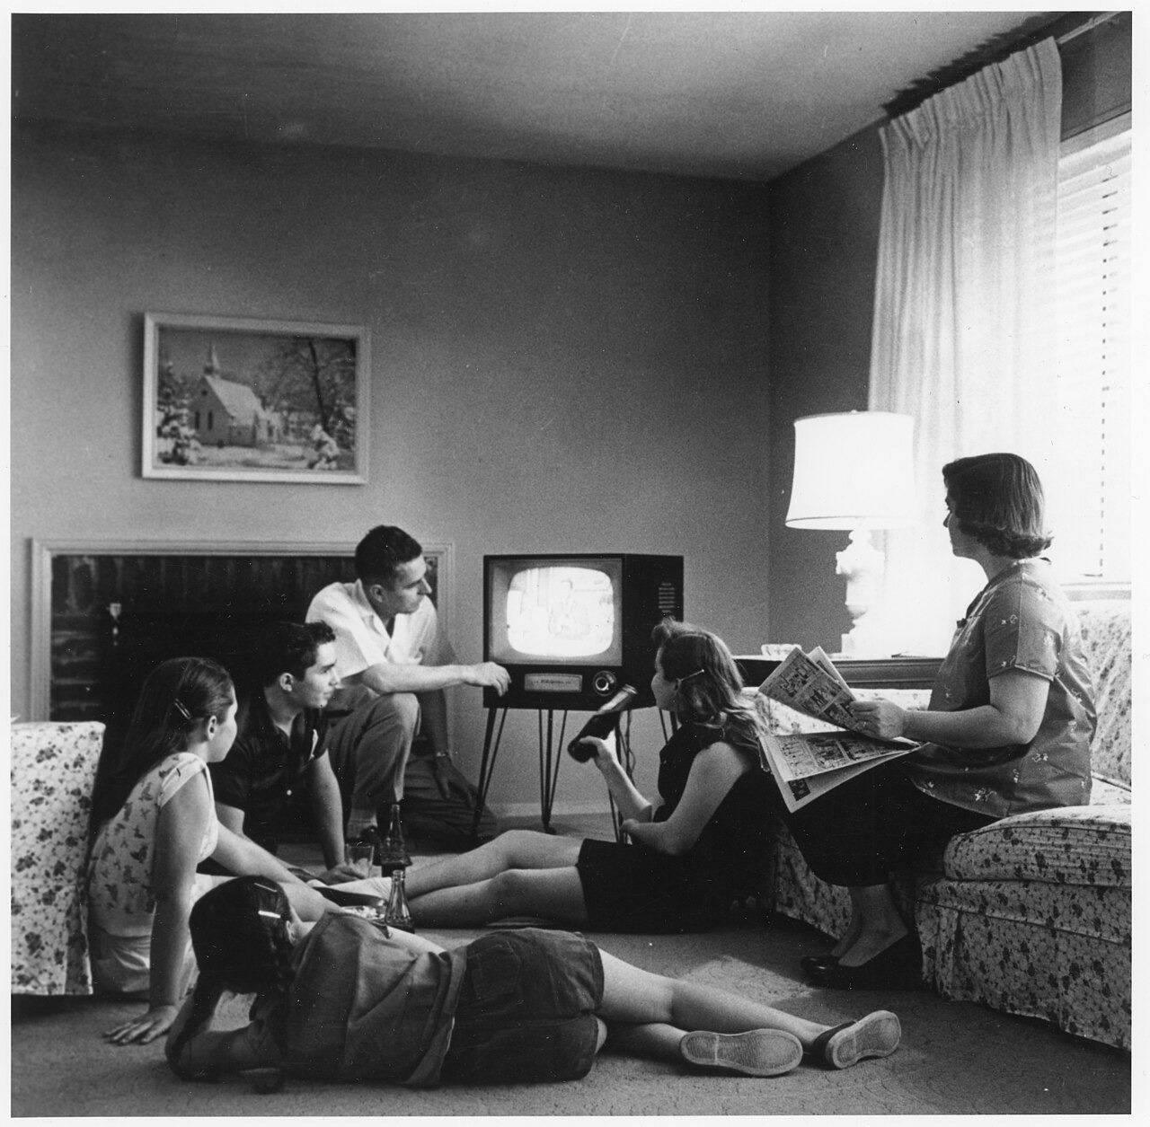
Family Watching Television in Their Home (c. 1958) · Evert F. Baumgardner / National Archives and Records Administration · c. 1958
Source: Baumgardner, Evert F. "Family Watching Television in Their Home." c. 1958. National Archives and Records Administration, via Wikimedia Commons, commons.wikimedia.org/wiki/File:Family_watching_television_1958.jpg. Public Domain https://commons.wikimedia.org/wiki/File:Family_watching_television_1958.jpg
HIPPO — analyze the source (prompt) | Your analysis
H — Historical context: what was happening when this was created?
I — Intended audience: who was meant to see or obey it?
P — Purpose: why was it created?
P — Point of view: whose perspective does it reflect?
O — Outside connection: how does it connect to this standard?
SUPPORT OPTION
Sentence frame: This source shows ______ because it ______, which reveals ______.
CONFIDENCE CHECK-IN
Rate your understanding of this standard (1–4): ______ One thing to revisit: ____________________

Activity 6 — Core Application: Practice Quiz — US.75 ⏱ ~8 min
RESPONSE CHOICE
Commit to an answer by marking it, saying it, or explaining it aloud before checking. Answer key is in the Teacher Guide (kept separate).
[DOK 2 · item q-us75-dok2-1 · pre-field-test]
How did television impact American politics during the 1950s and early 1960s?
A. Televised debates and news coverage transformed how voters chose leaders
B. It combined audio and visuals to influence consumer preferences at scale
C. TV advertising created national demand for products and shaped consumer desires
D. TV became the center of family entertainment and a source of news
[DOK 2 · item q-us75-add-1 · pre-field-test]
How did television change American politics in the 1960s?
A. Candidates invested more in image, televised appearances, and short message framing
B. The 1960 Kennedy-Nixon debate showed that television image mattered as much as policy
C. Families across regions watched the same news, sports, and entertainment programs
D. Broadcast images of protests and violence drew national attention to segregation
[DOK 3 · item u1-us75-dok3-tc · pre-field-test]
What impact did the 1960 Kennedy-Nixon debates have on the role of television in politics?
A. The debates demonstrated TV's power to influence voters through visual appearance—radio listeners thought Nixon won, but TV viewers favored the telegenic Kennedy, transforming how candidates campaign
B. The debates had no significant impact on political campaigns, but contemporary accounts suggest a different explanation, which does not align with the documented historical record
C. Both candidates were equally effective on television, despite limited evidence supporting this interpretation when examined alongside the available primary and secondary sources
D. Television was not used for political debates until the 1970s, although historical sources do not support this conclusion, although historical sources do not support this conclusion

Activity 7 — Constructed Response (CER) — US.75 ⏱ ~15 min
BIG-QUESTION ORGANIZER — in postwar America, who shared in the prosperity and the new consumer culture, and who was left out?
Jot quick notes from THIS standard: Who benefited? · Who bore the costs? · Who decided?

CONSTRUCTED RESPONSE (CER) — builds SSP.04 Argumentation
Claim + Evidence + Reasoning: Using this standard, take a position on the central question — analyze the increasing impact of television and mass media on the American home, politics, and economy? Support your claim with two pieces of evidence from the passage and explain your reasoning.
Part | Write here
Claim
Evidence (two specifics)
Reasoning
SELF-CHECK (CER rubric — see Toolkit)
Is my claim defensible? · TWO specific pieces of evidence? · Does my reasoning explain HOW the evidence proves the claim?
EXIT TICKET — before you leave [item us75-q1 · DOK 2 · pre-field-test]
How did television replace radio as the center of American family entertainment and home life?
A. Radio remained more popular than television, but this oversimplifies the complex factors at work, although this overlooks critical economic and social factors involved, which contradicts the primary source evidence from this era
B. Television was only popular in wealthy households, which does not reflect the consensus among historians, which does not align with the documented historical record, but closer analysis reveals a more complicated historical reality
C. TV became the center of family entertainment, with families scheduling activities around programs, sharing cultural experiences through popular shows, and redesigning living rooms around television sets
D. Families spent less time at home after television's introduction, although this view has been largely discredited by scholars, which does not align with the documented historical record
Show what you know (your choice): mark the best answer, say it, or explain it — then rate how sure you are: ☐ Not yet ☐ Getting there ☐ Got it
Answer key and next steps are in the Teacher Guide.

Standard US.76 — Youth Culture and Tennessee Music
TN Academic Standard US.76: Describe the emergence of a youth culture, including beatniks and the progression of popular music (from swing to rhythm and blues to rock 'n' roll), and the impact of Tennessee on the music industry, including the influence of B.B. King, Elvis Presley, Stax Records, and Sun Studio. (TCA)
LEARNING TARGETS — I can…
• I can describe the emergence of a youth culture, including beatniks and the progression of popular music, and the impact of Tennessee on the music industry, including B.B. King, Elvis Presley, Stax Records, and Sun Studio.
Lenses for this standard: History · Culture · Tennessee Connection
CORE PATH — the same for every student
Same rigor for everyone: analyze the sources and vocabulary, then show what you learned on the Practice Quiz and the CER.
UDL and MTSS give you flexible ways in — they never lower the bar.
Check yourself against the learning targets on the Cornell Notes page.
★ Tennessee Connection
Memphis's Sun Records and producer Sam Phillips launched the careers of Elvis Presley, Johnny Cash, Carl Perkins, and Jerry Lee Lewis — figures who defined the progression from country and blues to rock and roll. Nashville's Grand Ole Opry continued to shape country music's national audience.
SET YOUR GOAL (self-direction)
My goal for this standard — what will I be able to do, and how will I show it?

HOOK — think before you dig in
Youth Culture and Tennessee Music: Describe the emergence of a youth culture, including beatniks and the progression of popular music (from swing to rhythm and blues to rock 'n' roll), and the impact of Tennessee on the music industry, including the influence of B.B. King, Elvis Presley, Stax Records, and Sun Studio. (TCA). Who gained, who was left out — and why does it still matter?

ACTIVATE — what do you already know or wonder?
Jot what you already know or want to find out about this standard. You’ll come back to it.

PREVIEW & PREDICT
Which learning target will be hardest, and why? Connect it to the unit’s big question: who shared in the postwar prosperity, and who was left out?

Activity 1 — Vocabulary (Part A: Reference / Word Bank) — US.76 ⏱ ~10 min
Use this word bank throughout the standard. The Spanish column supports access, not translation of assessment.
Term | Student-friendly meaning | Spanish
Beatniks | Members of the 1950s Beat Generation—writers like Jack Kerouac and Allen Ginsberg—who rejected mainstream culture, materialism, and conformity. | Beatniks
Rock ’n’ Roll | Revolutionary 1950s music genre combining rhythm and blues, country, and gospel; Elvis Presley became its “King,” representing youth rebellion. | Rock ’n’ Roll
Elvis Presley | Tennessee singer who became “The King of Rock ’n’ Roll” in the 1950s, revolutionizing popular culture and launching rock as a global phenomenon. | Elvis Presley
Sun Studio | Memphis recording studio where Elvis Presley, Johnny Cash, Jerry Lee Lewis, and others recorded, creating the “Memphis Sound” of rock ’n’ roll. | Sun Studio
Stax Records | Memphis record label founded 1957, legendary for soul music and home to Otis Redding and Isaac Hayes, putting Tennessee at the center of American music. | Stax Records
B.B. King | Mississippi-born blues guitarist who recorded in Memphis and became “King of the Blues,” shaping rock, soul, and popular music from Tennessee. | B.B. King
LANGUAGE SUPPORT
Pronunciations: Beatniks (BEET-niks); Rock ’n’ Roll (rok un ROHL); Elvis Presley (EL-vis PREZ-lee); Sun Studio (sun STOO-dee-oh); Stax Records (staks); B.B. King (bee-bee KING).

VOCABULARY SELF-CHECK · Knowledge Rating
Rate each term NOW in pencil, then again at the END — growth is the goal; no penalty for “never seen it.”
Term | 1 · never seen it | 2 · heard it | 3 · can use it | 4 · can teach it
Beatniks
Rock ’n’ Roll
Elvis Presley
Sun Studio
Stax Records
B.B. King

Activity 2 — Vocabulary Studio (Frayer-inspired) — US.76 ⏱ ~7 min
RESPONSE CHOICE
Complete each studio by writing, speaking, or diagramming.

PRIORITY TERM 1 Beatniks · ES: Beatniks
Word-bank meaning to build on: Members of the 1950s Beat Generation—writers like Jack Kerouac and Allen Ginsberg—who rejected mainstream culture, materialism, and conformity.
Definition (in your own words) | Characteristics
Examples | Non-examples
Use it to explain
Write one sentence that uses “Beatniks” to explain this standard.

PRIORITY TERM 2 Rock ’n’ Roll · ES: Rock ’n’ Roll
Word-bank meaning to build on: Revolutionary 1950s music genre combining rhythm and blues, country, and gospel; Elvis Presley became its “King,” representing youth rebellion.
Definition (in your own words) | Characteristics
Examples | Non-examples
Use it to explain
Write one sentence that uses “Rock ’n’ Roll” to explain this standard.

CONNECT THE TERMS (UDL · build understanding)
How do these priority terms fit together? Write or sketch how one leads to or affects another.

Activity 3 — Direct Teaching Cornell Notes — US.76 ⏱ ~20 min
Name: ______________________ Class / Period: __________ Date: __________
US.76 — Youth Culture and Tennessee Music • These notes capture the direct-teaching content and the Close Read for this standard.
Your learning targets are on this standard’s opening page — take notes that help you meet them.
Cues (tied to your learning targets) | My notes
What does the passage say about the Beat Generation?
What does the passage say about tennessee's Central Role in Music?
What does the passage say about breaking Racial Barriers Through Music?
Key terms →
DOODLE ZONE — draw your thinking (UDL · another way in)
Need another way in? Sketch the key idea, a quick timeline, or how the pieces connect. Words optional.

Cornell Notes — keep going, then process & check — US.76
MORE NOTES / DIAGRAMS
Continue your notes here, add a quick sketch, or map how the ideas connect.

Key terms to list
Beatniks · Rock ’n’ Roll · Elvis Presley · Sun Studio · Stax Records · B.B. King
Summary — In your own words (2–3 sentences)
PROGRESS CHECK · one question
Why did Tennessee become the center of American popular music development in the 1950s?
A. Tennessee had no significant role in music history, but this fails to account for the broader historical context and fails to account for key developments in the broader context
B. Sun Studio and Stax Records in Memphis combined African American and white musical traditions, while artists like Elvis and B.B. King crossed racial boundaries to create rock 'n' roll and soul music
C. Tennessee only produced country music, but this fails to account for the broader historical context when examined alongside the available primary and secondary sources, although historical sources do not support this conclusion
D. Music development occurred primarily in New York and Los Angeles, but contemporary accounts suggest a different explanation, which represents a common misconception about this historical period
Commit before you move on — mark it, say it, or explain it aloud.
CHECK YOURSELF — how am I doing?
Which learning targets (on this standard’s opening page) can you now meet? Tick the number; circle any you still need help with.
☐ 1
My 12–15 word headline for this standard

Activity 4 — Close Read — US.76 ⏱ ~15 min
Reading type: History Hack-authored instructional synthesis. This is not a primary source. Builds SSP.03 (synthesize) and SSP.05 (historical awareness).
CORE PATH — read one chunk at a time
The Beat Generation
Beatniks rejected 1950s conformity, materialism, and conventional career paths. They embraced artistic expression, questioned authority, experimented with alternative lifestyles, and criticized suburban conformity. Writers like Jack Kerouac and Allen Ginsberg became cultural icons. This laid groundwork for 1960s counterculture movements.
Tennessee's Central Role in Music
Tennessee, particularly Memphis and Nashville, became crucial to American popular music because of: Sun Studio's role in developing rock 'n' roll, Stax Records promoting rhythm and blues, the convergence of African American and white musical traditions, and artists like Elvis Presley and B.B. King who crossed racial boundaries in music.
Breaking Racial Barriers Through Music
Artists like Elvis Presley, who recorded at Sun Studio in Memphis, brought African American musical styles to white audiences. B.B. King and other blues artists at Stax Records gained crossover appeal. Music became one of the first areas where racial integration occurred naturally, challenging segregation through shared cultural experiences.
Sun Studio and Stax Records
Sun Studio, founded by Sam Phillips in Memphis, recorded Elvis Presley, Johnny Cash, Jerry Lee Lewis, and Carl Perkins—creating rock 'n' roll. Stax Records, also in Memphis, produced soul music with artists like Otis Redding and Booker T. & the M.G.'s. These Tennessee institutions shaped American music history.
LANGUAGE SUPPORT
Key terms to know first: Beatniks, Rock ’n’ Roll. Read once for the gist, then again for evidence.
CLOSE-READ EVIDENCE LAB — for each question: quote the EVIDENCE from the passage above, then write YOUR ANSWER (or answer aloud / diagram it).
Text-dependent question | Evidence from the passage | Your answer (what it shows)
What is the main idea of the “The Beat Generation” section, and what evidence supports it?
What is the main idea of the “Tennessee's Central Role in Music” section, and what evidence supports it?
What is the main idea of the “Breaking Racial Barriers Through Music” section, and what evidence supports it?

Activity 5 — Primary Source / Data Analysis — US.76 ⏱ ~15 min
Primary source (photograph) — analyze it with HIPPO. Builds SSP.01–SSP.02.
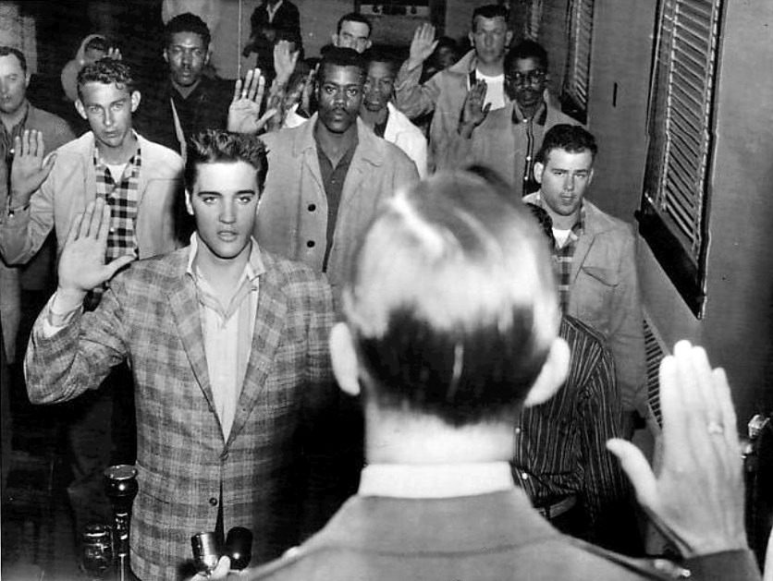
Elvis Presley Sworn into the U.S. Army, Fort Chaffee, Arkansas (March 25, 1958) · Associated Press / Standard-Sentinel · March 25, 1958
Source: Associated Press. "Elvis Presley Sworn into the U.S. Army at Fort Chaffee, Arkansas." 25 Mar. 1958. Standard-Sentinel, via Wikimedia Commons, commons.wikimedia.org/wiki/File:Elvis_sworn_into_army_1958.jpg. Public Domain https://commons.wikimedia.org/wiki/File:Elvis_sworn_into_army_1958.jpg
HIPPO — analyze the source (prompt) | Your analysis
H — Historical context: what was happening when this was created?
I — Intended audience: who was meant to see or obey it?
P — Purpose: why was it created?
P — Point of view: whose perspective does it reflect?
O — Outside connection: how does it connect to this standard?
SUPPORT OPTION
Sentence frame: This source shows ______ because it ______, which reveals ______.
CONFIDENCE CHECK-IN
Rate your understanding of this standard (1–4): ______ One thing to revisit: ____________________

Activity 6 — Core Application: Practice Quiz — US.76 ⏱ ~8 min
RESPONSE CHOICE
Commit to an answer by marking it, saying it, or explaining it aloud before checking. Answer key is in the Teacher Guide (kept separate).
[DOK 2 · item q-us72-dok2-1 · pre-field-test]
How did the baby boom generation impact the American economy and culture?
A. It drove demand for schools, housing, consumer goods, and new services
B. It caused severe economic depression due to overcrowded job markets
C. It had minimal impact because most baby boomers emigrated to Europe
D. It primarily strengthened rural agricultural communities across America
[DOK 2 · item q-us74-dok2-1 · pre-field-test]
How did the automobile transform American business and culture in the 1950s?
A. It reduced consumer spending because families saved money on transit
B. It created fast food chains, motels, shopping centers, and drive-ins
C. It eliminated the need for any new road construction across the nation
D. It primarily benefited the railroad industry by increasing train travel
[DOK 3 · item u1-us76-dok3-tc · pre-field-test]
Why did Tennessee become the center of American popular music development in the 1950s?
A. Tennessee had no significant role in music history, but this fails to account for the broader historical context and fails to account for key developments in the broader context
B. Sun Studio and Stax Records in Memphis combined African American and white musical traditions, while artists like Elvis and B.B. King crossed racial boundaries to create rock 'n' roll and soul music
C. Tennessee only produced country music, but this fails to account for the broader historical context when examined alongside the available primary and secondary sources, although historical sources do not support this conclusion
D. Music development occurred primarily in New York and Los Angeles, but contemporary accounts suggest a different explanation, which represents a common misconception about this historical period

Activity 7 — Constructed Response (CER) — US.76 ⏱ ~15 min
BIG-QUESTION ORGANIZER — in postwar America, who shared in the prosperity and the new consumer culture, and who was left out?
Jot quick notes from THIS standard: Who benefited? · Who bore the costs? · Who decided?

CONSTRUCTED RESPONSE (CER) — builds SSP.04 Argumentation
Claim + Evidence + Reasoning: Using this standard, take a position on the central question — describe the emergence of a youth culture, including beatniks and the progression of popular music, and the impact of Tennessee on the music industry, including B.B. King, Elvis Presley, Stax Records, and Sun Studio? Support your claim with two pieces of evidence from the passage and explain your reasoning.
Part | Write here
Claim
Evidence (two specifics)
Reasoning
SELF-CHECK (CER rubric — see Toolkit)
Is my claim defensible? · TWO specific pieces of evidence? · Does my reasoning explain HOW the evidence proves the claim?
EXIT TICKET — before you leave [item us76-q1 · DOK 2 · pre-field-test]
How did the Beat Generation challenge 1950s conformity and traditional American values?
A. The Beat Generation embraced suburban conformity, although this overlooks critical economic and social factors despite the fact that multiple contemporary sources contradict this
B. The Beat Generation had no influence on American culture, but this oversimplifies the complex factors at work, and this view has been largely revised by modern historical research
C. Beatniks supported traditional family values, though this interpretation lacks supporting historical evidence when examined alongside the available primary and secondary sources
D. Beatniks rejected materialism and conventional careers, embraced artistic expression, questioned authority, and criticized conformity, laying groundwork for 1960s counterculture
Show what you know (your choice): mark the best answer, say it, or explain it — then rate how sure you are: ☐ Not yet ☐ Getting there ☐ Got it
Answer key and next steps are in the Teacher Guide.

Standard US.77 — Kennedy's New Frontier
TN Academic Standard US.77: Describe President John F. Kennedy's New Frontier programs to improve education, end racial discrimination, create the Peace Corps, and put a man on the moon.
LEARNING TARGETS — I can…
• I can describe President John F. Kennedy's New Frontier programs to improve education, end racial discrimination, create the Peace Corps, and put a man on the moon.
Lenses for this standard: Politics/Government · Culture · Economics
CORE PATH — the same for every student
Same rigor for everyone: analyze the sources and vocabulary, then show what you learned on the Practice Quiz and the CER.
UDL and MTSS give you flexible ways in — they never lower the bar.
Check yourself against the learning targets on the Cornell Notes page.
★ Tennessee Connection
President Kennedy's New Frontier had direct Tennessee impacts. The Area Redevelopment Act targeted Appalachian Tennessee, one of the nation's poorest regions. Kennedy appointed Tennessean Frank Clement's ally Buford Ellington to key roles, and the administration's focus on education spending benefited Tennessee schools.
SET YOUR GOAL (self-direction)
My goal for this standard — what will I be able to do, and how will I show it?

HOOK — think before you dig in
Kennedy's New Frontier: Describe President John F. Kennedy's New Frontier programs to improve education, end racial discrimination, create the Peace Corps, and put a man on the moon. Who gained, who was left out — and why does it still matter?

ACTIVATE — what do you already know or wonder?
Jot what you already know or want to find out about this standard. You’ll come back to it.

PREVIEW & PREDICT
Which learning target will be hardest, and why? Connect it to the unit’s big question: who shared in the postwar prosperity, and who was left out?

Activity 1 — Vocabulary (Part A: Reference / Word Bank) — US.77 ⏱ ~10 min
Use this word bank throughout the standard. The Spanish column supports access, not translation of assessment.
Term | Student-friendly meaning | Spanish
New Frontier | President John F. Kennedy’s 1960s domestic program promoting economic growth, education, civil rights, and space exploration; a symbol of optimism. | Nueva Frontera
Peace Corps | Volunteer program created by President Kennedy in 1961, sending Americans to developing countries to help with education, health, and economic development. | Cuerpo de Paz
Moon Landing Goal | President Kennedy’s 1961 pledge to land Americans on the moon before 1970, mobilizing national resources, advancing technology, and inspiring a generation. | Objetivo de Aterrizaje Lunar
Space Race | The Cold War competition between the U.S. and Soviet Union to achieve firsts in space exploration; a top New Frontier priority. | Carrera Espacial
John F. Kennedy | The 35th U.S. President (1961–1963) whose New Frontier promised progress in civil rights, the economy, and space. | John F. Kennedy
Apollo Program | The NASA program launched under Kennedy's goal of landing an American on the Moon before the decade's end. | Programa Apolo
LANGUAGE SUPPORT
Pronunciations: New Frontier (noo frun-TEER); Peace Corps (pees KOR); Moon Landing Goal (moon LAND-ing); Space Race (spays rays); John F. Kennedy (KEN-eh-dee); Apollo Program (uh-POL-oh).

VOCABULARY SELF-CHECK · Knowledge Rating
Rate each term NOW in pencil, then again at the END — growth is the goal; no penalty for “never seen it.”
Term | 1 · never seen it | 2 · heard it | 3 · can use it | 4 · can teach it
New Frontier
Peace Corps
Moon Landing Goal
Space Race
John F. Kennedy
Apollo Program

Activity 2 — Vocabulary Studio (Frayer-inspired) — US.77 ⏱ ~7 min
RESPONSE CHOICE
Complete each studio by writing, speaking, or diagramming.

PRIORITY TERM 1 New Frontier · ES: Nueva Frontera
Word-bank meaning to build on: President John F. Kennedy’s 1960s domestic program promoting economic growth, education, civil rights, and space exploration; a symbol of optimism.
Definition (in your own words) | Characteristics
Examples | Non-examples
Use it to explain
Write one sentence that uses “New Frontier” to explain this standard.

PRIORITY TERM 2 Peace Corps · ES: Cuerpo de Paz
Word-bank meaning to build on: Volunteer program created by President Kennedy in 1961, sending Americans to developing countries to help with education, health, and economic development.
Definition (in your own words) | Characteristics
Examples | Non-examples
Use it to explain
Write one sentence that uses “Peace Corps” to explain this standard.

CONNECT THE TERMS (UDL · build understanding)
How do these priority terms fit together? Write or sketch how one leads to or affects another.

Activity 3 — Direct Teaching Cornell Notes — US.77 ⏱ ~20 min
Name: ______________________ Class / Period: __________ Date: __________
US.77 — Kennedy's New Frontier • These notes capture the direct-teaching content and the Close Read for this standard.
Your learning targets are on this standard’s opening page — take notes that help you meet them.
Cues (tied to your learning targets) | My notes
What does the passage say about new Frontier Goals?
What does the passage say about the Peace Corps?
What does the passage say about the Space Race Priority?
Key terms →
DOODLE ZONE — draw your thinking (UDL · another way in)
Need another way in? Sketch the key idea, a quick timeline, or how the pieces connect. Words optional.

Cornell Notes — keep going, then process & check — US.77
MORE NOTES / DIAGRAMS
Continue your notes here, add a quick sketch, or map how the ideas connect.

Key terms to list
New Frontier · Peace Corps · Moon Landing Goal · Space Race · John F. Kennedy · Apollo Program
Summary — In your own words (2–3 sentences)
PROGRESS CHECK · one question
Why did Kennedy commit America to landing on the moon during the Cold War space race?
A. Kennedy had no interest in space exploration, which ignores key developments that shaped the outcome, but closer analysis reveals a more complicated historical reality
B. The moon landing was planned before Kennedy took office, although historical sources do not support this conclusion, though this interpretation lacks supporting historical evidence
C. After Soviet successes with Sputnik and Gagarin's flight, Kennedy committed to the moon landing to demonstrate American technological superiority and prove democracy could achieve ambitious goals
D. Kennedy's moon commitment was unpopular with Americans, although this overlooks critical economic and social factors, which contradicts the primary source evidence from this era
Commit before you move on — mark it, say it, or explain it aloud.
CHECK YOURSELF — how am I doing?
Which learning targets (on this standard’s opening page) can you now meet? Tick the number; circle any you still need help with.
☐ 1
My 12–15 word headline for this standard

Activity 4 — Close Read — US.77 ⏱ ~15 min
Reading type: History Hack-authored instructional synthesis. This is not a primary source. Builds SSP.03 (synthesize) and SSP.05 (historical awareness).
CORE PATH — read one chunk at a time
New Frontier Goals
Kennedy's New Frontier programs aimed to address multiple challenges: Education through federal aid to improve schools and expand higher education access; Civil Rights through federal enforcement of desegregation and voting rights; Space Exploration by competing with the Soviet Union to land on the moon; and Economics through tax cuts and public investment to stimulate growth.
The Peace Corps
The Peace Corps, established in 1961, sent American volunteers to developing countries to provide technical assistance, education, and healthcare. It reflected Kennedy's vision of America promoting its values through service rather than military force. Thousands of young Americans served abroad, building goodwill and demonstrating American idealism.
The Space Race Priority
Kennedy committed America to landing on the moon by the end of the decade, making space exploration a national priority. After the Soviet Union launched Sputnik (1957) and put Yuri Gagarin in orbit (1961), America needed to demonstrate its technological capabilities and democratic system's effectiveness in achieving ambitious goals.
Legacy and Limitations
Many New Frontier programs faced congressional resistance, limiting Kennedy's domestic achievements. However, his space commitment led to the 1969 moon landing, the Peace Corps continues today, and his civil rights advocacy set the stage for Johnson's Great Society legislation after Kennedy's assassination.
Key terms first: New Frontier, Peace Corps. Read once for the gist, then again for evidence.
CLOSE-READ EVIDENCE LAB — for each question: quote the EVIDENCE from the passage above, then write YOUR ANSWER (or answer aloud / diagram it).
Text-dependent question | Evidence from the passage | Your answer (what it shows)
What is the main idea of the “New Frontier Goals” section, and what evidence supports it?
What is the main idea of the “The Peace Corps” section, and what evidence supports it?
What is the main idea of the “The Space Race Priority” section, and what evidence supports it?

Activity 5 — Primary Source / Data Analysis — US.77 ⏱ ~15 min
Primary source (photograph) — analyze it with HIPPO. Builds SSP.01–SSP.02.
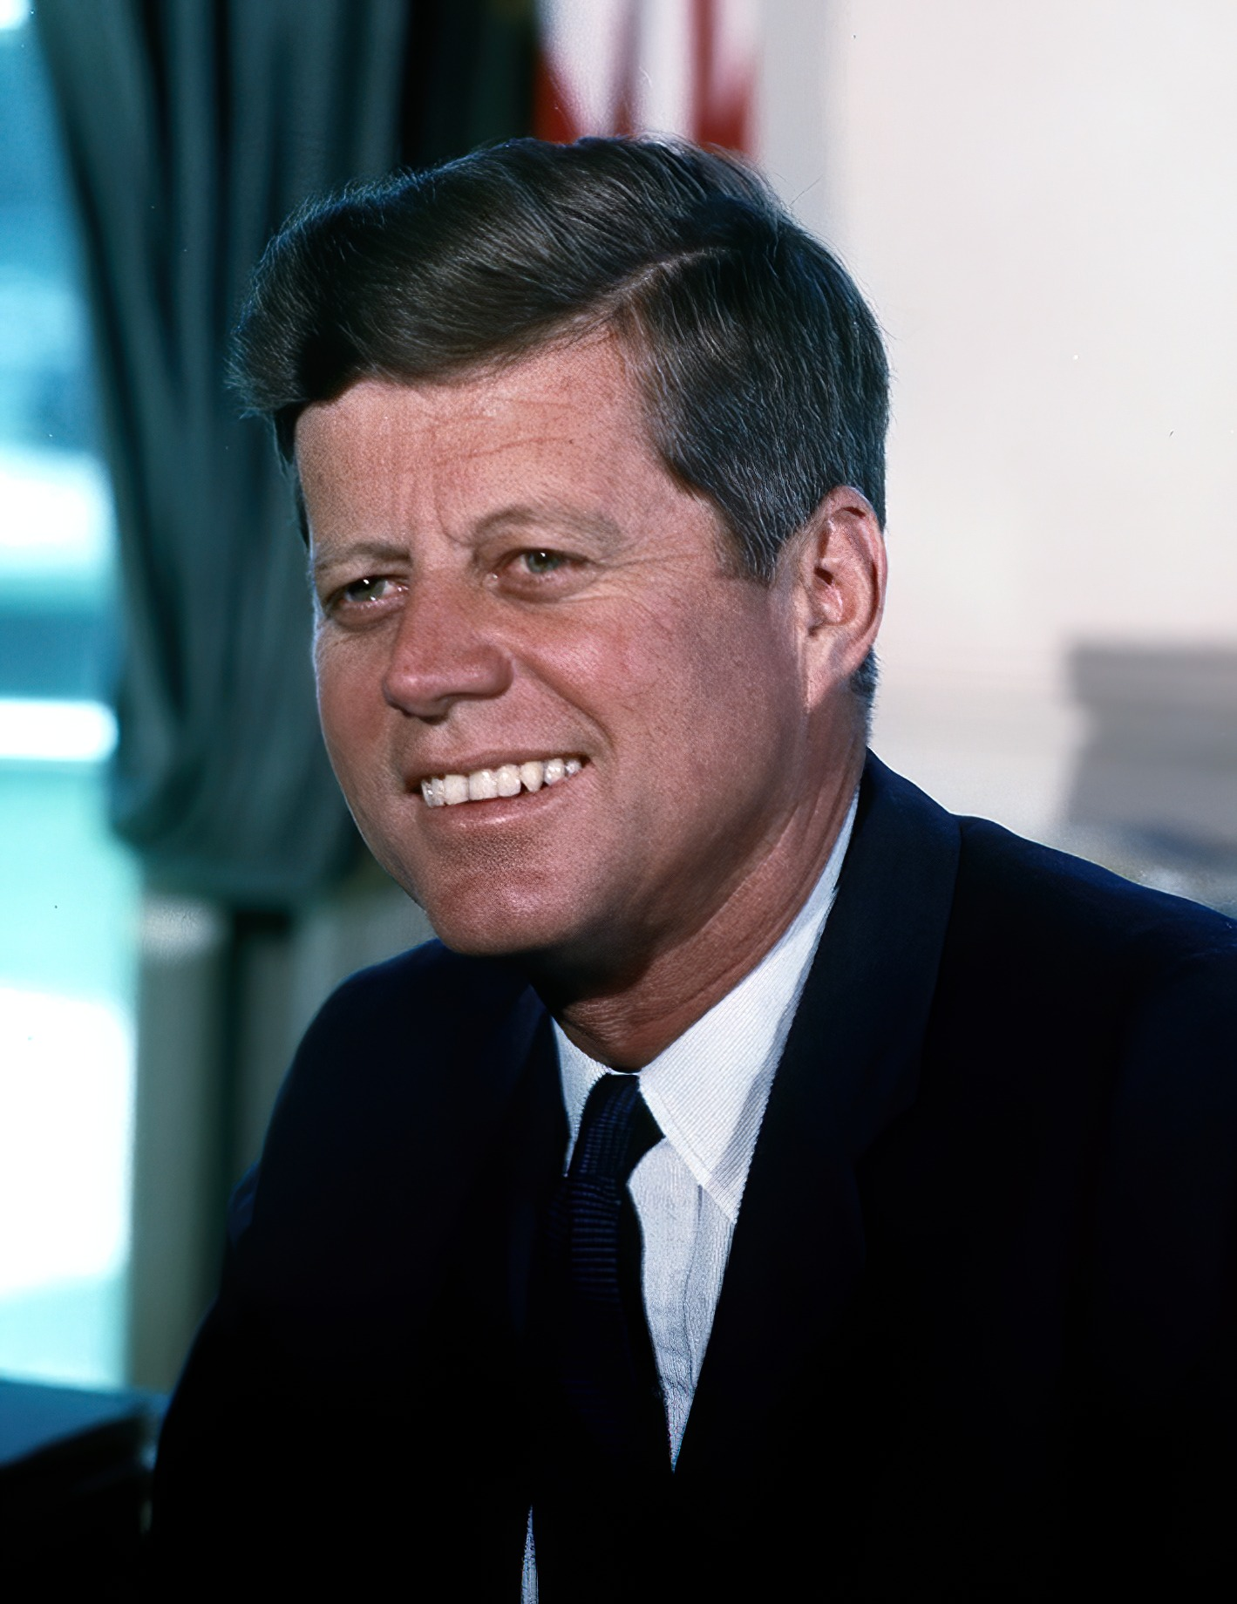
President John F. Kennedy, White House Color Portrait (c. 1961–1963) · Cecil Stoughton / White House / Executive Office of the President · c. 1961–1963
Source: Stoughton, Cecil. "President John F. Kennedy, White House Color Portrait." c. 1961–1963. Executive Office of the President / White House, via Wikimedia Commons, commons.wikimedia.org/wiki/File:John_F._Kennedy,_White_House_color_photo_portrait.jpg. Public Domain https://commons.wikimedia.org/wiki/File:John_F._Kennedy,_White_House_color_photo_portrait.jpg
HIPPO — analyze the source (prompt) | Your analysis
H — Historical context: what was happening when this was created?
I — Intended audience: who was meant to see or obey it?
P — Purpose: why was it created?
P — Point of view: whose perspective does it reflect?
O — Outside connection: how does it connect to this standard?
SUPPORT OPTION
Sentence frame: This source shows ______ because it ______, which reveals ______.
CONFIDENCE CHECK-IN
Rate your understanding of this standard (1–4): ______ One thing to revisit: ____________________

Activity 6 — Core Application: Practice Quiz — US.77 ⏱ ~8 min
RESPONSE CHOICE
Commit to an answer by marking it, saying it, or explaining it aloud before checking. Answer key is in the Teacher Guide (kept separate).
[DOK 2 · item us77-q2 · pre-field-test]
How did the Peace Corps reflect Kennedy's vision for America's role in the world?
A. The Peace Corps sent volunteers to developing countries to provide assistance, reflecting Kennedy's vision of promoting American values through service and idealism rather than military force
B. The Peace Corps was a military program, despite the fact that multiple sources contradict this view and fails to account for key developments in the broader context
C. The Peace Corps only operated within the United States, yet the available evidence points to a different conclusion, but closer analysis reveals a more complicated historical reality
D. Kennedy opposed the Peace Corps concept, yet the available evidence points to a different conclusion, though this interpretation lacks supporting historical evidence
[DOK 2 · item q-us77-dok2-2 · pre-field-test]
How did President Kennedy's space program goal reflect Cold War competition?
A. Domestic agenda to improve education, end discrimination, and reach the moon
B. Landing on the moon would demonstrate American technological superiority
C. Send American volunteers to developing nations to provide assistance
D. Commitment to landing Americans on the moon before the decade ended
[DOK 3 · item u1-us77-dok3-tc · pre-field-test]
Why did Kennedy commit America to landing on the moon during the Cold War space race?
A. Kennedy had no interest in space exploration, which ignores key developments that shaped the outcome, but closer analysis reveals a more complicated historical reality
B. The moon landing was planned before Kennedy took office, although historical sources do not support this conclusion, though this interpretation lacks supporting historical evidence
C. After Soviet successes with Sputnik and Gagarin's flight, Kennedy committed to the moon landing to demonstrate American technological superiority and prove democracy could achieve ambitious goals
D. Kennedy's moon commitment was unpopular with Americans, although this overlooks critical economic and social factors, which contradicts the primary source evidence from this era

Activity 7 — Constructed Response (CER) — US.77 ⏱ ~15 min
BIG-QUESTION ORGANIZER — in postwar America, who shared in the prosperity and the new consumer culture, and who was left out?
Jot quick notes from THIS standard: Who benefited? · Who bore the costs? · Who decided?

CONSTRUCTED RESPONSE (CER) — builds SSP.04 Argumentation
Claim + Evidence + Reasoning: Using this standard, take a position on the central question — describe President John F. Kennedy's New Frontier programs to improve education, end racial discrimination, create the Peace Corps, and put a man on the moon? Support your claim with two pieces of evidence from the passage and explain your reasoning.
Part | Write here
Claim
Evidence (two specifics)
Reasoning
SELF-CHECK (CER rubric — see Toolkit)
Is my claim defensible? · TWO specific pieces of evidence? · Does my reasoning explain HOW the evidence proves the claim?
EXIT TICKET — before you leave [item us77-q1 · DOK 2 · pre-field-test]
What were President Kennedy's main domestic and international goals through the New Frontier programs?
A. Kennedy's New Frontier aimed to improve education, enforce civil rights, compete in space exploration, create the Peace Corps, and stimulate economic growth
B. Kennedy focused only on military expansion, although historical sources do not support this conclusion, which ignores significant political and cultural developments of the era
C. The New Frontier only addressed foreign policy, although historical sources do not support this conclusion when examined alongside the available primary and secondary sources
D. Kennedy had no significant domestic agenda, despite limited evidence supporting this interpretation and does not reflect the scholarly consensus on this topic
Show what you know (your choice): mark the best answer, say it, or explain it — then rate how sure you are: ☐ Not yet ☐ Getting there ☐ Got it
Answer key and next steps are in the Teacher Guide.

Your Tennessee Connection
TENNESSEE CONNECTION · MEMPHIS, MUSIC, AND THE MODERN SOUTH
Postwar Tennessee helped invent modern American culture. At Sun Records in Memphis, producer Sam Phillips blended Black rhythm-and-blues with white country music and launched Elvis Presley, Johnny Cash, Carl Perkins, and Jerry Lee Lewis — the sound of a new teenage culture (US.76). Nashville’s WSM-TV brought the Grand Ole Opry to television and helped make the city “Music City” (US.75). Off the airwaves, the interstate boom remade the state: I-40, I-65, I-24, and I-75 crossed Tennessee (US.73–US.74), fueling suburban growth around Nashville, Memphis, and Knoxville (US.71–US.72), while President Kennedy’s New Frontier targeted Appalachian poverty in East Tennessee (US.77).
Reflect (RESPONSE CHOICE): How does a local story change the way you understand a national event? Answer by writing, recording, or diagramming.

Local History Investigation
Industrialization touched Tennessee too — railroads, mines, mills, and the people who worked them. Investigate one local connection and record what you find.
Prompt | Your findings
A person, place, or industry from this era near me
One source I could check (library, TSLA, family, museum)
Who benefited / who bore the costs, locally
One question I still have

Progress Tracker & Cumulative Review
Track your Progress Check result for each standard and note one thing to revisit.
Standard | Progress Check (✓ / reteach) | One thing to revisit
US.71
US.72
US.73
US.74
US.75
US.76
US.77

Optional Extension Bank (higher-DOK, open to all)
Any student may choose an extension. These are EXTENSION, not a track.
US.71: Using this standard, take a position on the central question — analyze the impact of prosperity and consumerism in the 1950s, including the growth of white-collar jobs, the "suburban ideal," the impact of the G.I. Bill, and the increased reliance on foreign oil? Support your claim with two pieces of evidence from the passage and explain your reasoning.
US.72: Using this standard, take a position on the central question — explain the impact of the baby boomer generation on the American economy and culture? Support your claim with two pieces of evidence from the passage and explain your reasoning.
US.73: Using this standard, take a position on the central question — describe domestic developments during President Eisenhower's administration, including advances in medicine and the creation of the Interstate Highway System? Support your claim with two pieces of evidence from the passage and explain your reasoning.
US.74: Using this standard, take a position on the central question — describe the growing influence of the automobile on American society, including the growth of suburbia, fast food chains, and the hotel industry? Support your claim with two pieces of evidence from the passage and explain your reasoning.
US.75: Using this standard, take a position on the central question — analyze the increasing impact of television and mass media on the American home, politics, and economy? Support your claim with two pieces of evidence from the passage and explain your reasoning.
US.76: Using this standard, take a position on the central question — describe the emergence of a youth culture, including beatniks and the progression of popular music, and the impact of Tennessee on the music industry, including B.B. King, Elvis Presley, Stax Records, and Sun Studio? Support your claim with two pieces of evidence from the passage and explain your reasoning.
US.77: Using this standard, take a position on the central question — describe President John F. Kennedy's New Frontier programs to improve education, end racial discrimination, create the Peace Corps, and put a man on the moon? Support your claim with two pieces of evidence from the passage and explain your reasoning.

Think Like a Test-Writer (unit review — open to all)
You met a quick “think like a test-writer” prompt in every standard. Here is the full how-to, once, plus room to write your best questions for the whole unit.
HOW TO WRITE A DOK-3 QUESTION
DOK-3 = strategic thinking: the reader must analyze, compare, evaluate, or justify using evidence — and there should be more than one defensible answer (not a fact you can just look up).
Sentence starters: “Why did ______ lead to ______?” · “Which mattered more — ______ or ______ — and why?” · “What is the BEST evidence that ______?” · “Evaluate whether ______.” · “Defend or challenge: ______.”
Frame: [Analyze / Evaluate / Justify] + [something from this unit] + “using evidence.”
Quick check: does my question make the reader THINK and use evidence? If yes, it’s DOK-3.
Standard | Your DOK-3 question | Your answer key (one sentence)

Reusable Toolkit & Source Library

Written Response Rubric (CER)
Level | Claim | Evidence | Reasoning
4 — Strong | Precise, defensible | 2+ accurate, specific | Explains how evidence proves the claim
3 — Proficient | Clear | 2 accurate | Explains the link
2 — Developing | General | 1 accurate | Partial link
1 — Beginning | Unclear/missing | Missing/inaccurate | No reasoning

Source Library — full citations & clickable links
US.71 — 1950s Prosperity & Consumerism
Servicemen's Readjustment Act (G.I. Bill). U.S. Congress, 1944. U.S. Congress. "Servicemen's Readjustment Act (G.I. Bill)." 1944. National Archives, https://www.archives.gov/milestone-documents/servicemens-readjustment-act.. Public domain. https://www.archives.gov/milestone-documents/servicemens-readjustment-act
Suburban Development Advertisement. Levittown Marketing, 1949. Levittown Marketing. "Suburban Development Advertisement." 1949. Library of Congress, www.loc.gov/collections/general-collections/.. Public domain. https://www.loc.gov/collections/general-collections/
US.72 — Baby Boomer Generation Impact
Census Bureau Population Report. U.S. Census Bureau, 1955. U.S. Census Bureau. "Census Bureau Population Report." 1955. U.S. Census Bureau, www.census.gov/history/.. Public domain. https://www.census.gov/history/
Report on School Construction Needs. U.S. Office of Education, 1957. U.S. Office of Education. "Report on School Construction Needs." 1957. Library of Congress, www.loc.gov/collections/general-collections/.. Public domain. https://www.loc.gov/collections/general-collections/
US.73 — Eisenhower Administration Developments
Federal-Aid Highway Act Message. President Dwight D. Eisenhower, 1955. Eisenhower, President Dwight D.. "Federal-Aid Highway Act Message." 1955. Dwight D. Eisenhower Presidential Library, www.eisenhowerlibrary.gov/research/online-d. Public domain. https://www.eisenhowerlibrary.gov/research/online-documents/interstate-highway-system
Polio Vaccine Announcement. Dr. Thomas Francis Jr., April 12, 1955. Jr., Dr. Thomas Francis. "Polio Vaccine Announcement." April 12, 1955. Library of Congress, www.loc.gov/item/2004664014/.. Public domain. https://www.loc.gov/item/2004664014/
US.74 — Automobile's Growing Influence
McDonald's Franchise Advertisement. McDonald's Corporation, 1955. McDonald's Corporation. "McDonald's Franchise Advertisement." 1955. Library of Congress, www.loc.gov/collections/general-collections/.. Public domain. https://www.loc.gov/collections/general-collections/
Holiday Inn Franchise Prospectus. Holiday Inn of America, 1957. Holiday Inn of America. "Holiday Inn Franchise Prospectus." 1957. Library of Congress, www.loc.gov/collections/general-collections/.. Public domain. https://www.loc.gov/collections/general-collections/
US.75 — Television and Mass Media Impact
Television and the 1960 Election. Theodore White, journalist, 1961. Theodore White, journalist. "Television and the 1960 Election." 1961. John F. Kennedy Presidential Library, www.jfklibrary.org/learn/about-jfk/jfk-in-history/ca. Public domain. https://www.jfklibrary.org/learn/about-jfk/jfk-in-history/campaign-of-1960
Television Bureau of Advertising Report. Television Bureau of Advertising, 1958. Television Bureau of Advertising. "Television Bureau of Advertising Report." 1958. Library of Congress, www.loc.gov/collections/general-collections/.. Public domain. https://www.loc.gov/collections/general-collections/
US.76 — Youth Culture and Tennessee Music
Sun Studio Press Release. Sun Records, Memphis, Tennessee, 1954. Sun Records, Memphis, Tennessee. "Sun Studio Press Release." 1954. Library of Congress, www.loc.gov/collections/national-jukebox/.. Public domain. https://www.loc.gov/collections/national-jukebox/
On the Road. Jack Kerouac, 1957. Kerouac, Jack. "On the Road." 1957. Library of Congress, www.loc.gov/item/57012tried/.. Public domain. https://www.loc.gov/item/57012tried/
US.77 — Kennedy's New Frontier
Special Message to Congress on the Peace Corps. President John F. Kennedy, March 1, 1961. Kennedy, President John F.. "Special Message to Congress on the Peace Corps." March 1, 1961. John F. Kennedy Presidential Library, www.jfklibrary.org/asset-view. Public domain. https://www.jfklibrary.org/asset-viewer/archives/JFKPOF/034/JFKPOF-034-002
Moon Speech at Rice University. President John F. Kennedy, September 12, 1962. Kennedy, President John F.. "Moon Speech at Rice University." September 12, 1962. John F. Kennedy Presidential Library, www.jfklibrary.org/learn/about-jfk/histo. Public domain. https://www.jfklibrary.org/learn/about-jfk/historic-speeches/address-at-rice-university-on-the-nations-space-effort

The Affluent Society — Who Shared the Boom, and Who Was Left Out
This section complicates the “happy days” image of the 1950s: postwar prosperity was real, but it reached some Americans far more than others. It is History Hack-authored instructional synthesis grounded in this unit’s sourced record — not a primary source.

The Suburban Boom
Cheap cars, new interstates, and easy credit built a consumer society (US.71, US.74) and a baby-boom generation raised in the suburbs (US.72). Television sold a shared national culture of family and prosperity (US.75).

Left Out of the Dream
The suburban boom was largely closed to Black families by redlining and restrictive covenants, and it passed by the rural and Appalachian poor — the poverty Kennedy’s New Frontier later targeted in East Tennessee (US.77).

A New Youth Culture
Teenagers became a force of their own. Rock and roll — born at Memphis’s Sun Records with Elvis and Johnny Cash (US.76) — crossed the color line in sound and unsettled the decade’s conformity.

Conformity and Its Cracks
Beneath the prosperity ran pressures to conform, and quiet challenges to it — early stirrings of the civil rights movement and questions about who the American Dream was really for.
Residual note (known follow-up): sourced visuals and named Key-Figure entries for these histories remain pending.

Unit Reflection
Return to the unit’s big question: in postwar America, who shared in the prosperity and the new consumer culture, and who was left out? Write a final claim with two pieces of evidence from different standards.
Part | Write here
My claim
Evidence 1 (standard: ___)
Evidence 2 (standard: ___)
Why it matters today

