U.S. HISTORY HACK™
COURSE STANDARD · PLATINUM EDITION

CIVIL RIGHTS
MOVEMENT
1954–1975
Unit 9 · High-School U.S. History · Standards-Aligned
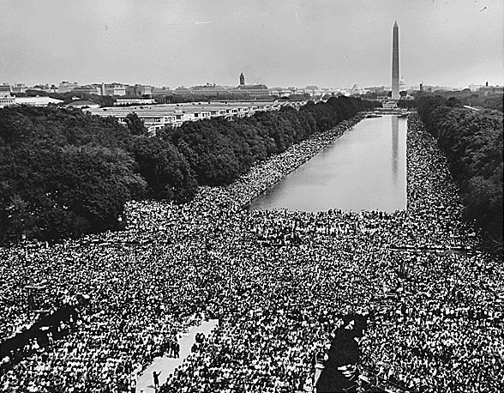
March on Washington for Jobs and Freedom, 1963 · U.S. National Archives · Public domain
STUDENT WORKBOOK

UDL 3.0 | MTSS | CER | Cornell | HIPPO | DOK
Universal Design for Learning · Multi-Tiered Supports · Evidence-Based Writing
Student Edition
TroopToTeacher Technologies LLC

U.S. HISTORY HACK™ Unit 9 — The Civil Rights Movement (1954–1975) STUDENT WORKBOOK · TroopToTeacher Technologies LLC
SPINE
Perfect-bound. At 57 pages on 60-lb (90 gsm) white offset the spine is ≈ 0.128 in (3.3 mm) — wide enough to print the spine text above. Recompute if the page count or paper changes (white 60-lb ≈ 0.002252 in/page).

U.S. HISTORY HACK™
The workbook that teaches every learner — without lowering the bar.
Unit 9 — The Civil Rights Movement (1954–1975) · Student Edition
WHAT MAKES THIS WORKBOOK DIFFERENT

◆ Built on UDL 3.0 (CAST). Every activity offers multiple means of engagement, representation, and action — word banks, sentence frames, visuals, and choice built in, so the rigor stays the same for every learner.
◆ MTSS tiers on every page. Core instruction with layered Guided and Light Support, plus a formative Exit Ticket for each standard and a “What’s Next” reteach path in the Teacher Edition.
◆ Writes like a historian — CER. A 6-point Claim–Evidence–Reasoning rubric runs through the whole course, with scaffolded organizers and lined response space.
◆ Real primary sources, cited. Photographs, political cartoons, and maps from the Library of Congress and National Archives — analyzed with the HIPPO routine — every source documented to Chicago style.
◆ Cornell notes paired to the slide deck. Structured note pages capture the direct-teaching slides, with retrieval checks and doodle zones for visual learners.
◆ Standards-aligned & TCAP-ready. DOK-balanced checks and a companion Assessment Book with two parallel forms, keyed to the standards and reporting categories.
INSIDE THIS UNIT — the five standards

US.78 Brown v. Board of Education
US.79 Civil Rights Advocates and Opponents
US.80 Significant Civil Rights Events
US.81 Civil and Voting Rights Legislation
US.82 American Indian, Chicano & Feminist Movements
Part of the U.S. History Hack™ Course Standard series — a complete, standards-aligned system: Student Workbook · Teacher Edition · Student & Teacher Slide Decks · Graphic Organizer Toolkit · Unit Assessment Book.
TroopToTeacher Technologies LLC  U.S. History Hack™ · Course Standard (Platinum) Edition · Student Edition  © 2026 TroopToTeacher Technologies LLC. All rights reserved. U.S. History Hack™ is a trademark of TroopToTeacher Technologies LLC. No part of this book may be reproduced without written permission, except as licensed for classroom use.  www.trooptoteacher.com · Printed in the U.S.A. · First Edition | ISBN barcode  ISBN 978-X-XXXXX-XXX-X  placeholder — replace at print

PRINT & ONLINE-LISTING SPEC
An internal handoff sheet for your printer and your storefront listing — not part of the printed book.
Title (listing) | U.S. History Hack™ — Unit 9: The Civil Rights Movement (1954–1975) · Student Workbook
Series | U.S. History Hack™ Course Standard (Platinum) Edition
Publisher / Author | TroopToTeacher Technologies LLC
Trim size | 8.5 × 11 in (US Letter)
Interior | 57 pages, black-and-white, 60-lb (90 gsm) white offset
Binding & spine | Perfect-bound; spine ≈ 0.128 in (3.3 mm). Print spine text.
Cover stock | 10-pt or 12-pt C1S gloss/matte laminate; full color
Bleed | Add 0.125 in bleed on all outside edges before print (this concept is at trim).
Copyright | © 2026 TroopToTeacher Technologies LLC. All rights reserved.
ISBN | Assign one ISBN per format (paperback / PDF); place barcode in the back-cover box.
Age / grade | Grades 9–12 · U.S. History
Categories | Education › Teaching Methods & Materials › Social Science; Study Aids › History
Keywords | U.S. history workbook, high school history, UDL curriculum, MTSS, CER writing, primary source analysis, Cornell notes, standards-aligned, civil rights movement, Brown v. Board, Martin Luther King, Rosa Parks, Nashville sit-ins, Voting Rights Act, Highlander, standards-aligned, TCAP review
BACK-COVER BLURB (for your storefront)
U.S. History Hack™ turns a full unit of high-school U.S. History into one student-ready workbook that reaches every learner without lowering the bar. Built on Universal Design for Learning (UDL 3.0) and Multi-Tiered Systems of Support (MTSS), each of the five standards moves from a core lesson to Cornell notes paired with the slide deck, real Library-of-Congress primary sources analyzed with HIPPO, evidence-based writing on a 6-point CER rubric, and a formative Exit Ticket with a built-in reteach path. Standards-aligned, DOK-balanced, and TCAP-ready — with a companion Assessment Book of two parallel forms. Unit 9 covers The Civil Rights Movement, 1954–1975.

