U.S. HISTORY HACK™
COURSE STANDARD · PLATINUM EDITION

CIVIL RIGHTS
MOVEMENT
1954–1975
Unit 9 · High-School U.S. History · Standards-Aligned
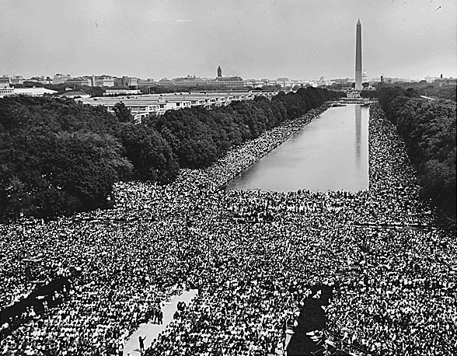
March on Washington for Jobs and Freedom, 1963 · U.S. National Archives · Public domain
TEACHER EDITION

UDL 3.0 | MTSS | CER | Cornell | HIPPO | DOK
Universal Design for Learning · Multi-Tiered Supports · Evidence-Based Writing
TroopToTeacher Technologies LLC

U.S. HISTORY HACK™ Unit 9 — The Civil Rights Movement (1954–1975) TEACHER EDITION · TroopToTeacher Technologies LLC
SPINE
Saddle-stitch. At 13 pages the folded spine is only ≈ 0.029 in (0.7 mm) — too thin to print spine text; bind saddle-stitch (no printed spine). To get a printable spine, perfect-bind at ≥ ~48 pages, or combine thin teacher books into one volume. The spine panel above is provided for when this title is perfect-bound.

U.S. HISTORY HACK™
Everything you need to teach the unit — with the supports already built in.
Unit 9 — The Civil Rights Movement (1954–1975) · Teacher Edition
WHAT’S IN THE TEACHER EDITION

◆ One standard, one period. A pacing map with honest per-activity time estimates and a menu — you choose what fills the 45 minutes; the rest become bell-ringers, stations, or homework.
◆ The MTSS decision cycle. Progress-monitor → identify barrier → select support → reteach → recheck → extend, with scaffold-fading guidance that never displaces IEP/504 accommodations.
◆ Crosswalks that pass review. Standards & SSP crosswalk and a dimension-coverage crosswalk (C·E·G·H·P·T), plus a district review evidence snapshot.
◆ The 6-point CER rubric. The same evidence-based-writing rubric used across the course, ready to score.
◆ Answer keys — teacher-side only. Practice-quiz keys with rationales and exit-ticket keys with “What’s Next” reteach routing, kept separate from student copies.
◆ Deck + Cornell workflow. How the Lean Student and Full Teacher decks pair with the workbook’s Cornell notes and primary-source analysis.
INSIDE THIS UNIT — the five standards

US.78 Brown v. Board of Education
US.79 Civil Rights Advocates and Opponents
US.80 Significant Civil Rights Events
US.81 Civil and Voting Rights Legislation
US.82 American Indian, Chicano & Feminist Movements
Part of the U.S. History Hack™ Course Standard series — a complete, standards-aligned system: Student Workbook · Teacher Edition · Student & Teacher Slide Decks · Graphic Organizer Toolkit · Unit Assessment Book.
TroopToTeacher Technologies LLC  U.S. History Hack™ · Course Standard (Platinum) Edition · Teacher Edition  © 2026 TroopToTeacher Technologies LLC. All rights reserved. U.S. History Hack™ is a trademark of TroopToTeacher Technologies LLC. No part of this book may be reproduced without written permission, except as licensed for classroom use.  www.trooptoteacher.com · Printed in the U.S.A. · First Edition | ISBN barcode  ISBN 978-X-XXXXX-XXX-X  placeholder — replace at print

PRINT & ONLINE-LISTING SPEC
An internal handoff sheet for your printer and your storefront listing — not part of the printed book.
Title (listing) | U.S. History Hack™ — Unit 9: The Civil Rights Movement · Teacher How-to-Use & MTSS Guide
Series | U.S. History Hack™ Course Standard (Platinum) Edition
Publisher / Author | TroopToTeacher Technologies LLC
Trim size | 8.5 × 11 in (US Letter)
Interior | 13 pages, black-and-white, 60-lb (90 gsm) white offset
Binding & spine | Saddle-stitch (no printed spine) at 13 pp; spine ≈ 0.029 in only. Perfect-bind at ≥ ~48 pp for a printable spine.
Cover stock | 10-pt or 12-pt C1S gloss/matte laminate; full color
Bleed | Add 0.125 in bleed on all outside edges before print (this concept is at trim).
Copyright | © 2026 TroopToTeacher Technologies LLC. All rights reserved.
ISBN | Assign one ISBN per format (paperback / PDF); place barcode in the back-cover box.
Age / grade | Grades 9–12 · U.S. History
Categories | Education › Teaching Methods & Materials › Social Science; Study Aids › History
Keywords | teacher edition, lesson plans, MTSS, UDL, CER rubric, social studies practices, standards crosswalk, pacing guide, U.S. history, answer key
BACK-COVER BLURB (for your storefront)
The Teacher Edition for U.S. History Hack™ Unit 9 gives you the full teaching system: a one-standard-one-period pacing map with honest activity time estimates, the MTSS decision cycle, standards/SSP and dimension crosswalks, the 6-point CER rubric, teacher-side answer keys with reteach routing, and the deck-plus-Cornell workflow. Designed on UDL 3.0 so the rigor stays the same for every learner.

