1776 - 2026 • AMERICA'S 250TH ANNIVERSARY • SEMIQUINCENTENNIAL EDITION
U.S. HISTORY HACK™
TROOPTOTEACHER TECHNOLOGIES
UNIT 9
The Civil Rights Movement, 1954–1975
COURSE STANDARD EDITION
US.78 – US.82 • 5 Tennessee U.S. History Standards • Grades 9–12
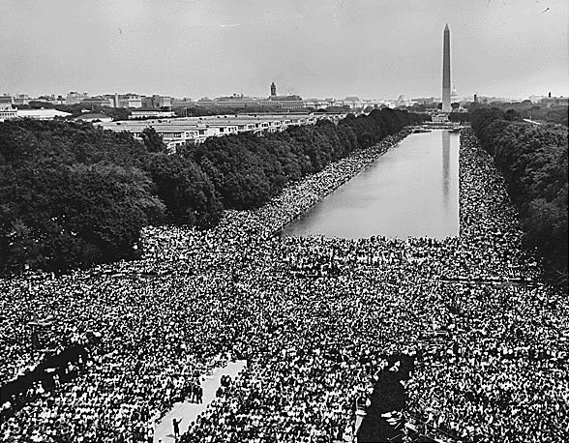
The March on Washington for Jobs and Freedom, August 28, 1963.
Source: U.S. National Archives. Public domain.
TENNESSEE CONNECTION · NASHVILLE, HIGHLANDER & MEMPHIS
Tennessee was at the heart of the civil rights movement. The Highlander Folk School in Monteagle trained leaders including Rosa Parks and Dr. Martin Luther King Jr. (US.79). In 1960, Fisk University students — among them Diane Nash and John Lewis — led the disciplined Nashville sit-ins that desegregated the city’s lunch counters (US.80). And in 1968, Dr. King came to Memphis to support striking sanitation workers, where he was assassinated at the Lorraine Motel (US.80).
One common workbook designed for learner variability. Every student works toward the same Tennessee standards; supports vary the means, not the goal or the ceiling.
Release-Ready · Pilot Edition
© 2026 TroopToTeacher Technologies LLC. All rights reserved. ISBN: [to be assigned]

Copyright, Ownership & Framework
U.S. History Hack™ — Unit 9: The Civil Rights Movement (1954–1975), Course Standard Edition.
© 2026 TroopToTeacher Technologies LLC. All rights reserved. This workbook is proprietary; reproduction or redistribution outside a licensed classroom is prohibited.
Source integrity. Every primary source in this unit is public-domain and cited to its holding repository (National Archives, Library of Congress, HathiTrust). See the Source Library.
Reading provenance (district-clear). Close-Read passages are labeled “History Hack-authored instructional synthesis” — they build on the standard record and are not presented as primary sources.
Framework stack. This workbook anchors to Tennessee U.S. History standards US.78–US.82 and the Social Studies Practices (SSP.01–SSP.06), and is designed on CAST UDL 3.0 and an MTSS support model.
Pacing. Each standard is built for one 45-minute class period. Each activity shows a ⏱ ~ minutes estimate at its heading. There is more here than one period holds — your teacher chooses which activities you do in class; the rest may become warm-ups, stations, or homework.

Table of Contents
Copyright, Ownership & Framework 2
Table of Contents 3
Tennessee Standards & SSP Crosswalk 5
Social Studies Practices (SSP.01–SSP.06) 5
Accessibility, UDL & Accommodations Matrix 6
How CAST UDL 3.0 is visible in this workbook 6
My Support Plan (optional — you choose) 6
How to Use This Workbook 7
Label legend — these appear throughout every standard cycle 7
Before You Begin — Set Your Goal 7
Standard US.78 — Brown v. Board of Education 8
Activity 1 — Vocabulary (Part A: Reference / Word Bank) — US.78 ⏱ ~10 min 9
Activity 2 — Vocabulary Studio (Frayer-inspired) — US.78 ⏱ ~7 min 10
Activity 3 — Direct Teaching Cornell Notes — US.78 ⏱ ~20 min 11
Cornell Notes — keep going, then process & check — US.78 12
Activity 4 — Close Read — US.78 ⏱ ~15 min 13
Activity 5 — Primary Source / Data Analysis — US.78 ⏱ ~15 min 14
Activity 6 — Core Application: Practice Quiz — US.78 ⏱ ~8 min 15
Activity 7 — Constructed Response (CER) — US.78 ⏱ ~15 min 16
Standard US.79 — Civil Rights Advocates and Opponents 17
Activity 1 — Vocabulary (Part A: Reference / Word Bank) — US.79 ⏱ ~10 min 18
Activity 2 — Vocabulary Studio (Frayer-inspired) — US.79 ⏱ ~7 min 19
Activity 3 — Direct Teaching Cornell Notes — US.79 ⏱ ~20 min 20
Cornell Notes — keep going, then process & check — US.79 21
Activity 4 — Close Read — US.79 ⏱ ~15 min 22
Activity 5 — Primary Source / Data Analysis — US.79 ⏱ ~15 min 23
Activity 6 — Core Application: Practice Quiz — US.79 ⏱ ~8 min 24
Activity 7 — Constructed Response (CER) — US.79 ⏱ ~15 min 25
Standard US.80 — Significant Civil Rights Events 26
Activity 1 — Vocabulary (Part A: Reference / Word Bank) — US.80 ⏱ ~10 min 27
Activity 2 — Vocabulary Studio (Frayer-inspired) — US.80 ⏱ ~7 min 28
Activity 3 — Direct Teaching Cornell Notes — US.80 ⏱ ~20 min 29
Cornell Notes — keep going, then process & check — US.80 30
Activity 4 — Close Read — US.80 ⏱ ~15 min 31
Geographer’s Lens — US.80 ⏱ ~12 min 32
Activity 5 — Primary Source / Data Analysis — US.80 ⏱ ~15 min 33
Activity 6 — Core Application: Practice Quiz — US.80 ⏱ ~8 min 34
Activity 7 — Constructed Response (CER) — US.80 ⏱ ~15 min 35
Standard US.81 — Civil and Voting Rights Legislation 36
Activity 1 — Vocabulary (Part A: Reference / Word Bank) — US.81 ⏱ ~10 min 37
Activity 2 — Vocabulary Studio (Frayer-inspired) — US.81 ⏱ ~7 min 38
Activity 3 — Direct Teaching Cornell Notes — US.81 ⏱ ~20 min 39
Cornell Notes — keep going, then process & check — US.81 40
Activity 4 — Close Read — US.81 ⏱ ~15 min 41
Activity 5 — Primary Source / Data Analysis — US.81 ⏱ ~15 min 42
Activity 6 — Core Application: Practice Quiz — US.81 ⏱ ~8 min 43
Activity 7 — Constructed Response (CER) — US.81 ⏱ ~15 min 44
Standard US.82 — American Indian, Chicano & Feminist Movements 45
Activity 1 — Vocabulary (Part A: Reference / Word Bank) — US.82 ⏱ ~10 min 46
Activity 2 — Vocabulary Studio (Frayer-inspired) — US.82 ⏱ ~7 min 47
Activity 3 — Direct Teaching Cornell Notes — US.82 ⏱ ~20 min 48
Cornell Notes — keep going, then process & check — US.82 49
Activity 4 — Close Read — US.82 ⏱ ~15 min 50
Activity 5 — Primary Source / Data Analysis — US.82 ⏱ ~15 min 51
Activity 6 — Core Application: Practice Quiz — US.82 ⏱ ~8 min 52
Activity 7 — Constructed Response (CER) — US.82 ⏱ ~15 min 53
Your Tennessee Connection 53
Local History Investigation 54
Progress Tracker & Cumulative Review 54
Optional Extension Bank (higher-DOK, open to all) 55
Think Like a Test-Writer (unit review — open to all) 55
Reusable Toolkit & Source Library 56
Written Response Rubric (CER) 56
Source Library — full citations & clickable links 56
Making Equality Real — Many Movements, Many Methods 57
Winning in the Courts 57
Winning in the Streets 57
Winning in the Law 57
A Wider Struggle 57
Unit Reflection 57

Tennessee Standards & SSP Crosswalk
Each standard below is taught to the full Course Standard expectation; the Social Studies Practices are embedded in every activity cycle.
Standard | Focus | Lenses
US.78 | Brown v. Board of Education | Culture · History · Tennessee Connection
US.79 | Civil Rights Advocates and Opponents | Culture · History · Tennessee Connection
US.80 | Significant Civil Rights Events | Culture · History · Politics/Government · Tennessee Connection
US.81 | Civil and Voting Rights Legislation | Culture · Politics/Government · History · Tennessee Connection
US.82 | American Indian, Chicano & Feminist Movements | Culture · History

Social Studies Practices (SSP.01–SSP.06)
SSP.01 Gather/evaluate sources · SSP.02 Critically examine a primary source · SSP.03 Synthesize evidence · SSP.04 Construct/communicate argument · SSP.05 Develop historical awareness · SSP.06 Chronological/spatial reasoning. Each Close Read, Primary Source/Data, and CER activity names the practices it builds.

Accessibility, UDL & Accommodations Matrix
One firm learning goal per standard; flexible, universal means. Supports are available by design and never lower the goal. They work alongside — never in place of — required IEP or 504 accommodations.
Universal support | What it is | Where it appears
CORE PATH | Essential instruction every student completes | Every activity
LANGUAGE SUPPORT | Vocabulary, pronunciation, Spanish cognates | Word Bank, Guided/Light Backs
RESPONSE CHOICE | Write, say/record, or diagram | Every activity
SUPPORT OPTION | Optional scaffold that keeps the goal | Guided Support Back, Primary Source
PROGRESS CHECK | Quick DOK-2/3 check to guide reteach/extend | Cornell Notes, Practice Quiz
EXTENSION | Deeper challenge once the goal is met | Extension Bank, CER

How CAST UDL 3.0 is visible in this workbook
Multiple means of Engagement (response choice, relevance via Tennessee Connection), Representation (Word Bank, pronunciation, Spanish, Close-Read supports), and Action & Expression (write/say/diagram, Frayer, CER). No fixed-track labels appear.

My Support Plan (optional — you choose)
Supports are available by design. Check the ones you might try; you can change your mind any time.
Support I might use | When it would help me
Word Bank + Spanish column
Guided or Light Support Back
Response choice (say/record or diagram)
Sentence frames / Rehearsal Lab

How to Use This Workbook
Each standard runs the same seven-activity cycle: (1) Vocabulary Word Bank, (2) Vocabulary Studio, (3) Direct-Teaching Cornell Notes with optional Guided and Light Support Backs, (4) Close Read, (5) Primary Source / Data Analysis, (6) Core Application Practice Quiz, (7) Constructed Response (CER). Work the CORE PATH; reach for SUPPORT OPTIONS as needed.

Label legend — these appear throughout every standard cycle
Label | Meaning
CORE PATH | The essential instruction every student completes.
SUPPORT OPTION | An optional scaffold that keeps the goal, not lowers it.
LANGUAGE SUPPORT | Vocabulary, pronunciation, and Spanish cognates for access.
RESPONSE CHOICE | Show learning by writing, saying/recording, or diagramming.
PROGRESS CHECK | A quick DOK-2/3 check that guides reteach or extend.
EXTENSION | A deeper challenge once the goal is met.

Before You Begin — Set Your Goal
This unit asks one big question: as the United States industrialized, who benefited and who bore the costs? Set a goal, then note what you already know.
Prompt | Your response
My goal for this unit is…
One thing I already know about this era…
One question I want answered…

Standard US.78 — Brown v. Board of Education
TN Academic Standard US.78: Examine the decision and impact of Brown v. Board of Education on desegregation. (TCA)
LEARNING TARGETS — I can…
• I can examine the decision and impact of Brown v. Board of Education on desegregation.
Lenses for this standard: Culture · History · Tennessee Connection
CORE PATH — the same for every student
Same rigor for everyone: analyze the sources and vocabulary, then show what you learned on the Practice Quiz and the CER.
UDL and MTSS give you flexible ways in — they never lower the bar.
Check yourself against the learning targets on the Cornell Notes page.
★ Tennessee Connection
Tennessee schools underwent desegregation following Brown v. Board of Education, though implementation was slow and contested. Clinton High School in Anderson County was one of the first public high schools in the South to desegregate in 1956. (TCA reference in standard)
SET YOUR GOAL (self-direction)
My goal for this standard — what will I be able to do, and how will I show it?

HOOK — think before you dig in
Brown v. Board of Education: Examine the decision and impact of Brown v. Board of Education on desegregation. (TCA). Who gained, who was left out — and why does it still matter?

ACTIVATE — what do you already know or wonder?
Jot what you already know or want to find out about this standard. You’ll come back to it.

PREVIEW & PREDICT
Which learning target will be hardest, and why? Connect it to the unit’s big question: how did people change the law and the nation, and what did it cost?

Activity 1 — Vocabulary (Part A: Reference / Word Bank) — US.78 ⏱ ~10 min
Use this word bank throughout the standard. The Spanish column supports access, not translation of assessment.
Term | Student-friendly meaning | Spanish
Brown v. Board of Education | The landmark 1954 Supreme Court decision that declared state laws establishing separate public schools for Black and white students unconstitutional, overturning Plessy v. Ferguson and ending legal school… | Brown contra el Consejo de Educación
Clinton 12 | The 12 African American students who integrated Clinton High School in Tennessee in 1956, making it the first state-supported high school in the South to integrate following Brown v. Board of Education. | Los 12 de Clinton
Little Rock Nine | The nine African American students who integrated Central High School in Little Rock, Arkansas in 1957, facing violent mobs and requiring federal troops protection ordered by President Eisenhower. | Los Nueve de Little Rock
Thurgood Marshall | Chief counsel for the NAACP Legal Defense Fund who argued Brown v. Board of Education before the Supreme Court and later became the first African American Supreme Court Justice in 1967. | Thurgood Marshall
Orval Faubus | Arkansas Governor who defied the Supreme Court by using the National Guard to prevent the Little Rock Nine from integrating Central High School in 1957. | Orval Faubus
Plessy v. Ferguson | The 1896 Supreme Court case that allowed 'separate but equal' segregation — the precedent overturned by Brown v. Board in 1954. | Plessy contra Ferguson
LANGUAGE SUPPORT
Pronunciations: Brown v. Board of Education (brown VER-sus bord); Clinton 12 (KLIN-tun twelv); Thurgood Marshall (THUR-good MAR-shul); Orval Faubus (OR-vul FAW-bus); Plessy v. Ferguson (PLES-ee VER-sus).

VOCABULARY SELF-CHECK · Knowledge Rating
Rate each term NOW in pencil, then again at the END — growth is the goal; no penalty for “never seen it.”
Term | 1 · never seen it | 2 · heard it | 3 · can use it | 4 · can teach it
Brown v. Board of Education
Clinton 12
Little Rock Nine
Thurgood Marshall
Orval Faubus
Plessy v. Ferguson

Activity 2 — Vocabulary Studio (Frayer-inspired) — US.78 ⏱ ~7 min
RESPONSE CHOICE
Complete each studio by writing, speaking, or diagramming.

PRIORITY TERM 1 Brown v. Board of Education · ES: Brown contra el Consejo de Educación
Word-bank meaning to build on: The landmark 1954 Supreme Court decision that declared state laws establishing separate public schools for Black and white students unconstitutional, overturning Plessy v. Ferguson and ending legal school…
Definition (in your own words) | Characteristics
Examples | Non-examples
Use it to explain
Write one sentence that uses “Brown v. Board of Education” to explain this standard.

PRIORITY TERM 2 Clinton 12 · ES: Los 12 de Clinton
Word-bank meaning to build on: The 12 African American students who integrated Clinton High School in Tennessee in 1956, making it the first state-supported high school in the South to integrate following Brown v. Board of Education.
Definition (in your own words) | Characteristics
Examples | Non-examples
Use it to explain
Write one sentence that uses “Clinton 12” to explain this standard.

CONNECT THE TERMS (UDL · build understanding)
How do these priority terms fit together? Write or sketch how one leads to or affects another.

Activity 3 — Direct Teaching Cornell Notes — US.78 ⏱ ~20 min
Name: ______________________ Class / Period: __________ Date: __________
US.78 — Brown v. Board of Education • These notes capture the direct-teaching content and the Close Read for this standard.
Your learning targets are on this standard’s opening page — take notes that help you meet them.
Cues (tied to your learning targets) | My notes
What does the passage say about historical Context Leading to Brown v. Board?
What does the passage say about key Details of the Court Case and Decision?
What does the passage say about impact on Desegregation?
Key terms →
DOODLE ZONE — draw your thinking (UDL · another way in)
Need another way in? Sketch the key idea, a quick timeline, or how the pieces connect. Words optional.

Cornell Notes — keep going, then process & check — US.78
MORE NOTES / DIAGRAMS
Continue your notes here, add a quick sketch, or map how the ideas connect.

Key terms to list
Brown v. Board of Education · Clinton 12 · Little Rock Nine · Thurgood Marshall · Orval Faubus · Plessy v. Ferguson
Summary — In your own words (2–3 sentences)
PROGRESS CHECK · one question
Why was school desegregation so difficult to implement despite the Supreme Court's ruling?
A. Brown II's "all deliberate speed" language allowed gradual implementation while Southern states launched "massive resistance" campaigns
B. The ruling only applied to a few specific school districts, but the historical record tells a more complex story
C. Federal troops refused to enforce the decision, but this fails to account for the broader historical context
D. Most Black families preferred segregated schools, but contemporary accounts suggest a different explanation
Commit before you move on — mark it, say it, or explain it aloud.
CHECK YOURSELF — how am I doing?
Which learning targets (on this standard’s opening page) can you now meet? Tick the number; circle any you still need help with.
☐ 1
My 12–15 word headline for this standard

Activity 4 — Close Read — US.78 ⏱ ~15 min
Reading type: History Hack-authored instructional synthesis. This is not a primary source. Builds SSP.03 (synthesize) and SSP.05 (historical awareness).
CORE PATH — read one chunk at a time
Historical Context Leading to Brown v. Board
The case emerged from decades of "separate but equal" doctrine established in Plessy v. Ferguson (1896). By the 1950s, the NAACP's legal strategy, led by Thurgood Marshall, systematically challenged segregated education. Previous cases like Sweatt v. Painter (1950) had already weakened the separate but equal principle in higher education. Social science research, including Kenneth Clark's doll tests, demonstrated segregation's psychological harm to Black children.
Key Details of the Court Case and Decision
The Supreme Court consolidated five cases challenging school segregation. Chief Justice Earl Warren wrote the unanimous decision stating that "separate educational facilities are inherently unequal" and violated the 14th Amendment's Equal Protection Clause. The Court rejected the separate but equal doctrine for public education, declaring that segregation generated feelings of inferiority that damaged Black children's educational opportunities.
Impact on Desegregation
The decision legally ended school segregation but implementation proved difficult. Brown II (1955) ordered desegregation "with all deliberate speed," allowing gradual implementation. Many Southern states resisted through "massive resistance" campaigns, creating private academies and closing public schools. Progress was slow—by 1964, only 2% of Black Southern students attended integrated schools. However, the decision provided legal foundation for the broader civil rights movement.
Key terms first: Brown v. Board of Education, Clinton 12. Read once for the gist, then again for evidence.
CLOSE-READ EVIDENCE LAB — for each question: quote the EVIDENCE from the passage above, then write YOUR ANSWER (or answer aloud / diagram it).
Text-dependent question | Evidence from the passage | Your answer (what it shows)
What is the main idea of the “Historical Context Leading to Brown v. Board” section, and what evidence supports it?
What is the main idea of the “Key Details of the Court Case and Decision” section, and what evidence supports it?
What is the main idea of the “Impact on Desegregation” section, and what evidence supports it?

Activity 5 — Primary Source / Data Analysis — US.78 ⏱ ~15 min
Primary source (photograph) — analyze it with HIPPO. Builds SSP.01–SSP.02.
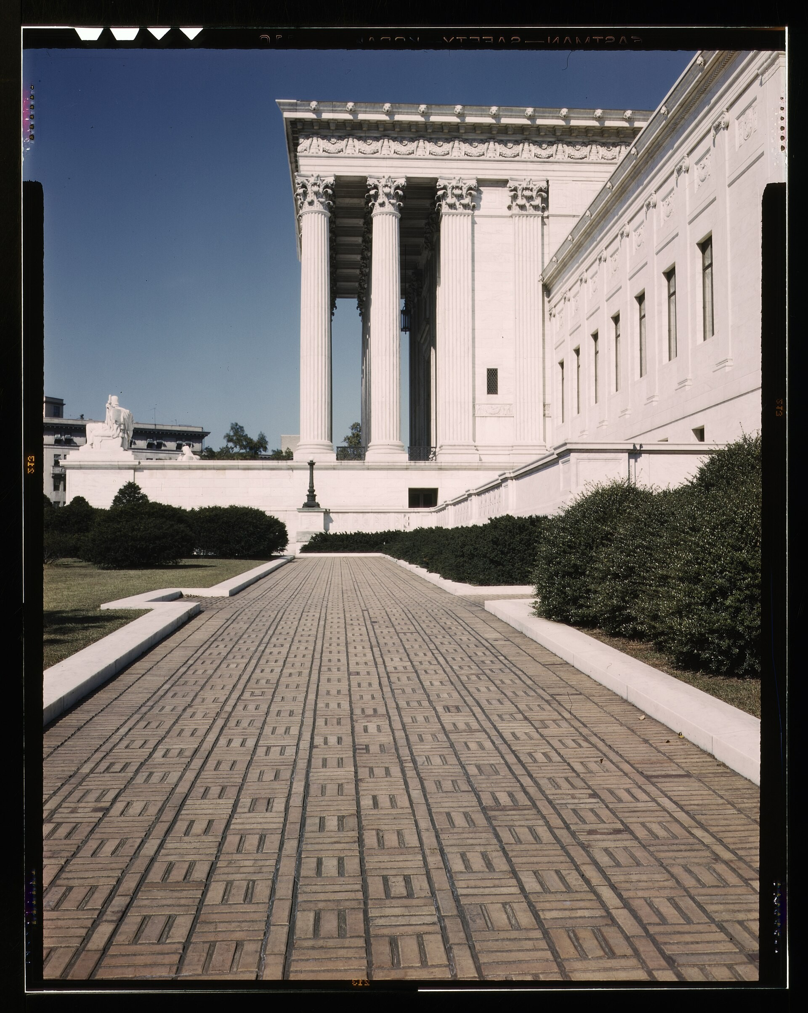
U.S. Supreme Court Building, Washington, D.C. (c. 1939) · Farm Security Administration / U.S. Federal Government · 1939
Source: Farm Security Administration. "U.S. Supreme Court Building, Washington, D.C." 1939. Library of Congress, Prints & Photographs Division (LCCN 2017878871), via Wikimedia Commons, commons.wikimedia.org/wiki/File:U.S._Supreme_Court_building,_Washington,_D.C._LCCN2017878871.jpg. Public Domain https://commons.wikimedia.org/wiki/File:U.S._Supreme_Court_building,_Washington,_D.C._LCCN2017878871.jpg
HIPPO — analyze the source (prompt) | Your analysis
H — Historical context: what was happening when this was created?
I — Intended audience: who was meant to see or obey it?
P — Purpose: why was it created?
P — Point of view: whose perspective does it reflect?
O — Outside connection: how does it connect to this standard?
SUPPORT OPTION
Sentence frame: This source shows ______ because it ______, which reveals ______.
CONFIDENCE CHECK-IN
Rate your understanding of this standard (1–4): ______ One thing to revisit: ____________________

Activity 6 — Core Application: Practice Quiz — US.78 ⏱ ~8 min
RESPONSE CHOICE
Commit to an answer by marking it, saying it, or explaining it aloud before checking. Answer key is in the Teacher Guide (kept separate).
[DOK 2 · item us78-q2 · pre-field-test]
How did the Supreme Court's decision in Brown v. Board overturn Plessy v. Ferguson?
A. It ruled that "separate educational facilities are inherently unequal," rejecting the separate but equal doctrine for public education
B. It declared all forms of segregation unconstitutional immediately, yet the available evidence points to a different conclusion
C. It upheld Plessy but made exceptions for public schools, despite the fact that multiple sources contradict this view
D. It delegated the decision to individual states, which ignores key developments that shaped the outcome
[DOK 2 · item us-78-x046 · pre-field-test]
Which statement best describes the long-term significance of Brown v. Board of Education for the civil rights movement?
A. It immediately ended segregation in all public facilities across the South
B. It established a legal and moral foundation that activists used to challenge broader racial discrimination
C. It persuaded most Southern whites to voluntarily accept school integration by 1960
D. It gave the president unlimited power to enforce civil rights laws without congressional approval
[DOK 3 · item u1-us78-dok3-tc · pre-field-test]
Why was school desegregation so difficult to implement despite the Supreme Court's ruling?
A. Brown II's "all deliberate speed" language allowed gradual implementation while Southern states launched "massive resistance" campaigns
B. The ruling only applied to a few specific school districts, but the historical record tells a more complex story
C. Federal troops refused to enforce the decision, but this fails to account for the broader historical context
D. Most Black families preferred segregated schools, but contemporary accounts suggest a different explanation

Activity 7 — Constructed Response (CER) — US.78 ⏱ ~15 min
BIG-QUESTION ORGANIZER — how did Americans fight to make the promise of equality real, and what did it take to change the law and the nation?
Jot quick notes from THIS standard: Who benefited? · Who bore the costs? · Who decided?

CONSTRUCTED RESPONSE (CER) — builds SSP.04 Argumentation
Claim + Evidence + Reasoning: Using this standard, take a position on the central question — examine the decision and impact of Brown v. Board of Education on desegregation? Support your claim with two pieces of evidence from the passage and explain your reasoning.
Part | Write here
Claim
Evidence (two specifics)
Reasoning
SELF-CHECK (CER rubric — see Toolkit)
Is my claim defensible? · TWO specific pieces of evidence? · Does my reasoning explain HOW the evidence proves the claim?
EXIT TICKET — before you leave [item us78-q1 · DOK 2 · pre-field-test]
What legal and social conditions led to the Brown v. Board case challenging "separate but equal" education?
A. A sudden change in public opinion supporting integration, but this oversimplifies the complex factors at work
B. Congressional legislation requiring the Supreme Court to review segregation, but the historical record tells a more complex story
C. The NAACP's systematic legal strategy and social science research showing segregation's harm to Black children
D. Southern states voluntarily requesting federal review of their schools, although historical sources do not support this conclusion
Show what you know (your choice): mark the best answer, say it, or explain it — then rate how sure you are: ☐ Not yet ☐ Getting there ☐ Got it
Answer key and next steps are in the Teacher Guide.

Standard US.79 — Civil Rights Advocates and Opponents
TN Academic Standard US.79: Examine the roles and actions of civil rights advocates and opponents and how they coincided, confronted, and challenged each other. (TCA)
LEARNING TARGETS — I can…
• I can examine the roles and actions of civil rights advocates (e.g., Malcolm X, Thurgood Marshall, Rosa Parks) and opponents (e.g., Bull Connor, Orval Faubus, Strom Thurmond) and how they coincided, confronted, and challenged each other.
Lenses for this standard: Culture · History · Tennessee Connection
CORE PATH — the same for every student
Same rigor for everyone: analyze the sources and vocabulary, then show what you learned on the Practice Quiz and the CER.
UDL and MTSS give you flexible ways in — they never lower the bar.
Check yourself against the learning targets on the Cornell Notes page.
★ Tennessee Connection
Highlander Folk School in Monteagle, Tennessee, trained civil rights leaders including Rosa Parks and Martin Luther King Jr. The school was a crucial training ground for nonviolent resistance strategies.
SET YOUR GOAL (self-direction)
My goal for this standard — what will I be able to do, and how will I show it?

HOOK — think before you dig in
Civil Rights Advocates and Opponents: Examine the roles and actions of civil rights advocates and opponents and how they coincided, confronted, and challenged each other. (TCA). Who gained, who was left out — and why does it still matter?

ACTIVATE — what do you already know or wonder?
Jot what you already know or want to find out about this standard. You’ll come back to it.

PREVIEW & PREDICT
Which learning target will be hardest, and why? Connect it to the unit’s big question: how did people change the law and the nation, and what did it cost?

Activity 1 — Vocabulary (Part A: Reference / Word Bank) — US.79 ⏱ ~10 min
Use this word bank throughout the standard. The Spanish column supports access, not translation of assessment.
Term | Student-friendly meaning | Spanish
Rosa Parks | The "Mother of the Civil Rights Movement" who refused to give up her bus seat to a white passenger in Montgomery, Alabama in 1955, sparking the Montgomery Bus Boycott. | Rosa Parks
Dr. Martin Luther King Jr. | Baptist minister and the most prominent leader of the Civil Rights Movement, advocating nonviolent resistance and delivering the iconic "I Have a Dream" speech at the 1963 March on Washington. | Dr. Martin Luther King Jr.
Malcolm X | Influential civil rights leader and Nation of Islam minister who advocated for Black nationalism, self-defense, and economic independence before his assassination in 1965. | Malcolm X
Bull Connor | Birmingham, Alabama's Commissioner of Public Safety who violently opposed civil rights protesters in 1963, using police dogs and fire hoses against peaceful demonstrators, including children. | Bull Connor
Strom Thurmond | South Carolina Senator who opposed civil rights legislation and conducted the longest individual filibuster in Senate history (24 hours, 18 minutes) against the Civil Rights Act of 1957. | Strom Thurmond
Nonviolent Resistance | The strategy of peaceful protest — boycotts, sit-ins, marches — used by Dr. King and others to confront segregation. | Resistencia No Violenta
LANGUAGE SUPPORT
Pronunciations: Rosa Parks (ROH-zuh parks); Dr. Martin Luther King Jr. (LOO-ther king); Malcolm X (MAL-kum eks); Bull Connor (bul KON-er); Strom Thurmond (strom THUR-mund); Nonviolent Resistance (non-VY-oh-lent).

VOCABULARY SELF-CHECK · Knowledge Rating
Rate each term NOW in pencil, then again at the END — growth is the goal; no penalty for “never seen it.”
Term | 1 · never seen it | 2 · heard it | 3 · can use it | 4 · can teach it
Rosa Parks
Dr. Martin Luther King Jr.
Malcolm X
Bull Connor
Strom Thurmond
Nonviolent Resistance

Activity 2 — Vocabulary Studio (Frayer-inspired) — US.79 ⏱ ~7 min
RESPONSE CHOICE
Complete each studio by writing, speaking, or diagramming.

PRIORITY TERM 1 Rosa Parks · ES: Rosa Parks
Word-bank meaning to build on: The "Mother of the Civil Rights Movement" who refused to give up her bus seat to a white passenger in Montgomery, Alabama in 1955, sparking the Montgomery Bus Boycott.
Definition (in your own words) | Characteristics
Examples | Non-examples
Use it to explain
Write one sentence that uses “Rosa Parks” to explain this standard.

PRIORITY TERM 2 Dr. Martin Luther King Jr. · ES: Dr. Martin Luther King Jr.
Word-bank meaning to build on: Baptist minister and the most prominent leader of the Civil Rights Movement, advocating nonviolent resistance and delivering the iconic "I Have a Dream" speech at the 1963 March on Washington.
Definition (in your own words) | Characteristics
Examples | Non-examples
Use it to explain
Write one sentence that uses “Dr. Martin Luther King Jr.” to explain this standard.

CONNECT THE TERMS (UDL · build understanding)
How do these priority terms fit together? Write or sketch how one leads to or affects another.

Activity 3 — Direct Teaching Cornell Notes — US.79 ⏱ ~20 min
Name: ______________________ Class / Period: __________ Date: __________
US.79 — Civil Rights Advocates and Opponents • These notes capture the direct-teaching content and the Close Read for this standard.
Your learning targets are on this standard’s opening page — take notes that help you meet them.
Cues (tied to your learning targets) | My notes
What does the passage say about civil Rights Advocates?
What does the passage say about civil Rights Opponents?
What does the passage say about comparing Approaches?
Key terms →
DOODLE ZONE — draw your thinking (UDL · another way in)
Need another way in? Sketch the key idea, a quick timeline, or how the pieces connect. Words optional.

Cornell Notes — keep going, then process & check — US.79
MORE NOTES / DIAGRAMS
Continue your notes here, add a quick sketch, or map how the ideas connect.

Key terms to list
Rosa Parks · Dr. Martin Luther King Jr. · Malcolm X · Bull Connor · Strom Thurmond · Nonviolent Resistance
Summary — In your own words (2–3 sentences)
PROGRESS CHECK · one question
Compare the philosophies of Martin Luther King Jr. and Malcolm X regarding integration and Black identity.
A. Both leaders held identical views throughout their careers, which ignores key developments that shaped the outcome and oversimplifies the complex factors at work during this period
B. King emphasized integration through Christian love and nonviolence while Malcolm X initially promoted Black nationalism and self-defense, though both evolved over time
C. Malcolm X always supported King's nonviolent approach, despite limited evidence supporting this interpretation, but contemporary accounts and primary sources suggest otherwise
D. King opposed integration while Malcolm X supported it, though this interpretation lacks supporting historical evidence, and this view has been largely revised by modern historical research
Commit before you move on — mark it, say it, or explain it aloud.
CHECK YOURSELF — how am I doing?
Which learning targets (on this standard’s opening page) can you now meet? Tick the number; circle any you still need help with.
☐ 1
My 12–15 word headline for this standard

Activity 4 — Close Read — US.79 ⏱ ~15 min
Reading type: History Hack-authored instructional synthesis. This is not a primary source. Builds SSP.03 (synthesize) and SSP.05 (historical awareness).
CORE PATH — read one chunk at a time
Civil Rights Advocates
Martin Luther King Jr. led nonviolent resistance, organized the Montgomery Bus Boycott, founded the Southern Christian Leadership Conference (SCLC), and delivered the "I Have a Dream" speech. Malcolm X initially promoted Black nationalism through the Nation of Islam, later evolving toward human rights after his pilgrimage to Mecca. Thurgood Marshall served as NAACP chief legal counsel, argued Brown v. Board, and became the first Black Supreme Court Justice. Rosa Parks sparked the Montgomery Bus Boycott and became a symbol of quiet dignity and resistance.
Civil Rights Opponents
Bull Connor, Birmingham Police Commissioner, used fire hoses and police dogs against peaceful protesters—his violent tactics backfired by generating sympathy for civil rights. Orval Faubus, Arkansas Governor, defied federal court orders using the National Guard to prevent the Little Rock Nine from entering Central High School, forcing President Eisenhower to intervene. Strom Thurmond, South Carolina Senator, led the "Dixiecrat" revolt in 1948 and conducted the longest individual Senate filibuster (24+ hours) against the 1957 Civil Rights Act.
Comparing Approaches
King emphasized integration and nonviolence while Malcolm X initially promoted separation and self-defense. Both evolved—King became more critical of economic inequality while Malcolm X moved toward a broader human rights perspective. Marshall used the courts while King used mass protests; both strategies complemented each other. Legal victories provided the framework while protests generated political pressure for change.
Key terms first: Rosa Parks, Dr. Martin Luther King Jr.. Read once for the gist, then again for evidence.
CLOSE-READ EVIDENCE LAB — for each question: quote the EVIDENCE from the passage above, then write YOUR ANSWER (or answer aloud / diagram it).
Text-dependent question | Evidence from the passage | Your answer (what it shows)
What is the main idea of the “Civil Rights Advocates” section, and what evidence supports it?
What is the main idea of the “Civil Rights Opponents” section, and what evidence supports it?
What is the main idea of the “Comparing Approaches” section, and what evidence supports it?

Activity 5 — Primary Source / Data Analysis — US.79 ⏱ ~15 min
Primary source (photograph) — analyze it with HIPPO. Builds SSP.01–SSP.02.
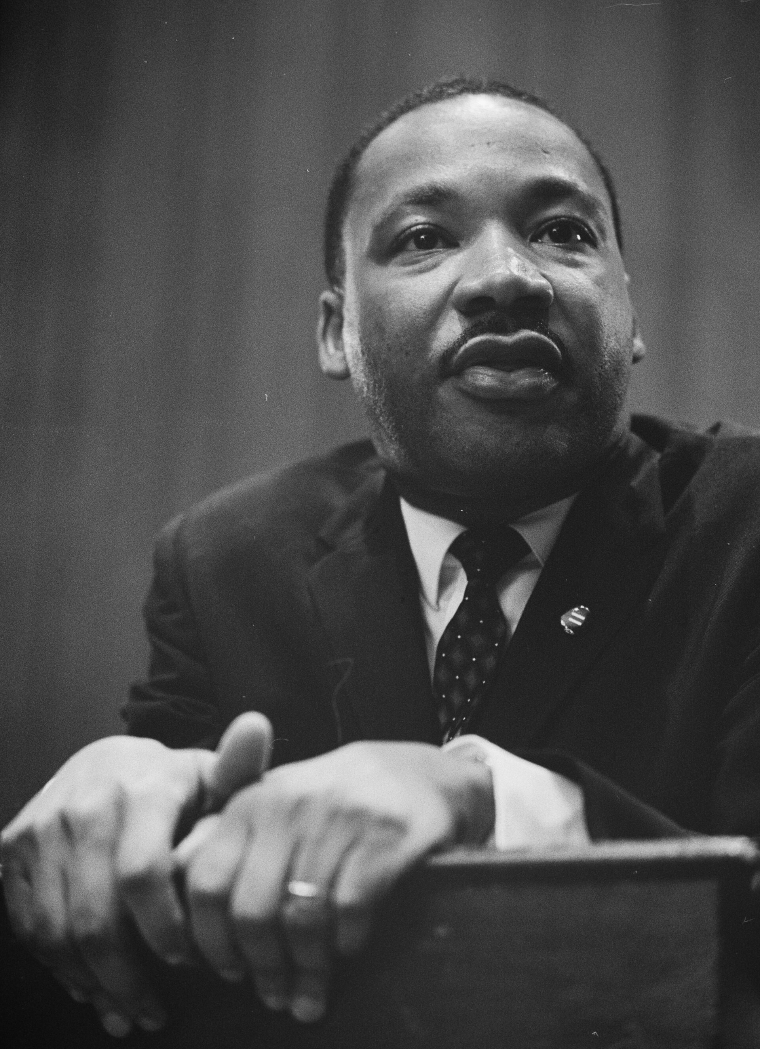
Martin Luther King Jr. at Press Conference Lectern (March 26, 1964) · Marion S. Trikosko, U.S. News & World Report Magazine · March 26, 1964
Source: Trikosko, Marion S. "Martin Luther King Jr. at Press Conference Lectern." 26 Mar. 1964. Library of Congress, Prints & Photographs Division, U.S. News & World Report Magazine Collection (LC-DIG-ppmsc-01269), via Wikimedia Commons, commons.wikimedia.org/wiki/File:Martin-Luther-King-1964-leaning-on-a-lectern.jpg. Public Domain https://commons.wikimedia.org/wiki/File:Martin-Luther-King-1964-leaning-on-a-lectern.jpg
HIPPO — analyze the source (prompt) | Your analysis
H — Historical context: what was happening when this was created?
I — Intended audience: who was meant to see or obey it?
P — Purpose: why was it created?
P — Point of view: whose perspective does it reflect?
O — Outside connection: how does it connect to this standard?
SUPPORT OPTION
Sentence frame: This source shows ______ because it ______, which reveals ______.
CONFIDENCE CHECK-IN
Rate your understanding of this standard (1–4): ______ One thing to revisit: ____________________

Activity 6 — Core Application: Practice Quiz — US.79 ⏱ ~8 min
RESPONSE CHOICE
Commit to an answer by marking it, saying it, or explaining it aloud before checking. Answer key is in the Teacher Guide (kept separate).
[DOK 2 · item us79-q2 · pre-field-test]
What tactics did opponents like Bull Connor, Orval Faubus, and Strom Thurmond use to resist civil rights progress?
A. Connor used police violence, Faubus defied federal courts with the National Guard, and Thurmond used Senate filibusters
B. They primarily used peaceful political lobbying, but contemporary accounts suggest a different explanation
C. They focused exclusively on legal challenges in court, although historical sources do not support this conclusion
D. They avoided public confrontation entirely, but the historical record tells a more complex story
[DOK 2 · item q-us79-add-1 · pre-field-test]
How did Malcolm X's approach to civil rights differ from Martin Luther King Jr.'s?
A. Both leaders agreed on every major strategy; their differences were only stylistic
B. Malcolm X advocated self-defense and Black nationalism while King promoted nonviolence
C. Malcolm X focused on rural sharecroppers while King focused on urban workers
D. Malcolm X supported the Civil Rights Act of 1964 while King opposed it
[DOK 3 · item u1-us79-dok3-tc · pre-field-test]
Compare the philosophies of Martin Luther King Jr. and Malcolm X regarding integration and Black identity.
A. Both leaders held identical views throughout their careers, which ignores key developments that shaped the outcome and oversimplifies the complex factors at work during this period
B. King emphasized integration through Christian love and nonviolence while Malcolm X initially promoted Black nationalism and self-defense, though both evolved over time
C. Malcolm X always supported King's nonviolent approach, despite limited evidence supporting this interpretation, but contemporary accounts and primary sources suggest otherwise
D. King opposed integration while Malcolm X supported it, though this interpretation lacks supporting historical evidence, and this view has been largely revised by modern historical research

Activity 7 — Constructed Response (CER) — US.79 ⏱ ~15 min
BIG-QUESTION ORGANIZER — how did Americans fight to make the promise of equality real, and what did it take to change the law and the nation?
Jot quick notes from THIS standard: Who benefited? · Who bore the costs? · Who decided?

CONSTRUCTED RESPONSE (CER) — builds SSP.04 Argumentation
Claim + Evidence + Reasoning: Using this standard, take a position on the central question — examine the roles and actions of civil rights advocates (e.g., Malcolm X, Thurgood Marshall, Rosa Parks) and opponents (e.g., Bull Connor, Orval Faubus, Strom Thurmond) and how they coincided, confronted, and challenged each other? Support your claim with two pieces of evidence from the passage and explain your reasoning.
Part | Write here
Claim
Evidence (two specifics)
Reasoning
SELF-CHECK (CER rubric — see Toolkit)
Is my claim defensible? · TWO specific pieces of evidence? · Does my reasoning explain HOW the evidence proves the claim?
EXIT TICKET — before you leave [item us79-q1 · DOK 2 · pre-field-test]
How did civil rights leaders like King, Malcolm X, Marshall, and Parks use different strategies to advance equality?
A. They all used identical nonviolent protest methods, despite the fact that multiple sources contradict this view, which does not align with the documented historical record
B. They worked exclusively through congressional lobbying, but this oversimplifies the complex factors at work, though this interpretation lacks supporting historical evidence
C. Each leader focused only on their local community, which does not align with the documented historical record and oversimplifies the complex factors at work during this period
D. King used nonviolent protest, Malcolm X promoted Black nationalism, Marshall used legal challenges, and Parks became a symbol through individual resistance
Show what you know (your choice): mark the best answer, say it, or explain it — then rate how sure you are: ☐ Not yet ☐ Getting there ☐ Got it
Answer key and next steps are in the Teacher Guide.

Standard US.80 — Significant Civil Rights Events
TN Academic Standard US.80: Describe the significant events in the struggle to secure civil rights for African Americans, including: Montgomery Bus Boycott, Integration of Clinton High School and Central High School, Freedom Riders, Highlander Folk School, Tent City in Fayette County, TN, marches/demonstrations/boycotts/sit-ins, March on Washington D.C., Birmingham bombings of 1963, and assassination of Martin Luther King Jr. (TCA)
LEARNING TARGETS — I can…
• I can describe the significant events in the struggle to secure civil rights for African Americans, including the Montgomery Bus Boycott, Freedom Riders, March on Washington, Birmingham bombings, and assassination of Martin Luther King Jr.
Lenses for this standard: Culture · History · Politics/Government · Tennessee Connection
CORE PATH — the same for every student
Same rigor for everyone: analyze the sources and vocabulary, then show what you learned on the Practice Quiz and the CER.
UDL and MTSS give you flexible ways in — they never lower the bar.
Check yourself against the learning targets on the Cornell Notes page.
★ Tennessee Connection
The Nashville sit-ins of 1960, led by students including Diane Nash and John Lewis from Fisk University, were among the most organized and successful of the civil rights movement. They desegregated Nashville's lunch counters and became a model for the movement.
SET YOUR GOAL (self-direction)
My goal for this standard — what will I be able to do, and how will I show it?

HOOK — think before you dig in
Significant Civil Rights Events: Describe the significant events in the struggle to secure civil rights for African Americans, including: Montgomery Bus Boycott, Integration of Clinton High School and Central High School, Freedom Riders, Highlander Folk School, Tent City in Fayette County, TN, marches/demonstrations/boycotts/sit-ins, March on Washington D.C., Birmingham bombings of 1963, and assassination of Martin Luther King Jr. (TCA). Who gained, who was left out — and why does it still matter?

ACTIVATE — what do you already know or wonder?
Jot what you already know or want to find out about this standard. You’ll come back to it.

PREVIEW & PREDICT
Which learning target will be hardest, and why? Connect it to the unit’s big question: how did people change the law and the nation, and what did it cost?

Activity 1 — Vocabulary (Part A: Reference / Word Bank) — US.80 ⏱ ~10 min
Use this word bank throughout the standard. The Spanish column supports access, not translation of assessment.
Term | Student-friendly meaning | Spanish
Montgomery Bus Boycott | The 381-day boycott (1955-1956) of the Montgomery, Alabama bus system by African Americans protesting segregated seating, ending when the Supreme Court ruled bus segregation unconstitutional. | Boicot de Autobuses de Montgomery
Freedom Riders | Interracial groups of civil rights activists who rode interstate buses into the segregated South in 1961 to challenge illegal segregation of public transportation, facing violent attacks. | Jinetes de la Libertad
Highlander Folk School | Tennessee education center founded in 1932 that trained civil rights leaders including Rosa Parks, Martin Luther King Jr., and John Lewis in nonviolent resistance and organizing tactics. | Escuela Popular Highlander
Tent City (Fayette County, TN) | A 1960 settlement of African Americans evicted from their homes in Fayette County, Tennessee after registering to vote, living in tents to maintain their right to vote despite economic retaliation. | Ciudad de Tiendas (Condado de Fayette, TN)
Sit-ins (Nashville) | Nonviolent protests where African Americans sat at segregated lunch counters requesting service, beginning in Greensboro (1960) and powerfully demonstrated in Nashville led by students like Diane Nash. | Sentadas (Nashville)
March on Washington | The massive August 28, 1963 demonstration where over 250,000 people gathered at the Lincoln Memorial to demand civil rights, highlighted by Martin Luther King Jr.'s "I Have a Dream" speech. | Marcha en Washington
LANGUAGE SUPPORT
Pronunciations: Montgomery Bus Boycott (munt-GUM-er-ee); Freedom Riders (FREE-dum RY-derz); Highlander Folk School (HY-land-er); Tent City (Fayette County, TN) (fay-ET); Sit-ins (Nashville) (SIT-inz); March on Washington (WOSH-ing-tun).

VOCABULARY SELF-CHECK · Knowledge Rating
Rate each term NOW in pencil, then again at the END — growth is the goal; no penalty for “never seen it.”
Term | 1 · never seen it | 2 · heard it | 3 · can use it | 4 · can teach it
Montgomery Bus Boycott
Freedom Riders
Highlander Folk School
Tent City (Fayette County, TN)
Sit-ins (Nashville)
March on Washington

Activity 2 — Vocabulary Studio (Frayer-inspired) — US.80 ⏱ ~7 min
RESPONSE CHOICE
Complete each studio by writing, speaking, or diagramming.

PRIORITY TERM 1 Montgomery Bus Boycott · ES: Boicot de Autobuses de Montgomery
Word-bank meaning to build on: The 381-day boycott (1955-1956) of the Montgomery, Alabama bus system by African Americans protesting segregated seating, ending when the Supreme Court ruled bus segregation unconstitutional.
Definition (in your own words) | Characteristics
Examples | Non-examples
Use it to explain
Write one sentence that uses “Montgomery Bus Boycott” to explain this standard.

PRIORITY TERM 2 Freedom Riders · ES: Jinetes de la Libertad
Word-bank meaning to build on: Interracial groups of civil rights activists who rode interstate buses into the segregated South in 1961 to challenge illegal segregation of public transportation, facing violent attacks.
Definition (in your own words) | Characteristics
Examples | Non-examples
Use it to explain
Write one sentence that uses “Freedom Riders” to explain this standard.

CONNECT THE TERMS (UDL · build understanding)
How do these priority terms fit together? Write or sketch how one leads to or affects another.

Activity 3 — Direct Teaching Cornell Notes — US.80 ⏱ ~20 min
Name: ______________________ Class / Period: __________ Date: __________
US.80 — Significant Civil Rights Events • These notes capture the direct-teaching content and the Close Read for this standard.
Your learning targets are on this standard’s opening page — take notes that help you meet them.
Cues (tied to your learning targets) | My notes
What does the passage say about early Movement Victories?
What does the passage say about tennessee's Role in the Movement?
What does the passage say about confrontations That Changed America?
Key terms →
DOODLE ZONE — draw your thinking (UDL · another way in)
Need another way in? Sketch the key idea, a quick timeline, or how the pieces connect. Words optional.

Cornell Notes — keep going, then process & check — US.80
MORE NOTES / DIAGRAMS
Continue your notes here, add a quick sketch, or map how the ideas connect.

Key terms to list
Montgomery Bus Boycott · Freedom Riders · Highlander Folk School · Tent City (Fayette County, TN) · Sit-ins (Nashville) · March on Washington
Summary — In your own words (2–3 sentences)
PROGRESS CHECK · one question
How did television coverage of events like Birmingham and Little Rock build national support for civil rights legislation?
A. Television had minimal impact on public opinion, despite limited evidence supporting this interpretation, but closer analysis reveals a more complicated historical reality
B. Television coverage primarily supported segregationists, yet the available evidence points to a different conclusion
C. Images of fire hoses, police dogs, and troops protecting children shocked Americans and generated sympathy for the movement, pressuring Congress to act
D. Most Americans did not have access to television coverage, yet the available evidence points to a different conclusion
Commit before you move on — mark it, say it, or explain it aloud.
CHECK YOURSELF — how am I doing?
Which learning targets (on this standard’s opening page) can you now meet? Tick the number; circle any you still need help with.
☐ 1
My 12–15 word headline for this standard

Activity 4 — Close Read — US.80 ⏱ ~15 min
Reading type: History Hack-authored instructional synthesis. This is not a primary source. Builds SSP.03 (synthesize) and SSP.05 (historical awareness).
CORE PATH — read one chunk at a time
Early Movement Victories
The Montgomery Bus Boycott (1955-1956), sparked by Rosa Parks' arrest, demonstrated Black economic power through 381 days of sustained action. It established nonviolent resistance as the primary strategy and elevated Martin Luther King Jr. to national leadership. The Nashville Sit-ins (1960), led by John Lewis and Diane Nash, used disciplined nonviolent protests to desegregate lunch counters, inspiring similar actions nationwide.
Tennessee's Role in the Movement
Clinton High School (1956) became the first Southern community to integrate its high school following Brown v. Board. Twelve Black students faced violent opposition, requiring National Guard protection. Highlander Folk School trained civil rights leaders including Rosa Parks and King in nonviolent resistance. Tent City in Fayette County (1960) formed when Black sharecroppers evicted for attempting to vote created a community on donated land, demonstrating both retaliation and resilience.
Confrontations That Changed America
The Little Rock Nine (1957) faced Governor Faubus's defiance until President Eisenhower sent federal troops. Freedom Riders (1961) tested desegregation rulings by riding buses through the South, facing firebombings and beatings that forced federal intervention. The Birmingham Campaign (1963) targeted "the most segregated city in America," where Bull Connor's violent response to peaceful protesters shocked the nation.
Culminating Events
The March on Washington (1963) brought 250,000 people to hear King's "I Have a Dream" speech, pressuring Congress for legislation. Martin Luther King Jr.'s assassination in Memphis (1968) while supporting striking sanitation workers triggered nationwide riots and galvanized support for the Fair Housing Act, marking both the movement's peak and transformation.
Key terms first: Montgomery Bus Boycott, Freedom Riders. Read once for the gist, then again for evidence.
CLOSE-READ EVIDENCE LAB — for each question: quote the EVIDENCE from the passage above, then write YOUR ANSWER (or answer aloud / diagram it).
Text-dependent question | Evidence from the passage | Your answer (what it shows)
What is the main idea of the “Early Movement Victories” section, and what evidence supports it?
What is the main idea of the “Tennessee's Role in the Movement” section, and what evidence supports it?
What is the main idea of the “Confrontations That Changed America” section, and what evidence supports it?

Geographer’s Lens — US.80 ⏱ ~12 min
Geographers don’t just find places — they explain how WHERE shapes WHAT happens. Work these like a geographer. Built on the Five Themes of Geography · C3 Dimension 2 · SSP.06 (spatial reasoning).
THE PLACES — then explain why geography put them there
The civil rights movement unfolded city by city across the South. Use the list below to map the key events, then explain why the movement targeted these particular places.
Place | Where | What happened (given) | Why HERE? (your analysis)
Montgomery, Alabama | Deep South | 1955–56 bus boycott sparked by Rosa Parks; MLK emerges
Little Rock, Arkansas | Upper South | 1957 — federal troops escort the 'Little Rock Nine' into Central High
Nashville, Tennessee | Tennessee | 1960 lunch-counter sit-ins led by Diane Nash and John Lewis
Birmingham, Alabama | Deep South | 1963 campaign; the children's march and police violence shock the nation
Selma, Alabama | Deep South | 1965 voting-rights march ('Bloody Sunday') to Montgomery
Memphis, Tennessee | Tennessee | 1968 sanitation strike; Dr. King assassinated at the Lorraine Motel
MOVEMENT & REGION — what’s the spatial pattern?
In 1–2 sentences: is this a movement, a cluster, or a whole region? Name the direction or shape it takes on a map.

GEOGRAPHY AS A FORCE — how did location shape the outcome?
How did geography change WHAT happened — who was affected, how far or fast it spread, or who was left out? Use one place above as your evidence.

READ IT LIKE A SOURCE — RESPONSE CHOICE
A map is a source with a point of view. Show your thinking your way — write it, OR sketch a quick arrows-and-labels diagram: what would a map of this make CLEAR, and what would it HIDE or leave out?

Activity 5 — Primary Source / Data Analysis — US.80 ⏱ ~15 min
Primary source (photograph) — analyze it with HIPPO. Builds SSP.01–SSP.02.
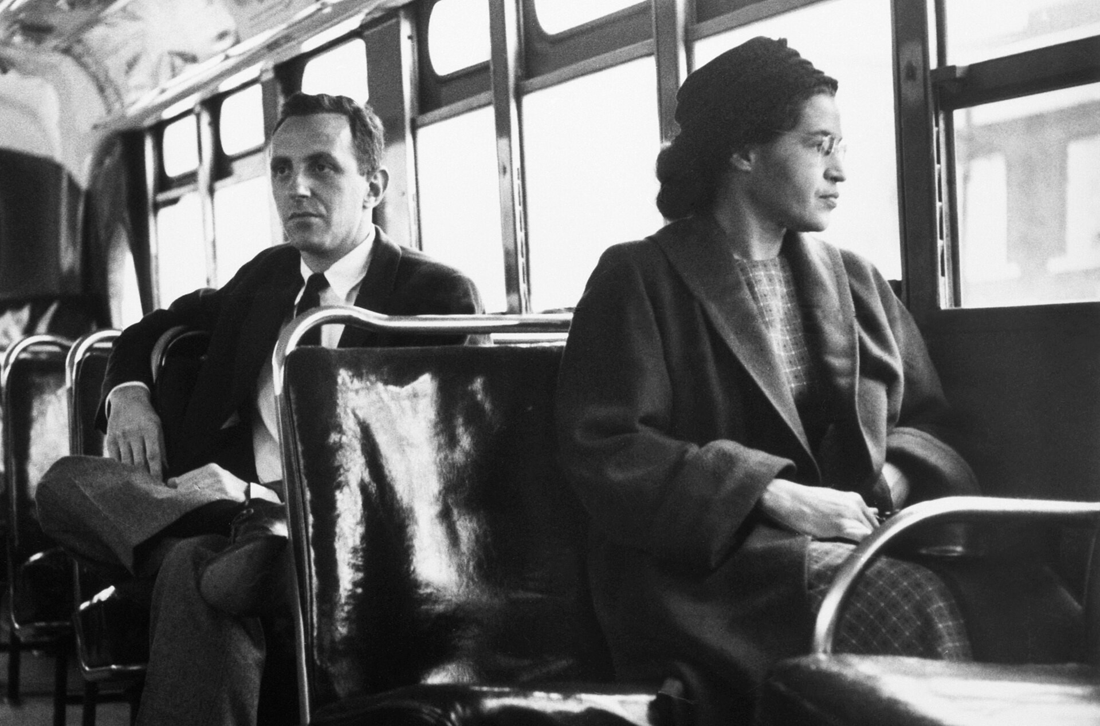
Rosa Parks Seated at Front of Montgomery Bus After Boycott Victory (December 21, 1956) · United Press International (UPI) wire photo · December 21, 1956
Source: United Press International. "Rosa Parks Seated at Front of Montgomery Bus After Boycott Victory." 21 Dec. 1956. Via Wikimedia Commons, commons.wikimedia.org/wiki/File:Rosa_Parks_on_bus_on_December_21,_1956.jpg. Public Domain https://commons.wikimedia.org/wiki/File:Rosa_Parks_on_bus_on_December_21,_1956.jpg
HIPPO — analyze the source (prompt) | Your analysis
H — Historical context: what was happening when this was created?
I — Intended audience: who was meant to see or obey it?
P — Purpose: why was it created?
P — Point of view: whose perspective does it reflect?
O — Outside connection: how does it connect to this standard?
SUPPORT OPTION
Sentence frame: This source shows ______ because it ______, which reveals ______.
CONFIDENCE CHECK-IN
Rate your understanding of this standard (1–4): ______ One thing to revisit: ____________________

Activity 6 — Core Application: Practice Quiz — US.80 ⏱ ~8 min
RESPONSE CHOICE
Commit to an answer by marking it, saying it, or explaining it aloud before checking. Answer key is in the Teacher Guide (kept separate).
[DOK 2 · item us80-q2 · pre-field-test]
What role did Tennessee play in the Civil Rights Movement through events like the Nashville sit-ins and Clinton High School integration?
A. Tennessee provided key sites including the first integrated Southern high school, student-led sit-ins, Highlander training center, and Tent City voter resistance
B. Tennessee was not involved in the Civil Rights Movement, but this oversimplifies the complex factors at work and oversimplifies the complex factors at work during this period
C. Tennessee only participated after the movement ended, but the historical record tells a more complex story, which does not align with the documented historical record
D. Tennessee's role was limited to opposing civil rights, although this overlooks critical economic and social factors, and this view has been largely revised by modern historical research
[DOK 2 · item q-us79-add-1 · pre-field-test]
How did Malcolm X's approach to civil rights differ from Martin Luther King Jr.'s?
A. Both leaders agreed on every major strategy; their differences were only stylistic
B. Malcolm X advocated self-defense and Black nationalism while King promoted nonviolence
C. Malcolm X focused on rural sharecroppers while King focused on urban workers
D. Malcolm X supported the Civil Rights Act of 1964 while King opposed it
[DOK 3 · item u1-us80-dok3-tc · pre-field-test]
How did television coverage of events like Birmingham and Little Rock build national support for civil rights legislation?
A. Television had minimal impact on public opinion, despite limited evidence supporting this interpretation, but closer analysis reveals a more complicated historical reality
B. Television coverage primarily supported segregationists, yet the available evidence points to a different conclusion
C. Images of fire hoses, police dogs, and troops protecting children shocked Americans and generated sympathy for the movement, pressuring Congress to act
D. Most Americans did not have access to television coverage, yet the available evidence points to a different conclusion

Activity 7 — Constructed Response (CER) — US.80 ⏱ ~15 min
BIG-QUESTION ORGANIZER — how did Americans fight to make the promise of equality real, and what did it take to change the law and the nation?
Jot quick notes from THIS standard: Who benefited? · Who bore the costs? · Who decided?

CONSTRUCTED RESPONSE (CER) — builds SSP.04 Argumentation
Claim + Evidence + Reasoning: Using this standard, take a position on the central question — describe the significant events in the struggle to secure civil rights for African Americans, including the Montgomery Bus Boycott, Freedom Riders, March on Washington, Birmingham bombings, and assassination of Martin Luther King Jr? Support your claim with two pieces of evidence from the passage and explain your reasoning.
Part | Write here
Claim
Evidence (two specifics)
Reasoning
SELF-CHECK (CER rubric — see Toolkit)
Is my claim defensible? · TWO specific pieces of evidence? · Does my reasoning explain HOW the evidence proves the claim?
EXIT TICKET — before you leave [item us80-q1 · DOK 2 · pre-field-test]
How did the Montgomery Bus Boycott establish nonviolent resistance as the primary civil rights strategy?
A. The 381-day boycott demonstrated Black economic power and organizational capability, proving sustained nonviolent action could achieve change
B. It was a spontaneous one-day protest, which ignores key developments that shaped the outcome, but the historical evidence paints a more nuanced picture
C. It relied primarily on legal challenges rather than direct action, which contradicts the primary source evidence from this era
D. The boycott failed to achieve its goals, although historical sources do not support this conclusion, which contradicts the primary source evidence from this era
Show what you know (your choice): mark the best answer, say it, or explain it — then rate how sure you are: ☐ Not yet ☐ Getting there ☐ Got it
Answer key and next steps are in the Teacher Guide.

Standard US.81 — Civil and Voting Rights Legislation
TN Academic Standard US.81: Analyze civil and voting rights legislation, including: The Civil Rights Act of 1964, the Voting Rights Act of 1965, the Civil Rights Act of 1968 (e.g., Fair Housing Act), and the 24th Amendment. (TCA)
LEARNING TARGETS — I can…
• I can analyze civil and voting rights legislation, including the Civil Rights Act of 1964, the Voting Rights Act of 1965, the Civil Rights Act of 1968 (Fair Housing Act), and the 24th Amendment.
Lenses for this standard: Culture · Politics/Government · History · Tennessee Connection
CORE PATH — the same for every student
Same rigor for everyone: analyze the sources and vocabulary, then show what you learned on the Practice Quiz and the CER.
UDL and MTSS give you flexible ways in — they never lower the bar.
Check yourself against the learning targets on the Cornell Notes page.
★ Tennessee Connection
Tennessee was a battleground for voting rights, with significant voter registration drives in Memphis and Nashville. The state's compliance with the Voting Rights Act of 1965 transformed political participation for African Americans across Tennessee.
SET YOUR GOAL (self-direction)
My goal for this standard — what will I be able to do, and how will I show it?

HOOK — think before you dig in
Civil and Voting Rights Legislation: Analyze civil and voting rights legislation, including: The Civil Rights Act of 1964, the Voting Rights Act of 1965, the Civil Rights Act of 1968 (e.g., Fair Housing Act), and the 24th Amendment. (TCA). Who gained, who was left out — and why does it still matter?

ACTIVATE — what do you already know or wonder?
Jot what you already know or want to find out about this standard. You’ll come back to it.

PREVIEW & PREDICT
Which learning target will be hardest, and why? Connect it to the unit’s big question: how did people change the law and the nation, and what did it cost?

Activity 1 — Vocabulary (Part A: Reference / Word Bank) — US.81 ⏱ ~10 min
Use this word bank throughout the standard. The Spanish column supports access, not translation of assessment.
Term | Student-friendly meaning | Spanish
Civil Rights Act of 1964 | Landmark federal legislation that outlawed discrimination based on race, color, religion, sex, or national origin, ending segregation in public accommodations and employment. | Ley de Derechos Civiles de 1964
Voting Rights Act of 1965 | Federal legislation that outlawed discriminatory voting practices (literacy tests, poll taxes) used to disenfranchise African Americans, dramatically increasing Black voter registration in the South. | Ley de Derechos de Voto de 1965
Civil Rights Act of 1968 (Fair Housing Act) | Federal law that prohibited discrimination in the sale, rental, and financing of housing based on race, religion, national origin, or sex, addressing residential segregation. | Ley de Derechos Civiles de 1968 (Ley de Vivienda Justa)
24th Amendment | Constitutional amendment ratified in 1964 that abolished poll taxes in federal elections, removing a barrier used to prevent poor African Americans from voting. | Enmienda 24
March on Washington | The 1963 civil rights rally where Dr. King delivered his 'I Have a Dream' speech, pressing for jobs and freedom. | Marcha sobre Washington
Lyndon B. Johnson | The 36th U.S. President who signed the Civil Rights Act of 1964 and the Voting Rights Act of 1965 into law. | Lyndon B. Johnson
LANGUAGE SUPPORT
Pronunciations: Civil Rights Act of 1964 (SIV-ul ryts); Civil Rights Act of 1968 (Fair Housing Act) (SIV-ul ryts); 24th Amendment (uh-MEND-ment); March on Washington (WOSH-ing-tun); Lyndon B. Johnson (LIN-dun).

VOCABULARY SELF-CHECK · Knowledge Rating
Rate each term NOW in pencil, then again at the END — growth is the goal; no penalty for “never seen it.”
Term | 1 · never seen it | 2 · heard it | 3 · can use it | 4 · can teach it
Civil Rights Act of 1964
Voting Rights Act of 1965
Civil Rights Act of 1968 (Fair Housing Act)
24th Amendment
March on Washington
Lyndon B. Johnson

Activity 2 — Vocabulary Studio (Frayer-inspired) — US.81 ⏱ ~7 min
RESPONSE CHOICE
Complete each studio by writing, speaking, or diagramming.

PRIORITY TERM 1 Civil Rights Act of 1964 · ES: Ley de Derechos Civiles de 1964
Word-bank meaning to build on: Landmark federal legislation that outlawed discrimination based on race, color, religion, sex, or national origin, ending segregation in public accommodations and employment.
Definition (in your own words) | Characteristics
Examples | Non-examples
Use it to explain
Write one sentence that uses “Civil Rights Act of 1964” to explain this standard.

PRIORITY TERM 2 Voting Rights Act of 1965 · ES: Ley de Derechos de Voto de 1965
Word-bank meaning to build on: Federal legislation that outlawed discriminatory voting practices (literacy tests, poll taxes) used to disenfranchise African Americans, dramatically increasing Black voter registration in the South.
Definition (in your own words) | Characteristics
Examples | Non-examples
Use it to explain
Write one sentence that uses “Voting Rights Act of 1965” to explain this standard.

CONNECT THE TERMS (UDL · build understanding)
How do these priority terms fit together? Write or sketch how one leads to or affects another.

Activity 3 — Direct Teaching Cornell Notes — US.81 ⏱ ~20 min
Name: ______________________ Class / Period: __________ Date: __________
US.81 — Civil and Voting Rights Legislation • These notes capture the direct-teaching content and the Close Read for this standard.
Your learning targets are on this standard’s opening page — take notes that help you meet them.
Cues (tied to your learning targets) | My notes
What does the passage say about civil Rights Act of 1964?
What does the passage say about voting Rights Act of 1965?
What does the passage say about civil Rights Act of 1968 (Fair Housing Act)?
Key terms →
DOODLE ZONE — draw your thinking (UDL · another way in)
Need another way in? Sketch the key idea, a quick timeline, or how the pieces connect. Words optional.

Cornell Notes — keep going, then process & check — US.81
MORE NOTES / DIAGRAMS
Continue your notes here, add a quick sketch, or map how the ideas connect.

Key terms to list
Civil Rights Act of 1964 · Voting Rights Act of 1965 · Civil Rights Act of 1968 (Fair Housing Act) · 24th Amendment · March on Washington · Lyndon B. Johnson
Summary — In your own words (2–3 sentences)
PROGRESS CHECK · one question
Why was the Fair Housing Act (1968) necessary even after earlier civil rights legislation?
A. Earlier legislation had already addressed housing discrimination, although this view has been largely discredited by scholars
B. Housing discrimination was not a significant problem, despite limited evidence supporting this interpretation
C. The Fair Housing Act replaced the 1964 Civil Rights Act, which does not align with the documented historical record
D. The 1964 Act focused on public accommodations and employment but did not address residential segregation, which perpetuated inequality
Commit before you move on — mark it, say it, or explain it aloud.
CHECK YOURSELF — how am I doing?
Which learning targets (on this standard’s opening page) can you now meet? Tick the number; circle any you still need help with.
☐ 1
My 12–15 word headline for this standard

Activity 4 — Close Read — US.81 ⏱ ~15 min
Reading type: History Hack-authored instructional synthesis. This is not a primary source. Builds SSP.03 (synthesize) and SSP.05 (historical awareness).
CORE PATH — read one chunk at a time
Civil Rights Act of 1964
This landmark legislation banned discrimination in public accommodations, employment, and federally funded programs. It created the Equal Employment Opportunity Commission (EEOC) and strengthened voting rights enforcement. The Act ended legal segregation in public facilities and opened economic opportunities for minorities, though housing discrimination and voting restrictions remained challenges.
Voting Rights Act of 1965
The Voting Rights Act banned literacy tests and other discriminatory voting practices. It required federal approval for voting changes in covered jurisdictions and authorized federal voting registrars in areas with low minority registration. The impact was dramatic—Black voter registration in the South increased from 23% to 61% by 1969, transforming Southern politics.
Civil Rights Act of 1968 (Fair Housing Act)
Passed after King's assassination amid national grief and urban riots, this Act prohibited discrimination in housing sales, rentals, and financing based on race, religion, national origin, or sex. It addressed residential segregation, though enforcement remained weak. The Act completed the legal framework for civil rights protection.
24th Amendment (1964)
This constitutional amendment eliminated poll taxes in federal elections, removing economic barriers to voting that particularly affected poor Black and white voters in the South. It extended voting rights protection beyond racial discrimination to address economic discrimination in the electoral process.
Key terms first: Civil Rights Act of 1964, Voting Rights Act of 1965. Read once for the gist, then again for evidence.
CLOSE-READ EVIDENCE LAB — for each question: quote the EVIDENCE from the passage above, then write YOUR ANSWER (or answer aloud / diagram it).
Text-dependent question | Evidence from the passage | Your answer (what it shows)
What is the main idea of the “Civil Rights Act of 1964” section, and what evidence supports it?
What is the main idea of the “Voting Rights Act of 1965” section, and what evidence supports it?
What is the main idea of the “Civil Rights Act of 1968 (Fair Housing Act)” section, and what evidence supports it?

Activity 5 — Primary Source / Data Analysis — US.81 ⏱ ~15 min
Primary source (photograph) — analyze it with HIPPO. Builds SSP.01–SSP.02.
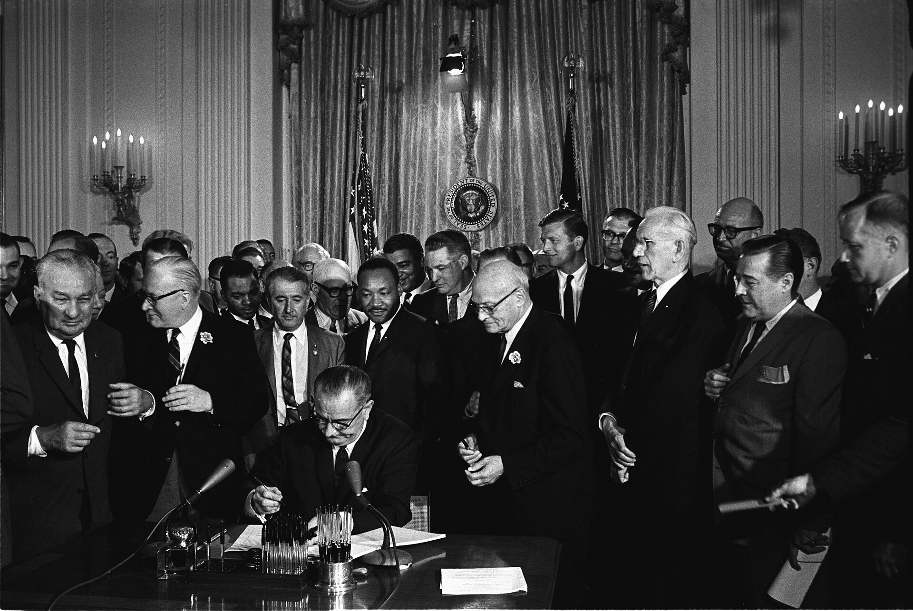
President Johnson Signs the Civil Rights Act of 1964 (July 2, 1964) · Cecil Stoughton, White House Press Office · July 2, 1964
Source: Stoughton, Cecil. "President Johnson Signs the Civil Rights Act of 1964." 2 July 1964. Executive Office of the President / White House, via Wikimedia Commons, commons.wikimedia.org/wiki/File:Lyndon_Johnson_signing_Civil_Rights_Act,_July_2,_1964.jpg. Public Domain https://commons.wikimedia.org/wiki/File:Lyndon_Johnson_signing_Civil_Rights_Act,_July_2,_1964.jpg
HIPPO — analyze the source (prompt) | Your analysis
H — Historical context: what was happening when this was created?
I — Intended audience: who was meant to see or obey it?
P — Purpose: why was it created?
P — Point of view: whose perspective does it reflect?
O — Outside connection: how does it connect to this standard?
SUPPORT OPTION
Sentence frame: This source shows ______ because it ______, which reveals ______.
CONFIDENCE CHECK-IN
Rate your understanding of this standard (1–4): ______ One thing to revisit: ____________________

Activity 6 — Core Application: Practice Quiz — US.81 ⏱ ~8 min
RESPONSE CHOICE
Commit to an answer by marking it, saying it, or explaining it aloud before checking. Answer key is in the Teacher Guide (kept separate).
[DOK 2 · item us81-q2 · pre-field-test]
What impact did the Voting Rights Act of 1965 have on Black political participation in the South?
A. Black voter registration increased dramatically from 23% to 61% by 1969, transforming Southern politics
B. It had minimal effect on voter registration, although this view has been largely discredited by scholars
C. It only affected Northern states, but this fails to account for the broader historical context
D. Registration rates decreased after the Act passed, yet the available evidence points to a different conclusion
[DOK 2 · item q-us79-add-1 · pre-field-test]
How did Malcolm X's approach to civil rights differ from Martin Luther King Jr.'s?
A. Both leaders agreed on every major strategy; their differences were only stylistic
B. Malcolm X advocated self-defense and Black nationalism while King promoted nonviolence
C. Malcolm X focused on rural sharecroppers while King focused on urban workers
D. Malcolm X supported the Civil Rights Act of 1964 while King opposed it
[DOK 3 · item u1-us81-dok3-tc · pre-field-test]
Why was the Fair Housing Act (1968) necessary even after earlier civil rights legislation?
A. Earlier legislation had already addressed housing discrimination, although this view has been largely discredited by scholars
B. Housing discrimination was not a significant problem, despite limited evidence supporting this interpretation
C. The Fair Housing Act replaced the 1964 Civil Rights Act, which does not align with the documented historical record
D. The 1964 Act focused on public accommodations and employment but did not address residential segregation, which perpetuated inequality

Activity 7 — Constructed Response (CER) — US.81 ⏱ ~15 min
BIG-QUESTION ORGANIZER — how did Americans fight to make the promise of equality real, and what did it take to change the law and the nation?
Jot quick notes from THIS standard: Who benefited? · Who bore the costs? · Who decided?

CONSTRUCTED RESPONSE (CER) — builds SSP.04 Argumentation
Claim + Evidence + Reasoning: Using this standard, take a position on the central question — analyze civil and voting rights legislation, including the Civil Rights Act of 1964, the Voting Rights Act of 1965, the Civil Rights Act of 1968 (Fair Housing Act), and the 24th Amendment? Support your claim with two pieces of evidence from the passage and explain your reasoning.
Part | Write here
Claim
Evidence (two specifics)
Reasoning
SELF-CHECK (CER rubric — see Toolkit)
Is my claim defensible? · TWO specific pieces of evidence? · Does my reasoning explain HOW the evidence proves the claim?
EXIT TICKET — before you leave [item us81-q1 · DOK 2 · pre-field-test]
How did the Civil Rights Act of 1964 end legal segregation and what enforcement mechanisms did it create?
A. It only addressed voting rights, which ignores key developments that shaped the outcome
B. It banned discrimination in public accommodations and employment while creating the EEOC to enforce these provisions
C. It relied entirely on state enforcement, which represents a common misconception about the period
D. It addressed housing but not public accommodations, but contemporary accounts suggest a different explanation
Show what you know (your choice): mark the best answer, say it, or explain it — then rate how sure you are: ☐ Not yet ☐ Getting there ☐ Got it
Answer key and next steps are in the Teacher Guide.

Standard US.82 — American Indian, Chicano & Feminist Movements
TN Academic Standard US.82: Analyze how the American Indian Movement, Chicano Movement, and Feminist Movement are related to the Civil Rights Movement in advancing equality across the broader spectrum of American society during this time period.
LEARNING TARGETS — I can…
• I can analyze how the American Indian Movement, Chicano Movement, and Feminist Movement are related to the Civil Rights Movement in advancing equality across American society.
Lenses for this standard: Culture · History
CORE PATH — the same for every student
Same rigor for everyone: analyze the sources and vocabulary, then show what you learned on the Practice Quiz and the CER.
UDL and MTSS give you flexible ways in — they never lower the bar.
Check yourself against the learning targets on the Cornell Notes page.
★ Tennessee Connection
Tennessee had its own dimensions of the broader social movements. The Highlander Folk School in Monteagle trained activists across movements. Wilma Mankiller, who became the first female Principal Chief of the Cherokee Nation, spent her early life connected to the Cherokee's Tennessee heritage before relocation.
SET YOUR GOAL (self-direction)
My goal for this standard — what will I be able to do, and how will I show it?

HOOK — think before you dig in
American Indian, Chicano & Feminist Movements: Analyze how the American Indian Movement, Chicano Movement, and Feminist Movement are related to the Civil Rights Movement in advancing equality across the broader spectrum of American society during this time period. Who gained, who was left out — and why does it still matter?

ACTIVATE — what do you already know or wonder?
Jot what you already know or want to find out about this standard. You’ll come back to it.

PREVIEW & PREDICT
Which learning target will be hardest, and why? Connect it to the unit’s big question: how did people change the law and the nation, and what did it cost?

Activity 1 — Vocabulary (Part A: Reference / Word Bank) — US.82 ⏱ ~10 min
Use this word bank throughout the standard. The Spanish column supports access, not translation of assessment.
Term | Student-friendly meaning | Spanish
American Indian Movement (AIM) | Civil rights organization founded in 1968 to address issues of poverty, police brutality, and treaty rights affecting Native Americans, using tactics inspired by the Black civil rights movement. | Movimiento Indio Americano
Chicano Movement | Mexican American civil rights movement of the 1960s-70s that fought for labor rights, education reform, political representation, and cultural pride, led by figures like Cesar Chavez. | Movimiento Chicano
Feminist Movement (1960s) | The "Second Wave" women's rights movement that fought for equal pay, reproductive rights, workplace equality, and passage of the Equal Rights Amendment, led by activists like Betty Friedan. | Movimiento Feminista (1960s)
Cesar Chavez | The labor leader who co-founded the United Farm Workers and led nonviolent strikes and boycotts for Mexican American farmworkers. | César Chávez
Equal Rights Amendment | A proposed constitutional amendment (revived in the 1970s feminist movement) to guarantee equal legal rights regardless of sex. | Enmienda de Igualdad de Derechos
United Farm Workers | The labor union founded by Cesar Chavez and Dolores Huerta to fight for better pay and conditions for farm laborers. | Unión de Campesinos
LANGUAGE SUPPORT
Pronunciations: American Indian Movement (AIM) (AY-im); Chicano Movement (chih-KAH-noh); Feminist Movement (1960s) (FEM-ih-nist); Cesar Chavez (SAY-zar SHAH-vez); Equal Rights Amendment (EE-kwul ryts); United Farm Workers (farm WUR-kerz).

VOCABULARY SELF-CHECK · Knowledge Rating
Rate each term NOW in pencil, then again at the END — growth is the goal; no penalty for “never seen it.”
Term | 1 · never seen it | 2 · heard it | 3 · can use it | 4 · can teach it
American Indian Movement (AIM)
Chicano Movement
Feminist Movement (1960s)
Cesar Chavez
Equal Rights Amendment
United Farm Workers

Activity 2 — Vocabulary Studio (Frayer-inspired) — US.82 ⏱ ~7 min
RESPONSE CHOICE
Complete each studio by writing, speaking, or diagramming.

PRIORITY TERM 1 American Indian Movement (AIM) · ES: Movimiento Indio Americano
Word-bank meaning to build on: Civil rights organization founded in 1968 to address issues of poverty, police brutality, and treaty rights affecting Native Americans, using tactics inspired by the Black civil rights movement.
Definition (in your own words) | Characteristics
Examples | Non-examples
Use it to explain
Write one sentence that uses “American Indian Movement (AIM)” to explain this standard.

PRIORITY TERM 2 Chicano Movement · ES: Movimiento Chicano
Word-bank meaning to build on: Mexican American civil rights movement of the 1960s-70s that fought for labor rights, education reform, political representation, and cultural pride, led by figures like Cesar Chavez.
Definition (in your own words) | Characteristics
Examples | Non-examples
Use it to explain
Write one sentence that uses “Chicano Movement” to explain this standard.

CONNECT THE TERMS (UDL · build understanding)
How do these priority terms fit together? Write or sketch how one leads to or affects another.

Activity 3 — Direct Teaching Cornell Notes — US.82 ⏱ ~20 min
Name: ______________________ Class / Period: __________ Date: __________
US.82 — American Indian, Chicano & Feminist Movements • These notes capture the direct-teaching content and the Close Read for this standard.
Your learning targets are on this standard’s opening page — take notes that help you meet them.
Cues (tied to your learning targets) | My notes
What does the passage say about american Indian Movement (AIM)?
What does the passage say about chicano Movement?
What does the passage say about feminist Movement?
Key terms →
DOODLE ZONE — draw your thinking (UDL · another way in)
Need another way in? Sketch the key idea, a quick timeline, or how the pieces connect. Words optional.

Cornell Notes — keep going, then process & check — US.82
MORE NOTES / DIAGRAMS
Continue your notes here, add a quick sketch, or map how the ideas connect.

Key terms to list
American Indian Movement (AIM) · Chicano Movement · Feminist Movement (1960s) · Cesar Chavez · Equal Rights Amendment · United Farm Workers
Summary — In your own words (2–3 sentences)
PROGRESS CHECK · one question
Compare how these movements both built upon and differed from the African American Civil Rights Movement.
A. They adopted similar tactics (protests, legal challenges, legislation) but pursued distinct goals reflecting their communities' unique experiences and cultural identities
B. These movements were completely unrelated to civil rights, although historical sources do not support this conclusion and oversimplifies the complex factors at work during this period
C. They opposed the African American civil rights movement, but the historical record tells a more complex story, which ignores significant political and cultural developments of the era
D. They were identical in every way to the civil rights movement, despite limited evidence supporting this interpretation and fails to account for key developments in the broader context
Commit before you move on — mark it, say it, or explain it aloud.
CHECK YOURSELF — how am I doing?
Which learning targets (on this standard’s opening page) can you now meet? Tick the number; circle any you still need help with.
☐ 1
My 12–15 word headline for this standard

Activity 4 — Close Read — US.82 ⏱ ~15 min
Reading type: History Hack-authored instructional synthesis. This is not a primary source. Builds SSP.03 (synthesize) and SSP.05 (historical awareness).
CORE PATH — read one chunk at a time
American Indian Movement (AIM)
AIM pursued tribal sovereignty, treaty rights, cultural preservation, and economic development on reservations. Key actions included the Occupation of Alcatraz (1969-1971), Trail of Broken Treaties march (1972), and Wounded Knee occupation (1973). Leader Russell Means advocated for "Red Power" and challenged federal Indian policies, using tactics similar to the civil rights movement while asserting distinct cultural identity.
Chicano Movement
The Chicano Movement sought educational equality, labor rights, political representation, and cultural pride for Mexican Americans. Key actions included East L.A. school walkouts (1968), formation of La Raza Unida Party, and grape boycotts. Cesar Chavez organized the United Farm Workers, using nonviolent tactics including strikes and boycotts to demand equal opportunities in employment and education.
Feminist Movement
The feminist movement pursued equal pay, reproductive rights, political representation, and ending gender discrimination. Key actions included formation of the National Organization for Women (NOW), consciousness-raising groups, and protests against discriminatory practices. Betty Friedan wrote "The Feminine Mystique" (1963), co-founded NOW, and challenged traditional gender roles, using civil rights legal strategies and protest tactics.
Synthesizing Connections
All movements shared common elements: legal strategies to challenge discriminatory laws, direct action through protests and demonstrations, pursuit of protective federal legislation, emphasis on group pride and cultural distinctiveness, coalition building with other movements, and strategic use of media. These movements collectively expanded civil rights from racial equality to broader concepts of human equality, creating templates for future social justice movements.
Key terms first: American Indian Movement (AIM), Chicano Movement. Read once for the gist, then again for evidence.
CLOSE-READ EVIDENCE LAB — for each question: quote the EVIDENCE from the passage above, then write YOUR ANSWER (or answer aloud / diagram it).
Text-dependent question | Evidence from the passage | Your answer (what it shows)
What is the main idea of the “American Indian Movement (AIM)” section, and what evidence supports it?
What is the main idea of the “Chicano Movement” section, and what evidence supports it?
What is the main idea of the “Feminist Movement” section, and what evidence supports it?

Activity 5 — Primary Source / Data Analysis — US.82 ⏱ ~15 min
Primary source (photograph) — analyze it with HIPPO. Builds SSP.01–SSP.02.
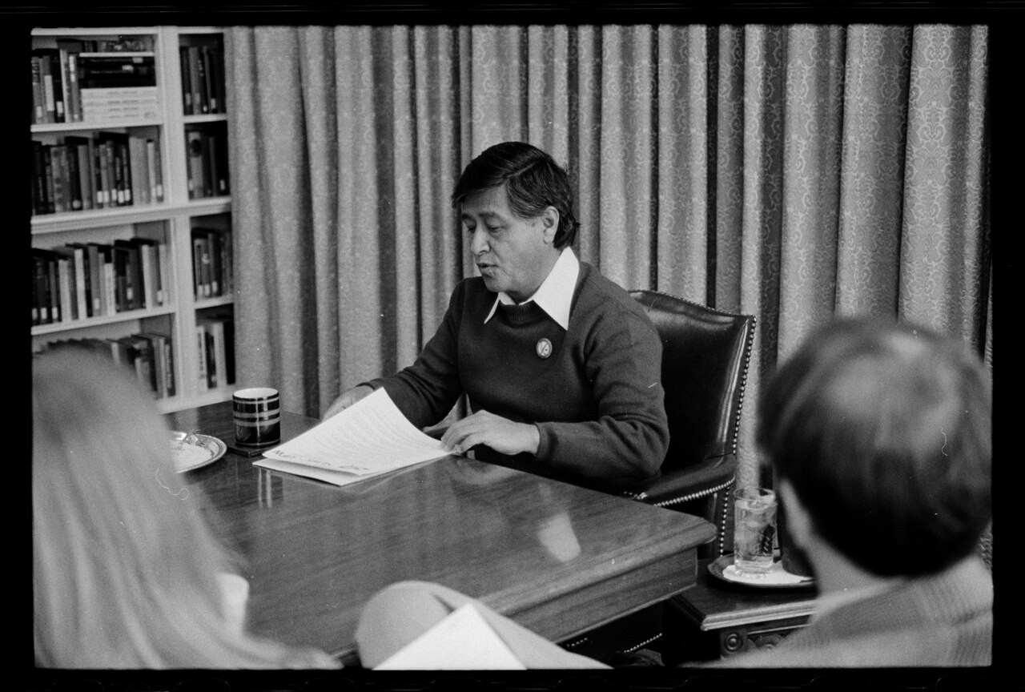
César Chávez Interview Portrait (April 20, 1979) · Marion S. Trikosko, U.S. News & World Report Magazine · April 20, 1979
Source: Trikosko, Marion S. "César Chávez Interview Portrait." 20 Apr. 1979. Library of Congress, Prints & Photographs Division, U.S. News & World Report Magazine Collection (LC-DIG-ppmsca-56576), via Wikimedia Commons, commons.wikimedia.org/wiki/File:Cesar_Chavez_40913a.tif. Public Domain https://commons.wikimedia.org/wiki/File:Cesar_Chavez_40913a.tif
HIPPO — analyze the source (prompt) | Your analysis
H — Historical context: what was happening when this was created?
I — Intended audience: who was meant to see or obey it?
P — Purpose: why was it created?
P — Point of view: whose perspective does it reflect?
O — Outside connection: how does it connect to this standard?
SUPPORT OPTION
Sentence frame: This source shows ______ because it ______, which reveals ______.
CONFIDENCE CHECK-IN
Rate your understanding of this standard (1–4): ______ One thing to revisit: ____________________

Activity 6 — Core Application: Practice Quiz — US.82 ⏱ ~8 min
RESPONSE CHOICE
Commit to an answer by marking it, saying it, or explaining it aloud before checking. Answer key is in the Teacher Guide (kept separate).
[DOK 2 · item us82-q2 · pre-field-test]
What specific goals did leaders like Russell Means, Cesar Chavez, and Betty Friedan pursue for their communities?
A. Means sought tribal sovereignty and treaty rights, Chavez fought for farm worker labor rights, and Friedan demanded gender equality and an end to discrimination
B. They all pursued identical goals, but this oversimplifies the complex factors at work, but the historical evidence paints a more nuanced picture
C. They focused exclusively on voting rights, but the historical record tells a more complex story when examined alongside the available primary and secondary sources
D. They avoided political activism entirely, but the historical record tells a more complex story and fails to account for key developments in the broader context
[DOK 2 · item q-us82-4 · pre-field-test]
How were the American Indian, Chicano, and Feminist movements related to the Civil Rights Movement?
A. They competed with the movement for federal resources
B. They drew inspiration from civil rights tactics and strategies
C. They focused exclusively on regional rather than national issues
D. They operated independently with no shared methods
[DOK 3 · item u1-us82-dok3-tc · pre-field-test]
Compare how these movements both built upon and differed from the African American Civil Rights Movement.
A. They adopted similar tactics (protests, legal challenges, legislation) but pursued distinct goals reflecting their communities' unique experiences and cultural identities
B. These movements were completely unrelated to civil rights, although historical sources do not support this conclusion and oversimplifies the complex factors at work during this period
C. They opposed the African American civil rights movement, but the historical record tells a more complex story, which ignores significant political and cultural developments of the era
D. They were identical in every way to the civil rights movement, despite limited evidence supporting this interpretation and fails to account for key developments in the broader context

Activity 7 — Constructed Response (CER) — US.82 ⏱ ~15 min
BIG-QUESTION ORGANIZER — how did Americans fight to make the promise of equality real, and what did it take to change the law and the nation?
Jot quick notes from THIS standard: Who benefited? · Who bore the costs? · Who decided?

CONSTRUCTED RESPONSE (CER) — builds SSP.04 Argumentation
Claim + Evidence + Reasoning: Using this standard, take a position on the central question — analyze how the American Indian Movement, Chicano Movement, and Feminist Movement are related to the Civil Rights Movement in advancing equality across American society? Support your claim with two pieces of evidence from the passage and explain your reasoning.
Part | Write here
Claim
Evidence (two specifics)
Reasoning
SELF-CHECK (CER rubric — see Toolkit)
Is my claim defensible? · TWO specific pieces of evidence? · Does my reasoning explain HOW the evidence proves the claim?
EXIT TICKET — before you leave [item us82-q1 · DOK 2 · pre-field-test]
How did the American Indian Movement, Chicano Movement, and Feminist Movement adopt civil rights strategies for their own causes?
A. They rejected all civil rights tactics, but this oversimplifies the complex factors at work, which ignores significant political and cultural developments of the era
B. They only used violent resistance, although this view has been largely discredited by scholars, though this interpretation lacks supporting historical evidence
C. They adapted legal challenges, direct action protests, media strategies, and legislative campaigns used by the African American civil rights movement
D. They worked exclusively through electoral politics, although this view has been largely discredited by scholars, but the historical evidence paints a more nuanced picture
Show what you know (your choice): mark the best answer, say it, or explain it — then rate how sure you are: ☐ Not yet ☐ Getting there ☐ Got it
Answer key and next steps are in the Teacher Guide.

Your Tennessee Connection
TENNESSEE CONNECTION · TENNESSEE AT THE HEART OF THE MOVEMENT
Few states were more central to the civil rights movement than Tennessee. In the mountains at Monteagle, the Highlander Folk School trained a generation of activists — Rosa Parks attended just months before the Montgomery bus boycott, and Dr. Martin Luther King Jr. spoke there (US.79, US.82). In Nashville, Fisk and other students led by Diane Nash and John Lewis ran the 1960 lunch-counter sit-ins with strict nonviolent discipline, making the city a national model and launching leaders of the wider movement (US.80). Tennessee schools desegregated unevenly after Brown, with Clinton among the first (US.78). And in April 1968, Dr. King traveled to Memphis to stand with striking sanitation workers — “I AM A MAN” — where he delivered his final “Mountaintop” speech and was assassinated at the Lorraine Motel (US.80–US.81).
Reflect (RESPONSE CHOICE): How does a local story change the way you understand a national event? Answer by writing, recording, or diagramming.

Local History Investigation
Industrialization touched Tennessee too — railroads, mines, mills, and the people who worked them. Investigate one local connection and record what you find.
Prompt | Your findings
A person, place, or industry from this era near me
One source I could check (library, TSLA, family, museum)
Who benefited / who bore the costs, locally
One question I still have

Progress Tracker & Cumulative Review
Track your Progress Check result for each standard and note one thing to revisit.
Standard | Progress Check (✓ / reteach) | One thing to revisit
US.78
US.79
US.80
US.81
US.82

Optional Extension Bank (higher-DOK, open to all)
Any student may choose an extension. These are EXTENSION, not a track.
US.78: Using this standard, take a position on the central question — examine the decision and impact of Brown v. Board of Education on desegregation? Support your claim with two pieces of evidence from the passage and explain your reasoning.
US.79: Using this standard, take a position on the central question — examine the roles and actions of civil rights advocates (e.g., Malcolm X, Thurgood Marshall, Rosa Parks) and opponents (e.g., Bull Connor, Orval Faubus, Strom Thurmond) and how they coincided, confronted, and challenged each other? Support your claim with two pieces of evidence from the passage and explain your reasoning.
US.80: Using this standard, take a position on the central question — describe the significant events in the struggle to secure civil rights for African Americans, including the Montgomery Bus Boycott, Freedom Riders, March on Washington, Birmingham bombings, and assassination of Martin Luther King Jr? Support your claim with two pieces of evidence from the passage and explain your reasoning.
US.81: Using this standard, take a position on the central question — analyze civil and voting rights legislation, including the Civil Rights Act of 1964, the Voting Rights Act of 1965, the Civil Rights Act of 1968 (Fair Housing Act), and the 24th Amendment? Support your claim with two pieces of evidence from the passage and explain your reasoning.
US.82: Using this standard, take a position on the central question — analyze how the American Indian Movement, Chicano Movement, and Feminist Movement are related to the Civil Rights Movement in advancing equality across American society? Support your claim with two pieces of evidence from the passage and explain your reasoning.

Think Like a Test-Writer (unit review — open to all)
You met a quick “think like a test-writer” prompt in every standard. Here is the full how-to, once, plus room to write your best questions for the whole unit.
HOW TO WRITE A DOK-3 QUESTION
DOK-3 = strategic thinking: the reader must analyze, compare, evaluate, or justify using evidence — and there should be more than one defensible answer (not a fact you can just look up).
Sentence starters: “Why did ______ lead to ______?” · “Which mattered more — ______ or ______ — and why?” · “What is the BEST evidence that ______?” · “Evaluate whether ______.” · “Defend or challenge: ______.”
Frame: [Analyze / Evaluate / Justify] + [something from this unit] + “using evidence.”
Quick check: does my question make the reader THINK and use evidence? If yes, it’s DOK-3.
Standard | Your DOK-3 question | Your answer key (one sentence)

Reusable Toolkit & Source Library

Written Response Rubric (CER)
Level | Claim | Evidence | Reasoning
4 — Strong | Precise, defensible | 2+ accurate, specific | Explains how evidence proves the claim
3 — Proficient | Clear | 2 accurate | Explains the link
2 — Developing | General | 1 accurate | Partial link
1 — Beginning | Unclear/missing | Missing/inaccurate | No reasoning

Source Library — full citations & clickable links
US.78 — Brown v. Board of Education
Brown v. Board of Education Decision. Chief Justice Earl Warren, May 17, 1954. Warren, Chief Justice Earl. "Brown v. Board of Education Decision." May 17, 1954. National Archives, https://www.archives.gov/milestone-documents/brown-v-board-. Public domain. https://www.archives.gov/milestone-documents/brown-v-board-of-education
NAACP Legal Defense Fund Brief. Thurgood Marshall, 1953. Marshall, Thurgood. "NAACP Legal Defense Fund Brief." 1953. Library of Congress, www.loc.gov/collections/thurgood-marshall-papers/.. Public domain. https://www.loc.gov/collections/thurgood-marshall-papers/
US.79 — Civil Rights Advocates and Opponents
Montgomery Bus Boycott Account. Rosa Parks, 1956. Parks, Rosa. "Montgomery Bus Boycott Account." 1956. Library of Congress, www.loc.gov/collections/rosa-parks-papers/.. Public domain. https://www.loc.gov/collections/rosa-parks-papers/
The Ballot or the Bullet. Malcolm X, April 3, 1964. X, Malcolm. "The Ballot or the Bullet." April 3, 1964. Library of Congress, www.loc.gov/collections/malcolm-x/.. Public domain. https://www.loc.gov/collections/malcolm-x/
US.80 — Significant Civil Rights Events
Letter from Birmingham Jail. Dr. Martin Luther King Jr., April 16, 1963. Jr., Dr. Martin Luther King. "Letter from Birmingham Jail." April 16, 1963. Martin Luther King Jr. Research and Education Institute, kinginstitute.stanford.edu/. Public domain. https://kinginstitute.stanford.edu/encyclopedia/letter-birmingham-jail
I Have a Dream Speech. Dr. Martin Luther King Jr., August 28, 1963. Jr., Dr. Martin Luther King. "I Have a Dream Speech." August 28, 1963. National Archives, https://www.archives.gov/milestone-documents/official-program-for-the-. Public domain. https://www.archives.gov/milestone-documents/official-program-for-the-march-on-washington
US.81 — Civil and Voting Rights Legislation
Civil Rights Act of 1964. U.S. Congress, July 2, 1964. U.S. Congress. "Civil Rights Act of 1964." July 2, 1964. National Archives, https://www.archives.gov/milestone-documents/civil-rights-act.. Public domain. https://www.archives.gov/milestone-documents/civil-rights-act
Voting Rights Act of 1965. U.S. Congress, August 6, 1965. U.S. Congress. "Voting Rights Act of 1965." August 6, 1965. National Archives, https://www.archives.gov/milestone-documents/voting-rights-act.. Public domain. https://www.archives.gov/milestone-documents/voting-rights-act
US.82 — American Indian, Chicano & Feminist Movements
National Organization for Women Statement of Purpose. Betty Friedan and NOW founders, 1966. founders, Betty Friedan and NOW. "National Organization for Women Statement of Purpose." 1966. National Organization for Women, now.org/about/history/statement-. Public domain. https://now.org/about/history/statement-of-purpose/
American Indian Movement Declaration. American Indian Movement, 1972. American Indian Movement. "American Indian Movement Declaration." 1972. Library of Congress, www.loc.gov/collections/general-collections/.. Public domain. https://www.loc.gov/collections/general-collections/

Making Equality Real — Many Movements, Many Methods
This section connects the threads of the era: the fight to make the promise of equality real took many movements and many methods — courts, marches, laws, and grassroots organizing. It is History Hack-authored instructional synthesis grounded in this unit’s sourced record — not a primary source.

Winning in the Courts
The NAACP’s long legal campaign overturned “separate but equal” in Brown v. Board of Education (US.78), declaring segregated schools unconstitutional and giving the movement a legal foundation — though enforcement was slow and fiercely resisted.

Winning in the Streets
Ordinary people forced change through nonviolent direct action (US.79–US.80): the Montgomery bus boycott, the Nashville and Greensboro sit-ins, the Freedom Rides, Birmingham, and the March on Washington built pressure the nation could not ignore.

Winning in the Law
That pressure produced landmark legislation (US.81): the Civil Rights Act of 1964 outlawed segregation and job discrimination, and the Voting Rights Act of 1965 struck down the barriers that had denied Black Southerners the ballot.

A Wider Struggle
The movement inspired others (US.82): the American Indian Movement, the Chicano movement and the United Farm Workers, and a revived women’s movement all pressed the country to widen the meaning of equality.
Residual note (known follow-up): sourced visuals and named Key-Figure entries for these histories remain pending.

Unit Reflection
Return to the unit’s big question: how did Americans fight to make the promise of equality real — and what did it take to change the law and the nation? Write a final claim with two pieces of evidence from different standards.
Part | Write here
My claim
Evidence 1 (standard: ___)
Evidence 2 (standard: ___)
Why it matters today

