1776 - 2026 • AMERICA'S 250TH ANNIVERSARY • SEMIQUINCENTENNIAL EDITION
U.S. HISTORY HACK™
TROOPTOTEACHER TECHNOLOGIES
UNIT 6
World War II, 1939–1945
TEACHER EDITION — ANSWER KEY · keep separate from students
COURSE STANDARD EDITION
US.45 – US.58 • 14 Tennessee U.S. History Standards • Grades 9–12
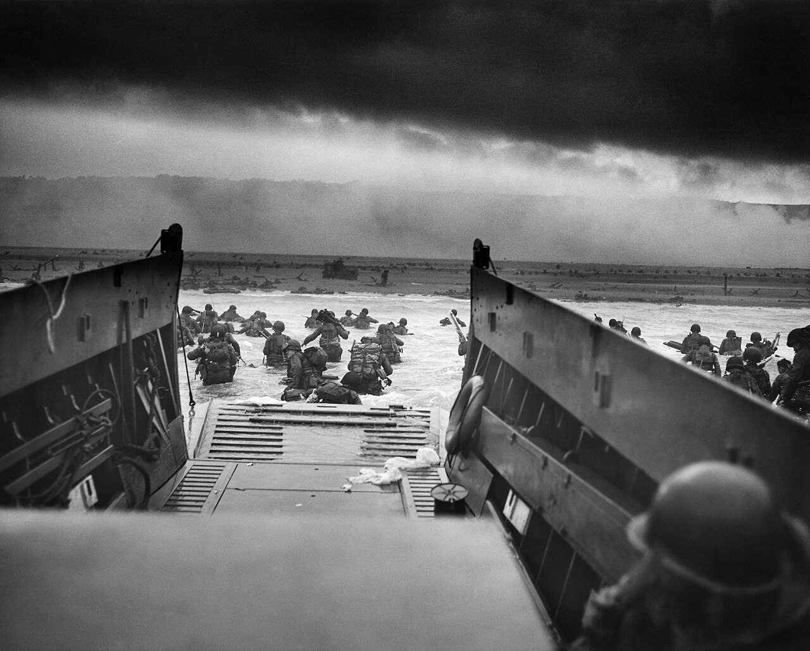
“Into the Jaws of Death” — U.S. troops wade ashore under fire at Omaha Beach, Normandy, on D-Day, June 6, 1944.
Source: Chief Photographer’s Mate Robert F. Sargent, U.S. Coast Guard / National Archives. Public domain.
TENNESSEE CONNECTION · OAK RIDGE, THE “SECRET CITY”
Tennessee helped build the atomic bomb. Oak Ridge — the “Secret City” — was a central site of the Manhattan Project (US.56), enriching the uranium used in the first atomic weapons. At its peak it held about 75,000 workers, many of whom never knew what they were making. Cordell Hull of Pickett County (US.58) helped found the United Nations, and Fort Campbell became home to the 101st Airborne (US.51).
One common workbook designed for learner variability. Every student works toward the same Tennessee standards; supports vary the means, not the goal or the ceiling.
Release-Ready · Pilot Edition
© 2026 TroopToTeacher Technologies LLC. All rights reserved. ISBN: [to be assigned]

Copyright, Ownership & Framework
U.S. History Hack™ — Unit 6: World War II (1939–1945), Course Standard Edition.
© 2026 TroopToTeacher Technologies LLC. All rights reserved. This workbook is proprietary; reproduction or redistribution outside a licensed classroom is prohibited.
Source integrity. Every primary source in this unit is public-domain and cited to its holding repository (National Archives, Library of Congress, HathiTrust). See the Source Library.
Reading provenance (district-clear). Close-Read passages are labeled “History Hack-authored instructional synthesis” — they build on the standard record and are not presented as primary sources.
Framework stack. This workbook anchors to Tennessee U.S. History standards US.45–US.58 and the Social Studies Practices (SSP.01–SSP.06), and is designed on CAST UDL 3.0 and an MTSS support model.
Pacing. Each standard is built for one 45-minute class period. Each activity shows a ⏱ ~ minutes estimate at its heading. There is more here than one period holds — your teacher chooses which activities you do in class; the rest may become warm-ups, stations, or homework.
License & permitted use. This purchase grants one teacher a single-classroom license. The licensed teacher may reproduce these pages, in print or as digital copies, for the students in their own classes, and may post them to a password-protected class platform (Google Classroom, Canvas, or a comparable LMS) accessible only to those students.
Usage restrictions. This workbook may not be resold, sublicensed, redistributed, or shared with other teachers, schools, or districts; posted to any public website, open shared drive, or file-sharing service; or used, in whole or in part, to train machine-learning or generative-AI systems. Each additional classroom requires its own license.
District & multi-classroom licensing. School, department, and district licenses are available at reduced per-teacher rates. For volume licensing, purchase orders, or permission requests beyond this license, contact TroopToTeacher Technologies LLC [licensing contact — to be added].
Trademarks. “U.S. History Hack,” “History Hack,” and the History Hack logo are trademarks of TroopToTeacher Technologies LLC. Tennessee Academic Standards, TCAP, and other marks are the property of their respective owners and are used for identification only.
Accessibility & accommodations. The universal supports in this workbook are available to every learner by design. They work alongside — never in place of — the accommodations and modifications required by a student’s IEP or 504 plan.
Edition. Course Standard Edition · First Printing · 2026 · ISBN: [to be assigned] · Printed in the United States of America.
How to cite this workbook. TroopToTeacher Technologies LLC. U.S. History Hack — Unit 6: World War II (1939–1945), Course Standard Edition. 2026.
Digital & printable use. This workbook is print-ready and inherently digital. The licensed teacher may print it for classroom use or assign it through a learning-management system for on-screen completion by their own students.

Unit at a Glance
World War II, 1939–1945 — fourteen standards, each built for one 45-minute class period. Every standard runs the same seven-activity cycle, so you always know what comes next.
The fourteen standards
US.45 Rise and Spread of Fascism, Communism, and Totalitarianism
US.46 FDR's Response to World Crises
US.47 U.S. Response to the Holocaust
US.48 American Entry into World War II
US.49 WWII Leaders & Key Figures
US.50 Major WWII Battles: Midway, Iwo Jima, Okinawa & D-Day
US.51 Special Fighting Forces in WWII
US.52 Women in World War II
US.53 African Americans in WWII
US.54 Japanese American Internment & Korematsu
US.55 Home Front Mobilization
US.56 Manhattan Project & Atomic Bomb
US.57 Yalta and Potsdam Conferences
US.58 Founding of the United Nations & Cordell Hull
The seven-activity cycle (repeats for every standard)
1. Vocabulary · 2. Vocabulary Studio · 3. Cornell Notes · 4. Close Read · 5. Primary Source (HIPPO) · 6. Practice Quiz · 7. Constructed Response (CER)
Each standard also opens with a warm-up (learning targets, goal, hook, preview) and closes with an exit ticket.

Tennessee Standards & SSP Crosswalk
Each standard below is taught to the full Course Standard expectation; the Social Studies Practices are embedded in every activity cycle.
Standard | Focus | Lenses
US.45 | Rise and Spread of Fascism, Communism, and Totalitarianism | History · Politics/Government
US.46 | FDR's Response to World Crises | Politics/Government · History
US.47 | U.S. Response to the Holocaust | History · Culture
US.48 | American Entry into World War II | History · Politics/Government
US.49 | WWII Leaders & Key Figures | History · Politics/Government
US.50 | Major WWII Battles: Midway, Iwo Jima, Okinawa & D-Day | History · Geography
US.51 | Special Fighting Forces in WWII | History · Culture
US.52 | Women in World War II | History · Economics · Culture
US.53 | African Americans in WWII | History · Culture · Economics · Tennessee Connection
US.54 | Japanese American Internment & Korematsu | Culture · History
US.55 | Home Front Mobilization | History · Economics
US.56 | Manhattan Project & Atomic Bomb | History · Geography
US.57 | Yalta and Potsdam Conferences | Politics/Government · History
US.58 | Founding of the United Nations & Cordell Hull | Politics/Government · Culture · History

Social Studies Practices (SSP.01–SSP.06)
• SSP.01 Gather and evaluate sources
• SSP.02 Critically examine a primary source
• SSP.03 Synthesize evidence
• SSP.04 Construct and communicate an argument
• SSP.05 Develop historical awareness
• SSP.06 Chronological and spatial reasoning
Each Close Read, Primary Source / Data, and CER activity names the practices it builds.

Accessibility, UDL & Accommodations Matrix
One firm learning goal per standard; flexible, universal means. Supports are available by design and never lower the goal. They work alongside — never in place of — required IEP or 504 accommodations.
Universal support | What it is | Where it appears
CORE PATH | Essential instruction every student completes | Every activity
LANGUAGE SUPPORT | Vocabulary, pronunciation, Spanish cognates | Word Bank, Guided/Light Backs
RESPONSE CHOICE | Write, say/record, or diagram | Every activity
SUPPORT OPTION | Optional scaffold that keeps the goal | Guided Support Back, Primary Source
PROGRESS CHECK | Quick DOK-2/3 check to guide reteach/extend | Cornell Notes, Practice Quiz
EXTENSION | Deeper challenge once the goal is met | Extension Bank, CER

How CAST UDL 3.0 is visible in this workbook
Multiple means of Engagement (response choice, relevance via Tennessee Connection), Representation (Word Bank, pronunciation, Spanish, Close-Read supports), and Action & Expression (write/say/diagram, Frayer, CER). No fixed-track labels appear.

My Support Plan (optional — you choose)
Supports are available by design. Check the ones you might try; you can change your mind any time.
Support I might use | When it would help me
Word Bank + Spanish column
Guided or Light Support Back
Response choice (say/record or diagram)
Sentence frames / Rehearsal Lab

How to Use This Workbook
Each standard runs the same seven-activity cycle: (1) Vocabulary Word Bank, (2) Vocabulary Studio, (3) Direct-Teaching Cornell Notes with optional Guided and Light Support Backs, (4) Close Read, (5) Primary Source / Data Analysis, (6) Core Application Practice Quiz, (7) Constructed Response (CER). Work the CORE PATH; reach for SUPPORT OPTIONS as needed.

Label legend — these appear throughout every standard cycle
Label | Meaning
CORE PATH | The essential instruction every student completes.
SUPPORT OPTION | An optional scaffold that keeps the goal, not lowers it.
LANGUAGE SUPPORT | Vocabulary, pronunciation, and Spanish cognates for access.
RESPONSE CHOICE | Show learning by writing, saying/recording, or diagramming.
PROGRESS CHECK | A quick DOK-2/3 check that guides reteach or extend.
EXTENSION | A deeper challenge once the goal is met.

Before You Begin — Set Your Goal
This unit asks one big question: as the United States industrialized, who benefited and who bore the costs? Set a goal, then note what you already know.
Prompt | Your response
My goal for this unit is…
One thing I already know about this era…
One question I want answered…
How to write a strong goal — an example. A strong goal names what you will be able to DO and how you will SHOW it.
Ask yourself: What should I understand by the end of this standard? How will I prove it? What might be hardest for me — and what will I do about it?
Example: “I can explain how economic crisis and fear helped dictators rise to power, and I will show it by writing a claim backed by two specific pieces of evidence.”

Standard US.45 — Rise and Spread of Fascism, Communism, and Totalitarianism
TN Academic Standard US.45: Explain the rise and spread of fascism, communism, and totalitarianism internationally.
LEARNING TARGETS — I can…
• I can explain the rise and spread of fascism, communism, and totalitarianism internationally, including the key characteristics and leaders of each system.
Lenses for this standard: History · Politics/Government
CORE PATH — the same for every student
Same rigor for everyone: analyze the sources and vocabulary, then show what you learned on the Practice Quiz and the CER.
Check yourself against the learning targets on the Cornell Notes page.
SET YOUR GOAL (self-direction)
My goal for this standard — what will I be able to do, and how will I show it?

HOOK — read before you dig in
In barely twenty years, a handful of leaders convinced whole nations to trade freedom for the promise of order — and the world slid toward its deadliest war. How does that happen? As you read, watch for the fear, anger, and broken promises that let dictators rise.
ACTIVATE — what do you already know or wonder?
Think about it, then jot a few notes in your notebook: what do you already know, and what do you wonder about this standard? You will come back to it.
PREVIEW & PREDICT
Which learning target will be hardest, and why? Connect it to the unit’s big question: how did the war change America at home and abroad, and who sacrificed even while excluded?

Activity 1 — Vocabulary (Part A: Reference / Word Bank) — US.45 ⏱ ~10 min ▶ Deck slide 8
Use this word bank throughout the standard. The Spanish column supports access, not translation of assessment.
Term | Student-friendly meaning | Spanish
Fascism | An authoritarian political ideology that emphasizes extreme nationalism, militarism, totalitarian control, and a dictatorial leader. Suppresses opposition and glorifies the state above individual rights. | Fascismo
Totalitarianism | A system of government where the state controls every aspect of public and private life, using propaganda, secret police, and terror to eliminate opposition. | Totalitarismo
Communism | A political and economic system in which the state owns property and the means of production in the name of the working class; in the 20th century it took the form of one-party dictatorship under leaders like… | Comunismo
Adolf Hitler | Nazi dictator of Germany (1933-1945) who led Germany into World War II and orchestrated the Holocaust, resulting in the deaths of 6 million Jews and millions of others. | Adolf Hitler
Benito Mussolini | Fascist dictator of Italy (1922-1943) who created the first fascist state, formed the Axis alliance with Hitler, and led Italy into World War II. | Benito Mussolini
Joseph Stalin | Communist dictator of the Soviet Union (1924-1953) who ruled through terror, forced collectivization, and purges, resulting in millions of deaths. | Joseph Stalin
LANGUAGE SUPPORT
Pronunciations: Fascism (FASH-iz-um); Totalitarianism (toh-tal-ih-TAIR-ee-uh-niz-um); Communism (KOM-yoo-niz-um); Adolf Hitler (AY-dolf HIT-ler); Benito Mussolini (beh-NEE-toh moo-suh-LEE-nee); Joseph Stalin (JOH-zef STAH-lin).
VOCABULARY SELF-CHECK · Knowledge Rating
Rate each term NOW in pencil, then again at the END — growth is the goal; no penalty for “never seen it.”
Term | 1 · never seen it | 2 · heard it | 3 · can use it | 4 · can teach it
Fascism
Totalitarianism
Communism
Adolf Hitler
Benito Mussolini
Joseph Stalin
MAKE IT YOURS (RESPONSE CHOICE): choose ONE term above and show you own it — write a sentence, sketch it, or give a real-world example. Do this in your notebook or on a whiteboard — be ready to share.
VOCABULARY SUPPORTS — make the words stick
Word-attack strategy: break long terms into parts — total-itarian-ism → “total control.” Many terms are Spanish cognates (fascism / fascismo), so use the Spanish column to unlock meaning.
Quick practice — choose ONE
• Draw a quick symbol for two terms.
• Write one sentence that uses two terms together.
• Teach a term to a partner in 20 seconds.

Do your quick practice here:

Use two terms together in one sentence:

Cognate connection — write the English term and its Spanish cognate for two words:

Study tip: cover the meaning column and quiz yourself, then re-rate each term on the self-check at the end of the standard.

Activity 2 — Vocabulary Studio (Frayer-inspired) — US.45 ⏱ ~7 min ▶ Deck slide 8
RESPONSE CHOICE
Complete each studio by writing, speaking, or diagramming.

PRIORITY TERM 1 Fascism · ES: Fascismo
Word-bank meaning to build on: An authoritarian political ideology that emphasizes extreme nationalism, militarism, totalitarian control, and a dictatorial leader. Suppresses opposition and glorifies the state above individual rights.
Definition (in your own words) | Characteristics
Examples | Non-examples
Use it to explain
Write one sentence that uses “Fascism” to explain this standard.

PRIORITY TERM 2 Totalitarianism · ES: Totalitarismo
Word-bank meaning to build on: A system of government where the state controls every aspect of public and private life, using propaganda, secret police, and terror to eliminate opposition.
Definition (in your own words) | Characteristics
Examples | Non-examples
Use it to explain
Write one sentence that uses “Totalitarianism” to explain this standard.

CONNECT THE TERMS (UDL · build understanding)
How do these priority terms fit together? On a whiteboard or in your notebook, draw a quick web or write 2–3 sentences showing how one leads to or affects another — be ready to share.

Activity 3 — Direct Teaching Cornell Notes — US.45 ⏱ ~20 min ▶ Deck slides 3–5
Name: ______________________ Class / Period: __________ Date: __________
US.45 — Rise and Spread of Fascism, Communism, and Totalitarianism • These notes capture the direct-teaching content and the Close Read for this standard.
Your learning targets are on this standard’s opening page — take notes that help you meet them.
Cues (tied to your learning targets) | My notes
What does the passage say about key Characteristics of Fascism?
What does the passage say about fundamental Tenets of Communism?
What does the passage say about totalitarianism in Italy, Germany, and Soviet Union?
Key terms →

Cornell Notes — keep going, then process & check — US.45
MORE NOTES / DIAGRAMS
Continue your notes here, add a quick sketch, or map how the ideas connect.

Key terms to list
Fascism · Totalitarianism · Communism · Adolf Hitler · Benito Mussolini · Joseph Stalin
Summary — In your own words (2–3 sentences)
PROGRESS CHECK · one question
How did economic crisis and political instability enable the rise of totalitarian regimes in Italy, Germany, and the Soviet Union?
A. The Great Depression, post-WWI disappointment, and political chaos created conditions where people accepted radical solutions and strong leaders promising stability
B. Economic prosperity led people to seek stronger government control, although this view has been largely discredited by scholars, which does not align with the documented historical record
C. Totalitarian regimes rose during periods of peace and prosperity, despite the fact that multiple sources contradict this view, which does not align with the documented historical record
D. Democratic governments actively promoted totalitarianism, which does not align with the documented historical record, but the historical evidence paints a more nuanced picture
Commit before you move on — mark it, say it, or explain it aloud.
CHECK YOURSELF — how am I doing?
Which learning targets (on this standard’s opening page) can you now meet? Tick the number; circle any you still need help with.
☐ 1
My 12–15 word headline for this standard

Activity 4 — Close Read — US.45 ⏱ ~15 min ▶ Deck slides 3–5
Reading type: History Hack-authored instructional synthesis. This is not a primary source. Builds SSP.03 (synthesize) and SSP.05 (historical awareness).
Key terms first: Fascism, Totalitarianism. Read once for the gist, then again for evidence.
CORE PATH — read one chunk at a time
Key Characteristics of Fascism
Fascism is characterized by ultranationalism (extreme devotion to nation above individual rights), authoritarian leadership with dictatorial power concentrated in a single leader (Führer, Duce), and militarism glorifying war and aggressive expansion. Fascists violently opposed communism and socialism, used mass mobilization through rallies and propaganda, and created a cult of personality around their leaders. They also scapegoated minority groups for national problems while maintaining a corporate state with government control of the economy.
Fundamental Tenets of Communism
Communism is based on class struggle as the driving force of history, requiring a proletarian revolution where the working class overthrows capitalism. It promotes collective ownership with state control of production and property, aiming for a classless society. Communists viewed their revolution as an international movement, led by a vanguard Communist Party governing on behalf of workers. The system relies on central planning where government directs all economic activity, and historically promoted atheism, opposing organized religion.
Totalitarianism in Italy, Germany, and Soviet Union
Totalitarianism is a political system where government exercises complete control over all public and private life. In Italy, Benito Mussolini ("Il Duce") established fascist dictatorship (1922-1943), using Blackshirts to intimidate opponents. In the Soviet Union, Joseph Stalin consolidated power after Lenin's death, implementing Five-Year Plans, forced collectivization causing famine, and the Great Purge eliminating millions. In Germany, Adolf Hitler ("Führer") established Nazi dictatorship (1933-1945), promoting Aryan supremacy and anti-Semitism, using the Gestapo secret police, and seeking "Lebensraum" through territorial expansion.
Factors Facilitating International Spread
Common factors enabling totalitarianism included the Great Depression creating conditions for radical solutions, political instability with weak democratic governments, social upheaval from war and revolution, charismatic leaders promising simple solutions, and mass communication enabling propaganda. The League of Nations' weakness, Western appeasement policies, and economic nationalism allowed aggression to go unchallenged. German rearmament, Italian conquest of Ethiopia, and Japanese expansion in Asia demonstrated international system breakdown.
CLOSE-READ EVIDENCE LAB — for each question: quote the EVIDENCE from the passage above, then write YOUR ANSWER (or answer aloud / diagram it).
Text-dependent question | Evidence from the passage | Your answer (what it shows)
What is the main idea of the “Key Characteristics of Fascism” section, and what evidence supports it?
What is the main idea of the “Fundamental Tenets of Communism” section, and what evidence supports it?

Activity 5 — Primary Source / Data Analysis — US.45 ⏱ ~15 min ▶ Deck slide 6
Primary source (photograph) — analyze it with HIPPO. Builds SSP.01–SSP.02.
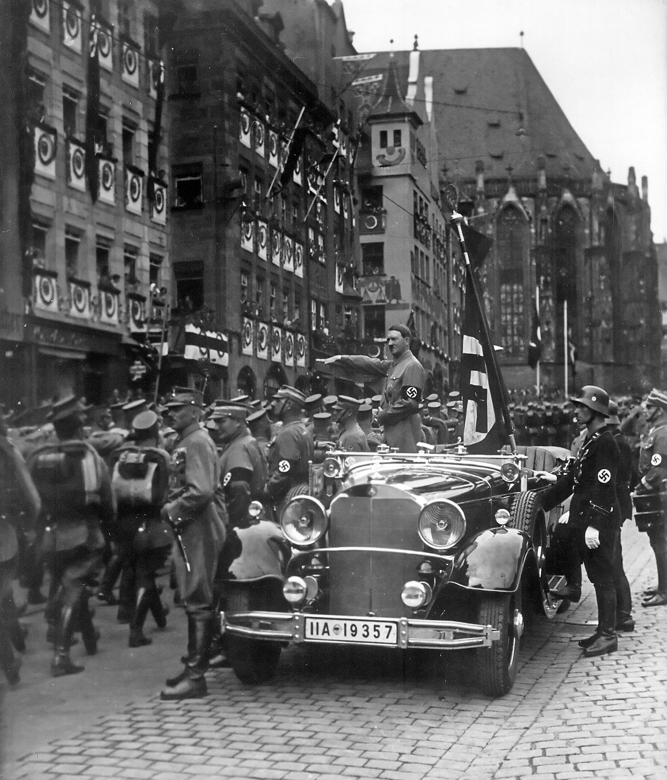
Reichsparteitag of the NSDAP in Nuremberg, SA troops march past Adolf Hitler, Sept. 1935 · Charles Russell (donor) / National Archives and Records Administration (NARA) · September 1935
Source: Russell, Charles. "Reichsparteitag of the NSDAP in Nuremberg, SA Troops March Past Adolf Hitler, Sept. 1935." September 1935. National Archives and Records Administration (NAID 558779), via Wikimedia Commons, commons.wikimedia.org/wiki/File:Reichsparteitag_of_the_NSDAP_in_Nuremberg,_SA_troops_march_past_Adolf_Hitler,_Sept._1935.jpg. Public Domain https://commons.wikimedia.org/wiki/File:Reichsparteitag_of_the_NSDAP_in_Nuremberg,_SA_troops_march_past_Adolf_Hitler,_Sept._1935.jpg
HIPPO — analyze the source (prompt) | Your analysis
H — Historical context: what was happening when this was created?
I — Intended audience: who was meant to see or obey it?
P — Purpose: why was it created?
P — Point of view: whose perspective does it reflect?
O — Outside connection: how does it connect to this standard?
CONFIDENCE CHECK-IN
Rate your understanding of this standard (1–4): ______ One thing to revisit: ____________________
HIPPO SUPPORTS — analyzing the source · US.45
Optional — use these to complete your HIPPO analysis. Your teacher may print this back page or leave it off.
Guiding questions
• H — Historical context: What was happening in the world when this was made?
• I — Intended audience: Who was meant to see or obey it?
• P — Purpose: Why did the creator make it? What did they want to happen?
• P — Point of view: Whose side does it show? Whose voice is missing?
• O — Outside connection: What have we studied that connects to this?
SUPPORT OPTION
Sentence frame: This source shows ______ because it ______, which reveals ______.
Model analysis (example)
H: Taken in 1935 as the Nazi regime consolidated power. I: Meant for the German public, to build loyalty and fear. P: Propaganda — to project unity, order, and strength. POV: It shows the regime’s view; the persecuted are absent. O: Connects to how totalitarian states used mass media to control people.
Try it — sourcing warm-up
Before you fill in HIPPO on the front, answer these in one line each:
• Who made this source, and when?

• What did they want the viewer to think or feel?

• How does that change how much you trust it?

Activity 6 — Core Application: Practice Quiz — US.45 ⏱ ~8 min ▶ Deck slide 9
RESPONSE CHOICE
Commit to an answer by marking it, saying it, or explaining it aloud — then self-check with the answer key at the bottom of this page.
[DOK 2 · item q-us45-dok2-1-b · pre-field-test]
1. How did the Treaty of Versailles contribute to the rise of Adolf Hitler and the Nazi Party in Germany?
✓ A. It imposed harsh reparations and humiliation that fueled resentment Hitler exploited
B. Program providing part-time jobs for students so they could afford to stay in school
C. Americans should not let fear paralyze them; the nation will recover with bold action
D. Military leaders seized control, pursued aggressive expansion, and suppressed dissent
[DOK 2 · item q-us45-dok2-3-b · pre-field-test]
2. How did Japan's militarism in the 1930s reflect the international spread of totalitarianism?
A. Americans should not let fear paralyze them; the nation will recover with bold action
✓ B. Military leaders seized control, pursued aggressive expansion, and suppressed dissent
C. Separated commercial and investment banking to reduce risky speculation with deposits
D. Whirlwind period where FDR pushed 15 major laws through Congress to combat Depression
[DOK 3 · item u1-us45-dok3-tc · pre-field-test]
3. How did economic crisis and political instability enable the rise of totalitarian regimes in Italy, Germany, and the Soviet Union?
✓ A. The Great Depression, post-WWI disappointment, and political chaos created conditions where people accepted radical solutions and strong leaders promising stability
B. Economic prosperity led people to seek stronger government control, although this view has been largely discredited by scholars, which does not align with the documented historical record
C. Totalitarian regimes rose during periods of peace and prosperity, despite the fact that multiple sources contradict this view, which does not align with the documented historical record
D. Democratic governments actively promoted totalitarianism, which does not align with the documented historical record, but the historical evidence paints a more nuanced picture
[DOK 2 · item q-us45-dok2-4 · pre-field-test]
4. Which feature most clearly distinguished fascism from communism in the 1920s–1930s?
✓ A. Fascism promoted extreme nationalism and a corporate state, while communism called for international class struggle and state ownership of production.
B. Fascism sought a classless society, while communism glorified the nation above the individual.
C. Both rejected dictatorship in favor of parliamentary democracy.
D. Both opposed propaganda and cults of personality around their leaders.
CHECK YOURSELF — quiz answer key
Commit your answers first, then check: 1. A 2. B 3. A 4. A
Missed one? Reread that section and fix your thinking — that is where the learning happens.

Activity 7 — Constructed Response (CER) — US.45 ⏱ ~15 min ▶ Deck slides 3–7
BIG-QUESTION ORGANIZER — in World War II, how did the war reshape America at home and its role in the world — and who sacrificed, even while being excluded?
Jot quick notes from THIS standard: Who benefited? · Who bore the costs? · Who decided?

CONSTRUCTED RESPONSE (CER) — builds SSP.04 Argumentation
Claim + Evidence + Reasoning: Using this standard, take a position on the central question — explain the rise and spread of fascism, communism, and totalitarianism internationally, including the key characteristics and leaders of each system? Support your claim with two pieces of evidence from the passage and explain your reasoning.
Part | Write here
Claim
Evidence (two specifics)
Reasoning
SELF-GRADE YOUR CER — score each trait 1–4
Trait | What a strong (3–4) response shows | My score (1–4)
Claim | Clear; directly answers the question
Evidence | Two specific facts from the sources
Reasoning | Explains HOW the evidence proves the claim
Conventions | Complete, readable sentences
My total: ______ / 16 · One thing I will improve next time: ______________________
Peer review — trade & improve
Glow — one thing that works:

Grow — one thing to strengthen:

My revision — one change I will make:

WRITING SUPPORTS — Constructed Response (CER) · US.45
Optional — use these to plan and write your CER. Your teacher may print this back page or leave it off; the goal on the front never changes.
Sentence stems
• Claim: “One major cause of ______ was ______.” / “______ happened mainly because ______.”
• Evidence: “According to the source, ______.” / “For example, ______ shows that ______.”
• Reasoning: “This evidence proves ______ because ______.” / “This matters because ______.”
• Go further: “Although some might say ______, the stronger evidence shows ______.”
Model response (example)
Claim: Economic crisis and fear allowed dictators to rise in the 1930s. Evidence: The Great Depression caused mass unemployment in Germany, and Hitler promised jobs and national pride. Reasoning: When people are desperate and afraid, they may accept a strongman who promises order — which is how the Nazi dictatorship gained power.
CER rubric — in your own words
• Claim — I answer the question in one clear sentence.
• Evidence — I use two specific facts from the sources.
• Reasoning — I explain HOW my evidence proves my claim.
• Conventions — I write in complete sentences a reader can follow.
Argument word bank
First · Because · For example · This shows that · As a result · Therefore · However · Although · In contrast · This matters because
EXIT TICKET — before you leave [item us45-q1 · DOK 2 · pre-field-test]
What key characteristics distinguished fascism from other political systems in 1930s Europe?
A. Fascism promoted democracy and individual rights above national interests, though this interpretation lacks supporting historical evidence
B. Fascism emphasized collective ownership and classless society, but contemporary accounts suggest a different explanation
✓ C. Fascism combined ultranationalism, authoritarian leadership, militarism, and scapegoating of minorities under a cult of personality
D. Fascism focused primarily on international cooperation and peace, although this overlooks critical economic and social factors
Show what you know (your choice): mark the best answer, say it, or explain it — then rate how sure you are: ☐ Not yet ☐ Getting there ☐ Got it
✔ ANSWER: C — Fascism combined ultranationalism, authoritarian leadership, militarism, and scapegoating under a cult of personality. (Full key & reteach in the Teacher Guide.)

Standard US.46 — FDR's Response to World Crises
TN Academic Standard US.46: Explain President Franklin D. Roosevelt's response to world crises, including: The Quarantine Speech, the Four Freedoms speech, the Atlantic Charter, and the Lend-Lease Act.
LEARNING TARGETS — I can…
• I can explain President Franklin D. Roosevelt's response to world crises, including the Quarantine Speech, the Four Freedoms speech, the Atlantic Charter, and the Lend-Lease Act.
Lenses for this standard: Politics/Government · History
CORE PATH — the same for every student
Same rigor for everyone: analyze the sources and vocabulary, then show what you learned on the Practice Quiz and the CER.
Check yourself against the learning targets on the Cornell Notes page.
SET YOUR GOAL (self-direction)
My goal for this standard — what will I be able to do, and how will I show it?

HOOK — think before you dig in
While most Americans wanted nothing to do with another European war, Roosevelt watched dictators swallow one country after another. How do you lead a nation toward a fight it refuses to join? As you read, watch how FDR used speeches, ships, and supplies to inch America off the sidelines.
ACTIVATE — what do you already know or wonder?
Think about it, then jot a few notes in your notebook: what do you already know, and what do you wonder about this standard? You will come back to it.
PREVIEW & PREDICT
Which learning target will be hardest, and why? Connect it to the unit’s big question: how did the war change America at home and abroad, and who sacrificed even while excluded?

Activity 1 — Vocabulary (Part A: Reference / Word Bank) — US.46 ⏱ ~10 min ▶ Deck slide 16
Use this word bank throughout the standard. The Spanish column supports access, not translation of assessment.
Term | Student-friendly meaning | Spanish
Quarantine Speech | FDR's 1937 address proposing that peace-loving nations 'quarantine' aggressor states to halt the spread of international lawlessness. | Discurso de la Cuarentena
Four Freedoms Speech | FDR's 1941 speech defining American war aims: freedom of speech, freedom of worship, freedom from want, and freedom from fear. | Discurso de las Cuatro Libertades
Lend-Lease Act (1941) | U.S. program allowing the President to lend or lease war supplies to any nation deemed vital to American defense, primarily Britain and the Soviet Union. | Ley de Préstamo y Arriendo (1941)
Appeasement | Policy of making concessions to aggressive powers to avoid conflict. Britain's PM Chamberlain practiced appeasement with Hitler at the Munich Conference (1938), allowing Germany to annex the Sudetenland from… | Apaciguamiento
Axis Powers | Military alliance of Germany, Italy, and Japan during World War II. United by shared goals of territorial expansion, militarism, and opposition to democratic nations. | Potencias del Eje
Allied Powers | The World War II coalition led by the United States, Great Britain, and the Soviet Union that fought and defeated the Axis Powers. | Potencias Aliadas
LANGUAGE SUPPORT
Pronunciations: Quarantine Speech (KWOR-un-teen speech); Four Freedoms Speech (for FREE-dumz speech); Lend-Lease Act (1941) (lend lees akt); Appeasement (uh-PEEZ-ment); Axis Powers (AK-sis POW-erz); Allied Powers (AL-yd POW-erz).
VOCABULARY SELF-CHECK · Knowledge Rating
Rate each term NOW in pencil, then again at the END — growth is the goal; no penalty for “never seen it.”
Term | 1 · never seen it | 2 · heard it | 3 · can use it | 4 · can teach it
Quarantine Speech
Four Freedoms Speech
Lend-Lease Act (1941)
Appeasement
Axis Powers
Allied Powers
MAKE IT YOURS (RESPONSE CHOICE): choose ONE term above and show you own it — write a sentence, sketch it, or give a real-world example. Do this in your notebook or on a whiteboard — be ready to share.
VOCABULARY SUPPORTS — make the words stick
Word-attack strategy: break long terms into parts — iso-lation-ism → “staying apart from others.” Several terms are Spanish cognates (neutrality / neutralidad), so use the Spanish column to unlock meaning.
Quick practice — choose ONE
• Draw a quick symbol for two terms.
• Write one sentence that uses two terms together.
• Teach a term to a partner in 20 seconds.

Do your quick practice here:

Use two terms together in one sentence:

Cognate connection — write the English term and its Spanish cognate for two words:

Study tip: cover the meaning column and quiz yourself, then re-rate each term on the self-check at the end of the standard.

Activity 2 — Vocabulary Studio (Frayer-inspired) — US.46 ⏱ ~7 min ▶ Deck slide 16
RESPONSE CHOICE
Complete each studio by writing, speaking, or diagramming.

PRIORITY TERM 1 Quarantine Speech · ES: Discurso de la Cuarentena
Word-bank meaning to build on: FDR's 1937 address proposing that peace-loving nations 'quarantine' aggressor states to halt the spread of international lawlessness.
Definition (in your own words) | Characteristics
Examples | Non-examples
Use it to explain
Write one sentence that uses “Quarantine Speech” to explain this standard.

PRIORITY TERM 2 Four Freedoms Speech · ES: Discurso de las Cuatro Libertades
Word-bank meaning to build on: FDR's 1941 speech defining American war aims: freedom of speech, freedom of worship, freedom from want, and freedom from fear.
Definition (in your own words) | Characteristics
Examples | Non-examples
Use it to explain
Write one sentence that uses “Four Freedoms Speech” to explain this standard.

CONNECT THE TERMS (UDL · build understanding)
How do these priority terms fit together? On a whiteboard or in your notebook, draw a quick web or write 2–3 sentences showing how one leads to or affects another — be ready to share.

Activity 3 — Direct Teaching Cornell Notes — US.46 ⏱ ~20 min ▶ Deck slides 11–13
Name: ______________________ Class / Period: __________ Date: __________
US.46 — FDR's Response to World Crises • These notes capture the direct-teaching content and the Close Read for this standard.
Your learning targets are on this standard’s opening page — take notes that help you meet them.
Cues (tied to your learning targets) | My notes
What does the passage say about quarantine Speech (October 5, 1937)?
What does the passage say about four Freedoms Speech (January 6, 1941)?
What does the passage say about atlantic Charter (August 14, 1941)?
Key terms →

Cornell Notes — keep going, then process & check — US.46
MORE NOTES / DIAGRAMS
Continue your notes here, add a quick sketch, or map how the ideas connect.

Key terms to list
Quarantine Speech · Four Freedoms Speech · Lend-Lease Act (1941) · Appeasement · Axis Powers · Allied Powers
Summary — In your own words (2–3 sentences)
PROGRESS CHECK · one question
How did the Atlantic Charter establish principles for the post-war international order?
A. It focused only on immediate military strategy, yet the available evidence points to a different conclusion, which contradicts the primary source evidence from this era
B. It established principles including self-determination, free trade, collective security, and disarmament that became the foundation for the United Nations and post-war international law
C. It divided the world into American and British spheres of influence, despite the fact that multiple sources contradict this view, but closer analysis reveals a more complicated historical reality
D. It had no lasting impact on international relations, though this interpretation lacks supporting historical evidence, although historical sources do not support this conclusion
Commit before you move on — mark it, say it, or explain it aloud.
CHECK YOURSELF — how am I doing?
Which learning targets (on this standard’s opening page) can you now meet? Tick the number; circle any you still need help with.
☐ 1
My 12–15 word headline for this standard

Activity 4 — Close Read — US.46 ⏱ ~15 min ▶ Deck slides 11–13
Reading type: History Hack-authored instructional synthesis. This is not a primary source. Builds SSP.03 (synthesize) and SSP.05 (historical awareness).
Key terms first: Quarantine Speech, Four Freedoms Speech. Read once for the gist, then again for evidence.
CORE PATH — read one chunk at a time
Quarantine Speech (October 5, 1937)
As Japan invaded China and European tensions grew, Roosevelt faced strong isolationist sentiment reflected in the Neutrality Acts (1935-1937). In his Quarantine Speech, FDR compared aggressor nations to a disease requiring quarantine, suggesting peace-loving nations should cooperate against aggressors. This was the first major departure from strict isolationism, laying groundwork for later interventionist policies, though public reaction was mixed and no immediate policy changes resulted.
Four Freedoms Speech (January 6, 1941)
Roosevelt outlined four essential freedoms that should exist "everywhere in the world": Freedom of Speech and Expression, Freedom of Worship, Freedom from Want (economic security), and Freedom from Fear (reduction of armaments). These freedoms provided moral justification for U.S. involvement in war, defined what America would fight for, and outlined goals for post-war international order. The Four Freedoms contrasted democratic values with fascist oppression and later influenced the Universal Declaration of Human Rights.
Atlantic Charter (August 14, 1941)
Meeting secretly with Winston Churchill off Newfoundland, Roosevelt established war aims and post-war principles: no territorial aggrandizement, self-determination for peoples, economic cooperation and free trade, freedom of the seas, disarmament after war, and collective security through international organization. The Charter became the foundation for the United Nations, encouraged decolonization movements, and established precedents for international human rights law.
Lend-Lease Act (March 11, 1941)
The Lend-Lease Act allowed the U.S. to provide military equipment to Britain without requiring immediate payment, circumventing neutrality while making America the "Arsenal of Democracy." Eventually totaling $50 billion, aid went primarily to Britain (60%), Soviet Union (20%), and China. The program enabled British survival, supported Soviet resistance to German invasion, and stimulated U.S. industrial production while effectively ending true American neutrality.
CLOSE-READ EVIDENCE LAB — for each question: quote the EVIDENCE from the passage above, then write YOUR ANSWER (or answer aloud / diagram it).
Text-dependent question | Evidence from the passage | Your answer (what it shows)
What is the main idea of the “Quarantine Speech (October 5, 1937)” section, and what evidence supports it?
What is the main idea of the “Four Freedoms Speech (January 6, 1941)” section, and what evidence supports it?

Activity 5 — Primary Source / Data Analysis — US.46 ⏱ ~15 min ▶ Deck slide 14
Document (text primary source — analyze with HIPPO). Builds SSP.01–SSP.02.
THE FOUR FREEDOMS SPEECH
“In the future days, which we seek to make secure, we look forward to a world founded upon four essential human freedoms. The first is freedom of speech and expression—everywhere in the world. The second is freedom of every person to worship”
Source: President Franklin D. Roosevelt, January 6, 1941. Roosevelt, President Franklin D.. "The Four Freedoms Speech." January 6, 1941. National Archives, https://www.archives.gov/milestone-documents/president-frankli. Public domain. https://www.archives.gov/milestone-documents/president-franklin-roosevelts-annual-message-to-congress
HIPPO — analyze the source (prompt) | Your analysis
H — Historical context: what was happening when this was created?
I — Intended audience: who was meant to see or obey it?
P — Purpose: why was it created?
P — Point of view: whose perspective does it reflect?
O — Outside connection: how does it connect to this standard?
SUPPORT OPTION
Sentence frame: This source shows ______ because it ______, which reveals ______.

EXTEND & RE-ENGAGE (open to all)
Push past the document — corroborate, contextualize, and judge its meaning.
Historian move | Your response
Corroborate — what other source would confirm or complicate this one?
Contextualize — what was happening at the time that explains it?
So what? — why does this source still matter?
CONFIDENCE CHECK-IN
Rate your understanding of this standard (1–4): ______ One thing to revisit: ____________________
HIPPO SUPPORTS — analyzing the source · US.46
Optional — use these to complete your HIPPO analysis. Your teacher may print this back page or leave it off.
Guiding questions
• H — Historical context: What was happening in the world when this was made?
• I — Intended audience: Who was meant to see or obey it?
• P — Purpose: Why did the creator make it? What did they want to happen?
• P — Point of view: Whose side does it show? Whose voice is missing?
• O — Outside connection: What have we studied that connects to this?
SUPPORT OPTION
Sentence frame: This source shows ______ because it ______, which reveals ______.
Model analysis (example)
H: Delivered January 6, 1941, in FDR’s State of the Union address, while World War II raged in Europe and Britain stood nearly alone against Nazi Germany — the U.S. was still officially neutral. I: The American public and Congress, to build support for aiding the Allies. P: Purpose — to persuade Americans that defending four universal freedoms was worth a larger U.S. role in the world. POV: It reflects Roosevelt’s internationalist view, framing U.S. aid as a moral duty. O: Connects to Lend-Lease and the Atlantic Charter — steps that moved America away from isolationism.
Try it — sourcing warm-up
Before you fill in HIPPO on the front, answer these in one line each:
• Who made this source, and when?

• What did they want the viewer to think or feel?

• How does that change how much you trust it?

Activity 6 — Core Application: Practice Quiz — US.46 ⏱ ~8 min ▶ Deck slide 17
RESPONSE CHOICE
Commit to an answer by marking it, saying it, or explaining it aloud before checking. Answer key is in the Teacher Guide (kept separate).
[DOK 1 · item q-us46-dok1-u6-1]
1. What was the Lend-Lease Act?
A. Freedom of speech, worship, from want, and from fear — defined war aims
B. It outlined principles of self-determination and international cooperation
✓ C. A program allowing the U.S. to supply war materials to Allied nations
D. More aggressive reforms including Social Security, WPA, and the Wagner Act
[DOK 1 · item q-us46-dok2-u6-1]
2. What were FDR's "Four Freedoms" and why were they significant?
✓ A. Freedom of speech, worship, from want, and from fear — defined war aims
B. Freedom of press, assembly, petition, and religion from the Bill of Rights
C. Freedom to trade, travel, immigrate, and invest in any foreign nation
D. Freedom from taxation, military service, government regulation, and debt
[DOK 1 · item q-us46-dok2-u6-2]
3. How did the Atlantic Charter shape the Allied vision for the postwar world?
A. More aggressive reforms including Social Security, WPA, and the Wagner Act
B. Wagner Act protection caused union membership to triple from 3 to 9 million
✓ C. It outlined principles of self-determination and international cooperation
D. Freedom of speech, worship, from want, and from fear — defined war aims
[DOK 2 · item q-us48-dok2-2]
4. How did the U.S. policy of neutrality evolve before Pearl Harbor?
✓ A. From strict isolationism to "Arsenal of Democracy" providing aid to the Allies
B. As a sudden, deliberate, and premeditated attack requiring righteous response
C. Isolationist organization opposing U.S. entry into WWII before Pearl Harbor
D. Unified Americans behind the war effort and ended isolationist sentiment overnight
CHECK YOURSELF — quiz answer key
Commit your answers first, then check: 1. C 2. A 3. C 4. A
Missed one? Reread that section and fix your thinking — that is where the learning happens.

Activity 7 — Constructed Response (CER) — US.46 ⏱ ~15 min ▶ Deck slides 11–15
BIG-QUESTION ORGANIZER — in World War II, how did the war reshape America at home and its role in the world — and who sacrificed, even while being excluded?
Jot quick notes from THIS standard: Who benefited? · Who bore the costs? · Who decided?

CONSTRUCTED RESPONSE (CER) — builds SSP.04 Argumentation
Claim + Evidence + Reasoning: Using this standard, take a position on the central question — explain President Franklin D. Roosevelt's response to world crises, including the Quarantine Speech, the Four Freedoms speech, the Atlantic Charter, and the Lend-Lease Act? Support your claim with two pieces of evidence from the passage and explain your reasoning.
Part | Write here
Claim
Evidence (two specifics)
Reasoning
SELF-GRADE YOUR CER — score each trait 1–4
Trait | What a strong (3–4) response shows | My score (1–4)
Claim | Clear; directly answers the question
Evidence | Two specific facts from the sources
Reasoning | Explains HOW the evidence proves the claim
Conventions | Complete, readable sentences
My total: ______ / 16 · One thing I will improve next time: ______________________
Peer review — trade & improve
Glow — one thing that works:

Grow — one thing to strengthen:

My revision — one change I will make:

WRITING SUPPORTS — Constructed Response (CER) · US.46
Optional — use these to plan and write your CER. Your teacher may print this back page or leave it off; the goal on the front never changes.
Sentence stems
• Claim: “One major cause of ______ was ______.” / “______ happened mainly because ______.”
• Evidence: “According to the source, ______.” / “For example, ______ shows that ______.”
• Reasoning: “This evidence proves ______ because ______.” / “This matters because ______.”
• Go further: “Although some might say ______, the stronger evidence shows ______.”
Model response (example)
Claim: Between 1937 and 1941, President Roosevelt steadily moved the United States away from isolationism toward supporting the Allies. Evidence: In the Four Freedoms Speech (January 1941) he called for defending universal freedoms everywhere in the world, and the Lend-Lease Act allowed the U.S. to supply weapons to Britain without sending troops. Reasoning: These steps show FDR used both speeches and policy to prepare Americans for a larger global role while stopping short of an immediate declaration of war.
CER rubric — in your own words
• Claim — I answer the question in one clear sentence.
• Evidence — I use two specific facts from the sources.
• Reasoning — I explain HOW my evidence proves my claim.
• Conventions — I write in complete sentences a reader can follow.
Argument word bank
First · Because · For example · This shows that · As a result · Therefore · However · Although · In contrast · This matters because
EXIT TICKET — before you leave [item us46-q1 · DOK 2 · pre-field-test]
How did Roosevelt's Quarantine Speech signal a shift away from American isolationism?
A. It declared immediate war on Germany and Japan, which contradicts the primary source evidence from this era and oversimplifies the complex factors at work during this period
B. It strengthened the Neutrality Acts, which does not align with the documented historical record, but contemporary accounts and primary sources suggest otherwise
C. It called for complete American withdrawal from world affairs, although historical sources do not support this conclusion, though this interpretation lacks supporting historical evidence
✓ D. It suggested that peace-loving nations should cooperate against aggressors like quarantining a disease, marking the first major departure from strict isolationism
Show what you know (your choice): mark the best answer, say it, or explain it — then rate how sure you are: ☐ Not yet ☐ Getting there ☐ Got it
✔ ANSWER: D — The Quarantine Speech urged peace-loving nations to act together against aggressors — a step away from isolationism. (Full key & reteach in the Teacher Guide.)

Standard US.47 — U.S. Response to the Holocaust
TN Academic Standard US.47: Analyze the response of the U.S. to the plight of European Jews before the start of the war, the U.S. liberation of concentration camps during the war, and the immigration of Holocaust survivors after the war.
LEARNING TARGETS — I can…
• I can analyze the response of the U.S. to the plight of European Jews before the war, the liberation of concentration camps during the war, and the immigration of Holocaust survivors after the war.
Lenses for this standard: History · Culture
CORE PATH — the same for every student
Same rigor for everyone: analyze the sources and vocabulary, then show what you learned on the Practice Quiz and the CER.
Check yourself against the learning targets on the Cornell Notes page.
SET YOUR GOAL (self-direction)
My goal for this standard — what will I be able to do, and how will I show it?

HOOK — think before you dig in
As reports of mass murder reached Washington, the United States kept its immigration doors mostly shut — and then its soldiers walked into the camps. Why did rescue come so late? As you read, weigh what America knew, when it knew it, and what it chose to do.
ACTIVATE — what do you already know or wonder?
Think about it, then jot a few notes in your notebook: what do you already know, and what do you wonder about this standard? You will come back to it.
PREVIEW & PREDICT
Which learning target will be hardest, and why? Connect it to the unit’s big question: how did the war change America at home and abroad, and who sacrificed even while excluded?

Activity 1 — Vocabulary (Part A: Reference / Word Bank) — US.47 ⏱ ~10 min ▶ Deck slide 24
Use this word bank throughout the standard. The Spanish column supports access, not translation of assessment.
Term | Student-friendly meaning | Spanish
Holocaust | Nazi Germany's systematic genocide of 6 million Jews and millions of others (Roma, disabled, homosexuals, political opponents) during World War II. | Holocausto
Nuremberg Laws (1935) | Nazi racial laws that stripped Jews of German citizenship, banned intermarriage between Jews and non-Jews, and defined "Jewishness" by ancestry. They institutionalized anti-Semitic persecution. | Leyes de Nuremberg (1935)
Adolf Hitler | Nazi dictator of Germany (1933-1945) who led Germany into World War II and orchestrated the Holocaust, resulting in the deaths of 6 million Jews and millions of others. | Adolf Hitler
Totalitarianism | A system of government where the state controls every aspect of public and private life, using propaganda, secret police, and terror to eliminate opposition. | Totalitarismo
Appeasement | Policy of making concessions to aggressive powers to avoid conflict. Britain's PM Chamberlain practiced appeasement with Hitler at the Munich Conference (1938), allowing Germany to annex the Sudetenland from… | Apaciguamiento
Axis Powers | Military alliance of Germany, Italy, and Japan during World War II. United by shared goals of territorial expansion, militarism, and opposition to democratic nations. | Potencias del Eje
LANGUAGE SUPPORT
Pronunciations: Holocaust (HOL-uh-kawst); Nuremberg Laws (1935) (NOOR-em-berg lawz); Adolf Hitler (AY-dolf HIT-ler); Totalitarianism (toh-tal-ih-TAIR-ee-uh-niz-um); Appeasement (uh-PEEZ-ment); Axis Powers (AK-sis POW-erz).
VOCABULARY SELF-CHECK · Knowledge Rating
Rate each term NOW in pencil, then again at the END — growth is the goal; no penalty for “never seen it.”
Term | 1 · never seen it | 2 · heard it | 3 · can use it | 4 · can teach it
Holocaust
Nuremberg Laws (1935)
Adolf Hitler
Totalitarianism
Appeasement
Axis Powers
MAKE IT YOURS (RESPONSE CHOICE): choose ONE term above and show you own it — write a sentence, sketch it, or give a real-world example. Do this in your notebook or on a whiteboard — be ready to share.
VOCABULARY SUPPORTS — make the words stick
Word-attack strategy: break long terms into smaller parts you recognize. Several terms are Spanish cognates (Holocaust / Holocausto), so use the Spanish column to unlock meaning.
Quick practice — choose ONE
• Draw a quick symbol for two terms.
• Write one sentence that uses two terms together.
• Teach a term to a partner in 20 seconds.

Do your quick practice here:

Use two terms together in one sentence:

Cognate connection — write the English term and its Spanish cognate for two words:

Study tip: cover the meaning column and quiz yourself, then re-rate each term on the self-check at the end of the standard.

Activity 2 — Vocabulary Studio (Frayer-inspired) — US.47 ⏱ ~7 min ▶ Deck slide 24
RESPONSE CHOICE
Complete each studio by writing, speaking, or diagramming.

PRIORITY TERM 1 Holocaust · ES: Holocausto
Word-bank meaning to build on: Nazi Germany's systematic genocide of 6 million Jews and millions of others (Roma, disabled, homosexuals, political opponents) during World War II.
Definition (in your own words) | Characteristics
Examples | Non-examples
Use it to explain
Write one sentence that uses “Holocaust” to explain this standard.

PRIORITY TERM 2 Nuremberg Laws (1935) · ES: Leyes de Nuremberg (1935)
Word-bank meaning to build on: Nazi racial laws that stripped Jews of German citizenship, banned intermarriage between Jews and non-Jews, and defined "Jewishness" by ancestry. They institutionalized anti-Semitic persecution.
Definition (in your own words) | Characteristics
Examples | Non-examples
Use it to explain
Write one sentence that uses “Nuremberg Laws (1935)” to explain this standard.

CONNECT THE TERMS (UDL · build understanding)
How do these priority terms fit together? On a whiteboard or in your notebook, draw a quick web or write 2–3 sentences showing how one leads to or affects another — be ready to share.

Activity 3 — Direct Teaching Cornell Notes — US.47 ⏱ ~20 min ▶ Deck slides 19–21
Name: ______________________ Class / Period: __________ Date: __________
US.47 — U.S. Response to the Holocaust • These notes capture the direct-teaching content and the Close Read for this standard.
Your learning targets are on this standard’s opening page — take notes that help you meet them.
Cues (tied to your learning targets) | My notes
What does the passage say about u.S. Response Before the War?
What does the passage say about liberation of Concentration Camps?
What does the passage say about post-War Immigration of Holocaust Survivors?
Key terms →

Cornell Notes — keep going, then process & check — US.47
MORE NOTES / DIAGRAMS
Continue your notes here, add a quick sketch, or map how the ideas connect.

Key terms to list
Holocaust · Nuremberg Laws (1935) · Adolf Hitler · Totalitarianism · Appeasement · Axis Powers
Summary — In your own words (2–3 sentences)
PROGRESS CHECK · one question
How did U.S. immigration restrictions and public attitudes limit American response to Jewish refugees before WWII?
A. The U.S. welcomed all Jewish refugees without restriction, which ignores key developments that shaped the outcome, but closer analysis reveals a more complicated historical reality
B. Only economic factors affected refugee policy, which does not reflect the consensus among historians and fails to account for key developments in the broader context
C. The National Origins Act quotas, consular obstruction, anti-Semitism, isolationism, and economic fears during the Depression combined to severely limit Jewish immigration
D. The U.S. had no immigration restrictions in the 1930s, but this oversimplifies the complex factors at work, although historical sources do not support this conclusion
Commit before you move on — mark it, say it, or explain it aloud.
CHECK YOURSELF — how am I doing?
Which learning targets (on this standard’s opening page) can you now meet? Tick the number; circle any you still need help with.
☐ 1
My 12–15 word headline for this standard

Activity 4 — Close Read — US.47 ⏱ ~15 min ▶ Deck slides 19–21
Reading type: History Hack-authored instructional synthesis. This is not a primary source. Builds SSP.03 (synthesize) and SSP.05 (historical awareness).
Key terms first: Holocaust, Nuremberg Laws (1935). Read once for the gist, then again for evidence.
CORE PATH — read one chunk at a time
U.S. Response Before the War
The National Origins Act (1924) limited immigration from Eastern and Southern Europe where most Jews lived. The quota system severely restricted Jewish immigration, and U.S. consuls often denied visas. The St. Louis incident (1939) saw a ship carrying 937 Jewish refugees turned away from U.S. ports. The Evian Conference (1938) failed to increase refugee admissions. American anti-Semitism, isolationism, economic concerns during the Depression, and security fears all limited response. The War Refugee Board wasn't created until 1944.
Liberation of Concentration Camps
Soviet forces liberated Majdanek (1944) and Auschwitz (1945), while U.S. forces liberated Buchenwald, Dachau, and Mauthausen. American soldiers were unprepared for the extent of Nazi atrocities. Military photographers documented evidence while medical personnel treated survivors. The Army provided food, medical care, and shelter, forced local German civilians to view camps, and established displaced persons camps. Liberation footage shocked the American public and provided evidence for the Nuremberg trials.
Post-War Immigration of Holocaust Survivors
The Displaced Persons Act (1948) initially admitted 205,000 displaced persons but gave preference to Baltic refugees over Jews. Amendments in 1950 expanded the program, eventually admitting about 80,000 Jewish survivors. Survivors faced bureaucratic delays, quota limitations, and anti-Semitic opposition. Jewish organizations provided financial and social support, helping survivors integrate into American society, rebuild careers, and preserve Holocaust memory through testimonies.
Moral and Ethical Implications (Honors)
Kristallnacht (November 9-10, 1938) was a coordinated Nazi attack on Jewish businesses and synagogues. The U.S. recalled its ambassador and extended tourist visas but maintained immigration quotas. This raises questions about whether the U.S. should have done more to help Jewish refugees, the responsibility of bystander nations during genocide, and the tension between moral obligations and national security concerns. These events contributed to the development of genocide prevention and international human rights law.
CLOSE-READ EVIDENCE LAB — for each question: quote the EVIDENCE from the passage above, then write YOUR ANSWER (or answer aloud / diagram it).
Text-dependent question | Evidence from the passage | Your answer (what it shows)
What is the main idea of the “U.S. Response Before the War” section, and what evidence supports it?
What is the main idea of the “Liberation of Concentration Camps” section, and what evidence supports it?

Activity 5 — Primary Source / Data Analysis — US.47 ⏱ ~15 min ▶ Deck slide 22
Primary source (photograph) — analyze it with HIPPO. Builds SSP.01–SSP.02.
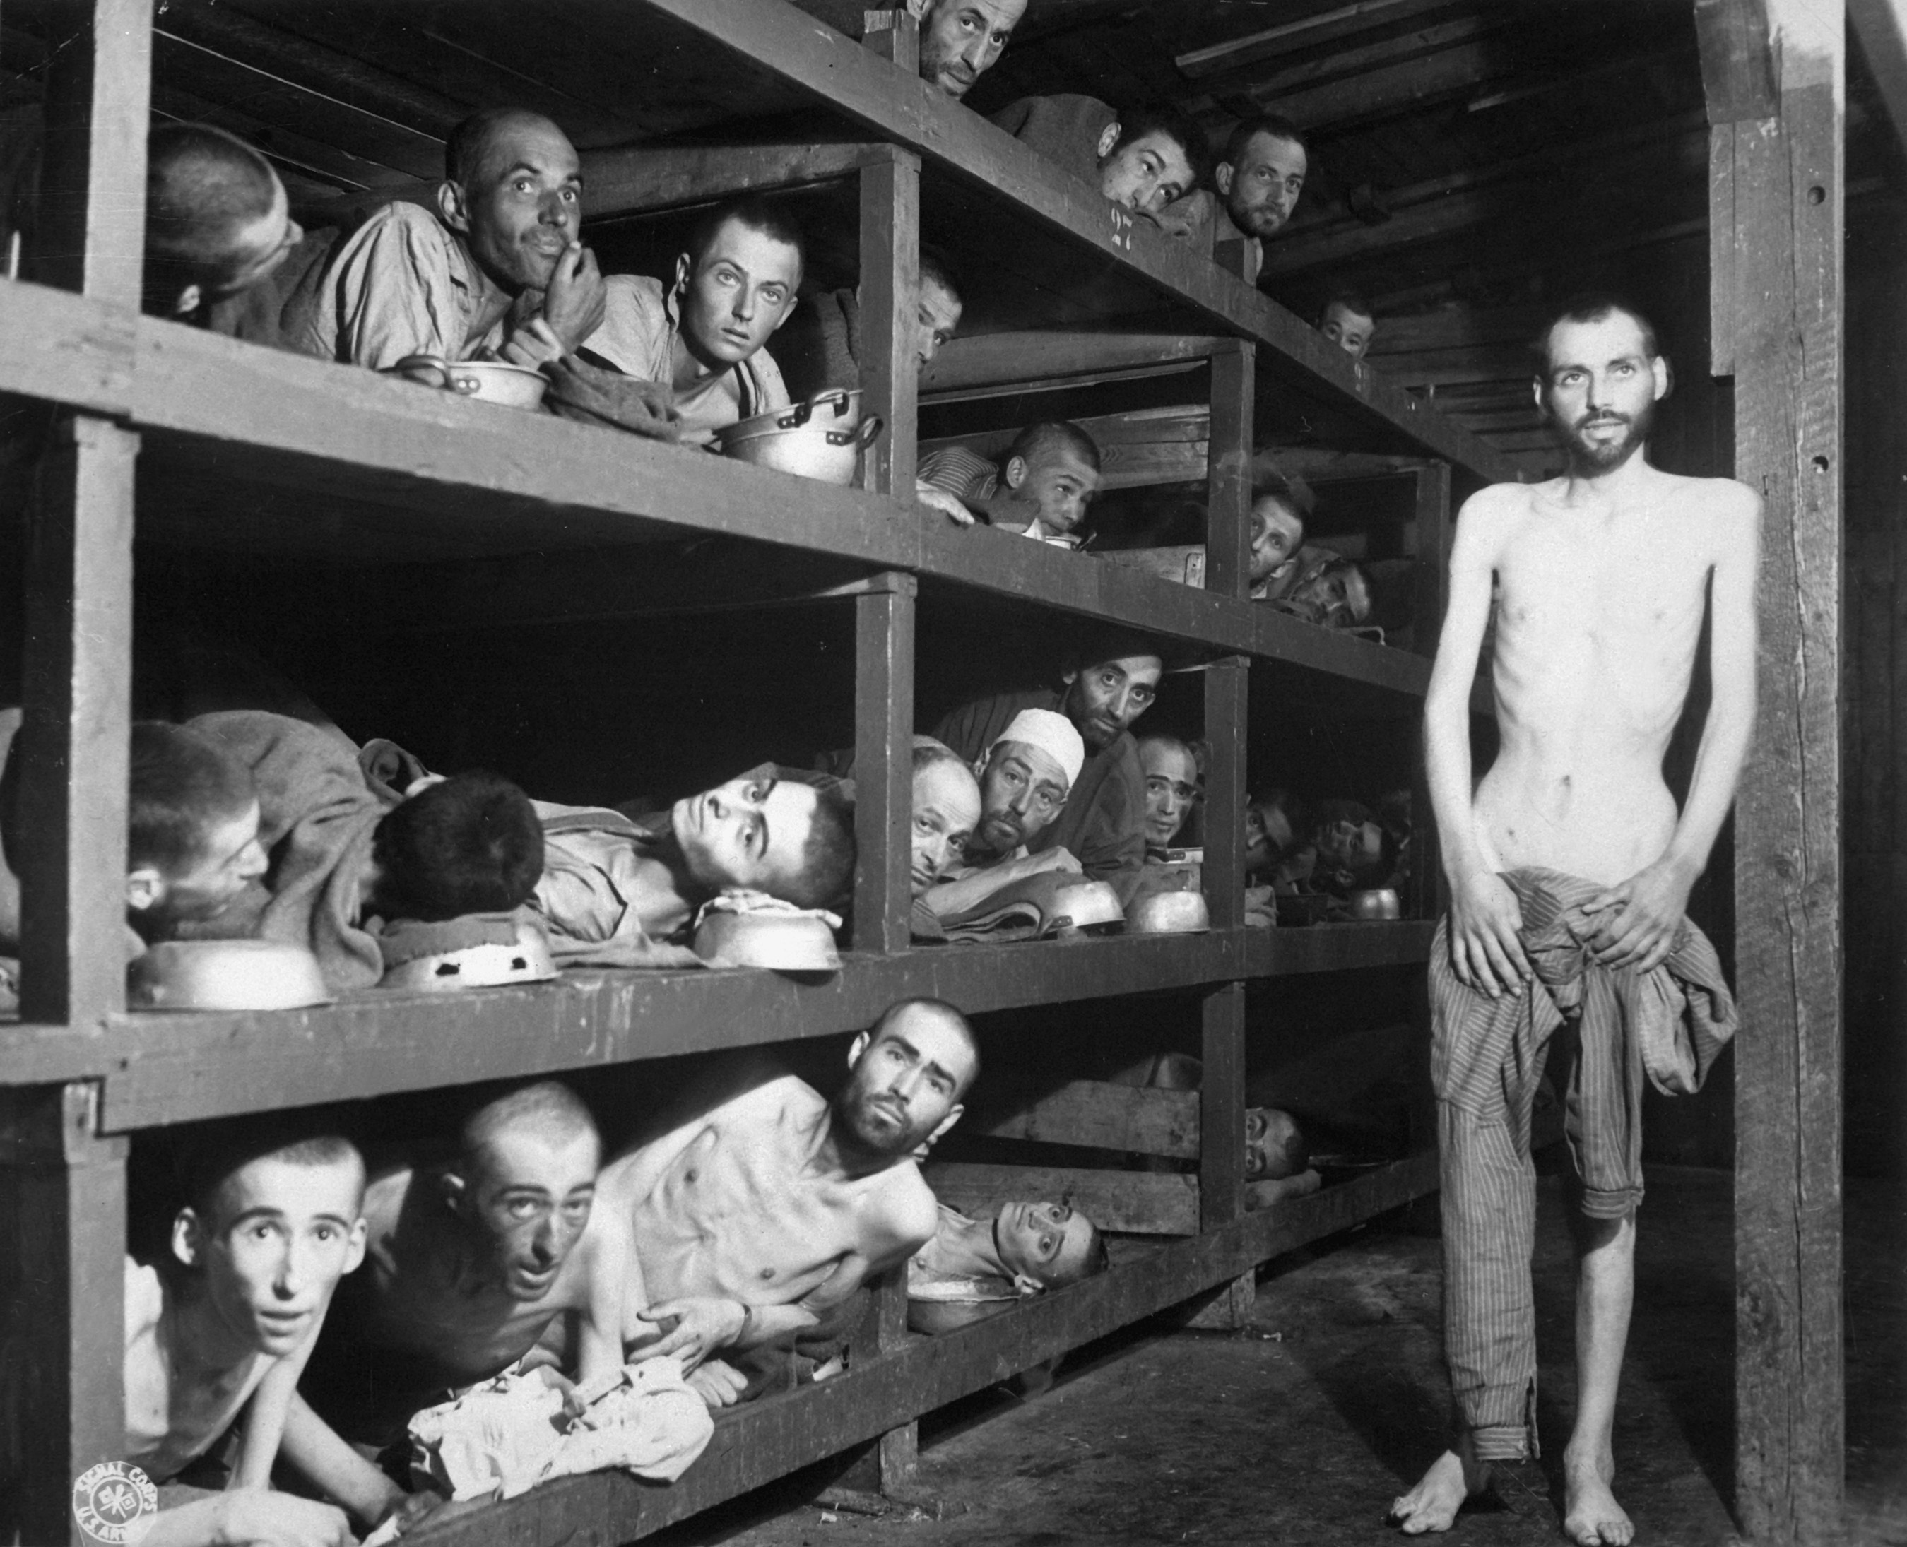
Buchenwald Slave Laborers Liberation (April 16, 1945) · Private H. Miller / U.S. Army Signal Corps · April 16, 1945
Source: Miller, H. "Buchenwald Slave Laborers Liberation." 16 Apr. 1945. U.S. Army Signal Corps / National Archives and Records Administration, via Wikimedia Commons, commons.wikimedia.org/wiki/File:Buchenwald_Slave_Laborers_Liberation.jpg. Public Domain https://commons.wikimedia.org/wiki/File:Buchenwald_Slave_Laborers_Liberation.jpg
HIPPO — analyze the source (prompt) | Your analysis
H — Historical context: what was happening when this was created?
I — Intended audience: who was meant to see or obey it?
P — Purpose: why was it created?
P — Point of view: whose perspective does it reflect?
O — Outside connection: how does it connect to this standard?
SUPPORT OPTION
Sentence frame: This source shows ______ because it ______, which reveals ______.
CONFIDENCE CHECK-IN
Rate your understanding of this standard (1–4): ______ One thing to revisit: ____________________
HIPPO SUPPORTS — analyzing the source · US.47
Optional — use these to complete your HIPPO analysis. Your teacher may print this back page or leave it off.
Guiding questions
• H — Historical context: What was happening in the world when this was made?
• I — Intended audience: Who was meant to see or obey it?
• P — Purpose: Why did the creator make it? What did they want to happen?
• P — Point of view: Whose side does it show? Whose voice is missing?
• O — Outside connection: What have we studied that connects to this?
SUPPORT OPTION
Sentence frame: This source shows ______ because it ______, which reveals ______.
Model analysis (example)
H: Taken April 16, 1945, as U.S. troops liberated the Buchenwald concentration camp near the end of the war in Europe, when the full scale of the Holocaust was being revealed. I: The American public and the world, released through the U.S. Army Signal Corps and the press. P: To create an official record of Nazi atrocities and confront denial that the camps existed. POV: It shows the liberators' and survivors' view; the perpetrators are outside the frame. O: Connects to earlier U.S. refusal to raise immigration quotas (the SS St. Louis, 1939) and to the postwar admission of survivors.
Try it — sourcing warm-up
Before you fill in HIPPO on the front, answer these in one line each:
• Who made this source, and when?

• What did they want the viewer to think or feel?

• How does that change how much you trust it?

Activity 6 — Core Application: Practice Quiz — US.47 ⏱ ~8 min ▶ Deck slide 25
RESPONSE CHOICE
Commit to an answer by marking it, saying it, or explaining it aloud before checking. Answer key is in the Teacher Guide (kept separate).
[DOK 1 · item q-us49-dok1-1]
1. What was the Holocaust?
A. Allied strategic bombing campaign targeting German industrial cities in Europe
B. Military campaign fought across North Africa between Allied and Axis forces
✓ C. Systematic Nazi genocide that killed 6 million Jews and millions of others
D. International peace agreement signed between the Allied and Axis powers
[DOK 2 · item q-us49-dok2-2]
2. What was Kristallnacht (Night of Broken Glass)?
A. Allied bombing raid targeting German military factories and industrial centers in 1943
✓ B. November 1938 Nazi pogrom destroying Jewish businesses, synagogues, and killing 91 Jews
C. Major German military victory on the Eastern Front that expanded Nazi-controlled territory
D. Public celebration in Germany marking the signing of a non-aggression pact with Soviets
[DOK 2 · item q-us49-dok2-1]
3. How did the U.S. respond to the Holocaust before entering World War II?
✓ A. Maintained strict immigration quotas and turned away refugee ships like St. Louis
B. Military alliance between fascist and militarist powers Italy, Germany, and Japan
C. Establish German racial supremacy and expand living space (Lebensraum) eastward
D. 1934 Nazi purge eliminating Hitler's political rivals and consolidating power
[DOK 2 · item q-us49-dok3-1]
4. Why did the U.S. and other nations fail to prevent the Holocaust?
✓ A. Immigration restrictions, anti-Semitism, disbelief of reports, and prioritizing military victory
B. Prison camps where Jews and others were detained, forced to labor, and systematically murdered
C. November 1938 Nazi pogrom destroying Jewish businesses, synagogues, and killing 91 Jews
D. Walled section of Warsaw where Nazis confined over 400,000 Jews in terrible conditions
CHECK YOURSELF — quiz answer key
Commit your answers first, then check: 1. C 2. B 3. A 4. A
Missed one? Reread that section and fix your thinking — that is where the learning happens.

Activity 7 — Constructed Response (CER) — US.47 ⏱ ~15 min ▶ Deck slides 19–23
BIG-QUESTION ORGANIZER — in World War II, how did the war reshape America at home and its role in the world — and who sacrificed, even while being excluded?
Jot quick notes from THIS standard: Who benefited? · Who bore the costs? · Who decided?

CONSTRUCTED RESPONSE (CER) — builds SSP.04 Argumentation
Claim + Evidence + Reasoning: Using this standard, take a position on the central question — analyze the response of the U.S. to the plight of European Jews before the war, the liberation of concentration camps during the war, and the immigration of Holocaust survivors after the war? Support your claim with two pieces of evidence from the passage and explain your reasoning.
Part | Write here
Claim
Evidence (two specifics)
Reasoning
SELF-GRADE YOUR CER — score each trait 1–4
Trait | What a strong (3–4) response shows | My score (1–4)
Claim | Clear; directly answers the question
Evidence | Two specific facts from the sources
Reasoning | Explains HOW the evidence proves the claim
Conventions | Complete, readable sentences
My total: ______ / 16 · One thing I will improve next time: ______________________
Peer review — trade & improve
Glow — one thing that works:

Grow — one thing to strengthen:

My revision — one change I will make:

WRITING SUPPORTS — Constructed Response (CER) · US.47
Optional — use these to plan and write your CER. Your teacher may print this back page or leave it off; the goal on the front never changes.
Sentence stems
• Claim: “One major cause of ______ was ______.” / “______ happened mainly because ______.”
• Evidence: “According to the source, ______.” / “For example, ______ shows that ______.”
• Reasoning: “This evidence proves ______ because ______.” / “This matters because ______.”
• Go further: “Although some might say ______, the stronger evidence shows ______.”
Model response (example)
Claim: The U.S. response to the Holocaust shifted from limited action before the war, to direct liberation during it, to gradual acceptance of survivors afterward. Evidence: Before the war strict immigration quotas kept many Jewish refugees out (the SS St. Louis was turned away in 1939); during the war U.S. troops liberated camps such as Buchenwald in 1945. Reasoning: This shows the U.S. did little to rescue Jews early but confronted the Holocaust once its armies reached the camps, and later loosened policy to admit survivors.
CER rubric — in your own words
• Claim — I answer the question in one clear sentence.
• Evidence — I use two specific facts from the sources.
• Reasoning — I explain HOW my evidence proves my claim.
• Conventions — I write in complete sentences a reader can follow.
Argument word bank
First · Because · For example · This shows that · As a result · Therefore · However · Although · In contrast · This matters because
EXIT TICKET — before you leave [item us47-q3 · DOK 2 · pre-field-test]
How did American forces respond when they liberated Nazi concentration camps, and what impact did this have on public awareness?
✓ A. Shocked soldiers provided immediate aid, documented evidence, and forced German civilians to view the camps; footage broadcast to America created lasting awareness and moral awakening
B. They had been prepared for what they found, which contradicts the primary source evidence from this era, but the historical evidence paints a more nuanced picture
C. Liberation had no impact on public awareness, which ignores key developments that shaped the outcome, which contradicts the primary source evidence from this era
D. American forces avoided the concentration camps, but contemporary accounts suggest a different explanation and oversimplifies the complex factors at work during this period
Show what you know (your choice): mark the best answer, say it, or explain it — then rate how sure you are: ☐ Not yet ☐ Getting there ☐ Got it
✔ ANSWER: A — U.S. troops liberated camps such as Buchenwald and Dachau in 1945, documenting Nazi atrocities. (Full key & reteach in the Teacher Guide.)

Standard US.48 — American Entry into World War II
TN Academic Standard US.48: Explain the reasons for American entry into World War II, including the attack on Pearl Harbor.
LEARNING TARGETS — I can…
• I can explain the reasons for American entry into World War II, including the attack on Pearl Harbor.
Lenses for this standard: History · Politics/Government
CORE PATH — the same for every student
Same rigor for everyone: analyze the sources and vocabulary, then show what you learned on the Practice Quiz and the CER.
Check yourself against the learning targets on the Cornell Notes page.
★ Tennessee Connection
After Pearl Harbor, Tennesseans enlisted in massive numbers, continuing the 'Volunteer State' tradition. Congressman Albert Gore Sr. of Carthage voted for the declaration of war and later served in the Army. Tennessee's industrial base rapidly converted to war production.
SET YOUR GOAL (self-direction)
My goal for this standard — what will I be able to do, and how will I show it?

HOOK — think before you dig in
For two years America stayed out of the war, protected by two oceans. In a single morning at Pearl Harbor, that safety vanished. What turns a neutral nation into a fighting one overnight? As you read, track how one attack united a divided country.
ACTIVATE — what do you already know or wonder?
Think about it, then jot a few notes in your notebook: what do you already know, and what do you wonder about this standard? You will come back to it.
PREVIEW & PREDICT
Which learning target will be hardest, and why? Connect it to the unit’s big question: how did the war change America at home and abroad, and who sacrificed even while excluded?

Activity 1 — Vocabulary (Part A: Reference / Word Bank) — US.48 ⏱ ~10 min ▶ Deck slide 32
Use this word bank throughout the standard. The Spanish column supports access, not translation of assessment.
Term | Student-friendly meaning | Spanish
Pearl Harbor | Japan's surprise attack on the U.S. naval base in Hawaii on December 7, 1941, killing over 2,400 Americans and bringing the United States into World War II. | Pearl Harbor
Hideki Tojo | Japanese military leader and Prime Minister (1941-1944) who led Japan into World War II and authorized the attack on Pearl Harbor. | Hideki Tojo
Axis Powers | Military alliance of Germany, Italy, and Japan during World War II. United by shared goals of territorial expansion, militarism, and opposition to democratic nations. | Potencias del Eje
Allied Powers | The World War II coalition led by the United States, Great Britain, and the Soviet Union that fought and defeated the Axis Powers. | Potencias Aliadas
Lend-Lease Act (1941) | U.S. program allowing the President to lend or lease war supplies to any nation deemed vital to American defense, primarily Britain and the Soviet Union. | Ley de Préstamo y Arriendo (1941)
Nazi-Soviet Pact (1939) | Non-aggression agreement between Hitler and Stalin (August 1939) that shocked the world. Secret provisions divided Poland and Eastern Europe between Germany and the Soviet Union. | Pacto Nazi-Soviético (1939)
LANGUAGE SUPPORT
Pronunciations: Pearl Harbor (purl HAR-ber); Hideki Tojo (hee-DEH-kee TOH-joh); Axis Powers (AK-sis POW-erz); Allied Powers (AL-yd POW-erz); Lend-Lease Act (1941) (lend lees akt); Nazi-Soviet Pact (1939) (NOT-see SOH-vee-et pakt).
VOCABULARY SELF-CHECK · Knowledge Rating
Rate each term NOW in pencil, then again at the END — growth is the goal; no penalty for “never seen it.”
Term | 1 · never seen it | 2 · heard it | 3 · can use it | 4 · can teach it
Pearl Harbor
Hideki Tojo
Axis Powers
Allied Powers
Lend-Lease Act (1941)
Nazi-Soviet Pact (1939)
MAKE IT YOURS (RESPONSE CHOICE): choose ONE term above and show you own it — write a sentence, sketch it, or give a real-world example. Do this in your notebook or on a whiteboard — be ready to share.
VOCABULARY SUPPORTS — make the words stick
Word-attack strategy: break long terms into smaller parts you recognize. Several terms are Spanish cognates (declaration / declaración), so use the Spanish column to unlock meaning.
Quick practice — choose ONE
• Draw a quick symbol for two terms.
• Write one sentence that uses two terms together.
• Teach a term to a partner in 20 seconds.

Do your quick practice here:

Use two terms together in one sentence:

Cognate connection — write the English term and its Spanish cognate for two words:

Study tip: cover the meaning column and quiz yourself, then re-rate each term on the self-check at the end of the standard.

Activity 2 — Vocabulary Studio (Frayer-inspired) — US.48 ⏱ ~7 min ▶ Deck slide 32
RESPONSE CHOICE
Complete each studio by writing, speaking, or diagramming.

PRIORITY TERM 1 Pearl Harbor · ES: Pearl Harbor
Word-bank meaning to build on: Japan's surprise attack on the U.S. naval base in Hawaii on December 7, 1941, killing over 2,400 Americans and bringing the United States into World War II.
Definition (in your own words) | Characteristics
Examples | Non-examples
Use it to explain
Write one sentence that uses “Pearl Harbor” to explain this standard.

PRIORITY TERM 2 Hideki Tojo · ES: Hideki Tojo
Word-bank meaning to build on: Japanese military leader and Prime Minister (1941-1944) who led Japan into World War II and authorized the attack on Pearl Harbor.
Definition (in your own words) | Characteristics
Examples | Non-examples
Use it to explain
Write one sentence that uses “Hideki Tojo” to explain this standard.

CONNECT THE TERMS (UDL · build understanding)
How do these priority terms fit together? On a whiteboard or in your notebook, draw a quick web or write 2–3 sentences showing how one leads to or affects another — be ready to share.

Activity 3 — Direct Teaching Cornell Notes — US.48 ⏱ ~20 min ▶ Deck slides 27–29
Name: ______________________ Class / Period: __________ Date: __________
US.48 — American Entry into World War II • These notes capture the direct-teaching content and the Close Read for this standard.
Your learning targets are on this standard’s opening page — take notes that help you meet them.
Cues (tied to your learning targets) | My notes
What does the passage say about factors in the European Theater?
What does the passage say about factors in the Pacific Theater?
What does the passage say about attack on Pearl Harbor (December 7, 1941)?
Key terms →

Cornell Notes — keep going, then process & check — US.48
MORE NOTES / DIAGRAMS
Continue your notes here, add a quick sketch, or map how the ideas connect.

Key terms to list
Pearl Harbor · Hideki Tojo · Axis Powers · Allied Powers · Lend-Lease Act (1941) · Nazi-Soviet Pact (1939)
Summary — In your own words (2–3 sentences)
PROGRESS CHECK · one question
How did the Pearl Harbor attack unite American public opinion and end isolationism?
A. Public opinion remained divided after Pearl Harbor, which contradicts the primary source evidence from this era, but the historical evidence paints a more nuanced picture
B. Isolationism continued throughout the war, but the historical record tells a more complex story and oversimplifies the complex factors at work during this period
C. Pearl Harbor had no effect on public opinion, but the historical record tells a more complex story and oversimplifies the complex factors at work during this period
D. The surprise attack shocked Americans, Roosevelt's "Date of Infamy" speech galvanized the nation, and Congress declared war with only one dissenting vote, destroying isolationist opposition
Commit before you move on — mark it, say it, or explain it aloud.
CHECK YOURSELF — how am I doing?
Which learning targets (on this standard’s opening page) can you now meet? Tick the number; circle any you still need help with.
☐ 1
My 12–15 word headline for this standard

Activity 4 — Close Read — US.48 ⏱ ~15 min ▶ Deck slides 27–29
Reading type: History Hack-authored instructional synthesis. This is not a primary source. Builds SSP.03 (synthesize) and SSP.05 (historical awareness).
Key terms first: Pearl Harbor, Hideki Tojo. Read once for the gist, then again for evidence.
CORE PATH — read one chunk at a time
Factors in the European Theater
German U-boats attacked U.S. ships carrying Lend-Lease supplies, leading to an undeclared naval war with the U.S. Navy escorting convoys and engaging German submarines. The Atlantic Charter created moral and strategic partnership with Britain. The Destroyer Deal exchanged U.S. destroyers for British bases, and U.S. forces occupied Iceland to prevent German control. These actions increasingly moved America toward war despite isolationist opposition.
Factors in the Pacific Theater
Japan conquered much of China and Southeast Asia, threatening U.S. territories and interests. In response, the U.S. imposed economic sanctions including an oil embargo and froze Japanese assets (July 1941). The Hull Note demanded Japanese withdrawal from China and Indochina, but negotiations failed to resolve differences. Japan's military leaders saw war with America as inevitable given the economic pressure.
Attack on Pearl Harbor (December 7, 1941)
Japan planned to eliminate the U.S. Pacific Fleet to prevent interference with expansion. Six aircraft carriers launched 353 planes in two waves on Sunday morning when defenses were relaxed. The attack sank or damaged 8 battleships, destroyed 188 planes, and killed 2,403 Americans. Intelligence failures left U.S. forces completely unprepared. Roosevelt's "Date of Infamy" speech galvanized the nation, and Congress declared war with only one dissenting vote.
Consequences of American Entry
Pearl Harbor destroyed isolationist opposition and unified American public opinion. Germany and Italy declared war on the U.S. (December 11), making the conflict worldwide. Domestically, war ended the Great Depression and created full employment, while the government gained unprecedented powers. Internationally, U.S. entry provided resources necessary to defeat the Axis, established America as the dominant world power, and led to the creation of the United Nations.
CLOSE-READ EVIDENCE LAB — for each question: quote the EVIDENCE from the passage above, then write YOUR ANSWER (or answer aloud / diagram it).
Text-dependent question | Evidence from the passage | Your answer (what it shows)
What is the main idea of the “Factors in the European Theater” section, and what evidence supports it?
What is the main idea of the “Factors in the Pacific Theater” section, and what evidence supports it?
What is the main idea of the “Attack on Pearl Harbor (December 7, 1941)” section, and what evidence supports it?

Activity 5 — Primary Source / Data Analysis — US.48 ⏱ ~15 min ▶ Deck slide 30
Primary source (photograph) — analyze it with HIPPO. Builds SSP.01–SSP.02.
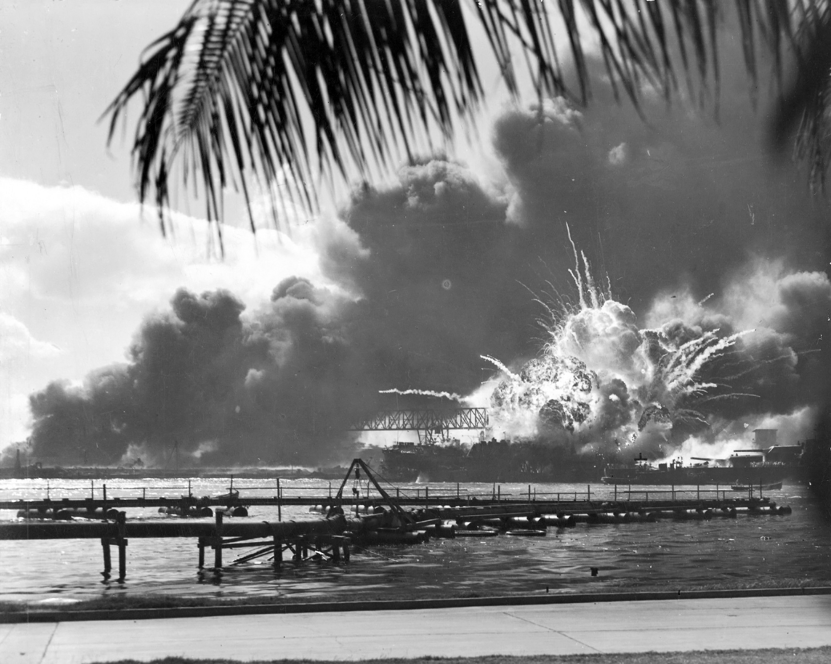
USS Shaw Exploding During the Japanese Raid on Pearl Harbor, T.H. (80-G-16871) · Unknown U.S. Navy photographer / U.S. Navy · December 7, 1941
Source: Unknown U.S. Navy photographer. "USS Shaw Exploding During the Japanese Raid on Pearl Harbor, T.H." 7 Dec. 1941. U.S. Navy / National Archives and Records Administration, via Wikimedia Commons, commons.wikimedia.org/wiki/File:USS_SHAW_exploding_Pearl_Harbor_Nara_80-G-16871_2.jpg. Public Domain https://commons.wikimedia.org/wiki/File:USS_SHAW_exploding_Pearl_Harbor_Nara_80-G-16871_2.jpg
HIPPO — analyze the source (prompt) | Your analysis
H — Historical context: what was happening when this was created?
I — Intended audience: who was meant to see or obey it?
P — Purpose: why was it created?
P — Point of view: whose perspective does it reflect?
O — Outside connection: how does it connect to this standard?
SUPPORT OPTION
Sentence frame: This source shows ______ because it ______, which reveals ______.
CONFIDENCE CHECK-IN
Rate your understanding of this standard (1–4): ______ One thing to revisit: ____________________
HIPPO SUPPORTS — analyzing the source · US.48
Optional — use these to complete your HIPPO analysis. Your teacher may print this back page or leave it off.
Guiding questions
• H — Historical context: What was happening in the world when this was made?
• I — Intended audience: Who was meant to see or obey it?
• P — Purpose: Why did the creator make it? What did they want to happen?
• P — Point of view: Whose side does it show? Whose voice is missing?
• O — Outside connection: What have we studied that connects to this?
SUPPORT OPTION
Sentence frame: This source shows ______ because it ______, which reveals ______.
Model analysis (example)
H: Photographed December 7, 1941, during Japan's surprise attack on the U.S. naval base at Pearl Harbor, Hawaii. I: The American public, published to show the devastation of the attack. P: To document the damage; once released, the image helped rally Americans for war. POV: The U.S. Navy's perspective as the victim of a surprise attack. O: Connects to FDR's “date which will live in infamy” speech and the U.S. declaration of war the next day.
Try it — sourcing warm-up
Before you fill in HIPPO on the front, answer these in one line each:
• Who made this source, and when?

• What did they want the viewer to think or feel?

• How does that change how much you trust it?

Activity 6 — Core Application: Practice Quiz — US.48 ⏱ ~8 min ▶ Deck slide 33
RESPONSE CHOICE
Commit to an answer by marking it, saying it, or explaining it aloud before checking. Answer key is in the Teacher Guide (kept separate).
[DOK 1 · item q-us48-dok1-1]
1. When did Japan attack Pearl Harbor?
A. Benito Mussolini, who created the first fascist state
B. Germany's invasion of Poland on September 1, 1939
✓ C. December 7, 1941, bringing the U.S. into World War II
D. Required military registration and draft of men ages 18-45
[DOK 1 · item q-us48-dok1-5]
2. What was the significance of the oil embargo against Japan before Pearl Harbor?
A. Actually increased American trade with Japan as private companies bypassed the restrictions
B. Had minimal effect on Japan's military since they had large oil reserves stored in depots
C. Served as a symbolic diplomatic gesture that Japan largely ignored without major consequences
✓ D. Cut off 90% of Japan's oil supply, pressuring them to stop military expansion in Asia
[DOK 2 · item q-us48-dok2-3]
3. What was the significance of the attack on Pearl Harbor for U.S. public opinion?
A. Created deep divisions among Americans with half supporting war and half opposing it
B. Increased support for isolationism and strengthened calls for staying out of the war
C. Had minimal impact on public opinion since most Americans already supported joining war
✓ D. Unified Americans behind the war effort and ended isolationist sentiment overnight
[DOK 2 · item q-us48-passage-dok2-1]
4. Based on FDR's "Day of Infamy" speech, how did he characterize the Pearl Harbor attack to justify declaring war?
✓ A. As a sudden, deliberate, and premeditated attack requiring righteous response
B. From strict isolationism to "Arsenal of Democracy" providing aid to the Allies
C. Isolationist organization opposing U.S. entry into WWII before Pearl Harbor
D. Unified Americans behind the war effort and ended isolationist sentiment overnight
CHECK YOURSELF — quiz answer key
Commit your answers first, then check: 1. C 2. D 3. D 4. A
Missed one? Reread that section and fix your thinking — that is where the learning happens.

Activity 7 — Constructed Response (CER) — US.48 ⏱ ~15 min ▶ Deck slides 27–31
BIG-QUESTION ORGANIZER — in World War II, how did the war reshape America at home and its role in the world — and who sacrificed, even while being excluded?
Jot quick notes from THIS standard: Who benefited? · Who bore the costs? · Who decided?

CONSTRUCTED RESPONSE (CER) — builds SSP.04 Argumentation
Claim + Evidence + Reasoning: Using this standard, take a position on the central question — explain the reasons for American entry into World War II, including the attack on Pearl Harbor? Support your claim with two pieces of evidence from the passage and explain your reasoning.
Part | Write here
Claim
Evidence (two specifics)
Reasoning
SELF-GRADE YOUR CER — score each trait 1–4
Trait | What a strong (3–4) response shows | My score (1–4)
Claim | Clear; directly answers the question
Evidence | Two specific facts from the sources
Reasoning | Explains HOW the evidence proves the claim
Conventions | Complete, readable sentences
My total: ______ / 16 · One thing I will improve next time: ______________________
Peer review — trade & improve
Glow — one thing that works:

Grow — one thing to strengthen:

My revision — one change I will make:

WRITING SUPPORTS — Constructed Response (CER) · US.48
Optional — use these to plan and write your CER. Your teacher may print this back page or leave it off; the goal on the front never changes.
Sentence stems
• Claim: “One major cause of ______ was ______.” / “______ happened mainly because ______.”
• Evidence: “According to the source, ______.” / “For example, ______ shows that ______.”
• Reasoning: “This evidence proves ______ because ______.” / “This matters because ______.”
• Go further: “Although some might say ______, the stronger evidence shows ______.”
Model response (example)
Claim: The Japanese attack on Pearl Harbor was the immediate cause that brought the United States into World War II. Evidence: On December 7, 1941, Japan bombed the U.S. fleet at Pearl Harbor, and the next day Congress declared war on Japan. Reasoning: The attack ended American isolationism overnight by making neutrality impossible and uniting public opinion behind entering the war.
CER rubric — in your own words
• Claim — I answer the question in one clear sentence.
• Evidence — I use two specific facts from the sources.
• Reasoning — I explain HOW my evidence proves my claim.
• Conventions — I write in complete sentences a reader can follow.
Argument word bank
First · Because · For example · This shows that · As a result · Therefore · However · Although · In contrast · This matters because
EXIT TICKET — before you leave [item us48-q1 · DOK 2 · pre-field-test]
What factors in both Europe and the Pacific pushed America toward war by 1941?
A. America had no interests in either region, but this oversimplifies the complex factors at work, but contemporary accounts and primary sources suggest otherwise
✓ B. In Europe, U-boat attacks and Lend-Lease involvement; in the Pacific, Japanese expansion threatening U.S. interests, economic sanctions, and failed diplomacy all pushed toward conflict
C. Only European factors mattered, but this fails to account for the broader historical context, which represents a common misconception about this historical period
D. America actively sought war in both regions, despite the fact that multiple sources contradict this view and fails to account for key developments in the broader context
Show what you know (your choice): mark the best answer, say it, or explain it — then rate how sure you are: ☐ Not yet ☐ Getting there ☐ Got it
✔ ANSWER: B — Aggression in both theaters — Axis expansion in Europe and Japan’s attack at Pearl Harbor — pushed the U.S. to war. (Full key & reteach in the Teacher Guide.)

Standard US.49 — WWII Leaders & Key Figures
TN Academic Standard US.49: Identify the roles and the significant actions of the following individuals in World War II: Winston Churchill, Dwight D. Eisenhower, Adolf Hitler, Douglas MacArthur, George C. Marshall, Benito Mussolini, President Franklin D. Roosevelt, Joseph Stalin, Hideki Tojo, President Harry S. Truman.
LEARNING TARGETS — I can…
• I can identify the roles and the significant actions of key individuals in World War II, including Churchill, Eisenhower, Hitler, MacArthur, Marshall, Mussolini, FDR, Stalin, Tojo, and Truman.
Lenses for this standard: History · Politics/Government
CORE PATH — the same for every student
Same rigor for everyone: analyze the sources and vocabulary, then show what you learned on the Practice Quiz and the CER.
Check yourself against the learning targets on the Cornell Notes page.
★ Tennessee Connection
Tennessee contributed key military leaders to WWII. Lieutenant Alexander 'Sandy' Ninninger, though born in Georgia, trained at Fort Oglethorpe near Chattanooga and was the first Medal of Honor recipient of WWII. Thousands of officers trained at Tennessee military installations before deploying to both theaters.
SET YOUR GOAL (self-direction)
My goal for this standard — what will I be able to do, and how will I show it?

HOOK — think before you dig in
A war fought by millions was steered by a handful of people — some who defended freedom, some who tried to destroy it. How much can one leader change history? As you read, compare the choices that led to victory with the ones that led to ruin.
ACTIVATE — what do you already know or wonder?
Think about it, then jot a few notes in your notebook: what do you already know, and what do you wonder about this standard? You will come back to it.
PREVIEW & PREDICT
Which learning target will be hardest, and why? Connect it to the unit’s big question: how did the war change America at home and abroad, and who sacrificed even while excluded?

Activity 1 — Vocabulary (Part A: Reference / Word Bank) — US.49 ⏱ ~10 min ▶ Deck slide 40
Use this word bank throughout the standard. The Spanish column supports access, not translation of assessment.
Term | Student-friendly meaning | Spanish
Dwight D. Eisenhower | Supreme Commander of Allied Forces in Europe who planned and led the D-Day invasion and coordinated Allied victory in Europe. Later became 34th President. | Dwight D. Eisenhower
Adolf Hitler | Nazi dictator of Germany (1933-1945) who led Germany into World War II and orchestrated the Holocaust, resulting in the deaths of 6 million Jews and millions of others. | Adolf Hitler
Joseph Stalin | Communist dictator of the Soviet Union (1924-1953) who ruled through terror, forced collectivization, and purges, resulting in millions of deaths. | Joseph Stalin
Hideki Tojo | Japanese military leader and Prime Minister (1941-1944) who led Japan into World War II and authorized the attack on Pearl Harbor. | Hideki Tojo
Allied Powers | The World War II coalition led by the United States, Great Britain, and the Soviet Union that fought and defeated the Axis Powers. | Potencias Aliadas
Axis Powers | Military alliance of Germany, Italy, and Japan during World War II. United by shared goals of territorial expansion, militarism, and opposition to democratic nations. | Potencias del Eje
LANGUAGE SUPPORT
Pronunciations: Dwight D. Eisenhower (dwyt EYE-zen-how-er); Adolf Hitler (AY-dolf HIT-ler); Joseph Stalin (JOH-zef STAH-lin); Hideki Tojo (hee-DEH-kee TOH-joh); Allied Powers (AL-yd POW-erz); Axis Powers (AK-sis POW-erz).
VOCABULARY SELF-CHECK · Knowledge Rating
Rate each term NOW in pencil, then again at the END — growth is the goal; no penalty for “never seen it.”
Term | 1 · never seen it | 2 · heard it | 3 · can use it | 4 · can teach it
Dwight D. Eisenhower
Adolf Hitler
Joseph Stalin
Hideki Tojo
Allied Powers
Axis Powers
MAKE IT YOURS (RESPONSE CHOICE): choose ONE term above and show you own it — write a sentence, sketch it, or give a real-world example. Do this in your notebook or on a whiteboard — be ready to share.
VOCABULARY SUPPORTS — make the words stick
Word-attack strategy: break long terms into smaller parts you recognize. Several terms are Spanish cognates (invasion / invasión), so use the Spanish column to unlock meaning.
Quick practice — choose ONE
• Draw a quick symbol for two terms.
• Write one sentence that uses two terms together.
• Teach a term to a partner in 20 seconds.

Do your quick practice here:

Use two terms together in one sentence:

Cognate connection — write the English term and its Spanish cognate for two words:

Study tip: cover the meaning column and quiz yourself, then re-rate each term on the self-check at the end of the standard.

Activity 2 — Vocabulary Studio (Frayer-inspired) — US.49 ⏱ ~7 min ▶ Deck slide 40
RESPONSE CHOICE
Complete each studio by writing, speaking, or diagramming.

PRIORITY TERM 1 Dwight D. Eisenhower · ES: Dwight D. Eisenhower
Word-bank meaning to build on: Supreme Commander of Allied Forces in Europe who planned and led the D-Day invasion and coordinated Allied victory in Europe. Later became 34th President.
Definition (in your own words) | Characteristics
Examples | Non-examples
Use it to explain
Write one sentence that uses “Dwight D. Eisenhower” to explain this standard.

PRIORITY TERM 2 Adolf Hitler · ES: Adolf Hitler
Word-bank meaning to build on: Nazi dictator of Germany (1933-1945) who led Germany into World War II and orchestrated the Holocaust, resulting in the deaths of 6 million Jews and millions of others.
Definition (in your own words) | Characteristics
Examples | Non-examples
Use it to explain
Write one sentence that uses “Adolf Hitler” to explain this standard.

CONNECT THE TERMS (UDL · build understanding)
How do these priority terms fit together? On a whiteboard or in your notebook, draw a quick web or write 2–3 sentences showing how one leads to or affects another — be ready to share.

Activity 3 — Direct Teaching Cornell Notes — US.49 ⏱ ~20 min ▶ Deck slides 35–37
Name: ______________________ Class / Period: __________ Date: __________
US.49 — WWII Leaders & Key Figures • These notes capture the direct-teaching content and the Close Read for this standard.
Your learning targets are on this standard’s opening page — take notes that help you meet them.
Cues (tied to your learning targets) | My notes
What does the passage say about allied Political Leaders?
What does the passage say about allied Military Leaders?
What does the passage say about axis Leaders?
Key terms →

Cornell Notes — keep going, then process & check — US.49
MORE NOTES / DIAGRAMS
Continue your notes here, add a quick sketch, or map how the ideas connect.

Key terms to list
Dwight D. Eisenhower · Adolf Hitler · Joseph Stalin · Hideki Tojo · Allied Powers · Axis Powers
Summary — In your own words (2–3 sentences)
PROGRESS CHECK · one question
How did Allied leaders like Roosevelt, Churchill, and Stalin coordinate their war efforts despite different goals?
A. Through conferences at Tehran and Yalta, the "Europe First" strategy, and division of responsibilities, they maintained cooperation despite tensions over post-war Europe and different ideological systems
B. They never coordinated their efforts, which does not align with the documented historical record and oversimplifies the complex factors at work during this period despite the fact that multiple contemporary sources contradict this
C. Stalin made all decisions for the alliance, though this interpretation lacks supporting historical evidence, although this overlooks critical economic and social factors involved
D. They fought completely separate wars, although historical sources do not support this conclusion and oversimplifies the complex factors at work during this period when examined alongside the available primary and secondary sources
Commit before you move on — mark it, say it, or explain it aloud.
CHECK YOURSELF — how am I doing?
Which learning targets (on this standard’s opening page) can you now meet? Tick the number; circle any you still need help with.
☐ 1
My 12–15 word headline for this standard

Activity 4 — Close Read — US.49 ⏱ ~15 min ▶ Deck slides 35–37
Reading type: History Hack-authored instructional synthesis. This is not a primary source. Builds SSP.03 (synthesize) and SSP.05 (historical awareness).
Key terms first: Dwight D. Eisenhower, Adolf Hitler. Read once for the gist, then again for evidence.
CORE PATH — read one chunk at a time
Allied Political Leaders
Winston Churchill served as British Prime Minister (1940-1945), inspiring British resistance during the Battle of Britain and partnering with FDR on the Atlantic Charter. Franklin D. Roosevelt led America as President, implementing Lend-Lease, maintaining the Grand Alliance with Churchill and Stalin, and supporting the "Europe First" strategy. Joseph Stalin defended the Soviet Union against German invasion, achieved victory at Stalingrad, and led the massive Soviet advance that captured Berlin. Harry S. Truman became President in 1945, making the atomic bomb decision and overseeing Japanese surrender.
Allied Military Leaders
Dwight D. Eisenhower served as Supreme Allied Commander in Europe, planning D-Day and successfully managing the multinational Allied command. Douglas MacArthur commanded Allied forces in the Southwest Pacific, developing the island-hopping strategy and accepting Japanese surrender aboard USS Missouri. George C. Marshall, as Army Chief of Staff, organized the expansion of the U.S. Army from 200,000 to 8 million, developed the "Europe First" strategy, and coordinated global logistics.
Axis Leaders
Adolf Hitler, as Führer of Nazi Germany, developed blitzkrieg tactics, launched Operation Barbarossa against the Soviet Union, and orchestrated the Holocaust before committing suicide as Berlin fell. Benito Mussolini established fascist Italy and formed the Axis alliance, but Italian military failures required German rescue before he was captured and executed by partisans. Hideki Tojo, Japanese Prime Minister, authorized the Pearl Harbor attack and led Japan's Pacific conquest before being executed as a war criminal.
Comparing Leadership Approaches
Churchill provided inspirational leadership through rhetoric and determination. Eisenhower excelled at diplomatic coalition management. Hitler's dictatorial style led to strategic mistakes like fighting a two-front war. MacArthur was dramatic and media-conscious. Marshall demonstrated exceptional organizational ability. Roosevelt and Churchill maintained a "special relationship" while managing the difficult alliance with Stalin. The contrast between Allied cooperation and Axis failures in coordination contributed significantly to the war's outcome.
CLOSE-READ EVIDENCE LAB — for each question: quote the EVIDENCE from the passage above, then write YOUR ANSWER (or answer aloud / diagram it).
Text-dependent question | Evidence from the passage | Your answer (what it shows)
What is the main idea of the “Allied Political Leaders” section, and what evidence supports it?
What is the main idea of the “Allied Military Leaders” section, and what evidence supports it?

Activity 5 — Primary Source / Data Analysis — US.49 ⏱ ~15 min ▶ Deck slide 38
Document (text primary source — analyze with HIPPO). Builds SSP.01–SSP.02.
WE SHALL FIGHT ON THE BEACHES SPEECH
“We shall fight on the beaches, we shall fight on the landing grounds, we shall fight in the fields and in the streets, we shall fight in the hills; we shall never surrender, and even if, which I do not for a moment believe, this Island or a”
Source: Winston Churchill, June 4, 1940. Churchill, Winston. "We Shall Fight on the Beaches Speech." June 4, 1940. International Churchill Society, winstonchurchill.org/resources/speeches/1940-the-fine. Public domain. https://winstonchurchill.org/resources/speeches/1940-the-finest-hour/we-shall-fight-on-the-beaches/
HIPPO — analyze the source (prompt) | Your analysis
H — Historical context: what was happening when this was created?
I — Intended audience: who was meant to see or obey it?
P — Purpose: why was it created?
P — Point of view: whose perspective does it reflect?
O — Outside connection: how does it connect to this standard?
SUPPORT OPTION
Sentence frame: This source shows ______ because it ______, which reveals ______.

EXTEND & RE-ENGAGE (open to all)
Push past the document — corroborate, contextualize, and judge its meaning.
Historian move | Your response
Corroborate — what other source would confirm or complicate this one?
Contextualize — what was happening at the time that explains it?
So what? — why does this source still matter?
CONFIDENCE CHECK-IN
Rate your understanding of this standard (1–4): ______ One thing to revisit: ____________________
HIPPO SUPPORTS — analyzing the source · US.49
Optional — use these to complete your HIPPO analysis. Your teacher may print this back page or leave it off.
Guiding questions
• H — Historical context: What was happening in the world when this was made?
• I — Intended audience: Who was meant to see or obey it?
• P — Purpose: Why did the creator make it? What did they want to happen?
• P — Point of view: Whose side does it show? Whose voice is missing?
• O — Outside connection: What have we studied that connects to this?
SUPPORT OPTION
Sentence frame: This source shows ______ because it ______, which reveals ______.
Model analysis (example)
H: Delivered June 4, 1940, to the British House of Commons after the evacuation of Dunkirk, as France was falling and Britain faced Nazi Germany largely alone. I: The British Parliament and public — and, indirectly, the still-neutral United States. P: To rally Britain to keep fighting and to signal determination to potential allies. POV: Churchill's defiant wartime-leadership perspective. O: Connects to U.S. Lend-Lease aid to Britain and to Churchill's later cooperation with Roosevelt and Stalin.
Try it — sourcing warm-up
Before you fill in HIPPO on the front, answer these in one line each:
• Who made this source, and when?

• What did they want the viewer to think or feel?

• How does that change how much you trust it?

Activity 6 — Core Application: Practice Quiz — US.49 ⏱ ~8 min ▶ Deck slide 41
RESPONSE CHOICE
Commit to an answer by marking it, saying it, or explaining it aloud before checking. Answer key is in the Teacher Guide (kept separate).
[DOK 1 · item U6-DOK1-0002]
1. Eisenhower issued this order on the day of which major operation?
A. The U.S. landing at Iwo Jima
B. The Battle of Midway
✓ C. The D-Day invasion of Normandy
D. The atomic bombing of Hiroshima
[DOK 2 · item U6-DOK2-0008]
2. How did the roles of General Dwight D. Eisenhower and General Douglas MacArthur differ in World War II?
✓ A. Eisenhower served as Supreme Allied Commander in Europe while MacArthur commanded Allied forces in the Pacific
B. Eisenhower commanded Pacific island-hopping campaigns while MacArthur directed the D-Day landings in Europe
C. Eisenhower focused on the naval war in the Atlantic while MacArthur managed the bombing campaign over Japan
D. Both generals shared command of European theater operations, with Eisenhower directing ground forces and MacArthur directing air forces
[DOK 3 · item dok3-gen-u6-039]
3. General George C. Marshall served as Army Chief of Staff throughout World War II and is credited by historians with transforming the U.S. Army from a small peacetime force into a multi-million-man global military in under three years. Churchill called him 'the organizer of victory.' What does Marshall's record most clearly reveal about the relationship between military logistics and strategy?
✓ A. Marshall's record demonstrates that military strategy depends fundamentally on logistical and organizational capacity — the ability to build, equip, supply, and sustain forces at scale is as decisive as battlefield tactical genius.
B. Marshall's success shows that in modern industrial warfare, professional battlefield commanders are unnecessary because administrative skill alone determines military outcomes.
C. Marshall's role was primarily symbolic, as the actual organizational transformation of the U.S. military was accomplished by Congress and the defense industry without significant military leadership direction.
D. The rapid expansion Marshall oversaw weakened rather than strengthened the U.S. military by sacrificing training quality for numerical quantity, making American forces less effective than their more experienced German counterparts.
[DOK 3 · item dok3-gen-u6-041]
4. General Douglas MacArthur commanded Allied forces in the Pacific with remarkable success from 1942 to 1945, yet he was later relieved of command by Truman in 1951. Analyzing MacArthur's WWII record, which of the following best explains how his strategic decisions in the Pacific reflected both his military genius and a problematic relationship with civilian authority?
A. MacArthur's WWII record reveals no tension with civilian authority, as he consistently followed orders and deferred to presidential and congressional direction throughout the Pacific campaign.
✓ B. MacArthur's brilliant island-hopping strategy demonstrated genuine operational genius while his documented tendency to circumvent or publicly challenge Joint Chiefs directives revealed a pattern of straining civilian-military boundaries that would culminate in his 1951 dismissal.
C. MacArthur's WWII performance was mediocre, and his reputation as a military genius was manufactured through deliberate manipulation of wartime press coverage for personal political ambition.
D. MacArthur's relationship with civilian authority was unproblematic during WWII, and the civilian-military tensions only emerged after the war ended, making them irrelevant to evaluating his wartime record.
CHECK YOURSELF — quiz answer key
Commit your answers first, then check: 1. C 2. A 3. A 4. B
Missed one? Reread that section and fix your thinking — that is where the learning happens.

Activity 7 — Constructed Response (CER) — US.49 ⏱ ~15 min ▶ Deck slides 35–39
BIG-QUESTION ORGANIZER — in World War II, how did the war reshape America at home and its role in the world — and who sacrificed, even while being excluded?
Jot quick notes from THIS standard: Who benefited? · Who bore the costs? · Who decided?

CONSTRUCTED RESPONSE (CER) — builds SSP.04 Argumentation
Claim + Evidence + Reasoning: Using this standard, take a position on the central question — identify the roles and the significant actions of key individuals in World War II, including Churchill, Eisenhower, Hitler, MacArthur, Marshall, Mussolini, FDR, Stalin, Tojo, and Truman? Support your claim with two pieces of evidence from the passage and explain your reasoning.
Part | Write here
Claim
Evidence (two specifics)
Reasoning
SELF-GRADE YOUR CER — score each trait 1–4
Trait | What a strong (3–4) response shows | My score (1–4)
Claim | Clear; directly answers the question
Evidence | Two specific facts from the sources
Reasoning | Explains HOW the evidence proves the claim
Conventions | Complete, readable sentences
My total: ______ / 16 · One thing I will improve next time: ______________________
Peer review — trade & improve
Glow — one thing that works:

Grow — one thing to strengthen:

My revision — one change I will make:

WRITING SUPPORTS — Constructed Response (CER) · US.49
Optional — use these to plan and write your CER. Your teacher may print this back page or leave it off; the goal on the front never changes.
Sentence stems
• Claim: “One major cause of ______ was ______.” / “______ happened mainly because ______.”
• Evidence: “According to the source, ______.” / “For example, ______ shows that ______.”
• Reasoning: “This evidence proves ______ because ______.” / “This matters because ______.”
• Go further: “Although some might say ______, the stronger evidence shows ______.”
Model response (example)
Claim: Individual leaders shaped the course of World War II through the decisions they made. Evidence: Churchill rallied Britain to resist Nazi Germany after Dunkirk in 1940, while Eisenhower planned and commanded the D-Day invasion in 1944. Reasoning: These leaders' choices — resistance and strategic command — show how key individuals directed the Allied war effort toward victory.
CER rubric — in your own words
• Claim — I answer the question in one clear sentence.
• Evidence — I use two specific facts from the sources.
• Reasoning — I explain HOW my evidence proves my claim.
• Conventions — I write in complete sentences a reader can follow.
Argument word bank
First · Because · For example · This shows that · As a result · Therefore · However · Although · In contrast · This matters because
EXIT TICKET — before you leave [item us49-q2 · DOK 2 · pre-field-test]
What military strategies did commanders like Eisenhower and MacArthur use to achieve victory?
A. They used identical strategies in all theaters, although historical sources do not support this conclusion, but the historical evidence paints a more nuanced picture
B. Neither commander developed effective strategies, though this interpretation lacks supporting historical evidence, although this overlooks critical economic and social factors involved
✓ C. Eisenhower coordinated multinational forces for the massive D-Day invasion in Europe while MacArthur developed island-hopping to bypass Japanese strongholds in the Pacific
D. They focused only on defensive operations, but this oversimplifies the complex factors at work, which does not align with the documented historical record
Show what you know (your choice): mark the best answer, say it, or explain it — then rate how sure you are: ☐ Not yet ☐ Getting there ☐ Got it
✔ ANSWER: C — Commanders coordinated combined-arms operations across theaters (Eisenhower in Europe, MacArthur in the Pacific). (Full key & reteach in the Teacher Guide.)

Standard US.50 — Major WWII Battles: Midway, Iwo Jima, Okinawa & D-Day
TN Academic Standard US.50: Explain the role of geographic and military factors on the outcomes of battles in the Pacific and European theaters of war, including the Battles of Midway, Iwo Jima, Okinawa, and D-Day.
LEARNING TARGETS — I can…
• I can explain the role of geographic and military factors on the outcomes of battles in the Pacific and European theaters, including Midway, Iwo Jima, Okinawa, and D-Day.
Lenses for this standard: History · Geography
CORE PATH — the same for every student
Same rigor for everyone: analyze the sources and vocabulary, then show what you learned on the Practice Quiz and the CER.
Check yourself against the learning targets on the Cornell Notes page.
★ Tennessee Connection
Tennesseans served in every major battle of WWII. The 30th Infantry Division, with soldiers from Tennessee, fought from Normandy to the Elbe River. Camp Forrest near Tullahoma trained troops who fought at Normandy, Iwo Jima, and across the Pacific.
SET YOUR GOAL (self-direction)
My goal for this standard — what will I be able to do, and how will I show it?

HOOK — think before you dig in
A tiny volcanic island, a stretch of French beach, a patch of open ocean — some of the war's biggest turning points happened in the smallest places. Why does geography decide battles? As you read, notice how maps, distance, and timing shaped who won.
ACTIVATE — what do you already know or wonder?
Think about it, then jot a few notes in your notebook: what do you already know, and what do you wonder about this standard? You will come back to it.
PREVIEW & PREDICT
Which learning target will be hardest, and why? Connect it to the unit’s big question: how did the war change America at home and abroad, and who sacrificed even while excluded?

Activity 1 — Vocabulary (Part A: Reference / Word Bank) — US.50 ⏱ ~10 min ▶ Deck slide 48
Use this word bank throughout the standard. The Spanish column supports access, not translation of assessment.
Term | Student-friendly meaning | Spanish
D-Day (Normandy Invasion) | June 6, 1944 Allied invasion of Nazi-occupied France across the beaches of Normandy, the largest amphibious assault in history, turning point of the war in Europe. | Día D (Invasión de Normandía)
Battle of Midway | June 1942 decisive U.S. naval victory that stopped Japanese expansion in the Pacific and marked the turning point of the Pacific War. | Batalla de Midway
Battle of Iwo Jima | February-March 1945 brutal battle for a strategic Pacific island, famous for the iconic flag-raising photograph on Mount Suribachi. | Batalla de Iwo Jima
Battle of the Bulge | Germany's last major offensive (December 1944-January 1945) in the Ardennes forest, creating a "bulge" in Allied lines before being defeated. | Batalla de las Ardenas
Dwight D. Eisenhower | Supreme Commander of Allied Forces in Europe who planned and led the D-Day invasion and coordinated Allied victory in Europe. Later became 34th President. | Dwight D. Eisenhower
Allied Powers | The World War II coalition led by the United States, Great Britain, and the Soviet Union that fought and defeated the Axis Powers. | Potencias Aliadas
LANGUAGE SUPPORT
Pronunciations: D-Day (Normandy Invasion) (dee-day NOR-mun-dee); Battle of Midway (BAT-ul uv MID-way); Battle of Iwo Jima (BAT-ul uv EE-woh JEE-muh); Battle of the Bulge (BAT-ul uv thuh bulj); Dwight D. Eisenhower (dwyt EYE-zen-how-er); Allied Powers (AL-yd POW-erz).
VOCABULARY SELF-CHECK · Knowledge Rating
Rate each term NOW in pencil, then again at the END — growth is the goal; no penalty for “never seen it.”
Term | 1 · never seen it | 2 · heard it | 3 · can use it | 4 · can teach it
D-Day (Normandy Invasion)
Battle of Midway
Battle of Iwo Jima
Battle of the Bulge
Dwight D. Eisenhower
Allied Powers
MAKE IT YOURS (RESPONSE CHOICE): choose ONE term above and show you own it — write a sentence, sketch it, or give a real-world example. Do this in your notebook or on a whiteboard — be ready to share.
VOCABULARY SUPPORTS — make the words stick
Word-attack strategy: break long terms into smaller parts you recognize. Several terms are Spanish cognates (strategy / estrategia), so use the Spanish column to unlock meaning.
Quick practice — choose ONE
• Draw a quick symbol for two terms.
• Write one sentence that uses two terms together.
• Teach a term to a partner in 20 seconds.

Do your quick practice here:

Use two terms together in one sentence:

Cognate connection — write the English term and its Spanish cognate for two words:

Study tip: cover the meaning column and quiz yourself, then re-rate each term on the self-check at the end of the standard.

Activity 2 — Vocabulary Studio (Frayer-inspired) — US.50 ⏱ ~7 min ▶ Deck slide 48
RESPONSE CHOICE
Complete each studio by writing, speaking, or diagramming.

PRIORITY TERM 1 D-Day (Normandy Invasion) · ES: Día D (Invasión de Normandía)
Word-bank meaning to build on: June 6, 1944 Allied invasion of Nazi-occupied France across the beaches of Normandy, the largest amphibious assault in history, turning point of the war in Europe.
Definition (in your own words) | Characteristics
Examples | Non-examples
Use it to explain
Write one sentence that uses “D-Day (Normandy Invasion)” to explain this standard.

PRIORITY TERM 2 Battle of Midway · ES: Batalla de Midway
Word-bank meaning to build on: June 1942 decisive U.S. naval victory that stopped Japanese expansion in the Pacific and marked the turning point of the Pacific War.
Definition (in your own words) | Characteristics
Examples | Non-examples
Use it to explain
Write one sentence that uses “Battle of Midway” to explain this standard.

CONNECT THE TERMS (UDL · build understanding)
How do these priority terms fit together? On a whiteboard or in your notebook, draw a quick web or write 2–3 sentences showing how one leads to or affects another — be ready to share.

Activity 3 — Direct Teaching Cornell Notes — US.50 ⏱ ~20 min ▶ Deck slides 43–45
Name: ______________________ Class / Period: __________ Date: __________
US.50 — Major WWII Battles: Midway, Iwo Jima, Okinawa & D-Day • These notes capture the direct-teaching content and the Close Read for this standard.
Your learning targets are on this standard’s opening page — take notes that help you meet them.
Cues (tied to your learning targets) | My notes
What does the passage say about battle of Midway (June 1942)?
What does the passage say about battle of Iwo Jima (February-March 1945)?
What does the passage say about battle of Okinawa (April-June 1945)?
Key terms →

Cornell Notes — keep going, then process & check — US.50
MORE NOTES / DIAGRAMS
Continue your notes here, add a quick sketch, or map how the ideas connect.

Key terms to list
D-Day (Normandy Invasion) · Battle of Midway · Battle of Iwo Jima · Battle of the Bulge · Dwight D. Eisenhower · Allied Powers
Summary — In your own words (2–3 sentences)
PROGRESS CHECK · one question
How did geographic features of the Pacific islands affect American military strategy in battles like Midway and Iwo Jima?
A. Geography had no effect on Pacific strategy, though this interpretation lacks supporting historical evidence, although historical sources do not support this conclusion
B. Midway's central location made it strategically vital, while Iwo Jima's volcanic terrain created natural fortifications requiring costly direct assault to secure airfields needed for bombing Japan
C. All Pacific islands were geographically identical, which does not reflect the consensus among historians, but the historical evidence paints a more nuanced picture and does not reflect the scholarly consensus on this topic
D. American forces avoided geographic challenges entirely, which does not align with the documented historical record, and this view has been largely revised by modern historical research
Commit before you move on — mark it, say it, or explain it aloud.
CHECK YOURSELF — how am I doing?
Which learning targets (on this standard’s opening page) can you now meet? Tick the number; circle any you still need help with.
☐ 1
My 12–15 word headline for this standard

Activity 4 — Close Read — US.50 ⏱ ~15 min ▶ Deck slides 43–45
Reading type: History Hack-authored instructional synthesis. This is not a primary source. Builds SSP.03 (synthesize) and SSP.05 (historical awareness).
Key terms first: D-Day (Normandy Invasion), Battle of Midway. Read once for the gist, then again for evidence.
CORE PATH — read one chunk at a time
Battle of Midway (June 1942)
Midway Atoll's strategic location in the central Pacific made it crucial for both Japanese expansion and American defense. U.S. codebreakers broke Japanese naval codes, revealing attack plans. American carriers ambushed the Japanese fleet, sinking four aircraft carriers and destroying Japan's offensive capability. This "Miracle at Midway" shifted the Pacific war's momentum permanently to the Allies, demonstrating the critical importance of intelligence in modern warfare.
Battle of Iwo Jima (February-March 1945)
Iwo Jima's volcanic terrain created natural fortifications that Japanese defenders exploited through an extensive tunnel system. The island's airfields were needed for emergency landings by B-29 bombers attacking Japan and for fighter escorts. Despite knowing the location of Japanese defenses, Marines suffered nearly 7,000 killed and 20,000 wounded in 36 days of fighting. The iconic flag raising on Mount Suribachi became a symbol of American determination.
Battle of Okinawa (April-June 1945)
Okinawa's proximity to Japan (340 miles) made it essential as a staging base for invasion. The 82-day battle was the bloodiest Pacific campaign, with over 12,000 Americans killed and 110,000 Japanese military deaths. Mass kamikaze attacks damaged or sank hundreds of ships. The horrific casualties influenced American decisions about invading Japan versus using atomic weapons, as projected invasion casualties ran into the hundreds of thousands.
D-Day: Normandy Invasion (June 6, 1944)
The Normandy coast was chosen for its beaches suitable for landing craft, proximity to English ports, and weaker defenses than Pas-de-Calais. Allied deception operations convinced Germans the main attack would come elsewhere. Despite heavy casualties at Omaha Beach, Allied forces established beachheads and broke through German defenses. The largest amphibious invasion in history required unprecedented coordination of land, sea, and air forces, opening the Western Front that would ultimately liberate Western Europe.
CLOSE-READ EVIDENCE LAB — for each question: quote the EVIDENCE from the passage above, then write YOUR ANSWER (or answer aloud / diagram it).
Text-dependent question | Evidence from the passage | Your answer (what it shows)
What is the main idea of the “Battle of Midway (June 1942)” section, and what evidence supports it?
What is the main idea of the “Battle of Iwo Jima (February-March 1945)” section, and what evidence supports it?

Geographer’s Lens — US.50 ⏱ ~12 min
Geographers don’t just find places — they explain how WHERE shapes WHAT happens. Work these like a geographer. Built on the Five Themes of Geography · C3 Dimension 2 · SSP.06 (spatial reasoning).
THE PLACES — then explain why geography put them there
World War II was fought across two enormous theaters. Use the list below to map the major battles in the Pacific and in Europe, then explain the island-hopping and second-front patterns.
Place | Where | What happened (given) | Why HERE? (your analysis)
Midway | Central Pacific | 1942 naval battle — the turning point in the Pacific
Iwo Jima | Pacific (near Japan) | 1945 island-hopping battle toward the Japanese mainland
Okinawa | Pacific (near Japan) | 1945 — the last major island before Japan
Normandy (D-Day) | France, Western Europe | 1944 Allied invasion — the second front in Europe
MOVEMENT & REGION — what’s the spatial pattern?
In 1–2 sentences: is this a movement, a cluster, or a whole region? Name the direction or shape it takes on a map.

GEOGRAPHY AS A FORCE — how did location shape the outcome?
How did geography change WHAT happened — who was affected, how far or fast it spread, or who was left out? Use one place above as your evidence.

READ IT LIKE A SOURCE — RESPONSE CHOICE
A map is a source with a point of view. Show your thinking your way — write it, OR sketch a quick arrows-and-labels diagram: what would a map of this make CLEAR, and what would it HIDE or leave out?

Activity 5 — Primary Source / Data Analysis — US.50 ⏱ ~15 min ▶ Deck slide 46
Primary source (photograph) — analyze it with HIPPO. Builds SSP.01–SSP.02.
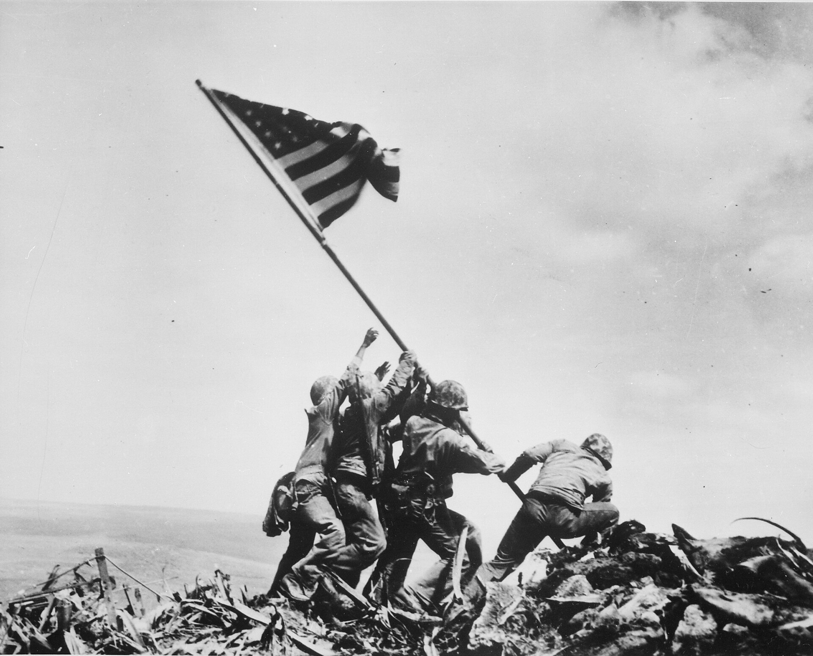
Raising the Flag on Iwo Jima (February 23, 1945) · Joe Rosenthal / Associated Press (remade from NARA File 520748) · February 23, 1945
Source: Rosenthal, Joe. "Raising the Flag on Iwo Jima." 23 Feb. 1945. Associated Press / National Archives and Records Administration, via Wikimedia Commons, commons.wikimedia.org/wiki/File:Raising_the_Flag_on_Iwo_Jima,_by_Joe_Rosenthal.jpg. Public Domain https://commons.wikimedia.org/wiki/File:Raising_the_Flag_on_Iwo_Jima,_by_Joe_Rosenthal.jpg
HIPPO — analyze the source (prompt) | Your analysis
H — Historical context: what was happening when this was created?
I — Intended audience: who was meant to see or obey it?
P — Purpose: why was it created?
P — Point of view: whose perspective does it reflect?
O — Outside connection: how does it connect to this standard?
SUPPORT OPTION
Sentence frame: This source shows ______ because it ______, which reveals ______.
CONFIDENCE CHECK-IN
Rate your understanding of this standard (1–4): ______ One thing to revisit: ____________________
HIPPO SUPPORTS — analyzing the source · US.50
Optional — use these to complete your HIPPO analysis. Your teacher may print this back page or leave it off.
Guiding questions
• H — Historical context: What was happening in the world when this was made?
• I — Intended audience: Who was meant to see or obey it?
• P — Purpose: Why did the creator make it? What did they want to happen?
• P — Point of view: Whose side does it show? Whose voice is missing?
• O — Outside connection: What have we studied that connects to this?
SUPPORT OPTION
Sentence frame: This source shows ______ because it ______, which reveals ______.
Model analysis (example)
H: Photographed February 23, 1945, during the Battle of Iwo Jima in the Pacific, as U.S. Marines captured the island. I: The American public; the image was soon used to promote war bonds. P: To capture the moment of victory on Mount Suribachi; later used for morale and fundraising. POV: The U.S. Marines' and American view of a hard-won Pacific victory. O: Connects to the island-hopping strategy and to the heavy casualties that shaped the decision to use the atomic bomb.
Try it — sourcing warm-up
Before you fill in HIPPO on the front, answer these in one line each:
• Who made this source, and when?

• What did they want the viewer to think or feel?

• How does that change how much you trust it?

Activity 6 — Core Application: Practice Quiz — US.50 ⏱ ~8 min ▶ Deck slide 49
RESPONSE CHOICE
Commit to an answer by marking it, saying it, or explaining it aloud before checking. Answer key is in the Teacher Guide (kept separate).
[DOK 1 · item q-us50-dok1-1]
1. What was D-Day?
✓ A. June 6, 1944 Allied invasion of Normandy, the largest amphibious assault in history
B. First meeting of Big Three (Roosevelt, Churchill, Stalin) to coordinate war strategy
C. Longest continuous military campaign; Allied victory ensured supply lines to Britain
D. U.S. destroyed four carriers, halting Japanese expansion and shifting war momentum
[DOK 2 · item q-us50-dok2-1]
2. Why was the Battle of Midway significant in the Pacific War?
A. June 6, 1944 Allied invasion of Normandy, the largest amphibious assault in history
✓ B. U.S. destroyed four carriers, halting Japanese expansion and shifting war momentum
C. First meeting of Big Three (Roosevelt, Churchill, Stalin) to coordinate war strategy
D. Longest continuous military campaign; Allied victory ensured supply lines to Britain
[DOK 2 · item q-us50-dok2-2]
3. What strategy did the Allies use in the Pacific Theater called "island hopping"?
✓ A. Capturing strategic islands while bypassing heavily defended ones to advance toward Japan
B. April 1942 surprise bombing raid on Tokyo that boosted American morale after Pearl Harbor
C. Failed Allied attempt to capture bridges in Netherlands and end war quickly (September 1944)
D. Last major battle before Japan surrendered; showed massive casualties an invasion would cause
[DOK 2 · item q-us50-dok3-1]
4. Why was the Battle of Stalingrad a major turning point in WWII?
A. Last major battle before Japan surrendered; showed massive casualties an invasion would cause
B. Failed Allied attempt to capture bridges in Netherlands and end war quickly (September 1944)
C. April 1942 surprise bombing raid on Tokyo that boosted American morale after Pearl Harbor
✓ D. Soviet victory ended German advance, destroyed entire army, shifted momentum on Eastern Front
CHECK YOURSELF — quiz answer key
Commit your answers first, then check: 1. A 2. B 3. A 4. D
Missed one? Reread that section and fix your thinking — that is where the learning happens.

Activity 7 — Constructed Response (CER) — US.50 ⏱ ~15 min ▶ Deck slides 43–47
BIG-QUESTION ORGANIZER — in World War II, how did the war reshape America at home and its role in the world — and who sacrificed, even while being excluded?
Jot quick notes from THIS standard: Who benefited? · Who bore the costs? · Who decided?

CONSTRUCTED RESPONSE (CER) — builds SSP.04 Argumentation
Claim + Evidence + Reasoning: Using this standard, take a position on the central question — explain the role of geographic and military factors on the outcomes of battles in the Pacific and European theaters, including Midway, Iwo Jima, Okinawa, and D-Day? Support your claim with two pieces of evidence from the passage and explain your reasoning.
Part | Write here
Claim
Evidence (two specifics)
Reasoning
SELF-GRADE YOUR CER — score each trait 1–4
Trait | What a strong (3–4) response shows | My score (1–4)
Claim | Clear; directly answers the question
Evidence | Two specific facts from the sources
Reasoning | Explains HOW the evidence proves the claim
Conventions | Complete, readable sentences
My total: ______ / 16 · One thing I will improve next time: ______________________
Peer review — trade & improve
Glow — one thing that works:

Grow — one thing to strengthen:

My revision — one change I will make:

WRITING SUPPORTS — Constructed Response (CER) · US.50
Optional — use these to plan and write your CER. Your teacher may print this back page or leave it off; the goal on the front never changes.
Sentence stems
• Claim: “One major cause of ______ was ______.” / “______ happened mainly because ______.”
• Evidence: “According to the source, ______.” / “For example, ______ shows that ______.”
• Reasoning: “This evidence proves ______ because ______.” / “This matters because ______.”
• Go further: “Although some might say ______, the stronger evidence shows ______.”
Model response (example)
Claim: Geography and military strategy strongly shaped the outcomes of key World War II battles. Evidence: At Midway (1942) U.S. code-breaking and carrier positioning let a smaller fleet defeat Japan, and Iwo Jima (1945) was taken for its strategic airfields despite heavy losses. Reasoning: These show that terrain, location, and strategy — not just numbers — decided battles and moved the Allies closer to Japan.
CER rubric — in your own words
• Claim — I answer the question in one clear sentence.
• Evidence — I use two specific facts from the sources.
• Reasoning — I explain HOW my evidence proves my claim.
• Conventions — I write in complete sentences a reader can follow.
Argument word bank
First · Because · For example · This shows that · As a result · Therefore · However · Although · In contrast · This matters because
EXIT TICKET — before you leave [item us50-q2 · DOK 2 · pre-field-test]
What role did intelligence gathering and code-breaking play in Allied victories at Midway and D-Day?
A. Intelligence had no impact on these battles, despite limited evidence supporting this interpretation, which ignores significant political and cultural developments of the era
B. The Allies avoided using intelligence entirely, which contradicts the primary source evidence from this era, although this overlooks critical economic and social factors involved
C. Only the Axis powers used intelligence effectively, but this oversimplifies the complex factors at work, but contemporary accounts and primary sources suggest otherwise
✓ D. Breaking Japanese codes revealed Midway attack plans enabling ambush, while deception operations convinced Germans the D-Day landing would come at Pas-de-Calais
Show what you know (your choice): mark the best answer, say it, or explain it — then rate how sure you are: ☐ Not yet ☐ Getting there ☐ Got it
✔ ANSWER: D — Intelligence and code-breaking (notably at Midway) let smaller forces anticipate and defeat the enemy. (Full key & reteach in the Teacher Guide.)

Standard US.51 — Special Fighting Forces in WWII
TN Academic Standard US.51: Identify the roles and sacrifices of individual American soldiers, as well as the unique contributions of special fighting forces such as the Tuskegee Airmen, the 442nd Regimental Combat team, the 101st Airborne, and the Navajo Code Talkers.
LEARNING TARGETS — I can…
• I can identify the roles and sacrifices of individual American soldiers and the unique contributions of special fighting forces such as the Tuskegee Airmen, the 442nd Regimental Combat Team, the 101st Airborne, and the Navajo Code Talkers.
Lenses for this standard: History · Culture
CORE PATH — the same for every student
Same rigor for everyone: analyze the sources and vocabulary, then show what you learned on the Practice Quiz and the CER.
Check yourself against the learning targets on the Cornell Notes page.
★ Tennessee Connection
Tennessee's Fort Campbell, straddling the Tennessee-Kentucky border, became home to the 101st Airborne Division ('Screaming Eagles'), one of the most celebrated special fighting forces of WWII. The division's paratroopers jumped into Normandy on D-Day and fought through the Battle of the Bulge.
SET YOUR GOAL (self-direction)
My goal for this standard — what will I be able to do, and how will I show it?

HOOK — think before you dig in
They flew, fought, and bled for a country that still treated them as second-class — and they were among the best it had. Why fight for freedom you don't fully enjoy at home? As you read, look for how these units answered that question with their service.
ACTIVATE — what do you already know or wonder?
Think about it, then jot a few notes in your notebook: what do you already know, and what do you wonder about this standard? You will come back to it.
PREVIEW & PREDICT
Which learning target will be hardest, and why? Connect it to the unit’s big question: how did the war change America at home and abroad, and who sacrificed even while excluded?

Activity 1 — Vocabulary (Part A: Reference / Word Bank) — US.51 ⏱ ~10 min ▶ Deck slide 56
Use this word bank throughout the standard. The Spanish column supports access, not translation of assessment.
Term | Student-friendly meaning | Spanish
Tuskegee Airmen | First African American military pilots who fought in World War II, proving their skill despite facing racial discrimination and segregation. | Aviadores de Tuskegee
442nd Regimental Combat Team | All Japanese-American unit that became the most decorated unit in U.S. military history, fighting in Europe while their families were interned at home. | 442º Equipo de Combate Regimental
Navajo Code Talkers | Navajo Marines who used their native language to create an unbreakable code for military communications in the Pacific theater. | Descifradores de Código Navajo
Battle of Iwo Jima | February-March 1945 brutal battle for a strategic Pacific island, famous for the iconic flag-raising photograph on Mount Suribachi. | Batalla de Iwo Jima
Allied Powers | The World War II coalition led by the United States, Great Britain, and the Soviet Union that fought and defeated the Axis Powers. | Potencias Aliadas
Holocaust | Nazi Germany's systematic genocide of 6 million Jews and millions of others (Roma, disabled, homosexuals, political opponents) during World War II. | Holocausto
LANGUAGE SUPPORT
Pronunciations: Tuskegee Airmen (tus-KEE-gee AIR-men); 442nd Regimental Combat Team (for-for-tee-SEK-und rej-ih-MEN-tul); Navajo Code Talkers (NAV-uh-hoh kohd TAWK-erz); Battle of Iwo Jima (BAT-ul uv EE-woh JEE-muh); Allied Powers (AL-yd POW-erz); Holocaust (HOL-uh-kawst).
VOCABULARY SELF-CHECK · Knowledge Rating
Rate each term NOW in pencil, then again at the END — growth is the goal; no penalty for “never seen it.”
Term | 1 · never seen it | 2 · heard it | 3 · can use it | 4 · can teach it
Tuskegee Airmen
442nd Regimental Combat Team
Navajo Code Talkers
Battle of Iwo Jima
Allied Powers
Holocaust
MAKE IT YOURS (RESPONSE CHOICE): choose ONE term above and show you own it — write a sentence, sketch it, or give a real-world example. Do this in your notebook or on a whiteboard — be ready to share.
VOCABULARY SUPPORTS — make the words stick
Word-attack strategy: break long terms into smaller parts you recognize. Several terms are Spanish cognates (combat / combate), so use the Spanish column to unlock meaning.
Quick practice — choose ONE
• Draw a quick symbol for two terms.
• Write one sentence that uses two terms together.
• Teach a term to a partner in 20 seconds.

Do your quick practice here:

Use two terms together in one sentence:

Cognate connection — write the English term and its Spanish cognate for two words:

Study tip: cover the meaning column and quiz yourself, then re-rate each term on the self-check at the end of the standard.

Activity 2 — Vocabulary Studio (Frayer-inspired) — US.51 ⏱ ~7 min ▶ Deck slide 56
RESPONSE CHOICE
Complete each studio by writing, speaking, or diagramming.

PRIORITY TERM 1 Tuskegee Airmen · ES: Aviadores de Tuskegee
Word-bank meaning to build on: First African American military pilots who fought in World War II, proving their skill despite facing racial discrimination and segregation.
Definition (in your own words) | Characteristics
Examples | Non-examples
Use it to explain
Write one sentence that uses “Tuskegee Airmen” to explain this standard.

PRIORITY TERM 2 442nd Regimental Combat Team · ES: 442º Equipo de Combate Regimental
Word-bank meaning to build on: All Japanese-American unit that became the most decorated unit in U.S. military history, fighting in Europe while their families were interned at home.
Definition (in your own words) | Characteristics
Examples | Non-examples
Use it to explain
Write one sentence that uses “442nd Regimental Combat Team” to explain this standard.

CONNECT THE TERMS (UDL · build understanding)
How do these priority terms fit together? On a whiteboard or in your notebook, draw a quick web or write 2–3 sentences showing how one leads to or affects another — be ready to share.

Activity 3 — Direct Teaching Cornell Notes — US.51 ⏱ ~20 min ▶ Deck slides 51–53
Name: ______________________ Class / Period: __________ Date: __________
US.51 — Special Fighting Forces in WWII • These notes capture the direct-teaching content and the Close Read for this standard.
Your learning targets are on this standard’s opening page — take notes that help you meet them.
Cues (tied to your learning targets) | My notes
What does the passage say about tuskegee Airmen?
What does the passage say about 442nd Regimental Combat Team?
What does the passage say about 101st Airborne Division?
Key terms →

Cornell Notes — keep going, then process & check — US.51
MORE NOTES / DIAGRAMS
Continue your notes here, add a quick sketch, or map how the ideas connect.

Key terms to list
Tuskegee Airmen · 442nd Regimental Combat Team · Navajo Code Talkers · Battle of Iwo Jima · Allied Powers · Holocaust
Summary — In your own words (2–3 sentences)
PROGRESS CHECK · one question
Why is the service of the 442nd Regimental Combat Team particularly significant given the internment of Japanese Americans?
A. Their service had no connection to internment policies, but the historical record tells a more complex story, and this view has been largely revised by modern historical research
B. The 442nd was composed of non-Japanese American soldiers, but this fails to account for the broader historical context, but the historical evidence paints a more nuanced picture
C. Japanese American soldiers volunteered to fight for a country that imprisoned their families, becoming the most decorated unit of their size while proving their loyalty despite profound injustice
D. They served only in the Pacific theater, but this fails to account for the broader historical context and does not reflect the scholarly consensus on this topic, which contradicts the primary source evidence from this era
Commit before you move on — mark it, say it, or explain it aloud.
CHECK YOURSELF — how am I doing?
Which learning targets (on this standard’s opening page) can you now meet? Tick the number; circle any you still need help with.
☐ 1
My 12–15 word headline for this standard

Activity 4 — Close Read — US.51 ⏱ ~15 min ▶ Deck slides 51–53
Reading type: History Hack-authored instructional synthesis. This is not a primary source. Builds SSP.03 (synthesize) and SSP.05 (historical awareness).
Key terms first: Tuskegee Airmen, 442nd Regimental Combat Team. Read once for the gist, then again for evidence.
CORE PATH — read one chunk at a time
Tuskegee Airmen
The Tuskegee Airmen were the first African American military aviators in the U.S. Armed Forces. Trained at Tuskegee Army Air Field in Alabama, the 332nd Fighter Group flew over 15,000 sorties in Europe and North Africa. They earned over 150 Distinguished Flying Crosses and a Presidential Unit Citation. Despite facing racism and segregation within the military, they compiled an outstanding combat record, helping to pave the way for the desegregation of the armed forces in 1948.
442nd Regimental Combat Team
The 442nd was composed almost entirely of Japanese American volunteers, many of whose families were confined in internment camps. Fighting in Europe, they became the most decorated unit of their size in U.S. military history, earning over 18,000 individual decorations including 21 Medals of Honor. Their motto "Go for Broke" reflected their determination to prove their loyalty to America despite the government's unjust treatment of their families.
101st Airborne Division
The "Screaming Eagles" of the 101st Airborne Division parachuted into Normandy on D-Day, June 6, 1944, securing key bridges and crossroads behind enemy lines to support the beach landings. They later defended Bastogne during the Battle of the Bulge, where Acting Commander General Anthony McAuliffe famously replied "Nuts!" to a German surrender demand. Their elite training and courage under fire made them one of the most celebrated units in American military history.
Navajo Code Talkers
Navajo Marines developed an unbreakable military code based on their native language, which had no written form and was virtually unknown outside the Navajo Nation. Code Talkers served in every major Marine operation in the Pacific from 1942-1945, transmitting battlefield communications that the Japanese never deciphered. Their contributions were so vital that commanders credited them with the success at Iwo Jima. Their service remained classified until 1968 and was formally recognized with Congressional Gold Medals in 2001.
Individual Sacrifice and Legacy
These special fighting forces demonstrated extraordinary courage while often fighting two wars—one against foreign enemies and another against discrimination at home. Their sacrifices challenged racial prejudices, proved that patriotism transcended race and ethnicity, and contributed to post-war civil rights advances. Veterans of these units became leaders in their communities and advocates for equality, using their military records to demand the rights they had fought to defend.
CLOSE-READ EVIDENCE LAB — for each question: quote the EVIDENCE from the passage above, then write YOUR ANSWER (or answer aloud / diagram it).
Text-dependent question | Evidence from the passage | Your answer (what it shows)
What is the main idea of the “Tuskegee Airmen” section, and what evidence supports it?
What is the main idea of the “442nd Regimental Combat Team” section, and what evidence supports it?

Activity 5 — Primary Source / Data Analysis — US.51 ⏱ ~15 min ▶ Deck slide 54
Primary source (photograph) — analyze it with HIPPO. Builds SSP.01–SSP.02.
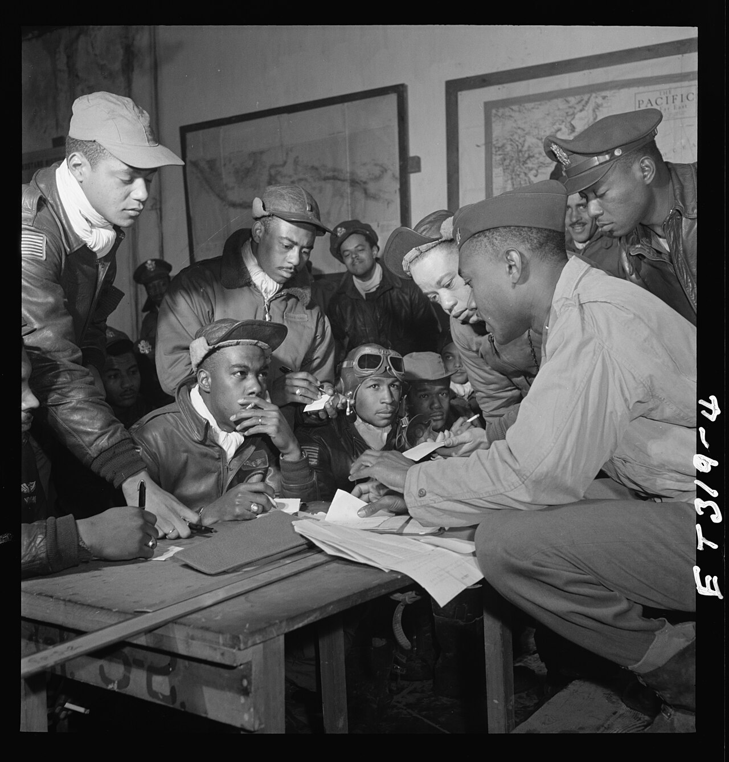
Tuskegee Airmen, 332nd Fighter Group, Ramitelli, Italy (March 1945) · Toni Frissell / Library of Congress, Toni Frissell Collection · March 1945
Source: Frissell, Toni. "Tuskegee Airmen, 332nd Fighter Group, Ramitelli, Italy." Mar. 1945. Library of Congress, Prints and Photographs Division, Toni Frissell Collection, commons.wikimedia.org/wiki/File:Tuskegee_airmen_2_original.jpg. Public Domain https://commons.wikimedia.org/wiki/File:Tuskegee_airmen_2_original.jpg
HIPPO — analyze the source (prompt) | Your analysis
H — Historical context: what was happening when this was created?
I — Intended audience: who was meant to see or obey it?
P — Purpose: why was it created?
P — Point of view: whose perspective does it reflect?
O — Outside connection: how does it connect to this standard?
SUPPORT OPTION
Sentence frame: This source shows ______ because it ______, which reveals ______.
CONFIDENCE CHECK-IN
Rate your understanding of this standard (1–4): ______ One thing to revisit: ____________________
HIPPO SUPPORTS — analyzing the source · US.51
Optional — use these to complete your HIPPO analysis. Your teacher may print this back page or leave it off.
Guiding questions
• H — Historical context: What was happening in the world when this was made?
• I — Intended audience: Who was meant to see or obey it?
• P — Purpose: Why did the creator make it? What did they want to happen?
• P — Point of view: Whose side does it show? Whose voice is missing?
• O — Outside connection: What have we studied that connects to this?
SUPPORT OPTION
Sentence frame: This source shows ______ because it ______, which reveals ______.
Model analysis (example)
H: Photographed March 1945 at Ramitelli, Italy, showing the Tuskegee Airmen (332nd Fighter Group), African American pilots who served in a still-segregated military. I: The American public and press, documenting the airmen's service. P: To record and publicize the contributions of Black pilots. POV: It highlights the airmen's excellence, taken within a segregated system that limited them. O: Connects to the Double V campaign and to the later integration of the armed forces in 1948.
Try it — sourcing warm-up
Before you fill in HIPPO on the front, answer these in one line each:
• Who made this source, and when?

• What did they want the viewer to think or feel?

• How does that change how much you trust it?

Activity 6 — Core Application: Practice Quiz — US.51 ⏱ ~8 min ▶ Deck slide 57
RESPONSE CHOICE
Commit to an answer by marking it, saying it, or explaining it aloud before checking. Answer key is in the Teacher Guide (kept separate).
[DOK 1 · item q-us51-dok1-1]
1. Who were the Tuskegee Airmen?
A. Women pilots who ferried planes, towed targets, and tested aircraft during WWII
B. Used Navajo language to create unbreakable military codes in the Pacific theater
C. All Japanese-American unit, most decorated in U.S. history despite family internment
✓ D. First African American military pilots who flew combat missions and escort duty
[DOK 1 · item q-us51-dok2-1]
2. What made the 442nd Regimental Combat Team unique?
A. 1943 racial violence in Los Angeles where servicemen attacked Mexican American youths
B. Used Navajo language to create unbreakable military codes in the Pacific theater
C. First African American military pilots who flew combat missions and escort duty
✓ D. All Japanese-American unit, most decorated in U.S. history despite family internment
[DOK 2 · item q-us51-dok2-2]
3. What role did Navajo Code Talkers play in WWII?
A. Served as translators helping communicate with Japanese prisoners of war in camps
✓ B. Used Navajo language to create unbreakable military codes in the Pacific theater
C. Fought exclusively in the European theater as specialized infantry scout units
D. Worked as intelligence analysts decoding Japanese military radio transmissions at bases
[DOK 1 · item q-us51-dok1-2]
4. What were the WASP (Women Airforce Service Pilots)?
A. First African American military pilots who flew combat missions and escort duty
B. Used Navajo language to create unbreakable military codes in the Pacific theater
C. All Japanese-American unit, most decorated in U.S. history despite family internment
✓ D. Women pilots who ferried planes, towed targets, and tested aircraft during WWII
CHECK YOURSELF — quiz answer key
Commit your answers first, then check: 1. D 2. D 3. B 4. D
Missed one? Reread that section and fix your thinking — that is where the learning happens.

Activity 7 — Constructed Response (CER) — US.51 ⏱ ~15 min ▶ Deck slides 51–55
BIG-QUESTION ORGANIZER — in World War II, how did the war reshape America at home and its role in the world — and who sacrificed, even while being excluded?
Jot quick notes from THIS standard: Who benefited? · Who bore the costs? · Who decided?

CONSTRUCTED RESPONSE (CER) — builds SSP.04 Argumentation
Claim + Evidence + Reasoning: Using this standard, take a position on the central question — identify the roles and sacrifices of individual American soldiers and the unique contributions of special fighting forces such as the Tuskegee Airmen, the 442nd Regimental Combat Team, the 101st Airborne, and the Navajo Code Talkers? Support your claim with two pieces of evidence from the passage and explain your reasoning.
Part | Write here
Claim
Evidence (two specifics)
Reasoning
SELF-GRADE YOUR CER — score each trait 1–4
Trait | What a strong (3–4) response shows | My score (1–4)
Claim | Clear; directly answers the question
Evidence | Two specific facts from the sources
Reasoning | Explains HOW the evidence proves the claim
Conventions | Complete, readable sentences
My total: ______ / 16 · One thing I will improve next time: ______________________
Peer review — trade & improve
Glow — one thing that works:

Grow — one thing to strengthen:

My revision — one change I will make:

WRITING SUPPORTS — Constructed Response (CER) · US.51
Optional — use these to plan and write your CER. Your teacher may print this back page or leave it off; the goal on the front never changes.
Sentence stems
• Claim: “One major cause of ______ was ______.” / “______ happened mainly because ______.”
• Evidence: “According to the source, ______.” / “For example, ______ shows that ______.”
• Reasoning: “This evidence proves ______ because ______.” / “This matters because ______.”
• Go further: “Although some might say ______, the stronger evidence shows ______.”
Model response (example)
Claim: Special fighting forces made vital contributions to World War II while facing discrimination at home. Evidence: The Tuskegee Airmen escorted bombers over Europe with a strong record, and the Japanese American 442nd Regimental Combat Team became one of the most decorated units in U.S. history. Reasoning: Their service proved the skill and loyalty of soldiers from groups facing prejudice, strengthening later arguments for civil rights and integration.
CER rubric — in your own words
• Claim — I answer the question in one clear sentence.
• Evidence — I use two specific facts from the sources.
• Reasoning — I explain HOW my evidence proves my claim.
• Conventions — I write in complete sentences a reader can follow.
Argument word bank
First · Because · For example · This shows that · As a result · Therefore · However · Although · In contrast · This matters because
EXIT TICKET — before you leave [item us51-q1 · DOK 2 · pre-field-test]
What unique contributions did the Tuskegee Airmen make to the war effort, and how did their service challenge racial barriers?
✓ A. They flew over 15,000 sorties, earned 150+ Distinguished Flying Crosses, and their outstanding record despite segregation helped pave the way for military desegregation
B. The Tuskegee Airmen had minimal impact on the war, which represents a common misconception about the period, which contradicts the primary source evidence from this era
C. They only served in non-combat roles, though this interpretation lacks supporting historical evidence, although historical sources do not support this conclusion
D. Their contributions were not recognized until the 21st century, but contemporary accounts suggest a different explanation, which does not align with the documented historical record
Show what you know (your choice): mark the best answer, say it, or explain it — then rate how sure you are: ☐ Not yet ☐ Getting there ☐ Got it
✔ ANSWER: A — The Tuskegee Airmen compiled a strong bomber-escort record, challenging segregation with proven excellence. (Full key & reteach in the Teacher Guide.)

Standard US.52 — Women in World War II
TN Academic Standard US.52: Examine and explain the entry of large numbers of women into the workforce and armed forces during World War II and the subsequent impact on American society.
LEARNING TARGETS — I can…
• I can examine and explain the entry of large numbers of women into the workforce and armed forces during World War II and the subsequent impact on American society.
Lenses for this standard: History · Economics · Culture
CORE PATH — the same for every student
Same rigor for everyone: analyze the sources and vocabulary, then show what you learned on the Practice Quiz and the CER.
Check yourself against the learning targets on the Cornell Notes page.
★ Tennessee Connection
Tennessee women entered the workforce in unprecedented numbers during WWII. At Oak Ridge, women made up a significant portion of the workforce — many operating calutrons to enrich uranium without knowing the full nature of their work. Tennessee women also served in the WAC, WAVES, and as nurses overseas.
SET YOUR GOAL (self-direction)
My goal for this standard — what will I be able to do, and how will I show it?

HOOK — think before you dig in
With the men overseas, American women built the bombers, cracked the codes, and put on the uniform. What happens to a society when 'a woman's place' suddenly changes? As you read, watch how the war rewrote the rules — and what happened when it ended.
ACTIVATE — what do you already know or wonder?
Think about it, then jot a few notes in your notebook: what do you already know, and what do you wonder about this standard? You will come back to it.
PREVIEW & PREDICT
Which learning target will be hardest, and why? Connect it to the unit’s big question: how did the war change America at home and abroad, and who sacrificed even while excluded?

Activity 1 — Vocabulary (Part A: Reference / Word Bank) — US.52 ⏱ ~10 min ▶ Deck slide 64
Use this word bank throughout the standard. The Spanish column supports access, not translation of assessment.
Term | Student-friendly meaning | Spanish
Rosie the Riveter | Cultural icon representing millions of American women who worked in factories and shipyards during World War II, filling jobs left by men who went to war. | Rosie la Remachadora
Tuskegee Airmen | First African American military pilots who fought in World War II, proving their skill despite facing racial discrimination and segregation. | Aviadores de Tuskegee
Rationing | Government-controlled limits on consumer goods during WWII to ensure adequate supplies for the military, requiring ration books and coupons. | Racionamiento
War Bonds | Government bonds sold to citizens to finance the war effort, promoted through massive publicity campaigns featuring celebrities and patriotic appeals. | Bonos de Guerra
Allied Powers | The World War II coalition led by the United States, Great Britain, and the Soviet Union that fought and defeated the Axis Powers. | Potencias Aliadas
442nd Regimental Combat Team | All Japanese-American unit that became the most decorated unit in U.S. military history, fighting in Europe while their families were interned at home. | 442º Equipo de Combate Regimental
LANGUAGE SUPPORT
Pronunciations: Rosie the Riveter (ROH-zee thuh RIV-eh-ter); Tuskegee Airmen (tus-KEE-gee AIR-men); Rationing (RASH-un-ing); War Bonds (wor bondz); Allied Powers (AL-yd POW-erz); 442nd Regimental Combat Team (for-for-tee-SEK-und rej-ih-MEN-tul).
VOCABULARY SELF-CHECK · Knowledge Rating
Rate each term NOW in pencil, then again at the END — growth is the goal; no penalty for “never seen it.”
Term | 1 · never seen it | 2 · heard it | 3 · can use it | 4 · can teach it
Rosie the Riveter
Tuskegee Airmen
Rationing
War Bonds
Allied Powers
442nd Regimental Combat Team
MAKE IT YOURS (RESPONSE CHOICE): choose ONE term above and show you own it — write a sentence, sketch it, or give a real-world example. Do this in your notebook or on a whiteboard — be ready to share.
VOCABULARY SUPPORTS — make the words stick
Word-attack strategy: break long terms into smaller parts you recognize. Several terms are Spanish cognates (industry / industria), so use the Spanish column to unlock meaning.
Quick practice — choose ONE
• Draw a quick symbol for two terms.
• Write one sentence that uses two terms together.
• Teach a term to a partner in 20 seconds.

Do your quick practice here:

Use two terms together in one sentence:

Cognate connection — write the English term and its Spanish cognate for two words:

Study tip: cover the meaning column and quiz yourself, then re-rate each term on the self-check at the end of the standard.

Activity 2 — Vocabulary Studio (Frayer-inspired) — US.52 ⏱ ~7 min ▶ Deck slide 64
RESPONSE CHOICE
Complete each studio by writing, speaking, or diagramming.

PRIORITY TERM 1 Rosie the Riveter · ES: Rosie la Remachadora
Word-bank meaning to build on: Cultural icon representing millions of American women who worked in factories and shipyards during World War II, filling jobs left by men who went to war.
Definition (in your own words) | Characteristics
Examples | Non-examples
Use it to explain
Write one sentence that uses “Rosie the Riveter” to explain this standard.

PRIORITY TERM 2 Tuskegee Airmen · ES: Aviadores de Tuskegee
Word-bank meaning to build on: First African American military pilots who fought in World War II, proving their skill despite facing racial discrimination and segregation.
Definition (in your own words) | Characteristics
Examples | Non-examples
Use it to explain
Write one sentence that uses “Tuskegee Airmen” to explain this standard.

CONNECT THE TERMS (UDL · build understanding)
How do these priority terms fit together? On a whiteboard or in your notebook, draw a quick web or write 2–3 sentences showing how one leads to or affects another — be ready to share.

Activity 3 — Direct Teaching Cornell Notes — US.52 ⏱ ~20 min ▶ Deck slides 59–61
Name: ______________________ Class / Period: __________ Date: __________
US.52 — Women in World War II • These notes capture the direct-teaching content and the Close Read for this standard.
Your learning targets are on this standard’s opening page — take notes that help you meet them.
Cues (tied to your learning targets) | My notes
What does the passage say about factors Leading to Women's Participation?
What does the passage say about challenges and Opportunities?
What does the passage say about impact on Production and Economy?
Key terms →

Cornell Notes — keep going, then process & check — US.52
MORE NOTES / DIAGRAMS
Continue your notes here, add a quick sketch, or map how the ideas connect.

Key terms to list
Rosie the Riveter · Tuskegee Airmen · Rationing · War Bonds · Allied Powers · 442nd Regimental Combat Team
Summary — In your own words (2–3 sentences)
PROGRESS CHECK · one question
How did "Rosie the Riveter" symbolize both opportunities and challenges facing working women?
A. Rosie only represented challenges women faced, despite limited evidence supporting this interpretation, which does not align with the documented historical record
B. Rosie represented only wealthy women, which does not reflect the consensus among historians despite the fact that multiple contemporary sources contradict this and does not reflect the scholarly consensus on this topic
C. The symbol had no cultural significance, which contradicts the primary source evidence from this era, but closer analysis reveals a more complicated historical reality
D. Rosie symbolized women's capability and patriotic duty while obscuring challenges like lower pay, discrimination, inadequate childcare, and expectations to maintain domestic responsibilities
Commit before you move on — mark it, say it, or explain it aloud.
CHECK YOURSELF — how am I doing?
Which learning targets (on this standard’s opening page) can you now meet? Tick the number; circle any you still need help with.
☐ 1
My 12–15 word headline for this standard

Activity 4 — Close Read — US.52 ⏱ ~15 min ▶ Deck slides 59–61
Reading type: History Hack-authored instructional synthesis. This is not a primary source. Builds SSP.03 (synthesize) and SSP.05 (historical awareness).
Key terms first: Rosie the Riveter, Tuskegee Airmen. Read once for the gist, then again for evidence.
CORE PATH — read one chunk at a time
Factors Leading to Women's Participation
With 16 million men serving in the armed forces, a massive labor shortage emerged as war production required doubling the manufacturing workforce. Government campaigns like "Rosie the Riveter" recruited women, while economic necessity pushed many families to rely on women's income. Women in the workforce grew from 12 million (1940) to 20 million (1945), comprising 36% of the civilian workforce. Women made up 65% of aircraft industry workers by war's end.
Challenges and Opportunities
Women faced discrimination including lower pay (about 65% of men's wages), dangerous conditions, long hours, and inadequate facilities. Social challenges included limited childcare, expectations to maintain domestic duties, and criticism for abandoning traditional roles. However, women gained economic independence, learned technical skills, some achieved supervisory positions, and military service provided professional training in communications, mechanics, and aviation.
Impact on Production and Economy
Women built bombers, fighters, and transport planes; constructed Liberty ships; manufactured ammunition and explosives; and assembled radios and radar equipment. Women's entry helped achieve record production levels—296,000 aircraft, 86,000 tanks, 2.3 million trucks. This contribution was essential to Allied victory, demonstrating women's capabilities in technical and leadership roles previously reserved for men.
Long-term Effects on Society
After the war, many women were laid off to make room for returning veterans, and social pressure emphasized homemaking and motherhood. However, women's labor force participation never returned to pre-war levels. The experience provided foundation for the women's rights movement of the 1960s-70s, established precedents for equal employment opportunities, and created pathways for women in previously male professions. Military services became permanent parts of armed forces.
CLOSE-READ EVIDENCE LAB — for each question: quote the EVIDENCE from the passage above, then write YOUR ANSWER (or answer aloud / diagram it).
Text-dependent question | Evidence from the passage | Your answer (what it shows)
What is the main idea of the “Factors Leading to Women's Participation” section, and what evidence supports it?
What is the main idea of the “Challenges and Opportunities” section, and what evidence supports it?
What is the main idea of the “Impact on Production and Economy” section, and what evidence supports it?

Activity 5 — Primary Source / Data Analysis — US.52 ⏱ ~15 min ▶ Deck slide 62
Primary source (photograph) — analyze it with HIPPO. Builds SSP.01–SSP.02.
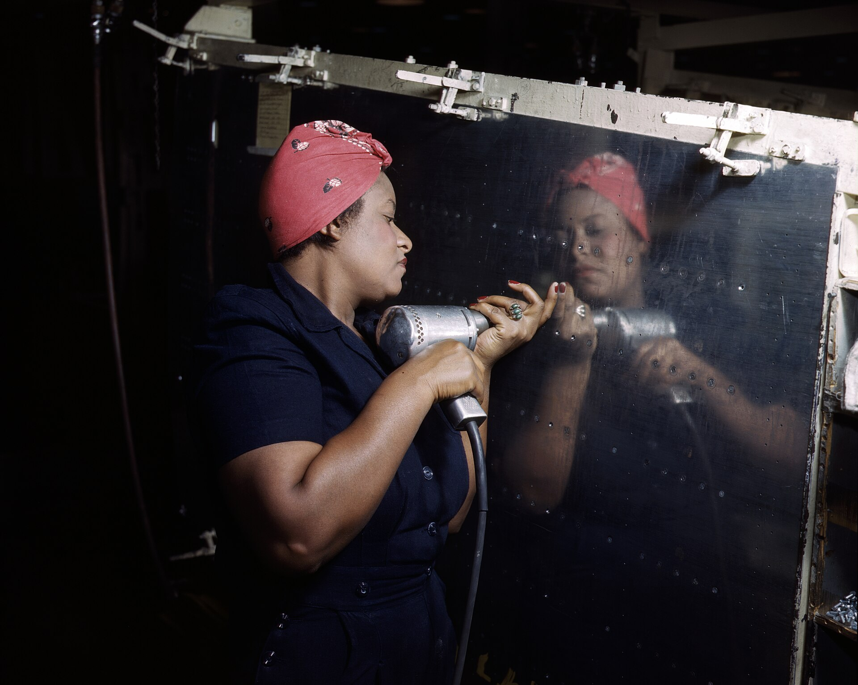
Operating a Hand Drill at Vultee-Nashville, Woman is Working on a ‘Vengeance’ Dive Bomber, Tennessee (February 1943) · Alfred T. Palmer / U.S. Office of War Information (OWI) / Farm Security Administration · February 1943
Source: Palmer, Alfred T. "Operating a Hand Drill at Vultee-Nashville, Woman Working on a Vengeance Dive Bomber, Tennessee." Feb. 1943. Library of Congress, Prints and Photographs Division, FSA/OWI Color Photographs Collection (LC-USW36-295), www.loc.gov/item/2017878540/. Public Domain https://www.loc.gov/item/2017878540/
HIPPO — analyze the source (prompt) | Your analysis
H — Historical context: what was happening when this was created?
I — Intended audience: who was meant to see or obey it?
P — Purpose: why was it created?
P — Point of view: whose perspective does it reflect?
O — Outside connection: how does it connect to this standard?
SUPPORT OPTION
Sentence frame: This source shows ______ because it ______, which reveals ______.
CONFIDENCE CHECK-IN
Rate your understanding of this standard (1–4): ______ One thing to revisit: ____________________
HIPPO SUPPORTS — analyzing the source · US.52
Optional — use these to complete your HIPPO analysis. Your teacher may print this back page or leave it off.
Guiding questions
• H — Historical context: What was happening in the world when this was made?
• I — Intended audience: Who was meant to see or obey it?
• P — Purpose: Why did the creator make it? What did they want to happen?
• P — Point of view: Whose side does it show? Whose voice is missing?
• O — Outside connection: What have we studied that connects to this?
SUPPORT OPTION
Sentence frame: This source shows ______ because it ______, which reveals ______.
Model analysis (example)
H: Photographed February 1943 at the Vultee aircraft plant in Nashville, Tennessee, as women filled defense jobs while men served overseas. I: The American public, produced by the Office of War Information to encourage women to join the workforce. P: Recruitment — to present women's war work as normal and patriotic. POV: The government's promotional view of women's labor; it downplays the barriers women faced. O: Connects to “Rosie the Riveter” and to postwar debates over whether women would keep their jobs.
Try it — sourcing warm-up
Before you fill in HIPPO on the front, answer these in one line each:
• Who made this source, and when?

• What did they want the viewer to think or feel?

• How does that change how much you trust it?

Activity 6 — Core Application: Practice Quiz — US.52 ⏱ ~8 min ▶ Deck slide 65
RESPONSE CHOICE
Commit to an answer by marking it, saying it, or explaining it aloud before checking. Answer key is in the Teacher Guide (kept separate).
[DOK 1 · item q-us53-dok1-1]
1. What did "Rosie the Riveter" represent?
A. Create propaganda to boost public morale and maintain support for the war effort
B. Women's military auxiliaries serving in the Army (WAC) and Navy (WAVES) branches
✓ C. Cultural icon representing millions of women who worked in defense industries
D. Entered workforce in record numbers, gained independence, and challenged gender roles
[DOK 1 · item q-us53-dok1-3]
2. What were WACs and WAVES?
A. Types of advanced military aircraft used for long-range bombing and reconnaissance missions
✓ B. Women's military auxiliaries serving in the Army (WAC) and Navy (WAVES) branches
C. Code names for top-secret Allied military operations conducted behind enemy lines in Europe
D. Government-sponsored propaganda campaigns encouraging civilian participation in war industries
[DOK 2 · item q-us53-dok2-1]
3. How did WWII change women's roles in American society?
A. Saw minimal changes with most continuing traditional household responsibilities exclusively
B. Were restricted to traditional domestic roles and prohibited from factory work
C. Worked primarily in clerical positions while men dominated war industries
✓ D. Entered workforce in record numbers, gained independence, and challenged gender roles
[DOK 2 · item q-us53-dok3-1]
4. Analyze the long-term impact of women's WWII work experience on the feminist movement.
A. Many were pressured to leave jobs for returning servicemen, facing social pressure to return home
B. Both ideologies promised stability and national pride to desperate populations suffering from economic collapse
✓ C. Proved women's capability in workforce; challenged gender roles; inspired 1960s-70s women's liberation movement
D. All-white communities that prohibited Black people after dark; limited where African Americans could live/work
CHECK YOURSELF — quiz answer key
Commit your answers first, then check: 1. C 2. B 3. D 4. C
Missed one? Reread that section and fix your thinking — that is where the learning happens.

Activity 7 — Constructed Response (CER) — US.52 ⏱ ~15 min ▶ Deck slides 59–63
BIG-QUESTION ORGANIZER — in World War II, how did the war reshape America at home and its role in the world — and who sacrificed, even while being excluded?
Jot quick notes from THIS standard: Who benefited? · Who bore the costs? · Who decided?

CONSTRUCTED RESPONSE (CER) — builds SSP.04 Argumentation
Claim + Evidence + Reasoning: Using this standard, take a position on the central question — examine and explain the entry of large numbers of women into the workforce and armed forces during World War II and the subsequent impact on American society? Support your claim with two pieces of evidence from the passage and explain your reasoning.
Part | Write here
Claim
Evidence (two specifics)
Reasoning
SELF-GRADE YOUR CER — score each trait 1–4
Trait | What a strong (3–4) response shows | My score (1–4)
Claim | Clear; directly answers the question
Evidence | Two specific facts from the sources
Reasoning | Explains HOW the evidence proves the claim
Conventions | Complete, readable sentences
My total: ______ / 16 · One thing I will improve next time: ______________________
Peer review — trade & improve
Glow — one thing that works:

Grow — one thing to strengthen:

My revision — one change I will make:

WRITING SUPPORTS — Constructed Response (CER) · US.52
Optional — use these to plan and write your CER. Your teacher may print this back page or leave it off; the goal on the front never changes.
Sentence stems
• Claim: “One major cause of ______ was ______.” / “______ happened mainly because ______.”
• Evidence: “According to the source, ______.” / “For example, ______ shows that ______.”
• Reasoning: “This evidence proves ______ because ______.” / “This matters because ______.”
• Go further: “Although some might say ______, the stronger evidence shows ______.”
Model response (example)
Claim: World War II brought large numbers of women into the workforce and military, changing American society. Evidence: Women took defense-industry jobs such as building aircraft (as at the Vultee plant in Nashville), and hundreds of thousands served in units like the WACs and WAVES. Reasoning: This showed women could do jobs once reserved for men and, though many left work after the war, it laid groundwork for later expansion of women's roles.
CER rubric — in your own words
• Claim — I answer the question in one clear sentence.
• Evidence — I use two specific facts from the sources.
• Reasoning — I explain HOW my evidence proves my claim.
• Conventions — I write in complete sentences a reader can follow.
Argument word bank
First · Because · For example · This shows that · As a result · Therefore · However · Although · In contrast · This matters because
EXIT TICKET — before you leave [item us52-q1 · DOK 2 · pre-field-test]
What factors led to the massive entry of women into the workforce and armed forces during WWII?
A. Women chose to work for personal fulfillment alone, but the historical record tells a more complex story, but the historical evidence paints a more nuanced picture and oversimplifies the complex factors at work during this period
✓ B. The labor shortage from 16 million men in military service, government recruitment campaigns like "Rosie the Riveter," war production demands, and family economic necessity drove women into the workforce
C. Women were forced into work against their will, which contradicts the primary source evidence from this era, which ignores significant political and cultural developments of the era
D. Only a small number of women entered the workforce, yet the available evidence points to a different conclusion and fails to account for key developments in the broader context
Show what you know (your choice): mark the best answer, say it, or explain it — then rate how sure you are: ☐ Not yet ☐ Getting there ☐ Got it
✔ ANSWER: B — With men overseas and labor demand high, millions of women entered defense industries and the military. (Full key & reteach in the Teacher Guide.)

Standard US.53 — African Americans in WWII
TN Academic Standard US.53: Examine the impact of World War II on economic and social conditions for African Americans, including the Fair Employment Practices Committee and the eventual integration of the armed forces by President Harry S. Truman. (TCA)
LEARNING TARGETS — I can…
• I can examine the impact of World War II on economic and social conditions for African Americans, including the Fair Employment Practices Committee and the eventual integration of the armed forces by President Truman.
Lenses for this standard: History · Culture · Economics · Tennessee Connection
CORE PATH — the same for every student
Same rigor for everyone: analyze the sources and vocabulary, then show what you learned on the Practice Quiz and the CER.
Check yourself against the learning targets on the Cornell Notes page.
★ Tennessee Connection
African Americans in Tennessee contributed significantly to the war effort despite facing segregation. The Fair Employment Practices Committee impacted Tennessee war industries, and African American soldiers from Tennessee served in segregated units. After the war, returning Black veterans became leaders in Tennessee's civil rights movement.
SET YOUR GOAL (self-direction)
My goal for this standard — what will I be able to do, and how will I show it?

HOOK — think before you dig in
Black Americans were asked to fight fascism abroad while facing segregation at home — so they launched a fight on two fronts at once. Can a war for freedom overseas change freedom at home? As you read, follow the 'Double V' from the factory floor to the battlefield.
ACTIVATE — what do you already know or wonder?
Think about it, then jot a few notes in your notebook: what do you already know, and what do you wonder about this standard? You will come back to it.
PREVIEW & PREDICT
Which learning target will be hardest, and why? Connect it to the unit’s big question: how did the war change America at home and abroad, and who sacrificed even while excluded?

Activity 1 — Vocabulary (Part A: Reference / Word Bank) — US.53 ⏱ ~10 min ▶ Deck slide 72
Use this word bank throughout the standard. The Spanish column supports access, not translation of assessment.
Term | Student-friendly meaning | Spanish
Executive Order 8802 | The June 1941 order signed by President Roosevelt banning racial discrimination in the defense industry and creating the Fair Employment Practices Committee. | Orden Ejecutiva 8802
Double V Campaign | A World War II campaign led by the Black press calling for a 'Double Victory' - over fascism abroad and racial discrimination at home. | Campaña de la Doble V
Tuskegee Airmen | First African American military pilots who fought in World War II, proving their skill despite facing racial discrimination and segregation. | Aviadores de Tuskegee
Rosie the Riveter | Cultural icon representing millions of American women who worked in factories and shipyards during World War II, filling jobs left by men who went to war. | Rosie la Remachadora
Rationing | Government-controlled limits on consumer goods during WWII to ensure adequate supplies for the military, requiring ration books and coupons. | Racionamiento
War Bonds | Government bonds sold to citizens to finance the war effort, promoted through massive publicity campaigns featuring celebrities and patriotic appeals. | Bonos de Guerra
LANGUAGE SUPPORT
Pronunciations: Executive Order 8802 (eg-ZEK-yuh-tiv OR-der); Double V Campaign (DUB-ul vee kam-PAYN); Tuskegee Airmen (tus-KEE-gee AIR-men); Rosie the Riveter (ROH-zee thuh RIV-eh-ter); Rationing (RASH-un-ing); War Bonds (wor bondz).
VOCABULARY SELF-CHECK · Knowledge Rating
Rate each term NOW in pencil, then again at the END — growth is the goal; no penalty for “never seen it.”
Term | 1 · never seen it | 2 · heard it | 3 · can use it | 4 · can teach it
Executive Order 8802
Double V Campaign
Tuskegee Airmen
Rosie the Riveter
Rationing
War Bonds
MAKE IT YOURS (RESPONSE CHOICE): choose ONE term above and show you own it — write a sentence, sketch it, or give a real-world example. Do this in your notebook or on a whiteboard — be ready to share.
VOCABULARY SUPPORTS — make the words stick
Word-attack strategy: break long terms into smaller parts you recognize. Several terms are Spanish cognates (discrimination / discriminación), so use the Spanish column to unlock meaning.
Quick practice — choose ONE
• Draw a quick symbol for two terms.
• Write one sentence that uses two terms together.
• Teach a term to a partner in 20 seconds.

Do your quick practice here:

Use two terms together in one sentence:

Cognate connection — write the English term and its Spanish cognate for two words:

Study tip: cover the meaning column and quiz yourself, then re-rate each term on the self-check at the end of the standard.

Activity 2 — Vocabulary Studio (Frayer-inspired) — US.53 ⏱ ~7 min ▶ Deck slide 72
RESPONSE CHOICE
Complete each studio by writing, speaking, or diagramming.

PRIORITY TERM 1 Executive Order 8802 · ES: Orden Ejecutiva 8802
Word-bank meaning to build on: The June 1941 order signed by President Roosevelt banning racial discrimination in the defense industry and creating the Fair Employment Practices Committee.
Definition (in your own words) | Characteristics
Examples | Non-examples
Use it to explain
Write one sentence that uses “Executive Order 8802” to explain this standard.

PRIORITY TERM 2 Double V Campaign · ES: Campaña de la Doble V
Word-bank meaning to build on: A World War II campaign led by the Black press calling for a 'Double Victory' - over fascism abroad and racial discrimination at home.
Definition (in your own words) | Characteristics
Examples | Non-examples
Use it to explain
Write one sentence that uses “Double V Campaign” to explain this standard.

CONNECT THE TERMS (UDL · build understanding)
How do these priority terms fit together? On a whiteboard or in your notebook, draw a quick web or write 2–3 sentences showing how one leads to or affects another — be ready to share.

Activity 3 — Direct Teaching Cornell Notes — US.53 ⏱ ~20 min ▶ Deck slides 67–69
Name: ______________________ Class / Period: __________ Date: __________
US.53 — African Americans in WWII • These notes capture the direct-teaching content and the Close Read for this standard.
Your learning targets are on this standard’s opening page — take notes that help you meet them.
Cues (tied to your learning targets) | My notes
What does the passage say about second Great Migration and Economic Opportunities?
What does the passage say about double V Campaign and Wartime Experiences?
What does the passage say about fair Employment Practices Committee (FEPC)?
Key terms →

Cornell Notes — keep going, then process & check — US.53
MORE NOTES / DIAGRAMS
Continue your notes here, add a quick sketch, or map how the ideas connect.

Key terms to list
Executive Order 8802 · Double V Campaign · Tuskegee Airmen · Rosie the Riveter · Rationing · War Bonds
Summary — In your own words (2–3 sentences)
PROGRESS CHECK · one question
What was the "Double V" campaign, and how did it connect the fight against fascism abroad with civil rights at home?
A. The Pittsburgh Courier's campaign demanded victory over fascism abroad and over racism at home, arguing that fighting for democracy overseas exposed the contradiction of denying democracy to Black Americans
B. It focused only on military victory, although this view has been largely discredited by scholars, which does not align with the documented historical record, which represents a common misconception about this historical period
C. It supported segregation, though this interpretation lacks supporting historical evidence, though this interpretation lacks supporting historical evidence, but closer analysis reveals a more complicated historical reality
D. It had no connection to civil rights, which ignores key developments that shaped the outcome, which represents a common misconception about this historical period, although historical sources do not support this conclusion
Commit before you move on — mark it, say it, or explain it aloud.
CHECK YOURSELF — how am I doing?
Which learning targets (on this standard’s opening page) can you now meet? Tick the number; circle any you still need help with.
☐ 1
My 12–15 word headline for this standard

Activity 4 — Close Read — US.53 ⏱ ~15 min ▶ Deck slides 67–69
Reading type: History Hack-authored instructional synthesis. This is not a primary source. Builds SSP.03 (synthesize) and SSP.05 (historical awareness).
Key terms first: Executive Order 8802, Double V Campaign. Read once for the gist, then again for evidence.
CORE PATH — read one chunk at a time
Second Great Migration and Economic Opportunities
1.5 million African Americans moved North and West during the 1940s to cities like Detroit, Chicago, and Los Angeles. Defense industries offered higher wages than Southern agriculture, and average Black family income doubled during the war. However, discrimination persisted—many employers refused to hire African Americans, job segregation confined Black workers to lowest-paying positions, and limited advancement opportunities existed.
Double V Campaign and Wartime Experiences
The Pittsburgh Courier promoted the "Double V" campaign—victory against fascism abroad and racism at home. One million African Americans served in segregated armed forces, facing prejudice and unequal treatment even while fighting for democracy. NAACP membership grew from 50,000 to 450,000 during the war. War rhetoric about democracy and freedom raised consciousness about civil rights contradictions in American society.
Fair Employment Practices Committee (FEPC)
A. Philip Randolph threatened a 100,000-person march on Washington, pressuring FDR to issue Executive Order 8802 (June 25, 1941) creating the FEPC. The committee investigated discrimination complaints from defense workers and held public hearings exposing discriminatory practices. Though it could only make recommendations without enforcement power, the FEPC established the principle of federal intervention in employment discrimination and laid groundwork for later civil rights agencies.
Integration of Armed Forces
Executive Order 9981 (1948) by President Truman ordered desegregation of the armed forces, citing merit and fairness. Implementation was gradual but historic, representing the first major federal civil rights action of the post-war era. The order built on WWII service records of units like the Tuskegee Airmen and 761st Tank Battalion, which had proven African American military capability. Military integration became a model for later civilian desegregation efforts.
CLOSE-READ EVIDENCE LAB — for each question: quote the EVIDENCE from the passage above, then write YOUR ANSWER (or answer aloud / diagram it).
Text-dependent question | Evidence from the passage | Your answer (what it shows)
What is the main idea of the “Second Great Migration and Economic Opportunities” section, and what evidence supports it?
What is the main idea of the “Double V Campaign and Wartime Experiences” section, and what evidence supports it?
What is the main idea of the “Fair Employment Practices Committee (FEPC)” section, and what evidence supports it?

Activity 5 — Primary Source / Data Analysis — US.53 ⏱ ~15 min ▶ Deck slide 70
Primary source (photograph) — analyze it with HIPPO. Builds SSP.01–SSP.02.
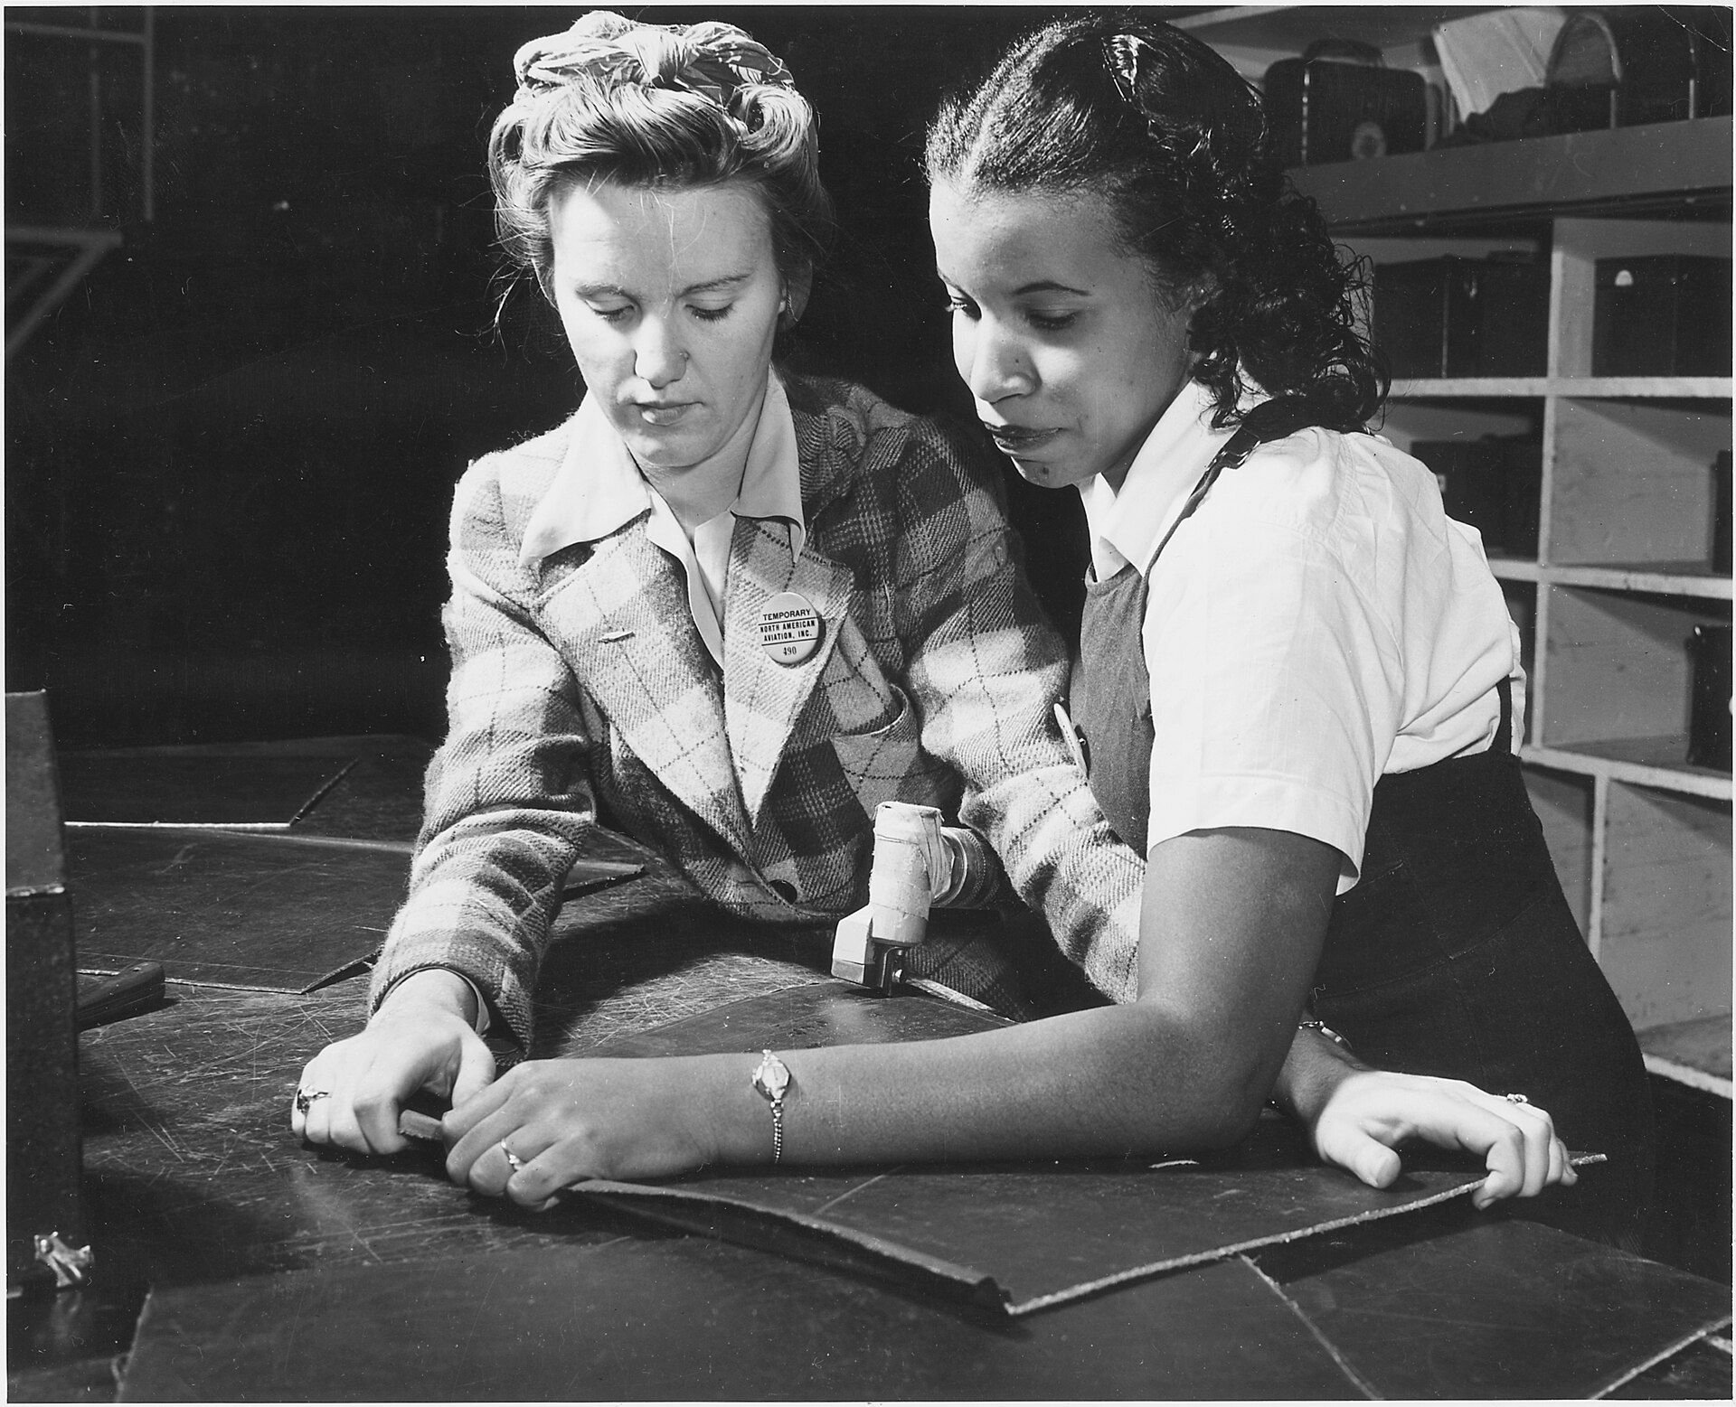
"White" & "Black" Work Side by Side — North American Aviation Co. Plant (c. 1942) · Unknown / U.S. Army Signal Corps / Office of War Information · c. 1942
Source: Unknown / U.S. Army Signal Corps. "'White' & 'Black' Work Side by Side — North American Aviation Co. Plant." c. 1942. National Archives and Records Administration (NAID 195477), via Wikimedia Commons, commons.wikimedia.org/wiki/File:%22White%22_%26_%22Black%22_work_side_by_side_-_North_American_Aviation_Co._Plant_-_NARA_-_195477.jpg. Public Domain https://commons.wikimedia.org/wiki/File:%22White%22_%26_%22Black%22_work_side_by_side_-_North_American_Aviation_Co._Plant_-_NARA_-_195477.jpg
HIPPO — analyze the source (prompt) | Your analysis
H — Historical context: what was happening when this was created?
I — Intended audience: who was meant to see or obey it?
P — Purpose: why was it created?
P — Point of view: whose perspective does it reflect?
O — Outside connection: how does it connect to this standard?
SUPPORT OPTION
Sentence frame: This source shows ______ because it ______, which reveals ______.
CONFIDENCE CHECK-IN
Rate your understanding of this standard (1–4): ______ One thing to revisit: ____________________
HIPPO SUPPORTS — analyzing the source · US.53
Optional — use these to complete your HIPPO analysis. Your teacher may print this back page or leave it off.
Guiding questions
• H — Historical context: What was happening in the world when this was made?
• I — Intended audience: Who was meant to see or obey it?
• P — Purpose: Why did the creator make it? What did they want to happen?
• P — Point of view: Whose side does it show? Whose voice is missing?
• O — Outside connection: What have we studied that connects to this?
SUPPORT OPTION
Sentence frame: This source shows ______ because it ______, which reveals ______.
Model analysis (example)
H: Photographed around 1942 at a North American Aviation plant, as wartime labor demand opened defense jobs to more workers. I: The public, documenting integrated war production. P: To show wartime industry and, implicitly, changing labor patterns. POV: An optimistic view of workplace integration; wartime segregation and discrimination still persisted. O: Connects to Executive Order 8802, the Fair Employment Practices Committee, and the Double V campaign.
Try it — sourcing warm-up
Before you fill in HIPPO on the front, answer these in one line each:
• Who made this source, and when?

• What did they want the viewer to think or feel?

• How does that change how much you trust it?

Activity 6 — Core Application: Practice Quiz — US.53 ⏱ ~8 min ▶ Deck slide 73
RESPONSE CHOICE
Commit to an answer by marking it, saying it, or explaining it aloud before checking. Answer key is in the Teacher Guide (kept separate).
[DOK 1 · item q-us52-dok1-3]
1. What was the significance of Executive Order 8802?
A. African American campaign for Victory abroad against fascism and Victory at home against racism
✓ B. Banned racial discrimination in defense industries and created Fair Employment Practices Committee
C. Exposed hypocrisy of fighting fascism abroad while tolerating racism at home; veterans demanded change
D. Civil rights leader who threatened a March on Washington, leading to Fair Employment order
[DOK 1 · item q-us52-dok2-2]
2. What was the "Double V Campaign" during WWII?
A. Banned racial discrimination in defense industries and created Fair Employment Practices Committee
B. Civil rights leader who threatened a March on Washington, leading to Fair Employment order
C. Exposed hypocrisy of fighting fascism abroad while tolerating racism at home; veterans demanded change
✓ D. African American campaign for Victory abroad against fascism and Victory at home against racism
[DOK 2 · item q-us52-dok2-1]
3. How did WWII impact African Americans economically and socially?
A. African Americans were excluded from war industries and military service
B. Economic conditions worsened with increased discrimination in defense employment nationwide
C. Military became more segregated with stricter racial separation policies enacted
✓ D. Fair Employment opened defense jobs; segregated service led to 1948 integration
[DOK 2 · item q-us52-dok3-1]
4. Analyze how WWII served as a catalyst for the post-war Civil Rights Movement.
✓ A. Exposed hypocrisy of fighting fascism abroad while tolerating racism at home; veterans demanded change
B. Banned racial discrimination in defense industries and created Fair Employment Practices Committee
C. African American campaign for Victory abroad against fascism and Victory at home against racism
D. All-white communities that prohibited Black people after dark; limited where African Americans could live/work
CHECK YOURSELF — quiz answer key
Commit your answers first, then check: 1. B 2. D 3. D 4. A
Missed one? Reread that section and fix your thinking — that is where the learning happens.

Activity 7 — Constructed Response (CER) — US.53 ⏱ ~15 min ▶ Deck slides 67–71
BIG-QUESTION ORGANIZER — in World War II, how did the war reshape America at home and its role in the world — and who sacrificed, even while being excluded?
Jot quick notes from THIS standard: Who benefited? · Who bore the costs? · Who decided?

CONSTRUCTED RESPONSE (CER) — builds SSP.04 Argumentation
Claim + Evidence + Reasoning: Using this standard, take a position on the central question — examine the impact of World War II on economic and social conditions for African Americans, including the Fair Employment Practices Committee and the eventual integration of the armed forces by President Truman? Support your claim with two pieces of evidence from the passage and explain your reasoning.
Part | Write here
Claim
Evidence (two specifics)
Reasoning
SELF-GRADE YOUR CER — score each trait 1–4
Trait | What a strong (3–4) response shows | My score (1–4)
Claim | Clear; directly answers the question
Evidence | Two specific facts from the sources
Reasoning | Explains HOW the evidence proves the claim
Conventions | Complete, readable sentences
My total: ______ / 16 · One thing I will improve next time: ______________________
Peer review — trade & improve
Glow — one thing that works:

Grow — one thing to strengthen:

My revision — one change I will make:

WRITING SUPPORTS — Constructed Response (CER) · US.53
Optional — use these to plan and write your CER. Your teacher may print this back page or leave it off; the goal on the front never changes.
Sentence stems
• Claim: “One major cause of ______ was ______.” / “______ happened mainly because ______.”
• Evidence: “According to the source, ______.” / “For example, ______ shows that ______.”
• Reasoning: “This evidence proves ______ because ______.” / “This matters because ______.”
• Go further: “Although some might say ______, the stronger evidence shows ______.”
Model response (example)
Claim: World War II improved some economic opportunities for African Americans and set the stage for civil rights gains. Evidence: Executive Order 8802 (1941) banned discrimination in defense industries and created the FEPC, and wartime pressure led toward integration of the armed forces in 1948. Reasoning: Wartime labor needs and Black activism (the Double V campaign) forced changes that became a foundation for the postwar civil rights movement.
CER rubric — in your own words
• Claim — I answer the question in one clear sentence.
• Evidence — I use two specific facts from the sources.
• Reasoning — I explain HOW my evidence proves my claim.
• Conventions — I write in complete sentences a reader can follow.
Argument word bank
First · Because · For example · This shows that · As a result · Therefore · However · Although · In contrast · This matters because
EXIT TICKET — before you leave [item us53-q1 · DOK 2 · pre-field-test]
How did WWII create new economic opportunities for African Americans through the Second Great Migration?
A. African Americans did not migrate during WWII, which represents a common misconception about the period, which represents a common misconception about this historical period
B. Economic conditions for African Americans worsened during the war, though this interpretation lacks supporting historical evidence, but closer analysis reveals a more complicated historical reality
✓ C. 1.5 million African Americans moved to Northern and Western cities where defense industries offered higher wages, doubling average Black family income despite continued discrimination
D. Only Southern industries offered opportunities, although this overlooks critical economic and social factors, although historical sources do not support this conclusion
Show what you know (your choice): mark the best answer, say it, or explain it — then rate how sure you are: ☐ Not yet ☐ Getting there ☐ Got it
✔ ANSWER: C — Wartime defense jobs drew ~1.5 million African Americans to Northern and Western cities. (Full key & reteach in the Teacher Guide.)

Standard US.54 — Japanese American Internment & Korematsu
TN Academic Standard US.54: Describe the constitutional issues and impact of the internment of Japanese Americans on the U.S., including the Fred Korematsu v. United States of America decision.
LEARNING TARGETS — I can…
• I can describe the constitutional issues and impact of the internment of Japanese Americans on the U.S., including the Fred Korematsu v. United States of America decision.
Lenses for this standard: Culture · History
CORE PATH — the same for every student
Same rigor for everyone: analyze the sources and vocabulary, then show what you learned on the Practice Quiz and the CER.
Check yourself against the learning targets on the Cornell Notes page.
SET YOUR GOAL (self-direction)
My goal for this standard — what will I be able to do, and how will I show it?

HOOK — think before you dig in
After Pearl Harbor, the government locked up about 120,000 people — most of them U.S. citizens — for their ancestry alone. When does 'security' cross the line into injustice? As you read, ask what the Constitution is worth under the pressure of fear.
ACTIVATE — what do you already know or wonder?
Think about it, then jot a few notes in your notebook: what do you already know, and what do you wonder about this standard? You will come back to it.
PREVIEW & PREDICT
Which learning target will be hardest, and why? Connect it to the unit’s big question: how did the war change America at home and abroad, and who sacrificed even while excluded?

Activity 1 — Vocabulary (Part A: Reference / Word Bank) — US.54 ⏱ ~10 min ▶ Deck slide 80
Use this word bank throughout the standard. The Spanish column supports access, not translation of assessment.
Term | Student-friendly meaning | Spanish
Japanese Internment | The forced relocation and incarceration of 120,000 Japanese Americans (two-thirds U.S. citizens) in concentration camps during WWII, based on racial prejudice, not evidence of disloyalty. | Internamiento Japonés
Korematsu v. United States | 1944 Supreme Court decision upholding Japanese internment as a wartime necessity, later widely condemned as one of the Court's worst decisions. | Korematsu contra Estados Unidos
Executive Order 9066 | The February 1942 order signed by President Roosevelt authorizing the military to exclude and relocate Japanese Americans from the West Coast. | Orden Ejecutiva 9066
442nd Regimental Combat Team | All Japanese-American unit that became the most decorated unit in U.S. military history, fighting in Europe while their families were interned at home. | 442º Equipo de Combate Regimental
Pearl Harbor | Japan's surprise attack on the U.S. naval base in Hawaii on December 7, 1941, killing over 2,400 Americans and bringing the United States into World War II. | Pearl Harbor
Totalitarianism | A system of government where the state controls every aspect of public and private life, using propaganda, secret police, and terror to eliminate opposition. | Totalitarismo
LANGUAGE SUPPORT
Pronunciations: Japanese Internment (jap-uh-NEEZ in-TERN-ment); Korematsu v. United States (kor-eh-MAT-soo); Executive Order 9066 (eg-ZEK-yuh-tiv OR-der); 442nd Regimental Combat Team (for-for-tee-SEK-und rej-ih-MEN-tul); Pearl Harbor (purl HAR-ber); Totalitarianism (toh-tal-ih-TAIR-ee-uh-niz-um).
VOCABULARY SELF-CHECK · Knowledge Rating
Rate each term NOW in pencil, then again at the END — growth is the goal; no penalty for “never seen it.”
Term | 1 · never seen it | 2 · heard it | 3 · can use it | 4 · can teach it
Japanese Internment
Korematsu v. United States
Executive Order 9066
442nd Regimental Combat Team
Pearl Harbor
Totalitarianism
MAKE IT YOURS (RESPONSE CHOICE): choose ONE term above and show you own it — write a sentence, sketch it, or give a real-world example. Do this in your notebook or on a whiteboard — be ready to share.
VOCABULARY SUPPORTS — make the words stick
Word-attack strategy: break long terms into smaller parts you recognize. Several terms are Spanish cognates (internment / internamiento), so use the Spanish column to unlock meaning.
Quick practice — choose ONE
• Draw a quick symbol for two terms.
• Write one sentence that uses two terms together.
• Teach a term to a partner in 20 seconds.

Do your quick practice here:

Use two terms together in one sentence:

Cognate connection — write the English term and its Spanish cognate for two words:

Study tip: cover the meaning column and quiz yourself, then re-rate each term on the self-check at the end of the standard.

Activity 2 — Vocabulary Studio (Frayer-inspired) — US.54 ⏱ ~7 min ▶ Deck slide 80
RESPONSE CHOICE
Complete each studio by writing, speaking, or diagramming.

PRIORITY TERM 1 Japanese Internment · ES: Internamiento Japonés
Word-bank meaning to build on: The forced relocation and incarceration of 120,000 Japanese Americans (two-thirds U.S. citizens) in concentration camps during WWII, based on racial prejudice, not evidence of disloyalty.
Definition (in your own words) | Characteristics
Examples | Non-examples
Use it to explain
Write one sentence that uses “Japanese Internment” to explain this standard.

PRIORITY TERM 2 Korematsu v. United States · ES: Korematsu contra Estados Unidos
Word-bank meaning to build on: 1944 Supreme Court decision upholding Japanese internment as a wartime necessity, later widely condemned as one of the Court's worst decisions.
Definition (in your own words) | Characteristics
Examples | Non-examples
Use it to explain
Write one sentence that uses “Korematsu v. United States” to explain this standard.

CONNECT THE TERMS (UDL · build understanding)
How do these priority terms fit together? On a whiteboard or in your notebook, draw a quick web or write 2–3 sentences showing how one leads to or affects another — be ready to share.

Activity 3 — Direct Teaching Cornell Notes — US.54 ⏱ ~20 min ▶ Deck slides 75–77
Name: ______________________ Class / Period: __________ Date: __________
US.54 — Japanese American Internment & Korematsu • These notes capture the direct-teaching content and the Close Read for this standard.
Your learning targets are on this standard’s opening page — take notes that help you meet them.
Cues (tied to your learning targets) | My notes
What does the passage say about executive Order 9066 and Internment?
What does the passage say about constitutional Issues?
What does the passage say about korematsu v. United States (1944)?
Key terms →

Cornell Notes — keep going, then process & check — US.54
MORE NOTES / DIAGRAMS
Continue your notes here, add a quick sketch, or map how the ideas connect.

Key terms to list
Japanese Internment · Korematsu v. United States · Executive Order 9066 · 442nd Regimental Combat Team · Pearl Harbor · Totalitarianism
Summary — In your own words (2–3 sentences)
PROGRESS CHECK · one question
How did Executive Order 9066 violate constitutional principles of due process and equal protection?
A. It followed all constitutional procedures, although historical sources do not support this conclusion, though this interpretation lacks supporting historical evidence, but the historical evidence paints a more nuanced picture
B. It denied due process by detaining people without individual hearings or evidence, and violated equal protection by targeting Japanese Americans while not similarly treating German or Italian Americans
C. It only affected non-citizens, but the historical record tells a more complex story, but closer analysis reveals a more complicated historical reality, although historical sources do not support this conclusion
D. The Constitution does not protect against internment, which does not align with the documented historical record, which ignores significant political and cultural developments of the era
Commit before you move on — mark it, say it, or explain it aloud.
CHECK YOURSELF — how am I doing?
Which learning targets (on this standard’s opening page) can you now meet? Tick the number; circle any you still need help with.
☐ 1
My 12–15 word headline for this standard

Activity 4 — Close Read — US.54 ⏱ ~15 min ▶ Deck slides 75–77
Reading type: History Hack-authored instructional synthesis. This is not a primary source. Builds SSP.03 (synthesize) and SSP.05 (historical awareness).
Key terms first: Japanese Internment, Korematsu v. United States. Read once for the gist, then again for evidence.
CORE PATH — read one chunk at a time
Executive Order 9066 and Internment
Following Pearl Harbor, Executive Order 9066 (February 1942) authorized removal of persons from designated military areas, leading to internment of approximately 120,000 Japanese Americans—two-thirds of whom were U.S. citizens. Families were forced to abandon homes, businesses, and property, often selling possessions at severe losses. They were transported to remote internment camps surrounded by barbed wire and guard towers, losing their civil liberties based solely on ancestry.
Constitutional Issues
Internment violated fundamental constitutional principles: due process (no individual hearings or evidence of disloyalty), equal protection (restrictive racial classification treating all Japanese Americans as suspects), and arguably habeas corpus (detention without charges). No similar mass detention was imposed on German or Italian Americans, highlighting the racial basis of the policy. Civil liberties groups protested, but wartime hysteria and racism overcame constitutional protections.
Korematsu v. United States (1944)
Fred Korematsu refused to report for internment and was arrested. The Supreme Court upheld the exclusion order 6-3, ruling that wartime necessity justified the racial classification. Justice Frank Murphy's dissent called the decision "legalization of racism." The decision was widely criticized and formally repudiated decades later. In 1983, Korematsu's conviction was vacated after evidence emerged that the government had suppressed evidence contradicting military necessity claims.
Impact and Historical Lessons
Internees lost an estimated $400 million in property and suffered lasting psychological trauma. The Civil Liberties Act of 1988 formally apologized and provided $20,000 reparations to surviving internees. Historical lessons emphasize the danger of racial profiling during wartime, the importance of judicial review protecting civil liberties, and how fear can override constitutional protections. The internment serves as a cautionary example still invoked in contemporary civil liberties debates.
CLOSE-READ EVIDENCE LAB — for each question: quote the EVIDENCE from the passage above, then write YOUR ANSWER (or answer aloud / diagram it).
Text-dependent question | Evidence from the passage | Your answer (what it shows)
What is the main idea of the “Executive Order 9066 and Internment” section, and what evidence supports it?
What is the main idea of the “Constitutional Issues” section, and what evidence supports it?

Activity 5 — Primary Source / Data Analysis — US.54 ⏱ ~15 min ▶ Deck slide 78
Primary source (photograph) — analyze it with HIPPO. Builds SSP.01–SSP.02.
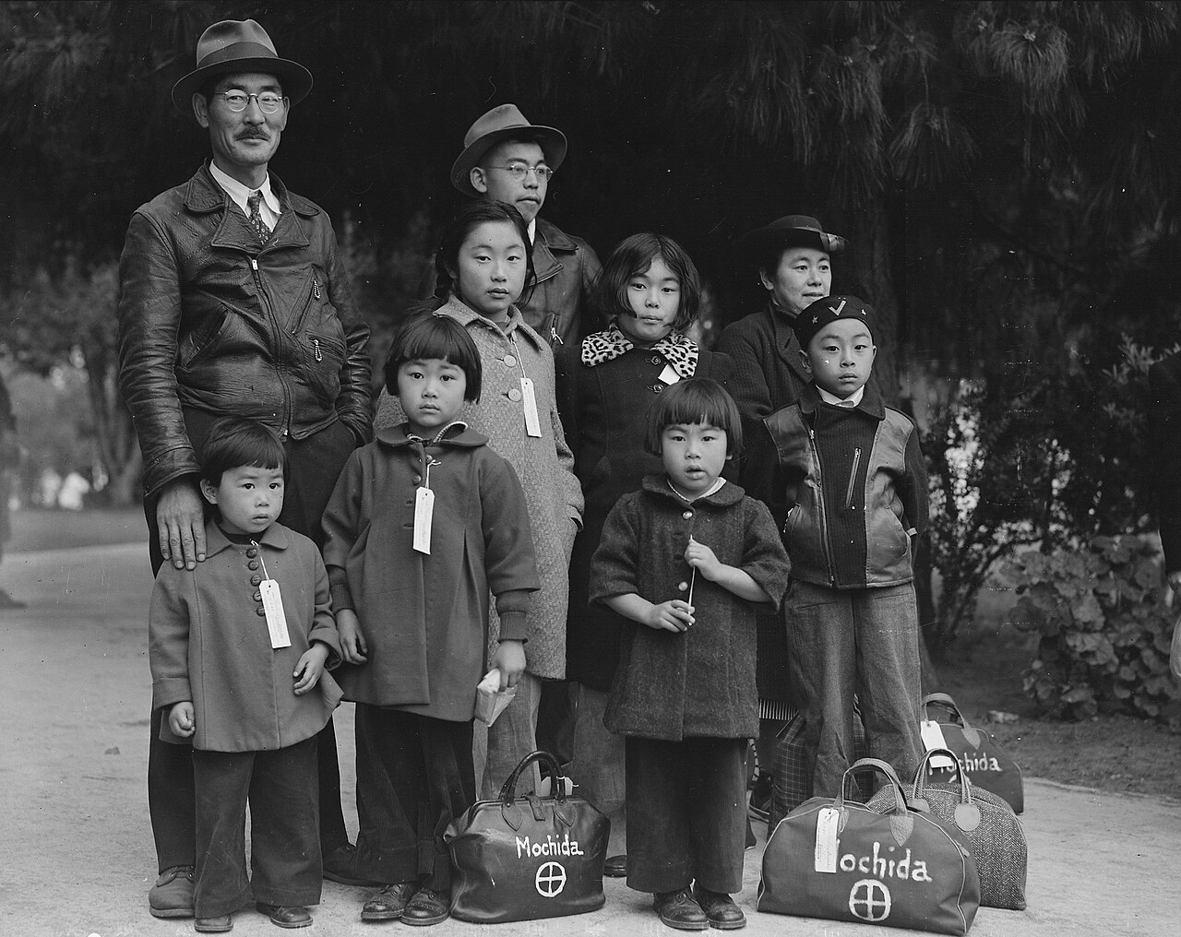
Photograph of Members of the Mochida Family Awaiting Evacuation Bus, Hayward, California (May 8, 1942) · Dorothea Lange / War Relocation Authority / National Archives and Records Administration · May 8, 1942
Source: Lange, Dorothea. "Photograph of Members of the Mochida Family Awaiting Evacuation Bus, Hayward, California." 8 May 1942. U.S. Department of the Interior, War Relocation Authority / National Archives and Records Administration (NAID 537505), via Wikimedia Commons, commons.wikimedia.org/wiki/File:Photograph_of_Members_of_the_Mochida_Family_Awaiting_Evacuation_-_NARA_-_537505.jpg. Public Domain https://commons.wikimedia.org/wiki/File:Photograph_of_Members_of_the_Mochida_Family_Awaiting_Evacuation_-_NARA_-_537505.jpg
HIPPO — analyze the source (prompt) | Your analysis
H — Historical context: what was happening when this was created?
I — Intended audience: who was meant to see or obey it?
P — Purpose: why was it created?
P — Point of view: whose perspective does it reflect?
O — Outside connection: how does it connect to this standard?
SUPPORT OPTION
Sentence frame: This source shows ______ because it ______, which reveals ______.
CONFIDENCE CHECK-IN
Rate your understanding of this standard (1–4): ______ One thing to revisit: ____________________
HIPPO SUPPORTS — analyzing the source · US.54
Optional — use these to complete your HIPPO analysis. Your teacher may print this back page or leave it off.
Guiding questions
• H — Historical context: What was happening in the world when this was made?
• I — Intended audience: Who was meant to see or obey it?
• P — Purpose: Why did the creator make it? What did they want to happen?
• P — Point of view: Whose side does it show? Whose voice is missing?
• O — Outside connection: What have we studied that connects to this?
SUPPORT OPTION
Sentence frame: This source shows ______ because it ______, which reveals ______.
Model analysis (example)
H: Photographed May 8, 1942, in Hayward, California, as the Mochida family awaited forced removal to an internment camp after Executive Order 9066. I: Taken for a U.S. government agency to document the removal; many of Lange's images were withheld at the time. P: To officially record the “evacuation”; Lange used it to quietly show the human cost. POV: Sympathetic to the interned families; the government framed removal as military necessity. O: Connects to Executive Order 9066 and to the Korematsu v. United States decision.
Try it — sourcing warm-up
Before you fill in HIPPO on the front, answer these in one line each:
• Who made this source, and when?

• What did they want the viewer to think or feel?

• How does that change how much you trust it?

Activity 6 — Core Application: Practice Quiz — US.54 ⏱ ~8 min ▶ Deck slide 81
RESPONSE CHOICE
Commit to an answer by marking it, saying it, or explaining it aloud before checking. Answer key is in the Teacher Guide (kept separate).
[DOK 1 · item q-us54-dok1-1]
1. How many Japanese Americans were forcibly interned during WWII?
A. 50,000 people, limited to non-citizens and first-generation immigrants only
B. 25,000 people, primarily those with direct ties to Japanese government
✓ C. 120,000 people, of whom two-thirds were American citizens by birth
D. 200,000 people, including German and Italian Americans from coastal areas
[DOK 2 · item q-us54-dok2-1]
2. What was Executive Order 9066?
A. Congressional declaration of war against Japan following the attack on Pearl Harbor
B. FDR's order directing scientists to begin developing the atomic bomb in secret labs
✓ C. FDR's order authorizing military to relocate Japanese Americans to internment camps
D. Truman's order requiring full racial integration of all branches of the armed forces
[DOK 1 · item q-us54-dok2-3]
3. How did Fred Korematsu challenge his internment?
A. Japanese Americans faced mass internment based on race; German/Italian Americans faced limited restrictions
B. Harsh: overcrowded barracks, inadequate sanitation, extreme weather, barbed wire, armed guards
C. Upheld internment based on race over constitutional rights; later overturned as based on lies
✓ D. Refused to report for internment; arrested and appealed to Supreme Court claiming constitutional violation
[DOK 3 · item q-us54-dok3-1]
4. Why is the Korematsu v. United States decision considered one of the Supreme Court's worst decisions?
✓ A. Upheld internment based on race over constitutional rights; later overturned as based on lies
B. Harsh: overcrowded barracks, inadequate sanitation, extreme weather, barbed wire, armed guards
C. FDR's order authorizing military to relocate Japanese Americans to internment camps
D. Refused to report for internment; arrested and appealed to Supreme Court claiming constitutional violation
CHECK YOURSELF — quiz answer key
Commit your answers first, then check: 1. C 2. C 3. D 4. A
Missed one? Reread that section and fix your thinking — that is where the learning happens.

Activity 7 — Constructed Response (CER) — US.54 ⏱ ~15 min ▶ Deck slides 75–79
BIG-QUESTION ORGANIZER — in World War II, how did the war reshape America at home and its role in the world — and who sacrificed, even while being excluded?
Jot quick notes from THIS standard: Who benefited? · Who bore the costs? · Who decided?

CONSTRUCTED RESPONSE (CER) — builds SSP.04 Argumentation
Claim + Evidence + Reasoning: Using this standard, take a position on the central question — describe the constitutional issues and impact of the internment of Japanese Americans on the U.S., including the Fred Korematsu v. United States of America decision? Support your claim with two pieces of evidence from the passage and explain your reasoning.
Part | Write here
Claim
Evidence (two specifics)
Reasoning
SELF-GRADE YOUR CER — score each trait 1–4
Trait | What a strong (3–4) response shows | My score (1–4)
Claim | Clear; directly answers the question
Evidence | Two specific facts from the sources
Reasoning | Explains HOW the evidence proves the claim
Conventions | Complete, readable sentences
My total: ______ / 16 · One thing I will improve next time: ______________________
Peer review — trade & improve
Glow — one thing that works:

Grow — one thing to strengthen:

My revision — one change I will make:

WRITING SUPPORTS — Constructed Response (CER) · US.54
Optional — use these to plan and write your CER. Your teacher may print this back page or leave it off; the goal on the front never changes.
Sentence stems
• Claim: “One major cause of ______ was ______.” / “______ happened mainly because ______.”
• Evidence: “According to the source, ______.” / “For example, ______ shows that ______.”
• Reasoning: “This evidence proves ______ because ______.” / “This matters because ______.”
• Go further: “Although some might say ______, the stronger evidence shows ______.”
Model response (example)
Claim: The internment of Japanese Americans violated constitutional rights in the name of wartime security. Evidence: Executive Order 9066 (1942) forced about 120,000 Japanese Americans — most of them U.S. citizens — into camps, and in Korematsu v. United States (1944) the Supreme Court upheld the removal. Reasoning: This shows how fear and prejudice led the government to suspend citizens' rights, a decision later condemned and formally apologized for in 1988.
CER rubric — in your own words
• Claim — I answer the question in one clear sentence.
• Evidence — I use two specific facts from the sources.
• Reasoning — I explain HOW my evidence proves my claim.
• Conventions — I write in complete sentences a reader can follow.
Argument word bank
First · Because · For example · This shows that · As a result · Therefore · However · Although · In contrast · This matters because
EXIT TICKET — before you leave [item us54-q1 · DOK 2 · pre-field-test]
What factors led to the decision to intern Japanese Americans after Pearl Harbor?
A. Evidence of widespread Japanese American disloyalty, yet the available evidence points to a different conclusion and does not reflect the scholarly consensus on this topic
B. Japanese Americans requested internment for protection, but this fails to account for the broader historical context, which ignores significant political and cultural developments of the era
C. Only non-citizens were interned, which ignores key developments that shaped the outcome, but the historical evidence paints a more nuanced picture, although historical sources do not support this conclusion
✓ D. Wartime hysteria, racial prejudice, economic competition from Japanese American businesses, and exaggerated military necessity claims combined to overcome constitutional protections
Show what you know (your choice): mark the best answer, say it, or explain it — then rate how sure you are: ☐ Not yet ☐ Getting there ☐ Got it
✔ ANSWER: D — Wartime fear and racial prejudice, framed as “military necessity,” drove EO 9066 and mass internment. (Full key & reteach in the Teacher Guide.)

Standard US.55 — Home Front Mobilization
TN Academic Standard US.55: Describe the war's impact on the home front, including: rationing, bond drives, propaganda, movement to cities and industrial centers, Bracero program, conversion of factories for wartime production, location of prisoner of war camps in Tennessee.
LEARNING TARGETS — I can…
• I can describe the war's impact on the home front, including rationing, bond drives, propaganda, movement to cities, the Bracero program, conversion of factories, and prisoner of war camps in Tennessee.
Lenses for this standard: History · Economics
CORE PATH — the same for every student
Same rigor for everyone: analyze the sources and vocabulary, then show what you learned on the Practice Quiz and the CER.
Check yourself against the learning targets on the Cornell Notes page.
★ Tennessee Connection
Tennessee was a major center for war production during WWII. Alcoa, Tennessee, produced aluminum for military aircraft, and Camp Forrest near Tullahoma served as a major Army training base. Women across the state joined the workforce in unprecedented numbers.
SET YOUR GOAL (self-direction)
My goal for this standard — what will I be able to do, and how will I show it?

HOOK — think before you dig in
You couldn't buy a new tire, sugar came by coupon, and your old pots might end up in a warplane. How does an entire nation retool itself for war? As you read, notice how everyday sacrifice at home fueled the fight abroad.
ACTIVATE — what do you already know or wonder?
Think about it, then jot a few notes in your notebook: what do you already know, and what do you wonder about this standard? You will come back to it.
PREVIEW & PREDICT
Which learning target will be hardest, and why? Connect it to the unit’s big question: how did the war change America at home and abroad, and who sacrificed even while excluded?

Activity 1 — Vocabulary (Part A: Reference / Word Bank) — US.55 ⏱ ~10 min ▶ Deck slide 88
Use this word bank throughout the standard. The Spanish column supports access, not translation of assessment.
Term | Student-friendly meaning | Spanish
Rationing | Government-controlled limits on consumer goods during WWII to ensure adequate supplies for the military, requiring ration books and coupons. | Racionamiento
War Bonds | Government bonds sold to citizens to finance the war effort, promoted through massive publicity campaigns featuring celebrities and patriotic appeals. | Bonos de Guerra
Rosie the Riveter | Cultural icon representing millions of American women who worked in factories and shipyards during World War II, filling jobs left by men who went to war. | Rosie la Remachadora
Manhattan Project | Top-secret U.S. program to develop the atomic bomb, involving sites at Oak Ridge (Tennessee), Los Alamos (New Mexico), and Hanford (Washington). | Proyecto Manhattan
Allied Powers | The World War II coalition led by the United States, Great Britain, and the Soviet Union that fought and defeated the Axis Powers. | Potencias Aliadas
Executive Order 8802 | The June 1941 order signed by President Roosevelt banning racial discrimination in the defense industry and creating the Fair Employment Practices Committee. | Orden Ejecutiva 8802
LANGUAGE SUPPORT
Pronunciations: Rationing (RASH-un-ing); War Bonds (wor bondz); Rosie the Riveter (ROH-zee thuh RIV-eh-ter); Manhattan Project (man-HAT-un PROJ-ekt); Allied Powers (AL-yd POW-erz); Executive Order 8802 (eg-ZEK-yuh-tiv OR-der).
VOCABULARY SELF-CHECK · Knowledge Rating
Rate each term NOW in pencil, then again at the END — growth is the goal; no penalty for “never seen it.”
Term | 1 · never seen it | 2 · heard it | 3 · can use it | 4 · can teach it
Rationing
War Bonds
Rosie the Riveter
Manhattan Project
Allied Powers
Executive Order 8802
MAKE IT YOURS (RESPONSE CHOICE): choose ONE term above and show you own it — write a sentence, sketch it, or give a real-world example. Do this in your notebook or on a whiteboard — be ready to share.
VOCABULARY SUPPORTS — make the words stick
Word-attack strategy: break long terms into smaller parts you recognize. Several terms are Spanish cognates (rationing / racionamiento), so use the Spanish column to unlock meaning.
Quick practice — choose ONE
• Draw a quick symbol for two terms.
• Write one sentence that uses two terms together.
• Teach a term to a partner in 20 seconds.

Do your quick practice here:

Use two terms together in one sentence:

Cognate connection — write the English term and its Spanish cognate for two words:

Study tip: cover the meaning column and quiz yourself, then re-rate each term on the self-check at the end of the standard.

Activity 2 — Vocabulary Studio (Frayer-inspired) — US.55 ⏱ ~7 min ▶ Deck slide 88
RESPONSE CHOICE
Complete each studio by writing, speaking, or diagramming.

PRIORITY TERM 1 Rationing · ES: Racionamiento
Word-bank meaning to build on: Government-controlled limits on consumer goods during WWII to ensure adequate supplies for the military, requiring ration books and coupons.
Definition (in your own words) | Characteristics
Examples | Non-examples
Use it to explain
Write one sentence that uses “Rationing” to explain this standard.

PRIORITY TERM 2 War Bonds · ES: Bonos de Guerra
Word-bank meaning to build on: Government bonds sold to citizens to finance the war effort, promoted through massive publicity campaigns featuring celebrities and patriotic appeals.
Definition (in your own words) | Characteristics
Examples | Non-examples
Use it to explain
Write one sentence that uses “War Bonds” to explain this standard.

CONNECT THE TERMS (UDL · build understanding)
How do these priority terms fit together? On a whiteboard or in your notebook, draw a quick web or write 2–3 sentences showing how one leads to or affects another — be ready to share.

Activity 3 — Direct Teaching Cornell Notes — US.55 ⏱ ~20 min ▶ Deck slides 83–85
Name: ______________________ Class / Period: __________ Date: __________
US.55 — Home Front Mobilization • These notes capture the direct-teaching content and the Close Read for this standard.
Your learning targets are on this standard’s opening page — take notes that help you meet them.
Cues (tied to your learning targets) | My notes
What does the passage say about rationing and Conservation?
What does the passage say about war Bonds and Propaganda?
What does the passage say about migration, Factory Conversion, and Bracero Program?
Key terms →

Cornell Notes — keep going, then process & check — US.55
MORE NOTES / DIAGRAMS
Continue your notes here, add a quick sketch, or map how the ideas connect.

Key terms to list
Rationing · War Bonds · Rosie the Riveter · Manhattan Project · Allied Powers · Executive Order 8802
Summary — In your own words (2–3 sentences)
PROGRESS CHECK · one question
What role did propaganda play in maintaining civilian morale and support for the war effort?
A. Propaganda was not used during WWII, but this fails to account for the broader historical context, but contemporary accounts and primary sources suggest otherwise
B. Propaganda only targeted military personnel, yet the available evidence points to a different conclusion, but the historical evidence paints a more nuanced picture
C. The Office of War Information used films, posters, and radio to demonize enemies, celebrate American values, recruit workers, and build national unity through shared purpose and sacrifice
D. Propaganda undermined the war effort, but this fails to account for the broader historical context, but contemporary accounts and primary sources suggest otherwise
Commit before you move on — mark it, say it, or explain it aloud.
CHECK YOURSELF — how am I doing?
Which learning targets (on this standard’s opening page) can you now meet? Tick the number; circle any you still need help with.
☐ 1
My 12–15 word headline for this standard

Activity 4 — Close Read — US.55 ⏱ ~15 min ▶ Deck slides 83–85
Reading type: History Hack-authored instructional synthesis. This is not a primary source. Builds SSP.03 (synthesize) and SSP.05 (historical awareness).
Key terms first: Rationing, War Bonds. Read once for the gist, then again for evidence.
CORE PATH — read one chunk at a time
Rationing and Conservation
Ration books with coupons controlled civilian access to gasoline, tires, sugar, meat, coffee, and other commodities. This ensured military supplies while distributing scarce goods fairly. Victory gardens encouraged citizens to grow their own vegetables, while scrap drives collected metal, rubber, and other materials. These programs fostered civilian investment in the war effort and created shared sacrifice that built national unity.
War Bonds and Propaganda
Liberty and Victory bonds financed the war while giving civilians a direct stake in victory. Bond drives featured celebrities and patriotic appeals, raising billions of dollars. The Office of War Information coordinated propaganda through films, posters, and radio, boosting morale and labor recruitment. Propaganda portrayed the enemy as evil while celebrating American values and workers' contributions.
Migration, Factory Conversion, and Bracero Program
Millions migrated to defense industry centers, creating housing shortages and demographic shifts that reshaped American cities. Auto plants converted to tank and aircraft factories through rapid retooling that enabled massive production increases. The Bracero Program (1942) brought contract labor from Mexico to fill agricultural shortages, providing economic benefits while creating exploitation issues that would persist for decades.
Tennessee's Wartime Role
Tennessee hosted significant wartime facilities including POW camps that housed Axis prisoners, providing labor for local agriculture and industry. Camp Forrest and other installations trained troops and processed prisoners. Most significantly, Oak Ridge was secretly built to enrich uranium for the Manhattan Project, making Tennessee crucial to developing the atomic bomb. These facilities transformed Tennessee's economy and population.
CLOSE-READ EVIDENCE LAB — for each question: quote the EVIDENCE from the passage above, then write YOUR ANSWER (or answer aloud / diagram it).
Text-dependent question | Evidence from the passage | Your answer (what it shows)
What is the main idea of the “Rationing and Conservation” section, and what evidence supports it?
What is the main idea of the “War Bonds and Propaganda” section, and what evidence supports it?
What is the main idea of the “Migration, Factory Conversion, and Bracero Program” section, and what evidence supports it?

Activity 5 — Primary Source / Data Analysis — US.55 ⏱ ~15 min ▶ Deck slide 86
Document (text primary source — analyze with HIPPO). Builds SSP.01–SSP.02.
WAR RATION BOOK INSTRUCTIONS
“This book is your Government's guarantee of your fair share of goods made scarce by war. Price ceilings and rationing are the most fair way to distribute scarce goods. Misuse of rationing stamps is a crime punishable by fine or imprisonment”
Source: Office of Price Administration, 1943. Office of Price Administration. "War Ration Book Instructions." 1943. National Archives, www.archives.gov/education/lessons/wwii-rationing.. Public domain. https://www.archives.gov/education/lessons/wwii-rationing
HIPPO — analyze the source (prompt) | Your analysis
H — Historical context: what was happening when this was created?
I — Intended audience: who was meant to see or obey it?
P — Purpose: why was it created?
P — Point of view: whose perspective does it reflect?
O — Outside connection: how does it connect to this standard?
SUPPORT OPTION
Sentence frame: This source shows ______ because it ______, which reveals ______.

EXTEND & RE-ENGAGE (open to all)
Push past the document — corroborate, contextualize, and judge its meaning.
Historian move | Your response
Corroborate — what other source would confirm or complicate this one?
Contextualize — what was happening at the time that explains it?
So what? — why does this source still matter?
CONFIDENCE CHECK-IN
Rate your understanding of this standard (1–4): ______ One thing to revisit: ____________________
HIPPO SUPPORTS — analyzing the source · US.55
Optional — use these to complete your HIPPO analysis. Your teacher may print this back page or leave it off.
Guiding questions
• H — Historical context: What was happening in the world when this was made?
• I — Intended audience: Who was meant to see or obey it?
• P — Purpose: Why did the creator make it? What did they want to happen?
• P — Point of view: Whose side does it show? Whose voice is missing?
• O — Outside connection: What have we studied that connects to this?
SUPPORT OPTION
Sentence frame: This source shows ______ because it ______, which reveals ______.
Model analysis (example)
H: Issued in 1943 by the Office of Price Administration, when the U.S. rationed scarce goods to support the war effort. I: American consumers and households, explaining how to use ration books. P: To share scarce resources fairly and to prevent inflation and hoarding. POV: The federal government's view that shared sacrifice was a patriotic duty. O: Connects to bond drives, factory conversion, and other home-front mobilization.
Try it — sourcing warm-up
Before you fill in HIPPO on the front, answer these in one line each:
• Who made this source, and when?

• What did they want the viewer to think or feel?

• How does that change how much you trust it?

Activity 6 — Core Application: Practice Quiz — US.55 ⏱ ~8 min ▶ Deck slide 89
RESPONSE CHOICE
Commit to an answer by marking it, saying it, or explaining it aloud before checking. Answer key is in the Teacher Guide (kept separate).
[DOK 1 · item q-us55-dok1-1]
1. What items were rationed on the WWII home front?
A. Only gasoline and rubber products were rationed to support military transportation needs
B. Only luxury goods like jewelry, perfume, and imported fabrics were limited by government
C. Clothing, furniture, and household appliances were the primary items under restriction
✓ D. Sugar, meat, butter, gasoline, tires, and shoes were rationed for military needs
[DOK 2 · item q-us55-dok2-1]
2. What were Victory Gardens and why were they important?
A. Government propaganda campaigns encouraging citizens to buy war bonds and save food
B. Military training facilities where soldiers practiced farming techniques for survival
C. Public memorial parks honoring fallen soldiers and decorated with patriotic symbols
✓ D. Home vegetable gardens that reduced demand on commercial agriculture for troops
[DOK 2 · item q-us55-dok2-2]
3. How did the U.S. mobilize its economy for WWII?
A. Focused exclusively on military recruitment without modifying industrial production systems
B. Maintained peacetime economy with minimal government intervention or production changes
✓ C. Converted factories to war production, rationed goods, sold bonds, employed women
D. Relied primarily on foreign imports and international aid for military supplies
[DOK 2 · item q-us55-dok3-1]
4. How did WWII mobilization transform the American economy permanently?
A. Produced propaganda films, morale-boosting entertainment, training films, and war bond drives
B. War production created massive industrial demand, eliminating unemployment almost entirely
C. Refused to report for internment; arrested and appealed to Supreme Court claiming constitutional violation
✓ D. Created military-industrial complex; expanded federal government; demonstrated Keynesian economics worked
CHECK YOURSELF — quiz answer key
Commit your answers first, then check: 1. D 2. D 3. C 4. D
Missed one? Reread that section and fix your thinking — that is where the learning happens.

Activity 7 — Constructed Response (CER) — US.55 ⏱ ~15 min ▶ Deck slides 83–87
BIG-QUESTION ORGANIZER — in World War II, how did the war reshape America at home and its role in the world — and who sacrificed, even while being excluded?
Jot quick notes from THIS standard: Who benefited? · Who bore the costs? · Who decided?

CONSTRUCTED RESPONSE (CER) — builds SSP.04 Argumentation
Claim + Evidence + Reasoning: Using this standard, take a position on the central question — describe the war's impact on the home front, including rationing, bond drives, propaganda, movement to cities, the Bracero program, conversion of factories, and prisoner of war camps in Tennessee? Support your claim with two pieces of evidence from the passage and explain your reasoning.
Part | Write here
Claim
Evidence (two specifics)
Reasoning
SELF-GRADE YOUR CER — score each trait 1–4
Trait | What a strong (3–4) response shows | My score (1–4)
Claim | Clear; directly answers the question
Evidence | Two specific facts from the sources
Reasoning | Explains HOW the evidence proves the claim
Conventions | Complete, readable sentences
My total: ______ / 16 · One thing I will improve next time: ______________________
Peer review — trade & improve
Glow — one thing that works:

Grow — one thing to strengthen:

My revision — one change I will make:

WRITING SUPPORTS — Constructed Response (CER) · US.55
Optional — use these to plan and write your CER. Your teacher may print this back page or leave it off; the goal on the front never changes.
Sentence stems
• Claim: “One major cause of ______ was ______.” / “______ happened mainly because ______.”
• Evidence: “According to the source, ______.” / “For example, ______ shows that ______.”
• Reasoning: “This evidence proves ______ because ______.” / “This matters because ______.”
• Go further: “Although some might say ______, the stronger evidence shows ______.”
Model response (example)
Claim: World War II transformed the American home front through shared sacrifice and government mobilization. Evidence: The government rationed goods such as gasoline and sugar with ration books (1942–43), and factories converted to war production of tanks, planes, and ships. Reasoning: These changes show how total war reached everyday life, requiring civilians to sacrifice and the economy to reorganize around military needs.
CER rubric — in your own words
• Claim — I answer the question in one clear sentence.
• Evidence — I use two specific facts from the sources.
• Reasoning — I explain HOW my evidence proves my claim.
• Conventions — I write in complete sentences a reader can follow.
Argument word bank
First · Because · For example · This shows that · As a result · Therefore · However · Although · In contrast · This matters because
EXIT TICKET — before you leave [item us55-q1 · DOK 2 · pre-field-test]
How did rationing, bond drives, and factory conversion mobilize American society for total war?
✓ A. Rationing ensured military supplies and fair distribution, bonds financed the war while building civilian investment, and factory conversion transformed auto plants into war production facilities
B. These programs had minimal impact on civilian life, although historical sources do not support this conclusion, although this overlooks critical economic and social factors involved
C. Only military personnel were affected by these programs, which contradicts the primary source evidence from this era and does not reflect the scholarly consensus on this topic
D. Civilians were not involved in the war effort, though this interpretation lacks supporting historical evidence, which ignores significant political and cultural developments of the era
Show what you know (your choice): mark the best answer, say it, or explain it — then rate how sure you are: ☐ Not yet ☐ Getting there ☐ Got it
✔ ANSWER: A — Rationing, bond drives, and factory conversion redirected the whole economy toward war production. (Full key & reteach in the Teacher Guide.)

Standard US.56 — Manhattan Project & Atomic Bomb
TN Academic Standard US.56: Describe the Manhattan Project and explain the rationale for using the atomic bomb to end the war.
LEARNING TARGETS — I can…
• I can describe the Manhattan Project and explain the rationale for using the atomic bomb to end the war.
Lenses for this standard: History · Geography
CORE PATH — the same for every student
Same rigor for everyone: analyze the sources and vocabulary, then show what you learned on the Practice Quiz and the CER.
Check yourself against the learning targets on the Cornell Notes page.
★ Tennessee Connection
Oak Ridge, Tennessee — the 'Secret City' — was a central site for the Manhattan Project. At its peak, Oak Ridge employed over 75,000 workers enriching uranium for the atomic bomb. The city was built from scratch in 1942 and was not shown on any maps.
SET YOUR GOAL (self-direction)
My goal for this standard — what will I be able to do, and how will I show it?

HOOK — think before you dig in
In secret desert labs, scientists raced to build a weapon powerful enough to end a war — and open a frightening new age. Should the United States have used it? As you read, weigh the reasoning behind one of history's most debated decisions.
ACTIVATE — what do you already know or wonder?
Think about it, then jot a few notes in your notebook: what do you already know, and what do you wonder about this standard? You will come back to it.
PREVIEW & PREDICT
Which learning target will be hardest, and why? Connect it to the unit’s big question: how did the war change America at home and abroad, and who sacrificed even while excluded?

Activity 1 — Vocabulary (Part A: Reference / Word Bank) — US.56 ⏱ ~10 min ▶ Deck slide 96
Use this word bank throughout the standard. The Spanish column supports access, not translation of assessment.
Term | Student-friendly meaning | Spanish
Manhattan Project | Top-secret U.S. program to develop the atomic bomb, involving sites at Oak Ridge (Tennessee), Los Alamos (New Mexico), and Hanford (Washington). | Proyecto Manhattan
Atomic Bomb | Nuclear weapons dropped on Hiroshima (August 6) and Nagasaki (August 9, 1945), killing over 200,000 people and forcing Japan's surrender, ending World War II. | Bomba Atómica
Battle of Iwo Jima | February-March 1945 brutal battle for a strategic Pacific island, famous for the iconic flag-raising photograph on Mount Suribachi. | Batalla de Iwo Jima
Allied Powers | The World War II coalition led by the United States, Great Britain, and the Soviet Union that fought and defeated the Axis Powers. | Potencias Aliadas
Hideki Tojo | Japanese military leader and Prime Minister (1941-1944) who led Japan into World War II and authorized the attack on Pearl Harbor. | Hideki Tojo
Pearl Harbor | Japan's surprise attack on the U.S. naval base in Hawaii on December 7, 1941, killing over 2,400 Americans and bringing the United States into World War II. | Pearl Harbor
LANGUAGE SUPPORT
Pronunciations: Manhattan Project (man-HAT-un PROJ-ekt); Atomic Bomb (uh-TOM-ik bom); Battle of Iwo Jima (BAT-ul uv EE-woh JEE-muh); Allied Powers (AL-yd POW-erz); Hideki Tojo (hee-DEH-kee TOH-joh); Pearl Harbor (purl HAR-ber).
VOCABULARY SELF-CHECK · Knowledge Rating
Rate each term NOW in pencil, then again at the END — growth is the goal; no penalty for “never seen it.”
Term | 1 · never seen it | 2 · heard it | 3 · can use it | 4 · can teach it
Manhattan Project
Atomic Bomb
Battle of Iwo Jima
Allied Powers
Hideki Tojo
Pearl Harbor
MAKE IT YOURS (RESPONSE CHOICE): choose ONE term above and show you own it — write a sentence, sketch it, or give a real-world example. Do this in your notebook or on a whiteboard — be ready to share.
VOCABULARY SUPPORTS — make the words stick
Word-attack strategy: break long terms into smaller parts you recognize. Several terms are Spanish cognates (atomic / atómica), so use the Spanish column to unlock meaning.
Quick practice — choose ONE
• Draw a quick symbol for two terms.
• Write one sentence that uses two terms together.
• Teach a term to a partner in 20 seconds.

Do your quick practice here:

Use two terms together in one sentence:

Cognate connection — write the English term and its Spanish cognate for two words:

Study tip: cover the meaning column and quiz yourself, then re-rate each term on the self-check at the end of the standard.

Activity 2 — Vocabulary Studio (Frayer-inspired) — US.56 ⏱ ~7 min ▶ Deck slide 96
RESPONSE CHOICE
Complete each studio by writing, speaking, or diagramming.

PRIORITY TERM 1 Manhattan Project · ES: Proyecto Manhattan
Word-bank meaning to build on: Top-secret U.S. program to develop the atomic bomb, involving sites at Oak Ridge (Tennessee), Los Alamos (New Mexico), and Hanford (Washington).
Definition (in your own words) | Characteristics
Examples | Non-examples
Use it to explain
Write one sentence that uses “Manhattan Project” to explain this standard.

PRIORITY TERM 2 Atomic Bomb · ES: Bomba Atómica
Word-bank meaning to build on: Nuclear weapons dropped on Hiroshima (August 6) and Nagasaki (August 9, 1945), killing over 200,000 people and forcing Japan's surrender, ending World War II.
Definition (in your own words) | Characteristics
Examples | Non-examples
Use it to explain
Write one sentence that uses “Atomic Bomb” to explain this standard.

CONNECT THE TERMS (UDL · build understanding)
How do these priority terms fit together? On a whiteboard or in your notebook, draw a quick web or write 2–3 sentences showing how one leads to or affects another — be ready to share.

Activity 3 — Direct Teaching Cornell Notes — US.56 ⏱ ~20 min ▶ Deck slides 91–93
Name: ______________________ Class / Period: __________ Date: __________
US.56 — Manhattan Project & Atomic Bomb • These notes capture the direct-teaching content and the Close Read for this standard.
Your learning targets are on this standard’s opening page — take notes that help you meet them.
Cues (tied to your learning targets) | My notes
What does the passage say about oak Ridge, Tennessee Selection?
What does the passage say about manhattan Project Overview?
What does the passage say about rationale for Using Atomic Weapons?
Key terms →

Cornell Notes — keep going, then process & check — US.56
MORE NOTES / DIAGRAMS
Continue your notes here, add a quick sketch, or map how the ideas connect.

Key terms to list
Manhattan Project · Atomic Bomb · Battle of Iwo Jima · Allied Powers · Hideki Tojo · Pearl Harbor
Summary — In your own words (2–3 sentences)
PROGRESS CHECK · one question
What factors influenced President Truman's decision to use atomic weapons against Japan?
A. Truman made the decision without considering alternatives, which does not align with the documented historical record, although historical sources do not support this conclusion
B. Only military factors were considered, but this fails to account for the broader historical context, which represents a common misconception about this historical period
C. Truman opposed using the bombs, but this fails to account for the broader historical context, which does not align with the documented historical record
D. Projected invasion casualties based on Okinawa, desire to end the war quickly, demonstrating power to the Soviet Union, and Japanese refusal to surrender all influenced the decision
Commit before you move on — mark it, say it, or explain it aloud.
CHECK YOURSELF — how am I doing?
Which learning targets (on this standard’s opening page) can you now meet? Tick the number; circle any you still need help with.
☐ 1
My 12–15 word headline for this standard

Activity 4 — Close Read — US.56 ⏱ ~15 min ▶ Deck slides 91–93
Reading type: History Hack-authored instructional synthesis. This is not a primary source. Builds SSP.03 (synthesize) and SSP.05 (historical awareness).
Key terms first: Manhattan Project, Atomic Bomb. Read once for the gist, then again for evidence.
CORE PATH — read one chunk at a time
Oak Ridge, Tennessee Selection
Oak Ridge was selected for uranium enrichment because of its remote location providing security isolation, abundant electrical power from TVA, good transportation access, and available land. The "Secret City" grew to 75,000 residents, most unaware of their work's purpose. Oak Ridge produced enriched uranium for the "Little Boy" bomb dropped on Hiroshima, making Tennessee crucial to the atomic bomb's development.
Manhattan Project Overview
The secret multi-site program included Los Alamos (weapon design), Oak Ridge (uranium enrichment), and Hanford (plutonium production). Led by General Leslie Groves and scientist J. Robert Oppenheimer, the project employed over 125,000 people and cost nearly $2 billion. The Trinity test (July 16, 1945) successfully demonstrated the first nuclear explosion in New Mexico, proving the concept worked.
Rationale for Using Atomic Weapons
President Truman authorized atomic bombs to end the war quickly, avoiding a costly invasion of Japan projected to cause hundreds of thousands of American casualties based on Okinawa experience. Additional factors included forcing rapid Japanese surrender, demonstrating American power to the Soviet Union, and justifying the massive investment in the Manhattan Project. The bombs on Hiroshima (August 6) and Nagasaki (August 9) killed over 100,000 immediately, with more dying later from radiation.
Ethical Debate
Arguments for use included ending the war quickly, saving lives on both sides that invasion would cost, and Japanese refusal to surrender despite conventional bombing. Arguments against included the targeting of civilians, long-term radiation effects, potential alternatives like demonstration or modified surrender terms, and the precedent of nuclear warfare. This debate continues among historians and ethicists, with no consensus on whether the decision was justified.
CLOSE-READ EVIDENCE LAB — for each question: quote the EVIDENCE from the passage above, then write YOUR ANSWER (or answer aloud / diagram it).
Text-dependent question | Evidence from the passage | Your answer (what it shows)
What is the main idea of the “Oak Ridge, Tennessee Selection” section, and what evidence supports it?
What is the main idea of the “Manhattan Project Overview” section, and what evidence supports it?
What is the main idea of the “Rationale for Using Atomic Weapons” section, and what evidence supports it?

Geographer’s Lens — US.56 ⏱ ~12 min
Geographers don’t just find places — they explain how WHERE shapes WHAT happens. Work these like a geographer. Built on the Five Themes of Geography · C3 Dimension 2 · SSP.06 (spatial reasoning).
THE PLACES — then explain why geography put them there
The atomic bomb was built and used across a handful of secret, far-flung sites. Use the list below to map them, then explain how geography kept the project secret and shaped the war's end.
Place | Where | What happened (given) | Why HERE? (your analysis)
Oak Ridge, Tennessee | East Tennessee | the 'Secret City' — enriched uranium for the bomb
Los Alamos, New Mexico | Desert Southwest | the lab where the bomb was designed (Oppenheimer)
Hanford, Washington | Pacific Northwest | produced plutonium for the 'Fat Man' bomb
Hiroshima, Japan | Japan | first atomic bomb dropped, August 6, 1945
Nagasaki, Japan | Japan | second atomic bomb dropped, August 9, 1945
MOVEMENT & REGION — what’s the spatial pattern?
In 1–2 sentences: is this a movement, a cluster, or a whole region? Name the direction or shape it takes on a map.

GEOGRAPHY AS A FORCE — how did location shape the outcome?
How did geography change WHAT happened — who was affected, how far or fast it spread, or who was left out? Use one place above as your evidence.

READ IT LIKE A SOURCE — RESPONSE CHOICE
A map is a source with a point of view. Show your thinking your way — write it, OR sketch a quick arrows-and-labels diagram: what would a map of this make CLEAR, and what would it HIDE or leave out?

Activity 5 — Primary Source / Data Analysis — US.56 ⏱ ~15 min ▶ Deck slide 94
Primary source (photograph) — analyze it with HIPPO. Builds SSP.01–SSP.02.
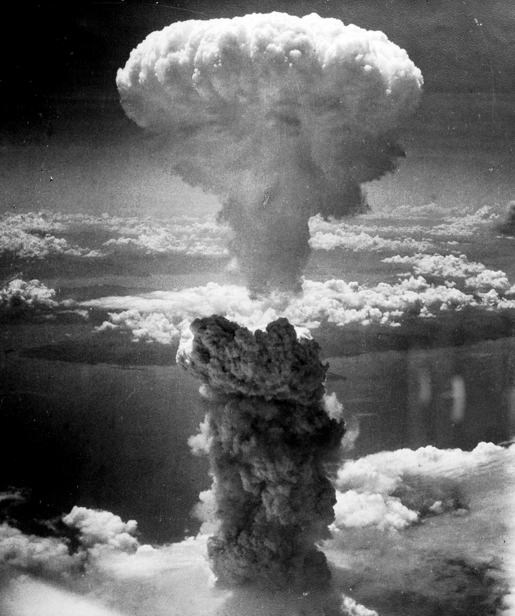
Mushroom Cloud above Nagasaki after Atomic Bombing, August 9, 1945 · Charles Levy / U.S. Army Air Forces / National Archives and Records Administration · August 9, 1945
Source: Levy, Charles. "Mushroom Cloud above Nagasaki after Atomic Bombing." 9 Aug. 1945. U.S. Army Air Forces / National Archives and Records Administration, via Wikimedia Commons, commons.wikimedia.org/wiki/File:Nagasakibomb.jpg. Public Domain https://commons.wikimedia.org/wiki/File:Nagasakibomb.jpg
HIPPO — analyze the source (prompt) | Your analysis
H — Historical context: what was happening when this was created?
I — Intended audience: who was meant to see or obey it?
P — Purpose: why was it created?
P — Point of view: whose perspective does it reflect?
O — Outside connection: how does it connect to this standard?
SUPPORT OPTION
Sentence frame: This source shows ______ because it ______, which reveals ______.
CONFIDENCE CHECK-IN
Rate your understanding of this standard (1–4): ______ One thing to revisit: ____________________
HIPPO SUPPORTS — analyzing the source · US.56
Optional — use these to complete your HIPPO analysis. Your teacher may print this back page or leave it off.
Guiding questions
• H — Historical context: What was happening in the world when this was made?
• I — Intended audience: Who was meant to see or obey it?
• P — Purpose: Why did the creator make it? What did they want to happen?
• P — Point of view: Whose side does it show? Whose voice is missing?
• O — Outside connection: What have we studied that connects to this?
SUPPORT OPTION
Sentence frame: This source shows ______ because it ______, which reveals ______.
Model analysis (example)
H: Photographed August 9, 1945, when the U.S. dropped the second atomic bomb on Nagasaki, days after Hiroshima, forcing Japan toward surrender. I: The military and, later, the public — documenting the new weapon's power. P: To record the bombing; the image became a symbol of the atomic age. POV: The U.S. Army Air Forces' perspective; the victims on the ground are unseen. O: Connects to the Manhattan Project and to the debate over ending the war versus its human cost.
Try it — sourcing warm-up
Before you fill in HIPPO on the front, answer these in one line each:
• Who made this source, and when?

• What did they want the viewer to think or feel?

• How does that change how much you trust it?

Activity 6 — Core Application: Practice Quiz — US.56 ⏱ ~8 min ▶ Deck slide 97
RESPONSE CHOICE
Commit to an answer by marking it, saying it, or explaining it aloud before checking. Answer key is in the Teacher Guide (kept separate).
[DOK 1 · item q-us56-dok1-1]
1. What were the three main Manhattan Project sites?
A. Washington DC (design); Pittsburgh, PA (materials); Denver, CO (assembly)
B. Chicago, IL (research); Detroit, MI (production); Albuquerque, NM (testing)
✓ C. Oak Ridge, TN (uranium); Los Alamos, NM (design); Hanford, WA (plutonium)
D. Boston, MA (research); Houston, TX (production); San Diego, CA (testing)
[DOK 1 · item q-us56-dok2-2]
2. What was the Manhattan Project?
✓ A. Top-secret U.S. program to develop the atomic bomb during World War II
B. U.S. economic aid program designed to rebuild war-devastated European cities
C. Military code name for the Allied invasion of Normandy on June 6, 1944
D. Coastal defense system protecting major American port cities from enemy attacks
[DOK 2 · item q-us56-dok2-1]
3. How many people died from the atomic bombings of Hiroshima and Nagasaki?
A. Approximately 10,000 military personnel were killed but civilian casualties were minimal
✓ B. Over 200,000 people, mostly civilians, died immediately or from radiation effects
C. Fewer than 5,000 people were harmed because most residents had already been evacuated
D. Between 20,000 and 30,000 people died primarily from the initial blast and fires
[DOK 3 · item q-us56-dok3-1]
4. Evaluate President Truman's rationale for using the atomic bomb against Japan.
A. Solely to punish Japan for the attack on Pearl Harbor and avenge American deaths
✓ B. Multiple factors including saving lives, ending war quickly, and strategic advantage
C. To test the new weapon on a civilian population for scientific research purposes
D. Because conventional bombing had proven completely ineffective against Japanese cities
CHECK YOURSELF — quiz answer key
Commit your answers first, then check: 1. C 2. A 3. B 4. B
Missed one? Reread that section and fix your thinking — that is where the learning happens.

Activity 7 — Constructed Response (CER) — US.56 ⏱ ~15 min ▶ Deck slides 91–95
BIG-QUESTION ORGANIZER — in World War II, how did the war reshape America at home and its role in the world — and who sacrificed, even while being excluded?
Jot quick notes from THIS standard: Who benefited? · Who bore the costs? · Who decided?

CONSTRUCTED RESPONSE (CER) — builds SSP.04 Argumentation
Claim + Evidence + Reasoning: Using this standard, take a position on the central question — describe the Manhattan Project and explain the rationale for using the atomic bomb to end the war? Support your claim with two pieces of evidence from the passage and explain your reasoning.
Part | Write here
Claim
Evidence (two specifics)
Reasoning
SELF-GRADE YOUR CER — score each trait 1–4
Trait | What a strong (3–4) response shows | My score (1–4)
Claim | Clear; directly answers the question
Evidence | Two specific facts from the sources
Reasoning | Explains HOW the evidence proves the claim
Conventions | Complete, readable sentences
My total: ______ / 16 · One thing I will improve next time: ______________________
Peer review — trade & improve
Glow — one thing that works:

Grow — one thing to strengthen:

My revision — one change I will make:

WRITING SUPPORTS — Constructed Response (CER) · US.56
Optional — use these to plan and write your CER. Your teacher may print this back page or leave it off; the goal on the front never changes.
Sentence stems
• Claim: “One major cause of ______ was ______.” / “______ happened mainly because ______.”
• Evidence: “According to the source, ______.” / “For example, ______ shows that ______.”
• Reasoning: “This evidence proves ______ because ______.” / “This matters because ______.”
• Go further: “Although some might say ______, the stronger evidence shows ______.”
Model response (example)
Claim: The U.S. used the atomic bomb to end the war quickly, though the decision remains debated. Evidence: The secret Manhattan Project built the bomb, and in August 1945 the U.S. dropped bombs on Hiroshima and Nagasaki, after which Japan surrendered. Reasoning: Leaders argued the bombs avoided a costly invasion of Japan, but the massive civilian deaths raised lasting moral questions.
CER rubric — in your own words
• Claim — I answer the question in one clear sentence.
• Evidence — I use two specific facts from the sources.
• Reasoning — I explain HOW my evidence proves my claim.
• Conventions — I write in complete sentences a reader can follow.
Argument word bank
First · Because · For example · This shows that · As a result · Therefore · However · Although · In contrast · This matters because
EXIT TICKET — before you leave [item us56-q1 · DOK 2 · pre-field-test]
Why was Oak Ridge, Tennessee selected as a key site for the Manhattan Project?
A. Oak Ridge was chosen randomly, despite limited evidence supporting this interpretation, although this overlooks critical economic and social factors involved
✓ B. Its remote location provided security, TVA provided abundant electricity for uranium enrichment, transportation was accessible, and land was available for the massive facilities needed
C. Oak Ridge was already a major industrial center, which does not reflect the consensus among historians, but closer analysis reveals a more complicated historical reality
D. Scientists preferred the climate, but contemporary accounts suggest a different explanation, although historical sources do not support this conclusion, but the historical evidence paints a more nuanced picture
Show what you know (your choice): mark the best answer, say it, or explain it — then rate how sure you are: ☐ Not yet ☐ Getting there ☐ Got it
✔ ANSWER: B — Oak Ridge, TN was chosen for its isolation, TVA electricity, and rail access to enrich uranium in secret. (Full key & reteach in the Teacher Guide.)

Standard US.57 — Yalta and Potsdam Conferences
TN Academic Standard US.57: Explain the major outcomes of the Yalta and Potsdam Conferences.
LEARNING TARGETS — I can…
• I can explain the major outcomes of the Yalta and Potsdam Conferences.
Lenses for this standard: Politics/Government · History
CORE PATH — the same for every student
Same rigor for everyone: analyze the sources and vocabulary, then show what you learned on the Practice Quiz and the CER.
Check yourself against the learning targets on the Cornell Notes page.
SET YOUR GOAL (self-direction)
My goal for this standard — what will I be able to do, and how will I show it?

HOOK — think before you dig in
With victory finally in sight, three leaders sat down to carve up the postwar world — and quietly planted the seeds of the next conflict. Can allies who win a war together keep the peace? As you read, watch cooperation begin to crack into rivalry.
ACTIVATE — what do you already know or wonder?
Think about it, then jot a few notes in your notebook: what do you already know, and what do you wonder about this standard? You will come back to it.
PREVIEW & PREDICT
Which learning target will be hardest, and why? Connect it to the unit’s big question: how did the war change America at home and abroad, and who sacrificed even while excluded?

Activity 1 — Vocabulary (Part A: Reference / Word Bank) — US.57 ⏱ ~10 min ▶ Deck slide 104
Use this word bank throughout the standard. The Spanish column supports access, not translation of assessment.
Term | Student-friendly meaning | Spanish
Yalta Conference | February 1945 meeting of Roosevelt, Churchill, and Stalin to plan post-war Europe, dividing Germany and establishing spheres of influence. | Conferencia de Yalta
Potsdam Conference | July-August 1945 meeting of Truman, Churchill/Attlee, and Stalin finalizing plans for occupied Germany and issuing surrender terms to Japan. | Conferencia de Potsdam
Joseph Stalin | Communist dictator of the Soviet Union (1924-1953) who ruled through terror, forced collectivization, and purges, resulting in millions of deaths. | Joseph Stalin
Atomic Bomb | Nuclear weapons dropped on Hiroshima (August 6) and Nagasaki (August 9, 1945), killing over 200,000 people and forcing Japan's surrender, ending World War II. | Bomba Atómica
Allied Powers | The World War II coalition led by the United States, Great Britain, and the Soviet Union that fought and defeated the Axis Powers. | Potencias Aliadas
Axis Powers | Military alliance of Germany, Italy, and Japan during World War II. United by shared goals of territorial expansion, militarism, and opposition to democratic nations. | Potencias del Eje
LANGUAGE SUPPORT
Pronunciations: Yalta Conference (YAWL-tuh KON-fer-ens); Potsdam Conference (POTS-dam KON-fer-ens); Joseph Stalin (JOH-zef STAH-lin); Atomic Bomb (uh-TOM-ik bom); Allied Powers (AL-yd POW-erz); Axis Powers (AK-sis POW-erz).
VOCABULARY SELF-CHECK · Knowledge Rating
Rate each term NOW in pencil, then again at the END — growth is the goal; no penalty for “never seen it.”
Term | 1 · never seen it | 2 · heard it | 3 · can use it | 4 · can teach it
Yalta Conference
Potsdam Conference
Joseph Stalin
Atomic Bomb
Allied Powers
Axis Powers
MAKE IT YOURS (RESPONSE CHOICE): choose ONE term above and show you own it — write a sentence, sketch it, or give a real-world example. Do this in your notebook or on a whiteboard — be ready to share.
VOCABULARY SUPPORTS — make the words stick
Word-attack strategy: break long terms into smaller parts you recognize. Several terms are Spanish cognates (conference / conferencia), so use the Spanish column to unlock meaning.
Quick practice — choose ONE
• Draw a quick symbol for two terms.
• Write one sentence that uses two terms together.
• Teach a term to a partner in 20 seconds.

Do your quick practice here:

Use two terms together in one sentence:

Cognate connection — write the English term and its Spanish cognate for two words:

Study tip: cover the meaning column and quiz yourself, then re-rate each term on the self-check at the end of the standard.

Activity 2 — Vocabulary Studio (Frayer-inspired) — US.57 ⏱ ~7 min ▶ Deck slide 104
RESPONSE CHOICE
Complete each studio by writing, speaking, or diagramming.

PRIORITY TERM 1 Yalta Conference · ES: Conferencia de Yalta
Word-bank meaning to build on: February 1945 meeting of Roosevelt, Churchill, and Stalin to plan post-war Europe, dividing Germany and establishing spheres of influence.
Definition (in your own words) | Characteristics
Examples | Non-examples
Use it to explain
Write one sentence that uses “Yalta Conference” to explain this standard.

PRIORITY TERM 2 Potsdam Conference · ES: Conferencia de Potsdam
Word-bank meaning to build on: July-August 1945 meeting of Truman, Churchill/Attlee, and Stalin finalizing plans for occupied Germany and issuing surrender terms to Japan.
Definition (in your own words) | Characteristics
Examples | Non-examples
Use it to explain
Write one sentence that uses “Potsdam Conference” to explain this standard.

CONNECT THE TERMS (UDL · build understanding)
How do these priority terms fit together? On a whiteboard or in your notebook, draw a quick web or write 2–3 sentences showing how one leads to or affects another — be ready to share.

Activity 3 — Direct Teaching Cornell Notes — US.57 ⏱ ~20 min ▶ Deck slides 99–101
Name: ______________________ Class / Period: __________ Date: __________
US.57 — Yalta and Potsdam Conferences • These notes capture the direct-teaching content and the Close Read for this standard.
Your learning targets are on this standard’s opening page — take notes that help you meet them.
Cues (tied to your learning targets) | My notes
What does the passage say about yalta Conference (February 1945)?
What does the passage say about potsdam Conference (July-August 1945)?
What does the passage say about cold War Origins?
Key terms →

Cornell Notes — keep going, then process & check — US.57
MORE NOTES / DIAGRAMS
Continue your notes here, add a quick sketch, or map how the ideas connect.

Key terms to list
Yalta Conference · Potsdam Conference · Joseph Stalin · Atomic Bomb · Allied Powers · Axis Powers
Summary — In your own words (2–3 sentences)
PROGRESS CHECK · one question
How did the Potsdam Conference reveal growing tensions between the United States and Soviet Union?
A. Disputes over Eastern European governments, German reparations, and differing visions for post-war Europe revealed fundamental disagreements that would define the Cold War
B. Potsdam showed complete Allied unity, though this interpretation lacks supporting historical evidence, which ignores significant political and cultural developments of the era
C. Only minor disagreements emerged, despite the fact that multiple sources contradict this view, which represents a common misconception about this historical period
D. The Soviet Union was excluded from Potsdam, though this interpretation lacks supporting historical evidence, though this interpretation lacks supporting historical evidence
Commit before you move on — mark it, say it, or explain it aloud.
CHECK YOURSELF — how am I doing?
Which learning targets (on this standard’s opening page) can you now meet? Tick the number; circle any you still need help with.
☐ 1
My 12–15 word headline for this standard

Activity 4 — Close Read — US.57 ⏱ ~15 min ▶ Deck slides 99–101
Reading type: History Hack-authored instructional synthesis. This is not a primary source. Builds SSP.03 (synthesize) and SSP.05 (historical awareness).
Key terms first: Yalta Conference, Potsdam Conference. Read once for the gist, then again for evidence.
CORE PATH — read one chunk at a time
Yalta Conference (February 1945)
Roosevelt, Churchill, and Stalin met as Allied victory approached. Major agreements included UN formation plans, division of Germany into occupation zones, and Soviet entry into the war against Japan. Controversially, Stalin promised "free elections" in liberated Eastern Europe—a promise he would break. The conference also addressed reparations from Germany and arrangements for post-war Poland. Roosevelt sought Soviet cooperation for the post-war order.
Potsdam Conference (July-August 1945)
Truman (replacing the deceased Roosevelt), Churchill (replaced mid-conference by Attlee), and Stalin met as Germany surrendered. The conference confirmed occupation zones, issued the Potsdam Declaration ultimatum to Japan demanding unconditional surrender, and agreed on German demilitarization and denazification. Tensions over Eastern Europe and reparations surfaced, revealing the growing divide between Soviet and Western visions for post-war Europe.
Cold War Origins
Disagreements over Eastern Europe proved irreconcilable. Stalin's interpretation of "free elections" meant communist-controlled governments, while the West expected genuine democratic choice. Soviet occupation of Eastern Europe created what Churchill would call the "Iron Curtain." German reparations disputes, with the Soviets stripping their zone of industrial equipment, deepened mistrust. These wartime conferences set the stage for the Cold War division of Europe.
Assessment of Allied Diplomacy
Critics argue Roosevelt conceded too much to Stalin at Yalta, though defenders note Soviet armies already occupied Eastern Europe and FDR sought Soviet help against Japan. Truman took a harder line at Potsdam but faced the same reality of Soviet military control. Whether better outcomes were possible remains debated—the fundamental conflict between Soviet security concerns and Western democratic values may have made Cold War inevitable regardless of conference diplomacy.
CLOSE-READ EVIDENCE LAB — for each question: quote the EVIDENCE from the passage above, then write YOUR ANSWER (or answer aloud / diagram it).
Text-dependent question | Evidence from the passage | Your answer (what it shows)
What is the main idea of the “Yalta Conference (February 1945)” section, and what evidence supports it?
What is the main idea of the “Potsdam Conference (July-August 1945)” section, and what evidence supports it?
What is the main idea of the “Cold War Origins” section, and what evidence supports it?

Activity 5 — Primary Source / Data Analysis — US.57 ⏱ ~15 min ▶ Deck slide 102
Primary source (photograph) — analyze it with HIPPO. Builds SSP.01–SSP.02.
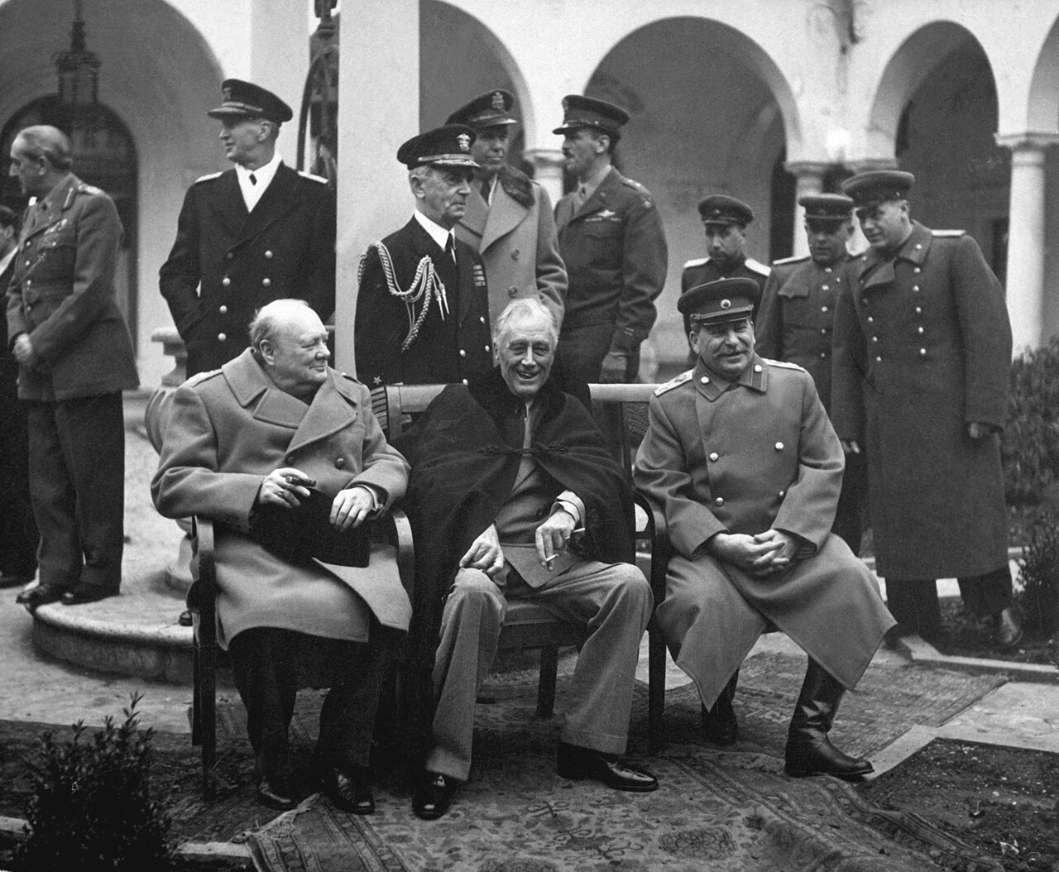
Yalta Conference, the Big Three: Churchill, Roosevelt, Stalin (February 1945) · U.S. Army Signal Corps / U.S. Federal Government · February 1945
Source: U.S. Army Signal Corps. "Yalta Conference, the Big Three: Churchill, Roosevelt, Stalin." Feb. 1945. National Archives and Records Administration, via Wikimedia Commons, commons.wikimedia.org/wiki/File:Yalta_Conference_(Churchill,_Roosevelt,_Stalin)_(B%26W).jpg. Public Domain https://commons.wikimedia.org/wiki/File:Yalta_Conference_(Churchill,_Roosevelt,_Stalin)_(B%26W).jpg
HIPPO — analyze the source (prompt) | Your analysis
H — Historical context: what was happening when this was created?
I — Intended audience: who was meant to see or obey it?
P — Purpose: why was it created?
P — Point of view: whose perspective does it reflect?
O — Outside connection: how does it connect to this standard?
SUPPORT OPTION
Sentence frame: This source shows ______ because it ______, which reveals ______.
CONFIDENCE CHECK-IN
Rate your understanding of this standard (1–4): ______ One thing to revisit: ____________________
HIPPO SUPPORTS — analyzing the source · US.57
Optional — use these to complete your HIPPO analysis. Your teacher may print this back page or leave it off.
Guiding questions
• H — Historical context: What was happening in the world when this was made?
• I — Intended audience: Who was meant to see or obey it?
• P — Purpose: Why did the creator make it? What did they want to happen?
• P — Point of view: Whose side does it show? Whose voice is missing?
• O — Outside connection: What have we studied that connects to this?
SUPPORT OPTION
Sentence frame: This source shows ______ because it ______, which reveals ______.
Model analysis (example)
H: Photographed February 1945 at the Yalta Conference, where Churchill, Roosevelt, and Stalin met as Allied victory neared. I: The public, showing unity among the “Big Three.” P: To project cooperation and to plan the postwar world. POV: The Allied leaders' official view of unity; tensions, especially over Eastern Europe, are hidden. O: Connects to the later Potsdam Conference and to the origins of the Cold War.
Try it — sourcing warm-up
Before you fill in HIPPO on the front, answer these in one line each:
• Who made this source, and when?

• What did they want the viewer to think or feel?

• How does that change how much you trust it?

Activity 6 — Core Application: Practice Quiz — US.57 ⏱ ~8 min ▶ Deck slide 105
RESPONSE CHOICE
Commit to an answer by marking it, saying it, or explaining it aloud before checking. Answer key is in the Teacher Guide (kept separate).
[DOK 1 · item q-us57-dok2-1]
1. What were the major outcomes of the Yalta Conference?
A. Contain the spread of communism by supporting free nations resisting Soviet subjugation
B. July 1945 meeting of Allied leaders after Germany surrendered to plan postwar order
C. U.S. program providing $13 billion to rebuild Western European economies after WWII
✓ D. Divided Germany; promised free elections in Eastern Europe; established United Nations
[DOK 1 · item q-us57-dok1-2]
2. What was the Potsdam Conference?
✓ A. July 1945 meeting of Allied leaders after Germany surrendered to plan postwar order
B. Pre-war diplomatic conference held to prevent conflict through negotiation and compromise
C. Emergency Allied meeting held specifically to coordinate the declaration of war on Japan
D. Major political rally organized by the Nazi party to demonstrate German military strength
[DOK 1 · item us-44-x030]
3. The Yalta Conference (1945) agreements regarding Eastern Europe became a source of U.S.-Soviet tension because:
A. FDR secretly agreed to Soviet control of Eastern Europe in exchange for Soviet entry into the Pacific War
B. The agreements gave the Soviet Union permanent veto power over Eastern European foreign policy
C. Stalin refused to honor FDR's demand that Eastern Europe be immediately liberated from Soviet occupation
✓ D. The Soviets interpreted 'free elections' differently from the Western Allies, installing communist-aligned governments
[DOK 2 · item q-us57-dok3-1]
4. How did WWII reshape the global balance of power?
A. Created Security Council with veto power for major powers; U.S. joined; had enforcement mechanisms
B. Contain the spread of communism by supporting free nations resisting Soviet subjugation
C. Divided Germany; promised free elections in Eastern Europe; established United Nations
✓ D. Created bipolar world with U.S. and USSR as superpowers; ended European dominance; began Cold War
CHECK YOURSELF — quiz answer key
Commit your answers first, then check: 1. D 2. A 3. D 4. D
Missed one? Reread that section and fix your thinking — that is where the learning happens.

Activity 7 — Constructed Response (CER) — US.57 ⏱ ~15 min ▶ Deck slides 99–103
BIG-QUESTION ORGANIZER — in World War II, how did the war reshape America at home and its role in the world — and who sacrificed, even while being excluded?
Jot quick notes from THIS standard: Who benefited? · Who bore the costs? · Who decided?

CONSTRUCTED RESPONSE (CER) — builds SSP.04 Argumentation
Claim + Evidence + Reasoning: Using this standard, take a position on the central question — explain the major outcomes of the Yalta and Potsdam Conferences? Support your claim with two pieces of evidence from the passage and explain your reasoning.
Part | Write here
Claim
Evidence (two specifics)
Reasoning
SELF-GRADE YOUR CER — score each trait 1–4
Trait | What a strong (3–4) response shows | My score (1–4)
Claim | Clear; directly answers the question
Evidence | Two specific facts from the sources
Reasoning | Explains HOW the evidence proves the claim
Conventions | Complete, readable sentences
My total: ______ / 16 · One thing I will improve next time: ______________________
Peer review — trade & improve
Glow — one thing that works:

Grow — one thing to strengthen:

My revision — one change I will make:

WRITING SUPPORTS — Constructed Response (CER) · US.57
Optional — use these to plan and write your CER. Your teacher may print this back page or leave it off; the goal on the front never changes.
Sentence stems
• Claim: “One major cause of ______ was ______.” / “______ happened mainly because ______.”
• Evidence: “According to the source, ______.” / “For example, ______ shows that ______.”
• Reasoning: “This evidence proves ______ because ______.” / “This matters because ______.”
• Go further: “Although some might say ______, the stronger evidence shows ______.”
Model response (example)
Claim: The Yalta and Potsdam Conferences shaped the postwar world and set the stage for the Cold War. Evidence: At Yalta (February 1945) the Allies agreed to divide Germany and create the United Nations, and at Potsdam (July–August 1945) they finalized occupation and demanded Japan's surrender. Reasoning: These decisions redrew borders and spheres of influence, but disputes — especially over Eastern Europe — soon divided the former allies.
CER rubric — in your own words
• Claim — I answer the question in one clear sentence.
• Evidence — I use two specific facts from the sources.
• Reasoning — I explain HOW my evidence proves my claim.
• Conventions — I write in complete sentences a reader can follow.
Argument word bank
First · Because · For example · This shows that · As a result · Therefore · However · Although · In contrast · This matters because
EXIT TICKET — before you leave [item us57-q1 · DOK 2 · pre-field-test]
What were the major agreements reached at the Yalta Conference regarding post-war Europe and the Pacific?
A. Yalta made no significant decisions, although this overlooks critical economic and social factors, and this view has been largely revised by modern historical research
B. Yalta only addressed Pacific issues, although this overlooks critical economic and social factors when examined alongside the available primary and secondary sources
✓ C. UN formation, German occupation zones, Soviet entry against Japan, and promises of free elections in Eastern Europe were key agreements, though Soviet commitments on elections proved meaningless
D. The conference ended without agreement, which does not align with the documented historical record, and this view has been largely revised by modern historical research
Show what you know (your choice): mark the best answer, say it, or explain it — then rate how sure you are: ☐ Not yet ☐ Getting there ☐ Got it
✔ ANSWER: C — Yalta divided Germany, promised free elections in Eastern Europe, and set up the United Nations. (Full key & reteach in the Teacher Guide.)

Standard US.58 — Founding of the United Nations & Cordell Hull
TN Academic Standard US.58: Identify and explain the reasons for the founding of the United Nations, including the role of Cordell Hull.
LEARNING TARGETS — I can…
• I can identify and explain the reasons for the founding of the United Nations, including the role of Cordell Hull.
Lenses for this standard: Politics/Government · Culture · History
CORE PATH — the same for every student
Same rigor for everyone: analyze the sources and vocabulary, then show what you learned on the Practice Quiz and the CER.
Check yourself against the learning targets on the Cornell Notes page.
★ Tennessee Connection
Cordell Hull of Pickett County, Tennessee, served as Secretary of State (1933-1944) and was instrumental in founding the United Nations. He received the Nobel Peace Prize in 1945 for his role in establishing the UN.
SET YOUR GOAL (self-direction)
My goal for this standard — what will I be able to do, and how will I show it?

HOOK — think before you dig in
Twice in thirty years the world had torn itself apart. This time, nations tried to build something that could stop it from happening again. Can the world keep its own peace? As you read, look for why leaders believed the UN could succeed where the League of Nations had failed.
ACTIVATE — what do you already know or wonder?
Think about it, then jot a few notes in your notebook: what do you already know, and what do you wonder about this standard? You will come back to it.
PREVIEW & PREDICT
Which learning target will be hardest, and why? Connect it to the unit’s big question: how did the war change America at home and abroad, and who sacrificed even while excluded?

Activity 1 — Vocabulary (Part A: Reference / Word Bank) — US.58 ⏱ ~10 min ▶ Deck slide 112
Use this word bank throughout the standard. The Spanish column supports access, not translation of assessment.
Term | Student-friendly meaning | Spanish
United Nations | An international organization founded in 1945 by 50 nations to maintain global peace, security, and cooperation and to prevent another world war through collective diplomacy. | United Nations
Cordell Hull | U.S. Secretary of State under Franklin D. Roosevelt (1933-1944), awarded the 1945 Nobel Peace Prize for his role in creating the United Nations. | Cordell Hull
Yalta Conference | February 1945 meeting of Roosevelt, Churchill, and Stalin to plan post-war Europe, dividing Germany and establishing spheres of influence. | Conferencia de Yalta
Allied Powers | The World War II coalition led by the United States, Great Britain, and the Soviet Union that fought and defeated the Axis Powers. | Potencias Aliadas
Four Freedoms Speech | FDR's 1941 speech defining American war aims: freedom of speech, freedom of worship, freedom from want, and freedom from fear. | Discurso de las Cuatro Libertades
Holocaust | Nazi Germany's systematic genocide of 6 million Jews and millions of others (Roma, disabled, homosexuals, political opponents) during World War II. | Holocausto
LANGUAGE SUPPORT
Pronunciations: United Nations (yoo-NY-ted NAY-shunz); Cordell Hull (kor-DEL hul); Yalta Conference (YAWL-tuh KON-fer-ens); Allied Powers (AL-yd POW-erz); Four Freedoms Speech (for FREE-dumz speech); Holocaust (HOL-uh-kawst).
VOCABULARY SELF-CHECK · Knowledge Rating
Rate each term NOW in pencil, then again at the END — growth is the goal; no penalty for “never seen it.”
Term | 1 · never seen it | 2 · heard it | 3 · can use it | 4 · can teach it
United Nations
Cordell Hull
Yalta Conference
Allied Powers
Four Freedoms Speech
Holocaust
MAKE IT YOURS (RESPONSE CHOICE): choose ONE term above and show you own it — write a sentence, sketch it, or give a real-world example. Do this in your notebook or on a whiteboard — be ready to share.
VOCABULARY SUPPORTS — make the words stick
Word-attack strategy: break long terms into smaller parts you recognize. Several terms are Spanish cognates (nations / naciones), so use the Spanish column to unlock meaning.
Quick practice — choose ONE
• Draw a quick symbol for two terms.
• Write one sentence that uses two terms together.
• Teach a term to a partner in 20 seconds.

Do your quick practice here:

Use two terms together in one sentence:

Cognate connection — write the English term and its Spanish cognate for two words:

Study tip: cover the meaning column and quiz yourself, then re-rate each term on the self-check at the end of the standard.

Activity 2 — Vocabulary Studio (Frayer-inspired) — US.58 ⏱ ~7 min ▶ Deck slide 112
RESPONSE CHOICE
Complete each studio by writing, speaking, or diagramming.

PRIORITY TERM 1 United Nations · ES: United Nations
Word-bank meaning to build on: An international organization founded in 1945 by 50 nations to maintain global peace, security, and cooperation and to prevent another world war through collective diplomacy.
Definition (in your own words) | Characteristics
Examples | Non-examples
Use it to explain
Write one sentence that uses “United Nations” to explain this standard.

PRIORITY TERM 2 Cordell Hull · ES: Cordell Hull
Word-bank meaning to build on: U.S. Secretary of State under Franklin D. Roosevelt (1933-1944), awarded the 1945 Nobel Peace Prize for his role in creating the United Nations.
Definition (in your own words) | Characteristics
Examples | Non-examples
Use it to explain
Write one sentence that uses “Cordell Hull” to explain this standard.

CONNECT THE TERMS (UDL · build understanding)
How do these priority terms fit together? On a whiteboard or in your notebook, draw a quick web or write 2–3 sentences showing how one leads to or affects another — be ready to share.

Activity 3 — Direct Teaching Cornell Notes — US.58 ⏱ ~20 min ▶ Deck slides 107–109
Name: ______________________ Class / Period: __________ Date: __________
US.58 — Founding of the United Nations & Cordell Hull • These notes capture the direct-teaching content and the Close Read for this standard.
Your learning targets are on this standard’s opening page — take notes that help you meet them.
Cues (tied to your learning targets) | My notes
What does the passage say about lessons from League of Nations Failure?
What does the passage say about cordell Hull's Role?
What does the passage say about uN Goals and Structure?
Key terms →

Cornell Notes — keep going, then process & check — US.58
MORE NOTES / DIAGRAMS
Continue your notes here, add a quick sketch, or map how the ideas connect.

Key terms to list
United Nations · Cordell Hull · Yalta Conference · Allied Powers · Four Freedoms Speech · Holocaust
Summary — In your own words (2–3 sentences)
PROGRESS CHECK · one question
What were the main goals of the United Nations, and how did they reflect wartime experiences?
A. The UN had no connection to WWII experiences, although this view has been largely discredited by scholars, but closer analysis reveals a more complicated historical reality, but the historical evidence paints a more nuanced picture
B. Goals of maintaining peace, promoting human rights, enabling self-determination, and fostering cooperation directly addressed the failures that led to WWII—aggression, human rights violations, and economic nationalism
C. The UN focused only on trade issues, although this view has been largely discredited by scholars and does not reflect the scholarly consensus on this topic, which ignores significant political and cultural developments of the era
D. Wartime experiences were irrelevant to UN design, but this fails to account for the broader historical context, which represents a common misconception about this historical period, which contradicts the primary source evidence from this era
Commit before you move on — mark it, say it, or explain it aloud.
CHECK YOURSELF — how am I doing?
Which learning targets (on this standard’s opening page) can you now meet? Tick the number; circle any you still need help with.
☐ 1
My 12–15 word headline for this standard

Activity 4 — Close Read — US.58 ⏱ ~15 min ▶ Deck slides 107–109
Reading type: History Hack-authored instructional synthesis. This is not a primary source. Builds SSP.03 (synthesize) and SSP.05 (historical awareness).
Key terms first: United Nations, Cordell Hull. Read once for the gist, then again for evidence.
CORE PATH — read one chunk at a time
Lessons from League of Nations Failure
The League of Nations failed because the United States never joined, it lacked enforcement mechanisms, major powers could ignore it, and it couldn't prevent aggression by Germany, Italy, and Japan. Planners sought to avoid these weaknesses in a new organization. American participation would be essential, and the new organization needed stronger enforcement authority, particularly through the Security Council with major power veto and potential for military action.
Cordell Hull's Role
Cordell Hull, FDR's Secretary of State and a Tennessean, was instrumental in planning the United Nations. He advocated for international organization throughout the war, led U.S. delegation efforts in preliminary planning, and helped shape UN principles. His decades of work promoting international cooperation earned him the Nobel Peace Prize in 1945, making him one of Tennessee's most significant contributions to world history.
UN Goals and Structure
The United Nations was designed to maintain international peace and security through collective action, develop friendly relations among nations based on equal rights and self-determination, promote social progress and human rights, and facilitate international cooperation on economic and humanitarian issues. The Security Council with five permanent members (US, UK, France, China, USSR) had primary responsibility for peace and security, with veto power ensuring major power buy-in.
UN Legacy and Limitations
The UN successfully avoided the League's fate—American membership was secured, and the organization has survived. However, Cold War rivalry often paralyzed the Security Council through vetoes. The UN has been most effective in humanitarian work, peacekeeping in conflicts where major powers agree, and establishing international norms through declarations and treaties. Its limitations in preventing great power conflicts reflect the inherent challenges of international organization.
CLOSE-READ EVIDENCE LAB — for each question: quote the EVIDENCE from the passage above, then write YOUR ANSWER (or answer aloud / diagram it).
Text-dependent question | Evidence from the passage | Your answer (what it shows)
What is the main idea of the “Lessons from League of Nations Failure” section, and what evidence supports it?
What is the main idea of the “Cordell Hull's Role” section, and what evidence supports it?
What is the main idea of the “UN Goals and Structure” section, and what evidence supports it?

Activity 5 — Primary Source / Data Analysis — US.58 ⏱ ~15 min ▶ Deck slide 110
Primary source (photograph) — analyze it with HIPPO. Builds SSP.01–SSP.02.
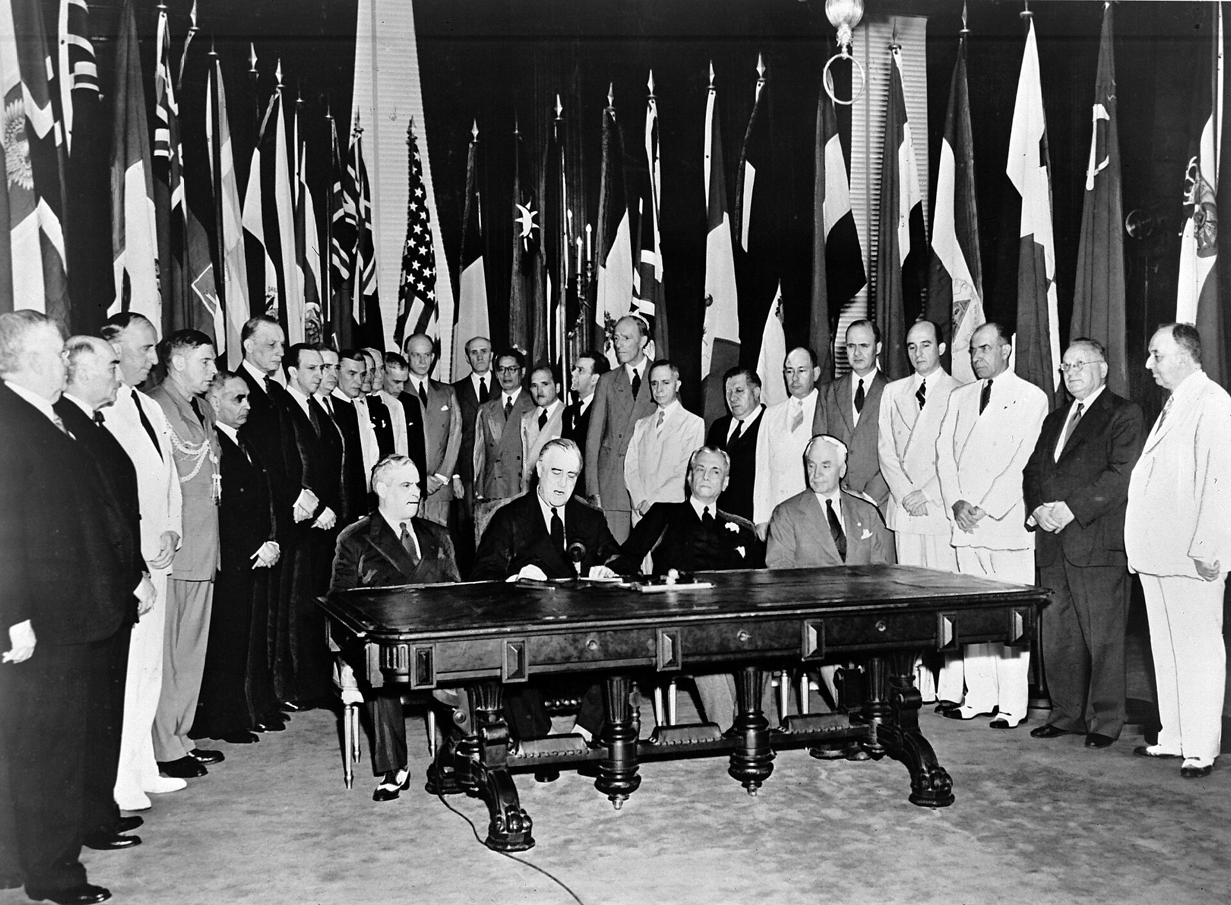
Signing of the Declaration by United Nations, Washington, D.C. (January 1, 1942) · Unknown photographer / United Nations · January 1, 1942
Source: Unknown photographer. "Signing of the Declaration by United Nations, Washington, D.C." 1 Jan. 1942. United Nations, via Wikimedia Commons, commons.wikimedia.org/wiki/File:Signing_Declaration_by_United_Nations.jpg. Public Domain https://commons.wikimedia.org/wiki/File:Signing_Declaration_by_United_Nations.jpg
HIPPO — analyze the source (prompt) | Your analysis
H — Historical context: what was happening when this was created?
I — Intended audience: who was meant to see or obey it?
P — Purpose: why was it created?
P — Point of view: whose perspective does it reflect?
O — Outside connection: how does it connect to this standard?
SUPPORT OPTION
Sentence frame: This source shows ______ because it ______, which reveals ______.
CONFIDENCE CHECK-IN
Rate your understanding of this standard (1–4): ______ One thing to revisit: ____________________
HIPPO SUPPORTS — analyzing the source · US.58
Optional — use these to complete your HIPPO analysis. Your teacher may print this back page or leave it off.
Guiding questions
• H — Historical context: What was happening in the world when this was made?
• I — Intended audience: Who was meant to see or obey it?
• P — Purpose: Why did the creator make it? What did they want to happen?
• P — Point of view: Whose side does it show? Whose voice is missing?
• O — Outside connection: What have we studied that connects to this?
SUPPORT OPTION
Sentence frame: This source shows ______ because it ______, which reveals ______.
Model analysis (example)
H: Photographed January 1, 1942, when 26 Allied nations signed the Declaration by United Nations, pledging to fight the Axis together. I: The world public, showing Allied commitment early in the U.S. war effort. P: To formalize the wartime alliance and lay groundwork for a postwar organization. POV: The Allied nations' perspective of unity against the Axis. O: Connects to Cordell Hull's diplomacy and to the 1945 founding of the United Nations.
Try it — sourcing warm-up
Before you fill in HIPPO on the front, answer these in one line each:
• Who made this source, and when?

• What did they want the viewer to think or feel?

• How does that change how much you trust it?

Activity 6 — Core Application: Practice Quiz — US.58 ⏱ ~8 min ▶ Deck slide 113
RESPONSE CHOICE
Commit to an answer by marking it, saying it, or explaining it aloud before checking. Answer key is in the Teacher Guide (kept separate).
[DOK 1 · item q-us58-dok1-u6-1]
1. Why was the United Nations founded in 1945?
A. To save future generations from the devastating effects of global warfare
B. Five permanent members with veto power and ten rotating elected members
✓ C. To maintain international peace and prevent another devastating world war
D. A UN document adopted in 1948 establishing fundamental rights for all people
[DOK 1 · item q-us58-dok2-u6-1]
2. What role did Tennessean Cordell Hull play in the founding of the United Nations?
A. Five permanent members with veto power and ten rotating elected members
✓ B. As Secretary of State, he laid the groundwork and won the Nobel Prize
C. The UN included the U.S. and had stronger peacekeeping mechanisms
D. To maintain international peace and prevent another devastating world war
[DOK 2 · item q-us58-dok2-u6-2]
3. How did the United Nations differ from the League of Nations?
A. The League of Nations was more effective at preventing armed conflicts
B. The UN had fewer member nations and less international authority
✓ C. The UN included the U.S. and had stronger peacekeeping mechanisms
D. The UN focused solely on trade while the League addressed all issues
[DOK 2 · item q-us58-dok3-1]
4. How did the failure of the League of Nations influence the structure of the United Nations?
✓ A. The UN gave veto power to major powers, ensuring their participation unlike the League
B. The UN eliminated all powerful nations from membership to prevent future abuse of power
C. The UN intentionally lacked enforcement mechanisms to avoid repeating League mistakes
D. The UN focused exclusively on humanitarian aid to avoid the political failures of the League
CHECK YOURSELF — quiz answer key
Commit your answers first, then check: 1. C 2. B 3. C 4. A
Missed one? Reread that section and fix your thinking — that is where the learning happens.

Activity 7 — Constructed Response (CER) — US.58 ⏱ ~15 min ▶ Deck slides 107–111
BIG-QUESTION ORGANIZER — in World War II, how did the war reshape America at home and its role in the world — and who sacrificed, even while being excluded?
Jot quick notes from THIS standard: Who benefited? · Who bore the costs? · Who decided?

CONSTRUCTED RESPONSE (CER) — builds SSP.04 Argumentation
Claim + Evidence + Reasoning: Using this standard, take a position on the central question — identify and explain the reasons for the founding of the United Nations, including the role of Cordell Hull? Support your claim with two pieces of evidence from the passage and explain your reasoning.
Part | Write here
Claim
Evidence (two specifics)
Reasoning
SELF-GRADE YOUR CER — score each trait 1–4
Trait | What a strong (3–4) response shows | My score (1–4)
Claim | Clear; directly answers the question
Evidence | Two specific facts from the sources
Reasoning | Explains HOW the evidence proves the claim
Conventions | Complete, readable sentences
My total: ______ / 16 · One thing I will improve next time: ______________________
Peer review — trade & improve
Glow — one thing that works:

Grow — one thing to strengthen:

My revision — one change I will make:

WRITING SUPPORTS — Constructed Response (CER) · US.58
Optional — use these to plan and write your CER. Your teacher may print this back page or leave it off; the goal on the front never changes.
Sentence stems
• Claim: “One major cause of ______ was ______.” / “______ happened mainly because ______.”
• Evidence: “According to the source, ______.” / “For example, ______ shows that ______.”
• Reasoning: “This evidence proves ______ because ______.” / “This matters because ______.”
• Go further: “Although some might say ______, the stronger evidence shows ______.”
Model response (example)
Claim: The United Nations was founded to prevent future world wars through international cooperation. Evidence: The 1942 Declaration by United Nations united the Allies, and Secretary of State Cordell Hull worked to design a permanent organization, leading to the UN's founding in 1945. Reasoning: Having seen the League of Nations fail and two world wars occur, leaders built the UN so nations could resolve disputes and keep the peace together.
CER rubric — in your own words
• Claim — I answer the question in one clear sentence.
• Evidence — I use two specific facts from the sources.
• Reasoning — I explain HOW my evidence proves my claim.
• Conventions — I write in complete sentences a reader can follow.
Argument word bank
First · Because · For example · This shows that · As a result · Therefore · However · Although · In contrast · This matters because
EXIT TICKET — before you leave [item us58-q1 · DOK 2 · pre-field-test]
What lessons from the League of Nations' failure influenced the design of the United Nations?
A. The League was considered successful, but this oversimplifies the complex factors at work, which ignores significant political and cultural developments of the era and does not reflect the scholarly consensus on this topic
B. The UN copied the League's structure exactly, although this view has been largely discredited by scholars despite the fact that multiple contemporary sources contradict this, though this interpretation lacks supporting historical evidence
C. No lessons were learned from the League, but this fails to account for the broader historical context and fails to account for key developments in the broader context and oversimplifies the complex factors at work during this period
✓ D. U.S. non-participation, weak enforcement, and inability to stop aggression led designers to ensure American membership, create the Security Council with enforcement authority, and give major powers veto to encourage participation
Show what you know (your choice): mark the best answer, say it, or explain it — then rate how sure you are: ☐ Not yet ☐ Getting there ☐ Got it
✔ ANSWER: D — The League failed partly because the U.S. never joined; the UN gave major powers a veto to keep them engaged. (Full key & reteach in the Teacher Guide.)

Your Tennessee Connection
TENNESSEE CONNECTION · OAK RIDGE, THE “SECRET CITY”
Tennessee was central to winning — and ending — World War II. In 1942 the federal government built Oak Ridge in the hills of East Tennessee as a secret site of the Manhattan Project (US.56). Its plants enriched the uranium used in the bomb dropped on Hiroshima. The town grew to about 75,000 people almost overnight, yet most workers — including thousands of women (US.52) — had no idea what they were building. Tennessee also sent its people to the war: Fort Campbell trained the 101st Airborne (US.51), Alcoa produced aluminum for warplanes (US.55), and Cordell Hull of Pickett County, Secretary of State, helped found the United Nations and won the Nobel Peace Prize (US.58).
Reflect (RESPONSE CHOICE): How does a local story change the way you understand a national event? Answer by writing, recording, or diagramming.

Local History Investigation
Industrialization touched Tennessee too — railroads, mines, mills, and the people who worked them. Investigate one local connection and record what you find.
Prompt | Your findings
A person, place, or industry from this era near me
One source I could check (library, TSLA, family, museum)
Who benefited / who bore the costs, locally
One question I still have

Progress Tracker & Cumulative Review
Track your Progress Check result for each standard and note one thing to revisit.
Standard | Progress Check (✓ / reteach) | One thing to revisit
US.45
US.46
US.47
US.48
US.49
US.50
US.51
US.52
US.53
US.54
US.55
US.56
US.57
US.58

Optional Extension Bank (higher-DOK, open to all)
Any student may choose an extension. These are EXTENSION, not a track.
US.45: Using this standard, take a position on the central question — explain the rise and spread of fascism, communism, and totalitarianism internationally, including the key characteristics and leaders of each system? Support your claim with two pieces of evidence from the passage and explain your reasoning.
US.46: Using this standard, take a position on the central question — explain President Franklin D. Roosevelt's response to world crises, including the Quarantine Speech, the Four Freedoms speech, the Atlantic Charter, and the Lend-Lease Act? Support your claim with two pieces of evidence from the passage and explain your reasoning.
US.47: Using this standard, take a position on the central question — analyze the response of the U.S. to the plight of European Jews before the war, the liberation of concentration camps during the war, and the immigration of Holocaust survivors after the war? Support your claim with two pieces of evidence from the passage and explain your reasoning.
US.48: Using this standard, take a position on the central question — explain the reasons for American entry into World War II, including the attack on Pearl Harbor? Support your claim with two pieces of evidence from the passage and explain your reasoning.
US.49: Using this standard, take a position on the central question — identify the roles and the significant actions of key individuals in World War II, including Churchill, Eisenhower, Hitler, MacArthur, Marshall, Mussolini, FDR, Stalin, Tojo, and Truman? Support your claim with two pieces of evidence from the passage and explain your reasoning.
US.50: Using this standard, take a position on the central question — explain the role of geographic and military factors on the outcomes of battles in the Pacific and European theaters, including Midway, Iwo Jima, Okinawa, and D-Day? Support your claim with two pieces of evidence from the passage and explain your reasoning.
US.51: Using this standard, take a position on the central question — identify the roles and sacrifices of individual American soldiers and the unique contributions of special fighting forces such as the Tuskegee Airmen, the 442nd Regimental Combat Team, the 101st Airborne, and the Navajo Code Talkers? Support your claim with two pieces of evidence from the passage and explain your reasoning.
US.52: Using this standard, take a position on the central question — examine and explain the entry of large numbers of women into the workforce and armed forces during World War II and the subsequent impact on American society? Support your claim with two pieces of evidence from the passage and explain your reasoning.
US.53: Using this standard, take a position on the central question — examine the impact of World War II on economic and social conditions for African Americans, including the Fair Employment Practices Committee and the eventual integration of the armed forces by President Truman? Support your claim with two pieces of evidence from the passage and explain your reasoning.
US.54: Using this standard, take a position on the central question — describe the constitutional issues and impact of the internment of Japanese Americans on the U.S., including the Fred Korematsu v. United States of America decision? Support your claim with two pieces of evidence from the passage and explain your reasoning.
US.55: Using this standard, take a position on the central question — describe the war's impact on the home front, including rationing, bond drives, propaganda, movement to cities, the Bracero program, conversion of factories, and prisoner of war camps in Tennessee? Support your claim with two pieces of evidence from the passage and explain your reasoning.
US.56: Using this standard, take a position on the central question — describe the Manhattan Project and explain the rationale for using the atomic bomb to end the war? Support your claim with two pieces of evidence from the passage and explain your reasoning.
US.57: Using this standard, take a position on the central question — explain the major outcomes of the Yalta and Potsdam Conferences? Support your claim with two pieces of evidence from the passage and explain your reasoning.
US.58: Using this standard, take a position on the central question — identify and explain the reasons for the founding of the United Nations, including the role of Cordell Hull? Support your claim with two pieces of evidence from the passage and explain your reasoning.

Think Like a Test-Writer (unit review — open to all)
You met a quick “think like a test-writer” prompt in every standard. Here is the full how-to, once, plus room to write your best questions for the whole unit.
HOW TO WRITE A DOK-3 QUESTION
DOK-3 = strategic thinking: the reader must analyze, compare, evaluate, or justify using evidence — and there should be more than one defensible answer (not a fact you can just look up).
Sentence starters: “Why did ______ lead to ______?” · “Which mattered more — ______ or ______ — and why?” · “What is the BEST evidence that ______?” · “Evaluate whether ______.” · “Defend or challenge: ______.”
Frame: [Analyze / Evaluate / Justify] + [something from this unit] + “using evidence.”
Quick check: does my question make the reader THINK and use evidence? If yes, it’s DOK-3.
Standard | Your DOK-3 question | Your answer key (one sentence)

Reusable Toolkit & Source Library

Written Response Rubric (CER)
Level | Claim | Evidence | Reasoning
4 — Strong | Precise, defensible | 2+ accurate, specific | Explains how evidence proves the claim
3 — Proficient | Clear | 2 accurate | Explains the link
2 — Developing | General | 1 accurate | Partial link
1 — Beginning | Unclear/missing | Missing/inaccurate | No reasoning

Source Library — full citations & clickable links
US.45 — Rise and Spread of Fascism, Communism, and Totalitarianism
The Doctrine of Fascism. Benito Mussolini, 1932. Mussolini, Benito. "The Doctrine of Fascism." 1932. Internet Archive, archive.org/details/doctrineoffascis00muss.. Public domain. https://archive.org/details/doctrineoffascis00muss
The Stalin Constitution of 1936 (Article 126). Government of the Union of Soviet Socialist Republics, December 5, 1936. Union of Soviet Socialist Republics. "Constitution (Fundamental Law) of the U.S.S.R., Article 126." 5 Dec. 1936. Avalon Project, Yale Law School, avalon.law.yal. Public domain. https://avalon.law.yale.edu/20th_century/ussr01.asp
US.46 — FDR's Response to World Crises
The Four Freedoms Speech. President Franklin D. Roosevelt, January 6, 1941. Roosevelt, President Franklin D.. "The Four Freedoms Speech." January 6, 1941. National Archives, https://www.archives.gov/milestone-documents/president-frankli. Public domain. https://www.archives.gov/milestone-documents/president-franklin-roosevelts-annual-message-to-congress
Lend-Lease Act Message to Congress. President Franklin D. Roosevelt, January 1941. Roosevelt, President Franklin D.. "Lend-Lease Act Message to Congress." January 1941. National Archives, https://www.archives.gov/milestone-documents/lend-lease. Public domain. https://www.archives.gov/milestone-documents/lend-lease-act
US.47 — U.S. Response to the Holocaust
Testimony of Holocaust Survivor. Elie Wiesel, 1945 (describing liberation). Wiesel, Elie. "Testimony of Holocaust Survivor." 1945 (describing liberation). United States Holocaust Memorial Museum, www.ushmm.org/collections/bibliography/e. Public domain. https://www.ushmm.org/collections/bibliography/elie-wiesel
Report to the Secretary on the Acquiescence of This Government in the Murder of the Jews. U.S. Treasury Department staff (Josiah DuBois and colleagues), January 1944. DuBois, Josiah, et al. "Report to the Secretary on the Acquiescence of This Government in the Murder of the Jews." Jan. 1944. Franklin D. Roosevelt Presidential. Public domain. https://www.fdrlibrary.org/holocaust
US.48 — American Entry into World War II
Day of Infamy Speech. President Franklin D. Roosevelt, December 8, 1941. Roosevelt, President Franklin D.. "Day of Infamy Speech." December 8, 1941. National Archives, https://www.archives.gov/legislative/features/day-of-infamy.. Public domain. https://www.archives.gov/legislative/features/day-of-infamy
Joint Resolution Declaring War Against Japan. United States Congress, December 8, 1941. United States Congress. "Joint Resolution Declaring That a State of War Exists Between the Imperial Government of Japan and the Government and the People of the. Public domain. https://www.archives.gov/milestone-documents/joint-resolution-declaration-of-war-against-japan
US.49 — WWII Leaders & Key Figures
We Shall Fight on the Beaches Speech. Winston Churchill, June 4, 1940. Churchill, Winston. "We Shall Fight on the Beaches Speech." June 4, 1940. International Churchill Society, winstonchurchill.org/resources/speeches/1940-the-fine. Public domain. https://winstonchurchill.org/resources/speeches/1940-the-finest-hour/we-shall-fight-on-the-beaches/
First Inaugural Address ("the only thing we have to fear"). President Franklin D. Roosevelt, March 4, 1933. Roosevelt, Franklin D. "First Inaugural Address." 4 Mar. 1933. Avalon Project, Yale Law School, avalon.law.yale.edu/20th_century/froos1.asp.. Public domain. https://avalon.law.yale.edu/20th_century/froos1.asp
US.50 — Major WWII Battles: Midway, Iwo Jima, Okinawa & D-Day
Order of the Day - D-Day. General Dwight D. Eisenhower, June 6, 1944. Eisenhower, General Dwight D.. "Order of the Day - D-Day." June 6, 1944. National Archives, www.archives.gov/historical-docs/todays-doc/?dod-date=606.. Public domain. https://www.archives.gov/historical-docs/todays-doc/?dod-date=606
Communiqué No. 1 from Supreme Headquarters (D-Day Landings). Supreme Headquarters Allied Expeditionary Force (SHAEF), June 6, 1944. Supreme Headquarters Allied Expeditionary Force. "Communiqué No. 1." 6 June 1944. Dwight D. Eisenhower Presidential Library, www.eisenhowerlibrary.gov.. Public domain. https://www.eisenhowerlibrary.gov/research/online-documents/d-day
US.51 — Special Fighting Forces in WWII
Tuskegee Airmen Commendation. U.S. Army Air Forces, 1945. U.S. Army Air Forces. "Tuskegee Airmen Commendation." 1945. National Archives, www.archives.gov/research/military/ww2/tuskegee-airmen.. Public domain. https://www.archives.gov/research/military/ww2/tuskegee-airmen
Executive Order 9981 — Desegregation of the Armed Forces. President Harry S. Truman, July 26, 1948. Truman, Harry S. "Executive Order 9981." 26 July 1948. National Archives, www.archives.gov.. Public domain. https://www.archives.gov/milestone-documents/executive-order-9981
US.52 — Women in World War II
War Production Board Poster Text. U.S. War Production Board, 1943. U.S. War Production Board. "War Production Board Poster Text." 1943. Library of Congress, www.loc.gov/collections/world-war-ii-posters/.. Public domain. https://www.loc.gov/collections/world-war-ii-posters/
Women in the War — We Can't Win Without Them (War Manpower Commission). U.S. War Manpower Commission / Office of War Information, 1943. U.S. War Manpower Commission. "Women in the War." 1943. National Archives, www.archives.gov.. Public domain. https://www.archives.gov/education/lessons/wwii-homefront
US.53 — African Americans in WWII
Executive Order 8802. President Franklin D. Roosevelt, June 25, 1941. Roosevelt, President Franklin D.. "Executive Order 8802." June 25, 1941. National Archives, https://www.archives.gov/milestone-documents/executive-order-8802.. Public domain. https://www.archives.gov/milestone-documents/executive-order-8802
The 'Double V' Campaign Editorial (Pittsburgh Courier). James G. Thompson, letter published in the Pittsburgh Courier, 1942. Thompson, James G. "Should I Sacrifice to Live 'Half-American'?" Pittsburgh Courier, 1942. Library of Congress, www.loc.gov.. Public domain. https://www.loc.gov/exhibitions/world-war-ii-on-the-american-home-front/
US.54 — Japanese American Internment & Korematsu
Executive Order 9066. President Franklin D. Roosevelt, February 19, 1942. Roosevelt, President Franklin D.. "Executive Order 9066." February 19, 1942. National Archives, https://www.archives.gov/milestone-documents/executive-order-906. Public domain. https://www.archives.gov/milestone-documents/executive-order-9066
Korematsu v. United States — Dissent of Justice Frank Murphy. Justice Frank Murphy, Supreme Court of the United States, December 18, 1944. Murphy, Frank. "Dissent, Korematsu v. United States, 323 U.S. 214." 18 Dec. 1944. Legal Information Institute, Cornell Law School, www.law.cornell.edu.. Public domain. https://www.law.cornell.edu/supremecourt/text/323/214
US.55 — Home Front Mobilization
War Ration Book Instructions. Office of Price Administration, 1943. Office of Price Administration. "War Ration Book Instructions." 1943. National Archives, www.archives.gov/education/lessons/wwii-rationing.. Public domain. https://www.archives.gov/education/lessons/wwii-rationing
Office of War Information Poster Text — "Plant a Victory Garden". U.S. Office of War Information, 1943. U.S. Office of War Information. "Plant a Victory Garden." 1943. National Archives, www.archives.gov.. Public domain. https://www.archives.gov/education/lessons/wwii-homefront
US.56 — Manhattan Project & Atomic Bomb
Statement on the Atomic Bomb. President Harry S. Truman, August 6, 1945. Truman, President Harry S.. "Statement on the Atomic Bomb." August 6, 1945. Harry S. Truman Presidential Library, www.trumanlibrary.gov/library/public-papers/93. Public domain. https://www.trumanlibrary.gov/library/public-papers/93/statement-president-announcing-use-bomb-hiroshima
Leaflet Dropped on Japanese Cities Before the Atomic Bombings. United States Army Air Forces (Office of War Information), August 1945. United States Army Air Forces. "Warning Leaflet (LeMay Leaflet) Dropped on Japan." Aug. 1945. Harry S. Truman Library and Museum, www.trumanlibrary.gov.. Public domain. https://www.trumanlibrary.gov/library/online-collections/decision-to-drop-atomic-bomb
US.57 — Yalta and Potsdam Conferences
Yalta Conference Communiqué. Roosevelt, Churchill, and Stalin, February 1945. Roosevelt, Churchill, and Stalin. "Yalta Conference Communiqué." February 1945. Avalon Project, Yale Law School, avalon.law.yale.edu/wwii/yalta.asp.. Public domain. https://avalon.law.yale.edu/wwii/yalta.asp
Potsdam Declaration — Terms for Japanese Surrender. United States, United Kingdom, and China, July 26, 1945. United States, United Kingdom, and China. "Potsdam Declaration." 26 July 1945. National Diet Library / Avalon Project, Yale Law School, avalon.law.yale.edu.. Public domain. https://avalon.law.yale.edu/20th_century/decade17.asp
US.58 — Founding of the United Nations & Cordell Hull
United Nations Charter Preamble. United Nations, June 26, 1945. United Nations. "United Nations Charter Preamble." June 26, 1945. United Nations, www.un.org/en/about-us/un-charter/preamble.. Public domain. https://www.un.org/en/about-us/un-charter/preamble
The Atlantic Charter. President Franklin D. Roosevelt and Prime Minister Winston Churchill, August 14, 1941. Roosevelt, Franklin D., and Winston Churchill. "The Atlantic Charter." 14 Aug. 1941. Avalon Project, Yale Law School, avalon.law.yale.edu/wwii/atlantic.asp.. Public domain. https://avalon.law.yale.edu/wwii/atlantic.asp

The Good War? — Who Fought, Who Sacrificed, Who Was Excluded
This section complicates the “Good War” narrative: the U.S. fought fascism abroad while denying rights to many of its own people at home. It is History Hack-authored instructional synthesis grounded in this unit’s sourced record — not a primary source.

Serving While Excluded
Black Americans fought under segregation and demanded a “Double V” — victory over fascism abroad and racism at home (US.53); the Tuskegee Airmen, Navajo Code Talkers, and the Japanese-American 442nd (US.51) served with distinction even as their communities faced discrimination.

A Freedom Denied at Home
While fighting for freedom, the U.S. forced about 120,000 Japanese Americans — most of them citizens — into internment camps under Executive Order 9066; the Supreme Court upheld it in Korematsu (US.54).

The Home Front & Women
Rationing, war bonds, and war production remade daily life (US.55); millions of women entered defense work — “Rosie the Riveter” (US.52) — including at Oak Ridge, though many lost those jobs when the war ended.

A New World Order — and the Bomb
The Manhattan Project ended the war with atomic weapons (US.56); Yalta and Potsdam (US.57) divided the postwar world; and the United Nations (US.58) was founded to prevent the next global war — even as the Holocaust (US.47) revealed how far totalitarianism had gone.
Residual note (known follow-up): sourced visuals and named Key-Figure entries for these histories remain pending.

Unit Reflection
Return to the unit’s big question: how did World War II reshape America at home and its role in the world — and who sacrificed for a freedom they were still denied? Write a final claim with two pieces of evidence from different standards.
Part | Write here
My claim
Evidence 1 (standard: ___)
Evidence 2 (standard: ___)
Why it matters today

