

COMSATS University Islamabad
(Attock Campus)

Information Security
LAB MID-TERM

Instructor: Miss. Amreen Gull
DATE: Oct 21, 2025

Submitted By:
Muhammad Talha Mehmood
SP24-BSE-041

Task 1: Simple XOR Encryption & Decryption [10 Marks]
def xor_cipher():
"""Performs XOR encryption and decryption with a single-character key."""

message = input("Enter message: ")
key = input("Enter a single-character key: ")[0]
key_value = ord(key)

# ENCRYPTION
ciphertext = ""
for char in message:
char_value = ord(char)
encrypted_value = char_value ^ key_value
encrypted_char = chr(encrypted_value)
ciphertext += encrypted_char

# DECRYPTION
decrypted_text = ""

for char in ciphertext:
char_value = ord(char)
decrypted_value = char_value ^ key_value
decrypted_char = chr(decrypted_value)

decrypted_text += decrypted_char

print("")
print("\nCiphertext:", ciphertext)
print("\nDecrypted text:", decrypted_text)
# Call the function to execute the XOR cipher
xor_cipher()
Output:
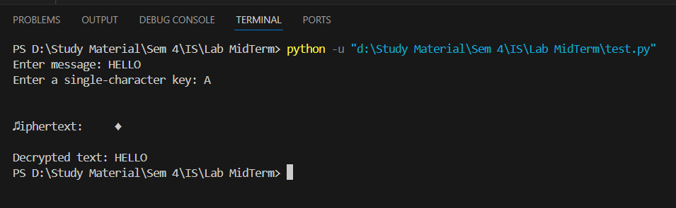
Task 2: Caesar Cipher (Decryption) [10 Marks]
def caesar_decrypt():
"""Decrypts a message using the Caesar Cipher."""

ciphertext = input("Enter ciphertext: ").upper()
shift = int(input("Enter shift (key): "))
plaintext = ""

for char in ciphertext:
if char.isalpha():

char_ascii = ord(char)
shifted_index = (char_ascii - ord('A') - shift) % 26
decrypted_char_ascii = shifted_index + ord('A')
plaintext += chr(decrypted_char_ascii)
else:
plaintext += char

print("Plaintext:", plaintext)

# Run the function
caesar_decrypt()
Output:
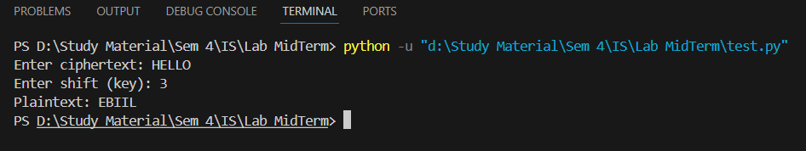

Task 3: Vigenère Cipher (Decryption Only) [5 Marks]
def vigenere_decrypt():
"""Decrypts a ciphertext using the Vigenère Cipher."""

ciphertext = input("Enter ciphertext: ").upper()
key = input("Enter key: ").upper()
plaintext = ""
key_index = 0

for char in ciphertext:
if char.isalpha():

C = ord(char) - ord('A')
K = ord(key[key_index % len(key)]) - ord('A')
P = (C - K + 26) % 26
plaintext += chr(P + ord('A'))
key_index += 1
else:
plaintext += char

print("Plaintext:", plaintext)

# Run the function
vigenere_decrypt()
Output:
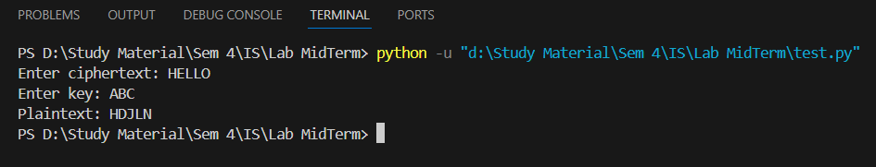

Task 4: Debugging Task (Caesar Cipher Code) [5 Marks]
def caesar_encrypt(text, shift):
result = ""
for char in text:
if char.isalpha():
start_point = ord('A') if char.isupper() else ord('a')
shifted_index = (ord(char) - start_point + shift) % 26
result += chr(shifted_index + start_point)
else:
result += char
return result
# input
msg = input("Enter message: ")
s = int(input("Enter shift: "))

# Print the result
print("Ciphertext:", caesar_encrypt(msg, s))
Output:
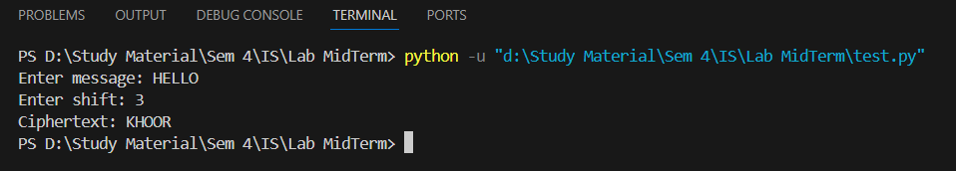

Task 5: Conceptual: DES and AES
- Write one similarity between DES and AES. (2 marks)

AES (Advanced Encryption Standard) and DES (Data Encryption Standard) are both symmetric block ciphers. This implies:
They both encrypt and decrypt using the same key. Both of them use fixed-size blocks to process the input data (DES uses a 64-bit block, AES uses a 128-bit block).
b) What does CBC mode stand for in block ciphers? (2 marks)
Cipher Block Chaining is referred to as CBC.
Block ciphers frequently work in this manner, where each block of plaintext is XORed with the block of ciphertext that came before it is encrypted. By ensuring that the encryption of any given block is dependent upon all previous blocks, this chaining mechanism improves security through diffusion.
c) Why is AES faster than DES? (1 mark)
AES is faster than DES primarily because of its more efficient and modern design structure.
AES uses a Substitution-Permutation Network (SPN). DES uses a Feistel structure , which requires more computational steps (16 rounds) involving splitting and swapping data halves, making it inherently slower to implement in both hardware and software.

