Matthew Irvine

1001401200

**TCP**

1. What is the IP address and TCP port number used by the client computer (source) that is transferring the file to gaia.cs.umass.edu? To answer this question, it’s probably easiest to select an HTTP message and explore the details of the TCP packet used to carry this HTTP message, using the “details of the selected packet header window” (refer to Figure 2 in the “Getting Started with Wireshark” Lab if you’re uncertain about the Wireshark windows.
   1. Port: 52888, IP: 192.168.1.130
2. What is the IP address of gaia.cs.umass.edu? On what port number is it sending and receiving TCP segments for this connection?
   1. IP: 128.199.245.12, Port: 80
3. If you have been able to create your own trace, answer the following question: What is the IP address and TCP port number used by your client computer (source) to transfer the file to gaia.cs.umass.edu?
   1. I did not create my own trace.
4. What is the sequence number of the TCP SYN segment that is used to initiate the TCP connection between the client computer and gaia.cs.umass.edu? What is it in the segment that identifies the segment as a SYN segment?
   1. Sequence number 0.
   2. The SYN flag is set to 1 (0x002).
5. What is the sequence number of the SYNACK segment sent by gaia.cs.umass.edu to the client computer in reply to the SYN? What is the value of the Acknowledgement field in the SYNACK segment? How did gaia.cs.umass.edu determine that value? What is it in the segment that identifies the segment as a SYNACK segment?
   1. Sequence number 0, acknowledgement number 1.
   2. Acknowledgement bit is set to 1.
   3. Gaia.cs.umass.edu determined this value by adding 1 to the initial sequence given by the client computer.
   4. Having both SYN and ACK bits set to 1 (0x012).
6. What is the sequence number of the TCP segment containing the HTTP POST command? Note that in order to find the POST command, you’ll need to dig into the packet content field at the bottom of the Wireshark window, looking for a segment with a “POST” within its DATA field.
   1. Sequence number 1.
7. Consider the TCP segment containing the HTTP POST as the first segment in the TCP connection. What are the sequence numbers of the first six segments in the TCP connection (including the segment containing the HTTP POST)? At what time was each segment sent?
   1. Sequence number: 1 [13:28:48.849073]
   2. Sequence number: 724 [13:28:48.849228]
   3. Sequence number: 2172 [13:28:48.849228]
   4. Sequence number: 3620 [13:28:48.849228]
   5. Sequence number: 5068 [13:28:48.849228]
   6. Sequence number: 6516 [13:28:48.849228]



1. When was the ACK for each segment received? Given the difference between when each TCP segment was sent, and when its acknowledgement was received, what is the RTT value for each of the six segments? What is the EstimatedRTT value (see Section 3.5.3, page 242in text) after the receipt of each ACK? Assume that the value of the EstimatedRTT is equal to the measured RTT for the first segment, and then is computed using the EstimatedRTT equation on page 242 for all subsequent segments. Note: Wireshark has a nice feature that allows you to plot the RTT for each of the TCP segments sent. Select a TCP segment in the “listing of captured packets” window that is being sent from the client to the gaia.cs.umass.edu server. Then select: Statistics->TCP Stream Graph->Round Trip Time Graph. 

|  |
| --- |
| ACK 1: 13:28:48.910029 |
| ACK 724: 13:28:48.910029 |
| ACK 2172: 13:28:48.910029 |
| ACK 3620: 13:28:48.910029 |
| ACK 5068: 13:28:48.910029 |
| ACK 6516: 13:28:48.910029 |

|  |
| --- |
| RTT 1: 0.060956 |
| RTT 724: 0.060801 |
| RTT 2172: 0.060801 |
| RTT 3620: 0.060801 |
| RTT 5068: 0.060801 |
| RTT 6516: 0.060801 |

EstimatedRTT:

[after ACK #]: value

1: 0.0609560

724: 0.060184

2172: 0.062609

3620: 0.063284

5068: 0.063875

6516: 0.064844

1. What is the length of each of the first six TCP segments?

Seq #: length

1: 723

724: 1448

2172: 1448

3620: 1448

5068: 1448

6516: 1448

1. What is the minimum amount of available buffer space advertised at the received for the entire trace? Does the lack of receiver buffer space ever throttle the sender?
   1. Starts at 28960 and increases to 64240 after the first acknowledgement.
   2. There was no Throttling.
2. Are there any retransmitted segments in the trace file? What did you check for (in the trace) in order to answer this question?

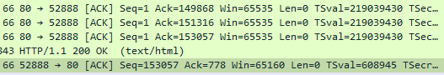

I think a retransmission occurred here since Seq 153057 was Acknowledged before it had been sent.

1. How much data does the receiver typically acknowledge in an ACK? Can you identify cases where the receiver is ACKing every other received segment (see Table 3.2 on page 250 in the text).
   1. 1448 bytes, I did not find one.
2. What is the throughput (bytes transferred per unit time) for the TCP connection? Explain how you calculated this value.
   1. 153056 bytes over a period of .24309 seconds gets 629626.8872 Bytes/sec.
   2. Found this value by taking the lask Ack number (153057) and subtracting the first sequence number (1) to get the number of bytes. Then take the Time difference of the first sequence and last acknowledgement then divide the bytes by this number.
3. Use the Time-Sequence-Graph(Stevens) plotting tool to view the sequence number versus time plot of segments being sent from the client to the gaia.cs.umass.edu server. Can you identify where TCP’s slow start phase begins and ends, and where congestion avoidance takes over? Comment on ways in which the measured data differs from the idealized behavior of TCP that we’ve studied in the text.

This is what I got:

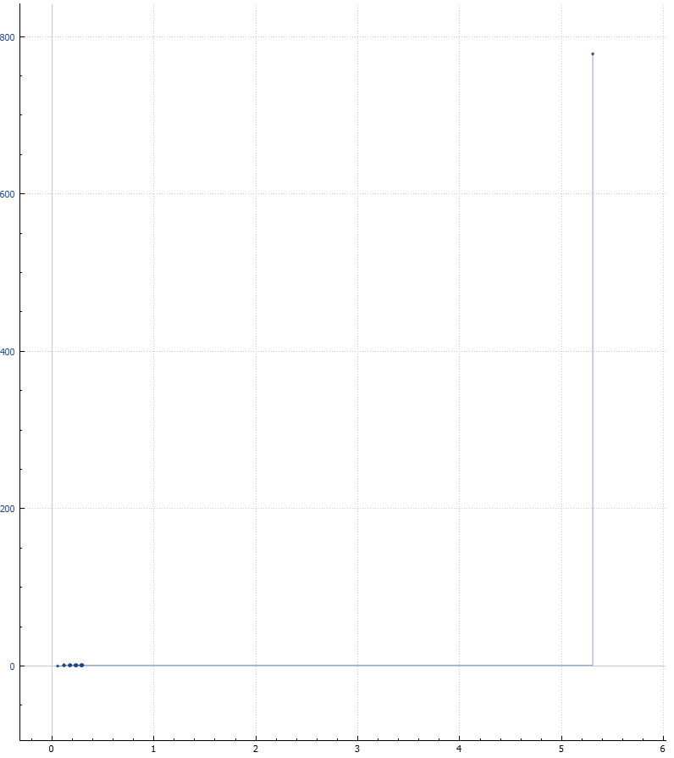

I guess this would be the slow connection startup:

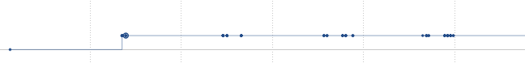

1. Answer each of two questions above for the trace that you have gathered when you transferred a file from your computer to gaia.cs.umass.edu

I did not use a trace file so I don’t know what to do here.