Empirically finding the typical luminous efficacy of an incandescent light-bulb through the inverse square law

# Design

## Introduction

I watched a video online discussing the historical usage of electrical light sources to illuminate the streets, where it focused on a “Moonlight tower” in San Jose, California that lights up an entire city through a single light source . The video considered it to be a joke of an invention for the very little light it gave out for pedestrians, as comparable to the actual moon — hence the name “Moonlight”. While it is common sense that the further you are from a light source, the less bright it seems. I was fascinated by how quickly the brightness had decreased, so much so that a sun-like light-bulb can be so dim only 100 meters away. I want to test how the light intensity changes with the distance to the light source.

Additionally, the relationship between light intensity and distance to the light source can reveal the efficiency of the light source: known as the typical luminous efficacy and measured in “amount” of light waves per unit power, or lumens per watt. I decided to select one of the light-bulbs from the school’s physics department and test its efficiency, because the class have been exclusively using them in learning the topic of electricity. I am curious in finding out how the efficiency of this light-bulb compares to a list of common light sources.

## Research Question

What is the relationship between the measured illuminance against the distance to an incandescent light-bulb?

## Background

For a light-bulb to produce light, an electrical current in the form of moving electrical charges must pass through a light emitting electrical resistor. This experiment will use an incandescent light-bulb as the light source, which functions by heating a wire filament to a temperature that emits light. For light waves are forms of energy, the amount of light produced is depended on the energy per second dissipated within the filament, known as power and represented with symbol . Power is defined as the voltage across the resistor times the current through the resistor, shown in figure [eq:work]. The higher the power dissipated within the light-bulb, the brighter the light-bulb is.

The energy dissipated in the filament within the light-bulb are converted into thermal energy and electromagnetic waves. These waves are energy disturbances in the air medium traveling in all directions originated from the filament, and the rate of these light waves incidence per unit area on a surface is the intensity of the light source at the location, represented with symbol and in units watts per meter squared ($\si{W/m^2}$). The light intensity changes over changing distances to the light source following the inverse square law :

where is the light intensity, is the distance to the light source, and is the power dissipated within the light source. The inverse square law states that light intensity is inversely proportional to the square of the distance from the source, and is proportional to the source power.

However, the light sensor I used instead measures light intensity in illuminance with unit lux. This is because the human eye does not perceive each wavelength of the electromagnetic spectrum equally — red light appears dimmer than green light at the same intensity, and the unit illuminance takes this into consideration by weighting each wavelength differently. Illuminance is defined through the following equation, where is the distance to the source, as the weighting function of a wavelength, and as the power of the light source.

By rearranging the illuminance equation in figure [eq:dti], it can be shown that illuminance also obeys the inverse square law. This means that illuminance is simply another measurement of light intensity:

By plotting the illuminance measurements against the distance, an inverse square graph to the likes of figure 1 is to be expected, with illuminance decreasing at a decreasing rate as distance to source is increased.

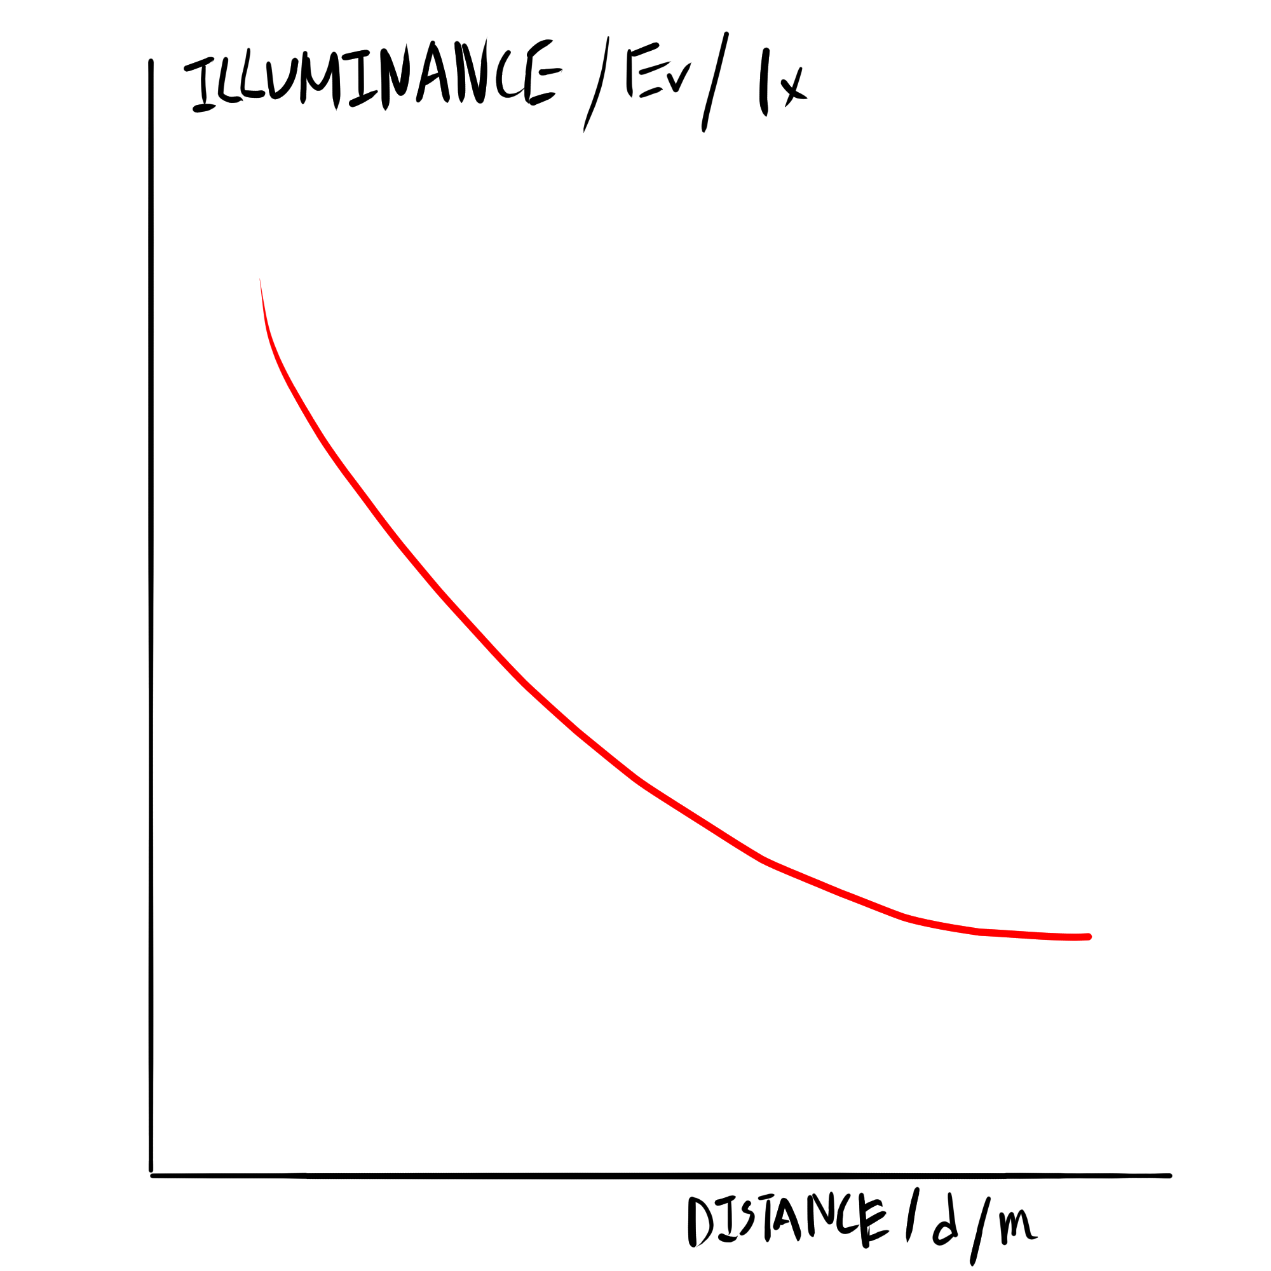

Graph of Illuminance against Distance

The efficiency of the incandescent light-bulb can then be calculated using the proportionality constant of the illuminance vs. relationship:

The typical luminous efficacy of a light source is a measurement of the amount of light waves produced per watt, in unit $\frac{\si{lm}}{W}$. As the proportionality constant have unit $\si{lm}$, the typical luminous efficacy is the proportionality constant divided by the source power :

To test the inverse square law, I decided to use a light sensor against a 5 watt light-bulb taken from the physics department. The light-bulb is supplied with only 8 volts out of the 12 volts power supply, as from past experience the bulb gets dangerously hot quickly on 12 volts. The dependent variable is the illuminance measurements from the light sensor, which ranges from 0-6000 lux. The independent variable is the distance of the light sensor from the light-bulb, ranging from 0.030m to 0.10m with steps of 0.01m, as this range provides a wide range of illuminance values from the specific light sensor. This is repeated for a total of 5 times because the light sensor often fluctuates even when held completely still. The repetition can help in reducing the uncertainties of the illuminance measurements.

Additionally, I decided to connect a voltmeter along side an ammeter, because I have observed that the voltage provided by the supply always decreases when a component is connected to it. This is likely due to the internal resistance within the power supply. Therefore the voltmeter ensures a more accurate voltage measurement than the knob value on the power supply.

## Variables

#### Independent Variable

The distance, measured in meters, the Vernier light sensor is from the 5W light-bulb.

#### Dependent Variable

The illuminance of the area measured by the Vernier light sensor in unit lux.

## Control Variables

P0.2|P0.35|P0.35 Controls & Reason & How  
Ambient light intensity & Systematically increase the illuminance measurements from the light-bulb at all distances & Conduct the experiment in a dark location, and record the ambient illuminance of the room  
The sensitivity of the light sensor & Light sensors are sensitive to angular tilts, and a disturbed sensor due to shaky hands most likely will produce random errors throughout the experiment & Use strong tape to clamp down the light sensor at the given distance  
Fluctuation of the outside light intensity & Environmental lighting leaking through the lab windows fluctuating can randomly change the illuminance measurements at all distances & Conduct the experiment early in the morning, or late at night to minimize the effects from the sun  
The power supplied to the light-bulb & A change in the supplied power will change measured illuminance at all distances, causing systematic errors & Assert the connected ammeter and voltmeter readings are unchanged after changing the independent variable, the distance  
The temperature of the bulb filament & For the resistance of a resistor tends to increase at higher temperatures, the electrical current may decrease, decreasing the power supplied, creating systematic errors & It is best to conduct the experiment quickly — in a span of an hour, as to minimize the extent of the heating of the light-bulb — the physics light-bulbs heats up very quickly.

## Materials

* Vernier light sensor ($\pm 2\si{lx}$) & connection hub
* laptop with Vernier Data Logger software
* 5W light-bulb
* 12V power supply
* digital ammeter ($\pm 0.01\si{A}$) and voltmeter ($\pm 0.01\si{V}$)
* one meter long ruler ($\pm 0.001\si{m}$)
* duct tape

## Method

1. Choose a location with the least amount of ambient light, preferably at a darkened room.
2. Connect the Vernier light sensor to the laptop, set light sensor’s range to (0–6000 ). Enable “Statistics” in the Vernier logger lite software by clicking “Stats”.
3. Set up the electrical circuit as shown in diagram [fig:cd], set the power supply voltage to 8V, with a digital ammeter and voltmeter.
4. Place the 1 meter ruler pointing towards the light-bulb, position the Vernier light sensor parallel to the ruler at a distance of 0.030m to the light-bulb. The final layout should be similar to figure 2.
5. Secure down the light sensor at distances from 0.030m to 0.100m, step 0.010m, for a total of 8 distances.
6. For each distance, record the readings on the ammeter and voltmeter, retry the measurement if they differ from the last distance. Record the illuminance over 10 seconds in the software, and note down the mean illuminance value as indicated in the software.
7. Repeat steps 5-6 for a total of five times.

## Diagrams

(0,3) to[battery,a=8V] (5,3) – (5,0) to[lamp,a=5W] (0,0) to[rmeter, t=A] (0,3) (1,0) – (1,-1.5) to[rmeter, t=V] (4,-1.5) – (4,0) ;

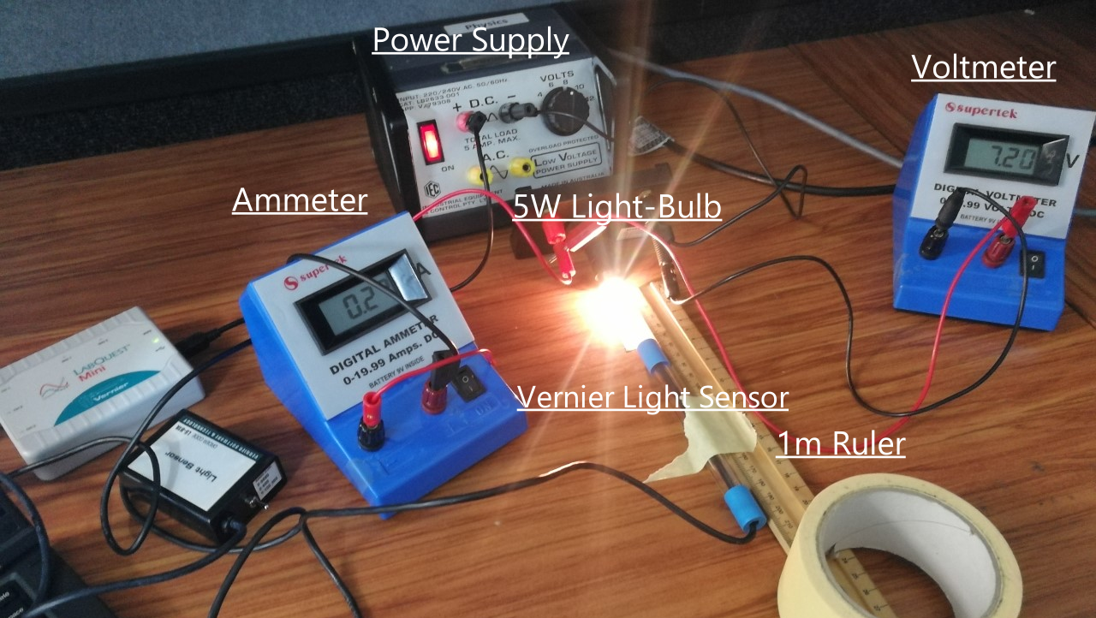

The experiment layout

## Safety

Avoid direct contact with exposed parts of the wires, additionally ensure a dry hand during the experiment. This will reduce the chance of an electrical accident.

Avoid touching the light-bulb throughout the experiment. The light-bulb got very hot during the experiment and direct skin contract may incur burns.

# Data

## Raw data

### Quantitative Data

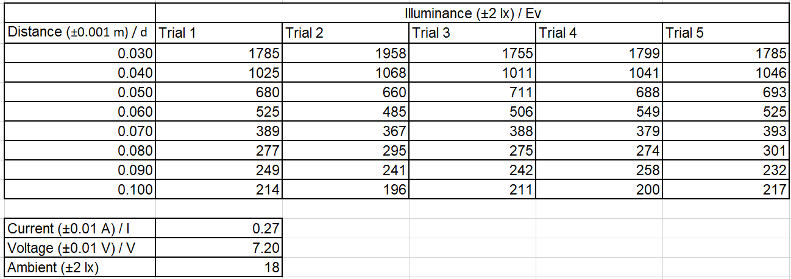

Raw quantitative experimental data

## Processing

#### Notation

Uncertainty: unc, Absolute uncertainty: unc, Relative uncertainty: %unc

### Processing Power

The power is defined as the current times the voltage (figure [eq:work]):

$$\begin{aligned}
\text{Power} &= \text{Current} \times \text{Voltage}\\
&= 0.27\si{A} \times 7.20\si{V} = 1.94 \si{W} \,(3 \,\text{sf})\end{aligned}$$

*Uncertainty of Power*: Power = Current + Voltage

$$\begin{aligned}
\% \text{unc}\,\si{I} &= \frac{0.01}{0.27},\quad &&\% \text{unc}\,\si{V} = \frac{0.01}{7.20}\\
\% \text{unc}\,\si{W} &= 0.04 \,(1 \,\text{sf}), \quad &&\Delta \text{unc}\,\si{W} = 0.07\si{W} \,(1 \,\text{sf})\end{aligned}$$

Therefore: $\text{Power} = 1.94 \pm 0.07 \si{W}$

### Processing Illuminance

**Correcting for the ambient illuminance**  
  
Subtract each illuminance values by the ambient illuminance value.

For example, in trial 1, at distance 0.030m:

$$\begin{aligned}
\text{Corrected} &= \text{Measured} - \text{Ambient }\\
&= 1785 - 18 = 1767 \si{lx}\end{aligned}$$

*Uncertainty of corrected illuminance*: Corrected = Measured + Ambient

$$\begin{aligned}
\Delta \text{unc}\,\text{Corrected} = 2 + 2 = 4\si{lx}\end{aligned}$$

**Averaging trial illuminances**  
  
Average the measured illuminance from 5 trials. Figure 4 shows the corrected illuminance values and the averages. Figure 5 plots the averaged illuminance values against the distances.

For example, averaging the illuminance measurements at distance 0.030m:

$$\begin{aligned}
\text{Illuminance}_{\text{average}} &= \frac{\sum \text{Illuminance}}{5}\\
&= \frac{1767+1940+1737+1781+1767}{5}\\
&= 1798\,\si{lx}\end{aligned}$$

*Uncertainty using half ranges:*

For example, at distance 0.030m:

$$\begin{aligned}
\Delta \text{unc}\,\text{Illuminance}_{\text{average}} &= \frac{1940-1737}{2}\\
&= 102 \,\si{lx}\\
\text{Illuminance}_{\text{average}} &= 1800 \pm 100 \,\si{lx}\end{aligned}$$

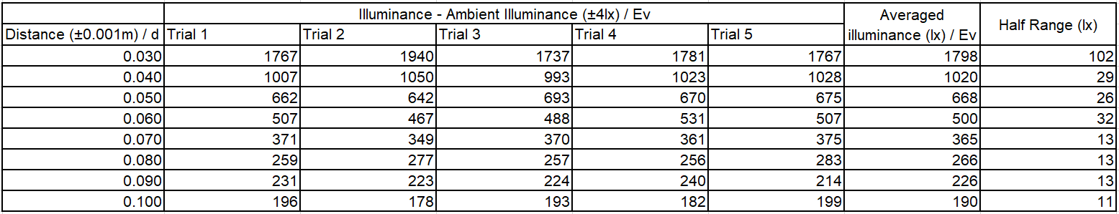

The averaged and corrected illuminance values

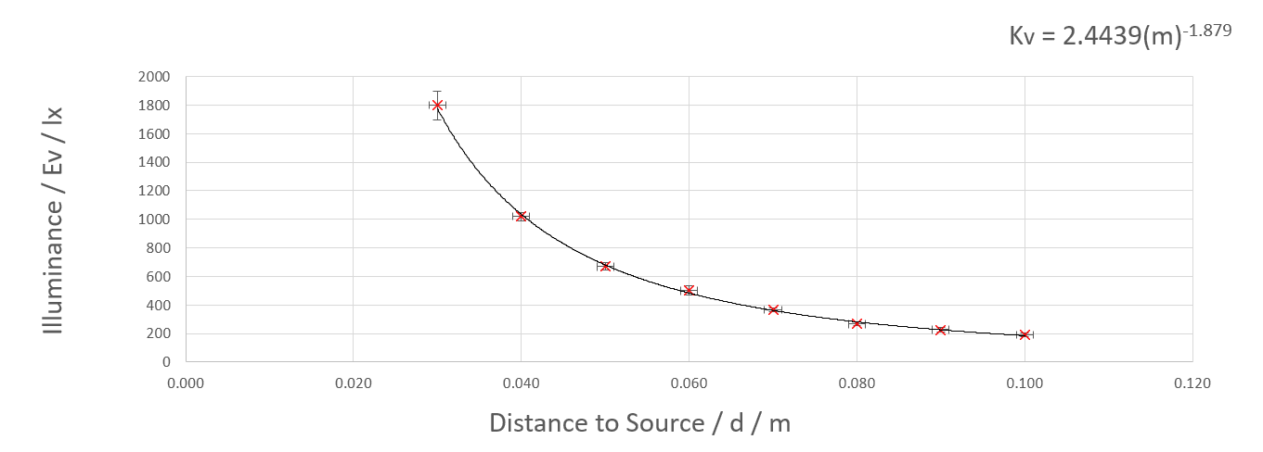

Graph of the corrected and averaged illuminance values

**Applying inverse squared transform on distance**  
  
As figure 5 looks like an inverse squared graph, thus apply transformation on the horizontal axis to straighten the graph. The transformation data and error is generated with Microsoft Excel (dataset: figure 6, graph: figure 7).

For example, at distance 0.030m:

$$\begin{aligned}
\frac{1}{\text{Distance}^2} &= 0.030 ^ {-2}\\
&= 1110\,\si{m^{-2}}\, (3 \,\text{sf})\\\end{aligned}$$

*Uncertainty of the transformed distance*: =

For distance 0.030m:

$$\begin{aligned}
\% \text{unc}\,1/{\text{Distance}}^2 = 2 \times \% \text{unc}\,\text{Distance} &= 2 \times 0.0333\\ &= 0.0667 \,(3 \,\text{sf})\\
\frac{1}{\text{Distance}^2} &= 1110\, \si{lx} \pm 6.67\%\\
&= 1110 \pm 70 \,\si{lx}\end{aligned}$$

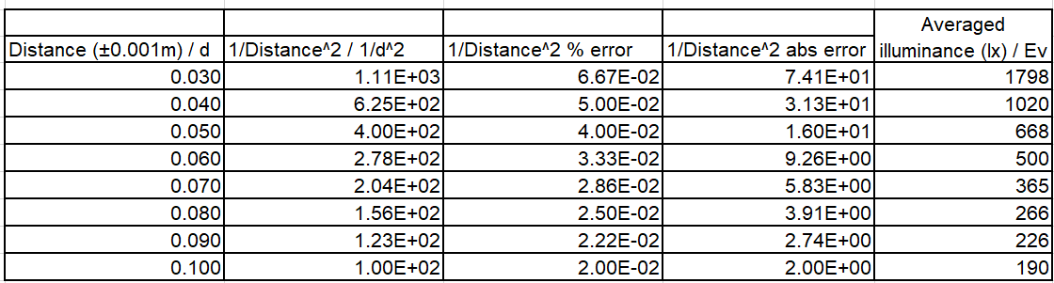

Transformed distance values and errors

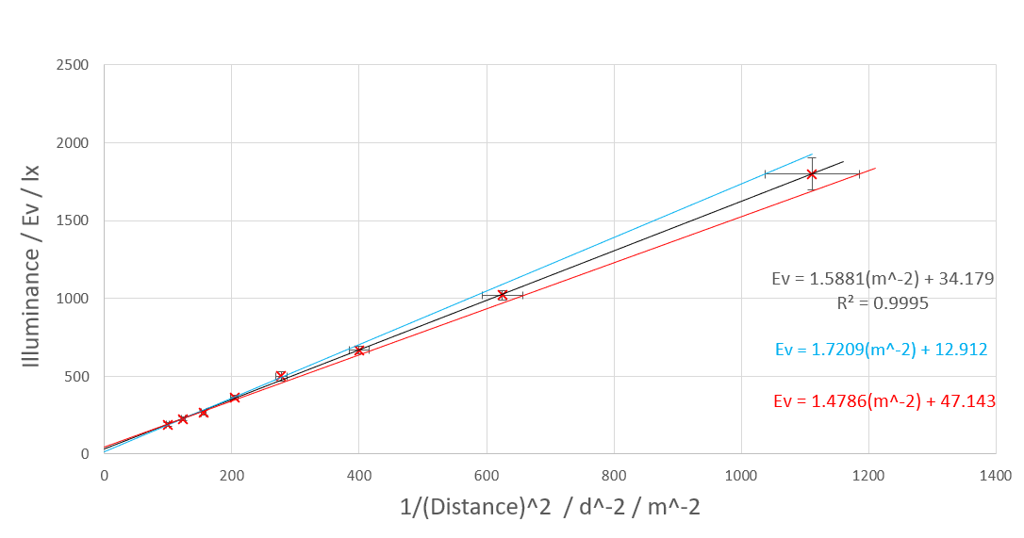

Inverse squared distance to light source against the illuminance

**Gradient and Errors**  
  
Figure 7 also displays the regression line and its equation (top equation), and the two lines of worst fits for error calculations (middle and lower equation). The horizontal error bars are used for plotting the line of worst fits as they are larger in size then the illuminance/vertical errors. The uncertainty of the gradient and y-intercept of the regression line are calculated using the half range of values in the line of worst fits.

Regression line gradient, y-intercept: 1.59, 34.2 ()

*Uncertainty of gradient using half range*:  
Highest gradient error line gradient, y-intercept: 1.72, 12.9 ().

Lowest gradient error line gradient, y-intercept: 1.48, 47.1 ().

Gradient uncertainty:

y-intercept uncertainty:

Therefore, the regression line and thus the relationship between illuminance against the distance is:

# Conclusions

## Result

There exists a clear and strong inverse squared relationship between the illuminance and the distance to the light-bulb, as shown in the transformed graph in figure 7, and the close to one correlation coefficient . This shows that as the distance to a light source increases, the illuminance decreases relatively rapidly at close distances but relatively less at far distances, and vice versa.

However, the theory of inverse square law also suggests that the relationship curve should have a y-intercept of 0. The non-zero y-intercept of the regression line — even considering the ranges of uncertainty (), suggests some systematical error are present. The curve is shifted upwards by a sizable amount, which could be caused by the erroneous reading of the ambient illuminance, parallax error in aligning the ruler, or by a lack of calibration of the light sensor. This indicates that the experiment data was not very accurate.

The graph (figure 7) consists of noticeable sized error bars that increases as distance increases. This is caused by the small distances used in combination with the moderately uncertain wooden ruler used. However the results are overall relatively precise due to the low percentage uncertainty of the two axis (figure 6, figure 4). The experiment data is considered to precise but inaccurate.

## Implications

The typical luminous efficacy can be calculated by dividing the gradient constant by the power dissipated (figure [fig:tle]):

$$\begin{aligned}
K &= \frac{k}{P} = \frac{1.6 \pm 0.1}{1.94 \pm 0.07}\\
&= 0.82 \pm 0.08\,\si{lm\per W}\,(2\, \,\text{sf})\end{aligned}$$

r0.45

|  |  |
| --- | --- |
| Category | Luminous Efficacy (lm/W) |
| Combustion | 1-2 |
| Incandescent | 5-17.5 |
| Halogen | 16.7-35 |
| Fluorescent | 46-104.2 |
| LED | 75-210 |

Comparing to the luminous efficacy values of a set of common light sources in figure [tbl:leff], the physics lab incandescent 5W light-bulb with a luminous efficacy value of $0.82 (\si{lm\per W})$, looks to be as efficient in producing light as a typical fireplace. This is unsurprising, as the outer glass casing of the bulb readily heats up when it is powered, indicating energy loss in the form of thermal energy. A suggestion is to made for the school physics department for a switch to safer (less glass temperature), and more energy efficient light-bulbs for general experiments.

## Reflection

Here is a list on the handling of the controlled variables/potential error factors, and future improvements to be made.

### Random Errors

#### Fluctuation of the outside light level

This is potentially a significant factor in creating a large uncertainty and low precision in the raw illuminance data. The advice would be to conduct the experiment at night, or in a totally blackout room without light pollution. This will increase the precision of the experiment and decrease the uncertainty on the luminous efficacy.

#### The sensitivity of the light sensor

Insignificant, for the equipment is properly taped down, removing the problem of a shaky hand.

#### The power supplied to the light-bulb

Insignificant, for the power held stable during the experiment.

### Systematic Errors

#### Environmental room intensity

A potentially significant variable. The small but existent systematic error is likely to be caused by the erroneous measure of the ambient room light level. Performing the experiment in a blackout room or at night is likely to reduce the effects of the ambient room intensity and increase the accuracy of the dataset, possibility creating a curve that intercepts closer to 0 on the y axis.

#### The temperature of the bulb filament

Insignificant, for the power is kept below the operating power limit and a lack of systematic decreasing illuminance during trials.

#### Parallax placements of the ruler

A potentially significant variable. For the wooden ruler have depth, an angled top-down view to place the ruler is likely to result in parallax errors, thus systematically displacing the measured distances. It may be wise to have used a paper with beforehand markings of the distances, which is likely in reducing the systematic error shown in the curve, and potentially help bring the intercept closer to point (0,0).

#### Accuracy of the light sensor

A variable that I was the most concerned about. This may be the largest cause of the systematic error. I could follow a lengthy calibration test listed on the manufacture’s website against a factory calibrated source, which will decrease the systematic error and increase the accuracy of the data.

## Further Investigations

Consider repeating the experiment with several other household lighting sources — LED, halogen, or fluorescent light-bulbs, and compare their typical luminous efficacy. The information can be used to determine the efficiency of different types of light sources to help the physics department to choose more efficient light-bulbs.