Pre Lab, Week 1
Statistics
Variable | Packaging | N | N* | Mean | SE Mean | StDev | Minimum | Q1 | Median | Q3 | Maximum
Moisture | glass | 30 | 0 | 128.35 | 2.76 | 15.14 | 97.13 | 118.87 | 124.81 | 138.35 | 153.84
 | HDPE | 30 | 0 | 138.09 | 2.54 | 13.92 | 114.51 | 127.51 | 136.05 | 149.06 | 168.35
 | PVDC | 30 | 0 | 135.45 | 2.72 | 14.90 | 99.15 | 125.79 | 132.28 | 143.98 | 170.83

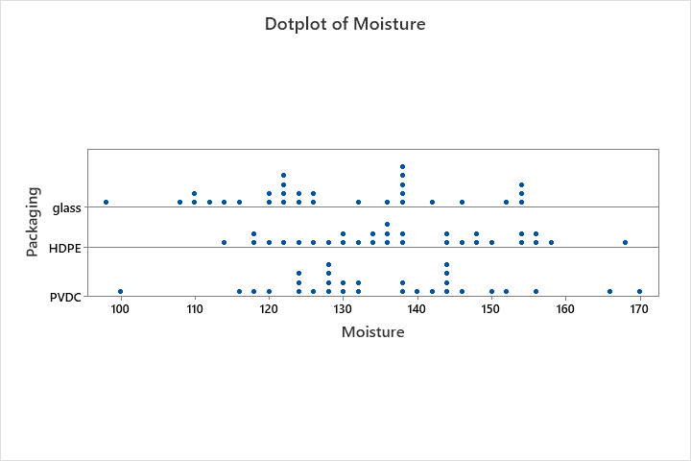

Glass seems to be the best packaging for compared to HDPE and PVDC, it has the lowest average and median of moisture. It’s relatively large SD should not be ignored, however.

