“Київський фаховий коледж зв’язку”

Циклова комісія комп’ютерної та програмної інженерії

**ЗВІТ ПО ВИКОНАННЮ**

**ЛАБОРАТОРНОЇ РОБОТИ №4**

з дисципліни: «Операційні системи»

**Тема: “Команди Linux для управління процесами”**

Виконав(ла/ли)

студент(ка/и)

групи: КСМ-23а

The Awkward Turtles:

Когут Б.М.,

Михайленко О.О.,

Трощинський Я.П.

Перевірила викладач

Сушанова В.С.

Київ 2024

*О.Михайленко*

*Я.Трощинський*

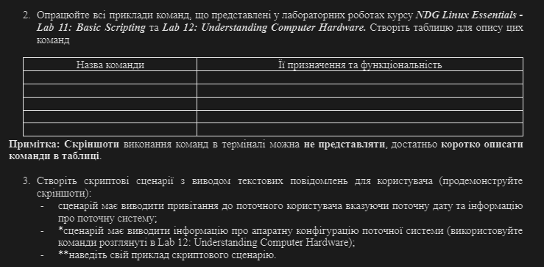

2. Work through all of the sample commands presented in the NDG Linux Essentials labs - Lab 11: Basic Scripting and Lab 12: Understanding Computer Hardware. Create a table to describe these commands

|  |  |
| --- | --- |
| **Command** | **Its function** |
| **vi file** | **Creates a file, and if file is already created opens a text editor** |
| **vi file.sh** | **Runs a script written in the file** |
| **bash file.sh** | **Same as vi file.sh** |
| **chmod file** | **Change permission to the file** |
| **read var** | **Read user input and put it in the $var** |
| **Lscpu** | **Determines the type of CPU** |
| **free -m** | **Show how much RAM is being used in mb** |
| **Lspci** | **Shows what devices are connected** |
| **Lsusb** | **Shows list of USB connected devices** |
| **Lsmod** | **Used to view the currently loaded modules** |
| **fdisk -l** | **Lists the disk devices** |

3. Create scripts that display text messages for the user (show screenshots):

* the script should display a greeting to the current user, indicating the current date and information about the current system;
* the script should display information about the hardware configuration of the current system (use the commands discussed in Lab 12: Understanding Computer Hardware);

Because of the similarity between the end of first and the start of second I thought to combine them into one script.

What is inside of file:

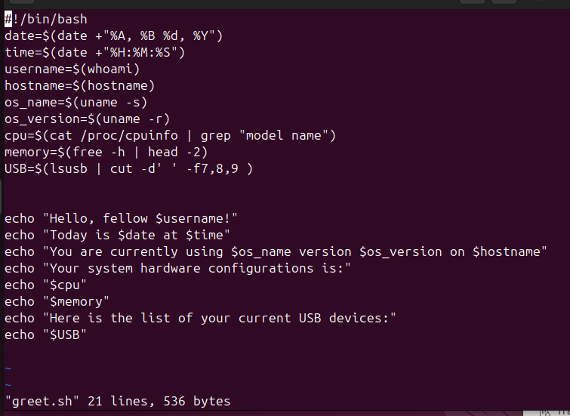

What is it doing:

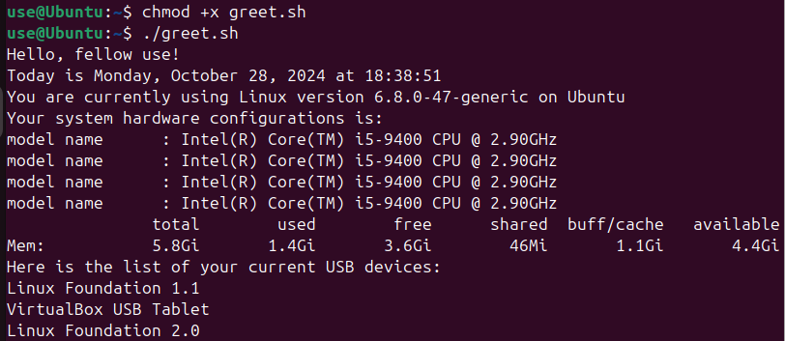

* Provide an example of your script.

For practice with vi text redactor I reopened lab 5 and did the same thing from there but using one file-function

Inside of file:

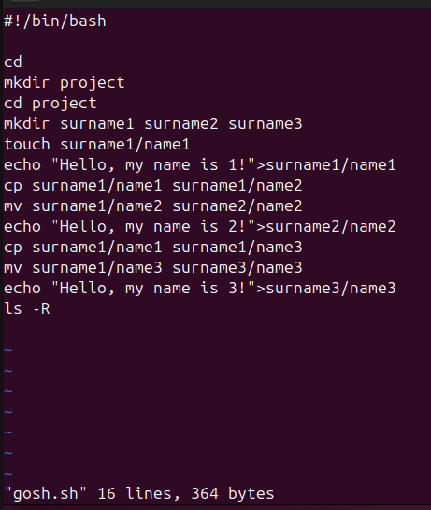

What is it doing:

Before: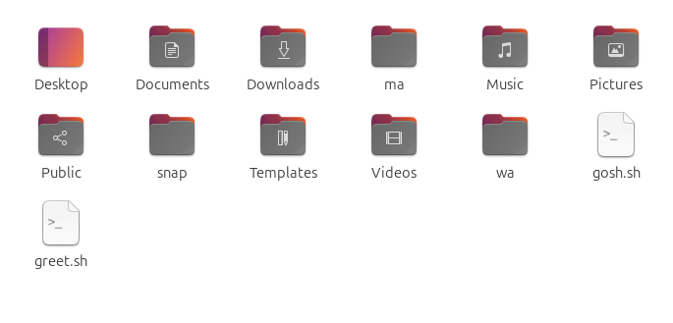

After:

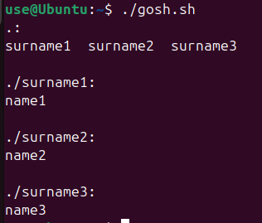

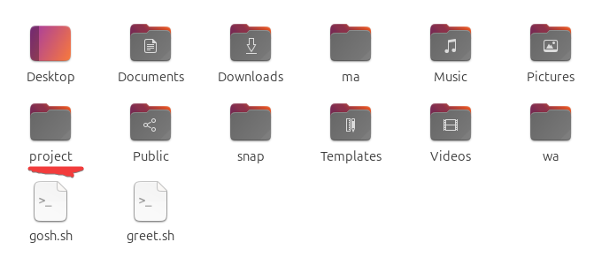

*Б.Когут*

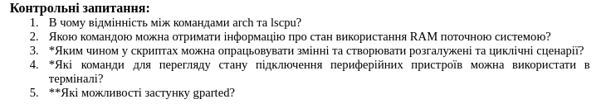

1. What is the difference between the arch and lscpu commands?

2. Which command can be used to obtain information about the current system’s RAM usage?

3. How can variables be processed in scripts and branching or looping scenarios created?

4. Which terminal commands can be used to view the connection status of peripheral devices?

5. What features does the gparted application offer?

1. Command arch shows the processor architecture,

Command lscpu show more detailed information about the processor architecture

2. Can use command free -h to look your information about RAM.

3. In Bash, variables can be defined by assigning value to them, for example:

variable_name=value. To use the value of a variable, you need to write $variable_name.

Conditional statements are created using if, else, and for loops – for, while.

4. lsusb – to display a list of USB devices;

lspci – to display a list of PCI devices;

dmesg – to view system messages that may contain information about connected devices;

cat /proc/partitions – to view partitions and storage devices.

5. gparted (Gnome Partition Editor) is a graphical tool for disk partition management. Its features include:

* Creating, deleting, resizing, moving, formatting, and checking partitions.
* Supporting various file systems: ext4, NTFS, FAT32, etc.
* Visualizing partitions and their usage on the disk.
* Applying partition changes with the option to undo operations before completing.

**Conclusion**

With this lab work, we gained practical skills in working with the Bash command shell and became familiar with the basic operations involved in working with script scenarios.