“Київський фаховий коледж зв’язку”

Циклова комісія комп’ютерної та програмної інженерії

**ЗВІТ ПО ВИКОНАННЮ**

**ЛАБОРАТОРНОЇ РОБОТИ №5**

з дисципліни: «Операційні системи»

**Тема: “Знайомство з командами навігації по файловій системі та керування файлами та каталогами”**

Виконав(ла/ли) студент(ка/и)

групи: КСМ-23а

The Awkward Turtles:

Когут Б.М., Михайленко О.О.,

Трощинський Я.П.

Перевірила викладач

Сушанова В.С.

Київ 2024

*Б.Когут*

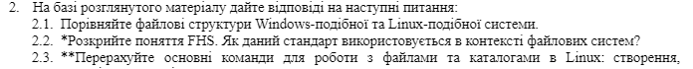

**2.1 Compare the File Structures of Windows-like and Linux-like Systems.**

**Windows**: The file structure is hierarchical, starting from "My Computer" or "This PC". Each drive (like C:, D:) is assigned a letter and contains folders and files. Windows uses a graphical approach for file management but also supports command-line tools like cmd or PowerShell.

**Linux**: Linux also has a hierarchical structure but starts with the **root directory** / instead of a drive letter. All files and directories are considered part of a single tree-like structure. Devices (like hard drives, USBs) are mounted under directories, not separate letters. The directory structure adheres to the **Filesystem Hierarchy Standard (FHS).**

**2.2 Explain the Concept of FHS. How is This Standard Used in the Context of File Systems?**

**The Filesystem Hierarchy Standard (FHS)** is a standard that defines the directory structure and directory contents in Linux and Unix-like systems. It ensures that applications, scripts, and users can predict where specific files and directories can be found on different systems. It also standardizes locations like /bin, /usr, /etc, ensuring consistency across various Linux distributions.

**2.3 List the Main Commands for Working with Files and Directories in Linux:**

**Creating Files**: touch filename creates an empty file.

**Copying Files**: cp source destination copies files. Use -r to copy directories recursively.

**Moving/Renaming Files**: mv source destination moves or renames files.

**Deleting Files**: rm filename deletes files, rm -r directory deletes directories and their contents.

**Creating Directories**: mkdir directoryname creates a new directory.

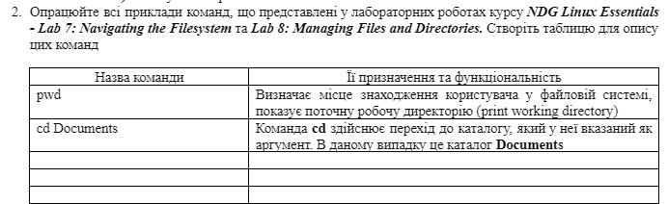

|  |  |
| --- | --- |
| **Command** | **Purpose and functionality** |
| pwd | Displays the current working directory. |
| Echo $home | Prints the path to the home directory of the current user. |
| cd | Changes to the user's home directory. |
| cd /home | Navigates to the /home directory. |
| cd ~ | Moves to the user's home directory using the tilde (~). |
| echo | Displays a message or the value of a variable. |
| cd ~root | Changes to the root user’s home directory. |
| cd /urs/bin | Navigates to the /usr/bin directory. |
| cd /urs | Navigates to the /usr directory. |
| cd /urs/share/doc | Navigates to the /usr/share/doc directory. |
| cd bash | Navigates to the bash directory |
| cd .. | Moves up one directory level. |
| cd ../dict | Navigates up one level and into the dict directory. |
| ls | Lists the contents of the current directory. |
| ls -a | Lists all contents of the current directory, including hidden files. |
| ls -l /etc/hosts | Displays detailed information about the /etc/hosts file. |
| ls -R /etc/undev | Lists the contents of the /etc/udev directory and its subdirectories recursively. |
| ls -d /etc/s* | Lists directories in /etc starting with the letter s. |
| ls -d /etc/???? | Lists directories in /etc with exactly four characters in their names. |
| ls -d /etc/[abcd]* | Lists directories in /etc that start with the letters a, b, c, or d. |
|  |  |
|  |  |

*Виконав Трощинський Ярослав*

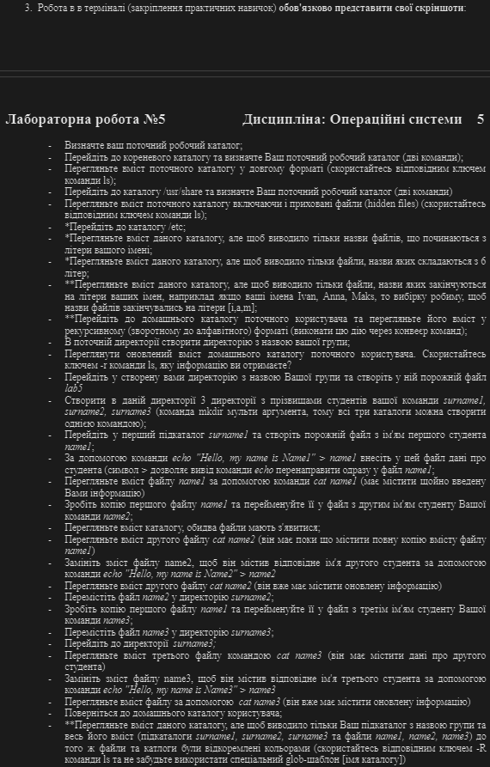

3. Working in the terminal (consolidation of practical skills) be sure to present your screenshots:

* Identify your current working directory;



* Go to the root catalog and determine your current working directory (two сommands);

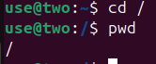

* View the content of the current catalog in a long format (use the relevant LS command key);

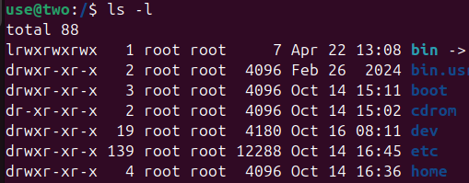

* Go to directory /USR /Share and determine your current work directory (two commands)

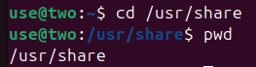

* View the content of the current directory including hidden files (Hidden Files) (use the corresponding LS command);

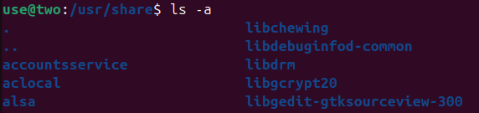

* *Go to the directory /etc;



* *Review the contents of this directory, but to display only file names starting with the letter of your name;



* *View the contents of this directory, but to display only files whose names consist of 6 letters;

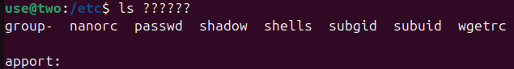

* ** View the contents of this directory, but to display only files whose names end in the letters of your names, for example, if your names Ivan, Anna, Maks, then we make a sample to make the file names end in letters [I, a, m];

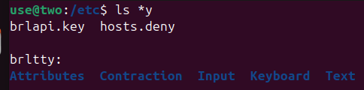

* ** Go to the current user's home directory and view its contents in recursive (reverse to alphabetical) format (perform this action through the commands of the commands);



* In the current Directory create a directory with the name of your group;



* View the updated content of your current user's home directory. Use the Ls -r -R key, what kind of information do you get?

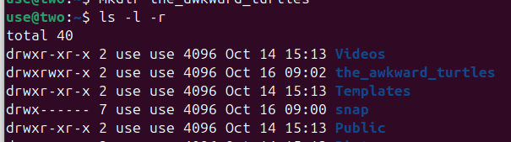

* Go to the Directory you created with your group name and create an empty Lab5 file in it

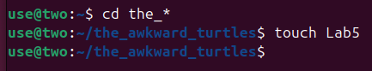

* To create in this Directory 3 Directories with the names of students of your team surname1, surname2, surname3 (the MKDIR Multi Argument command, so all three catalogs can be created by one commnad);

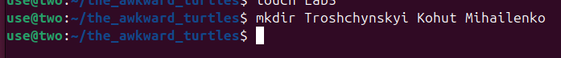

* Go to the first Surname1 subdirector and create an empty file with the first student Name1;

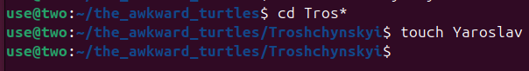

* Use the ECHO "Hello, My Name Is Name1" command "> Name1, enter the student's data into this file (symbol> allows the ECHO command to renew the Name1 file immediately;



* View the contents of the Name1 file using the CAT Name1 command (must contain the information you just entered)



* Make a copy of the first Name1 file and rename it to a file with the second name of your Name2 student student;



* View the content of the directory, both files should appear;



* View the content of the second CAT Name2 file (it must still contain a complete copy of Name1 file content)



* Replace the content of the Name2 file to contain the appropriate second student name with the Echo command "Hello, My Name Is Name2"> Name2



* View the content of the second CAT Name2 file (it should already contain updated information)



* Move the Name2 file to Surname2 Directory;



* Make a copy of the first Name1 file and rename it to a file with the third name of your Name3 student student;



* Move the Name3 file to the Surname3 Directory;



* Go to the Surname3 Directory;

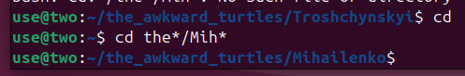

* View the contents of the third file by Cat Name3 (it must contain second student data)



* Replace Name3 file content so that it contains the corresponding third student's name using the Echo command "Hello, My Name Is Name3"> Name3



* Review the content of the file using CAT NAME3 (it should already contain updated information)



* Return to the user's home directory;



* ** View the contents of this directory, but to display only your subdirector with the name of the group and all its contents (sub-blogs surname1, surname2, surname3 and Name1, Name2, NAME3) files and catalogs were reinforced with color (sneak LS commands and don't forget to use a special Glob scabbling [directory name])

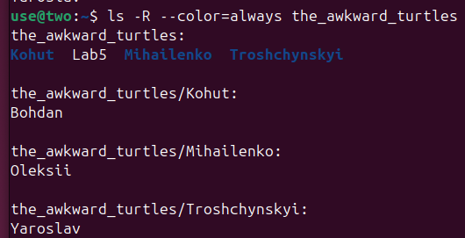

### *Виконував Михайленко*

### **Viewing the path to the user's home directory using the echo command**

There are two ways to view the path to the user's home directory:

1. **Using the $HOME environment variable:**

**echo $HOME**

1. **Using the tilde (~) symbol:**

echo ~

### **Viewing the contents of the root directory while in the home directory**

You can view the contents of the root directory without changing into it by using an absolute path. Use the following command:

ls /

### **Adding information to an empty file**

To add information to an empty file, you can use the echo command with a redirection operator >:

echo "Text to add" > file.txt

This will create a new file or overwrite an existing one. If you want to append information to an existing file without overwriting it, use the >> operator:

echo "Additional text" >> file.txt

### **Copying and deleting an existing directory**

1. **Copying a directory:** If the directory is **empty**, you can use the cp command:

cp -r /path/to/source /path/to/destination

The -r flag (recursive) is used to copy the contents of a directory along with all subdirectories and files.

1. **Deleting a directory:** If the directory is **empty**, you can use the rmdir command:

rmdir /path/to/directory

If the directory is **not empty**, use the rm command with the -r flag:

rm -r /path/to/directory

### **Examples of moving and renaming files**

1. **Moving a file:**

mv /work/tech/comp.png /Desktop

This command moves the file comp.png from the /work/tech directory to the Desktop without changing the file's name.

1. **Renaming a file:**

mv /work/tech/comp.png /work/tech/my_car.png

This command renames the file comp.png to my_car.png within the same directory /work/tech.

1. **Moving and renaming a file at the same time:**

mv /work/tech/comp.png /Desktop/computer.png

Conclusion:

The goal of this exercise is to gain practical skills in working with the **Bash** command shell, learn basic navigation commands for moving through the file system, and master the fundamental commands for managing files and directories.