REFERENCE MANUAL
ADD-REM Volume

Content:

- Introduction............................................................................................................................. 3
- Purpose.................................................................................................................................... 3
- Using the program.................................................................................................................. 3
- Limitation................................................................................................................................ 4
- Installation............................................................................................................................... 4
- Future...................................................................................................................................... 4
- Support.................................................................................................................................... 4

1. Introduction

This program allows user easy to ADD or REMOVE selected items placed into the volume of box, shown with blue-hidden lines.

2. Purpose

Program was developed for possibility ADD or REMOVE to the selected volume according
following possibilities:
Program ADDs or REMOVEs only selected items...PIPE,SCTN,FRMW...to ALL. Program respects switched on/off settings of Auto colour, or user can switch off Auto colour function, and to use option for colours....after using button COLOUR the ADD Elem button will be coloured according selected colour. For removing user can use 2 possibilities:
Remove box – will remove all elements from selected box
Remove added – will remove only what was added new to current displayed elements, during enlarging of box borders with +/- coordinate.

Program can omits for (Add or Remove) function wished strings eg ‘TEST’ the value of text STRINGS is voluntary by user.
Program allows choose the colour and visibility for added items
Program can increase UP(+) or DOWN(-) volume
Program allows user very quickly use function CLIPBOX according borders of blue-hidden lines BOX

3. Using the Program

Use button CE or put name of item – programs automatically generates volume on the screen or use pick and select item on the screen.
User can use OWNER option or if needs to enlarge volume, you can:
a, chose PICK NEXT and select new item about which volume will be current volume enlarged
b, press button + or -, and current volume will be increased in the value ‘DIST’, user can set own distance e.g. 1500
c, user can increases volume to all sides or only to selected side e.g. only to the North -> set ENLARGE ‘N’
user can set any colour and visibility, button ADD ELEM will be coloured according of selected colour, or can be used autocolour
For ignoring of some strings, it is necessary write text to ‘IGNORE’ gadget e.g. ‘Basic’ or ‘12001’ – program will ignores all items what contains in the name string ‘Basic’ or ‘12001’, e.g. if my zone is /Basic/AAA, contains pipe /Sam/1200145-12-A and equipment /AC01, at the same time equipment and pipe are in the selected volume, both will not be added to this volume using of this macro or if they are shown, will not be removed.
For searching elements with some STRING use gadget WITH STRING program will ignores all items according IGNORING LIST this rule has higher priority, but shows you only elements, which contain STRING in the name.
For cancelling of text – select string and use button REM
User can simply after pressing of clip box function works only in the selected volume, the button changes colour according set ACTIVE colour in Settings->Graphics->Representation

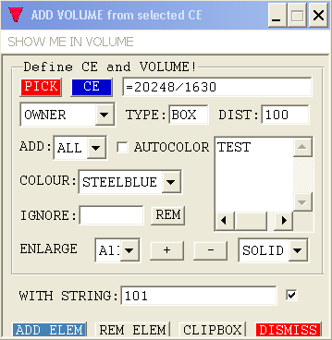

4. Limitation

Program currently work only in MM units.

5. Installation

For installation of macro is necessary to copy the files
rvafaddvol.pmlfrm
rvaaddvcount.pmlobj
loadaddrem.pmlfnc
rvaaddvprimit.pmlobj
rvaaddvcount.pmlobj
findppoint.pmlfnc
findlength.pmlfnc

to pmllib directory eg:

c:\xxx\yyy\pmllib\...\ADDvol
where ADDvol is directory where will be stored 3 above mentioned files.

This program will install with running of function loadaddrem.pmlfnc
and it is necessary to write:

Before 1th using:
pml rehash all

!!loadaddrem()

For calling of program is necessary write :
Show !!rvafaddvol Free Centred xr0.2 yr0.2

Where Free Centred xr0.2 yr0.2 means position of shown form
Is strongly recommended to define this command to some other form – add new button etc.

- Future

For future this program will be extended in possibility to calculate weight of contained and the same time shown – pipes dry or with water, sctns, primitives and make screen drawing automatically.
Is now available, test it please, send me comments.

- Support

For question or support, ask:

Robert Vancisin

rvancisin@yahoo.com
vancisin@aminet.sk

++ 421 (0)907 280 210

