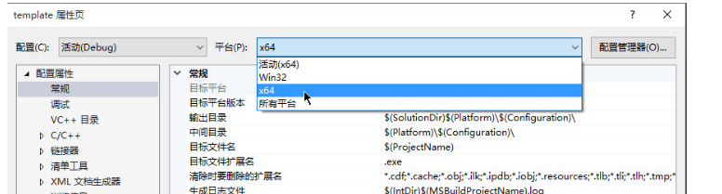

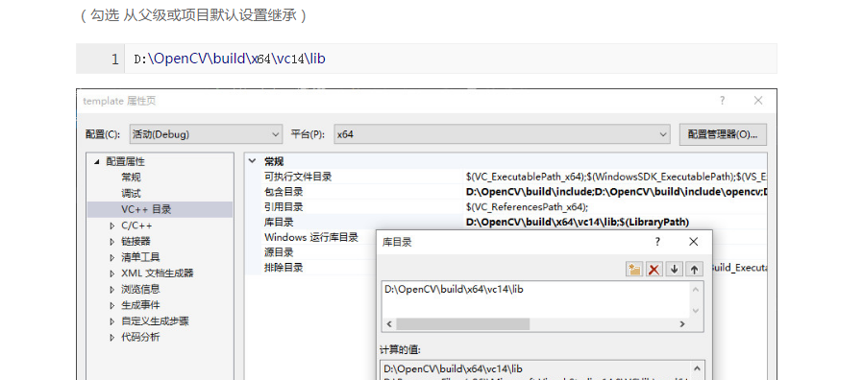

opencv_ml2410d.lib  
opencv_calib3d2410d.lib  
opencv_contrib2410d.lib  
opencv_core2410d.lib  
opencv_features2d2410d.lib  
opencv_flann2410d.lib  
opencv_gpu2410d.lib  
opencv_highgui2410d.lib  
opencv_imgproc2410d.lib  
opencv_legacy2410d.lib  
opencv_objdetect2410d.lib  
opencv_ts2410d.lib  
opencv_video2410d.lib  
opencv_nonfree2410d.lib  
opencv_ocl2410d.lib  
opencv_photo2410d.lib  
opencv_stitching2410d.lib  
opencv_superres2410d.lib  
opencv_videostab2410d.lib  
opencv_objdetect2410.lib  
opencv_ts2410.lib  
opencv_video2410.lib  
opencv_nonfree2410.lib  
opencv_ocl2410.lib  
opencv_photo2410.lib  
opencv_stitching2410.lib  
opencv_superres2410.lib  
opencv_videostab2410.lib  
opencv_calib3d2410.lib  
opencv_contrib2410.lib  
opencv_core2410.lib  
opencv_features2d2410.lib  
opencv_flann2410.lib  
opencv_gpu2410.lib  
opencv_highgui2410.lib  
opencv_imgproc2410.lib  
opencv_legacy2410.lib  
opencv_ml2410.lib

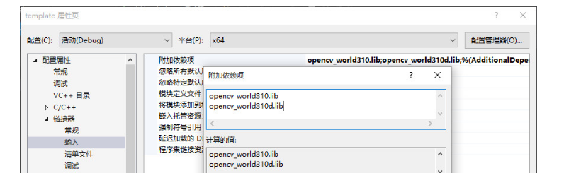

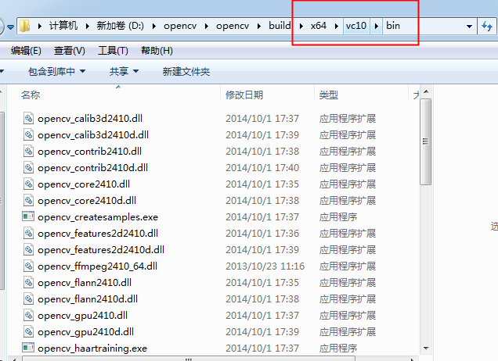

下的动态链接库复制到

