**Assignment 5**

**1301058**

**Zhang Junming**

**Exercise 1**

Question

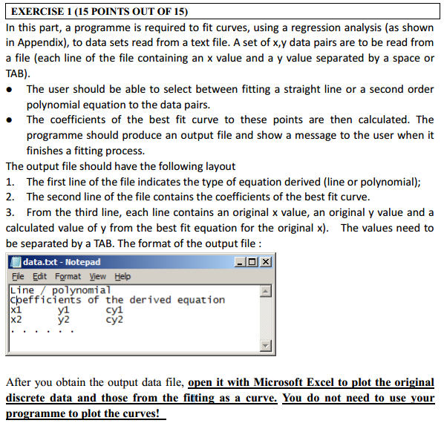

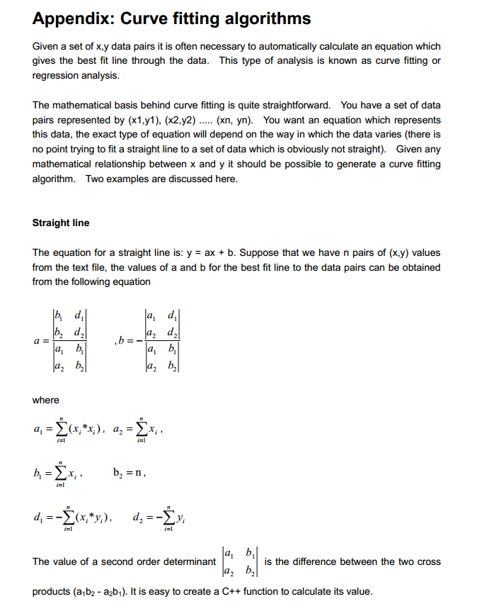

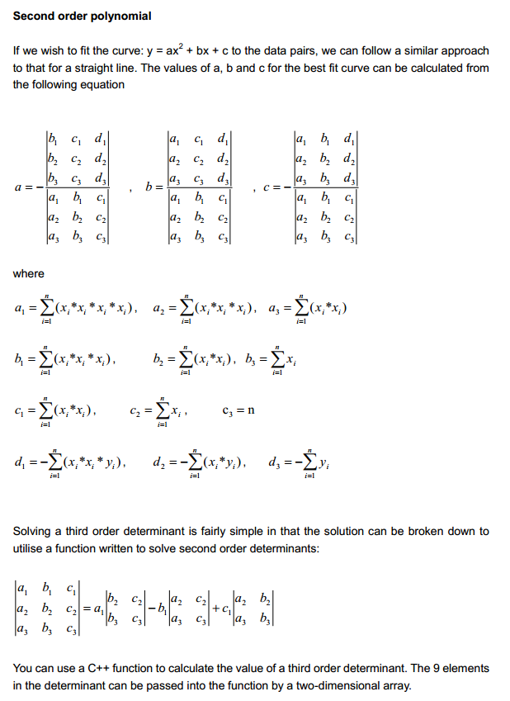

Model Answer

Software Development Process

1. **Problem statement**

This program is used to analyze and calculate a series of coordinates to fit curve. The way of analyzing called regression analysis and the detail about it has showed on the question part.

Users are asked to input the value of x and y for combining to coordinates and output these coordinates into a text file, after that, choose a way to fit curve ( straight line or second order polynomial equation), finally output them to text too.

1. **Analysis**

Inputs:

1. Coordinates: input a series value of x and y to combine the coordinate
2. Option 1: read the coordinates which store in the text and fit them with a straight line
3. Option 2: read the coordinates which store in the text and fit them with a second order polynomial equation

Outputs:

1. A text file called data which store the entered coordinates
2. A text file called data_straight line which store the regression analysis in the way of straight line
3. A text file called data_second order polynomial which store the regression analysis in the way of second order polynomial

Additional requirements or constraint

The result should plot by using Microsoft Excel

1. **Design**
2. Add header file iostream and fstream

<1> using of the ste namespace

2. Write the main function

<1> int i j k n m - for counting

<2> int m - store the number of coordinates

<3> ask user to input the number of coordinates and store the value in m

<4> double **p - construct a double dimensions array to store coordinates

<5> allocate memory to this first dimension of array

<6> setting up a loop to allocate memory to the second dimension of array

<7> display and ask user to input the value of x and y to create coordinates

<8> display these coordinates which user entered on srceen

<9> output these coordinates to a text called data and let the value of x on the left side, the value of y on the right side

<10> display a menu to ask user to choose how to deal with these data, 1 for straight line and 2 for second order polynomial equation

<11> setting up a switch

1- tell user to deal with these coordinates as straight line

a. open text file data.txt

b. read these coordinates which store in text data.txt and store them in a new array P1

c. double a1 a2 b1 b2 d1 d2 - for calculate a and b in regression analysis

d. using straight line formula to calculate

e. double a and b - coefficients of the derived equation

f. calculate each value of y with y = ax + b and store the value in array cy

g. output the type of regression analysis which is line, the coefficients a and b, the value of x, y and cy to text data_straight line.txt

2- tell user to deal with these coordinates as second order polynomial equation

a. open text file data.txt

b. read these coordinates which store in text data.txt and store them in a new array P2

c. double a1 a2 a3 b1 b2 b3 c1 c2 c3 d1 d2 d3- for calculate a and b in regression analysis

d. using straight line formula to calculate

e. double a and b - coefficients of the derived equation

f. calculate each value of y with y = ax^2 + bx +c and store the value in array cy

g. output the type of regression analysis which is line, the coefficients a and b, the value of x, y and cy to text data_second order polynomial.txt

<12> write default case, tell user enter error

<13> return 0

1. **test**:

1.png

at start, ask user to confirm how many coordinates will be entered

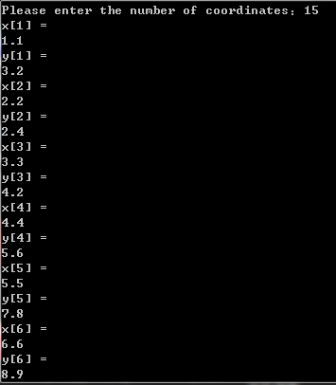

the process of inputting

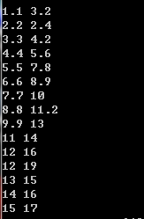

after input, the result will be displayed

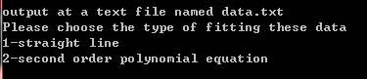

menu

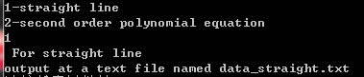

the way of straight

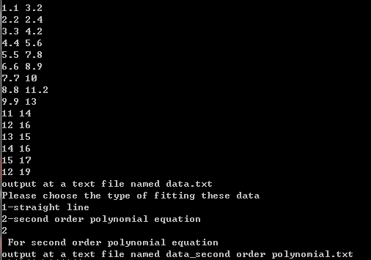

the way of second order polynomial equation

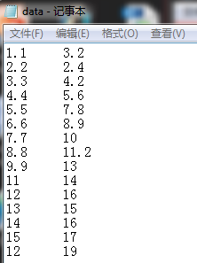

text file of data

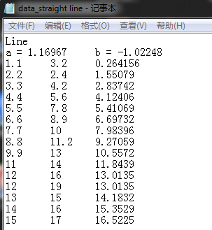

text file of straight line

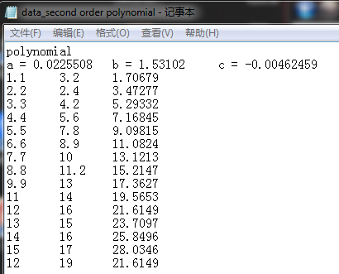

test file of second order polynomial

Plot in EXCEL

