Assignment 1

Zhang Junming 1303058

**Exercise 1**

Software Development Process

1. Problem statement:

To ask user to input name (English or Chinese) and student ID number, then display the name and ID number on screen.

1. Analysis:

Inputs: name on characters and ID number on real numbers.

Outputs: print the name and ID number on screen.

Additional requirements or constraints: none.

1. Design

Algorithm:

1.char name-represents the name .

int ID_number- represents the ID number.

2.Ask user to input name on characters and ID number on real numbers.

3.Read and store the input characters and real numbers.

4.Display the name and ID number on screen.

4. Implementation: see the C code in file exercise1.c with comments.

5. Testing: the C program was tested by carrying out a set of experiments and the C program output was verified successfully. For instance,

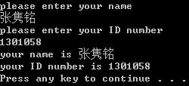 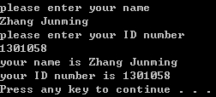

C code

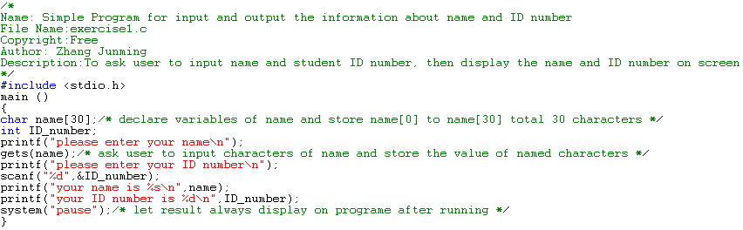

**Exercise 2**

Software Development Process

1. Problem statement:

Design a program to transform the temperature’s unit in Fahrenheit to Celsius degrees.

1. Analysis:

Input: a float number representing the temperature in Fahrenheit.

Outputs: this value of temperature in Celsius.

Additional requirements or constraints: Celsius = (5/9) × (Fahrenheit-32), 5 and 9 are integral, therefore, the value of 5/9 is o in qunicy because the program acquiesce in 5/9 is an integral. (Fahrenheit-32)*5/9 could get correct result.

1. Design:

Algorithm:

1.Float Fahrenheit- represents the input temperature in Fahrenheit.

Float Celsius- represents the output temperature in Celsius.

2. ask user to input a real number representing the temperature in Fahrenheit.

3.read the input real number and store the value into Fahrenheit.

4.compute the temperature at the given Fahrenheit in degree Celsius according to the provided formula.

5.display the Celsius temperature at the given value.

1. Implementation: see the C code in file exercise2.c with comments.
2. Testing: the C program was tested by carrying out a set of experiments and the C program output was verified successfully. For instance,

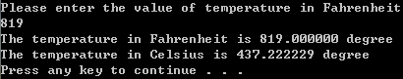

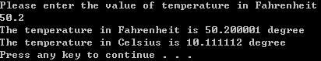

C code

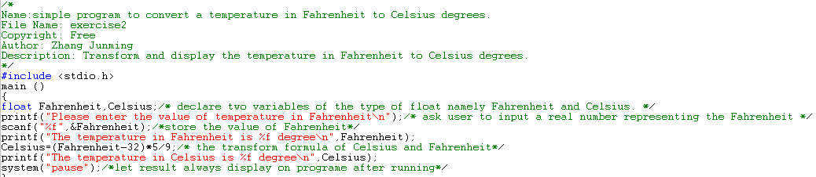

**Exercise 3**

Software Development Process

1. Problem statement:

Design a program to calculate the area enclosed by a circle when PI=3.1416.

1. Analysis:

Inputs: a real number representing the radius.

Outputs: to print the area based on radius.

Additional requirements or constraints: r^2 is error in quincy, use r*r or function express.

1. Design

Algorithm

1. Define PI is 3.1416
2. Float r-represents the radius.

Float Area-represents the area.

1. Ask user to input a real number representing the radius.
2. Read and store the value of radius.
3. Compute the area based on the circle area formula.
4. Display the value of area.
5. Implementation: see the C code in file exercise3.c with comments.
6. Testing: the C program was tested by carrying out a set of experiments; and the C program output was verified successfully. For instance, 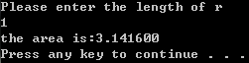

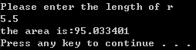

C code

