**Assignment4**

**exercise 1**

Question

A polynomial of degree 2 in x is given by **ax^2+bx+c**

Write a **C** program that read the values of *a, b, c,* and *x*, from the user and compute the value of the polynomial, by calling a function

double f(double a, double b, double c, double x)

{

......

}

Model Answer

Software Development Process

1. **Problem statement**

To ask user to input four values of variables represent the parameter of a polynomial, then calculate the result.

1. **Analysis**

Inputs:

1.double a,b,c,x-represent four parameters of this polynomial.

2.double sum-represents the value of result.

Outputs:

To display the result of polynomial with given parameters.

Additional requirements or constraint

Using User-defined Function: double f (double a, double b, double c, double x).

**3. Design**

Algorithm

1. Crate defined function, declare the double f with four parameters a,b,c and x :

double sum-represents the result of this polynomial.

2. Crate function sum=a*x*x+b*x+c for defined f.

3. Return the result to 'sum'.

4. Declare five variables namely double a, b, c, x and z, intuitively:

a, b, c - represent the coefficient of quadratic, first power and constant

term.

x - represents variable of this polynomial.

sum - represents the result.

5. Ask user to enter four numbers represent a,b,c and x.

6. Reading and storing these values.

7.  Setting up f function(defined function).

8. Input variables into f function.

9. Display the result on the screen.

1. **Implementation**:

See the C code in file exercise1.c with comments.

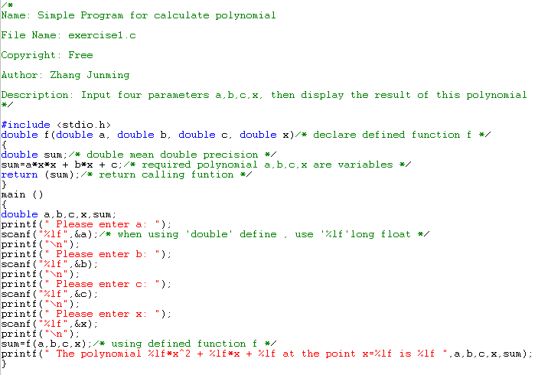

1. **Testing:**

The C program was tested by carrying out a set of experiments; and the C program output was verified successfully. For instance,

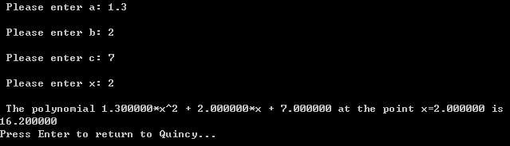

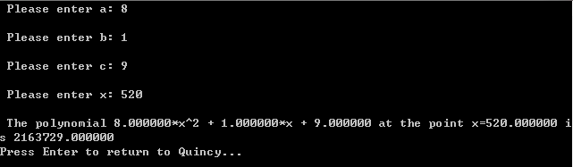

**Exercises2**

Question

The aim of this exercise is to write a C program that reads two characters from keyboard and prints on the screen the shape shown below using those characters through function calls. For example if the characters are A and B, the program should display:

BBBABBB

BBA ABB

BA AB

A A

BA AB

BBA ABB

BBBABBB

-picture1

Model Answer

Software Development Process

1. **Problem statement**

Choose two characters from A to Z then use these two characters crate a rhombus like picture1.

1. **Analysis**

Inputs:

Two characters from A to Z.

Outputs:

A rhombus consist from characters.

Additional requirements or constraints:

Do not use a 'printf' statement for each line or one long printf statement.

**3. Design**

Algorithm

1. Create defined function, char info and limit it store 666 characters

(1)z-represents entered character.

(2)Ask user to enter a letter from A to Z

(3)Read and store this character.

(4)Return this characters' first character using [0].

2. Create another defined function, int shape

(1)char a-represents first character; char b-represents second character.

(2)int i-represents lines; int j-represents rows.

(3)Setting up a loop using 'for'

(4)Analyze this shape, then find regular arithmetic.

(5)Using 'if-else' and regular arithmetic create this shape.

(6)Display shape.

3. Declare char a,b represent entered character.

4. Display only first entered character is effective.

5. Using defined function info in char a and b.

6. Using defined function shape on char a and b.

7. Setting up f function(defined function).

8. Setting up 'system pause' let this shape display on screen after running.

4. Implementation: see the C code in file exercise2.c with comments.

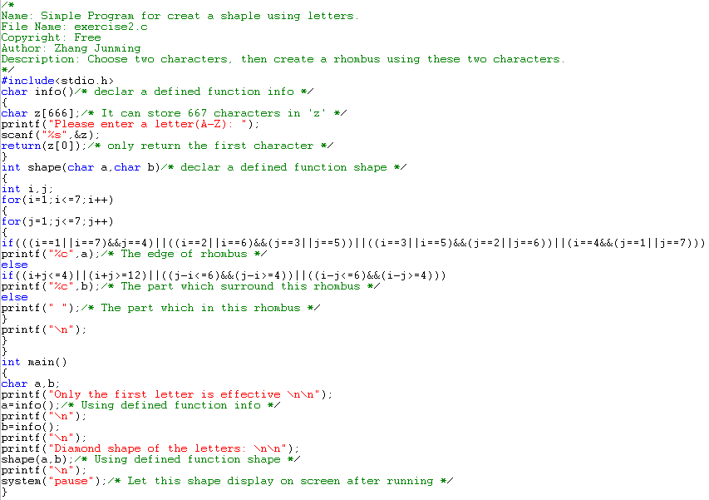

5. Testing:

The C program was tested by carrying out a set of experiments; and the C program output was verified successfully. For instance,

