Miss Lili Dai’s Blog

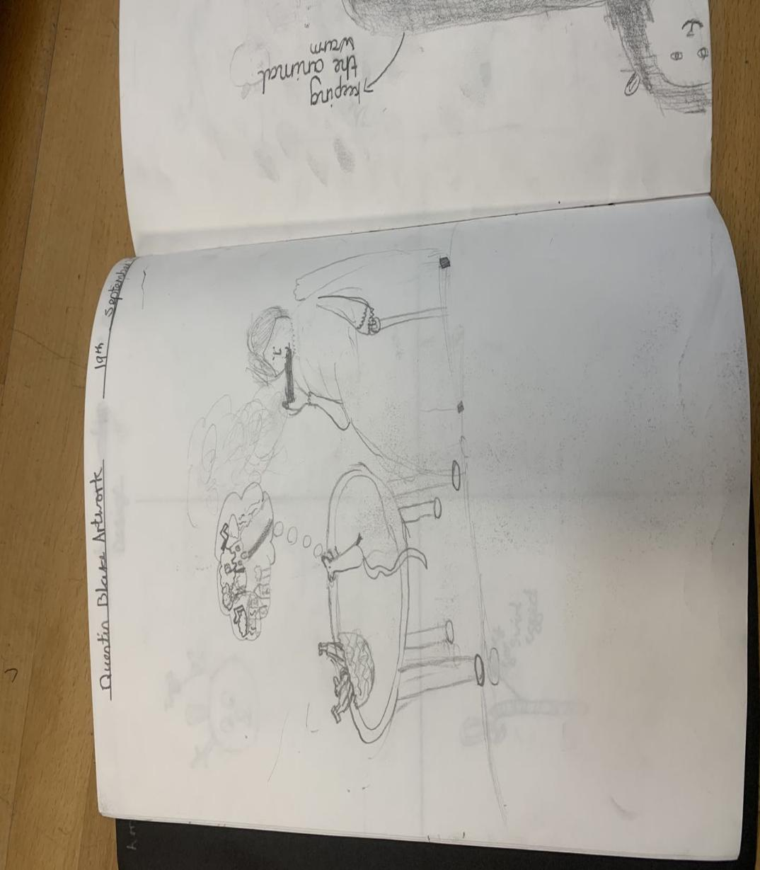

Picture

On a sunny morning, The school organized us to visit a very special primary school. I am honored to have this opportunity to visit a primary school and experience the life of these students. I feel very happy and excited to discuss with teachers and students about creativity.

This picture comes from this primary school. It was painted by a second grade student. The first time I saw this painting, I was attracted to it. In this picture, it is not just an old lady who is smoking a cigarette leisurely, but also draws the trajectory of cigarette smoke, like a cloud. It also shows that there is a mouse on the table. At this time, the mouse was no longer crawling, but standing, both hands seem to be asking what the grandmother is praying for, as if asking the grandma to eat, and want a home. This kid also drew the mouse's inner thoughts in the way he thought. In order to bring out the beauty of the whole picture, a plate of fruit was also drawn on the table, so that people would know at a glance that they were at home.

Children’s Possibility Thinking

Craft and Chappell (2014) studied two schools in Exeter, which implemented the concept of possible thinking as much as possible in their operation. Therefore, I think Pt can be implemented in various fields and aspects, such as a class activity or a student's textbook. It does not have any restrictions, can let students, teachers and parents can play at will.

Therefore, I can't help thinking about a question: "why can such a young child draw a picture with the same scene as in real life? And can you add your own imagination (Possibility Thinking) of the scene? " There is a teacher beside me and the answer she gave me was: "Children's creativity lies in their novel perspectives on this world. Their understanding of the world is different from that of adults, so they will build a magical world different from that of adults through their own vision and ideas."

I also think that as children grow older, they are constantly accumulating knowledge of the world and the things around them. When they have accumulated a certain amount of these things, they can better exert their creativity and imagination, which is exactly a manifestation of children exploring the unknown.

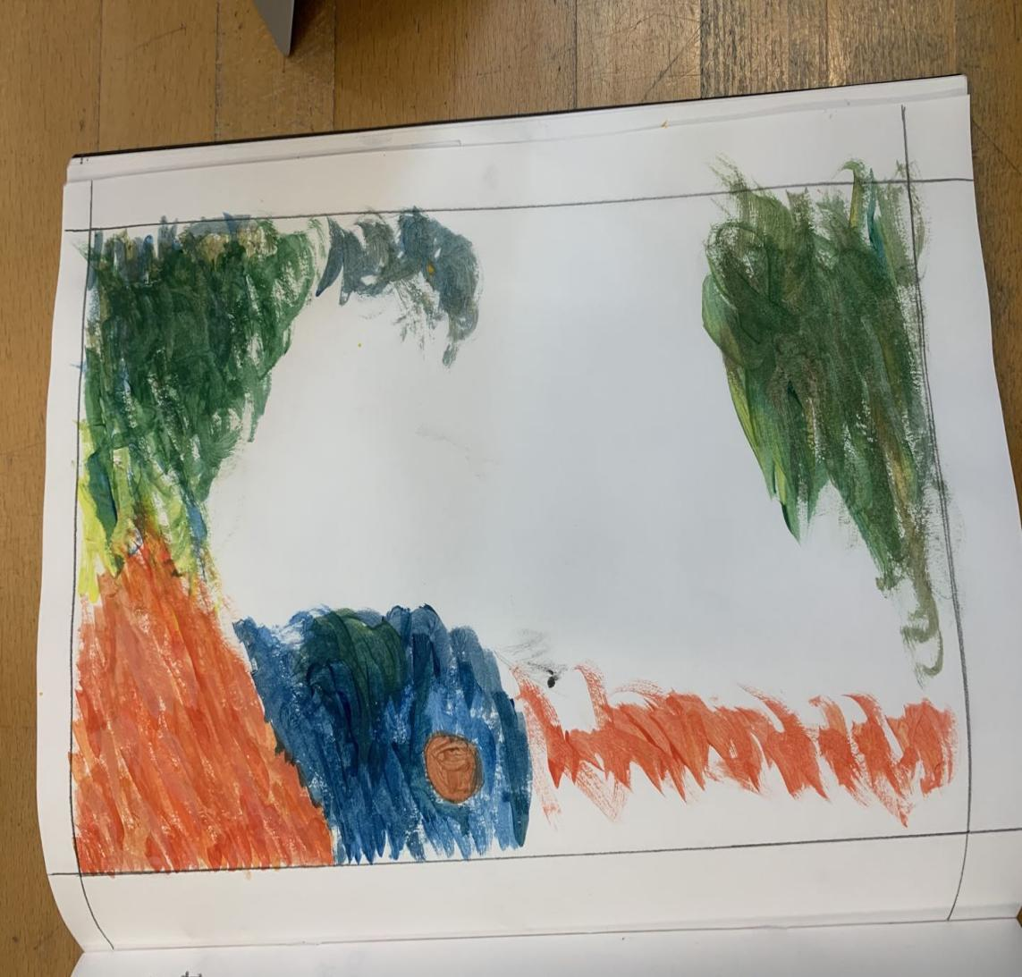

Reflections on children‘s creativity:

As an adult, when I saw this picture, I didn't see what the children were drawing at the first sight, but when I looked carefully, I found that it seemed to draw a tornado process, the bottom eye was small, but the more upward, the wind was bigger, the color was deeper and deeper, as if a lot of things were rolled in. After watching this picture, I could not help but have a question: "Is the creativity of children born?". Before visiting the school, my thought was: "Children's creativity may be born, just like some students are naturally good at solving mathematics problems, and some students are naturally good at sports." However, After I visited the school, I made such notes:

"Children are born with creativity, but after carrying out some high-quality art practice, they can still maintain creativity in adulthood, and art education will consciously cultivate creativity. (This kind of training does not mean that the teacher first demonstrates a painting method to the students, and then the students follow the teacher's painting one by one.).”

“Art has no ‘standard’ answer in art, which is exactly the value that art pursues and the thinking basis for continuous creativity. ”

Confirm children's creativity with correct response

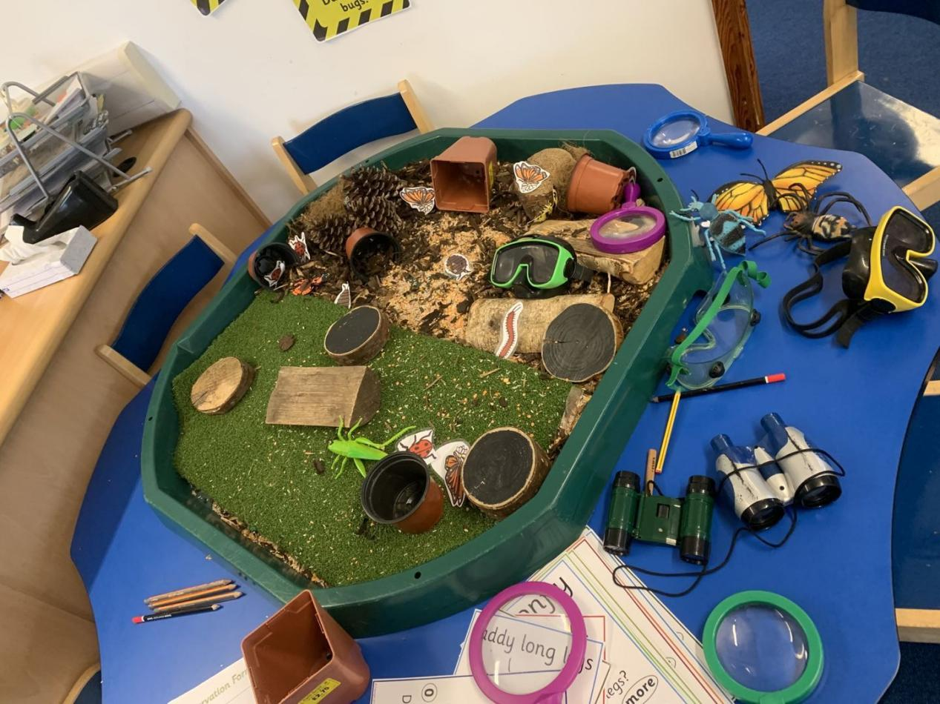

Children are naturally more fond of creative toys or creative gameplay, such as the sand table in the picture, and children can create something they imagine in the middle. Many people wonder: why does the interest in some toys not last long? A teacher told me: " This is because children generally prefer creative things. Some toys are already shaped and do not need them to research, so there is not much interest." In the process of visiting the school, I gradually found that: Many things that children like, such as mud, sand and so on.

It is difficult for us adults to find where the fun is. But they can always play happily. This is very similar to the description of materials in art education. This open material does not have certain rules of play. Children prefer the things that we cannot see, but they can enjoy the space created by putting a pile of ordinary sand. Create castles and imagined giants, or create a swimming party in the sand table with their friends and their parents, although these people may be strangely shaped.

The children seem to be all born directors, and younger children are unable to distinguish their real thoughts from the imagination of the world. Sometimes what we see is just a pile of cushions on the sofa, but in the eyes of children, it may be the stone steps leading to the magical world. The broom behind the door can fly on it. I think this is related to PT. Children use their imagination to put together sofas, chairs, cushions, quilts, and houses, and squeeze them inside happily, and they will not be afraid of the storm and wind outside.

Therefore, I think that in response to some of the children's thoughts, no matter the teacher or the parents, they should not be too "serious", because it is not difficult to find that when we are still seriously thinking about the child's last problem, they have taken the topic shifted to the next question. This is not a sign that children do not want to find answers, but that they are "playing and practicing" their own thoughts and talking to them.

In work and study, we will meet different types of people. They think and handle things differently, but people who are creative and dare to put forward bold ideas must be very confident. To let children discover the world with creativity and confidence, we need to respond to the budding creativity in the early stage of their lives in the right way.

Peer Teaching

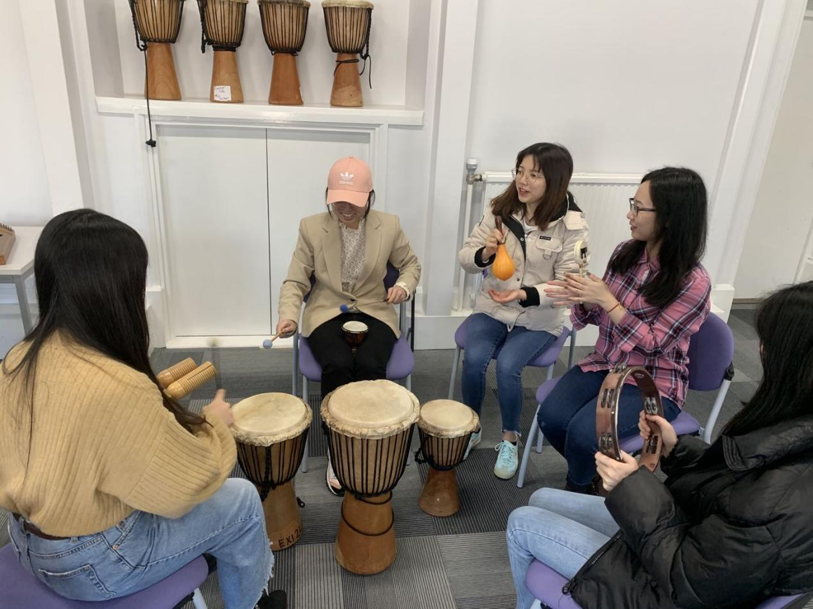

I would also like to share some of my feelings in peer teaching. I had a very interesting peer teaching with my classmates. I mainly taught music innovation. First of all, I want them to use different instruments and create their own music according to different environmental backgrounds. Then share it with your peers. Next, try to use your own music and the music created by your friends to see if it can form a good music. In this process, my peers are very happy in creating music, and finally they also cooperated to play a very interesting music. But in this process, I found that:

Although they finally created a piece of music, in the process of creation, my peers will first look at how others created it, rather than exploring it by themselves. This may be related to China's education system. In the context of China's education, there are "standard answers" to many things, whether in study or life. So when they create music, the first thing they think about is to learn from other people's ideas, rather than create their own things. This also triggered my reflection:

“Why are Chinese students less creative than Western students?”

“Is there any other reason that can affect students' creativity?”

（The people involved in the pictures in this blog，I have contacted them and agreed to put the pictures into the blog, which conforms to any moral standards）