Chapter 2

1.2.5 Storage, Backup and Recovery Procedure

Polytechnic University of the Philippines require their faculty members to fill up a form called QAR which stands for Quarterly Accomplishment Report. The QAR includes details of the progress of the ongoing advanced professional study or research that the faculty member is conducting as well as research publication, presentation, citation, utilization and Copyrighted Research Output. The QAR is filled up by the faculty every quarter of the year. This form is then passed and stored by The Office of the Vice President for Research, Extension, and Development (OVPRED). The office of the vice president records the submission of each faculty member with MS Excel as a backup then stores these physical document of the QAR by sorting and compiling them by college and then storing them in a cabinet arranged by time. If Physical documents are damaged or lost, the office can produce the lost files from the MS Excel database.

1.2.6 Security Procedures

To ensure that the QAR’s information remains untampered by any individuals other than the faculty member who submitted the document him/herself, the QAR is directly passed on to the Office of the Vice President which means the document won’t have any detours. After the data has been verified, the data stored is kept in a database which cannot be accessed without authorization from the Office of the Vice President. Same goes for the Physical Documents involved in these research data. The Physical documents are kept in the office which is constantly monitored by security. The data is also kept safe by the staff of the Office of the Vice President. Any access to the research data would require proper request from the office to record its transaction.

1.2.7 Policies and Procedures

The following are the policies and procedures regarding the storage of research progress information.

1. The QAR is submitted by every faculty member of the university every quarter of the year.
2. The QAR is kept by the The Office of the Vice President for Research, Extension, and Development (OVPRED).
3. The data of the QAR can be provided by the OVPRED depending on the level of the individual requesting for the data. The Dean can access the research information of the faculty members that are in their particular college while the chairperson can access all of QAR data.
4. A faculty member can request for these data by submitting a request.
5. The Office of the Vice President cannot change the information on the QAR submissions.
6. The QAR submissions will first be verified by the Office of the Vice President for its validity and authenticity before storing them in the database.
7. A faculty member can submit multiple research information as long as it is truly conducted.
8. The research publication, presentation, citation, and utilization can come from an already existing research in the database as long as the faculty member is involved in it.
9. The faculty member can submit a completed research report and also submit its other accomplishments at the same time such as the research’s publication or presentation.

1.2.8. Data and Process

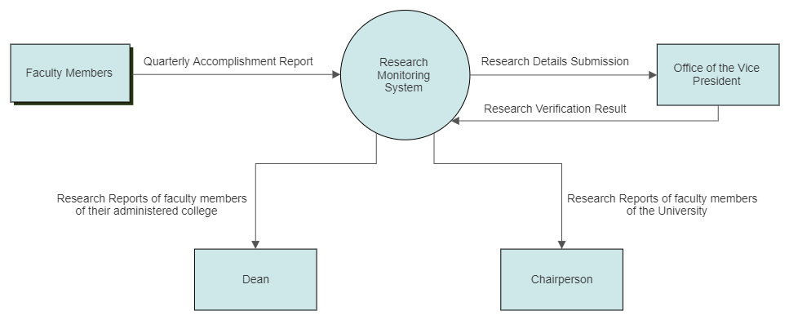

Figure 1: Context Diagram

The data that is utilized in this system will come from the Quarterly Accomplishment Report that is submitted by every faculty member in the University. The Office of the Vice President Collects these submissions and verifies the validity of the submission.

The Dean can access the research data of their college while the Chairperson can access all of the University’s research information.

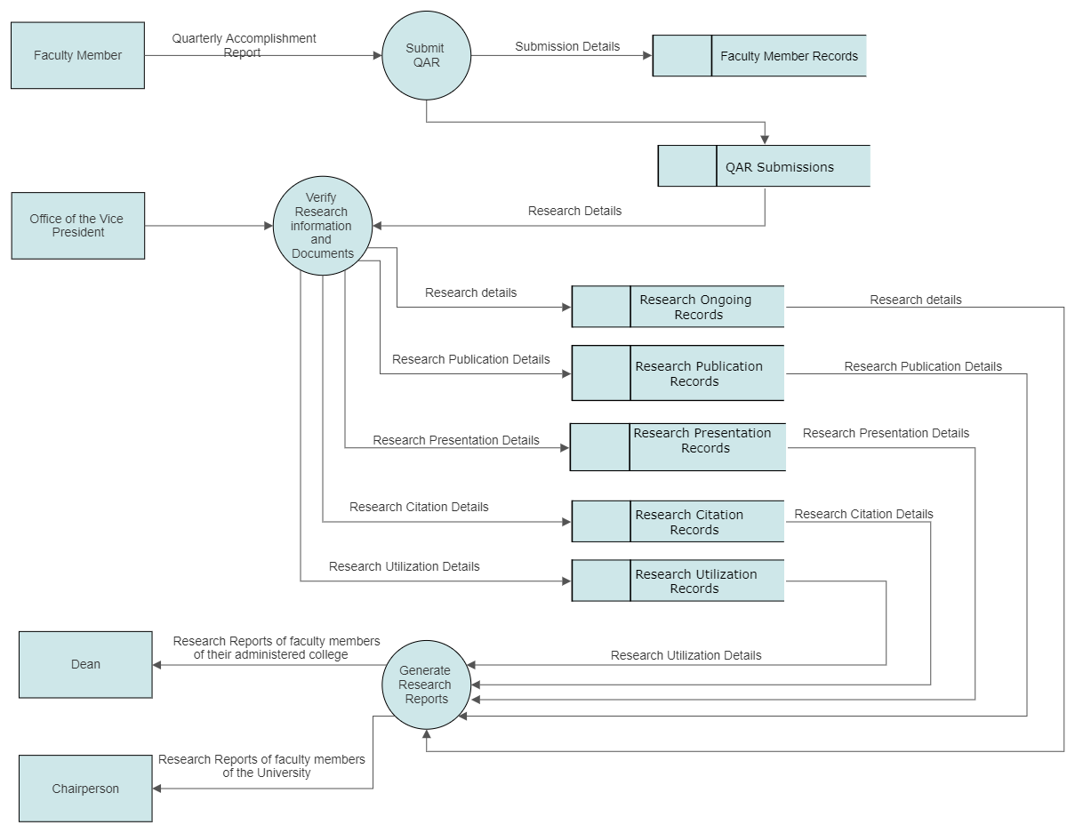

Figure 2: Data Flow Diagram Level 1

The Quality Assurance Report includes all of the faculty member’s activities in a quarter of the work year. This includes attendance, Trainings, Seminars, or memberships. From the QAR, the research segment is used to monitor the research progress of every faculty member, which are the Ongoing Research/Study, Research Presentation, Research Publication, Research Citation, Research Utilization, and Copyrighted Research Output. This is then verified by The office of the Vice President before storing the data. From These data, reports can be generated depending on the level of access of the faculty requesting.

1.4

The Faculty Research Monitoring System is designed to improve the research monitoring process of the Polytechnic University of the Philippines. The current practice of storing research data for monitoring requires faculty members to fill up a form, which is the Quarterly Accomplishment Report, and pass it on to the office personally. This system allows faculty members to submit the information and status of their research online to improve efficiency. The system also provides the Office of the Vice President, who manages the research data, a more efficient and fast way to access data since it will provide features of producing research list of desired filter, and generate statistic reports on the performance of the faculty members of the university.