According to PCN 1207, the OLEDs of SmartFusion Evaluation board and SmartFusion Development board has been changed, <http://www.actel.com/documents/PCN1207_Kit_OLED_change.pdf>

To distinguish between NEW OLED board and OLD OLED board, please check below images.

**OLD OLED**

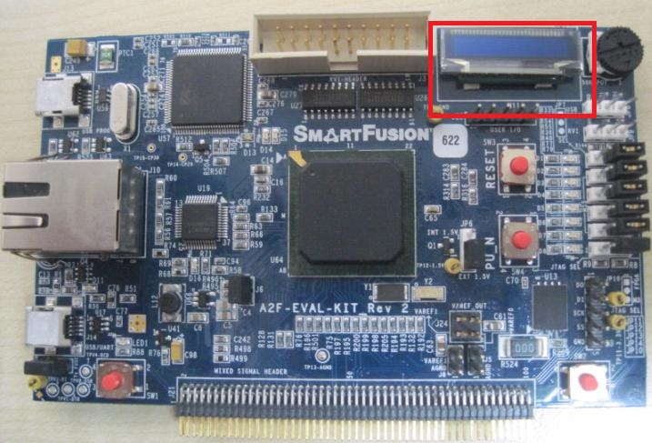

This board has **blue OLED** that soldered on PCB.

**NEW OLED**

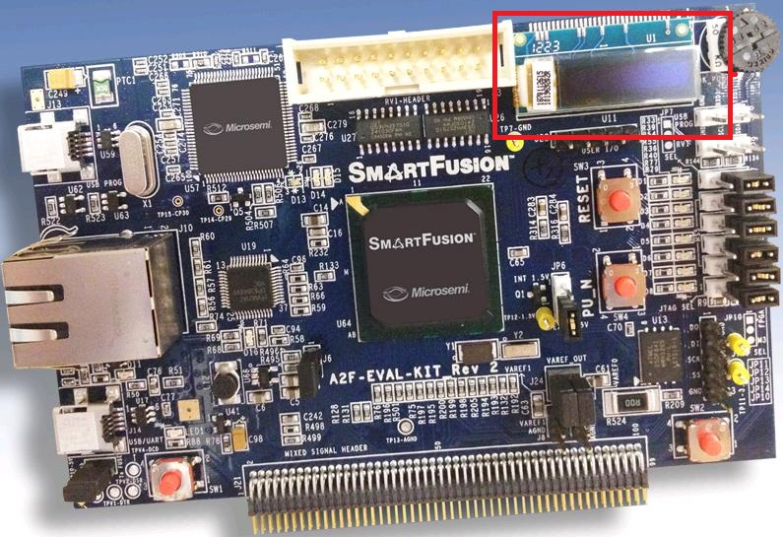

This board has **white OLED module** that soldered on PCB.

******************************************

DESIGN FILE DIRECTORY STRUCTURE

******************************************

|---Programming File

|

|---A2F200

| |----New_Oled

| |----Old_Oled

|

|---A2F500

| |----New_Oled

| |----Old_Oled

|

|---Read Me

**Programming File**

****************

This folder consists of programming files (*.STP) for A2F200 based SmartFusion Evaluation board and A2F500 based SmartFusion Development board (for both New OLED and Old OLED board) design to be run in Release Mode.

The provided programming files include embedded NVM application client with application programs in release mode.

**A2F200**

****************

This folder consists of two sub folders

**New_Oled:**

This folder includes the (*. STP) file for A2F200 based SmartFusion Evaluation board With New OLED.

**Old_Oled:**

This folder includes the (*. STP) file forA2F200 based SmartFusion Evaluation board With Old OLED.

**A2F500**

****************

This folder consists of two sub folders

**New_Oled:**

This folder includes the (*. STP) file for A2F200 based SmartFusion Evaluation board With New OLED.

**Old_Oled:**

This folder includes the (*. STP) file forA2F200 based SmartFusion Evaluation board With Old OLED.