To-Do List Application – User Manual

# 1. Introduction

This is a To-Do List application developed in Python using Tkinter. It allows users to manage their daily tasks by adding, deleting, and checking them off when completed. Additional features include a link to the developer’s GitHub and an “About/User Manual” button for project information.

# 2. System Requirements

- Python   
- Tkinter (comes pre-installed with Python)  
- Windows, macOS, or Linux

# 3. How to Launch the Program

Double-click the Python file

# 4. Features and How to Use Them

- Add Task: Type a task in the input field and click “Add Task.”

- Delete Task: Select a task in the list and click “Delete Task.”

- Check Task: Select a task and click “Check Task” to mark it as complete.

- Exit: Click the “Exit” button to close the app.

- About/User Manual: Displays additional information about the project.

- GitHub Link: Click the “Click me for my GitHub link!” button to open the project’s GitHub page.

# 5. Example Task

Turn in Final - due: 5/10/25

# 6. Screenshot

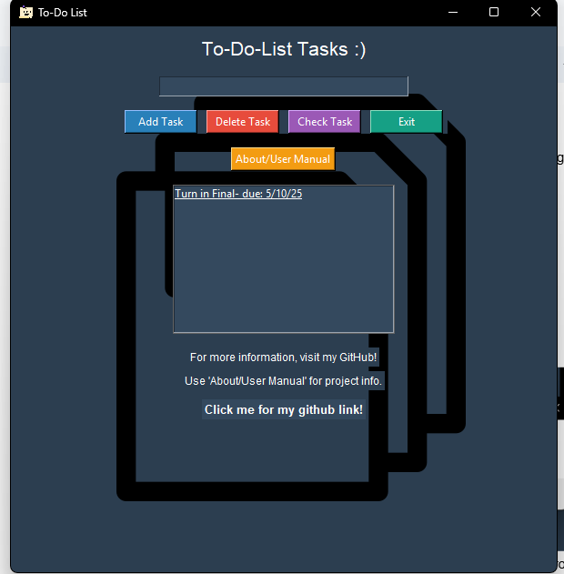

# 7. Troubleshooting

|  |  |
| --- | --- |
| **Problem** | **Solution** |
| Task won’t add | Ensure the input field is not empty. |
| Task won’t delete | Make sure you selected a task first. |
| GitHub link not working | Ensure you’re connected to the internet. |