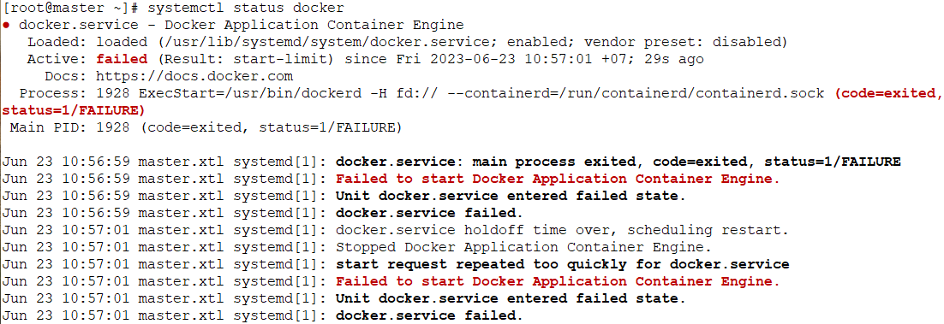

mv etc/docker/daemon.json daemon.conf

systemctl daemon-reload

service docker restart