
NAME: SSEKITTO BOB SAMUEL
REG NO: 23/2/306/D/149
COURSE: BCS
COURSE UNIT: CRYPTOGRAPHY AND CYBERSECURITY
Network Scanning and Analysis Using Nmap
1. Introduction
Network scanning is an essential technique in cybersecurity used to identify devices, services, and potential security weaknesses within a network. By actively probing systems, it is possible to understand how devices communicate and what resources they expose.
In this coursework, Nmap (Network Mapper) was used to perform various scanning techniques including host discovery, port scanning, service detection, and vulnerability analysis. The aim was not only to execute these scans but also to interpret the results and understand their security implications.
Nmap is a powerful open-source tool widely used by network administrators and ethical hackers to audit network security, discover hosts, and detect running services.

2. Methodology
The practical tasks were carried out in a controlled and authorized environment using either localhost (127.0.0.1) or a private network range. Each scan was executed step-by-step using specific Nmap commands, and the outputs were carefully analyzed.
For each task:
- The command was executed in the terminal
- Output results were recorded
- Screenshots were captured as evidence
- Observations and analysis were made based on the results

Task 1: Installation and Setup
installation
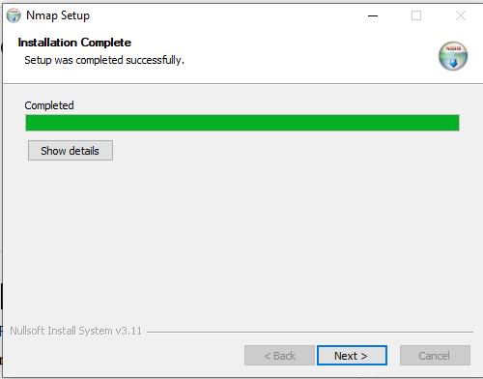
Version output
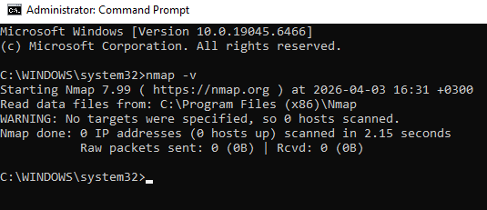
Explanation: Nmap was installed successfully and verified using the -v (verbose) option. This option increases the level of detail displayed during execution, allowing better visibility into the scanning process.
Sample Observation: The command displayed the installed version of Nmap along with initialization details, confirming that the tool was ready for use.

Task 2: Host Discovery
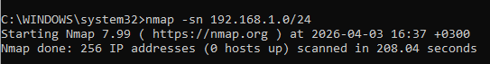
Explanation: This command performs a “ping scan” to identify active hosts within the specified subnet. It does not scan ports but instead checks which devices are reachable.
Results:
- Active Hosts Identified: There were no active hosts identified at the time of the scan.

Task 3: Port Scanning
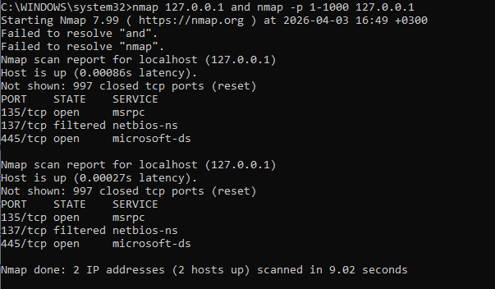
Explanation: The first command scans commonly used ports, while the second command extends the scan to ports 1 through 1000, providing a broader view of available services.
Results:
Port | State | Service
135 | Open | msrpc
445 | Open | Microsoft-ds

Analysis: Open ports indicate active services running on the system. For example, port 135 is associated with Microsoft Remote Procedure Call (MSRPC), which is used for communication between networked Windows systems, while port 445 is linked to Microsoft Directory Services (SMB), commonly used for file and printer sharing. The presence of these open ports suggests that the system is offering network services that could be targeted if not properly secured. For instance, SMB (port 445) has historically been exploited by malware such as WannaCry. Therefore, having multiple open ports increases the system’s attack surface, making it essential to implement proper security measures such as firewalls, regular patching, and access controls.

Task 4: Service Detection
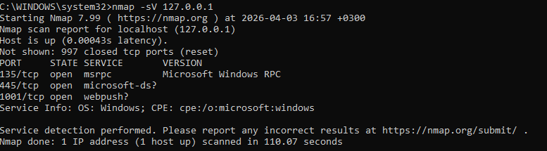
Explanation: This command identifies the services running on open ports along with their version numbers.
Results:
Port | Service | Version
135 | msrpc | Microsoft windows RPC

Analysis: Service detection provides deeper insight into the system by revealing the exact software in use. Outdated versions may contain known vulnerabilities, making this step critical for security assessment.

Task 5: OS Detection
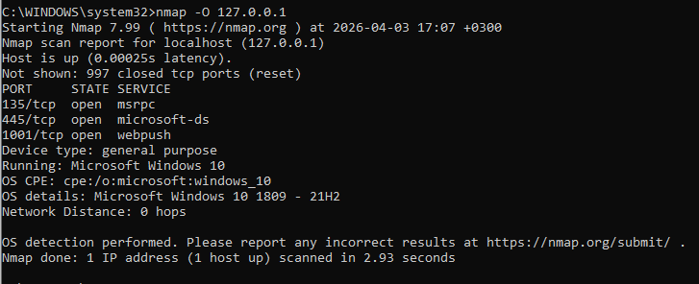
Explanation: Nmap attempts to identify the operating system using TCP/IP fingerprinting techniques based on how the target responds to specific probes.
Results:
- Detected OS: Microsoft Windows 10 1809 – 21H2
Analysis: The detected operating system provides useful context for further security analysis. However, the accuracy may vary depending on network conditions and firewall configurations.

Task 6: Advanced Scans
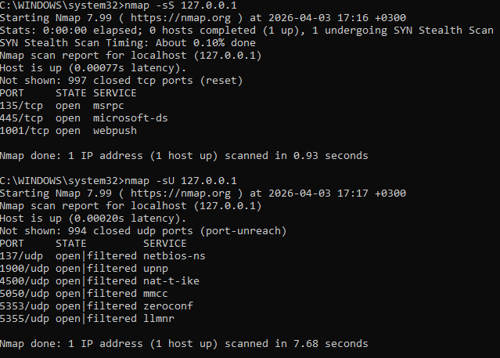
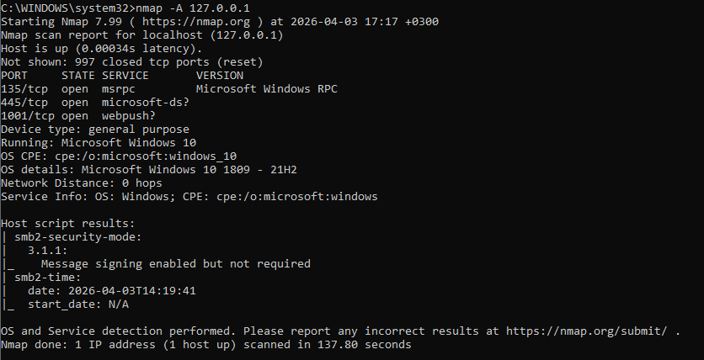

Explanation:
- SYN Scan (-sS): A stealthy scan that does not complete the full TCP handshake, making it less detectable.
- UDP Scan (-sU): Used to identify UDP services, though slower due to limited responses.
- Aggressive Scan (-A): Combines multiple techniques including OS detection, version detection, and script scanning.
Results:
Comparison:
Scan Type | Speed | Stealth | Detail Level
SYN Scan | Fast | High | Moderate
UDP Scan | Slow | Medium | Low
Aggressive | Medium | Low | Very High

Analysis: The SYN scan was efficient and less intrusive, while the UDP scan took longer and provided limited results. The aggressive scan produced the most comprehensive information but is more likely to be detected by security systems.

Task 7: Vulnerability Scan
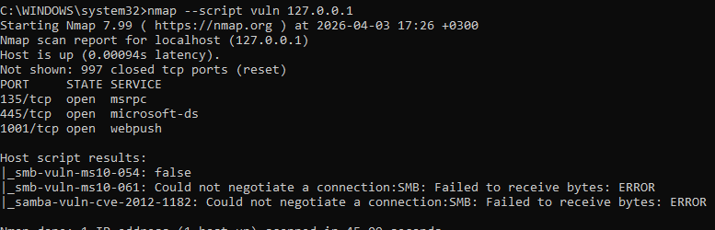

Explanation: This scan uses the Nmap Scripting Engine (NSE) to check for known vulnerabilities in detected services.
Results:
- Vulnerabilities found: Could not negotiate a connection:SMB: Failed to receive bytes: ERROR
Analysis: The scan identified potential weaknesses that could be exploited if not addressed. This highlights the importance of regular vulnerability assessments.

Task 8: Additional Commands
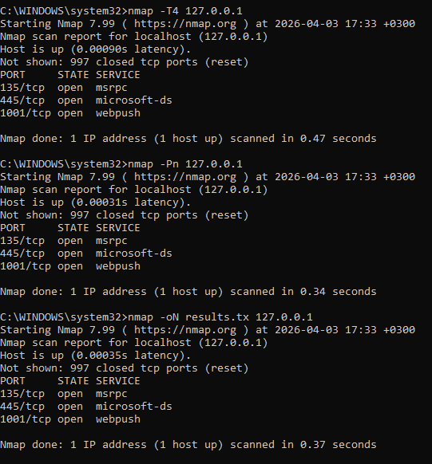
Explanation:
- -T4 increases scan speed
- -Pn skips host discovery
- -oN saves results to a file
Analysis: These commands improve efficiency and allow better documentation of scan results, which is essential in real-world network assessments.

Conclusion
This coursework demonstrated the practical use of Nmap in network scanning and analysis. Through various scanning techniques, it was possible to identify active hosts, detect open ports, determine running services, and uncover potential vulnerabilities.
Understanding these techniques is crucial for both securing networks and performing ethical security assessments.

