Software Processes in Software Engineering

1. Introduction
A software process is a structured set of activities required to develop a software system. It acts as a blueprint guiding developers through planning, designing, building, testing, and maintaining software systems.
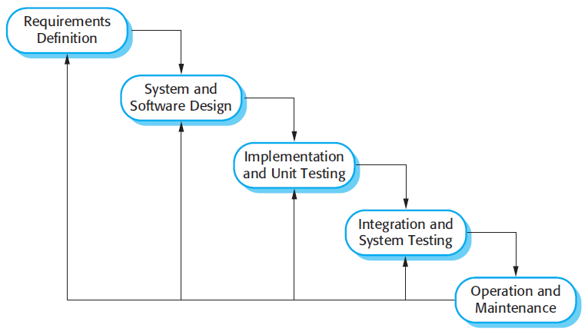

2. Key Components of Software Processes

2.1 Specification (Requirements Engineering)
This phase involves understanding and documenting what the system should do. It includes requirements gathering, analysis, and validation to ensure the system meets user needs.

2.2 Design
Design defines the system architecture and components. It ensures scalability, modularity, and maintainability.
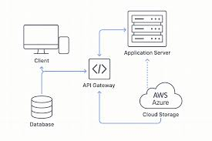
System architecture diagram

2.3 Implementation
Implementation involves coding based on the design. Developers focus on writing efficient, clean, and maintainable code.

2.4 Testing
Testing ensures the software is free of defects and meets requirements. It includes unit, integration, system, and acceptance testing.
Testing Pyramid diagram
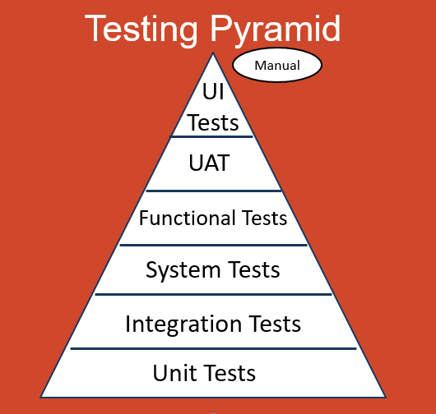

2.5 Deployment
Deployment involves releasing the software to users and ensuring it runs in the production environment.

2.6 Maintenance
Maintenance includes fixing bugs, improving performance, and adding new features after deployment.

3. Software Process Models

Waterfall Model
A linear and sequential approach where each phase must be completed before the next begins.
Waterfall Model Diagram
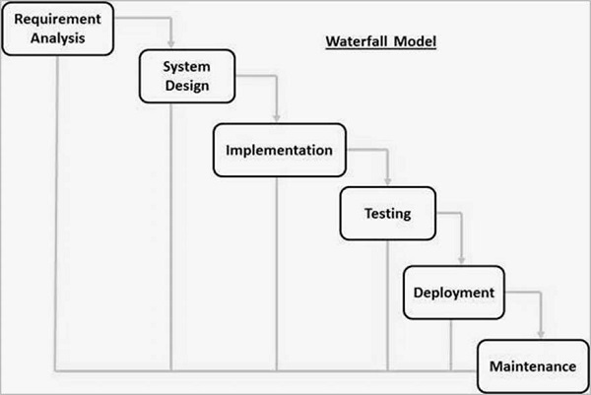

V-Model
An extension of the waterfall model that emphasizes verification and validation.
V-Model Diagram
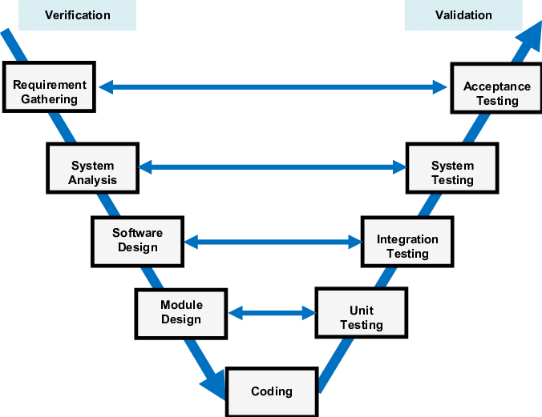

Incremental Model
Software is developed in increments, each adding functionality.
Incremental Model
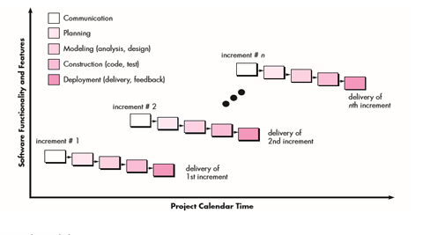

Spiral Model
Focuses on risk management through iterative cycles.
Spiral Model Diagram
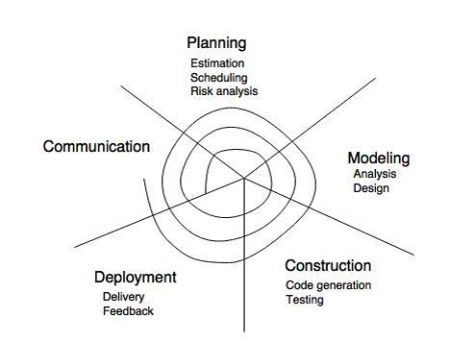

Agile Model
An iterative and flexible approach emphasizing collaboration and feedback

4. Key Principles
Modern software processes emphasize iterative development, collaboration, flexibility, and automation.
[Insert Diagram Here: Iterative Development Cycle]

5. Software Process Metrics
Metrics include productivity, quality, time-to-market, and maintainability.
[Insert Diagram Here: Metrics Comparison Chart]

6. Emerging Trends
Emerging trends include DevOps, AI-assisted development, microservices, and continuous feedback.
[Insert Diagram Here: DevOps Pipeline]

7. Conclusion
Software processes are essential for delivering high-quality software efficiently. Choosing the right model depends on project requirements, team expertise, and risk levels.

