H(AI)LP
Architecture Comparison: Baseline GPT vs RWKV Recurrent Model
Project Summary & Benchmark Metrics

1. Project Overview
H(AI)LP compares two language-model architectures at a similar parameter scale, with the goal of identifying the most suitable architecture for compact, offline-capable deployment on sub-$100 Android devices.

Baseline GPT — standard transformer with full O(n²) self-attention and a KV cache that grows with sequence length.
H(AI)LP RWKV — recurrent architecture with fixed-size state (no KV cache), O(n) time-mixing, FFN weight sharing, and low-rank attention.
Both models are trained on the same data with the same training loop, so the comparison is architecturally fair.

2. Architecture Comparison
The diagram below illustrates the structural differences between the two models at each layer.

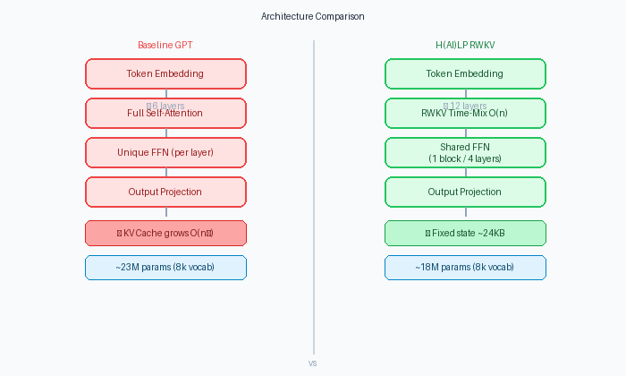
Figure 1 — Side-by-side layer structure: Baseline GPT (left) vs H(AI)LP RWKV (right)

2.1 Model Configuration
Metric | Baseline GPT | H(AI)LP RWKV
Layers | 6 | 12
Hidden Size | 512 | 512
Parameter Count (8k vocab) | ~23M (within ±20%) | ~18M (within ±20%)
Attention | Full O(n²), 8 heads | RWKV time-mixing O(n), rank-64
FFN | Unique per layer | Shared every 4 layers (3 unique blocks for 12 layers)

Note: Configs used in benchmarks/demo use vocab_size=8,000 (YAML target). Training uses vocab_size=50,257 (GPT-2 BPE) for compatibility with the Wikipedia tokenizer.

3. Capabilities
Both models share a unified training and evaluation framework. The table below summarizes the system capabilities.

Capability | Description
Training | Train both models on Simple English Wikipedia (streaming). AdamW, cosine LR, gradient clipping, mixed precision (bf16 on GPU).
Checkpointing | Rotating last 3 checkpoints + best.pt per model. Resume with --resume.
Experiment Tracking | Weights & Biases (hailp-arch-comparison): loss, perplexity, tokens/sec, RAM at seq 64/256/512.
Memory Benchmark | Measures KV cache (baseline) vs fixed recurrent state (H(AI)LP) across sequence lengths.
Speed Benchmark | Measures forward-pass tokens/second at configurable seq lengths and batch sizes.
Quality Evaluation | Validation loss and perplexity on the same val set as training; optional load from best.pt.
Demo | Single script: forward shapes, memory comparison, recurrent state behaviour, parameter counts.
Tests | 43 tests: forward pass, parameter count, KV cache growth, fixed state, parameter sharing, low-rank projections.

4. Memory Benchmark
Measured with benchmarks/memory_benchmark.py (batch=1, sequence lengths 8–512). The key architectural advantage of H(AI)LP is a fixed recurrent state that does not grow with sequence length, unlike the baseline's KV cache.

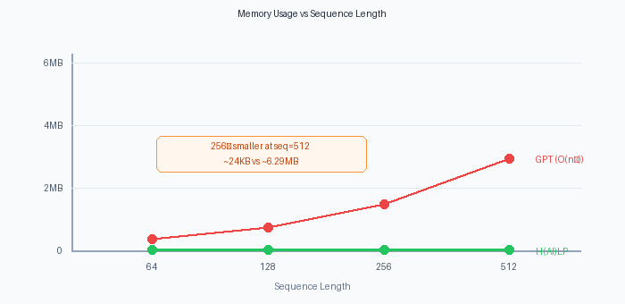
Figure 2 — Memory usage vs sequence length: GPT KV cache (red) grows linearly; H(AI)LP state (green) stays flat

Sequence Length | Baseline GPT (KV cache) | H(AI)LP (recurrent state)
64 | ~786 KB | 24,576 B (fixed)
128 | ~1.57 MB | 24,576 B (fixed)
256 | ~3.15 MB | 24,576 B (fixed)
512 | ~6.29 MB | 24,576 B (fixed)

Key finding: At seq=512, H(AI)LP's working state is approximately 256× smaller than the baseline's KV cache (~24 KB vs ~6.29 MB). The baseline cache grows linearly (~8× from seq 64 to 512) while H(AI)LP's state remains constant regardless of sequence length.

5. Speed Benchmark
Measured with benchmarks/speed_profile.py (warmup=1, repeats=3, device: CPU, batch=4). Results demonstrate how each architecture scales with sequence length.

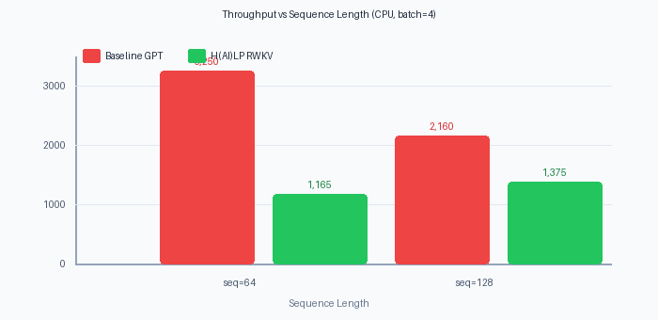
Figure 3 — Throughput comparison: Baseline GPT throughput drops with sequence length (O(n²)); H(AI)LP is flatter (O(n))
Seq Length | Baseline GPT (tokens/sec) | H(AI)LP RWKV (tokens/sec)
64 | ~3,250 | ~1,165
128 | ~2,160 | ~1,375
Key finding: Baseline throughput drops ~34% from seq=64 to seq=128, reflecting the O(n²) attention cost. H(AI)LP throughput actually increases ~18% over the same range due to O(n) scaling. On GPU or with longer contexts, H(AI)LP is expected to outperform the baseline..
6. Summary
 | Baseline GPT | H(AI)LP RWKV
Architecture | Transformer (full attention) | RWKV recurrent
Memory scaling | O(n) — grows with context | O(1) — always ~24 KB
Compute scaling | O(n²) — slows at long ctx | O(n) — stays flat
Parameters (8k vocab) | ~23M | ~18M
Offline suitability | Limited (cache grows) | Strong (fixed state)
Target hardware | General GPU/CPU | Sub-$100 Android (INT4)

H(AI)LP RWKV demonstrates the architectural properties necessary for deployment in resource-constrained, offline environments: constant memory footprint, O(n) scaling, fewer parameters, and weight sharing — without sacrificing model depth (12 layers vs 6).

