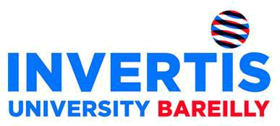
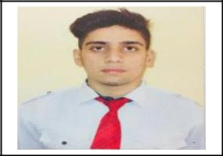

Name: AKASH VERMA
Email id: khoya121.av@gmail.com
Contact: 6399961265

CAREER OBJECTIVE

To work for the organization that can give a better boosting and prospect to my career.

ACADEMIC QUALIFICATION

Name of the | Name of the Institute | Board/University | Year | Percentage
Examination
B.Tech(Computer | Invertis University Of | Invertis University | 2015-19 | 61.16%
Science & | Engineering
Engineering)
XII | Mallikarjun school,pithoragarh | CBSE | 2015 | 63%
 | (uk)
X | Mallikarjun school,pithoragarh | CBSE | 2013 | 8.0 CGPA
 | (uk)

SUMMER INTERNSHIP TRAINING

Name of Organization: Aspire Vision(Bangalore)MTA Education
Duration: 6 Weeks
Key Learning: Android

PROJECT

Name of Organization: Aspire Vision(Bangalore)MTA Education

Duration: 2 Weeks
Profile: Blood Bank App

Key Take Away: Designing and Coding

INDUSTRIAL VISIT:

Name of organization: Bloomont Pvt Ltd(Bangalore) and Huawei(Gurgaon).
Key Take Away: Get knowledge that how the software companies work.
Technical Skills

Languages | • C,Java,Android,.Net with c#.

CERTIFICATE PROGRAMME/ WORKSHOPS/CONFERENCES

Jun-Jul’16 | • (Certified Ethical Hacker) training & certification.
Nov’17 | • Attended a 2 day workshop on Robotics
 | • Attended a 80 hours training on .Net with C#
 | • Attended a 2 day workshop on Python
 | • Attended a 2 day workshop on PHP
 | • Attended a 6 week training on JAVA
 | • Attended a 6 week training on Android

ACHIEVEMENTS

Worked on project(Blood Bank App,HR Management System). Come up with a new idea that improved things.

KEY ATTRIBUTES

Honesty

Work Ethic

Technical Competency Flexibility

Loyalty

Good Knowledge in C,Java,Android,.Net with C#

INTEREST

Fitness Biking

Travelling Reading Writing
PERSONAL PROFILE

Date of Birth: 07 September 1997
Father’s Name: Mr. Mukesh Verma
Mother’s Name: Mrs. Sapna Verma
Gender: Male
Language: Hindi ,English

Address: 887,Mr Mukesh Verma,Katra Chand Kha,Azad Nagar Colony,Bareilly – 243005

DECLARATION

I hereby declare that the information provided above is true and the best of my knowledge.

Date:29August2018 Signature:Akash Verma

