Title: DUIDUI Bang

You are given an 8 by 8 chessboard and five different kinds of pawn. The rule is simple; you can only swap two adjacent pawns. After the swap, if there are three or more consecutive identical pieces either horizontally or vertically, they will be eliminated. After that, the pawn will fall down to fill the empty grids. The empty grids that no pawn fills will be filled by randomly picked pawn from top edge. Sometimes you may be lucky enough to have the pawn eliminated automatically according to the rules above. In addition, if there is one move leads to eight or more than eight pawn to be eliminated, the player will be granted a combo. A smart guy as you are, could you please tell us what is the maximum possibility to trigger a combo in one swap?

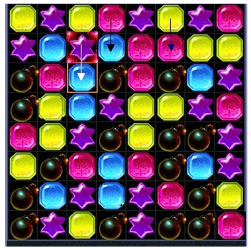

In the figure, for example, swap the blue gem and the purple star will ensure a combo. Because, this will cause the red gem fall down and eliminated. The yellow gems will disappear after the red ones.

## Input

The first line contains a single integer t, the number of test cases.

For each case, 8 lines contain pawn data. See sample input for more details.

## Output

For each case, output maximum possibility of combo. See sample output for more details.

## Sample Input

2

10112344

13213241

30404021

31104204

23221011

02041200

14102122

22330443

13143243

42422004

11012130

34400104

03142423

21220441

01021133

43044200

## Sample Output

Case 1: 1.000

Case 2: 0.525