**Probability and Applied Stats**

**Pokemon App**

In this section of our final we were tasked with attempting to create an application that can be run on our cellphones using the code we developed for our Pokemon game from the last project. For me, the struggles with this portion of the project started before I was even able to write any code. I built my app using Xcode, a software for developing apps on IOS. Immediately I was faced with issues as Xcode required close to fifty gigabytes of clear space on my laptop just for it to download. After hours of just clearing out my mac, purchasing extra Google and iCloud storage, and freaking out because I thought I accidentally deleted everything off my laptop somehow, I was finally able to get Xcode downloaded, only to realize that the version I downloaded could not be run on the version of IOS my mac is running since my laptop is on the older side. However, with my storage where it needed to be now, deleting that version, and downloading an older one was the simplest part of this whole process. Now that I had the right version, I was able to begin transferring my app over to the format of Xcode, which uses the programming language Swift. I am not too familiar with Swift, so I began to do tutorials and what not in order to gain the knowledge I needed. 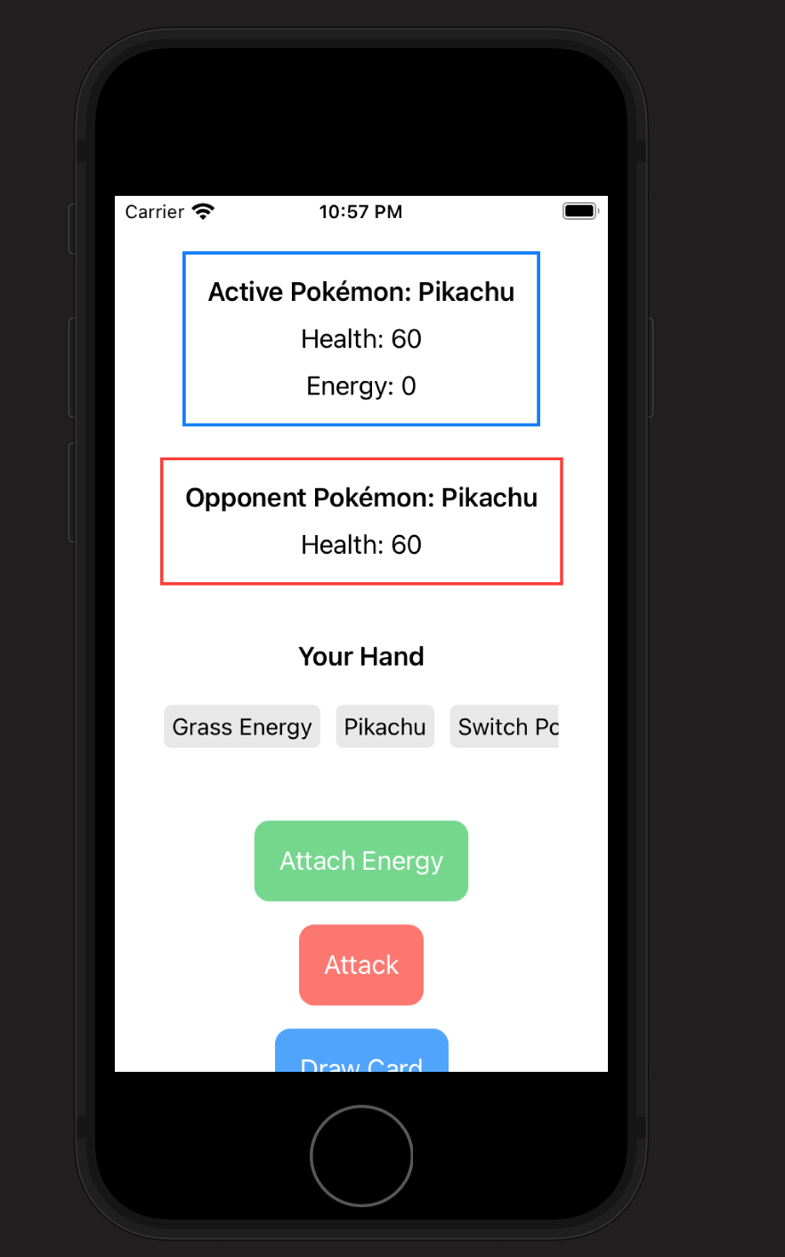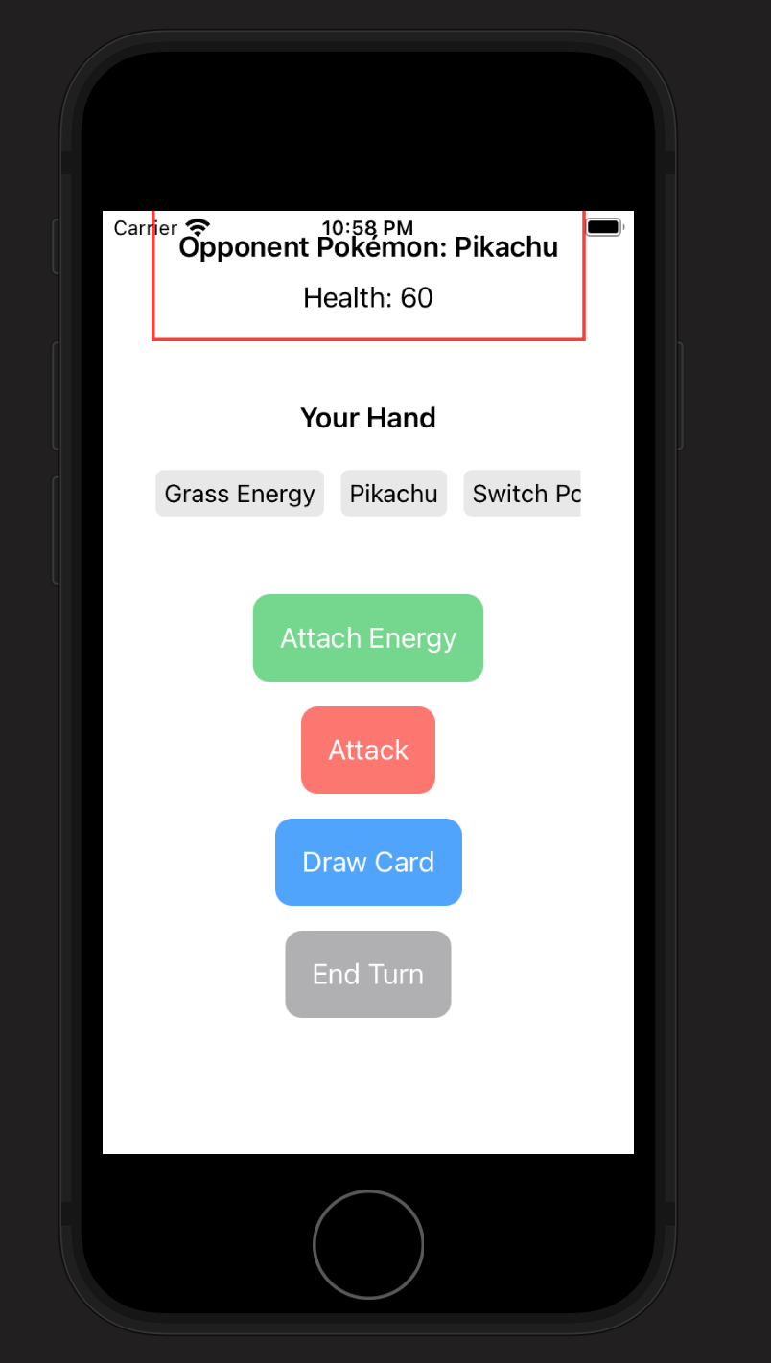

I was able to get all of my labels and buttons onto my VM phone, along with the user’s hand. It also shows the user their Pokemon, health, the energy attached to the Pokemon, and the opponents Pokemon and health. After this however, I struggled applying the same exact functionality that my program had in the first project. The player is able to perform attacks, draw cards, and attach energy. I struggled with the actual game logic, such as the opponent's turn or checking the game state to see if the player has won or lost after each turn or received a prize card. Lastly, I would have been able to get the app on my phone if it were not for the struggles mentioned before with the version of Xcode and IOS I was currently using. When trying to transport the app to my real phone I found that My phones IOS was too far ahead of the IOS which I built the app for. This was because, again, I had to download an older version of Xcode because of my older laptop. So, the app I produced was made for IOS 15.2, and my phone's current IOS is in the 17s. For these reasons, I was only able to get the app on the VM phone.

Closing Remarks on the Class:

I am very grateful that I was able to take this class with you as the professor because when I registered, I was not looking forward to doing boring stats all semester. Luckily for me though, this class was able to blend in interesting projects to keep the course fresh. If I had any type of feedback for you as the professor, I would maybe suggest assigning a small coding project in the beginning of the semester that you grade and give back to the students before the midterm. One of the reasons that I was personally so stressed for the midterm project, was that I did not have any idea of how you like to grade things. For example, some teachers in my past would take points off for not having our name in the comments at the top of our program, or not having our brackets properly lined up how they preferred. Little things like that stick with me, so when I don’t have any idea of my professors' grading tendencies, I get a little bit nervous. Other than that, I enjoyed the class about as much as anybody could enjoy a Probability and Stats class, Thank you.