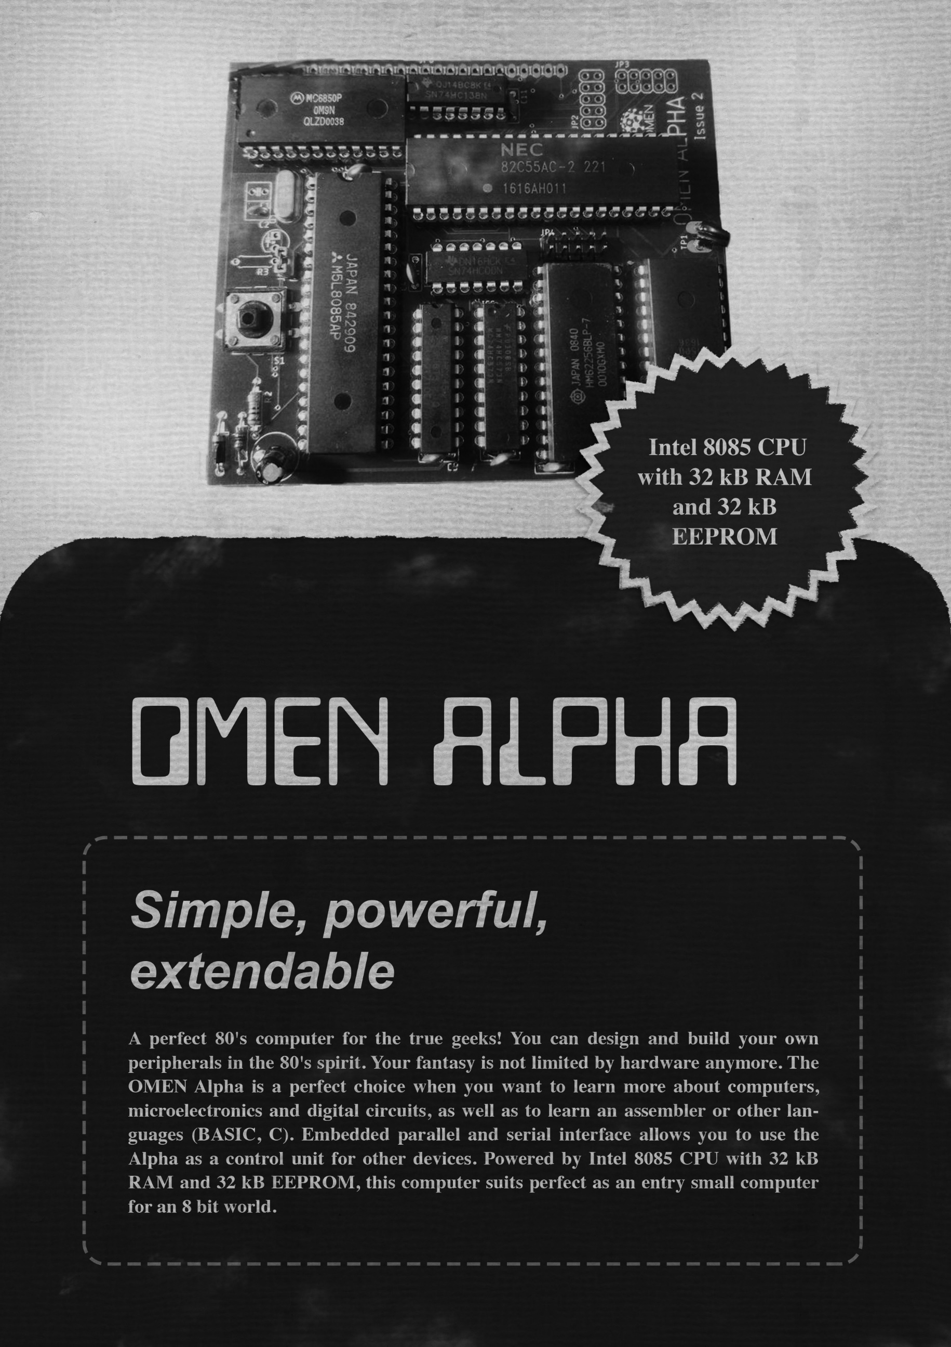

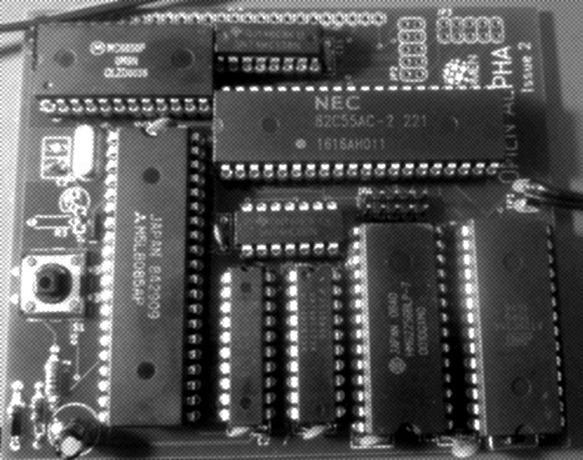

OMEN Alpha / issue 4

Technical Documentation

INTRODUCTION

===========

The OMEN Alpha computer kit is a low-cost computer trainer, based on the Intel 80C85 CPU. It has these features:

* 80C85 CPU working at 1.8432 MHz
* 32 kB RAM
* 32 kB EEPROM
* Serial port up to 115.200 Bd / MC6850
* 3 parallel ports / Intel 8255
* Application system bus

ASSEMBLY INSTRUCTIONS

===================

1. Solder sockets for the integrated circuits
2. Test all soldered connections
   1. Test if all pins are well connected
   2. Check if GND is not short connected to Vcc
   3. Check if each IC has properly connected GND and Vcc
3. Solder all passive parts /capacitors, diode, resistors, push button, crystal/
4. Connect the power adapter and check
5. Insert the CPU into its socket /keep the proper orientation!/ and try to power it up. Check if oscillator lives /at CPU pin 37/
6. Insert the essential ICs: 74245, 74573, 7400, 62256 and AT28C256. Again: keep the proper orientation! Bad orientation can damage the IC!
7. Connect the serial pins TxD, RxD and GND /pinhead JP1/ to the TTL-to-USB converter
8. Start the serial terminal on your PC, select proper serial port and set the parameters to 115.200 Bd, 8 data bits, no parity, 1 stop bit.
9. Power your Alpha and check the terminal.

MONITOR

=======

The main software for OMEN Alpha issue 4 is the Dave Dunfield’s MON85 Serial Monitor, improved by Roman Borik.

Usage is described on the https://8bt.cz/mon85 or see the Appendix 1

You can invoke the installed Tiny BASIC v.2 by jumping to the 1000h – just enter “G1000” /no quotes/ and press the ENTER key.

THE BOARD

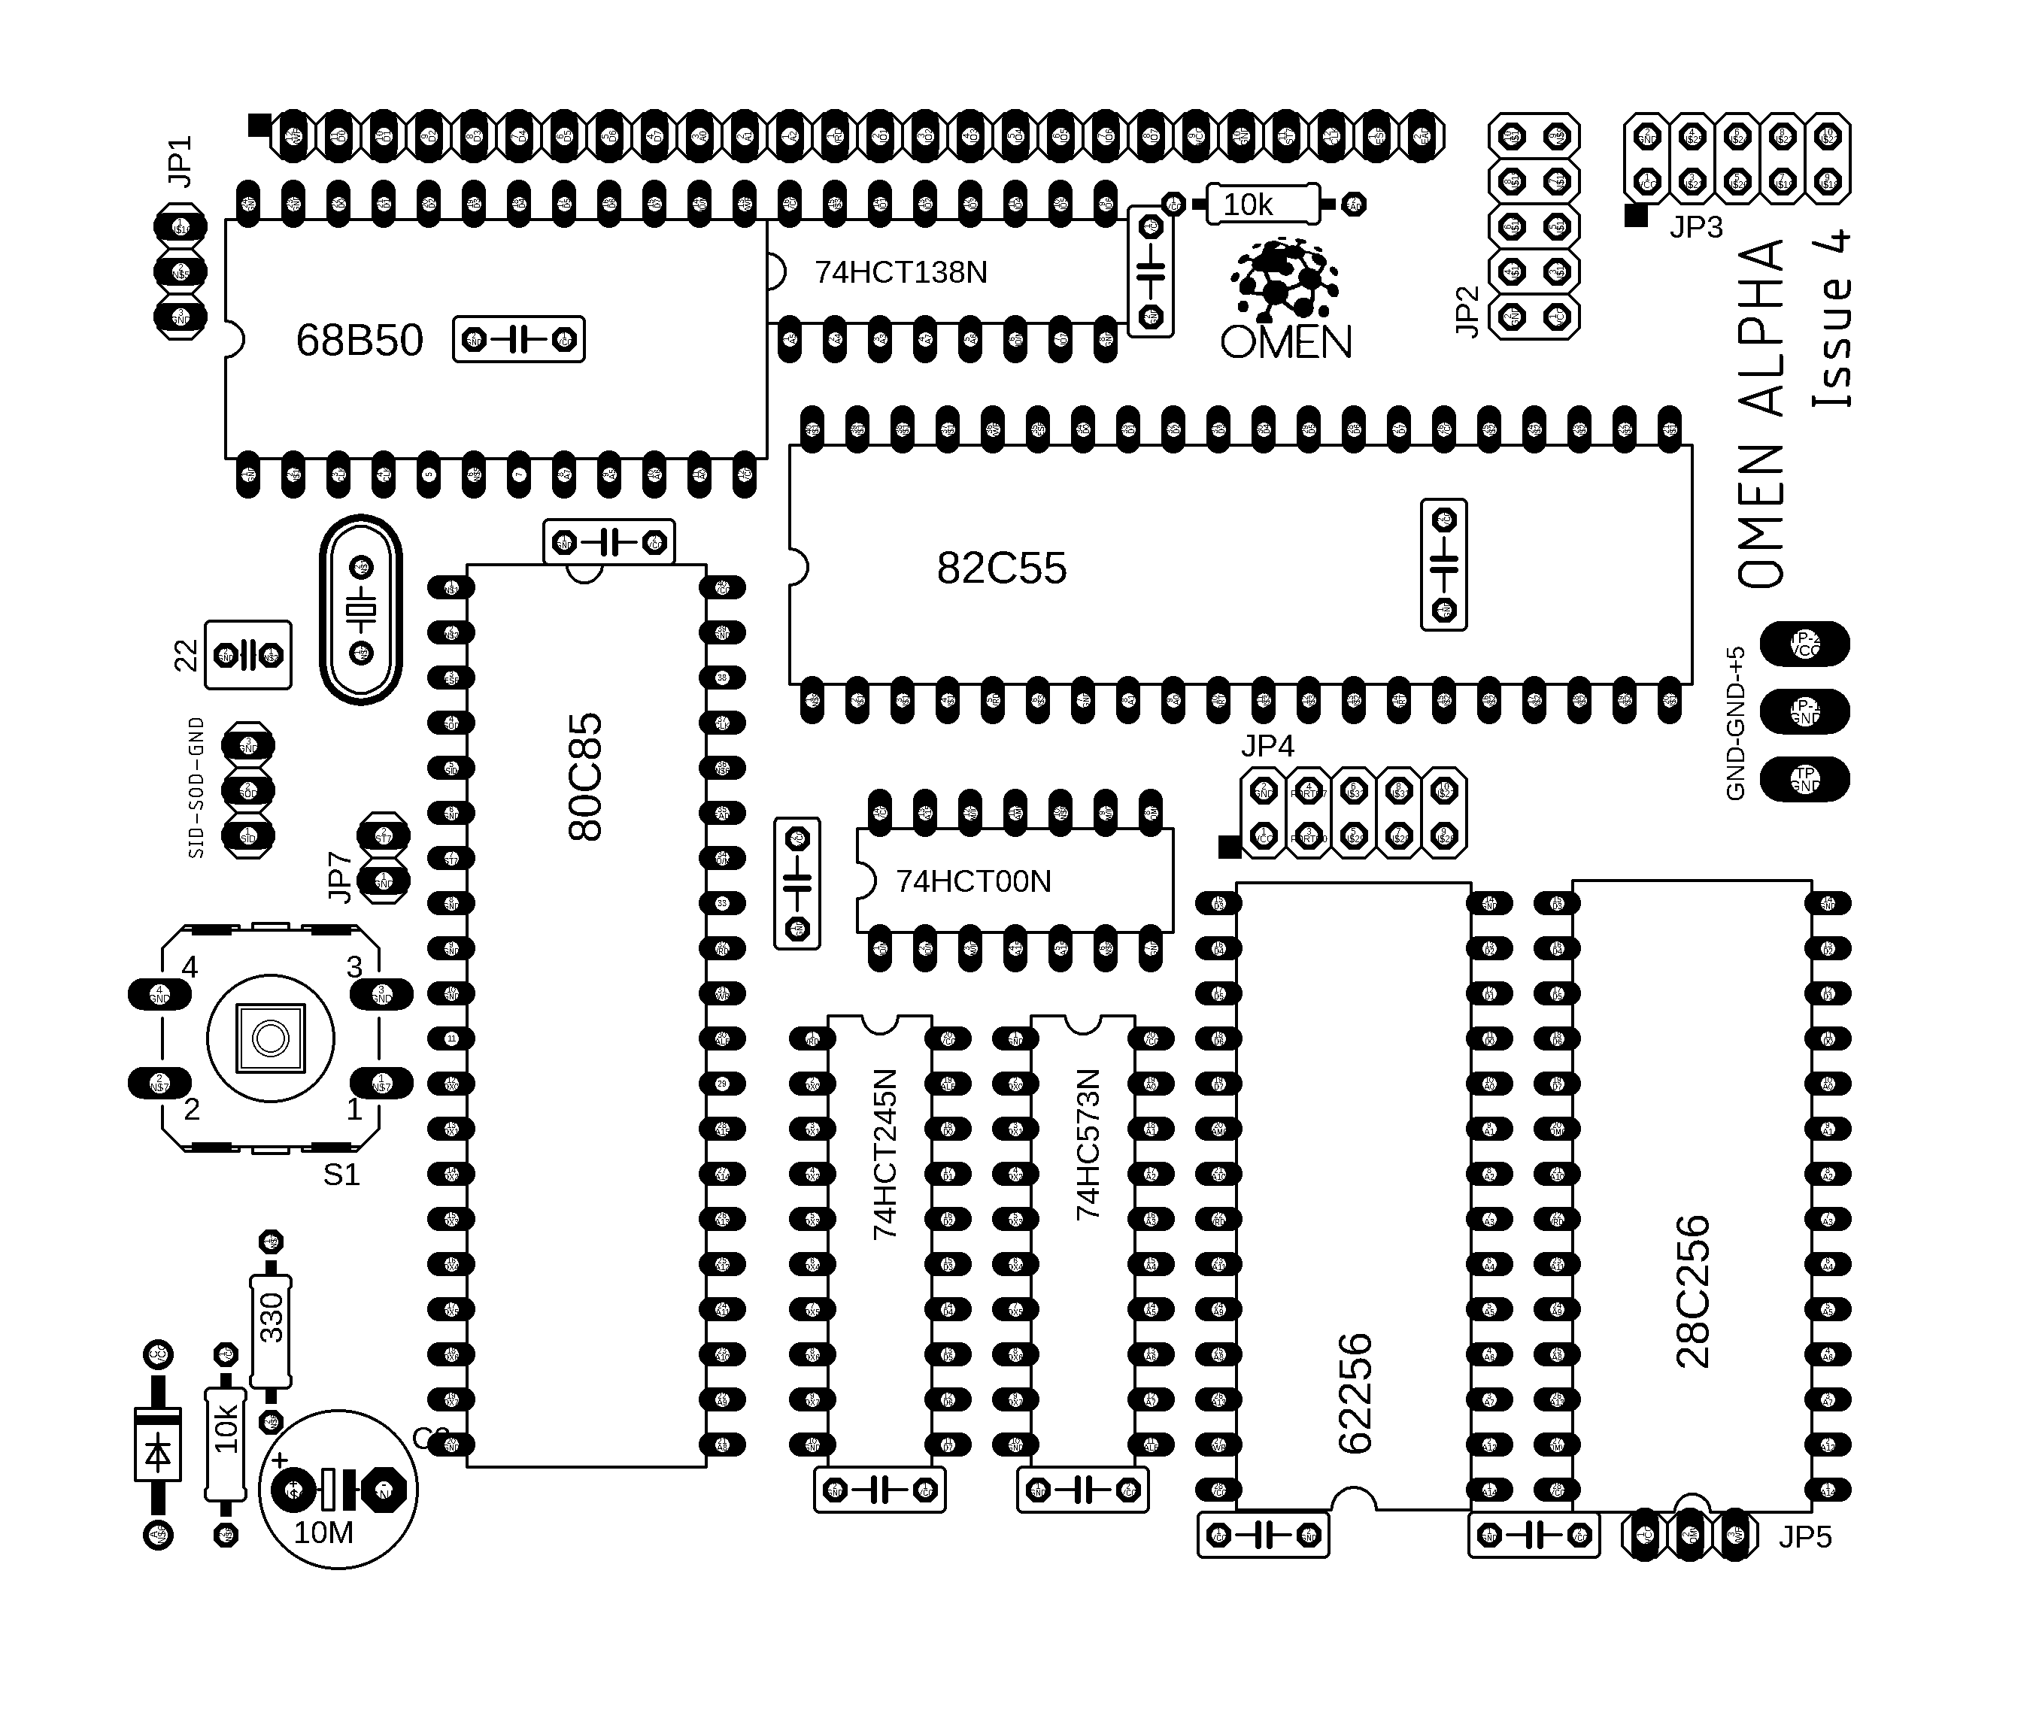========

Jumpers and pin headers

--------------------

JP1: Serial port. Pins are GND, TxD, RxD from left to right, RxD is next to the JP1 label

JP2, JP3, JP4: Parallel ports. See below. The square marks the pin 1.

JP5: EEPROM write enable. Short pins 1-2 to disable writing, or short pins 2-3 to enable writings. Pin 1 is on the left, pin 3 is next to the JP5 label

JP7: RST7.5 enabler. Close to disable interrupts, open to leave it on the application bus. Connect the 10k resistor to make it “open-collector signal”.

JP8: Serial signals SID and SOD

PARALLEL PORTS

=============

JP2:

+-----+-----+-----+-----+-----+  
| GND | PA7 | PA6 | PA5 | PA4 |  
+-----+-----+-----+-----+-----+  
| Vcc | PA0 | PA1 | PA2 | PA3 |  
+-----+-----+-----+-----+-----+

JP3:

+-----+-----+-----+-----+-----+  
| GND | PB7 | PB6 | PB5 | PB4 |  
+-----+-----+-----+-----+-----+  
| Vcc | PB0 | PB1 | PB2 | PB3 |  
+-----+-----+-----+-----+-----+

JP4:

+-----+-----+-----+-----+-----+  
| GND | PC7 | PC6 | PC5 | PC4 |  
+-----+-----+-----+-----+-----+  
| Vcc | PC0 | PC1 | PC2 | PC3 |  
+-----+-----+-----+-----+-----+

SYSTEM APPLICATION CONNECTOR

=========================

This connector is on the upper edge of board. Pin 1 is on the left side.

Pins:

1. /WR
2. D0
3. D1
4. D2
5. D3
6. D4
7. D5
8. D6
9. D7
10. A0
11. A1
12. A2
13. /RD
14. IO1 --- 20h – 27h
15. IO2 --- 10h – 17h
16. IO3 --- 30h – 37h
17. IO4 --- 08h – 0Fh IOx signals are decoded by 74138
18. IO5 --- 28h – 2Fh
19. IO6 --- 18h – 1Fh
20. IO7 --- 38h – 3Fh
21. Vcc
22. GND
23. RST7.5 -- see JP7
24. CLK
25. RESET -- Output signal
26. READY -- Pull it low to force a WAIT state
27. /BUSRQ /not connected on Alpha/
28. /BUSACK /not connected on Alpha/
29. /not connected on Alpha/
30. /not connected on Alpha/

PERIPHERAL IC ADDRESSES  
=====================

ACIA 6850:  
--------

DEh – Controll Register / Status Register

DFh – Data Register

PPI 8255:  
-------

04h – PORT A

05h – PORT B

06h – PORT C

07h – Control port

MEMORY MAP  
==========

0000h – 7FFFh - EEPROM 32k

8000h – FFFFh – System RAM

APPENDIX 1 – The MON85 Manual

=============================

MON85

A

Software Debug Monitor

For the 8085/8080

Dunfield Development Systems

----------------------------

High quality tools for

Embedded Development

at low prices.

http://www.dunfield.com

Copyright 1979-2007 Dave Dunfield

All rights reserved

MON85

TABLE OF CONTENTS

1. INTRODUCTION

1.1 8085 Restart Interrupts

1.2 Breakpoints

2. MON85 COMMANDS

2.1 A ON|OFF

2.2 B [0-7 address]

2.3 C <source> <destination> <size>

2.4 D <address>

2.5 E <address>

2.6 F <start> <end> <value>

2.7 G [address]

2.8 I <port>

2.9 L [address]

2.10 M <address>

2.11 O <port> <data>

2.12 R [rp value]

2.13 S ON|OFF

2.14 T ON|OFF

2.15 U [address]

2.16 ?

3. COMMAND SUMMARY

1. INTRODUCTION

MON85 is a ROMable interactive debugging program for the 8085

processor, which contains a full complement of commands to monitor

and control the execution of your program. It may also be used on an

8080 processor, as long as you do not attempt to use the 8085

specific SIM and RIM instructions, or the '.5' type interrupt

vectors.

MON85 must be installed beginning at location $0000 in the 8085

processor memory map, allowing it to intercept the interrupt vectors.

Provision has been made to re-vector interrupts to locations within

the user program.

All functions of MON85 are performed via software without hardware

assist. The only hardware specific subroutines required by the

monitor are used to communicate with the console terminal, and are

located at the very end of the monitor source code listing:

INIT - Called to initialize any hardware required for I/O.

OUT - Write the character in A to the console. No processor

registers should be modified by this routine.

IN - Test for a character from the console, and return it

in A if one is available. Otherwise clear A to zero.

No other registers should be modified by this routine.

1.1 8085 Restart Interrupts

MON85 reserves two "restart" interrupts: RST 0 is similar to a

physical RESET, causes a cold restart of the monitor. This

instruction should be used with CAUTION during a debugging session

because any breakpoints set in the user program will be

"forgotten", and not properly removed. RST 1 is used by MON85 to

regain control at breakpoints. Opcodes of breakpointed

instructions are replaced by RST 1 whenever the user program is

executed, and are restored whenever the monitor is re-entered.

This insures that the operation of breakpoints is transparent to

you during the debugging session.

If for any reason a 'RST 1' ($CF) instruction is encountered in

the user program (and is not a breakpoint), command mode will be

entered without the '\*\* Breakpoint' message.

All other "restart" interrupts are re-vectored to the

corresponding locations in the first page of memory occupied by

the user program (as identified by the 'U' command).

1.2 Breakpoints

MON85 allows you to set breakpoints in your program, such that

you will be given control whenever the program reaches a

breakpoint, and can examine or change things before proceeding.

MON85 also allows you to TRACE a program, so that you can see each

instruction and register contents as it executes.

MON85 is completely transparent to the program being tested

(unless timing loops are interrupted with BREAKPOINTS or TRACE).

When a breakpoint is encountered, or an instruction is traced,

MON85 uses one stack entry on the user program stack. Since this

consists of a PUSH and a POP, it should not affect any information

stacked by the user program. However, you should be aware of this,

in case you are examining the stack, or your program trys to

reclaim data already popped from the stack. (It is very poor

practice, to write programs which depend on the stack contents

below the stack pointer).

When a breakpoint is encountered, the message '\*\* Breakpoint n'

is printed where n is the number of the breakpoint (0-7). If TRACE

is ON, no other action is taken, otherwise command mode is entered

(If the 'A' switch (see below) is ON the registers are also

displayed).

2. MON85 COMMANDS

The following commands are recognized by MON85, and may be entered

whenever MON85 is in COMMAND MODE, which is indicated by the 'C> '

prompt:

2.1 A ON|OFF

This switch turns ON or OFF the automatic register display which

occurs whenever a breakpoint is encountered or an instruction is

stepped in trace mode (see below). The default value for 'A' is

ON.

2.2 B [0-7 address]

Sets one of eight breakpoints [0-7] at the specified address. Once

set, a breakpoint remains in effect until it is removed by setting

it to address ZERO (0). Breakpoints are completely invisible, and

may be added, removed or changed at any time without adverse

affects. If the 'B' command is issued with no operands, the

current breakpoints, and the settings of the 'A', 'S' and 'T'

flags (see below) are displayed. A displayed address of '\*\*\*\*'

indicates that a breakpoint is not set.

2.3 C <source> <destination> <size>

Copies <size> bytes of memory from the <source> to the

<destination> address.

2.4 D <address>

Displays memory in assembly listing format, starting at <address>,

continuing until an ESCAPE character is entered. Output can be

temporarily stopped with the SPACE BAR, and restarted with the

RETURN key (Additional SPACE's will output single lines). The

output is displayed in the following form:

'<address> <opcodes> <ascii> <instruction>'

<address> is the current memory location, <opcodes> is the

instruction opcodes (1, 2 or 3 bytes), <ascii> is ASCII

representation of <opcodes> (all non-printable characters are

displayed as dots), and <instruction> is the assembly language

instruction and operands which <opcodes> represents.

2.5 E <address>

Edits memory, starting at <address>. The address, and its contents

are displayed, followed by a '=' prompt. Sub commands are:

nn [nn ...] - Replace memory contents with HEX data bytes

'text ... - Replace memory contents with ASCII text

- - Backup to previous locations

<blank line>- Advance to next location with change

<ESCAPE> - Return to MON85 command prompt

2.6 F <start> <end> <value>

Fills memory between the <start> and <end> addressses with the

specified <value>.

2.7 G [address]

Loads the user program registers, and begins execution at the

specified address. If no [address] is given, execution begins at

the address contained in the user program program counter (PC). A

simple 'G' with no operands, is all that is needed to resume

execution after a breakpoint interrupt, or to resume trace mode

exection.

2.8 I <port>

Reads the specified 8085 I/O port, and displays the data.

2.9 L [address]

Downloads code from the console port. MON85 will recognize and

accept either INTEL or MOTOROLA hex format download records. The

address in the FIRST download record is recorded as the program

BASE address (See 'U' command). If an [address] is given, the

address fields of each record are adjusted so that the code image

will be loaded into memory beginning at that address, otherwise it

is placed in memory at the absolute address contained in each

record.

If you accidently enter this command, you may enter either 'S9' or

':00' to signify a null download file and return to the command

prompt.

2.10 M <address>

Displays memory in HEX/ASCII dump format starting at the specified

address. ESCAPE, SPACE, and CARRIAGE-RETURN can be used to control

the listing, the same is with the 'D' command.

2.11 O <port> <data>

This command writes the <data> byte to the specified 8085 I/O

<port>.

2.12 R [rp value]

Changes the contents of the user program register pair <rp> to the

specified <value>. Valid pairs are BC, DE, HL, SP, PC, and PSW. If

no operands are given, the contents of the user program registers

are displayed.

2.13 S ON|OFF

Controls the handling of subroutine calls when in trace mode (see

below). When 'S' is set ON, subroutines will be be traced in the

normal fashion. When set OFF, subroutines calls are not traced,

and trace will resume at the next instruction following the CALL

(After the subroutine executes).

WARNING: DO NOT SET BREAKPOINTS IN THE SUBROUTINES WHEN 'S' IS SET

OFF. When 'S' is set off, MON85 considers the subroutine (and all

of it's embedded instructions) to be one single operation. If a

breakpoint is encountered inside the subroutine, TRACE will lose

the address at which to resume following the subroutine call. This

will cause unpredictable action when the subroutine returns.

Otherwise, 'S' may be turned on and off at any time with no

adverse effects. The default value for 'S' is ON.

2.14 T ON|OFF

Turns TRACE mode ON and OFF. When TRACE is set ON, and the GO

command is issued, MON85 will first prompt with 'T>' before

beginning program execution.

Entering a space (' ') will display and execute one instruction,

and return to the 'T>' prompt.

Entering '?' will display the processor registers. (If the 'A'

switch is set ON, they will always be displayed following every

instruction that is traced).

An ESCAPE charecter will cause MON85 to return to the usual

command prompt (TRACE remains ON, and will resume with the next

'G' command).

Trace may be turned on and off at any time in a program, with no

adverse effects. (If you begin execution with TRACE off, you will

have to hit a breakpoint to get you back to command mode before

you can turn TRACE on).

When a breakpointed instruction is encountered by the tracer, The

message '\*\* Breakpoint n' will be issued at the end of the

previous instruction, indicating that the breakpointed instruction

occurs NEXT. Pressing the SPACE BAR would then execute the

breakpointed instruction. The default value for 'T' is OFF.

2.15 U [address]

Identifies the starting address of a user program. MON85 uses this

address to re-map the "restart" interrupt vectors. When a 'L'oad

command is performed, MON85 initializes 'U' to the address

contained in the first download record. If no [address] is

specified, MON85 will display the current user program starting

address.

2.16 ?

This command displays a short summary of the other MON85 commnds.

3. COMMAND SUMMARY

A ON/OFF - Enables/Disables auto register display.

B [0-7 address] - Sets/Removes/Displays breakpoints.

C <src> <dest> <size> - Copy memory

D <address> - Displays memory in disassembly format.

E <address> - Edit memory contents.

F <start> <end> <value> - Fill memory with a value.

G [address] - Begin/Resume program execution.

I <port> - Input from port

L [address] - Download from host

M <address> - Displays memory in dump format.

O <port> <data> - Output to port

R [rp value] - Sets/Displays register contents.

S ON|OFF - Enables/Disables subroutine traceing.

T ON|OFF - Enables/Disables TRACE mode.

U [address] - Set/Displays program base address.

? - Display command summary

MON85 Improvements by Martin Borik:

* Support for undocumented 8085 instructions DSUB B, ARHL, RDEL, LDHI d8, LDSI d8, LHLX D, SHLX D, JNK a16, JK a16, RSTV
* Command R displays all flags of F register (SZKA3PVC). If flag is not set dash '-' is displayed.
* Added restart vector RST 8 (0040h) for possibility to handle RSTV call.
* Changed TRACE mode. After entering TRACE mode, instruction on actual PC and content of registers (if it is switched on) are displayed. Entering a space ' ' executes this instruction, and returns to the 'T>' prompt with the next instruction.
* Instructions LXI, DAD, INX, DCX displays argument 'SP' rather than 'S'.
* Commands that requires 1 byte parameter raises error if entered value not fit to 1 byte.
* Command 'C' checks overlap of source and destination block and for copying uses appropriate direction.
* Command 'F' checks <start> and <end> parameters and raises error, if <end> is lower than <start>.
* Added command 'H' to send out memory content in Intel HEX format.
* Sending of LF and CR characters were reversed and are sent in the usual order - CR first and followed by LF.