Crash it: Different Types of X++ Exceptions in D365FO and how to monitor them
In this post, I describe different types of exceptions that can happen in D365FO X++ code, what causes them, and how to monitor them. To test these scenarios, I used a sample class DEVCSXppExceptionGenerate (https://github.com/TrudAX/XppTools/blob/master/DEVTools/DEVCallStackInfolog/AxClass/DEVCSXppExceptionGenerate.xml that allows you to generate each exception type on demand.

The "throw error()" Exception
This is the most common exception in X++. A developer explicitly calls throw error("message") to stop execution and show a message to the user.
xpp
private void generateErrorException()
{
throw error("VALIDATE EXCEPTION ERROR");
}
You see this pattern everywhere in D365FO — in validate() methods, business logic checks, and data entry validations. The Global::error() method writes a message to the Infolog and returns Exception::Error, which throw then raises.
This is the only exception type that Microsoft's standard telemetry logs.
You can enable it in Monitoring and telemetry parameters
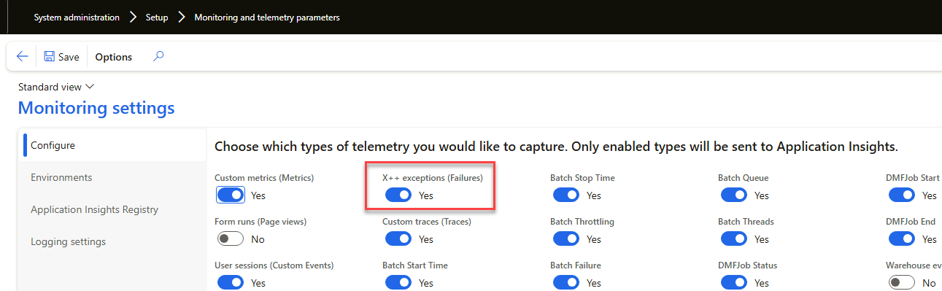
And then use KQL queries to read exception log
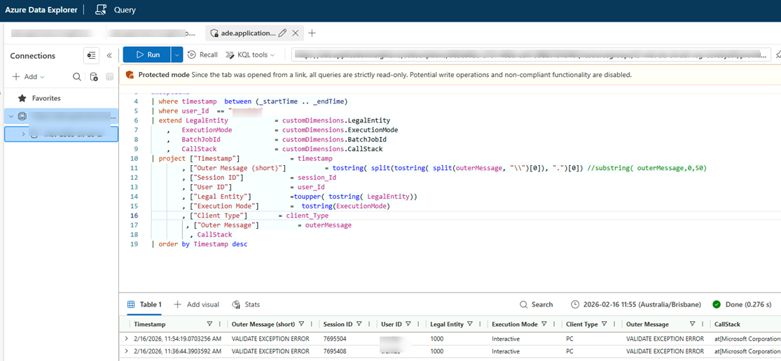
Also a very important note – current D365FO batch framework can’t handle this exception properly, if you raise it inside batch job, it will be restarted 5 times before going to Error stage, I wrote an article about this some time ago Batch Job errors in D365FO: How they can ruin the performance and how to fix them https://denistrunin.com/performance-d365batch/
All other exceptions described below are not captured by the standard monitoring tools.
Code Exceptions not captured by standard telemetry
The X++ kernel generates several exception types that don't go through throw error(). Standard Microsoft telemetry described above doesn't log them(at least for 10.0.46 version), so they can easily go unnoticed in production — especially in batch jobs where nobody watches the Infolog.
To solve this problem, I created the Infolog call stack tool. It subscribes to the Info.onInfoLogMessageAdd() delegate and saves the full X++ call stack for every Infolog message to a database table. This way you can see the source of any error message without debugging, and it works for all exception types described in this section.
Record Not Selected
Happens when you try to update a record buffer that was never fetched by a select statement.
xpp
CustGroup custGroup;
// No select — buffer is empty
custGroup.Name = "Test";
custGroup.update(); // Exception: Record not selected
Update Not in TTS
Happens when you try to update a record outside of a ttsbegin/ttscommit block.
xpp
CustGroup custGroup;
select firstonly forupdate custGroup;
// No ttsbegin here
custGroup.Name = custGroup.Name;
custGroup.update(); // Exception: Update not in TTS
Update Conflict (Update by Different User)
Happens when two processes update the same record and the second one has a stale RecVersion. This is how Optimistic Concurrency Control (OCC) works — the system checks that nobody changed the record since you read it.
xpp
ttsbegin;
select firstonly forupdate custGroup;
custGroupCopy.data(custGroup);

custGroup.Name = custGroup.Name + " ";
custGroup.update(); // RecVersion changes

custGroupCopy.Name = custGroupCopy.Name + "X";
custGroupCopy.update(); // Exception: old RecVersion
ttsabort;
This exception can be caught inside a transaction scope. The standard approach is to retry a few times and then throw Exception::UpdateConflictNotRecovered.
Deadlock
Happens when two database sessions lock resources in opposite order, creating a circular wait. SQL Server detects this and kills one session.
To reproduce this, you need two sessions. Session 1 locks Record A, then tries to lock Record B. Session 2 locks Record B, then tries to lock Record A. The test class uses a reverseLockOrder flag and a sleep() to coordinate this.
Like update conflicts, deadlocks can be caught and retried in batch jobs.
Duplicate Key
Happens when you try to insert a record that violates a unique index.
xpp
select firstonly custGroup;
ttsbegin;
custGroupDuplicate.CustGroup = custGroup.CustGroup;
custGroupDuplicate.Name = "Duplicate Test";
custGroupDuplicate.insert(); // Exception: duplicate key
ttsabort;
This is the second exception type (along with Update Conflict) that can be caught inside a transaction scope.
Stack Overflow — The AOS Crash
This exception is different from everything above. For the current D365FO version 10.0.46, It crashes the AOS process.
xpp
public void causeAOSCrash()
{
this.causeAOSCrash(); // Infinite recursion
}
Stack overflows are rare, but they do happen — usually from circular class references, recursive methods without a proper exit condition, or deeply nested event chains.
It can be emulated using this button. UI reaction in this case will be like this
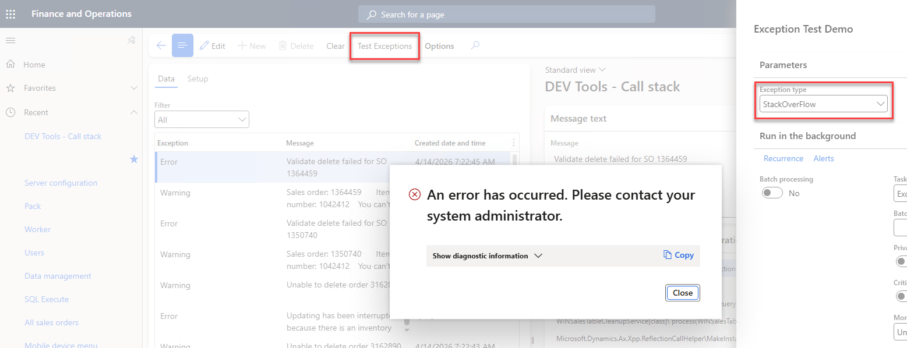
If code runs on Tier1 you get an error in Application log
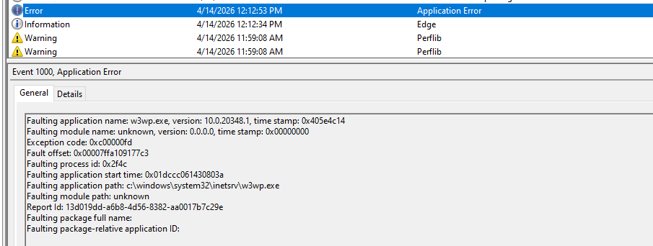
On Tier2 if you get this exception, you can see the following pattern in the LCS-Environment monitoring Memory tab
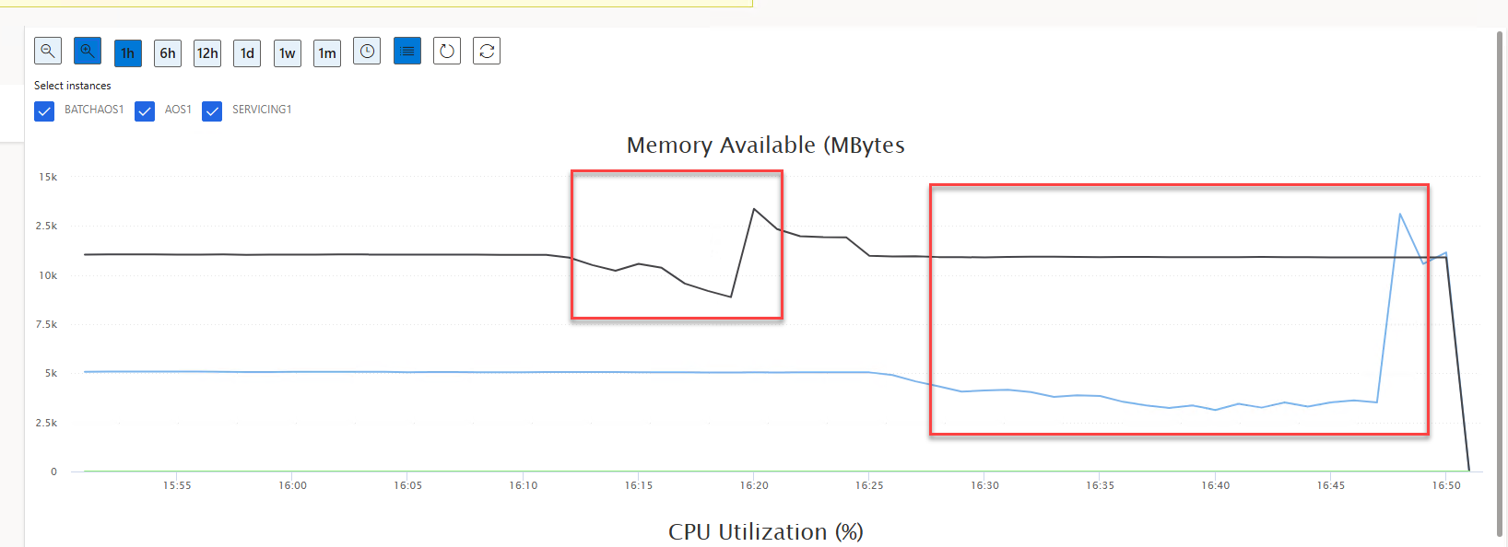

The main issue: currently, there is no publicly available tool that can capture it — not standard telemetry, not the Infolog call stack tool, nothing that runs inside the X++ runtime.
Microsoft support internally has this data, but it may be tricky to get access to the engineer who can check it and provide you with some info(e.g. call stack)

Summary
When you develop and support D365FO, it's important to understand what kind of X++ Exceptions may occur and the current monitoring limitations. I hope this article gives some overview, it will be interesting to know how you currently monitor exceptions, especially AOS crashes. Fell free to share comments

